PHYSIO-CHEMICAL AND SENSORY ATTRIBUTES OF COOKIES PRODUCED FROM COMPOSITE FLOUR BLENDS OF MODIFIED ‘GBACHE’ AND SOYBEAN

Abstract
The study evaluated the quality of composite flour and cookies produced from gbache and Soybean. The samples were formulated as 100, 90:10, 80:20, 70:30, 60:40 and 505:50 respectively and was labelled samples A, B, C, D and E. the samples were analyzed for proximate composition, functional properties, anti-nutrients, physical properties, pasting properties and Mineral elements. The proximate composition shows that Moisture content ranged from 4.94 to 7.03%, Ash content ranged from 0.03 to 3.17%, Fat content ranged from 0.35 to 15.19%, Fibre content ranged from 0.07 to 2.81%, Protein content ranged from 6.67 to 32.26% and Carbohydrate content ranged from 41.57 to 85.84%. Mineral elements content shows that Calcium content ranged from 13.52 to 14.55 mg, Zinc content ranged from 0.22 to 0.385 mg, Iron content ranged from 0.67 to 2.96 mg, Magnesium content ranged from 3.30 to 16.67 mg, Manganese content ranged from 0.13 to 1.40 mg, Sodium content ranged from 27.67 to 37.10 mg and Potassium content ranged from 12.26 to 40.09 mg respectively. The physical properties of the cookie show that the Diameter ranged from 2.10 to 2.30 cm, thickness ranged from 0.40 to 0.48 cm, spread ratio ranged from 4.95 to 5.29 cm and Break strength ranged from 4.00 to 10.00 kg. The sensory scores show that sample B was the most preferred sample amongst the formulated samples; with an overall acceptability score of 6.90 on the 9- point Hedonic scale. In conclusion, the above results shows that cookies could be produced from blends of gbache and Soybean composite flour.

Keywords: Gbache, Soybean, composite Flour, Modified, Coolies

Introduction
Composite flour as expressed by Hasmadi et al. (2020) is a mixture of flours obtained from tubers, which are rich in starch such as cassava, yam, potato, protein-rich flour and cereals, with or without wheat flour that are created to satisfy specific functional characteristics and nutrient composition, For example, wheat with sweet potatoes, wheat and cassava, wheat and many legumes, wheat and millet, or without wheat flour and other composites. According to Sulieman et al. (2019), composite flour has better nutritional value concerning elements of minerals, vitamins, fibres and proteins than flour milled from any specific cereal alone. Shanthakumani et al. (2008) reported that the composite flour mixture could provide a balanced nutrient. In recent years, composite flour became the subject of numerous studies. There has been increasing interest in replacing conventional gluten-free formulations made from refined gluten-free flour, starch, and hydrocolloids with those enriched with functional gluten-free ingredients. Another study by Hasmadi et al. (2014) described composite flour as an innovative flour which has attracted much attention in research as well as food product development. In developing countries such as Africa and other parts of the world, the use of composite flours has many benefits in a saving of hard currency and as a promotion of high yielding native plant species. Adeyeye et al. (2019) also stated that the use of composite flour would promote better overall use of domestic agriculture production. There are two significant reasons for mixing wheat flour with other flours; economic and nutritional. The capability, availability, and cost at the point of use are the most important things overlooked in selecting the raw material to produce good blended flour in terms of preference, variety, nutrition, and low cost as to fulfill consumer demands. According to Nuareen et al. (2017), composite flour technology refers to the process of mixing wheat flour with cereals and legumes to make economic use of local raw material to produce high quality food products. Cereal-pulse combinations have been employed for the production of various products. In addition to being a rich protein source, pulses are being recognized as having therapeutic/medicinal properties. It is apparent that composite flour prepared by blending wheat and legumes in proper proportions can provide the required amino acids to the consumer. FAO (2004) initiated the concept of composite technology which was targeted at reducing the cost of support for temperate countries by encouraging the use of indigenous crops such as cassava, yam, maize and others in partial substitution of wheat flour. The FAO reported that the application of composite flour in various food products would be economically advantageous if the imports of wheat could be reduced or even eliminated, and that demand for bread and pastry products could be met by the use of domestically grown products instead of wheat.
Cookies, which represent the largest category of snack foods in most parts of the world are a form of confectionery product dried to a low moisture content and widely consumed by individuals in all age groups. The projected global market for cookies in 2016 has reported to be around $1,825.00 billion dollars in 2016. In Nigeria, like many other developing countries, the increasing phenomenon of urbanization, coupled with the growing number of working mothers, have contributed greatly to the popularity and increased consumption of snack foods such as cookies and biscuits (Sengev et al., 2015).
Polynesian arrowroot (Tacca leontopetaloides (L.) Kuntze) is popularly known as ˝Amora,˝ or ˝’Gbache’˝ by some ethnic nationalities in Nigeria. It is native to tropical Africa, South Asia, Southeast Asia, northern Australia, New Guinea, Samoa, Micronesia, and Fiji. It belongs to the genus Tacca and family Taccaceae (IPNI, 2005). However, some taxonomists group it with the yam family Dioscoreaceae. It is a perennial monocot, found as a plant only in the rainy season, because from September through the dry season, the shoot dies off and the tubers become dormant; new shoots sprout and emerge at the onset of rains, the following year. It can be propagated both by seed and by tuber. In Nigeria, as in other parts of Africa, these plants grow in the wild as solitary plants in open fields, under the shade of trees or on hilltops (Satdom and Ajala, 2020). Polynesian arrowroot is found naturally growing in the tropical rainforest and guinea savannah agro-ecologies of Nigeria. The plant is wide-spread in the middle belt of Nigeria and in the south-western states (Borokini et al., 2014). Specifically, Pate et al., (2014) reported that it is found widely in Plateau and Nasarawa states. They have also been collected from the wild in Anyamelu L.G.A. of Anambra State and Bende LGA of Imo State. In Plateau State, the tubers are a delicacy to the people of Shendam, Langtang and other inhabitants of lower Plateau and are eaten especially when other staple foods are scarce (Ogbonna et al., 2017). The tubers are rich in starch, which varies according to growing conditions and soil substrate. Starch content ranges from 10% to 25% of tuber weight). Although, the tubers are poisonous, the poison is removed by soaking or washing them in water and rinsing repeatedly. Oil and protein contents together constitute about 60 % of dry soybeans. The remaining dry matter is composed of mainly carbohydrates (35 %) (17 % of which dietary fiber) and ash (5 %). Since the water content of stored mature beans is usually about 13 % to ensure storage stability, on a wet basis, soybeans contain about 35 % protein, 17 % oil, 31 % carbohydrate and 4.4 % ash. According to the standard for measuring protein quality, Protein Digestibility Corrected Amino Acid Score, soybean protein has a biological value of 74, whole soybeans 96, soybean milk 91, and eggs 97 (FAO/WHO, 1989). On the other hand, Soy vegetable oil is another product of processing the soybean crop used in many industrial applications. Soybean oil contains about 15.65 % saturated fatty acids, 22.78 % monounsaturated fatty acids, and 57.74 % polyunsaturated fatty acids (7 % linolenic acid and 54 % linoleic acid) Furthermore, soybeans contain several bioactive compounds such as isoflavones among others, which possess many beneficial effects on animal and human health.
Rahman et al. (2011) reported that soybean protein contains sufficient lysine, which is deficient in most cereal proteins. Therefore, soybean amino acid profile is complementary to cereal amino acid profile. Thereby, legumes may be used to fortify cereals. Soybeans normally contain 18-22 % oil. Fat fraction contains mainly triglycerides that make up 99 % of soybean fat. Minor components include phospholipids, unsaponifiable matter (tocopherols, phytosterols, and carbohydrates), and free fatty acids. Most beans are very low in fat, but soybeans are an exception because their fat content is the highest among the beans, containing 47 % of energy from fat. Soybean fat stands out for its high content of the polyunsaturated fatty acids, linoleic (C18: 2) and linolenic (C18: 3) acids. It also contains considerable amounts of another unsaturated fatty acids, oleic acid (C18: 1) and moderate amounts of the saturated fatty acids, palmitic acid (C16: 0) and stearic acid (C18: 0). (GarcíaRebollar et al., 2016). Soybeans contain a fair amount of both soluble and insoluble fiber. The insoluble fibers are mainly alpha-galactosides, which may cause flatulence and diarrhea in sensitive individuals. Alpha-galactosides belong to a class of fibers called FODMAPs, which may exacerbate the symptoms of irritable bowel syndrome (IBS). Despite causing unpleasant side effects in some people, insoluble fibers in soybeans are generally considered healthy. They are fermented by bacteria in the colon, leading to the formation of short-chain fatty acids (SCFAs), which may improve gut health and reduce the risk of colon cancer. Soybeans are also a good source of several vitamins and minerals, including vitamin K1, folate, copper, manganese, phosphorus, and thiamine. ‘Gbache’ flour is prepared as food by boiling the flour in water with addition of ingredients like salt, paper, condiment, fish and can be sold in local restaurant, which serve as source of income to the locals. Soups, thickeners and ‘Gbache’ flour can also be sold in the market for researchers, this can also generate money for the locals.
MATERIALS AND METHODS
Source of Materials
Tubers of Polynesian arrowroot were be harvested from the wild bush in Mbaav Turan community, Kwande Local Government Area and soybean seeds were purchased from reserve, where they were conveyed to dry processing laboratory, Joseph Sarwuan Tarka University, Makurdi. Benue State, Nigeria.
Preparation of Samples
Preparation of arrowroot flour
Polynesian arrowroot tubers were be sorted and cleaned to remove adhering soils and foreign materials, they were peeled and grated into slurry and allowed to settle. The slurry was decantated to reduce the antinutrients and then finally sundried to constant weight. The ‘Gbache’ starch was then toasted (85ºC for 1 hour) to have ‘Gbache’ flour. The flow chart used to produce ‘Gbache’ flour is shown in Fig. 1.


Sorting
Washing
Peeling
Grating
Sedimentation
Decantation
Sun drying (72 hrs)
Milling

Modified Gbache flour
Figure 1: Flow Chart for Production of Modified ‘Gbache’ Flour
Source: Okereke et al. (2021)

Preparation of Soybean flour
Soybeans flour was produced using the method of Adeyeye, (2019) modified as shown in Fig 2. Soybeans was sorted by hand picking the chaff and stones. The sorted soybean seeds was washed with water in order to remove the adhering dirt and poured in heated water of 100 ˚C to boil for 30 minutes to remove the anti-nutritional factors and beany flavour. The boiled soybeans was dehulled and washed properly. The grains was dried in an oven (Pax 2 and Pax 3 vented oven lid 2.0) at 60 ˚C for 24 - 48 h to a moisture content of about 10 %. The dried grains was milled using Attrition milling machine and the flour was sieved into fine uniform particle size by passing them through a 0.5 mm mesh sieve. The flour was packaged in polyethylene bags and kept at room temperature for later use.


Sorting
Washing
Boiling (100 ⁰C for 30 min)
Dehulling and washing
Oven drying (60 ⁰C 48 h)
Milling (attrition milling machine)
Sieving (0.5 mm)

Figure 2: Flow Chart for the Production of Soybean Flour
Source: Adeyeye, (2019) modified.

Table 1: Blend Formulation of ‘Gbache’ and Soybean Composite Flour (g)
Sample | ‘Gbache’ | Soybean
A | 100 | 0
B | 90 | 10
C | 80 | 20
D | 70 | 30
E | 60 | 40
F | 50 | 50

Cookies Formulation and Preparation
The cookies were formulated from the standard cookies recipe given as follows: composite flour (100g), sugar (2g), margarine (5g), and water (15ml). The cookies were prepared according to the method as described by (Sengev et al. 2015). The weighed sugar and margarine were creamed with a wooden spoon at medium speed until it became fluffy in a mixing bowl. The eggs were then whisked into it and blended by mixing. Milk was added to the mixture and afterwards the flour and other ingredients were mixed thoroughly to form dough. It was kneaded until it became smooth and lumpless and then rolled out thinly. The dough was cut with a cookie cutter into sizes and shapes of 6cm diameter, and then placed gently on the baking pan greased with margarine and then put inside the oven. The six blend formulations were baked using temperature of 150ºC for 12 min. After baking, the cookies were spread on the clean working table and allowed to cool, then packaged in transparent polyethylene bags.

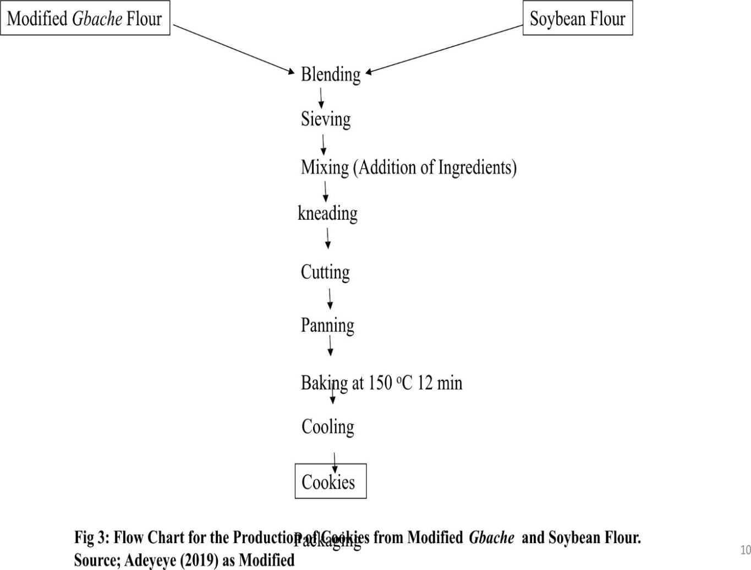
Figure 3:

Results
Pasting properties of flour blends
Pasting properties of the flour blends were determined using a Rapid Visco-Analyzer (Newport Scientific, RVA super 3, Switzerland) as described by AACC, (2012). Three grams each (on a 100% dry matter basis) of the flour samples was weighed into the canister. The paddle was placed into the canister and the canister was inserted into the instrument. The measurement cycle was initiated by depressing the motor tower of the instrument when the computer commands “Press down the tower”. The canister was removed on completion of the test. Flour suspensions (9%w/w dry flour basis, 28 g total weight) were equilibrated at 300°C. All determinations were done in duplicate.
Physical properties
The diameter (D) and thickness (T) of the cookies were determined using the method described by Sengev et al., (2015). This involves arranging six cookies in a row and taking their average diameter using ruler and thickness using a Vernier caliper with 0.01 mm accuracy (Cappera Precision, China). The spread ratio (SR) was calculated as in the formula: SR = T/D ……………………………………………………… (6)
Determination of Proximate composition of flours and cookies
The ash, moisture, crude fat, crude protein, crude fibre and carbohydrate content of the composite flour were determined.
Determination of Ash content
The AOAC (2012) method for determining ash content was used. An empty crucible was preheated and cooled in a desiccator after which it was weighed (W1) using a digital weighing balance (3000g x 0.01g 6.6LB). Two (2) gram of sample was added into the crucible and its content weighed (W2). The crucible with its content was then heated in a muffle furnace at 550 ⁰C for 6 – 7 h. The crucible was cooled in a desiccator and weighed soon after reaching room temperature (W3). Ash content was determined by incinerating the sample in a furnace at 550 ⁰C, the total ash was calculated as percentage of the original sample weight.
$Ash content \left(\%\right)=\frac{W3-W2}{W2-W1}$x 100 …………………………………. (7)
Where: W₁ = weight of empty crucible
W₂ = weight of crucible + weight of sample before Ashing
W₃ = weight of crucible + weight of sample after ashing.
Determination of Moisture content
The moisture content will be determined according to the method described by AOAC (2012). The crucibles was washed and dried in an oven at 100ºC for 1 hour. The crucibles was cooled and weighed as (W1). The sample (2 g) was weighed into the crucible (W2) and dried at 70 ⁰C until a constant weight was obtained (W3). The moisture content of each variety was calculated as loss in weight of original sample and expressed as percentage moisture content.
$Moisture content \left(\%\right)=\frac{W3-W2}{W2-W1}$ x 100 ………………………………. (8)
Where: W₁ = Initial weight of empty crucible
W₂ = weight of crucible + sample before drying
W₃ = weight of crucible + sample after drying
Determination of Fat content:
This will be determined using the Soxhlet extraction method as described by AOAC (2012). The sample (2 g) was weighed into a labeled extraction thimble and placed in an extraction flask. 300 ml of diethyl ether was added to the flask. The extraction thimble was sealed with cotton wool and extraction carried out for 6 hours. At the end of the extraction the diethyl ether was removed by evaporation on an electrical heater. When the flask was free of the ether, it was dried at 70 ⁰C for an hour in an oven and cooled in desiccators before it was weighed.
$Fat content \left(\%\right)=\frac{W3-W2}{W2-W1} x 100$ ………………………….. (9)
Determination of Protein content
The method described by Onwuka, (2005) was used for protein content determination. The nitrogen content was determined by the micro-Kjeldahl apparatus equipped with Kjeldahl digester and distilling system. Sample (2 g) was weighed into Kjeldahl flask and 5 g of anhydrous sodium sulphate was added. Then, copper sulphate (1 g) was added. Into the mixture, 25 ml of concentrated Sulphuric acid was introduced and 5 glass beads was added for prevention of bumping during heating. In the fume cupboard, the mixture was heated very gently first and then increased with occasional shaking till solution assumed green colour (temperature of the digester was above 4200C for about 30 minutes). The sample was cooled and every black particle that showed at the mouth and neck of the flask was washed down with distilled water. The sample was gently re-heated till the green colour disappeared and the cooled. The cooled sample (digest) was transferred into a 250 ml volumetric flask after several washings. The volume was made up to 250 ml mark with distilled water. Distillation was carried out using Markham distillation apparatus which was first steamed for about 15 minutes. Then, a 100 ml conical flask (that contained 5 ml of boric indicator such that the condenser tip was under the liquid) was placed under the condenser. The digest (5 ml) was pipetted into the body of the apparatus via a small funnel aperture and washed down with distilled water and followed by 5 ml of 60% NaOH solution. The mixture was steamed through for about 5-7 minutes to collect enough ammonium sulphate. The receiving flask was removed and washed down the tip of the condenser into the flask before the condensed water was removed. Then the solution in the receiving flask was titrated using 0.01N hydrochloric acid and the titre value was recorded. The blank was run along with sample. The nitrogen content and hence the protein content of the sample was calculated:
$$\% Nitrogen=\frac{Vs-Vb x N acid x 0.0142 x 10 x 100}{w}$$
Where Vs = Vol (ml) of acid required to titrate sample
Vb = Vol (ml) of acid required to titrate the blank
Nacid = normality of acid (0.1N)
W= Weight of sample in grams
% Protein = % Nitrogen x Conversion Factor (6.25)
Determination of Fibre content
Crude fibre was determined based on the procedures of AOAC (2012). The sample (2 g) was defatted with diethyl ether and thereafter, 0.255 M sulphuric acid (200 ml H₂SO₄) and dilute sodium hydroxide (200 ml NaOH) will be addded to it. The mixture was heated to boiling point and the insoluble material was transferred to a filter paper through a Buchner funnel connected to a vacuum pump. The filtrate was dried at 130 ± 2 ºC for 2 h, cooled in a desiccator and weighed. The filtrate was transferred to a muffle furnace (Shanghai box type resistance furnace, No. SX2-4-10N) and ignited at 550 ºC for 30 min, cooled and weighed. The percentage crude fibre content was calculated as:
% Crude fibre = the loss in weight after incineration x 100 ………………. (10)
Determination of Carbohydrate content
According to AOAC (2012), the available carbohydrate was determined by difference. That is by subtracting crude protein (%), moisture (%), fat (%), crude fibre (%) and ash (%) contents of the sample from 100.
Carbohydrates = 100 – {protein (g %) + fat (g %) + water (g %) + fibre (g %) + ash (g %)}….. (11)
Determination of Mineral composition
Two grams (2 g) of each composite flour sample was weighed into a clean ceramic crucible using the method of AOAC, (2010). A blank was prepared with empty crucible. The crucible was placed in a muffle furnace at 500˚C for 4 hours. The samples was allowed to cool down in the oven after which it was removed carefully. The ash samples were poured into already labelled 50 mL centrifuge tube. The crucible was rinsed with 5 mL of distilled water into the centrifuge tube. The crucible was rinsed again with 5 mL of aqua regid. This will be repeated to make a total volume of 20 mL. The sample was mixed properly and centrifuged by 10 min. The supernatant was decanted into clear vials for minerals determination. The absorbance was read on atomic absorption spectrophotometer (Buck Scientific Model 200A) at different wavelengths for each mineral element.
Determination of Zinc content
Zinc in the samples of composite four was determined according to Onwuka, (2018) by molybdate method using hydroquinone as a reducing agent. Five milliliters (5 mL) of the test solution was pipetted into 50 ml graduated flask. Then 10 mL of molybdate mixture was added and diluted to mark with water. It was allowed to stand for 30 minutes for colour development. The absorbance was measured at 660 nm against a blank. A curve relating absorbance to mg zinc present was constructed. Using the zinc standard solution, and following the same procedure for the test sample, a standard curve was plotted to determine the concentration of zinc in the composite flour sample.
$\% Zinc=+\frac{graph reading×solution volume}{100}$ ……………………… (12)

Determination of Iron content
Iron was determined following the phenanthroline method of AOAC, (2012). Five milliliters of digested sample of composite flour was placed in a 50 mL volumetric flask. Then 3 mL of phenanthroline solution, 2 mL of hydrochloric acid and 1mL of hydroxylamine solution was added to the sample in sequence. The sample solution was boiled for 2 minutes and 9 ml of ammonium acetate buffer solution was added to the solution. The solution was diluted with water to 50 mL volume. The absorbance was determined at 510 nm wavelength. Iron standard solution was prepared in order to plot a calibration curve to determine the concentration of the sample. Standard solution containing 100 mg/mL of ferric irons was prepared from 1g pure iron wires. The wires was dissolved in 100 mL concentrated nitric acid, boiled in a water bath and diluted to 100 mL with distilled water after cooling. Standard solutions of known concentrations was prepared by pipetting 2, 4, 6, 8 and 10 mL standard iron solution into 100 mL volumetric flasks and made up to volume.
Determination of Potassium content
Potassium was determined by a procedure described by AOAC, (2012) using a flame photometer. Potassium standard was prepared. The standard solution was used to calibrate the instrument read out of composite four. The meter reading was at 100% E (emission) to aspire the top concentration of the standards. The 100% E of all the intermediate standard curves was plotted on linear graph paper with these readings. The sample solution was aspired on the instrument and the readings (% E) was recorded. The concentration of the element in the sample solution was read from the standard curve.
$\% Potassium=+\frac{Ppm×100×DF}{1 million}$ ……………………… (13)
Determination of Calcium content
Calcium was determined using the method described by AOAC, (2012). Twenty-five milliliter (25 mL) of the digested samples of composite four was pipetted into 250 mL conical flask and a pinch of Eriochrome Black-T-Indicator (EBT) was added. Thereafter, 2 mL of 0.1N NaOH solution will be added and the mixture titrated with standard EDTA (0.01M EDTA) solution.
$Calcium (mg/L)=\frac{Titre value×Molarity of EDTA×Equiv. Wt. of}{Vol.of sample used}$ …………………. (14)
Sensory Evaluation cookies
Sensory quality attributes of cookies produced from modified ‘Gbache’ and soybean flours such as colour, taste, texture, flavour, crispiness and overall acceptability were evaluated using a 15–member trained panel, made up of students of the Joseph Sarwuan Tarka University, Makurdi. A 9-point Hedonic score system as described by (Sengev et al. 2015) was used where 9=Like extremely, 8=like very much, 7=like moderately, 4=Like slightly, 5= Neither like nor dislike, 4=Dislike slightly, 3=Dislike moderately, 2=Dislike very much and 1=Dislike extremely
Experimental Design and Statistical Analyses
The samples were presented in three (3) digits codes white plates. The sensory evaluation was carried out in a sensory evaluation under controlled conditions. The experiment was conducted in complete randomize design (CRD). Data were generated replicate and subjected to analysis of variance (ANOVA) using SPSS version 25. Means were separated by Duncan’s Multiple Range Test (DMRT). Significance was accepted at (p < 0.05)
Data obtained were analyzed using SPSS statistical package version 25. ANOVA was performed to determine the difference. Means will be tested for significant differences by Duncan’s Multiple Range Test (DMRT). Significance will be accepted at (p < 0.05).
Discussion
Physical properties of cookies
Table 1 shows the physical properties of cookies produced from composite flours of ‘Gbache’ and Soybean flour. There was increase in spread ratio of the samples increased with increase in ‘gbache’ flour. Sample D and E cookies had the least spread ratio and also had the highest thickness. Chinma and Gernah (2001) reported similar trend in cookies produced from cassava/soya/mango composite flour and attributed it to the hydrophilic nature of the flour used in the products which led to decrease in spread ratio and increase in thickness. Ade et al., (2012), noted that, when a dough or batter becomes less viscous, it tends to spread more and increase in diameter. The break strength showed that sample F (10.00g) had the highest value. This may be due to 50:50 addition effect of ‘Gbache’ and Soy flour while sample A (4.00g) had the least (Ubbor and Akobundu, 2009).

Table 2: Physical Properties of Cookies Produced from Composite Flours of ‘Gbache’ and Soybean flour
SAMPLES | Diameter (cm) | Thickness (cm) | Spread ratio (cm) | Break strength (kg)
A (Control) | 2.10ª±0.00 | 0.41ª±0.01 | 4.95ª±0.00 | 4.00ª±0.00
B | 2.15ª±0.01 | 0.42ª±0.00 | 5.15ª±0.04 | 4.00ª±0.00
C | 2.15ª±0.01 | 0.43ª±0.03 | 5.20ª±0.02 | 6.00^{b}±0.00
D | 2.20ª±0.00 | 0.45ª±0.01 | 5.25ª±0.00 | 6.00^{b}±0.00
E | 2.25ª±0.00 | 0.46ª±0.00 | 5.25ª±0.00 | 10.00^{c}±0.00
F | 2.30ª±0.02 | 0.48ª±0.01 | 5.29ª±0.06 | 10.00^{c}±0.00
* Values are means of ± SD 0.05 of replication
Keys:
A = 100% ‘Gbache’
B = 90% ‘Gbache’ flour and 10% Soybean flour
C = 80% ‘Gbache’ flour and 20% Soybean flour
D = 70% ‘Gbache’ flour and 30% Soybean flour
E = 60% ‘Gbache’ flour and 40% Soybean flour
F = 50% ‘Gbache’ flour and 50% Soybean flour

Proximate composition of cookies
Table 3 shows the proximate composition of cookies produced from ‘Gbache’ and Soybean flour blends. The protein content of this cookies ranged from 6.345%-25.155, were is a significant (p<0.05) increase in protein contents as the level of Soybean increased. This may probably be due to addition effect, as Soybean flour contained more, protein than ‘Gbache’ flour. Sample A, clearly indicates that, cookies made from ‘Gbache’ flour sample, has low protein content of 6.345%. The flour blends with low protein contents could be utilized in food preparation for consumers at risk of celiac disease.
The ash contents of the cookies made from ‘Gbache’ and soybean blend ranged from 1.430-2.55%. The high ash content of the cookies from sample F could be attributed equal quantity of ‘Gbache’ and Soybean flour blends with the Ash content increased with increased ‘Gbache’ level. This indicates high level of mineral elements in sample F. Modification could affects the availability of mineral element in sample A. There was significant (p<0.05) increase in fibre contents of the cookies with respect to percentage increase in ‘Gbache’ flour level fibre is very important in food as, it helps in alleviating problems associated with constipation by expanding the walls of the colon, absorb water and provides roughage for the bowels for softer and bulkier stool. The fat contents of cookies ranged from 19.64 -27.108%. The difference in fat contents of the flour, which was 15.194-0.350% to that of cookies is as result of the butter added during mixing of the cookies. Higher values of fat suggest possibilities of a product undergoing rapid deterioration due to rancidity and risks of obesity, coronary heart disease and certain type’s cancer (WHO, 2004). The low values are also desirable for those who are health conscious and cautions of their fat intake.
The carbohydrate contents of the cookies ranged from 33.43-65.498%, with significant difference (p<0.05) between the samples. Bosha et al. (2013) reported 76% carbohydrate for Taccaleontopetaloides and Ubwa et al., (2011) reported 71% carbohydrate for T. leontopetaloides peels. The high carbohydrate contents of the sample shows that, it will be a good source of energy required for the daily activities of man. The moisture content of cookies ranged from 6.585% -9.625. It increased with percentage increase in ‘Gbache’ flour. The moisture content of the cookies is in agreement with SON and PAG (Protein Advisory Group-United Nations) who reported moisture contents of between 5 and 10% maximum. The range of moisture would have a positive effect on the shelf-life stability of the cookies (Bassey, 2004; Emmanuel et al., 2012).

Table 3: proximate composition of composite flour
Samples | Moisture | Ash | Fat | Fibre | Protein | carbohydrate
A (Control) | 7.04ª±0.01 | 0.03ª±0.01 | 0.35ª±0.03 | 0.07ª±0.01 | 6.67ª±0.16 | 85.84ª±0.21
B | 6.13^{b}±0.01 | 0.54^{b}±0.02 | 3.25^{b}±0.002 | 0.18ª±0.21 | 8.97^{b}±0.31 | 80.79^{b}±0.36
C | 5.96^{c}±0.00 | 1.08^{c}±0.00 | 6.43^{c}±0.02 | 1.08^{c}±0.03 | 13.13^{c}±0.00 | 72.33^{c}±0.05
D | 5.06^{d}±0.01 | 1.48^{d}±0.00 | 8.34^{d}±0.00 | 1.22^{c}±0.03 | 20.79^{d}±1.55 | 63.11^{d}±1.50
E | 4.54e±0.21 | 2.33e±0.00 | 13.16e±0.18 | 1.88^{d}±0.04 | 25.72e±0.75 | 52.38e±0.54
F | 4.94e±0.05 | 3.18^{f}±0.00 | 15.19^{f}±0.00 | 2.81e±0.26 | 32.27^{f}±0.77 | 41.57^{f}±1.05
Values are means of ± SD 0.05 of replication

A = 100% ‘Gbache’
B = 90% ‘Gbache’ flour and 10% Soybean flour
C = 80% ‘Gbache’ flour and 20% Soybean flour
D = 70% ‘Gbache’ flour and 30% Soybean flour
E = 60% ‘Gbache’ flour and 40% Soybean flour
F = 50% ‘Gbache’ flour and 50% Soybean flour
Mineral element contents of cookies
Table 4 shows the mineral elements contents of cookies produced from ‘Gbache’ and Soybean flour blends. The cookies had some minerals that are of beneficial to human bodies. Calcium helps in calcification of bones and its deficiency results to syndromes like rickets (Dauhouervon et al., 2012). Zinc is very important for protein and nucleic acid synthesis, zinc deficiency is associated with poor appetite poor growth and hypogeusia. Iron contents of the cookies ranged from 0.670 -2.960 mg with the highest value in sample E (2.960 mg). Iron is very important in production and building of blood cell and is also needed for transporting haemoglobin and for immune responses (Trease et al., 2012). Magnesium helps in phosphate transfer in most reactions, its deficiency results to severe migraine, hypertension, stroke and other disease conditions (Bello et al., 2013) Manganese is involved in a number of enzyme system (Abara, 2011). Sodium and potassium control body fluid, required for maintenance of water balanced and body pH. Deficiency causes reduction in utilization of digestive protein and energy.

Table 4: Mineral composition (mg/100g) of cookies from gbache and soybean flour blends
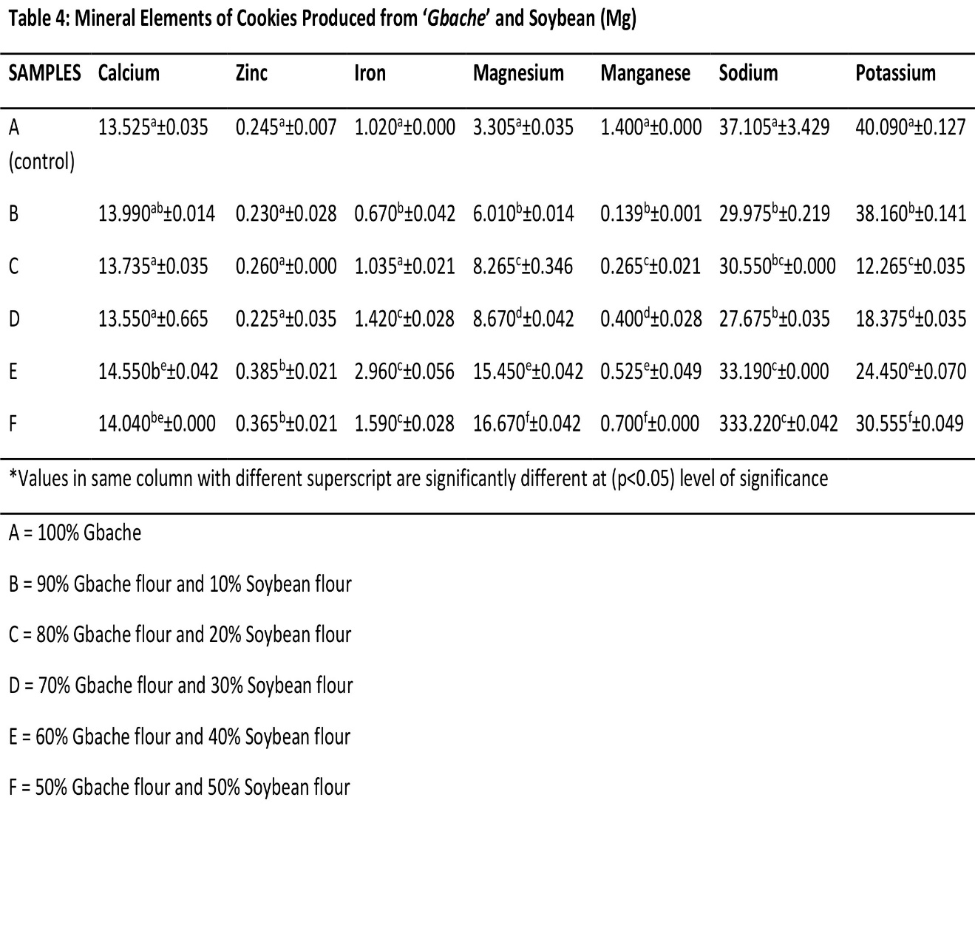
Values are means of ± SD 0.05 of replication
Sensory properties of cookies
Table 5 shows the sensory properties of cookies produced from ‘Gbache’ and Soybean flour blends. Sample C (7.45) had the highest score for appearance and sample D had the least (7.10) score. This may be attributed to 80% inclusion of soybean flour, protein are known in coating surfaces of food, which enhance acceptability. The least value in sample D could be a a result of increase ‘Gbache’ flour level. The aroma shows that sample B was most preferred to the other samples and only sample B (7.30 of 90% ‘Gbache’ and 10% Soybean flour) that was significantly different (P<0.05) between samples A, C, D, E and F. The texture scores showed that sample B had the highest value of 7.10 and sample A the least (6.40). There was no significant difference with respect to other samples (A, C, D, E and F). The overall acceptability scores showed that B was the most preferred amongst the Gbache -Soybean cookies.

Table 5: Sensory properties of Cookies Produced from ‘‘Gbache’’ and Soybean flour blends
SAMPLES | Appearance | Aroma | Texture | Overall Acceptability
A (control) | 6.75ª±1.68 | 6.85ª±1.26 | 6.40ª±1.54 | 6.30^{b}±1.92
B | 7.25^{b}±1.68 | 7.30^{b}±1.34 | 7.10^{b}±1.45 | 6.90ª±1.80
C | 7.45^{b}±1.05 | 6.85ª±1.31 | 6.90ª±1.33 | 6.80ª±1.51
D | 7.10^{b}±1.07 | 6.75ª±1.16 | 6.60ª±1.57 | 6.25^{c}±1.74
E | 6.75ª±1.06 | 6.65ª±1.23 | 6.45ª±1.39 | 6.30^{b}±1.63
F | 6.80ª±1.32 | 6.45ª±1.57 | 6.50ª±1.73 | 5.75^{d}±1.71
* Values are means of ± SD 0.05 of replication
Keys:
A = 100% ‘Gbache’
B = 90% ‘Gbache’ flour and 10% Soybean flour
C = 80% ‘Gbache’ flour and 20% Soybean flour
D = 70% ‘Gbache’ flour and 30% Soybean flour
E = 60% ‘Gbache’ flour and 40% Soybean flour
F = 50% ‘Gbache’ flour and 50% Soybean flour

Conclusion
It could be concluded therefore, that the variation in the functional properties of the blend studied, could be of significance in choosing ‘Gbache’ replacement level for different products. Hence, partial replacement of wheat with high quality composite flour of ‘Gbache’ and soybean could yield desirable results. The composite cookies samples of sample F were found to have high diameter, thickness, spread ratio and Break strength, this may be as a result of high amount or level of soybean .increase in soybean level, improved the crude fibre and crude protein content of the cookies respectively. The mineral content of the composite cookies appears to be higher with increase in ‘Gbache’ level for calcium, Zinc and Magnesium. The sensory attributes on the other hand, showed that, sample B was preferred amongst the cookies sample. Therefore, acceptable and nutritious cookies could be produced from composite flour of ‘Gbache’ and soybean. The composite flour cookies of sample F was more nutritious. Increase level of ‘Gbache’ improved the dietary fibre. The composite flour cookies samples were more nutritious. However, with the present cost of wheat flour, it advantageous to seriously explore the possibility of using ‘Gbache’ flour in commercial production bakery foods and other products.

References
Abara AE (2011) Proximate and Mineral Elements Compositions of the tissue and peel of Dioscorea bulbifera tuber. Pakistan. Journal of Nutrition 2011;10:543-51.
Adeyeye, S. A., Bolaji, O., Abegunde, T., Adebayo-Oyetoro, A., Tiamiyu H. K and Idowu-Adebayo F. (2019). Quality Characteristics and Consumer Acceptance of Bread from Wheat and Rice Composite Flour. Current Research in Nutrition and Food Science; 7 (2): 488-495.
Ade-Omowaye B I O, Abioye V F, Babarinde G O and Adesigbin M K. (2011). Chemical, physico-chemical and sensory properties of soy-plantain flour. African Journal of Food Science 5(4): 176–180.
AOAC, (2012) Official Methods of Analysis. 18th Edition, Association of Official Analytical Chemists, Arlington, 806-84
AOAC Association of Official Analytical Chemists. Official Methods of Analysis of the AOAC. 15th edn. (Gaithersburg, S. edn)In: Washington DC USA. 2006;78-90.
American Association of Cereal Chemists (AACC). (2000). Approve methods of the American Association of Cereal Chemists: Method 66-50, 10th ed. St. Paul, MN, USA: AACC.
Bassey, F (2004) Chemical Composition. Functional properties and shelf-life study of weaning food processed from cooking Banana. Unpublished PhD Thesis University of Calabar Nigeria.
Bello, F. A., Akpan, E. E., & Ntukidem, V. E. (2020). Development and quality characteristics of cookies from sprouted sorghum, pigeon pea and orange fleshed sweet potato flour blends. European Journal of Nutrition and Food Safety, 12(2), 11-21.
Borokini, T. I., Lawyer, E. F. and Ayodele, A. E. (2011). In vitro propagation of Tacca leontopetaloides (L.) Kuntze in Nigeria. Egyptian Journal of Biology, 13: 51-56. http://dx.doi.org/10.4314/ejb.v13i1.8.
Bosha JA, Gberinder FA, Asuzu IU (2013) Antihyperglyceamic Effect of Tacca involucrata on Alloxan Induced Diabetic Rats. Ghana Biomedical Convention, Cape Coast. 2013;56.
Chinma, C. E., and Gernah, D. I., (2007). Physical and sensory properties of cookies produced from cassava/soybean/mango composite flours. Journal of Food Technology, 5(3), 256 – 260.
Dahouervon -Ahoussi E, Adjou ES, Lozes E, (2012) Nutritional and microbiological characterization of pulp powder of locust bean (Parkia biglobosa Benth) used as a supplement in infant feeding in Northern Benin. African Journal of Food Science 2012;6:232-8.
Emmanuel-Ikennme C.A, Ekpeyong I.O and Igile, G.O (2012). Nutritional and sensory characteristics of an infant food based on Soybean seed and Tigernut. British Journal Cci ABD technology 2(4) 356-36
FAO: The State of Food Insecurity in the World. Monitoring the progress towards the world food Summit FAO, Rome Italy 2004.
FAO/WHO (1989). Protein Quality Evaluation: Report of the Joint FAO/WHO Expert Consultation. Bethesda, MD (USA): Food and Agriculture Organization of the Unit‐ ed Nations (Food and Nutrition Paper) 1989:51.
Hasmadi, M., Noorfarahzilah, M., Noraidah, H., Zainol, M.K. and Jahurul, M.H.A (2020). Functional properties of composite flour: a review. Food Research; 4 (6): 1820 – 1831.
Hasmadi, M., Patricia, M., Salwa, J., Siti, F., Mansoor, A., & Ainnor, S. (2014). The effect of seaweed composite flour on the textural properties of dough and bread. Journal of Applied Physiology, 26(2).
International Plant Names Index, (2005) Taccaceae Tacca leontopetaloides (L.) Kuntze Revisio G e n e r u m P l a n t a r u m 1 8 9 1 I P N I http://www.ipni.org/ipni/idPlantNameSearch.do?i d=827910-1.
Naureen, S., Masood, S. B., Saleem U. R. and Kamran, S. (2017). Chemical characteristics of various composite flours. International Journal of Agriculture and Biology; 7(1): 105–108.
Ogbonna, A.I., Adepoju, S.O., Ogbonna, C.I.C., Yakubu, T., Itelima, J.U. and Dajin, V.Y. (2017). Root tuber of Tacca leontopetaloides L. (kunze) for food and nutritional security. Microbiology: Current Research 1(1):7-13.
Okereke G.O (2012) Modification of starches from selected cassava Species and application in baked goods M.sc Thesis Michael Opkara University of Agriculture Umudike, 2012.
Onwuka, G. I. (2018). Food analysis and instrumentation. Theory and practices. Revised edition. Naphtali Prints Lagos, Nigeria, 10-20.
Pate, H.S, Badi, S.H. Dikwahal, H.D Jibung G.G. and Molchen, M.D. (2014) Response of Polynesian Arrowroot Tacca leontopetaloides to Fertilizer and Intra-Row Spacing at Garkawa. Journal of Biology, Agriculture and Healthcare www.iiste.org ISSN 2224-3208 (Paper) ISSN 2225-093X (Online) 4, (11).
Rahman, M. V., Pramilarani, B. and Satyanarayana, A.(2011). Genetic variability, correlation and path analysis in soybean. Journal of Oilseeds Resource. 17(1):32-35
Satdom S.M. and Ajala, B.A. (2020). Effect of Seed Tuber Sizes on the Growth and Yield of Tacca Leontopetaloides (Amora) at Varying NPK Fertilizer Levels in Jos Plateau S t a t e . International Journal Advanced Research 8(05), 1197-1204.
Sengev, I. A., Gernah, D. I. and M. C. Bunde-Tsegba. C. M. (2015). Physical, Chemical and Sensory Properties of Cookies Produced from Sweet Potato and Mango Mesocarp Flours. African Journal of Food, Agriculture, Nutrition and Development. 15(5): 10428-10442.
Shanthakumari S, Mohan V, Britto J. Nutritional evaluation and elimination of toxic principles in wild yam (Dioscorea spp.). Tropical Subtropical Agro-ecosystem. 2008;8: 225-319.
Suleiman, A.A., Zhu, K.X., Hasssan, H.A., Obadi, M., Siddeg, A., Zhou, M.-H. (2019). Rheological and quality characteristics of composite gluten-free dough and biscuits
Trease EC, Evans WC. Pharmacognosy. 16th Edition, W.B. Saunders, Philadelphia, 2009; 365-650.
Ubbor, S. C., and Akobundu, E. N. T. (2009). Quality characteristics of cookies and composite flours of watermelon seed, cassava and wheat. Pakistan Journal of Nutrition, 8(7), 1097-1102.
Ubwa ST, Anhwange BA, Chia JT (2011) Chemical Analysis of Tacca leontopetaloides Peels. American Journal of Food Technology 2011;6:932-8

