Case Report
Pyoderma Gangrenosum as the Initial Presenting Manifestation of Ulcerative Colitis: A Case Report and Literature Review

Abstract
Pyoderma gangrenosum (PG) is a rare neutrophilic dermatosis frequently associated with inflammatory bowel disease (IBD), particularly ulcerative colitis (UC). Although PG usually occurs during the course of established IBD, it may rarely precede the intestinal manifestations, creating a significant diagnostic challenge. We report the case of a 36-year-old woman with no relevant medical history who presented with severe painful ulceronecrotic skin lesions involving the left wrist and dorsal region, without digestive symptoms. Histopathological examination revealed a dense neutrophilic dermal infiltrate. After extensive exclusion of infectious, vascular, neoplastic, and autoimmune causes, the diagnosis of PG was established according to the Maverakis et al. criteria. Systemic corticosteroid therapy was initiated, resulting in progressive healing of the cutaneous lesions. Two months later, the patient developed bloody diarrhea and abdominal pain. Colonoscopy demonstrated continuous inflammatory lesions compatible with moderately active left-sided UC, and histological examination confirmed the diagnosis. Oral mesalazine was introduced in association with corticosteroid tapering, leading to a favorable clinical course for both cutaneous and intestinal manifestations. This case highlights PG as a possible initial extraintestinal manifestation of UC, preceding digestive symptoms. The atypical localization of the lesions and the absence of gastrointestinal complaints at presentation contributed to the diagnostic difficulty. Early recognition of PG should prompt systematic screening for underlying IBD, as timely diagnosis may significantly influence therapeutic management and long-term prognosis.
Keywords: pyoderma gangrenosum; ulcerative colitis; extraintestinal manifestation; neutrophilic dermatosis; inflammatory bowel disease; early diagnosis

Introduction
Pyoderma gangrenosum (PG) is a rare neutrophilic dermatosis of uncertain etiology, with an estimated incidence of 3 to 10 cases per million inhabitants per year [1]. First described by Brunsting et al. in 1930, it typically manifests as painful cutaneous ulcerations with undermined violaceous borders, progressing gradually and potentially reaching considerable dimensions [2]. Lesions generally begin as pustules or erythematous nodules that rapidly ulcerate, giving way to deep ulcers with a necrotic base [3].
PG is frequently associated with systemic diseases in approximately 50% of cases [4]. Among these, chronic inflammatory bowel diseases (IBD) — particularly Crohn's disease and ulcerative colitis — represent the most common associations, found in 30% of PG cases [5]. Although PG most often occurs in patients with an already-established IBD, it may also precede the diagnosis of the digestive disease, sometimes by several months or years, thereby constituting a true initial presentation and a significant diagnostic challenge [6].
The pathophysiology of PG remains incompletely understood. Abnormalities in innate immune response, neutrophil dysfunction, and dysregulation of interleukin signaling pathways (notably IL-1β, IL-17, and TNF-α) appear to play a central role in the pathogenesis of this condition [7]. The discovery of PSTPIP1 gene mutations in certain syndromic forms underscores the genetic component of the disease [8].
The diagnostic criteria of Maverakis et al. (2018) currently represent the reference standard, based on one major criterion — a skin biopsy at the ulcer border showing a neutrophilic infiltrate — and eight minor clinical, historical, and disease course criteria, including the exclusion of infection [9].
We report the case of a 36-year-old patient in whom severe pyoderma gangrenosum constituted the initial presenting manifestation of left-sided ulcerative colitis, diagnosed subsequently after the appearance of digestive symptoms during follow-up. This observation underscores the importance of systematically investigating for IBD in any case of pyoderma gangrenosum, even in the absence of initial digestive manifestations.

Case Report
A 36-year-old woman with no notable personal or family medical history was admitted to the dermatology department for painful skin lesions evolving over six weeks. On history-taking, there was no notion of recent trauma, unusual medication intake, or associated digestive symptoms.
Dermatological examination revealed two major ulcero-necrotic lesions, located respectively at the left wrist (Figure 1) and the dorsal region (Figure 2). The lesions presented as deep ulcerations with a necrotic base, undermined and infiltrated violaceous borders, with extension to the subcutaneous tissue and marked pain. The overall picture was strongly suggestive of pyoderma gangrenosum.

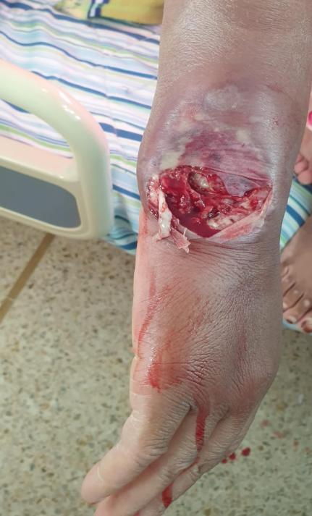
Figure 1: Pyoderma gangrenosum lesion at the left wrist.

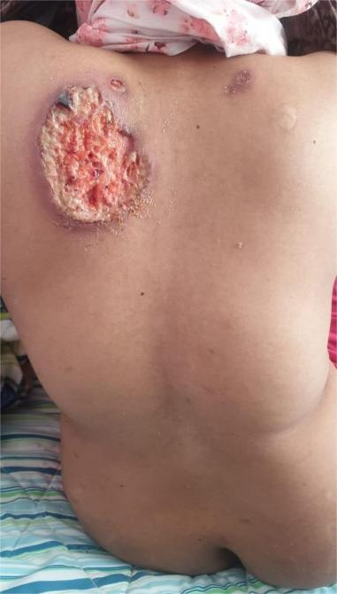
Figure 2: Pyoderma gangrenosum lesion located in the dorsal region.

Laboratory workup revealed a marked inflammatory syndrome with C-reactive protein elevated at 150 mg/L and neutrophil-predominant leukocytosis at 12,000/mm³. Comprehensive infectious workup — including bacterial, mycobacterial, and fungal cultures from lesion samples as well as viral serologies — was negative.
Histopathological examination of skin biopsies taken at the lesion borders revealed a dense dermal inflammatory infiltrate predominantly composed of neutrophils, with signs of tissue necrosis, without evidence of overt vasculitis or specific infection. These histological findings, combined with the Maverakis et al. clinical criteria, confirmed the diagnosis of pyoderma gangrenosum.
Systemic corticosteroid therapy with prednisone at a dose of 1 mg/kg/day was initiated, resulting in progressive improvement of the skin lesions.

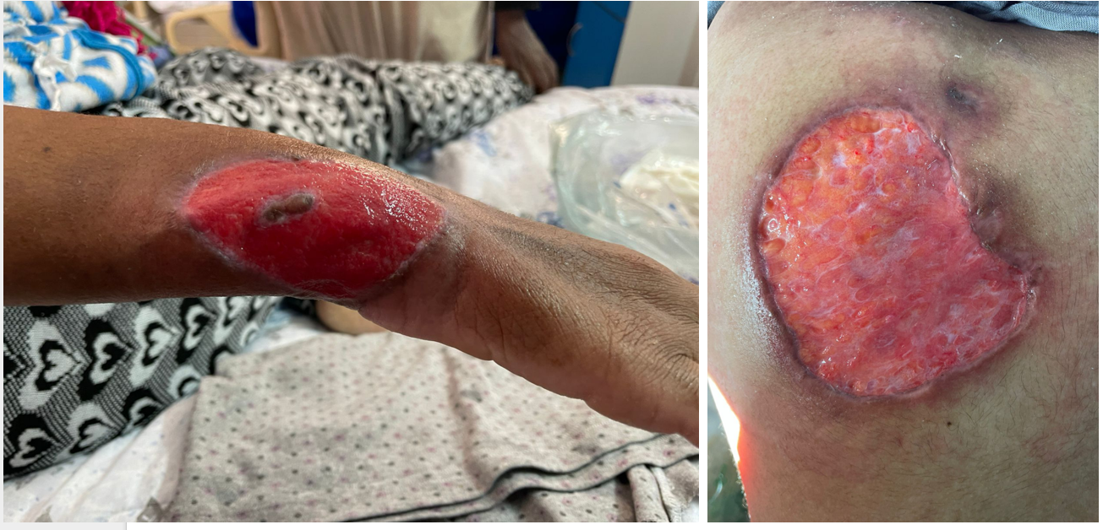
Figure 3: Pyoderma gangrenosum lesions in the process of healing under corticosteroid therapy.

Two months after the initiation of treatment, the patient reported the onset of bloody mucous diarrhea with three bowel movements per day, associated with rectal symptoms including tenesmus and fecal urgency. No obvious triggering factor was identified.
Total colonoscopy revealed continuous inflammatory involvement affecting the rectum, sigmoid colon, and descending colon, with a clear demarcation line at the descending colon–transverse colon junction. The mucosa was erythematous, friable on contact, with loss of the vascular pattern, compatible with moderately active left-sided ulcerative colitis (Mayo endoscopic score 2). The transverse colon, right colon, and terminal ileum were macroscopically normal.

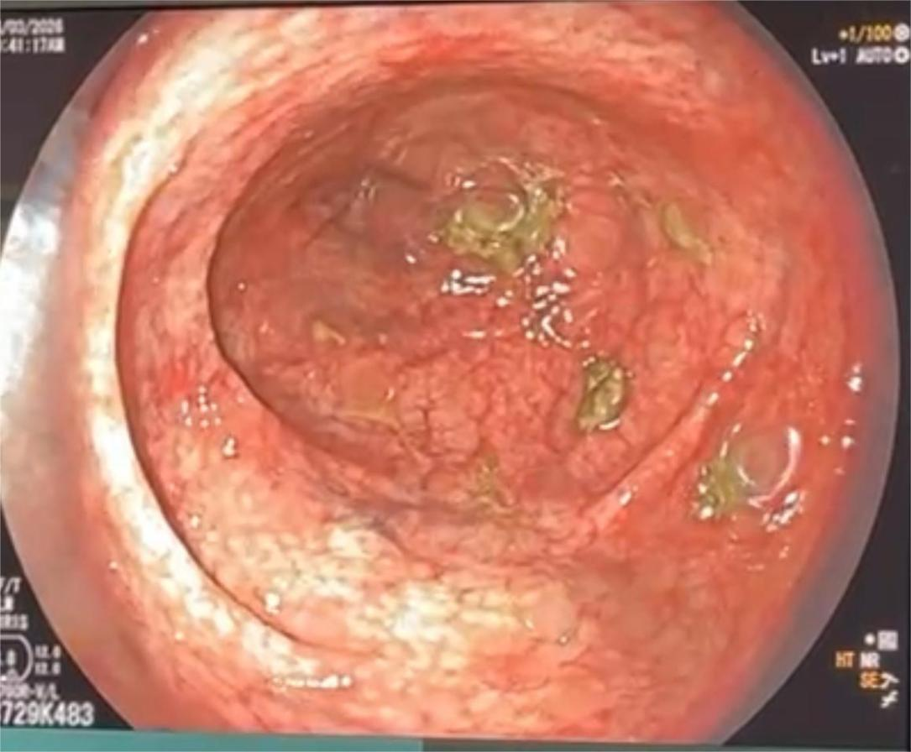
Figure 4: Endoscopic appearance of left-sided ulcerative colitis (Mayo score 2).

Serial colonic biopsies on histopathological examination showed a diffuse lymphoplasmacytic infiltrate of the lamina propria, associated with architectural glandular distortion, cryptitis, and crypt abscesses. An infectious etiology was formally excluded by negative stool cultures and negative parasitological stool examination. The overall histological findings were compatible with the diagnosis of ulcerative colitis.
Systemic corticosteroid therapy was continued on a progressive tapering schedule. Oral mesalazine at a dose of 3 g/day, combined with topical treatment, was initiated. The clinical course was favorable with progressive resolution of digestive symptoms and normalization of the inflammatory syndrome.
Simultaneously, the pyoderma gangrenosum lesions continued to improve with progressive reduction in size, decreased exudate, and gradual re-epithelialization.

Discussion
The case we report illustrates a particularly noteworthy presentation of pyoderma gangrenosum as the revealing manifestation of ulcerative colitis (UC), in the absence of any initial digestive symptoms. Cutaneous extra-intestinal manifestations represent a heterogeneous group of frequent complications of IBD, found in approximately 9.5% of UC cases and 19% of Crohn's disease cases, encompassing mainly pyoderma gangrenosum, erythema nodosum, and aphthous stomatitis [10]. Among these, PG remains the most debilitating, with a prevalence of 0.5 to 2% in patients with IBD, and a preferential association with UC rather than Crohn's disease [11].
The key feature of this case is the chronological sequence of events: the cutaneous PG lesions preceded the clinical onset of UC by several weeks. This sequence, although less common than PG occurring in the context of established IBD, has already been described in the literature [12]. In approximately 9% of cases, PG may precede the diagnosis of IBD, sometimes by several months [12]. The situation of our patient, in whom UC was diagnosed two months after the initiation of corticosteroid therapy, underscores the importance of active digestive surveillance and the performance of colonoscopy when supported by clinical, biological, or disease course findings. The atypical cutaneous locations observed in our case — at the wrist and back — also deserve emphasis, as PG associated with IBD typically involves the lower limbs [12,13].
From a pathophysiological standpoint, the link between PG and UC is explained by a shared immune dysfunction, involving aberrant neutrophil activation, exaggerated production of pro-inflammatory cytokines such as IL-1β, IL-17, and TNF-α, as well as a disruption of intestinal epithelial barrier homeostasis [7,12]. These mechanisms of systemic immune activation may promote the development of distant cutaneous lesions, even in the absence of clinically apparent colitis [14].
From a diagnostic perspective, our observation illustrates the challenges inherent to pyoderma gangrenosum, whose diagnosis remains clinico-histological and one of exclusion. In our case, the diagnosis was established according to the Maverakis et al. (2018) criteria, with the patient presenting the major histological criterion along with several minor criteria, notably the exclusion of infection, the characteristic clinical appearance of the lesions, and their improvement under corticosteroid therapy [9]. The pathergy phenomenon — worsening of lesions following minor skin trauma — constitutes an additional clinical clue, although it was not observed in this case [15]. Rigorous exclusion of differential diagnoses, including vascular ulcers, deep fungal infections, and vasculitides, is essential, particularly in the absence of a suggestive digestive context.
The therapeutic management of our patient consisted of systemic corticosteroid therapy as first-line treatment for PG, in accordance with current recommendations [16]. The subsequent introduction of mesalazine, following the diagnosis of UC, achieved a favorable response in both conditions. This favorable outcome under mesalazine in mild-to-moderate forms of left-sided UC is well established [17]. It should be noted, however, that in forms of PG associated with IBD requiring biologic therapy, anti-TNF-α agents — particularly infliximab — allow simultaneous treatment of both conditions, with a growing level of evidence [18]. In our case, the moderate activity of the UC and the good initial response to corticosteroid therapy justified a conventional approach, without recourse to biologic therapies.

Conclusion
Pyoderma gangrenosum may constitute an initial extraintestinal manifestation of ulcerative colitis, preceding the appearance of digestive symptoms by several weeks or months. Our observation illustrates this unusual presentation through atypically located lesions and the absence of initial intestinal manifestations, making diagnosis particularly challenging. It underscores the importance of a rigorous diagnostic approach based on the exclusion of differential diagnoses and the application of validated diagnostic criteria.
In any case of pyoderma gangrenosum, even isolated and without digestive symptoms, systematic investigation for inflammatory bowel disease should be considered, combined with regular clinical surveillance. Early recognition of this association enables appropriate and multidisciplinary management, capable of improving both cutaneous and digestive outcomes for patients.

Limitations
This observation presents the limitations inherent to a single case report, precluding generalization or establishment of a causal relationship. Furthermore, the limited follow-up does not allow evaluation of long-term outcomes or recurrence risk. Prospective studies and larger case series are needed to better characterize the association between pyoderma gangrenosum and inflammatory bowel disease.

Consent: Written informed consent was obtained from the patient for this case report and accompanying images.
Ethical Approval: Not applicable.
Disclaimer (Artificial Intelligence): The author(s) hereby declare that NO generative AI technologies such as Large Language Models (ChatGPT, COPILOT, etc.) and text-to-image generators have been used during the writing or editing of this manuscript.
Competing Interests: Authors have declared that no competing interests exist.

COMPETING INTERESTS DISCLAIMER:
Authors have declared that they have no known competing financial interests OR non-financial interests OR personal relationships that could have appeared to influence the work reported in this paper.

References
[1] Cozzani E, Gasparini G, Parodi A. Pyoderma gangrenosum: a systematic review. G Ital Dermatol Venereol. 2014 Oct;149(5):587-600. PMID: 25213386.
[2] Brunsting LA, Goeckerman WH, O'Leary PA. Pyoderma (ecthyma) gangrenosum: clinical and experimental observations in five cases occurring in adults. Arch Dermatol Syphilol. 1930;22(4):655-680. doi:10.1001/archderm.1930.01440160053009
[3] Maverakis E, Marzano AV, Le ST, Callen JP, Brüggen MC, Guenova E, Dissemond J, Shinkai K, Langan SM. Pyoderma gangrenosum. Nat Rev Dis Primers. 2020 Oct 8;6(1):81. doi: 10.1038/s41572-020-0213-x.
[4] Ahronowitz I, Harp J, Shinkai K. Etiology and management of pyoderma gangrenosum: a comprehensive review. Am J Clin Dermatol. 2012 Jun 1;13(3):191-211. doi: 10.2165/11595240-000000000-00000.
[5] Brooklyn T, Dunnill G, Probert C. Diagnosis and treatment of pyoderma gangrenosum. BMJ. 2006 Jul 22;333(7560):181-4. doi: 10.1136/bmj.333.7560.181.
[6] Marzano AV, Borghi A, Stadnicki A, Crosti C, Cugno M. Cutaneous manifestations in patients with inflammatory bowel diseases: pathophysiology, clinical features, and therapy. Inflamm Bowel Dis. 2014 Jan;20(1):213-27. doi: 10.1097/01.MIB.0000436959.62286.f9.
[7] Braswell SF, Kostopoulos TC, Ortega-Loayza AG. Pathophysiology of pyoderma gangrenosum (PG): an updated review. J Am Acad Dermatol. 2015 Oct;73(4):691-8. doi: 10.1016/j.jaad.2015.06.021.
[8] Lindor NM, Arsenault TM, Solomon H, Seidman CE, McEvoy MT. A new autosomal dominant disorder of pyogenic sterile arthritis, pyoderma gangrenosum, and acne: PAPA syndrome. Mayo Clin Proc. 1997 Jul;72(7):611-5. doi: 10.1016/S0025-6196(11)63565-9.
[9] Maverakis E, Ma C, Shinkai K, et al. Diagnostic Criteria of Ulcerative Pyoderma Gangrenosum: A Delphi Consensus of International Experts. JAMA Dermatol. 2018 Apr 1;154(4):461-466. doi: 10.1001/jamadermatol.2017.5980.
[10] Roth N, Biedermann L, Fournier N, et al. Occurrence of skin manifestations in patients of the Swiss Inflammatory Bowel Disease Cohort Study. PLoS One. 2019 Jan 25;14(1):e0210436. doi: 10.1371/journal.pone.0210436.
[11] Greuter T, Navarini A, Vavricka SR. Skin Manifestations of Inflammatory Bowel Disease. Clin Rev Allergy Immunol. 2017 Dec;53(3):413-427. doi: 10.1007/s12016-017-8617-4.
[12] Downey K, Zhang R, Ortega-Loayza AG. Pyoderma Gangrenosum and Inflammatory Bowel Disease: Recent Insights into Epidemiology, Pathogenesis, and Therapeutic Approaches. J Inflamm Res. 2025 Nov 12;18:15859-15873. doi: 10.2147/JIR.S540840.
[13] Binus AM, Qureshi AA, Li VW, Winterfield LS. Pyoderma gangrenosum: a retrospective review of patient characteristics, comorbidities and therapy in 103 patients. Br J Dermatol. 2011 Dec;165(6):1244-50. doi: 10.1111/j.1365-2133.2011.10565.x.
[14] Jatana S, Ponti AK, Johnson EE, et al. A novel murine model of pyoderma gangrenosum reveals that inflammatory skin-gut crosstalk is mediated by IL-1β-primed neutrophils. Front Immunol. 2023 Jul 5;14:1148893. doi: 10.3389/fimmu.2023.1148893.
[15] George C, Deroide F, Rustin M. Pyoderma gangrenosum – a guide to diagnosis and management. Clin Med (Lond). 2019;19(3):224-228. doi:10.7861/clinmedicine.19-3-224.
[16] Maronese CA, Pimentel MA, Li MM, et al. Pyoderma Gangrenosum: An Updated Literature Review on Established and Emerging Pharmacological Treatments. Am J Clin Dermatol. 2022 Sep;23(5):615-634. doi: 10.1007/s40257-022-00699-8.
[17] Raine T, Bonovas S, Burisch J, et al. ECCO Guidelines on Therapeutics in Ulcerative Colitis: Medical Treatment. J Crohns Colitis. 2022 Jan 28;16(1):2-17. doi: 10.1093/ecco-jcc/jjab178.
[18] Brooklyn TN, Dunnill MG, Shetty A, et al. Infliximab for the treatment of pyoderma gangrenosum: a randomised, double blind, placebo controlled trial. Gut. 2006;55(4):505-509. doi:10.1136/gut.2005.074815.

