Original Research Article
Impact Resistance of Pavement slabs reinforced with polyethylene terephthalate (PET) mesh

Abstract
This paper presents an experimental study of the resistance to impact loading of concrete slabs reinforced with polyethylene terephthalate (PET) mesh. Rectangular slabs measuring 300mm x 300mm x 30mm were reinforced with PET mesh of varying spacing (25mm c/c, 50mm c/c, 75mm c/c and 100mm c/c) positioned at the mid-depth of the slabs. The slabs were subjected to impact loading due to a falling steel ball of mass 0.95kg dropped from a height of 2.5m. The results showed that the introduction of the PET mesh significantly reduced the development cracks and increased the crack impact resistance of the slabs. The total length of cracks and maximum crack widths were reduced. Mesh spacing of 25mm c/c recorded the highest impact resistance that was about 400% and 424% respectively of the 24 N/mm² and 35N/mm² plain concrete(control). It also produced the least crack widths and minimum total length of cracks.
Keywords: pavement slab, crack impact resistance, polyethylene terephthalate, mesh, potential energy
Introduction
The efficient disposal of waste in developing countries still remains one of the biggest challenges. Plastics form a major component of these wastes. In most West African countries, packaging (of beverages, fast foods etc.) is done with plastics. An estimated 250 tonnes of plastic waste is generated daily in Ghana (Oil city Magazine, 2012) of which only 2 percent of these plastic wastes are recycled in the country. The remaining 98 percent proceed to waste management companies such as Zoomlion or in drains, streets, and water bodies polluting mostly the urban areas and clogging drainage systems. Their lightness, durability and versatility as well as their resistance to humidity, chemical reagents and degradation is actually what makes them an environmental menace.
The commonest way to get rid of them is by burning them in the open, but this poses a lot of threats to human health and also contributes to climatic changes (Weinaah, 2007). According to Tsiboe and Marbell (2004), plastics also pollute our water bodies which serve as a source of drinking water and also destroy aquatic lives. In order to ameliorate the menace, environmentalists, policy-makers, civil organizations and researchers all over the world have been considering efficient ways to dispose these plastics.
Their incorporation in concrete/ mortar as aggregates or fibre reinforcements have been studied and found useful ( Jahidul et al., 2016; Azad, 2017 ; Zhi et al., 2015; Reis and Carneiro, 2012 ). The production of fuel and energy from plastics is also another breakthrough (Shafferina et al., 2017).
Concretes made with polyethylene terephthalate (PET) as fine aggregates exhibit higher ductility yet their workability features, compressive strength, and splitting tensile strength are slightly lower than the conventional concrete (Frigione, 2013). When used as aggregates, the resulting concrete composite is lighter and as fibres, PET controls plastic shrinkage and also improve the toughness of the concrete
Concrete slabs used in many construction applications such as walkways, road lay-bys, pavement blocks etc, in most developing countries are unreinforced for reasons of cost and constitute brittle elements. In this study, the use of PET mesh to improve the impact resistance of concrete slabs due to falling loads has been assessed.
PET is a condensation polymer formed from the monomers a diol, ethylene glycol (a colourless liquid obtained from ethylene) and terephthatalic acid (a crystalline solid obtained from xylene). The hydroxyl and the carbonyl group in the presence of catalyst and heat react to form ester (COOR) group which links PET units together into a long chain polymer (Jens et al., 2003). The presence of the aromatic ring in the PET repeating units gives the polymer its characteristic stiffness and strength, especially when the polymer chain is aligned with one another in an orderly arrangement by stretching. PET exists as an amorphous (transparent) and as a semi-crystalline (opaque and white) thermoplastic material (Jens et al., 2003). The high strength of PET in comparison to its light weight is a major key to its energy efficiency. Choi et al. (2005) researched the effects of waste PET bottles on properties of concrete and it was observed that waste plastic can decrease the weight of conventional concrete by 2-6 %. However, the compressive strength was reduced by 33 % to that of normal concrete. Similarly the observations of Batayneh et al.(2007) showed a decrease of compressive strength with an increased proportion of plastic content.
The tensile strength of polyethylene terephthalate is 160N/mm² (Foti, 2013). The wetting tension of PET fibre is 40 N/mm². PET has higher alkali resistance compared with Polypropylene (PP) and Polyvinyl alcohol (PVA) which are all types of plastics. PET can retain 99% of its strength after alkali resistance test has been carried out. Thus PET is high alkali resistant material; it can therefore resist the corrosion/chemical reactions induced by an alkaline environment such as in concrete.

2.0 Materials and Methods
2.1 Materials
Binder: Ordinary Portland cement class 42.5R was used as the hydraulic binding agent.
Aggregates : River sand and crushed rock coarse aggregates of maximum size 2mm and 10mm respectively were used in the study. Table 1 presents a summary of the physical properties of the fine and coarse aggregates. Both aggregates satisfied the BS 882 specifications.
Table 1: Physical properties of aggregates
Aggregate | Fines content  (%) | Fineness modulus | Water absorption  (%) | Moisture content  (%) | Specific gravity | Crushing value
River sand | 4.2 | 2.61 | 2.05 | 4.2 | 2.45 | -
Coarse aggregate | - | - | 1.01 | 1.3 | 2.75 | 11.9

PET mesh: with the aid of a pair of scissors, strips of width 5mm were obtained from the lateral sides of empty PET mineral water bottles. The bottom and bottleneck portions of the bottles were discarded after severing them. Table 2 presents a summary of some physical properties of the PET strips.

Table 2: Physical properties of PET strips
Tensile strength (N/mm²) | 160
Modulus of elasticity (kN/mm²) | 63.0
Specific gravity | 0.94
Thickness (mm) | 1.5
Width (mm) | 5mm
2.2 Preparation of the specimens
Different mesh centre-to-centre sizes (25mm, 50mm, 75mm and 100mm ) were produced with the aid of an epoxy adhesive as shown in Figure 1. A lapping length of 20mm was adopted. Meshes were laid at mid-depth of slab specimens.
Two mix proportions by mass, 1:2:4 and 1:1.5:3(cement: sand: stones), were adopted for the experiment. A constant water-cement ratio of 0.55 was also maintained.
The required quantities of sand and cement were measured and dry-mixed in a mixing bowl. The coarse aggregates were then added and thoroughly mixed until a uniform matrix was obtained. Finally, water in the right proportion was gradually added whilst mixing continued until a well-mixed matrix was obtained. A fairly constant slump of 60mm was maintained for the mixes. The concrete was then poured into wooden moulds of internal dimensions (length x breadth x depth) 300mm x 300mm x 30mm in two layers. The PET mesh was placed after the first layer had been compacted at the mid-depth of the mould. A total of twenty (20) slab specimens were made and cured for 28days before testing. A total of 18 cubes of dimension 150mm were also cast, cured and tested on the 7th, 21st and 28th day for the compressive strength of the concretes. With the exception of the control samples, all other test samples for the impact test were reinforced with PET mesh positioned at the mid-depth.

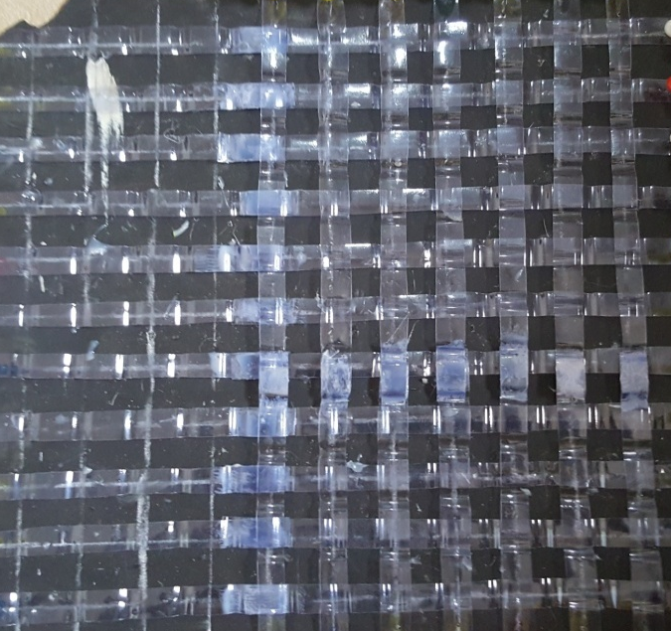
Figure 1. Sample of PET mesh
2.3 Test Procedure
To mimic service conditions, a wooden box of plan dimension 500mm x 500mm containing sand bed of thickness 300mm was prepared and test specimens were centrally placed on it. The test load consisted of a steel ball of mass 0.95 kg that was freely dropped from a constant height of 2.5m through a guide at the top of the wooden frame to hit approximately the center of the slab on top of the sand bed. The test set up is shown in figure 2. Crack depths and widths were measured with a manually operated crack detection microscope. The total lengths of cracks were measured as well.
Steel ball
Concrete
slab
Box of sand
Wooden stand
2.5m

Centrally placed concrete slab
300mm x 300mm x 30mm
Box of sand
500mm x 500mm x 300mm
2.5m
Wooden stand

Figure 2. Experimental Set-Up for the Tests
2.4 Theoretical base for evaluating performance
There is a loss of potential energy when a body falls from a height under gravity. When such bodies collide with objects, such as concrete slabs, the potential energy is absorbed and dissipated as strain energy within the slabs. This induces stresses which may result in the formation and development of cracks. The intensity of the impact energy, the amount of energy absorbed together with other properties of the concrete determines the severity of the cracks .i.e. the crack width, length and depth.
A relationship for the potential energy of an impact loading due to a falling body and the strain energy dissipated in cracks that develop was proposed by Kankam (1999) as:
Q h = R_{u} L_{c} d_{c} w_{c}
Where
Q = the mass of the falling body
h = the height of falling
R_{u} = the ultimate cracking resistance to impact load of the target structure
L_{c} = the total length of all cracks
d_{c} = the maximum crack depth
w_{c}=the maximum crack width
4.Results and Discussion
4.0 Experimental results
Some cracks patterns developed as a result of the impact loading have been shown in Figure 3. The results of the tests which are the total length, maximum depth and maximum width of cracks that developed in the test samples for the different mix design ratios of the concrete as well as the varying mesh sizes have been provided in Table 3. The average compressive strength of the specimens obtained from the design mix of 1:2:4 and 1:1.5:3 were 24N/mm² and 35N/mm² respectively. Similarly the average densities were 23.5kN/m³ and 24.3 kN/m³ for the 1;2;4 and 1;1.5;3 mix design ratios respectively.
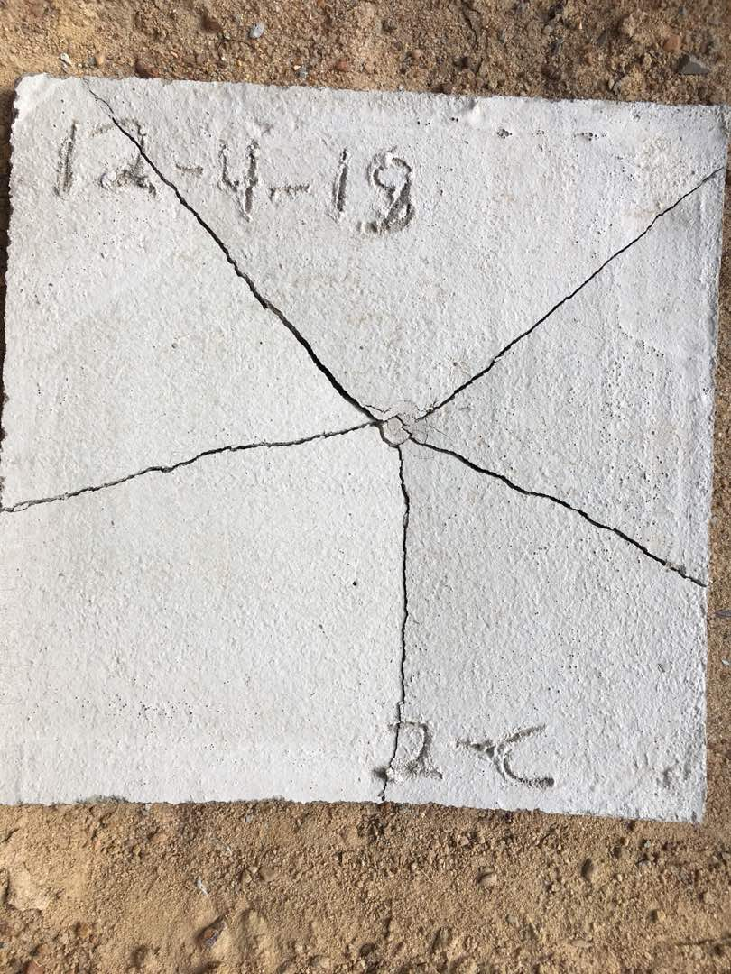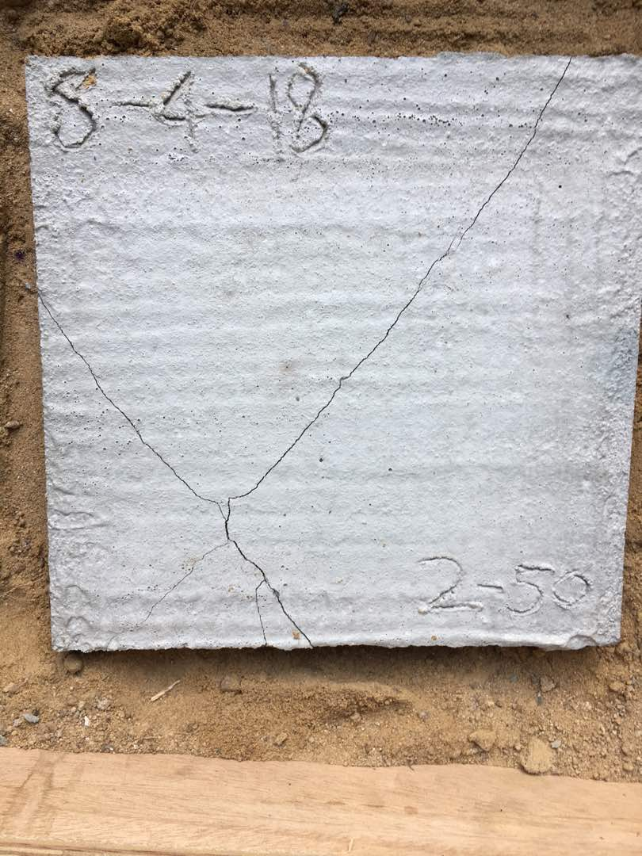
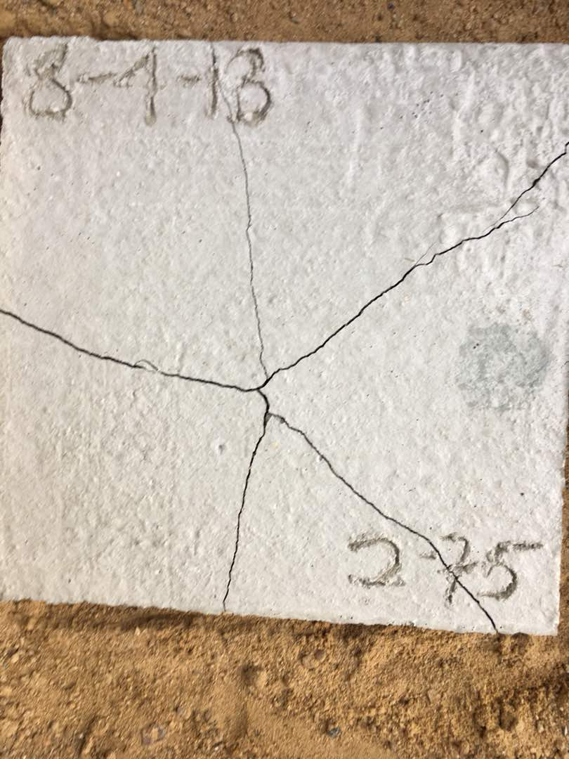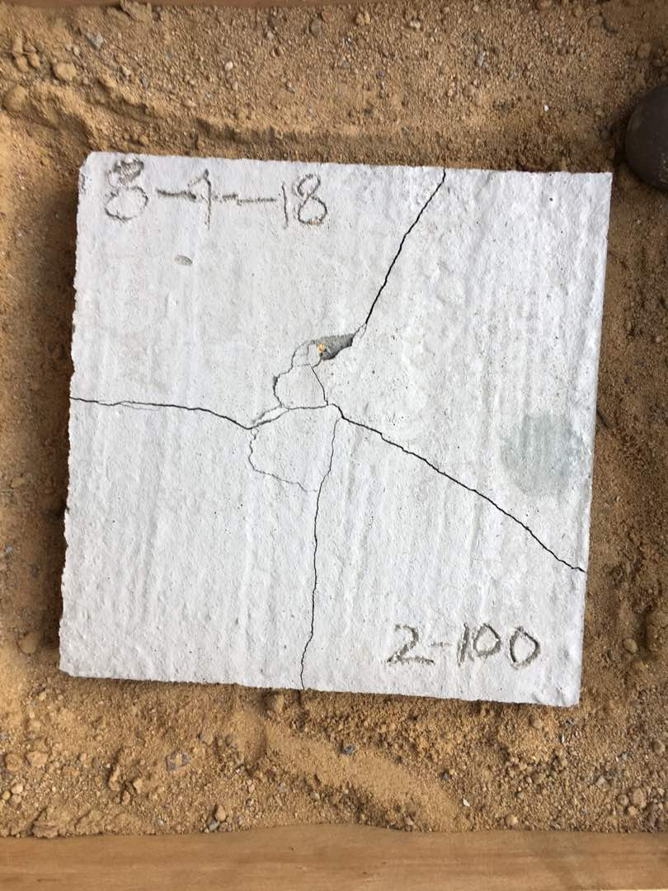
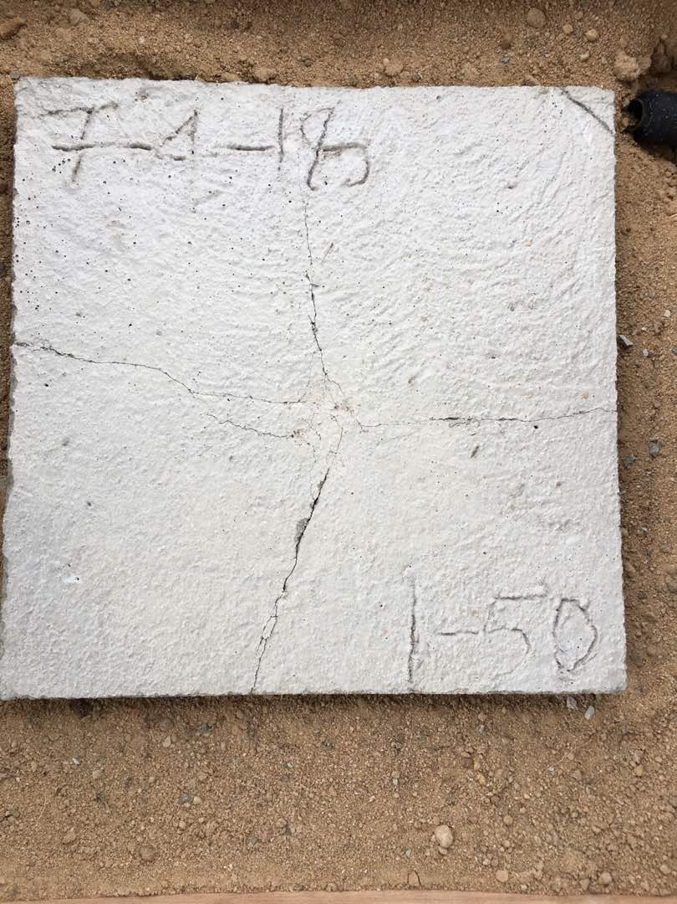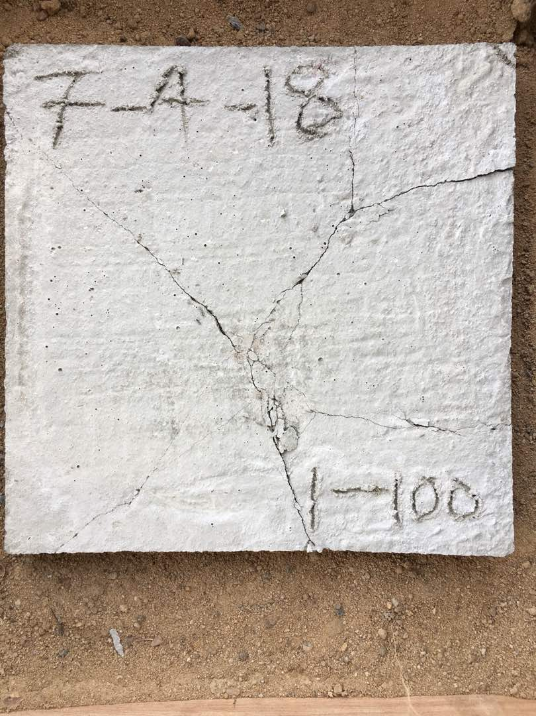
Figure 3. Typical crack pattern slabs after impact test

Table 3. Impact Test Results of Slab Specimen
Mix ratio | Specimen number | PET Mesh size  (mm c/c) | Total crack length, L_{c} (mm) | Maximum crack depth, d_{c} (mm) | Maximum crack width, w_{c} (mm) | Impact crack resistance  (N/mm²) | Average Impact crack resistance, R_{c}  (N/mm²) | Crack resistance ratio R_{c}/f_{cu}
1:2:4 | Control 1 | - | 602 | 30 | 0.30 | 4.30 | 3.99 | 0.17
1:2:4 | Control 2 | - | 641 | 30 | 0.33 | 3.67 | 3.99 | 0.17
1:2:4 | 1-25a | 25 | 351 | 30 | 0.14 | 15.80 | 15.89 | 0.66
1:2:4 | 1-25b | 25 | 374 | 30 | 0.13 | 15.97 | 15.89 | 0.66
1:2:4 | 1-50a | 50 | 435 | 30 | 0.15 | 11.90 | 11.69 | 0.49
1:2:4 | 1-50b | 50 | 451 | 30 | 0.15 | 11.48 | 11.69 | 0.49
1:2:4 | 1-75a | 75 | 491 | 30 | 0.17 | 9.30 | 8.88 | 0.37
1:2:4 | 1-75b | 75 | 484 | 30 | 0.19 | 8.45 | 8.88 | 0.37
1:2:4 | 1-100a | 100 | 561 | 30 | 0.21 | 6.59 | 6.48 | 0.27
1:2:4 | 1-100b | 100 | 554 | 30 | 0.22 | 6.37 | 6.48 | 0.27
1:1.5:3 | Control 1 | - | 512 | 30 | 0.28 | 5.42 | 5.47 | 0.16
1:1.5:3 | Control 2 | - | 521 | 30 | 0.27 | 5.52 | 5.47 | 0.16
1:1.5:3 | 2-25a | 25 | 289 | 30 | 0.11 | 24.43 | 23.22 | 0.66
1:1.5:3 | 2-25b | 25 | 294 | 30 | 0.12 | 22.01 | 23.22 | 0.66
1:1.5:3 | 2-50a | 50 | 397 | 30 | 0.14 | 13.97 | 14.44 | 0.41
1:1.5:3 | 2-50b | 50 | 401 | 30 | 0.13 | 14.90 | 14.44 | 0.41
1:1.5:3 | 2-75a | 75 | 467 | 30 | 0.16 | 10.39 | 9.90 | 0.28
1:1.5:3 | 2-75b | 75 | 459 | 30 | 0.18 | 9.40 | 9.90 | 0.28
1:1.5:3 | 2-100a | 100 | 500 | 30 | 0.20 | 7.77 | 7.95 | 0.23
1:1.5:3 | 2-100b | 100 | 503 | 30 | 0.19 | 8.13 | 7.95 | 0.23

From the Table 3, it was clearly observed that as the mesh spacing increased, the average total crack length also increased significantly. For instance, with respect to the mix ratio of 1:2:4, at a mesh spacing of 25mm center to center the average total crack length was 363mm. These average total crack lengths increased to 443mm, 488mm and 558mm as the mesh spacing increased to 50mm, 75mm and 100mm center to center respectively. A similar observation was made with respect to the maximum crack width. The average crack widths increased as the mesh spacing also increased.
It was also observed that the impact crack resistance of all specimens with the PET mesh were higher than their corresponding control samples. This implies that the introduction of the mesh irrespective of the spacing improves the impact crack resistance of the slabs. However the slabs prepared from the 1:1.5:3 exhibited higher impact crack resistance than those from 1:2:4 specimens. Generally, the smaller the mesh spacing, the higher the impact crack resistance. The highest impact crack resistance was 66% of the crushing strength for both mixes. This was achieved with the mesh spacing of 25mm c/c.
It can be concluded that the PET mesh enhances the energy absorption characteristics of concrete slabs when subjected to impact loading. Their inclusion controls the formation and propagation of cracks by redistributing the tensile stresses induced in the concrete slabs. Concrete pavement slabs reinforced with PET mesh and subjected to impact loading will therefore be more durable and will render better service due to their improved crack distribution and post-cracking ductility properties.
5.0 Conclusion
Based on the results and observations of the experimental investigations on the use of PET mesh to improve the impact crack resistance of concrete pavement slabs, the following conclusions can be drawn:
- The average total crack lengths reduced as the mesh spacing reduced.
- The maximum crack widths also reduced as the mesh spacing reduced.
- PET mesh, irrespective of the spacing, controls the formation of cracks due to impact loading.
- All the slabs with PET mesh exhibited better crack impact resistance than their respective control samples.
- The reductions in the crack lengths and widths will prevent/reduce chemical solution intrusion to react with the concrete matrix.
- Separation/disintegration of slabs will be prevented or minimized.
- Crack impact resistance is improved between 20% and 66%

COMPETING INTERESTS DISCLAIMER:
Authors have declared that they have no known competing financial interests OR non-financial interests OR personal relationships that could have appeared to influence the work reported in this paper.

References

Azad A.M. (2017). Flexural behaviour and analysis of reinforced concrete beams made of recycled PET waste concrete. Construction and Building Materials Volume 155, Pages 593-604

Batayneh M., Marie I., Asi I., (2007) Use of selected waste materials in concrete mixes. Waste Management Volume 27, Issue 12, Pages 1870-1876

BS 882 (1992), Specification for aggregates from natural sources for concrete

Choi Y., Moon D., Chung J., Cho S. (2005) Effects of waste PET bottles aggregate on the properties of concrete. Cement and Concrete Research Volume 35, Issue 4, Pages 776-781

Foti D. (2013). Use of recycled waste pet bottles fibers for the reinforcement of concrete. Composite Structures Volume 96, Pages 396-404

Frigione M. (2013) Recycling of PET bottles as fine aggregate in concrete. Waste Management Volume 30, Issue 6, Pages 1101-1106

Jahidul I., Salamah M., Rakinul I. A.K.M (2016). Effects of waste PET as coarse aggregate on the fresh and harden properties of concrete. Construction and Building Materials Volume 125Pages 946-951

Jens O. B., Rinne S., Schäfer C., Neumann B.,Stammler H., Mattay J., (2003) Synthesis and PET oxidative cyclization of silyl enol ethers: build-up of quasi-steroidal carbocycles. Tetrahedron Letters Volume 44, Issue 1, Pages 45-48

Kankam C.K. (1999) Impact resistance of palm kernel fiber-reinforced concrete pavement slab. Journalof Ferrocement Vol 29, No. 4. 279-285

Oil city magazine, (2012). Volume 3, Issue 1

Reis J.M.L., Carneiro E.P. (2012) Evaluation of PET waste aggregates in polymer mortars Construction and Building Materials Volume 27, Issue 1, Pages 107-111

Shafferina D. A. S., Faisal A., Wan M. A.W. D., Aroua M. K. (2017) Energy recovery from pyrolysis of plastic waste: Study on non-recycled plastics (NRP) data as the real measure of plastic waste. Energy Conversion and Management Volume 148, Pages 925-934

Tsiboe, I. A. & Marbell, E. (2004). A look at urban solid waste disposal problem in Accra, Ghana. Master’s Thesis submitted to Roskilde University, Roskilde, Denmark

Wienaah M. M. (2007). Sustainable plastic waste management – A case of Accra, Ghana.

Zhi G., HongyaY., Renjuan S. (2015) Properties of mortar produced with recycled clay brick aggregate and PET. Construction and Building Materials Volume 93, Pages 851-856

