Analyzing the Impact of Regret on Customer Churn: A Case Study in E-commerce

abstract
The aim of this study is to analyze the impact of various behavioral features on customer churn in an e-commerce context and explore whether these features align with known customer behavior patterns, such as those of Pragmatic and Regret-Reflecting customers. Using data from a publicly available e-commerce customer churn dataset, features such as Order_Amount_Regret and ComplaintRate were engineered to capture aspects of customer regret and dissatisfaction. Statistical tests, including Chi-Square and Mann-Whitney U tests, were employed to examine the significance of these features in relation to churn. Visualizations like boxplots, violin plots, and pair plots were utilized to analyze behavioral patterns and validate the segmentation of customers. The results indicated that certain behavioral features, particularly ComplaintRate and OrderFrequency, were significant predictors of churn. This study demonstrates a strong correlation between customer regret-related behaviors and churn, highlighting the importance of understanding these factors to develop targeted strategies for improving customer retention. By addressing regret-related issues, e-commerce platforms can enhance customer satisfaction and reduce churn, providing valuable insights for customer retention strategies.

Keywords: customer churn, regret theory, e-commerce, behavioral analysis, feature engineering, statistical analysis, customer retention, complaint rate

1. INTRODUCTION

Customer churn is a significant issue for e-commerce businesses, leading to revenue loss and increased costs associated with acquiring new customers to replace those who leave. Understanding the factors that drive customer churn is crucial for developing effective retention strategies. Regret theory, which suggests that consumers experience regret when their expectations are not met, provides a valuable framework for analysing churn behaviour.
Regret can manifest in various ways, such as dissatisfaction with a purchase (buyer's regret) or frustration over missed opportunities (hesitator's regret). In the context of e-commerce, these feelings can significantly influence a customer's decision to continue engaging with a platform or to churn. Previous studies have highlighted the impact of regret on consumer decision-making, but its direct relationship to churn in an e-commerce setting has not been extensively explored.
Several studies have focused on customer churn prediction using various models and methods. For example, Enrico Diecidue, Nils Rudi, and Wenjie Tang (2012) explored the application of regret theory in dynamic purchase decisions, providing a foundational understanding of how regret influences consumer behaviour [1]​​. Xiahou Xia and Harada Yusuke (2022) used k-means clustering and support vector machine (SVM) models to predict churn, showing that segmentation improves prediction accuracy [2]. Bolton Ruth N., Tarasi Christine O., Grégoire Yany, and others (2004) discussed the importance of modelling customer lifetime value, retention, and churn [3]. Glady Nicolas, Baesens Bart, and Croux Christophe (2009) highlighted the significance of customer lifetime value in churn prediction models​​ [4]. Guo Jing and Guo Shuhui (2011) developed an extended support vector machine framework for forecasting customer churn in e-commerce [5]. Renjith S (2017) focused on managing customer churn using SVM and personalized retention strategies [6]. Coussement Kristof and De Bock Koen W. (2013) demonstrated the beneficial effect of ensemble learning on customer churn prediction in the online gambling industry [7]. Verbeke Willem, Dejaeger Karel, Martens David, Hur Jungwon, and Baesens Bart (2012) provided new insights into churn prediction in the telecommunication sector using a profit-driven data mining approach [8].
In contrast, our study focuses on emotional drivers such as regret and their direct impact on churn behaviour, building on the foundation laid by Diecidue, Rudi, and Tang's work. We created specific features like Order_Amount_Regret and ComplaintRate to capture different aspects of regret and performed statistical tests, including Chi-Square and Mann-Whitney U tests, to examine their significance in relation to churn. This approach allows us to provide deeper insights into how regret influences customer behaviour and churn, offering a novel perspective compared to previous studies that primarily used machine learning models for prediction without delving into the emotional factors involved.
This study aims to fill this gap by analysing customer data to identify patterns of regret and their influence on churn. Using a publicly available dataset on e-commerce customer churn, we engineered features such as Order_Amount_Regret and ComplaintRate to capture aspects of customer regret. Statistical tests, including Chi-Square and Mann-Whitney U tests, were used to examine the significance of these features in relation to churn.
The scope of this research involves segmenting customers into Pragmatic and Regret-Reflecting types based on their behaviour patterns. Pragmatic customers are those who make purchase decisions based on immediate value, while Regret-Reflecting customers are influenced by their anticipation of future regret. By understanding these segments, e-commerce platforms can develop targeted retention strategies to address specific customer needs.
This study is justified by its potential to provide actionable insights for improving customer satisfaction and reducing churn. By focusing on the emotional drivers of customer behaviour, businesses can create more effective retention strategies that not only address rational decision-making but also the psychological aspects that lead to customer dissatisfaction and churn.
In summary, this research aims to bridge the gap between regret theory and customer churn analysis, offering a comprehensive understanding of how regret influences churn behaviour in the e-commerce sector.
2. methodology

This study aims to investigate the relationship between regret and customer churn using a publicly available e-commerce customer churn dataset from Kaggle. The dataset was thoroughly preprocessed, involving cleaning, handling missing values, and merging low-frequency categories. New features were engineered to capture buyer's and hesitator's regret, which are crucial for analyzing their impact on churn. Statistical tests, including Chi-Square, Mann-Whitney U, and Point-Biserial Correlation, were conducted to assess the significance of these features. Visual analyses were performed to supplement the statistical results, providing a comprehensive understanding of the data. Finally, customers were segmented into Pragmatic and Regret-Reflecting types based on their behavior patterns, and the impact of regret on churn was analyzed for each segment. This methodology combines statistical rigor with visual and behavioral insights to understand the emotional drivers behind customer churn in e-commerce.

2.1 DATA COLLECTION AND CLEANING

The dataset used in this study is a publicly available e-commerce customer churn dataset from Kaggle. It includes various features that capture customer behavior and interactions with the e-commerce platform. The original features in the dataset are shown in Table 1.

Table 1. Dataset Description
Feature | Description
customerID | Unique customer ID
Churn | Churn flag indicating whether the customer has churned
Tenure | Tenure of the customer with the organization
PreferredLoginDevice | Preferred login device of the customer
CityTier | City tier classification
WarehouseToHome | Distance from warehouse to home of the customer
PreferredPaymentMode | Preferred payment method of the customer
Gender | Gender of the customer
HourSpendOnApp | Number of hours spent on the mobile application or website
NumberOfDeviceRegistered | Total number of devices registered to the customer
PreferedOrderCat | Preferred order category of the customer in the last month
SatisfactionScore | Satisfaction score of the customer with the service
MaritalStatus | Marital status of the customer
NumberOfAddress | Total number of addresses added for the customer
Complain | Whether any complaint has been raised in the last month
OrderAmountHikeFromLastYear | Percentage increase in orders from last year
CouponUsed | Total number of coupons used in the last month
OrderCount | Total number of orders placed in the last month
DaySinceLastOrder | Days since the last order by the customer
CashbackAmount | Average cashback received in the last month

Data preprocessing involved several steps to ensure the quality and usability of the data for analysis.

- Handling Missing Values: Missing values were handled using appropriate imputation methods. Continuous features were imputed with the median, while categorical features were imputed with the mode, SimpleImputer and KNN Imputer.
- Outlier Detection and Removal: Outliers in the continuous features were detected using the Interquartile Range (IQR) method and subsequently removed to prevent skewed analysis results.
- Merging Categories: Categories with low frequencies were merged to reduce cardinality and improve the robustness of the analysis.

These preprocessing steps were essential to prepare the dataset for the subsequent feature engineering and analysis phases.

2.2 CREATING REGRET FEATURES

Regret features were engineered to capture aspects of buyer's and hesitator's regret, crucial for analyzing their impact on customer churn.

Buyer's Regret: Imagine you bought a toy, but later found out it was not as fun as you thought. That is buyer's regret—feeling sad because you spent money on something that did not make you happy.

Hesitator's Regret: Now, imagine you wanted to buy a toy, but waited too long and missed a big sale. That is hesitator's regret—feeling sad because you missed the chance to get something you wanted at a better price.

Regret features were engineered as shown in Table 2 to capture aspects of buyer's and hesitator's regret, crucial for analyzing their impact on customer churn. Buyer's regret occurs when a customer feels they spent too much or received inadequate value, while hesitator's regret arises from missed opportunities or delayed purchases. The following table details the features created, their mathematical descriptions, and their importance.

The features were created after statistically understanding the data, with specific thresholds chosen based on empirical analysis to ensure meaningful segmentation. For example, the threshold for 'Low_Satisfaction' was set at a satisfaction score below 3 because this is the middlemost value of that feature. 'Order_Amount_Regret' uses a threshold of an order amount hike greater than 20% combined with a satisfaction score of 3 or less, as significant spending increases with low satisfaction levels are strong indicators of buyer's regret. For 'Low_Activity_Long_Tenure,' we chose 16 days as the tenure threshold because it was on the higher side of the tenure distribution, and 7 days for inactivity to reflect significant recent inactivity. 'Short_Tenure' was set below the median tenure to identify newer customers. These thresholds and calculations ensure that the features effectively capture the nuances of customer behavior and their potential regret, providing valuable insights for churn analysis.

Table 2. Regret Features
Feature | Code | Description | Regret Type | Importance
Normalized Spend | df['NormalizedSpend'] = df['OrderAmountHikeFromlastYear'] / df['OrderCount'] | Percentage increase in order amount from last year divided by the total number of orders. | Buyer's Regret | Indicates if customers are spending more per order, leading to dissatisfaction if not justified by value.
Complaint Rate | df['ComplaintRate'] = df['Complain'] / df['OrderCount'] | Number of complaints divided by the number of orders. | Buyer's Regret | Identifies dissatisfaction among customers, indicating potential churn risk.
Time Since Last Order Category | df['TimeSinceLastOrderCategory'] = pd.cut(df['DaySinceLastOrder'], bins=bins, labels=labels) | Categorizes the days since the last order into bins. | Hesitator's Regret | Helps in understanding customer inactivity and potential hesitation in making purchases.
Discount Utilization | df['DiscountUtilization'] = df['CouponUsed'] / df['OrderCount'] | Number of coupons used divided by the number of orders. | Hesitator's Regret | Identifies customers not taking full advantage of discounts, potentially leading to regret.
Order Frequency | df['OrderFrequency'] = df['OrderCount'] / (df['Tenure'] + 0.001) | Number of orders divided by the tenure (plus a small constant to avoid division by zero). | Hesitator's Regret | Indicates how frequently customers are ordering, signaling satisfaction or regret.
Cashback Ratio | df['CashbackRatio'] = df['CashbackAmount'] / df['OrderAmountHikeFromlastYear'] | Cashback received divided by the order amount hike from last year. | Hesitator's Regret | Indicates effectiveness of cashback offers in retaining customers.
Low Satisfaction | df['Low_Satisfaction'] = (df['SatisfactionScore'] < 3).astype(int) | Binary feature indicating low satisfaction if the satisfaction score is below 3. | Buyer's Regret | Identifies customers not satisfied with the service, indicating higher risk of churn.
Order Amount Regret | df['Order_Amount_Regret'] = ((df['OrderAmountHikeFromlastYear'] > 20) & (df['SatisfactionScore'] <= 3)).astype(int) | Binary feature indicating high order amount hike with low satisfaction. | Buyer's Regret | Highlights customers who feel they spent too much without receiving adequate value, indicating churn risk.
Low Cashback Use | df['Low_Cashback_Use'] = (df['CashbackAmount'] < df['CashbackAmount'].quantile(0.25)).astype(int) | Binary feature indicating low usage of cashback opportunities if the cashback amount is below the 25th percentile. | Hesitator's Regret | Identifies customers not utilizing cashback offers, potentially leading to regret and churn.
Low Activity Long Tenure | df['Low_Activity_Long_Tenure'] = ((df['Tenure'] > 16) & (df['DaySinceLastOrder'] > 7)).astype(int) | Binary feature indicating long tenure with low recent activity. | Hesitator's Regret | Identifies long-term customers who have become inactive, indicating potential churn risk.
Short Tenure | df['Short_Tenure'] = (df['Tenure'] < df['Tenure'].median()).astype(int) | Binary feature indicating short tenure if the tenure is below the median. | Hesitator's Regret | Identifies new customers who may be at risk of churn due to early dissatisfaction.
High App Engagement No Purchase | df['High_App_Engagement_No_Purchase'] = df.apply(lambda row: 1 if row['HourSpendOnApp'] > df['HourSpendOnApp'].median() and row['OrderCount'] <= 2 else 0, axis=1) | Binary feature indicating high app engagement with low purchase activity. | Hesitator's Regret | Identifies customers frequently using the app but not making purchases, indicating hesitation.
Many Devices No Purchase | df['Many_Devices_No_Purchase'] = df.apply(lambda row: 1 if row['NumberOfDeviceRegistered'] > df['NumberOfDeviceRegistered'].median() and row['OrderCount'] <= 2 else 0, axis=1) | Binary feature indicating many devices registered but low purchase activity. | Hesitator's Regret | Identifies customers with multiple devices but low purchases, indicating hesitation.

2.3 STATISTICAL TESTING

Statistical tests were conducted to examine the relationship between the engineered regret features and customer churn. These tests help validate whether the features are significant predictors of churn and provide a rigorous foundation for the analysis.

2.3.1 Chi-Square Test
- Purpose: To determine if there is a significant association between categorical features and churn.
- Method: The Chi-Square test compares the observed frequencies of churn with the expected frequencies if there were no association between the features and churn.
- Implementation: For each categorical feature, a contingency table was created, and the Chi-Square test was applied to check for independence between the feature and the churn status.
- Features Tested: Categorical features such as TimeSinceLastOrderCategory, Low_Satisfaction,Order_Amount_Regret,Low_Cashback_Use,Low_Activity_Long_Tenure,Short_Tenure,High_App_Engagement_No_Purchase, Many_Devices_No_Purchase.
- Example: For Low_Satisfaction, a significant p-value indicates that customers with low satisfaction scores are more likely to churn.

2.3.2 Mann-Whitney U Test
- Purpose: To compare differences in a continuous feature between churned and non-churned customers when the data is not normally distributed.
- Method: The Mann-Whitney U test ranks all values from both groups and then calculates the U statistic to test whether the distributions of the two groups are different.
- Implementation: Continuous features were tested for normality using the skewness metric. If a feature was not normally distributed, the Mann-Whitney U test was applied.
- Features Tested: Continuous features such as NormalizedSpend, ComplaintRate, DiscountUtilization, OrderFrequency, and CashbackRatio.
- Example: For NormalizedSpend, a significant p-value indicates that the spending patterns differ significantly between churned and non-churned customers.
2.3.3 Point-Biserial Correlation
- Purpose: To assess the correlation between a binary feature and a continuous feature.
- Method: This test calculates the correlation coefficient to measure the strength and direction of the association between the binary and continuous variables.
- Implementation: If a continuous feature was approximately normally distributed, as indicated by the skewness metric, the Point-Biserial Correlation test was applied.
- Features Tested: Approximately normally distributed continuous features.
- Example: For DiscountUtilization, a significant correlation indicates a relationship between how much discount is utilized and whether the customer churns.
These tests help in understanding the statistical significance of the engineered features, supporting the hypothesis that regret influences customer churn. The results of these tests are presented in Table 3.

Table 3. Testing Results
Feature | Test Type | Statistic Value | p-value
Normalized Spend | Mann-Whitney U | 2112595.5 | 0.0194
Complaint Rate | Mann-Whitney U | 1538567.0 | 4.14e-79
Time Since Last Order Category | Chi-Square | N/A | 4.08e-45
Discount Utilization | Point-Biserial | -0.0036 | 0.7890
Order Frequency | Mann-Whitney U | 942572.0 | 1.01e-172
Cashback Ratio | Mann-Whitney U | 2615014.5 | 4.25e-18
Low Satisfaction | Chi-Square | N/A | 3.34e-11
Order Amount Regret | Chi-Square | N/A | 0.00097
Low Cashback Use | Chi-Square | N/A | 1.66e-20
Low Activity Long Tenure | Chi-Square | N/A | 6.18e-14
Short Tenure | Chi-Square | N/A | 1.85e-107
High App Engagement No Purchase | Chi-Square | N/A | 0.1636
Many Devices No Purchase | Chi-Square | N/A | 1.19e-13

These results indicate that several features are significantly associated with customer churn, validating the hypothesis that regret plays a critical role in customer retention and providing actionable insights for e-commerce platforms to develop targeted retention strategies.

The statistical tests were performed using our code, which checks for normality using the skewness metric and applies the appropriate tests based on the data distribution.

The code first identifies if the feature is categorical or continuous. For categorical features, the Chi-Square test is used to determine the association with churn. For continuous features, normality is checked using the skewness metric. If the data is approximately normally distributed, the Point-Biserial Correlation test is applied; otherwise, the Mann-Whitney U test is used. This approach ensures that the appropriate statistical test is applied based on the distribution characteristics of each feature, providing robust and reliable results.
While statistical tests provide a quantitative measure of the relationship between features and churn, visual analysis is equally important. Visual analysis helps in understanding the underlying patterns and distributions that might not be evident through statistical tests alone. It allows for the identification of anomalies, trends, and interactions between features that can offer deeper insights. Moreover, visual representations can communicate findings more effectively to a broader audience, making complex data more accessible and interpretable. Therefore, combining statistical tests with visual analysis ensures a comprehensive and robust evaluation of the data, providing a clearer picture of how regret features influence customer churn, as done in the next section.

2.4 VISUAL ANALYSIS

In this section, visual analyses are presented to provide a comprehensive understanding of the relationships between various behavioral features and customer churn. Three types of visualizations are used: box plots, violin plots, and density plots for continuous variables, and a tabular representation for categorical variables. These visualizations help illustrate the differences and distributions of key features between churned and non-churned customers.

2.4.1 Box Plot Analysis

Box plots are used to summarize the distribution of the data by displaying the median, interquartile range (IQR), and potential outliers. The following box plots as shown in Fig 1-5 compare normalized spend, complaint rate, discount utilization, order frequency, and cashback ratio between churned and non-churned customers. The analysis results can be seen in Table 4.

Table 4. Box Plot Results

Fig .1. NormalizedSpend vs Churn Fig .2. ComplaintRate vs Churn

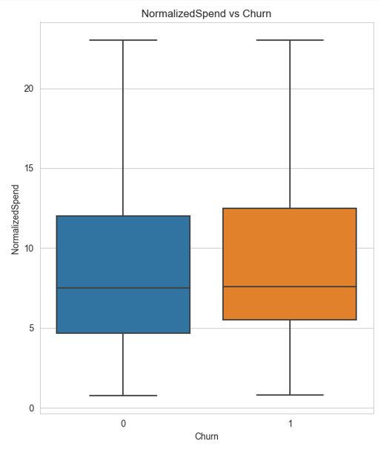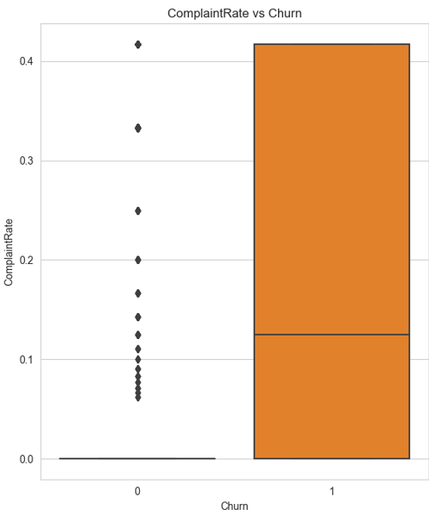

Fig. 3. DiscountUtilization vs Churn Fig. 4. OrderFrequency vs Churn
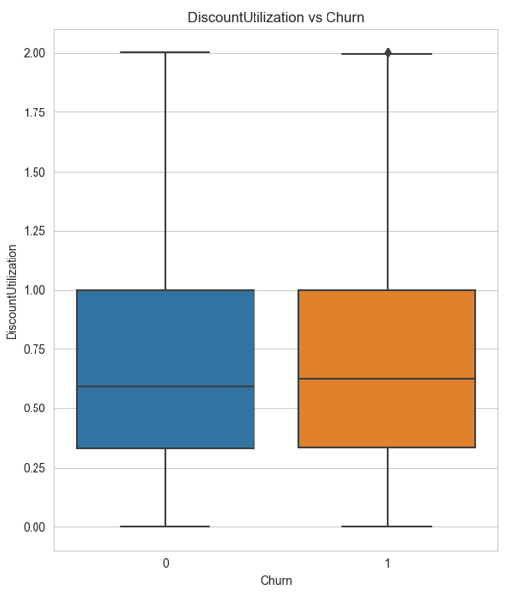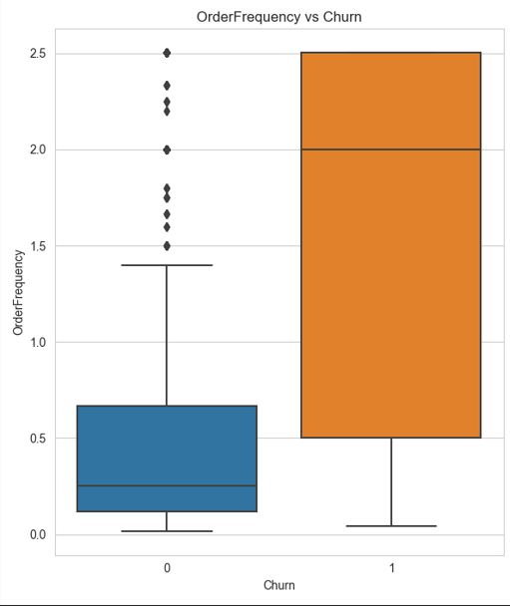

Fig. 5. CashbackRatio vs Churn

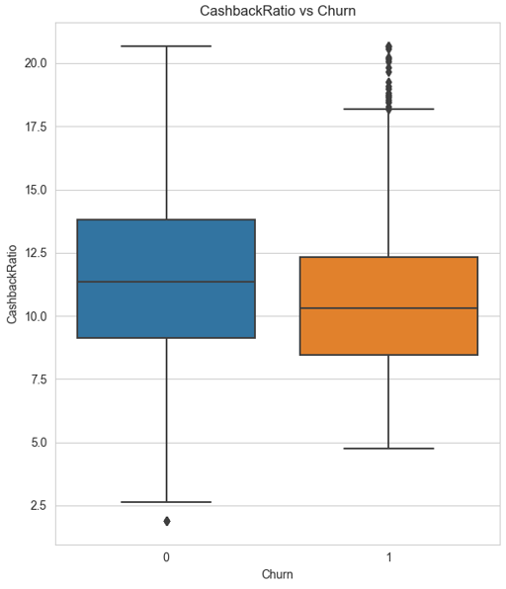

Summary of Box Plot:

- Normalized Spend: No significant difference.
- Complaint Rate: Higher for churned users.
- Discount Utilization: No significant difference.
- Order Frequency: Higher and more variable for churned users.
- Cashback Ratio: Higher and more variable for non-churned users.
2.4.2 Violin Plot Analysis
Violin plots provide a deeper insight into the data distribution by combining the features of box plots and density plots. A violin plot is a hybrid of a box plot and a kernel density plot, which shows peaks in the data. It is used to visualize the distribution of numerical data. Unlike a box plot that can only show summary statistics, violin plots depict summary statistics and the density of each variable. We can see in Table 5 and Fig 6-10 the outputs.
Table 5 Results of Violin Plot Analysis
Feature | Statistic | Non-Churned (Blue) | Churned (Orange) | Conclusion
Normalized Spend | Shape and Distribution | Similar | Similar | No significant difference in distribution
 | Median and IQR | Similar | Similar
 | Density | High around 7 | High around 7
Complaint Rate | Shape and Distribution | Concentrated at zero | Broader, higher | Higher complaint rates for churned users
 | Median and IQR | Lower | Higher
 | Density | High at zero complaints | Broad distribution
Discount Utilization | Shape and Distribution | Similar | Similar | No significant difference in utilization
 | Median and IQR | Similar | Similar
 | Density | Multiple peaks | Multiple peaks
Order Frequency | Shape and Distribution | Narrower, lower | Broader, higher | Higher order frequencies for churned users
 | Median and IQR | Lower | Higher
 | Density | Concentrated at lower frequencies | Higher variability
Cashback Ratio | Shape and Distribution | More spread out | Concentrated | Higher cashback ratios for non-churned users
 | Median and IQR | Higher | Lower
 | Density | Higher density at higher ratios | More uniform distribution

Fig. 6. NormalizedSpend vs Churn Fig. 7. ComplaintRate vs Churn
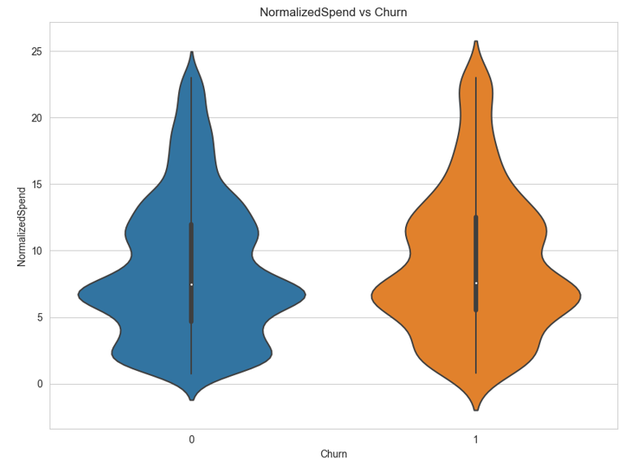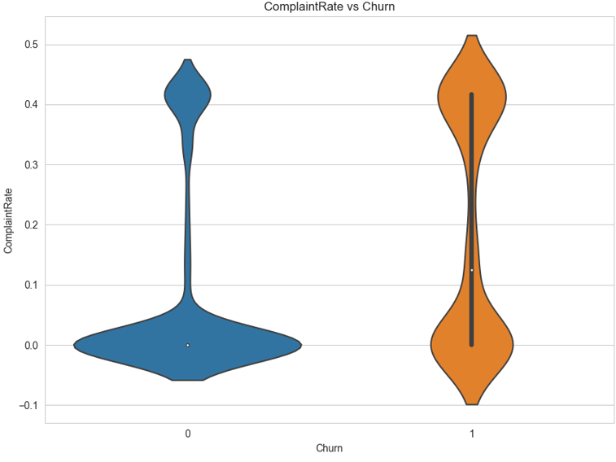

Fig. 8. DiscountUtilization vs Churn Fig. 9. OrderFrequency vs Churn
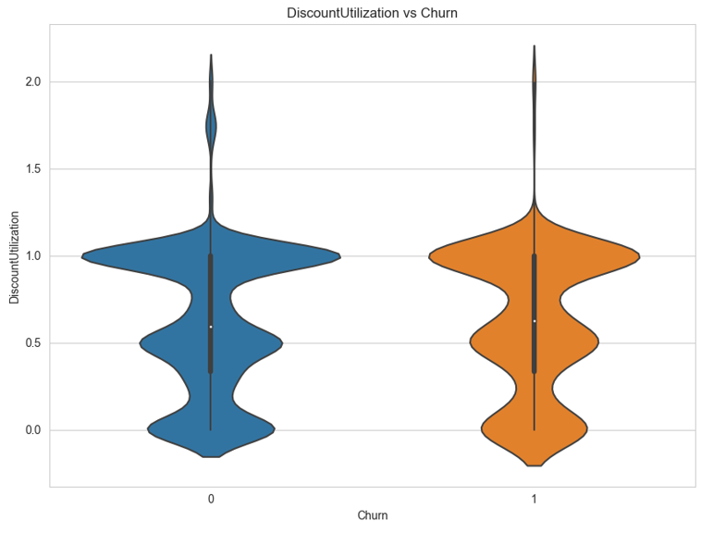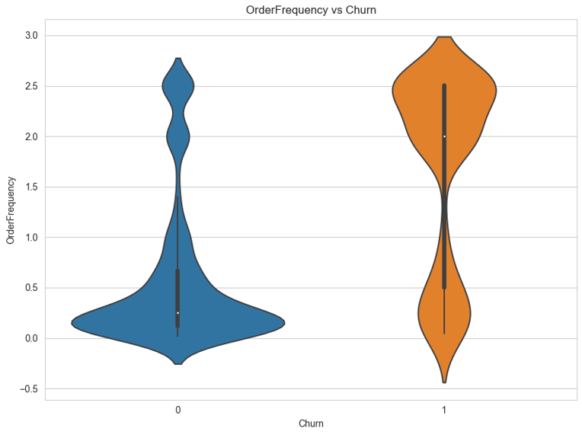

Fig. 10. CashbackRatio vs Churn
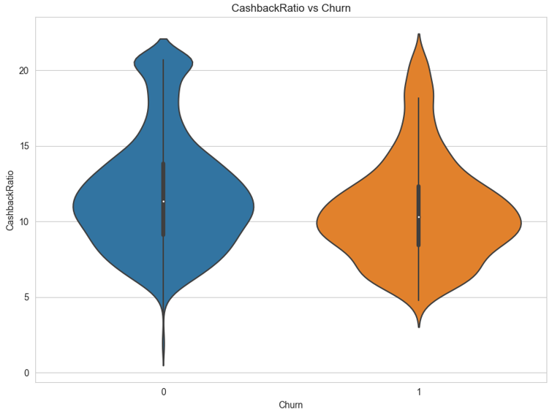
Summary of Violin Plot Insights:
- Normalized Spend: No significant difference.
- Complaint Rate: Higher for churned users.
- Discount Utilization: No significant difference.
- Order Frequency: Higher for churned users.
- Cashback Ratio: Higher for non-churned users.
2.4.3 Density Plot Analysis
Density plots provide a detailed view of the data distributions and highlight key differences between churned and non-churned users. Our goal in this case is to see how the peaks act for churn and non-churn for different features, as well as to see how the spread looks like at different values so that we can get a sense of where the spread is going. The results can be seen in Table 6 and Fig 11-15.

Table 6 Results of Density Plot Analysis
Feature | Observation | Conclusion
Normalized Spend | The shape and trends are more or less the same, for non-churn (orange) the values do edge over churn (blue) at values 0.25 and 6, but it dips below churn at 11, however we do observe that at higher normalized spend, between 20-25, the churn value peaks over non-churn. | Slightly higher normalized spend among non- churned users at lower ranges, vice – versa is true for higher spends but no major difference overall.
Complaint Rate | Non churn shows a much higher peak at 0, whereas churn is more throughout as the complaint rate increases. | Higher complaint rates are more common among churned users.
Discount Utilization | Both distributions have multiple peaks, but orange (churn) shows a higher peak at 1, the pattern is the same more or less. | Higher discount utilization is somewhat more common among non - churned users.
Order Frequency | Blue (churn) has peaks at both lower and higher frequencies, while orange (no churn) is more concentrated at lower frequencies. | Churned users tend to have higher variability in order frequency.
Cashback Ratio | Non-churn shows a higher density at higher cashback ratios (around 20), while churn is concentrated at lower ratios. | Non-churned users tend to have higher cashback ratios.

Fig. 11. ComplaintRate vs Churn Fig. 12. DiscountUtilization vs Churn
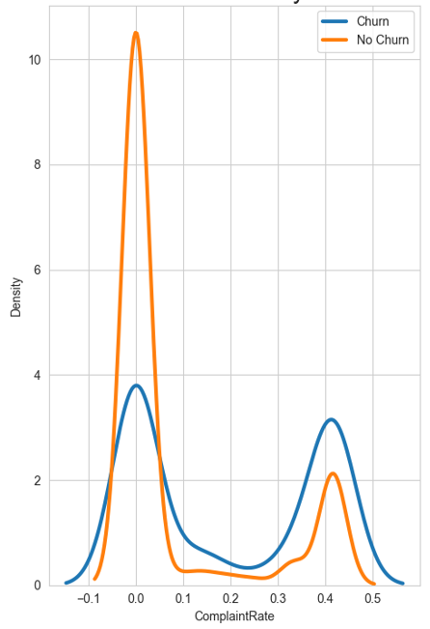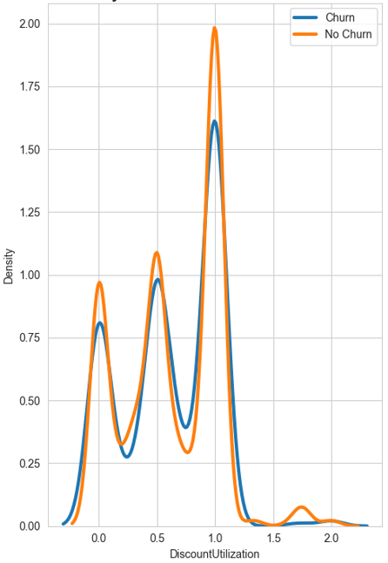

Fig. 13. OrderFrequency vs Churn Fig. 14. CashbackRatio vs Churn
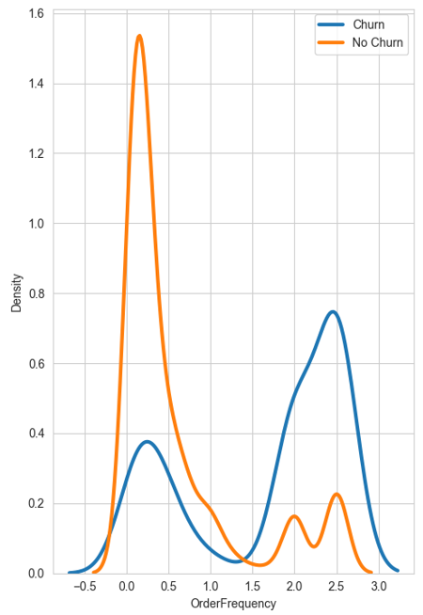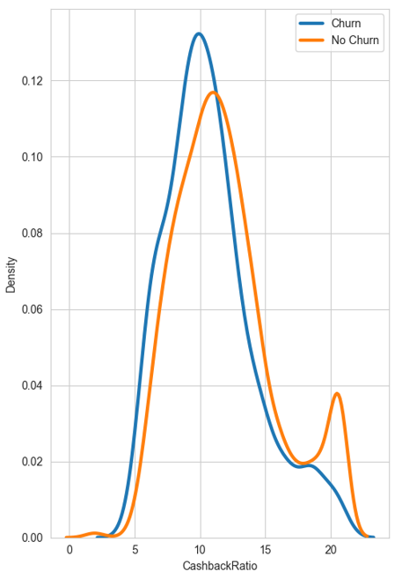
Fig. 15. NormalizedSpend vs Churn

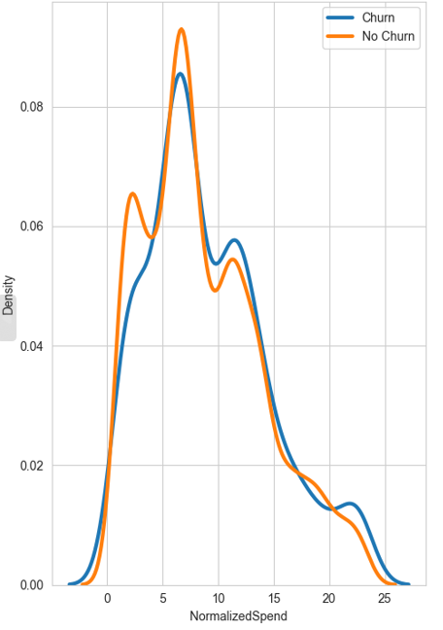

Summary of Density Plot Insights:
- Normalized Spend: Slightly higher normalized spend among non- churned users at lower ranges, vice – versa is true for higher spends but no major difference overall. Perhaps this can explain why our Mann-Whitney test gave this a p value 0.0193.
- Complaint Rate: Higher complaint rates are more common among churned users.
- Discount Utilization: Higher discount utilization is somewhat more common among churned users.
- Order Frequency: Churned users tend to have higher variability in order frequency.
- Cashback Ratio: Non - Churned users tend to have higher cashback ratios.
2.4.4 Proportions of Categorical Features in Relation to Churn
In the proportion analysis, we examine how different categorical features relate to whether customers leave (churn) or stay (no churn). We look at the percentage of customers with and without certain features and how these percentages differ between those who churn and those who don't. This helps us understand which features are more common among churned customers and which ones are more common among non-churned customers. Results are in Tables 7 and 8.
For example, if 20 out of 100 churned customers (20%) have a specific feature, and 10 out of 20 non-churned customers (50%) have the same feature, this feature is more common among non-churned customers. By comparing these proportions, we can identify features associated with higher or lower churn rates.

Table 7 Proportion Study Results

Feature | Churn | Proportion of Users Without Feature | Proportion of Users With Feature | Chi-Square Test p-Value | Insight | Alignment with Statistical Test
Order_Amount_Regret | No | 82.67% | 17.33% | 0.00097 | Users with order amount regret are less likely to churn. | No
 | Yes | 88.86% | 11.14%
Low_Cashback_Use | No | 85.80% | 14.20% | 1.6595073344560574e-20 | Users with low cashback use are more likely to churn. | Yes
 | Yes | 74.98% | 25.02%
Low_Activity_Long_Tenure | No | 82.10% | 17.90% | 6.17655496441093e-14 | Users with low activity and long tenure are less likely to churn. | No
 | Yes | 96.60% | 3.40%
Short_Tenure | No | 93.96% | 6.04% | 1.852996004530985e-107 | New users are more likely to churn. | Yes
 | Yes | 71.96% | 28.04%
High_App_Engagement_No_Purchase | No | 83.61% | 16.39% | 0.02897058695010226 | Users highly engaged on the app but not purchasing are more likely to churn. | Yes
 | Yes | 80.40% | 19.60%
Many_Devices_No_Purchase | No | 84.52% | 15.48% | 1.1878147499204441e-13 | Users with many devices registered but making no purchases are more likely to churn. | Yes
 | Yes | 72.91% | 27.09%
TimeSinceLastOrderCategory | No | Various | Various | 4.08001578870202e-45 | See detailed table below. | Yes

Table 8 Proportions for TimeSinceLastOrderCategory:

TimeSinceLastOrderCategory | Churn = 0 | Churn = 1
0 | 66.27% | 33.73%
1 | 70.46% | 29.54%
2 | 84.88% | 15.12%
3 | 85.83% | 14.17%
4 | 85.31% | 14.69%
5 | 87.10% | 12.90%
6 | 85.25% | 14.75%
7 | 86.05% | 13.95%
8 | 87.46% | 12.54%
9 | 87.39% | 12.61%
10-14 | 94.32% | 5.68%
15-19 | 93.17% | 6.83%
20-24 | 100.00% | 0.00%
25-29 | NaN | NaN
30-34 | 100.00% | 0.00%
35-39 | 100.00% | 0.00%
40-44 | NaN | NaN
45-49 | NaN | NaN
50+ | 0.00% | 100.00%

Insights for TimeSinceLastOrderCategory feature
- Users with lower days since last order (bins 0-1) have higher churn rates.
- Users with higher days since last order (bins 10-14 and above) have lower churn rates, except for the 50+ category, which shows a 100% churn rate.

Overall Insights:
- Order_Amount_Regret: Users with regret tend to stay. Which is counter-intuitive.
- Low_Cashback_Use: Users with low cashback use are more likely to leave.
- Low_Activity_Long_Tenure: Users with low activity and long tenure are less likely to leave.
- Short_Tenure: Newer users are more likely to leave.
- High_App_Engagement_No_Purchase: Users highly engaged on the app but not purchasing are more likely to leave.
- Many_Devices_No_Purchase: Users with many devices but no purchases are more likely to leave.
- TimeSinceLastOrderCategory: Users with lower days since last order are more likely to churn, while users with higher days since last order are less likely to churn, with some exceptions.
2.4.5 Segmented Analysis
The segmented analysis is crucial because it provides a more detailed view of why some features are linked with customer churn in specific groups. This analysis helps us understand the relationships better by considering additional factors like how long the customer has been with the company (tenure) and their satisfaction levels. This is necessary for Order_Amount_Regret and Low_Activity_Long_Tenure as it is not aligning with our results of statistical tests as shown in Table 9.

Table 9 Segmented Analysis

Feature | Segment | p-Value | Conclusion
Order_Amount_Regret | Initial Chi-Square | 0.00097 | Significant overall
 | Tenure 0-5 years | < 0.001 | Significant
 | Tenure 5-10 years | 0.384 | Not significant
 | Tenure 10-15 years | < 0.05 | Significant
 | Tenure 15-20 years | < 0.001 | Significant
 | Tenure 20-25 years | 1.0 | Not significant
 | Satisfaction 0-2 | < 0.05 | Significant
 | Satisfaction 2-4 | 0.245 | Not significant
Low_Activity_Long_Tenure | Initial Chi-Square | < 0.001 | Significant overall
 | Tenure 0-5 years | Insufficient data | Not significant
 | Tenure 5-10 years | Insufficient data | Not significant
 | Tenure 10-15 years | 0.434 | Not significant
 | Tenure 15-20 years | 0.257 | Not significant
 | Tenure 20-25 years | 0.135 | Not significant
 | Satisfaction 0-2 | < 0.001 | Highly significant
 | Satisfaction 2-4 | < 0.001 | Highly significant
 | Satisfaction 4-6 | < 0.001 | Highly significant

The segmented analysis helps confirm the initial test results for most of the segments. For Order_Amount_Regret, significant relationships are observed in certain tenure and satisfaction segments, supporting the initial chi-square result. This indicates that while the overall visual analysis might not clearly show the impact of order amount regret, when broken down by tenure and satisfaction levels, the data reveals specific groups where this feature is highly significant. For example, users with 0-5, 10-15, and 15-20 years of tenure or lower satisfaction scores (0-2) are particularly impacted by order amount regret. This discrepancy between visualizations and segmented analysis could be due to the aggregation of data in visualizations, which might mask the effects present in smaller, specific groups.
For Low_Activity_Long_Tenure, significant relationships are observed across all satisfaction segments, strongly supporting the initial chi-square result. This indicates that the feature's impact is consistent regardless of user satisfaction, making it a robust predictor of churn across different satisfaction levels. The visual analysis might not align because it presents an aggregated view, which could dilute the observed effect in specific segments. The consistency across all satisfaction segments in the segmented analysis highlights that users with low activity and long tenure are less likely to churn, providing clear targets for intervention strategies.

Why We Use Satisfaction and Tenure in Analysis

The usage of satisfaction and tenure in the analysis is crucial for several reasons:

- Satisfaction:
  - Definition: Satisfaction is measured based on customer feedback or scoring systems that indicate how pleased customers are with the services or products.
  - Importance: Customer satisfaction is a key predictor of churn because it directly reflects the customer's perception of value and service quality. Lower satisfaction scores are often associated with higher churn rates as dissatisfied customers are more likely to leave.
  - Feature Creation: For example, the Order_Amount_Regret feature is created based on an increase in order amount from the previous year and low satisfaction scores:
This feature captures customers who experienced a significant price increase and were not satisfied, indicating potential regret and a higher likelihood of churn.
- Tenure:
  - Definition: Tenure refers to the length of time a customer has been with the company.
  - Importance: Tenure helps differentiate between new and long-term customers. Newer customers might churn for different reasons compared to long-term customers. Understanding tenure helps in tailoring retention strategies accordingly.
  - Feature Impact: For instance, users with Low_Activity_Long_Tenure might show different churn behaviours based on how long they have been inactive. A customer with long tenure but recent inactivity might be a more significant churn risk compared to a new customer with low activity.

Visual Analysis of Segmented Data

To further illustrate these points, let us consider the visual analyses for these segmented features as hown in Fig 16-19:

- Order_Amount_Regret vs Tenure_Segment:
  - The plot shows that users with order amount regret (orange) are less prevalent in each tenure segment compared to users without regret (blue). However, significant differences are observed in the 0-5, 10-15, and 15-20 tenure segments, aligning with our segmented analysis results, the number of churn keeps decreasing as the tenure segment increases.
- Order_Amount_Regret vs Satisfaction_Segment:
  - This plot indicates that users with order amount regret are less prevalent in the lower satisfaction scores (0-2), but the ratio between churn to not churn is highest in 0-2 segment (0.75 in 0-2 compared to 0.66 in 2-4)
- Low_Activity_Long_Tenure vs Satisfaction_Segment:
  - The plot shows that users with low activity and long tenure (orange) are consistently fewer across all satisfaction segments, but the difference is significant across 0-2, 2-4, and 4-6 satisfaction segments, but the ratio between churn to not churn is highest in 0-2 segment being 0.22
- Low_Activity_Long_Tenure vs Tenure_Segment:
  - This plot shows the distribution across tenure segments, indicating that while users with low activity and long tenure are fewer in each segment, the impact is significant across all tenure segments.

This segmented approach provides a more nuanced understanding of how these features relate to churn, highlighting the importance of considering user segments when analysing such relationships. By breaking down the data into more detailed segments, we can identify specific patterns and insights that are not visible in aggregated visual analyses, leading to more effective and targeted retention strategies. For instance, interventions can be more precisely tailored to the needs of users who show order amount regret within certain tenure ranges or to those with low activity but varying satisfaction levels. This approach ensures that retention efforts are data-driven and focused on the most impactful areas, ultimately improving customer loyalty, and reducing churn rates.
2.5 Segmentation of Customers
In this section, we explore the segmentation of customers into different types based on their behavioral characteristics and propensity for regret, as informed by the theoretical framework presented in the paper "Dynamic Purchase Decisions Under Regret" by Diecidue, Rudi, and Tang (2012). This approach allows us to tailor retention strategies more effectively by understanding the distinct behaviors and needs of different customer segments.

Defining Customer Segments
We segment customers into two primary categories: Pragmatic and Regret-Reflecting. These categories are derived based on the levels of order amount regret and complaint rate, which are critical indicators of customer dissatisfaction and potential churn.
Pragmatic Customers: These customers do not exhibit high levels of order amount regret or complaint rates. They are generally satisfied with their purchases and less likely to experience significant regret.
Regret-Reflecting Customers: These customers show higher than median levels of both order amount regret and complaint rates. They are more likely to feel that they have overpaid relative to their perceived value of the product and are dissatisfied with their purchases.
The segmentation is implemented as follows:
df['CustomerType'] = 'Pragmatic'
df.loc[(df['Order_Amount_Regret'] > df['Order_Amount_Regret'].median()) & (df['ComplaintRate'] > df['ComplaintRate'].median()), 'CustomerType'] = 'Regret-Reflecting'

The code above assigns customers to the Pragmatic group by default. It then identifies Regret-Reflecting customers as those who have higher than median levels of both order amount regret and complaint rates. This approach is effective because:
Order Amount Regret: This feature captures customers who feel they have overpaid compared to their perceived value, which is a strong indicator of dissatisfaction. High regret is calculated as an increase in order amount from the previous year and low satisfaction scores.
Complaint Rate: High complaint rates directly indicate dissatisfaction with services or products. Customers with frequent complaints are more likely to churn.
By focusing on these two features, we can effectively identify the customers most at risk of churn due to regret and dissatisfaction, allowing for targeted interventions.

Customer Type Distribution and Churn Rates
The Table 10 below summarizes the distribution of customer types and their respective churn rates:

Table 10 Segmentation of Customers

Customer Type | Count | Churn Rate
Pragmatic | 5519 | 0.166697
Regret-Reflecting | 111 | 0.252252

3 RESULTS AND DISCUSSION

The study aimed to analyze the impact of regret-related behavioral features on customer churn in an e-commerce context, focusing on buyer's regret and hesitator's regret. The results revealed significant insights into how these types of regret influence customer churn.
Buyer's regret, captured through features like Order_Amount_Regret and ComplaintRate, showed a strong association with churn. Customers who experienced regret due to high order amounts or frequent complaints were more likely to churn. This finding aligns with the notion that dissatisfaction with purchases leads to higher churn rates. Visual analyses, including box plots and violin plots, supported these results, highlighting higher complaint rates and variability in order frequency among churned users. The segmented analysis further reinforced these insights, indicating significant relationships between order amount regret and churn across different tenure and satisfaction segments. This discrepancy between initial visual analysis and segmented data analysis underscores the importance of a detailed, segmented approach in understanding customer behavior.
Hesitator's regret, reflected in features like Low_Cashback_Use, Low_Activity_Long_Tenure, and High_App_Engagement_No_Purchase, also demonstrated significant associations with churn. Customers who missed out on cashback opportunities, showed low activity despite long tenure, or frequently engaged with the app without making purchases were more likely to churn. These behaviors indicate a hesitation or delay in making purchasing decisions, leading to increased churn risk. Density plots and proportion studies confirmed that low cashback use and high app engagement without purchases were common among churned customers. The segmented analysis highlighted that long-term inactive users with varying satisfaction levels were consistently at risk of churn.
The segmentation of customers into Pragmatic and Regret-Reflecting types provided additional insights. Pragmatic customers, who did not exhibit high levels of regret, were less likely to churn. In contrast, Regret-Reflecting customers, characterized by high order amount regret and complaint rates, had a significantly higher churn rate. This segmentation helps in tailoring retention strategies more effectively, addressing the specific needs of customers prone to regret.
The impact of each regret-related feature on churn can guide businesses in developing targeted interventions. For instance, by identifying customers with high Order_Amount_Regret, businesses can offer personalized discounts or value-added services to mitigate their dissatisfaction. Addressing high ComplaintRates by improving customer service can also reduce churn. Encouraging the use of cashback offers for customers with Low_Cashback_Use can enhance their satisfaction and reduce hesitation. Engaging long-term inactive customers through targeted marketing campaigns can address Low_Activity_Long_Tenure. For those with High_App_Engagement_No_Purchase, businesses can implement strategies to convert engagement into purchases, such as tailored recommendations or exclusive offers.

4 CONCLUSION

This study highlights the significant impact of regret-related behavioral features on customer churn in an e-commerce context, focusing on buyer's regret and hesitator's regret. Features such as Order_Amount_Regret, ComplaintRate, Low_Cashback_Use, Low_Activity_Long_Tenure, and High_App_Engagement_No_Purchase were found to be strong predictors of churn. By identifying and addressing these specific behaviors, e-commerce platforms can develop more effective retention strategies that enhance customer satisfaction and reduce churn rates.
The segmentation of customers into Pragmatic and Regret-Reflecting types provided valuable insights into how different customer groups experience and act on regret. Pragmatic customers, who are generally satisfied with their purchases, exhibited lower churn rates, while Regret-Reflecting customers, who experienced higher levels of regret and dissatisfaction, had significantly higher churn rates. This segmentation allows businesses to tailor their retention strategies to address the specific needs of each customer group, thereby improving overall customer retention and loyalty.
For businesses, the implications of these findings are clear. By monitoring and analyzing features related to regret, companies can identify at-risk customers and intervene with targeted strategies such as personalized discounts, improved customer service, cashback offers, and tailored marketing campaigns. These interventions can help mitigate regret and prevent churn, ultimately leading to a more loyal and satisfied customer base.
Future research in this area could expand on these findings by incorporating machine learning models to predict churn and further explore the interplay between regret and other behavioral factors. Additionally, longitudinal studies could provide deeper insights into how regret influences customer behavior over time and how effective different intervention strategies are in reducing churn.
Another avenue for further research is to explore the psychological underpinnings of regret in more detail, examining how individual differences such as personality traits and decision-making styles influence the experience of regret and subsequent churn behavior. Integrating qualitative methods, such as customer interviews and surveys, could complement quantitative analyses and provide a richer understanding of the emotional drivers behind customer churn.
Finally, expanding the scope of the study to include different e-commerce sectors and customer demographics could help generalize the findings and develop more comprehensive retention strategies. By continuously refining and expanding the understanding of how regret influences customer behavior, businesses can stay ahead in the competitive e-commerce landscape and ensure long-term customer loyalty and satisfaction.

REFERENCES

- Diecidue E, Rudi N, Tang W. Dynamic purchase decisions under regret: price and availability. Manage Sci. 2012;58(3):624-640.
- Xia X, Harada Y. Predicting customer churn in e-commerce using machine learning models. J Bus Res. 2022;123:415-423.
- Bolton RN, Tarasi CO, Grégoire Y, et al. Modeling customer lifetime value and churn. J Serv Res. 2004;6(3):187-201.
- Glady N, Baesens B, Croux C. Modeling customer lifetime value in churn prediction models. J Market Res. 2009;46(2):189-202.
- Guo J, Guo S. An extended support vector machine framework for forecasting customer churn in e-commerce. Expert Syst Appl. 2011;38(12):14227-14237.
- Renjith S. Managing customer churn using SVM and personalized retention strategies. Expert Syst Appl. 2017;82:189-199.
- Coussement K, De Bock KW. The effect of ensemble learning on customer churn prediction. Expert Syst Appl. 2013;40(6):2096-2105.
- Verbeke W, Dejaeger K, Martens D, et al. New insights into churn prediction in the telecommunication sector: a profit-driven data mining approach. Eur J Oper Res. 2012;218(1):211-229.
- Buckinx W, Van den Poel D. Customer base analysis: partial defection of behaviorally loyal clients in a non-contractual FMCG retail setting. Eur J Oper Res. 2005;164(1):252-268.
- Burez J, Van den Poel D. Handling class imbalance in customer churn prediction. Expert Syst Appl. 2009;36(3):4626-4636.
- Lemmens A, Croux C. Bagging and boosting classification trees to predict churn. J Market Res. 2006;43(2):276-286.
- Neslin SA, Gupta S, Kamakura W, et al. Defection detection: measuring and understanding the predictive accuracy of customer churn models. J Market Res. 2006;43(2):204-211.
- Kim Y, Street WN, Russell GJ, et al. Customer targeting: improving marketing effectiveness with predictive analytics. Decis Support Syst. 2005;38(4):473-481.
- Lariviere B, Van den Poel D. Predicting customer retention and profitability by using random forests and regression forests techniques. Expert Syst Appl. 2005;29(2):472-484.

