ENERGY AUDIT AND ALTERNATIVE ENERGY SOURCE FOR SUSTAINABLE PROCESSING OF CASSAVA PRODUCTS IN OYO STATE, NIGERIA.

ABSTRACT
Recently, the increase in electrical energy tariff in Nigeria coupled with the epileptic electricity supply has led to the rise in production cost and price of cassava products. In this study, an audit of the electrical energy used in three cassava processing industries (Niji farm, ATMANCorp Nigeria, and Psaltry International Limited) in Oyo state, Nigeria was carried out and biofuels as an alternative energy produced from cassava processing waste to enhance the sustainability of cassava processing are presented. The audit investigates the cost of energy consumption in producing different cassava products, ranging from garri, cassava flour, and cassava starch. The computation and analysis of energy use were carried out using the spreadsheet on Microsoft Excel. The results showed that the observed monthly energy consumed with the cost of the energy for Niji farm, ATMANCorp Nigeria, and Psaltry International Limited were 45002.16 kW/h (NGN1,330,560), 65581.92 kW/h (NGN1,668,535), and 923774.40 kW/h (NGN27,501,120) respectively. The analysis also observed that bioenergy such as bioethanol, biodiesel, biomass, or biogas produced biochemically from cassava processing by-products can be used as a suitable biofuel to run types of machinery in cassava processing. This study proffers a solution to the high cost of energy used in cassava processing industries thereby reducing the production cost resulting in lower prices of cassava products in the market.
Keywords: Energy audit, renewable energy, biofuel, cassava processing, cassava by-product.

- INTRODUCTION
The concept of energy efficiency has become increasingly pertinent as industries worldwide grapple with the twin challenges of resource scarcity and operational sustainability. Within this context, the practice of energy auditing has emerged as a critical tool for industries seeking to optimize their energy consumption, reduce operational costs, and minimize their ecological footprint (Akpan et al, 2022; Akpan et al, 2024). An energy audit entails a systematic evaluation of an organization's energy usage, identifying inefficiencies, and proposing strategies to enhance energy efficiency and reduce operational costs (Gupta et al., 2015). The adoption of energy audit findings into effective energy management strategies not only benefits industries financially but also contributes to the broader goals of energy conservation and environmental protection. Energy auditing is achieved in three stages (i.e., pre-audit stage, audit stage, and post-audit stage) which are further segmented into different steps as shown in Fig. 1.
Energy Audit
Interview Planning and Participant Selection
Questionnaire Preparation
Familiarization with Machine Data
Logistics and Equipment
Pre-Audit Stage
Site Tour and Inspection
Data Collection
Analysis and Insights Integration
Audit Stage
Outlining Alternative Renewable Energy

Recommendations

Implementation and Follow-up
Post-Audit Stage
Fig. 1 Three stages of energy auditing (Adapted from Kubule et al., 2020)

Cassava is a valuable commodity that is widely used in various industries due to its unique functional properties. Cassava processing is of paramount importance as it not only ensures food security by converting cassava, a staple crop, into various food products but also stimulates economic development by generating income and employment opportunities, while concurrently diversifying the range of available products and industries (Bala et al., 2018; Iyiola et al., 2022; Ogundahunsi, et al., 2022a). Waste from cassava processing can be bio-converted into biofuels which are value-added products that can be used to supply the energy needed in processing cassava into other products thereby self-supplying some major energy needed for the operation of the industries (Zhang et al., 2016, Amorim et al, 2014; Ogundahunsi et al, 2024).
Oyo State shown in Fig. 2 is situated in southwestern Nigeria and renowned for its active participation in cassava cultivation and processing. The cassava processing industry in this region comprises a diverse range of enterprises, from traditional small-scale operations to larger mechanized processing units. This sector is faced with a serious energy problem which is frequently wasteful and unsustainable. While these industries are crucial for Oyo State's economy, their energy consumption patterns cum alternative renewable energy for its sustainability have not been comprehensively studied. To maximize energy usage, an energy audit that involves a systematic assessment of energy use and the identification of some biofuels as an alternative energy source for cassava processing sustainability and competitiveness in Oyo State is essential.
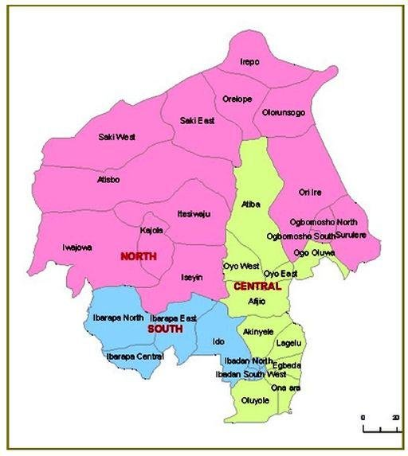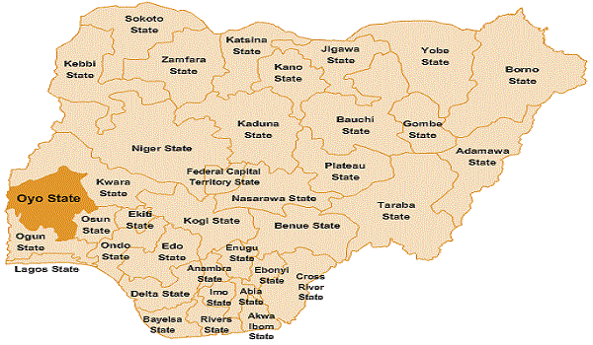

Fig. 2 Map of Oyo State from the map of Nigeria

Jekayinfa and Olajide (2007) investigated the energy utilization patterns in cassava processing mills in Nigeria. The study reveals that cassava starch production required the highest energy per ton of fresh cassava tuber, followed by cassava flour and 'garri.' Energy-intensive operations within each production line were identified, and optimization models were developed to minimize energy input. Oladimeji et al. (2022) researched an “analysis of energy consumption on energy-dependent electrical devices in garri production in Nigeria”. In the research, energy consumption data were obtained and energy losses in the process line were identified, isolated, and eliminated to maximize the energy use. In another study, the energy evaluation and processing cost reduction in the maize and cassava processing industry was investigated, analyzing the cost incurred on the use of electricity, diesel, and labor. The study discovered that diesel contributed more to production costs than electricity and labor and therefore, recommended the setting up of an energy monitoring team to monitor procurement and control utilization of diesel to reduce production cost.
Through bioconversion of cassava processing by-products, bioethanol, biodiesel, biogas, bio-hydrogen, and bio-electricity can be produced (Ogundahunsi et al, 2024). Cassava wastewater by-product obtained from starch or garri production has energy potential which makes it particularly appealing as a substrate for bio-energy generation using the microbial fuel cell (MFC) since degradation of biological substrate is the driving force for electricity generation in the MFC. Also, cassava leaves, peels, pulp, chips, and stalks obtained in cassava processing can be used as a feedstock for biodiesel, bioethanol, biogas, and bio-hydrogen production and the usage of this cassava processing by-product in this procedure would lessen the environmental effect of disposing of it without first treating it (Amorim et al., 2014; Zhang et al., 2016; Ogundahunsi et al., 2022b; Ogundahunsi et al., 2022c).
In this study, an energy audit of three major cassava processing industries in Oyo state (Psaltry International Company Limited in Ado Awaye, ATMANCorp Nigeria Limited in Ibadan, and Niji farm in Ilero) was carried out and some biofuels that can be produced from their processing by-product were outlined and suggested to supplement the use of electricity from the grid.
- METHODOLOGY
This research was carried out on three selected cassava processing farms in Oyo State. In this research, Oyo State was deliberately selected due to its active participation in cassava cultivation and processing.
The three cassava processing industries were surveyed for the data collection on electrical-powered machinery used for cassava processing in the industries through unstructured questionnaires and interviews with the personnel who know the power consumption of machinery used operating time, and equipment details. The unstructured questionnaire consists of questions relating to energy consumption, equipment specifications, operational practices, and energy management strategies. The industries understudied were; Psaltry International Company Limited in Ado Awaye, ATMANCorp Nigeria Limited in Ibadan, and Niji Farm in Ilero.
Data obtained from electrical-powered machinery used in cassava processing in the industries were extracted from the questionnaire and were sectioned into starch and cassava flour production. To analyze these data, the daily and monthly power consumed was recorded concerning the daily and monthly number of hours the machinery operates respectively. This was further used to calculate the cost of running these machinery in these sectors.
Peels & Waste water
Pulp Waste
Water
Water & Starch residue
Cassava Root

Peeling & Washing
Grating

Sieving
Extraction

Sedimentation

Dewatering
Milling

Pressing
Drying

Starch

Waste Cassava Water
Cassava Peels, Pulps, & Starch Residue
Microbial Fuel Cells (MFC)
Electricity Generation
Anaerobic Digestion
Biogas
Drying
Milling
Hydrolysis
Fermentation
Fractional Distillation
Bioethanol
Peels
Drying
Milling
Binding
Briquette

Fig. 3 Flowchart of the starch production process, waste generated during the process, and the biofuels produced from the waste. (Adapted from Ullah et al., 2023; Siddique et al., 2017; Izah and Ohimain, 2015).

Peels & Waste water
Water
Cassava Root

Peeling & Washing
Grating

Dewatering
Pulverizing

Drying

Milling

Screening
Cassava Flour

Waste Cassava Water
Cassava Peels
Microbial Fuel Cells (MFC)
Electricity Generation
Anaerobic Digestion
Biogas
Drying
Milling
Hydrolysis
Fermentation
Fractional Distillation
Bioethanol
Peels
Drying
Milling
Binding
Briquette

Fig. 4 Flowchart of cassava flour production process, waste generated during the process, and the biofuels produced from the waste. (Adapted from Ullah et al., 2023; Ekop et al., 2019; Siddique et al., 2017; Izah & Ohimain, 2015).
Peels & Waste water
Water
Cassava Root

Peeling & Washing
Grating

Fermentation
Squeezing

Sieving

Drying

Screening
Garri
Waste Cassava Water
Cassava Peels
Microbial Fuel Cells (MFC)
Electricity Generation
Anaerobic Digestion
Biogas
Drying
Milling
Hydrolysis
Fermentation
Fractional Distillation
Bioethanol
Peels
Drying
Milling
Binding
Briquette

Fig. 5 Flowchart of the Garri production process, waste generated during the process, and the biofuels produced from the waste. (Adapted from Ullah et al., 2023; Ekop et al., 2019; Siddique et al., 2017; Izah & Ohimain, 2015).
3.0 RESULT AND DISCUSSION
In Niji Farm, the result shown in Table 1a reveals that the total energy consumed for a month in the industry is 45,002.16 kW/h with the starch production section having 19,017.60 kW/h, cassava flour production (both wet and dry) section having 20,059.2 kW/h and garri processing section having 5,275.20 kW/hr. In ATMANCorp Nigeria the result shown in Table 1b shows that the total energy consumed per month is 65,581.92 kW/h with cassava flour (wet and dry) section and feed mill production section having 42,638.4 and 12,979.44 kW/h respectively. In Psaltry International Company Limited, the result shown in Table 1c revealed that the total energy is 923,774.40 kW/h with starch and cassava flour production sections having 767,448.00 and 149,256.00 kW/h respectively.
Table 1 shows the monthly energy used with its charges, and alternative biofuel produced from the cassava processing by-product in each of the three industries that can be used to supplement the electric energy used for the sustainability of the industry.
4.0 CONCLUSION
The result obtained from this study shows an intricate energy consumption landscape in the cassava processing industries. It was also observed that the small-scale cassava processing industries spend at least over a million naira on energy while large-scale industries spend over twenty million naira which can be reduced drastically through the use of biofuel. From the analysis, it was also observed that biofuels such as bioethanol, biodiesel, biomass, or biogas produced biochemically from cassava processing by-products can be used as a suitable biofuel to run types of machinery in cassava processing to achieve sustainability of the industry. This study proffers a solution to the high cost of energy used in cassava processing industries thereby enhancing food security by reducing the production cost resulting in lower prices of cassava products in the market.

Table 1 The monthly energy used, monthly charges, and alternative biofuel that can be used to supplement the electric energy.
1a
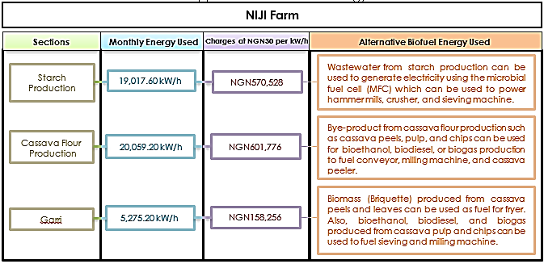
1b
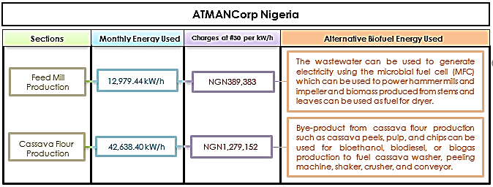

1c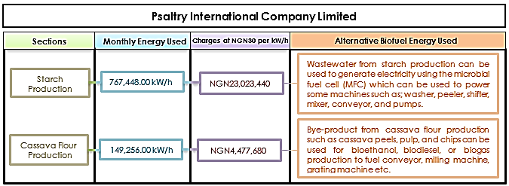

REFERENCES
Akpan, G. E., Aregbesola, O. A. and Olagunju, T. M. (2024). Analysis of drying kinetics and energy consumption of brine pretreated freshwater prawn fillets, Journal of Food Process Engineering, DOI: https://doi.org/10.1111/jfpe.14683
Akpan, G. E., Udom, I. J., Olatunji, O. M., Etim, P. J., Ekanem, J. T. and Ogundahunsi, O. E. (2022). Use of Response Surface Methodology (RSM) to Optimize the Process Parameters for Drying Prawns (Macrobrachium felicinum), Adeleke University Journal of Engineering and Technology, 5(1):63-71
Amorim, N. C. S., Alves, I., Martins, J. S., and Amorim, E. L. C. (2014) Biohydrogen production from cassava wastewater in an anaerobic fluidized bed reactor. Brazilian Journal of Chemical Engineering. Vol. 31(3), pp. 603 – 612.
Bala, R. M., Sravya, S. M., Srinivasa, R. G., Naga, B. K. and Suchitra, Y. (2018). Energy Conservation and Audit - A Case Study: Research and Reviews. International Journal of Advanced Research in Electrical, Electronics and Instrumentation Engineering, ISSN ONLINE (2278-8875) PRINT (2320-3765).
Ekop, I. E., Simonyan, K. J., and Evwierhoma, E. T. (2019). Utilization of Cassava Wastes for Value Added Products: An Overview. International Journal of Scientific Engineering and Science. 3(1): 31-39.
Gupta, A., Verma, P. and Priyadarshani, R. (2015). A Review on Energy Management and Audit. International Journal of Advanced Research in Electrical, Electronics and Instrumentation Engineering, 4(2), ISSN (Print): 2320 – 3765. Iwuoha, J.-P.
Iyiola A. O., Babafemi O.P., Ogundahunsi, O. E., and Ojeleye, A. E. (2022) Food security: a pathway towards improved nutrition and biodiversity conservation. In: Izah SC (ed) Biodiversity in Africa: potentials, threats and conservation, sustainable development and biodiversity. 29:369–394. Springer. https://doi.org/10.1007/978-981-19-3326-4_4
Izah, S. C. and Ohimain, E. I. (2015). Bioethanol Production from Cassava Mill Effluents Supplemented with Solid Agricultural Residues Using Bakers' Yeast (Saccharomyces cerevisiae).
Jekayinfa, S. O., and Olajide, J. O. (2007). Analysis of energy usage in the production of three selected cassava-based foods in Nigeria. Journal of Food Engineering, 82(2), 217–226. https://doi.org/10.1016/j.jfoodeng.2007.02.003
Kubule, K., Ločmelis, D., and Blumberga, (2020). “Analysis of the results of national energy audit program in Latvia”. Journal of Energy. 202: 117679. https://doi.org/10.1016/j.energy.2020.
Ogundahunsi, O. E, Akpan, G. E., Shittu, T. D. and Umani, K. C. (2024) Biofuel production from cassava processing by-products and processing wastes. In: Ogwu, M, C., Izah, S. C., Alfredo A. C. and Suresh C. B. (ed) Sustainable cassava: strategies from production through waste management. Plant biology, sustainability, and climate change, Elsevier, Pp 311-328, https://doi.org/10.1016/B978-0-443-21747-0.00017-5
Ogundahunsi, O. E., Akpan, G. E., Ayorinde, T. A., Babafemi, O. P., and Ayodele, A. A. (2022a) Industrial applications of biodiversity potentials in Africa. In: Chibueze Izah S (ed) Biodiversity in Africa: potentials, threats and conservation. Sustainable development and biodiversity, Springer, Singapore. 29. https://doi.org/10.1007/978-981-19-3326-4_2
Ogundahunsi, O. E., Ogunsina, B. S., and Aransiola, E. F. (2022b). Kariya Pod-husks: A Novel Biocatalyst in Biodiesel Production. Journal of Biotechnology & Bioinformatics Research. 4(2): 1-4 https://doi.org/10.47363/JBBR/2022(4)150
Ogundahunsi, O. E., Ogunsina, B. S., and Aransiola, E. F. (2022c). Kariya Biodiesel Process Optimization Using Kariya Pod-husks Bio-catalyzed. Journal of Energy Research and Reviews. 11(4): 33-47. https://doi.org/10.9734/JENRR/2022/v11i430285
Oladimeji, S., Oke, A. O., and Oladejo, K. A. (2022). Analysis of Energy Consumption on Energy Dependent Electrical Devices in Gari Production in Nigeria. A Case Study of Niji Farms, Oyo State. October. https://www.researchgate.net/publication/364196269.
Siddique, M.B.A., Yasir, M.W., Asjid, U., Mahmood, S., and Khalid. A. (2017). Microbial fuel cells as a novel technology for energy production and wastewater treatment. Journal of Applied Agricultural Biotechnology, 1(2):1-18.
Ullah, S., Noor, R. S., Sanaullah, and Gang, T. (2023). Analysis of biofuel (briquette) production from forest biomass: a socioeconomic incentive towards deforestation. 13:1951–1965. https://doi.org/10.1007/s13399-021-01311-5
Zhang, M., Xie, L., Yin, Z., Khanal, Z. K., and Zhou, Q. (2016). Biorefinery approach for cassava-based industrial wastes: current status and opportunities.

