Potential of gridded precipitation estimate products for hydrological modelling: The case of small watersheds in Côte d'Ivoire.

.
ABSTRACT

Rainfall information measured on the ground is not sufficiently representative at the watershed scale in Côte d'Ivoire. The use of gridded precipitation estimate products is an alternative to remedy this lack of information. Therefore, the aim of this study was to evaluate the performance of CHIRPS, GPCC, MSWEP, PERSIANN-CDR, PERSIANN-CCS-CDR, TAMSAT, WFDE5-CRU, and WFDE5-CRU-GPCC rainfall estimates for hydrological modelling in Côte d'Ivoire. A GR4J lumped model was used to simulate the flows in 14 small watersheds. The methodology was based on a global analysis to identify the products that gave the best scores in both calibration and validation over the selected watersheds. KGE2, NSE, VE, PBIAS, and ME were the metrics considered. The performance of these gridded precipitation estimate products was then evaluated according to the different climatic zones of Côte d'Ivoire. The results showed that WFDE5-CRU-GPCC performed well in all climatic zones. CHIRPS and PERSIANN-CDR exhibited the best performance in the transitional tropical and mountainous zones, whereas WFDE5-CRU was good, mainly in the mountainous zone.

Keywords: Gridded precipitation estimate products, hydrological modelling, GR4J, lumped model, climatic zones, Côte d'Ivoire.

1. INTRODUCTION

The effects of climate change are among the current challenges faced by humanity. In both urban and rural areas of sub-Saharan African countries, such as Côte d'Ivoire, climate change causes the recurrence of droughts and floods. This results in the vulnerability of agricultural areas, residential areas, infrastructure, and populations to extreme events. To address these issues, the need to build hydrological scenarios to assess, anticipate, and mitigate the consequences of climate change has emerged in developing countries, such as Côte d'Ivoire. Thus, rainfall appears to be the main variable in the prevention of natural disasters [34].
However, one of the realities encountered in Côte d'Ivoire is the low density of the ground measurement network. This makes it difficult to monitor the evolution of rainfall during different seasons in a balanced and timely manner throughout the country. Indeed, in Côte d'Ivoire, the 322,462 km² surface area is covered by only fourteen (14) synoptic stations spread over the territory and spaced more than 100 km apart, whereas twice the current number of stations is needed, according to the World Meteorological Organization standards (National Framework for Climate Services, 2016). Therefore, the rainfall information is not sufficiently representative at the watershed scale. To this first reality is added the high rate of gaps in both rainfall time series and flow records due to the previous socio-political crises that shook the country. These crises have led to interruptions in data collection and equipment maintenance over the period going from 1995 to 2015 [11,17,22]. Another reality is that the sub-Saharan region is characterized by a low literacy rate in rural areas, where the equipment is entrusted to local people. Thus, there is a concern about the reliability of the data, which must be analysed and corrected manually by experienced staff [8].
The undeniable need for efficient rainfall estimates from a practical perspective has aroused the interest of meteorologists, climatologists, and hydrologists in recent years. One of the solutions for better spatialization of rainfall information is the use of satellite data to estimate rainfall, particularly in ungauged or poorly gauged basins. The wide spatial coverage of satellites, their frequency of data acquisition, and free access to estimated variables appear to be valuable reinforcements for conventional rainfall measurement methods in developing countries [26].
Hydrological modelling is a solution to the dual challenge of reconstructing flow series and anticipating the evolution of runoff in catchment areas to prevent water-related disasters [8,18,21].
Various studies have been conducted to assess the effectiveness of gridded precipitation, and other climate variables have been used to estimate products for hydrological modelling. This is particularly true in Asia, where an increase in extreme droughts and typhoons drives innovation in forecasting. In India, the TRMM satellite precipitation estimate product performed well when forcing the semi-distributed SWAT model, outperforming CHIRPS and CFSR [28,30]. Furthermore, in Nepal, over the West Rapti River basin, the IMERG Final Run v.6 GPM grid performed better than CHIRPS and PERSIANN-CCS with the SWAT model [31]. For the Upper Nan River basin in northern Thailand, GPM IMERG Final Run v.6 outperformed PERSIANN (CDR, CCS, and RT) and TRMM (TMPA-3B42 and TMPA-RT) products as inputs to the HEC-HMS model [12]. In the wet region of southern China, the combination of CMORPH and the VIC model allowed better reproduction of extreme flows, followed by TMPA and SWAT coupling. CHIRPS and PERSIANN-CDR products are in the last position [33].
Other studies have evaluated satellite-based precipitation estimation products for South America. For example, the use of TRMM as an input to the SWAT model has been successful in the Pirapama River Basin in northeast Brazil [32]. Of the 19 precipitation estimate products, GPM IMERG Final Run and CMORPH-BLD obtained the best performance for simulating flows with the GR4J and HyMOD global models over the Jurua River Basin in Amazonia, Brazil [27].
In Africa, recent studies have made it possible to evaluate certain rainfall estimate products. The results showed that CMORPH CRT and PERSIANN CDR presented the best Nash score averages for the simulation of runoff with the HBV light-lumped model over West African basins (Burkina Faso, Ghana, and Benin) [24]. In West Africa, 17 rainfall estimate products, including the two mentioned above, were evaluated in the Volta Basin using the distributed mesoscale Hydrologic Model (mHM) [7]. Moreover, CHIRPS was the most effective for hydrological modelling in West and Central Africa at a monthly time step using the lumped model GR2M. It was followed by WFDEI-CRU, CRU, WFDEI-GPCC, and GPCC [19].
All the studies mentioned above prove that there are no "one size fits all" estimate products. However, the performance of these products fluctuates according to the regional or subregional hydroclimatic context. The present study aims to identify the best gridded precipitation estimate products (GPEPs) for rainfall-runoff modelling in Cote d’Ivoire on a daily time step. The aim was to determine the potential of gridded precipitation estimate products for infilling and enhancing existing ground-based hydrometeorological data in Côte d'Ivoire. These data play an important role in water resource management and in the prevention of water-related risks.
To achieve this general objective, the following specific objectives were retained:
- to evaluate the overall performance of each precipitation estimate product by considering all targeted watersheds.
- to classify the gridded precipitation estimate products according to their performance in the different climatic regimes observed in Côte d'Ivoire.
2. material and methods

2.1 Study Area and Data Collection

2.1.1 Generalities on the study area

The study area comprises watersheds spread throughout Côte d'Ivoire. The latter is a country located between 4° and 11° north latitude in West Africa, between the Tropic of Cancer and the Equator, and between 2° and 9° west longitude. It covers an area of 322,462 km². Its relatively flat and uneven terrain is composed of plains and plateaus, except for the western part of the country, which has mountainous terrain. The country is divided into two main vegetation zones. From north to south, there is a transition from a wooded savannah to an increasingly dense equatorial forest. Four (04) types of climates can be distinguished according to rainfall:
- I: Transitional Equatorial climate or Attiéen climate (south)
- II: Attenuated Transitional Equatorial climate or Baouléen climate (in the centre)
- III: Transitional Tropical climate or Sudanese climate (north)
- IV: Mountainous climate (west).
The hydrographic context of our study area consisted of 14 watersheds distributed across the four climatic zones of Côte d'Ivoire, as presented in Table 1. The spatial distributions of the climate zones and catchment areas are shown in Fig.1.

Table 1. Inventory and characteristics of targeted watersheds

ID | Station | Watershed | Climate zone | Area (km²)
1094801501 | Babokon | Boubo | I | 3411
1095501003 | Niébé | Hana | I | 4230
1098802003 | Rte Grand-Béréby | Néro | I | 1210
1095502003 | Tai-Pont | N'Cé | I | 1240
1099001503 | Yaka | Taboo | I | 810
1090103503 | Dimbokro-Kan | Kan | II | 6200
1090401305 | N'dakro | Ba | II | 6222
1092501903 | Nibéhibé | Lobo | II | 7280
1091601406 | Djirila | Baoule | III | 3970
1090102505 | Rte Katiola-Dabakala | N'Zi | III | 6620
1090402406 | Tehini | Iringou | III | 2155
1092501303 | Badala | Bafing | IV | 5930
1095500103 | Flampleu | Cavally | IV | 2470
1092504003 | Man-Ko | Ko | IV | 153

Fig. 1. Overview of the study area.

2.1.2 Flow and precipitation records

The hydrometric data for this study consisted of fourteen (14) series of daily flows over the period 1984-2004 (Fig. 2.). In addition, eight gridded precipitation estimates and one gridded evapotranspiration (ETP) estimate product were used as inputs for the hydrological model. Three of these, namely, CHIRPS, MSWEP, and PERSIANN-CDR, have already been identified among the most accurate satellite-based gridded precipitation products over West Africa at daily and monthly time steps [19,26]. The newest product, PERSIANN-CCS-CDR, is the fourth and last satellite-based gridded precipitation estimation product [25]. WFDE5-CRU and WFDE5-CRU-GPCC, which are based on the WATCH Forcing Data methodology applied to the ERA5 reanalysis product, are reanalysis products corrected using the ground-based products CRU and GPCC [13]. Finally, GPCC v2022 daily was the only ground-based gridded precipitation estimate product considered in this study (Table 2). These nine gridded datasets were chosen instead of the most recent and well-known gridded products, such as CMORPH, GPM, and GSMaP, because they share a common availability period with the flow measurements on the period 1983-2004.
Precipitation and evapotranspiration timeseries for each watershed were extracted from weighted average of values of the pixels overlaying these watersheds areas. This procedure was made using functions from “raster” package in RStudio.

Table 2. Characteristics of gridded precipitation and evapotranspiration estimate products
Acronym | Data source | Temporal coverage | Temporal resolution | Spatial coverage | Spatial resolutions | Latency | References
CHIRPS v.2 | S,R,G | 1981-present | Daily | 50°S-50°N | 0.05° | 1 month | (Funk et al., 2015)
GLEAM | S,R | 1980-present | Daily | Global | 0.25° | Several months | (Martens et al., 2017)
GPCC Full Data Daily v2022 | G | 1982-2020 | Daily | Global | 1° | Stopped | (Schamm et al., 2014)
MSWEP v2.8 | S,R,G | 1979-present | 3h | Global | 0.1° | Several months | (Beck et al., 2019)
PERSIANN-CCS-CDR | S,G | 1983-present | 3h | 60°S-60°N | 0.04° | 6 months | (Sadeghi et al., 2021)
PERSIANN-CDR | S,G | 1983-present | Daily | 60°S-60°N | 0.25° | 6 months | (Ashouri et al., 2016, 2015)
TAMSAT v.3 | S,G | 1983-present | Daily | Africa | 0.0375° | ~1 week | (Maidment et al., 2017)
WFDE5-CRU v.2.0 | R,G | 1979-2019 | Hourly | Global land | 0.5° | Stopped | (Cucchi et al., 2020)
WFDE5-CRU-GPCC v.2.0 | R,G | 1979-2019 | Hourly | Global land | 0.5° | Stopped | (Cucchi et al., 2020)

Fig. 2. Availability of flow data over 1984-2004 period. Missing data are plotted in red, whereas available data are shown in green.

2.2 Description of the GR4J model

The GR4J model (Génie Rural à 4 paramètres au pas de temps journalier) is a lumped rainfall-runoff model with four (04) parameters and a daily time step. The effectiveness of this model in simulating flows in West Africa has been confirmed in several studies [3,4,16,20] Several versions of this model exist. The version presented here was revised by Perrin et al. (2003).
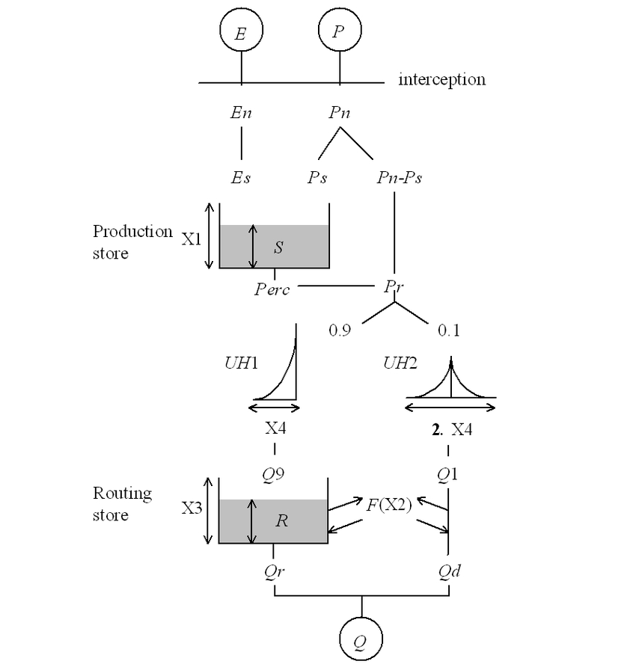
Fig. 3. Diagram of the GR4J rainfall-runoff model [23]

The first modelling step involved neutralizing raw rainfall by evapotranspiration (Fig. 3.). If the interception consumes the entire quantity of precipitated water, excess evapotranspiration (Es) leads to a decrease in the level (S) in the production reservoir. Otherwise, part of the net rainfall (Pn), noted Ps, flows into the production reservoir (production store). Another part (Pn-Ps) flows towards the outlet of the basin. This flow is then divided into two fractions: the first one (10%) is routed by a unit hydrograph (UH2) and reaches the outlet, whereas a major part of the flow (90%) transits towards a second reservoir called the routing store after being delayed by a unit hydrograph (UH1). Finally, a discharge law is applied to the content of the routing store. The four parameters to be calibrated are as follows:
- X1 Maximum capacity of production store (mm)
- X2 Underground exchange coefficient (mm)
- X3 One-day capacity of the routing store (mm)
- X4 Base time of unit hydrograph UH1 (days).
Please refer to Perrin et al. (2003) for further details regarding the intermediate formula and processes of the GR4J model.

2.3 Model performance metrics

Water resource management requires a reliable representation of the temporal dynamics of precipitation, as measured by the correlation coefficient (r) and volume, explained by the bias (β), and the variability described by the coefficient of variation (γ). Therefore, in this study, the main performance metric used for the calibration and validation of GR4J is the modified Kling-Gupta criterion (KGE2), which combines the three statistical coefficients mentioned above, namely r, β, and γ [1,15]. It has the advantage of considering the bias relative to the volume of water in the hydrological balance, which is often underestimated when optimizing the Nash-Sutcliffe Efficiency (NSE) criterion. The modified Kling-Gupta criterion is as follows:
$KGE2=1- \sqrt{{(r-1)}^{2}+ {(β-1)}^{2}+{(γ-1)}^{2}}$ (1)
With:
$γ= \frac{\frac{σ_{sim}}{μ_{sim}}}{\frac{σ_{obs}}{μ_{obs}}}$ (2): ratio of the coefficient of variation of the simulated flow $(\frac{σ_{sim}}{μ_{sim}})$ to the coefficient of variation of the observed flows $\left(\frac{σ_{obs}}{μ_{obs}}\right).$
$σ_{obs}$ (resp. $σ_{sim}$) is the standard deviation of the observed flow (resp. the simulated flow).
$β=\frac{μ_{sim}}{μ_{obs}}$ (3): ratio of the mean of the simulated flow ${(μ}_{sim})$ to the mean observed flow $(μ_{obs})$.
$r= \frac{1}{n}\sum_{i}^{n}{\frac{\left(Q_{i}^{obs}-μ_{obs}\right)\left(Q_{i}^{sim}-μ_{sim}\right)}{σ_{obs}σ_{sim}}}$ (4): correlation coefficient between the observed $(Q_{i}^{obs})$ and simulated flows $(Q_{i}^{sim})$.
KGE2’s range is equal to ]-∞ ; 1].

2.4 Calibration-validation procedure

A Split Sample Test (SST) procedure was used to split the flow time series into a calibration period and a validation period [14]. Ideally, an equal length of calibration and validation periods was pursued over the time span of the flow time series for which the performance metric was maximized.
3. results and discussion

3.1 Determination of calibration-validation
The selection of the different calibration and validation periods for the modelling was mainly based on the spatiotemporal availability of satellite-based products and daily flow data for each station, as well as on the constraints linked to the model (at least one year of warm-up). Thus, considering all these conditions, here is below the distribution of the calibration and validation periods for each station as well as the gap rates in the flow time series related to these periods. Gaps in the flow data were not filled because GR4J allows such a dataset.

Table 3. Distribution of calibration and validation periods for each station

 | SST1 |  |  |  | SST2
Station | Cal_deb | Cal_fin | Val_deb | Val_fin | Cal_deb | Cal_fin | Val_deb | Val_fin
Babokon | 1/1/1985 | 31/12/1994 | 1/1/1995 | 31/12/2004 | 1/1/1995 | 31/12/2004 | 1/1/1985 | 31/12/1994
Badala | 1/1/1986 | 31/12/1993 | 1/1/1994 | 31/12/2001 | 1/1/1994 | 31/12/2001 | 1/1/1986 | 31/12/1993
Dimbokro-Kan | 1/1/1985 | 31/12/1989 | 1/1/1990 | 31/12/1994 | 1/1/1990 | 31/12/1994 | 1/1/1985 | 31/12/1989
Djirila | 1/1/1986 | 31/12/1990 | 1/1/1991 | 31/12/1995 | 1/1/1991 | 31/12/1995 | 1/1/1986 | 31/12/1990
Flampleu | 1/1/1986 | 31/12/1993 | 1/1/1994 | 31/12/2001 | 1/1/1994 | 31/12/2001 | 1/1/1986 | 31/12/1993
Man-Ko | 1/1/1986 | 31/12/1990 | 1/1/1991 | 31/12/1995 | 1/1/1991 | 31/12/1995 | 1/1/1986 | 31/12/1990
N’Dakro | 1/1/1985 | 31/12/1994 | 1/1/1995 | 31/12/2004 | 1/1/1995 | 31/12/2004 | 1/1/1985 | 31/12/1994
Nibehibe | 1/1/1986 | 31/12/1990 | 1/1/1991 | 31/12/1995 | 1/1/1991 | 31/12/1995 | 1/1/1986 | 31/12/1990
Niebe | 1/1/1986 | 31/12/1993 | 1/1/1994 | 31/12/2001 | 1/1/1994 | 31/12/2001 | 1/1/1986 | 31/12/1993
Rte Grand Bereby | 1/1/1986 | 31/12/1990 | 1/1/1991 | 31/12/1995 | 1/1/1991 | 31/12/1995 | 1/1/1986 | 31/12/1990
Rte Katiola-Dabakala | 1/1/1985 | 31/12/1988 | 1/1/1991 | 31/12/1994 | 1/1/1991 | 31/12/1994 | 1/1/1985 | 31/12/1988
Tai Pont | 1/1/1987 | 31/12/1995 | 1/1/1996 | 31/12/2004 | 1/1/1996 | 31/12/2004 | 1/1/1987 | 31/12/1995
Tehini | 1/1/1986 | 31/12/1991 | 1/1/1992 | 31/12/1997 | 1/1/1992 | 31/12/1997 | 1/1/1986 | 31/12/1991
Yaka | 1/1/1986 | 31/12/1990 | 1/1/1991 | 31/12/1995 | 1/1/1991 | 31/12/1995 | 1/1/1986 | 31/12/1990

3.2 Overall performance analysis
In this section, emphasis is placed on the performance of the various satellite-based products in the calibration and validation of all target watersheds.
3.2.1 Calibration
For the SST1 period, the rainfall time series from PERSIANN-CDR, CHIRPS, WFDE5-CRU-GPCC, WFDE5-CRU, and GPCC gave good values ​​ for KGE2 in calibration, with median values ​​all above 0.7 (Fig. 4.). PERSIANN-CCS-CDR had the lowest calibration performance, with a KGE2 median value of 0.252. The performance of MSWEP was average in calibration, with scattered values ranging from 0.349 to 0.921 and a median of 0.617. The TAMSAT KGE2 values were unsatisfactory, with a median value below 0.5. Finally, CHIRPS stands out with its 1st quartile, 3rd quartile and maximum values of KGE2 (0.746, 0.871, and 0.957, respectively) being better than those of the other products.
Likewise, for the SST2 period, PERSIANN-CDR, CHIRPS, WFDE5-CRU-GPCC, WFDE5-CRU, and GPCC remained the best products for calibration according to their KGE2 values (Fig. 4). Nevertheless, there was a large drop in the performance of the gridded precipitation estimate products compared with that of SST1. The median values of KGE2 for GPCC, MSWEP, and WFDE5-CRU were below 0.7 (resp. 0.658, 0.540, 0.643). TAMSAT performed better than MSWEP, with median, 3rd quartile and maximum values of 0.618, 0.733, and 0.841 compared to 0.54, 0.634, and 0.806, respectively. In addition, the performance of PERSIANN-CCS-CDR slightly increased (the KGE2 median increased from 0.252 to 0.32). However, this last product was still the lowest ranked among the eight (8) gridded precipitation estimate products considered in this study. WFDE5-CRU-GPCC slightly outperformed CHIRPS considering the KGE2 median values (0.755 vs. 0.741). However, CHIRPS still had the best 3rd quartile and maximum values (0.826 and 0.912 against 0.808 and 0.887 for WFDE5-CRU-GPCC, respectively). A similar observation was made between GPCC and WFDE5-CRU.
The drop in performance in calibration from SST1 to SST2 considering both the mean and median values of KGE2 is approximately between 5% and 12% for the precipitation estimate products, in addition to PERSIANN-CCS-CDR and TAMSAT. For these two exceptions, the median and maximum values of the KGE2 scores increased by 26% and 9%, respectively.
3.2.2 Validation
For validation, in SST1, WFDE5-CRU-GPCC outperformed CHIRPS and the other gridded precipitation estimate products (Fig. 4). The best minimum, median, 3rd quartile, and maximum values of KGE2 were observed for WFDE5-CRU-GPCC (resp. 0.405, 0.625, 0.684, 0.773). PERSIANN-CDR exhibited the second-best performance (KGE2 median = 0.606), followed by CHIRPS (KGE2 median = 0.560). Unlike the calibration step for SS1, TAMSAT performed better than MSWEP for the upper 50% of KGE2 values (0.475 and 0.388, respectively). However, the KGE2 values for TAMSAT were more scattered below the median, as indicated by the thin and downward elongated shape of the violin (Figure 3). The results were similar for SST2 with respect to the KGE2 values. WFDE5-CRU-GPCC maintains its best performance followed this time by PERSIANN-CDR, WFDE5-CRU and CHIRPS. MSWEP outperformed TAMSAT.
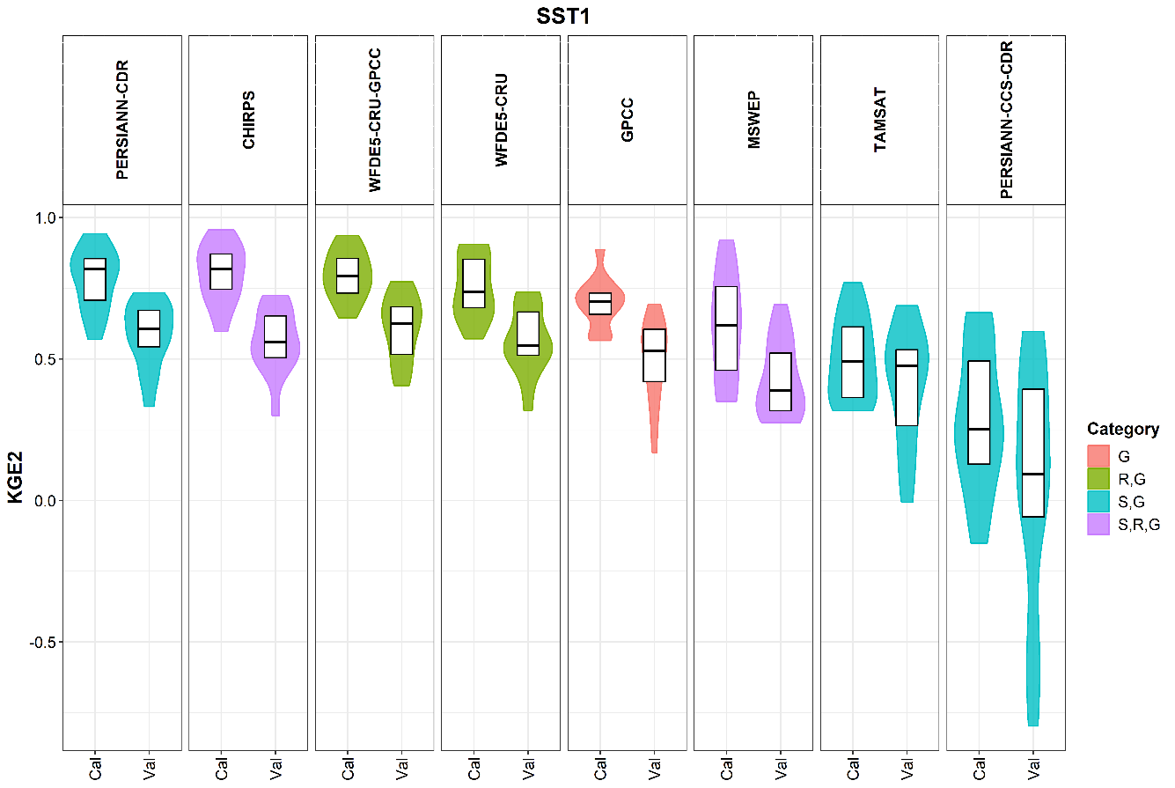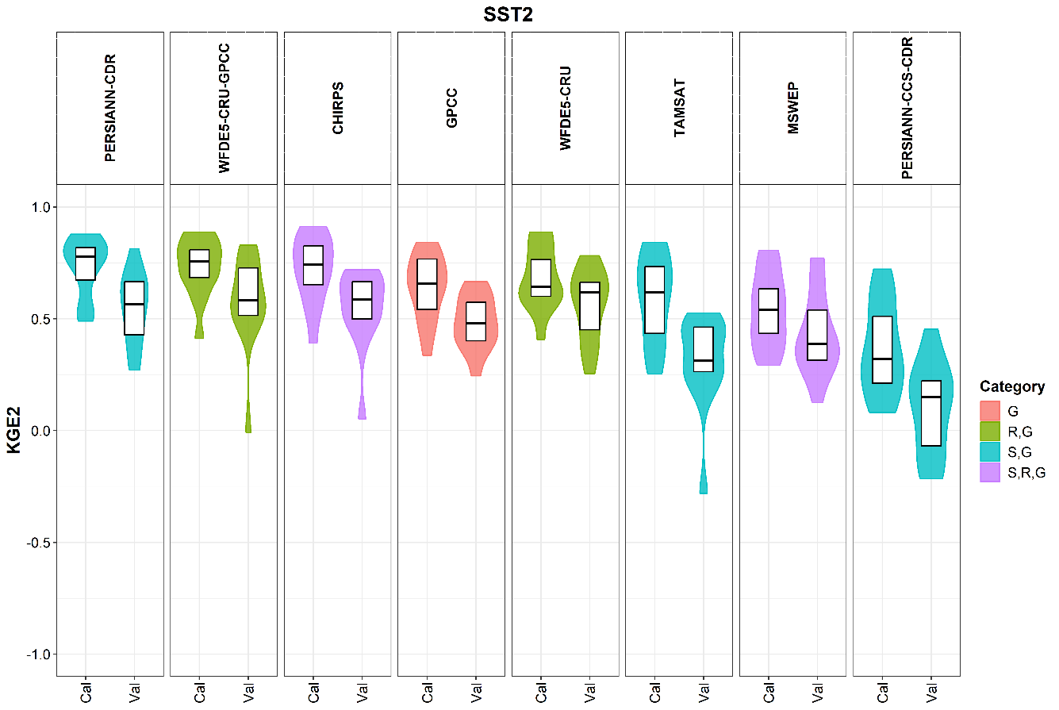
Fig. 4. Violin graphs of KGE2 values obtained from calibration and validation.
Letters ‘G’, ‘R,G’, ‘S,R’ and ‘S,R,G’ respectively stand for ‘Gauge’ , ‘Reanalysis and Gauge’ , ‘Satellite and Reanalysis’ and ‘Satellite, Reanalysis and Gauge’. The products are ordered from left to right by decreasing the calibration KGE2 median values.
3.3 Spatial analysis
The spatial analysis consisted of studying the influence of the climate regime on the calibration and validation scores according to the different gridded precipitation estimate products used as inputs to the GR4J model.
3.3.1 Spatial performance in SST1
The KGE2 values ​​obtained from the fourteen (14) hydrometric stations after calibration and validation in SST1 from all the estimate products are spatially represented in Fig. 5.
For the top five performing products in Section 4.2, CHIRPS, PERSIANN-CDR, WFDE5-CRU-GPCC, WFDE5-CRU, and GPCC good calibration, KGE2 values were well distributed over the four (4) climate zones observed in Côte d’Ivoire. This is shown by the colours of the triangles representing the hydrometric station results for calibration in Figure 5, which vary from yellow to marine blue (KGE2 ≥ 0.6). MSWEP has poor calibration performance over the southwest area included in the Transitional Equatorial regime zone, as indicated by the red triangle (KGE2 < 0.6). Good calibration KGE2 values (KGE2 ≥ 0.6) for TAMSAT were obtained in the Transitional Tropical regime in the north, as well as in the mountain regime in the western part of the country. PERSIANN-CCS-CDR performed well in calibration for only two hydrometric stations located in the extreme northwest, included in the Transitional Tropical regime zone, and in the western area, included in the mountainous regime zone (0.6 ≤ KGE2 < 0.7).
The validation values of KGE2 are represented by circles plotted beneath the triangles in Fig. 5. Maximum values across all gridded precipitation estimate products and climate zones are under 0.8 (0.7 ≤ KGE2 < 0.8) and plotted in green. Only WFDE5-CRU-GPCC and PERSIANN-CDR have good performance spread over all the climate zones in validation (0.6 ≤ KGE2 < 0.8; yellow and green colours). CHIRPS performs better in the Transitional Tropical regime zone (0.6 ≤ KGE2 < 0.7; yellow colour) and in the Mountain regime zone (0.7 ≤ KGE2 < 0.8; green colour). WFDE5-CRU and TAMSAT performed well only in the mountain regime zone (green and yellow, respectively). GPCC performs as well as TAMSAT in Mountain regime but also obtains good validation KGE2 (0.6 ≤ KGE2 < 0.7; yellow colour) for two hydrometric stations located in the southwest (Transitional Equatorial regime) and central west (Attenuated Transitional Equatorial regime). Good MSWEP scores (0.6 ≤ KGE2 < 0.7; yellow) were observed at two stations in the northern and northeastern parts of Côte d’Ivoire, inside the Transitional Tropical regime zone. The PERSIANN-CCS-CDR results were all < 0.6.
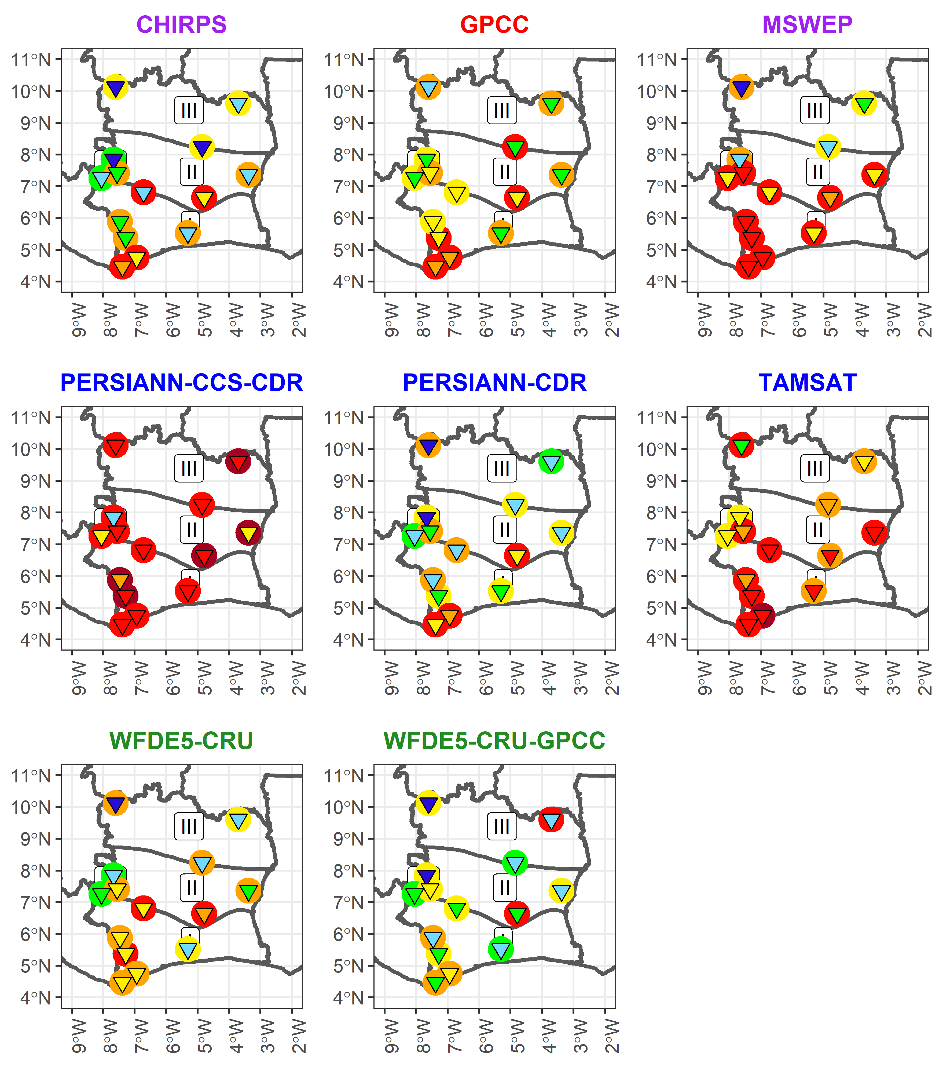
SST 1
Fig. 5: Spatial representation of KGE2 values obtained from calibration and validation for SST1.
Calibration values are plotted in triangular shape. Validation values are plotted in circular shape beneath the triangles.
3.3.2 Spatial performance in SST2
The KGE2 values obtained for all hydrometric stations after calibration and validation in SST2 from all the precipitation estimate products considered are illustrated in Fig. 6.
Like the SST1 calibration step, CHIRPS, PERSIANN-CDR, WFDE5-CRU-GPCC, WFDE5-CRU, and GPCC, good performance was well distributed over the Côte d’Ivoire climate zones for the SST2 calibration. The MSWEP highest results in the calibration were spread over the Transitional Equatorial regime zone and mountain regime zone. Interestingly, TAMSAT best KGE2 values are distributed over the Transitional Equatorial regime, Attenuated Transitional Equatorial regime and Mountain regime zones (0.6 ≤ KGE2 < 0.8; yellow, green and blue colourations). PERSIANN-CCS-CDR performed well at only 3 stations over 14.
In the SST2 validation step, only PERSIANN-CDR, WFDE5-CRU, and WFDE5-CRU-GPCC had a KGE2 ≥ 0.6 in at least one station in each of the four climate zones. WFDE5-CRU performed slightly better than the other two products (seven hydrometric stations against six for PERSIANN-CDR and WFDE5-CRU-GPCC). CHIRPS lacks good KGE2 scores in the Attenuated Transitional Equatorial regime. Good MSWEP performance was obtained at two of the three stations in the Transitional Tropical regime zone. PERSIANN-CCS-CDR and TAMSAT results were all < 0.6.

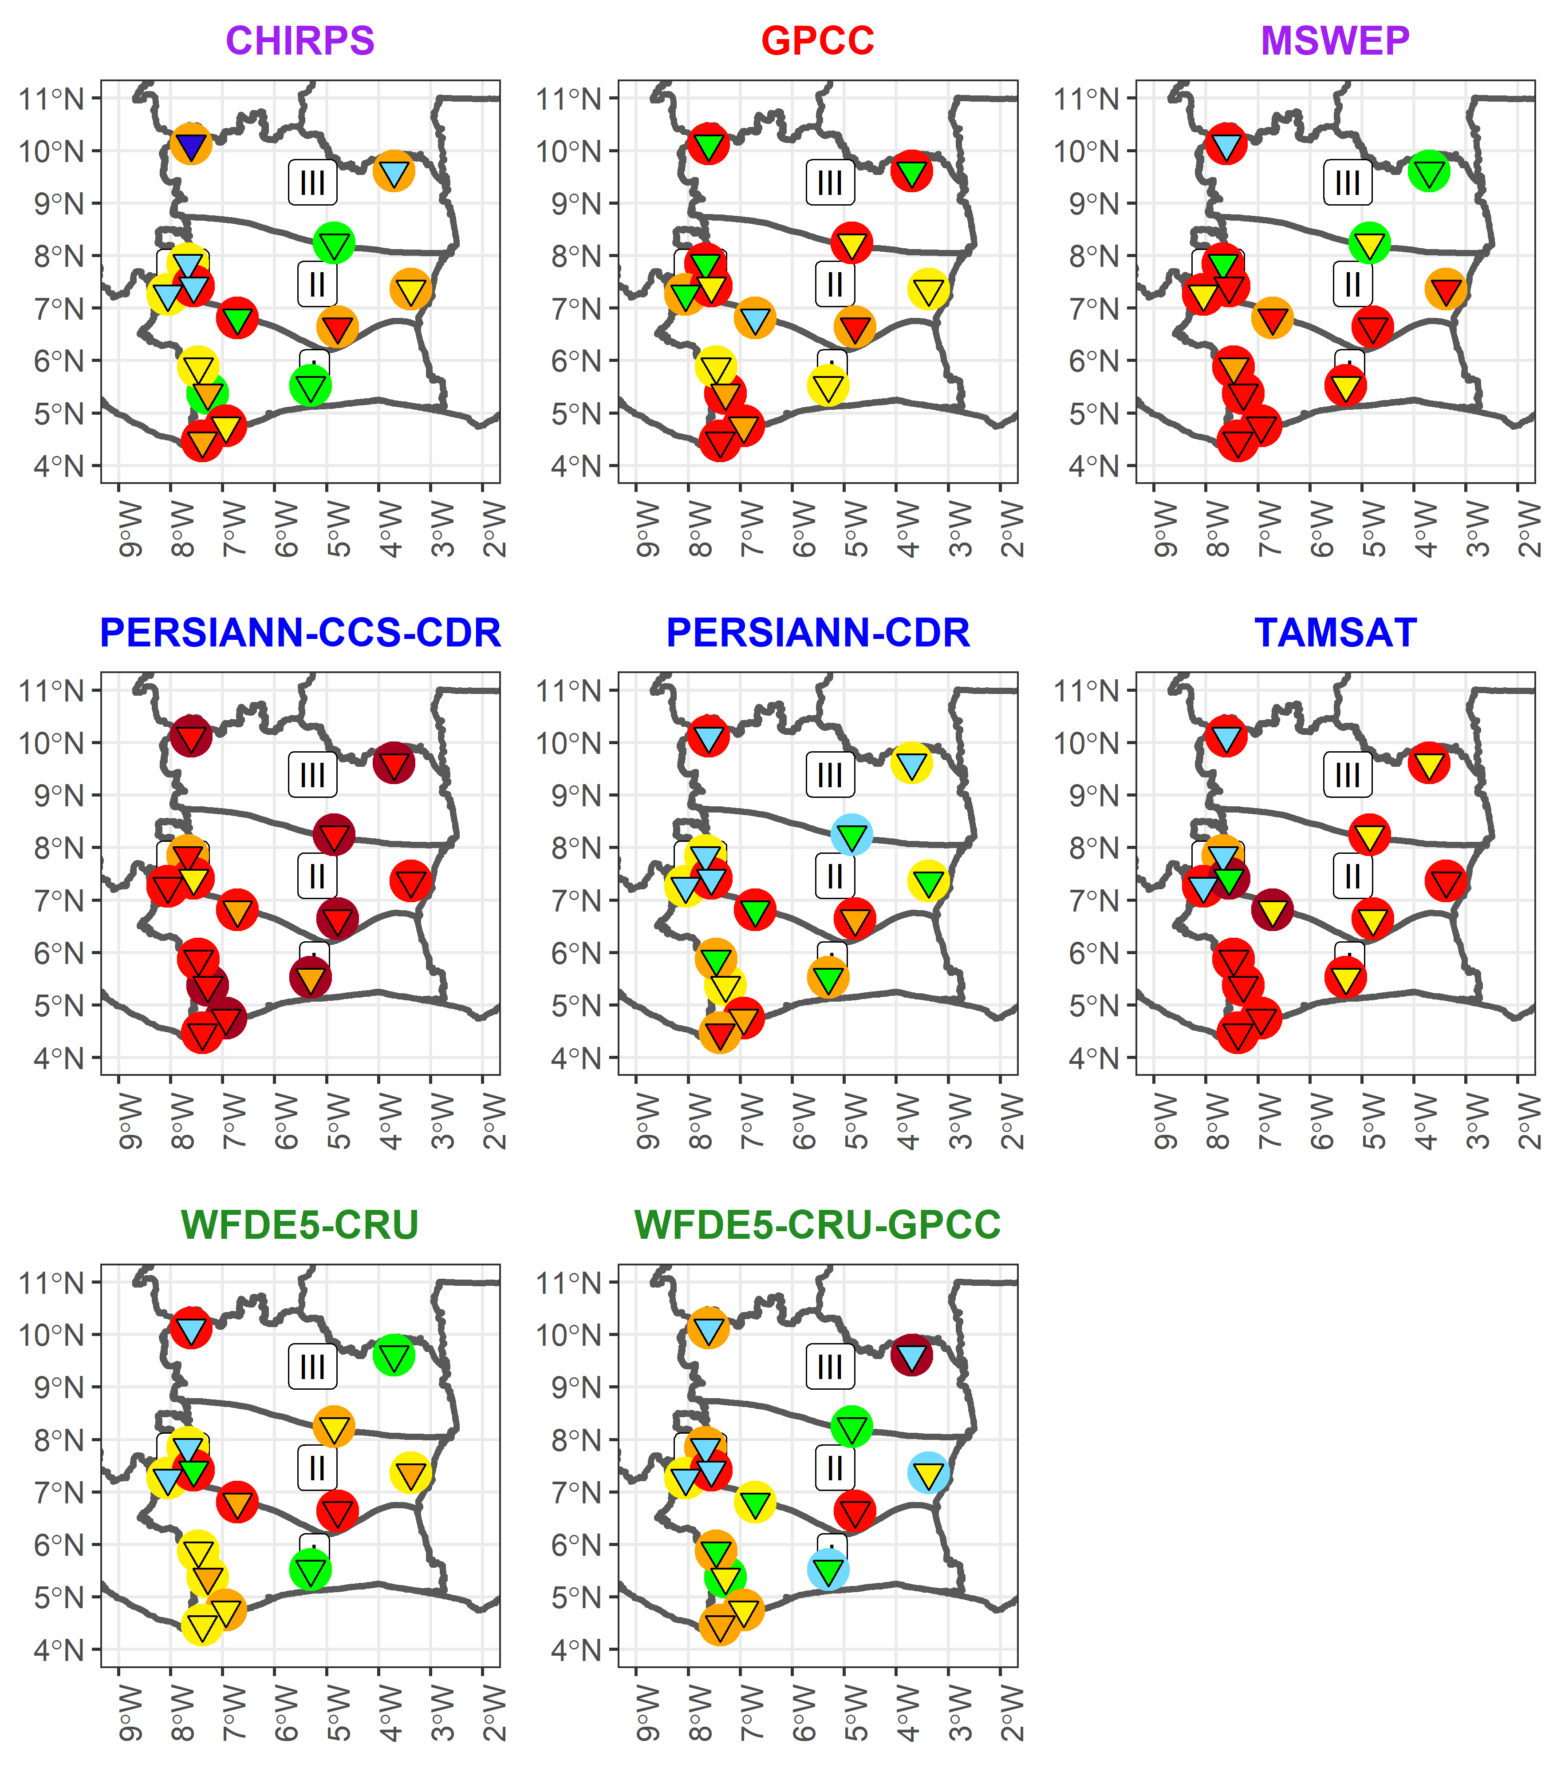
SST 2
Fig. 6. Spatial representation of KGE2 values obtained from calibration and validation in SST2.
The calibration values are plotted in a triangular shape. The validation values are plotted in a circular shape beneath the triangles.
3.4 Discussion
The results of the different analyses mentioned above showed that WFDE5-CRU-GPCC had the best validation scores over almost all study basins (except for Dimbokro with a KGE2 below 0.5). This performance confirms its design purposes by the Copernicus Climate Change Service as a meteorological forcing dataset for land surface and hydrological models. In addition, the modelling results of WFDE5-CRU and WFDE5-CRU-GPCC in the mountainous area of Côte d'Ivoire were similar to those of Probst and Mauser (2022) for the sub-catchments in the mountainous area of the Danube. This confirms their effectiveness in the mountainous areas. This result is important considering that, in mountainous areas, a major source of uncertainty is the systematic measurement bias due to wind-induced undercatch at rainfall gauging stations. This is particularly important in windy areas, which leads to a systematic underestimation of precipitation [29]. Fortunately, the WFDE5 forcing dataset includes a measurement bias correction for this undercatch in its design [5,6,9].
Overall, the TAMSAT estimates did not provide sufficiently high KGE2 values. However, for catchments in mountainous areas (such as the Flampleu and Badala catchments), the calibration and validation scores were much better than those in other catchments. MSWEP also produced fairly good results, mainly in the transitional tropical zone. It is important to note that the overall performance of the TAMSAT and MSWEP products obtained in this study was not in all respects, which was expected given their spatial resolutions (0.375° and 0.1°, respectively). Indeed, a high spatial resolution allows the product to be used in small catchments, as in the current study, which should reduce uncertainties and errors [10]. Then, the performance of GR4J should have increased. The quality of the gauge station database used for calibrating the estimation algorithms or leading bias correction over Côte d’Ivoire should be the main reason for such poor outcomes.
Furthermore, CHIRPS provides satisfactory results, but mainly in two climatic zones: the mountainous zone and the tropical transition zone. Such good outcomes have also been reported in other studies on West African catchments [7,24].
On the other hand, PERSIANN-CDR achieved good KGE2 values in validation, especially in mountainous and tropical transition zones. The performance of this product is in line with our expectations, as it is intended for hydrological and climatic studies that require consistent long-term data, such as trend and risk analyses [2]. Surprisingly, PERSIANN-CCS-CDR (Precipitation Estimation from Remotely Sensed Information using Artificial Neural Networks - Cloud Classification System - Climate Data Record), a recent product designed for typical applications in hydrological modelling flood forecasting, drought monitoring, and soil moisture analysis [25], is the worst product for hydrological modelling in Côte d’Ivoire. This result is relevant for the upgrade of PERSIANN-CCS-CDR in the western African region.
At the end of the study, it was found that for some stations, the validation scores remained low, regardless of the satellite-based product used. This is notably the case for the Yaka, Rte Grand Bereby, and Dimbokro Stations. These results can be explained by the difficulty of the model in understanding the behaviour of the watersheds involved. This difficulty may be due to the quality of the flow data for the post-1990 period, given the sharp drop in performance after very good calibrations (KGE2 > 0.7) for the pre-1990 period for products such as CHIRPS, WFDE5-CRU-GPCC, and PERSIANN-CDR. The period 1990-2011 was marked by various episodes of sociopolitical turmoil that periodically hampered the maintenance of hydrometeorological measurement networks and data collection. Data-filling activities and the resumption of measurements are sometimes subject to calculation or updating errors of the rating curves. Anthropogenic impacts on river flow regimes can also be considered the cause of such results.

4. Conclusion

Rainfall is the main input data for hydrological modelling. Gridded precipitation estimate products have become an important source of this information, especially in areas where precipitation measurements are nonexistent, scarce, or difficult to access. This study evaluated the performance of some of these gridded estimate products in the hydrological modelling of small watersheds in Côte d’Ivoire using the GR4J lumped model. These products were compared using the modified Kling and Gupta evaluation criteria (KGE2) for calibration and validation. At the end of the overall analysis, the WFDE5-CRU-GPCC product had the highest modelling scores, followed by CHIRPS, PERSIANN-CDR, and WFDE5-CRU. In contrast, TAMSAT and MSWEP exhibited unsatisfactory overall performance. In addition, an analysis of the performance according to the climate zone was conducted. The analysis showed that WFDE5-CRU-GPCC performed well in all climate zones. CHIRPS and PERSIANN-CDR performed well in Transitional Tropical and Mountainous climate zones in both calibration and validation. However, PERSIANN-CDR slightly outperformed CHIRPS. WFDE5-CDR performed better only in the Mountainous climate zone. Ultimately, we conclude that the WFDE5-CRU-GPCC seems to be the most adapted rainfall estimate product for daily time-step hydrological modelling in Côte d’Ivoire. CHIRPS, PERSIANN-CDR, and WFDE5-CRU should be equally suitable, but only in the above-mentioned climate zones where they have been more effective.
The best products discovered in this study have good potential for water resources as well as disaster risk assessment and prevention activities.
This study may help advance the search for ways to overcome the problem of rainfall data deficiency in Côte d’Ivoire. Nevertheless, this study has some limitations. Notably, GR4J does not consider the physical factors that can influence runoff, such as topographical information, land use, human activities, and entities such as dams and ponds. Therefore, in future studies, it would be beneficial to add distributed models or physically based models in the assessment process. Finally, more recent (post-2000) time coverage products, such as CMORPH, GPM IMERG, and GSMaP, can be tested on Ivorian catchments if hydrological data for this period are available. This would provide a more operational framework with the simulation of flows in near-real time at lags ranging from 24 h to 3 h from the present time.

References

1. Althoff D, Rodrigues LN. Goodness-of-Fit Criteria for Hydrological Models: Model Calibration and Performance Assessment. Journal of Hydrology. 2021;600:126674. DOI: 10.1016/j.jhydrol.2021.126674.
2. Ashouri H, Hsu K-L, Sorooshian S, Braithwaite DK, Knapp KR, Cecil LD, et al. PERSIANN-CDR: Daily Precipitation Climate Data Record from Multisatellite Observations for Hydrological and Climate Studies. Bulletin of the American Meteorological Society. 2015;96(1):69–83. DOI: 10.1175/BAMS-D-13-00068.1.
3. Bodian A, Dezetter A, Diop L, Deme A, Djaman K, Diop A. Future Climate Change Impacts on Streamflows of Two Main West Africa River Basins: Senegal and Gambia. Hydrology. 2018;5(1):21. DOI: 10.3390/hydrology5010021.
4. Brocca L, Massari C, Pellarin T, Filippucci P, Ciabatta L, Camici S, et al. River Flow Prediction in Data Scarce Regions: Soil Moisture Integrated Satellite Rainfall Products Outperform Rain Gauge Observations in West Africa. Sci Rep. 2020;10(1):12517. DOI: 10.1038/s41598-020-69343-x.
5. Cornes RC, van der Schrier G, van den Besselaar EJM, Jones PD. An Ensemble Version of the E-OBS Temperature and Precipitation Data Sets. Journal of Geophysical Research: Atmospheres. 2018;123(17):9391–409. DOI: 10.1029/2017JD028200.
6. Cucchi M, Weedon GP, Amici A, Bellouin N, Lange S, Müller Schmied H, et al. WFDE5: Bias-Adjusted ERA5 Reanalysis Data for Impact Studies. Earth System Science Data. 2020;12(3):2097–120. DOI: https://doi.org/10.5194/essd-12-2097-2020.
7. Dembélé M, Schaefli B, van de Giesen N, Mariéthoz G. Suitability of 17 Rainfall and Temperature Gridded Datasets for Large scale hydrological Modelling in West Africa. Hydrometeorology/Remote Sensing and GIS; 2020 Apr. DOI: 10.5194/hess-2020-68.
8. Ekeu-wei I, Blackburn G, Pedruco P. Infilling Missing Data in Hydrology: Solutions Using Satellite Radar Altimetry and Multiple Imputation for Data-Sparse Regions. Water. 2018;10(10):1483. DOI: 10.3390/w10101483.
9. Fick SE, Hijmans RJ. WorldClim 2: New 1‐km Spatial Resolution Climate Surfaces for Global Land Areas. Int J Climatol. 2017;37(12):4302–15. DOI: 10.1002/joc.5086.
10. Geleta CD, Deressa TA. Evaluation of Climate Hazards Group InfraRed Precipitation Station (CHIRPS) satellite‐based Rainfall Estimates over Finchaa and Neshe Watersheds, Ethiopia. Engineering Reports. 2021;3(6). DOI: 10.1002/eng2.12338.
11. Gosset M, Dibi-Anoh PA, Schumann G, Hostache R, Paris A, Zahiri E-P, et al. Hydrometeorological Extreme Events in Africa: The Role of Satellite Observations for Monitoring Pluvial and Fluvial Flood Risk. Surv Geophys. 2023;44(1):197–223. DOI: 10.1007/s10712-022-09749-6.
12. Gunathilake MB, Amaratunga YV, Perera A, Karunanayake C, Gunathilake AS, Rathnayake U. Statistical Evaluation and Hydrologic Simulation Capacity of Different Satellite-Based Precipitation Products (SbPPs) in the Upper Nan River Basin, Northern Thailand. Journal of Hydrology: Regional Studies. 2020;32:100743. DOI: 10.1016/j.ejrh.2020.100743.
13. Hersbach H, Bell B, Berrisford P, Hirahara S, Horányi A, Muñoz‐Sabater J, et al. The ERA5 Global Reanalysis. QJR Meteorol Soc. 2020;146(730):1999–2049. DOI: 10.1002/qj.3803.
14. Klemeš V. Operational Testing of Hydrological Simulation Models. Hydrological Sciences Journal. 1986;31(1):13–24. DOI: 10.1080/02626668609491024.
15. Kling H, Fuchs M, Paulin M. Runoff Conditions in the Upper Danube Basin under an Ensemble of Climate Change Scenarios. Journal of Hydrology. 2012;424–425:264–77. DOI: 10.1016/j.jhydrol.2012.01.011.
16. Kodja DJ, Akognongbé AJS, Amoussou E, Mahé G, Vissin EW, Paturel J-E, et al. Calibration of the Hydrological Model GR4J from Potential Evapotranspiration Estimates by the Penman-Monteith and Oudin Methods in the Ouémé Watershed (West Africa). Proc IAHS. 2020;383:163–9. DOI: 10.5194/piahs-383-163-2020.
17. Koffi SÉ, Koffi TK, Perrin J-L, Séguis L, Guilliod M, Goné DL, et al. Hydrological and Water Quality Assessment of the Aghien Lagoon Hydrosystem (Abidjan, Côte d’Ivoire). Hydrological Sciences Journal. 2019;64(15):1893–908. DOI: 10.1080/02626667.2019.1672875.
18. Koriche SA, Rientjes THM. Application of Satellite Products and Hydrological Modelling for Flood Early Warning. Physics and Chemistry of the Earth, Parts A/B/C. 2016;93:12–23. DOI: 10.1016/j.pce.2016.03.007.
19. Kouakou C, Paturel J-E, Satgé F, Tramblay Y, Defrance D, Rouché N. Comparison of Gridded Precipitation Estimates for Regional Hydrological Modeling in West and Central Africa. Journal of Hydrology: Regional Studies. 2023;47:101409. DOI: 10.1016/j.ejrh.2023.101409.
20. Koubodana HD, Atchonouglo K, Adounkpe JG, Amoussou E, Kodja DJ, Koungbanane D, et al. Surface Runoff Prediction and Comparison Using IHACRES and GR4J Lumped Models in the Mono Catchment, West Africa. Proc IAHS. 2021;384:63–8. DOI: 10.5194/piahs-384-63-2021.
21. Neal J, Schumann G, Bates P. A Subgrid Channel Model for Simulating River Hydraulics and Floodplain Inundation over Large and Data Sparse Areas: FLOODPLAIN INUNDATION OVER LARGE AREAS. Water Resour Res. 2012;48(11). DOI: 10.1029/2012WR012514.
22. Paturel J-E, Boubacar I, L’aour-Cres A, Mahe G. Note de recherche : Grilles mensuelles de pluie en Afrique de l’Ouest et Centrale. rseau. 2010;23(4):325–33. French. DOI: 10.7202/045095ar.
23. Perrin C, Michel C, Andréassian V. Improvement of a Parsimonious Model for Streamflow Simulation. Journal of Hydrology. 2003;279(1–4):275–89. DOI: 10.1016/S0022-1694(03)00225-7.
24. Poméon T, Jackisch D, Diekkrüger B. Evaluating the Performance of Remotely Sensed and Reanalysed Precipitation Data over West Africa Using HBV Light. Journal of Hydrology. 2017;547:222–35. DOI: 10.1016/j.jhydrol.2017.01.055.
25. Sadeghi M, Nguyen P, Naeini MR, Hsu K, Braithwaite D, Sorooshian S. PERSIANN-CCS-CDR, a 3-Hourly 0.04° Global Precipitation Climate Data Record for Heavy Precipitation Studies. Sci Data. 2021;8(1):157. DOI: 10.1038/s41597-021-00940-9.
26. Satgé F, Defrance D, Sultan B, Bonnet M-P, Seyler F, Rouché N, et al. Evaluation of 23 Gridded Precipitation Datasets across West Africa. Journal of Hydrology. 2020;581:124412. DOI: 10.1016/j.jhydrol.2019.124412.
27. Satgé F, Pillot B, Roig H, Bonnet M-P. Are Gridded Precipitation Datasets a Good Option for Streamflow Simulation across the Juruá River Basin, Amazon? Journal of Hydrology. 2021;602:126773. DOI: 10.1016/j.jhydrol.2021.126773.
28. Setti S, Maheswaran R, Sridhar V, Barik KK, Merz B, Agarwal A. Inter-Comparison of Gauge-Based Gridded Data, Reanalysis and Satellite Precipitation Product with an Emphasis on Hydrological Modeling. Atmosphere. 2020;11(11):1252. DOI: 10.3390/atmos11111252.
29. Sevruk B, Chvíla B. Error Sources of Precipitation Measurements Using Electronic Weight Systems. Atmospheric Research. 2005;77(1):39–47. DOI: 10.1016/j.atmosres.2004.10.026.
30. Sharannya TM, Al-Ansari N, Deb Barma S, Mahesha A. Evaluation of Satellite Precipitation Products in Simulating Streamflow in a Humid Tropical Catchment of India Using a Semi-Distributed Hydrological Model. Water. 2020;12(9):2400. DOI: 10.3390/w12092400.
31. Talchabhadel R, Aryal A, Kawaike K, Yamanoi K, Nakagawa H, Bhatta B, et al. Evaluation of Precipitation Elasticity Using Precipitation Data from Ground and Satellite-Based Estimates and Watershed Modeling in Western Nepal. Journal of Hydrology: Regional Studies. 2021;33:100768. DOI: 10.1016/j.ejrh.2020.100768.
32. Viana JF de S, Montenegro SMGL, da Silva BB, da Silva RM, Srinivasan R, Santos CAG, et al. Evaluation of Gridded Meteorological Datasets and Their Potential Hydrological Application to a Humid Area with Scarce Data for Pirapama River Basin, Northeastern Brazil. Theor Appl Climatol. 2021;145(1–2):393–410. DOI: 10.1007/s00704-021-03628-7.
33. Wang Q, Xia J, She D, Zhang X, Liu J, Zhang Y. Assessment of Four Latest Long-Term Satellite-Based Precipitation Products in Capturing the Extreme Precipitation and Streamflow across a Humid Region of Southern China. Atmospheric Research. 2021;257:105554. DOI: 10.1016/j.atmosres.2021.105554.
34. State of the Climate in Africa 2021. Geneva, Switzerland: World Meteorological Organization (WMO); 2022.

