Assessing the Sustainability of Kilongo Forest Reserve under Community-Based Forest Management in Wangingómbe District, Njombe Region, Tanzania

ABSTRACT
Over the past three decades, community forest management regimes, which involve collaborative decision-making for forest resource management, have been the dominant form of forest management in the global south. Among other things, this management regime has been associated with improving both forest conditions and community livelihoods. Recent studies, however, indicate that forests under community-based forest management (CBFM) are decreasing, subjecting them to degradation and complete land use change. This study, therefore, assesses the sustainability of Kilongo Forest Reserve under CBFM in Wangingómbe District, Njombe Region, Tanzania. Data was gathered from 90 heads of Kilongo Sub-Village households in the study village of Masaulwa using both probability and non-probability techniques. Data was collected through structured interviews, in-depth interviews, and documentary reviews. The results showed that the conditions of Kilongo Forest Reserve improved noticeably under CBFM over the period of 20 years, among other things, due to the existence of rules and regulations and the involvement of villagers in managing the forest. However, with the exception of the increased harvests of honey, the results demonstrate that the improved forest conditions did not significantly improve the livelihoods of the villagers. On the other hand, the forest reserve faced the challenge of animals passing through or grazing within the forest, as well as illegal harvesting of forest resources. Generally, the management of the Kilongo Forest Reserve under CBFM was somehow effective but not sustainable. This was because there were many actors, multiple power centres, and a village environmental management committee (VEMC) that was neither accountable to the villagers nor under their control. Additionally, the forest management efforts were demotivated, especially among VEMC members, due to the uneven distribution of benefits. This study concludes that the management of Kilongo Forest Reserve under CBFM is unsustainable. Thus, to ensure the sustainability of Kilongo Forest Reserve under CBFM, first, the village assembly, through the VEMC, should have full power to control the forest reserve, and second, the government must explore alternative energy sources for the rural population, who rely heavily on wood.
Keywords: Community-based forest management; forest conditions; forest reserve; livelihoods; Tanzania.
- INTRODUCTION
Forests are crucial in providing a wide range of environmental services, including watershed protection, biodiversity conservation, improving soil quality, and regulating the climate [1, 2, 3, 4]. Also, more than 1.6 billion people globally rely on forests for food, energy, shelter, medicines, and income, and approximately 70 million people live in forests as their homes [5, 6, 7, 8]. As a result, the fate of our forests determines our own destiny.
However, for years, forest degradation, specifically deforestation, has been at stake, particularly in the global south [9, 10, 11]. For instance, estimates from the early 1980s indicated that the clearing of forests in Africa was occurring 29 times faster than the planting of new ones [12]. Eventually, in the early 1990s, the world adopted a decentralised forest management system to reverse the situation, replacing the centralised system that seemed to have failed to secure proper management of forest resources [13,14, 15].
In this regard, many government states introduced community-based forest management (CBFM) approaches that involved local communities in protecting and managing forests [16,17]. The CBFM empowers the local communities adjacent to the forests to manage the resource [18,19, 20]. Gilmour [21] characterises community-based forest management as “a set of initiatives, sciences, policies, institutions, and processes aimed at enhancing the involvement of local people in the governance and management of forest resources”.
Numerous studies demonstrate that the implementation of Community-Based Forest Management (CBFM) has effectively enhanced the availability of forest products, improved the livelihoods of rural communities, created environmentally-friendly jobs, restored degraded land and habitats, and promoted biodiversity [22, 14, 19, 20]. The successes are attributed to the high level of people's participation in rule formulation, cooperation, rule compliance, and sound monitoring of forest resources [14].
Subsequently, one-third of the global forests were under community-based forestry management as of 2020 [16,17]. During the same time period, around 732 million hectares, or 28% of the world's forests, were under community-based forest management approaches in developing countries, representing 62 countries [15]. Africa, on the other hand, did not fall behind. As of 2017, there were 24 million hectares of forest land under community-based forest management on the continent, which is equivalent to 6% of the 376 million hectares of total forested land [23].
Overall, the rate of forest loss has slowed globally. For instance, the rate of forest loss declined from 7.8 million hectares per year between 1990 and 2000 to 5.2 million hectares per year between 2000 and 2010, and 4.7 million hectares per year between 2010 and 2020 [24, 17]. On the contrary, the rate of forest loss has been much higher in Africa in each of the three decades since 1990 [18], with the largest annual rate of net forest loss between 2010 and 2020 at 3.9 million hectares [25, 18]. At the local level, Tanzania was losing 469,000 hectares of forest per year as of 2020 [26].
However, despite the widespread adoption of a community-based forest management approach over the past decades, its implementation is highly variable in developing countries, where the capacity to use or enforce community forest management policies, laws, and regulations remains unequal [3, 21]. Also, other pitfalls in the implementation of CBFM include benefit capture by local elites and inadequate community institutional capacity [13]. Thus, establishing a better understanding of CBFM's performance in improving the condition of the forests and livelihoods of local people remains critical for sustainable forest management.
Tanzania, like many other developing countries in the world, decentralised forest management in the early 1990s [18] with the aim of enhancing the contribution of the forest sector to sustainable development in the country and the conservation and management of natural resources. Eventually, communities were managing 45% of the country's total forest (37.7 million hectares) on village land until 2017 [27]. This followed the establishment of the National Forest Policy of 1998 and the enactment of the Forest Act No. 14 of 2002, which introduced community-based forest management in the country [28].
Estimates indicate that CBFM forests encompass 2,202,335 hectares of forest area, accounting for approximately 8% of villages in Mainland Tanzania [27]. However, despite this, the forest area under community-based forest management increased from 2,060,608 hectares to 2,366,693 hectares between 2006 and 2012, and then decreased to 2,202,335 hectares in 2022. Generally, the number of villages with community-based forest management has decreased from 1,102 in 2006 to 988 in 2022, and the forest size has decreased over the years [28].
Reports indicate that various factors led to the loss of about 14,665.7 hectares of CBFM forest area during the same period. The primary factors contributing to deforestation are forest degradation and the change of land use, such as the conversion of forests into agricultural or grazing areas [28]. According to Nzunda and Manyanda [18] regardless of the ownership in which forests and woodlands fall, deforestation and forest degradation pose major challenges to Tanzania's forest sector. As a result, understanding how CBFM works is critical for sustainable forest management.
Similarly, Kilongo Forest Reserve in Wangingómbe District, Njombe Region, has been under a community-based forest management system since 2004 [29]. The forest reserve is essential for people's livelihoods, as is the case for many forest reserves in the country. Apart from other environmental services, the forest reserve is home to two major water springs that serve the lowland irrigation and livestock of Masaulwa and Itambo villages. However, there is scant information on its sustainability, as reports show that the district has been losing its forests. For instance, Gibbs & Harris [30] indicate that Wangingómbe District lost 42 hectares of primary forest between 2002 and 2023, making up 0.78% of its total tree cover loss in the same period.
Various studies show that community-based forest management has not always been practical in the country. According to Nzunda and Manyanda [18] and Sungusia et al. [31], there is a disconnect between ideals and reality in many community-based forest management practisess. Thus, since there is limited information available regarding the sustainability of Kilongo Forest Reserve under community-based forest management, this study aimed to (a) analyse the perceptions of the local community on community-based forest management and (b) assess the effectiveness of community-based forest management in the study village. Assessing the sustainability of Kilongo Forest Reserve through community-based forest management is crucial, as it enhances understanding and provides guidance to policymakers and other forestry stakeholders on enhancing community-based forest management for the purpose of achieving sustainable forest management.
- MATERIALS AND METHODS
2.1 Description of the Study Site
The Kilongo Forest Reserve covers 58.21 hectares in Masaulwa village, Imalinyi Ward, Wangingómbe District, Njombe Region. Wangingómbe is one of the two districts in Njombe Region that practisess community-based forest management. Masaulwa is one of 10 villages in Njombe Region declared for community-based forest management by the government [28]. The forest reserve is located between latitudes 8⁰06’S to 9⁰10’S and longitudes 34⁰34’E to 34⁰37’E (Figure 1). In 2004, the District of Wangingómbe designated the Kilongo Forest Reserve as the first under the community-based forest management approach [29]. Administratively, the village of Masaulwa comprises five sub-villages, namely, Bomani, Ikaula, Kilongo, Uheni, and Yeriko [30]. The village's local community, as of 2023, consisted of 500 households [32].
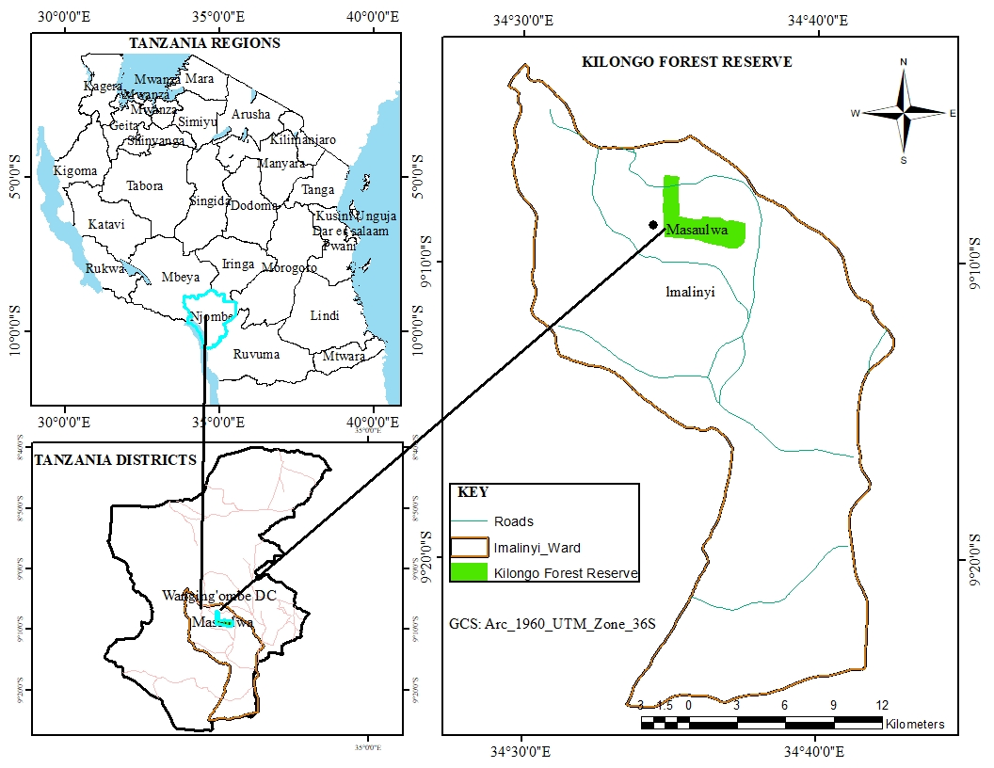
Figure 1: Location of Kilongo Forest Reserve
The study area is located in the Highland agro-ecological zone in Tanzania. This zone is an extension of the southern highlands, characterised by undulating topography with scattered plateaus and mountains. The altitude of the area is over 1,800 metres above sea level. The temperature is between 15°C and 24°C, and the area receives between 900 and 2000 mm of rainfall per year. Planted and natural forest trees, fruit trees, scattered shrubs, and grasslands primarily cover the highland zones [33].
Natural forest in the district of Wangingómbe covers 135,557 hectares, with 5,457 being village land forest reserves, 13,500 hectares being game reserves, and 116,600 hectares being forest in general land. Plantation forests, on the other hand, cover an estimated 18,635 hectares of land; over 99% of the total plantation forest areas are privately owned [33].
The Kilongo Forest Reserve was selected for this study due to its dual nature, as it is operated by both the Masaulwa Village Environmental Management Committee (VEMC), under the Ministry of Natural Resources and Tourism, and the MBUMTILU Sub-Catchment Water Users Association (WUA), known in Swahili as "Jumuiya ya Watumia Maji Bonde Dogo la Mito Mbukwa, Mtitafu, and Lumbidzi" [34], under the Ministry of Water. Thus, understanding how duality nature affect the management of forest is crucial for the sustainability of the village forest reserve. Moreover, the forest reserve was the first in the district to be declared under community-based forest management in 2004 [29]. Thus, it is worth assessing its sustainability. According to van Hensbergen et al. [35], the duration of forest management plans should exceed 10 years, as shorter periods fail to offer the medium-term stability necessary for the consistent implementation of sustainable forest management.
2.2 Sample Size and Sampling Procedures
The study employed purposeful sampling to select eight members of the village environmental management committee (VEMC), eight members of the MBUMTILU Sub-Catchment water users’ association, and a village government officer. Others included the Wangingómbe District Water Supply and Sanitation Authority officer and the Tanzania Forest Services (TFS) officer at the district level. Additionally, two members of the forest reserve patrol team and six individuals consisting of two village elders and four villagers living adjacent to the forest reserve were selected purposefully. Moreover, the Kilongo sub-village with 116 total households was selected purposefully because it borders the village's forest reserve, and its community was close enough to be able to notice any forms of interactions and changes in the forest reserve. Thus, the heads of households in the sub-village were selected as sample units from the village for this study, thereby representing the local community. A sample of 90 heads of households was selected from the total of 116 households in the sub-village. The Israel 1992 formula was applied to determine the sample size.
$n=\frac{N}{{1+N(e)}^{2}}$…………………………...............Equation (1)
whereby n represents the sample size, N denotes the total number of households in the village, 1 represents the confidence level (95%), and e signifies the accuracy level. Thus;
$$90=\frac{116}{{1+116(0.05)}^{2}}$$
Then, the heads of households were selected through systematic sampling from the village government office's list of all households in the sub-village.
2.3 Data Collection
Participatory Rural Appraisals (PRAs), i.e., group discussion and key informants’ interviews with the villagers, and questionnaires (i.e., household surveys), were the tools used in data collection to address critical forestry management aspects. Various studies have utilised the Participatory Rural Appraisal (PRA) approach to investigate the perceptions of rural communities on environmental issues that affect their livelihoods [36, 37, 38].
As a result, the study employed semi-structured interview guides to conduct in-depth interviews with members of the village environmental management committee (VEMC), members of the MBUMTILU Sub-Catchment water users’ association, a village government officer, Wangingómbe Water Supply and Sanitation Authority officer and a Tanzania Forest Services (TFS) officer at the district level. Also, the same tool and method were employed to get information from the village forest reserve patrol team, which consisted of two members. There was one focus discussion group that consisted of two village elders, village government officials, two dry-season lowland farmers, and two beekeepers. Data was collected through face-to-face interviews using semi-structured questions. The method helped to gather data from 90 household heads in the Kilongo sub-village.
Moreover, the documentary review method was used to review different documents on community-based forest management at the global, regional, and local levels. But also documents on Tanzania integrated water resources management (IWRM) and water user associations (WUA) were reviewed. Internet searches were the major medium for searching the materials. On the other hand, the village government office provided much of the information on the demographic characteristics of the respondents.
2.4 Data Analysis
The content analysis method was used to analyse the qualitative data. The International Business Machines Statistical Products and Service Solutions (IBM SPSS) software version 23 was used to analyse the quantitative data obtained from semi-structured interviews, whereby frequencies and percentages were produced. On the other hand, Microsoft Excel software was used to create figures and graphs. Finally, quantitative data was presented in figures and tables, and qualitative data was presented using explanations.
2.5 The Conceptual Framework of Community-based Forest Management
This study uses the Agrawal and Ribot [39] framework to analyse and assess the effectiveness of decentralisation in managing common property resources, specifically the village forest reserve in Masaulwa Village. The framework is based on three key dimensions: actors, powers, and accountability, which are essential for successful decentralisation. According to the framework, any analysis of the effectiveness of decentralisation should take into account the powers held by different actors, the areas in which they exercise these powers, and the individuals or entities to whom they are accountable [39].
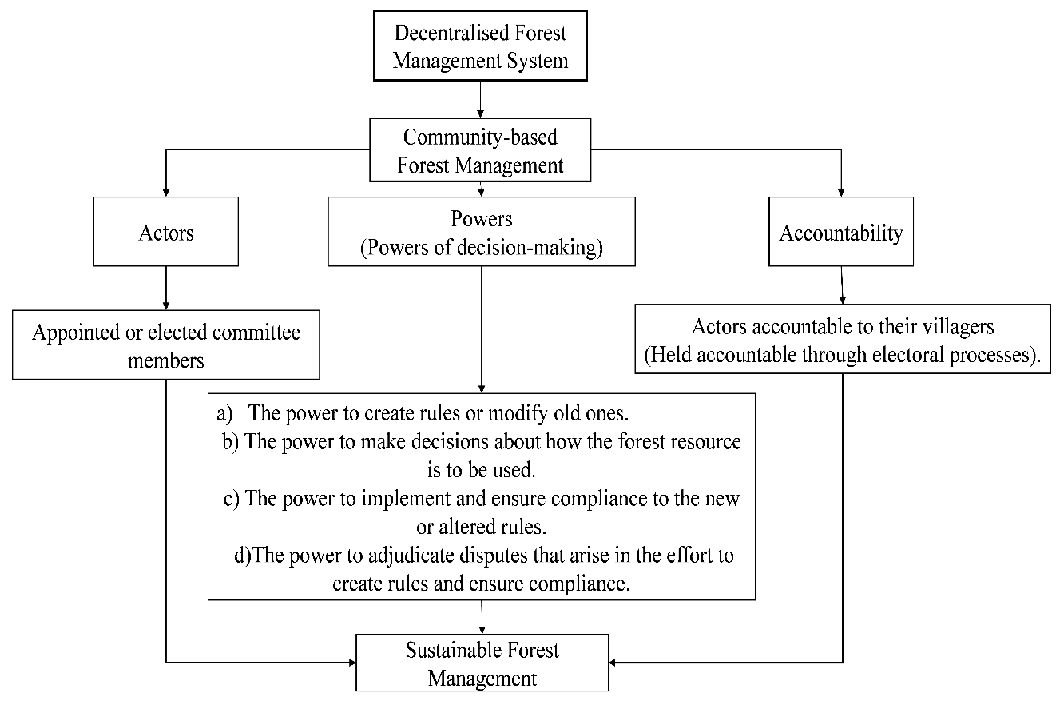
Figure 2: The Conceptual Framework of Community-based Forest Management
Source: Modified from Agrawal & Ribot [39].
Actors involved in decentralisation encompass both appointed and elected officials, influential individuals, as well as committees that have authority over communal resources. Each of these players is often situated inside a distinct framework of responsibility and possesses distinctive forms of authority. The nature of these relationships is contingent upon the social and political structure of each individual entity, which is determined by the process of election and appointment. Actors are bound by legal regulations. Actors are situated at various levels of social engagement, and the effectiveness of decentralisation relies heavily on which individuals have the authority to exert power and the corresponding responsibility they are held accountable to [39].
Understanding the effectiveness of decentralisation requires a thorough grasp of decision-making powers. The powers encompassed are as follows: a) the authority to establish or revise regulations; b) the ability to determine the use of a specific resource or opportunity; c) the capacity to enforce and guarantee adherence to the revised or new regulations; and d) the jurisdiction to settle conflicts that arise during the process of establishing regulations and ensuring compliance. Decentralisation is created when lower-level actors are allocated different sets of decision-making and rule-making powers [39].
Finally, in order for decentralisation to be effective, it is necessary to transfer powers to constituents (villagers) and ensure that actors (elected leaders) are accountable to them. Downward responsibility expands participation in the governance of shared resources, such as community forest reserves. Electoral systems have the ability to ensure that individuals or groups are held responsible for their actions towards the specific communities they represent. Additional mechanisms for enhancing local or vertical accountability of elected officials or other local actors are promoting widespread participation and public reporting requirement for elected leaders or any other local actors [39].
- RESULTS AND DISCUSSION
3.1 The Perceptions of the Local Community on Community-based Forest Management in the Study Village
a. Improvement of Forest Reserve
The results from analyses indicate that respondents perceived notable improvement in the Kilongo Forest Reserve condition over the past 20 years under CBFM. Table 1 presents the demographic characteristics of the households. The survey findings indicate that a significant proportion of respondents were male, accounting for 81.1% of the total population. The majority of respondents were between the ages of 36 and 64 (57.8%). About 77.8% of the respondents had completed primary education. The primary livelihood activities were crop production (68.9%) and mixed farming (31.1%) (Table 1). The main crops grown in the study area include maize, beans, sweet potatoes, Irish potatoes, and temperate fruits such as avocado. Few households kept cattle, sheep, and goats. The findings indicate that beekeeping was a part-time occupation in the study village, practised in the Kilongo forest reserve and in the village general land.

Table 1: Summary of demographic and occupation characteristics of respondents
Variables | Frequency | Percentage
Age
18-35 | 35 | 38.9
36-64 | 52 | 57.8
65+ | 3 | 3.3
Sex of the household head
Male | 73 | 81.1
Female | 17 | 18.9
Level of education
Non-formal | 3 | 3.3
Primary | 70 | 77.8
Secondary | 15 | 16.7
Tertiary | 2 | 2.2
Occupation
Crop production | 62 | 68.9
Mixed farming (i.e., crop and animal farming) | 28 | 31.1
n=90

The study further revealed a correlation between the ages of respondents and their knowledge of changes in Kilongo Forest Reserve. Table 2 shows that the majority of adults (between 36 and 64 years) and older people (65 years and above) strongly perceived improvements in forest conditions (at 53.3% and 3.3%, respectively) over the past 20 years, compared to 7.8% of those aged between 18 and 35 years. Their perceptions are based on the increased density of the forest, the height of trees, the diversity of undergrowth, and the presence of wild animals like antelopes, dik-diks, and hares, as well as big snakes like pythons. But they also said there were many birds of different types in the forest reserve. In addition to noting these observations in relation to the forest's previous status, they also compared the condition of the forest to that of the village's general land, where villagers were accessing it freely.

Table 2: Response (based on age) to the question “Has the condition of Kilongo Forest Reserve improved over the past 20 years?”
Age of Respondents | Has the condition of Kilongo Forest Reserve improved over the past 20 years? |  |  |  |  | Total
Age of Respondents | Strongly Agree | Agree | Neutral | Disagree | Strongly Disagree | Total
18-35 | 7.8% | 12.2% | 14.4% | 2.2% | 2.2% | 38.9%
36-64 | 53.3% | 4.4% | 0.0% | 0.0% | 0.0% | 57.8%
65+ | 3.3% | 0.0% | 0.0% | 0.0% | 0.0% | 3.3%
Total | 58 | 15 | 13 | 2 | 2 | 90
Total | 64.4% | 16.7% | 14.4% | 2.2% | 2.2% | 100.0%

Moreover, the findings indicate that respondents associated the improved condition of Kilongo Forest Reserve with a community-based forest management (CBFM) regime. Table 3 shows the reasons for the improved condition of the Kilongo Forest Reserve. About 53.3% of the respondents perceived that the presence and enforcement of bylaws improved the condition of the forest reserve. They said the presence of the forest patrol team, made up of two adults who lived adjacent to the forest, helped to safeguard the forest. The patrol team members performed this duty and received a small amount of honey during the harvest season as payment. Furthermore, Table 3's results indicate that villagers' involvement in forest management issues gave them a sense of ownership over the forest reserve (26.7%). For example, it was established that the majority of people in the adjacent sub-village volunteered to save a large portion of the forest from fire, by setting it off, in 2023.

While 20% of the participants expressed that the benefits of conservation drove them to engage in CBFM activities (Table 3). Non-timber products such as honey, mushrooms, and spring water were among the benefits mentioned. For instance, individuals were allowed to install their own beehives in the Kilongo Forest Reserve with the condition that, after harvest, they would contribute something to the village government. They cited the example of Mzee Msigala (pseudo name), an elderly conservationist and member of VEMC, who had installed and owned the majority of the traditional beehives in the forest reserve and was earning a lot of money from the sales of honey. Benefit-sharing has played a crucial role in empowering local communities residing near forests to participate in the management of natural resources and improve the outcomes of biodiversity conservation [40, 41].

Table 3: Reasons for the improved condition of the Kilongo Forest Reserve
Reasons for improvement of forest condition | Frequency | Percent
The presence and enforcement of bylaws improved the condition of the forest reserve. | 48 | 53.3
Their involvement gave them a sense of ownership over the forest reserve. | 24 | 26.7
Villagers see conservation as beneficial to them, which motivates them to participate in CBFM activities. | 18 | 20.0
Total | 90 | 100.0

Correspondingly, interview and discussion accounts revealed that the response to conservation efforts was positive from the villagers. For example, over the past 20 years, there was only one incident of fire, which occurred in 2023. A madman who lived adjacent to the forest in the village is believed to have set the fire in the forest reserve. This implies that people were abiding by the rules and regulations governing the management of Kilongo Forest Reserve. Additionally, the presence of two major water springs in the forest reserve, which drained water downstream, benefited lowland irrigation and livestock in the villages of Masaulwa and Itambo, which shared the Mbukwa River valley. This in turn motivated the villagers to manage the Kilongo Forest Reserve. Furthermore, the conservation appeared to be beneficial to the villagers because sales from honey harvested from the forest reserve helped renovate one of the classrooms in the village. The study established that the beekeeping project was among the CBFM projects operated by the village environmental management committee (VEMC). Other studies in developing countries have reported success stories of community-based forest management improving forest conditions [42,15].

b. Improvement of Livelihoods
Despite notable improvements in the Kilongo Forest Reserve condition over the past 20 years under CBFM, the findings from the analysis show that the local community's livelihoods did not improve with an increased supply of forest products (timber and non-timber). Figure 3 indicates that the majority of the respondents (73%) perceived no improvement in livelihoods associated with improved forest conditions. 18% of the respondents perceived improvement in livelihoods with improved forest conditions; they associated improved livelihoods with increased harvests of honey, mushrooms, and herbs from the forest reserve. Others highlighted the year-round flow of water springs as a benefit of forest service, especially those respondents who engaged in dry-season lowland irrigation and those who owned livestock.

Figure 3: Response to the question “Has the livelihood improved due to the increased supply of forest products (timber and non-timber)?”
On the other hand, the result indicates that the Kilongo Forest Reserve was facing some challenges. Figure 3 reveals that 81% of the respondents mentioned the challenge of animals passing through or grazing in the forest reserve. There were some serious cases of animals degrading the forest reserve. The members of the forest patrol team revealed that the situation was more serious during the dry season, as normally there is a scarcity of pasture in the village's general land. Also, 13% of respondents mentioned illegal harvesting of forest resources and products as another challenge facing the forest reserve. The illegal harvesting of forest resources, especially dry wood, for energy appeared to be a common phenomenon. This involves entering the forest reserve without permission. And a small proportion of the respondents (13%) mentioned the fire incident as one of the challenges facing Kilongo Forest Reserve management (Figure 3).

Figure 4: Challenges facing Kilongo Forest Reserve
Interviews and discussion accounts revealed that, apart from the increased frequency of illegal entry into the forest reserve following the fire incident in 2023 as people wanted to collect dead wood for energy, the growing population in the village has also been associated with increased demand for wood for energy, eventually, increasing cases of illegal entry into the forest reserve. They believed that only an alternative energy source for the villagers could prevent illegal wood harvesting in the Kilongo Forest Reserve. As the majority of households in rural developing nations lack access to contemporary energy sources [43].
Additionally, the results of the interviews and a discussion show that, as a short-term strategy for overcoming the problem of animals passing through or grazing in the forest reserve, they installed more beehives along the animal corridor. The beehives had been donated to the village government by MBUMTILU. The exercise served as a deterrent, as bees have the potential to bite animals. "You know, bees are animals' biggest enemies. In order to address this issue, we have installed additional beehives in the forest reserve, strategically placed along the established animal corridors that pastoralists previously used to pass through”. (Explanations from a VEMC member).
3.2 The Effectiveness of Community-based Forest Management in the Study Village
Based on the three dimensions of actors, powers, and accountability that usher in effective decentralisation [39], analyses of interviews and discussion accounts indicate that community-based forest management at Kilongo Forest Reserve was effective, though not sustainable. The forest reserve was not sustainable, as explained in the subsequent paragraphs.
Actors: Two actors concurrently managed the Kilongo Forest Reserve: the VEMC under the Ministry of Natural Resources and Tourism (MNRT) and the MBUMTILU under the Ministry of Water. Interviews and discussion revealed that both ministries performed their duties through VEMC. The VEMC members simultaneously served as virtual members of MBUMTILU. The VEMC had to report to the Wangingómbe District Forestry and Beekeeping Department on forestry management issues and to River Basin Water Boards (RBWB) through MBUMTILU on issues of water resources management. The MBUMTILU Sub-Catchment Water Users' Association's role was to manage water, allocate water, and spread information on water-related issues within communities [44]. Both organs are statutory: the VEMC, formed under the Forest Act No. 14 of 2002 [28], and the MBUMTILU Sub-Catchment Water Users’ Association (WUAs) under the National Water Policy of 2002 [45].
This study established that there were competing interests in the management of the Kilongo Forest Reserve, as different authorities had different objectives. According to the study survey, the VEMC faced administrative challenges in executing orders from various authorities during the implementation stage. For example, the District Forestry and Beekeeping Department provided 10 beehives to the VEMC, while the MBUMTILU provided the remaining 10 beehives, necessitating the beehive management to adhere to directives from two distinct entities with the potential to jeopardise the management of the Kilongo Forest Reserve.
Powers: Interviews and discussion accounts reveal that decentralisation failed to empower VEMC through village council to have a say on all matters pertaining to resource management, allocation, and distribution in the village. This is because the VEMC did not have the ability to determine the use of forest products (honey) or the capacity to enforce regulations. The study established that there were two power centres acting in the management of Kilongo Forest Reserve: the VEMC and Mzee Msigala (pseudo name), who was also a member of the VEMC and a conservationist by nature. The village council vested the VEMC with the power to develop bylaws on behalf of the village assembly and enforce regulations [28]. However, the study established that, despite Kilongo Forest Reserve management having formulated the VEMC, it was powerless and not functioning.
Instead, Mzee Msigala took on the role of managing the Kilongo Forest Reserve. This is because other members of the VEMC decided to step aside after realising that Mzee Msigala was too vocal and centralised the VEMC's decisions. It reached a point where Mzee Msigala was even harvesting honey from the communal beehives without consulting other VEMC members, as was the tradition. It was noted that, he was not remitting any dues from honey sales to the village government. Furthermore, VEMC accused Mzee Msigala of seizing its honey harvesting facilities, which included a special jacket and some containers. Ultimately, there was no collaborative decision-making for the forest resource management.
Accountability: While villagers elected VEMC members in the village assembly meeting, interviews and discussion accounts reveal their inability to hold VEMC members accountable and responsible for their actions. This happened when Mzee Msigala was harvesting honey from the communal beehives and contributing nothing to the village government. The situation demotivated conservation efforts, leading the villagers to stop participating in the CBFM activities.
These findings imply that, despite the existence of rules and regulations that govern the management of Kilongo Forest Reserve under CBFM, its effectiveness remains questionable. This is because of the involvement of numerous actors, the presence of multiple power centres, and a VEMC that was neither accountable to the villagers nor under their control. Similarly, the presence of inequality in cost and benefit sharing was not instrumental in empowering villagers' involvement in Kilongo Forest Reserve management. Contrary to popular belief, CBFM is well known for its ability to enhance the social and economic circumstances of those who depend on forests, impacting both forest management and governance [18, 19, 46, 47].
- CONCLUSION
This paper aimed to assess Kilongo Forest Reserve's sustainability under community-based forest management in Wangingómbe District, Njombe Region, Tanzania. Both probability and non-probability approaches were used. The paper concluded that CBFM was effective but not sustainable. First, the paper linked the CBFM to improved conditions in the Kilongo Forest Reserve. Enforcing rules and regulations and involving villagers in forest management helped achieve this. However, even with improved forest conditions, the livelihoods of the villagers did not improve.
Second, the management of the Kilongo Forest Reserve under CBFM's control was not sustainable due to the involvement of multiple actors, the presence of numerous power centres, and a village environmental management committee (VEMC) that was neither accountable to the villagers nor under their control. The other setback was the inequitable sharing of benefits among the villagers. Therefore, to ensure the sustainability of the Kilongo Forest Reserve under CBFM, the village assembly, through the village environmental management committee (VEMC), should take complete control of the forest reserve's management. Additionally, there is a need for the government to develop alternative sources of energy for the rural population, which depends on wood. Moreover, it is necessary to establish a management boundary between the Ministry of Natural Resources and Tourism and the Ministry of Water, as they have conflicting interests.

REFERENCES
- Xofis P, Kefalas G, Poirazidis K. Biodiversity and conservation of forests. Forests. 2023; 14:1871. https://doi.org/10.3390/ f14091871.
- Fichtner A, Härdtle W. Forest Ecosystems: A functional and biodiversity perspective. In: Hobohm C. (eds). Perspectives for biodiversity and ecosystems. Environmental challenges and solutions. Springer, Cham. 2021. https://doi.org/10.1007/978-3-030-57710-0_16.
- Martínez PG, Perera AH, Peterson U, Iverson LR. Ecosystem services from forest landscapes: an overview. In: Perera A, Peterson U, Pastur G, Iverson L (eds). Ecosystem services from forest landscapes. Springer, Cham. 2018. https://doi.org/10.1007/978-3-319-74515-2_1.
- Eckehard GB, Luc B, Bastien C, David IF, Barry G, Jose´ RGO, et al. Forest biodiversity, ecosystem functioning and the provision of ecosystem services. Biodivers Conserv. 2017; 26:3005–3035.doi:10.1007/s10531-017-1453-2.
- United Nations Department of Economic and Social Affairs (UN DESA), United Nations Forum on Forests Secretariat. The global forest goals report 2021. 2021. www.un.org/esa/forests.
- International Union for Conservation of Nature (IUCN). Issues brief. IUCN’s Forest Programme. 2021. iucn.org/forest.
- Baumgartner RJ. Sustainable development goals and the forest sector-a complex relationship. Forests. 2019;10 (152); doi:10.3390/f10020152.
- United Nations (UN). 15 Life on land. The sustainable development goals extended report 2022. UN Statistics Division Sustainable Development Goals.2022. https://unstats.un.org/sdgs/report/2022/extended-report/Extended-Report_Goal-15.pdf.
- Souza C, Tenneson K, Dilger J, Wespestad C, Bullock E. Forest degradation and deforestation. In: Cardille JA, Crowley MA, Saah D, Clinton NE. (eds). Cloud-based remote sensing with Google Earth Engine. Springer, Cham. 2024. https://doi.org/10.1007/978-3-031-26588-4_49.
- Ritchie H. “Global deforestation peaked in the 1980s. Can we bring it to an end?” Published online at OurWorldInData.org. 2021. Accessed 24 April 2024. Available: https://ourworldindata.org/global-deforestation-peak. Our World in Data.
- Palo M. Global prospects on deforestation and forest transition. In: Palo M, Vanhanen H. (eds). World forests from deforestation to transition? World Forests. 2000; 2. Springer, Dordrecht. https://doi.org/10.1007/978-94-010-0942-3_1.
- Holmberg J, Bass S, Timberlake L. Defending the future. London: Earthscan;1991.

- Khurram S, Shalizi MN, Bashari M, Akamani K, Groninger JW. Barriers and opportunities regarding community-based forest management in Afghanistan: considerations for fragile states. Environmental Conservation. 2024; 51: 6–16. doi: 10.1017/S0376892923000280.
- Ghimire P, Lamichhane U. Community based forest management in Nepal: current status, successes and challenges. Grassroots Journal of Natural Resources. 2020; 3 (2): 16-29. Doi: https://doi.org/10.33002/nr2581.6853.03022.
- Bwagalilo F, Mwamfupe A, Olwig MF. Forestry decentralisation policies and community-based forest enterprises in Tanzania: A literature review. NEPSUS working paper 2019/1. 2019. https://www.cbs.dk/en/research/departments-and-centres/department-of-managementsociety-and-communication/centre-business-and-development-studies-cbds.
- Laudari HK, Sapkota LM, Maraseni T, Subedi P, Pariyar S, Kaini TR, et al. Community forestry in a changing context: A perspective from Nepal’s mid-hill. Land Use Policy. 2024; 138. https://doi.org/10.1016/j.landusepol.2023.107018.
- FAO. Global forest resources assessment 2020-Key findings. Rome. 2020. https://doi.org/10.4060/ca8753en.
- Nzunda EF, Manyanda BJ. A SWOT analysis of community-based forest management policy as a basis for REDD+ in Tanzania. GSC Advanced Research and Reviews. 2023;15(3):022–037. doi: https://doi.org/10.30574/gscarr.2023.15.3.0157.
- Duguma LA, Atela J, Negassa Ayana A, Alemagi D, Mpanda M, Nyago M, et al. Community forestry frameworks in sub-Saharan Africa and the impact on sustainable development. Ecology and Society. 2018; 23(4):21. https://doi.org/10.5751/ES-10514-230421.
- Arts B, de Koning J. Community forest management: an assessment and explanation of its performance through QCA. World Development. 2017; 96: 315-325. https://doi.org/10.1016/j.worlddev.2017.03.014.
- Gilmour D. Forty years of community-based forestry: A review of its extent and effectiveness. Rome, Italy. Food and Agriculture Organisation of the United Nations. 2016. www.fao.org/publications.
- Ota L, Mukul SA, Gregorio N, Herbohn J. Community-based management of tropical forests: lessons learned and implications for sustainable forest management. Tropical Forests and People Research Centre-University of the Sunshine Coast, Australia. 2021. http://dx.doi.org/10.19103/AS.2020.0074.24.
- FAO. Community-based forestry. Extent, effectiveness and potential. 2017. www.fao.org/forestry/participatory.
- FAO, Forestry Division. The State of the world’s forests report 2022-forest pathways for green recovery and building inclusive, resilient and sustainable economies. 2022. https://www.fao.org.
- Xiao H, Liu J, He G, Zhang X, Wang H, Long T, et al. Data-Driven Forest Cover Change and Its Driving Factors Analysis in Africa. Frontiers in Environmental Science. 2022; 9: doi:10.3389/fenvs.2021.780069.
- Nzunda EF, Yusuph AS. Forest degradation in Tanzania: A systematic literature review. Intech open; 2022. doi:10.5772/intechopen.107157.
- MNRT. PFM facts and figures. Forestry and beekeeping division. Ministry of Natural Resource and Tourism, Dodoma.2022.
- United Republic of Tanzania (URT), Ministry of Natural Resources and Tourism (MNRT), Forestry and Beekeeping Division, The national community-based forest management (CBFM) action plan 2021 – 2031.2022.
- Kaganga L, Ndumbaro FGJ. People’s perception on community-based forest management: The case study of Njombe District, Tanzania. Journal of the Geographical Association of Tanzania. 2021; 36(1):1-15. doi: 10.56279/jgat.v36i1.134. https://journals.udsm.ac.tz.
- Gibbs DA, Harris N, Global forest watch: world resources institute. 2024. Accessed 10 June 2024. Available:https://www.globalforestwatch.org/blog/data/whats-new-carbon-flux-monitoring/.
- Sungusia E, Lund JF, Hansen CP, Amanzi N, Ngaga YM, Mbeyale G. Rethinking participatory forest management in Tanzania, IFRO working paper, No. 2020/02. University of Copenhagen, Department of Food and Resource Economics (IFRO), Copenhagen. 2020. https://hdl.handle.net/10419/214834.
- Masaulwa Village Government Records. Field survey, 2024.

- United Republic of Tanzania (URT), President’s Office Regional Administration and Local Government (PO-RALG). Wanging’ombe district council strategic plan for the year 2015/16 –2019/2020. 2020.
- Kayunze K. Processes, experiences and guidelines for the formation of sub-catchment water users’ associations in the Great Ruaha River Catchment Area – Iringa and Mbeya Regions, Tanzania. WWF Tanzania Country Office-Ruaha Water Programme; 2009.
- van Hensbergen H, Shono K, Cedergren J. A guide to multiple-use forest management planning for small and medium forest enterprises. Forestry working paper, No. 39. Rome, FAO. 2023. https://doi.org/10.4060/cc6780en.
- Raj C, Arunkumar B, Sam Deva Asir RM, Shalini FJ, Ravi R. A study on the application of PRA in the process of community development. International Journal of Research in Humanities, Arts and Science. 2022; 7 (5):2456-5571.
- Sontakki B, Venkatesan P, Rao VKJ. Participatory Rural Appraisal (PRA): Tools and Techniques. ICAR-National Academy of Agricultural Research Management. Hyderabad, India;2019. https://naarm.org.in
- Mkonda MY, He X, Festin SE. Comparing smallholder farmers’ perception of climate change with meteorological data: experience from seven agroecological zones of Tanzania. American Meteorological Society. 2018: 435–452. doi: https://doi.org/10.1175/wcas-d-17-0036.1
- Agrawal A, Ribot JC. Accountability in decentralisation: a framework with South Asian and African Cases. J. Dev. Areas. 1999; 33: 473–502.
- Kegamba JJ, Sangha KK, Wurm P, Garnett ST. A review of conservation-related benefit-sharing mechanisms in Tanzania. Global Ecology and Conservation. 2022; 33. https://doi.org/10.1016/j.gecco.2021.e01955.
- James TC, Rajasekharan S. Access and benefit sharing of biological resources and associated TK: A Multi-tiered responsibility. In: Oommen OV, Laladhas KP, Nelliyat P, Pisupati B. (eds). Biodiversity conservation through access and benefit sharing (ABS). Springer, Cham. 2022. https://doi.org/10.1007/978-3-031-16186-5_5
- Smith AC, Hurni K, Fox J, Van Den Hoek J. Community forest management led to rapid local forest gain in Nepal: A 29-year mixed methods retrospective case study. Land Use Policy. 2023; 126. https://doi.org/10.1016/j.landusepol.2022.106526
- Tucho GT, Nonhebel S. Alternative energy supply system to a rural village in Ethiopia. Energ Sustain Soc. 2017;33. https://doi.org/10.1186/s13705-017-0136-x
- Ngonyani H, Mourad KA. Role of Water User Associations on the Restoration of the Ecosystem in Tanzania. Water. 2019;11 (141). doi:10.3390/w11010141. www.mdpi.com/journal/water
- United Republic of Tanzania (URT). National water policy of 2002. Ministry of Water and Livestock Development. 2002.
- Friedman RS, Guerrero AM, McAllister RRJ, Rhodes JR, Santika T, Budiharta S. Beyond the community in participatory forest management: A governance network perspective. Land Use Policy. 2020; 97. https://doi.org/10.1016/j.landusepol.2020.104738.
- Luz AC, Ruiz-Mallén I. Community-Based Management and Research to Forest Conservation. In: Filho WL, Azul A, Brandli L, Lange Salvia A, Wall T. (eds). Life on land. Encyclopedia of the UN Sustainable Development Goals. Springer, Cham. 2020. https://doi.org/10.1007/978-3-319-71065-5_133-1.

