Assessing Multi-decadal Landmass Changes and River Bank Erosion in the Char Areas of Majuli River Island of Assam: A Case Study

.
ABSTRACT

Majuli, the biggest populated river island, which is bordered to the north by the Subansiri River and to the south by the powerful Brahmaputra River. Since ancient times, the island has been continuously eroding, which is cause for serious concern. The current method uses Remote Sensing (RS) satellite imagery covering the years 1976 to 2024 and Survey of India (SOI) toposheets to study the erosion–deposition processes in a Geographic Information System (GIS) environment. The observation has revealed a dramatic change in reduction of land area of the Majuli Island. This case study provides a comprehensive analysis of the long-term changes in landmass and erosion patterns in the char areas of Majuli Island, highlighting both the environmental challenges and the socio-economic implications for local communities. It is evident that the erosion rate on the island mass was significantly higher than that of the depositional processes.

Keywords: Char areas, Erosion, GIS, Remote Sensing.

1. INTRODUCTION

The issue of erosion and land cover change in the char areas of Majuli river island is a critical environmental and socio-economic concern. Majuli, located in the Brahmaputra River in Assam, India, is the largest river island in the world and is known for its unique cultural heritage and biodiversity. However, the island faces severe erosion due to the shifting course of the Brahmaputra River, exacerbated by climate change and human activities. Riverbank erosion along the Brahmaputra river on Majuli has displaced thousands of people, leaving them landless and homeless. Those affected by riverbank erosion, however, are ineligible for assistance from the Central and State governments natural hazard programs because erosion is not defined as a hazard under Indian law. This paper contends that riverbank erosion in Assam is more than just lateral erosion; it is a complex process involving mass migration of the river channel and associated bank failure. A close look at the fluvial geomorphology of the Brahmaputra using Geographic Positioning System (GIS) and Remote Sensing (RS) techniques for the segment of the Brahmaputra on the island of Majuli, suggests the process and effects counter the rationale for excluding riverbank erosion. An attempt has been made to observe the trends of erosion in Majuli island using satellite data of 1976 to 2024. Image processing of digital data has been done in QGIS software. Supervised for delineation of river from land and then change detection analysis has been done to find out changes in river course from 1976 to 2024. Erosion and deposition maps of the area have been prepared and the erosion of island is measured. The observation has revealed a dramatic change in reduction of land area of the Majuli Island. Subansiri is the largest tributary of Brahmaputra and water yield to the Brahmaputra is 0.076 cumec/km² [1]. The Brahmaputra is a classic example of a braided river consisting of a network of interlacing channels with unstable bars and islands As the flow begins to rise with the onset of the monsoon, most of the islands are submerged and the river then flows in more or less single channel. The most striking feature is the continuous shift of the thalweg (deep channel) from one location to another within the Bankline, its movement being high in the rising stage (May to August), most erratic during the falling stage (September to October) and minimal in the low flow stages [1]. The mechanism of braiding may be attributed as the effect of excessive sediment load, large and variable flow, erosion-prone banks and the rapid aggradation of the channel [2]. The extreme braided nature of the Brahmaputra coupled with silt and sand strata of the banks is the main cause of erosion. Erosion in this area was not much before the 1950 earthquake of magnitude 8.6 Richter scale but became active thereafter and attained serious dimension after the 1954 flood. In 1987, Majuli suffered the most severe flood having lost 50,000 cattle and crop [3]. Porcupines (erosion control structures were being used to control erosion only at a few places on the riverbank of Majuli island, but it has not been found to be effective measure for controlling riverbank erosion problems in the region [4].

The majority of works on natural hazards render there is no mention of erosion or, particularly, riverbank erosion as a hazard. The following hazards affect India: snowfall, cold waves, hailstorms, lightning, thunderstorms, squalls, dust storms, heat waves, cloudbursts, gales, cyclones, heavy rain, flood, flash flood, drought, and earthquake [5]. Flooding [6-8], earthquakes [9-10] and volcanic activity [11] are commonly associated with disasters, according to geomorphological studies. The Emergency Event Database's hazard classification provides no mention of erosion or riverbank erosion [12].

The present investigation highlights the importance of utilizing remote sensing (RS) and Geographic Information Systems (GIS) technologies to detect and analyze changes in land cover over different years in the Majuli river Island. Employing GIS and RS techniques, we can accurately monitor and visualize changes in land use and land cover, providing critical insights into the dynamics of riverbank erosion [13]. Moreover, the synergy between RS and GIS enhances the accuracy and precision of erosion detection. This integrated approach enables a more comprehensive understanding of how natural factors and anthropogenic activities have contribute to riverbank erosion.
2. methodology

Erosion of the island is a continuous process since historical times and possess a significant concern. The present approach has been made to study the erosion-deposition processes with the help of data resource generated from the Survey of India (SOI) toposheets and Landsat satellite imagery spanning the period from 1976 to 2024 to investigate spatial changes over available period of time. Such information is considered valuable in providing information for a period of more than 40 years, which is often beyond the scope of empirical observation. Ground truth observations were made to prepare the interpretation key and Garmin’s Global Positioning System (GPS) model was used to locate the latitude, longitude and altitude of the study sites. Geomorphic attributes of the flood plain, morphology of the channel and banks, and erosion/deposition activities have been evaluated from the toposheets, imageries and after proper field checking were used for interpretative use of the present study.

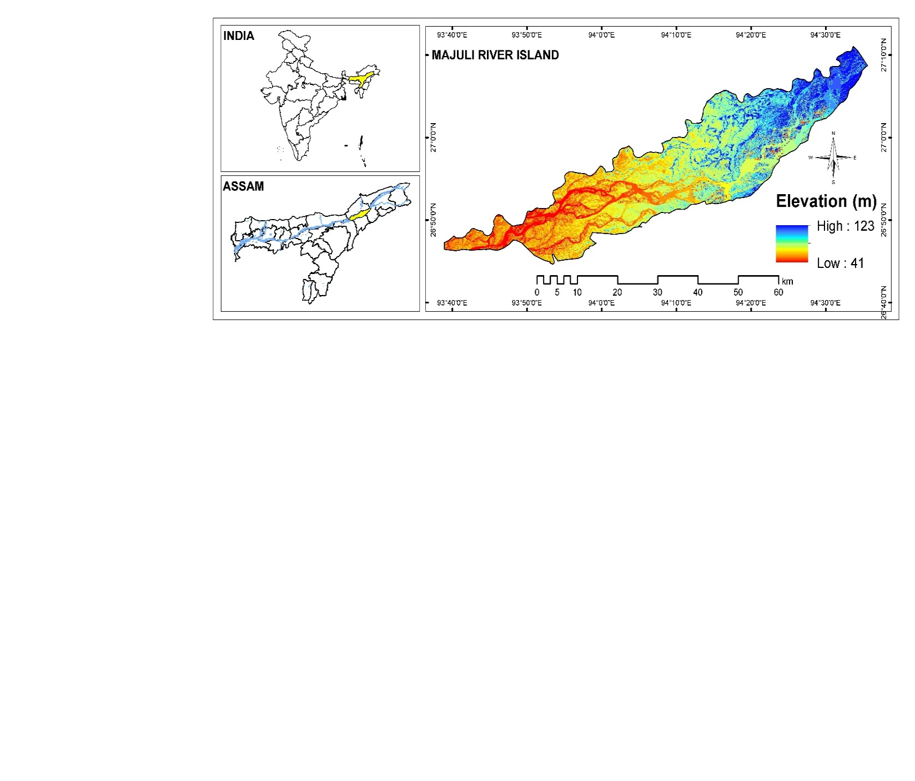
Fig. 1. Map showing the location of study area

Table 1: Acquired data and source

Sl. | Data source | Sensor | Year | Resolution | Path/row | Source
1 | Landsat 2 | MSS | 1976 | 60 m | 145/041 | Earth Explorer, USGS
2 | Landsat 4 | TM | 1992 | 30 m | 135/041 | Earth Explorer, USGS
3 | Landsat 5 | TM | 2001, 2007 | 30 m | 135/041 | Earth Explorer, USGS
4 | Landsat 8 | OLI-TIRS | 2013, 2020, 2024 | 15 m | 135/042 | Earth Explorer, USGS
2.1 Image processing and classification

All computational image processing and pre-processing were done with ArcMap 10.8 software. This process involved stacking individual bands into a single image file. Following haze reduction procedures, false color composite (FCC) images were created by stacking the individual bands for all MSS bands for Landsat 2 file, TM bands for Landsat 4 and 5 file, and OLI-TIRS bands for Landsat 8 image file. After layer stacking, the study area was extracted using ArcGIS masking.

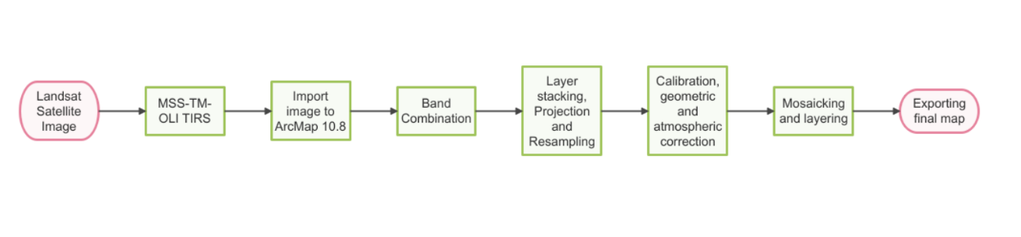
Fig.2. Flowchart of methodology for image processing and classification in ArcMap

2.2 Analysis of channel shifting

The Brahmaputra River on the south of Majuli river island is divided into 4 brief section reference on the basis of transact lines drawn made using Channel Migration Toolbox in ArcMap v10.8 software [14]. The toolbox was generated by the Department of Ecology in the State of Washington in order to determine channel migration zone and to identify periods of historical changes in the stream channel over the years. The transacts lines were numbered from upstream to downstream along the Brahmaputra river and were used to illustrate the direction of channel shifting of the river. The Brahmaputra River banks and island area in the study area have been digitized for 1976 and 2024 at appropriate scales, taking into account the river baseline and current position. This detailed digitization process enables a comprehensive analysis of the river's dynamic behavior, identifying areas of significant erosion and deposition. By comparing the historical and current river alignments, insights into the patterns and drivers of channel migration can be gained, informing flood management, land use planning, and conservation efforts. The study underscores the importance of understanding river dynamics to mitigate the impacts on the surrounding environment.
2.3 NDWI computation

The Normalized Difference Water Index (NDWI) was first proposed by for detecting the extension of water bodies over the surface. Although the index was developed for using with MSS sensor image data, it has been successfully used with TM and OLI-TRIS sensors for measurement of extension of water bodies. (Ref: NDWI-3). As classified by Mcfeeters in 1996, the value of NDWI greater than zero are assumed to represent water surfaces, while less than or equal to zero represent non-water surfaces. The values of NDWI were calculated from QGIS v3.22.12 using the equation [15]:

NDWI = (B_{Green} - B_{NIR}/ (B_{Green} + B_{NIR})

Where, B_{NIR} represents near-infrared (NIR) reflectance (Band 6: MSS; Band 4: TM; Band 5: OLI-TRIS) and B_{Green} represents green band (Band 2: TM; Band 1: MSS; Band 3: OLI-TRIS)

The index in the present study was employed for determining the extent of char areas on Majuli river Island. The NDWI values obtained from Landsat satellite imagery can be used to accurately delineate water bodies and non-water surfaces within the study area. This method is a reliable way to monitor changes in water coverage and evaluate the dynamics of char land formation and erosion over time. The findings may assist investigators gain insight into the environmental and hydrological processes that affect Majuli River Island, which could lead to better locale-specific management and conservation strategies.

3. results and discussion

3.1 Change in landmass

The case study titled "Assessing multi-decadal landmass changes and river bank erosion in the char areas of Majuli river island of Assam" focuses on evaluating long-term changes in landmass and erosion patterns in the char areas of Majuli, a river island in assam, India. In 1996, the Space Application Centre (SAC) and the Brahmaputra Board conducted a collaborative study on Majuli Island's river erosion issue [16]. The study identified the parts of the island that have experienced alterations along their backlines as a result of the river's unpredictable behavior. The island's size was listed as 925 km² in a study published by the Brahmaputra Board in 1997. The change in landmass of Majuli river island was analyzed using the Landsat images in ArcMap software over the period 1976 to March, 2024. (Fig. 3). The comparison of landmass over the multiple decades indicated that the land surface area has been observed to be decreasing significantly. During the period of 1976 to 1998 a significant change was observed in the migration of bank line of river Brahmaputra. Heavy erosion of the island was caused by Brahmaputra river during this period as the river migrates towards north at most of the places. The river channel had migrated for a distance of about 6.49 km near Mayadebi, 5.24 km near Manikmukh kuamargaon, 1.73 km at Bengena Ati and 4.24 kms near Khorapargaon [17]. This results in erosion of Majuli Island and thereby decreasing the total area. The next stretch of 65 km mainly showed migration towards the north. The river migrated towards north bank about 1.53 km near Khorapargaon, 1.14 km near Bengena Ati, 1.53 km near Rajgurubari and 2.5 km near Ujani Gejargaon. In between, the river had migrated towards south at Khoraholgaon and Kapahchali for about a distance of 1.25 kms and 1.8 kms respectively with reference to the 1998 position of the river bank line.

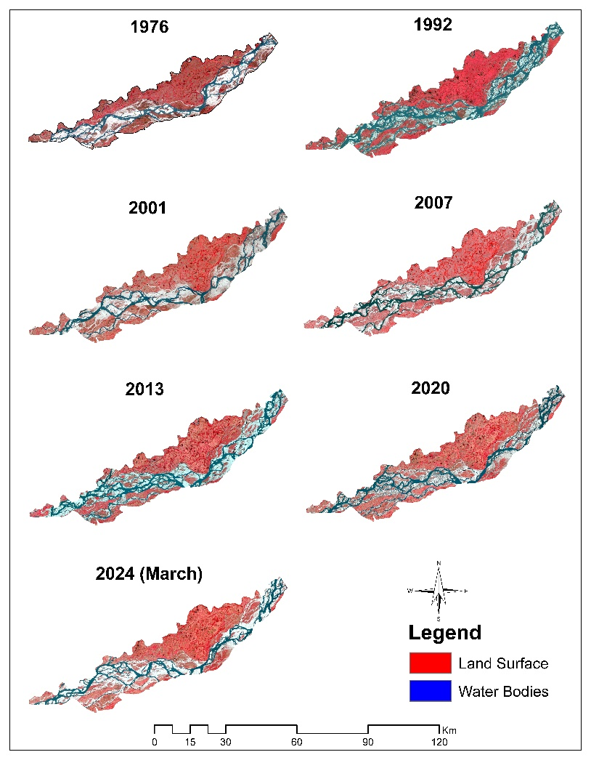

Fig.3. Variation in land surface and water body change from 1976 to 2024

3.2 Analysis of Channel migration

Analysis on total observation covering the period from 1976 to 2024, it was clearly visible that the river Brahmaputra has migrated for a maximum distance of about 6 km towards north near Mayadebi and Khorapargaon areas. However, near Bengena Ati and Ujani Gejeragaon the bank line was migrated towards north of a distance of about 2.87km and 5.1 km respectively [17]. From the present investigation it can clearly be attributed that there has been a continuous shift in the bank line of the Brahmaputra River channel indicating significant erosion affect at many places of the Majuli Island. Which is physically verified during ground truth verification. The morphological change in the Brahmaputra river have been studied and compared between the year 1976 and 2024. The change indicates that the western region of the river has shown an upward shifting part and a downward shift is observed in the eastern part of the region (Fig. 4). The upward shift in the western bank suggests increased erosion and sediment deposition patterns that have caused the river to move northward over the years. Conversely, the downward shift in the eastern bank indicates a retreat of the Bankline, which may be due to reduced sediment supply, changes in river flow dynamics and other associated environmental factors.

Overall, these shifts in the river Bankline have significant implications for the local environment, agriculture, and settlements on Majuli Island.

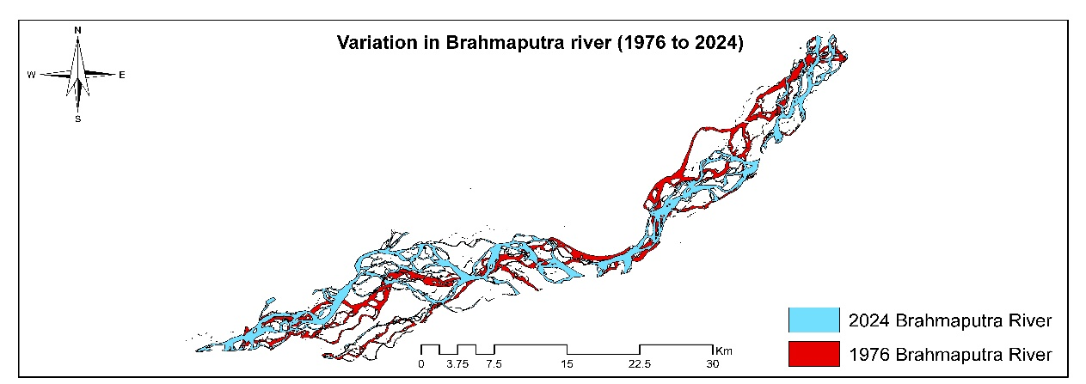
Fig.4. Morphology of Brahmaputra river from 1976 to 2024

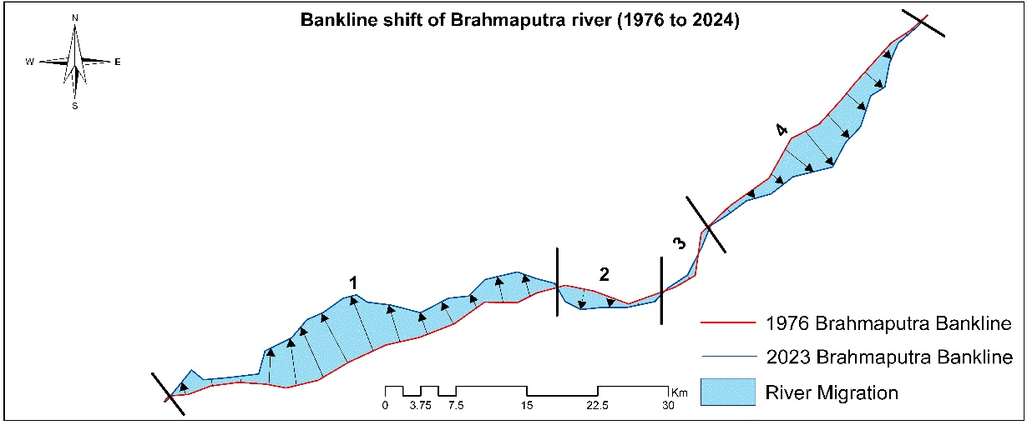
Fig.5. Channel migration of Brahmaputra River

For detailed analysis of morphology of the Brahmaputra river, the channel toolbox was employed using which the whole channel was classified into 4 sections (Fig. 5). Table 2 shows the calculated migration measured and studied along the sections from the maps (earlier map 1976 and recent map 2024). The significant channel migration has occurred in section-1 with a shift of 132733977.04 km², where the channel shifted towards the south-west direction. In contrast, the smallest channel migration has occurred in the cross-section section-3 with a shift of 2028399.53 km² towards the south-east direction. Overall, during the past few decades, the channel has shifted a total area of 211536370.37 km².

Table 2: Channel Migration at different section

Section | Direction | Area migrated (Km²)
1 | South-West | 132733977.04
2 | North-West | 12672228.86
3 | South-East | 2028399.54
4 | South-East | 64101764.93
3.3 Erosion activities around Majuli Island

The activity of erosion deposition processes around Majuli Island with reference to the Brahmaputra Rivers have been evaluated. In the light of generated information an interpretative discussion has been attempted in the preceding sections (Fig. 6). The stretch up to 20km from the western end of Majuli Island suffered erosion with maximum at Bohumari and Nunibari of about 8.83 km² and 10.77 km² respectively. Thereafter, there was deposition of about 6.07 km² at Major Chapori and 12.26 km² at Kumolia Gaon. The average annual erosion and deposition are given by the total area of erosion and deposition divided by the period of years. It gives the amount of erosion or deposition in each year. The rate of average annual erosion and deposition per unit length is given by average annual erosion or deposition divided by the stretch in kilometers. Spanning the period over to 2008 the study attributed that the total average annual erosion and deposition covering the entire period were 8.76 km²/yr and 1.87 km²/yr respectively. Comparatively higher erosion potential was confined to the south bank of Majuli Island than the north bank. The south bank of Majuli Island showed a higher rate of average annual erosion per unit length of 0.08 km²/km by the Brahmaputra. In the study conducted by Sarma and Phukan in the year 2004, riverbank erosion was found to be dominant in the southern bank with the maximum rate of retreat being 0.480 km/yr [18]. The landmass of Majuli has shown a continuous decrease in land surface area from 751.31 km² in 1917 to 564.01 km² in 1966-1972, 453.76 km² in 1996 and 421.65 km² in 2001 [18].
Fig.6. Conversion of land surface area to sand and water bodies (1976-2024)

In the present study, employing NDWI (Normalized difference water index) land, sand and water classified and reclassified as showed in Figures 6 & 7 and found that 14757.66 ha land lose and sand deposited area increase by 12412.53 ha. The application of NDWI for performing time series analysis with additional land trend analysis information showed that there was reclamation of area which was previously land surface was converted into char land and water bodies based on NDWI values (Fig. 7). The comparison of NDWI maps of 1976 and 2024 showcased that the NDWI value were increasing on yearly basis indicating that the landmass is gradually converting into char land and waterbodies. These char lands can provide critical habitats for wildlife and are often used for agriculture by local communities. Despite their formation, the frequent rise in water levels due to seasonal floods and other hydrological changes causes these chars to erode or submerge, leading to their gradual disappearance.
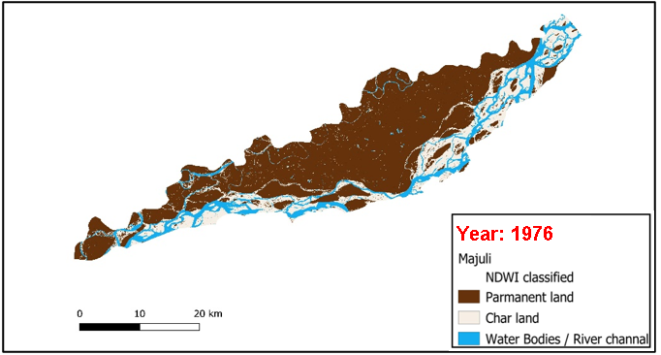
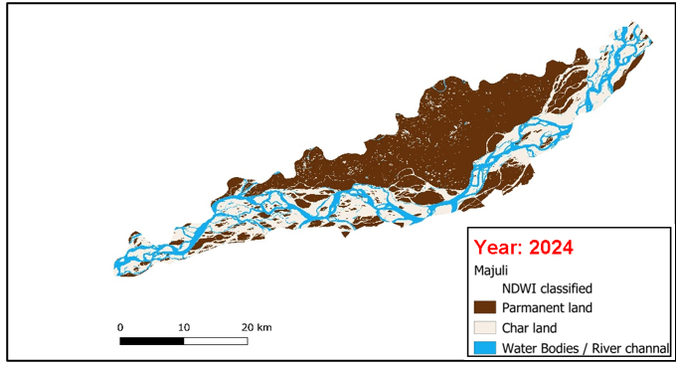
Fig.7. NDWI estimation of change in land area from 1976 to 2024

However, ground verification is required to accurately understand river erosion and changes in landmass due to the channel shifting of the river. In Figure 8, the following ground verification points were considered which were obtained through field visits to capture the actual conditions and for comparing the further data with satellite imagery, creating a for better perspective of the riverbank erosion. These ground verification points allow for a more detailed and accurate assessment of the changes observed in the satellite data, ensuring that the interpretations of remote sensing data reflect the real-world situation.

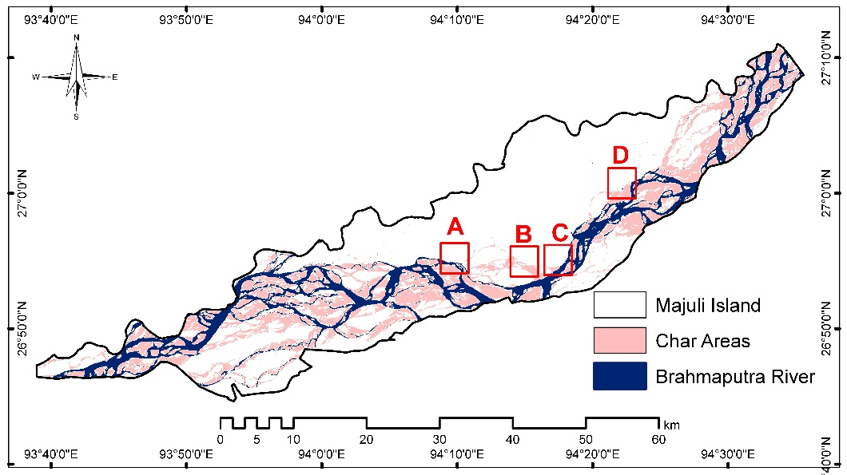
Fig.8. Ground verification points over Majuli

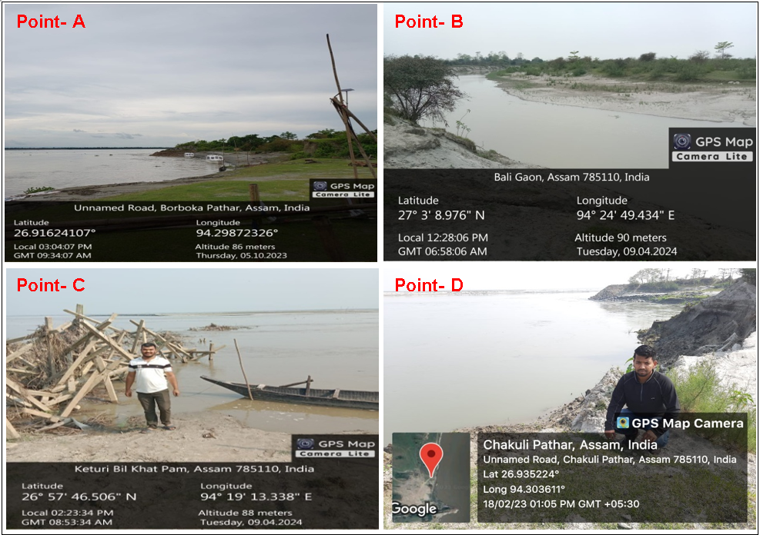
Fig.9. Photographic evidence of riverbank erosion in Majuli

4. Conclusion

The river island Majuli have suffered a significant rate of erosion since historical time. Observation on the bank line migration spanning the period from 1976 to 2024 an extensive rate of migration was observed. Erosion in the char lands of Majuli require a multi-pronged approach that combines scientific research, technological innovation, community engagement and policy support. By understanding the causes, monitoring changes, and implementing sustainable solutions, it is possible to mitigate the adverse effects of erosion and ensure the long-term resilience of Majuli's unique ecosystem and its communities. Thus, the erosion of the world’s largest inhabited river island Majuli should be considered as a national problem and should be addressed in time to stabilize ecological balance.
RS: Remote Sensing
GIS: Geographic Information System
GPS: Global Positioning System
SOI: Survey of India
QGIS: Quantum Geographic Information System
MSS: Multispectral Scanner
TM: Thematic Mapper
OLI-TRIS: Operational Land Imager and Thermal Infrared Sensor
USGS: United States Geological Survey
NDWI: Normalized Difference Water index

DISCLAIMER (ARTIFICIAL INTELLIGENCE)
Author(s) hereby declares that no generative ai technologies such as large language models (ChatGPT, COPILOT, etc.) and text-to-image generators have been used during writing or editing of manuscripts.

References

- Goswami D C. Fluvial Regime and Flood Hydrology of Brahmaputra River, Assam. In: V.S Kale (ed.) Flood Studies in India, Memoir 41, Geological Society of India. 1998; pp. 53-75.
- Leopold L B, Wolman M G, Miller J P. Fluvial Processes of Geomorphology. W. Freeman, San Francisco. 1964; 522 p.
- Centre for Natural Disaster Management, Assam Administrative Staff College, Jawaharnagar, Khanapara
- Brahmaputra Board. Report on the Erosion Problem of Majuli Island, Brahmaputra Board, Guwahati.1997.
- Kapur A. Vulnerable India: A Geographical Study of Disasters. New Delhi: SAGE Publications India. 2008.
- Kale V S. Geomorphic and Hydrologic Aspects of Monsoon Floods on the Narmada and Tapi Rivers in Central India. Geomorphology. 1994; 10(1): 157-168.
- Baker V R. Geomorphological Understanding of Floods. Geomorphology. 1994; 10(1): 139-156.
- Chowdhuri M R. An Assessment of Flood Forecasting in Bangladesh: The Experience of 1998 Flood. Natural Hazards. 2000; 22(2): 139-163.
- Panizza M. Geomorphology and Seismic Risk. Earth-Science Reviews. 1991; 31(1): 11-20.
- Ordaz M, Reyes C. Earthquake Hazards in Mexico City: Observations versus Computations. Bulletin-Seismological Society of America. 1999; 89(5): 1379-1383.
- Thouret J C. Urban Hazards and Risks; Consequences of Earthquakes and Volcanic Eruptions: An Introduction. Geo Journal. 1999; 49(2): 131-135.
- EM-DAT. Discriminating between meandering and braided rivers using a physical model: The Emriver Process Simulator. Doctoral dissertation, Wittenberg University. 2011
- Sarkar A, Garg R D, Sharma N. RS-GIS based assessment of river dynamics of Brahmaputra River in India. Journal of Water Resource and Protection. 2012; 4(2): 63-72.
- Hooke J M. Process of Planform Change on Meandering River Channels in the UK. Changing River Channel, edited by A.M. Gurnel and G.E. Petts, 87-105. Chichester: John Wiley and Sons. 1995.
- McFeeters S K. The use of normalized difference water index (NDWI) in the delineation of open water features. International Journal of Remote Sensing. 1996; 17: 1425–1432.
- SAC and Brahmaputra Board. Report on bank erosion on Majuli Island, Assam: a study based on multi temporal satellite data. Space Application Centre, Ahmedabad and Brahmaputra Board, Guwahati. 1996.
- Dutta M K, Barman S, Aggarwal S P. A study of erosion-deposition processes around Majuli Island, Assam. Earth Science India. 2010; 3(4).
- Sarma J N, Phukan M K. Origin and some geomorphological changes of Majuli Island of the Brahmaputra River in Assam, India. Geomorphology. 2004; 60:1-19.

