Original Research Article
Natural occurrence of Nuclear polyhedrosis virus (NPV) on Fall Armyworm, Spodoptera frugiperda, J. E. Smith in maize crop of Biswanath district, Assam

ABSTRACT

The Fall Armyworm (FAW), Spodoptera frugiperda (Lepidoptera: Noctuidae), poses a significant threat to maize production globally. The natural occurrence of Nuclear polyhedrosis virus (NPV) on FAW in maize field at PG Research field Biswanath college of Agriculture, Assam during kharif season 2024 was investigated. The infected and dead larvae exhibiting the symptoms which resembled NPV infection were identified. Moreover, the infected larvae were collected and reared for further study in the laboratory. The present investigation has highlighted the possibility of NPV as a natural management of FAW populations, potentially offering sustainable management strategies for maize farmers in this region.

Keyword: Fall armyworm; Spodoptera frugiperda; Nuclear polyhedrosis virus (NPV); Biocontrol; Maize.

1. INTRODUCTION

Maize, Zea mays L. is one of the most adaptable and multipurpose crops that can be grown in a wide range of ecologies. It is referred to as the "Queen of cereals" due to its large genetic potential and higher yield capacity. The crop is affected by weeds, diseases, nematodes, insect pests, birds and environmental factors [1] and they reduce crop yield up to 75% [2,3,4]. The arthropod pests were found everywhere [5] about 40 species belong to the maize crop [6,7,8,9,10] which cause real destruction of plants in mature and developmental stages [11,12,13]. Among these pests, an invasive pest fall armyworm (FAW), Spodoptera frugiperda (J. E. Smith) (Lepidoptera: Noctuidae) originating from tropical and subtropical regions of the America cause havoc on maize fields, displaying a remarkable adaptability by targeting over 100 host plants. After causing huge losses in Africa and Asia, it is now affecting the large area of India, and its initial report of Fall Armyworm (FAW), S. frugiperda on maize was in May 2018, from the states of Karnataka [14]. In Northeast India its outbreak was initially discovered in Mizoram in March 2019(ref). FAW relatively new to Assam, and it was found on the two sides of the Brahmaputra in different months. Its initial attack was documented in Kharif 2018 on the north side of the Brahmaputra in the Kokrajhar district, and in May 2019 it was also observed on the south bank of the river in the Karbi Anglong district [15]. The existence was scientifically validated by October and November, 2020 on the campus of Biswanath College of Agriculture, AAU [15]. It is a notorious pestiferous insect with higher dispersal ability, wide host ranges and high fecundity that make it one of the most severe economic pests.
One promising natural control mechanism is the occurrence of Nuclear polyhedrosis virus (NPV), a type of baculovirus that specially targets and infects this pest. NPVs are known as for their high host specificity and effectiveness in pest management, making them a crucial component of integrated pest management (IPM). Understanding the natural occurrence and dynamics of NPV in fall armyworm populations can offer insights into sustainable and eco-friendly pest control methods, reducing the reliance on chemical pesticides and mitigating their adverse environmental impacts.

2. MATERIALS AND METHODS

The experiment was conducted in PG research experimental field of Biswanath College of Agriculture, Assam. The experiment was laid in Randomized block design (RBD) with four replications with five dates of sowing as treatments viz., second fortnight of February (T₁), first fortnight of March (T₂), second fortnight of March (T₃), first fortnight of April (T₄) and second fortnight of April (T₅) during kharif season 2024. The net area was 240 sq.m. and the individual plot size was 4x3sq.m. Maize seeds were sown at various dates to assess the impact of sowing time on crop development and pest prevalence. The field was inspected daily for insects pests and also for dead larvae suspected for pathogens. The dead and infected larvae of FAW (second to fifth instars) were collected and placed separately in sterilized plastic containers for continued growth in the laboratory (at 25° ± 1°C temperature, 75% ± 5% relative humidity and 12: 12 light: dark period). Fresh primordial maize leaves were offered as larval feeding throughout development. To prevent food contamination, maize leaves were surface-sterilized using an aqueous solution of sodium hypochlorite (0.05%) and cleansed with sterile distilled water.

3. RESULTS AND DISCUSSION

A large-scale mortality of fall armyworm larvae were observed in T₃, T₄ and T₅ due to the infection of Nuclear Polyhedrosis virus (NPV) which showed the typical symptoms of hanging upside down with abdominal prolegs (caterpillar wilt) on maize plants (Fig:1). The humid climatic condition which is prevalent in NE India is congenial for development of NPV which is the important biocontrol agent of S. frugiperda. The dead larvae further stopped feeding and came out from the leaf whorl of maize (Fig: 3). Moreover, the symptoms of sluggishness, a lighter body colour that gradually darkens, regurgitation, and liquefaction of the body were also observed in laboratory reared larvae. In addition, the orange- brownish liquid discharge was also observed from the dead larvae of 4th and 5th instar (Fig: 2).

Table 1. Details of crop and location where NPV infected larvae of FAW were collected

Sl. No. | Date of sowing | Crop stages | Mean number infected larvae
1.  2.  3. | Second fortnight of  March (T₃)  First fortnight of April (T₄)  Second fortnight of  April (T₅) | Vegetative stage  (65 DAS)  Vegetative stage  (55 DAS)  Vegetative stage  (40 DAS) | 9  15  12
* Place: PG Research Field of Biswanath college of Agriculture, AAU, Assam

It was noticed that due to NPV infection, 40% of the field-collected larvae were died prior to reaching the adult stage. The surviving adults were allowed to mate and deposit eggs inside the oviposition cages. The adults were given a 10% honey solution soaked on cotton pads as food. After hatching from the eggs, 15 neonate larvae from the second generation were individually placed in sterilized plastic containers for further development on maize leaves. The larvae after hatching were found less active with reduced feeding. The FAW rearing process continued until the fifth generation (Fig: 4). Late instar larvae turned pale pinkish colour, discharged body fluid, also observed larval-pupal intermediates (Fig:4) and deformed pupa gradually degrading. The mortality tendency was found to be higher in the second and fifth generations. A total of 30.30 % mortality of 2nd – 5th instar larvae were recorded during FAW developed from the initial field-collected larvae. Several researchers have documented similar observations on NPV infected S. frugiperda infesting maize. FAW larvae have also been found to be infected with spfrNPV in Gujarat, India [16], while Firake and Behere, 2020 reported identical findings in Meghalaya, India [17]. In worldwide, it has already been stated in China [18] and Indonesia [19] that S. frugiperda multiple nucleopolyhedrovirus (SFMNPV) is a prevalent pathogen in FAW populations, where the pest has recently invaded. The virus commonly causes mortality of 1% and 5% in S. frugiperda larvae [20,21,22]. This virus has attracted attention as the active ingredient in the development of biological insecticides against this pest, and several commercial products have been developed [23]. Therefore, in-depth research could provide greater clarity on the different traits of NPV that infect FAW in India. Further detailed study on NPV's effectiveness in the laboratory and in the field is necessary to assess its ability to prevent FAW. By focusing on these thrust areas, future research can enhance the understanding and utilization of NPV as a natural and sustainable solution for managing FAW in maize, ultimately contributing to improved crop protection and food security.

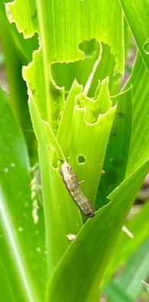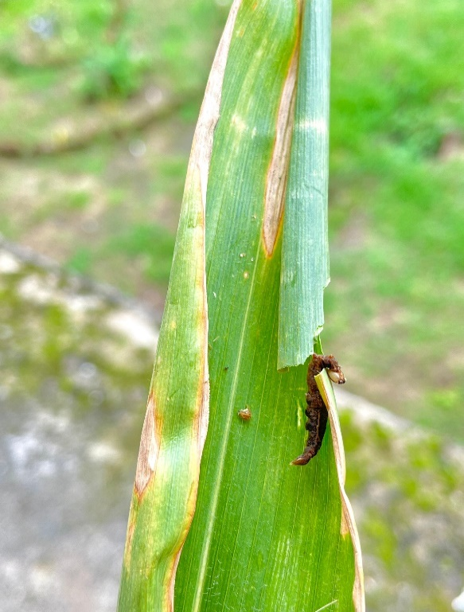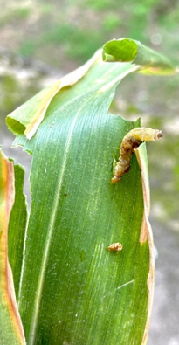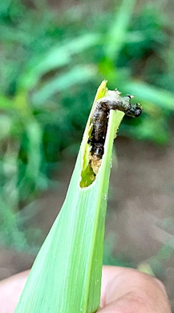
a) b) c) d)
Fig:1 (a-d) Nuclear polyhedrosis virus (NPV) infected dead larvae of fall armyworm, Spodoptera frugiperda infesting Maize crop.

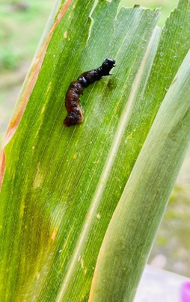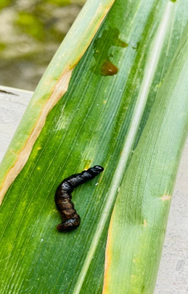
Fig:2 orange brown liquid discharge from body of larvae

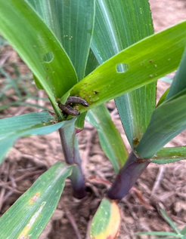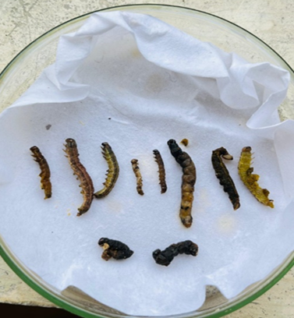
Fig:3 NPV infected larvae before death Fig:4 Dead larvae from laboratory

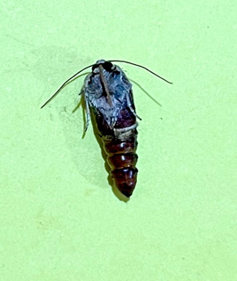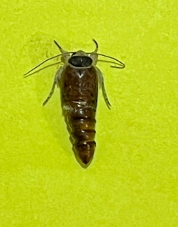
Fig:5 Larval- pupal intermediates due to NPV infection

4. CONCLUSION

The natural occurrence of NPV on FAW larvae in Biswanath may provide additional opportunity to the farmers of the region to utilize this potential biocontrol agent against this invasive pest. Worldwide, several NPVs have been isolated from FAW and used for the control of the pest with higher than 80% efficacy, indicating its role as a potent biopesticide against this notorious pest. NPV variants have been shown to be a promising alternative to chemical pesticides for managing FAW due to their high specificity, virulence, and environmental safety. Therefore, further detailed studies could provide more information on the characteristics of NPV infection FAW in Assam, India.

REFERENCES

- Karavina C, Mandumbu R. and Mukaro R. Evaluation of three-way maize (Zea mays L.) hybrids for yield and resistance to maize streak virus and turcicum leaf blight diseases. J. of Ani. and Pl. Sci. 2014;24:216-220
- Kumar H. Resistance in maize to the larger grain borer, Prostephanus truncatus (Horn) (Coleoptera: bostrichidae). J. of Stored Products Res. 2002;38(3):267-280
- Moyal P. Infestation patterns and parasitism of the maize stalk borer, Busseala fusea (Fuller) (Lepidoptera: Noctuidae), in the Ivory Coast. African Entomology, 1998;6:289-296
- Tefera T, Mugo S, Mwimali M, Anani, B, Tende R, Beyene Y, Gichuki S, Oikeh SO, Nang’ayo F, Okeno J, Njeru E, Pillay K, Meisel B. and Prasanna BM. Resistance of Bt-maize (MON810) against the stem borers Busseola fusca (Fuller) and Chilo partellus (Swinhoe) and its yield performance in Kenya. Crop Protection. 2016;89:202-208
- Oliveira C, Auad A, Mendes S. and Frizzas M. Crop losses and the economic impact of insect pests on Brazilian agriculture. Crop Protection. 2014;56:50-54
- Arabjafari K. and Jalali S. Identification and analysis of host plant resistance in leading maize genotypes against spotted stem borer, Chilo partellus (Swinhoe) (Lepidoptera: pyralidae). Pakistan Journal of Biological Sciences, 2007;10(11):1885-1895
- Kasim PD, Suneetha P, Srideepthi R, Sahithya LU. and Krishna M, Survival and development of Chilo partellus (Swinehoe) (Lepidoptera: Pyralidae) green gram-based diet in laboratory conditions. Research Journal of Pharmaceutical, Biological and Chemical Sciences. 2016;7:561-567
- Moraes JC, Goussain MM, Carvalho GA. and Costa RR. Feeding non-preference of the corn leaf aphid Rhopalosiphum maidis (Fitch, 1856) (Hemiptera: Aphididae) to corn plants (Zea mays L.) treated with silicon. Ciencia e Agrotecnologia, 2005;29(4):761-766
- Okweche S, Ogunwolu E. and Adeyemo M. Parameters, interrelationships with yield and use of carbofuran to control stem borers in maize (Zea mays L.) at Makurdi in the Nigerian Southern Guinea Savanna. Greener Journal of Agricultural Sciences, 2013;3(10):702-708
- Singh A. and Gandhi S. Agricultural insect pest: occurrence and infestation level in agricultural fields of Vadodara, Gujarat. International Journal of Scientific and Research Publications. 2012;2:1-5
- Mutyambai DM, Bruce TJ, Midega CA, Woodcock CM, Caulfield JC, Van den berg J, Pickett JA. and Khan ZR. Responses of parasitoids to volatiles induced by Chilo partellus oviposition on teosinte, a wild ancestor of maize. Journal of Chemical Ecology, 2015;41(4):323-329
- Sajjad A, Hayat B, Mashwani M. and Khan M. Effect of different planting dates of maize on infestation of maize stem borer Chilo partellus (Swinhoe) Pyralidae: lepidoptera. Sarhad Journal of Agriculture. 2010;26:621-624
- Samkov A, Jansta P. and Huber JT. Anaphes flavipes: redescription, neotype designation, and comparison with A. nipponicus (Hymenoptera: Chalcidoidea: Mymaridae. Acta Entomologica Musei Nationalis Pragae. 2017;57(2):677-712
- Sharanabasappa CM, Asokan R, Swamy HM, Maruthi MS, Pavithra HB et al.First report of fall armyworm, Spodoptera frugiperda (J. E. Smith) (Lepidoptera: Noctuidae), an alien invasive pest on maize in India. Pest Management in Horticultural Ecosystem. 2018;24(1):23-29.
- Sarma AK, Goswami H, Kalita J, Sarma PK. and Barthakur L. Occurrence of fall army worm Spodoptera frugiperda (JE Smith) in Assam. Ind. J. of Ent. 2023;85(4):1039-1042
- Raghunandan BL, Patel NM, Dava HJ. and Mehta DM. Natural occurrence of nucleopolyhedrovirus infecting fall armyworm, Spodoptera frugiperda (J. E. Smith) (Lepidoptera: Noctuidae) in Gujrat, India, J. of Ent and zoo studies. 2019;7(2):1040-1043
- Firake DM. and Behere GT. Natural mortality of invasive fall armyworm, Spodoptera frugiperda (J.E. Smith) (Lepidoptera: Noctuidae) in maize agroecosystems of northeast India. Biol. Control, 2020;148:104303
- Lei C, Yang J, Wang J, Hu J, Sun X. Molecular and biological characterization of Spodoptera frugiperda multiple nucleopolyhedrovirus field isolate and genotypes from China. Insects. 2020;11:777
- Ginting S, Zarkani A, Wibowo RH, Sipriyadi. New invasive pest, Spodoptera frugiperda (JE Smith) (Lepidoptera: Noctuidae) attacking corns in Bengkulu, Indonesia. Serangga. 2020;25:105–117
- Valicente FH, Barreto M.R. Levantamento dos inimigos naturais da lagarta do cartucho do milho, Spodoptera frugiperda (JE Smith) (Lepidoptera: Noctuidae), na regiao de Cascavel, PR. An. Soc. Entomol. Brasil. 1999;28:333–337.
- Molina-Ochoa J, Lezama-Gutierrez R, Gonzalez-Ramirez M, Lopez-Edwards M, Rodriguez-Vega MA, Arceo-Palacios F Pathogens and parasitic nematodes associated with populations of fall armyworm (Lepidoptera: Noctuidae) larvae in Mexico. Fl. Entomol. 2003;86:244–253
- Garcia-Gutierrez C, Escobedo-Bonilla CM, Lopez MA. Infectivity of a Sinaloa native isolate of multicapsid nuclear polyhedrosis virus (SfMNPV) against fall armyworm, Spodoptera frugiperda (Lepidoptera: Noctuidae) Southwest. Entomol; 2013;38:597–604.
- Kenis M, Benelli G, Biondi A, Calatayud PA, Day R, Desneux N, Harrison RD, Kriticos D, Rwomushana I, van den Berg J, et al. Invasiveness, biology, ecology, and management of the fall armyworm, Spodoptera frugiperda. Entomol. Gen. Entomologia Generalis. 2023; 43(2) :187–241

