Original Research Article
Effective media validation, benefits and costs for achieving high yield in ribbed gourd in soilless culture under matric suction irrigation

.
ABSTRACT

Aims: To standardize an appropriate method of finding suitable particulate organic substrates for composing soilless media, a soilless experiment was conducted in an open wasteland area in pandal system under matric suction irrigation
Study design: Completely Randomized Design
Place and Duration of Study: Department of Soil Science and Agricultural Chemistry, Anbil Dharmalingam Agricultural College and Research Institute, Trichy, Tamil Nadu during Rabi 2020-2021
Methodology: Three growing media were tested with ten replications. For composing the growing media equal proportion (on weight basis) of substrates viz., coirpith, vermicompost, flyash, green manure (Dhaincha) and sand were mixed in different combination. Ribbed gourd CoH-1 was raised in growing media in containers that were interconnected by tubs and tubes to maintain moisture always by matric suction irrigation technique.
Results: Growing media having Coirpith: Vermicompost: Green Manure: Sand registered the highest fruit yield (10.033 kg pot⁻¹), water use efficiency (411.2 kg fresh fruit mm⁻¹) and benefit-cost ratio (1.95) than that of the growing media combination with flyash. This green manure combination significantly recorded 18% more yield and water use efficiency than that of coirpith and vermicompost combination.
Conclusion: Exploitation of the potentiality of particulate organic materials demonstrated in soilless system technique may be useful for farmers to generate additional farm income with proper use of particulate organic substrates obtainable/ available in their farm.

Keywords: growing media, substrates, green manure, flyash, sand, ribbed gourd, matric suction

1. INTRODUCTION

The diverse climate and physio-geographical conditions of India ensures growing various kinds of horticultural crops. Owing to that India stands as the second largest producer of vegetable crops accounting for 15 per cent of the World production [1]. The vegetables production in India has increased by 25.6% over the last nine years from 169.48 million metric tonne in 2014-15 to 212.91 million metric tonne in 2022-23 [2]. Vegetables are a major source of vitamins like niacin, riboflavin, thiamin, vitamin-A and vitamin-C. In addition, they supply minerals like calcium and iron, proteins, and carbohydrates and are the important sources of dietary fiber and antioxidants [3,4,5].
Luffa, the popular fibrous fruit vegetable in the family of Cucurbitaceae, is said to have originated in India and also grown throughout the country and in many parts of the world. It is a creeper and has a climbing or trailing habit. It is also called as ridge gourd or ribbed gourd in many regions. The green immature fruits are cooked as vegetable. Ribbed gourd fruits chemically constitute carbohydrates, carotene, fat, protein, phytin, flavonoids, saponin, amino acids, luffangulin, sapogenin, oleanolic acid and cucurbitacin B. It contains good amount of fiber, vitamins and minerals including Vitamin B₂, Vitamin B₃, Vitamin C, carotene, calcium, phosphorus and iron in small quantities [6]. Fresh fruits can supply about 300 μg β-carotene and 1000 μg carotenoids per 100 g. Hence it has various pharmacological actions like hepatoprotective, antidiabetic, antioxidant, abortifacient and antifungal activity. It is recommended for purifying blood, as an appetizer, as laxative, cure for jaundice, reduce weight, as anti-inflammatory and antibiotic, strengthening the immune system, skin cure and for the health of stomach [7].
Feeding millions in India is getting increasingly difficult as the population grows, urbanization spreads, and industrialization accelerates. Although the population is growing at a quicker rate, agricultural land capacity can only rise by 2%. An estimated 342 million tonnes of vegetables will be required to meet consumer demand by 2050. As a result, growing vegetable using containers appears to be a promising strategy for increasing crop productivity and intensity [1]. Soilless culture, the most sustainable and environmentally acceptable alternative to traditional soil-based intensive agriculture, is now regarded as a convenient approach for conserving energy, fertilizers, and water. Specifically, by changing fertigation solution volume and nutrient concentration according to crop demand, proper augmentation in yield and fertilizer usage efficiency can be obtained without accumulating pollutants [8].
Organic substrates such as manures and composts have long been used to compose growing media, giving beneficial characteristics such as water retention, aeration, and nutrient availability. Bulky materials that are readily available locally are typically selected to formulate low-cost growing media. Coirpith and vermicompost are particularly popular. Green manures rich in nitrogen and phosphorus breakdown quickly, therefore they can also be utilized as a substrate in the form of dry powder. Furthermore, flyash, an oxidized inorganic substance that accumulates in pyrogenic industrial premises, has some desirable substrate qualities. Individually, no substrate qualifies for usage as soilless media, and each may have limitations. These common limitations of these substrates include undesired salinity, bulk density, aeration, water holding capacity, pH, and so on. These constraints can be mitigated by choosing the right combination of substrates.
Matric suction irrigation is a technique for continually supplying moisture to the growing media from bottom to top during the crop period. Containers (plastic pots) holding growing material are placed in tubs with standing water. All baths are connected via tubes. Each tub has the same level of standing water. Water lost through evapotranspiration in tubs is promptly replenished from the storage tank. There is no nitrogen loss due to leaching or drainage of water. Previously, a study with growing media and fertilization methods revealed that coirpith, vermicompost, and fly ash were the most suitable substrates for growing snake gourd in soilless culture [9]. Further, Elakiya and Arulmozhiselvan [10] evaluated the effect of salinity and media composition on growth and yield of ribbed gourd in soilless culture under matric suction irrigation. In the present study, container experiment with ribbed gourd was conducted in order to validate the effective growing media for obtaining high yield of ribbed gourd in pandal system under matric suction irrigation to choose the best growing media combination.

2. material and methods

The location of experiment is Anbil Dharmalingam Agricultural College and Research Institute, Trichy, Tamil Nadu (10⁰45.205’N, 78⁰36.141’ E, Altitude: 85 m MSL), which is part of Tamil Nadu's Cauvery delta agro-climatic zone, which has a tropical environment with an annual average rainfall of 860 mm. The soilless container study (pot experiment) was carried out in an open wasteland area using a test crop of ribbed gourd (Luffa acutangula L.) in a pandal structure (climber support) coupled with a matric suction irrigation system (Fig. 1). The pandal structure was built to support vines at a height of around 6 feet by installing 30 concrete pillars and linking them on top with steel wires.

2.1 Assembly of matric suction irrigation system
The setup of soilless container culture with matric suction irrigation was established using the design and materials originally described for open land soilless system [9,10]. In the method of irrigation by matric suction moisture is continuously supplied to growing media without break from bottom to top. Matric suction of growing media is the force with which water is adsorbed on the physical surfaces of substrate particles. In this validation study, the substrates used were coir pith, vermicompost and green manure (Daincha). The mineral/ inorganic constituents viz., fly ash and sand (<1.0 mm) was used in combination. Standing water is present all the time in tubs which wets the bottom of containers and in turn the growing media is wetted.

The components (Fig.2) of this system were (1) Overhead water tank, (2) Steady water level tub with ball valve assembly, (3) Series of plastic tubs interconnected through 20 mm black HDPE tubes and (4) Plastic 20 L capacity container filled with growing media. The series of tubs set on level platforms were linked through the steady water level tub to the storage tank, and by doing so, all tubs were aligned to the same level, ensuring that water was filled uniformly at all times by gravitational flow.

The plastic 20 L container comprises 8 holes (10 mm in diameter) at the bottom. A nylon mesh (No. 400) measuring 18 x 18 inches square was inserted into the bottom of each container and filled to a height of 4 inches with manufactured sand (m-sand) as the base media. The base media was partially submerged in the water contained in the tub. Above the base media, a nylon mesh (No. 400) with a square dimension of 18 x 18 inch was put to prevent the downward migration of growing media particles. Growing media was spread over the mesh until it reached a height of nine inches. The base media is hydrated through matric and capillary suction, initially by contact with water, and then maintained at almost saturated moisture content. The growth material was successively hydrated using solely matric suction. The base media is always at a lower matric suction. When the particle surfaces of growth media are empty of water due to evaporation or transpiration, the matric suction increases. This scenario provides a matric suction gradient, which works as a driving force, causing water to migrate upward from the base media to the growing media via particle-to-particle contact.

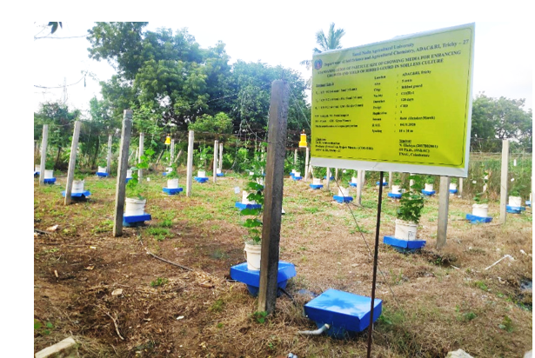

Fig.1. View of soilless media experiment in pandal structure

Concrete slabs (2 x 2 feet) were installed over a brick work adjacent to the 30 concrete poles fixed for the pandal construction (6 lines x 5 rows) with a 10-foot spacing on either side. The concrete slabs were firmly aligned at a constant height using the tube level. The tubs were put on concrete slabs. Each tub had a growing media container. Each container was filled with growth media based on the randomization of treatments (Fig.3).

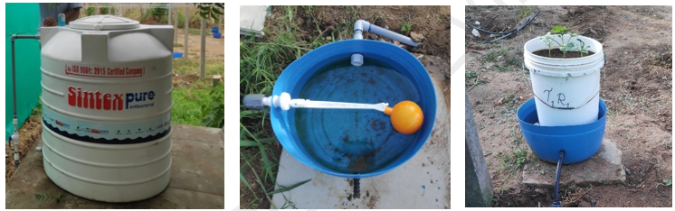

c) Container inside plastic tub
b) Steady water level tub
a) Overhead water tank

Fig.2. Components of matric suction irrigation assembly
The treatments imposed consists of 3 combinations of media and accordingly, the containers were arranged in completely randomized design, with 10 replications (Table 1). The treatments were designed to validate the well performed growing media in previous experiments to evaluate the effect of salinity and composition of media on growth and yield of ribbed gourd in soilless culture under matric suction irrigation [10]. The test crop of ribbed gourd (hybrid CoH1) was raised in the season Rabi 2020–2021.

Table 1 Treatment details of the pandal experiment

Particulars | Details | Composition of Media
Experimental design | Completely Randomized Design | T₁ | CP+VC+S (1:1:1)
No. of treatments | 3 | T₂ | CP+VC+FA+S (1:1:1:1)
Replication | 10 | T₃ | CP+VC+GM+S (1:1:1:1)
Test crop | Ribbed gourd (CoH 1) | CP - Coirpith  VC - Vermicompost  GM - Green manure  FA - Fly ash  S - Sand  () - Ratio of mixing on weight basis
Duration | 120 days
Season | Rabi (October – March)
Spacing | 10 feet x 10 feet
Experimental plot size | 5 cents

In the water storage overhead tank, non-saline water (EC 0.34 dS m⁻¹) was stored for continuous watering. Water from the tank was cycled to all of the tubs and containers. Once a week, the height of standing water inside the tank was measured with a graduated scale. Based on the previous measurement's decrease in water height, the volume of water consumed for cropping was determined for a given period (area of tank x drop in height). The salinity of the media was monitored every time of fertilizer application, one day before and one day after. The salinity of the growing media was determined by measuring electrical conductivity in the filtrate obtained after cloth filtering the suspension made by soaking two grams of growing media in 100 mL of distilled water for 30 minutes. The measured electrical conductivity was multiplied by ten to get the values in dS m⁻¹ for a substrate-water ratio of 1:5. The pH of the same filtrate was measured with a pH meter, and the findings were expressed by subtracting one unit of pH from the observed value to compensate for dilution.

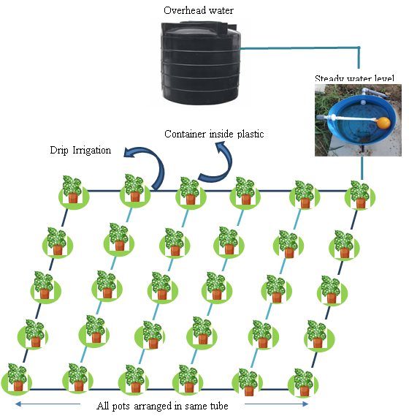

Fig.3. Illustration of ribbed gourd plant placed in plastic tubs, drip line, steady level water tub and overhead tank during pandal experiment
2.2 Fertilization of crop

For this soilless experiment with ribbed gourd crop, the dose of primary nutrients adopted was 125g N, 25 g P₂O₅ and 25 g K₂O per container. The calculated quantity of water-soluble fertilizers viz., urea, mono ammonium phosphate (MAP) and muriate of potash (MOP) were taken and applied to each container in 19 split doses at 5 days intervals. Specific fertilizer dose at specific crop stage was done by adding to the irrigation water stored in the tank for circulation to all containers. For supplying secondary and micronutrients commonly, a nutrient solution was prepared by taking 30 g of fertilizer mixture comprising 5 g MgSO₄, 5 g CaCl₂, 3 g FeSO₄, 3 g ZnSO₄, 2 g CuSO₄, 2 g MnSO₄ and 10 g Citric acid and dissolving in 1 L of water. At weekly intervals 100 ml of this nutrient solution was added to water in the storage overhead tank.
2.3 Cultural operations, climber support and observations

All plant protection measures were carried out periodically to control pest and diseases during ribbed gourd crop growth as per recommendations. Uniform dose of 30 g of Pseudomonas fluorescens, 30 g of Trichoderma viride, 10 g Furadon and 10 g Fenvalerate was added to all the growing media mixture. As a natural means of insect control neem cake (0.5 kg container⁻¹) was applied over the surface of the media mixtures particularly to prevent the coconut grub attack.

Spraying of neem-based products was done initially in the vegetative stages to control the sucking pests. Fruit fly traps with Chipku pheromone lure were installed in the experimental area to monitor the fruit fly (Bactrocera cucurbitae) population in the area prior to flower initiation, which helped in reducing the number of flies in the experimental area. Neem oil @ 3% was foliar sprayed, whenever the observations of number of fruit fly in the traps were higher. For restricting algal growth on the surface of the water tubs, metal sheets were cut in a square shape and placed over the surface of the blue tubs as a lid. A round shaped hole was made at centre to keep the container on the water tubs. In addition, the containers were covered around with chick mesh net to prevent damage of the seedlings and young plants by peacocks and squirrels.

2.4 Statistical analysis

The statistical analysis of growing media and method of fertilization on plant growth and yield parameters of crops, nutrient content, nutrient uptake and nutrient use efficiency were subjected to analysis of variance as described by Panse and Sukhatme [11].

3 Results and Discussion

Growing vegetable crops provides farmers more since they grow faster, have a longer yielding period, and are more easily marketable. When viable land for vegetable production becomes scarce, techniques such as soilless culture may offer an alternate solution. The current study was conducted to standardize the soilless culture method for the production of pandal vegetable crop in plain wasteland areas using typically organic/mineral substrates available near farmers' holdings. The effect of composition of media was studied by relating initial properties of substrates to the growth, yield, nutrient uptake and water use performances of the crop. At harvest stage vegetative parameters viz., leaf width, vine length and vine drymatter and yield parameters viz., fruit length, number of fruits harvested and fruit drymatter were recorded. The yield of fruits was recorded on fresh weight basis for every container (pot). Harvest Index was calculated as the ratio of fruit drymatter to total (vine + fruit) drymatter. Water productivity was calculated by dividing fresh weight of harvested fruits (in kg ha⁻¹) by the total amount of water consumed (in mm).

3.1 Initial characteristics of growing media
The different growing media studied were prepared from substrates which had wide variability in their physico-chemical properties (Table 2). Among the substrates, the content of soluble salts was high in daincha (EC 13.43 dS m⁻¹) followed by coirpith (EC 8.43 dS m⁻¹), whereas moderate soluble salt content was found in vermicompost (EC 1.86 dS m⁻¹) and flyash (EC 1.14 dS m⁻¹). The reaction state of coirpith and daincha were near slight acidic where as vermicompost and flyash were slight alkaline. The total dissolved solids (TDS) estimated was highest in daincha (6612 mg L⁻¹) and moderate in coirpith (4292 mg L⁻¹) .Very high content total nitrogen (N) was present in daincha (22.412 g kg⁻¹). High total phosphorus (P) was estimated in vermicompost (5.065 g kg⁻¹). Total potassium (K) was abundant in daincha (4.082 g kg⁻¹), followed by coirpith and flyash.

Table 2 Physico-chemical properties and nutrient content of substrates
Physical properties and chemical composition
S. No. | Parameter | Unit | Coirpith | Vermicompost | Flyash | Daincha
 | Bulk density | Mg m⁻³ | 0.118 | 0.592 | 1.059 | 0.255
 | Water holding capacity | % | 426.31 | 52.85 | 46.48 | 56.85
 | Total Carbon | % | 33.84 | 16.62 | 0.78 | 35.64
 | TDS (1:5 dilution) | mg L⁻¹ | 4296 | 886 | 516 | 6612
 | pH (1:5 dilution) | pH | 6.49 | 7.46 | 7.88 | 6.59
 | EC (1:5 dilution) | dS m⁻¹ | 8.53 | 1.86 | 1.14 | 13.43
 | C/N Ratio | - | 52.9 | 25.1 | 16.2 | 17.7
Nutrient Composition
 | Total N | g kg⁻¹ | 2.821 | 11.265 | 1.134 | 22.412
 | Total P | g kg⁻¹ | 0.193 | 5.065 | 0.699 | 3.810
 | Total K | g kg⁻¹ | 2.324 | 1.162 | 0.456 | 4.082

3.2 Vegetative and yield parameters of ribbed gourd
The effect of treatments on growth of ribbed gourd vine was estimated by recording leaf width, vine length and vine drymatter at harvest stage (Table 3).The highest leaf width (27.17 cm), vine length (5.55 m) and vine drymatter (1500.6 g pot⁻¹) were recorded with plant raised in the growing media (Fig.4) containing of Coirpith: Vermicompost: Green manure: Sand (T₃). Growing media consisting of Coirpith: Vermicompost: Fly ash: Sand (T₂) showed relatively high growth in leaf width (25.15 cm), vine length (5.52 m) and vine dry matter (1403.2 g pot⁻¹). The lowest leaf width (22.48 cm), vine length (4.90 m) and vine drymatter (1306.7 g pot⁻¹) was registered in growing media comprising Coirpith: Vermicompost: Sand (T₁) (Fig.5).
Significant variation was recorded in the yield and yield parameters of ribbed gourd fruit yield due to the influence of growing media selected for validation (Table 3). The fruits of plants raised in coirpith: vermicompost: green manure: sand (T₃) recorded the highest fruit length (37.61 cm), number of fruits per pot (30.4). Fruit yield per pot followed the order: coirpith: vermicompost: green manure: sand (T₃) (10.033 kg pot⁻¹) > coirpith: vermicompost: fly ash: sand (T₂) (9.470 kg pot⁻¹) > coirpith: vermicompost: sand (T₁) (8.220 kg pot⁻¹). The highest dry matter was recorded by the growing media comprising coirpith: vermicompost: green manure: sand (T₃) (666.8 g pot⁻¹) which was comparable with coirpith: vermicompost: fly ash: sand (T₂) (662.8 g pot⁻¹).
Table 3 Effect of treatments on vegetative and yield parameters of ribbed gourd
T.No | Vegetative parameters |  |  | Yield parameters
T.No | Leaf width | Vine length | Vine drymatter | Fruit length | No. of fruits harvested | Fruit Yield (fresh weight) | Fruit drymatter
T.No | cm | m | g pot⁻¹ | cm | Nos. pot⁻¹ | kg pot⁻¹ | g pot⁻¹
CP+VC+S | 22.48 | 4.90 | 1306.7 | 33.51 | 24.2 | 8.220 | 529.9
CP+VC+FA+S | 25.15 | 5.52 | 1403.2 | 35.40 | 26.8 | 9.470 | 662.8
CP+VC+GM+S | 27.17 | 5.55 | 1500.6 | 37.61 | 30.4 | 10.033 | 666.8
SEd | 0.361 | 0.084 | 18.82 | 0.413 | 0.38 | 0.131 | 8.06
CD (P=0.05) | 0.615** | 0.142** | 32.05** | 0.703** | 0.64** | 0.224** | 13.73**

Growth measured by vine length and number of leaves, and yield parameters viz., fruit length, fruit girth, single fruit weight, total fruits harvested and fruit drymatter of ribbed gourd was highest in growing media containing coirpith: vermicompost; green manure: sand, which consequently resulted in the highest fruit yield. Relatively high yield was obtained when green manure was substituted with flyash. Yield of fruits was moderately high when growing media contained coirpith and vermicompost with sand. Coirpith, vermicompost, flyash and green manure as the stable physical substrate, vermicompost, green manure, and flyash as the nutrient supplier, and sand as a material to improve porosity have been well established in the present study confirmatively.
Chanda et al. [12] discovered that combining vermicompost with inorganic fertilizers enhanced the fruit weight and yield of bitter gourd. Anuja and Poovizhi [13] reported similar findings in cucumber, as did Kameswari et al. [14] in sponge gourd. When vermicompost was put to sand + rice husk substrate, it increased vegetative growth and production of celery and red cabbage by up to 20% [15]. Similarly, adding vermicompost as a substrate has been shown to improve both the growth and the yield of sweet paper, snap beans, lettuce, strawberries, celery, salad cabbage, and red cabbage [16,17]. Arancon et al.[18] in ribbed gourd and Soobhany et al. [19] in green beans both proposed that the presence of substances such as humic acid in vermicompost could have had a direct encouraging influence on growth and yield in addition to nutritional provision. Because vermicompost contains a high concentration of organic matter, it would have improved the physical and chemical qualities of growing media while also providing nutrients, as demonstrated by experiments conducted by Arancon et al. [20] on tomato and peas and Arancon et al. (2004)[21] on strawberry.
The growth and yield of ribbed gourd were significantly higher in the growing substrate that contained flyash. Flyash increased crop production and biomass [22,23], therefore it is used as fertiliser to improve the productivity of many crops [24,25] because it includes essential elements such as K, Mg, and S [26]. The favourable impact of flyash on plant growth and biomass production has been explored in wheat [27], rice [28], carrot [25], radish [29] and safed musli [30]. About 15 per cent increase in terms of shoot length, shoot fresh and dry weight, number of leaves and leaf area in beetroot was reported with fly ash application [31].
Munda et al. [32] found that using biochar and flyash increased the number of tillers per plant in rice, which could be attributed to the rise in very high porosity and water holding capacity. The absolute hollow silt-sized particles in flyash may facilitate transport and supply water molecules [33]. In studies with bottle gourd and sponge gourd, application of flyash at 120 and 180 Mg ha⁻¹, respectively, increased yield by 10-15% [34]. According to Yeledhalli et al. [35], applying fly ash increases soil bacteria count and enzyme activity of dehydrogenase, urease, and alkaline phosphatase.
Daincha, the most popular green manure crop, thrives well in both saline and alkaline soils. Bhuiyan et al. [36] found that roughly eight weeks old dhaincha plants had 3% N in addition to other nutrients. The addition of Daincha as dry powder to vermicompost and coirpith resulted in a considerable boost in growth and yield parameters.

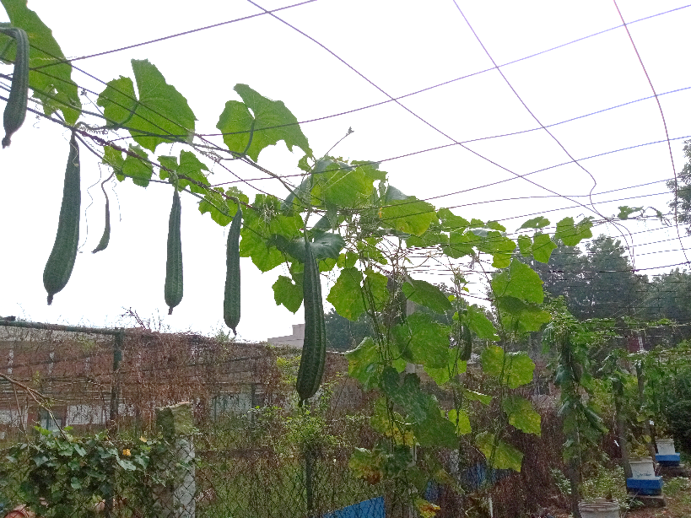
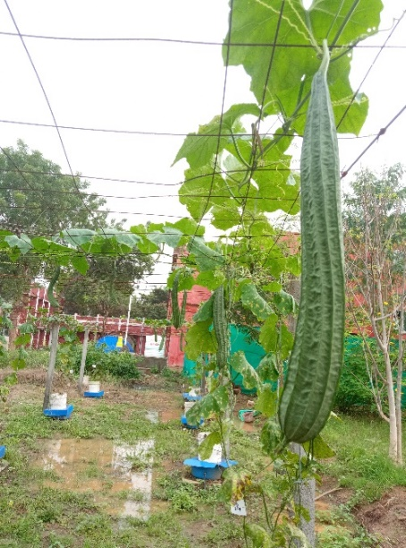

Fig.4. Experimental view of ribbed gourd at yielding stage

3.4 Nutrient uptake
The treatments imposed set prominent variations on nutrient uptake of the vine and the fruit of ribbed gourd (Table 4). The highest amount of total N (28.795 g pot⁻¹), total P (2.821 g pot⁻¹) and total K (44.052 g pot⁻¹), total Ca (18.896 g pot⁻¹), total Mg (11.395 g pot⁻¹) and total S (6.627 g pot⁻¹) uptake was observed in the growing media comprising of Coirpith: Vermicompost: Green Manure: Sand (T₃).

Table 4 Effect of treatments on nutrient uptake, harvest index and water productivity

T.No | Total nutrient uptake (g pot⁻¹)
T.No | N | P | K | Ca | Mg | S
CP+VC+S | 23.144 | 2.128 | 33.500 | 15.368 | 8.303 | 5.260
CP+VC+FA+S | 26.741 | 2.591 | 42.935 | 17.780 | 10.413 | 6.540
CP+VC+GM+S | 28.795 | 2.821 | 44.052 | 18.896 | 11.395 | 6.627
SEd | 0.846 | 0.061 | 1.116 | 0.686 | 0.361 | 0.216
CD(P=0.05) | 1.441** | 0.104** | 1.901** | 1.168** | 0.615** | 0.368**
Application of fertilizer nutrients through irrigation water in split doses was effective in getting distributed to all growing media causing adequate uptake by plants. Possibly use of low-saline irrigation water and continuous availability of nutrients in growing media might have resulted in high uptake of nutrients by ribbed gourd in the drymatter of vine and fruits. Particularly growing media containing coirpith: vermicompost: green manure: sand recorded the highest nutrient uptake of N, P, K, Ca, Mg and S. In this particular combination, especially the effect of green manure would have been much more pronounced contributing more nutrients. Chanda et al. [12] found that incorporation of dhaincha remarkably increased soil pH, SOC, N, P, K and S contents in soil when compared to initial soil status. Increased nutrient supply reached a peak upto 50 days after incorporation and declined thereafter except K and S. Similarly, the goat manure in combination with Azolla and Sesbania improved organic carbon, nitrogen, and C/N ratio of the soil over the initial value [37].
The availability of adequate nitrogen in the vegetative phase could lead to numerous physiological and metabolic processes, as it is intimately associated to protein formation, tissue growth, physiological function, substance synthesis and distribution [38,39,40]. In the current study, regular fertilisation of plants in split dosages using water soluble fertilisers may have supported adequate plant growth. Aside from the increased nutrient supply provided by substrates, notably daincha and vermicompost would have enhanced longer vine length and higher dry matter production in ribbed gourd. Daincha's proximate elements, such as ash, crude protein, and crude fibre, may have boosted the availability of nutrients in the growing media [41,42].
Once the available nutrients from media gradually decline from the crop's earliest stages, the application of fertiliser solution would provide the crop with the nutrients it requires [43]. Vermicompost may supply necessary nutrients for crop growth since it contains readily available nutrients such as nitrates, exchangeable P, K, Ca, and Mg [44]. Some of these primary mineral types are transformed into soluble forms that plants can absorb [45]. The use of flyash improves the availability of nutrients such as Cu, Fe, Al, Si, P, S, K, Mg, and Ca. After the available nutrients from media gradually decline from initial stages of the crop, the application of fertilizer solution would supply the necessary nutrients to the crop is in accordance with the findings of Shree et al. [45]. Part of growing media containing vermicompost may provide essential nutrients for the growth of crop since the nutrients in vermicompost are present in readily available forms such as nitrates, exchangeable P, K, Ca, and Mg [44]. Some of these main mineral forms are converted into soluble forms which are used for plant uptake [45]. Application of flyash increases the availability of nutrients such as Cu, Fe, Al, Si, P, S, K, Mg, and Ca, etc. [25]. In the present study the identified role of vermicompost and flyash has been utilized positively by including it as a component in all growing media tested.

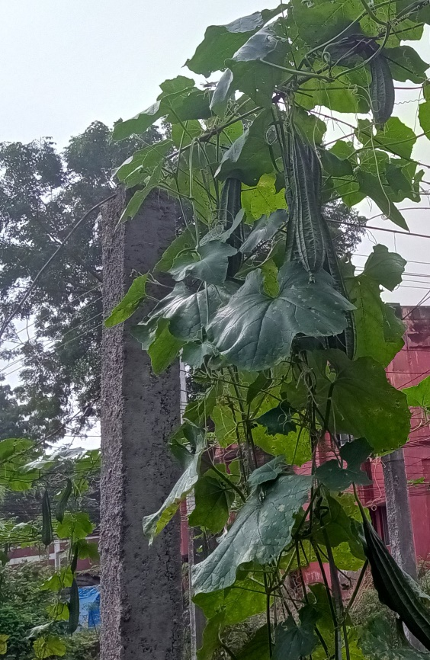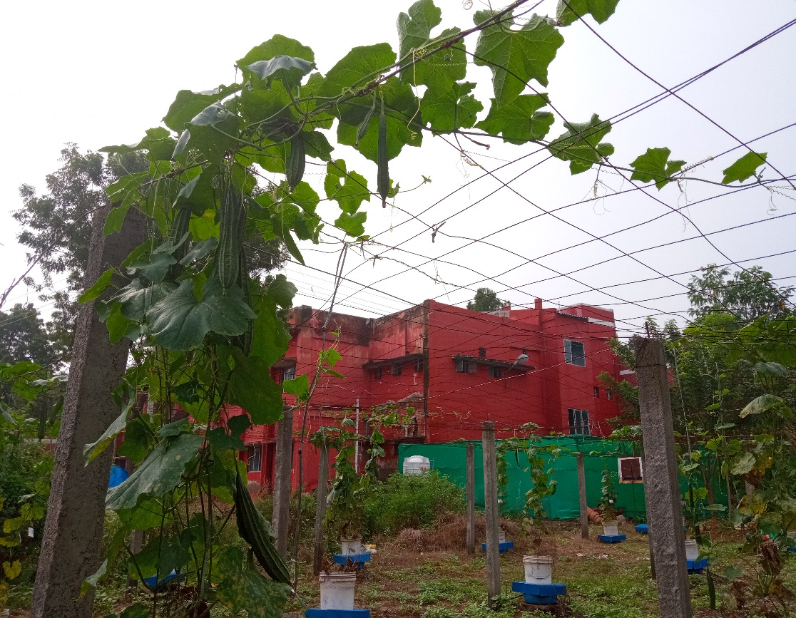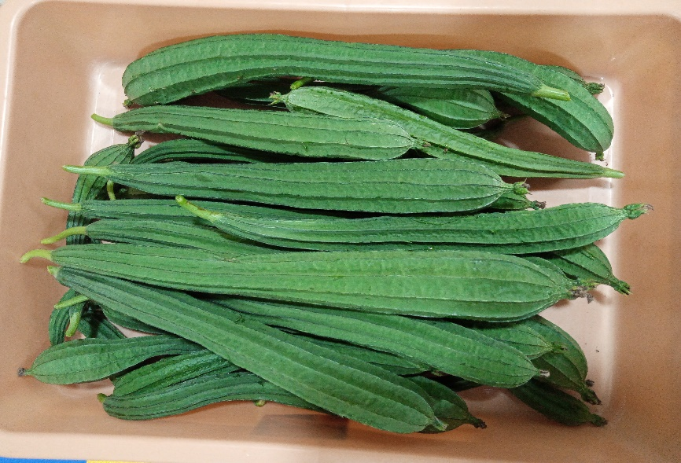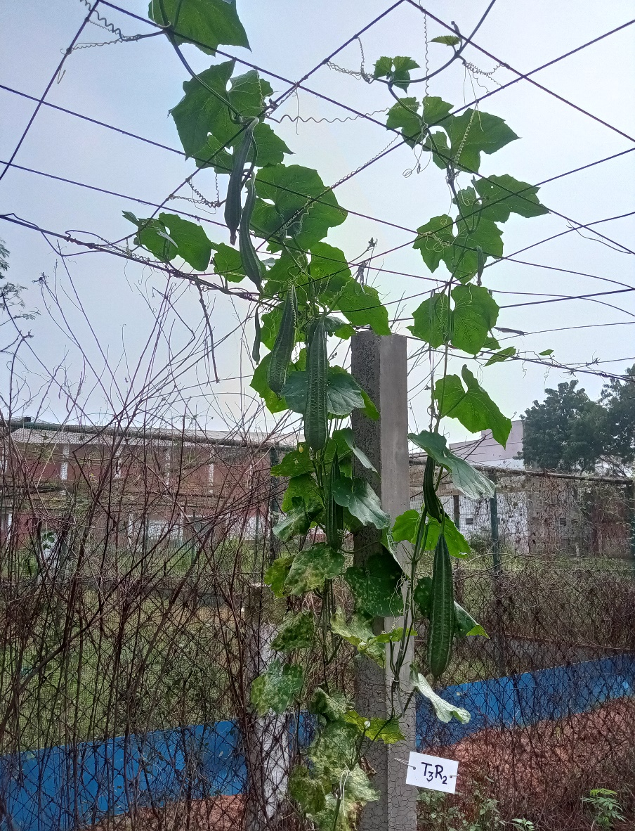
a) Fruiting in growing media with CP+VC+GM+Sand
c) Fruiting in growing media with CP+VC+Sand
b) Fruiting in growing media with CP+VC+FA+Sand
d) Harvested fruits

Fig.5. View of ribbed gourd crop treatment wise at fruiting stage

3.5 Nutrient use efficiency
Nutrient use efficiency (Table 5) was computed in terms of response ratio, apparent nutrient recovery and physiological efficiency for the applied N, P and K nutrients. The highest response ratio of N (78.11), P (834.8) and K (439.3) was recorded in the treatment having the combination of growing media containing coirpith: vermicompost: green manure: sand (T₃). The physiological efficiency of N varied from 350.1 to 356.7 and the variation was not significant. Physiological efficiency of P (3871) and K (246.3) was highest with growing media with coirpith: vermicompost: sand (T₁) while lowest physiological efficiency was noted in coirpith: vermicompost: green manure: sand (T₃) for P (3570) and in coirpith: vermicompost: fly ash: sand (T₂) for K (221.8). Apparent recovery was highest in the growing media with coirpith: vermicompost: green manure: sand (T₃) for N (22.42%), P (23.47 %), and K (192.9 %).

Table 5. Nutrient use efficiency, water use efficiency and benefit-cost ratio of ribbed gourd at harvest stage

T. No. | Response Ratio  (kg yield / kg nutrient applied) |  |  |  |  |  | Physiological Efficiency  kg yield / kg nutrient absorbed
T. No. | N |  | P |  | K |  | N |  | P |  | K
CP+VC+S | 64.00 |  | 683.9 |  | 359.9 |  | 356.7 |  | 3871 |  | 246.3
CP+VC+FA+S | 73.73 |  | 787.9 |  | 414.6 |  | 355.4 |  | 3665 |  | 221.8
CP+VC+GM+S | 78.11 |  | 834.8 |  | 439.3 |  | 350.1 |  | 3570 |  | 228.2
SEd | 1.02 |  | 10.93 |  | 5.75 |  | 11.2 |  | 110.8 |  | 7.79
CD(P=0.05) | 1.74** |  | 18.62** |  | 9.80** |  | NS |  | 188.7* |  | 13.27*
T. No. | Apparent Nutrient Recovery (%) |  |  |  |  | Harvest Index |  | Water use efficiency
T. No. | N | P |  | K |  |  |  | kg fresh fruit mm⁻¹ |  | g fresh fruit L⁻¹
CP+VC+S | 18.02 | 17.71 |  | 146.7 |  | 0.289 |  | 336.9 |  | 33.7
CP+VC+FA+S | 20.82 | 21.56 |  | 188.0 |  | 0.321 |  | 388.1 |  | 38.8
CP+VC+GM+S | 22.42 | 23.47 |  | 192.9 |  | 0.308 |  | 411.2 |  | 41.1
SEd | 0.66 | 0.51 |  | 4.89 |  | 0.0046** |  | 5.38 |  | 0.54
CD(P=0.05) | 1.12** | 0.87** |  | 8.32** |  | 0.0078** |  | 9.17** |  | 0.92**
T. No. | Profit for cropping each container
T. No. | Components of growing media |  |  |  |  |  |  | Net profit  Profit Rs. |  | Benefit- Cost Ratio
T₁ | CP+VC+S |  |  |  |  |  |  | 301.91 |  | 1.50
T₂ | CP+VC+FA+S |  |  |  |  |  |  | 354.41 |  | 1.89
T₃ | CP+VC+GM+S |  |  |  |  |  |  | 378.06 |  | 1.95
According to the trend of yield obtained, the response ratio, harvest index, apparent nutrient recovery of N, P and K as well as water use efficiency were found out. Apparent nutrient recovery recorded ranged from 18.02 to 22.42 per cent for N and 17.71 to 23.41 per cent for P, and 146.7 to 192.9 per cent for K. These recovery values indicated that in spite of efficient circulation of nutrients through irrigation water, only about 20 per cent of applied N and P were recoverable by crop. The remaining N and P may be either retained in growing media or remained in irrigation water or lost. The loss may occur particularly for N as ammonia volatilization and denitrification. Extremely high efficiency indicated for K may be due to greater recovery of K by crop than the applied K, which may be related to the phenomenon of luxury consumption of K by crops. As substrates used in growing media contained large amount of unbound K, more amount K would have been absorbed by crop.

3.5. Harvest Index and Water productivity
Harvest index is an indication of the ability of the plant to divert the total drymatter to form the economic part. Comparably, very high harvest index was realized in growing media containing Coirpith: Vermicompost: Fly ash in combination with sand (0.321) followed by coirpith: vermicompost: green manure: sand (T₃) (0.308).

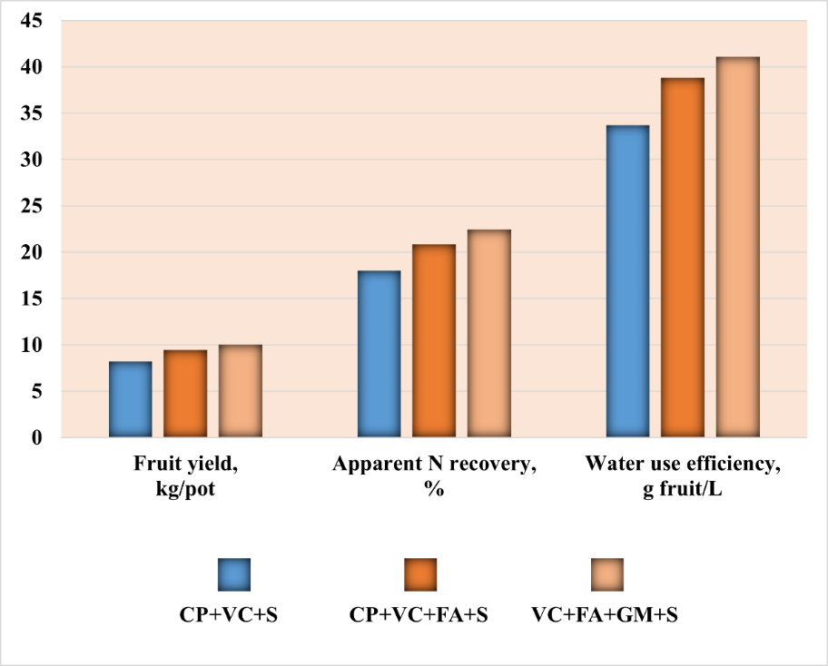

Fig.6. Fruit yield, Apparent N recovery and Water use efficiency in ribbed gourd pandal experiment
The water productivity computed as weight of fresh fruit produced per mm of consumed water was highest to the tune of 411.2 kg mm⁻¹ in growing media containing Coirpith: Vermicompost: Green Manure: Sand (T₃) followed by in coirpith: vermicompost: fly ash: sand (T₂) (388.1 kg mm⁻¹) and coirpith: vermicompost: sand (T₁) (336.9 kg mm⁻¹) (Fig.6).

3.6. Benefit-Cost ratio

BC ratio computed for each container basis (Annexure A2) showed a promise to implement this kind of soilless culture for profitable crop production. Benefit-Cost ratio was highest (1.95) in growing media with coirpith: vermicompost: green manure: sand with a net profit of Rs. 378.06, which was followed by coirpith: vermicompost: fly ash: sand (1.89) with a net profit of Rs. 354.41 and coirpith: vermicompost: sand (1.50) with net profit of Rs. 301.91 per container. Accountable profitable results were obtained because of the simplicity of the method used for soilless culture and use of low cost materials.

4 Conclusion
Based on the promising effects identified in previous experiments present validation experiment was conducted. The results confirmed that the growth, yield and nutrient uptake were highest in growing media containing coirpith: vermicompost: green manure: sand, followed by coirpith: vermicompost: flyash: sand, and coirpith: vermicompost: sand. The salinity of raw substrates used in growing media were well reduced in matric suction irrigation method as low-saline irrigation water was used for circulation. Limited usage of water for crop production has been achieved, which was evidenced in high values recorded in water productivity. Conclusively the exploitation of the potentiality of particulate organic materials has been well demonstrated in soilless system for growing crop in open waste land area. This technique may be useful for farmers to generate additional farm income with proper use of particulate organic substrates obtainable/ available in their farm.

REFERENCES
- Krishna H, Chaurasia SN, Bahadur A, Singh SK, Sharma S, Kumar R, Roy S, Singh MK. Protected cultivation of vegetables crops for sustainable food production. Indian Horticulture. 2023; 68(2): 39-44. Retrieved from https://epubs.icar.org.in/index.php/IndHort/article/view/135847
- DAFW. Department of Agriculture and Farmers Welfare, Ministry of Agriculture and Farmers Welfare, Second Advance Estimates 2022-23, 2023, Government of India. Retrieved from https://agricoop.nic.in/en/statistics/state-level
- Craig W, Beck L. Phytochemicals. Health Protective Effects. Canadian Journal of Dietetic practice and Research. 1999; 60: 78-84.
- Wargovich MJ. Anticancer properties of fruits and vegetables. Hort Science. 2000; 35(4): 573-575.
- Dias JS, Ryder EJ. World vegetable industry: production, breeding, trends. Horticultural Reviews. 2011; 38: 299-356.
- Kandoliya UK, Marviya GV, Bodar NP, Bhadja NV, Golakiya BA. Nutritional and antioxidant components of ridge gourd (Luffa acutangula L. Roxb) fruits of promising genotypes and varieties. Sch J Agric Vet Sci. 2016; 3(5):397-401.
- Kandlakunta B, Rajendran A, Thingnganing L. Carotene content of some common (cereals, pulses, vegetables, spices and condiments) and unconventional sources of plant origin. Food Chem. 2008; 106: 85–89.
- Dufour L, Guérin V. Nutrient solution effects on the development and yield of Anthurium andreanum Lind in tropical soilless conditions. Sci. Hort. 2005; 105: 269-282.
- Kannan B, Arulmozhiselvan K. Effect of growing media and fertilization methods on growth and yield of snake gourd grown under matric suction irrigation. The Pharma Innovation Journal. 2019; 8 (11): 163-170.
- Elakiya N, Arulmozhiselvan K. Effect of salinity and composition of growing media on growth and Yield of ribbed gourd in soilless culture under matric suction irrigation. The Pharma Inno. J. 2021;10(10):578-85.
- Panse VG, Sukhatme PV. 1985."Statistical methods for agricultural workers." Statistical methods for agricultural workers.
- Chanda, Sontosh, Md Islam, AKM Sarwar. 2021. Organic Matter Decomposition and Nutrient Release from Different Dhaincha (Sesbania spp.) Genotypes. Journal of Agricultural Sciences–Sri Lanka 16 (2).
- Anuja S, Poovizhi K. Effect of organic nutrients on yield and yield attributes of cucumber (Cucumis sativus) cv. Long green. Vegetable Science 2009;6(2):163-166.
- Kameswari M, Lalitha P, Narayanamma S, Riazuddin A, Charturvedi A. Influence of integrated nutrient management in ridge gourd (Luffa acutangula (Roxb.) L.). Vegetable Science, 2011; 38(2): 209-211.
- Ahmed SH, Emam MSA, Abul-Soud M. Effect of different vermicompost rates and pot volume on producing celery and red cabbage under urban horticulture conditions. Zagazig Journal of Agricultural Research. 2017; 44(4):1245-1258.
- Abul-Soud M, Emam M, El-Rahman N. The potential use of vermicompost in soilless culture for producing strawberry. Int. J. Plant Soil Sci. 2015; 8(5): 1-15.
- Abul-Soud M, Emam M, Hawash A, Mohammed M, Maharik Z. The utilization of vermicomposting outputs in ecology soilless culture of lettuce. J. Agric. Ecol. Res. Int. 2016; 5(1): 1-15.
- Arancon NQ, Edwards CA, Bierman P, Metzger JD, Lucht C. Effects of vermicomposts produced from cattle manure, food waste and paper waste on the growth and yields of peppers in the field. Pedobiologia. 2005; 49:297-306.
- Soobhany N, Mohee R, Garg VK. A comparative analysis of composts and vermicomposts derived from municipal solid waste for the growth and yield of green bean (Phaseolus vulgaris). Environmental Science and Pollution Research. 2017; 24: 11228-11239.DOI: https://doi.org/10.1007/s11356-017-8774-2
- Arancon NQ, Edwards CA, Bierman P, Metzger J, Lee S, Welch C. Applications of vermicomposts to tomatoes and peppers grown in the field and strawberries grown under high plastic tunnels. Proc. Int. Earthworm Symposium, Cardiff Wales 2002.
- Arancon NQ, Edwards CA, Atiyeh R, Metzger JD. Effects of vermicomposts produced from food waste on the growth and yield of greenhouse peppers. Bioresource Technol. 2004; 93:139-144.
- Thind HS, Yadvinder-Singh, Bijay-Singh, Varinderpal-Singh, Sharma S, Vashistha M et al. Land application of rice husk ash, bagasse ash and coal fly ash: effects on crop productivity and nutrient uptake in rice-wheat system on an alkaline loamy sand. Field Crop. Res 2012; 135:137-144.
- Ukwattage NL, Ranjith PG, Bouazza M. The use of coal combustion fly ash as a soil amendment in agricultural lands (with comments on its potential to improve food security and sequester carbon). Fuel 2013; 109:400-408.
- Ahmad G, Khan AA, Ansari S. Interaction of a fly ash and rootknot nematode pathogens on pumpkin (Cucurbita moschata Duch. ex Lam.). Trop. Plant Res. 2017; 4:449-455.
- Haris M, Ahmad G, Shakeel A, Khan AA. Utilization of fly ash to improve the growth and the management of root-knot nematode on carrot. Haya Saudi J. Life Sci. 2019; 4: 221–226.
- Yousuf A, Manzoor SO, Youssouf M, Malik ZA, Khawaja KS. Fly ash: production and utilization in India - an overview. J Mater Environ Sci. 2020; 11(6):911-921.
- Ochecova P, Tlustos P, Szakova J. Wheat and soil response to wood fly ash application in contaminated soils. Agron. J. 2014; 206:995-1002.
- Bisoi SS, Mishra SS, Barik J, Panda D. Effects of different treatments of fly ash and mining soil on growth and antioxidant protection of Indian wild rice. Int. J Phytoremediation 2017; 19:446-452.
- Sharma B, Singh RP. Physiological, biochemical, growth, and yield responses of Radish (Raphanus sativus L.) plants grown on different sewage sludge-fly ash mixture (SLASH) ratios. In: Ghosh S (ed) Waste valorisation and recycling. Springer, Singapore. 2019; 539-552.
- Hadke PB, Wankhade SG, Ingle SN. Consequence of FYM and fly ash application on yield, nutrient uptake, and quality of safedmusli grown on inceptisols. Int. J Curr. Microbiol. Appl. Sci 2019; 8:263-273.
- Shakeel A, Abrar Ahmad Khan, Khalid Rehman Hakeem. Growth, biochemical, and antioxidant response of beetroot (Beta vulgaris L.) grown in fly ash-amended soil. SN Applied Sciences 2020; 2:1378. DOI: https://doi.org/10.1007/s42452-020-3191-4
- Munda SE, Nayak AK, Mishra PN, Bhattacharyya P, Sangita Mohanty, Anjani Kumar et al. Combined application of rice husk biochar and fly ash improved the yield of lowland rice. Soil Research 2016;54:451-459. DOI: https://doi.org/10.1071/SR15295
- Skousen J, Yang JE, Lee JS, Ziemkiewicz P. Review of fly ash as a soil amendment. Geosys Eng 2013; 16: 249-256.
- Parab N, Seema Mishra, Bhonde SR. Prospects of Bulk Utilization of Fly Ash in Agriculture for Integrated Nutrient Management. Bulletin of the National Institute of Ecology. 2012; 23:31-46.
- Yeledhalli NA, Prakash SS, Gurumurthy SB, Ravi MV. Coal fly ash as modifier of physico-chemical and biological properties of soil. Karnataka J. Agric. Sci. 2007; 20: 531-534.
- Bhuiyan NI, Zaman SK, Panaullah GM. Dhaincha green manure: A potential nitrogen source for rain-fed lowland rice. Proceedings of Workshop, International Rice Research Institute, Philippines 1988, 108.
- Setiawati, Mieke Rochimi, Muhamad Khais Prayoga, Silke Stöber, Kustiwa Adinata, Tualar Simarmata. Performance of rice paddy varieties under various organic soil fertility strategies. Open Agriculture. 2020; 5 (1) : 509-515.
- Maathuis FJM. Physiological functions of mineral macronutrients. Curr. Op. Plant Biol. 2009; 12(3): 250–8.
- Zhong LC, Cao X, Hu J, Zhu L, Zhang J, Huang J et al. Nitrogen metabolism in adaptation of photosynthesis to water stress in rice grown under different nitrogen. Front Plant Sci. 2017;8:1079.
- Souri MK, Hatamian M. Aminochelates in plant nutrition; a review. J Plant Nutr. 2019;42(1):67-78.
- Shi J. Decomposition and Nutrient Release of Different Cover Crops in Organic Farm Systems. MS thesis, University of Nebraska – Lincoln, New Zealand 2013, 1-75. https://digitalcommons.unl.edu/natresdiss/75
- Kabir AKMA, Moniruzzaman M, Gulshan Z, Rahman ABMM, Sarwar AKM Golam. Biomass yield, chemical content and in vitro gas production of different Dhaincha (Sesbania spp.) accessions from Bangladesh. Indian Journal of Animal Nutrition. 2018; 35: 397-402. DOI: https://doi.org/10.5958/2231-6744.2018.00060.9
- Shree S, Champa Lal Regar, Fiza Ahmad, Vijay Kumar Singh, Ritu Kumari, Amrita Kumari. Effect of organic and inorganic fertilizers on growth, yield and quality attributes of hybrid bitter gourd (Momordica charantiaL.). Int. J. Curr. Microbiol. App. Sci. 2018;7(4): 2256-2266.
- Orozco FH, Cegarra J, Trujillo LMAR. Vermicomposting of coffee pulp using the earthworm Eisenia fetida: effects on C and N contents and the availability of nutrients. Biol. Fertil. Soils. 1996; 22:162-166.
- Nair J, Sekiozoic V, Anda M. Effect of pre-composting on vermicomposting of kitchen waste. Bioresour. Technol. 2006; 97: 2091– 2095.

Pandal experiment
DAS | Date in year  2020-2021 | Water dropped in tank in a week (cm) | Water consumed (L)
7 | 10-Nov | 19.1 | 121
14 | 17-Nov | 22.4 | 142
21 | 24-Nov | 22.6 | 143
28 | 01-Dec | 26.2 | 166
35 | 08-Dec | 28.3 | 180
42 | 15-Dec | 40.3 | 257
49 | 22-Dec | 46.1 | 293
56 | 29-Dec | 57.9 | 368
63 | 05-Jan | 77.0 | 490
70 | 12-Jan | 85.9 | 546
77 | 19-Jan | 97.6 | 621
84 | 26-Jan | 92.1 | 586
91 | 02-Feb | 87.4 | 556
98 | 09-Feb | 102.9 | 654
105 | 16-Feb | 110.8 | 705
112 | 23-Feb | 111.3 | 708
119 | 01-Mar | 122.7 | 780
Total water consumed (L) |  |  | 7318
ANNEXURES

A1. Account of water consumed by ribbed gourd crop in matric suction irrigation (for 30 pots)
A2. Worksheet for calculating Benefit – Cost Ratio for cultivation of ribbed gourd in Pandal system under matric suction irrigation
Treatments | Fixed Cost | Working Cost (for a single growing media container)
Treatments | Basic Cost  (Container + Pandhal)  (Rs.) | Cost of media (Rs.) | Cost Fertilization (Rs.) | Cost of Sowing  (Rs.) | Cost of Plant Protection  (Rs.) | Cost of Labour  (Rs.) | land cost + Interest at 5% | Working cost  (Rs.)
CP+VC+Sand | 43.33 | 78.00 | 12.28 | 2.00 | 20.00 | 11.00 | 5.00 | 171.61
CP+VC+FA+Sand | 43.33 | 66.25 | 12.28 | 2.00 | 20.00 | 11.00 | 5.00 | 159.86
CP+VC+GM+Sand | 43.33 | 72.50 | 12.28 | 2.00 | 20.00 | 11.00 | 5.00 | 166.11

Working cost | Gross Cost (for a single growing media container)
Working cost | Interest on WC at 10.5% | Managerial Cost @ 6.5% | Gross working Cost per Pot (Rs.)
171.61 | 18.02 | 11.15 | 200.78
159.86 | 16.78 | 10.39 | 187.03
166.11 | 17.44 | 10.80 | 194.34

Yield of fruits  Pot⁻¹ | Fruit selling  cost/kg | Gross Profit per Pot  (Rs.) | Fixed cost  Repayment | Net Profit  (Rs.) | B:C  Ratio
8.22 | 42.00 | 345.24 | 43.33 | 301.91 | 1.50
9.47 | 42.00 | 397.74 | 43.33 | 354.41 | 1.89
10.03 | 42.00 | 421.39 | 43.33 | 378.06 | 1.95
Cost of pandal system for 30 containers (30 Poles): Rs. 50000/- (Life expectancy -50 years); Fixed Cost per season/ container Rs.33.33/-
Cost of Tub+container+tubing = Rs. 400/- ; Cost per season (life expectancy of 10 years (20 crops)) = Rs.10/-

