BIOLOGY AND HOST PREFERENCE OF RED FLOUR BEETLE (Tribolium castaneum)

ABSTRACT
This study investigates the host preferences and developmental biology of the red flour beetle (Tribolium castaneum) across three food sources: broken rice with rice flour, broken wheat with wheat flour, and tapioca flour. Beetle development was observed in ventilated containers under controlled conditions (28-30°C, 65% relative humidity) with 25 beetles per container. Results showed significant differences in beetle survival and development. Wheat flour was the most favourable host, supporting 304 live adults, followed by broken wheat with 145 live adults. Rice flour supported 20 adults and 11 larvae, indicating moderate suitability. Whole rice grain and tapioca flour were the least effective, with only dead adults and few larvae. Despite host quality variations, the developmental stages (egg incubation: 4-7 days, larval: 65-70 days, pupal: 6-9 days) were consistent across food sources. The study highlights wheat flour as the most supportive environment for T. castaneum development.

Introduction
Post-harvest food losses during storage are significant and arise from various factors, including pest infestations, which can cause considerable damage to stored cereals, pulses, and oilseeds depending on the crop, storage conditions, and post-harvest processing methods (Kitinoja and Gorny, 1999; Musa, 1984; Tindall and Proctor, 1980). Among the pests, the red flour beetle (Tribolium castaneum Hbst.) problematic particularly in tropical regions. Being a secondary pest, this beetle primarily infests grains that are already damaged and cannot penetrate intact grains (Howe, 1956). It thrives on a variety of stored products, including wheat flour, dried fruits, and legumes, due to its adaptability to low humidity environments, facilitated by a specialized cryptonephridial condition (Richards et al., 2008). The red flour beetle's feeding habits reduce the mass and quality of stored grains, increase their moisture content and temperature, and can lead to a significant decrease in germination capacity (Padin et al., 2002; Faroni and Sousa, 2006). Furthermore, heavy infestations result in discoloured, mold-prone flour with a disagreeable odor due to the beetles' scent glands (Good, 1936; El-Desouky et al., 2018).
Life cycle of red flour beetle includes egg, larval, pupal, and adult stages, with the most prolific reproductive period occurring between one week and two months post-emergence (Park, 1949). Females lay hundreds of eggs throughout their lifespan, contributing to the beetle's high infestation potential (Bennett, 2003). The species' ability to reproduce continuously in warm conditions further exacerbates its pest status. Effective pest management strategies necessitate understanding the beetle's biology and development, such as determining the number of larval instars through measurements like head capsule width, following Dyar’s rule (Panzavolta, 2007; Cazado et al., 2014). Additionally, diet plays a crucial role in the beetle's development and reproductive success, with larger amounts of flour supporting higher oviposition rates and faster development (Campbell and Runnion, 2003). The present study focuses on the biology and host preference of the red flour beetle across various substrates, including wheat flour, broken wheat, rice flour, rice, and tapioca flour.
Materials and methods;
To investigate the host preferences and developmental biology of the red flour beetle (Tribolium castaneum), three food sources were prepared: broken rice with rice flour, broken wheat with wheat flour, and tapioca flour. Each combination was placed in separate, ventilated plastic containers covered with muslin cloth. Adult beetles were introduced at a sex ratio of 1 female to 4 males, with a total of 25 beetles (5 females and 20 males) per container. The containers were maintained at a constant temperature of 28-30°C and 65% relative humidity. The adult red flour beetles utilized in this study were sourced from the seed centre laboratory located adjacent to TNAU and RI College. The development of the beetles was monitored daily, and the duration of each developmental stage was recorded, including the incubation (egg to larva), larval (larva to pupa), and pupal (pupa to adult) periods. Observations were made using digital microscope. Each treatment was replicated three times to ensure the reliability of the results, with appropriate controls maintained to account for external variables.
Results:
The study on the host preferences and developmental biology of the red flour beetle (Tribolium castaneum) revealed notable differences in the beetles' survival and development across various food sources.
The biology of the red flour beetle (Tribolium castaneum) encompasses distinct developmental stages, starting with an egg period that lasts between 4 to 7 days. Following this, the beetle enters the grub (larval) period, which spans 65 to 70 days and involves progressing through 1 to 6 instars. The pupal period, during which the beetle transforms from larva to adult, lasts for approximately 6 to 9 days. The adult longevity of the red flour beetle varies significantly depending on the host food source, with some adults surviving for extended periods when provided with optimal nutrition. This variation in lifespan highlights the impact of host quality on the beetle’s life cycle and reproductive success.

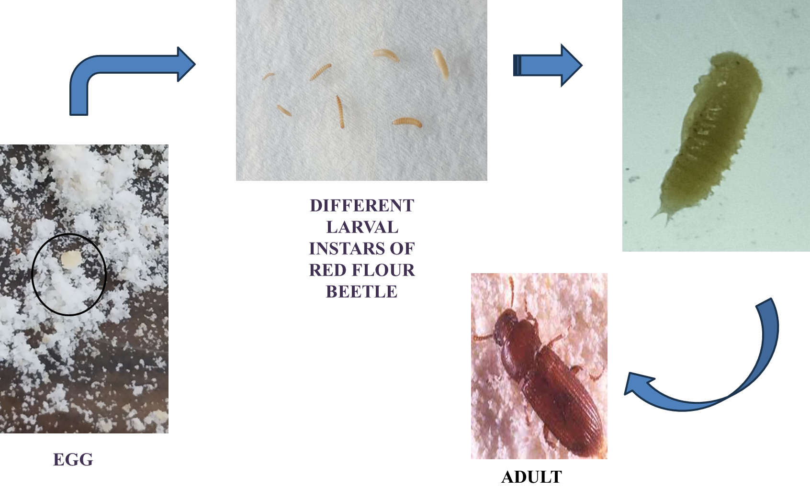
Fig 1. Life stages of red flour beetle
Wheat flour was identified as the most preferred host, yielding the highest total adult population of 304 live beetles. This indicates that wheat flour provides the most conducive environment for the beetle's life cycle, supporting optimal conditions for reproduction and survival. Broken wheat was the second most favourable host, supporting a total of 145 live adults, demonstrating its significant suitability for the beetles. These findings highlight that both wheat-based hosts are highly supportive of the beetle’s developmental needs.
In comparison, rice flour, although still preferred, supported a much lower total of 20 live adults and 11 larvae. This suggests that while rice flour is adequate for the early stages of the beetle's development, it may not be as supportive for adult survival and longevity. Whole rice grain, on the other hand, showed poor suitability, with only 12 dead adults and 2 larvae observed, indicating that it does not provide favourable conditions for the beetle's development. Tapioca flour was found to be the least preferred host, with 12 dead adults and no larvae, underscoring its inadequacy as a food source for the beetles.
Despite the differences in host suitability, the developmental stages, including the incubation period (4-7 days), larval period (65-70 days), and pupal period (6-9 days), were relatively consistent across all food sources. However, the study noted significant variations in adult multiplication and longevity, which were influenced by the type of host. These results suggest that while the early stages of the beetle’s life cycle can be supported by a variety of food sources, the quality of the host plays a crucial role in adult survival and reproductive success. The findings emphasize that wheat flour is the most favourable environment for the red flour beetle's life cycle, followed by broken wheat, with rice flour being moderately suitable, and whole rice grain and tapioca flour being less effective, particularly the latter, which is unsuitable for supporting the beetle’s development and survival.
Table 1. Early stages of the beetle’s life cycle
Parameters | Wheat Flour | Broken Wheat | Rice Flour | Whole Rice Grain | Tapioca flour
Total adult population | 304 live | 145 live | 20 adults  11 larva | 12 Dead  2 larva | 12 dead
Host Preference | Most preferred | Most preferred | Preferred | Less Preferred | Least preferred

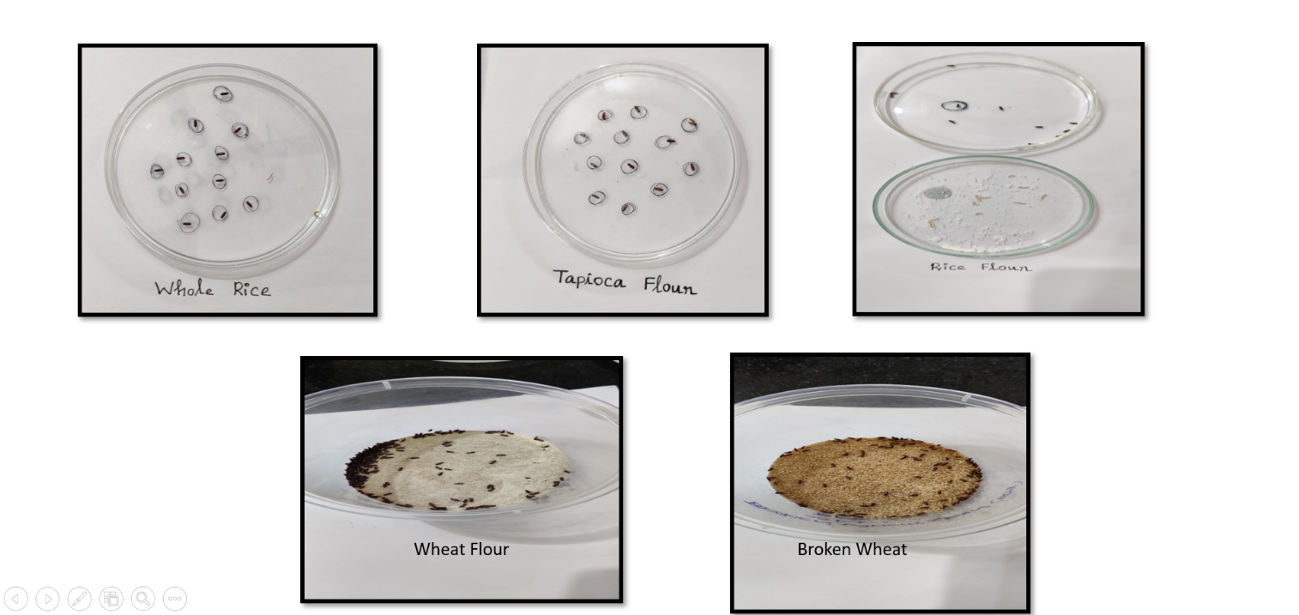
Fig 2. Red flour beetle in different hosts

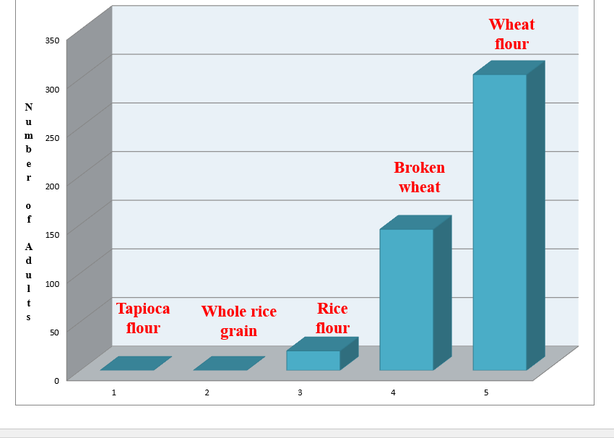

Fig 3. Host preference of Red flour beetle
Tribolium castaneum, commonly known as the red flour beetle, exhibits a marked preference for wheat flour, which serves as a suitable host for its development (Soomro and Ahmed, 2023; Astuti, 2020). Larval development is notably quicker in cracked wheat compared to other substrates, while cracked maize tends to result in lower fecundity (Skourti et al., 2020). The study of the life cycle of T. castaneum (Kayode et al.,2014) on different cereal flours highlights wheat flour as a favorable host due to its ability to sustain the growth and development of the pest insect (Soomro and Ahmed, 2023). The current study findings align with previous studies, demonstrating the suitability of wheat flour as a host for T. castaneum. This study shows that wheat flour effectively supports the lifecycle and development of T. castaneum, particularly when compared to rice, and tapioca flour.
Conclusion:
Based on our experiment to study the biology and host preference of red flour beetle with 5 different hosts, such as wheat flour, broken wheat, rice flour, rice, tapioca flour. Based on our observation, the incubation period, larval period and pupal period are more or less equal in all host range whereas the adult multiplication and longevity varies with host, which reveals that among five hosts, the wheat flour (adult – 304 live) found to be most preferred host followed by broken wheat (adult – 145 live)
References:
Astuti, L. P. (2020). Host preference of Tribolium castaneum (Herbst) on six kinds of flour. Indonesian Journal of Entomology, 17(3), 456507.
Bennett, S. (2003). Tribolium confusum (Confused Flour Beetle) and Tribolium castaneum (Rust Red Flour Beetle), Journal of Applied Bioscience 3, (93): 827–835
Campbell, J.F. & Runnion, C. (2003). Patches exploitation by female red flour beetles, Tribolium castaneum, Journal of Insect Science, 8: 3:20.
Cazado, L. E., Van Nieuwenhove, G. A., O’Brien C. W., Gastaminza, G. A., & Murua M. G., (2014). Determination of number of instars of Rhyssomatus subtilis (Coleoptera: Curculionidae) based on head capsule widths. Florida Entomologist, 97: 639–643
El-Desouky, T. A., Elbadawy, S. S., Hussain, H. B. H., & Hassan, N. A. (2018). Impact of insect densities Tribolium castaneum on the benzoquinone secretions and aflatoxins levels in wheat flour during storage periods. Open Biotechnology Journal, 12: 104–111
Faroni, L. R. D. A., & Sousa, A. H. (2006). Aspectos biologicos etaxonomicos dos principais insetos-praga de produtos armazenados. Tecnologia de armazenagem em sementes. Campina Grande: UFCG, 1, 371-402
Good, N. E. (1936). The flour beetle of the genus Tribolium castaneum. Technical Bulletin of U.S. Department of Agriculture No. 498: 57
Howe, R.W. (1956). The effect of temperature and humidity on the rate of development and mortality of Tribolium castaneum (Herbst). Annals of Applied Biology, 44: 356368.
Kayode, O. Y., Adedire, C. O., & Akinkurolere, R. O. (2014). Influence of four cereal flours on the growth of Tribolium castaneum Herbst (Coleoptera: Tenebrionidae). Ife Journal of science, 16(3), 505-516.
Kitinoja, L., & Gorny, J. R. (1999). Postharvest Technology for Small-scale Produce Marketers: Economic Opportunities, Quality and Food Safety. University of California Postharvest Horticulture Series No. 21.
Martinez, S. S. & Emden, H. F. (2001). Van growth disruption, abnormalities and mortality of Spodoptera littoralis (Boisduval) (Lepidoptera: Noctuidae) caused by Azadirachtin. Neotropical Entomology, 30(1): 113- 125.
Musa, S. K. (1984). Reduction of postharvest losses in vegetables and fruits in a developing country. In: McLoughlin, J. V., & McKenna, B. M. (Eds.), Food Science and Technology: Present Status and Future Direction. Boole Press Ltd., Dublin, p. 165-176.
Namrata, T. (1993). Thesis on Studies on the biology genetics and toxicology of Tribolium castaneum. Dayalbagh educational institute (deemed university). Agra
Padin, S., Dal Bello, G., & Fabrizio, M. (2002). Grain loss caused by Tribolium castaneum, Sitophilus oryzae and Acanthoscelides obtectus in stored durum wheat and beans treated with Beauveria bassiana. Journal of Stored Product Research, 38: 69-74
Panzavolta, T. (2007). Instar determination for Pissodes castaneus (Coleoptera: Curculionidae) using head capsule widths and lengths. Environmental Entomology, 36: 1054–1058.
Park, T. (1932). Studies in population physiology: the relation of numbers to initial population growth in the flour beetle Tribolium confusum Duval. Ecology, 13(2), 172-181
Park, T. (1932). Studies in population physiology: the relation of numbers to initial population growth in the flour beetle Tribolium confusum Duval. Ecology, 13(2), 172-181
Skourti, A., Kavallieratos, N. G., & Papanikolaou, N. E. (2020). Suitability of semolina, cracked wheat and cracked maize as feeding commodities for Tribolium castaneum (Herbst; Coleoptera: Tenebrionidae). Insects, 11(2), 99.
Soomro, F., & Ahmed, W. (2023). Study on the life cycle of Tribolium castaneum (Coleoptera: Tenebroinidae) on different cereals.
Tindall, H. D., & Proctor, F. J. (1980). Loss prevention of horticultural crops in the tropics. Progress in Food and Nutritional Science, 4 (3-4): 25-40.

