The Oxytocic and Abortifacient Activities of Xylopia Aethiopica Ethanol Fruit Extract on Female Wistar Rats

Abstract
The goal of this study was to investigate the oxytocic effects of ethanol fruit extract of Xylopia aethiopica (X. aethiopica). Pregnancy describes the period of fetal development in the uterus until delivery. Pregnancy, labour and puerperium present challenges that encourage use of medications to relieve symptoms, terminate pregnancy and prevent primary postpartum haemorrhage. Some pregnant women still rely on herbal remedies for treatment of pregnancy related problems. X. aethiopica is a natural spice used in preparing soup for women after delivery to prevent primary postpartum haemorrhage. Sixty six adult wistar rats comprising of 12 males for mating and 44 females that weighed 150 – 180g were used in this study. Acute toxicity test, qualitative phytochemical analysis, abortifacient and oxytocic studies were all done. Statistical analysis was done using IBMSPSS version 26. The results were presented as mean ± standard deviation while comparison between groups was done using One-Way Analysis of Variance ANOVA with subsequent analysis using Post Hoc Test. A P value of < 0.05 was considered statistically significant. The Median LD50 was established to be 1703 mg/kg in rats. The phytochemical analytes were found to be Flavonoids, phenols, cardiac glycosides and steroids. There was dose dependent decrease in body weight of the animals treated with X. aethiopica. The extract did not have oxytocic effect on postpartum uterus like oxytocin. It rather caused relaxation of the uterus. Ethanol fruit extract of X. aethiopica did not exert oxytocic effect on female wistar rats. It is therefore not recommended in the prevention of primary postpartum haemorrhage.

Keywords: Oxytocin, postpartum, haemorrhage, pregnancy

Introduction
Uterus the Site of Pregnancy
The female uterus, also known as the womb, is a hollow, muscular organ in the pelvis that plays a crucial role in mensuration, pregnancy, and childbirth¹. It forms between the fifth and sixth weeks of pregnancy through the fusion of Mullerian or paramesonephric ducts, forming the fallopian tube and the uterus and upper section of the vagina. The absence of circulating testosterone and Anti Mullerian Hormone causes uterine development in female embryos². The uterus undergoes significant changes throughout pregnancy, including hypertrophy and hyperplasia, and is responsible for fetal protection and expulsion at term. Ligaments and folds are used to support and maintain the uterus, with two types: the anterior Uterovesical fold of Peritoneum and the posterior retro-vaginal fold³.
Gross Features and Location of the Uterus
The uterus is divided into four parts: fundus, corpus, cervix, and cervical canal. The fundus is the upper part above the insertion of tubes, while the corpus connects fallopian tubes and extends downward to the cervix and isthmus⁴. The uterus is located behind the bladder and in front of the rectum.

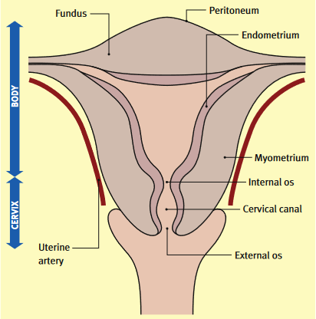

Figure 1: Showing the features of the uterus⁵
Histology perspective
The uterus is a muscular structure with three layers: the endometrium, myometrium, and perimetrium. The endometrium is the inner lining of the uterus and requires the ability to change across the menstrual cycle to regenerate, decidualize, and shed. It supports implantation and pregnancy when necessary⁶. In the absence of implantation, shedding of the luminal two-thirds of the endometrium occurs during menstruation, under the control of endocrine, immune, vascular, and coagulationsystems⁷.
The endometrium is composed of connective tissue stroma surrounding glands and surface epithelium. It serves as the implantation site for a fertilized egg and plays a crucial role in its nourishment and development ⁸. Estrogen primes the endometrium by inducing a proliferative response with increased mitotic activity in glands and the stroma. High levels of progesterone decrease the number of estrogen receptors in endometrial cells to shift towards secretory differentiation.
The perimetrium is the outer lining of the uterus, consisting of a thin layer of loose connective tissue lined by squamous mesothelium. The myometrium is the muscular layer between the endometrium and perimetrium, providing the bulk of the uterus. The inner and outer myometrial layers are mostly associated with the initial layers of the paramesonephric ducts⁹.
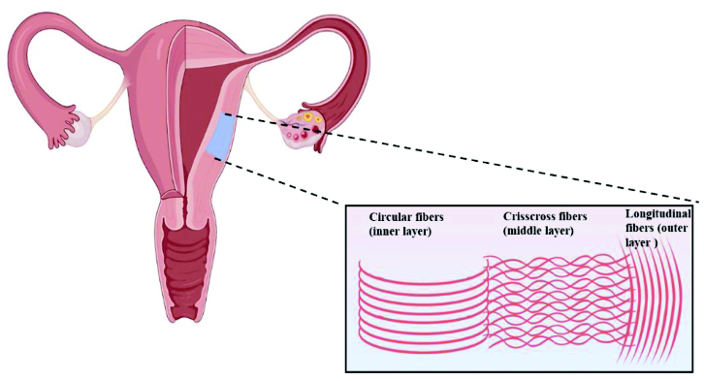

Figure 2: Showing the muscle arrangement of the myometrium of the uterus (Hanuman et al., 2023)
The uterine system is composed of several layers, including the middle intermediate layer, which contributes to the uterine thickness and provides numerous blood vessels for nutritional and nervous supply. The myometrium, a smooth muscle, expands and contracts to facilitate parturition¹⁰.
Blood supply
The uterine artery, which originates from the internal iliac artery, is the major contributor to the blood supply reaching the uterus. The uterine vein accompanies the artery and drains into the internal iliac vein¹¹.
Lymphatics
The fundal area of the uterus drains into para-aortic lymph nodes, ovarian and fallopian tube lymphatic drainage, and superficial inguinal lymph nodes along the round ligament. Lower portions of the uterus drain along uterine blood vessels into external and internal iliac lymph nodes¹².

Nerve supply
The uterus is innervated via the inferior hypogastric plexus, which receives post-ganglionic sympathetic fibers from the inferior hypogastric nerves and preganglionic parasympathetic fibers from pelvic splanchnic nerves from S2-S4. Visceral afferent fibers pass within the pelvic splanchnic nerves¹³.
Clinical anatomy
Uterine atony after delivery
Uterine atony is characterized by inadequate contraction of the myometrial cells of the corpus uteri while responding to endogenous oxytocin, which is released during delivery¹³.

Uterine fibroma
Uterine fibroma, or leiomyoma, is the most common benign tumor of the female genital tract, affecting around 50% of women during their fertile life¹⁴.
Primary Postpartum Haemorrhage (PPH)
Postpartum hemorrhage (PPH) is a leading cause of global maternal morbidity and mortality, accounting for approximately 30% of all pregnancy-related deaths in Asia and Africa. Any delay in achieving hemostasis after birth can result in a major loss of maternal blood volume, leading to hypotension, hypoxia, acidosis, renal failure, and even disseminated intravascular coagulation (DIC)¹⁵.
Oxytocin and uterus
Oxytocin, also known as α-Hypophamine, is a non-peptide hormone containing nine amino acids and plays a pivotal role during human labor and birth¹⁶. It is produced in neurons that originate in the paraventricular (PVN) and supraoptic nuclei (SON) of the hypothalamus and is transported to the posterior pituitary where it is stored. During labor, oxytocin is released in pulses from the pituitary into the circulation to induce uterine contractions¹⁶. It performs a wide variety of functions, with pituitary gland secretions responsible for its peripheral functions and centrally projecting oxytocin neurons responsible for its behavioral effects¹⁷.
Brain secretion of the oxytocin
Brain secretion of oxytocin involves transporting it from magnocellular neurons from the SON and PVN to the posterior pituitary, where it is released into the circulation. It is released into many areas of the brain from axon collaterals emanating from the axons of the magnocellular neurons from the SON and PVN, projecting to the posterior pituitary¹⁸.

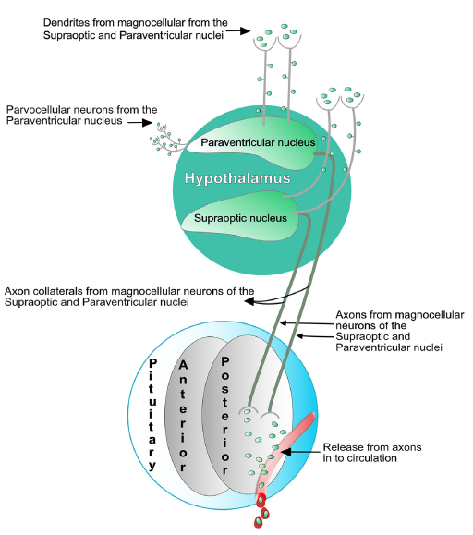

Figure 3: Displaying the Brain Secretion of Oxytocin¹⁹

Functions of oxytocin
Oxytocin is a hormone that plays a crucial role in the body's physiological functions, including mood enhancement, social interaction promotion, anxiety reduction, and stress reduction. It is commonly used in maternity care to induce labor and prevent postpartum haemorrhage. However, the increased use of synthetic oxytocin raises questions about its potential impacts on endogenous oxytocin levels and its effects on mothers and babies²⁰.
Oxytocin levels during labour and birth
During labor and birth, oxytocin levels gradually rise, reaching maximum frequency just before the baby is born. Some peaks may be spontaneous and centrally induced, while others may be induced by the Ferguson reflex, which is stimulated by uterine contractions²¹. This reflex activates afferent sensory nerve fibres, releasing oxytocin into the brain and circulation. The maximum expression of this reflex during birth corresponds to a 3- to 4-fold rise in oxytocin levels during and immediately after the baby's birth. Sympathetic afferents from the myometrium are activated by myometrial contractions, reducing the release of oxytocin²¹.

Connection between synthetic oxytocin and contraction of uterus
The connection between synthetic oxytocin and uterine contraction has been well-established for over four decades²². The uterine muscles are highly sensitive to oxytocin during labor and birth due to the upregulation of oxytocin receptors by high oestrogen elevations in late pregnancy. Oxytocin release in labour promotes prostaglandin release, further strengthening uterine contractions and labour progress²³.

Levels and effects after infusion of synthetic oxytocin
Administrative of synthetic oxytocin produces flat oxytocin levels in maternal blood, which may influence the pattern of uterine contractions and contribute to hyperstimulation that can result from high doses of synthetic oxytocin²⁴. Excessive uterine activity may also compromise fetal blood supply, causing hypoxia. Prolonged exposure to synthetic oxytocin may eventually lead to reduced contractility of the uterine muscles due to desensitization of oxytocin receptors. The decreased efficacy of oxytocin may also increase the risk of postpartum haemorrhage²⁵.
Pharmacological agents used as oxytocics
Pharmacological agents used as oxytocics include oxytocin, ergometrin, misoprostol, and their combinations. These agents have been tried in prevention of postpartum hemorrhage (PPH) with varying safety and effectiveness²⁶. Either of the oxytocics or their combination is given at the third stage of labor (after delivery of the baby) to enhance uterine contraction, which is one of the components of active management of the third stage of labour²⁷.
Oxytocin, ergometrin, and misoprostol have all been successfully used to reduce blood loss following delivery, miscarriage, and induced abortion with varying efficacy. Oral misoprostol has been reported to have more uterotonic effect on first trimester pregnancy as there was less bleeding following surgical evacuation in the misoprostol group²⁷.
Non- pharmacological agents used as oxytocics
Non-pharmacological agents used as oxytocics include methanol and ether crude extracts of Vernonia amygdalina, Melaleuca lanceolata, and Rhynchohyalus natalensis, Sida acuta plant extract, Nymphaea alba, Piper guineense seed Uvariodendron anisatum, and xylopia aethiopica²⁸.
Oxytocic uses of xylopia aethiopica
Xylopia aethiopica is said to possess more uterine contraction property than Ocimum gratissium, comparable to standard oxytocin. However, it is recommended not to be used in early pregnancy as it could cause miscarriage²⁹.
Herbal consumption in pregnancy
Herbal consumption during pregnancy is a growing concern, with many women using herbs for various reasons. Some herbs can induce uterine contractions and high blood pressure, leading to miscarriage, premature birth, or even death. A study by Jahan et al. (2022) found that 71.80% of pregnant women consumed herbs, similar to previous studies in Bangladesh and the United Kingdom³⁰. In Nigeria, herbal medicine consumption was found to be 36.8% among pregnant and lactating mothers³¹. In Kenya, about 12% of women took herb throughout their pregnancy cycle³¹.
The most commonly mentioned herbs in this study include ginger, Nigella sativa, Citrus limon, Prunus domestica, and Allium sativum L. Ginger, garlic, peppermint, and Chinese Okra are also common. However, little information about X. aethiopica’s uses during pregnancy is available, and its roles as oxytocic and abortifacient remain unclear. The higher prevalence of herb use during the third trimester (50.91%) may be due to mothers' increased concern for the baby's body structure and organ system³². The majority of users (71.8%) believed herbs were safer than medicines, with 91.03% reporting no negative effects from any herb. Informal sources of information, such as personal views and friends/family, were cited as critical in women's decision to explore herbal treatment.
Xylopia Aethiopica
X. aethiopica, a tall, slim, aromatic evergreen tree, grows in the Savanna region of Africa, including Nigeria, Ghana, Ethiopia Cameroon, and Senegal. Its fruits are small, twisted bean-pods with dark brown color, cylindrical shape, and 5 to 8 kidney-shaped seeds³².
Taxonomy
Fetse et al. (2016) reported that X. aethiopica, also known as Negro pepper, is an angiosperm belonging to the custard apple family, Annonaceae. The genus X. aethiopica consists of 150 plants, distributed in tropical and subtropical Africa³³.
Medicinal use of XA
X. aethiopica, also known as Negro pepper, is used medicinally for its anti-infective properties, anti-emetic properties, and headache treatment. The stem bark of X. aethiopica is used in combination with other medicinal plants as an alcoholic decoction for postpartum breast infections.
In Nigeria, X. aethiopica fruits and seeds are used to prevent fever, cough, and postpartum bleeding, and facilitate post-natal recovery³⁴. Previous studies have reported antioxidant, hypolipidemic, antifungal, and antibacterial effects of whole X. aethiopica fruits, as well as their preventive effects against dysentery and male/female fertility challenges. However, the information on the relative abundances of proximate, mineral, and phytochemical constituents in the different anatomical parts of X. aethiopica fruits remains limited³⁵.

Materials and methods
Materials
Study location
This experiment was carried out at the Pharmacology Departments of both Ebonyi State University Abakaliki and University of Nigeria Teaching Hospital Enugu.
Collection of plant materials
Dry fruit of XA was collected from the local forest together with its cobs.
Identification and authentication of the plant material
The plant was identified and authenticated by Mr Nwankwo in Applied Biology Department of Ebonyi State University.

Animals used for the study
A total of sixty six (66) wistar rats weighing 150 to 180g were used for this study. The animals were procured from the animal house of the Faculty of Medicine/Pharmaceutical Sciences of Nnamdi Azikiwe University, Awka, Anambra State, Nigeria. The rats were separated into male and females during the period of acclimatization in the pharmacology Laboratory, Ebonyi State University, Abakaliki that lasted for two weeks. Twelve (12) of the 66 wistars were males, and were used for mating. Twelve female wistars were used for the acute toxicity test. Thirty pregnant rats were divided into 5 groups of 6 rats each and were used to study the abortifacient effect of the extract. Twelve pregnant rats were used to study the oxytocic effect of the extract.

Drugs/chemicals/reagents
This included ethanol, cytotec, oxytocin, tween 80 and De Jalon solution
Equipment/instruments
Clean glass tube, filter paper, stainless plates, water bath, organ bath, refrigerator, cages and kymograph.

Ethical approval
Before the commencement of this study, ethical approval was sought for and obtained. Following the approval of this study, the Directorate of Research, Innovation and Commercialization of Ebonyi State Research Ethics Committee gave this study an ethical code which was EBSU/DRIC/UREC/Vol 08/001

Methods
Extraction technique
The dry fruits of X. aethiopica was washed and air dried at room temperature. It was ground into powdered form and weighed. Five hundred and forty grams (540g) of the powdered X. aethiopica fruit was macerated in 2 litres of ethanol. The extract was shook and starred intermittently for 24 hours, after which it was sieved into a clean glass tube using the filter paper. The filtrate was poured into stainless plates and dried on a water bath at a reduced temperature of 45ºC to recover the extract. The final extract was 27% w/w Semi-solid brown powder. The dried extract was stored in airtight sterile containers in a refrigerator until the experimental period.
Before the administration to the experimental animals, 1000mg was dissolved in 2 ml of tween 80 since the extract was not soluble in water and dissolving it in ethanol would result in making the animals drowsy and possibly unfit for the study. After which 8 ml of distilled water was added to make it to 10 ml for easy calculation.

Phytochemical screening of the X. aethiopica
The preliminary phytochemistry of X. aethiopica ethanol fruit extract was carried out to determine different secondary metabolites and these include the following test; for tannins, some quantities of X. aethiopica extract about 0.5g by approximation was dissolved in 1ml of distilled water, stirred and filtered. Some drops of ferric Chloride reagent was introduced into the filtered solution. The presence of blue-black, green or blue green precipitate indicates the presence of tannins ³⁶ For alkaloids, 0.5g of the X. aethiopica extract was turned in 5ml of 1% diluted HCl_{aq} on heated water bath. Thereafter, 1ml of the resulting solution was added with some few drops of Mayer’s reagent, Dragendort’s reagent, and picic acid solution. The presence of precipitates was seen an indication of the presence of alkaloids in the extract ³⁷. For saponins, approximately 0.5g of X. aethiopica extract was dissolved in water and thoroughly shaken in a test tube. The continuous appearance of frothing upon heating was seen as indication of the presence of saponin ³⁷. For steroids, about 0.5g of the X. aethiopica was collected and liquefied in water and filtered thereafter. 1ml of the resulting solution was introduced to 2ml of H₂SO₄ in a test tube. Steroid was taken to be present so long as reddish brown ring is seen within the interface ³⁷.
For terpenoids, some portion of X. aethiopica extract was dissolved in water and 5ml of the portion received 2ml of chloroform and subjected to evaporation by means of water bath. Thereafter, the resulting portion was boiled in 3ml of concentrated H₂SO₄. The appearance of grey colouration was taken to indicate the availability of terpenoid.
For flavonoids, lead sub acetate test was used. 100mg of the extract of X. aethiopica was liquefy in 5ml of water and filtered thereafter. Lead sub acetate of about two to three drops was introduced. Precipitation of yellow colouration suggests the availability of flavonoids. For anthraquinones, some quantities of X. aethiopica was collected into a conical flask containing 10ml of benzene and was allowed to thoroughly mix for 10minutes. It was filtered and 10ml of solution of 10% ammonia was introduced to it and shaken very strongly within 30 seconds. Any appearance of pink, violet and or red colour suggest the presence of anthraquinones ³⁸.

Pregnancy confirmation
The animals were paired for mating in the ratio of 3 female rats to 1 male rat. After the period of acclamatization, the male and female rats were placed together in a large mating cage. Pregnancy was confirmed with the aid of vaginal plug in the females’ vagina clearly seen with the help of a ×5 magnifying hand lens and weight gain. Thirty pregnant rats divided into 6 groups were used to study the abortifacient effects of the extract.

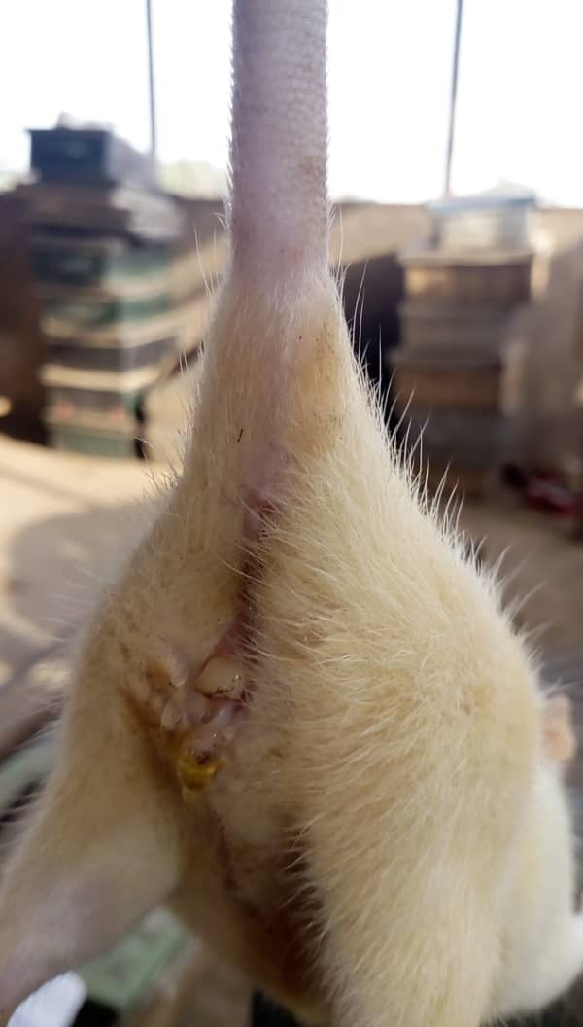

Figure 4: Showing vaginal plug in the females’ vagina clearly seen with the help of a ×5 magnifying

Acute toxicity study
This study followed Lorke's method and involved 12 adult female rats in two phases. In the first phase, three groups of rats were given different dosages of ethanol extract of X. aethiopica via orogastric administration. The rats were observed for signs of toxicity, such as hyperactivity, salivation, paw-licking, writhing, muscle paralysis, respiratory distress, and mortality within the first 4 hours and after 24 hours. In the second phase, three groups of animals were given different dosages of ethanol extract of X. aethiopica. The rats were observed for signs of toxicity and mortality at the first 4 hours, 24 hours, and 72 hours. Mortality was observed at the dosages of 2900 mg/kg and 5000 mg/kg. A fresh De Jalon solution was prepared and used for the organ bath experiment³⁹.
Histological examination
The uterine horns were examined for implantation and pregnancy resorption sites, and the number of fetuses. Endometrial samples were taken for histology, preserved with formalin, and sent to the Anatomy department of EBSU's histopathology laboratory. The tissue was fixed, embedded, sectioned, stained, and examined using a light microscope.

Experimental assessment of oxytocic effect
The study involved a surgical procedure where rats were sacrificed, and a caesarean section was performed. The uterine horns were dissected and cut into equal halves, and the tissue was aerated with oxygen at 300C. The uterus was suspended in the De Jalon Solution and allowed to equilibrate for 30 minutes before the experiment. The drug introduction was allowed a contact time of 30 seconds before stimulation, and the tissue was washed three times to remove any remnant drug. The kymograph was used for tracing contractions.
The experiment began with 0.1 to 1 international units of oxytocin, followed by varying concentrations of the extract in the organ bath. The effect of the fractions was also determined in the presence of 0.2 µg of calcium channel blocker verapamil. The procedure was repeated with both oxytocin and the extract, and the effects were recorded.
The data was meticulously documented and entered into the International Business Machine Statistical Package for Social Sciences (IBMSPSS) version 26, Chicago II, USA. Comparisons between groups were made using One-Way Analysis of Variance and Post Hoc Test, with a significance difference set at P < 0.05. The qualitative components of the study were analyzed manually.

Results
Acute toxicity studies
The acute toxicity of X. aethiopica’s ethanol fruit extract was assessed in rats after oral administration at dual doses (2900 mg/kg and 5000 mg/kg), with the median LD50 being 1703 mg/kg.

Qualitative phytochemical analysis of XA fruits
The study analyzed the phytochemical constituents of X. aethiopica fruits' ethanol extract, revealing ten secondary metabolites including alkaloids, flavonoids, cardiac glycosides, phenol, phlobatannins, terpenoids, tannins, steroids, saponins, and anthraquinones, as well as other compounds.

Table 1: Showing Outcome of the Phytochemical Screening of the Ethanol Extract of X. aethiopica Fruit
Phytochemical Constituents | Designation
Alkaloids | +
Flavonoids | ++
Cardiac glycosides | ++
Phenols | ++
Phlobatannins | +
Terpenoids | ++
Tannins | +
Steroids | ++
Saponins | +
Anthraquinones | +
Keys: + and ++ denoted less and more presence

Weight of the Pregnant Rats after 7 and 14 Days and comparison between groups
This study revealed mean ± SD of 184.50±14.50, 171.80±16.84, 172.67±18.03, 168.17±17.02 and 157.67±11.88 for the female pregnant wistar rats in groups 1, 2, 3, 4 and 5 respectively after 7 days. This study further indicated that 14 days, female pregnant wistar rats in groups 1, 2, 3, 4 and 5 presented mean ± SD of 210.67±14.22, 171.00±18.93, 180.83±16.63, 166.50±19.38 and 149.17±25.69 correspondingly.
No significance difference in weight was observed in the comparison of the weight of female pregnant wistar in group 1 to weight of female pregnant rats in groups 5 (P = 0.676), 2 (P = 0.694), 3 (P = 0.400), and 4 (P = 0.050) as well as the comparison of the weight of the female pregnant rats in group 5 to weight of female pregnant wistar rats in groups 2 (P = 1.000), 3 (P = 0.995) and 4 (P = 0.584) after 7 days.
Significance difference in weight was observed in the comparison of the weight of female pregnant wistar in group 1 to weight of female pregnant rats in groups 5 (P = 0.019), 3 (P = 0.005), and 4 (P = 0.000) but no significance difference was observed in the comparison of the weight female pregnant in group 1 to weight of pregnant female wistar rats in group 2 (P = 0.089). No significance difference in weight was observed in the comparison of the weight of the female pregnant rats in group 5 to weight of female pregnant wistar rats in groups 2 (P = 0.916), 3 (P = 0.995) and 4 (P = 0.364) after 14 days as shown in table 2.

Table 2: Showing Mean Weight of Female Pregnant Wistar Rats after 7 and 14 days and Comparison of Weight of Female Wistar Rats in Group 1 to weights of Pregnant Rats in Groups 5, 2. 3 and 4 and Weight of Pregnant Rats in Group 5 to Weight of Pregnant Rats in Groups 2, 3 and 4
 |  | Weight (g) | P-values ^{N} | P-values ^{P}
 | Groups | Mean ± SD
7th Days | 1 (Negative Control) | 184.50±14.50
7th Days | 5 (Positive Control) | 171.80±16.84 | 0.676
7th Days | 2 | 172.67±18.03 | 0.694 | 1.000
7th Days | 3 | 168.17±17.02 | 0.400 | 0.995
7th Days | 4 | 157.67±11.88 | 0.050 | 0.584
14th Days | 1 (Negative Control) | 210.67±14.22
14th Days | 5 (Positive Control) | 171.00±18.93 | 0.019
14th Days | 2 | 180.83±16.63 | 0.089 | 0.916
14th Days | 3 | 166.50±19.38 | 0.005 | 0.995
14th Days | 4 | 149.17±25.69 | 0.000 | 0.364
N and P are the P values when group 1 was compared to groups 5, 2, 3, and 4 as well as when group 5 was compared to group2, 3 and 4 correspondingly.

Tissue histology of endometrial plate
Plate 1: Tissue histology of group 1
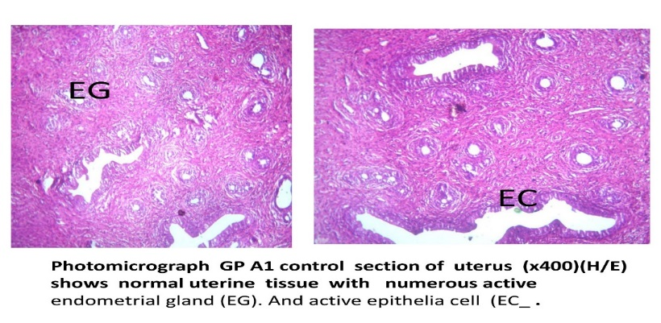

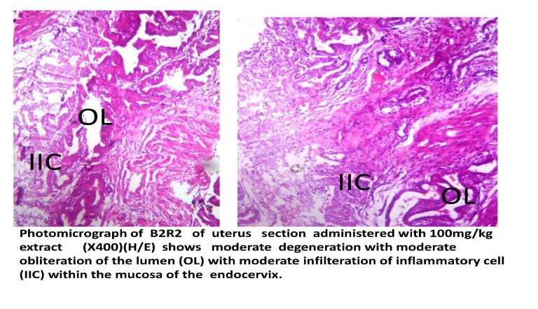
Plate 2: Tissue histology of group 2.

Plate 3: Tissue histology of group 3
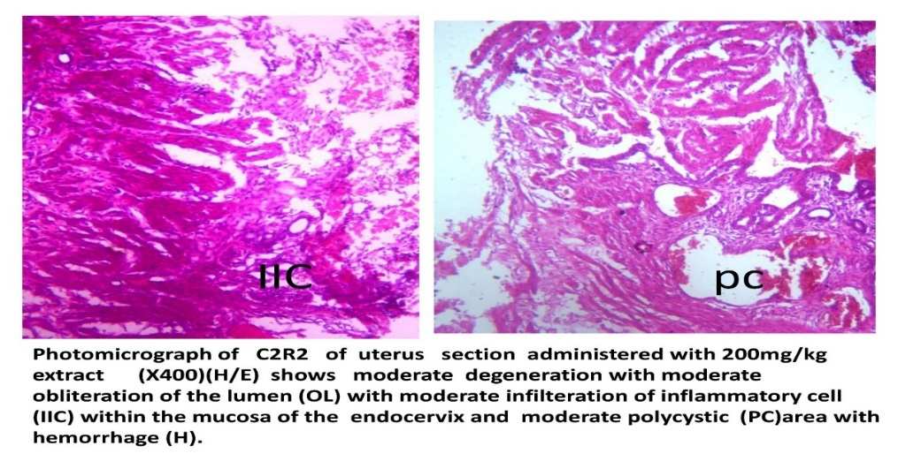

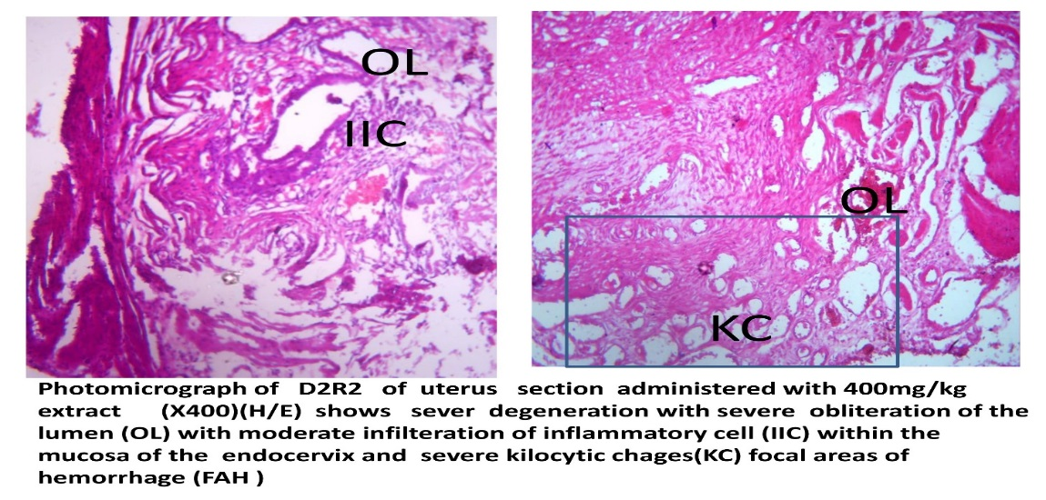
Plate 4: Tissue histology of group 4

Plate 5: Tissue histology of group 5
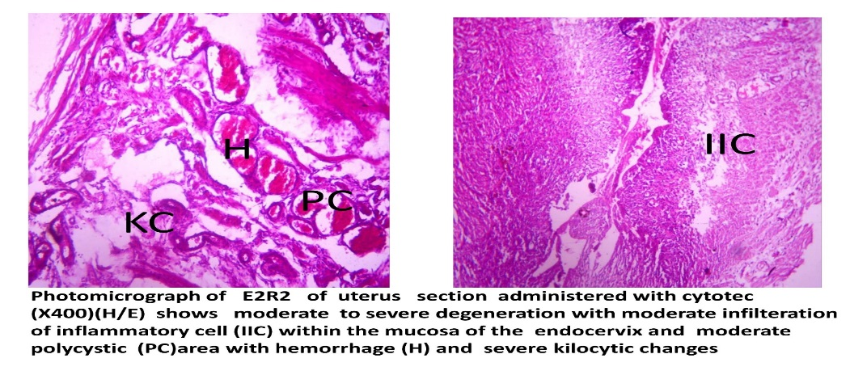

Response of uterus to oxytocin and ethanol extract of X. aethiopica
Ethanol extract of XA stimulated uterine contraction to peak once at 0.3cm which is like a twitch. On the other hand, the administration of oxytocin resulted to uterine contractions peaking at 1.4 cm decreasing to 0.8 cm and peaking to 1.3 cm which is the normal oxytocin curve as shown in Figure 5.
Figure 5: Showing Response of Uterine Contraction

Discussion
Phytochemicals, found in plants, are antinutrients with various nutritional, biological, and pharmacological properties. They play a crucial role in human health, influencing antioxidant activity, hormone mimicking, and disease suppression. Minerals in spices and food products are essential for human health and maintaining certain physicochemical processes. Some comounds, such as alkaloids, flavonoids, and terpenoids, can be toxic due to their ability to stimulate oxidative stress⁴⁰. A study found that the ethanol extract of X. aethiopica fruits had a lower LD50 (1703 mg/kg in rats) than the aqueous LD50 (2154 mg/kg)⁴¹. This study also found that the weight of female Wistar rats decreased with increasing dosage of the ethanol fruit extract, consistent with previous studies. The ethanol fruit extract caused a dose-dependent reduction in body weight, with death occurring in extreme cases.
The ethanol fruit extract of X. aethiopica did not show significant oxytocic effect in the organ bath experiment, as it only showed a twitch that was not enough to sustain uterine activity. This could be linked to the various roles or possible interplay between the phytochemical constituents in causing postpartum uterine relaxation. Tannic acid, flavonoids, alkaloids, and phenols have been shown to possess uterine stimulating effects.
The N-Haxane fruit extract of X. aethiopica showed some oxytocic effect at high doses on the guinea pig uterus more than Ocimum gratissium, but this was not statistically significant according previous findings⁴². Another study by Wood et al reported that the ethanol fruit extract of X. aethiopica caused relaxation of the wistar rat ileum, similar to the findings of this study⁴³.
Both the extract studied and oxytocin did not have effect on the virgin uterus, likely because oxytocin receptors develop in later dates of pregnancy.

Conclusion
In this current study, the investigation of the oxytocic effect of the X. aethiopica extract, it was found to cause postpartum uterine relaxation rather than contraction except the few occasional twitches caused by the extract.

References
1. Ameer MA, Chaudhry H, Mushtaq J, et al. An Overview of Systemic Lupus Erythematosus (SLE) Pathogenesis, Classification, and Management. Cureus. Oct 2022;14 (10):e30330.

2. Ameer MA, Fagan SE, Sosa-Stanley JN, Peterson DC. Anatomy, Abdomen and Pelvis: Uterus. StatPearls. StatPearls Publishing Copyright © 2024,
3. Clark KM, Pandya AM. Anatomy, Abdomen and Pelvis: Cardinal Ligaments (Mackenrodts, Transverse Cervical, or Lateral Cervical Ligaments). StatPearls. StatPearls Publishing Copyright © 2024, StatPearls Publishing LLC.; 2024.
4. Ramanah R, Berger MB, Parratte BM, DeLancey JO. Anatomy and histology of apical support: a literature review concerning cardinal and uterosacral ligaments. International urogynecology journal. Nov 2012;23(11):1483-94.

5. Ellis H. Anatomy of the uterus. Anaesthesia & Intensive Care Medicine. 2005/03/01/ 2005;6(3):74-75.

6. Philip M, Snow RJ, Gatta PAD, Bellofiore N, Ellery SJ. Creatine metabolism in the uterus: potential implications for reproductive biology. Amino Acids. 2020/09/01 2020;52(9):1275-1283.

7. Han C, Wang C, Han L, et al. Incarceration of the gravid uterus: a case report and literature review. BMC pregnancy and childbirth. Nov 8 2019;19(1):408.

8. Edwards JK, Solsona B, N EN, et al. Switching off hydrogen peroxide hydrogenation in the direct synthesis process. Science. 2009;323(5917):1037-41.

9. Hanuman S, Pande G, Nune M. Current status and challenges in uterine myometrial tissue engineering. 2023;14(1):2251847.

10. Taylor AH, Habiba M. The Myometrium in Heath and Disease. In: Habiba M, Benagiano G, eds. Uterine Adenomyosis. Springer International Publishing; 2016:71-79.

11. Liapis K, Tasis N. Anatomic variations of the Uterine Artery. Review of the literature and their clinical significance. Mar 2020;17(1):58-62.

12. Selçuk İ, Öz M. Para-aortic lymphadenectomy: step by step surgical education video. Aug 31 2021;22(3):253-254. doi:10.4274/jtgga.galenos.2019.2019.0117

13. Koutras A, Fasoulakis Z, Syllaios A, et al. Physiology and Pathology of Contractility of the Myometrium. In vivo (Athens, Greece). May-Jun 2021;35(3):1401-1408. doi:10.21873/invivo.12392

14. Barjon K, Mikhail LN. Uterine Leiomyomata. StatPearls. StatPearls Publishing Copyright © 2024, StatPearls Publishing LLC.; 2024.
15. McLintock C. Prevention and treatment of postpartum hemorrhage: focus on hematological aspects of management. Hematology American Society of Hematology Education Program. Dec 4 2020;2020(1):542-546. doi:10.1182/hematology.2020000139

16. Lee HJ, Macbeth AH, Pagani JH, Young WS, 3rd. Oxytocin: the great facilitator of life. Prog Neurobiol. Jun 2009;88(2):127-51. doi:10.1016/j.pneurobio.2009.04.001

17. Viero C, Shibuya I, Kitamura N, et al. REVIEW: Oxytocin: Crossing the bridge between basic science and pharmacotherapy. CNS Neurosci Ther. Oct 2010;16(5):e138-56. doi:10.1111/j.1755-5949.2010.00185.x

18. Grinevich V, Neumann ID. Brain oxytocin: how puzzle stones from animal studies translate into psychiatry. Jan 2021;26(1):265-279. doi:10.1038/s41380-020-0802-9

19. Begley C, Nilsson C, Wijk H, Lindahl G, Uvnäs-Moberg K, Berg M. Herd. doi:10.1177/19375867221124232

20. Uvnäs-Moberg K. The physiology and pharmacology of oxytocin in labor and in the peripartum period. American journal of obstetrics and gynecology. Mar 2024;230(3s):S740-s758. doi:10.1016/j.ajog.2023.04.011

21. Uvnäs-Moberg K. The physiology and pharmacology of oxytocin in labor and in the peripartum period. American journal of obstetrics and gynecology. 2023;230 3S:S740-S758.

22. Hermesch AC, Kernberg AS, Layoun VR, Caughey AB. Oxytocin: physiology, pharmacology, and clinical application for labor management. American journal of obstetrics and gynecology. 2024/03/01/ 2024;230(3, Supplement):S729-S739. doi:https://doi.org/10.1016/j.ajog.2023.06.041

23. Bell AF, Erickson EN, Carter CS. Beyond labor: the role of natural and synthetic oxytocin in the transition to motherhood. Journal of midwifery & women's health. Jan-Feb 2014;59(1):35-42: quiz 108. doi:10.1111/jmwh.12101

24. Uvnäs-Moberg K, Ekström-Bergström A, Berg M, et al. Maternal plasma levels of oxytocin during physiological childbirth - a systematic review with implications for uterine contractions and central actions of oxytocin. BMC pregnancy and childbirth. Aug 9 2019;19(1):285. doi:10.1186/s12884-019-2365-9

25. Uvnäs-Moberg K, Ekström-Bergström A, Berg M, et al. Maternal plasma levels of oxytocin during physiological childbirth – a systematic review with implications for uterine contractions and central actions of oxytocin. BMC pregnancy and childbirth. 2019/08/09 2019;19(1):285. doi:10.1186/s12884-019-2365-9
26. Jones AJ, Federspiel JJ, Eke AC. Preventing postpartum hemorrhage with combined therapy rather than oxytocin alone. American journal of obstetrics & gynecology MFM. Feb 2023;5(2s):100731. doi:10.1016/j.ajogmf.2022.100731

27. Jaffer D, Singh PM, Aslam A, Cahill AG, Palanisamy A, Monks DT. Preventing postpartum hemorrhage after cesarean delivery: a network meta-analysis of available pharmacologic agents. American journal of obstetrics and gynecology. Mar 2022;226(3):347-365. doi:10.1016/j.ajog.2021.08.060

28. Ugbogu EA, Emmanuel O, Dike ED, et al. The Phytochemistry, Ethnobotanical, and Pharmacological Potentials of the Medicinal Plant-Vernonia amygdalina L. (bitter Leaf). Clinical Complementary Medicine and Pharmacology. 2021/12/01/ 2021;1(1):100006. doi:https://doi.org/10.1016/j.ccmp.2021.100006

29. Anyamele T, Ugbogu EA, Nwankwo VC, Ibe C. A review of the traditional uses, phytochemistry and toxicological profile of Xylopia aethiopica A.Rich. Pharmacological Research - Natural Products. 2023/12/01/ 2023;1:100001. doi:https://doi.org/10.1016/j.prenap.2023.100001

30. Jahan S, Mozumder ZM, Shill DK. Use of herbal medicines during pregnancy in a group of Bangladeshi women. Heliyon. 2022/01/01/ 2022;8(1):e08854. doi:https://doi.org/10.1016/j.heliyon.2022.e08854

31. Adeoye I, Etuk V. Prevalence, predictors and pregnancy outcomes of unprescribed and herbal medicine use in Ibadan, Nigeria. BMC Complementary Medicine and Therapies. 2023/01/20 2023;23(1):17. doi:10.1186/s12906-023-03838-8

32. Katawa G, Ataba E. Anti-Th17 and anti-Th2 responses effects of hydro-ethanolic extracts of Aframomum melegueta, Khaya senegalensis and Xylopia aethiopica in hyperreactive onchocerciasis individuals' peripheral blood mononuclear cells. Apr 2022;16(4):e0010341. doi:10.1371/journal.pntd.0010341

33. Johnson DM, Murray NA. A revision of Xylopia L. (Annonaceae): the species of Tropical Africa. PhytoKeys. 2018;97:1-252. doi:10.3897/phytokeys.97.20975

34. Fategbe MA, Avwioroko OJ, Ibukun EO. Comparative Biochemical Evaluation of the Proximate, Mineral, and Phytochemical Constituents of Xylopia aethiopica Whole Fruit, Seed, and Pericarp. Preventive nutrition and food science. Jun 30 2021;26(2):219-229. doi:10.3746/pnf.2021.26.2.219

35. Yin X, Chávez León M, Osae R, Linus LO, Qi LW, Alolga RN. Xylopia aethiopica Seeds from Two Countries in West Africa Exhibit Differences in Their Proteomes, Mineral Content and Bioactive Phytochemical Composition. Molecules (Basel, Switzerland). May 23 2019;24(10)doi:10.3390/molecules24101979
36. Nakaziba R, Lubega A. Phytochemical Analysis, Acute Toxicity, as well as Antihyperglycemic and Antidiabetic Activities of Corchorus olitorius L. Leaf Extracts. 2022;2022:1376817. doi:10.1155/2022/1376817

37. Thotathil V, Sidiq N. Phytochemical Analysis of Anastatica hierochuntica and Aerva javanica Grown in Qatar: Their Biological Activities and Identification of Some Active Ingredients. Apr 11 2023;28(8)doi:10.3390/molecules28083364

38. Afzal T, Bibi Y, Ishaque M, et al. Pharmacological properties and preliminary phytochemical analysis of Pseudocaryopteris foetida (D.Don) P.D. Cantino leaves. Saudi journal of biological sciences. Feb 2022;29(2):1185-1190. doi:10.1016/j.sjbs.2021.09.048

39. Tata CM, Sewani-Rusike CR, Oyedeji OO, Gwebu ET, Mahlakata F, Nkeh-Chungag BN. Antihypertensive effects of the hydro-ethanol extract of Senecio serratuloides DC in rats. BMC Complement Altern Med. Feb 28 2019;19(1):52. doi:10.1186/s12906-019-2463-2

40. Dias MC, Pinto D. Plant Flavonoids: Chemical Characteristics and Biological Activity. Sep 4 2021;26(17)doi:10.3390/molecules26175377

41. Obiri DD, Osafo N. Aqueous ethanol extract of the fruit of Xylopia aethiopica (Annonaceae) exhibits anti-anaphylactic and anti-inflammatory actions in mice. J Ethnopharmacol. Jul 30 2013;148(3):940-5. doi:10.1016/j.jep.2013.05.047

42. Biney RP, Benneh CK, Ameyaw EO, Boakye-Gyasi E, Woode E. Xylopia aethiopica fruit extract exhibits antidepressant-like effect via interaction with serotonergic neurotransmission in mice. Journal of ethnopharmacology. 2016/05/26/ 2016;184:49-57. doi:https://doi.org/10.1016/j.jep.2016.02.023

43. Woode E, Ameyaw EO, Boakye-Gyasi E, Abotsi WK. Analgesic effects of an ethanol extract of the fruits of Xylopia aethiopica (Dunal) A. Rich (Annonaceae) and the major constituent, xylopic acid in murine models. J Pharm Bioallied Sci. Oct 2012;4(4):291-301. doi:10.4103/0975-7406.103251

