Original Research Article
Effect of workload and pedalling rate on physiological response for male worker

ABSTRACT
Until about two and half centuries ago, muscle power was the prime source of energy for performing all the physical activities on our earth, and much of this power had been from human muscles. Because of the socio-economic conditions of farmers in developing countries including India, human muscle power is going to contribute energy requirements for performing many farm activities for the next two decades. Pedalling is the most efficient way of utilising power from human muscles. Pedal power enables a person to drive devices at the same or higher rate as that achieved by hand cranking, but with far less effort and fatigue. However, the use of pedal power for occupational work such as stationary farm operations has got scant attention in the past. Keeping these points into consideration a study was planned for Effect of workload and pedalling rate on physiological response for male worker. Physiological responses of 20 male subjects were studied on a computerised bicycle ergometer at four levels of power output (60, 70, 80, 90 W) four levels of pedalling rates (40, 50, 60, 70 rev/min). Analysis of data indicated that physiological responses were significantly affected with power output as well as pedalling rate. Increases in physiological responses (heart rate and oxygen consumption rate) over rest were significantly higher when pedalling frequency was 50rev/min and above 60rev/min. There was no significant difference between physiological responses at 50 and 60 rev/min. Physiological responses increased linearly with power output and were significantly different at different power outputs. The average value of physiological responses at 60W power output at male agriculture worker at 50rev/min pedalling rate were within acceptable limits for continuous pedalling work.
Keywords: Heart rate, OCR, Work load, pedalling rate, EER.
INTRODUCTION
As we know that India is a developing country with the farm power availability about 1.84 kW/h (Mehta et al., 2014) most of farming operation like weeding, harvesting etc. are done by manually. In India in remote villages, where electric power supply is not available and repair and maintenance facilities for internal combustion engines are rare, human power is still one of the major contributors of energy for production agriculture as well as for post-harvest agricultural operations.
Human energy has generally been utilized through arms, hands, and back. It was only with the invention of the bicycle; those legs also began to be considered as a means of developing power from human muscles. The power levels that a human being can produce through pedalling depend on how strong he/she is and on how long he/she can pedal. If the task to be powered has to continue for hours at a time, 75W mechanical power is generally considered the limit for a larger, healthy non-athlete. A person who is smaller and less nourished, but not ill, would produce less; the estimate for such a person should probably be 50 W for the same kind of power production over an extended period (Wilson, 1986). Looking into the increasing prices and unreliable supplies of petroleum fuels and non availability of repair and maintenance facilities in remote villages in India, the internal combustion engines are not so attractive power source especially for stationary farm operations and pedal-powered devices may be much more suitable. Performance during pedalling work is affected by the interaction of a number of variables including pedalling technique (workload, pedalling rate and posture), pedalling device (pedal type, saddle height, crank length and head angle), environment (temperature, humidity and air velocity), and human factors (age, gender, weight and training level). There are few studies available on Indian farm worker to referring to their pedalling operation and power output. It becomes necessary to study for workload study for physiological cost of operation in pedalling operation.
MATERIALS AND METHODS
Selection of Subjects
Twenty male subjects were selected in the age group of 20-45 years because they usually attain their highest strength level between 20-45 years (Mc Ardle et al., 2001). All the subjects were physically fit and were not suffering from any physical anamalities to perform the selected activity. Resting heart rate of the subject should not be more than 80 beats/min of any subject as subject having resting heart rate of more than 80 beats/min might be having some physical/psychological problem. Subjects were given training of using the setup/machine with complete operational techniques involved in it. The selected subjects were representative of user’s population (5th to 95th percentile of stature and body weight) of male agriculture workers.
Measurement of HR, OCR and EER
Heart rate is a number of ventricular beats per min and OCR is oxygen taken by the subject per minute. It is sensitive fine discriminating measure for evaluating strain in muscular work. In addition to this, heart rate and OCR can be measured and analyzed easily in practice without any disturbance to the worker by using Computerized Ambulatory Metabolic Measurement System used in study. The instrument is Cosmed make K4b² model of Italy.
The HR _{work} and the OCR (VO_{2 work}) was measured between 6th to 20th minute of work of each subject as it is considered that the heart rate gets stable after 3-5th minute of the work (Astrand and Rodahl, 1977). The average HR and OCR were taken as representative value for each subject for the working duration.
The energy expenditure rate was calculated in kJ/min multiplying the OCR (l/min) with 20.93 (1 litre O₂ = 20.93 kJ). The maximum heart rate of an adult can be determined by the following formula:
Max. heart rate (beats/min) = 220- Age. (Robergs R and Landwehr R, 2002)
For experimentation the heart rate of the subject should not exceed to the 85 percent of the maximum heart rate of the subject.
Experimental procedure
Subjects were asked to report in the laboratory at 9 AM for the measurement of physiological responses on the bicycle ergometer. The subjects were instructed to have a light breakfast about 2 hr before they report in the laboratory. All the trials were conducted between 10:00 AM to 01:30 PM and 02:30 PM to 05:00 PM in a controlled environment condition. The dry bulb temperature in the laboratory varied from 23 to 27ºC and relative humidity varied from 50 to 60% during the experiment. A minimum gap of 2 hr was maintained between food intake and start of a trial. After arrival in the laboratory, each subject was given a warm up exercise on a bicycle ergometer and was allowed to ride the ergometer to make himself familiar with the machine.
The subject was prepared for trial by fastening the Polar chest belt and facemask with other accessories and was allowed to sit on chair in rest position. Physiological responses for first 5 min were taken while the subject was resting by sitting on a chair. Minimum heart rate and oxygen consumption rate had been reported at saddle height of 100% of trochanteric height (Nordeen- Snyder, 1977; Price and Donne, 1997). Therefore, the saddle height for this experiment was set equal to the trochanteric height of the subject. The crank length was kept standard (178.5 mm) as supplied with the ergometer. After taking 5 min data of physiological responses during resting the subject was asked to start pedalling work on the bicycle ergometer at a pre-set pedalling rate. The metronome for pedalling rate was set as per the requirement for that trial. The subject was attend to monitor the desired pedalling rate according to the display on the ergometer. The workload was increasing the level required for the trial within first 30 second using the load increasing screw on the ergometer. The subject worked on the ergometer at the set pedalling rate and workload for duration of 15 min. At the end of 15 min trial he was asked to stop pedalling work, get down from the ergometer and have rest while sitting on a chair placed by the side of the ergometer.

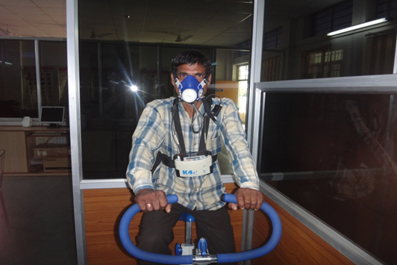 | 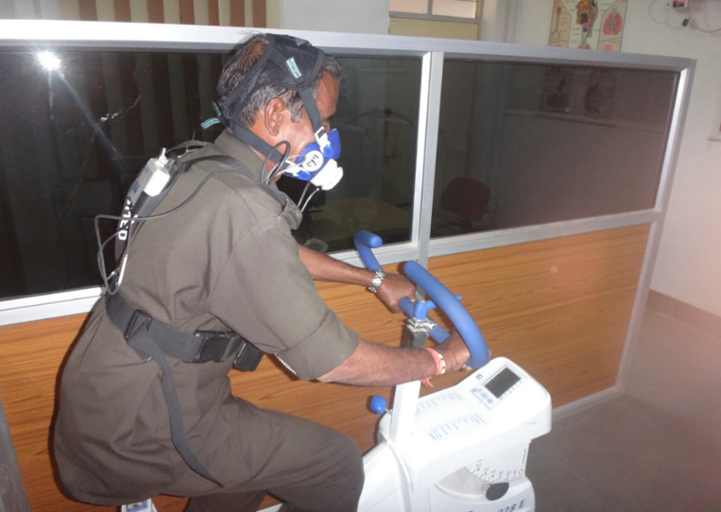
Fig 1: Physiological cost estimation of male agricultural workers
Meanwhile another subject was prepared for experiment by mounting the gadgets as described earlier. Similar resting heart rate and OCR was recovered. After that second subject was allowed to ride the bicycle ergometer and pedal at same rpm and load condition. The subject was allowed to take rest for two hour to settle down and remove the residual effect of first set of load. After gap of two hours the procedure was repeated for first subject followed by second subject as described earlier but for different load condition.
RESULTS AND DISCUSSION
Effect of workload on heart rate in pedalling operation
The mean heart rate (n=20) increased from 117.26 to 149.52 beats/min with increasing load from 60 W to 90 W with mean heart rate of 133.20 beats/min. These values differ significantly at 1 percent for each load condition.

Fig 2: Relation between work load and working heart rate
The relationship between work load in pedalling operation and working heart rate is linear with high degree of positive correlation as evident in fig 1 and correlation coefficient.
Considering the acceptable limit of 110 beats/min of heart rate for continuous work as proposed by Saha et al. (1979) and taking the value of resting heart rate as 70 beats/min, the acceptable limit of ∆HR for continuous work comes to 40 beats/min. Wilson (1986) reported that the reasonable workload for continuous power generation for the Western population would be about 75 W for a young and healthy person. He also reported that pedalling at a load of about 90W could be sustained for around 60 min. In present study the power outcome from male subject were considered as 60 W for continuous work for Indian male agriculture workers.
Effect of workload on oxygen consumption rate in pedalling operation
The oxygen consumption rate (OCR) of male agriculture workers increases with the increasing work load in pedalling operation. The mean OCR (n=20) increased from 939 ml/min to 1400 ml/min with increasing with increase in load from 60 W to 90 W. These values significantly differ for each load condition at percent level of significance.

Fig 3: relation between work load and working OCR
The relationship between work load and oxygen consumption rate in pedalling operation is linear with high degree of position correlation as evident in fig 2 and correlation coefficient values for all the pedalling rate.
The acceptable limit of oxygen consumption rate (OCR) for continuous was considered work as 35 per cent of VO₂ max, as proposed by Saha et al. (1979). Based on the power outcome from male subject were considered as 60 W for continuous work.
Effect of work load on Energy Expenditure rate.
The Energy Expenditure rate (EER) increased with the increasing work load at different pedalling rates. The average Energy Expenditure rate (n=20) increased from 16.64 kJ/min to 29.28 kJ/min with the increase in load from 60 W to 90 W.
Table 1: physiological cost of work for male subject at different power output
Power output, W | Pedalling rate, rev/min | Avg. HR(work) beats/min | Avg.OCR (work) l/min | Energy expenditure kJ/min | Avg. EER, kJ/min
60 | 40 | 120.17 | 0.84 | 17.58 | 16.64
60 | 50 | 116.83 | 0.77 | 16.11 | 16.64
60 | 60 | 114.92 | 0.79 | 16.53 | 16.64
60 | 70 | 117.09 | 0.82 | 17.16 | 16.64
70 | 40 | 130.77 | 1.17 | 24.50 | 23.53
70 | 50 | 127.10 | 1.11 | 23.23 | 23.53
70 | 60 | 124.24 | 1.08 | 22.62 | 23.53
70 | 70 | 128.12 | 1.14 | 23.87 | 23.53
80 | 40 | 142.74 | 1.35 | 28.26 | 26.56
80 | 50 | 137.01 | 1.25 | 26.16 | 26.56
80 | 60 | 136.32 | 1.19 | 24.92 | 26.56
80 | 70 | 137.82 | 1.29 | 27.01 | 26.56
90 | 40 | 154.74 | 1.44 | 30.14 | 29.28
90 | 50 | 148.44 | 1.40 | 29.32 | 29.28
90 | 60 | 147.20 | 1.34 | 28.05 | 29.28
90 | 70 | 147.69 | 1.42 | 29.73 | 29.28

The limit of Energy Expenditure rate for continuous operation in 4 kcal/min i.e 20.93 kJ/min according to Murrel formula therefore the work load or power output for male agriculture workers for continues work was 60 W as EER for this work load is 16.64 kJ/min only. A load above 60 W work rest cycle should be adopted to avoid fatigue and get better work performance.
CONCLUSION
Based on the study it was concluded that at a given power output the physiological responses during pedalling on bicycle ergometer, heart rate and oxygen consumption rate increased linearly with increased power output at each pedal rate. Male subject mean working heart rate, oxygen consumption rate and energy expenditure rate were 133.20(± 20) beats/min, 1.18 (± 0.26) lit/min and 24.77 (± 5.9) kJ/min respectively. It was concluded that for Indian agricultural workers the muscular power output in pedalling mode, which could be sustained for long duration pedalling work is 60W based on heart rate, oxygen consumption rate and Energy Expenditure rate.
REFERENCES
Astrand, I., 1960, Aerobic work capacity in men and women. Acta Physiologica Scandinavica. 4, Supplement 169.
Astrand, P. O. and Rodahl, K., 1977, A Texbook of Work Physiology. New York: Mc.Graw Hill.
Christensen, E. H., 1953, Physiological valuation of work in Nykroppa iron works. In W.F. Floyd and t Wellford (eds), Ergonomics Society Symposium on fatigue, Lewis,London., 93-108.
Gite.L. P., 2009, A Texbook of Anthropometric and strength data of Indian agriculture worker for farm equipment design. CIAE, Bhopal
Marsh, A. P. and Martin, P. E., 1997, Effect of cycling experience, aerobic power and power output on preferred and most economical cycling cadences. Med. Sci. Sports Exerc., 29 (9): 1225-1232.
Mehta, C. R., Chandel, N. S. and Senthilkumar, T., 2014, Status, Challenges and Strategies for Farm Mechanization in India. Agricultural mechanization in asia, africa, and latin America., 45(4): 43-50
Murrel, K. F. H., 1965, Ergonomics: Man in His Working Environment. Chapman and Hall Ltd., London., 239-242.
Robert, A. Robergs and Roberto Landwehr., 2002, The surprising history of the “HRmax=220-age” equation. J. of Exercise Physiology online., 5(2):1-10.
Saha, P. N., Datta, S. R., Banerjee, P. K. and Narayane, G. G., 1979, An acceptable workload for Indian workers. Ergonomics., 22: 1059-1071.
Shephard, R. J., 1967, Physiological determinants of cardiorespiratory fitness. J. Sports Med. Phys. Fitness., 7:111-134.
Tiwari, P. S., Gite, L. P., Pandey, M. M. and Shrivastava, A. K., 2011, Pedal power for occupational activities: Effect of power output and pedalling rate on physiological responses. International J. of Industrial Ergonomics.,41: 261-267.
Wilson, G. D., 1986, Understanding Pedal Power. Volunteers in Technical Assistance, Virginia, USA.

