IMPACT OF VARIOUS PRESOWING SEED TREATMENTS ON
Teak (TECTONA GRANDIS L.f)

Abstract - The world's most magnificent cylindrical deciduous tree, the teak (Tectona grandis), is well-known for its industrial uses. Since ancient times, teak has also been used in building projects. Its characteristic reddish-brown hue is the main cause of this. The most sought-after species in the furniture production sector is teak because of its fine-grained finish and leathery appearance. The current study examined the impact of various seed treatment techniques on teak germination at the Neotia University West Bengal agroforestry nursery. It includes data on the commercial cultivation of teak as well as the development and performance of Tectona grandis in four seed treatment techniques, namely. (T₁) For 48 hours, seeds were submerged in cold water. (T₂) For seventy-two hours, seeds were submerged in cold water, (T₃) For 10 minutes, seeds were immersed in 80% H₂SO₄, (T₄) Control. After five months, the performance of the seedlings was measured. The results revealed that the maximum germination percentage (40.83%), collar diameter (1.23 cm) and root length (35.35 cm) was found in T₃ (Seeds were soaked in (80%) H₂SO₄) while the highest seedling height (30.22 cm) was recorded in T₂ (Seeds were soaked in cold water for 72 hours) treatments. According to the study, a 10-minute conc. H₂SO₄ (80%) treatment for seed germination produces good results, breaks dormancy easily, and produces healthy seedlings.

Key words: seed treatment, germination percentage and growth.

Introduction – Tectona grandis was first formally described by Carl Linnaeus the Younger in his 1782 work Supplemental Plantarum (Cardoso, 2015). Teak occurs in natural forests between 9° to 26° N latitude and 73° to 104° E longitude, which includes southern and central Indiameter, Myanmar, Laos People's Democratic Republic and northern Thailand (White, 1991). A member of the Verbenaceae family, teak (Tectona grandis) is the most beautiful cylindrical deciduous tree in the world and is extensively used in industry worldwide. For the compliant tree, regional names include Brazil Teca, Indiameter Sagwan, Thekku, and Java-Teak in Germany. Teak wood is a luxurious species hardwood with physical properties, durability, and good esthetic (Sanwo, 1987). Teak wood has a medium specific gravity, strength and dimensional stability (Freitas, 1958), corrosion resistance and easy processing with good seasoning performance, and reputed for its excellent weathering and decay resistance (Baille`res and Durand 2000).
The inborn qualities of teak timber, fast growth rate with elasticity in seedling establishment mechanism makes it superior species in all aspects in many counties (Indra and Basha, 1999). Although Teak having good market value, but people do not interest in growing teak seedling in their own farm due to their low germination percentage. Jackson (1994) also stated that the drupes germinate very slowly and asymmetrical if they are untreated. Uncertainty germination provides low quality seedlings as well as degraded timber quality. So that the management cost of teak nursery increases. Several studies found that the Teak seeds have a low moisture content because of which they are inactive., (Adhikari et al., 2021). But hydro-priming beforehand encourages water imbibition, which makes enzymes active, moves them, and enables them to utilize food that has been kept. Therefore, it is a more challenging subject for each forester to find out the correct and easy pre seed treatment methodology for Teak seed germination, which help to reduce the failure percentage of seed plantation works. Many researcher climes that pre-sowing treatment of teak seed can enhance the seed germination percentage (Palani et al., 1996, Billah et al., 2015). Therefore, the goal of the study is to determine the best ways to break the dormancy of T. grandis seeds and to determine their germination length, germination percentage, and germination rate under the current conditions.
Material and methods- The Neotia University agroforestry nursery select for following teak germination study, which is located at Amira, Diamond Harbour road, West Bengal Pin 733368 (See Fig 1). Ranging between 22⁰.15’38’N to 88⁰.11’53’’E.
Fig 1
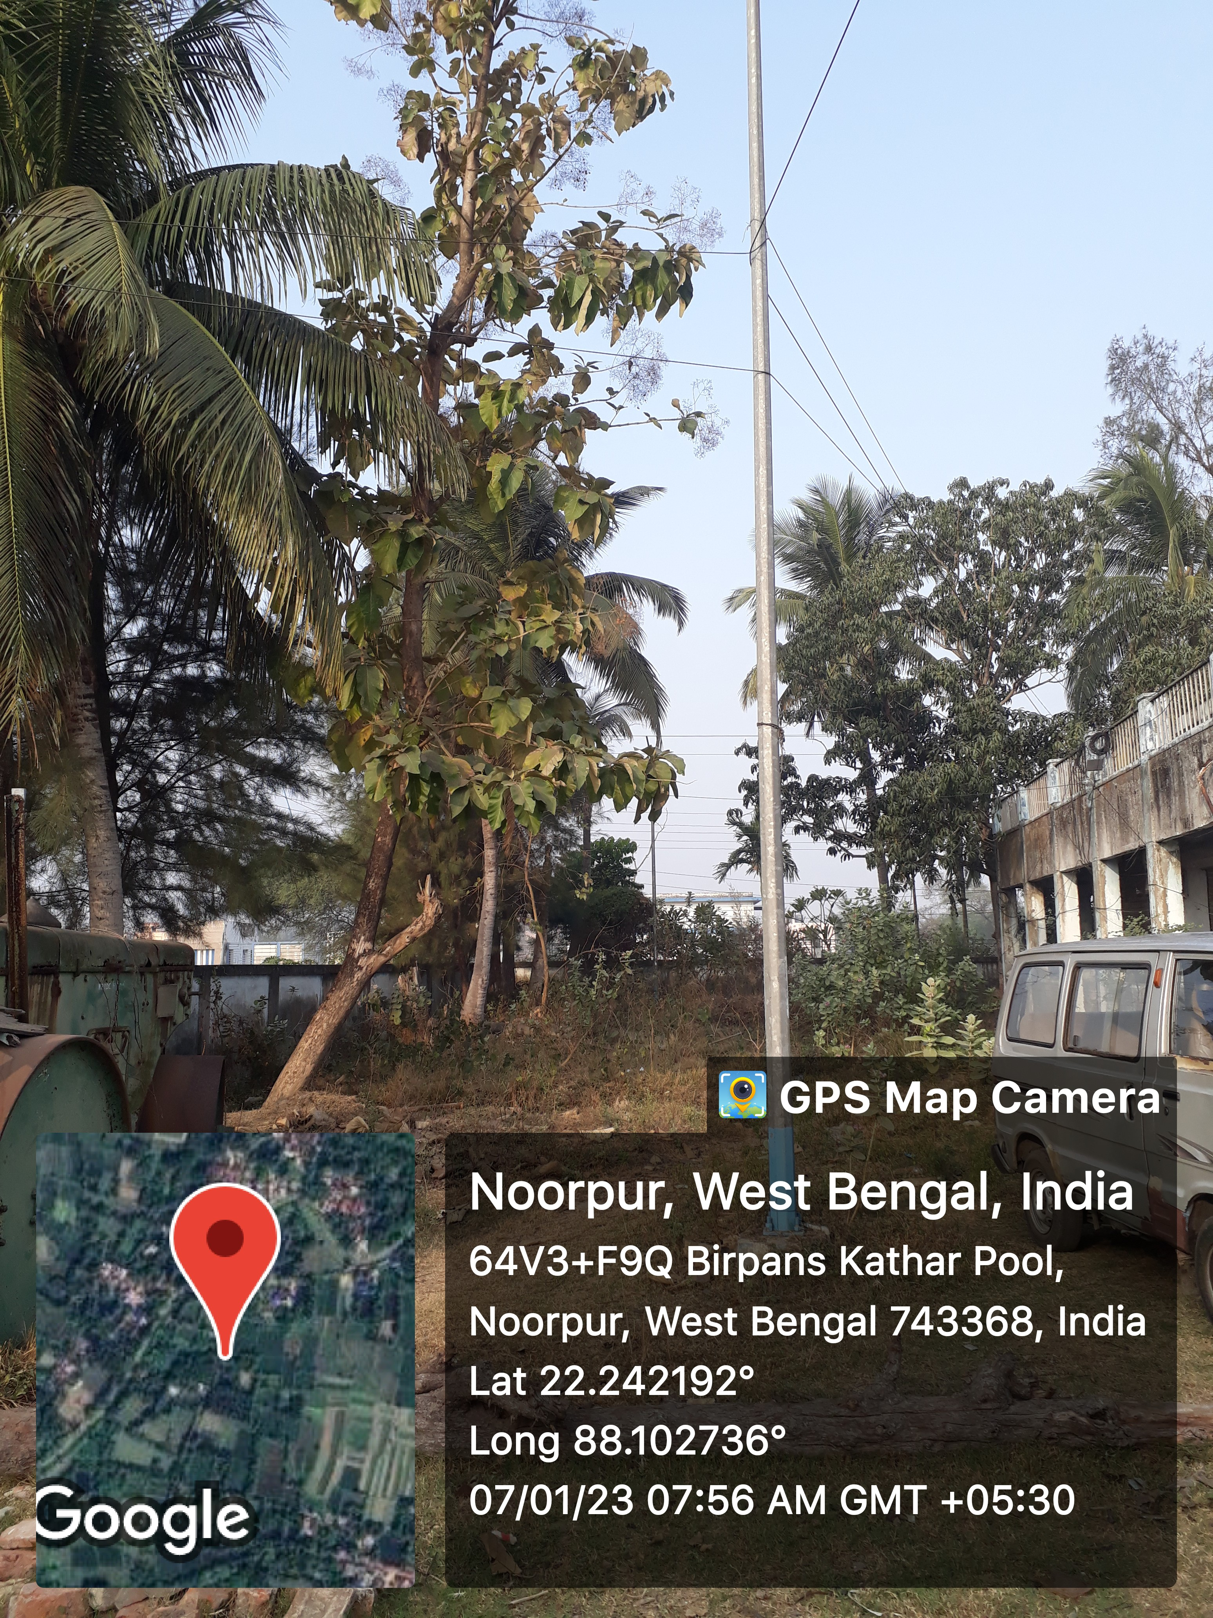

Teak Mother Plant Teak seedling after five months

Teak seeds were collected from 50 km (Falta, Sector Number 4 South 24 Phargna) from the university, during the cold season (December-January) 2023. The seeds were immersed in room temperature water to hasten the germination process for 12 hours (Njehoya et al. 2014). Subsequently, four treatments were created, each of which has 50 seeds.
T₁ = Seeds were soaked in cold water for 48 hours.
T₂ = Seeds were soaked in cold water for 72 hours.
T₃= Seeds were soaked in (80%) H₂SO₄ for 10 minutes.
T₄= Control.
Which was replicated four times. Following seed treatment, the seeds were allowed to dry overnight at room temperature.

Fig 2
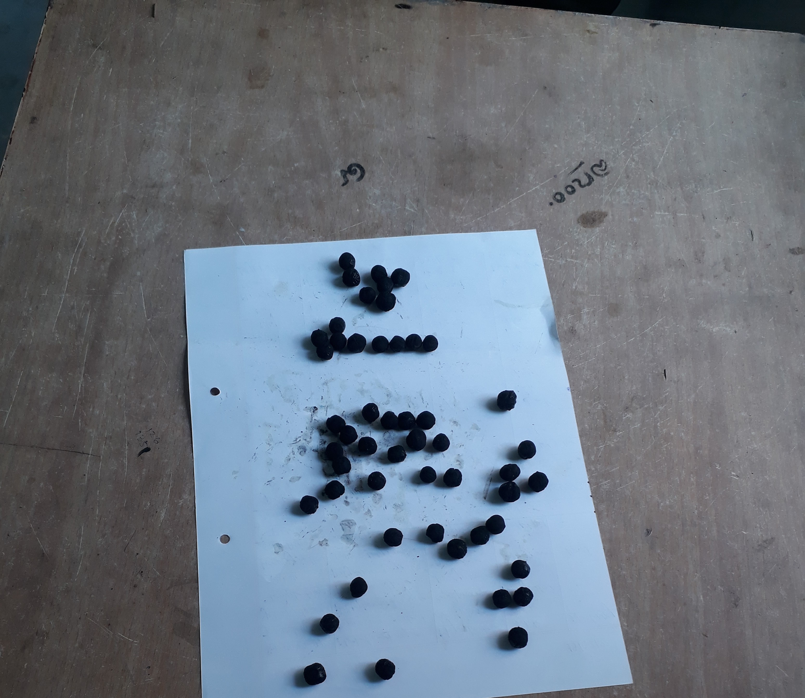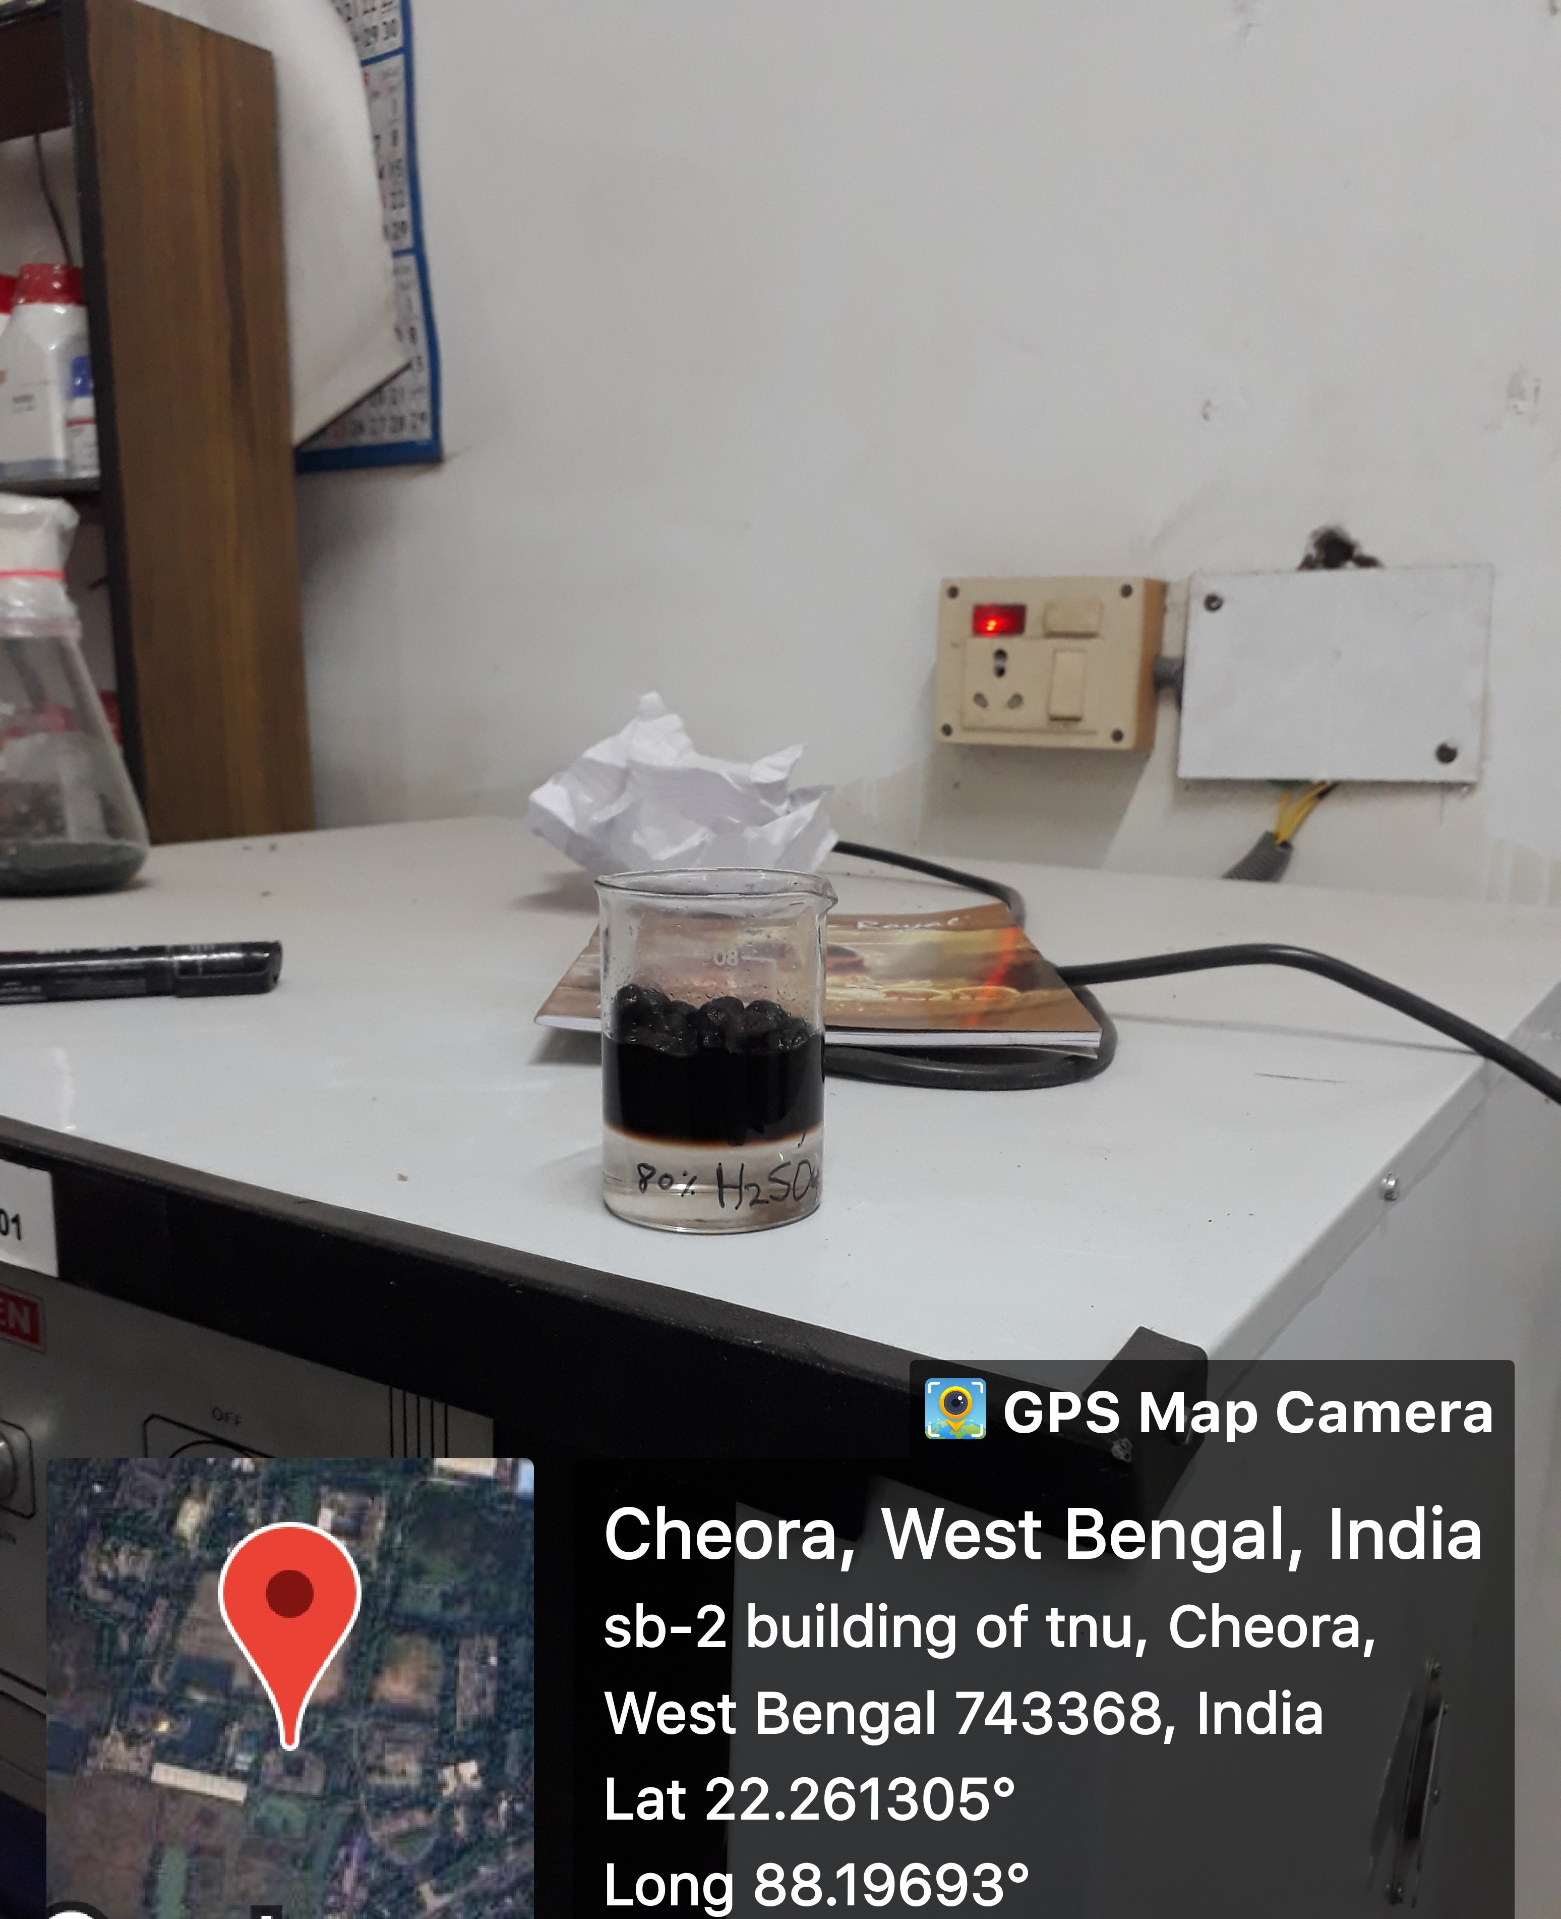
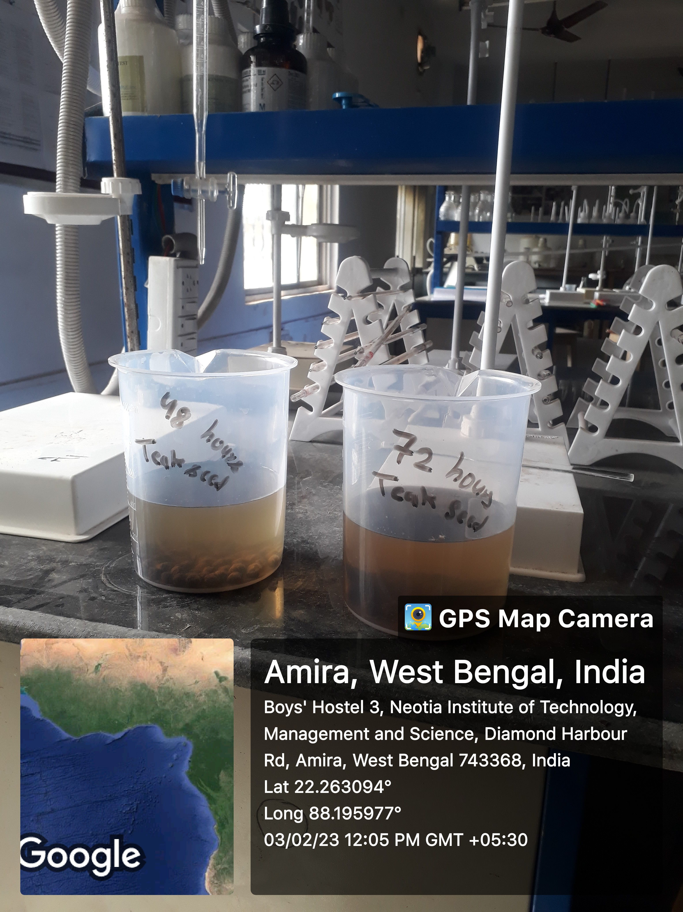
Water treatment for teak seeds Teak seed treated with 80% H₂SO₄

From each seed treatment, five seeds per poly-packet (5 × 7 inch) were planted at a depth of 2 cm. (Cardoso et al. 2006) in rooting medium containing sand: soil: vermi-compost in the ratio of 1:1:1. Due to urbanization, some limitations occur for sunlight facilities in the agroforestry nursery areas during the research work. The pond water was used for irrigation purpose which was given after each and every 2 days. The germinants emerging at weekly interval up to four weeks.

Germination % | Number of germinated seeds | × 100
Germination % | Number of the total seed | × 100

The seedling height and collar diameter-meter was measured at 5th month of sowing. All reported results were manually clustered for treatment-wise under four replications focused on different observable criteria and analyzed using one-way analysis of variance (ANOVA) for complete randomized block design (CRD). Duncan’s multiple range tests at a 5% level of probability was done to compare the means.
Results and Discussion
Effect of different treatment on seed germination
Teak is a king of timber and one of the superior species which is grow in various types of soils prior to planting of viable seeds into the germination bed treatment of seeds with appropriate mechanical, chemicals or biological means is needed to break the dormancy of seed germination. Because of the thick seed coat, the seed consumes water gradually resulting in sluggish germination and hence field emergence is always a problem in bitter gourd, even with the seed having high germinability (Asna et al., 2020).
The results revealed that the seed germination percent was found very well in T₃ (40.83) followed by treatment T₂ (31.04), and T₁ (26.33) percent. The Teak seed germination list was found in control T₄ (25.42) percent. Hossain et al., (2002) found similar results in their investigation. Numerous writers have maintained that many presowing techniques increase the germination rate and quicken the germination process. (Teketay, 1996; Alamgir and Hossain, 2005 and Azad et al., 2010a, b). In general, the pericarp of the teak diameter spore is impervious to water and shields the seeds. It consists of a seed or spore together with any extra tissues that aid in dispersal. Additionally, the mesocarp and endocarp have a layer of thick-walled palisade cells that are covered in waxy cuticles on the outside, which results in seed dormancy (Diameters et al. 2009). The limiting variables include the seed's physiological immaturity and the presence of chemical inhibitors in the pericarp (Georgin et al. 2014). Inhibitors can be broken down and the seed coat softened by soaking the seeds in intense sulfuric acid or other chemicals. The positive effect of sulfuric acid on seed germination observed in the present study has been also reported by Imani et al., (2014). Similar improvements in teak drupe germination have also been documented by Manonmani (2003). Use of H₂SO₄ can enhance seed germination percentage also stated by (Khader and Chacko, 2000, Nourmohammadi et al. 2019).
Effect of different treatment on growth parameter
The morphological growth of seedlings, including height, collar diameter, and root length, is displayed in table 1. Research revealed that the collar diameter and root length after fifth month was maximum found in (1.23 cm) and (35.35 cm) was found T₃ (soaked in 80% H₂SO₄ for 10 minutes) which was significantly higher than T₂ and T₁. The minimum collar diameter and root length was found in T₄ (Control) 0.58 cm and 27.58 cm respectively. It may be due to sulfuric acid treatment because concentrated sulfuric acid treatment can increase the germination and enhance the development of plumule and radical development which is the part of seed embryo.

Table-1. Effect of seed hydro-priming durations on germination percentage.
Treatment | Germination % | 5th month
Treatment | Germination % | Collar diameter (cm) | Plant  Height (cm) | Root  Length (cm)
T1 | 26.33 | 0.68 | 25.78 | 29.39
T2 | 31.04 | 1.12 | 30.33 | 31.37
T3 | 40.83 | 1.23 | 29.03 | 35.35
T4 | 25.42 | 0.58 | 24.72 | 27.58
F Value | 4.06 | 5.63 | 5.01 | 5.13
P Value | 0.03 | 0.012 | 0.018 | 0.016
SE(m) | 3.50 | 0.14 | 1.18 | 1.14
C.D. at 5% | 10.80 | 0.42 | 3.65 | 4.54
C.V. % | 22.67 | 29.99 | 8.62 | 9.52

Sulfuric acid treatment helps to break this dormancy by weakening the seed coat and allowing water and oxygen to penetrate more easily. This, in turn, stimulates the growth of the radicle (primary root) and the subsequent development of fasciculate roots, faster than the other treatment. An increase in radicle length after seed treated with sulfuric acid was also stated by Imani (2014), Khaleghe et al., (2009). The collar is the region where the stem and root of a seedling join. A larger collar diameter signifies a stronger root system, which is essential for anchoring the seedling and absorbing water and nutrients from the soil. Similar diameter was also reported by Vijayalakshmi and Jamaludheen, (2020), Hadedy et al., (2024). Table 1. shows the significant difference in plant height. The Maximum plant height was governed by T₂ (30.33 cm) which was significantly higher than T₃ (29.03 cm) and T₁ (25.78 cm). The Minimum height was achieved by T₄ (24.72 cm). It may be due to an increase in cell elongation and cell division of meristematic tissues. The effect of cold-water treatment on cell elongation was also reported by Dezfuliet al. (2008), Kahn et al., (2006).

Conclusion- The result of this study shows that pre sowing treatment of teak seed provides significant impact on growth and development of seedling. Teak (Tectona grandis) is commercially very popular in the industrial sector. The above study revealed that plant height after five month was found maximum in 72 hours’ cold-water treatment, while advanced germination, root growth, and collar diameter was found in (T₃) seeds were soaked in (80%) H₂SO₄ for 10 minutes treatments followed by 72 hours and 48 hour’s cold-water treatments.

References
"Tectona grandis". (1782). International Plant Names Index (IPNI). Royal Botanic Gardens, Kew; Harvard University Herbaria & Libraries; Australian National Botanic Gardens. urn:lsid:ipni.org:names:864923-1.
Adhikari B, Dhital P R, Ranabhat S, Poudel H (2021) Effect of seed hydro-priming durations on germination and seedling growth of bitter gourd (Momordica charantia). Plos One 16(8):e0255258. https://doi.org/10.1371/journal.
Asna A.C., Joseph J., Joseph John K. (2020). The Bitter Gourd Genome. In: Kole C., Matsumura H., Behera T. K., editors. Cham: Springer International Publishing. p. 7–31. https://doi.org/10.1007/978-3-030-15062-4_2.
Azad M. S., Paul N.K., Matin M.A. (2010b). Do pre-sowing treatments affect seed germination in Albizzia richardiameterna and Lagerstroemia speciosa? Frontiers of Agriculture in China. 4(2) 181–184.
Azad, M.S., Musa Z.A. and Matin A. (2010a). Effect of pre-sowing treatments on seed germination of Melia azedarach. Journal of Forestry Research 21(2):193- 196.
Baille`res H, Durand P Y (2000) Non-destructive techniques for wood quality assessment of plantation grown teak. Bois et Foreˆt des tropiques 263:17-27.
Billah, M. A. S. Kawsar, M. H. Titu, A. P. Pavel M. A. A., and Masum K. M. (2015). Effect of Pre-Sowing Treatments on Seed Germination of Tectona grandis. International Journal of Bioinformatics and Biomedical Engineering Vol. (1):37-42.
Cardoso S. Sousa V. B. Quilho T. Pereira H. (2015). Anatomical variation of teakwood from unmanaged mature plantations in East Timor. Journal of Wood Science. 61:326-333. DOI10.1007/s10086-015-1474-y.
Cardoso, M., Medeiros, C., Carvalho, D. & Hipólito, A. (2006). "Profundidad y posición de la semilla en la emergenciay desarrollo de plántulas de Moringa". Centro Agrícola, 33(1): 5-8, ISSN: 2072-2001.
Dezfuli, P.M., Sharifzadeh, F &. Janmohammadi,M. (2008). Influence of priming techniques on seed germination behavior of maize inbred lines (Zae mays L.). Journal of Agricultural and Biological Science. 3(3):1-4.
Dhaka R. K. and Jha S. K. (2017). Evaluation of five Teak (Tectona grandis L. F.) provenances for germination test to find out reasons of low germination. International Journal of Pure & Applied Bioscience. 5 (5): 1420-1426. DOI: http://dx.doi.org/10.18782/2320-7051.5930.
Diameters, J. R. M. Caproni A. L. Wadt P. G. S. Silva L. M. Tavella L.B. and Oliveira J. P. (2009). Quebra de dormência em diásporos de teca (Tectona grandis L. f.). Acta Amazonica, v. 39, n. 3, p. 549-554.
Fajrina, M.A., dan Soetopo, L. (2018). The effect of difference concentration and immersion time of sulfuric acid (H₂SO₄) for breaking dormancy and viability of teak seed (Tectona grandis L.f). Journal of Produksi Tanaman, 6(8), 1634-1640.
Freitas MCPG (1958) Estudo das madeiras de Timor. II Contribuic ¸a˜o (in Portuguese). Memo´rias da Junta de Investigac¸o˜es do Ultramar. Ministe´rio do Ultramar, Lisboa, Portugal.
Georgin J., Bazzoti R. and Perrando E. (2014). Inducing to the rooting of teak (Tectona grandis L.F.). REGET - V. 18(3) p.1246-1256.
Hadedy, S.H.A., Basheer, S. A., Idrees, M.S. and Taee K. A. Y. (2024). Sulfuric acid and hot water treatment effects on the seed germination and growth traits of Sesbania punicea L. SABRAO Journal of Breeding and Genetics 56 (1) 444-452.
Hossain M. A., Arefin M. K., Khan B.M., Rahman M. A. (2005). Effects of Seed Treatments on Germination and Seedling Growth Attributes of Horitaki (Terminalia chebula Retz.) in the nursery. Research Journal Agriculture and Biological Sciences 1(2):135-141.
Hossain M. K., Khan B. K. and Koirala B. (2002). Effect of presowing treatment on Tectona grandis L.f. seeds and initial seedlings development in the nursery. The Pakistan Journal of forestry. Vol 52(2):99-108.
Imani A. F., Sardoei A. S. and Shahdadneghad M. (2014). Effect of H₂SO₄ on Seed Germination and Viability of Canna indica L. Ornamental Plant. International journal of Advanced Biological and Biomedical Research. Vol (2) 1:223-229. http://www.ijabbr.com
Indira, E. P. and Basha, S. C. (1999). Effects of seeds from different sources on germination and growth in Teak (Tectona grandis L. f.) nursery. Annals of Forestry, vol. 7, no. 1, pp. 39-44.
Jackson JK (1994) Manual of afforestation in Nepal. Forest Research and Survey center. 2: 718-724.
Jamil M., Bashir S., Anwar S., Bibi S., Bangash A., Ullah F. (2012). Effect of salinity on physiological and biochemical characteristics of different varieties of rice. Pakistan Journal of Botany. 2012; 44 (SPL.ISS.1):7-13.
Khader, S. A and Chacko, K. C., (2000). Seed characteristics and germination of Thespesia populnea. Indiametern Journal of Forestry., 23(4): 428-432.
Khaleghe, A and Dehghan. Mollami, N (2009). Effects of sulfuric acid and hot water treatments on seed germination index and Acacia Sour Hindi, Iranian Journal of Horticultural Science, 3: 20-27.
Khan, A.A. & Abawi, G.S., 2006. Integrating matrio-conditioning and fungicidal treatment of table beet seed to improve stand establishment and yield.Crop. Sci. 32: 231-237.
Kurra R., G., Benu Y., Purba N., P., Aryani N. K. D., and Manek L.M. (2024). Teak seeds (Tectona grandis L.F.) germination based on different concentration and soaking time length using sulfuric acid (H₂SO₄). Jurnal Belantara Vol. 7(2), 209-217.
Manonmani V. Studies on enhancing seed germination and seedling vigour in Teak (Tectona grandis). Journal of Tropical Forest Science 15(1): 51-58.
Njehoya, C.A., Bourou, S., Awono, P.K. & Bouba, H. (2014). "Évaluation du potentiel de germination de Moringa oleifera dans la zone soudano-guinéenne du Cameroun". Journal of Applied Biosciences, 74(1): 6141-6148, ISSN: 1997-5902, DOI: https://doi.org/10.4314/jab.v74i1.5.
Nourmohammadi K, Kartoolinejad D, Naghdi R, Baskin C.C. (2019). Effects of dormancy breaking methods on germination of the water-impermeable seeds of Gleditsia caspica (Fabaceae) and seedling growth. Folia Oecologica. 46: 115-126.
Palani MG, Dasthagir K, Kumaran K, Jerlin R (1996) Effect of pre-sowing treatment on growth attributes of Albizia lebbeck (L.) Benth. Annals of Forestry. 4(1): 85-88.
pone.0255258 Alamgir M., Hossain M. K. (2005). Effect of pre-sowing treatments on germination and initial seedling development of Albizzia saman in the nursery. Journal of Forestry Research 16(3): 200-204.
Sanwo S. (1987). The characteristics of the crown-formed and stem-formed wood in plantation grown teak (Tectona grandis L.f.) in Nigeria J. Inst. Wood Sci. 11(2) 85-8.
Tania S. S., Hossain M. M., Hossain M. A. (2019). Effects of hydropriming on seed germination, seedling growth and yield of bitter gourd. Journal of Bangladesh Agricultural University. 17(3):281-7.
Teketay D. (1996). The effect of different pre-sowing treatment, temperature and light on the germination of five senna species from Ethiopia. New Forest. 11:155-171.
Teketay D. The effect of different pre-sowing treatment, temperature and light on the germination of five senna species from Ethiopia. New Forest. 1996; 11:155-171.
Vijayalakshmi K. P. and Jamaludheen V. (2020). Effect of seed pre- treatments on germination and seedling characteristics of teak seed. Journal of Pharmacognosy and Phytochemistry 2020; 9(4): 3361-3363.
White, K. J. (1991). Teak: some aspects of research and develop-ment. Publication 1991/17. FAO Regional Office for Asia and the Pacific (RAPA), Bangkok, Thailand.

