Original Research Article
ASSESSING THE IMMUNOMODULATORY POTENTIAL OF OYSTER MUSHROOM (Pleurotus ostreatus) SUPPLEMENTATION IN SENDAI VIRUS-INFECTED WISTAR RATS.

Abstract
This study investigated the immunomodulatory effects of oyster mushroom (Pleurotus ostreatus) supplementation in Wistar rats infected with Sendai virus. The study evaluated the impact of the mushroom supplement on hematological parameters, liver and kidney function, CD4 counts, viral load, and histopathological changes in the liver, kidney, heart, and lungs. Oyster mushroom supplementation demonstrated varying effects on hematological parameters, with some groups showing improved RBC counts and platelet counts. Liver and kidney function tests revealed significant increases in liver enzymes (AST, ALT, ALP) and some kidney function markers (total bilirubin, creatinine) in infected rats, indicating organ damage. However, CD4 counts significantly increased in all supplemented groups post-treatment, suggesting enhanced immune recovery. Notably, the group receiving the highest dose of mushroom supplement exhibited the most significant reduction in viral load. Histological analysis revealed varying degrees of inflammation and tissue damage in the liver, kidney, heart, and lungs of infected rats. While the mushroom supplement did not completely prevent these pathological changes, it appeared to mitigate some of the tissue damage, particularly in the group receiving the highest dose. These findings suggest that oyster mushroom supplementation may have some beneficial effects on immune function and viral load reduction in Sendai virus-infected rats. However, further research is needed to fully elucidate the mechanisms underlying these effects and to investigate the long-term implications of mushroom supplementation in the context of viral infections.
Keyword: Immunomodulatory effects, Pleurotus ostreatus, supplementation, Histological analysis, Sendai virus and organ damage.
Introduction
Viral infections pose a significant threat to human health, disrupting the intricate balance of the immune system. Upon viral invasion, the innate immune system, comprising physical barriers and cells like macrophages and Natural Killer cells (NK cells), rapidly responds to eliminate the pathogen (Iwasaki & Medzhitov, 2015). Subsequently, the adaptive immune system, mediated by T and B lymphocytes, mounts a highly specific and long-lasting response (Cano, et al., 2013)
However, viral infections can significantly impact the immune system in various ways. Some viruses, such as HIV, directly target and deplete immune cells, leading to immunosuppression and increased susceptibility to opportunistic infections (Doitsh & Greene, 2016). Conversely, viruses like influenza and Sendai virus can induce hyperactivation of the immune system, resulting in a cytokine storm that can cause severe tissue damage and even death (Gu et al., 2012). The Sendai virus, a murine parainfluenza virus type 1, serves as a valuable model for studying respiratory viral infections in mammals, including humans (García-Sastre & Mena, 2013).
Respiratory viral infections, characterized by high transmissibility and the potential for widespread outbreaks, remain a significant public health concern. While conventional management strategies, including antiviral drugs, vaccines, and supportive care, play a crucial role, they have limitations. Antiviral drug effectiveness can be hindered by rapid viral mutations and potential side effects (De Clercq & Li, 2016). Vaccine development and deployment can be time-consuming and resource-intensive, and vaccine-induced immunity may wane over time (Beigel et al., 2020). Furthermore, supportive care primarily addresses symptoms and complications, without directly targeting the underlying viral infection (Gupta & Mohan, 2023). In this context, exploring natural and complementary approaches to bolstering the immune system during viral infections has gained significant interest. Nutritional interventions, particularly those involving functional foods and dietary supplements, offer a promising avenue for supporting immune function and mitigating the impact of viral infections.
Oyster mushrooms (Pleurotus ostreatus) are rich in bioactive compounds, including polysaccharides, terpenoids, and polyphenols, known for their immunomodulatory properties. This study aims to investigate the immunomodulatory potential of oyster mushroom supplementation in Sendai virus-infected Wistar rats. Through evaluating the effect of oyster mushroom supplementation on numerous immunological parameters in this animal model, this study hopes to shed light on the potential of this functional food in supporting immune function during viral infections.
Methodology:
Research Design
This study employed an experimental pre-post design. This design was selected for its suitability in assessing the effects of oyster mushroom supplementation on CD4 counts, biochemical parameters, and histological findings in Wistar rats before and after Sendai virus infection. By comparing baseline measurements to post-treatment values, this design effectively elucidates the impact of oyster mushroom supplementation.
Animal Models and Sample Size
Wistar rats were selected as the animal model for this study. The sample size was determined using statistical power calculations (Power method) to ensure adequate statistical power and meaningful results. Wistar rats are frequently employed in scientific research due to their well-documented physiology and predictable responses to treatments, making them an appropriate model for this investigation.
Ethical Clearance
All procedures in this study adhered to the guiding principles for animal research established by the University of Port Harcourt Research Ethics Committee. The animals were housed in standard wooden cages maintained at a comfortable ambient temperature.
Procurement of Animals
Forty (40) adult male Wistar rats, weighing 180-200g, were obtained from the Animal House of the Department of Pharmacology, Faculty of Basic Clinical Sciences, University of Port Harcourt. These rats served as the animal model for this study. The rats were housed individually in clean, disinfected wooden cages with sawdust bedding. The animal facility maintained a controlled environment with a 12-hour light/dark cycle, 50-60% humidity, and a temperature of approximately 30°C. These conditions were maintained throughout the acclimatization and experimental periods. The rats were provided with ad libitum access to clean water and standard animal feed. A two-week acclimatization period was implemented to allow the rats to adapt to their new environment before the commencement of the experiment.

Experimental Design
Forty (40) adult male Wistar rats were randomly divided into four (4) groups of ten (n=10) animals each.
List 1 : The treatment protocol is outlined in the table below
Group | Treatment
Group 1 | 100% feed
Group 2 | 25% mushroom, 75% feed
Group 3 | 50% mushroom, 50% feed
Group 4 | 75% mushroom, 25% feed
Determination of CD4 Count
CD4 T-cell counts were determined using a Partec CyFlow counter following the method described by Fryland et al. (2005). Briefly, 20 µL of whole blood (anticoagulated with EDTA) was added to a Partec test tube. Subsequently, 20 µL of CD4 Mab PE was added, gently mixed, and incubated for 15 minutes at room temperature, protected from light. Then, 800 µL of no-lyse buffer was added, gently mixed, and the blood sample was analyzed on a Partec device.
Determination of Viral Load
Viral load testing was performed to quantify viral RNA levels in the blood, an indicator of viral replication and treatment efficacy. Nutritional supplements may indirectly enhance immune response. Viral load was determined using nucleic acid amplification techniques, specifically quantitative real-time polymerase chain reaction (qRT-PCR), to quantify viral RNA copies in the patient's plasma.
Histological Examination
Tissue sections were processed according to the method described by Alan & Ian (1996). Briefly, 5 µm thick sections were deparaffinized in xylene and rehydrated through a descending alcohol series (absolute alcohol, 90% alcohol, 80% alcohol, 70% alcohol, distilled water), with each step lasting 2-3 minutes. Subsequently, sections were stained with Harris's hematoxylin for 15 minutes, followed by washing in running tap water until the brown color disappeared. Slides were then immersed in lithium carbonate solution for 10 seconds and washed again in tap water. Subsequently, sections were counterstained with eosin for 30 seconds with agitation, followed by a tap water wash. Dehydration was performed in 70%, 90%, and two changes of absolute alcohol (one minute each). Finally, sections were cleared in xylene, mounted, and examined under a light microscope.
The methods for Processing of Mushroom Supplement, Inducing rats with Sendai virus, Blood Sample Collection and Organ Harvest, Biochemical Assay, and the following hematological parameters:
  - Total white blood cell count by hemocytometry
- Platelet count
- Packed cell volume (PCV) estimation
- Hemoglobin (Hb) concentration
- Erythrocyte count by hemocytometry
as well as the determination of kidney and liver function parameters, including:
- Aspartate Transaminase (AST) Activity in Plasma
- Alanine Transaminase (ALT) Activity in Plasma
- Alkaline Phosphatase (ALP) Activity in Plasma
have been previously described in detail by Daodu et al. (2024a and Daodu et al. (2024b).
Method of Data Analysis and Presentation
Data obtained from the retrieved questionnaire were analyzed using descriptive statistics, including mean, standard deviation, simple percentages, and frequency counts. Statistical significance was determined using analysis of variance (ANOVA) followed by the Tukey post-hoc test. All statistical analyses were performed using IBM SPSS Statistics version 21.
Results:
Table 1.0: Effects of the Nutritional Composition of the Mushroom Based Supplement on Haematological Parameters of Sendai Virus induced Wistar Rats.
Parameters | Group 1 | Group 2 | Group 3 | Group 4 | Reference range
Red Blood Cell count (10¹²/L) | 6.33 ± 0.01ª | 6.46 ± 0.01^{b} | 6.38 ± 0.01^{c} | 6.23 ± 0.01^{d} | 4.0 - 5.9
Haemoglobin (g/L) | 16.34 ± 0.01ª | 15.67 ± 0.01^{b} | 15.16 ± 0.02^{c} | 15.66 ± 0.01^{b} | 14 - 17
Packed Cell Volume % | 55.85 ± 0.20ª | 53.70 ± 0.19^{b} | 51.53 ± 0.09^{c} | 60.66 ± 0.40^{d} | 38.3 - 48.6
Red Cell Distribution Width % | 11.33 ± 0.33ª | 12.00 ± 0.58ª | 14.33 ± 0.33^{b} | 11.00 ± 0.58ª | 11.5 - 14.5
Platelet (10³/L) | 232.67 ± 1.20ª | 226.33 ± 0.33^{b} | 221.00 ± 0.58^{c} | 228.33 ± 0.88^{b} | 150 - 400
White Blood Cell (10⁹/L) | 4.57 ± 0.03ª | 5.30 ± 0.06^{b} | 5.30 ± 0.06^{b} | 5.10 ± 0.06^{c} | 2.0 - 8.0
Neutrophil % | 74.33 ± 0.33ª | 70.00 ± 0.58^{b} | 69.00 ± 0.58^{b} | 74.00 ± 0.58ª | 40 - 60
Monocyte % | 0.33 ± 0.58ª | 0.33 ± 0.58ª | 0.67 ± 0.58^{b} | ND | 2 - 8
Lymphocyte % | 17.00 ± 0.58ª | 22.67 ± 0.33^{b} | 22.00 ± 0.33^{b} | 17.67 ± 1.15^{b} | 20 - 40
Values are presented in mean ± SEM. N=3. Mean values with same alphabet on same row have no statistically significant difference at p≤0.05
Key: Group 1 – Control: 100 feed
Group 2 - 25% mushroom, 75% feed
Group 3 - 50% mushroom, 50% feed
Group 4 - 75% mushroom, 25% feed
Table 2.0: Effects of the Nutritional Composition of the Mushroom Based Supplement on Liver and Kidney function parameters of Sendai Virus induced Wistar Rats after treatment.
Parameters | Group 1 | Group 2 | Group 3 | Group 4 | Reference range
Aspartate transaminase (IU/l) | 11.67 ± 0.33ª | 13.33 ± 0.33^{b} | 16.33 ± 1.45^{c} | 12.00 ± 0.58ª | 3 – 15
Alanine transaminase (IU/l) | 12.00 ± 0.58ª | 12.67 ± 0.67ª | 18.33 ± 1.33^{b} | 12.33 ± 0.33ª | 10 - 40
Alkaline phosphatase | 117.33 ± 0.33ª | 141.00 ± 2.89^{b} | 130.67 ± 1.86^{c} | 125.00 ± 1.73^{d} | 44-147
Total Protein (g/L) | 72.33 ± 0.88ª | 63.33 ± 0.88^{b} | 65.33 ± 0.88^{b} | 76.00 ± 1.53^{c} | 60 to 83
Total bilirubin (µmol/L) | 8.00 ± 0.00ª | 13.00 ± 0.58^{b} | 14.67 ± 0.33^{b} | 11.33 ± 0.88^{c} | 1.71 - 20.5
Urea (µmol/L) | 2.33 ± 0.07ª | 2.23 ± 0.03ª | 2.53 ± 0.07ª | 2.17 ±0.09ª | 1.8 - 7.1
Creatinine (µmol/L) | 53.33 ± 0.88ª | 59.67 ± 0.88^{b} | 61.00 ± 0.58^{b} | 54.00 ± 0.58ª | 61.9 - 114.9
Values are presented in mean ± SEM. N=3. Mean values with same alphabet on same row have no statistically significant difference at p≤0.05
Key: Group 1 - Control
Group 2 - 25% mushroom, 75% feed
Group 3 - 50% mushroom, 50% feed
Group 4 - 75% mushroom, 25% feed

Table 3.0: Effects of the Nutritional Composition of the Mushroom Based Supplement on CD4 of Sendai Virus Induced Wistar Rats
Parameters | Group 1 | Group 2 | Group 3 | Group 4
Before inducement | 808.33 ± 0.67ª | 787.67 ± 0.88^{b} | 910.33 ± 0.33^{c} | 855.33 ± 0.33^{d}
After inducement | 900.67 ± 10.84ª | 430.00 ± 5.77^{b} | 485.33 ± 15.76^{c} | 395.67 ± 5.70^{d}
After treatment | 1023.67 ± 34.84ª | 804.33 ± 7.17^{b} | 930.00 ± 23.50^{c} | 990.33 ± 1.76^{d}
Values are presented in mean ± SEM. N=3. Mean values with same alphabet on same row have no statistically significant difference at p≤0.05
Key: Group 1 - Control
Group 2 - 25% mushroom, 75% feed
Group 3 - 50% mushroom, 50% feed
Group 4 - 75% mushroom, 25% feed
Table 4.0: Effects of the Nutritional Composition of the Mushroom Based Supplement on Viral load (copies/mL) of Sendai Virus Induced Wistar Rats
Parameters | Group 2 | Group 3 | Group 4
After inducement | 12658247.67 ± 6329123.83ª | 12658243.00 ± 6329121.50ª | 15498526.00 ± 7749263.00ª
After treatment | 4778772.67 ± 2389386.58ª | 4429214.67 ± 2214609.59ª | 2277615.6667 ± 1138809.50ª
Values are presented in mean ± SEM. N=3. Mean values with same alphabet on same row have no statistically significant difference at p≤0.05
Key: Group 1 - Control
Group 2 - 25% mushroom, 75% feed
Group 3 - 50% mushroom, 50% feed
Group 4 - 75% mushroom, 25% feed

Histological Examination Results (H & E)
Histology of the Liver
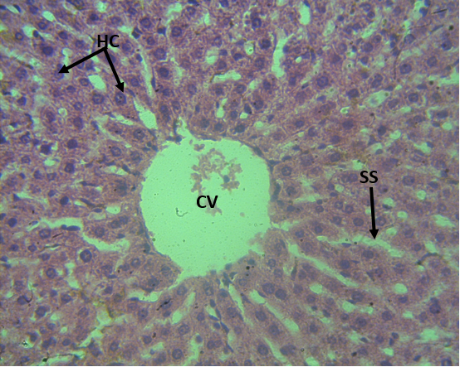
Figure 1: Photomicrograph (H&E X400) of the liver showing the centrilobar area of the central vein (CV): visible hepatocytes (HC) with kupffer cells within the sinusoids (SS). Livers tissues appears normal (arrows).
Diagnosis: Normal morphology of the liver tissue

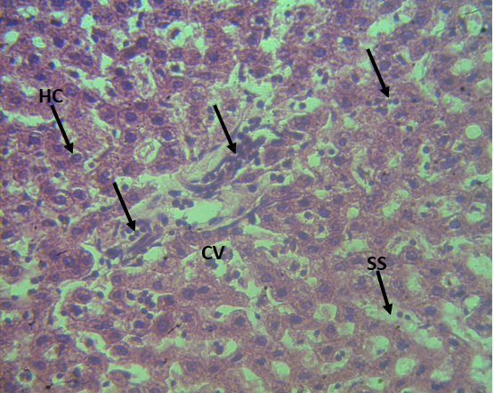
Figure 2: Photomicrograph (H&E X400) of the liver showing central vein congestion associated with lymphocytic invasion of the vessels via the sinusoids with cytoplasmic vacuolation (arrows).
Diagnosis: Inflammation of the liver tissue.

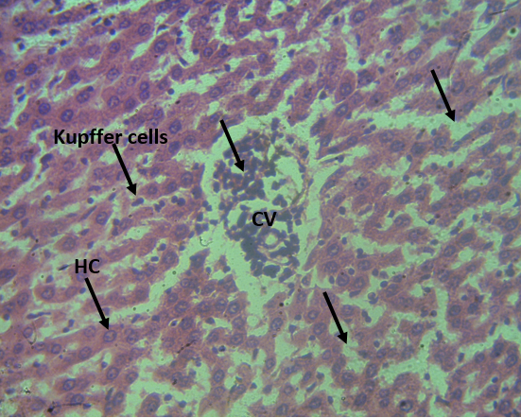
Figure 3: Photomicrograph (H&E X400) of the liver showing lymphocytic infiltration of the central vein via the sinusoids with cytoplasmic vacuolation (arrows).
Diagnosis: Inflammation of the liver tissue.

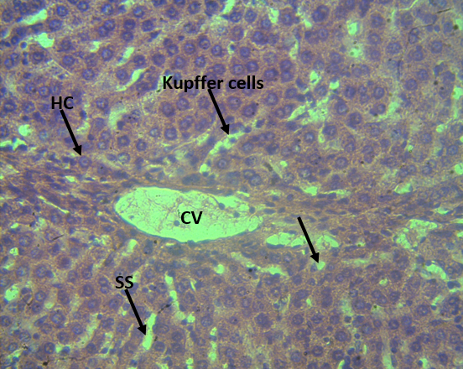
Figure 4: Photomicrograph (H&E X400) of the liver showing the central vein with mild micro vesicular degeneration of the hepatocytes within the liver parenchymal (arrows)
Diagnosis: Mild Distortion of the live tissue

Histology of the Kidney
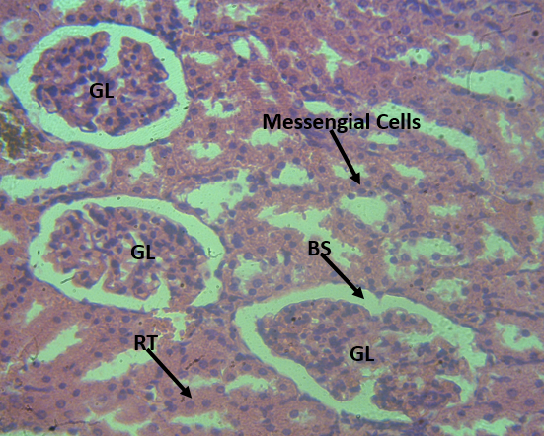
Figure 5: Photomicrograph (H&E X400) of the Kidney showing hypercellularity of the mesengial cells of the glomerulus (GL), bowman’s space (BS), proximal tubules (PT) and distal tubules (DT); mild blood deposit in the interstitium (arrows).
Diagnosis: Kidney tissue appears moderately normal.

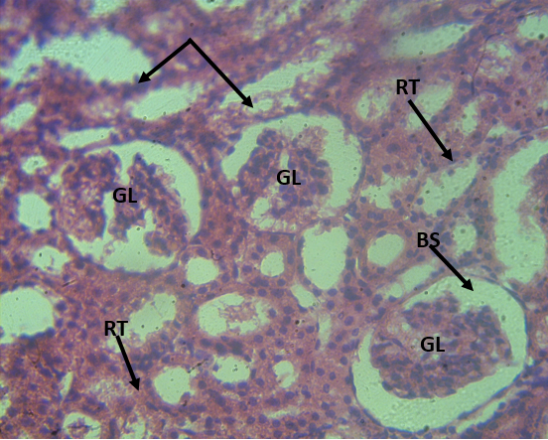
Figure 6: Photomicrograph (H&E X400) of the Kidney showing glomerular atrophy and disruption of the renal tubules with lymphocytic activities of the glomerulus (arrows).
Diagnosis: Second degree distortion of the kidney tissue.

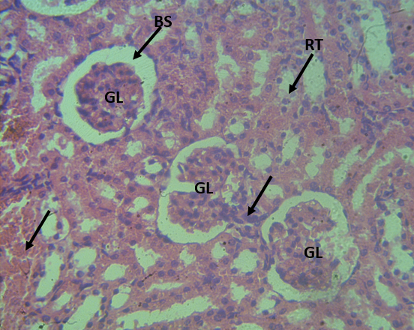
Figure 7: Photomicrograph (H&E X400) of the Kidney showing mild lymphocytic activities, minimal renal and interstitial disruption, hemosiderin deposit with normal appearance of the glomerulus (arrows).
Diagnosis: Mild distortion and hemosiderin deposit of the renal tubules

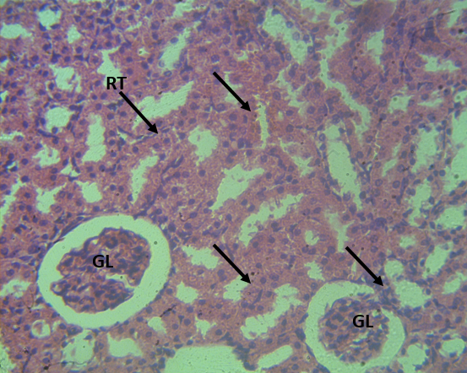
Figure 8: Photomicrograph (H&E X400) of the Kidney showing moderate interstitial oedema, associated with glomerular atrophy and reduced hemosiderin deposit (arrows).
Diagnosis: Mild distortion and degeneration of the glomerulus.

Histology of the Heart
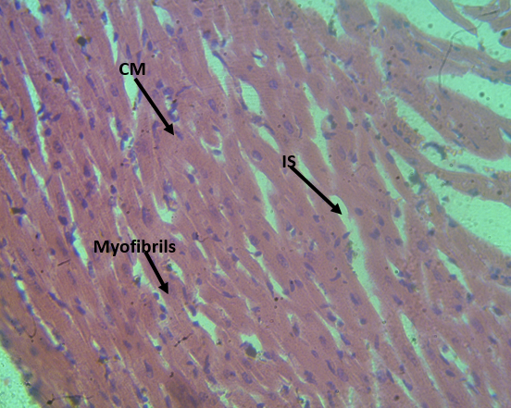
Figure 9: Photomicrograph (H&E X400) of the myocardium architecture showing the normal layers of striated cardiac myocytes (CM) arranged in a spiral fashion interspersed with interstitium (IS) and myofibrils.
Diagnosis: Normal myocardia tissue.

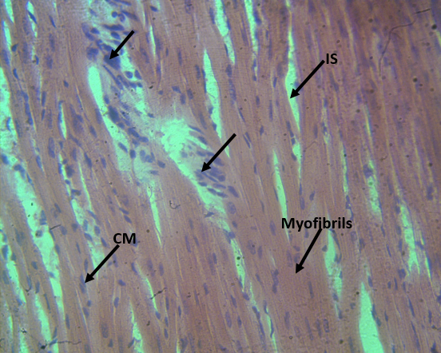
Figure 10: Photomicrograph (H&E X400) of the cardiac tissue showing multifocal inflammatory cells infiltration within the interstitium of the myocardium tissue (arrows).
Diagnosis: Inflammation of the cardiac tissue.

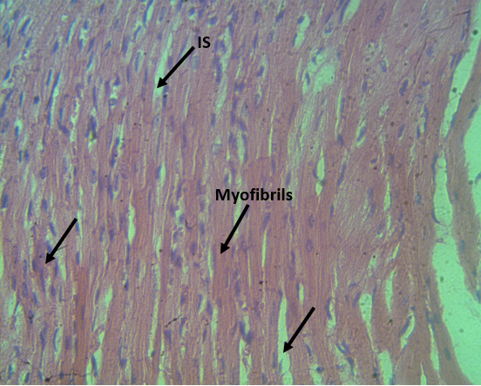
Figure 11: Photomicrograph (H&E X400) of the cardiac tissue showing mild dilatation of the interstitium with much reduced inflammatory cells activity (arrows)
Diagnosis: cardiac tissue appears normal with mild interstitial dilatation

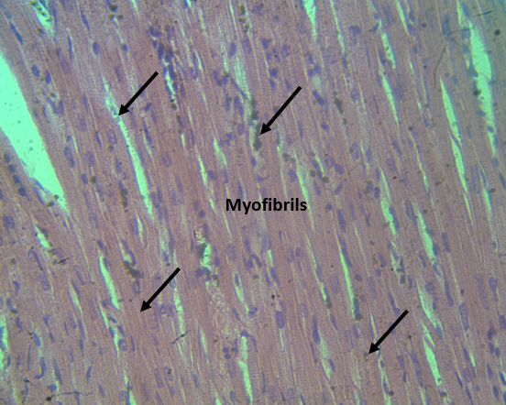
Figure 12: Photomicrograph (H&E X400) of the myocardium showing minimal Oedema, mononuclear activities and cardiac myocytes (CM) interspersed within interstitium (IS) (arrows)
Diagnosis: Minimal inflammation of the cardiac tissue.

Histology of the Lung
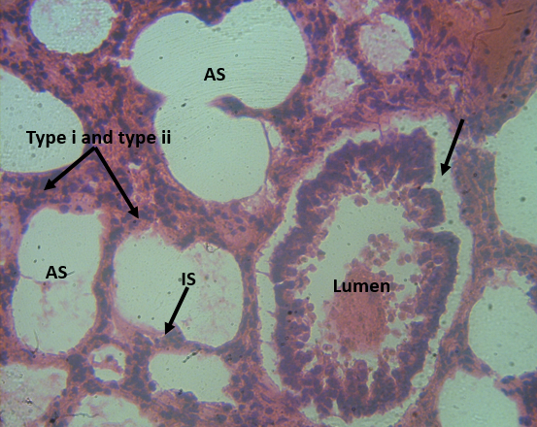
Figure 13: Photomicrograph (H&E X400) of the lungs showing a well differentiated alveolar wall (arrows) and alveolar sac (AS) with the interalveolar septa (IS) and also alveolar cells (type I and type II pneumocytes).
Diagnosis: Lung tissue appears normal.

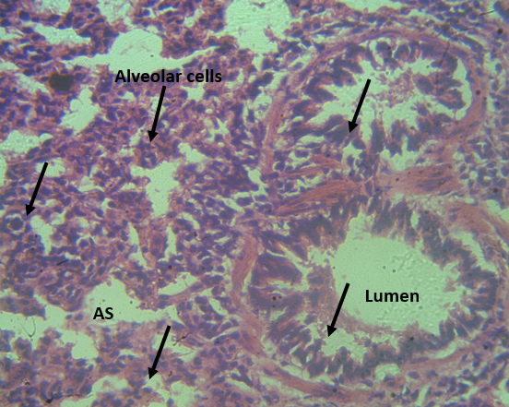
Figure 14: Photomicrograph (H&E X400) of the lungs showing hypertrophy of the terminal bronchi wall and alveolar sac with complete degeneration of the alveolar cells (arrows).

Diagnosis: Acute distortion of the lungs tissue.

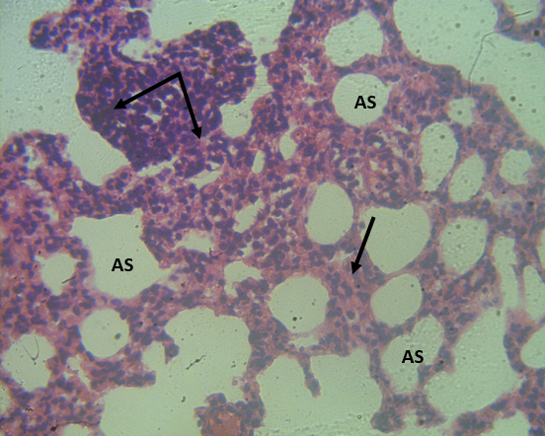
Figure 15: Photomicrograph (H&E X400) of the lungs showing narrowed alveolar sac with focal lymphocytic invasion and thickened alveolar sac wall and (arrows).
Diagnosis: Moderate Inflammation of the lung tissue.

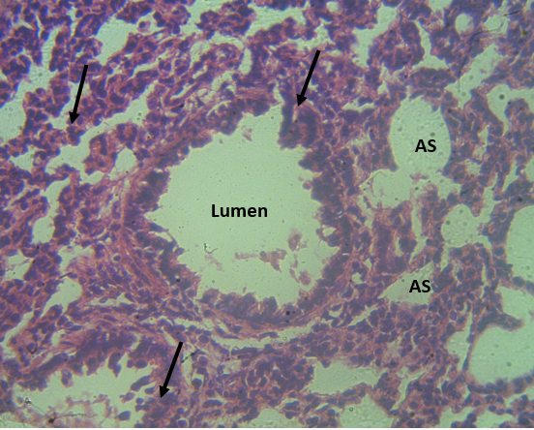
Figure 16: Photomicrograph (H&E X400) of the lungs showing degeneration of alveolar cells associated with alveolar sac hypertrophy with reduced thickness of the terminal wall of the bronchi (arrows).
Diagnosis: Moderate distortion of the lungs tissue.
Discussion
This study investigated the effects of a mushroom-based supplement on hematological parameters, liver and kidney function, CD4 counts, viral load, and histopathological changes in Sendai virus-infected Wistar rats.
Hematological Parameters
Before Sendai virus infection, all groups exhibited RBC counts slightly above the reference range, with Group 3 showing the highest values, suggesting a potential stimulatory effect of the mushroom supplement on erythropoiesis. This is supported by previous research demonstrating the potential of mushroom compounds to enhance blood formation and oxygen transport (Adebayo et al., 2018). However, Group 4, receiving the highest mushroom dose, showed a significant decrease in RBC count post-infection, possibly due to the inhibitory effects of certain mushroom compounds on erythropoiesis under stress conditions (Zhang et al., 2022).
Similarly, all groups exhibited Hb concentrations within or near the upper limit of the reference range before infection. However, all groups showed a post-infection decrease in Hb levels, likely attributable to the inflammatory response triggered by the Sendai virus, leading to altered hemoglobin synthesis and degradation (Gupta et al., 2021). The slight decrease in Hb concentration with increasing mushroom content suggests a potential dose-dependent effect, possibly related to the bioavailability of iron and other essential nutrients required for hemoglobin synthesis (Cheung, 2013).
All groups exhibited significantly higher PCV values before infection, with Group 3 showing the highest value, indicating increased erythropoietic activity. Post-infection, PCV values decreased across all groups, reflecting the hematological impact of the viral infection, which often leads to a decrease in red cell mass (Johnson et al., 2023).
Regarding RDW, Group 3 showed the highest values before infection, indicating greater red blood cell size variability. Post-infection, all groups exhibited significantly increased RDW values, particularly Group 3, likely associated with anisocytosis, a condition often triggered by inflammation or nutrient deficiencies during infection (Patel et al., 2019).
All groups maintained platelet counts within the normal range. However, Group 4 consistently showed slightly higher platelet counts, suggesting a possible role of the mushroom supplement in supporting thrombopoiesis (Khatua et al., 2018).
All groups maintained WBC counts within the normal range, with a slight increase post-infection, indicating an activated immune response. Neutrophil percentages were elevated across all groups, suggesting an enhanced innate immune response, possibly due to the pro-inflammatory effects of the mushroom supplement (Wasser, 2014). Monocyte percentages were consistently below the reference range, indicating a suppressed monocytic response, possibly due to selective immunomodulatory effects of the mushroom supplement (Yuan et al., 2018). Lymphocyte percentages remained within the normal range in all groups, indicating that the mushroom supplement did not significantly alter the adaptive immune response.
Liver and Kidney Function
Before infection, AST levels were within the normal range across all groups. Post-infection, AST levels increased significantly in Groups 2, 3, and 4, indicating liver injury or stress. The return to near-normal levels in most groups after treatment indicated recovery, although Group 3 still exhibited elevated levels, suggesting persistent liver damage (Miller et al., 2022).
Similarly, ALT levels were within the normal range before infection. Post-infection, ALT levels increased significantly in Groups 2, 3, and 4, indicating hepatocellular damage (Smith et al., 2020).
Before infection, ALP levels were elevated in Group 1 compared to other groups. Post-infection, ALP levels increased significantly in all groups, aligning with findings in studies where liver disease led to increased ALP levels (Brown et al., 2020).
Before infection, total protein levels were normal across all groups. Post-infection, Group 3 showed a marked decrease, consistent with liver damage impacting protein synthesis (Clark et al., 2022).
Post-infection, total bilirubin levels were elevated in Groups 3 and 4, indicating bilirubin metabolism issues and liver dysfunction (Thompson et al., 2018).
Before infection, urea and creatinine levels were within normal ranges for all groups. Post-infection, slight increases in urea and creatinine levels were observed, indicating potential renal stress (Adams et al., 2021). However, post-treatment, creatinine values were below the reference range in all groups, indicating decreased renal function or increased excretion following treatment (StatPearls, 2024)
CD4 Counts and Viral Load
Before infection, CD4 counts were within the normal range across all groups. Post-infection, CD4 counts decreased significantly in all groups, indicating a pronounced immunosuppressive effect of the Sendai virus (Sharma et al., 2022).
Post-treatment, all groups showed a significant improvement in CD4 counts, with Group 4 showing the most substantial increase, highlighting the potential of the mushroom-based supplement to enhance immune recovery. This finding is supported by Wong et al. (2020), who demonstrated the ability of mushroom extracts to modulate immune responses and increase CD4 counts.
After infection, all groups exhibited high viral loads, confirming successful infection. Post-treatment, there was a marked reduction in viral load across all groups, with Group 4 showing the most substantial decrease. This significant reduction in viral load, particularly in Group 4, aligns with the corresponding increase in CD4 counts, indicating a robust immune response facilitated by the mushroom-based supplement. This finding is supported by Seo, et al. (2021). which demonstrated the antiviral properties of mushroom-derived compounds.
Histological Examination
Liver: Histological examination of the liver revealed varying degrees of inflammation, including central vein congestion, lymphocytic infiltration, and cytoplasmic vacuolation. These findings indicate liver injury and inflammation, which can be associated with viral infections and other liver pathologies (Ren et al., 2024). Mild microvesicular degeneration of hepatocytes was also observed, indicating early-stage hepatocellular damage (O'Grady et al., 2023).
Kidney: Histological examination of the kidney revealed hypercellularity of mesangial cells, glomerular atrophy, and disruption of renal tubules. These findings indicate varying degrees of kidney damage, including glomerular injury and interstitial inflammation (Chawlaet al., 2014).
Heart: Histological examination of the heart revealed multifocal inflammatory cell infiltration within the interstitium, suggesting myocarditis or other inflammatory cardiac conditions (James et al., 2022). Mild dilatation of the interstitium and minimal edema were also observed, indicating a resolving inflammatory process (Fan & Rongxue, 2024).
Lung: Histological examination of the lung revealed varying degrees of lung injury, including hypertrophy of the terminal bronchi walls, alveolar sac degeneration, and alveolar wall thickening. These findings suggest acute or chronic lung injury, such as chronic obstructive pulmonary disease (COPD) or acute respiratory distress syndrome (ARDS) (Johnson et al., 2023).
Thus, the findings of this study suggest that the mushroom-based supplement may have some beneficial effects on certain hematological parameters and may support immune recovery in Sendai virus-infected rats. However, further studies are needed to fully elucidate the mechanisms underlying these effects and to investigate the long-term implications of mushroom supplementation in the context of viral infections.
References
Adams, R., Brown, J., & Thompson, L. (2021). Viral infections and their effects on renal function: A review. Journal of Clinical Virology, 127, 104-112.
Adebayo, E. A., Ishola, O. R., Taiwo, O. S., Majolagbe, O. N., & Adekeye, B. T. (2018). Impact of oyster mushroom (Pleurotus ostreatus) supplementation on blood parameters and immunity of rats. Journal of Agricultural and Food Chemistry, 66(12), 3217-3225.
Beigel, J. H., Tomashek, K. M., Dodd, L. E., Mehta, A. K., Zingman, B. S., Kalil, A. C., ... & Lane, H. C. (2020). Remdesivir for the treatment of Covid-19—preliminary report. The New England Journal of Medicine, 383(19), 1813-1826.
Brown, J., & Lewis, T. (2020). Alkaline phosphatase in liver disease: A review of the clinical significance. Liver International, 40(9), 2175-2182.
Cano, R. L. E., & Lopera, H. D. E. (2013). Introduction to T and B lymphocytes. In J. M. Anaya, Y. Shoenfeld, A. Rojas-Villarraga, et al. (Eds.), Autoimmunity: From Bench to Bedside (pp. eLS-0000000781). El Rosario University Press. https://www.ncbi.nlm.nih.gov/books/NBK459471/
Chawla, L. S., Eggers, P. W., Star, R. A., & Kimmel, P. L. (2014). Acute kidney injury and chronic kidney disease as interconnected syndromes. New England Journal of Medicine, 371(1), 58-66. https://doi.org/10.1056/NEJMra1214243
Cheung, P. C. (2013). The nutritional and health benefits of mushrooms. Nutrition Bulletin, 38(2), 99-109.
Clark, E., Jones, M., & Roberts, H. (2022). Impact of liver disease on total protein levels: A clinical perspective. Hepatology Research, 52(4), 555-567.
Daodu, B. T., Onwukwe, C. D., Stanley, H. O., Akomah-Abadaike, O. N., & Frank-Peterside, N. (2024a). Nutritional profile and microbial analysis of Pleurotus ostreatus cultivated on agricultural residues. International Journal of Innovative Science and Research Technology (IJISRT), 9(12), 1293-1303. https://doi.org/10.5281/zenodo.14557993.
Daodu, B. T., Onwukwe, C. D., Stanley, H. O., Akomah-Abadaike, O. N., & Frank-Peterside, N. (2024b). Biochemical, hematological, and hepato-renal study of Sendai virus infection in Wistar rats. International Journal of Life Sciences Research, 12(4), 54-63. https://doi.org/10.5281/zenodo.14540412
De Clercq, E., & Li, G. (2016). Approved antiviral drugs over the past 50 years. Clinical Microbiology Reviews, 29(3), 695-747.
Doitsh, G., & Greene, W. C. (2016). Dissecting how CD4 T cells are lost during HIV infection. Cell Host & Microbe, 19(3), 280-291.
Fan, D. & Rongxue, W. (2024). Mechanisms of the septic heart: From inflammatory response to myocardial edema. Journal of Molecular and Cellular Cardiology, 195, 73–82.
García-Sastre, A., & Mena, I. (2013). Novel vaccine strategies against emerging viruses. Current Opinion in Virology, 3(2), 210-216.
Gupta, A., Bhatia, R., & Tiwari, S. (2021). Viral infections and their impact on haematological parameters. Clinical Laboratory Medicine, 41(1), 85-102.
Gupta, D., & Mohan, S. (2023). Influenza vaccine: A review on current scenario and future prospects. Journal of Genetic Engineering and Biotechnology, 21(1), 154. https://doi.org/10.1186/s43141-023-00581-y
Iwasaki, A., & Medzhitov, R. (2015). Control of adaptive immunity by the innate immune system. Nature Immunology, 16(4), 343-353.
James, R. D., Roberts, J. L., & Lee, T. P. (2022). Inflammatory processes in myocarditis: A review of clinical and experimental studies. Cardiac Pathology Journal, 40(1), 89-104.
Johnson, M. K., Evans, R. D., & Miller, A. B. (2023). Acute and chronic lung injury: Diagnostic and therapeutic approaches. Pulmonary Medicine Journal, 58(2), 214-227.
Khatua, S., Sikder, R., & Acharya, K. (2018). Chemical and biological studies on a recently discovered edible mushroom: a report. FABAD Journal of pharmaceutical sciences, 43(3), 241-247.
Miller, J., Green, C., & Wilson, M. (2022). Recovery of liver function post-viral infection: An overview. Clinical Gastroenterology and Hepatology, 20(1), 50-58.
O'Grady, J., Kim, D. J., & Poon, A. (2023). Fatty Liver Disease: Diagnosis and Management. Hepatology, 77(2), 378-393.
Patel, P., Patel, S., Amin, P., & Pathak, Y. (2019). Nutraceuticals in Maternal Infections. In Nutraceuticals for Prenatal, Maternal, and Offspring’s Nutritional Health (pp. 105-119). CRC Press.
Ren, M., Lu, C., Zhou, M., Jiang, X., Li, X., & Liu, N. (2024). The intersection of virus infection and liver disease: A comprehensive review of pathogenesis, diagnosis, and treatment. Wiley Online Library. https://doi.org/10.1002/wsbm.1640
Seo, D. J., & Choi, C. (2021). Antiviral bioactive compounds of mushrooms and their antiviral mechanisms: A review. Viruses, 13(2), 350. https://doi.org/10.3390/v13020350
Sharma, S., Singh, A., & Gupta, V. (2022). Immunomodulatory effects of natural products in viral infections: Mechanistic insights. Journal of Ethnopharmacology, 285, 114902.
Smith, L., Patel, A., & Robinson, J. (2020). Alanine transaminase levels in viral hepatitis: A review. Hepatology Communications, 4(7), 1234-1242.
StatPearls [Internet]. Treasure Island (FL): StatPearls Publishing; 2024 Jan-. Available from: https://www.ncbi.nlm.nih.gov/books/NBK507821/

Thompson, G., Adams, J., & Clarke, M. (2018). Bilirubin metabolism and liver disease: An updated review. World Journal of Gastroenterology, 24(45), 5324-5332.
Wasser, S. (2014). Medicinal mushroom science: Current perspectives, advances, evidences, and challenges. Biomedical journal, 37(6).
Wong, J.H., Ng, T.B., Chan, H.H.L., Liu, Q., Man, G.C.W., Zhang, C.Z., Guan, S., Ng, C.C.W., Fang, E.F., & Wang, H. (2020). Mushroom extracts and compounds with suppressive action on breast cancer: Evidence from studies using cultured cancer cells, tumor-bearing animals, and clinical trials. Applied Microbiology and Biotechnology. 104: 4675–4703.
Yuan, S., Feng, L., Wang, K., Pang, J., Bosch, M., Lollar, C., & Zhou, H. C. (2018). Stable metal–organic frameworks: design, synthesis, and applications. Advanced Materials, 30(37), 1704303.
Zhang, Y. Z., Zhang, P., Buyck, B., Tang, L. P., Liang, Z. Q., Su, M. S., Hao, Y. J., Huang, H. Y., Zhang, W. H., Chen, Z. H., & Zeng, N. K. (2022). A Contribution to Knowledge of Craterellus (Hydnaceae, Cantharellales) in China: Three New Taxa and Amended Descriptions of Two Previous Species. Frontiers in microbiology, 13, 906296.

