Spatial Configuration of Market Spaces: Accessibility and Management Challenges in Bamenda City, Cameroon

Abstract

Market spaces are essential to urban life, particularly in cities across Cameroon. Amid rapid urbanization, the spatial placement markets has emerged as critical centers for commerce, socio-economic interactions, and cultural exchanges, significantly influencing the daily routines of urban residents. However, accessibility to these markets is hindered by congestion, inadequate infrastructure, spatial disorganization, and limited parking facilities. This study analyzes the spatial location, layout, and design of market spaces in Bamenda, highlighting their implications for access among diverse user groups and management challenges faced by market participants. Qualitative and quantitative Data were collected through informant interviews and 324 questionnaires administered to market participants, including vendors, customers, and shop owners, addressing functionality, accessibility issues, and satisfaction levels. Spatial analysis mapping was employed to assess the locations, layouts, and proximities of the markets. Key findings reveal a variety of market types that cater to the urban population, particularly the Bamenda Main Market, Nkwen Market, Food Market, and Ntarikon Markets. However, the spatial layout of these markets suffers from accessibility issues, including congestion, narrow pathways, and uneven flooring, exacerbated by poor infrastructure, limited space, and security concerns. The study strongly recommends the effective implementation of Bamenda's proposed Master Plan to regulate unplanned urban spaces, particularly market infrastructure, and to ensure the proper execution of the Plan of Soil Occupation (POS). Such measures will help curb the haphazard arrangement of market stalls and the illegal operations of certain markets.

Keywords: Spatial Configuration, Market Spaces, Accessibility, Management Challenges, Bamenda City, Cameroon

1. Introduction
In recent years, the dynamics of market spaces in cities have been influenced by a range of contemporary trends, including globalization, urbanization, and technological advancements. Globalization has led to increased competition among market traders, while urbanization has resulted in rapid growth and development of cities, leading to changes in the physical structure and organization of market spaces.
In developed countries such as Australia, USA, Britain and Germany, market spaces in these countries are essential components of the urban economy and serve as important meeting places for socio-economic activities. In Britain, market environment has for centuries been at the heart of economic and social prosperity, providing businesses with the certainty that they need to grow and thrive. One of the key features of the economy has been its integration and strong economic ties binding the UK together (Alok Sharma, 2020). In the United State of America, market spaces have been digitalized making urban market transaction becoming more mobile through information technology (Pari S., and Virginia L.2004). The development of new information and analysis tools to understand opportunities in underserved urban and metropolitan markets has been a focused effort of such corporations as MetroEdge, a subsidiary of ShoreBank Advisory Services in Chicago, and the national not-for-profit initiative Social Compact. Both groups have pioneered the use of new datasets to create better information for understanding urban markets. It is curtained that the magnitude and density of people and activities in urban areas facilitates the development and exchange of information and products through easy face-to-face interactions, the development of mass media, the concentration of intellectual capital, and the construction of intricate transportation networks. Healthy communities and neighborhoods within these well- functioning urban areas typically have a vibrant investment climate, a robust labor market, and a wide array of neighborhood social and retail services (Pari S., and Virginia L.2004). In Europe, there is a visible change in the understanding of the role of the market in the contemporary city, as well as important changes in what constitutes market communities. Markets are no longer just places of trade, but also cultural spaces. According to Greater London Authority (GLA, 2017), public markets play an important role in the socio-economic structure of modern cities. In addition, cities, their districts and different public spaces including public and local markets, like other market brands, carry cultural meaning, cache and recognizable symbols of a given city or neighborhood. This view is in line with Bennett, R.; Savani, S., (2003) who documented economic functionality of markets in cities while also deﬁning the city’s identity as being recognizable symbol. In Poland, the existence of traditional markets has been an integral part of the lives of urban communities, but their role is seen only as a space of trade, often used only for two days of the week (Dmytrów, K., & Bieszk-Stolorz, B., 2021).
In developing countries especially on the African continent, the layouts of urban markets are dynamic and vary according to needs. The development of urban markets in Africa depends on the type of establishment (spontaneous, by administrative decree or according Master or Communal Development (Imorou, 2006). In Sub-Saharan Africa, informal businesses have greatly transformed market spaces, which account for a significant portion of the region's economic activity (African Development Bank, 2019). Currently, periodic markets account for 80 to 90 percent of all food consumed in African cities and serve as channels through which small-scale farmers are able to reach the urban food markets (Alliance for a Green Revolution in Africa, 2020). Markets are the primary livelihood source, especially for the rural poor and people with limited transport options (Babajo, Yusuf and Musa, 2018). These markets fulfill the demand of consumers where permanent markets are not present, or a daily marketing system is not feasible (Nirmalya and Chattopadhyay 2015). Their occurrence at specific intervals also allows traders to prepare sufficiently in terms of resources for the next market day (Eff and Jensen 2007). In Ghana, markets places are major places for the sale of agricultural produce and are preferred mostly by low-income and non-college educated households due to their competitive price. The periodic markets also form a significant part of Ghana’s revenue mobilization efforts and the food retail system and remain the oldest retail format in distributing domestic food, including fish, meat, livestock, cereals, vegetables, and fruits (Meng, T., Florkowski, W.J., Sarpong, D.B., Chinnan, et al., 2014). For instance, the Asesewa and the Agormanya market in the Eastern Region, the Ejura and the Ejisu market in the Ashanti Region, the Dunkwa and the Twifo-Praso market in the Central Region have been reported to contribute significantly to employment creation and revenue mobilization (Godfred, Dinye and Emmanuel 2015, Angmor 2012, Owusu and Lund 2004).
However, various challenges accrue in most markets as a result of inadequate infrastructure, poor management, and inadequate planning, which can compromise the effectiveness and efficiency of market activities (Chen & Li, 2020; Muzondidya & Gadzirayi, 2019). In many cities across the sub-continent, market environments are concentrated in specific areas, often referred to as market districts or zones. City centers have been designated by local authorities for market activities while some have developed organically over time due to factors such as proximity to transport hubs and commercial activities (UN-Habitat, 2003). The spatial organization of market spaces in these areas can vary widely, ranging from formal buildings and structures to temporary stalls and tents (Bamfo & Agyeiwaa, 2019).
Markets involve the public gatherings of buyers and sellers of commodities at a specified location at a regular interval (Mandal 2006). These markets are nodes of the temporal convergence of the surrounding rural population. Such nodes may be defined as where people (producers, consumers, and traders) converge to buy and sell their goods and services at regular intervals. These markets vary greatly based on the locational pattern, size, nature, and scale of economic functions. According to Nirmalya D., and Guru P. C., (2015), the spatial arrangements of markets is critical for clients as it enables them to prepare in terms of money and wares adequately. Research on the spatial location of market spaces has described the market's origin and its positionality within the urban area (Ikioda FO., 2013). Most of the reports show limited access to physical market infrastructure and associated environmental degradation. For example, on market days, the conflict of space by users due to the influx of drivers, vendors and buyers without an organized traffic management system contributes to traffic congestions, decreased sales and stress (Agyapong and Ojo, 2018). Limited access to waste disposal services has created a significant challenge to maintaining and sustaining hygiene within markets. The implications of such are food safety compromises and the spread of infectious diseases associated with such spaces and vendors (Rheinlander, T., Olsen, M., Bakang, J.A., Takyi, H., et al., 2008; Omari R., Joost J., George E., Godfred F., and Guido R., 2016).
In Cameroon cities, the spatial organization of market spaces is an important aspect of urban planning and economic development. Markets in the cities serve as important centers of commerce, social interaction, and cultural exchange, playing a vital role in the daily lives of the urban residents. Studies carried out by Mabogunje (2012) and Nkwi et al., 2017 shows that markets in Cameroonian cities are dynamic and complex, shaped by socio-economic and cultural factors. The markets exhibit diverse spatial patterns and organization structure in open air characterized by informal stalls arranged in a decentralized manner. There also exist modern market complexes of enclosed structure and designated spaces for different types of goods and services (Nkwi et al., 2017). Research work carried out by Ngala, H.N., & Ebai, E.E.O., (2014) on market infrastructures in Yaounde Markets, demonstrate that population increase of traders is putting pressure on the ability of the local councils in Yaounde to provide adequate marketing infrastructure. This has serious implications on health, sanitation, environment as well as the aesthetic value of markets. Their study suggests a long-term commitment by the Yaounde City Council authorities to provide adequate and adapted infrastructure in markets and stronger private sector involvement in market development.
In Bamenda, markets spaces are diverse in their setting and management, catering to the various needs of the city residents. The markets serve as important economic hubs for the transaction of goods and services for the residents. The lay out of the markets involves various components noticeable by physical lay-out, market management and market participants who are involves in various socio-economic activities. Four principal markets commands goods and services in these markets: the Bamenda Main Market, Food market, Nkwen market and Ntarikon markets. Besides these markets, there exist sub-divisional council markets which functions within council motor-parks: they include Mile 4 motor-park market, Bamenda I Motor-park market, Ntaturu park market, Mbengwi park market. The transport agencies themselves constitute informal markets within the agencies. Some spontaneous markets have started developing along some major axis of the city, these includes Foncha junction and below Foncha. While the City Council together with the Municipal councils have put in enormous efforts in the management of the markets, their spatial organization and layout still possess significant challenge. Therefore, understanding their spatial configuration, functional accessibility and socio-economic implications provide valuable insights into the market spaces management dynamics.
- Conceptual review
  - The concept of space management
Th Space management is a multifaceted concept that involves the strategic allocation, utilization, and organization of physical space to optimize productivity and functionality. Efficient space management includes elements such as space allocation, utilization, and organization, as well as the integration of technology and stakeholder engagement. The concept of space management typically applies to various settings including offices, retail stores, healthcare facilities, commercial facilities, educational institutions and public spaces. However, the concept of space management stands out as a crucial element that concentrates on the method of locating and ranking vacant space, it involves proper space utilization through organization, planning, upkeep, and employee access to resources. It also entails planning the ideal seating arrangement for the workers to use at their workplaces (Handiman, 2023). Assessing space require allocating spaces strategically, optimizing layouts, and incorporating flexibility are crucial elements in this phase.
Space management is a critical aspect of efficient and effective facility operations and planning. It involves the strategic allocation, utilization, and organization of physical space within a facility to maximize productivity, improve workflow, and enhance the overall functionality of the space (Smoyer-Tomic, 2016). This concept is applicable across various sectors, including commercial establishments, healthcare facilities, educational institutions, and government offices. In order to fully comprehend the concept of space management, it is important to understand its key elements and principles. One fundamental aspect of space management is space allocation. This entails determining the optimal use of available space based on the unique needs and requirements of different departments or functions within a facility. For example, a healthcare facility may allocate specific areas for patient consultation, treatment, and administrative tasks (Ogunlana, 2012). Similarly, in an educational institution, classrooms, laboratories, and multipurpose spaces need to be carefully allocated to cater to different academic requirements (Olsen, 2018).
Dimensions
Space Management
Indicators
Variables
Concept
- Size and shape of space
- Layout and design
- Accessibility
- Number of infrastructures
- Proximity and amenities

- Zoning and land use patterns
- Transport network
- Infrastructure services
- urban design
- Neighborhoods design
Physical layout

Number of
  - Commercial spaces
  - Social services
- Space occupancy rate
- Transport structures
- Market structures
- Public amenities
- Commercial zones
- Industrial site
- Economic development
- Social services
- Housing affordability
- Transport development
- Market spaces
- Public amenities
Resources allocation

- Waste management practices
- Green infrastructure practices
- Carbon footprint
- Energy usage
- Aesthetic

- Environmental conservation
- Recreation sites
- Green spaces
- Development of parks
- Development of gardens

Environmental sustainability

- Public surveys
- Users and occupancy rate
- Level of community engagement
- Accessibility of spaces
- Use of amenities
- Decision making
User satisfaction
  - Survey satisfaction
- User feedback rating
- Numb. Of complaints
- Cleanliness
- User preference

Figure 1: Concept of space management
Sources: Authors conception, 2023
Efficient space allocation requires a deep understanding of the current and future needs of the facility, which can be determined through analysis of utilization data, stakeholder input, and industry best practices (Smoyer-Tomic, 2016). For instance, a workplace may conduct surveys or interviews to gather information on the space requirements of different departments or teams, taking into account variables such as the number of employees, types of activities conducted, and storage needs (Wenyu et al., 2016). By considering these factors, space managers can ensure that each area is appropriately sized and equipped to support its intended use, while avoiding underutilization or overcrowding. Another critical aspect of space management is space utilization. This involves monitoring and optimizing the usage of allocated space to minimize waste and maximize productivity (Gontarz, 2014). Space utilization can be assessed through various methods, such as occupancy sensors, manual headcounts, or utilization surveys (Dimitrijević et al., 2017). By analyzing the data collected, space managers can identify patterns and trends in space usage, allowing them to make informed decisions on reallocating or reconfiguring space to better match the needs of users.
The implementation of technology-based solutions, such as facility management software and building automation systems, can greatly enhance space utilization efforts (Ogunlana, 2012). For example, the use of sensors and real-time data analytics can provide insights into usage patterns, allowing for dynamic adjustments to space allocation and resource utilization. This can result in significant cost savings, increased operational efficiency, and improved user satisfaction (Dimitrijević et al., 2017). Space allocation and utilization, space management also involves organization and layout planning. This refers to how the physical space is structured and arranged to promote productivity, collaboration, and ease of movement (Smoyer-Tomic, 2016). A well-designed layout ensures that various functions or operations within a facility are appropriately placed, taking into consideration factors such as workflow, safety, and accessibility (Olsen, 2018). Organizational strategies, such as open office concepts or modular furniture systems, can be employed to optimize space utilization and flexibility (Wenyu et al., 2016). These strategies promote collaboration and adaptability, allowing for easy reconfiguration of space to accommodate changing needs and requirements. Furthermore, the implementation of ergonomic principles in workspace design can enhance user comfort and productivity, while minimizing health and safety risks (Gontarz, 2014).
To effectively manage space, it is crucial to involve stakeholders and users in the decision-making process (Ogunlana, 2012). This collaboration ensures that their needs and feedback are considered, fostering a sense of ownership and engagement. Regular communication and feedback loops can help space managers identify emerging needs or issues, facilitating the continuous improvement of space allocation and utilization practices (Dimitrijević et al., 2017). Studies conducted on physical dimensions of space management by Asojo, A., Vo, H., Bae, S., (2021). examined the impact of space layout on occupants' satisfaction and productivity in open-plan offices. The findings revealed that a well-designed layout that considers factors such as privacy, noise control, and visual distractions positively affects occupants' well-being and performance. Another study by
Hansika W.A.M., and Buddhini A., (2016) explored the impact of office design on employee engagement and productivity. The results suggested that a well-organized and comfortable workspace positively influences employees' motivation and efficiency.
One of the key reasons why space management is vital for markets activities is its impact on operational efficiency. According to Mollenkopf and Frankel (2019), efficient space management can result in improved productivity and reduced costs. By carefully organizing and allocating available space, market managers can enhance workflow, minimize congestion, and ensure a smooth flow of goods and customers. This can contribute to faster service delivery, reduced waiting times, and enhanced overall operational efficiency. Customer satisfaction is another significant consideration in space management for market activities. Cotte and Coulter (2016) emphasize that the layout and organization of a market play a crucial role in shaping customers' experiences. A well-designed and conveniently arranged market space can facilitate customer navigation, promote product visibility, and encourage exploration. Huang et al. (2017) argue that maximizing the use of physical space is essential for market sustainability and profitability. By carefully analyzing customer traffic patterns, market managers can identify underutilized areas and optimize their use. This may involve rearranging stalls or diversifying offerings in specific sections to attract more customers and increase sales potential.
- Materials and Methods
The study was conducted in Bamenda city, which serves as the administrative headquarters of the North West Region of Cameroon, Figure 1. Positioned between Latitudes 5° 56’ and 5° 58’ north of the Equator and longitudes 10° 09’ and 10°11’ east of the Greenwich Meridian, Bamenda covers a total surface area of 3125 km2 (CAMGIS, 2014). It shares its administrative boundaries with Mbengwi to the west and Bali to the southwest, while being bordered by Bafut to the north, Santa to the south, and Bambui to the northeast. The city is divided into three sub-divisions for efficient administration: Bamenda I comprising Bamendankwe, Bamenda II comprising Mankon, Chomba, Mbatu, Ntumbong, Mulang, Alamandum, and Bamenda III comprising Nkwen and Nzah clans. Each sub-division has its own municipal council, although all are accountable to the Bamenda City Council.
The city of Bamenda gained prominence during the colonial era when British, French, and Germans struggled for control of Cameroon in the 19th century. Evolving from a traditional monoculture village, Bamenda transformed into a diverse city offering various services to its urban population. This transformation has positioned Bamenda as a significant crossroads and commercial hub along the Trans-African Highway corridor. Beyond being the regional headquarters, Bamenda serves as the socio-economic nuclei of the region, playing a pivotal role in major political, religious, and cultural events in Cameroon.

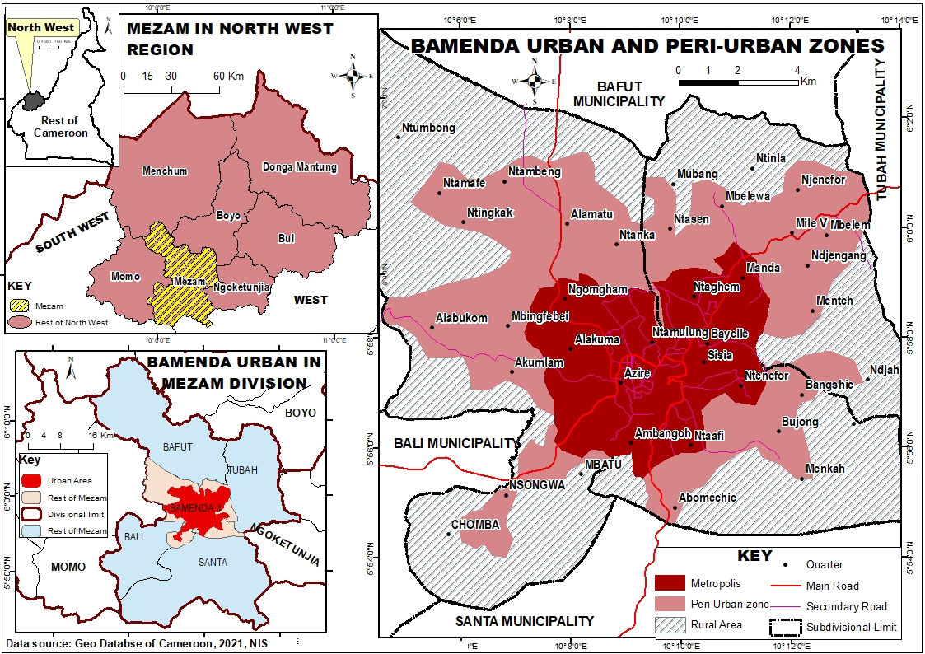
Figure 2: Location of Bamenda city in Mezam Division, North West Region of Cameroon
Source: Geo Database of Cameroon, NIS, 2021

The study used a mixed research design integrating both quantitative and qualitative methods to investigate the spatial arrangement and management of market spaces in Bamenda city. The research examines data related to the spatial allocation of market spaces, zoning regulations, space management practices within the markets, infrastructure development, and their correlation with socio-economic development indicators such as stall arrangements, and parking spaces in the City. Landsat images sourced from Google Earth were utilized to illustrate the spatial distribution of market spaces and existing infrastructure developments that support various socio-economic activities within the markets.
Table1: Target neighborhoods and distribution of sample questionnaires
Municipalities | Neighbourhood Markets | Target shopkeepers, vendors, market masters, | Sample % | Sample size
Bamenda I | BBM Market | 463 | 5 | 23
Bamenda II | Main Market, Food Market, Ntarikon Market, Markets inside agencies | 2573 | 5 | 128
Bamenda III | Nkwen Market, Mile 4 Market, Markets inside agencies, Below Fonch street market | 3461 | 5 | 173
Total |  | 6057 | 5 | 324
Source: Fieldwork, 2024
To gather quantitative data, a total of 354 semi-structured questionnaires were administered to targeted market participants. The sample size for the study was drawn from the target population of the study made up of shop owners, traders, market masters and customers. Altogether, 6057 target population was drawn during fieldwork and from this target population, 5% sample size was drawn which gave a total sample size of 324 sample representatives as shown on table 1.
Additionally, field surveys and observations were conducted in the city to evaluate the actual utilization of space by different socio-economic activities, measure and document the physical dimensions of locations, analyze occupancy rates and patterns, and identify any disparities between planned and actual space utilization. Ethical considerations were paramount throughout the research process. Informed consent was obtained from all participants involved in the surveys and observations. Confidentiality of the collected data was maintained to protect the privacy of the respondents. The research adhered to ethical guidelines to ensure the well-being and rights of the participants were respected at all times.
- Results and Discussions
  - Market types and spatial arrangement in Bamenda
Bamenda city hosts a variety of markets, each serving distinct purposes. The municipal markets in the city are under the ownership and management of the City Council, with four such markets strategically located in the Downtown area. These markets include the Bamenda Main Market, Food Market, Ntarikon Market, and Nkwen Market, all of which are among the oldest markets in the city and play a significant role in commercial activities while catering to a large portion of the urban population. In addition to the municipal markets, there are council motor-park markets that serve similar functions but primarily cater to inter-urban transport activities, serving as departure and arrival points for urban commuters. Another unique market type is owned and operated by transport agencies, situated within confined spaces on agency premises. These markets cater mainly to inter-urban passengers as their primary clientele. Last set of markets are clandestine markets, these markets are temporal and operate illegally along the road junctions. Figure 3 Figure shows the spatial location map of markets in Bamenda city. It indicates the markets controlled by the City Council; the motor-park markets controlled by three the Municipal councils. It also indicates spontaneous market locations and the markets controlled by transport agency proprietors.
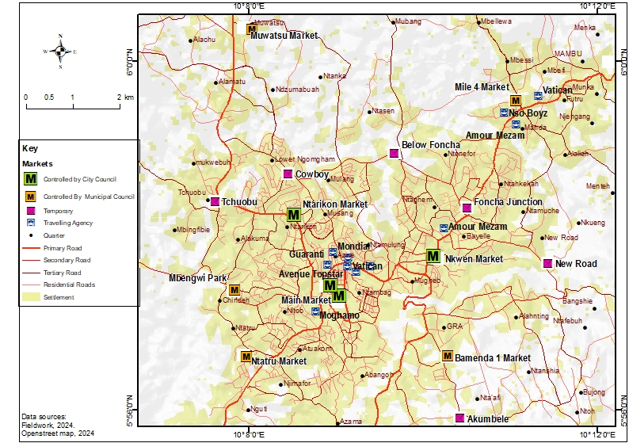
Figure 3: Spatial location of markets in Bamenda

    - The Bamenda Main Market
The Bamenda Main Market, established in 1966 by the then Prime Minister of West Cameroon stands as one of the oldest markets in the city. Situated at the core of the Central Business District (CBD), this market boasts a prime location that is easily accessible. Known for its efficient organization and high levels of congestion, the market offers a wide array of products for sale, catering to both wholesale and retail customers. Wholesale buyers from neighboring communities such as Bafut, Bali, Kom, Babessi, Ndop, and Banso frequent the market. Internally, the market comprises closed sheds that primarily deal with consumer durable goods sourced from locations like Douala, Bafoussam, Nigeria, China, and Dubai. Externally, temporary traders occupy the outer areas of the market, displaying their products on the ground. The bustling trading activities near the main entrances of the market contribute to significant traffic congestion, prompting concerns from city authorities. Issues such as illegal occupation of pedestrian public spaces and parking areas further compound the challenges faced within the market vicinity. Businesses within the market are categorized into various section with specific identification for the trading line. Each section specializes in particular types of products such as tailoring, ready-made dresses, hairdressing, jewelry, cosmetics, shoes, fabrics, and other retail points. These distinct activities were observed and documented during fieldwork. The sheds within the market are labeled with unique numbers at their entrances. In total, there are 702 closed sheds, 456 open sheds, 345 temporary spaces, and 129 attachments that were identified during the field study.

    - Nkwen Market
Nkwen Market is also one of the oldest markets in the city, with its operations dating back to the colonial period. The construction of sheds within the market commenced in the 1970s, and over time, numerous additional sheds have been erected. Initially, the market was built with an enclosure that left a central open space for the sale of various products. Presently, the market area is densely populated, featuring 12 well-structured shed lines within the inner market, along with numerous peripheral buildings and shops at the outer area. Each section of the market is designated for specific products, including vegetable stalls, poultry sales areas, cosmetics, clothing, and tailoring workshops. The market has two entrances, with most of the open sheds and attachments situated near the entry points, leading to significant traffic congestion during peak hours at the main road. Unfortunately, there are no designated parking spaces for vehicles within the market premises. In total, the market comprises 369 enclosed shops, 265 open shops, and 136 attachments.
    - Food Market
The Food Market is the second-largest market in the city in terms of surface area and serves as a vibrant center for economic activities. The market is predominantly occupied by vendors offering a wide variety of groceries, including fresh fruits, vegetables, meat, fish, spices, tomatoes, maize, plantains, and coco-yam. It showcases diverse cultures and cuisines, with vendors from different regions of Cameroon selling their unique specialties. It stands as the largest food market in the city, having been constructed in 1997 and officially inaugurated in 1998. Regarding the market's spatial layout, it comprises 386 enclosed sheds, 328 open sheds, and 1367 temporary and open spaces and attachments. The permanent spaces feature a mix of covered and open sheds with zinc sheet roofing. The open spaces within the market are constructed using flammable blank-wood, posing a fire hazard. The market is physically divided into three sections: permanent structures, temporary structures, and the open-space section.
The permanent sheds cater to the sale of clothing, cultural items, and handicrafts, including traditional bags and garments. Constructed with cement blocks, this section of the market offers a secure environment for both vendors and customers. In contrast, the open spaces primarily feature bamboo and wooden tables for displaying perishable goods such as watermelons, papayas, oranges, tomatoes, and an assortment of fresh herbs. Temporary structures within the open areas are often made from easily removable materials like old zinc sheets, plastic tarps, wood, and bamboo. Many vendors use ropes or wires to delineate their stalls and prevent theft. In this section, traders display a multitude of products on single tables, including onions, ginger, peppers, palm oil, refined oil, and various types of beans. The uncovered parts of the market extend linearly along the roadside, reaching all the way to the Hospital Roundabout. A notable feature is that many products are displayed directly on the ground, old plastic sheets, or bags, which adds to the market's bustling, informal atmosphere.

    - Ntarikon market
Ntarikon Market was established in the 1970s and is structured with over twelve lines of sheds. It has undergone three distinct phases of construction: the first phase included 51 sheds, the second phase added 87 sheds, and the most recent expansion has resulted in an estimated total of 362 operational and non-operational sheds. However, the pathways within the market remain uncovered, and many of the open shed areas are poorly maintained, giving them an outdated appearance. This section of the market features a diverse array of products, including fresh fruits, vegetables, and herbs, which are vital for local nutrition and economy. However, the current political unrest in Bamenda has led to a significant decline in the market's condition. The market now appears totally neglected, with waste, particularly discarded cabbages, strewn throughout the market area and extending onto the adjacent main road. As a consequence, many traders and customers have vacated the market, resulting in a substantial decrease in the market population and overall vibrancy. The decline not only reflects social and economic challenges but also raises concerns regarding food security and community resilience in Bamenda.
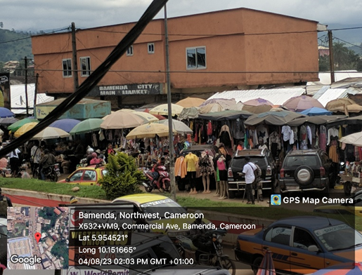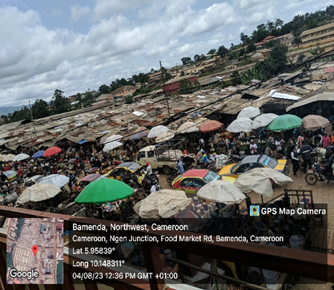
Bamenda Main Market
Food Market
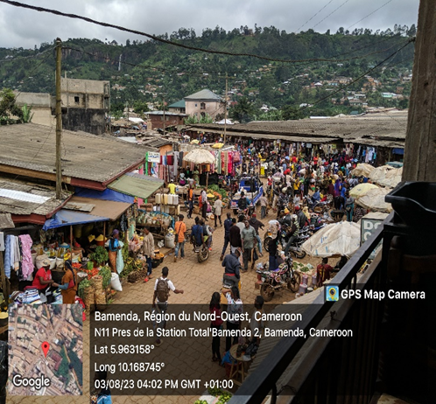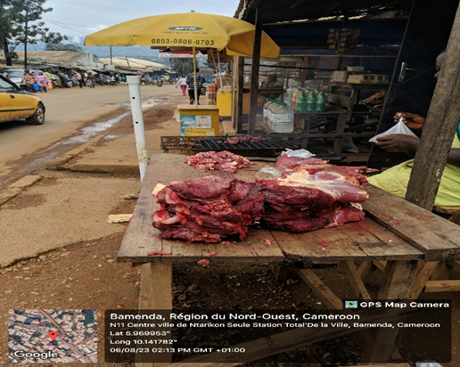
Ntarikon market
Nkwen market
Figure 4. Partial view of the Bamenda municipal markets

    - Motor-park Markets
The Motor Park markets in Bamenda are divided into two categories: Council park-markets, which are owned and directly managed by the municipal council, and Transport Agency markets, which are owned and managed by transport agency proprietors. While the Council markets are open-air, the Transport Agency markets are enclosed and clearly defined. Bamenda city currently has five municipal council markets: Mile 4 Motor-Park Market, BMM Motor-Park Market, Ntahturu or Bali Motor-Park Market, Mbengwi Motor-Park Market, and Mile 8 Motor-Park Market. Among these, Mile 4 and BMM Motor-Park Markets are the most accessible due to their inter-urban transport activities. Traders in these markets bring their goods from outside and sell them within the park, paying a daily fee of 250 FCFA to occupy an open space for their products. The stalls and boutiques within the parks are managed jointly by the Bamenda City Council (BCC) and are filled with various items such as cosmetics, restaurants, salons, bars, and call boxes. The rental fees for market sheds range from 3,000 to 15,000 FCFA per month. Table 2 provides a descriptive overview of the council park markets in Bamenda city.
Table 2: Descriptive information on Council Park Markets in Bamenda City
Name of park Market | Key information
Bamenda Municipal Park market  Date of creation: 2008 | Manage by Bamenda I counccil, on the old site of the municipal forest reserve Up-Station, a market at the site, 90 sheds in total with 50 sheds unoccupied, 50000fcfa advance a shed, two market days (Wednesdays and Saturdays), park operate 6am-6pm, Electricity, water, pit toilets: OK, Entrance: untarred road
Mile 4 Motor Park Market  Date of creation: 2008 | Managed by Bamenda III council. Electricity, water, public toilet:OK, Entrance: tarred, park operate 6am-6pm, Drivers syndicate, park boys, security in the market, spontaneous market, normal activities. 96 sheds all occupied for business activities, 46 open spaces for market products
Bali Motor Park or Ntahturu Park  Date of creation: 1996 | Managed by Bamenda II council. Electricity, Entrance: untarred road, local security, drivers’ union, park boys, park operate 6am-6pm, 27 occupied sheds for business activities and 3 offices, 3000fcfa a shed per month, spontaneous market.
Mbengwi Park  Date of creation: 2003 | Manage by Bamenda II council. Electricity, water, public toilet:OK, Entrance: un tarred, partial barrier, security intervention, park boys, drivers’ union, operate 6am-6pm, 42 sheds and two offices, 5000fcfa a shed per month, spontaneous market
Mile 8 Motor Park Or Muwatsu Park  Date of creation:2003 | Manage by Bamenda II council. Electricity, water, public toilets: OK, partial barrier, 60 sheds, 10000fcfa a shed per month, 1 office, drivers’ union, park boys, operate 6am-6pm, no security, spontaneous market activities.
Source: Field work, 2024
Table 3 shows the location and operation of transport agency markets. This particular set of markets in Bamenda operate within transport agencies and traders mostly target inter-urban passengers as their customers. The markets are confined and managed by proprietors of transport agencies; the markets fully operate in rentage shops while traders expose most of their products in front of their shops. Prominent among transport agency markets are the Amour Mezam, Vatican, Nso Boys, Moghamo, and the Oasis agency markets.

Table 3: Information on transport agencies markets in Bamenda
Location | Travel Agency Market | Toilets | Shops | State of the markets | Estimated passengers transported daily
Mile 2 opposite PMI Nkwen | Amour Mezam Express | 6 | 39 | Permanent site well developed | 620
City Chemist roundabout, Mile 4 | Vatican Express | 4 | 19 | Permanent site, well developed | 560
Food market road | Guarantee Express | 2 | 8 | Permanent site well developed | 120
Longla street Small Mankon | Mondial Express | 1 | 5 | Permanent site well developed | 83
SONAC Street  Food market street, | Moghamo Express | 2 | 7 | Temporal site on rent | 550
Sonac street | Oasis Express | 1 | 11 | Temporary site on a rent | 350
Food market street, Mile 4 | Nso Boys | 2 | 6 | Permanent site, not well developed | 700
Food market Road | Symbol Of Unity | 2 | 3 | Temporary site on rent | 83
Source: Field data, 2024
    - Spatial flow of market products in Bamenda city
As seen on figure 5 Bamenda Main Market is the principal distributor of non-perishable products to the surrounding markets. Most warehouses for products are found in the Main Market, this has given specific orientation in the flow of goods. Most traders in Food, Ntarinkon and Nkwen markets retail their products from the Bamenda Main market, this the same for traders found in motor parks and transport agencies. Traders within the Main market get their goods from Dubai, Nigeria, and some markets within Cameroon such Bafoussam and Douala.
While Bamenda Main Market specialize mostly in the sale of non-perishable products, Food market, Ntarinkon and Nkwen market and others specialized in the sale of both perishable and non-perishable goods. Example of products sold in the Bamenda Main Market includes: cloths, shoes, baby wears, dishes, wrappers, hair dresses, and cosmetics. The other markets have mixed products of durable, semi-durable products and food stuffs. These includes among others, rice, maize, Savon, cooking oil, beans, magi, salt, and others. Within these markets, most of the products are align in sections, for example, a section for fruits, charcoal, traditional wears, plantains and fish.

Mbengwi Park
Mile 4 Park

Nso Boys

Amour Mezam

Ntarinkon Market
Moghamo
Nkwen Market
Main Market
Oasis Express
Ntaturu Park
Mendankwe Park
Guaranti
Mondial
Food Market
Vatcan
Figure 5: Spatial flow of market products in Bamenda
    - Functionality and Accessibility of Market Spaces in Bamenda city
The functionality and accessibility of market spaces in Bamenda play a crucial role in the overall economic development and welfare of the city’s residents. Market spaces in Bamenda serve as important platform for trade and where buyers and sellers meet to bargain. These spaces allow individuals to sell or purchase goods and services, thereby creating opportunities for entrepreneurship and economic growth. Accessibility plays an important role for analyzing the spatial distribution of economic activity within the markets. However, the markets functioning and access to the markets face various challenges that need to be addressed in order to improve the overall market experience for both vendors and consumers.
    - Accessibility of markets in Bamenda city
Majority of the markets in Bamenda are situated near access roads. The municipal markets: Main Market, Foot Market, Ntarinkon Markets are situated within the city center, and just near inter-urban transportable roads. This is the same for Transport Agency Markets. Others such as the council park markets are situated some few meters away from the main road but very close to access roads. Accessibility to the markets premises is easy but accessibility inside the markets is challenged by congestion.
Table 4 shows the estimated distances of market locations from access roads and the proximity of market participants to various markets in Bamenda. The markets in Bamenda are typically located between 2 to 4m from access roads. Central markets such as Bamenda Main Market, Foot Market, Ntarinkon Market, and Nkwen Market face significant congestion challenges due to their close proximity, only 2m away from the main road. These markets lack parking spaces for vehicles and designated stopping points for taxis, leading to traffic congestion and slower mobility in the city. The council parks that also serve as market spaces in Bamenda are decentralized across the city. While these markets are situated farther from main roads, they are closer to access roads, making them more accessible to the urban population of the city.
Table 4: Estimated distances and proximity of population to the markets in Bamenda
Name of Markets | Estimated distance from the road | Proximity of market participants within Bamenda to the markets
Name of Markets | Estimated distance from the road | Less than 1km |  | 1 to 5km |  | 6 to 10km
Name of Markets | Estimated distance from the road | Freq. | % | Freq. | % | Freq. | %
Main Market | 4 meters | 68 | 20,9 | 159 | 49,1 | 97 | 30,0
Foot Market | 1 meter | 84 | 25,9 | 176 | 55,6 | 80 | 24,6
Ntarinkon Market | 2 meters | 129 | 39,8 | 115 | 35,4 | 64 | 19,7
Nkwen market | 2 meters | 132 | 40,7 | 173 | 53,4 | 79 | 24,4
Agency markets | 2 meters | 35 | 10,8 | 26 | 8,0 | 15 | 4,6
Mile 4 Park market | 4 meters | 122 | 37,6 | 169 | 52,2 | 33 | 10,2
BMM park market | 4 meters | 106 | 32,7 | 103 | 31,7 | 34 | 10,4
Ntaturu park market | 4 meters | 115 | 35,4 | 81 | 25,0% | 20 | 6,2
Mbengwi park mkt | 4 meters | 100 | 30,8 | 55 | 16,9 | 51 | 15,7

The study also assessed the proximity of the markets to the market participants in terms of the distance covered by the participants to access the markets, as shown in Table 4. The results revealed that Nkwen market was the most accessible market for the population within a distance of less than 1 km, with a percentage of 40.7%, closely followed by Ntarinkon Market at 39.8%. On the other hand, Agency markets had the lowest rate of market participants within a distance of less than 1 km, with a rate of 10.8%. It is important to note that the majority of participants in the Agency markets are inter-urban passengers who are in transit.
Between distances of 1 to 5 km, the Food market was found to be the most accessible market for the population in Bamenda, with 55.6% of market participants coming from this distance. Nkwen market also had a high percentage of participants from this distance, at 53.4%. The Bamenda Main market followed closely with 49.1%, Ntarinkon market at 35.4%, while Agency markets had the lowest rate at this distance with 8.0%. The final category of market participants included those coming from distances from 6 to 10 km within the city. Within this range, the Bamenda Main market received 30.0% of market participants, with most of the population coming from Mile 4, Mile Nkwen, Up-Station, and Ntarinkon. The Food Market received 24.6%, Nkwen market 24.4%, and Ntarinkon market 19.7%. The remaining market populations ranged from 4.6% for Agency markets to 15.7% for Mbengwi markets.
    - Rating of layout of markets in Bamenda
The findings as indicated on figure 6 shows that 74, 3% of the layout of markets in the city was rated to be poor, congestion in the markets was rated at 66, 9% and very noisy. 83, 1% of the layout and organization is decent but need improvement. In terms of accessibility into the markets, 97, 2% accessibility was rated to be is difficult, this because most of the market has one main in-let and out-let. This rating was attested by the population who acknowledged that the markets especially Bamenda Main Market, Nkwen Market, Ntarinkon and Food Market, accessibility into the markets is only by foot, there is no access path for vehicles nor parking spaces.

Figure 6: rating layout of markets in Bamenda city

    - Rating accessibility within the markets in Bamenda
Accessibility within markets was assesses especially taken into consideration various factors such as physical barriers, and ease of navigation for participants with mobility challenges. Figure 7 revealed several areas within the markets that presented obstacles for market customers. Physical barriers such as narrow pathways 97, 2%, uneven flooring 78, 3%, and undesignated shop lines 91, 9%, made it difficult for individuals to navigate the market spaces. Additionally, the lack of accessible amenities, such as seating areas 100, 0%, and no orientation center 100, 0%, further restricted the ability of people to fully participate in market activities.

Figure 7: Assessment of accessibility within the markets in Bamenda

One of the key issues identified during the fieldwork was the lack of awareness and training among market vendors and market masters on how to assist customers. Many vendors were unaware of the specific needs of customers and were not equipped to provide appropriate support. This lack of training and awareness contributed to the overall inaccessibility of the market spaces. It is essential for market authorities to prioritize accessibility and inclusion in their planning and design of market spaces. This can include implementing measures such as creating accessible pathways, and providing training to vendors on how to assist customers. By taking these steps, markets in Bamenda can become more inclusive and welcoming spaces for all members of the community.
    - Challenges face by participants in the markets in Bamenda
Figure 8 present various challenges face by market traders on a daily basis in the markets in Bamenda that affect their ability to effectively conduct businesses. One of the major problems faced by traders was the issue of poor infrastructure in the markets. Results indicates that 84,5% of market stalls are in a state of disrepair, with leaking roofs, broken floors and inadequate sanitation facilities, to this effect, 75,6% of the market participant grumbled of poor hygiene practices. This was mostly observed in Food market, Nkwen market and Ntarinkon markets. This not only create a poor working environment for the traders but also possess a health risk to both traders and customers. Another visible challenge face by markets traders is that of limited access ways inside the market, 82, 7% of market customers complain of congestion and accessing the markets freely. This has a direct impact on trader’s business location as it may be hard to trace by customers. 77, 4% of the market vendors complained of high rents by the City Council, thus weighing a lot on business turnout.

Figure 8: Difficulties face by traders in markets in Bamenda
Source: Field work, 2024

Theft and vandalism are common occurrences in the markets, leading to financial losses for the traders. Additionally, the lack of adequate security measures makes traders vulnerable to physical harm, especially during late hours when the markets are less crowded. The last challenge advanced by traders was the issue of space, 89, 0% of the traders complained of limited space to expose their products. Storage spaces for goods in the markets are not provided for traders, as a result 25, 5% of them dealing with wholesale goods find it difficult to store their goods. Majority of the markets are not also secured as 53, 4% of the market participants complained of insecurity in the markets especially at Food market, Ntarinkon and Mile 4 markets.
  - Management practices of markets in Bamenda
Feedback from the field shows that traders were not satisfied with the management practices within the markets except for regular cleaning of the markets 91, 0% of the traders were satisfied with the outcome. Waste management of the markets was generally poor and 83, 9% of the market traders were not satisfied with the situation. This was the same for provision of security in the markets. Except for the Main market and Nkwen were 24,3% of the traders reported they were satisfied with the security measures in the market, 75,7% of the rest of the traders were not satisfied with the security situation in Food market, Ntarinkon and Mile 4 markets.
Also, concerning facilities maintenance in the markets such as toilets, hand washing tanks, and waste discharge points, only 32, 5% of the traders were satisfied with the current situation while 67, 5% were not satisfied. According to these traders, the toilets in the markets are not modern and the carry capacity of the toilets are high. For example, a market like the Bamenda Main market with above 700 market traders has just four (4) toilets. Another feedback was gotten from the market traders as concerns upgrading of their stalls. From all indication, 50, 5% of them were satisfied with their shops but emphasize that the painting of the stalls is done by them, and not the City Council, except the entrance of the gate which is done by the city council. The remaining 49, 5% of the traders were not satisfied with the nature of their stalls, according to them, the shop sizes are first of all small, not spaces to move freely in the shops, they frequently suffer from leakage of the roofs during rainy season. Traders feedback on electricity installation in the markets shows that 6, 7% of them were very satisfied, 32, 7% of them were satisfied, while 60, 6% where not satisfied with the lighting situation in the markets.
Table 5: Management practices of market spaces in Bamenda
Management practices | Trader’s feedback on satisfaction
Management practices | Very satisfied |  | Satisfied |  | Not satisfied
Management practices | Freq. | % | Freq. | % | Freq. | %
Regular cleaning of the markets | 32 | 9,0 | 322 | 91,0 | 00 | 00,0
Waste management | 00 | 00,0 | 57 | 16,1 | 297 | 83,9
Provision of security in the markets | 00 | 00,0 | 86 | 24,3 | 268 | 75,7
Maintenance of facilities such as toilets, hand washing points | 00 | 00,0 | 115 | 32,5 | 209 | 67,5
Upgrading stalls | 00 | 00,0 | 179 | 50,5 | 175 | 49,5
Installation of light | 24 | 6,7 | 116 | 32,7 | 214 | 60,6
Training of vendors on customer service skills | - | - | - | - | - | -
Construction of proper drainage systems | 00 | 00,0 | 124 | 35,0 | 230 | 65,0
Provision of parking spaces | 00 | 00,0 | 58 | 16,4 | 296 | 83,6
Enforcement of rules on operating hours | 127 | 35,9 | 227 | 64,1 | 00 | 00,0
Monitoring and evaluation of management practices | 00 | 00,0 | 54 | 15,3 | 300 | 84,7
Source: Field work, 2024
There was absent of training of vendors on customers services in all the market. Concerning the construction of drainage systems, 35, 0% of the traders were satisfied with the practice, this was against 65, 0% of the traders who were not satisfied with the management of the drainage systems. Feedback from parking spaces in the markets shows that only 16, 4% of the market traders were satisfied current management of parking space, 83, 6% were not satisfied at all. The complaint the market lacks parking spaces, customers trek to the markets. Rules on operating hours in the market was highly respected and enforced, 35, 9% of the traders were very satisfied, 64, 1% were satisfied. Lastly, the trader’s feedback was sampled on the monitoring and evaluation of management practices of the markets 15, 3% of the traders were satisfied while 84, 7% were not satisfied.
  - Recommendations
Based on the findings from the study, the following key recommendations are proposed to guide policymakers in Bamenda toward sustainable urban market management that meets future generations' needs.
- Participatory Planning: The planning and design of marketplaces should prioritize the genuine spatial needs of market traders. This can be achieved through participatory approaches that involve collaboration among traders, customers, municipal authorities, architects, planners, and other stakeholders to ensure the project meets diverse requirements.
- Enhanced Training: Architecture and planning training programs should emphasize awareness and sensitivity to the complexities of market trading environments. Given the dynamic nature of these spaces, traditional standards may not suffice. A context-specific framework for identifying, developing, and applying design concepts is essential for creating functional marketplaces.
- Implementation of the Master Plan: The proposed Master Plan for Bamenda must be vigorously enforced to manage unplanned urban spaces, particularly market infrastructures. Effective execution of the Plan of Soil Occupation (POS) will mitigate the disorderly placement of market stalls and the illegal operation of markets.
- Stakeholder Collaboration: Active collaboration among all market trading stakeholders is vital. This cooperative approach will not only facilitate the provision of adequate trading spaces but also ensure the protection of both private and public interests.
- Infrastructure Improvement: Invest in upgrading access roads and transport facilities leading to market areas. Improved infrastructure will enhance accessibility for both traders and customers, ultimately boosting economic activity.
- Sustainability and Environmental Considerations: Incorporate sustainable practices in market design, such as eco-friendly materials and waste management systems, to minimize environmental impact while fostering a healthier trading environment.
- Monitoring and Evaluation Framework: Establish a robust monitoring and evaluation system to assess the effectiveness of market policies and infrastructure over time. This will help in adapting strategies as needed and ensuring that market spaces evolve in response to changing community needs.
Conclusion
The findings from the study on the spatial configuration of market spaces in Bamenda City, reveal some significant insights into the accessibility and management challenges faced by urban markets. The analysis demonstrates that the current spatial arrangements of markets in cities often hinder efficient movement and accessibility for both traders and customers, contributing to congestion and inefficiencies in market operations. The study identifies that inadequate infrastructure and unplanned market layouts exacerbate these challenges, limiting the potential for economic growth and community engagement. The lack of a cohesive management strategy further complicates the situation, resulting in disorganized market environments that do not meet the needs of users effectively. Critically, the findings highlight the necessity for a collaborative approach to market planning that involves all stakeholders. By prioritizing participatory design methods and context-specific solutions, Bamenda can improve accessibility and create more functional market spaces. The study further reveals that effective enforcement of the proposed Master Plan of Bamenda city and the Plan of Soil Occupation is crucial in curbing unplanned market developments, thereby enhancing order and accessibility. Moreover, the recommendations for improved infrastructure, sustainability practices, and a robust monitoring framework are essential to ensure that urban markets remain vibrant and resilient in the face of future challenges.
References
- African Development Bank. (2019). African Economic Outlook 2019: Macroeconomic Performance and Prospects. Retrieved from https://www.afdb.org/en/knowledge/publications/african-economic-outlook-
- Alliance for a Green Revolution in Africa., (2020). Feeding Africa’s Cities: Opportunities, Challenges, and Policies for Linking African Farmers with Growing Urban Food Markets. Nairobi, Kenya.
- Alok Sharma (2020). UK internal market, Presented to Parliament by the Secretary of State for Business, Energy and Industrial Strategy https://www.uk-internal-market/uk-internal
- Angmor, E. N. (2012). Can Traditional Markets be Improved Through Transportation Service:(The case of Asesewa and Agormanya Traditional Markets, Ghana). International Journal of Academic Research in Business and Social Sciences, 2(6), 366.
- Asojo, A.; Vo, H.; Bae, S., (2021). The Impact of Design Interventions on Occupant Satisfaction: A Workplace Pre-and Post-Occupancy Evaluation Analysis. Sustainability Vol. 13, 13571. https://doi.org/10.3390/su132413571
- Babajo. H, Yusuf, R. O. & Musa, I. J., (2018). Effects of periodic markets on job creation, socio economic growth and sustainable development. Global Journal of Human-Social Science: B Geography, Geo Sciences, Environmental Science and Disaster management 18(5) Version 1.0. https://globaljournals.org/GJHSS_Volume18/4-Effects-of-Periodic-
- Dmytrów, K., & Bieszk-Stolorz, B. (2021). Comparison of changes in the labour markets of post- communist countries with other EU member states. Equilibrium. Quarterly Journal of Economics and Economic Policy, 16(4), 741-764. https://doi.org/10.24136/eq.2021.027
- Markets.pdfBamfo, B. A., & Agyeiwaa, E. (2019). The Impact of Market Spaces on Vendors' Livelihood: A Study of Asafo Market, Kumasi, Ghana. Journal of African Business, 20(4), 502-515. https://doi:10.1080
- Bennett, R., & Savani, S. (2014). The Rebranding of City Places: An International Comparative Investigation. International Public Management Review, 4(2), 70–87. Retrieved from https://ipmr.net/index.php/ipmr/article/view/217
- Chen, Y., & Li, Y. (2020). The Challenges of Informal Sector in Africa: A Review of Literature. Journal of African Development, 22(2), 71-96. https://doi:10.5555/1596-8308.22.2.71
- Cotte, J., & Coulter, R. A. (2016). Pleasure, arousal, dominance: Mehrabian and Russell revisited. Food Quality and Preference, 51, 141-149
- Dimitrijević, B., Jaćimović, S., Bogetić, S., & Nikšić, D. (2017). Utilization of space for the efficient space management. Procedia Engineering, 178, 33-42.
- Eff, E. A., & Jensen, C. D. (2007). The Integration of Periodic Markets in Mayan Guatemala: A gravity approach (No. 200705).
- Handisman. S, (2023). The ultimate guide to space management for facility managers, www.handiman.in
- Hansika W.A.M., and Buddhini A., (2016). Impact of Office Design on Employees' Productivity; A Case Study of Banking Organizations of North Western Province in Sri Lanka, SSRN Electronic Journal, https://doi:10.2139/ssrn.2910255
- Huang, Y., Su, S. C., Dyerson, R., & Wu, M. (2017). Evaluating the effects of a food market’s atmospheric cues on visitor satisfaction and loyalty. Journal of Place Management and Development, 10(3), 320-347.
- Ikioda FO., (2013). Urban Markets in Lagos, Nigeria, Volume7, Issue7 Pp517-526 https://doi.org/10.1111/gec3.12057
- Imorou A, (2006). “Dynamics of local powers linked to the management of the Central Market of Parakou”, In Bulletin of the APAD, Rural-urban interactions: circulation and mobilization of resources, http://apad.revues.org/436
- Godfred, A., Dinye, R. D., & Emmanuel, O. (2015). The Contribution of Periodic Markets to Internally Generated Fund (IGF) of Ejisu-Juaben Municipal Assembly. Journal of Studies in Social Sciences, 11(1).
- Gontarz, A. (2014). Ergonomics and space management in office space. Procedia Manufacturing, 22, 892-897.
- Mabogunje, A.L., (2012). The spatial organization of markets in West Africa. Geo.journal, 77(4) 443-456
- Mandal, U., (2006). Determination of Relative Importance of Periodic Market Places in Rural Development in Saptari District, Eastern Nepal. Nepalese Journal of Development and Rural Studies 3 (2): 1-9.
- Meng, T., Florkowski, W.J., Sarpong, D.B., Chinnan, M.S. and Resurreccion, A.V.A. (2014), “Consumer’s food shopping choice in Ghana: supermarket or traditional outlets?”,International Food and Agribusiness Management Review, Vol. 17 No. SpecialIssueA, pp. 107-129, https://doi:10.22004/ag.econ.164600
- Mollenkopf, D. A., & Frankel, R. (2019). Space and opportunity in marketplaces: The case of farmers’ markets. Journal of Public Policy and Marketing, 38(2), 235-252.)
- Muzondidya, J., & Gadzirayi, C. T. (2019). Informal Markets in African Cities: Implications for Urban Planning and Public Health. Journal of Planning Literature, 34(2), 166-182. https://doi:10.1177/0885412218823553
- Nirmalya D., and Guru P. C., (2015). Periodicity and Spatio-Temporal Spacing of Rural Markets of Purba Medinipur District, West Bengal: An Appraisal of the Market Centre Development, Golden Research Thoughts, Volume 4, Issue 7., Available online at www.aygrt.isrj.org
- Ngala, H.,Ndi1 & Ebai, E.E. O., (2014). Space and Infrastructure Functionality in Yaounde Markets. Journal of Geography and Geology; Vol. 6, No. 2; ISSN 1916-9779
- Nkwi, P.N., Fonsah, E.G., & Mba,C.I., (2017). The spatial organization of markets and urban development in Cameroon. Africa Geographical Review, 36(1), 38-56
- Ogunlana, S. (2012). Space planning and management: roles, responsibilities, and benefits. Facilities, 30(13/14), 590-603.
- Olsen, A. (2018). Space planning: A foundational step in facility management. FMJ, 27(4), 40- 41.
- Omari, R., Joost J., George E., Godfred F., and Guido R., (2016). “The Role of Convenience in Fast Food Consumption in Urban Ghana”. Journal of Scientific Research and Reports 11 (4):1-12. https://doi.org/10.9734/JSRR/2016/27927.
- Owusu, G., & Lund, R. (2004). Markets and Women's Trade: Exploring their Role in District Development in Ghana. Norsk Geografisk Tidsskrift-Norwegian Journal of Geography, 58(3), 113-124.
- Pari Sabety and Virginia L. Carlson (2004). Using Information to Drive Change: New Ways to Move Urban Markets, the Brookings Institution, Urban Markets Initiative

- Rheinlander, T., Olsen, M., Bakang, J.A., Takyi, H., et al. (2008). Keeping up Appearances: Perceptions of Street Food Safety in Urban Kumasi, Ghana. Journal of Urban Health, Vol 85, 952-964. https://doi.org/10.1007/s11524-008-9318-3
- Smoyer-Tomic, K. E. (2016). Space management. In Encyclopedia of Geography (pp. 1-5). SAGE Publications.
- UN-Habitat. (2003). The Challenge of Slums: Global Report on Human Settlements 2003. Retrieved from https://www.un-ilibrary.org/content/books/9781844070557
- Wenyu, D., Wanli, Z., & Chau, K. H. (2016). Enhancing space efficiency through office space layouts. Facilities, 34(13/14), 733-748.

