Emerging Trends and Insights: A Comprehensive Bibliometric Analysis of Artificial Intelligence Applications in Healthcare and Psychology

Abstract

Purpose—This article provides a bibliometric analysis of advancements in Artificial Intelligence in Healthcare and Psychology (AIHCP) and a recent status assessment of healthcare, Psychology, and Artificial intelligence trends. As this is a very emerging area of research, a research trend is required.

Design/methodology/approach – A full bibliometric analysis (BA) was done using a two-stage filtering system on an initial volume of 1,499 documents in the initial stage from 1960 to 2023, 1362 documents from 2013 and 2023, and 11 publications in the final phase of the evaluation which stressed further in 2018–2023 from the Scopus database. Frequency analysis on sources, journal, type, subject area, sponsor, author, country, and organization/institution of publication were evaluated during the first phase of the analyses. The co-author and the authors' proof of teamwork were also considered. The subsequent phase included a network analysis of co-occurring keywords. Additionally, text mining/mapping of the document articles was presented.

Findings—Emerging trends (ET) in health psychology research include but are not restricted to, historical research on artificial intelligence in health care and psychology applications, using a chatbot, acceptability, and VOSviewer. The possibility that these innovations can solve the present challenges in health psychology was also reviewed.

Originality/value – This finding offers a global overview of AI application in Health Psychology research trends while recognizing existing issues. In addition, the research relies on extracting text from unstructured abstracts, which was not described in AIHCP.
Keywords-Text mining, Artificial intelligence, Chatbot, VOSviewer, Scopus

Introduction
Artificial intelligence (AI) is a fast-changing field of computer science that involves developing algorithms and systems capable of carrying out tasks that usually require human intelligence (Littman et al., 2022). It is the study of how computers can learn and reason, perceive and interact with the world, and solve complex problems using a variety of approaches, including machine learning, deep learning, natural language processing, and computer vision (Sarker, 2021). AI aims to create machines that can operate autonomously, make data-based decisions, and adapt to new situations and environments (Khayyam, Javadi, Jalili, & Jazar, 2020). AI can potentially revolutionize many aspects of our lives, including healthcare, transportation, finance, education, and entertainment (Diamandis & Kotler, 2020). With the increasing availability of data and computing power, AI has become more accessible to businesses, researchers, and individuals, leading to a surge in innovation and development (Mhlanga, 2021). AI can be divided into two general categories: strong AI and narrow AI (Kalanderian & Nasrallah, 2019). AI systems built for a single purpose, such as image recognition or natural language processing, are called narrow AI (Gil, Hobson, Mojsilović, Puri, & Smith, 2020). These highly specialized systems can perform their tasks with great accuracy and speed. On the other hand, general AI refers to systems that can perform a wide range of tasks and reason and learn like humans (Gunning & Aha, 2019). General Artificial intelligence is still in its formative stages, and researchers are working towards creating systems that can mimic human intelligence more holistically. Despite AI’s potential benefits, concerns about its impact on employment, privacy, and safety exist. As AI systems become more capable, there are fears that they may replace human workers, exacerbate existing inequalities, and be used to perpetrate cyberattacks. AI can revolutionise healthcare by improving diagnosis, treatment, and patient outcomes (Farina, Zhdanov, Karimov, & Lavazza, 2022).

A chatbot is a computer software designed to mimic human communication; chatbots are typically used in message or chat interfaces. (Adam, Wessel, & Benlian, 2021). Chatbots enable more human-like interactions between users and themselves by utilizing natural language processing (NLP) to comprehend user inputs and provide relevant responses. (Bharti et al., 2020). Chatbots can be divided into two categories: those that rely on rules and those that use machine learning. Using predetermined rules and responses, rule-based chatbots produce responses to user inquiries. They are simple and easy to build but limited in understanding complex inputs and generating natural-sounding responses. Conversely, chatbots that are based on machine learning employ algorithms to gain knowledge from user interactions and enhance their responses over time. They need a lot of training data and are more difficult to construct. But they can also offer more tailored and precise solutions, which are getting more and more well-liked across a range of sectors, such as healthcare, e-commerce, and customer service. They can help businesses automate customer support, improve response times, and provide personalized assistance to customers (Maher, Bhable, Lahase, & Nimbhore, 2022). For example, chatbot help patients schedule appointments, receive medication reminders, and provide information about symptoms and treatments (Palanica, Flaschner, Thommandram, Li, & Fossat, 2019). The use of chatbots in mental health interventions is a promising area of research, with evidence suggesting that they can provide adequate support and therapy for various mental health concerns (Boucher et al., 2021).

Healthcare and psychology are interrelated fields crucial for promoting and maintaining physical and mental health (Gruber et al., 2021). Healthcare involves preventing, diagnosing, and treating illnesses and medical conditions, while psychology is the scientific study of human behavior and mental processes. Psychology is an essential component of healthcare because it helps healthcare professionals understand how patients think, feel, and behave (Ho, Chee, & Ho, 2020). It can inform the development of effective treatments and interventions that address not only the physical symptoms of an illness but also the emotional and psychological effects it may have on patients. For instance, mindfulness-based interventions and cognitive-behavioural therapy (CBT) are psychological therapies that are useful in treating a variety of mental health issues, including depression, anxiety, and post-traumatic stress disorder (Apolinário-Hagen, Drüge, & Fritsche, 2020). In addition, understanding the psychological factors that influence health behaviors, such as diet and exercise, can help healthcare professionals develop interventions that promote healthy habits and prevent chronic diseases.

Literature Review
Several recent studies have explored the use of AI in healthcare, including machine learning and deep learning algorithms. For example, a study by Kim et al. (2020) used deep learning algorithms to predict patient outcomes based on electronic health record data. The study found that the algorithm could predict patient outcomes with high accuracy, demonstrating the potential of AI in improving patient care. Another study by Zhu et al. (2021) used a machine learning algorithm to predict sepsis in patients based on vital signs and laboratory data. The algorithm could accurately predict sepsis several hours before it was clinically diagnosed, allowing for earlier intervention and treatment. AI has also been used in diagnostic imaging, including radiology and pathology. For example, a study by Lotter et al. (2021) used a deep learning algorithm to accurately detect breast cancer on mammograms, demonstrating the potential of AI in improving the accuracy and efficiency of a cancer diagnosis. AI is also increasingly used in psychology, particularly in developing mental health interventions and digital therapies. For example, the study found that the chatbot intervention effectively reduced symptoms of depression and anxiety, demonstrating the potential of AI in delivering accessible and effective mental health care.

AI is also used to develop digital therapies for various mental health conditions. For example, a study by Chekroud et al. (2021) used a machine learning algorithm to develop a personalized digital therapy for depression, which was found to be effective in reducing symptoms of depression in patients. AI is also used to improve the accuracy of psychological assessments and diagnoses. For example, a study by Vakadkar, Purkayastha, and Krishnan (2021) used a machine learning algorithm to accurately predict the diagnosis of autism spectrum disorder in children based on standardized assessments, demonstrating the potential of AI in improving the accuracy and efficiency of psychological assessment. AI in healthcare and psychology can transform these fields by improving diagnosis, treatment, and patient outcomes. However, there are also challenges to implementing AI in these fields, including the need for large amounts of high-quality data and ethical considerations around data privacy and bias. Further research is needed to realise AI's potential in healthcare and psychology and address these challenges responsibly and ethically.

Despite this noticeable application associated with the propagation of AI in health psychology, the research and progress on the topic as a whole are getting better and better, particularly with significantly improved effectiveness and latent likelihoods of profitability essential to the use of the technology in health care psychology.

Research Methods
Metric studies refer to the quantitative analysis and measurement of various phenomena using standardized methods and instruments(Wu et al., 2023). These studies involve collecting and analyzing data to determine a particular phenomenon or behaviour's magnitude, frequency, and distribution. Metrics are commonly used in many fields, including business, economics, health, social sciences, and technology. For example, health metrics are used to me outcomes, such as life expectancy, mortality rates, disease prevalence, and risk factors (Lelieveld et al., 2020). Metric studies play a crucial role in decision-making, planning, and evaluation in many fields, helping to provide valuable insights and improve performance (Schildkamp, 2019).

Bibliometrics is a study involving quantitative analysis of academic literature, including books, articles, and other forms of research output (Kirtil & Aşkun, 2021). It has become an increasingly popular method for evaluating research impact, identifying trends and patterns in scholarly communication, and informing research funding decisions. The field is based on key concepts, including citation analysis, impact factor, and h-index. In addition, it employs data collection and analysis methods, such as Web of Science, Scopus, and Google Scholar. Bibliometrics has numerous applications in academia and beyond, including research evaluation, knowledge discovery, and policy making. However, the field has also been subject to criticisms and limitations, such as the potential influence of self-citations, editorial policies, and publication biases on bibliometric indicators. Despite these challenges, bibliometrics remains a valuable tool for understanding the complex dynamics of academic publishing and the impact of research on society. Ongoing developments in the field, such as integrating metrics and social media metrics, will likely continue to shape the future of bibliometrics and its applications in research and policymaking.

Bibliometrics and artificial intelligence are increasingly being applied in health psychology better to understand the impact and dissemination of research findings. By utilizing advanced algorithms and natural language processing techniques, AI can analyze vast amounts of scholarly literature and identify patterns and trends in research. Bibliometric analysis can identify gaps in the literature, inform research priorities, and assess the impact of interventions and treatments. AI applications in bibliometrics can also help identify emerging research topics and potential collaborators, facilitating the development of multidisciplinary research teams. Overall, combining bibliometrics and AI can significantly enhance our understanding of the complex interplay between psychology and health and contribute to developing more effective interventions and treatments. The flowchart for this study is shown in Figure 1. The techniques implemented include:

Scopus Database

Initial Output=1499

Output=1362

VOSviewer 1=Stage of analyses analysis\\

Frequency Analyses
Co-authorship Analyses

Final Extraction=11

Bibliometric Analysis Second Stage

Co-occurrence of Keywords
Text Mapping & Mining

Figure 1: The flow chart of the research design.

- Publication frequency analyses by type of journal, territory/country, organizations/ institution, sponsor, subject area, year, and authors within ten years between 2013 and 2023.
- Co-author analyses that involve co-occurrence and indication of a collective link of authors enclosed in the analysis corpus.
- Co-occurrence of keywords estimation because it classifies the relationship and interrelations among related trends in literature. The co-occurrence of keywords was restricted to 2018-2023 to classify current movements with other related elimination measures.
- Text mapping/mining of abstracts of research manuscripts from Scopus, as they describe the material of the research organism, referred to in the papers. It goes beyond keywords to recognize names and related phrases of names, providing a better understanding of the evolution of research.

Due to the global nature of AI in health care and psychology and the keyword diversity, the Scopus database was chosen for this research because it offers high-quality data and can be used to improve search queries and strings. Furthermore, Scopus is also considered one of the world's most important analytical research and scientific citation platforms.

The Scopus collection was the subject of an on-line search and extraction. The database collection search and extract approach was implemented to produce strong and wide-ranging search items. First, a two-stage sort was done to screen the appropriate documents from the filtered results. The pre-selection process was established based on the criteria for excluding materials that were not published in book chapters, manuals, or editorials. After that, the co-occurrence of the filtered result was examined in light of the published documents' details, including the dates, the number of publications pertaining to a certain author, the nation, the kind of publication, and the publication's source. This research is imperative to assess and progress AI in Health care and psychology.

The initial search was completed, and 1362 items were retrieved over the 10 years since 2013. Keyword search was used to extract relevant records from the Scopus database (“artificial AND intelligent AND in AND healthcare”) was the string used to search the database. It later streamed to keyword search (“artificial AND intelligent AND in AND healthcare AND psychology”). A total of 11 documents were then re-claimed.

Tool selection required for analysis
Network analysis is a rapidly growing field with broad applications in many areas, including social science, computer science, biology, and engineering. Recent literature has focused on developing new methods and techniques for analyzing networks' structure, function, and evolution and exploring their practical applications. Some of the key themes in this literature include network analysis for understanding complex systems, developing dynamic network models, and integrating network analysis with other statistical and computational methods (Su, Lin, Chen, & Lai, 2020).

VOSviewer is a widely used and powerful software tool for constructing and visualizing bibliometric networks, providing a range of functionalities for network analysis and customization (McAllister, Lennertz, & Atencio Mojica, 2022). Its intuitive interface and user-friendly features make it accessible to researchers and practitioners. VOSviewer has contributed to advancing bibliometric research by enabling users to explore large datasets of scientific publications, identify patterns and trends in research fields, and generate insights into the structure and dynamics of research networks. Its popularity is evidenced by its frequent use in academic publications and the citation of its developers' work, demonstrating its value and impact in bibliometrics (Meng, Wen, Brewin, & Wu, 2020). The data analysed in this work were obtained from the database of Scopus. The work investigated co-authorship and co-occurrence analyses for keywords using VOSviewer version 1.6.19. In the VOSviewer results, circles and labels show the parts of the visualization network.

Frequency Analysis
Publication by journals
As illustrated in Table 1, of the 1362 publication sources found in the Scopus database, The top 10 most mentioned publication documents are shown with the number of articles published and the total number of various citations retrieved. The journals include “the Journal of Lecture Notes in Computer Science, which leads in the number of documents published overall, with 42 documents, followed by the Journal of Advance in Intelligent Systems and Computing with 41 documents, and Ceur Workshop Proceedings was the least on this list, with 12 documents”.

Table 1. Publication by journals.
No | Journal Source | Documents
1 | Lecture Notes in Computer Science Including Subseries Lecture Notes in Artificial Intelligence and Lecture Notes In Bioinformatics | 42
2 | Advances in Intelligent Systems and Computing | 41
3 | IEEE Access | 39
4 | Communication in Computer and Information Science | 20
5 | Smart Innovation Systems and Technologies | 16
6 | Lecture Note in Network and Systems | 15
7 | Studies in Health Technology and Informatics | 15
8 | Procedia Computer Science | 13
9 | ACM International Conference Proceeding Series | 12
10 | Ceur Workshop Proceedings | 12

Territory/country distribution
Figure 2 shows the country publication outline on research of AI in Health care and psychology across world regions. Five continents are considered to indicate active research and advance in research, namely Asia (China 207, South Korea 62, India 359, Saudi Arabia 89, and Pakistan 64) with a combined production of 781 publications, North America has a joint publication of 201 (USA 153 and Canada 48). A total of 176 documents from Italy 65 and the UK 111 are in Europe. Australia now has 55 papers in total. This is by no means a comprehensive list, but it does include all of the continents and nations where research has been actively published. There is no evidence of AI in health care and psychology research.

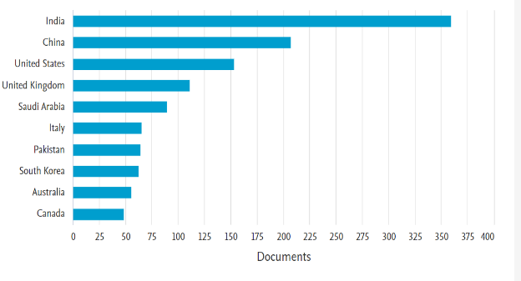

Figure 2: Document by country.

Publication per author and co-authorship network
Co-authorship network refers to the social network of authors who collaborate on scholarly publications. Each author is a node in the network, and their connections represent their co-authorship relationships (HabibAgahi, Kermani, & Maghsoudi, 2022). A network of co-authors was established on authors who make significant contributions to the research and trends of the AIHCP. Figure 3 highlights More influential authors and scientific contributions to research on AI in health care and psychology. A brief review of the most productive authors revealed that Tanwar, S. (8 documents), Gupta, R. (7 documents), Chatterjee, P. (6 documents), Machado, J. (6 documents), Abbasi, Q.H. (5 documents), Gulzani, M. (5 documents), Gupta, D (5 documents), Kadry, S. (5 documents), and Rodrigues, J.J. P.C. (5 documents) had had an extremely significant scientific impact in the area of research being studied. The impact of the research was calculated in terms of the number of documents.

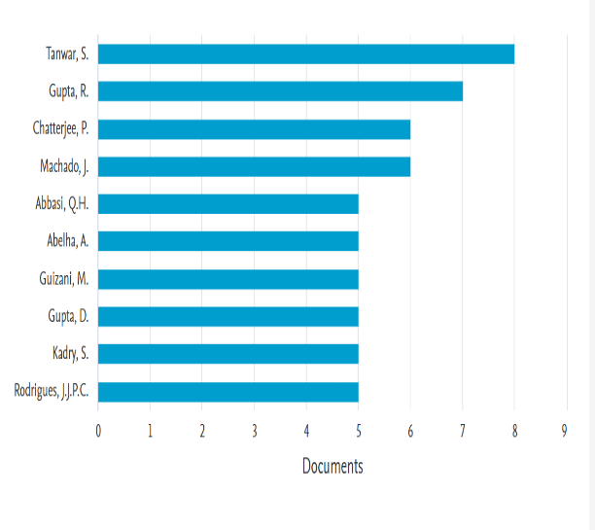
Figure 3: Document by Author.
Publications produced by organization/institution
This section contains a list of publications produced by organizations. The search results thus constituted the selection criteria. Figure 4 shows the volume of publications published by different organizations and universities since 2013.

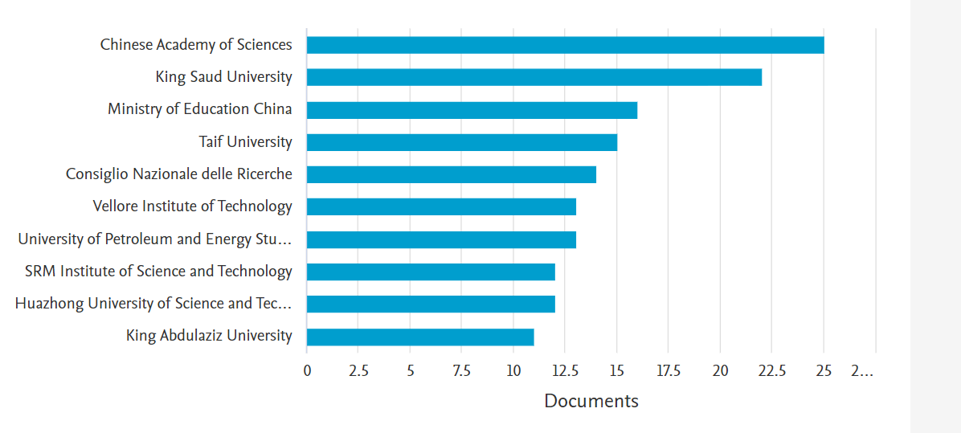

Figure 4: Document by Organization and University.

Publications produced by Sponsor
This section contains the list of the ten publications produced by the sponsor, which is also examined. The National Natural Science Foundation of China has the highest number of sponsors, with 87, followed by the National Key Research and Development Program of China, with 20, and the Horizon 2020 framework program, with 10 sponsors, as shown in Figure 5.

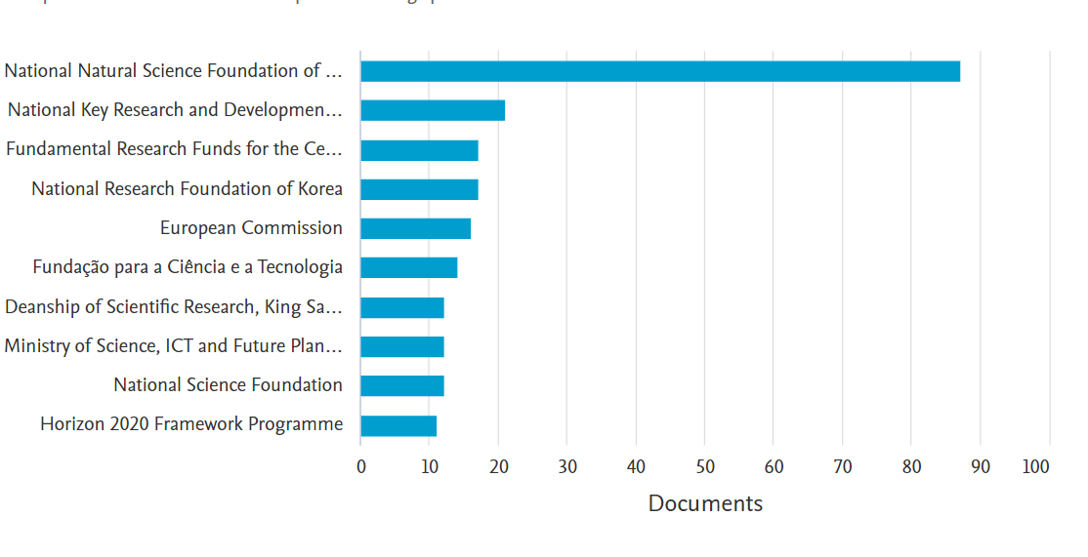

Figure 5: Document by Sponsor.

Publications produced by the Subject area
This section contains the list of publications produced by the subject area. Figure 6 shows that computer science has the highest percentage, 31.3%, followed by engineering with 20.3%, and the energy subject area has the least, 1.9%.

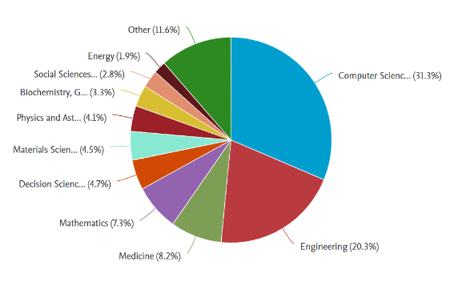

Figure 6: Document by Subject Area.
Publications produced by type
This section contains the list of the publications produced by type is also examined. The article has the highest percentage with 41.2%, followed by conference paper with 34.0%, and short survey has the lowest with 0.1%, as shown in Figure 7.

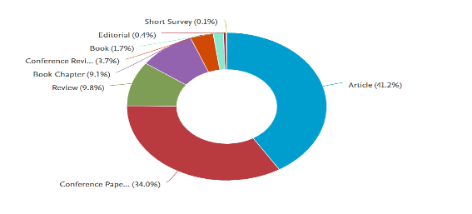

Figure 7: Document by type.
Publications produced by the Journal
This section contains the list of the publications produced by the journal is also examined. The computer science lecture notes, comprising the subseries lecture notes on AI and the bioinformation lecture notes, have the highest point that spread across the graph in red. The volume of publications published since 2013 by the journal is shown in Figure 8.

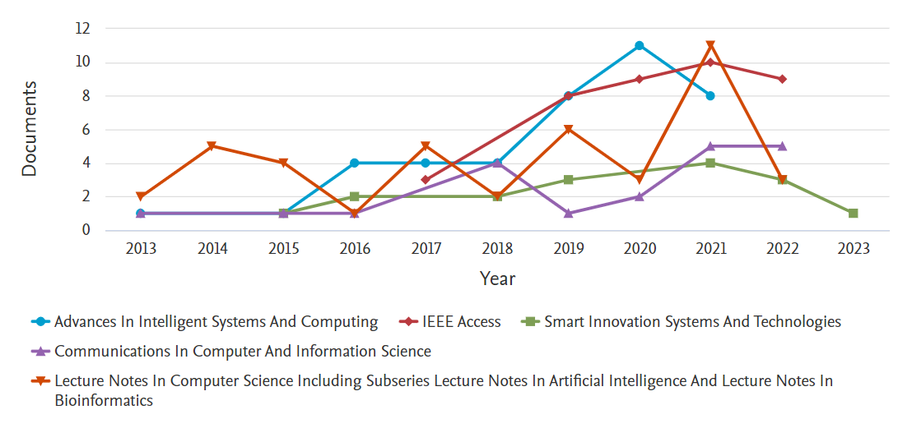
Figure 8: Document by Journal.

Publications produced by Year
This section contains a list of publications produced by year. The graph shows an increment in documents by year from 2013 to 2020. This indicates that this area of research is receiving the attention of authors and researchers. The volume of publications published by the journal since 2013 is shown in Figure 9.

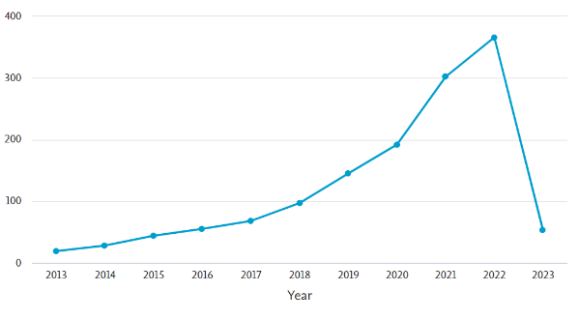
Figure 9: Document by Year.

The final stage of bibliometric analysis.
Fifty of the 5021 authors fulfil the requirements. The overall strength of co-authorship ties with other writers for each of the 50 authors was computed. The writers that have the strongest overall strength link are chosen. As can be seen in the network visualization in Figure 10, seven co-author clusters with 33 network items were found, and 133 total link strengths were produced along with the authors. There were 109 links between researchers. The clusters detected reflect active teamwork among scholars, particularly within the clusters of authors such as Wang S, Chen J, Wang J, Yang J, LH J, and Zhang H. The release timelines also reveal that the research results were incremental from 2013 to 2023.

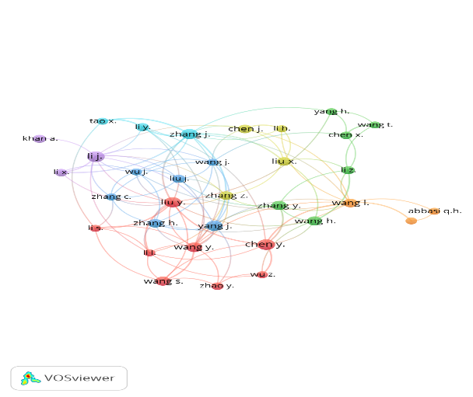

Figure 10: Network visualization for co-author map.
Co-occurring network of keywords
Keywords are phrases, terms and names which signify the heart of a publication. Co-occurrence is the familiar presence or closeness of similar keywords. As shown in Figure 11, the co-occurrence network was progressive from an entire volume of 1054 keywords using the VOSviewer software. The minimum inclusion standard for the selection of a keyword was 5. Of the 10549 keywords, 873 words met this threshold, and seven (7) clusters were identified. The total link strength of 103547, links 53027, and 873 items. The identified clusters are charted as shown in Figure 11. Due to large clusters of keywords, Common words previously associated generally with AI in health care and psychology will not be very relevant as the study and discussions will focus on innovations and trends.

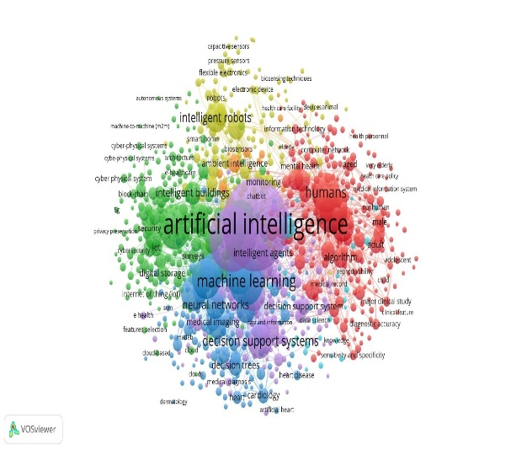

Figure 11: Co-occurrence overlay visualization.

Cluster #1 is marked with red as shown in Figure 11. There are 217 keyword combinations. with this cluster. Keywords include algorithms, computer network, health personnel, health key policy, medical information system, reproducibility, diagnostic accuracy, adolescent, health personnel, health care delivery, child, age, male, and clinical features. This can be further summarize as project team optimization about the proposed project.
Cluster #2 is marked with green also with 215 keywords and contains unique keywords such as blockchain, cyber security, digital storage, privacy preservation, security, cyber-physical system, e-health care, autonomous systems, machine to machine, internet of things (IoT), feature selection, and smart home. This cluster identifies the security features in AI to health psychology.
Cluster #3 is marked in blue with 138 keywords in it. The cluster contains unique keywords such as machine learning medical imaging, neural network, decision tree, medical diagnosis, heart diseases, cloud, hear, cardiology, and decision support system. This cluster identifies AI’s technological capabilities in health care and psychology.
Cluster #4 is marked pale yellow with 136 keywords in it. The cluster contains unique keywords such as robots, capacity sensors, pressure sensors, flexible electronics, electronic devices, biosensing techniques, and intelligent robots. This cluster identifies the technological capabilities of AI in health pschology.
Cluster #5 is marked purple with 121 keywords in it. The cluster contains unique keywords such as artificial intelligence, intelligent agents, monitoring, data and information, monitoring diagnosis, health care provider, and e-health. This cluster identified with computer systems for AI in health care and psychology.
Cluster #6 is marked light blue with 32 keywords in the cluster. Unique keywords include non-human, drug discovery, drug development, perception, sars-cov-2, statistics, decision making computer-assisted, electronic health record, receiver operating charasteristics, diagnosis imaging, epidemics, and world heath organisation. This cluster comprises words necessary for the process essentials of AI in health care and psychology.
Cluster #7 is marked orange color with 14 keywords in the cluster. Unique keywords include ambient intelligence, ambient assisted living, sensor network, ubiquitous computing, technological development, intelligent environment, and intelligent environment. This cluster comprises intelligent information for the process essentials of AI in health care and psychology.

Text mapping/mining
Text mining, also known as text analytics or natural language processing, is extracting useful information and insights from unstructured textual data. This data can come from various sources, such as emails, social media posts, customer reviews, news articles, and more. lt involves several steps, including data collection, pre-processing, analysis, and interpretation. During the pre-processing step, the text data is cleaned, formatted, and transformed into a structured format that machine learning algorithms can analyze. The analysis involves applying various techniques such as sentiment analysis, topic modeling, and entity recognition to uncover patterns, trends, and insights within the text data. The analysis results are then interpreted to gain insights and make informed decisions. Text mining has numerous applications across industries, such as customer experience management, market research, fraud detection, and sentiment analysis. With the explosion of data in recent years, text mining has become an increasingly important tool for organizations looking to gain insights from their unstructured data.

In coloring and visualization as illustrated in Figure 12, Purple signifies the least represented cluster, followed by yellow and then light yellow as preset defaults. In contrast, red signifies the most cited cluster. Using VOSviewer for text mapping, abstracts of the 521 documents were digitized and the text has been undermined based on the occurrences and relevance of active names in the body of the text. Words with an occurrence of at least 10 were extracted, and the software calculated the relevancy of these words. Of the 31512 words listed, 869 words met the threshold. Relevance was then computed on 60% of default parameters and sorting options, such as removing word texts and abbreviations.

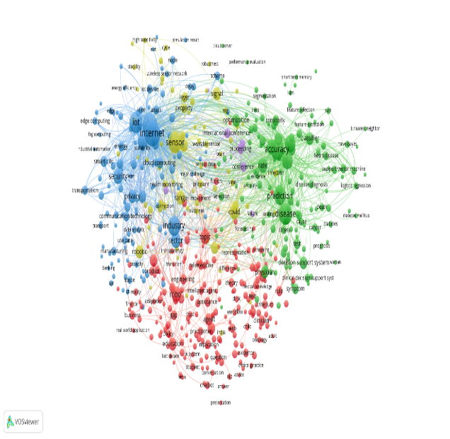

Figure 12: Network visualization map of text mining data.

Figure 12 provides a network visualization map of the most effective specific words related to the text mining activity. A total of 521 words were chosen based on program relevance; six clusters were recognized as visualized in Figure 12. The most active cluster comprised 180 items and concentrated on AI applications and healthcare professionals. AI application concerns include AI technology, chatbots, ambient intelligence, and intelligent machines. Healthcare professionals such as public health, patient care, medical knowledge, human health, and health care providers are also highlighted in Cluster 1 (red). The green cluster is the second most pertinent identified cluster, with 140 items. Artificial neural networks and diseases such as prediction, diabetes, cancer, infection, heart diseases, prognosis, system, and feature extraction are contained in cluster 2. Cluster 3 (blue) with 129 items classify with the internet and security, such as IoT devices, digitization, intelligent service, security, wireless sensor networks, privacy, data security, and drones. Cluster 4 (pale yellow), with 60 items, concentrates on words such as sensor, signal, innovative healthcare system, health rate, and temperature. Cluster 5 (yellow), with 8 items, concentrates on words such as COVID-19, infection, spread, virus, outbreak, and pandemic. Cluster 6 (purple) with four items, focusing on conference proceedings and visualization.

Discussion and outcomes from this study
This study has identified geographical areas of AIHCP innovation trends. While a significant volume of research trends has been relaunched in Asia, North America, Europe, and Australia trend The research corpus does not include Africa and South American countries. The findings of this analysis also show that the challenges found in the literature are being progressively adopted through the efficiency and enhancement of AI in health care and psychological research. In addition, the connections between AI in health care and psychology are evidenced by the co-occurrence of keywords and the exploration of text mining. This study found relevant and current improvements in AI health care and psychological research. It linked existing AI innovations and challenges in health care and psychology use, which should streamline literal terms, recognize trends, and enable a better perception of recent developments.

Conclusion
AI in health care and psychological research has attracted international attention. With innovative disruptions in the related domains of informatics, public health, and psychology. Additional research will continue to seek to enhance global AI in health care and psychological delivery. The study reviewed bibliometric evidence from relevant publications on AI in healthcare research and psychology. The publications have been exported from Scopus' core collection of indexed search papers from various countries. The first phase of the analysis includes journal type, territory/country, organizations/institution, sponsor, subject area, year, authors, co-authors, and collaborations. Due to the objective of capturing relevant health care and psychological trends, a five-year publication duration was estimated from 2018 to 2023. An analysis of the co-occurrence of keywords has led to the identification of seven clusters of keywords in recent research that were analyzed. Mapping/text mining was also conducted on the unstructured textual data contained in the abstract of relevant publications to reveal other ideas relevant to the trends. This study only took records from Scopus' main collection of indexed articles and future work may focus on a report relating various databases.

Reference

- Adam, M., Wessel, M., & Benlian, A. (2021). AI-based chatbots in customer service and their effects on user compliance. Electronic Markets, 31(2), 427-445.
- Apolinário-Hagen, J., Drüge, M., & Fritsche, L. (2020). Cognitive behavioral therapy, mindfulness-based cognitive therapy and acceptance commitment therapy for anxiety disorders: integrating traditional with digital treatment approaches. Anxiety Disorders: Rethinking and Understanding Recent Discoveries, 291-329.
- Bharti, U., Bajaj, D., Batra, H., Lalit, S., Lalit, S., & Gangwani, A. (2020). Medbot: Conversational artificial intelligence powered chatbot for delivering tele-health after covid-19. Paper presented at the 2020 5th International Conference on Communication and Electronics Systems (ICCES).
- Boucher, E. M., Harake, N. R., Ward, H. E., Stoeckl, S. E., Vargas, J., Minkel, J., . . . Zilca, R. (2021). Artificially intelligent chatbots in digital mental health interventions: a review. Expert Review of Medical Devices, 18(sup1), 37-49.
- Chekroud, A. M., Bondar, J., Delgadillo, J., Doherty, G., Wasil, A., Fokkema, M., . . . Iniesta, R. (2021). The promise of machine learning in predicting treatment outcomes in psychiatry. World Psychiatry, 20(2), 154-170.
- Diamandis, P. H., & Kotler, S. (2020). The future is faster than you think: How converging technologies are transforming business, industries, and our lives: Simon & Schuster.
- Farina, M., Zhdanov, P., Karimov, A., & Lavazza, A. (2022). AI and society: a virtue ethics approach. AI & SOCIETY, 1-14.
- Gil, D., Hobson, S., Mojsilović, A., Puri, R., & Smith, J. R. (2020). AI for management: An overview. The future of management in an AI world: Redefining purpose and strategy in the fourth industrial revolution, 3-19.
- Gruber, J., Prinstein, M. J., Clark, L. A., Rottenberg, J., Abramowitz, J. S., Albano, A. M., . . . Davila, J. (2021). Mental health and clinical psychological science in the time of COVID-19: Challenges, opportunities, and a call to action. American psychologist, 76(3), 409.
- Gunning, D., & Aha, D. (2019). DARPA’s explainable artificial intelligence (XAI) program. AI magazine, 40(2), 44-58.
- HabibAgahi, M. R., Kermani, M. A. M. A., & Maghsoudi, M. (2022). On the Co-authorship network analysis in the Process Mining research Community: A social network analysis perspective. Expert Systems with Applications, 206, 117853.
- Ho, C. S., Chee, C. Y., & Ho, R. C. (2020). Mental health strategies to combat the psychological impact of COVID-19 beyond paranoia and panic. Ann Acad Med Singapore, 49(1), 1-3.
- Kalanderian, H., & Nasrallah, H. A. (2019). Artificial intelligence in psychiatry. Current Psychiatry, 18(8), 33-38.
- Khayyam, H., Javadi, B., Jalili, M., & Jazar, R. N. (2020). Artificial intelligence and internet of things for autonomous vehicles. Nonlinear Approaches in Engineering Applications: Automotive Applications of Engineering Problems, 39-68.
- Kim, Y., Lee, J. H., Choi, S., Lee, J. M., Kim, J.-H., Seok, J., & Joo, H. J. (2020). Validation of deep learning natural language processing algorithm for keyword extraction from pathology reports in electronic health records. Scientific Reports, 10(1), 1-9.
- Kirtil, I. G., & Aşkun, V. (2021). Artificial intelligence in tourism: a review and bibliometrics research. Advances in Hospitality and Tourism Research (AHTR).
- Lelieveld, J., Pozzer, A., Pöschl, U., Fnais, M., Haines, A., & Münzel, T. (2020). Loss of life expectancy from air pollution compared to other risk factors: a worldwide perspective. Cardiovascular research, 116(11), 1910-1917.
- Littman, M. L., Ajunwa, I., Berger, G., Boutilier, C., Currie, M., Doshi-Velez, F., . . . Kitano, H. (2022). Gathering strength, gathering storms: The one hundred year study on artificial intelligence (AI100) 2021 study panel report. arXiv preprint arXiv:2210.15767.
- Lotter, W., Diab, A. R., Haslam, B., Kim, J. G., Grisot, G., Wu, E., . . . Boxerman, J. L. (2021). Robust breast cancer detection in mammography and digital breast tomosynthesis using an annotation-efficient deep learning approach. Nature Medicine, 27(2), 244-249.
- Maher, S. K., Bhable, S. G., Lahase, A. R., & Nimbhore, S. S. (2022). AI and Deep Learning-driven Chatbots: A Comprehensive Analysis and Application Trends. Paper presented at the 2022 6th International Conference on Intelligent Computing and Control Systems (ICICCS).
- McAllister, J. T., Lennertz, L., & Atencio Mojica, Z. (2022). Mapping a discipline: a guide to using VOSviewer for bibliometric and visual analysis. Science & Technology Libraries, 41(3), 319-348.
- Meng, L., Wen, K.-H., Brewin, R., & Wu, Q. (2020). Knowledge atlas on the relationship between urban street space and residents’ health—a bibliometric analysis based on VOSviewer and CiteSpace. Sustainability, 12(6), 2384.
- Mhlanga, D. (2021). Artificial intelligence in the industry 4.0, and its impact on poverty, innovation, infrastructure development, and the sustainable development goals: Lessons from emerging economies? Sustainability, 13(11), 5788.
- Palanica, A., Flaschner, P., Thommandram, A., Li, M., & Fossat, Y. (2019). Physicians’ perceptions of chatbots in health care: cross-sectional web-based survey. Journal of medical Internet research, 21(4), e12887.
- Sarker, I. H. (2021). Deep learning: a comprehensive overview on techniques, taxonomy, applications and research directions. SN Computer Science, 2(6), 420.
- Schildkamp, K. (2019). Data-based decision-making for school improvement: Research insights and gaps. Educational research, 61(3), 257-273.
- Su, Y.-S., Lin, C.-L., Chen, S.-Y., & Lai, C.-F. (2020). Bibliometric study of social network analysis literature. Library Hi Tech, 38(2), 420-433.
- Vakadkar, K., Purkayastha, D., & Krishnan, D. (2021). Detection of autism spectrum disorder in children using machine learning techniques. SN Computer Science, 2, 1-9.
- Wu, W.-T., Lin, C.-Y., Shu, Y.-C., Chen, L.-R., Özçakar, L., & Chang, K.-V. (2023). Subacromial motion metrics in painful shoulder impingement: A dynamic quantitative ultrasonography analysis. Archives of physical medicine and rehabilitation, 104(2), 260-269.
- Zhu, Y., Zhang, J., Wang, G., Yao, R., Ren, C., Chen, G., . . . Zheng, H. (2021). Machine learning prediction models for mechanically ventilated patients: analyses of the MIMIC-III database. Frontiers in medicine, 8, 662340.

