Original Research Article
Quantifying Heavy Metals in White Clay and Groundwater of Bijoypur: A Comprehensive Study of Potential Impact Analysis

Abstract- Heavy metal contamination in water especially in groundwater sources is increasing due to changes in geochemistry in the aquifers. This study aimed to investigate the abundance of heavy metals in white clay, lake water and groundwater along with assess the potential heavy metal impact on groundwater. Four white clay, two lake water and six groundwater samples were taken from Bijoypur and its vicinity. Quantification of heavy metal concentrations in white clay and water samples were conducted by using ICPMS. To assess the degree of pollution in the water samples, the Metal Index (MI) and Heavy Metal Pollution Index (HPI) were computed. The mean concentrations (mg kg⁻¹) of heavy metal in white clay were As (0.0104), Cd (0.0005), Co (0.0105), Cr (0.2230), Cu (0.0290), Fe (36.08), Mn (0.044), Ni (0.15), Pb (0.059) and Zn (0.045). The mean concentrations (mg L⁻¹) of heavy metal in groundwater showed that As (0.029), Fe (15.093), Mn (0.383) and Ni (0.043) exceeded WHO, 2011 recommended permissible values. As-Fe (r=0.89), Cr-Pb (r=0.93) exhibits a very strong correlation in groundwater. As per the HPI values, 17% of samples show a high pollution index and 33% of samples show a medium pollution index. As per the MI values, 33% of the samples show a seriously affected water quality. The findings revealed a significance presence of heavy metal in white clay, lake water and groundwater. It is imperative to thoroughly monitor any potential effects of heavy metals (HMs) on human health that may result from direct groundwater drinking.
Keywords: White clay, Groundwater, Heavy metal, Metal index, Bijoypur

- INTRODUCTION
Clays and clay minerals, originated from the Earth's surface rocks are formed, mostly by chemical weathering and hydrothermal activities for thousands of years (Dhakal et al., 2021). White Clay refers to the fine-grained naturally occurring particles as the outcome of mechanical weathering and chemical alteration of rocks. These rocks include phyllosilicates and other minerals that provide plasticity. Sedimentologists typically indicate the ideal dimension of <4 mm for clay grain size (Guggenheim and Martin, 1995). One of the most common methods for determining the movement patterns of sediments, the degree of weathering, and the reconstruction of paleoclimate and paleo depositional environments in a variety of geological contexts is clay mineralogy (Gazi et al., 2017; Li et al., 2017). Bangladesh's residual clay is primarily white clay, which is purer, has larger grains, and is less malleable. Little clay mineral lenses have been found in the Dupi Tila Formation in Sylhet and Bandarban, whereas large clay layers, known locally as Bijoypur Clay, can be found in Netrokona (Gazi et al., 2021). For example, feldspar weathering, transit and deposition results in altered products such as montmorillonite, kaolinite, and other clay minerals rich in aluminum. Clay is eliminated by weathering, chemical breakdown, and mechanical fragmentation of the parent rocks, and they are either deposited in their original locations or are transported from their source by natural forces (Gazi et al., 2021). There have been few studies conducted to ascertain the provenance, distribution, and mineralogical composition of clay minerals in the Bengal Basin and surrounding regions, as well as how these assemblages are transported (Heroy et al., 2003; Li et al., 2017; Flood et al., 2018).
Bijoypur white clay deposits are exposed in a series of hillocks from Bhedikura in the west to Gopalpur in the east in a 10.5 km long narrow strip of about 610 m. The area between Gopalpur and Bhedikura comprises a series of low rounded hillocks. These hillocks are separated by shallow, wide valleys. The maximum and minimum heights of the hillock are 43 m and 15 m respectively above mean sea level. The valleys are on the average 12 m above mean sea level (Chowdhury, 1993). Water has the unique property of dissolving and carrying in suspension a huge variety of chemicals and hence water can easily become contaminated (Islam et al., 2021). The necessity of using ground water is growing at an accelerated rate these days due to the nation's constantly rising water demand (Shamsur et al., 2017). Heavy metal ions pollution becomes a global concern because of its influence on the food chain. However, Heavy metal ions in soil and water are among the major contaminants. Because of anthropogenic activities as well as natural occurrence, heavy metals are present in the environment in large quantities (Islam et al., 2020). Most common heavy metals include Arsenic (As), Chromium (Cr), Zinc (Zn), Copper (Cu), Cadmium (Cd), Lead (Pb), Nickle (Ni), Iron (Fe), Manganese (Mn) and Cobalt (Co) (Mohsenipour and Shahid, 2013). The most basic element needed by humans, plants, and animals is water, which is often obtained from two main natural sources: fresh surface water from lakes, rivers, and groundwater (Vanloon and Duffy, 2005). Additionally, water is essential for a variety of uses in Bangladesh, including drinking, residential and industrial uses, livestock and aquaculture, and irrigation (Uddin et al., 2013; Hossain et al., 2020). It is unclear how water's unique chemical properties which stem from its polarization and hydrogen bonds-allow it to absorb, dissolve, and suspend different combinations of substances in natural water while also absorbing pollutants from nearby sources and from people, animals, and other biochemical processes (Mendie, 2005). The supreme significant environmental problems today are ground water contamination (Vodela et al., 2001) and among the extensive variety of pollutants effecting water properties, heavy metals obtain specific concern seeing their tough toxicity even at small applications (Marcovecchio et al., 2007). Heavy metal can origin major effects of health with diverse signs dependent on the nature and amount of the heavy metal consumed (Adepoju and Alibi, 2005). Water quality deteriorates and becomes contaminated due to chemical or biological pollution. Both humans and other living things are negatively impacted by this water (Hanif et al., 2020). Mining operations and other forms of human interference usually hasten the detrimental effects of geology's influence on water quality (Baba and Gunde, 2017). A contaminant released into the environment may travel throughout an aquifer similarly to how ground water flows, depending on its physical, chemical, and biological characteristics. Permeable and porous soils have a tendency to transfer water and some kinds of pollutants rather easily to an aquifer below. Heavy metals contamination in aquatic environment is of critical concern, due to toxicity of metals and their accumulation in aquatic habitats (Rahman et al., 2016).
The water-soil interface and the water-atmosphere interface are the medium through which the heavy metals travel (Varol, 2011; Ali et al., 2018). In this context, it is currently considered that one of the main factors influencing the quality of water resources is the interaction between water and rocks in the changing areas of geological units. These interactions are mostly responsible for a variety of health consequences of local inhabitants who consume such water resources for drinking purposes (Nouri et al., 2008; Baba and Gunde, 2017). The key objectives of this study was to determine the abundance of heavy metals in white clay, lake water and groundwater of Bijoypur area and analysis the potential heavy metal impact on groundwater.
- MATERIALS AND METHODS
2.1 Location of the study area
The Bijoypur white clay deposit which is studied in this research is located in the north eastern part of Bangladesh. White clay deposits are exposed in a series of hillocks from Bhedikura in the west to Gopalpur in the east in an area of about 10.5 km long 600 meters wide (Islam, 1985). This study area is located in the near of Garo Hills of Meghalaya. It lies between 25°09´26.89´´N to 25°10´25.64´´N latitudes and 90°38´37.26´´E to 90°36´56.07´´E longitudes. It comprises mostly at Kullagora union in Durgapur Upazilas of Netrokona District (Figure 1). The diverse colors of soil, water and the endless beauty of nature captivates the mind. White, pink, yellow, purple, brown, blue mud hills of different colors attract the eye. The Mymensingh-Birishiri highway runs through the north-eastern part of the surveyed area. The nearest bus stations are at Birishiri. There are some sub roads leading to the investigated areas from the highway.
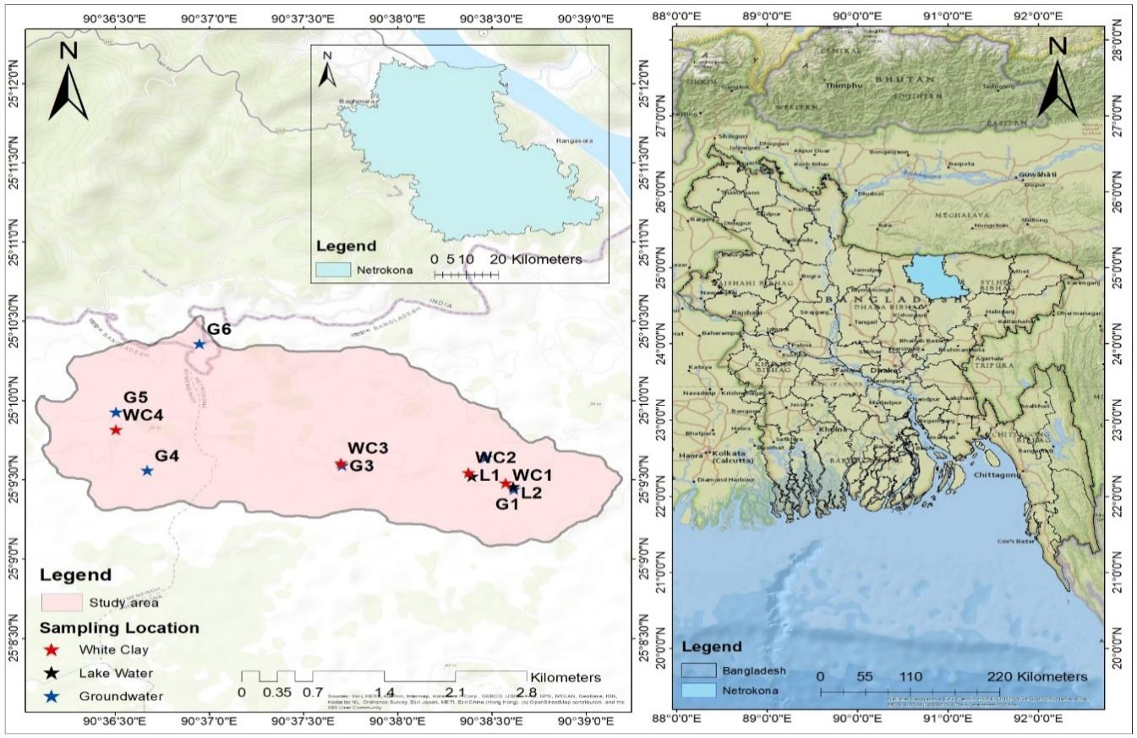
Fig. 1. Location map of the study area
2.2 Sample collection
White clay samples were collected from four locations of Bijoypur i.e., Hill 1, Hill 2, Bipinganj and Monoshapara. Samples were taken at a depth of 5-10 cm which was quickly packed in air tight polythene sampling bags. Approximately, 400-500 g white clay samples were collected from each sampling site. Groundwater samples were collected from six locations of the Bijoypur and its surrounding area such as Bijoypur, Bipinganj, Bhedikura, Monoshapara, and Gesuapara. Also, Lake water samples were collected from two lakes of Bijoypur. Groundwater samples collected in the depth of different range. Samples were acidified with 10% HNO₃.
2.3 Sample preparation
To begin with, white clay samples were sun- dried for 48 hours. After that, samples were transported to the laboratory. The samples were dried in an oven at 70 °C for 48 hours and ground using a mortar and pestle. Then the samples were sieved by a sieve (0.63 to .75 mm). The lower particle size fraction was homogenized by grinding again in the mortar and stored in plastic bag until chemical analyses were carried out and marked well. Precautions were taken to avoid contamination during drying, grinding, sieving and storage. At a time acidify water samples were stored in ice box.
2.4 Digestion of white clay
For metal analysis, powdered white clay sample weighing 0.2g was digested using 7 ml 70% Nitric acid (HNO₃) and 3 ml H₂O₂. Both chemicals were used of analytical grade. Sample and both reagents were mixed in vessel tube. After that, all of vessels were sealed properly and kept in Microwave Digestion system (Ethos Easy Milestone) for 40 minutes where temperature rising up to 200 °C. After cooling, this digested samples filtered by using 125 mm filter paper (Whatman grade 42). Thereafter filtered paper kept in separate places to avoid contamination. After filtering the mixer was poured into 50 ml plastic bottle and filled with deionized water. Also for detection of heavy metals from water, 50 ml acidified water samples were filtered using 125 mm filter paper (Whatman grade 42) and poured into plastic bottles. Samples were again filtered by syringe filter (0.45 µm hpPTFE) then set into ICP-MS sampling point by using test tube. Filtered white clay and water samples were prepared for ICP-MS (Inducted Coupled Plasma mass Spectrometry) (SHIMADZU-2030LF) analysis.

2.5 Data analysis
HPI, Correlation analysis and MI were used to perform an analysis of all the statistical analysis in this study by Microsoft excel 2016. ArcGIS 10.8 software was used to explore the spatial distribution of different heavy metals of groundwater employing the IDW technique (APHA, 2005; Robinson and Metternicht, 2006), a type of deterministic methods for multivariate interpolation used to predict a value of any unmeasured or un-sampled location employing a set of measured values.
To assess the relationship between the groundwater's heavy metal concentrations, Pearson's correlation coefficient matrix (r) was utilized (Javed et al., 2019). The ideal linear relationship between the two variables is represented by a value of r that is closer to +1 or -1 (Al hadithi, 2012), while zero indicates that there is no connection at all between the parameters (Srivastava and Ramanathan, 2007). If the value of r is more than 0.7, it is considered as strongly correlated, whereas if its value extends from 0.5 to 0.7, the parameters are moderately correlated, and in case of negative value, it implies that the value of one parameter is diminishing with the expansion in another parameter (Giridharan et al., 2007).
2.6 Heavy Metal Pollution Index (HPI)
The heavy metal pollution index (HPI) is a ranking system and a useful tool for determining the quality of water in terms of heavy metals (Sheykhi and Moore, 2012). This was used as a representation of the cumulative effect of metals on general water quality (Reza and Singh, 2010; Reza et al., 2011).
$HPI=\frac{\sum_{i=1}^{n}{W_{i}*Q_{i}}}{\sum_{i=1}^{n}{W_{i}}}$ ………………eq (1)
Where, Q_{i} = Sub index of the i^{th} parameter
W_{i} = The unit weight of the i^{th} parameter and n is the number of parameters considered.
The sub index (Q_{i}) of the parameter is calculated by
$Q_{i}=\sum_{i=1}^{n}{\frac{(M_{i}-I_{i})}{(S_{i}-I_{i})}×100}$ ………...............eq (2)
Where,
M_{i} = Monitored value of heavy metal of the i^{th} parameter
I_{i} = Ideal value of the i^{th} parameter
S_{i} = Standard value of i^{th} parameter
According to HPI values, the groundwater is divided into three zones: low (<90), medium (90–180), and high (>180) (Prasad and Sangita, 2008; Reza and Singh, 2010).
2.7 Metal Index (MI)
When the metal index is assessed for drinking water, it provides information about the possible cumulative effects of all the heavy metals that can be detected in the water on human health, which is extremely helpful in determining the overall quality of the water. MI was computed by:
$$MI=\frac{M_{i}}{S_{i}}$$
Where MI is the metal index, M_{i} is the observed metal level in water and S_{i} is the highest recommended permissible limit. MI is a technique used to assess the appropriateness and quality of water for human consumption. The classification of water quality using metal index are; <0.3 very pure, 0.3-1.0 pure, 1.0-2.0 slightly affected, 2.0-4.0 moderately affected, 4.0-6.0 strongly affected and >6.0 seriously affected (Yusuf et al., 2018).
- RESULTS AND DISCUSSION
  - Abundance of Heavy metals in white clay
In this study, presence of heavy metal in all studied white clay sample of Bijoypur area, which imposed a matter of concern in terms of heavy metal pollution in the groundwater. Present study indicate that highest concentration of arsenic was found at Monoshapara sampling point (WC4). Xu et al., (2021) studied heavy metal in black shale which is sedimentary rock and found that Cd, As, Pb, Cu, Cr and Ni concentrations in the Gaoqiao are 3.2–97.7 mg kg⁻¹, 12.3–62.0 mg kg⁻¹, 11.6– 105.0 mg kg⁻¹, 327.0–919.0 mg kg⁻¹, 100.0–4630.0 mg kg⁻¹ and 7.2–98.2 mg kg⁻¹ respectively. Present study detected that high percentage of heavy metal is present (Table 1) in Bijoypur white clay like Arsenic (0.0104 mg kg⁻¹), Cadmium(0.0005 mg kg⁻¹), Cobalt (0.01 mg kg⁻¹), Chromium (0.22 mg kg⁻¹), Copper (0.029 mg kg⁻¹), Iron (36.08 mg kg⁻¹), Manganese (0.044 mg kg⁻¹), Nickel (0.15 mg kg⁻¹), Lead (0.059 mg kg⁻¹) and Zinc (0.045 mg kg⁻¹) which is lower than Xu et al., 2021 study.

Table 1. Heavy metals concentration ((mg kg⁻¹) in white clay

Sampling point | As | Cd | Co | Cr | Cu | Fe | Mn | Ni | Pb | Zn
WC1 | 0.012 | 0.0006 | 0.012 | 0.25 | 0.033 | 34 | 0.051 | 0.163 | 0.086 | 0.050
WC2 | 0.0086 | 0.00043 | 0.011 | 0.22 | 0.035 | 47.8 | 0.054 | 0.17 | 0.043 | 0.046
WC3 | 0.0084 | 0.00042 | 0.006 | 0.14 | 0.014 | 9.2 | 0.030 | 0.0616 | 0.039 | 0.028
WC4 | 0.014 | 0.00042 | 0.011 | 0.27 | 0.032 | 53.3 | 0.036 | 0.187 | 0.066 | 0.051
Mean | 0.0104 | 0.0005 | 0.01 | 0.22 | 0.029 | 36.08 | 0.044 | 0.15 | 0.059 | 0.045

A research conducted by Woode and Hackman (2014) revealed that geoghagic clayey soils sold in three major markets (Madina, Makola and Ashaiman) in Ghana contained high levels of As, Pb, Hg, Cd and Co. According to Momade and Gawu (2009), the most popular geophagic clay in Ghana is called "white clay," which is primarily composed of kaolin and is especially popular in Anfoega, in the Volta Region (Woode and Hackman, 2014). Present study also declared that major heavy metals on Bijoypur white clay like Arsenic, Cadmium, Chromium, Cobalt etc. Several studies have been reported on the mineralogy and microbiology of geophagic clay in sub-saharan Africa including Ghana (Ngole et al., 2010; Gichumbi et al., 2011). The upper crustal abundances of As, Cd, Cr, Cu, Hg, Mn, Ni, Pb and Zn were 1.5, 0.098, 35, 25, 0.103, 600, 20, 20, and 71 mg kg⁻¹, respectively (Taylor and Mclennan, 1995). It is well known that white clay or kaolin are widely distributed in the world and many varieties shale have been recognized and studied on the basis of trace element concentrations.
Nkansha et al., (2016) stated that, the levels of Arsenic (As) in the geophagic clay samples from selected markets in the Kumasi Metropolis ranged from 8.11 to 14.18 mg kg⁻¹ which is higher than bijoypur study. The levels of Lead (Pb) in 70 g of geophagic clay samples from the selected markets in the range (0.54934 mg kg⁻¹ 0.62292 mg kg⁻¹) which is lower than to current investigation. Mahurpawar (2015) stated that Ingestion of large amounts of arsenic can lead to gastrointestinal symptoms such as severe vomiting, disturbances of the blood and circulation systems, damage to the nervous system, and eventually death. High concentrations of lead can result in coma, seizure and even death (Bonglaisn et al., 2011). Lead targets multiple organs in the body due to its systemic toxicity which can cause cardiovascular, renal, gastro-intestinal and hematological effects (Mahurpawar, 2015). The high levels of the essential metals can cause serious health problems to consumers. According to Mathee et al., (2014), high concentration of Iron (Fe) in geophagic clayey samples can result in anaemia among pregnant women and children. Of the six metals investigated, only As and Cd have the potential of inducing both noncarcinogenic and carcinogenic risk, while Pb has the potential of inducing only noncarcinogenic risk. In the case of mercury very sparse data is available on its carcinogenicity. It is necessary to calculate the cancer risk value to estimate whether the consumers within the Kumasi Metropolis are likely to suffer from cancer (Liu et al., 2013). The fact that zinc is regarded as a necessary component for the growth of organisms, its great bio accessibility may not have any negative health effects. Zinc is a mineral found in all bodily fluids and tissues, and it plays a variety of roles in cellular metabolism. In addition to hundreds of proteins that transport zinc, it has been estimated that roughly 10% of human proteins have the ability to bind zinc.
3.2 Abundance of Heavy metals in lake water
The given Table (Table 2) contains average measurements of various heavy metals (As, Cd, Co, Cr, Cu, Fe, Mn, Ni, Zn) in two different lake water samples. Each value represents the concentration of a particular heavy metal in the sample, likely measured in units such milligrams per liter (mg L⁻¹). In Bijoypur Lake different heavy metal were analyzed by ICP-MS. According to Table 2, Mn, Fe, Cu and Zn had the largest concentrations of heavy elements in Lakes. The geological composition of the surrounding area can influence the presence of heavy metals in lake water. White clay deposits may occur in areas with geological formations containing minerals rich in heavy metals. Over time, erosion and weathering processes can release these metals into the surrounding water bodies, leading to elevated concentrations in the lake water. White clay soils are typically found in areas with low permeability, which can lead to increased runoff and erosion during rainfall events. This runoff can transport sediment containing heavy metals from surrounding areas into the lake, contributing to elevated concentrations of heavy metals in the water.

Table 2. Heavy metals concentration (mg L⁻¹) in lake water

Sample Name | As | Cd | Co | Cr | Cu | Fe | Mn | Ni | Zn
L1 | 0.0009 | 0.001 | 0.00015 | 0.00053 | 0.0035 | 0.0171 | 0.071 | -0.000701 | 0.0288
L2 | 0.0013 | 0.0005 | 0.00025 | 0.00056 | 0.0023 | 1.03 | 0.149 | 0.0000735 | 0.0119
Mean | 0.0011 | 0.0008 | 0.0002 | 0.0005 | 0.0029 | 0.5236 | 0.1105 | -0.0003 | 0.0204

3.3 Abundance of Heavy metals in groundwater
Figure 2 (a) illustrates the Arsenic (As) concentration of different sampling point. Highest Arsenic (As) value (0.108 mg L⁻¹) was found at Monoshapara which was G5 sampling point of Bijoypur and the lowest Arsenic (As) concentration (0.000957 mg L⁻¹) was found at Bipinganj. Here, except for samples G3 and G4, the rest of the samples (G1, G2, G5 and G6) exceeded WHO guideline value (WHO, 2011). Figure 2 (b) provides a spatial distribution map of Nickel (Ni). The highest Nickel (Ni) value (0.102 mg L⁻¹) was found at Monoshapara which was G5 sampling point of Bijoypur area and the lowest value (-0.0021 mg L⁻¹) of Nickel (Ni) was found at Bipinganj which was G3 sampling point. Except for samples G1, G2, G3, G4 and G6, the remaining sample (G5) exceeded the WHO guideline value (WHO, 2011). Based on the investigated Arsenic (As) content, it is clear that four samples fall within the permissible limits of Bangladesh Standard (ECR, 1997).
Two samples (G3 and G4) were lower than the acceptable limit, according to WHO (2011), whereas the other samples (G1, G2, G5, G6) above the WHO threshold value of 0.01 ppm. The average value of arsenic was found (0.02927 mg L⁻¹). Figure 2 (a) illustrates the spatial distribution of As content across the study area, revealing that only two sampling site fall under the area of relatively lower concentration at the central part but remaining four samples stated that a very high concentration persists across the study area. The average Arsenic value for groundwater in Kalihati Upazila, Bangladesh was determined to be 0.007 mg L⁻¹ in a study by Jahan et al., (2020), which is significantly lower than the results of the current investigation. The arsenic concentration (0.0026-0.0092 mg L⁻¹) reported in a study by Deda et al., (2019) is likewise significantly lower than that of the current investigation. In a groundwater investigation conducted in southern Italy, Triassi et al., (2023) reported an average Arsenic (As) value of 0.00356 mg L⁻¹, which is also lower than the previous study.
The average Arsenic (As) level in the southwest portion of the Cuddapah Basin in South India was determined to be 0.0106 mg L⁻¹ in a study by Reddy and Sunitha (2023), which is likewise less than the amount obtained in this study. The presence of high Arsenic in drinking groundwater is a direct result of geogenic sources. Such sources may include mining actions, rock-water interaction, weathering, which has been identified as a severe environmental concern by many researchers such as documented by (Abbas et al., 2021; Rashid et al., 2022). Geogenic Arsenic (As) pollution of groundwater is more widespread in alluvial aquifers. Gravel, sandstone, silt, and sand that have been in a river canal or flood plain for a long time make up these aquifers (Mallongi et al., 2022).
According to the spatial distribution map of Nickel (Ni) (Figure 2 (b)), G5 sampling area showed the highest concentration of Nickel, which is above the WHO (2011) standard value of 0.07 mg L⁻¹. The average nickel concentration, according to the current investigation, was 0.043158 mg L⁻¹. (Ni) may be present in some groundwater sources due to dissolution from Nickel ore-bearing rocks (Jehan et al., 2020; Bhatti et al., 2022). The average Nickel content at Karu LGA in Nasarawa state, Nigeria, was reported to be 0.018 mg L⁻¹ in a study by Daniel (2023), which is less than the value found in this study. According to a study by Triassi et al., (2023), the average concentration of Nickel (Ni) in groundwater in southern Italy was determined to be 0.00366 mg L⁻¹, which is also lower than the current investigation. A study by Reddy and Sunitha (2023) discovered that the Cuddapah Basin in India's southwest section had an average nickel concentration of 0.028 mg L⁻¹ which is also lower than my study.

a
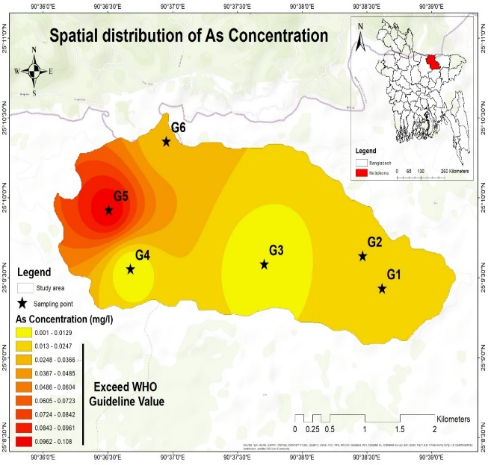
b

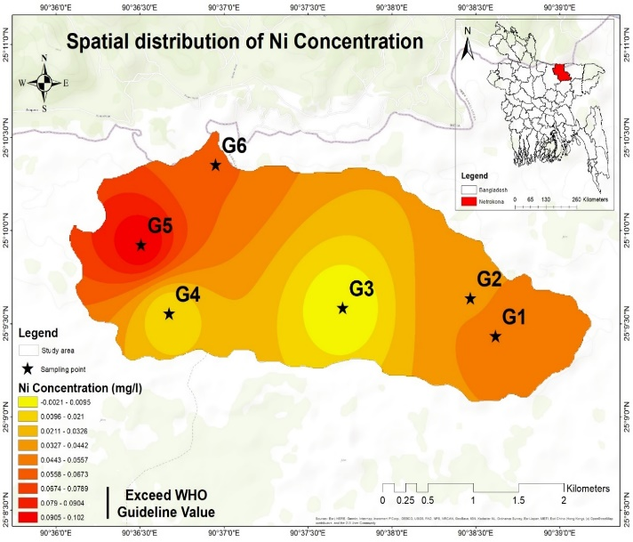
Fig. 2. Spatial distribution of (a) Arsenic (As) and (b) Nickel (Ni) concentration

Figure 3 (a) shows a spatial distribution map of Iron (Fe). The highest Iron (Fe) value (43.2 mg L⁻¹) was found at Monoshapara which was G5 sampling point of Bijoypur area and the lowest value (0.0266 mg L⁻¹) of Fe was found at Bipinganj which was G3 sampling point. Except for samples G3, the remaining sample (G1, G2, G4, G5 and G6) exceeded the WHO guideline value (WHO, 2011). Figure 3 (b) provides a spatial distribution map of Manganese (Mn). The highest Manganese (Mn) value (0.757 mg L⁻¹) was found at Bipinganj which was G3 sampling point of Bijoypur area and the lowest value (0.0247 mg L⁻¹) of Manganese (Mn) was found at Gesuapara which was G6 sampling point. Except for samples G6, the remaining sample (G1, G2, G3, G4, and G5) exceeded the WHO guideline value (WHO, 2011).
The Iron (Fe) concentration in groundwater samples ranged from 0.0266–43.2 mg L⁻¹ (Figure 3 (a)) with an average value of 15.093 mg L⁻¹; 5 samples were beyond the permitted limit recommended by WHO (2011). Iron is the second most abundant metallic element in the Earth’s crust, while it has a low concentration in water. The most prevalent sources of iron in groundwater are naturally occurring, such as weathering of iron containing minerals in rocks (Ullah et al., 2022). According to Hossain et al., 2020, Fe concentrations in water samples ranged from 0.05 to 1.1 mg/L in terms of chemical characteristics in Dhaka, Mymensingh, Gazipur, Rangpur regions whereas Pb was totally absent in all analyzed water samples.
Iron (Fe) is an essential element in human nutrition as the taste of water is not usually noticeable at Fe concentrations less than 0.3 mg L⁻¹ (Vasudevan et al., 2009). Present study found the average Iron concentration 15.093 mg L⁻¹. The concentration of Fe content has been noted to be generally relatively higher throughout the study area. The spatial pattern of Fe content across the study area is depicted in Figure 3 (a), demonstrating that a relatively higher concentration was evident in the west part, whereas a decreasing trend was found in the central part. The occurrence of a higher concentration of Fe content in groundwater might be due to the natural weathering of Fe content in grey non-indurated alluvial sediments, which is geologically present in the aquifer systems of the investigated zone. The relatively higher concentration of Fe content in the groundwater may accelerate the growth of pathogenic organisms (Andrews et al., 2003). According to a study by Triassi et al., (2023), the average concentration of Iron (Fe) in groundwater in southern Italy was determined to be 0.0297 mg L⁻¹, which is also lower than the current investigation. The average Iron (Fe) level in the southwest portion of the Cuddapah Basin in South India was determined to be 0.0065 mg L⁻¹ in a study by Reddy and Sunitha (2023), which is likewise less than the amount obtained in this study.
The concentration of Mn in groundwater samples ranged from 0.0247-0.757 mg L⁻¹ with an average value of 0.38295 mg L⁻¹; most of the samples were beyond the permitted limit recommended by WHO (2011) and ECR (1997) (Figure 3 (b)). Mn is a naturally occurring mineral and is one of the most numerous metals on the planet’s surface, in air, water, and soil. It can be found in natural sources of groundwater and surface water and human activity such as mining (Vinnarasi et al., 2022). A study by Reddy and Sunitha (2023) discovered that the Cuddapah Basin in India's southwest section had an average Manganese concentration of 0.0038 mg L⁻¹ which is lower than my study. According to a study by Triassi et al., (2023), the average concentration of Manganese in groundwater in southern Italy was determined to be 0.0139 mg L⁻¹, which is also lower than current investigation. The average Mn content at Karu LGA in Nasarawa state, Nigeria, was reported to be 0.055 mg L⁻¹ in a study by Daniel (2023), which is also lower than the value found in this study.

a
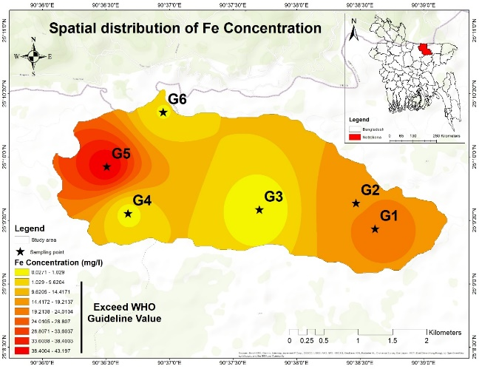
b
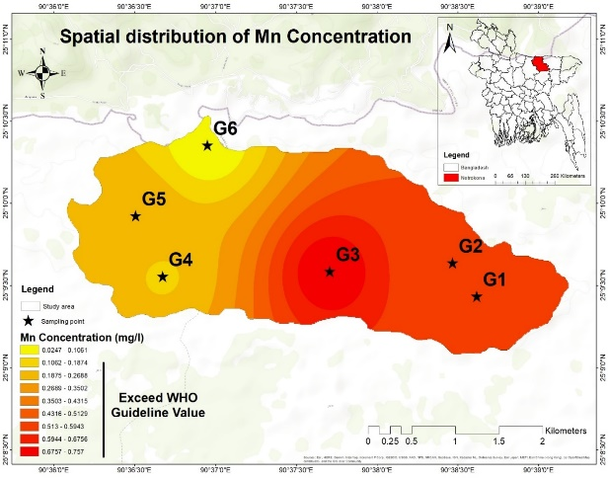
Fig. 3. Spatial distribution of (a) Iron (Fe) and (b) Manganese (Mn) concentration
Table 3 illustrates the remaining heavy metal concentration (Cd, Co, Cr, Cu and Zn). Here, highest concentration of Cadmium (Cd) was measured 0.00042 mg L⁻¹ at the Bipinganj sampling point and the lowest concentration of Cadmium (Cd) was measured 0.000379 mg L⁻¹ at the Bijoypur 2 sampling point. Cobalt (Co) concentration (0.00129 mg L⁻¹) was also high at Bipinganj sampling point and lowest (-0.000208 mg L⁻¹) at Bijoypur 1 sampling point. The peak measurement of Chromium (Cr) concentration was (0.00161 mg L⁻¹) at the Monoshapa sampling point and lowest was (0.000498 mg L⁻¹) at Bijoypur 1 sampling point. Highest Copper (Cu) concentration (0.00425 mg L⁻¹) was found at Bijoypur 2 sampling point and highest Zinc (Zn) concentration (0.0206 mg L⁻¹) was found at Gesuapara.
Table 3. Heavy metals concentration (Cd, Co, Cr, Cu and Zn) in groundwater
Sample Name | Cd | Co | Cr | Cu | Zn
G1 | 0.0004 | -0.00021 | 0.000498 | 0.000098 | 0.00702
G2 | 0.00038 | -0.00015 | 0.000585 | 0.0042 | 0.0152
G3 | 0.0004 | 0.00129 | 0.000516 | 0.0035 | 0.0174
G4 | 0.00039 | 0.00104 | 0.000841 | 0.00137 | 0.00874
G5 | 0.0004 | 0.000249 | 0.00161 | 0.00252 | 0.0178
G6 | 0.00038 | -0.00016 | 0.000874 | 0.00042 | 0.0206
Mean | 0.00039 | 0.000344 | 0.000821 | 0.00203 | 0.01446

In the present study average Cadmium (Cd) was found 0.000394 mg L⁻¹. A recent study by (Tamanna and Gupta, 2023) average Cadmium was found for groundwater in Bathinda district of Punjab, India was 0.037 mg L⁻¹ which much higher than current investigations. The concentration of Cu varied from 0.0000983-0.00425 mg L⁻¹ with an average value of 0.0021 mg L⁻¹ and all of the sample were in acceptable guidelines of WHO (2011). Groundwater was found to have an average Copper content of 0.41 mg L⁻¹ in a recent study (Ullah et al., 2022) which is much higher than what is reported in present investigations. The average content of Copper in southern Italian groundwater was found to be 0.00387 mg L⁻¹ in a study by Triassi et al., (2023), which is much higher than the current research. A recent study (Ullah et al., 2022) indicated that the average Zinc (Zn) content of groundwater was 1.07 mg L⁻¹, which is significantly greater than what is reported in current investigations. The average Chromium and Cobalt level in the southwest portion of the Cuddapah Basin in South India was determined to be 0.0016 mg L⁻¹ and 0.011 mg L⁻¹ in a study by Reddy and Sunitha (2023), which is likewise higher than the amount obtained in this study.
3.4 Pearson’s correlation matrix of different Heavy metals
To determine the coherence pattern and interrelationships between the selected variables, as shown in Table 4, the correlation coefficient matrix (r) was computed taking the significance level into account. A very strong correlation ranged indicate 0.74 to 0.93 (Table 4).
Table 4. Pearson’s correlation matrix of different heavy metals in groundwater
Parameters | As | Cd | Co | Cr | Cu | Fe | Mn | Ni | Pb | Zn
As | 1
Cd | -0.25 | 1
Co | -0.32 | 0.76** | 1
Cr | 0.89** | -0.24 | -0.05 | 1
Cu | -0.02 | 0.12 | 0.31 | -0.02 | 1
Fe | 0.89** | -0.41 | -0.46 | 0.68* | 0.10 | 1
Mn | -0.31 | 0.54* | 0.25 | -0.57 | 0.50* | -0.06 | 1
Ni | 0.91** | -0.54 | -0.67* | 0.74** | -0.17 | 0.87** | -0.41 | 1
Pb | 0.86** | -0.08 | 0.11 | 0.93** | 0.05 | 0.74** | -0.32 | 0.64* | 1
Zn | 0.32 | 0.06 | -0.05 | 0.36 | 0.35 | 0.03 | -0.21 | 0.28 | 0.12 | 1
** Correlation is significant at the 0.01 level (2-tailed); * Correlation is significant at the 0.05 level (2-tailed).
A very strong and significant relationship at the 0.01 level (2-tailed test) was seen in several studies, including As-Cr (r=0.89), As-Fe (r=0.89), Cr-Pb (r=0.93), As-Ni (r=0.91). With a correlation coefficient value of more than 0.7, the pairs of As-Pb, Cd-Co, Cr-Ni, Fe-Ni and Fe-Pb were also significantly correlated at the 0.01 level (2-tailed test), indicating that most metals in groundwater are derived from a similar source.
Even though the pairs of Cd-Mn, Cr-Fe, Cu-Mn and Ni-Pb were significantly correlated at the 0.05 level (2-tailed test) overall in the study area with a moderate correlation coefficient ranged from 0.5 to 0.7. Whereas the As-Zn, Cd-Zn, Co-Mn, Co-Pb, Cr-Zn, Cu-Fe, Cu-Pb, Cu-Zn, Fe-Zn, Ni-Zn and Pb-Zn pairs were insignificantly correlated with a weak correlation coefficient value of less than 0.5. There was a negative correlation between several pairs of values.
3.5 Heavy Metal Pollution Index (HPI)
Heavy metal pollution index (HPI) values ranged from 26.90 to 284.14 with a mean of 102.01 in the groundwater (Table 5). The highest HPI value was found at Monoshapara sampling point and lowest was found at Bhedikura sampling point.
HPI values ranged from 26.90 to 284.14 with a mean of 102.1 in the groundwater sample (Table 5). 17 % of samples fall under the high pollution index, while 33% of the samples belong to the medium pollution index and 50% of samples belong to the low pollution index in the present study region (Table 5).
Table 5. HPI classification of groundwater quality of the study area
Sample ID | HPI | Degree of pollution
G1 | 97.90 | Medium
G2 | 91.58 | Medium
G3 | 38.53 | Low
G4 | 26.90 | Low
G5 | 284.14 | High
G6 | 72.97 | Low

3.6 Metal Index (MI)
Metal index (MI) values for Bijoypur groundwater ranged from 1.343 to 7.565 with a mean 4.87 in the groundwater (Table 6). The highest MI value was found for G1 sampling point which is mostly near to white clay hill.
MI values for Bijoypur groundwater ranged from 1.343 to 7.565 with a mean 4.87 in the groundwater (Table 6). The highest MI value was found for G3 sampling point which is mostly near to white clay hill. The value appears that some groundwater samples (G1, G2, G3, G5) are more significantly contaminated with metals than others (G4, G6), based on the Metal Index values reported. The division of water quality into "seriously affected" and "strongly affected" categories, which denote higher degrees of contamination.
Table 6. MI classification of groundwater quality of the study area
Sample ID | MI | Water Quality
G1 | 6.634 | Seriously affected
G2 | 5.920 | Strongly affected
G3 | 7.565 | Seriously affected
G4 | 1.915 | Slightly affected
G5 | 5.784 | Strongly affected
G6 | 1.343 | Slightly affected

  - Parent rock - groundwater relationship
The white clay layer parent rocks have elevated heavy metals (HMs) concentrations and act as a source of heavy metals. It is widely accepted that extreme acidity were usually related to high solubility of HMs, and therefore increased concentration in the soil (Sabovljevc et al., 2020). The clay minerals transport as well as deposit by the gradual disintegrating of older continental and marine rocks and soils, which are significant processes of the sedimentary rock formation cycle (Thiry, 2000). Here, we noticed that the soil inherited and enriched metal elements obviously which released from white clay. It was believed that heavy metal elements released from white clay (such as silicates and carbonates) may migrate as ions under acidic conditions (Woode and Hackman, 2014). Therefore, the released HMs from the weathering of white clay materials contribute considerably to their accumulation and contamination of groundwater.

4. CONCLUSIONS
This investigation of heavy metals in white clay and groundwater represents that the emerging pollutant is widely present in Bijoypur and its surrounding area. The present study revealed that Bijoypur white clay deposit are contains of some heavy metals such as As (0.0104 mg kg⁻¹), Cr (0.223 mg kg⁻¹), Cu (0.029 mg kg⁻¹), Fe (36.08 mg kg⁻¹), Mn (0.044 mg kg⁻¹), Ni (0.15 mg kg⁻¹), Pb (0.059 mg kg⁻¹) and Zn (0.045 mg kg⁻¹). The presence of these heavy metals in the clay could be due to natural occurrences. Additionally, the lake water samples from the nearby lake in Bijoypur have HMs order of Fe>Mn>Zn>Cu>As>Cd>Cr>Co>Ni. The released HMs from the weathering of white clay materials contribute considerably to their accumulation and contamination in groundwater. The findings of the analysis showed that the heavy metal concentrations detected in all groundwater sample were as follows: Fe>Mn>Ni>As>Zn>Cu>Cr>Cd>Co. It has also been observed that, the mean value of Heavy Metals in the water samples analyzed shows abnormal concentration except, Copper (Cu), Cobalt (Co), Chromium (Cr), Cadmium (Cd) whose, concentration is within the acceptable limit set by WHO, 2011. According to the HPI results, 17% of the sample are in the high pollution category and 33% of the samples are in medium pollution category. However, evaluated MI for the samples revealed that groundwater sources in Bijoypur are not pure and affected by heavy metals. The result of the HPI and the MI presented in this research work confirms the contamination of ground water resources in the study area, hence; the water is considered to be unsuitable for consumption without any prior treatments. It is strongly recommended that government agencies or individual owners of bore holes and mining companies should be engaged to remediate the impact of heavy metal contamination of groundwater sources. Furthermore, it is high time to closely monitor the potential impact of HMs on human health that may arise from the consumption of groundwater directly.

REFERENCES
Abbas, Z., Imran, M., Natasha, N., Murtaza, B., Amjad, M., & Shah, N.S. (2021). Distribution and health risk assessment of trace elements in ground/surface water of kot addu, Punjab, Pakistan: A multivariate analysis. Environmental Monitoring Assessment 193 351–362. doi:10.1007/s10661-021-09150-7.
Adepoju, A.A., Alabi, O.M. (2005). Heavy metals: A review. Nigerian Journal of Pharmaceutical Research 37 41-45.
Alhadithi, M. (2012). Application of water quality index to assess suitability of groundwater quality for drinking purposes in Ratmao –Pathri Rao watershed, Haridwar District, India. American Journal of Scientific and Industrial Research 3 396– 402. doi: 10.5251/ajsir.2012.3.6.395.402.
Ali, M.M., Ali, L.M., Islam, S.M., Rahman, Z.M. (2018). Assessment of toxic metals in water and sediment of Pasur River in Bangladesh. Water Science and Technology 77(5) 1418-1430. doi.org/10.2166/wst.2018.016.
Andrews, S.C., Robinson, A.K., Rodriguez, Q.F. (2003). Bacterial iron homeostasis. FEMS Microbiology Reviews 27 215–237. doi: 10.1016/s0168- 6445(03)00055-x.
APHA, (2005). Standard methods for the examination of water and wastewater. American Public Health Association, Washington, USA.
Baba, A., Gunde, O. (2017). Effect of Geogenic Factors on Water Quality and Its Relation to Human Health around Mount Ida, Turkey. Water 9 66. doi:10.3390/w9010066.

Bhatti, Z., Ishtiaq, M., Khan, S., Baig, S., Muhammad, I., Din, Z. (2022). Contamination level, source identification and health risk assessment of potentially toxic elements in drinking water sources of mining non-Mining Areas of Khyber Pakhtunkhwa, Pakistan. Journal of water and health 20(9) 1343-1363.
Bonglaisin, J.N., Mbofung, C.M.F., Lantum, D.N. (2011) Intake of Lead, Cadmium and Mercury in Kailon eating: A Quality Assessment. Journal of Medical Sciences 11(7) 267-273.
Chowdhury, F.Z. (1993). Effect of Heat Treatment on the Electrical Properties of Bijoypur White Clay, M. Phill Thesis, Department of Physics, Bangladesh University of Engineering and Technology, Dhaka.
Daniel, O.O. (2023). Occurrence and Impact of Heavy Metals on Groundwater Sources: A Case Study of Two Communities in Nasarawa State, Nigeria. Heavy metals-Recent advances. Intech Open. DOI: 10.5772/intechopen.110444
Deda, A., Alushllari, M., Mico, S. (2019). Measurement of Heavy Metal Concentrations in Groundwater. AIP Conference Proceedings. https://doi.org/10.1063/1.51101.
Dhakal, M., Adhikari, N.M., Duwal, N., Joshi, S., Bhattari, J. (2021). Genesis Exploration of White Clays Deposited in Thimi Area of Kathmandu Valley. Journal of Nepal Chemical Society 42 80-88.
ECR, (1997). Ministry of Environment and Forest, Government of the People’s Republic of Bangladesh. The Environment Conservation Rules 205-207.
Flood, R.P., Barr, I.D., Weltje, G.J., Roberson, S., Russell, M.I., Meneely, J., Orford, J.D. (2018). Provenance and depositional variability of the Thin Mud Facies in the lower Ganges-Brahmaputra delta, West Bengal Sundarbans, India. Marine Geology 395 198-218.
Gazi, M.Y., Apu, S.I., Sharmili, N. (2021). Origin and characterization of clay deposits in the Dupi Tila Formation of the Bengal Basin, Bangladesh. Journal of Solid Earth Sciences, 6 313-327. https://doi.org/10.1016/j.sesci.2021.07.001.
Gazi, M.Y., Kabir, S.M., Imam, M.B., Rahman, A., Islam, M.A. (2017). Geochemistry of Neogene Mudrocks from Sitakund anticline, Bengal Basin: Implications for provenance, weathering, tectonic setting and depositional environment. Journal of Geoscience and Environmental Protection 5 147-171.
Gichumbi, J.M., Ombaka, O., Githaiga, J.G. (2011). Chemical And Mineralogical Analysis of Geophagic Materials Consumed By Pregnant Women In Eastern Nairobi And Nyanza Provinces In Kenya. Journal of Environmental Studies 1(1) 116-122.
Giridharan, L., Venugopal, T., Jayaprakash, M. (2007). Evaluation of the seasonal variation on the geochemical parameters and quality assessment of the groundwater in the proximity of River Cooum, Chennai, India. Environmental Monitoring and Assessment 143 161–178. doi: 10.1007/s10661-007-9965-y.
Guggenheim, S., Martin, R.T. (1995). Definition of clay and clay mineral: joint report of the AIPEA nomenclature and CMS nomenclature committees. Clays and Clay Minerals 43 255-256.
Hanif, M.A., Miah, R., Islam, M.A., Marzia, S. (2020). Impact of Kapotaksha river water pollution on human health and environment. Progressive Agriculture 31 (1), 1-9.
Heroy, D.C., Kuehl, S.A., Goodbred, S.L. (2003). Mineralogy of the Ganges and Brahmaputra Rivers: Implications for river switching and Late Quaternary climate change. Sedimentary Geology 155 343-359.
Hossain, M.M., Biswas, P., Islam, M.A., Usha, K.F., Marzia, S. (2020). Physicochemical characterization of drinking water of selected regions in Bangladesh. Progressive Agriculture 31(1) 36-44.
Islam, M.A., Ema, I.J., Usha, K.F., Kabir, S.M.L. (2021). Physico-chemical and microbiological assessment of drinking water of the selected restaurants in Mymensingh district of Bangladesh. Progressive Agriculture 32 (2), 84–95.
Islam, M.A., Nuruzzaman, M., Das, R.R., Afrin, N., Habiba, U. (2020). Contamination of heavy metals in water, sediments and fish is a consequence of paddy cultivation: focusing river pollution in Bangladesh. Ministry of Science and Technology 48-59.
Islam, M.N. (1985). Whit clay (Kaolin) deposits of Bijoypur area, Netrokona district, Bangladesh. Geological survey of Bangladesh 4(3).
Jahan, N., Khan, M.B., Ali, M.A., Islam, M.T., Siddik, S.M. (2020). Spatial appraisal of groundwater quality for drinking purposes: A case study of Kalihati Upazila, Bangladesh. Fundamental and Applied Agriculture 5(4) 521-536.
Javed, T., Sarwar, T., Ullah, I., Ahmad, S., Rashid, S. (2019). Evaluation of groundwater quality in district Karak Khyber Pakhtunkhwa, Pakistan. Water Science 33 1–9. doi: 10.1080/11104929.2019.1626630.
Jehan, S., Khattak, S.A., Muhammad, S., Ali, L., Rashid, A., Hussain, M.L. (2020). Human health risks by potentially toxic metals in drinking water along the Hattar Industrial Estate, Pakistan. Environmental science and pollution research 27 2677–2690. doi:10. 1007/s11356-019-07219-y.
Li, J., Liu, S., Shi, X., Feng, X., Fang, X., Cao, P., Sun, X., Wenxing, Y., Khokiattiwong, S., Kornkanitnan, N. (2017a). Distributions of clay minerals in surface sediments of the middle Bay of Bengal: Source and transport pattern. Continental Shelf Research 145 59-67.
Liu, X., Song, Q., Tang, Y., Li, W., Xu, J., Wu J Wang, F. (2013). Human Health Risk Assessment of Heavy Metals in Soil–Vegetable System: A multi-medianalysis. Science of the Total Environment 40 530-540.
Mahurpawar, M. (2015). Effects of Heavy Metals on Human Health. International Journal of Research-Granthaalayah 1-7.
Mallongi, A., Rauf, A.U., Daud, A., Hatta, M., Al-Madhoun, W., Amiruddin, R. (2022). Health risk assessment of potentially toxic elements in maros karst groundwater: A Monte Carlo simulation approach. Geomatics, Natural Hazards and Risk 13 338–363. doi:10.1080/19475705.2022.2027528.
Marcovecchio, J.E., Botte, S.E., Freije, R.H. (2007). Heavy Metals, Major Metals, Trace Elements. In: Nollet LM, Handbook of Water Analysis. (2nd edn), CRC Press, London 275-311.
Mathee, A., Naicker, N., Kootbodien, T., Mahuma, T., Nkomo, P., Naik, I., De Wet, T. (2014). A Cross-sectional Analytical Study of Geophagia Practices and Blood Metal Concentrations in Pregnant Women in Johannesburg, South Africa. South Africa Medical Journal 104 (8) 568-573.
Mendie, U. (2005). The Nature of Water. In: The Theory and Practice of Clean Water Production for Domestic and Industrial Use. Lacto-Medals Publishers, Lagos 1-21.
Mohsenipour, M., Shahid, S. (2013). The Impact of Chemical Compositions of Kaolin on the Adsorption of Heavy Metals. 4th IGCESH.
Momade, F.W.Y., Gawu, S.K.Y. (2009). Geochemical and mineralogical characteristics of Lithomargic clay. Journal of Science and Technology 29 (2) 96-106.
Ngole, V.M., Ekosse, G.E., De Jager, L., Songca, S.P. (2010). Physicochemical Characteristics of Geophagic Clayey Soils from South Africa and Swaziland. African Journal of Biotechnology 9 (36) 5929-5937.
Nkansha, M.A., Korankye, M., Darko, G., Dodd, M. (2016). Heavy Metal Content and Potential Health Risk of Geophagic White Clay from the Kumasi Metropolis in Ghana. Toxicology reports 3 644-651.
Nouri, J., Mahvi, A.H., Jahed, G.R., Babaei, A.A. (2008). Regional distribution pattern of groundwater heavy metals resulting from agricultural activities. Environmental Geology 55 1337–1343.
Prasad, B., Sangita, K. (2008). Heavy metal pollution index of ground water of an abandoned open cast mine filled with fly ash: A case study. Mine Water Environment 27 (4) 265–267.
Rahman, M.M., Islam, M.A., Khan, M.B. (2016). Status of heavy metal pollution of water and fishes in Balu and Brahmaputra rivers. Progressive Agriculture 27 (4), 444-452.
Rahman, S., Ali, M.A., Islam, M.A., Sayema, T.F.K., Mohammod, L.K. (2017). Assessment of Drinking Water Quality and Hygienic Conditions of the People Living around the Dingaputha Haor Area of Netrokona District, Bangladesh. Journal of Ecology and Environmental Sciences 5 (1), 12-23.
Rashid, A., Ayub, M., Ullah, Z., Ali, A., Khattak, S.A., Ali, L. (2022). Geochemical modeling source provenance, public health exposure, and evaluating potentially harmful elements in groundwater: Statistical and human health risk assessment (HHRA). International Journal of Environmental Research and Public Health 19 6472. doi:10.3390/ ijerph19116472.
Reddy, Y.S., Sunitha, V. (2023). Assessment of Heavy metal pollution and its health implications in groundwater for drinking purpose around inactive mines, SW region of Cuddapah Basin, South India. Total Environment Research Themes 8 100069. https://doi.org/10.1016/j.totert.2023.100069.
Reza, R., Singh, G. (2010). Assessment of heavy metal contamination and its indexing approach for river water. International Journal of Environmental Science and Technology 7(4) 785–792.
Reza, R., Singh, G., Jain, M.K. (2011). Application of heavy metal pollution index for ground water quality assessment in Angul district of Orissa, India. International Journal of Research in Chemistry and Environment 1(2) 118–122
Robinson, T.P., Metternicht, G. (2006). Testing the performance of spatial interpolation techniques for mapping soil properties. Computers and Electronics in Agriculture 50 97–108. doi: 10.1016/j.compag.2005.07.003.
Sabovljevc, M.S., Weidinger, M., Sabovljevc, A.D., Stankovic, J., Adlassnig, W., Lang, I. (2020). Metal accumulation in the acrocarp moss Atrichum undulatum under controlled conditions. Environmental Pollution 113397.
Sheykhi, V., Moore, F. (2012). Geochemical characterization of Kor River water quality, Fars Province, Southwest Iran. Water Quality Exposure and Health 4 25–38.
Srivastava, S.K., Ramanathan, A.L. (2007). Geochemical assessment of groundwater quality in vicinity of Bhalswa landfill, Delhi, India, using graphical and multivariate statistical methods. Environmental Geology 53 1509–1528. doi: 10.1007/s00254-007-0762-2.
Tamanna., Gupta, N.C. (2023). A Study and Evaluation of Groundwater Quality and Heavy Metal Contamination in Bathinda district of Punjab, India. Ecology, Environment and Conservation 29 (4) 1847-1856.
Taylor, S.R., Mclennan, S.M. (1995). The geochemical evolution of the continental crust. Review of Geophysics 33. https:// doi. org/ 10. 1029/ 95RG00262.
Thiry, M. (2000). Palaeoclimatic interpretation of clay minerals in marine deposits: An outlook from the continental origin. Earth Science Review 49 (1-4) 201-221.
Triassi, M., Cerino, P., Montouri, P., Pizzolante, A., Trama, U., Nicodemo, F., D Auria, J.L., Vita, S.D., Rosa, E.D., Limone, A. (2023). Heavy Metals in Groundwater of Southern Italy: Occurrence and Potential Adverse Effects on the Environment and Human Health. Environmental Research and Public Health 20 1693.
Uddin, M.N., Rahaman, M.M., Mondal, M.S. (2013). Assessment of Ground Water Quality at Mawlana Bhashani Science and Technology University Campus, Tangail, Bangladesh. Journal of Environmental Science and Natural Resources 6(2) 177-180.
Ullah, Z., Rashid, A., Ghani, J., Nawab, J., Zeng, X.C., Shah, M., Alrefaei, A.F., Kamel, M., Aleya, L., Daim, M.M.A., Iqbal, J. (2022). Groundwater contamination through potentially harmful metals and its implications in groundwater management. Toxicology, Pollution and the Environment 10 1021596.
Vanloon, G.W., Duffy, S.J. (2005). The Hydrosphere. In: Environmental Chemistry: A Global Perspective. Oxford University Press, New York, USA 2 197-211.
Varol, M. (2011). Assessment of heavy metal contamination in sediments of the Tigris River (Turkey) using pollution indices and multivariate statistical techniques. Journal of Hazardous Materials 195 355-364.
Vasudevan, S., Lakshmi, J., Sozhan, G. (2009). Studies on the removal of iron from drinking water by electrocoagulation - a clean process. CLEAN - Soil, Air, Water 37 45–51. doi: 10.1002/clen.200800175.
Vinnarasi, F., Srinivasamoorthy, K., Saravanan, K., Kanna, A.R., Gopinath, S., Prakash, R. (2022). Hydrogeochemical characteristics and risk evaluation of potential toxic elements in groundwater from Shanmughanadhi, Tamilnadu, India. Environmental Research 204 112199. doi:10.1016/j.envres.2021.112199.
Vodela, J.K., Renden, J.A., Lenz, S.D., Mcelhenney, W.H., Kemppainen, B.W. (2001). Drinking water contaminants. Poultry Science 76 1474-1492.
WHO, (2011). Guidelines for drinking-water quality, fourth edition. Retrieved from http://whqlibdoc.who.int/publications/2011/9789241548151_eng.pdf.
Woode, A., Hackman, D.S.F. (2014). Risks Associated with Geophagia in Ghana. Canadian Journal of Pure and Applied Sciences 8(1) 2789-2794.
Xu, Y., Yang, R., Zhang, J., Gao, L., Ni, X. (2021). Distribution and Dispersion of Heavy Metals in the Rock–soil–moss System in Areas Covered by Black Shale ;in the Southeast of Guizhou Province, China, , Research Square, 1-28, https://doi.org/10.21203/rs.3.rs-206352/v1.
Yusuf, A., Olasehinde, A., Mboringong, M.N., Tabale, R.P., Daniel, E.P. (2018). Evaluation of heavy metals concentration in groundwater around Kashere and its environs, upper Benue Trough, North eastern Nigeria. Global Journal Geological Science 16 25-36.

