Comparative Analysis of ANN, FNN, KNN Models for Groundwater Level Prediction in upper Bhavani region in Coimbatore, Tamil Nadu

ABSTRACT
In this paper, three machine learning models—Artificial Neural Networks, Feed-Forward Neural Networks, and K-Nearest Neighbors are compared in order to predict the groundwater level in the Upper Bhavani region, Coimbatore, Tamil Nadu. In this work, implementation of the models will be done in Python, and this manuscript estimates the impact of several environmental parameters on groundwater levels; rainfall is found to be the most robust predictor. The models were judged based on their R² score, Mean Squared Error, Root Mean Squared Error, and Mean Absolute Error.The KNN model had the maximum predictive accuracy, with an R² score of 0.9602 and a mean squared error of 0.1651 for the training data, and it had an R² score of 0.9220 with a mean squared error of 0.3173 for the testing data. The ANN model performed very well, with the R² score of 0.8579 and the MSE of 0.5901 for the training data, while on the testing data, it had an R² score of 0.8445, with an MSE of 0.6331. Although effective, the FFNN model turned out to perform the poorest among the three models, with an R² score of 0.8496 and an MSE of 0.7141 on the training data and an R² score of 0.8576 with an MSE of 0.6679 on the testing data. The expectation is that the comparative study will lead to better practices in the management of water resources by pointing out the strong and limiting points of each model for ground water management.
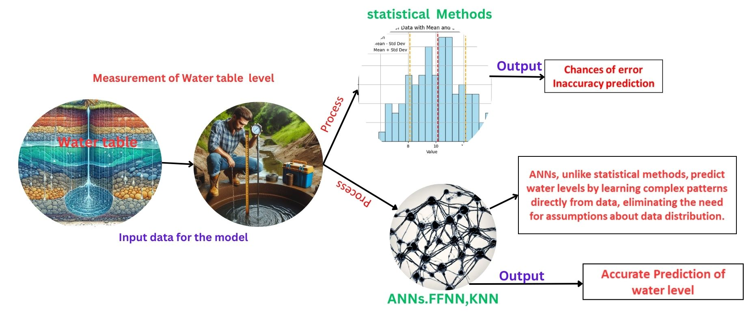
Figure 1. Graphical abstract
Keywords: Environmental Parameters, Groundwater Level Prediction,Nearest Neighbors (KNN), Machine Learning Models, Predictive Accuracy
Highlights
- Comparisons of machine learning models like ANN, FFNN and KNN in predicting the groundwater level using the effective tool python.
- Find the most robust predictor variable in groundwater level estimation, as evidenced by its Spearman correlation coefficient.

1 INTRODUCTION
Groundwater contribution towards global agriculture is about 43% of irrigation water supply ¹. It's a natural resource that serves human consumption and agriculture. Even though it's a finite resource, groundwater is rechargeable. Transport, public health, and food supply are some of the fields that knowingly rely on quality and quantity in groundwater resources, hence impacting greatly on the standard of living in society². Groundwater supplies more than 50% of irrigation water in most arid and semi-arid regions, such as in the case described by FAO in 2015. Globally, it caters to about 38% of irrigated areas, hence effectively contributing towards food security ³.Groundwater irrigates almost 60% of the total irrigated area in India. The United States utilizes this source for about 65% of its irrigation needs, and in India, it is almost 60% of the total irrigated area. Unsustainable extraction has however resulted in depletion in many areas, and it has been estimated that an estimated 20% of the world's aquifers are over-exploited. Such sustainable management of this vital resource will be required in order to guarantee agricultural productivity and food security over the long term.
In recent years, machine learning techniques have emerged as powerful tools for groundwater studies, particularly in level prediction. These methods have demonstrated superior accuracy in modelling complex, non-linear hydrological systems compared to traditional approaches. Artificial Neural Networks (ANNs), for instance, have shown promise in simulating intricate relationships between climatic variables and groundwater systems ⁴.The use of ANN in groundwater studies has even expanded into climate change impact assessments. ANN models to determine whether the results might be influenced by climate change on groundwater resources⁵. It was shown in the study that the model can simulate any complex relationship between climatic variables and groundwater systems. With development not stopping in these areas, researchers have applied ANN in groundwater studies on water level predictions. Growth has been most phenomenal in areas that face critical water management challenges. Further integration of ANNs with other technologies and data sources has provided additional utility to them in groundwater management. ANN applications in groundwater studies have further been extended to the assessment of climate change impacts .The prediction of groundwater level is a very critical component of water resource management, and correct predictions have huge ramifications for both environmental sustainability and water security. Machine learning techniques have come to the fore in this field in the past few years because of their ability to model complex, nonlinear relationships that are inherent in hydrogeological systems. Based on the provided content, I can offer a structured introduction for a study on groundwater level prediction using machine learning techniques. In this regard, the current research investigates and compares the efficiency of five machine learning models in the prediction of groundwater levels: ANNs, FFNNs and K-Nearest Neighbors Regression. Each model has its own advantages, ranging from the simplicity of linear regression to the complexity of neural networks, which can capture nonlinear relations and time-series patterns in groundwater data. In the present study, an attempt is made to compare the efficiency of five machine learning models for groundwater level predictions: ANNs, FFNNs and KNN. All of them have their benefits—some very basic, others going a step ahead in fitting nonlinear relations or even seasonality of the groundwater data, like neural networks.
The study aims to compare these models across different hydrogeological settings to examine their relative strengths and limitations. Such findings will help in making more informed decisions about water resource management for the sustainability of water use and environmental protection. ANN and FFNN have been reportedly satisfactory in simulating nonlinear relationships and temporal patterns in groundwater data. Due to the simplicity of linear regression, it was used to provide a base for comparison. In the present research, their performances will be compared to understand the strengths and limitations of the models in predicting the groundwater level for different hydrogeological setups. This shall be beneficial in deciding a thing or two better regarding water resources.
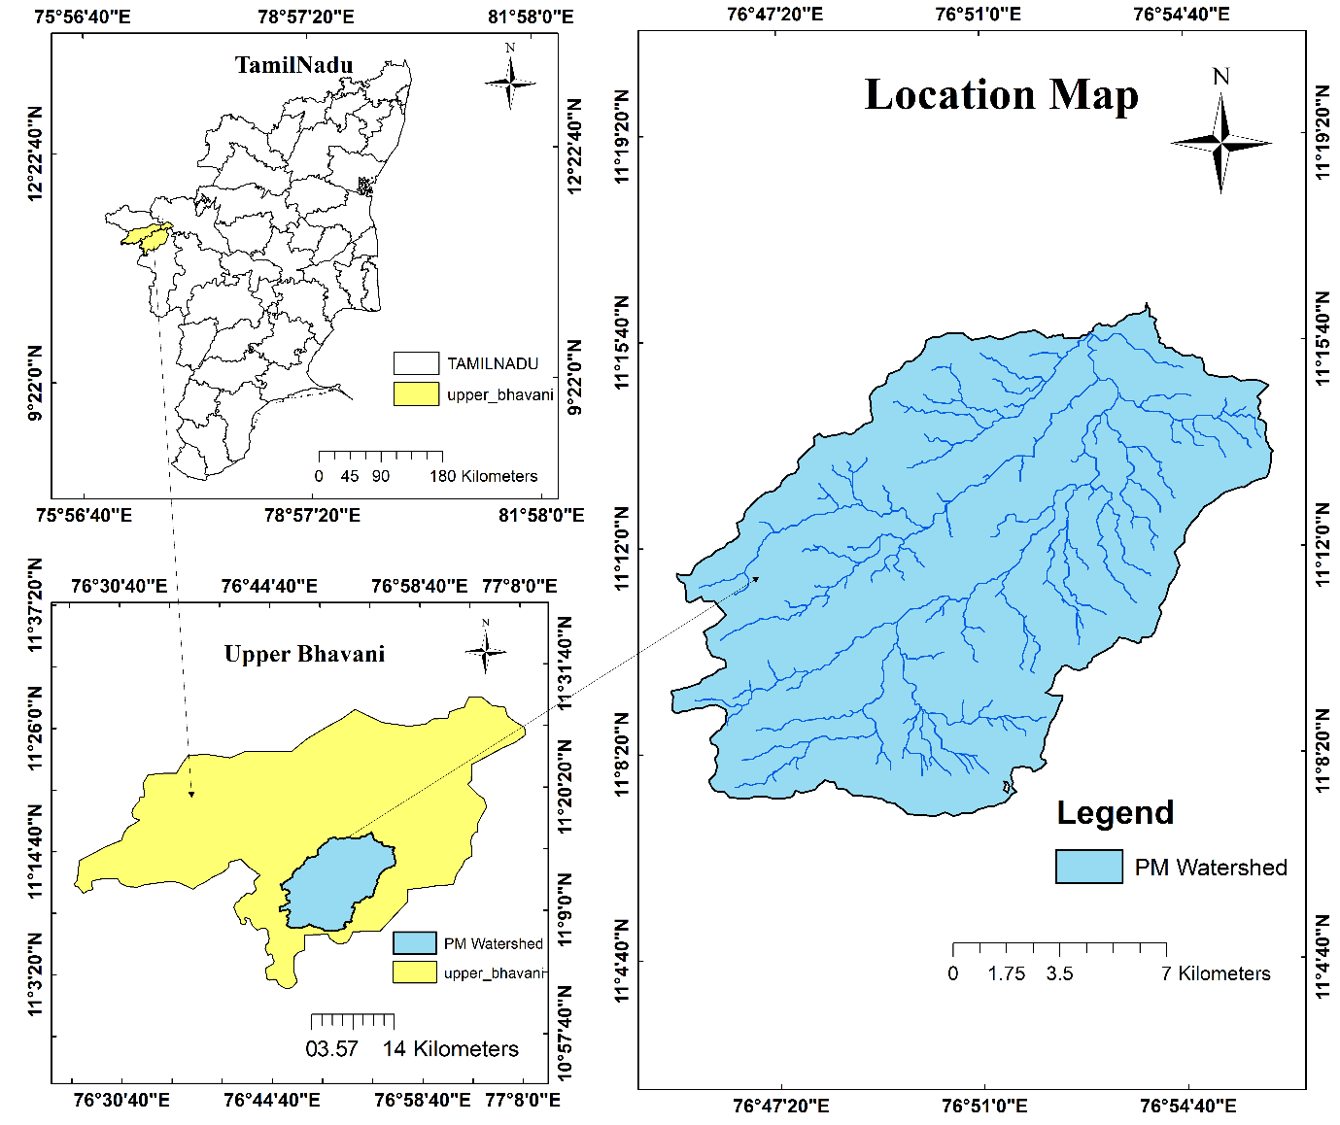
1.1 Study area
Figure 2 .watershed delineation in the upper Bhavani Area in Coimbatore
The Periyapalam watershed lies in the Karamadai Block of Coimbatore District, Tamil Nadu. It is an agriculturally rich area at the foothills of the Nilgiri Mountains. It has a geographic position of about 11.2804° N, 76.9564° E within the Bhavani River basin, which is one of the major tributaries of the Cauvery. However, as in most parts of Tamil Nadu, Karamadai is also susceptible to issues connected with the depletion of groundwater. The watershed area in the Karamadai block is 200 square kilometres. This was done with the help of ArcGIS 10.8, whereby it helped to demarcate the boundaries that enclosed the area, which drained into a particular water body or outlet point.
1.2 Data Collection
Ground water level data was obtained from Water Resources Information System, WRIS (1994-2021, daily), rainfall data from India Meteorological Department, IMD, while soil moisture, relative humidity, wind speeds, and temperature data were from National Aeronautics and Space Administration, NASA's Prediction Of Worldwide Energy Resources, POWER project.
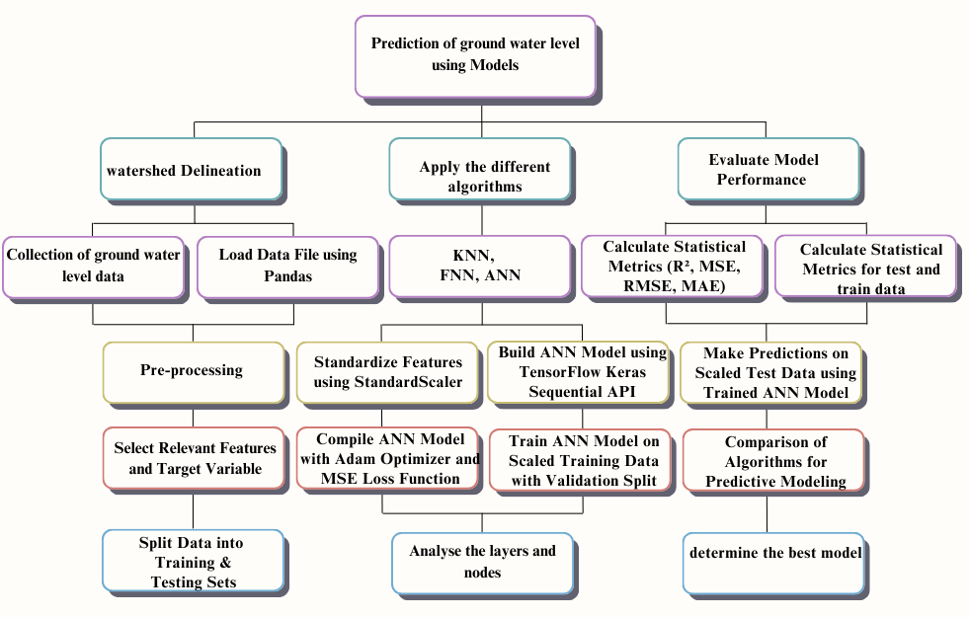
II.Methodology

Figure 3.Methodology for Prediction of Groundwater Level Using Various Models.
A correlation analysis was done to prove the relationships between the levels of groundwater and a variety of environmental parameters. The analysis is projected to inform on the strength and direction of the associations that exist between the levels of groundwater and variables of rainfall, soil moisture, relative humidity, wind speed, and temperatures. Results will help identify what factors most significantly affect water level fluctuations and shed light on the intricate linkages within a hydrological system.

$$ρ = 1 -\frac{\sum_{ }^{ }{di²}}{ n(n² - 1)}$$
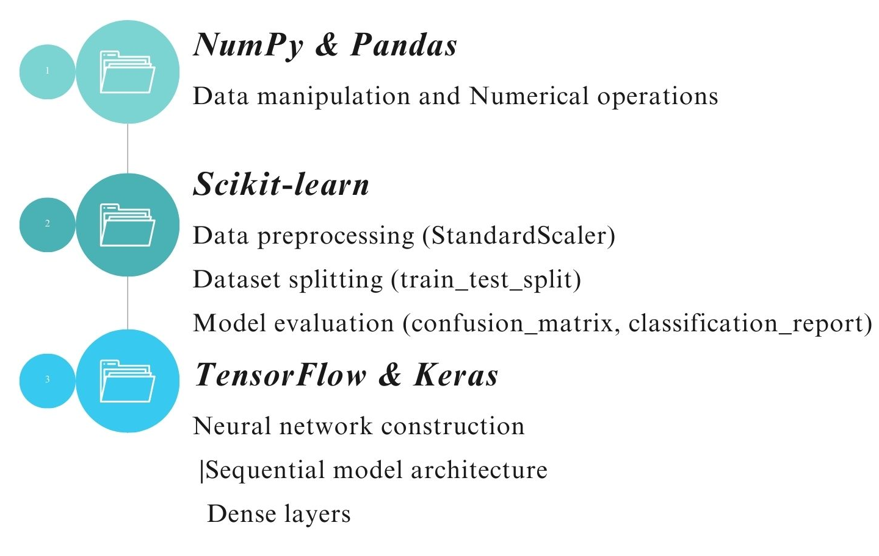

.\

Figure 4.Essential Libraries and Components in the Machine Learning Pipeline
2.1 APPLY ANN TO PREDICT THE WATER LEVEL (m)
Basically, the methodology used here in this code is to create an Artificial Neural Network model for regression. This is mainly done for the prediction of Water Level respect to several features or inputs like Rainfall, Soil Moisture, Relative Humidity, Minimum Temperature, and Maximum Temperature.
(i)The Model Architecture for ANN has been explain as Input Layer has 5 nodes (corresponding to the 5 input features) and First Hidden Layer: 64 nodes with ReLU activation

$$h1=ReLU \left(W1 * X + b1\right)$$
Second Hidden Layer: 64 nodes with ReLU activation

$$h2=ReLU \left(W2 * h1 + b2\right)$$
Output Layer: 1 node (linear activation)

$$h3=W3 * h2 + b3$$

$Water Level prediction=$f3 (W3 * f2 (W2 * f1 (W1 * X + b1) + b2) + b3)
Where
X = input vector [x1, x2, x3, x4, x5] representing the 5 features
W1, W2, W3= weight matrices for each layer
b1, b2, b3 = bias vectors for each layer
f1 and f2 are ReLU activation functions: f(x) = max(0, x)
f3 is the identity function for the output layer: f(x) = x
(ii) In the model architecture for feed-forward neural network (FFNN) the Input layer takes in the input features, which have been scaled using the `StandardScaler`. X may be the pareameters like Rainfall, soil moisture, Relative humidity, Wind_min, Wind_max, min_temp, max_temp.The first hidden layer has 64 nodes with the ReLU (Rectified Linear Unit) activation function. The second hidden layer has 32 nodes with the ReLU activation function.

$$H^{1}=σ\left(W^{1}X + b^{1}\right)$$
Where σ is the ReLU activation function, W₁ is the weight matrix, and b₁ is the bias vector for this layer. Similarly, W₂ and b₂ are the weights and biases for the second layer.

$$H^{2}=σ\left(W^{2}H^{1}+ b^{2}\right)$$
The output layer has a single node, which represents the predicted Water Level. The number of nodes in the hidden layers is a hyper parameter that needs to be tuned based on the complexity of the problem and the size of the dataset. In this case, 64 and 32 nodes are chosen for the two hidden layers, respectively.

$$Ŷ =W^{3}H^{2}+ b^{3}$$
This is a linear transformation to produce the final output (predicted Water Level).
2.2 In model architecture for feed-forward neural network (FFNN) with regularization. Input Layer has 7 nodes (one for each input feature).First Hidden Layer: 64 nodes with ReLU activation and L2 regularization and Dropout Layer is 20% dropout rate. First hidden layer with dropout as expressed as

$$h1=D1\left(f1\left(W1 * X + b1\right)\right)$$
Second Hidden Layer has 32 nodes with ReLU activation and L2 regularization and Dropout Layer is 20% dropout rate

$h2=$D2 (f2 (W2 * h1 + b2))
Output Layer has 1 node (linear activation)
$$y_{pred}=W3 * h2 + b3$$
$$y_{pred}=f3\left(W3 * f2\left(D2\left(W2 * f1\left(D1\left(W1 * X + b1\right)\right)+ b2\right)\right)+ b3\right)$$
Where:
- X is the input vector [x1, x2, ..., x7] representing the 7 features
- W1, W2, W3 are weight matrices for each layer
- b1, b2, b3 are bias vectors for each layer
- f1 and f2 are ReLU activation functions: f(x) = max(0, x)
- f3 is the identity function for the output layer: f(x) = x
- D1 and D2 represent dropout operations
[Note: Additional components L2 Regularization is added to the loss function for the first two layers
L2_penalty = 0.001 * (sum of squared weights)
Dropout is randomly sets a fraction of input units to 0 at each update during training, which helps prevent over fitting.]This architecture allows the model to learn complex, non-linear relationships between the input features and the target variable (Water Level). The ReLU activations introduce non-linearity, L2 regularization helps prevent over fitting by penalizing large weights, and dropout further improves generalization by reducing reliance on specific neurons.
2.3 The model architecture of k-nearest neighbors regression (KNN)
K-Nearest Neighbour’s Regression (KNN) model Architecture is Instance-based learning
$$y=\frac{1}{k}\sum_{ }^{ }{\left(yi\right)}$$
Where k is the number of nearest neighbors, yi are the target values of the k nearest neighbors. All models use StandardScaler for feature normalization
$$X_{scaled}=\frac{\left(X - mean\left(X\right)\right)}{kstd\left(X\right)}$$
The Adam optimizer and mean squared error loss function will be used for the model. This is because mean squared error is one of the standard loss functions for regression problems. So, the model will be trained on the scaled training data for 100 epochs with a batch size of 32 and a validation split of 0.2.3.14 Model Evaluation.R²,MSE, MSE, MAE on the test data, which provides an overall measure of the model's performance.

2.4 R-squared (R²) Score
$$R^{2}=1 -\frac{\left(SSres \right)}{\left(SStot\right)}$$
Where SS_{res} is the sum of squared residuals (Σ(yi - ŷi)²) and SS_{tot} is the total sum of squares (Σ(yi - ȳ)²). Here, yi represents actual values, ŷi predicted values, and ȳ the mean of actual values. R² ranges from 0 to 1, with 1 indicating a perfect fit. It measures the proportion of variance in the target variable explained by the model.
2.5 Mean Squared Error (MSE)
A lower MSE value indicates better model performance.
$$MSE=\frac{1}{n}\sum_{ }^{ }{{\left(yi - ŷi\right)}^{2}}$$
a. Calculate the difference between each predicted and actual value${\left(yi – ŷi\right)}^{ }$
b. Square each difference: ${\left(yi – ŷi\right)}^{ }$²
c. Sum all these squared differences: ∑${\left(yi – ŷi\right)}^{2}$
d. Divide by the number of samples (n) to get the average
2.6 Root Mean Squared Error (RMSE)
$RMSE= \sqrt{MSE}=\sqrt{\frac{1}{n}}$∑${\left(yi – ŷi\right)}^{2}$
2.7 Mean Absolute Error (MAE)
This metric calculates the average absolute difference between the predicted and actual values, providing a more intuitive measure of the model's error.
$MAE=\left(\frac{1}{n}\right)$∑${\left(yi – ŷi\right)}^{ }$
a. Calculate the difference between each predicted and actual value: ${\left(yi – ŷi\right)}^{ }$
b. Take the absolute value of each difference: ${\left(yi – ŷi\right)}^{ }$
c. Sum all these absolute differences∑${\left(yi – ŷi\right)}^{ }$
d. Divide by the number of samples (n) to get the average
III.RESULT AND DISCUSSION
Rainfall, in comparison to other variables, has the strongest positive correlation with water level, consistently high correlations ranging from 0.83 to 0.89, and slightly increasing over time. This was followed by relative humidity, which has a moderate to strong positive correlation ranging from 0.55 to 0.63, which strengthened in the later periods. Soil moisture has a modest positive relationship of 0.40 to 0.45 throughout, but again the pattern is scattered, which supports the premise of some more complex relationship. Both minimum and maximum temperatures surprisingly show a quite consistent, moderate negative correlation with the water level, thereby showing that lower temperatures are associated with higher water levels. Wind speed, in both its maximum and minimum, produces a much weaker and varied positive correlation with the water level, which says something about how its impact is much less direct or constant. The overall outcome, though, is that most of the relationships exist relatively similarly across different time periods, pointing to a multidimensional system where several environmental factors interplay to determine the water levels. Such holistic understanding about these relationships would be very useful in effective management of water resources and for hydrological modelling with good accuracy.
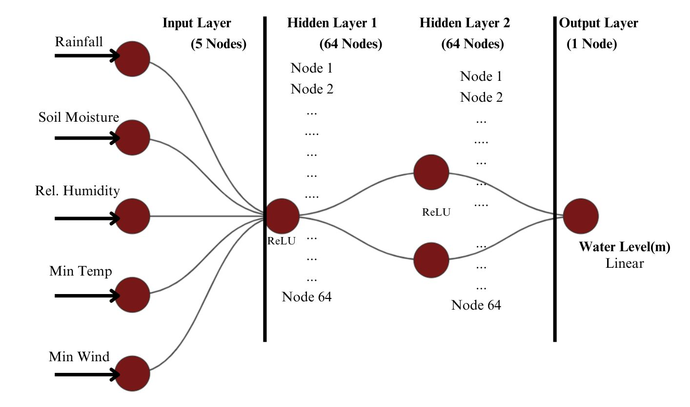
Figure 5.ANN Architecture diagram

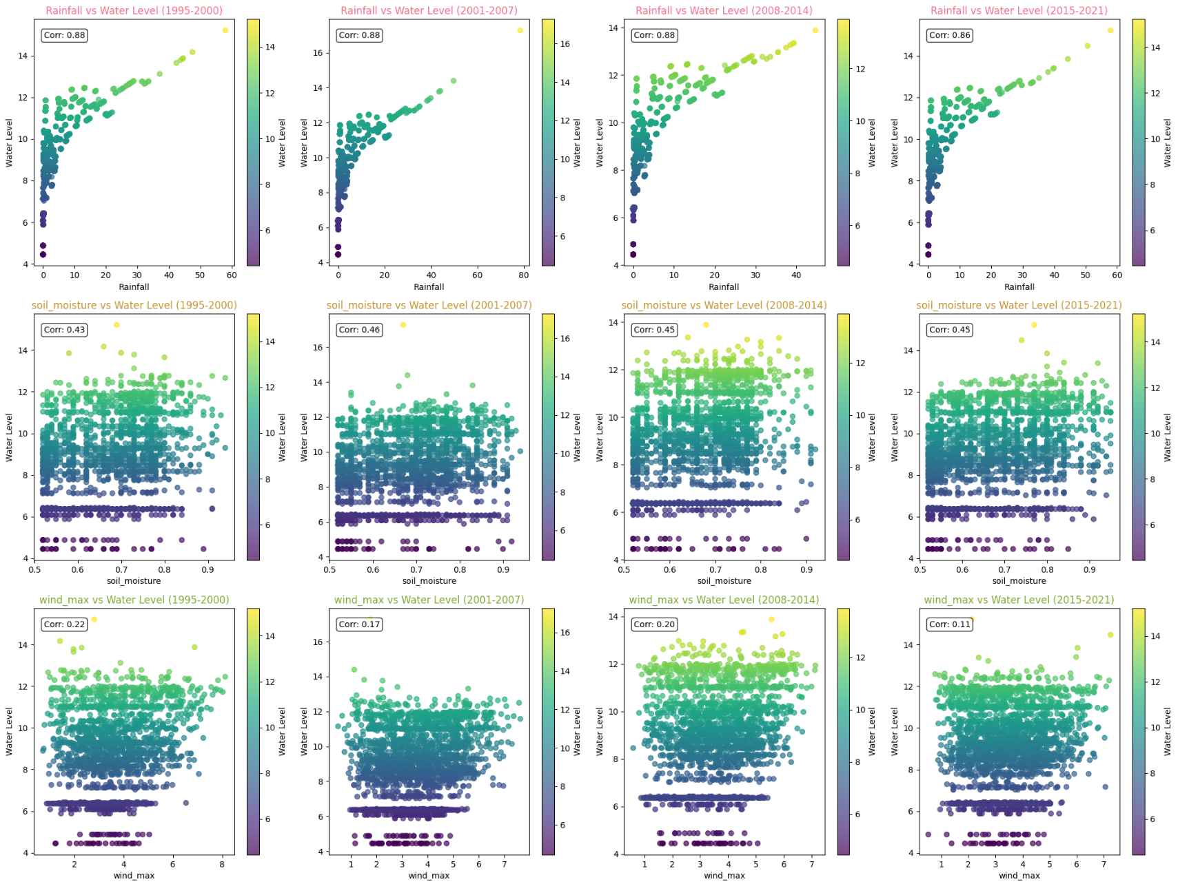

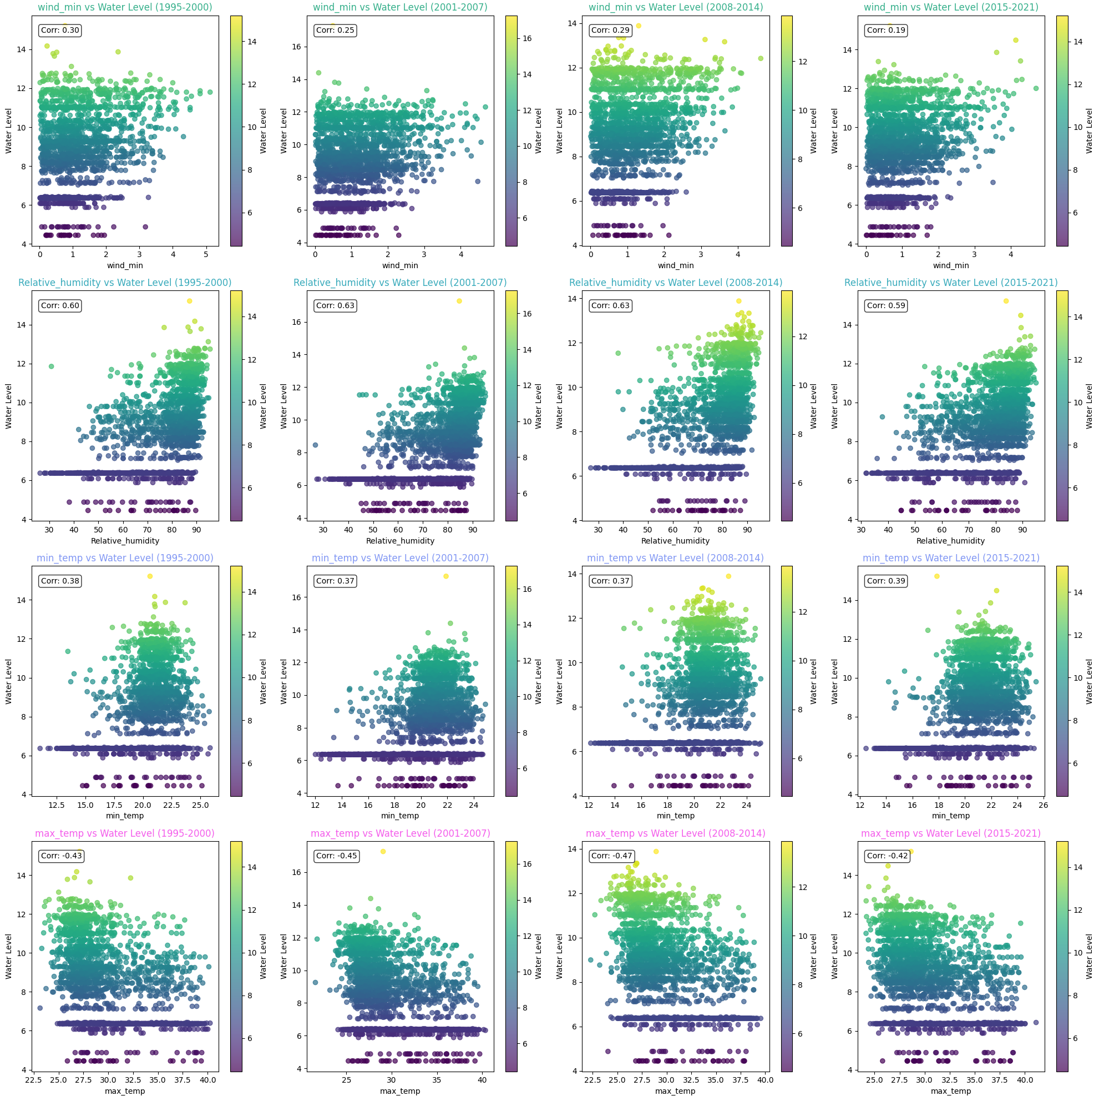
Figure 6. Correlation analysis of parameters with Water level (m)

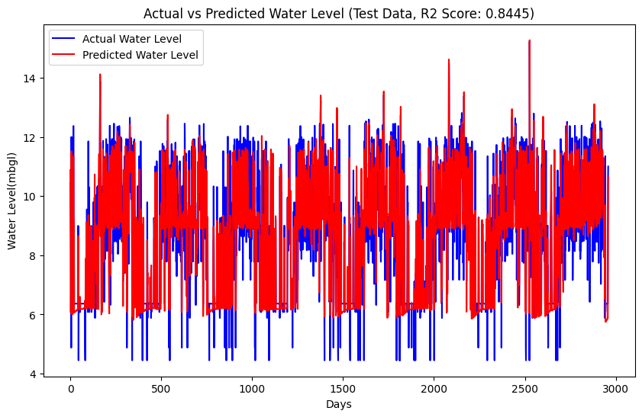
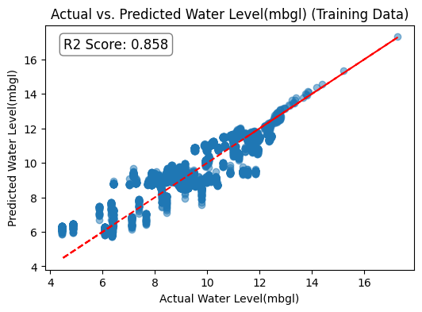

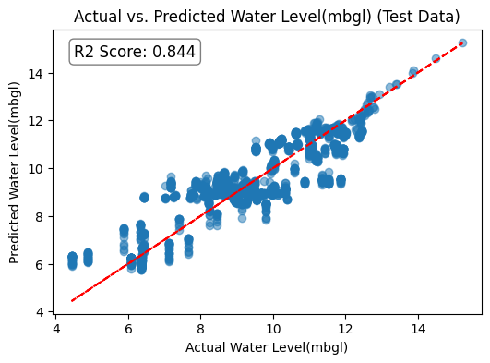

Figure 7. Prediction using ANN, Actual and predicted water level(m) for Training& Test Data

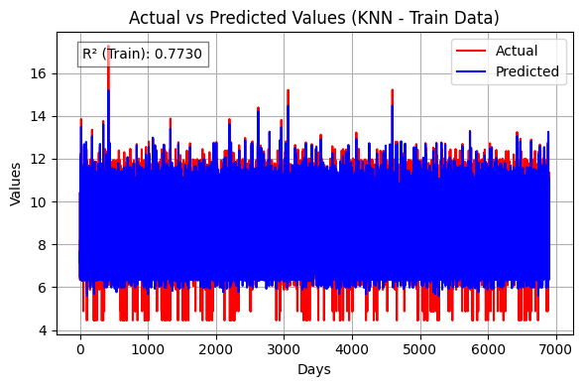
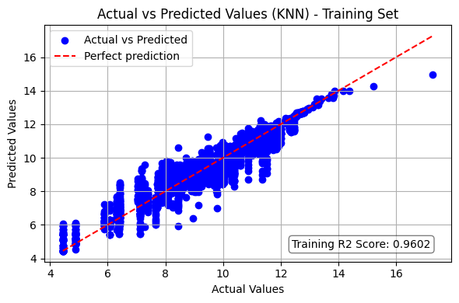
Fig. 8 Actual and predicted water level(m) for train Data
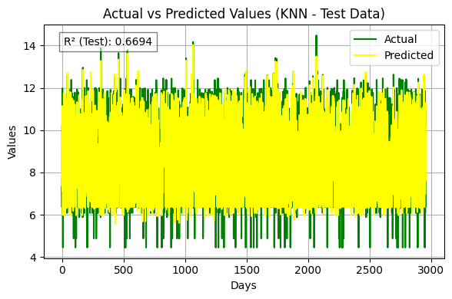
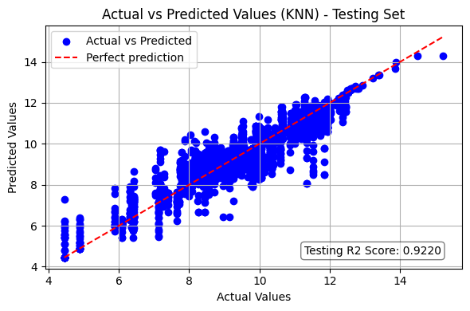
Figure 9. Prediction using KNN Actual and predicted water level(m) for test Data

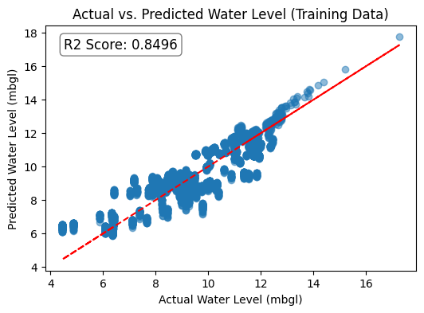
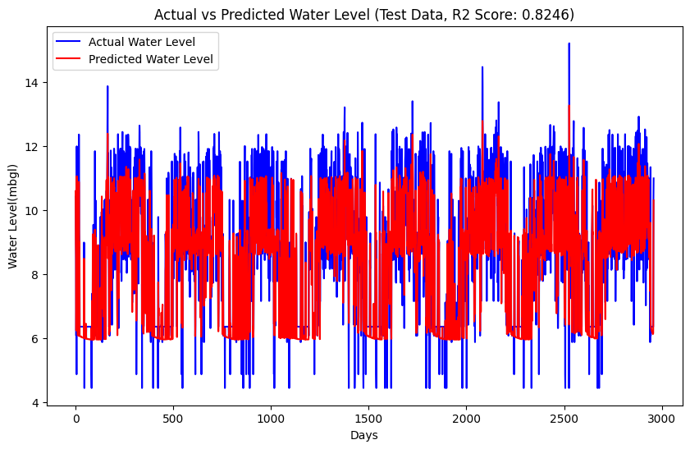
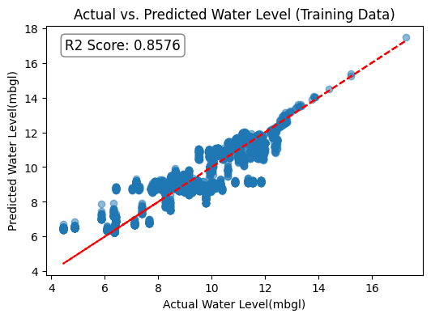
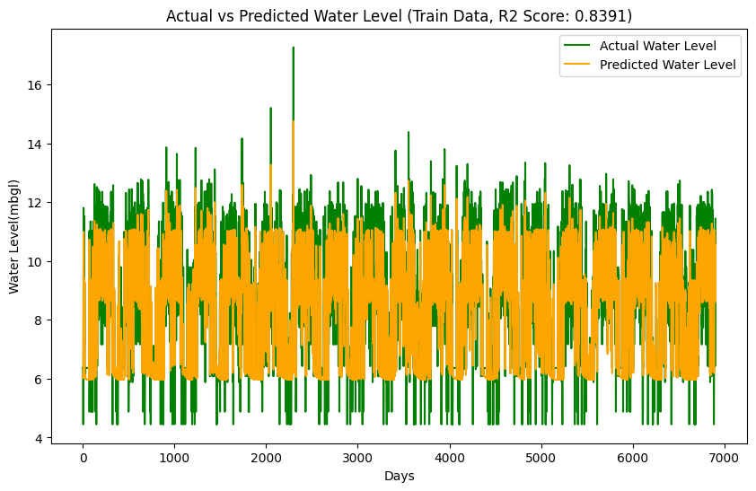

level(m) for train Data

Figure 10. Prediction using FNN Actual and predicted water for Training and Test data
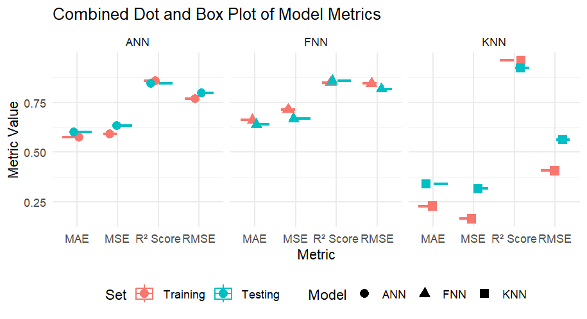

Figure 11. Model Matrics

Performance analysis clearly shows that there are vast differences in predictive accuracy and error rates between the FNN, ANN, and KNN models. The most surpassing model is the KNN, with the highest R-squared in the training (0.9602) and testing (0.9220) data, showing immense strong explanatory power over the variance in the data. Further, it shows the lowest Mean Squared Error (MSE) of 0.1651 in training and 0.3173 in testing, together with the lowest Root Mean Squared Error (RMSE) of 0.4064 and 0.5633, respectively. This shows that the predictions done by KNN are close enough to the real values as compared to the other models. Besides, KNN performs very strong when compared to the lowest MAE (0.2291) in training and 0.3398 in testing, meaning it is very suitable in predicting exact values. On the other hand, wanting the ANN model being good in relative terms,

Issuing the top-ranked R² score, it also has slightly reduced MSE, RMSE, and MAE compared to the FNN model. On the contrary, a FNN model, although usable, is characterized by the highest error metrics and extremely low R² among the three. As a result, reflected KNN was the most effective model of this dataset, and it gave the greatest values of all the parameters at the lowest error rates. In contrast, the ANN led to a balanced performance, and the FNN was weakest in this regard. The above analysis points to the need for selecting the right model through the performance metrics to be used in order to realize the best accuracy possible in prediction.

REFERENCES

1. Coppola, E., Szidarovszky, F., Poulton, M., & Charles, E. (2014). Artificial neural network approach for predicting transient water levels in a multilayered groundwater system under variable state, pumping, and climate conditions. Journal of Hydrologic Engineering, 19(3), 343-358. https://doi.org/10.1061/(ASCE)HE.1943-5584.0000803
2. FAO. (2015). Global framework for action to achieve the vision on groundwater governance. Food and Agriculture Organization of the United Nations. https://doi.org/10.4060/ca7537en
3. Gates, J. B., Edmunds, W. M., Ma, J., & Sheppard, P. R. (2011). A 700-year history of groundwater recharge in the drylands of NW China. The Holocene, 21(7), 1049-1059. https://doi.org/10.1177/0959683611400460
4. Gupta, S. K., Deshpande, R. D., Agarwal, M., & Raval, B. R. (2004). Origin of high fluoride in groundwater in the North Gujarat-Cambay region, India. Hydrogeology Journal, 12(4), 438-450. https://doi.org/10.1007/s10040-004-0320-y
5. Siebert, S., Burke, J., Faures, J. M., Frenken, K., Hoogeveen, J., Döll, P., & Portmann, F. T. (2010). Groundwater use for irrigation – a global inventory. Hydrology and Earth System Sciences, 14(10), 1863-1880. https://doi.org/10.5194/hess-14-1863-2010
6. Villholth, K. G., López-Gunn, E., Conti, K., Garrido, A., & Van Der Gun, J. (2016). Advances in groundwater governance. CRC Press. https://doi.org/10.1201/9781315210025
7. Coppola, E. A., Rana, A. J., Poulton, M. M., Szidarovszky, F., & Uhl, V. W. (2005). A neural network model for predicting aquifer water level elevations. Groundwater, 43(2), 231-241. https://doi.org/10.1111/j.1745-6584.2005.0003.x
8. Mohanty, S., Jha, M. K., Kumar, A., & Sudheer, K. P. (2010). Artificial neural network modeling for groundwater level forecasting in a river island of eastern India. Water Resources Management, 24(9), 1845-1865. https://doi.org/10.1007/s11269-009-9527-x

9. Nayak, P. C., Satyaji Rao, Y. R., & Sudheer, K. P. (2006). Groundwater level forecasting in a shallow aquifer using artificial neural network approach. Water Resources Management, 20(1), 77-90. https://doi.org/10.1007/s11269-006-4007-z
10. Daliakopoulos, I. N., Coulibaly, P., & Tsanis, I. K. (2005). Groundwater level forecasting using artificial neural networks. Journal of Hydrology, 309(1-4), 229-240. https://doi.org/10.1016/j.jhydrol.2004.12.001
11. Kumar, S., Sharma, A., & Sharma, S. K. (2020). Prediction of groundwater level using artificial neural network and multiple linear regression techniques: a case study. Environmental Earth Sciences, 79(12), 1-14. https://doi.org/10.1007/s12665-020-09002-6
12. Sahoo, S., & Jha, M. K. (2013). Groundwater-level prediction using multiple linear regression and artificial neural network techniques: a comparative assessment. Hydrogeology Journal, 21(8), 1865-1887. https://doi.org/10.1007/s10040-013-1029-5
13. Rajaee, T., Ebrahimi, H., & Nourani, V. (2019). A review of the artificial intelligence methods in groundwater level modeling. Journal of Hydrology, 572, 336-351. https://doi.org/10.1016/j.jhydrol.2019.02.054
14. Yadav, B., & Mathur, S. (2008). Multilayer perceptron neural networks for groundwater level prediction. International Journal of Earth Sciences and Engineering, 1(4), 42-48. https://doi.org/10.1007/s12145-008-0008-1
15. Yoon, H., Jun, S. C., Hyun, Y., Bae, G. O., & Lee, K. K. (2011). A comparative study of artificial neural networks and support vector machines for predicting groundwater levels in a coastal aquifer. Journal of Hydrology, 396(1-2), 128-138. https://doi.org/10.1016/j.jhydrol.2010.11.002 Singh, A.K., Tripathi, J.N., Kotlia, B.S., Singh, K.K. and Kumar, A., 2019. Monitoring groundwater fluctuations over India during Indian Summer Monsoon (ISM) and Northeast monsoon using GRACE satellite: Impact on agriculture. Quaternary International, 507, pp.342-351 https://doi.org/10.1016/J.QUAINT.2018.10.036
16.Sarma, R., & Singh, S. K. (2022). A comparative study of data-driven models for groundwater level forecasting. Water Resources Management, 36(8), 2741-2756.
17. Moghaddam, H.K., Moghaddam, H.K., Kivi, Z.R., Bahreinimotlagh, M. and Alizadeh, M.J., 2019. Developing comparative mathematic models, BN and ANN for forecasting of GWL. Groundwater for Sustainable Development, 9, p.100237. https://doi.org/10.1016/J.GSD.2019.100237
18. Daliakopoulos, I. N., Coulibaly, P., & Tsanis, I. K. (2005). Groundwater level forecasting using artificial neural networks. Journal of hydrology, 309(1-4), 229-240. http://dx.doi.org/10.2166/hydro.2008.006
19. Esfe, M. H., Toghraie, D., & Amoozadkhalili, F. (2023). Optimization and design of ANN with Levenberg-Marquardt algorithm to increase the accuracy in predicting the viscosity of SAE40 oil-based hybrid nano-lubricant. Powder Technology, 415, 118097. https://doi.org/10.1016/j.powtec.2022.118097
20. Kvaal, K., & McEwan, J. A. (1996). Analysing complex sensory data by non-linear artificial neural networks. In Data Handling in Science and Technology (Vol. 16, pp. 103-133). Elsevier
21. Adeloye AJ (2009) Multiple linear regression and ANNmodels for generalized reservoir storage–yield–reliability function for reservoir planning. J Hydrol Eng ASCE 14(7):731–738 https://doi.org/10.1061/(ASCE)HE.1943-5584.0000041
22. Yadav B., Ch S., Mathur S., Adamowski J. 2017. Assessing the suitability of extreme learning machines (ELM) for groundwater level prediction. Journal of Water and Land Development. No. 32 p. 103–112. DOI: 10.1515/jwld-2017-0012. DOI:10.1515/jwld-2017-0012
23.Wang, Xuanhui, Tailian Liu, Xilai Zheng, Hui Peng, Jia Xin, and Bo Zhang. "Short-term prediction of groundwater level using improved random forest regression with a combination of random features." Applied Water Science 8 (2018): 1-12. https://doi.org/10.1007/s13201-018-0742-6
24.Ebrahimi, H., & Rajaee, T. (2017). Simulation of groundwater level variations using wavelet combined with neural network, linear regression and support vector machine. Global and Planetary Change, 148, 181-191. https://doi.org/10.1016/J.GLOPLACHA.2016.11.014
25.Adamowski, J., Fung Chan, H., Prasher, S. O., Ozga‐Zielinski, B., & Sliusarieva, A. (2012). Comparison of multiple linear and nonlinear regression, autoregressive integrated moving average, artificial neural network, and wavelet ANNmethods for urban water demand forecasting in Montreal, Canada. Water Resources Research, 48(1). https://doi.org/10.1029/2010WR009945

