Review Article

DUAL RELEASE TABLETS: A NOVEL APPROACH TO OPTIMIZED DRUG RELEASE

ABSTRACT: The Dual release tablet marks a turning point in the development of extended release tablets with a variety of features to produce an efficient drug delivery. Dual release tablets may be the greatest solution for avoiding chemical or physical incompatibilities between Active Pharmaceutical Ingredients (APIs) while also making it easier to produce medications with diverse drug release qualities. Bilayer tablets are appropriate for the sequential discharge of two medications, as well as the sustained release of a tablet with one layer for immediate discharge as a loading dose and the second layer for maintenance dose. The ongoing development of practical technology in bilayer tablets addresses the disadvantages of single-layered tablets. Today, combination therapy is employed in both developed and developing countries to treat Analgesic, anti-diabetic, and antihypertensive medications are only a few of the numerous illnesses that can be loaded using the sequential release of two drugs paired with the sustained discharge of a tablet with one layer for immediate release. Diabetes mellitus and hypertension are two disorders that require long-term care. A bilayer tablet combines compressibility with consolidation. The major goal of sustained-release bilayer tablets is to improve oral therapeutic efficacy while maintaining ideal control over medication plasma levels. The pills' bioavailability is also intended to increase patient adherence. This paper provides an overview of the manufacturing problems of bilayer tablets, including the numerous tablet presses used, the standard and current good manufacturing practice protocol for their mass production, the various dual release tableting procedures and techniques, pre and post compression evaluation, and software.
KEYWORDS: Bilayer tablets, sustain release, fast release, Maintenance dose, Loading dose, Consolidation, Compression, current good manufacturing practice requirements, pre and post evaluation, software, techniques.
INTRODUCTION:
Tablets, capsules, solutions, suspensions, creams, ointments, suppositories, liquids, and injectables are examples of traditional drug delivery systems that have been used for many decades to treat both acute and chronic conditions. These conventional therapy kinds are the most commonly utilized and can be purchased over-the-counter or with a prescription. A small delay results in fluctuations in medication concentration, which impairs patient compliance. Conventional therapy must be provided multiple times during the day to maintain and reach drug concentration within an effective therapeutic range.^{[1]}
The development of Prolonged release medication delivery systems has received more attention during the last three decades. In order to increase patient convenience and compliance, the pharmaceutical industry has increasingly used combinations of dual or additional pharmaceutical agents in a unit dose form. A simplest method for creating a controlled release formulation that is economical and successful is the dual release strategy. Bilayer tablets' ability to separate incompatible substances and their suitability for the sequential delivery of multiple drugs make them more effective than traditional dose forms. The initial dose (immediate release) is represented by the first layer of a sustained release or controlled release tablet, while the maintenance dose (controlled release) is represented by the second layer.^{[2]}
The fast discharge layer consists super disintegrants that quicken the drug discharge kinetics and accomplish the start of activity, whilst the sustained release layer contains low viscosity polymers that help with the sustained release of the medication over a sustained period of time.^{[3].} HIV/AIDS, type 2 diabetes, hypertension, coronary heart disease, and pain are among the illnesses that are primarily treated by bilayer drug delivery systems. Numerous techniques, including as compression coating, active coating, multilayer tablets, bilayer floating tablets, and oral administration systems, are used to administer FDC medicines to patients. ^{[4]}
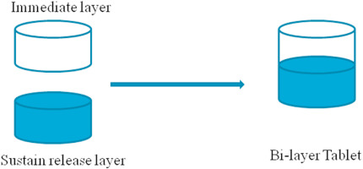
Fig.1 Bilayer tablet (same API with variability in release pattern)
OBJECTIVE OF BILAYER TABLETs:
- For the purpose of regulating the rate of distribution of one or two distinct active medicinal substances ^{[6], [7]}
- To keep irreconcilable APIs apart, and to use the functional qualities of other layers (such osmotic properties) to regulate the release of one API from one layer.
- To alter the total surface area available for the API layer, one or two inactive layers can be sandwiched between the API layer to create swellable/erodible barriers for modified release ^{[5].}
- To offer fixed dose combinations of various APIs, extend the drug product's shelf life, and create innovative drug delivery techniques such chewing tools, oral delivery systems, and floating tablets for gastro-retentive drug delivery systems.^{[8]}
MERITS OF BILAYER TABLET:
- Cost effective
- Light and condensed
- Unchallenging and affordable to pouch and pillage.
- Mask objectional Odor and bitter taste
- Least tendency to hung up
- Produce on large scale
- Chemically and microbially stable
- Identification of product is rapid and easy.
- Better dose precision and the small content variability, greatest capabilities. ^{[9]}
DISADVANTAGES OF BILAYER TABLET:
- Amorphous and low-density drug resist compression.
- Encapsulation or coating required for drug with bitter taste, objectional odours, and oxygen sensitivity.
- Difficult for youngsters and unconscious patients to swallow;
- Difficult to formulate medications with a slow rate of breakdown, poor wetting qualities, and high absorption. ^{[9]}

CHALLENGES IN BILAYER TABLET:
- Separate layer weight control is inaccurate.
- cross contamination.
- A large elastic modulus ratio between neighboring layers may lead to poor interfacial strength and insufficient layer bonding.
- The production yield and delaminate (distinct layer separation) diminish at the non-planer interface between the subsequent compressed layers.^{[10]}
- Low drug load combined with an uneven layer weight ratio.
- Not enough hardness ^{[10]}
- Durable chemical and physical integrity for the course of the shelf life.
- Large pill size, which may affect how easily the unit dose is swallowed.
- High humidity and temperature effects on layer adhesion during storage.
TYPES OF BILAYER TABLET:
1. Equivalent Type: Dual release tablets are the best choice for medications with different release patterns. Bilayer tablets are composed of two layers: one layer contains the medicine for rapid release, and the other layer releases the drug either as part of another dose or in a prolonged release pattern. (Fig 1) ^{[11]}
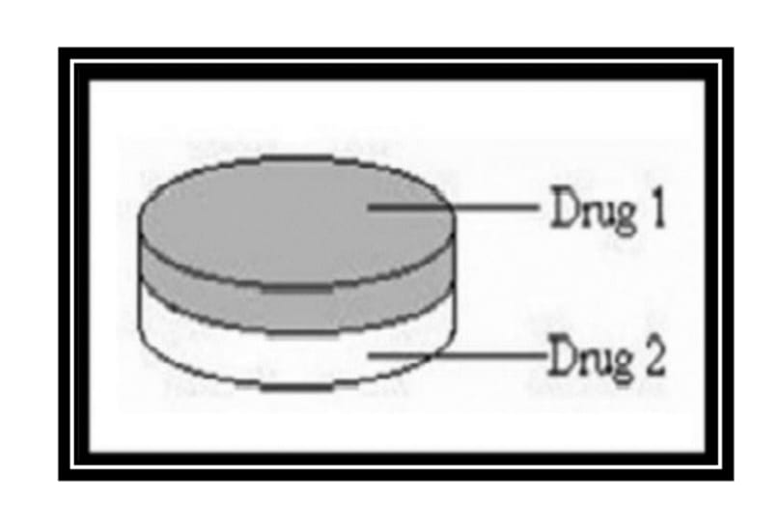
2. Heterogeneous Type: Two incompatible substances can be separated using bilayer tablets, or two medications can be released sequentially in conjunction. ^{[12]}

Fig 2. Bilayer tablet (two different drugs- Heterogenous)
IDEAL CANDIDATES OF BILAYER TABLETS:
- Medications that have a synergistic or additive effect example, Antiasthamatic drugs like salbutamol + theophylline.
- When drugs have opposing adverse effect, they can lessen each other’s side effect example, Omeprazole + NSAIDS.
- Drugs that are incompatible.
- For modified release bilayers, a low biological half-life is optimal.
- Unstable in the stomach or at intestinal pH (perfect for bilayer floating)
- Low half-life and high first pass metabolism (perfect for Bucco sticky bilayer)^{[13]}

BILAYER TABLET: STANDARD AND CURRENT GOOD MANUFACTURING PRATICES NECESSITIES:
In order to manufacture a high-quality bilayer tablet in compliance with GMP, the chosen press should be able to:
- Avoid topping and parting of the two discrete layers that make up the dual release tablets.
- Adequate pill firmness is provided.
- Preventing contamination from spreading between the two layers.
- The two layers are visually separated.
- Superabundant
- Precisely and separately controlling the weight of the two layers. ^{[14,15]}

FEATURES DISTRESSING THE ORAL EXTENDED-RELEASE MEASURE SYSTEM STRATEGY:
- Pharmacokinetics factors:
- Pharmacological Half- life: Drugs with a biological half-life of two to eight hours are thought to be the best candidates for extended-release dosage forms since they can lower the frequency of dosages. Because medications with extremely short pharmacological half-lives may need disproportionately high dosage levels per dosage unit to have long-lasting effects, this has the drawback of making the dose form itself restrictive.
- Absorption: The drug's discharge rate consistent from the dosage form determines the rate of absorption of a sustained formulation, and the absorption of medications absorbed via active transport is restricted to the intestine.
- Distribution: How medications are distributed into tissues may have a big impact on the kinetics of overall drug clearance. Because it may be rate limiting in its equilibrium with blood and extravascular tissue, in addition to lowering the concentration of the drug in circulation, the apparent volume of distribution takes on varying values depending on the drug disposal time course. Therefore, understanding the drug's disposition is necessary for designing sustain release products.
- Metabolism: Before changing into a different form, the metabolic conversion to a medication must be taken into account. Because a successful sustained release product may be created as long as the location, pace, and extent of metabolism are known.
- Drugs Properties relevant to sustain release formulation:
1. Dosage proportions: The maximum dosage for a traditional dosage form is 500–1000 mg. The same is true for dose forms with sustained release. Given that the administration of large doses with a limited therapeutic range involves safety considerations related to dosage size.
2. Hydrophilic solubility, ionisation, and pKa: Most drugs are mild acids or bases that must disperse in the water phase bordering the administration location before separating into the absorption membrane in order to be absorbed.
3. Partition Coefficient: The partition coefficient has a significant impact on a drug's bioavailability since the biological membrane is lipophilic, meaning that the drug's capacity to move across it is mostly dependent on its partition coefficient. The aqueous phase will be the location of drugs with low partition coefficients, making them poor candidates for sustain release formulations.
4. Drug stability: During oral administration, medications encounter enzymatic breakdown and acid-base hydrolysis. If the drug is unstable in the stomach, a drug release mechanism that delivers the medication over a longer length of time is desired; if the drug is unstable in the intestine, on the other hand, there will be an issue with reduced bioavailability.
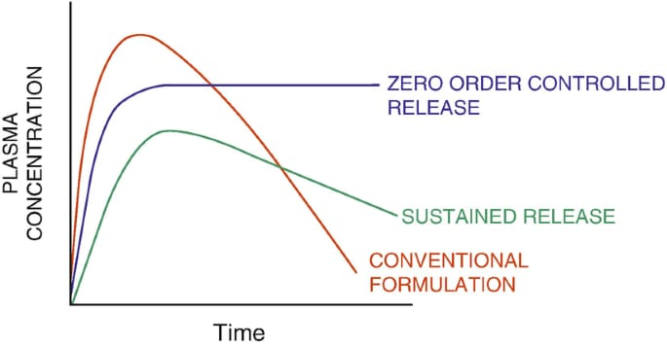
Fig. 3 Graph showing different release

FOR FAST RELEASE:
These tablets are made to dissolve and release their medication without the need for additional coatings or other rate-controlling mechanisms. Immediate release tablets have just begun to acquire acceptance and appeal as a medication delivery method, mostly due to their convenience of administration, rapid beginning of action, affordability, and improved patient compliance. For instant release (IR) solid oral dose forms, there are three main parameters that determine the pace and degree of drug absorption:
1. Rate of dissolution.
2. Solvable.
3. Duodenal penetrability.
When fast release dosage forms with pharmacological constituents (APIs) exhibit high duodenal penetrability, increased solvable capacity , and quick dissolution, a biowaiver—a departure from conducting bioequivalence studies—can be scientifically justified.
METHOD OF PREPRATION OF BILAYER TABLET:
- Wet granulation: A powder blend is transformed into big, uniform aggregates known as granules through a process called wet granulation. This procedure improves:
1) Flow characteristics
2) Avoid separating
3) Makes compression easier.
Procedures for wet granulation:
1) Grinding: The medication is put in the granulator and ground.
2) Blending: In a blender, appropriate adjuvants (excipients and diluents) are added and combined.
3) Damp mass preparation: To create a cohesive mass, a binder solution is added to a powder mixture.
4) Wet Screening: Sieve numbers 8 or 10 are used to screen the wet mass powder blend.
5) Drying: Wet granules are dried at 60⁰ Celsius in an oven.
6) Dry Screening: To obtain uniformly sized grains, dried grains were passed through mesh no. 20. It causes a decrease in size.
7) Blending: After adding the lubricant, the mixture is well blended. At this point, the remaining quantity of extra disintegrants is also added.
8) Compression: A tablet punching machine compresses the resulting granules. Compression procedures for bilayer tablets:
1) First layer filling.
2) First-layer compression.
3) The upper punch is ejected.
4) The second layer is filled.
5) The two layers are compressed together.
6) Bilayer Tablet Ejection. ^{[13, 16]}

Compaction is influenced by a material's compressibility and consolidation.
Compression is the term used to describe a reduction in bulk capacity brought about by the elimination of hollows and the relatively close contact of particles.
Consolidation is a material feature where inter-particulate interaction (bonding) increases the material's mechanical strength. One important factor influencing pill delamination was found to be the firmness pressure on coat one. ^{[17,18]}
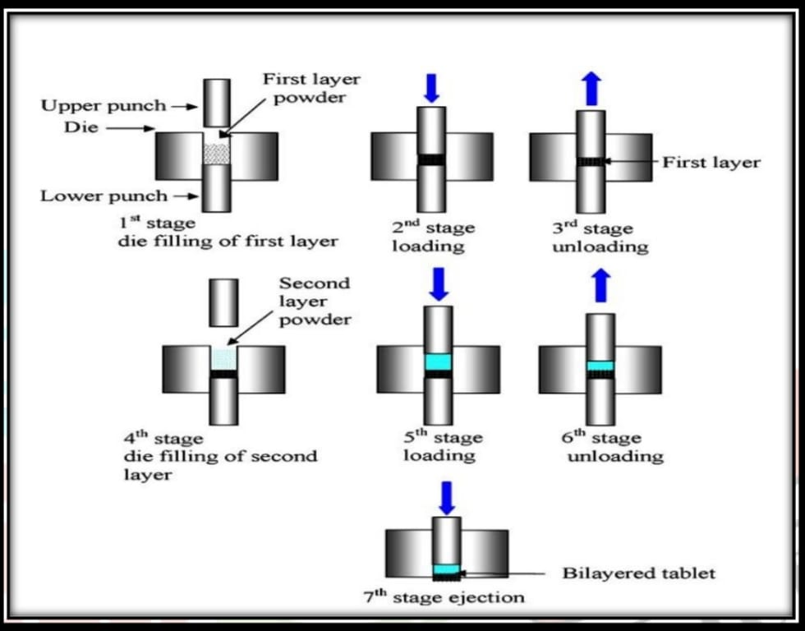

Fig 4. Double layer compression process.
2. Direct Compression: The direct compression method for tablet manufacturing involves several key steps:
1. Milling (Optional): If necessary, reduce the particle size of active ingredients and excipients to enhance flowability.
2. Blending: Mix the active ingredients with direct compression excipients to achieve a homogeneous blend.
3. Filling: Load the blend into a tablet compression machine's die cavity.
4. Compression: Apply pressure to compact the blend into tablets using tooling.
5. Ejection: Use the lower punch to eject the compressed tablets from the pass away cavity. ^{[19,20]}

CATEGORIES OF DUAL RELEASE PILL PRESS:
1. One-sided pill press
2. Pill Press with Binary Edges
3. Dislocation Monitoring Bilayer Tablet Press
4. Fundamentals of Multilayer Compression

1. One-sided pill press: Numerous types of bilayer presses have been created over time. A single-sided press with two divided compartments for the double feeder is the most basic type. The tablet's two distinct layers are made by force-feeding or gravity-feeding a different powder into each chamber. The entire tablet is crushed in one or two phases after the dye is covered with the first and second layers of powder as it passes beneath the feeder. This is the easiest technique for making a bilayer tablet since the two dye layers blend softly at their interface and frequently link sufficiently that there is no layer detachment when the tablet is formed ^{[21, 22]}
Limitation:
1. The limited compression roller's dwell duration could lead to hardness issues and inadequate deaeration capping.
2. No control or weight monitoring is available for the individual layers.
3. There is no clear visible distinction between the two levels.
4. By lowering the turret rotation speed, the residence time can be extended; however, the tablet output will be decreased. ^{[23, 24, 25]}
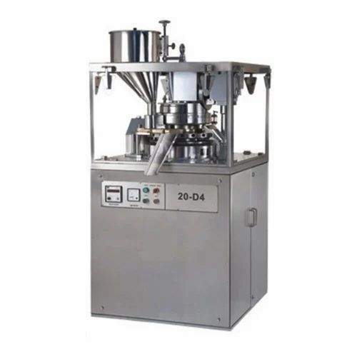
Fig. 5. One-sided pill press.
- Pill Press with Binary Edges: The majority of double-sided tablet presses with machine-driven production oversight use compression force to monitor and control tablet weights. the compression system's effective compression force applied to each tablet during the initial compression of the layer. This mechanism helps reject the tolerance tablets and adjust the dies' fill depth as necessary.^{[26]}

Advantages of Pill Press with Binary Edges:
1. Extended precompression dwell times for the first and second layers to provide enough hardness at maximum turret speed.
2. The top layer receives a low compression force to avoid chapping and layer separation.
3. Displacement weight monitoring enables precise and autonomous layer-by-layer weight control.
4. Peak protection against two-layer cross-contamination
5. Optimal yield
6. The two layers are well distinguished. ^{[27]}
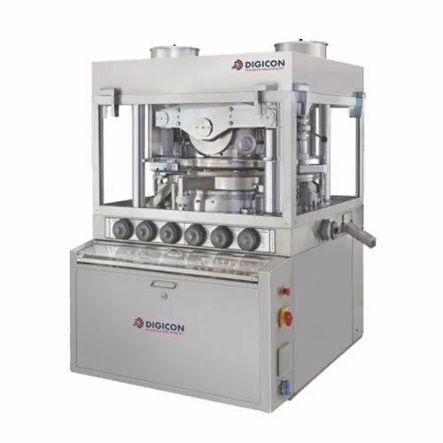
Fig. 6. Pill Press with Binary Edges
Limitation of Pill Press with Binary Edges:
1. Optimal attachment can only be attained when the first layer is crushed at a low compression force, allowing interaction with second layer during the final compression.
2. If a large pressing force is employed to the first layer, the bond strength is too weak.
3. Unfortunately, the low pressing force required to compress the first layer decreases the accuracy of weight monitoring and control when tablet presses with compression force measurement are used.^{[22]}
3. BILAYER TABLET PRESS WITH DISLOCATION MONITORING:
The principles of compression force control and displacement pill weight management are essentially distinct. The applied precompression force determines the sensitivity of the control system when sensing displacement rather than the tablet weight. ^{[28]}
Advantages:
1. Accurate and autonomous weight control of individual layers by weight monitoring and control.
2. To avoid capping and layer separation, the first layer is subjected to a low compression force.
3. Extended dwell time for first and second layer precompression to provide sufficient hardness at the turret speed.
4. The highest level of protection against cross-contamination between the two layers.
5. The two layers are visually separated and have the maximum yield. ^{[28]}
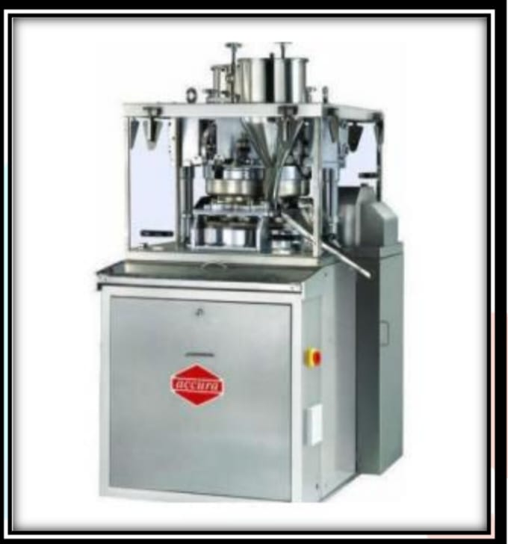
Fig. 7. Dislocation monitoring press.
4. MULTILAYER COMPRESSION BASICS:
Multipliers can be added to presses, or a standard double press can be specially designed for multi-layer compression. Drug formulations with extended release have long been made using the concept of a multilayer tablet. In order to maintain drug release from the tablet, these tablets may have a fast-releasing layer in addition to double or triple layers. Because drug release from fast-releasing granules causes a sharp increase in blood concentration, the pharmacokinetics advantage depends on the fact that blood levels stay constant when the drug is released from sustained granules. ^{[22]}
NUMEROUS METHODS OF BILAYER PILL:
1. Buoyant drug delivery systems
Because of their low density, these are made to float proceeding the contents of the stomach after administration until the system breaks down or the device absorbs fluid to a point where its mass is so high that it loses its resistance and can exit the stomach more readily. Motility is in charge of gastric emptying. While the other layer of the bilayer tablet is intended to float, the first layer is designed to release the medicine instantly, giving the tablet a quick onset of action. Methods for FDDS Design: The following methods have been used to construct floating dosage forms for systems with one or more units. Bilayer floating tablets inserted into the stomach: These are also instantaneous and sustained-release compressed tablets. ^{[33, 34]}
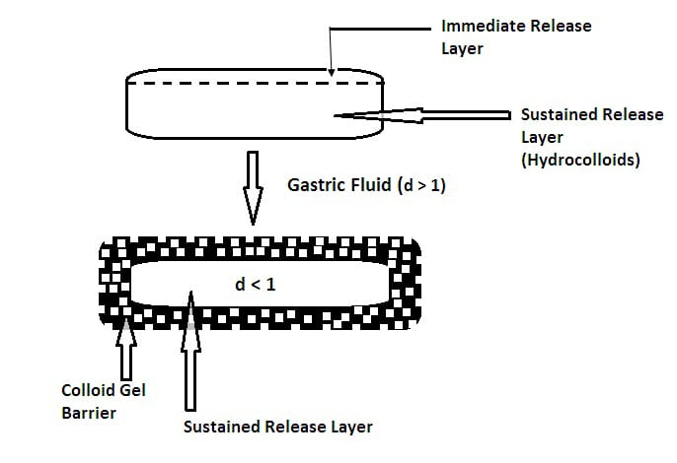
Fig. 8. Intra gastric bilayer buoyant pill.

Several unit type buoyant pills:
Sustained-release pills with two layers around them serve as the "seeds" in these systems. Effervescent agents make up the inner layer, whereas swellable membrane layers make up the outer layer. The system immediately falls when immersed in a body-temperature dissolving liquid, creating larger tablets that resemble balloons and float because of their reduced density.^{[33]}
2. Polymeric Bio adhesive system: After ingestion, these are intended to absorb fluid such that the outer layer solidifies into a sticky, gummy substance that sticks to the layer of stomach mucosa. This should encourage stomach retention when the adhesive forces are lowered. There are two layers in these, one with fast dosing and the other with bioadhesive properties.
Disadvantages: The effectiveness of the method in animal models has not been translated to human subjects because of the differences in lubricant amounts and constancy between humans and animals. Instead of adhering to mucosa, the mechanism adheres to secretion. Individuals’ mucosa
layer would seem to shed easily, bringing whatever dose form with it. Therefore, it doesn't seem like the bio adhesive dosage form provides a way to provide medication over an extended period of time.^{[33]}
3. Enlargement System: When given, these are made to be sufficiently tiny to facilitate easy administration of the dose form (for example, round tablets have a diameter of 10–12 mm, whereas oval or capsule-shaped tablets are less than 23 mm long and less than 11 mm broad). When consumed, they quickly expand, disintegrate, or unfurl to a size that makes it impossible for them to permit over the pylorus until the drug release has advanced to the necessary level. The system leaves the stomach by gradually eroding or dissolving into tiny particles. A rapid release layer and a prolonged release or traditional release layer are both possible for the basic bilayer tablet. ^{[28]}
NUMEROUS METHODS FOR DUAL RELEASE PILLS:
1.OROS® push pull technology: OROS® Push Pull Technology is a two or three-layer system, with the push layer making up the remaining layers and one or more of the layers being required for the medicine. Drug and two or more excipients make up the majority of the drug layer. Therefore, the medication in this drug layer is in a form that is not very soluble. An osmotic agent and a suspending agent are also added. A semi-permeable membrane encloses the tablet core.
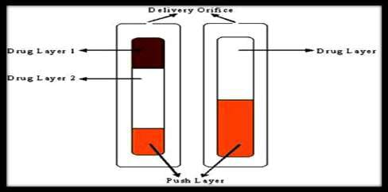
Fig 9. OROS push pull technology
2. L-OROSTM Technology: This device is used to measure the solubility of Problem Alza developed the L-OROS system, which begins with a dissolved drug-containing lipid soft gel product. After that, a barrier layer, an osmotic push layer, and a semi-permeable membrane with an exit hole drilled in it are applied.

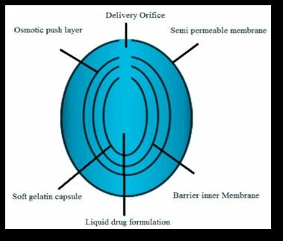
Fig 10. L-OROS technology
3. PRODAS or Programable Oral Drug Absorption System:
PRODAS (Elan Corporation) is another term for multi-particulate drug technology. This technique involves encasing small, prolonged-release pills that range in size from 1.5 to 4 mm. This technology combines hetrogenous pill technology with hydrophilic matrix tablet technology to give the previously mentioned utility technologies in single dosage forms. PRODAS technology facilitates the distribution of targeted medications. Minitab uses different release speeds to target GIT. Minitab combines controlled release, delayed release, and instant release into one dose form, allowing you to choose the right release rate.
4. EN SO TROC Technology:
An improvement in solubility of an direction to extent or the development of an ideal dosage formula The primary objective of Shire Laboratory's integrated approach to drug delivery is to identify the enhancer and incorporate it into prolonged release technologies.
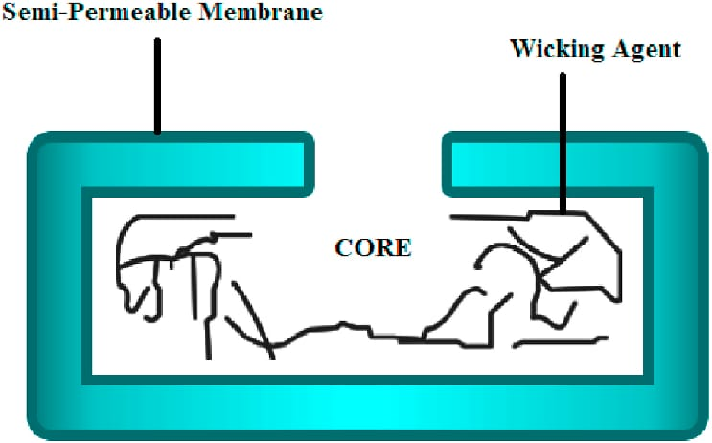
Fig 11. EN SO TROC technology
- DUROS Technology:
The primary component of the system is the outside cylindrical reservoir made of titanium alloy. This reservoir shields the drug molecules from enzymes and has a high impact strength. Unlike small syringes and irregularly sized volumes of concentrated form, the DUROS technology is a tiny medicine distribution system that has been consistent and dependable over several months or a year.
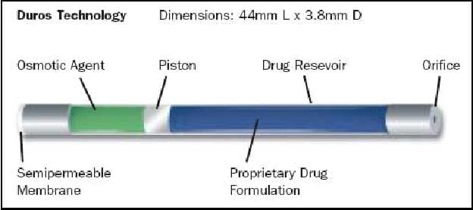
Fig 12. DUROS TECNIQUES A
- DUREDASTM technology:
Two medications in single dose form with varying release kinetics and both fast and prolonged release are provided by the dual release tablet (DUREDASTM Technology). Two distinct layers within a single pill can be produced by the pill making process: an fast-release grains and a prolonged-release hydrophilic pattern core complex. Hydrophilic polymers are blended to give the dose form its modified-release characteristics.
DUREDAS TM technology offers the following advantages:
1. Bilayer tableting technology;
2. two medication components release at distinct rates;
3. Two different CR formulations can be combined,
4. one tablet can have both immediate release and modified release components.
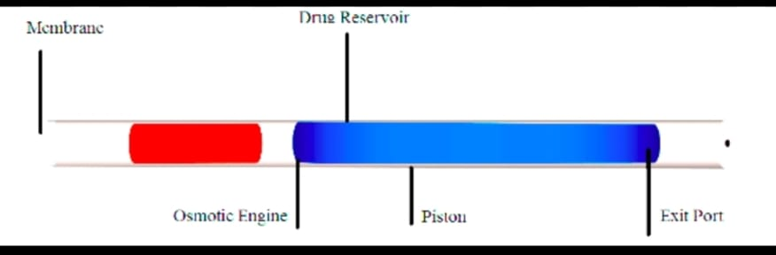

Fig 13. DUREDAS TECHNIQUE
- GEMINEX TECHNIQUE:
The process significantly improves the therapeutic efficacy of API while lowering their adverse effects. It used a solo dose to provide single or extra API with varying rates of release. It is very beneficial to both industry and patients. Pen West uses it extensively to treat cancer, diabetes, heart disease, central nervous system illnesses, and other conditions.

8. GEOMATRIX TECHNIQUE:
The active component in multiplayer tablets made using Geomatrix Technology is housed within a pattern core in addition encircled by single or more barrier-forming modifying coatings that are connected to the central pattern during the pill's production method. These blockades' main purpose is to keep the liquifying agent and core from coming into touch. ^{[29, 30, 31, 32]}
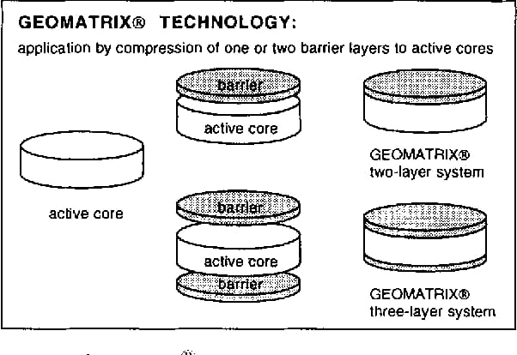
Fig 14. GEOMATRIX TECHNIQUE

RoTab Bilayer:
Software:
Programs Because of its modular nature, this software can always be updated to include new features. Fast graphical evaluations and accurate findings are guaranteed by a state-of-the-art industrial PC system with a 15" touch screen. A practically flawless laboratory-scale simulation of production machines is made possible by the variety of instruments.
Basic Technique:
Fundamental Method software for the RoTab Bilayer that is now in production phase. operation using a 15" touch screen, automatic dosage control via compression force, die table modification, and Optifiller speed. Independent hardness regulation is an optional feature.
RandD Modified Techniques:
RandD's Modified Method the RoTab Bilayer's basic package for galenical RandD. includes a 15" touchscreen display with valuation and graphic representation of instrumented measuring points, such as compression first coat pre-main compression and ejection force. An extra alarm feature that can be chosen is punch tightness control. You can upgrade to RandD Plus whenever you want.
RandD Plus:
RandD.Plus includes all of Basic and RandD's features as well as the ability to assess and view the following unique tools on a 15" touch screen. control of punch tightness, force scraper strength for tablets, and force displacement display. The RoTab Bilayer raises the bar for tabletting technology with RandD Plus. ^{[35]}
VALUATION OF BILAYER PILL:
Preformulation studies:
- Determination of λmax:
The maximum absorbance of APIs must be determined by dissolving them in a solvent, diluting them using the same solvent, and then scanning them with a UV visible spectrophotometer. ^{[36]}

- Solvable capacity: The shake flask method will be used to evaluate the API's solubility in purified water, methyl alcohol, ethyl alcohol, propanone, trichloromethane, and pH 6.8 phosphate buffer. A UV-Visible Spectrophotometer is used to measure optical density. Typical graph is used to establish the API content.^{[37]}

- The fusing temperature:
Using the capillary approach, the fusing temperature of the API must be ascertained in triplicate to find standard deviation. ^{[38]}

- Standard Calibration Curve for API:
To made stock A sol., 100 mg of API must be properly balanced and thinned in 100 ml of solvent. The stock B sol., by thinning 10 mL of the previously taken stock A to 100 mL using the same solvent. The last sol., must be thinned from the aliquot amount of the stock B sol., in order to achieve 5, 10, 15, 20, 25, and 30 microgram/ml. And Ultra-Vis spectrophotometer used to quantify the absorption. ^{[39]}

- Compatibility studies:
The API compatibility with other non-active pharmacological materials is investigated using Fourier transfer infrared spectroscopy.

- FT-IR Spectroscopy:
This study performed to make sure the API and non-active pharmacological material were compatible. The instrument utilized for infrared spectroscopy is a thermal Nicolet FTIR. The range of 4000 to 400 MHz cm ⁻¹ is where the spectrum is recorded. A hydraulic press is used to compress the sample (API and non-active material combination in 1:1 ratio) in discs in KBr (200-400 mg) for 5 minutes at a pressure of 5 tons. To inspect how a API and excipient interact, IR-spectral analyses look for any change in the drug peaks in the spectrum of a physical mixture of the two. ^{[40]}

- Formulation using DSC Analysis:
A Differential Scanning Calorimeter is used to analyse the physical combination of API and excipients as well as the thermal properties of the pure medication. Aluminium pans that are thermically enclosed are used to heat the samples. Each sample's heat runs are set between 25 and 350⁰ Celsius, using nitrogen as a blanket gas and a heating rate of 10⁰C/min. ^{[41]}
Precompression Evaluation:
- Gradation: The screening method is used to measure the gradation. ^{[[42,43]}
- Photomicroscope study: TGG and GG were photographed using a photomicroscope at X450 magnifications. ^{[42]}
- Angle of sliding: The formula Ø = tan-1(h/r) was used to calculate the powder peak width and angle of sliding,
where "r" and "h" stand for the powder cone's radius and height, respectively. ^{[42]}
- Moisture Sorption Capacity: All disintegrants are hygroscopic, which affects medications that are Water- reactive. The moisture absorption was measured by taking 1 gram of consistently disintegrated material in a cell-culture dish and keep it in an environmental chamber at 37±1°C and at dew point for two days. The weight fluctuations were used to determine how much moisture was absorbed. ^{[42]}
- Density: The following equations were utilized to calculate the tapped density and bulk density
Powder wt. by bulk volume equals bulk density. (Tapping 300 time gives us compact density)
Compact Density = Powder Weight / Compact Volume. ^{[42,43]}
- Compressibility is calculated using the Carr’s Index (CI).
CI = (compact density – Bulk Density) / compact density ×100. ^{[43]}
- Hausner's Proportion: Determine the flow characteristics of granules and powders.
Hausner’s Proportion = Tapped Density / Bulk Density. ^{[42]}
Post- Compaction evaluation Studies:
- General Appearance: The dimensions, structure, colour, Flavour, surface, physical deformity, evenness, and legibility of any identifying markings of the tablet, as well as its visual image and overall "elegance," are all important factors in determining consumer acceptance. ^{[44]}
- Size and Shape: Dimensional specifications, monitoring, and control are available for tablet size and shape. ^{[45]}
- Tablet Thickness: When employing filling machinery as a counting system, tablet thickness is a crucial quality for both duplicating appearance and counting. Ten tablets were measured for thickness using a micrometre. A tablet's thickness should typically range between 30% to 50% of its size. ^{[44]}
- Tablet Firmness: A pill's ability to withstand breaking or shipping during handling, storage, and transit is determined by its hardness. The tablets in each formulation were tested for hardness using a Monsanto firmness checker. Tablets are generally thought to need a pressing strength of at least 4 kg/cm². The hardness of oral pills is typically 4–10 kg/cm². Hypodermic and chewable pills are frequently substantially mushy (3kg). The weight of some sustained-release tablets ranges from 10 to 20 kg/cm².
- Friability: The capacity of a tablet to tolerate scraping during pick-up, carrying, and packing is known as its friability. To measure friability, one uses the Rache friabilator. A certain number of tablets is determined and put inside the device, where they go through shocks and rolling while dropping six inches every time. After 100 rotations or 4 minutes of therapy, the pills are weighed, and the weight is recorded and compared to the starting weight. Abrasion-induced loss is a gauge of tablet friability. The percentage % is used to express the outcome value. Any fractured or smashed tablets are not selected during friability testing, and weight loss of up to 1% of the total weight of the tablets is typically regarded as acceptable: Friability is measured in percentage as:
% Friability = 1- (loss in weight / initial weight) × 100. ^{[45]}
- Drug Assay and Release: The quantity of the drug in each tablet must be tracked from batch to batch and tablet to tablet, and the tablets' capacity to release the drug must be ascertained in order to evaluate the effectiveness of the tablets.
- Weight variations: 20 pills are particularly taken simultaneously from lot and balanced distinctly in order to assess weight variance. Calculate the average weight of the tablets and compare it to the weight of each individual pill. The tablet meets the USP requirements. if no tablet deviates from the % limit by more than two times, and if no more than two tablets are discovered to be outside the limitations. The US United States Pharmacopoeia allows for a small degree of variance in tablet weight. As indicated in table no.1, the following percentage deviation is permitted in weight fluctuation. ^{[44]}
Avg. weight of pill: | % Deviation:
0.130gm or less | ±10
>0.130 gm and <0.324 gm ±7.5 | ±7.5
0.324 gm or more. | ±5

- In-vitro dissolution testing: The in vitro dissolution testing is begin in stomach pH to mimic the conditions and intestinal fluids to evaluate their ability to provide the desired controlled drug delivery. The vitro drug release studies are carried out using USP dissolution test apparatus test at 100 rpm, 37±0.5°C, and PH 1.2 buffer (900 ml) (i.e. 0.1N HCL) for 2 hours because average gastric emptying time is around 2 hours. The medium of dissolution was replaced with 6.8 phosphate buffer (900 ml) and the experiment was repeated for another 10 hours. At various time intervals, 5ml of samples were withdrawn and replaced with 5 ml of drug-free dissolution medium. UV spectrophotometer was used to analysed the withdrawn samples using multi-component mode of analysis. ^{[43,45]}

FUTURE SCOPE:
- Advanced Drug Delivery Systems: Development of specialized delivery mechanisms like:
Chewing devices
Buccal/mucoadhesive systems
Floating tablets for gastro-retentive delivery5
- Technological Advancements The future of bilayer tablets will likely focus on:
Implementing Quality by Design (QbD) principles to enhance product quality, safety, and efficacy
Using advanced process analytical technologies like near-infrared and Raman spectroscopy for improved manufacturing
- Overcoming current manufacturing challenges related to layer compression and mechanical properties
CONCLUSION: A bilayer tablet is an enhanced, useful technology that addresses the shortcomings of a single-layered tablet. Bilayer tablets, which are made of multilayered matrices or monolithic partly covered materials, have a variety of uses. Bilayer tablets can be used for separated incompatible compounds, for the sequential release of two medications in combination, or for sustained release tablets, where the first layer is an immediate release dose and the second layer is a maintenance dose. In order to give control release tablet preparations with surrounding or multiple swelling layers, and to create methods for the administration of medications that are incompatible, multilayer tablet preparation is utilized. The quality of bilayer tablets and their GMP standards can differ greatly. This explains the wide variety of presses that are being used.

List 1 -RECENT DEVELOPMENT IN FIELD OF BILAYER TABLET: ^{[42,43, 46,47]}
1. | MTF HCl, Glimepiride | Dual release pill | Synergist impact in diabetics
2. | Pioglitazone HCl, Gliclazide | Dual release pill | Treatment of type II diabetics
3. | MTF HCl, Pioglitazone | Dual release pill | Synergist impact in Diabetics mellitus
4. | Diclofenac, Cyclobenzaprine | Dual release pill | Synergist effect in pain
5. | MTF HCl, Atorvastatin calcium | Dual release pill | To develop polytherapy for treatment of NSAIDS and hyperlipidaemia
6. | Diclofenac Sodium, Paracetamol | Dual release pill | Synergist impact in pain
7. | Ibuprofen, Methocarbamol | Dual release pill | Synergist impact in back pain
8. | Montelukast, Levocetirizine | Dual release pill | Expand Constancy of drugs in combination
9. | Amlocard with Atehexal | Dual release pill | expand constancy of drugs in combination.
10. | MTF HCl, Glipid. | Dual release pill | Keep away the interface between in-compatible API.

REFERENCES:
- Chein Y W. Novel drug delivery system. Drugs and pharmaceutical sciences. 2nd edition. Informa health care.2009; 50: 1-2.
- Naisarg D, Pujararonak K, Gokani and Jalpa S. (2011). Bilayer tablet – An emerging trend. International Journal of Pharmaceutical Research and Development, 4(04), 102 – 111.
- T. Sandhyarani, B. Srinath, C. Surya, P. Reddy, and C. Sowmya, “BILAYER TABLET AND IT’ S TECHNOLOGY: AN OVERVIEW”, [Online].
- Benkerrour L, Galley O, Quinet F, Abebe A, Timmins P. Multilayered tablet containing pravastatin and aspirin and method, US patent, US2004/0115265, 2004.
- Efentakis, “Effect of excipients on swelling and drug release from compressed matrices” Drug development and industrial pharmacy, 1997, 23,107-112.
- Kevin Roe, Bogan “Distribution of the Unionide. Modified from bogan” 2008.
- Abdul S., Poddar SS. A flexible technology for modified release of drugs: multi layered tablets. J. Control Release, 2004; 97:393–405.
- Shila vDevtalu, Ashwini E. Patil, Manoj M. Bari, Dr. Shashikant D. Barhate. A Review on Novel Approach-Bilayer Tablet Technology, International Journal of Pharmaceutical sciences Review and Research.
- S. Singh Tomar, A. K. Mishra, and A. K. Pathak, “A Review on Novel Approach of Bilayer Tablet,” 2015.
- Abdul S, Poddar SS. A flexible technology for modified release of drugs: multi layered tablets. Journal of controlled release, 2004; 7, 97(3): 393-405.
- M. S. Syed, M. Venkata Anjaneyulu, C. Anusha, V. Shekar, and R. Chejeti, “A REVIEW ARTICLE ON BILAYER TABLETS,” 2013.
- F. NIZAMI and Y. MALVIYA, “RECENT ADVANCEMENT AND CHALLENGES IN BILAYER TABLET TECHNOLOGY: AN OVERVIEW,” Current Research in Pharmaceutical Sciences, vol. 11, no. 4, pp. 91–97, Jan. 2022, Doi: 10.24092/CRPS.2021.110401.
- Hoffmann BB. Catecholamines, sympathomimetics drug and adrenergic receptor antagonist. In hardman JG, Limbird LE, Goodman and Gilmans the Pharmacological basis of therapeutics. 2011.
- Kumar, A.H., Kavitha, K., Kumar, S.A., Kumar, M.R. and Singh, S.D., 2013. NOVEL APPROACH OF BILAYER TABLET TECHNOLOGY-A REVIEW. International journal of pharmaceutical, Chemical & Biological Sciences, 3(3).
- Aggarwal, S., Syan, N. and Mathur, P., 2013. Bi-layer tablet technology—opening new ways in drug delivery systems: an overview. International Journal of Research in Pharmaceutical and Biomedical Sciences, 4(1), pp.8-16.
- Lachman Leon, Liebermann HA. The theory and practice of industrial pharmacy. Special Indian edition. CBS publishers and distributors.2009. p. 293
- SH Lakade, MR Bhalekar. Formulation and Evaluation of Sustained Release Matrix Tablet of Anti-Anginal Drug, Influence of Combination of Hydrophobic and Hydrophilic Matrix Former. Research J. Pharm. and Tech. 1(4): Oct.-Dec. 2008; Page 410-413.
- Pateriya A, Bhowmick M, Pandey GK, Joshi A, and Dubey BR. Formulation and evaluation of player tablets of candesartan and hydrochlorothiazide for the treatment of hypertension. JDDT. 2013;3(6):21-35.
- Meeus L, Direct Compression Versus Granulation, Pharmaceutical technology Europe, 2011; 23,
- Norman AA. Tablet Manufacture by Direct Compression. In: James S, editor. Encyclopedia of pharmaceutical technology. 2 New York (NY): Information Healthcare USA, Inc, 2007; 3674.
- Kumar, A.H., Kavitha, K., Kumar, S.A., Kumar, M.R. and Singh, S.D., 2013. NOVEL APPROACH OF BILAYER TABLET TECHNOLOGY-A REVIEW. International journal of pharmaceutical, Chemical & Biological Sciences, 3(3).
- Kiran, B., Rao, P.S., Babu, G.R. and Kumari, M.V., 2015. Bilayer Tablets-A Review. International Journal of Pharmaceutical, Chemical & Biological Sciences, 5(3).
- Das, M.K., Sahu, B.P. and Hazarika, J.N.R., 2017. Development of bilayer tablets for immediate and controlled release of allicin. Int J Curr Pharm Res, 9(4), pp.153-160.
- Singh, A., Das, S., Gupta, S. and Ghosh, S., 2021. The Challenges of Producing Bilayer Tablet: A Review. Journal of Drug Delivery and Therapeutics, 11(4-S), pp.171-175.
- Nazim, S., Ahmed, A. and Patel, S., 2015. Formulation and evaluation of bilayer tablets of metoprolol succinate. Research Journal of Pharmacy and Technology, 8(3), p.292.
- Rameshwar, V., Kishor, D. and Tushar, G., 2014. Bi-layer tablets for various drugs: A review. Scholars Academic Journal of Pharmacy, 3(3), pp.271-279.
- Abebe, A., Akseli, I., Sprockel, O., Kottala, N. and Cuitiño, A.M., 2014. Review of bilayer tablet technology. International journal of pharmaceutics, 461(1-2), pp.549-558.
- Gopinath, C., Bindu, V.H. and Nischala, M., 2013. An overview on bilayered tablet technology. Journal of global trends in pharmaceutical sciences, 4(2), pp.1077-1085.
- Saripilli Rajeswari, Teella Prasanthi et al. A Recent Review On Dual Release Bilayered Tablets Scholars Academic Journal of Pharmacy (SAJP)
- Swapnil salve et al, Review on bilayer tablet. Journal of Emerging Technologies and Innovative Research (JETIR) July 2023, volume 10, Issue 7.
- A Sequential Review on Bilayer Tablets: Mehul Patel, Nihar Shah. Journal of Pharmaceutical Science and Bioscientific Research (JPSBR), Volume 3, Issue5:2013.
- Sharma, S.K., Mohan, S., Jaimini, M., Chauhan, B.S. and Chatterjee, A., 2014. Formulation and in-vitro evaluation of Bilayer tablets containing Pioglitazone HCL and Gliclazide for type II diabetes. International Journal of Pharm Tech Research,6(2), pp.607-22
- Bhadange, M.D., Darekar, A.B. and Saudagar, R.B., 2015. Bi-layer tablet technology-opening new ways in drug Delivery system: an overview. World J of Pharm Res, 4(1), pp.529-548.
- Ghosh, R., Haque, M.A., Paul, T.R., Bhuiyan, A.A.M.A. and Dewan, I., 2014. Bilayered tablet technology: Аn overview. World Journal of Pharmaceutical Research, 3(4), pp.150-63.
- www. Flamel. technologies.com (info @flamel .com)
- Madan J, Avachat A, Banode S, Dangi M. Formulation and evaluation of a bilayer floating drug delivery system of nizatidine for nocturnal acid breakthrough.
- Sharma V. Formulation, optimization and evaluation of bilayer tablet of antihypertensive drug. Journal of Drug Delivery and Therapeutics, 2019; 15, 9(4): 704-8.
- Seta Y, Higuchi F, Kawahara Y, Nishimura K, Okada R. Design and preparation of captopril sustained release dosage forms and their biopharmaceutical properties. International journal of pharmaceutics, 1988; 1, 41(3): 245-54.
- Bera H, Boddupalli S, Nayak AK. Mucoadhesive-floating zinc-pectinate–sterculia gum interpenetrating polymer network beads encapsulating ziprasidone. Carbohydrate polymers, 2015; 20, 131: 108-18.
- Pahwa R, Saini N, Kumar V, Kohli K. Chitosan-based gastroretentive floating drug delivery technology: an updated review. Expert opinion on drug delivery, 2012; 1, 9(5): 525-39.
- Kajale AD, Chandewar AV. Recent advancement in gastroretentive drug delivery systema review. Indo Am J Pharm Res, 2013; 3: 5
- Bilayer Tablet - An Emerging Trend Shaikh Aamer Khaleel, P. R. Patil, P. R. Mahaparale and Monika Bhagat European Journal of Pharmaceutical and Medical Research.EJPMR,2017,4(12).471-480.
- An Overview on bilayer tablet technology, C Gopinath, V. Hima Bindu, M. Nischala. Journal of Global Trends in Pharmaceutical Sciences, Volume 4, Issue 2, pp-1077-1085,2013.
- Concept of Bilayer tablet: A Review by Tushar Humbe,Tushar Kale,Dhairyasheel Gund,Trusha Shangrapawar, Ashok Bhosale. International Journal of Pharmacy and Pharmaceutical Research,June 2021,volume 21,Issue3.
- A Sequential Review on Bilayer Tablets: Mehul Patel ,, Nihar Shah. Journal of Pharmaceutical Science and Bioscientific Research (JPSBR), Volume 3, Issue5:2013.
- Shila v.Devtalu ,Ashwini E.Patil,Manoj M.Bari ,Dr. Shashikant D.Barhate.A Review on Novel Approach-Bilayer Tablet Technology ,International Journal of Pharmaceutical sciences Review and Research.
- Bi-layer tablets for various drugs: A review Verma Rameshwar, Devre Kishor, Gangrade Tushar Scholars Academic Journal of Pharmacy (SAJP).

