Original Research Article

Efficacy of Essential Oils in managing Oxidative Stress in Scabietic dogs

ABSTRACT

Aims: To evaluate the oxidant-antioxidant balance in Sarcoptic scabiei infected dogs and to investigate the effect 2% combination of three essential oils, i.e. 1% Lemongrass oil (Cymbopogon citratus), 0.5% Tulsi oil (Ocimum tenuiflorum) and 0.5% Sandalwood oil (Santalum album) in ameliorating these parameters.
Study design: Dogs that were brought to the Veterinary Clinical Complex with symptoms of sarcoptic mange were included in the study. Oxidative stress indices of positive dogs were analyzed and compared to the healthy ones to identify any significant difference caused by Sarcoptes scabiei. Further, efficacy of topical application of these essential oils was compared with Ivermectin.
Place and Duration of Study: The study was conducted at Department of Veterinary Medicine and Veterinary Clinical Complex, DUVASU, Mathura, India, over a span of 18 months, from February, 2023 to July, 2024.
Methodology: Twelve dogs suffering from sarcoptic mange were divided into two groups, one treated with the 2% essential oil combination topically, and the other with Ivermectin injection, given subcutaneously. Six apparently healthy dogs were treated as control. Total oxidant status (TOS), Total antioxidant capacity (TAOC) and Oxidative stress index (OSI) parameters were estimated at days 0 (pre-therapy), and days 14 and 28 (post-therapy). Student’s t-test and Analysis of Variance (ANOVA) in Graphpad Prism software was used for statistical analysis.
Results: The infected dogs had a significantly elevated TOS and OSI values, whereas TAOC levels were observed to be significantly low. Both the treatment groups in this study were successful in amelioration of these oxidative stress indicator panels post-therapy, but the essential oil (EO) treated group was better than the ivermectin treated group.
Conclusion: These findings indicate a correlation between the oxidative stress markers and sarcoptic mange with possible antioxidant potential of the essential oil combination under study.

Keywords: Sarcoptes scabiei; oxidative stress; essential oils; dog; Mathura; India.

- INTRODUCTION
Throughout their lifespan, dogs are susceptible to various fatal diseases, including bacterial, viral, protozoan, nutritional deficiencies, and systemic diseases. Dermatological ailments are very common in small animal practice comprising approximately 25% morbidity (Mir, M.H., 2013). There are over 55,000 identified mite species, and at least 50 of them are responsible for causing various types of mange diseases (OIE, 2016). Among these, Sarcoptes scabiei, the burrowing parasite causing sarcoptic mange, stands out as the most significant species, affecting numerous domestic and wildlife species (Escobar et al., 2022). Sarcoptic mange is a highly contagious skin ailment in mammals, and has been documented in at least 148 species of domestic and wild mammals, establishing itself as one of the most versatile ectoparasites (Escobar et al., 2022). The mite exhibits a near-global distribution, facilitated by various forms of transmission and its ability to utilize a diverse range of host species.
The transmission primarily occurs through direct contact among hosts, involving all three stages: larvae, nymphs, and adults, each capable of migration. Inanimate objects like bedding and grooming tools facilitates in its transmission. The clinical and pathological signs are influenced by the host's immune responses to the mite. These pathological outcomes generally fall into two categories, which depend on the type of hypersensitivity reaction initiated by the host: a Type I immediate antibody-mediated immune response, and a Type IV delayed cell-mediated immune response. Excessive production of free radicals, beyond the body’s endogenous defense mechanisms, has been observed in infections and inflammatory conditions, triggering the production of proinflammatory cytokines such as IL-1α, IL-1β, TNFα, and IFNγ, secreted by keratinocytes, spleen, lymph node, and peripheral blood mononuclear cells (Allam et al., 2014). Additionally, the physical irritation produced by burrowing mites may lead to the production of cytokines as a consequence of skin inflammation (Beigh et al., 2013).
This proinflammatory cascade can trigger an overproduction of reactive oxidants and free radicals, leading to metabolic dysfunction and oxidative damage to biomolecules, causing pathological changes in tissues (Allam et al., 2014). Thus, this study was aimed to investigate the oxidative stress levels in dogs naturally infected with sarcoptic mange and the efficacy of essential oils in managing its levels.
- MATERIALS AND METHODS
The study included 12 dogs suffering from sarcoptic mange that were brought to the Veterinary Clinical Complex (VCC), Kothari Hospital, DUVASU, Mathura, over a span of 18 months, from February, 2023 to July, 2024. Dogs exhibited symptoms such as pruritus, crusting, alopecia, erythema, irritability, papules, excoriations along with intense itching and self-inflicted trauma from scratching. The primary areas affected were the ear margins, legs (especially the elbows and hocks), face, and ventral region. All the dogs showed a markedly positive pinnal-pedal scratch reflex on day 0, while the healthy dogs had a good body condition.
As per the consent of the pet owner regarding the trial, blood was collected from each dog from the recurrent tarsal or cephalic vein using disposable syringe and needle, at days 0 (pre-treatment) and days 14 and 28 (post-treatment), and was transferred into clot activator vials. The vials were placed in a slanted position for 25-30 minutes at normal room temperature, followed by centrifugation at 2000 rpm for 5 minutes to harvest the serum for conducting oxidant/antioxidant assay.
Oxidant-antioxidant study was done using commercially available Colorimetric assay kits (BT Lab) and Total oxidant status (TOS), Total antioxidant capacity (T-AOC) was estimated as per the manufacturer’s protocol. The TOS to TAOC ratio is regarded as the OSI. To perform the calculation, the result unit of TAOC, mmol/L, is changed to µmol/L, and the OSI value was calculated as follows: OSI = [(TOS, µmol/L)/ (TAC, µmol/ L) ×100] (Camkerten et al., 2009).
Essential oils combination (2%) comprising of 1% Lemongrass oil (Cymbopogon citratus), 0.5% Tulsi oil (Ocimum tenuiflorum) and 0.5% Sandalwood oil (Santalum album) was tested against 12 Sarcoptes infected dogs. Group 1 comprised of 6 apparently healthy dogs, of any age, breed and sex. Group 2 had six infected dogs that were treated topically with the 2% EO combination, once a week, till 4 weeks, while group 3 had six infected dogs that were treated with Inj. Ivermectin @ 0.2 mg/kg b.wt. SC every week for 4 treatments.
The values of various parameters were expressed as mean ± S.E. and data were analyzed for any significant variation by t-test and Analysis of Variance (ANOVA) using Graphpad Prism software. The level of statistical significance for all comparisons was established at (P= .05).
- RESULTS AND DISCUSSION
The Mean ± SE values of TOS, TAOC and OSI of healthy dogs and dogs suffering from canine sarcoptic acariasis are presented in Table 1. The standard curve of TOS concentration against absorbance at 590 nm is represented in Fig 1. The TOS values were observed to be significantly elevated on day 0 in both the treatment groups in comparison to the healthy group (Fig 2). Significant reduction (P <0.0001) was noted in both the groups at days 14 and 28 post-therapy when compared to their own day 0 values (Fig 3), although none of the groups could attain comparable values as the healthy one.
The standard curve of TAOC concentration against absorbance at 590 nm is represented in Fig 4. The TAOC values were found to be significantly reduced (P <0.0001) on day 0 in both the Sarcoptes affected groups as compared to the healthy group at day 0 (Fig 5). Significant rise was observed in TAOC levels on days 14 and 28 in both the treatment groups, when compared to their own day 0 values (Fig 6). Although none of the groups could attain comparable values as the healthy one on day 28th post therapy, but better amelioration of this parameter was noticeable in group 2 than group 3. Similarly, the OSI values were significantly elevated (P <0.0001) in both the treatment groups as compared to the healthy group on day 0 (Fig 7). Both the treatment groups showed significant decrement in these values on days 14 and 28 post treatment, although neither group could achieve comparable levels as the healthy group (Fig 8).
Table 1: Total Oxidant Status (µmol/L), Total Antioxidant Capacity (mmol/L) and Oxidative Stress Index (OSI) of healthy dogs and dogs suffering from canine sarcoptic acariasis
Parameter | Groups | Day 0 | Day 14 | Day 28
TOS (µmol/L) | 1 (Healthy) | 12.23 ± 0.21^{Dd} | 12.23 ± 0.21^{Dd} | 12.23 ± 0.21^{Dd}
TOS (µmol/L) | 2 (EO treated) | 21.21 ± 1.01^{Aa} | 16.34 ± 0.73^{Bb} | 13.45 ± 0.67^{Cc}
TOS (µmol/L) | 3 (IVM control) | 21.33 ± 1.60^{Aa} | 17.88 ± 1.24^{Bb} | 15.95 ± 1.54^{Cc}
TAOC (mmol/L) | 1 (Healthy) | 0.43 ± 0.02^{Aa} | 0.43 ± 0.02^{Aa} | 0.43 ± 0.02^{Aa}
TAOC (mmol/L) | 2 (EO treated) | 0.17 ± 0.03^{Df} | 0.24 ± 0.01^{Cd} | 0.33 ± 0.01^{Bb}
TAOC (mmol/L) | 3 (IVM control) | 0.17 ± 0.02^{Df} | 0.21 ± 0.02^{Ce} | 0.28 ± 0.03^{Bc}
OSI | 1 (Healthy) | 2.87 ± 0.12^{Dg} | 2.87 ± 0.12^{Dg} | 2.87 ± 0.12^{Dg}
OSI | 2 (EO treated) | 12.40 ± 0.53^{Ab} | 6.89 ± 0.44^{Bd} | 4.13 ± 0.26^{Cf}
OSI | 3 (IVM control) | 12.65 ± 1.28^{Aa} | 8.39 ± 0.83^{Bc} | 5.63 ± 0.49^{Ce}
Mean with different superscript (a, b, c, d) in rows are differing significantly in between the groups, otherwise non-significant.
Mean with different superscript (A, B, C, D) in columns are differing significantly in between the intervals, otherwise non-significant.
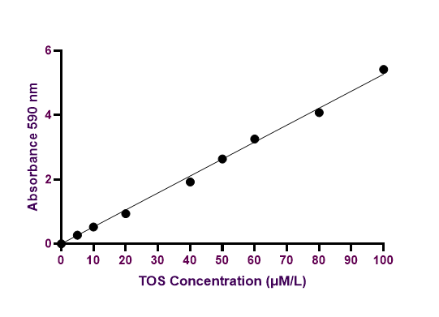
Fig. 1. Standard curve of TOS concentration against absorbance at 590 nm
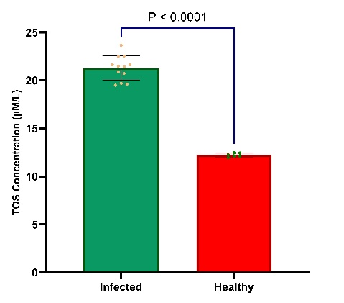
Fig. 2. TOS concentration in infected vs. healthy dogs
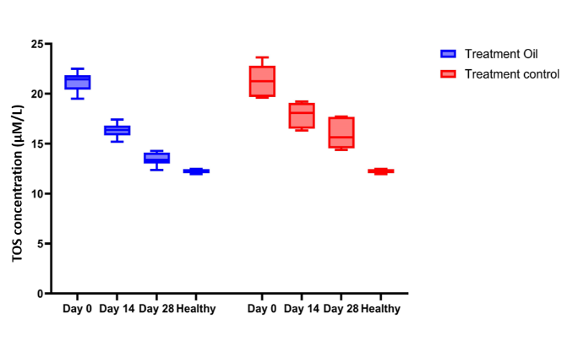
Fig. 3. TOS concentration in treatment groups on days 0, 14 and 28

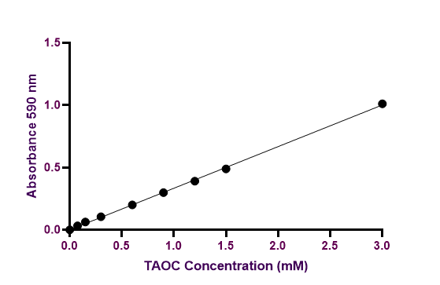
Fig. 4. Standard curve of TAOC concentration against absorbance at 590 nm

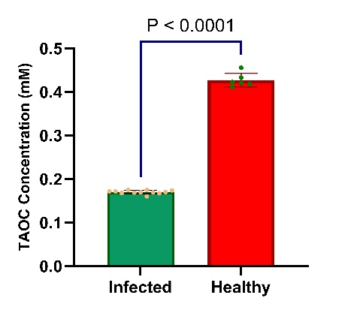
Fig. 5. TAOC concentration in infected vs. healthy dogs

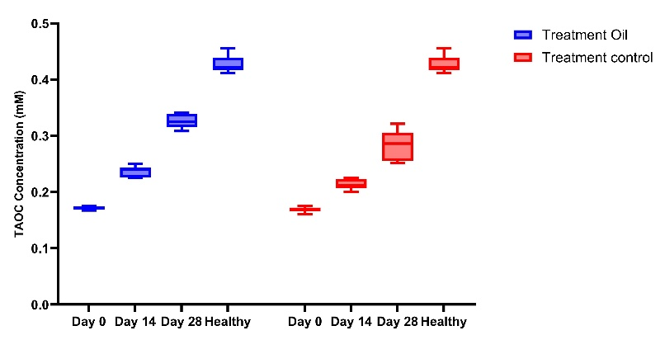
Fig. 6. TAOC concentration in treatment groups on days 0, 14 and 28

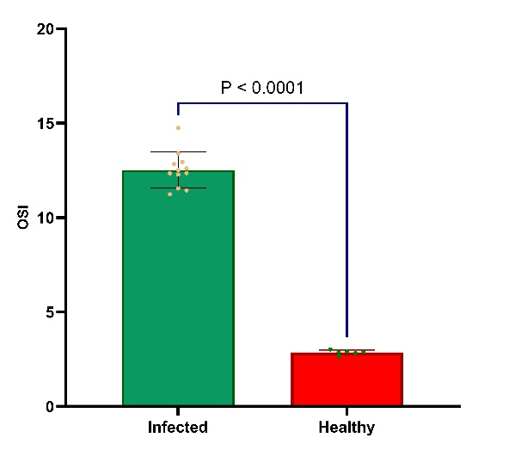
Fig. 7. OSI concentration in infected vs. healthy dogs
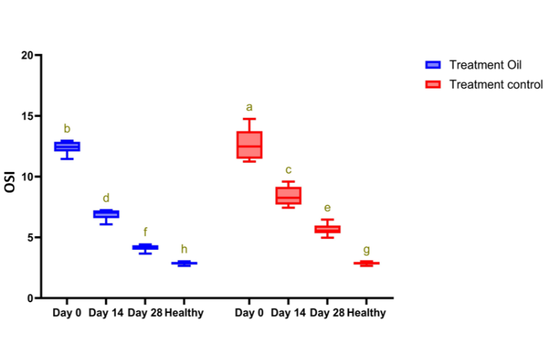
Fig. 8. OSI concentration in treatment groups on days 0, 14 and 28
The infected dogs in this study had a significantly elevated TOS and OSI values, whereas TAOC levels were observed to be significantly low. These results are in accordance with Behera et al. (2011), Allam et al. (2014), De and Dey (2010) and Beigh et al. (2016). Excessive production of free radicals, beyond the body’s endogenous defence mechanisms, has been observed in infections and inflammatory conditions (Allam et al., 2014). A key factor in the pathogenesis of these conditions is the production of proinflammatory cytokines, including IL-1α, IL-1β, TNFα, and IFNγ, secreted by keratinocytes, spleen, lymph node, and peripheral blood mononuclear cells. Additionally, cytokines may be produced as a result of skin inflammation caused by physical irritation from burrowing mites (Beigh et al., 2013). This proinflammatory cascade can trigger an overproduction of reactive oxidants and free radicals, such as reactive oxygen species (ROS)—including hydroperoxide (OH) and superoxide anion (O2)—and reactive nitrogen species (RNS), such as nitric oxide (NO), within the body.
While free radicals play an important role in the immune defence against invading parasites, their excessive production can lead to metabolic dysfunction and oxidative damage to biomolecules, contributing to pathological changes in tissues. Lipids and proteins are targets of various ROS and RNS, resulting in the formation of various toxic byproducts (Allam et al., 2014; Behera et al., 2011). Thus, oxidative stress occurs when there is an imbalance between radical-generating and radical scavenging activity, resulting in accumulation of oxidation products and tissue damage (Saleh et al. 2011).
In this study, the dogs exhibited significant oxidative stress along with an altered antioxidant defence mechanism. This may be the consequence of overproduction of free radicals by the inflammatory cells recruited to fight the parasites, leading to the depletion of dog’s antioxidant systems (Allam et al., 2014). Elevated levels of endogenous oxidants have been associated with various disorders, including inflammation and sarcoptic mange (Camkerten et al., 2009; De and Dey, 2010). Therefore, oxidative stress is a significant indicator for assessing the extent of tissue damage in the host system, as stated by De and Dey (2010).
Both the treatment groups in this study were successful in amelioration of these oxidative stress indicator panels post-therapy, but the EO treated group was better than the ivermectin treated group. The essential oils are proven to possess a range of biological properties, like antibacterial, antipruritic, anti-inflammatory (Andriantsoanirina et al., 2022), antioxidant (Choudhary and Chaudhary, 2021), antifungal (Li et al., 2020), anthelmintic (El-Speiy et al., 2016) and antiviral activities (Nardoni and Mancianti, 2022). According to Raina et al. (2013), Ocimum tenuiflorum essential oil was suggested to possess strong antimicrobial, insecticidal, antihelmenthic, nematicidal, antioxidant, myorelaxant, stimulant and anaesthetic properties. Sandalwood essential oil was observed to suppress the expression of pro-inflammatory cytokine, IL-1b, in keratinocytes, reducing irritant dermatitis in mouse skin stimulated with haptens (Moy and Levenson, 2017). Mirghani et al. (2012) observed their extracted lemongrass EO to have a high anti-oxidant activity, owing to the phenolic compounds present in the oil, which are free radical scavengers.
- CONCLUSION
From the data of the present study, it can be concluded that infestation by sarcoptic mites induces a state of oxidant-antioxidant imbalance in the affected dogs. Combination of three essential oils comprising 1% Lemongrass oil (Cymbopogon citratus), 0.5% Tulsi oil (Ocimum tenuiflorum) and 0.5% Sandalwood oil (Santalum album) when applied topically displayed strong antioxidant potential bringing the elevated TOS, OSI and decreased TAOC levels to near normalcy. This essential oil combination may be recommended either as an adjunctive remedy along with a miticide, or as an alternative therapy to manage clinical canine sarcoptic mange. Further, large-scale studies are needed for these assumptions to be confirmed.
Ethical approval

The blood was collected from the diseased dogs and healthy animals under the ethical standards and guidelines of the Institutional Animal Ethics Committee (IAEC) and due permission was received from the ethical committee of the University via voucher no. IAEC/22/2/14 dated 28-12-2022.

References

- Allaam MA, Allam TS, Elkhatam AO. 2014. Biochemical and circulating oxidative stress biomarkers in Egyptian buffaloes (Bubalus bubalis) infested by sarcoptic mange. Global Veterinaria, 13(4):656-661.
- Andriantsoanirina V, Guillot J, Ratsimbason M, Mekhloufi G, Randriamialinoro F, Ranarivelo L, Ariey F, Durand R. 2022. In vitro efficacy of essential oils against Sarcoptes scabiei. Scientific Reports, 12(1):1-8.
- Behera SK, Dimri U, Singh SK, Mohanta RK. 2011. The curative and antioxidative efficiency of ivermectin and ivermectin+ vitamin E-selenium treatment on canine Sarcoptes scabiei infestation. Veterinary Research Communications, 35:237-244.
- Beigh SA, Soodan JS, Bhat AM. 2016. Sarcoptic mange in dogs: Its effect on liver, oxidative stress, trace minerals and vitamins. Veterinary Parasitology, 227:30-34.
- Beigh SA, Soodan JS, Singh R, Raina R. 2013. Plasma Zinc, Iron, Vitamin A and Hematological Parameters in Dogs with Sarcoptic Mange. Israel Journal of Veterinary Medicine, 68(4):239-245.
- Camkerten I, Sahin T, Borazan G, Gokcen A, Erel O, Das A. 2009. Evaluation of blood oxidant/antioxidant balance in dogs with sarcoptic mange. Veterinary Parasitology, 161(1-2):106-9.
- Choudhary S, Chaudhary G. 2021. Sandalwood (Santalum album): ancient tree with significant medicinal benefits. International Journal of Ayurveda and Pharma Research, 9(4):90-99.
- De UK, Dey S. 2010. Evaluation of organ function and oxidant/antioxidant status in goats with sarcoptic mange. Tropical Animal Health and Production, 42:1663-1668.
- El-Spiey M, Elsawy M, Sadaka T, Tony M. 2016. Comparative studies on reproductive male rabbits as affected by ivermectin or both of garlic and cinnamon oils treatments 1. Acaricidal efficacy of ivermectin, garlic and cinnamon oils against Sarcoptes scabiei in suffering infested rabbits. Egyptian Journal of Rabbit Science, 26(1): 21-38.
- Escobar LE, Carver S, Cross PC, Rossi L, Almberg ES, Yabsley MJ, Astorga F. 2022. Sarcoptic mange: An emerging panzootic in wildlife. Transboundary and Emerging Diseases, 69(3):927-942.
- Li M, Liu B, Bernigaud C, Fischer K, Guillot J, Fang F. 2020. Lemongrass (Cymbopogon citratus) oil: A promising miticidal and ovicidal agent against Sarcoptes scabiei. PLoS Neglected Tropical Diseases, 14(4):0008225.
- Mir MH. 2013. Evaluation of antioxidant and immunomodulatory potential of withania somnifera in canine sarcoptic acariasis (Doctoral dissertation) submitted to IVRI, Izzat Nagar, India.
- Mirghani MES, Liyana Y, Parveen J. 2012. Bioactivity analysis of lemongrass (Cymbopogan citratus) essential oil. International Food Research Journal, 19(2):569-575.
- Moy RL, Levenson C. 2017. Sandalwood album oil as a botanical therapeutic in dermatology. The Journal of clinical and aesthetic dermatology, 10(10):34.
- Nardoni S, Mancianti F. 2022. Essential oils against Sarcoptes scabiei. Molecules, 27(24):9067.
- OIE. 2016. Mange. In: OIE Manual of diagnostic tests and vaccines for terrestrial animals. 6th edn. World Organisation for Animal Health, pp 1255–1266.
- Raina AP, Kumar A, Dutta M. 2013. Chemical characterization of aroma compounds in essential oil isolated from “Holy Basil” (Ocimum tenuiflorum L.) grown in India. Genetic Resources and Crop Evolution, 60:1727-1735.
- Saleh MA, Mahran OM, Bassam Al-Salahy M. 2011. Circulating oxidative stress status in dromedary camels infested with sarcoptic mange. Veterinary research communications, 35:35-45.

