Characterization of Fusarium spp associated with Solanaceous seeds in Burkina Faso

ABSTRACT

The Solanaceae family, comprising tomato, pepper, chili, and eggplant, plays a pivotal role in agriculture in Burkina Faso. However, these crops face significant biotic challenges, notably from fungi of the Fusarium genus, which are responsible for severe diseases and yield losses that can reach up to 80%. Beyond their devastating effects on both the quantity and quality of harvests, these pathogens also produce mycotoxins that compromise food safety. This study aims to enhance the production of Solanaceous crops by characterizing the Fusarium fungal agents associated with their seeds in Burkina Faso. A sanitary analysis of 400 seeds per seed type (both disinfected and non-disinfected) identified 11 fungal genera, including Fusarium, Colletotrichum, Curvularia, Alternaria, Aspergillus, Didymella, Epicoccum, Melanospora, Spirodactylon, Rhizopus, and Stachybotrys, with varying proportions depending on the genus. Among these, Fusarium spp. predominated, even after disinfection, though fungal diversity and contamination rates were lower. Microscopic and molecular analyses revealed several Fusarium species, including F. solani, F. proliferatum, F. incarnatum, and F. equiseti. Pathogenicity tests showed a high incidence of Fusarium wilt on seedlings, with variability based on the isolates and crops. Specifically, isolates T2F, P3F, and Pi1F exhibited particularly aggressive behavior on tomato, pepper, and chili, respectively. These findings underscore the urgent need for effective seed management to limit the spread of these pathogens and safeguard agricultural productivity in Burkina Faso.

Keywords: Solanaceae, Seeds, Sanitary analysis, Pathogenicity, Virulence, Burkina Faso

1. INTRODUCTION

Market gardening, introduced to Burkina Faso between 1920 and 1930 by missionaries and government officials(1), has since become a central component of the country’s agricultural sector. Among the market crops, Solanaceae species such as tomato (Solanum lycopersicum), pepper (Capsicum annuum), chili (Capsicum frutescens), and eggplant (Solanum melongena) are particularly significant for their nutritional, economic, and cultural contributions.
Tomato is a cornerstone crop, providing substantial income for farmers and playing a pivotal role in reducing poverty and seasonal unemployment in various regions (2,3). Beyond its economic value, it is crucial for food security, offering a rich source of carbohydrates, proteins, vitamins, and minerals. Its regular consumption is associated with improved public health, reducing the risks of cardiovascular diseases, cancers, and diabetes (2).
Chilies, especially Capsicum annuum, can yield up to 4.8 tons per hectare under optimal conditions (4). Their cultivation, well-suited to the local climate, generates significant income and contributes to alleviating rural poverty (5). Rich in antioxidants and phenolic compounds, chilies enhance the nutritional value of local diets and play a key role in food security (6). Additionally, their production creates seasonal employment opportunities, particularly for vulnerable populations in both rural and urban areas (7).
Pepper is another lucrative crop that bolsters farmers' financial stability while diversifying the local diet (2).
Eggplant plays an essential role in combating malnutrition, especially among women and children, due to its high content of vitamins and minerals (8). This crop contributes to the economic stability of rural communities and supports agricultural biodiversity, enhancing food security and resilience to climate change (9). Its genetic diversity allows for better adaptation to local conditions, supporting sustainable production (10).
The Solanaceous crops, valued for their nutritional and economic benefits, serve as a strategic pillar for the socio-economic development of Burkina Faso. However, their production faces both abiotic and biotic challenges, particularly diseases caused by Fusarium fungi. These pathogens induce vascular wilt, root and collar rot, and produce mycotoxins, which compromise both the quality and safety of agricultural products (11). Seven major Fusarium species have been identified in Burkina Faso, including F. oxysporum, F. solani, and F. proliferatum (11,12). These fungi are often transmitted through soil, seeds, and environmental conditions, and can also be introduced via the importation of contaminated seeds, which exacerbates the risks to local production systems (13).
In this context, early detection of pathogens on seeds and the management of their spread are essential to ensuring the sustainability of market gardening production. The current study, titled "Characterization of Fusarium spp. associated with Solanaceous Seeds in Burkina Faso," aims to inventory the fungal species linked to Solanaceous seeds, characterize the Fusarium spp. found on these seeds, and evaluate the pathogenicity of these fungi on seeds of the four most widely cultivated Solanaceous crops in Burkina Faso.

2. material and methods

2.1 Seed Sampling
The plant material studied includes the main Solanaceae varieties cultivated in Burkina Faso, sourced from two origins: improved seeds from commercial companies and local farmer seeds collected from local producers. This selection reflects the common agricultural practices, which vary between seed reuse and the purchase of improved varieties. The varieties studied are:
- Tomato Cobra F1: an early maturing variety, tolerant to TYLCV and bacterial wilt.
- Pepper Simbad F1: a very early variety, resistant to multiple pathogens.
- Yellow Chili from Burkina: a late maturing, highly pungent variety with bright yellow fruits.
- Eggplant Safari Cobra F1: a long-cycle variety with purple fruits and a strong flavor.
- Farmer seeds, collected from local market gardeners.
2.2 Sanitary seed analysis
A total of 400 seeds per seed type were analyzed, divided into two groups: 200 disinfected seeds (treated with 70% alcohol, 1% bleach, and rinsed with sterile water) and 200 non-disinfected seeds. These seeds were incubated in sterile Petri dishes at 25°C, with regular observations over one month to monitor fungal contamination. Fungal colonies were analyzed under a microscope to examine their morphological structures. Species identification was carried out using the key from (14), and the data were recorded on a registration sheet. Fusarium spp. colonies were isolated and transferred onto PDA medium, then incubated at 27°C with 12 hours of UV light. Successive subcultures were performed to obtain pure cultures for further analysis.
2.3 Microscopic Characterization
To characterize the fungi microscopically, a conidial suspension was prepared by adding 10 ml of sterile distilled water to a seven-day-old culture. A drop of this suspension was placed on a slide for observation under an optical microscope. The microscopic analysis was performed using a system consisting of a microscope connected to a camera and computer. Using Image Focus Plus V2 software, the length and width of 50 conidia per isolate were measured, and the number of septa was recorded. These parameters provided essential information for species identification.
2.4 Molecular Characterization
DNA extraction was carried out using a modified CTAB method (Permingeat et al., 1998). Monospore isolates of Fusarium spp. grown on PDA were sampled to obtain 40 mg of mycelium. The mycelium was homogenized with 600 µl of CTAB solution and ground at 30 Hz for 2 minutes. After incubation at 65°C for 15 minutes, 1 mL of chloroform-isoamyl alcohol was added, followed by centrifugation at 14,000 rpm. DNA was precipitated with 450 µl of cold isopropanol, washed twice with 70% ethanol, dried, and resuspended in 100 µl of sterile distilled water before being stored at -20°C. The extracted DNA was quantified and amplified by PCR. Two specific primer pairs targeted F. solani and F. oxysporum, while a universal primer pair (ITS1-F/ITS4) was used to assess genetic diversity (Table 1). Each PCR reaction (25 µl) included 5 µl of DNA, 2.5 µl of each primer (10 mM), 5 µl of Fire Hot Mix, and 10 µl of distilled water. Negative controls were included to prevent contamination. Amplification was performed on a thermocycler with programs tailored for the specific primers.
The PCR products were separated on a 1% agarose gel prepared with TAE buffer, containing 0.5 μg/ml of BET and 3 µl of GelRed™. After solidification, 4 µl of each amplified product was loaded into the wells, and electrophoresis was conducted at 100 V for 30 minutes. A 100 bp molecular marker was used to estimate the size of the DNA fragments. DNA bands were visualized using a gel imager. Isolates showing amplicons of the expected size (targeted by the ITS1-F/ITS4 primers) were sent to Genewiz for sequencing. The obtained sequences were analyzed and assembled into consensus sequences using BioEdit software, and then compared with the NCBI database via BLAST for identification.
Table 1. Characteristics of the primers used
Primers | Codes | Sequences | Authors | Hybridation temperature
Fusarium solani | TER-Fs4r | GGC-GTC-TGT-TGA-TTG-TTA-G | Moine, 2013 | 58°C
Fusarium solani | FO-F | AGG-GTC-ATG-CTC-TGA-AGC-AGA-G | Moine, 2013 | 58°C
Fusarium oxysporum | FO-R | GAA-CTG-TTT-AAT-GTT-CTG-AAT-TTC-A | Yada et al., 2017 | 58°C
Fusarium oxysporum | FO-F | AGG-GTC-ATG-CTC-TGA-AGC-AGA-G | Yada et al., 2017 | 58°C
ITS | ITS1-F | CTTGGTCATTTAGAGGAAGTAA | Gardes et al., 1993 ;  White et al., 1990 | 52°C
ITS | ITS4 | TCCTCCGCTTATTGATATGC | Gardes et al., 1993 ;  White et al., 1990 | 52°C

2.5 Pathogenicity Testing
Four Fusarium spp. isolates (T2F, Pi1F, P3F, and A5F), identified through molecular assays and originating from tomato, pepper, chili, and eggplant seeds, were selected for pathogenicity testing. The seeds were disinfected with 95% ethanol for 1 minute, rinsed with sterile water, and subsequently exposed to 7-day-old mycelium for 12 hours at room temperature. The control seeds were incubated on PDA medium without mycelium. After the incubation period, the seeds were sown in alveolar plates filled with sterilized potting soil, and regular watering was performed every two days with distilled water. The experiment included 12 repetitions for each seed type (tomato, pepper, and chili), resulting in a total of three plates with 72 wells each.
2.6 Data Analysis
Three primary parameters were assessed from the collected data :
- Fusarium Incidence: Measured on the 40th day after sowing (DAS) by counting plants exhibiting necrosis, chlorosis, or mortality. The average incidence for each treatment group was determined using the formula outlined by Cooke et al. (2006) :
$$I=\sum{(\frac{n}{N}}).100$$
I represents the incidence, n is the number of diseased plants, and N is the total number of plants observed (N = 12).
- Fusarium Severity: Evaluated on the 40th DAS using the five-class scale by (Abawi and Oastor-Corales, 1990):
1 : No visible symptoms.
3 : 1 to 3 leaves (10% of the foliage) wilted and chlorotic.
5 : About 25% of the leaves and branches wilted and chlorotic.
7 : About 50% of the leaves and branches wilted and chlorotic.
9 : About 75% of the leaves and branches wilted, chlorotic, or defoliated, with possible plant death.
The severity index (Is) was calculated according to the formula by (16):
$$IS=\sum{(\frac{Xi.ni}{N.Z}}).100$$
Is is the severity index; Xi is the severity of class i; ni is the number of plants affected in this class; N is the total number of plants observed (N = 12), and Z is the maximum severity class (Z = 9).
The collected data were entered and organized using Microsoft Excel 2019, which was also used to generate graphs. Statistical analyses, including analysis of variance (ANOVA) and mean comparisons, were conducted using XLSTAT software (version 2016), applying Fisher's test at a 5% significance level.
3. results and discussion

3.1 Results
3.1.1. Fungal identification on ieeds from both origins analyzed
Fusarium, Colletotrichum, Curvularia, Alternaria, Aspergillus, Didymella, Epicoccum, Melanospora, Spirodactylon, Rhizopus, and Stachybotrys (Figure 1). Prior to disinfection, the farmer-saved seeds from the various crops exhibited high levels of fungal contamination, predominantly caused by Fusarium spp. along with species specific to each crop. Tomato seeds were infected exclusively by Fusarium spp. (24%), which remained the dominant fungus even after disinfection, despite the emergence of Colletotrichum spp. and Curvularia spp. In chili seeds, Fusarium spp. (21%) predominated before disinfection, followed by Epicoccum spp. (4%), with only Fusarium spp. (6%) and Melanospora spp. (12%) persisting after disinfection. Pepper seeds showed a high incidence of Fusarium spp. (41%) and a minor presence of Aspergillus flavus (2.5%) before disinfection. After treatment, Fusarium spp. (6.5%) and Spirodactylon spp. (20%) were the predominant fungi. Finally, eggplant seeds were primarily contaminated by Aspergillus niger (14.5%) and Fusarium spp. (12.5%), but post-disinfection, the contamination levels dropped to 2.87% for Fusarium spp. and 3.5% for Spirodactylon spp. These findings demonstrate that disinfection significantly reduces both the fungal diversity and infestation levels, although Fusarium spp. remains the most prevalent species.
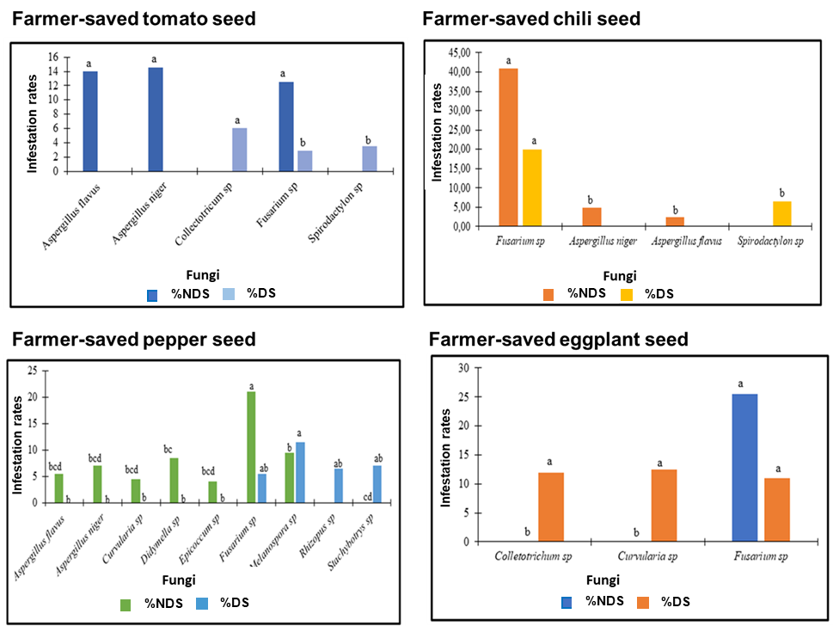
Fig. 1. Fungal Species Infestation Rates on Farmer-Saved Seeds
NDS: No-disinfected seed ; DS: Disinfected seed

3.1.2 Improved Varieties Seeds
The improved seeds of tomato, chili, pepper, and eggplant showed two genera of fungi: Fusarium spp. and Alternaria spp. Fusarium spp. reached a maximum infestation rate of 22% on tomato, while Alternaria spp. was less frequent (1.5% on chili). Fusarium spp. significantly dominates all the crops (Figure 2).

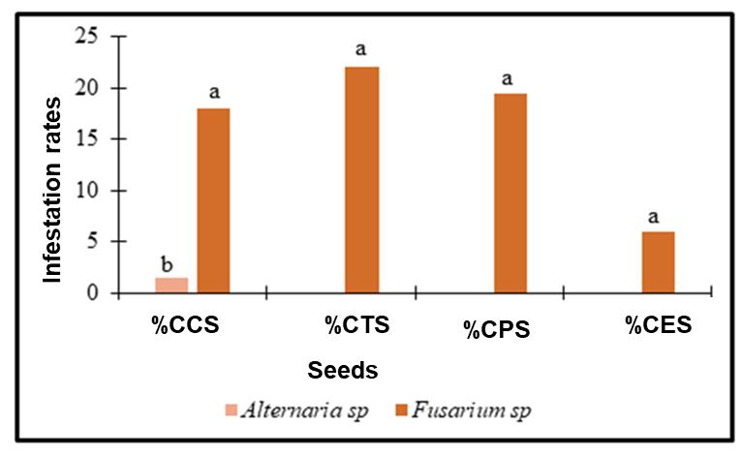
Fig. 2. Infestation rates of fungal species on improved seeds
CCS : Commercial Chili Seed, CTS : Commercial Tomato Seed, CPS : Commercial Pepper Seed, CES : Commercial Eggplant Seed.
Given the significance of Fusarium on all the analyzed seeds, even after disinfection, and its negative impact on the resulting plant health, a thorough characterization of this pathogen was carried out.
3.1.3 Morphological Characteristics

The analysis of morphological characteristics, based on macroscopic and microscopic parameters, revealed the distinction of four groups of isolates (Table 2).

Table 2. Morphological characteristics of the isolates

Groups | Mycelium on PDA | Conidia under the microscope | Morphological characteristics
Group 1 : P1F ; P3F ; P4F | 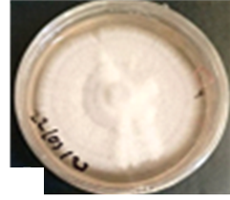 | 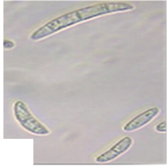 | Colony: Whitish on both the surface and underside of the Petri dish with a regular outline. The mycelium has a cotton-like appearance. The fungus contained fusiform or ellipsoidal macroconidia, septate (1 to 3 septa), with an average size of 10.65 - 14.62 µm x 3.44 - 3.61 µm.
Group 2 : T1F ; T2F | 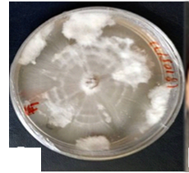 | 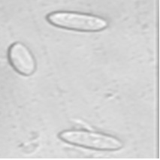 | The mycelium is whitish with a fluffy appearance. The macroconidia were ellipsoidal with an average size of 6.54 - 13.34 µm x 1.85 - 4.62 µm.
Group 3 ; T3F ; T4F | 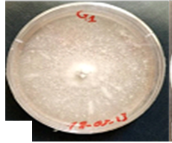 | 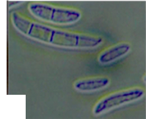 | The mycelium had a granular appearance with moderately fast growth. Fusiform and septate macroconidia (1 to 3 septa) and microconidia were present. The macroconidia had an average size of 15.41 - 28.18 µm x 3.61 - 3.65 µm.
Group 4 : Pi₁F ; Pi2F | 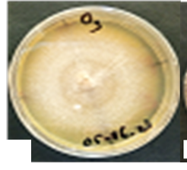 | 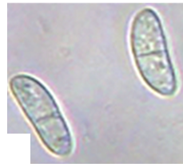 | The mycelium was brown in the center and white at the periphery on the surface, with a light yellow color on the underside of the Petri dish. It had a cotton-like appearance. The macroconidia were ellipsoidal in shape and septate (1 to 3 septa). The average size was 16.31 - 29.25 µm x 2.80 - 4.13 µm.

3.1.4 Molecular Characteristics
PCR analyses with universal primers specific to Fusarium spp. allowed the detection of amplicons of approximately 500 bp in 14 isolates : 3 from tomato (T2F, T3F, T4F), 4 from chili (Pi1F, Pi2F, Pi3F, Pi4F), 2 from pepper (P2F, P3F), and 5 from eggplant (A1F, A2F, A3F, A5F, A6F) (Figure 3A).
Tests conducted with primers specific to Fusarium solani (500-600 bp) confirmed the presence of this pathogen in 7 isolates : 3 from tomato (T2F, T3F, T4F), 2 from chili (Pi1F, Pi3F), 1 from pepper (P3F), and 1 from eggplant (A5F) (Figure 3B).
However, no amplification was obtained with primers specific to Fusarium oxysporum.
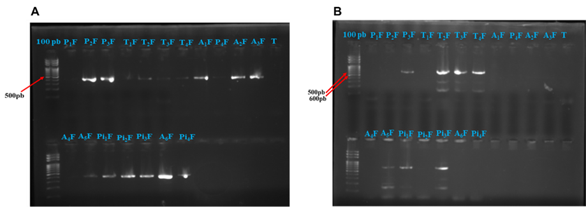

Fig. 3. Migration profile on agarose gel for the detection of Fusarium spp. and Fusarium solani
A : Fusarium spp. detection gel; B : gel Fusarium solani detection gel
3.1.5 Sequence Analysis
The sequence analysis of Fusarium spp. isolates from Burkina Faso revealed their close relation to four species: F. solani (P1F, T3F, T4F, Pi1F), F. proliferatum (A2F), F. incarnatum (A3F), and F. equiseti (A5F, Pi4F) (Table 3).
Table 3. Blast of consensus sequences of isolates from different Fusarium species on www.ncbi.nlm.nih.gov
Isolate Code | Seed | Species | Size (pb) | Accession | Similarity (%)
T3F | Tomato | F. solani | 574 | ON377361.1 | 99,09
T4F | Tomato | F. solani | 574 | ON377361.1 | 100
Pi1F | Chilli | F. solani | 551 | MN602849.1 | 94,92
Pi4F | Chilli | F. equiseti | 536 | KX196808.1 | 99,23
P1F | Pepper | F. solani | 568 | KU382502.1 | 99,40
A2F | Eggplant | F. proliferatum | 535 | KX196810.1 | 98,85
A3F | Eggplant | F. incarnatum | 525 | OQ422695.1 | 99,48
A5F | Eggplant | F. equiseti | 543 | OL998441.1 | 99,43

3.1.6 Pathogenicity of the Isolates
3.1.6.1 Fusariosis incidence
The incidence of fusariosis in tomato, pepper, and chili plants derived from infested seeds varied depending on the crop and the isolates at the 40 ^{th} day after sowing (DAS). Statistical analysis revealed a highly significant difference (p < 0.001) among the isolates across all crops at the 5% threshold (Table 4). The isolate T2F caused a high incidence of 41.67% in tomato seedlings, while the isolate P3F resulted in high incidences of 16.67% and 75.00% in pepper and chili seedlings, respectively (Table 4).
Table 4. Incidence of four Fusarium spp. isolates on tomato, pepper, and chili plants
 | Incidence (%)
Isolates | Tomato | Pepper | Chili
Pi1F | 16,67d | 00c | 33,34c
T2F | 41,67a | 8,34b | 41,67b
P3F | 33,34b | 16,67a | 75,00a
A5F | 25,00c | 8,34b | 41,67b
Control | 00e | 00c | 0,00d
Standard Deviation | 15,28 | 6,05 | 25,67
Probability | < 0,001 | < 0,0001 | < 0,0001
Significance | THS | THS | THS
The values followed by different alphabetical letters are significantly different at the 5% threshold according to Fisher's test; THS: Very Highly Significant. Pi1F : Isolate 1 of Fusarium from chili seed ; T2F : Isolate 2 of Fusarium from tomato seed ; P3F : Isolate 3 of Fusarium from pepper seed ; A5F : Isolate 5 of Fusarium from eggplant seed.

3.1.6.2 Fusariosis Severity
The results revealed variability in disease severity depending on the crops. For tomato, only the isolate T2F caused a significantly higher severity (20.41%) compared to the control. In contrast, for pepper, no significant difference was observed (p > 0.05). For chili, the severity of fusariosis was similar in plants derived from seeds infested with the four Fusarium isolates, and this severity was higher than that observed in the control (Table 5).

Table 5. Severity Index of Four Fusarium spp. strains on Tomato, Pepper, and Chili Plants

 | Severity (%)
Isolates | Tomato | Pepper | Chili
Pi1F | 0,83b | 00 | 27,50a
T2F | 20,41a | 13,33 | 31,25a
P3F | 13,33ab | 8,75 | 50,83a
A5F | 7,91ab | 7,91 | 32,91a
Control | 00b | 00 | 00b
Standard Deviation | 2,45 | 2,06 | 3,79
Probability | < 0,05 | > 0,05 | < 0,01
Significance | S | NS | HS

The values followed by different alphabetic letters are significantly different at the 5% level according to Fisher's test; S: Significant; NS: Not Significant; HS: Highly Significant. Pi1F: Fusarium isolate 1 from chili seeds; T2F: Fusarium isolate 2 from tomato seeds; P3F: Fusarium isolate 3 from pepper seeds; A5F: Fusarium isolate 5 from eggplant seeds.

3.2 Discussion
Seed and plant quality is a key factor in agricultural production. The sanitary analysis of seeds from the four most widely cultivated Solanaceae species in Burkina Faso revealed a high diversity of associated fungi, with 11 genera identified. Similar studies have shown comparable fungal diversity transmitted by seeds. For example, Gyasi et al. (2020) detected nine genera and 11 fungal species associated with pepper seeds in Ghana. Research conducted in Pakistan (18) and India (19) also identified numerous fungal species, including genera like Colletotrichum, Curvularia, and Fusarium on tomato seeds. (20), in Bangladesh, observed 11 fungal species from seven vegetables, including eggplant and tomato.
Seed infestation rates varied depending on their origin. Indeed, farmer-saved seeds were contaminated by 11 genera of fungi, while commercial seeds were only contaminated by Fusarium spp. and Alternaria spp. These results indicate that local seeds have a higher contamination rate than commercial ones. This can be explained by the lack of sanitary control over farmer-saved seeds before use, unlike commercial seeds, which are treated, selected, and protected. According to Gyasi et al. (2020), over 70% of farmers in developing countries use their own untreated seeds, which may favor the spread of pathogens and the increase in seed-borne diseases.
The vulnerability of seeds to fungal attacks, whether saprophytic or parasitic, is well documented (21). Most of the fungi identified in this study, such as Fusarium, Aspergillus, and Colletotrichum, can negatively affect seed germination and seedling development. Diseases caused by Colletotrichum lead to significant yield losses in various parts of the world, including Malaysia for tomato (22) and Indonesia for eggplant (23). Additionally, A. flavus and A. niger are concerning due to their ability to produce aflatoxins, toxic metabolites that affect human health and the quality of fruits and seeds (24). These results confirm the crucial role of seeds as disease vectors, emphasizing the need for control measures, including preventive treatments to reduce the spread of pathogens.
Molecular characterization results confirmed the presence of four Fusarium species among the isolates analyzed. These findings highlight the importance of molecular characterization for precise identification, as some morphologically similar species can only be distinguished using molecular methods. Molecular analyses also revealed the presence of F. solani in seeds from all four Solanaceae species studied, a pathogen responsible for root and seedling rot. These results align with studies by Hami et al. (2021), which also identified F. solani as the main pathogen of chili.
F. solani was identified as the most frequently associated species with the seeds of the studied Solanaceae and was shown to be pathogenic in cross-inoculation tests. Managing seeds, especially through appropriate fungicidal treatments, could reduce the spread of this disease. The results of this study reinforce the importance of molecular characterization for reliable pathogen identification and highlight the risks that infected seeds pose to agricultural production. Finally, particular attention should be paid to the quality of seeds used, especially in developing countries where untreated seeds are commonly used.

4. Conclusion

This study revealed the fungal diversity associated with Solanaceae seeds grown in Burkina Faso, identifying 11 fungal genera, including pathogens such as Fusarium , Colletotrichum, and Aspergillus. Farmer-saved seeds, often untreated, exhibited a higher contamination rate than commercial seeds, emphasizing the importance of rigorous sanitary control. Fusarium solani was identified as a major pathogen, calling for proactive seed management, including fungicidal treatments. The study also highlights the importance of molecular characterization for precise pathogen identification and the need to strengthen seed management, particularly in developing countries. For sustainable agricultural production, tailored prevention strategies and strict sanitary control are essential.

Consent

Not applicable

Ethical approval

Not applicable

Disclaimer (Artificial intelligence)
Author(s) hereby declare that NO generative AI technologies such as Large Language Models (ChatGPT, COPILOT, etc.) and text-to-image generators have been used during the writing or editing of this manuscript.

References

1. Ouedraogo M. History and consequences of the introduction of market gardening in the Sudano-Sahelian zone in Burkina Faso. 1995;257-63.
2. Ouattara S, Konate M. The Tomato: A Nutritious and Profitable Vegetable to Promote in Burkina Faso. Alexandria Science Exchange Journal. 31 Mar 2024;45(1):11-20.
3. Traore M, Gadiaga AD, Gadiaga A, Some K, Hien E. Effect of different types of fertilizers on soil macrofauna dynamics and yields in tomato (Solanum lycopersicum L.) cultivation in central Burkina Faso. Int J Bio Chem Sci. 8 Jun 2022;16(1):134-44.
4. Garané A, Somé K, Nikiema J, Traoré M, Sawadogo M. Agro-morphological evaluation of some varieties of pepper or sweet pepper (Capsicum annuum L) in northern Burkina Faso. J App Bioscience. 21 Feb 2019;130(1):13245.
5. Kaboré DP. Financial profitability and technical efficiency of horticultural crops in the Nakanb River Watershed in Burkina Faso. J Dev Agric Econ. 1 Sep 2014;6(9):405-11.
6. Bayili RG, Fatoumata AL, Oumou H. K, Mamounata D, Imael H. N. B, Mamoudou H. D. Phenolic compounds and antioxidant activities in some fruits and vegetables from Burkina Faso. Afr J Biotechnol [Internet]. 12 Oct 2011 [cited 25 Dec 2024];10(62). Available at: http://www.academicjournals.org/ajb/abstracts/abs2011/12Oct/Bayili%20et%20al.htm
7. Asravor J, Onumah E, Osei-Asare Y. Economic Efficiency of Chili Pepper Producers in the Volta Region of Ghana. ropentag, Berlin, Germany September 16-18. 2015;
8. Regine TK, Salibo S, Abdou T, Yakubu BI, Ousmane N. Assessment of traditional African vegetable production in Burkina Faso. J Agric Ext Rural Dev. 31 Aug 2016;8(8):141-50.
9. MERTZ O, ANNE ML, ANETTE R. economic Botany 55(2) pp. 276-289. 2001 [cited 25 Dec 2024]. Importance and Seasonality of Vegetable Consumption and Marketing in Burkina Faso on JSTOR. Available at: https://www.jstor.org/stable/4256428
10. Sawadogo B, Bationo-Kando P, Sawadogo N, Kiebre Z, Kiebre M, Nanema KR, et al. Variation, correlation and heritability of interest characters for selection of African eggplant. Afr Crop Sci J. 20 May 2016;24(2):213.
11. Boutigny AL, Basler R, Gautier A, Dauthieux F, Leite S, Valade R, et al. A molecular tool based on high-throughput sequencing to characterize Fusarium on cereals Innovations Agronomiques 59, 55-61. 2017 [cited 18 Dec 2024]; Available at: https://hal.inrae.fr/ARINRAE-INNOVAGRO/hal-01675815
12. Ouali PD, Zida EP, Guissou LMK. Evaluation of the pathogenicity of 42 Fusarium isolates associated with sesame seeds (Sesamum indicum L.) in Burkina Faso. Int J Bio Chem Sci. 4 Sep 2024;18(3):1046‑61.
13. Tiendrebeogo A, Bonzi S, Dabiré GT, Son D, Sanou A, Kambire HS, et al. Identification of cultivable fungi associated with tomato diseases in Burkina Faso. Biotechnol Agron Soc Environ. 2023;
14. Mathur SB, Kongsdal O. Common Laboratory Seed Health Testing Methods for Detecting Fungi [Internet]. International Seed Testing Association; 2003. Available at: https://books.google.bf/books?id=hdxJAAAAYAAJ
15. Abawi GS, Oastor-Corales M a. Seed transmission and effect of fungicide seed treatments against Macrophomina phaseolina in dry edible beans. Turrialba. 1990;40(3):334‑9.
16. Kranz J. Measuring Plant Disease. Experimental Techniques in Plant Disease Epidemiology © Springer-Verlag Heidelberg. 1988;
17. Gyasi E, Kwoseh C, Moses E. Identification of seed-borne fungi of farmer-saved seeds of pepper and their control with some selected botanicals. Ghana J Agric Sci. Jul 16, 2020;55(1):43‑53.
18. Tareen HU, Rauf CA, Qadir G, Bhutta AR. BIOLOGICAL STUDIES ON SEED BORNE MYCOFLORA OF EXOTIC TOMATO SEED. 2014;26.
19. Kp R, Renganayaki P, Sundareswaran S, Kumar SM, Kamalakannan A. Seed mycobiome of tomato cultivar PKM 1. J Entomol Zool Stud. 1 Nov 2020;8(6):1843‑6.
20. Hamim I, Mohanto DC, Sarker MA, Ali MA. Effect of seed borne pathogens on germination of some vegetable seeds. 2014;
21. Agarwal VK, Sinclair JB. Principles of Seed Pathology, Second Edition [Internet]. 2nd Edition. Boca Raton: CRC Press; 1996 [cited Dec 18, 2024]. 560 p. Available at: https://www.taylorfrancis.com/books/9781482275650
22. Shahriar SA, Husna A, Paul TT, Eaty MostNK, Quamruzzaman M, Siddique AB, et al. Colletotrichum truncatum Causing Anthracnose of Tomato (Solanum lycopersicum L.) in Malaysia. Microorganisms. 16 Jan 2023;11(1):226.
23. Suparman, Rahmiyah M, Pujiastuti Y, Gunawan B, Arsi. Cross inoculation of anthracnose pathogens infecting various tropical fruits. IOP Conf Ser: Earth Environ Sci. Jan 2018;102:012080.
24. Balogun O, Odeyemi G, Fawole O. Evaluation of the pathogenic effect of some fungal isolates on fruits and seedlings of pepper (Capsicum spp). Journal of Agricultural Research and Development. 2 Oct 2008;4(2):159‑69.
25. Hami A, Rasool RS, Khan NA, Mansoor S, Mir MA, Ahmed N, et al. Morpho-molecular identification and first report of Fusarium equiseti in causing chilli wilt from Kashmir (Northern Himalayas). SciRep. Feb 112021;11(1):3610.

