Original Research Article
Enhancing Flood Area Mapping Accuracy Using Advanced SAR Data Processing

ABSTRACT

Aim: To assess the spatial distribution of floods in 2024 using remote sensing data, specifically Synthetic Aperture Radar (SAR), a powerful tool in flood monitoring and mapping due to its ability to capture data under all weather conditions, including rain and cloud cover provides high-resolution imagery suitable for identifying and analyzing flood extents.
Study Area and Duration: North-Eastern districts of Tamil Nadu viz., Tiruvannamalai, Ranipet, Chengalpat, Kancheepuram, Tiruvallur, Viluppuram, Cuddalore, Nagapattinam, Thanjavur, Tiruvarur, Kallakurichi and Mayiladuthurai.
Methodology: Flood mapping uses imagery collected from the European Space Agency's (ESA) Sentinel-1A satellite to identify and map flooded regions. Flood mapping receives assistance from this satellite's C-band SAR sensor, which can capture images in any weather condition without affecting the data.
Results: The flood vulnerability assessment using Sentinel-1A satellite data has provided critical insights into the extent and impact of flooding across Tamil Nadu in 2024. With a total of 90,369 hectares of agricultural land affected, the study highlights the urgency of implementing targeted flood management strategies. 350 ground truth points were collected, out of which 309 points coincided with the flood-affected areas. Among these 309 points, 214 were flood points and 95 were non-flood points. The overall accuracy of the results was 90.00 per cent. The producer and user accuracy for flood-affected areas was 92.10 per cent and 93.40 per cent, respectively. The producer and user accuracy for non-flood areas. was 85.30 per cent and 82.70 per cent with Kappa index of 0.80.
Conclusion: These findings underscore the importance of integrating advanced remote sensing technologies with ground-level data to better understand flood dynamics and provides a foundation for sustainable disaster risk management and resource allocation, ensuring long-term agricultural and environmental security in Tamil Nadu.

Keywords: Flood affected areas, Rainfall, Sentinel 1A satellite data and SAR data

1. INTRODUCTION

Floods are among the most frequent and destructive natural disasters worldwide. These floods occur in various forms, including riverine floods, coastal floods, flash floods, and urban floods, each with distinct characteristics based on their location and causes George, S. L. et al., (2022). These events are primarily triggered by extreme rainfall, snowmelt, dam failures, or the overflow of lakes or rivers. The frequency and severity of floods have been increasing, largely due to industrialization, rapid urbanization, and insufficient consideration of environmental and climatic factors. The impact of floods on social, economic, and environmental structures can be devastating, making effective flood risk management crucial.
Flood-prone areas are typically low-lying regions that are vulnerable to inundation from various water sources. These areas include river valleys, coastal zones, islands, and reefs, where the landscape’s micro-relief influences the extent of flooding. In India, for instance, flood rescue and analysis teams work collaboratively to manage flood risks, focusing more on rescue operations during flood events rather than relocating residents to flood-resistant areas Sundaram, S. et al., (2022).
Given the unpredictable nature of weather phenomena, there is an increasing need for fast, reliable methods for mapping flooded areas to support emergency response efforts. Accurate flood mapping is essential for assessing flood hazards, predicting damage, and supporting long-term urban planning to mitigate flood risks Tavus, B., et al., (2020). In this context, satellite remote sensing has emerged as a cost-effective and efficient technique for flood mapping.
One of the most valuable tools in flood mapping is Synthetic Aperture Radar (SAR), a remote sensing technology capable of capturing data under all weather conditions, including rain and cloud cover. This makes SAR particularly useful for flood monitoring during periods of extended rainfall when optical satellite images are often obscured. By performing multi-temporal analysis of SAR images, researchers can detect changes in the landscape and identify areas prone to flooding. These flood spatial extent maps, derived from SAR imagery, provide vital information for flood risk management and decision-making, enabling more effective emergency response and long-term planning.
2. material and methods

2.1 Study Area
These regions are located in the north-eastern part of India, primarily within the state of Tamil Nadu. It stretches between approximately 10°00'N to 11°30'N latitude and 78°30'E to 80°30'E longitude, with its southern boundary reaching the Palk Strait near Nagapattinam (10.7677°N, 79.8470°E). To the east, the delta is bordered by the coastline along the Bay of Bengal, while the western boundary is defined by the foothills of the Eastern Ghats. This geographical location subjects the delta to the influence of both monsoon rainfall and tidal effects from the Bay of Bengal, making it particularly vulnerable to seasonal flooding. North-Eastern districts of Tamil Nadu viz., Tiruvannamalai, Ranipet, Chengalpat, Kancheepuram, Tiruvallur, Viluppuram, Cuddalore, Nagapattinam, Thanjavur, Tiruvarur, Kallakurichi and Mayiladuthurai. The region is intersected by the Cauvery River and its numerous distributaries, which play a critical role in supporting local agriculture. However, these waterways also pose significant challenges in flood management. To assess areas prone to flooding, various locations were selected as monitoring sites across the region. (Fig. 1). provides a clear representation of the study area.
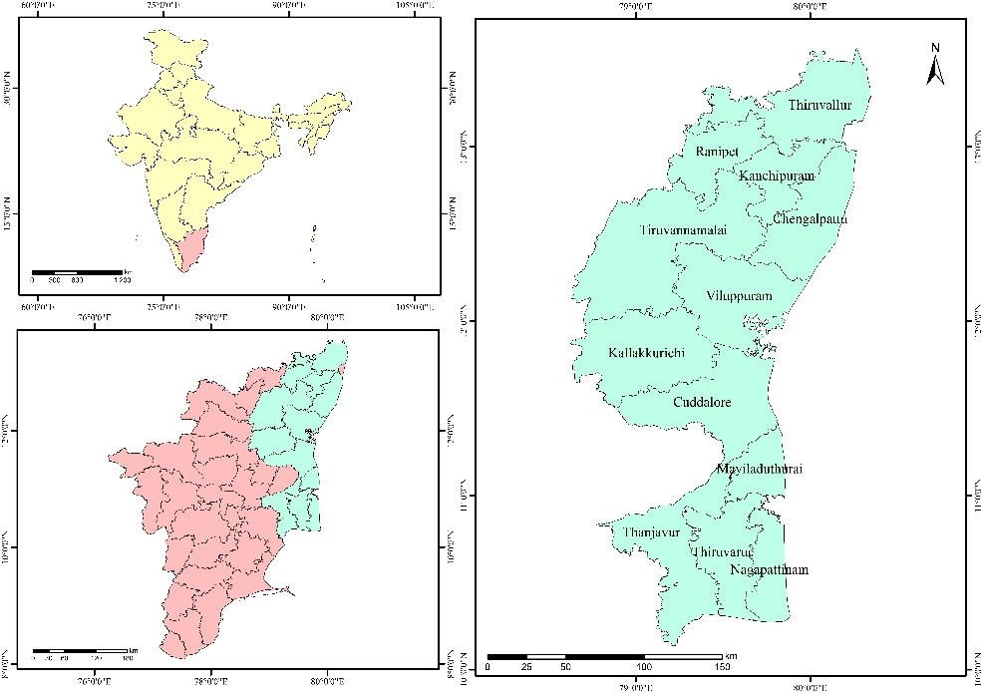
Fig. 1. Location map of the Study area

2.2 Data used in the study Sentinel 1A SAR satellite data
Sentinel-1A, launched by the European Space Agency in 2014, is a Synthetic Aperture Radar (SAR) sensor operating in the microwave region. It provides Vertical-Horizontal (VH) polarization and has a temporal resolution of 12 days, with a spatial resolution of 20 meters, which affords consistent and wide area monitoring (Table 1). The product modes of the satellite are represented diagrammatically (Fig. 2). The satellite is equipped with a single C-band SAR instrument that operates at a central frequency of 5.405 GHz. The satellite data was subsequently optimized through a series of processing steps to enhance its suitability for classification applications. These processing techniques involved radiometric calibration, speckle filtering, and terrain correction, ensuring the data's accuracy and relevance for further analysis. This pre-processing enabled more precise interpretation of environmental changes.
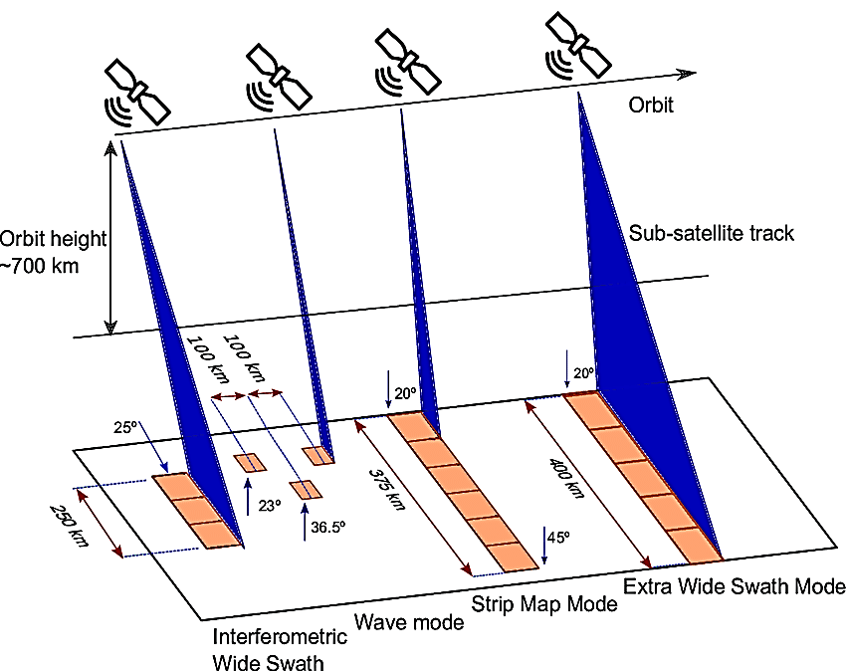
Fig. 2. Sentinel 1A satellite product modes

Table 1. Details of Sentinel 1A (IW-GRD) Data
Parameters | Characteristics
Pixel value | Magnitude detected
Coordinate system | Ground Range
Polarizations | Single (VV), Cross (VH) and Dual (VV+VH)
Ground range coverage (km) | 251.8
Radiometric resolution (dB) | 1.7
Bits per pixel | 16
Resolution (range x azimuth) (m) | 20.4 x 22.5
Pixel spacing (range x azimuth) (m) | 10 x 10
Incident angle | 32.9º
Number of looks | 5 x 1
Range look bandwidth (MHz) | 14.1
Azimuth look bandwidth (Hz) | 315
Equivalent number of looks (ENL) | 4.4
Absolute location accuracy (m) (NRT) | 7

2.3. Data collection and pre-processing
The pre-processing workflow for Sentinel 1A GRD has seven steps to reduce errors. Its steps are designed to be user-friendly, and the code required to perform the workflow is available on GitHub. The first step is to apply the precise orbit available in SNAP to obtain accurate satellite position and velocity information. The second step is thermal noise removal, which reduces noise effects, normalizes the backscatter signal, and eliminates discontinuities between sub-swaths. The border noise removal algorithm in SNAP is used to remove low-intensity noise and invalid data on scene edges. Calibration is a critical step that converts digital pixel values to radiometrically calibrated SAR backscatter. The workflow includes LUTs to produce sigma naught values, an essential aspect of the pre-processing workflow.
2.4. Mapping of Flood Prone Areas
Flood mapping uses imagery collected from the European Space Agency's (ESA) Sentinel-1A satellite to identify and map flooded regions. Flood mapping receives assistance from this satellite's C-band SAR sensor, which can take images in any weather or at any time of day. There are multiple steps in the process:
Data Acquisition: Sentinel-1A provides SAR imagery via approved sources like the Copernicus Open Access Hub of the ESA. Usually, the pictures are Level-1 Ground Range Detected (GRD) items.
Pre-processing: Geometric and radiometric distortions are corrected in the SAR data, which may include radiometric calibration, speckle noise reduction, and terrain variation correction.
Image Pairing: A minimum of two SAR photos of the same region, taken prior to as well as after the flood event occurred, are obtained in order to detect changes brought on by flooding. The terms "pre-flood" and "post-flood" are frequently used to describe these images.
Image Co-registration: To guarantee automated co-registration techniques, the pre- and post-flood images are accurately aligned.
Change Detection: To identify areas impacted by flooding, a change detection analysis is carried out. This involves contrasting the relevant pixel intensity values in the pre- and post-flood images. Changes in intensity may indicate the presence of water or other flood-related changes to the environment.
Thresholding and Classification: To distinguish between flood inundated and unaffected areas, the results of change detection are subjected to the appropriate thresholding techniques. Different threshold values may be required for various terrain types, depending on the scene’s complexity.
Validation: By contrasting the flood mapping results with ground truth data from dependable sources like field surveys or local authorities, the correctness of the results is confirmed.
Visualization and Reporting: The flood mapping data are visualized using Geographic Information Systems (GIS) software or other mapping tools. To show the size of the flooded areas, reports and visual aids are produced.
2.5 Software used for Analysis
Processing high-resolution Sentinel 1A SAR data requires thorough pre-processing, which is both labour-intensive and time-consuming. To streamline this, the study employs specialized software tailored for sequential data processing and spatial analysis, incorporating advanced GIS tools. The data processing and spatial analysis were carried out using the following software package: This approach significantly reduces manual intervention, enhances the efficiency of data handling, and ensures more accurate analysis results. Furthermore, it allows for the integration of various datasets, enabling comprehensive spatial insights.
- MAPscape RICE: SAR data processing and rice area estimation
- ArcGIS and QGIS: Handling spatial datasets and GIS operations
- MS-Excel: Generation of graphs and driving statistics

2.6 Ground Truth Collection
To validate flood area estimations obtained from satellite data, ground truth points were gathered from regions affected by floods. Through portable GPS receivers, spatial data such as latitude, longitude, altitude, date and time were captured. In the study region, about 309 flood points were selected at random, of which 214 are flood points and 95 are exempt. A total of 60 per cent of the points were utilized for training, while the remaining 40 per cent were used for validation.
2.7 Accuracy assessment
To check the accuracy of a flood area map, we compare it to ground truth data. We validate flood and non-flood points and put them into a confusion matrix. ANLD filtering procedures can lower the effective resolution, but we adjust for this by gathering validation data in areas with uniform land cover in a 15m radius around each GPS location. We use this data to evaluate the accuracy of the estimated rice area using an error matrix and Kappa statistics. We estimate the accuracy of overall, producer's, and user's from the error matrix.
$$\begin{matrix}\text{Overall Accuracy =} & \frac{\sum{\left(\text{Correctly classified classes along diagonal}\right)}}{\sum{\left(\text{ Row Total or Column Total}\right)}}\end{matrix}$$
The producer’s accuracy (errors of omission) of each class was computed by dividing the number of samples that were classified correctly by the total number of reference samples as follows:
$$\begin{matrix}\text{Producer's Accuracy =} & \frac{\text{Number of correctly classified classes in a column}}{\text{ Total number of items verified in that column}}\end{matrix}$$
The user’s accuracy (errors of commission) of each class was computed by dividing the number of correctly classified samples of that class by the total number of samples that were verified as belonging to the class as follows:
$$\begin{matrix}\text{User's Accuracy =} & \frac{\text{Number of correctly classified items in a row}}{\text{ Total number of items verified in that row}}\end{matrix}$$
Kappa Coefficient
Another measure of classification accuracy is the kappa coefficient, which measures the proportional (or percentage) improvement by the classifier over a purely random assignment to classes (Richards, 1996). The kappa coefficient can be estimated from the formula given below.
$$\hat{K}=\frac{NA-B}{N^{2}-B}$$
For an error matrix with r rows, and hence the same number of columns,
Where,
A = the sum of r diagonal elements, which is the numerator in the computation of overall accuracy
B = sum of the r products (row total x column total)
N = the number of pixels in the error matrix (the sum of all r individual cell values)

3. results and discussion

3.1 Delineating flood affected areas
Floods can cause significant damage to crops and farmland, leading to devastating economic losses. Identifying flood-prone agricultural areas allows farmers to take preventive measures or select more resilient crops, thereby minimizing these losses. In addition to agricultural impacts, flood-affected regions often experience changes in water quality and disruptions to local ecosystems Melkamu, T., et al., (2022). Flood vulnerability assessment is the process of determining and quantifying the susceptibility of an area to flooding. This assessment involves combining flood hazard maps with the population distribution in the area to rank and prioritize flood risk. As a result, it provides valuable information for both mitigation efforts and resource allocation.
In 2024, floods affected a total of 90,369 hectares across various regions in Tamil Nadu. Tiruvannamalai faced the highest impact, with 15,633 hectares submerged, while Mayiladuthurai experienced the least damage, covering only 2,202 hectares. Cuddalore was also heavily impacted, with floods affecting 11,565 hectares. Other regions such as Viluppuram, Ranipet, Chengalpattu, and Thanjavur had significant flood areas, with approximately 10,659, 9,291, 9,162, and 8,943 hectares impacted, respectively. Kancheepuram was affected over 7,605 hectares, while areas like Tiruvallur and Tiruvarur had 4,602 and 4,361 hectares submerged. Kallakurichi and Nagapattinam experienced relatively smaller flood impacts, affecting around 3,830 and 2,517 hectares, respectively (Table 2). This information emphasizes the need for targeted flood management and resilience strategies across these regions to reduce future risks and protect both livelihoods and the environment.
Table 2. Flood affected areas in the Study regions
District | Flood Area (ha)
Tiruvannamalai | 15633
Cuddalore | 11565
Viluppuram | 10659
Ranipet | 9291
Chengalpattu | 9162
Thanjavur | 8943
Kancheepuram | 7605
Thiruvallur | 4602
Thiruvarur | 4361
Kallakurichi | 3830
Nagapattinam | 2517
Mayiladuthurai | 2202
Total Area | 90369

3.2. Flood area Mapping
Flood inundation mapping is a technique used to identify areas along rivers that are at greater risk of flooding when stream flow exceeds the bank-full capacity. These maps are created using up-to-date data on riverbanks and flood events, illustrating the extent of flooding for various levels of water release Ahmed, T. (2021). Such inundation often affects large portions of agricultural land, particularly during extreme precipitation events that occur within a short time frame.
Gasparovic, M. and D. Klobucar (2021) reported that the ability of the maps to detect waterbodies of different sizes was evaluated by comparing them to known waterbody extents. Additionally, the overall precision of the flood maps was assessed by comparing them to Sentinel-1A satellite imagery. To further assess the accuracy of flood boundary delineation on a local scale, the maps were compared to observed flood extents. Flood depth maps generated from Sentinel-1 SAR images enhance and verify data regarding the spatial and temporal progression of floods.
The rainfall data from the source revealed that the study area experienced maximum rainfall exceeding 200 mm during the 48th week of November and December 2024, respectively. Hence impact of flood is severe in those respective weeks. The rainfall that ranged between 100-200 mm indicated that impact of flood is moderate in the particular years respectively. Rainfall data that ranged between 100-130 mm indicated that impact of flood is less. This was analyzed considering the increase in torrential rain associated with climate change, and the resulting probability of flooding was calculated accordingly and maps were created which is illustrated in (Fig. 3-14).

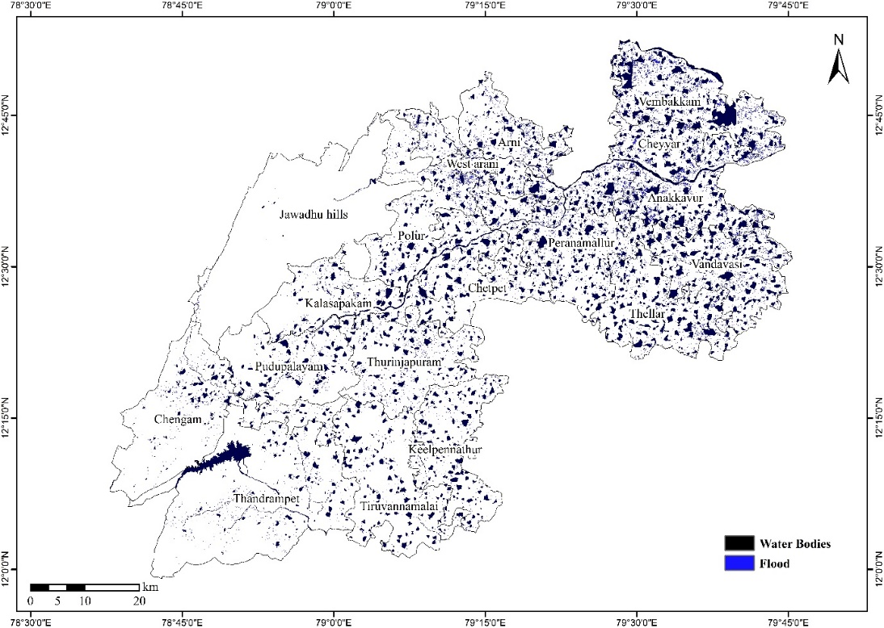
Fig. 3. Flood area mapping in Tiruvannamalai district
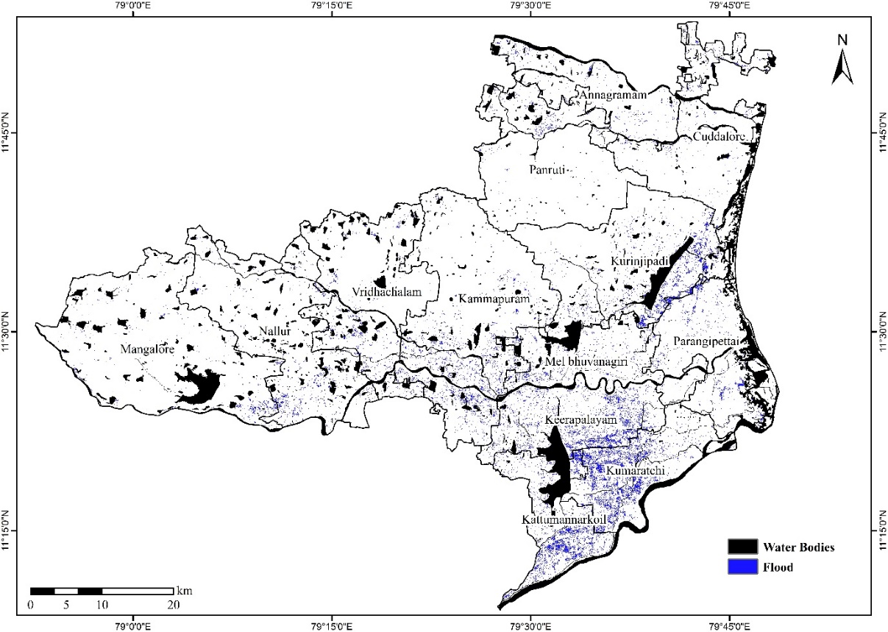
Fig. 4. Flood area mapping in Cuddalore district
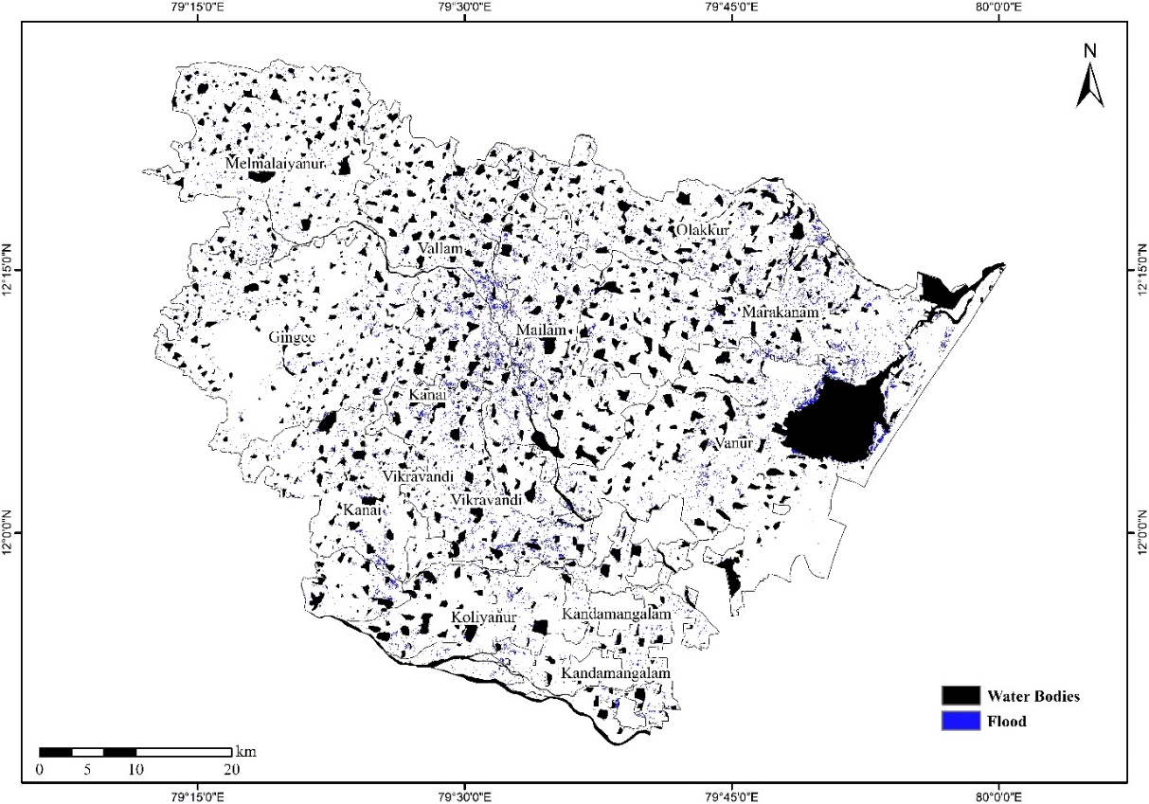
Fig. 5. Flood area mapping in Viluppuram district
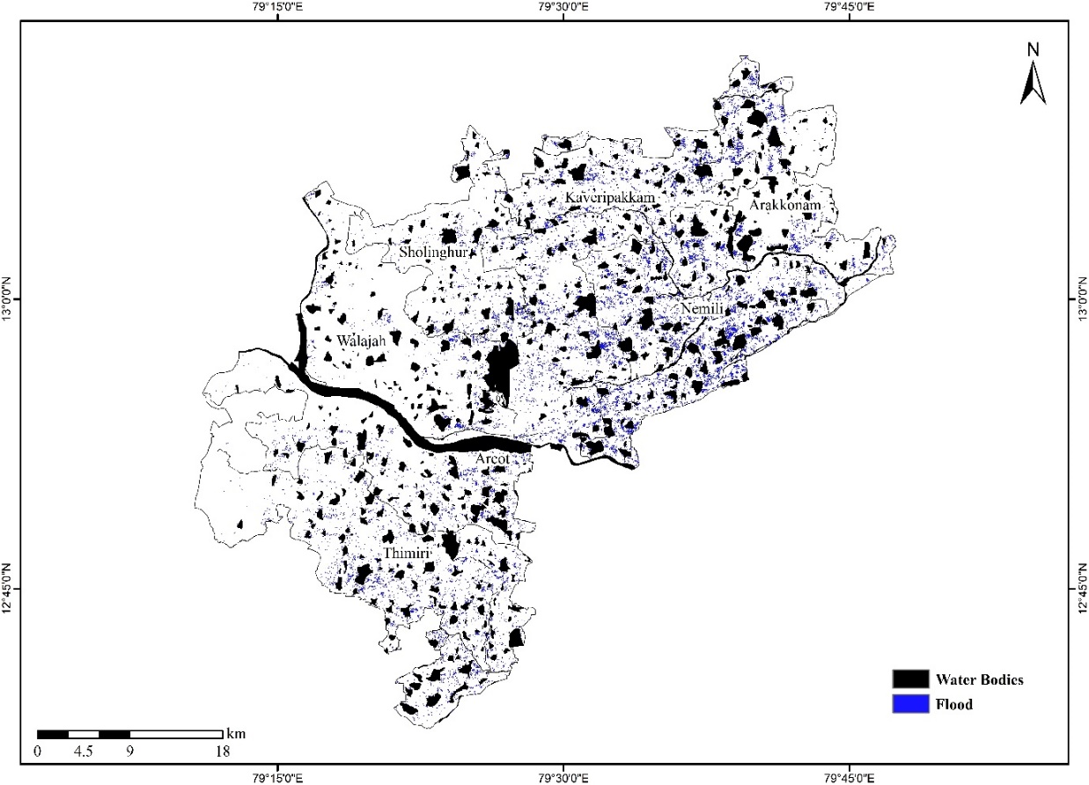
Fig. 6. Flood area mapping in Ranipet district
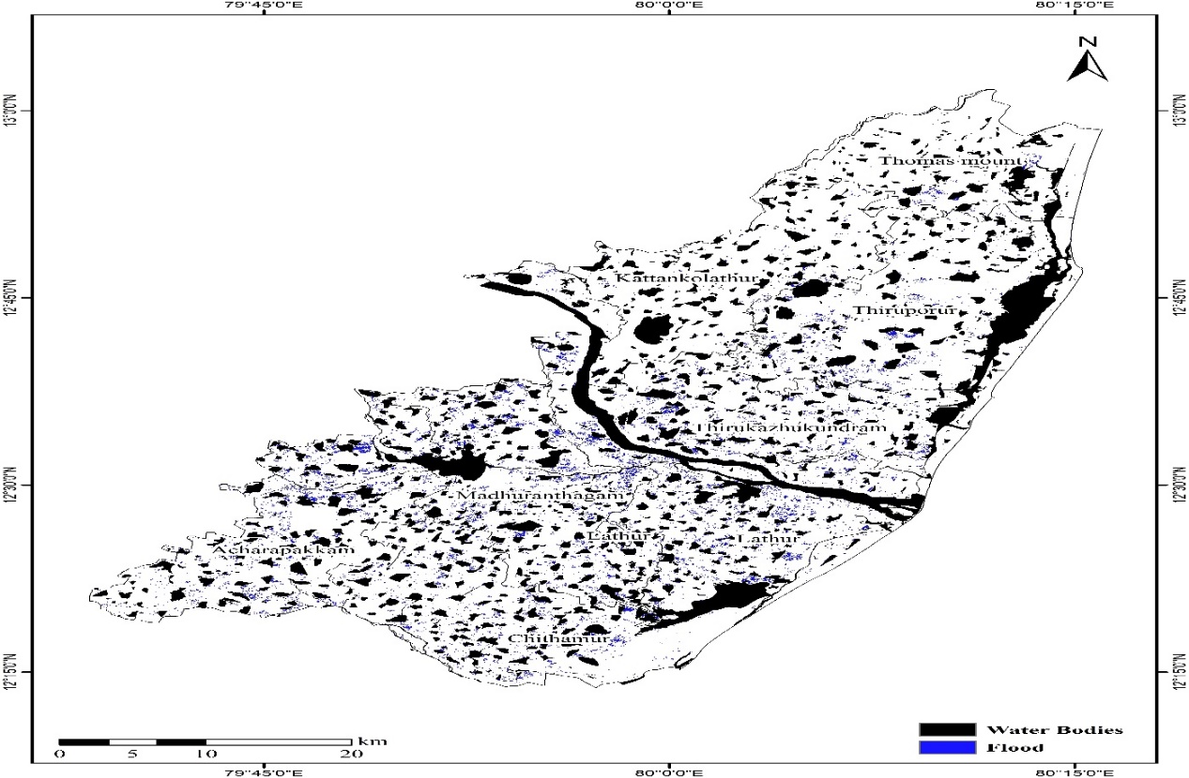
Fig. 7. Flood area mapping in Chengalpattu district
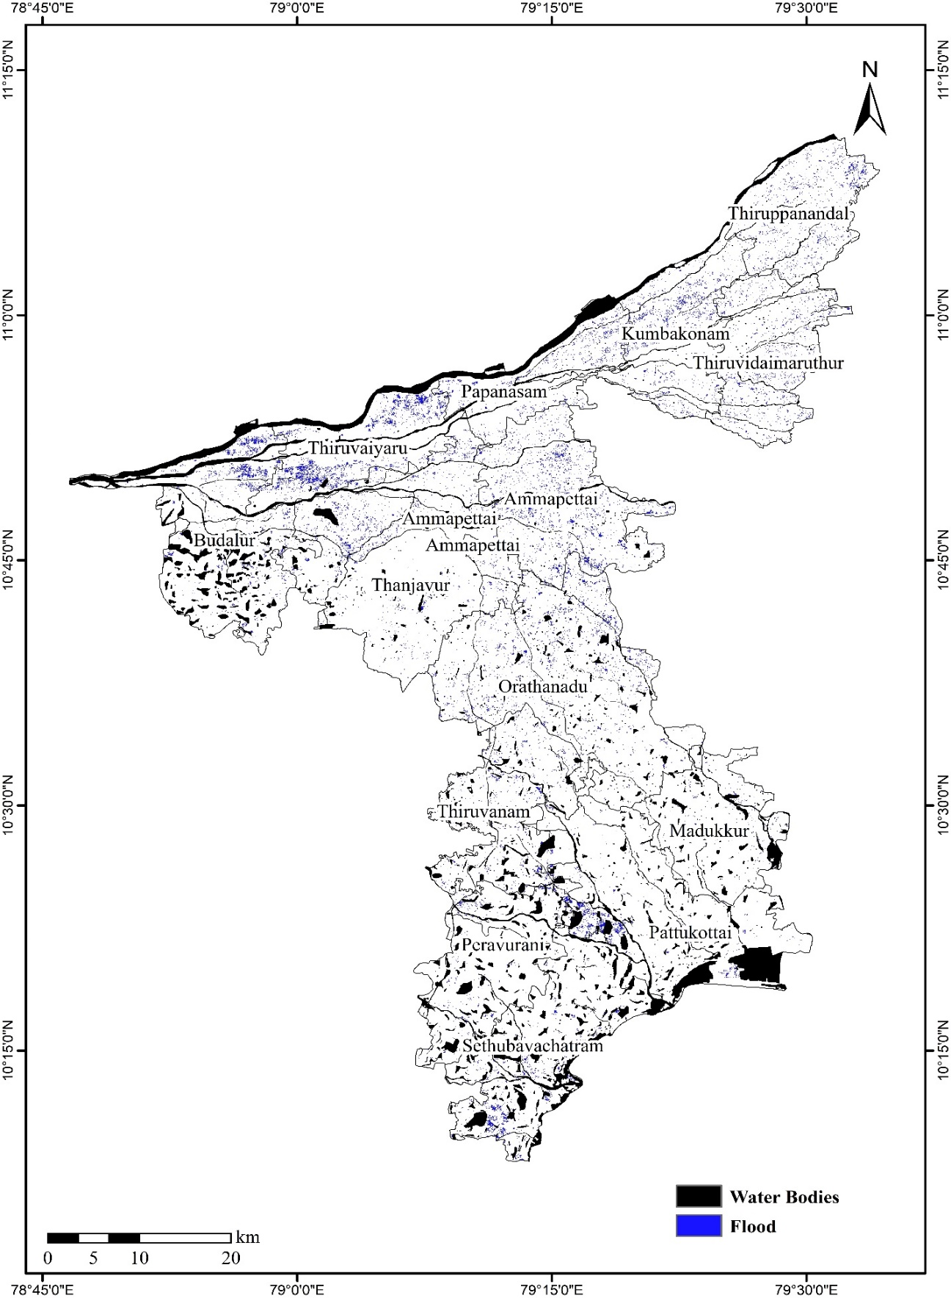
Fig. 8. Flood area mapping in Thanjavur district

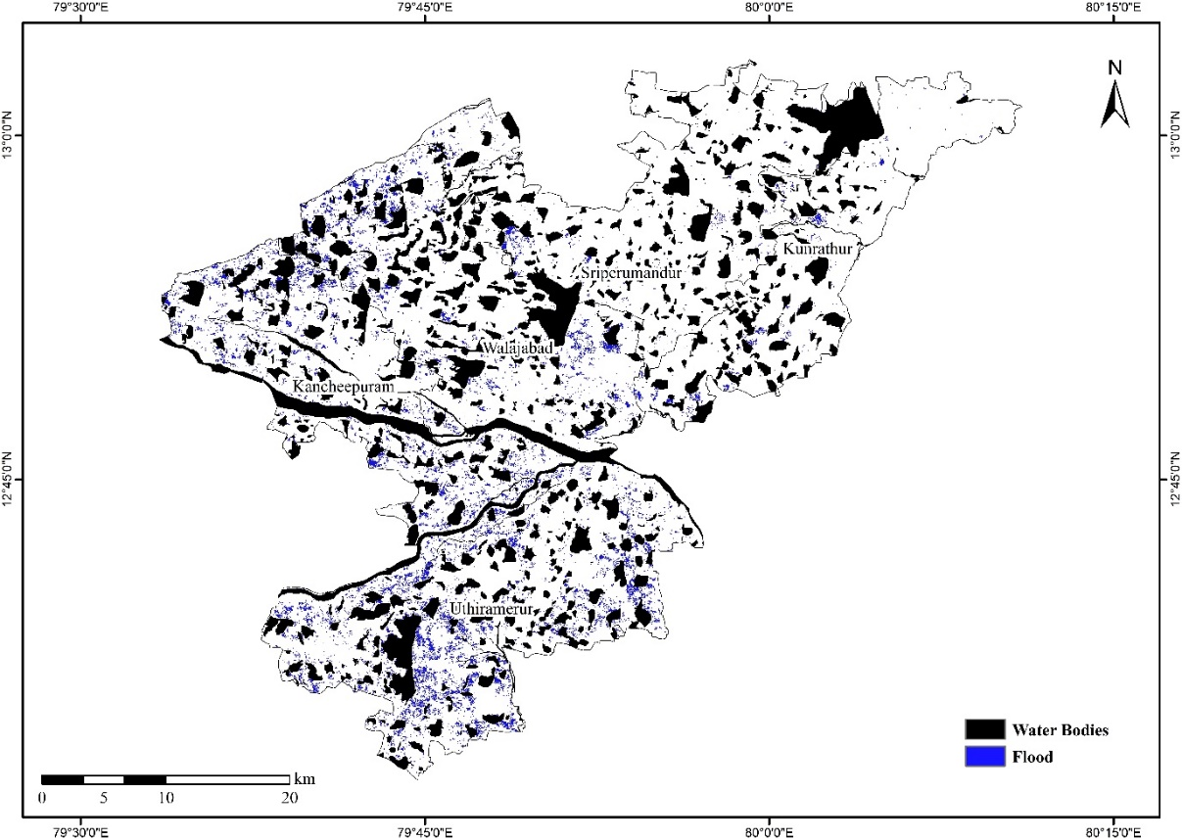
Fig. 9. Flood area mapping in Thanjavur district
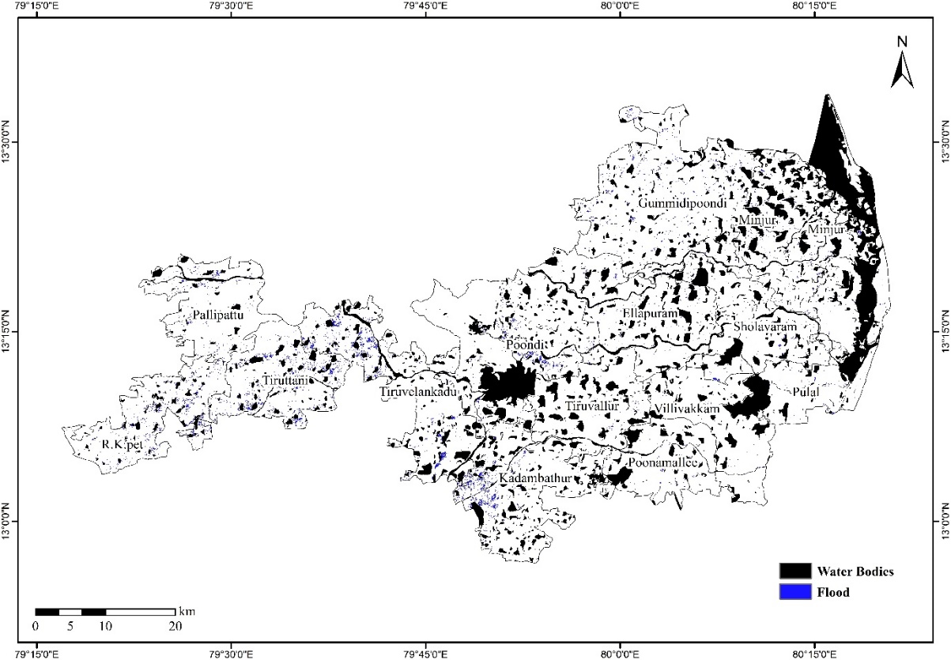
Fig. 10. Flood area mapping in Thiruvallur district
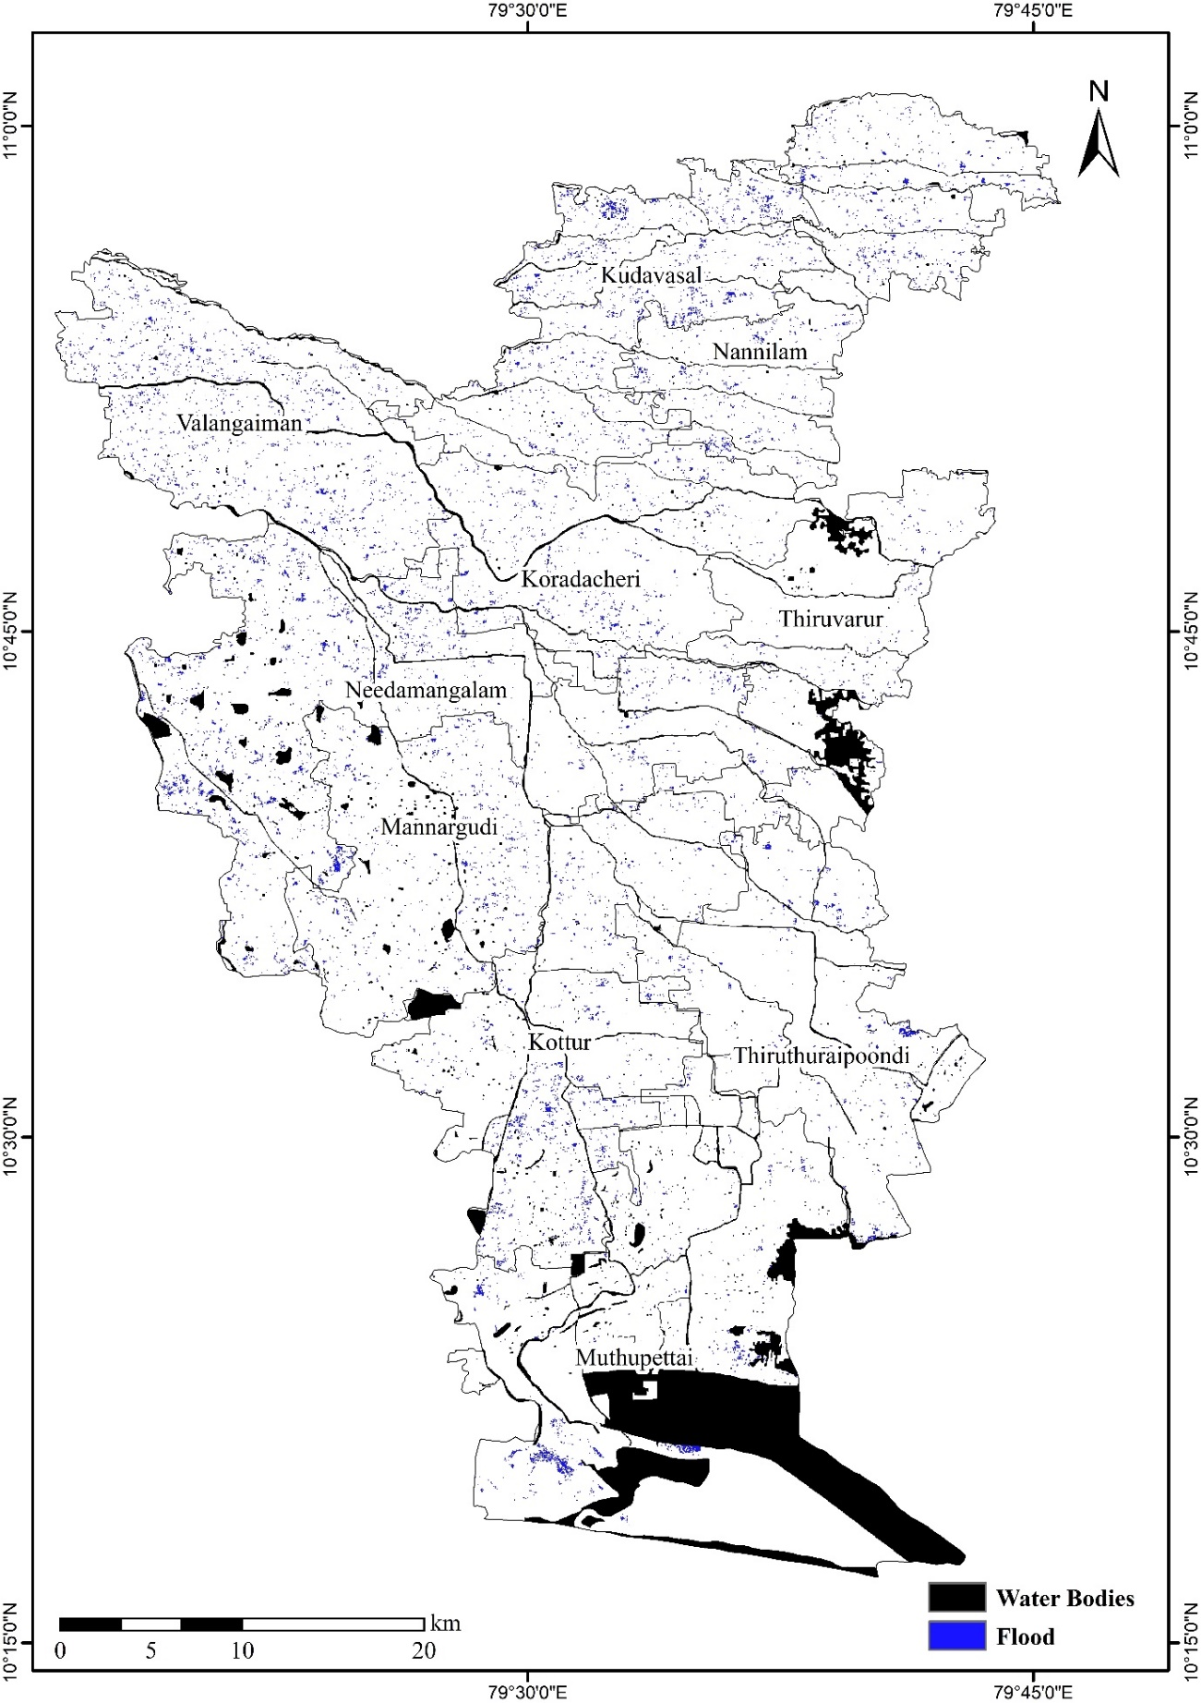
Fig. 11. Flood area mapping in Thiruvarur district

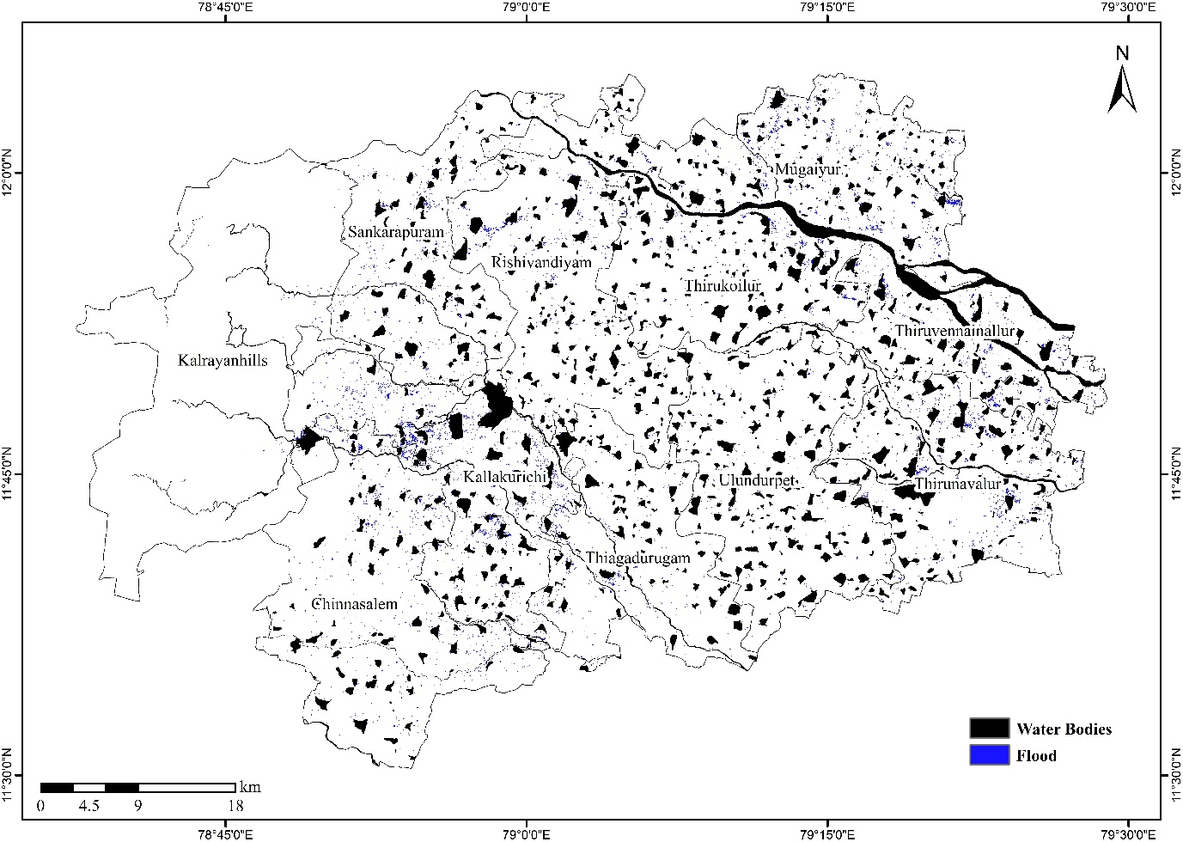
Fig. 12. Flood area mapping in Kallakurichi district
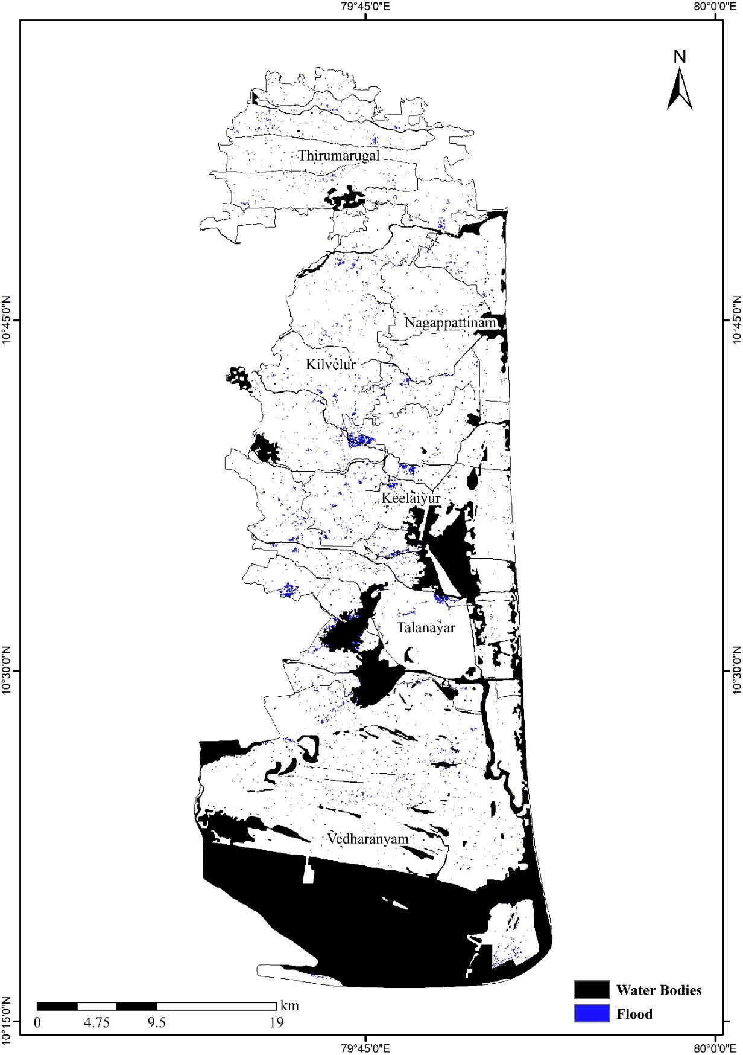

Fig. 13. Flood area mapping in Nagapattinam district
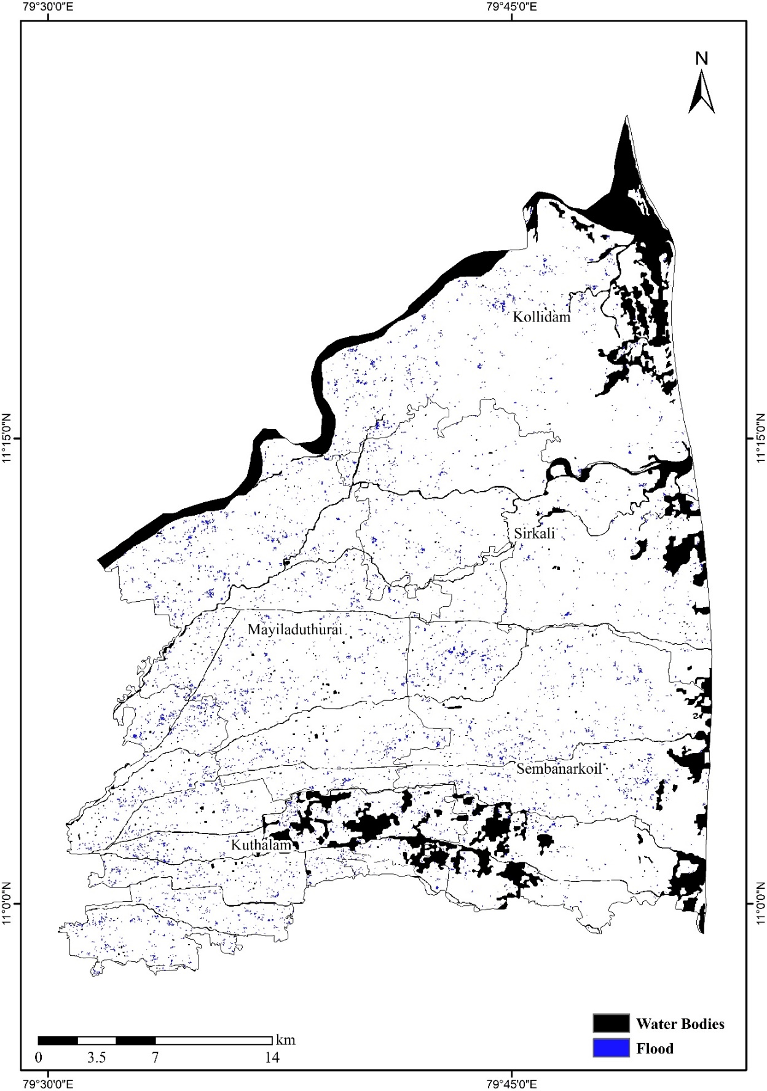
Fig. 14. Flood area mapping in Mayiladuthurai district

3.3 Accuracy assessment
To validate flood area estimates from satellite data, ground truth points were collected from regions affected by flood affected regions. These points were used to check the accuracy of the results. The categorized outputs were validated using the points collected during the survey. 350 ground truth points were collected, out of which 309 points coincided with the flood-affected areas. Among these 309 points, 214 were flood points and 95 were non-flood points. A confusion matrix was generated to determine the flood area estimation and accuracy classification (Table 3).
Among the 214 ground truth flood points, 197 points were correctly classified as flood-affected areas. The overall accuracy of the results was 90.00 per cent. The producer and user accuracy for flood-affected areas was 92.10 per cent and 93.40 per cent, respectively. The producer and user accuracy for non-flood areas. was 85.30 per cent and 82.70 per cent, respectively. A Kappa index of 0.80 was obtained, which indicates high defining accuracy.

Table 3. Confusion matrix for accuracy assessment
Actual class from the survey | Predicted class from the map
Actual class from the survey |  | Flood | Non-Flood | Accuracy
Actual class from the survey | Flood | 197 | 17 | 92.1%
Actual class from the survey | Non-Flood | 14 | 81 | 85.3%
Actual class from the survey | Reliability | 93.4% | 82.7% | 90.0%
Average accuracy |  | 88.7% | Good Accuracy
Average reliability |  | 88.0%
Overall accuracy |  | 90.0%
Kappa index |  | 0.80

Based on the aforementioned data, flood inundated areas were examined for the year 2024.The results obtained in the study are discussed in the chapter.
Floods are one of the most common natural disasters in the world, occurring when a great amount of rain falls in a short period of time, resulting in a large volume of surface runoff Abdelkareem et al., (2017) Flood disasters have become the most common natural phenomena as a result of climate change and other environmental circumstances. Floods pose a serious threat to human lives around the world since most countries are vulnerable to them, and they cause various sorts of harm, including numerous environmental and socio-economic effects Taylor et al., (2011) Flash floods create widespread devastation particularly in cropping areas.
In 2024, maximum rainfall exceeding 200 mm led to severe flood impacts, while rainfall between 100-200 mm caused moderate effects. Rainfall ranging between 100-130 mm indicated less severe flooding (Fig. 15). These trends reflect the rising probability of floods due to increased torrential rains linked to climate change.
Recently, cyclones Nivar and Burevi, along with persistent low-pressure systems in 2021, brought intense rainfall to the Chennai–Cuddalore and delta regions, severely affecting low-lying communities. Unlike the Chennai metropolitan area, the Villupuram, Cuddalore, and Cauvery delta regions have a significant portion of agricultural land. Even brief inundation of water, less than a foot deep, resulted in flooding and substantial crop losses Khan et al., (2021).
The results clearly show that the north eastern regions extending from Tiruvannamalai to Nagapattinam districts are subject to very high exposure of economic elements to flood hazards.

Fig. 15. Total Precipitation range in the study area

4. Conclusion

The study analyzed flooding in a specific area for 2024, using rainfall and flood damage data. The research revealed that heavy rainfall was a significant contributor to flooding in the region. Despite under adverse weather conditions, the study revealed that Synthetic Aperture Radar (SAR) data was a useful tool for identifying locations that had been inundated and for delivering accurate information during a flood event. The flood vulnerability assessment using Sentinel-1A satellite data has provided critical insights into the extent and impact of flooding across Tamil Nadu in 2024. With a total of 90,369 hectares of agricultural land affected, the study highlights the urgency of implementing targeted flood management strategies. Regions like Tiruvannamalai, Cuddalore, and Viluppuram have been identified as high-priority areas due to the extensive damage observed, while areas such as Mayiladuthurai and Nagapattinam, though less affected, still require proactive measures to mitigate future risks. These findings underscore the importance of integrating advanced remote sensing technologies with ground-level data to better understand flood dynamics and prioritize mitigation efforts. By focusing on resilience-building measures, such as improving water management infrastructure, adopting flood-tolerant crop varieties, and enhancing ecosystem restoration in vulnerable areas, stakeholders can protect livelihoods and reduce the environmental impact of future floods. This data-driven approach provides a foundation for sustainable disaster risk management and resource allocation, ensuring long-term agricultural and environmental security in Tamil Nadu.

References

Abdelkareem, M. (2017). Targeting flash flood potential areas using remotely sensed data and GIS techniques. Natural Hazards, 85(1), 19-37.
Ahmed, T. (2021). "Monitoring and mapping of flash flood of Patna city using sentinel-1 images: a case of India’s most flood prone state." Academia Letters " 2.
Gasparovic, M. and D. Klobucar (2021). "Mapping floods in lowland forest using sentinel-1 and sentinel-2 data and an object-based approach." Forests "12(5): 553.
George, S. L., Kantamaneni, K., V, R. A., Prasad, K. A., Shekhar, S., Panneer, S. & Balasubramani, K. (2022). A multi-data geospatial approach for understanding flood risk in the coastal plains of Tamil Nadu, India. Earth, 3(1), 383-400.
Khan, I., Lei, H., Shah, A. A., Khan, I., & Muhammad, I. (2021). Climate change impact assessment, flood management, and mitigation strategies in Pakistan for sustainable future. Environmental Science and Pollution Research, 28, 29720-29731.
Melkamu, T., Bagyaraj, M., Adimaw, M., Ngusie, A., & Karuppannan, S. (2022). Detecting and mapping flood inundation areas in Fogera-Dera Floodplain, Ethiopia during an extreme wet season using Sentinel-1 data. Physics and Chemistry of the Earth, Parts a/b/c, 127, 103189.
Melkamu, T., Bagyaraj, M., Adimaw, M., Ngusie, A., & Karuppannan, S. (2022). Detecting and mapping flood inundation areas in Fogera-Dera Floodplain, Ethiopia during an extreme wet season using Sentinel-1 data. Physics and Chemistry of the Earth, Parts a/b/c, 127, 103189.
Parthasarathy, K. and S. Kundapura (2022). Mapping of Flood-Inundated Urban Regions Using Sentinel-1 SAR Imagery for the 2018 and 2019 Kerala Floods. International Conference on River Corridor Research and Management, Springer.
Periyasamy, P., Yagoub, M. M., & Sudalaimuthu, M. (2018). Flood vulnerable zones in the rural blocks of Thiruvallur district, South India. Geoenvironmental Disasters, 5, 1-16.
Richards, J. A. (1996). Classifier performance and map accuracy. Remote sensing of environment, 57(3), 161-166.
Sreechanth, S. and K. Yarrakula (2017). "Multi-temporal analysis of Sentinel-1 SAR data for urban flood inundation mapping: Case study of Chennai Metropolitan City".
Sundaram, S., Devaraj, S., & Yarrakula, K. (2022). Mapping and Assessing Spatial Extent of Floods from Multitemporal Synthetic Aperture Radar Images: A Case Study over Chennai City, India.
Taylor, J., Man Lai, K., Davies, M., Clifton, D., Ridley, I., & Biddulph, P. (2011). Flood management: prediction of microbial contamination in large-scale floods in urban environments. Environment international, 37(5), 1019-1029.

Abbreviations

GIS | : | Geographic Information System
ha. | : | Hectare
LANDSAT | : | Land Remote-Sensing Satellite System
LiDAR | : | Light Detection and Ranging
viz., | : | Namely
% | : | Percentage
RADARSAT | : | Radar Satellite
SAR | : | Synthetic Aperture Radar
S1 | : | Sentinel 1
S2 | : | Sentinel 2
S2A | : | Sentinel 2a
VH | : | Vertically Transmitted, Horizontally Received
VV | : | Vertically Transmitted, Vertically Received

