Synergistic impact of biochar and organic amendments on field bean (Vicia faba) growth and soil characteristics

Abstract
Many studies have explored the effects of various biochar types and their combinations with inorganic fertilizers, but few have focused on identifying the most effective organic amendments when used with biochar in sandy loam soil. This study aims to determine the impact of different biochar doses combined with organic amendments on plant growth and yield (Vicia faba) in sandy loam soil. Biochar doses of 15, 20, and 25 t/ha were applied in combination with organic amendments such as farmyard manure (FYM), vermicompost (VC), Ghanajeevamruth (GA), and their various combinations. The effectiveness of these treatments was compared to the use of biochar alone. Results indicated that the combination of biochar and organic amendments significantly increased average pod number (by 36.19% to 88.63%) and pod weight (by 24.11% to 83.18%) compared to biochar alone. Higher biochar doses consistently resulted in increased pH levels in the soil, regardless of the organic amendment used. Additionally, biochar combined with organic amendments led to higher nutrient levels, including nitrogen, phosphorus, potassium, calcium, magnesium, and sulfur, compared to biochar alone. The study concluded that biochar, particularly in combination with Ghanajeevamruth, had superior effects on plant growth and yield. The choice of amendment and biochar dosage significantly influenced soil pH, nutrient availability, bulk density, and water holding capacity. These findings underscore the potential of combining biochar with organic amendments to enhance soil fertility and agricultural productivity, offering valuable strategies for sustainable nutrient management in sandy loam soils.
Keywords: Biochar, organic amendments, FYM, Ghanajeevamruth, Vermicompost, soil nurients, Field bean, Growth parameters, Yield parameters.

Introduction
Growing population demands have resulted in unsustainable farming practises and a significant reliance on chemical pesticides and fertilisers, which have degraded the soil quality (Vijay et al. 2021). Because of the fast decomposition of soil organic matter and ensuing decline in soil carbon content, over use of chemical fertilisers can result in soil fertility loss, nutritional imbalances, and global warming (Foley et al. 2005).This impact is particularly severe in tropical areas as only a tiny amount of newly introduced organic materials settle in soil over time and the rest of the carbon is released to the environment as carbon dioxide (Agegnehu et al. 2016). The application of organic manures produced from biomass and animals plays a significant role in nutrient recycling through improving nutrient availability and soil physical properties (Hasler et al. 2015).Apart from the conventionally used organic manures like farmyard manure and vermicomposting ,one of the key areas that captured global attention is the application of recalcitrant biochar produced from agricultural biomass (Bruun et al. 2016; Speratti et al. 2018).There are numerous studies that reported the role of biochar in enhancing soil quality (Kammann et al. 2015;Spokas et al. 2012; Xu et al. 2014) boosted crop productivity, and encouraged plant development (Major et al. 2010; Zhang et al. 2010). Addition of biochar influences several mechanisms, including initial addition of soluble nutrients contained in the biochar (Sohi et al. 2010) ,mineralization of the labile fraction of biochar containing organically bound nutrients (Lehmann et al. 2015), reduction of nutrient leaching due to biochar's physicochemical properties (Liang et al. 2006), and retention of N, P, and S associated with plants, have been proposed for increasing plant nutrient availability in nutrient-limited agroecosystems(Pietikainen et al. 2000).
Nelissen et al. 2015 reported that the application of biochar improves the physical quality of the soil to some extent by increasing porosity, reducing soil bulk density, and enhancing soil aggregation especially one year after application. Additionally, an increase in the exchangeable cations in the biochar amended soil attributed to the high specific area and carboxylic groups of the biochar (Hammes et al. 2012). It also enhances the conductivity of soil by 124.6 %, reduce soil acidity by 31.9 % (Oguntunde et al. 2008) and increases the extractable elements like Na, K, Ca and Mg upto 60-670% Wang et al. (2014), which showed an overall improvement in the soil fertility and nutrient retention.
There are many formulations that blend biochar with various kinds of organic matter to create "terra pretta" like planting substrates (Wolf and Wedig., 2007). Terra pretta also known as Amazonian black soil was historically created by the charring of vegetation and the addition of organic materials like leaf litter, kitchen waste, and faeces. The pre-Columbian inhabitants of the amazon basin were aware of the advantages such soil amendments have on plant development and growth (Kammann et al. 2016). Recent years have seen the development of scientific data to support these traditional methods (Lehmann and Joseph, 2015). The vast majority of studies revealed that applying biochar along with compost yielded superior results in terms of plant development than doing it individually. This is because of the nutrient absorption, particularly nitrate, and their subsequent gradual release into the soil (Joseph et al. 2013 ; Schulz et al. 2013 ). Such co-composting data on biochar shows its positive effects on plant growth and soil improvement. However, there aren't many researches that recognise the direct interaction between biochar and organic amendments (Rawat et al. 2019). But because there is a dearth of knowledge, the amount and type of organic resources that should be combined with biochar are insufficient. In this background our investigation mainly aimed to understand how different organic fertiliser combinations with biochar affect plant performance and soil quality. This study for the first time provides a better comparison of different organic fertilizer combination with effective dosages of biochar to be used as soil supplement.
Materials and methods
The experiment was conducted at Advanced Research Centre on Biofuels, University of Agricultural Sciences (13°08 'N and 77°57 'E), Bangalore, India. The region received an average rainfall of 358.2 mm during the cropping period (September to December).The maximum and minimum temperature varied from 27.2 °C to 34.5 °C and 19.0 °C to 20.5 °C, respectively. The soil used for the experiment was neutral to alkaline with a pH of 7.2 and was acquired from the Research Institute on Organic Farming, GKVK, Bangalore. Based on the textural categorization using the international pipette technique(Jena etal 2013), the soil was identified as sandy loam (62.73 % sand, 20.41 % silt, and 16.86 % clay).The soil organic carbon content is 0.72%(less than 1%).
Field beans (Vicia faba) variety, Hebbal avare from the Research institute on organic farming, University of Agricultural Sciences, Bangalore was used for this study. Three doses of biochar (15,20 and 25 t/ha) were amended with organic amendments like FYM, Vermicompost and ganajeevamruth. Apart from these soils with different doses of biochar without any organic amendments were kept as control. Thus a total of eighteen treatments were replicated thrice in the 18 ×18 inches pot for the experiment. Following the harvest of the crop, soil samples were taken from each of the experimental treatment pots at a plough layer depth (0–15 cm). The collected samples were rendered with a pestle and mortar to grind them, and then passed through a 2 mm sieve after drying in the shade.

Biochar preparation
The biochar was produced by pyrolysis from paddy straw in a pilot scale pyrolysis machine with an average residence time of 4 hours and a fixed temperature of 500°C. The paddy straw was sun dried to an optimal moisture content of 10% and shredded into 8 to 12 mm pieces. To produce biochar, these paddy straws were fed into a resistively heated fixed-bed reactor where sweeping gas descends through a bundle of resistively heated samples. The resulting biochar was ground to pass through a 0.2 mm sieve for further analysis.
Characterization of soil, biochar and other organic amendments
The soil and biochar were characterised in accordance with accepted procedures. Potentiometry was used to measure pH and electrical conductivity (Stitt 1999). The Keen's cup method was used to calculate bulk density (g/cc) and MWHC (%) (Katkar et al. 2018). The Dry Combustion technique (CHNS, LECO) was used to calculate the % of total carbon (Sparks et al. 2020). Other elements are determined by standard approach given by (Stitt 1999). Total nitrogen % was calculated using the Kjeldahl digestion and distillation method, phosphorus % and potassium % by acid digestion and the vanadomolybdate method, calcium (%) and magnesium (%) by complexometric titration. Sulphur (ppm) was analysed by 0.15 % CaCl extraction and turbidity analysis (Lucheta and Lambais 2012).Iron, copper, manganese, and zinc (ppm) were analysed by diacid digestion and atomic absorption spectroscopy (Anita et al. 2018), respectively. The biochar was subjected to a proximate analysis using the guidelines outlined by ASTM, 2007. Table 1 lists the characteristics of the rice straw biochar that were used in the study.
Farmyard manure (FYM), vermicompost (VC), ganajeevamruth (GA), and combinations of these were used in conjunction with biochar dosages. The organic amendment, ganajeevamruth, include 10 kg of desi cow dung, 500 g of pulse flour, 500 ml of desi cow urine, 100 g of jaggery, and a handful of soil, which was then powdered and utilised in the experiment. A detailed characterization of the organic amendments utilised in the study are given in Table 2.
Determination of plant growth and nutrient uptake
Average plant height, number of leaves and branches were measured at 30, 60 days after sowing and at harvest. Similarly, yield related parameters such as number of pods per plant and pod weight were determined after harvest. Dried, ground-up plant samples from the crop were tested for macronutrients (N, P, K, Ca, Mg, and S) and micronutrients (Fe, Zn, Mn and Cu). A vacuumed chamber at 85 ° C on a sand bath was used to digest one gram of the dried and ground samples after predigesting them for 24 hours with 10 ml HNO₃ (62 %). The pre-digested samples were treated with 10 ml of a di-acid mixture reagent (10:4 HNO₃ + HClO₄) and held on a sand bath until white precipitate was left at the bottom. After filtration, the digested samples were diluted with distilled water and volume formed to a defined concentrations. This extract was used to assess P, K, Ca, Mg, and micronutrients (Fe, Cu, Mn, and Zn) using conventional methods. The amount of nitrogen, potassium, phosphorus, calcium, and magnesium was determined from the diacid digested content using the Micro Kjeldhal digestion and titration, flame photometric method, vanodo molybdo phosphoric yellow colour method, and versenate titration process, respectively (Pipper 1966). Micronutrients (Zn, Cu, Mn and Fe) in plants were measured by feeding the digested extract samples after being diluted to an appropriate concentration of the Perkin Elmer atomic absorption spectrophotometer using correct hallow cathode lamps and presented as mg kg⁻¹ in plant and seed sample samples (Jackson 1973).
Statistical analysis
Statistical analysis and graphs were plotted by R version 4.0.2 each data point was summarized by calculating the average value and standard deviation (S.D.) ( Team R). Additional packages ‘ggplot2’ was used for plotting the graphs (Wickham 2016) One-way analysis of variance (ANOVA) at the significance level of 0.05 was used to test the differences between the control and biochar in combination with organic amendments separately for each soil property. Multiway ANOVA was used to understand the effects of biochar combinations with organic amendments (A), biochar dosages (B) and the interaction of A×B on plant growth parameters and soil physicochemical properties. To detect the difference among the treatments after ANOVA, Tukey’s honestly significant difference at 0.05 confidence level was used (Mendiburu 2019). Pearson correlation analysis was applied for measuring the linear dependence among soil properties. The five-point scale was used for interpreting the size of the correlation coefficient (Hinkle et al. 2003).
Results and Discussion
The study demonstrates the synergistic effects of combining biochar and organic amendments on soil properties, crop growth, and yield. The characterization of paddy straw biochar reveals its highly carbonized nature, with significant fixed carbon content (6.1%) and alkaline pH (10.29). This biochar, when combined with organic amendments like Ghanajeevamruth (GA), Vermicompost (VC), and Farmyard manure (FYM), significantly improves the soil's nutrient profile, pH, and other essential physical properties. The study shows that the combination of biochar with organic inputs resulted in higher soil pH, improved organic carbon levels, and better plant growth parameters like height, pod number, and pod weight in field bean (Vicia faba).

Effect on Plant Growth and Yield
The combination of biochar with organic amendments consistently enhanced plant growth across different growth stages. Higher plant heights, greater pod numbers, and increased pod weights were observed with biochar-amendment combinations compared to biochar alone. Specifically, the combination of 25 t/ha biochar with GA showed the highest plant height across all stages (30, 60 days after sowing, and harvest), and biochar combined with FYM and GA resulted in the most significant improvements in pod number and weight. This can be attributed to the nutrient release dynamics facilitated by biochar's porous structure and organic amendments, which promote better nutrient availability and microbial activity. The addition of organic fertilizers in combination with biochar likely facilitated enhanced microbial mineralization, increasing the availability of essential nutrients such as nitrogen, phosphorus, and potassium (Dai et al., 2017).

Soil Properties
The study highlights the significant impact of biochar-amendment combinations on soil properties. Soil pH increased by 0.60 to 13.84% across all treatments, with the maximum pH of 8.19 observed in the combination of 25 t/ha biochar with FYM and VC. The alkaline nature of biochar contributed to this rise in pH. This increase in pH could reduce soil acidity, improving nutrient availability and microbial activity (Haseena et al., 2022). Additionally, biochar application, especially at higher doses (25 t/ha), decreased soil bulk density (BD) and increased the maximum water holding capacity (MWHC), which are beneficial for plant growth. The decrease in BD and increase in MWHC indicate improved soil structure and porosity, leading to better root development and water retention, essential for optimal plant growth (Blanco-Canqui, 2017). Biochar combined with organic amendments such as GA and FYM also resulted in higher soil organic carbon (SOC), nitrogen, phosphorus, potassium, calcium, magnesium, and sulphur. This enhancement in nutrient availability can be attributed to the combined effect of biochar's capacity to adsorb and retain nutrients and the nutrient-rich nature of organic amendments. Biochar's porous structure supports the formation of organo-mineral complexes, stabilizing organic carbon and reducing nutrient leaching (Ngo et al., 2013). These improvements in soil fertility contribute to better plant growth and yield.
Characterization of Paddy Bio oil.
Bio oil was separated from the liquid mixture using 4 ml toluene and the bio oil was analyzed using GCMS and the result is represented in the Table 3
The components identified were phenol with the ketone and aldehyde groups attached, and almost all of the functional groups showed the widespread presence of oxygen. On the other hand, the analysis showed that the abundant aldehydes and ketones make the substance particularly hydrophilic, which makes it difficult to remove water. Luo et al. (2004) showed that the relevant information on rice straw bio oil was not available, the bio-oil from Prunus indicus comprised of laevoglucose, furfural, phenols (with methyl, methoxy and/or propenyl groups), aldehydes (including benzaldehyde with methyl and/or hydroxyl) and vanillin according to the GC–MS analysis. The bio oil indicates that the bio-oil is a complicated organic compound that mainly consists of water, acids and heterocyclic substances and found to be rich in phenol with 27.23% by weight followed by p-cresol 16.95% on par with 4-ethyl- Phenol having 8.99%, and the lowest amount of L-.alpha.-Terpineol (1.52%) was recorded. Bio-oils have received extensive recognition from international energy organizations around the world for their characteristics as fuels used in combustors, engines or gas turbines and resources in chemical industries. Many substances can be extracted from biooil, such as phenol used in the plastics industry, volatile organic acid to form a film forming agent, laevoglucose, hydroxyl acetaldehyde and some additives are applications in the pharmaceutical industry, synthetic fibres or fertilizers and flavouring agents in food products. Yan et al., (2001) The 99.7% of bio-oil, a complex mixture containing carbon, hydrogen and oxygen, is composed of acids, alcohols, aldehydes, esters, ketones, sugars, phenols, guaiacols, syringols, furans, lignin derived phenols and extractible terpene with multi-functional groups.
The findings from this study align with the growing body of research highlighting the benefits of biochar and organic amendments for improving soil health and promoting sustainable agricultural practices. Biochar's role in enhancing soil structure, increasing nutrient retention, and raising pH is well-documented (Steiner et al., 2007; Lehmann et al., 2011). When combined with organic amendments like GA, VC, and FYM, biochar helps improve soil fertility by increasing nutrient availability and promoting microbial activity, which further supports plant growth and yields. These interactions likely occur due to the high surface area and porous structure of biochar, which supports nutrient adsorption and microbial colonization.
The study also highlights the long-term benefits of biochar in combination with organic amendments, such as improved soil organic carbon content and nutrient stability, which can contribute to carbon sequestration and sustainable soil management practices. These effects are crucial for addressing the challenges of soil degradation and nutrient depletion in agriculture, as seen in the decreasing Soil Organic Carbon (SOC) content in India (National Rain-fed Area Authority, 2022).

Correlation Analysis
The correlation analysis reinforced the positive relationship between soil organic matter and nutrient content, showing that higher organic matter increases the availability of key nutrients like nitrogen, phosphorus, potassium, calcium, magnesium, and sulphur. A negative correlation between bulk density (BD) and electrical conductivity (EC) was also observed, with lower BD enhancing nutrient availability and improving soil structure. Furthermore, the study showed that MWHC negatively correlated with BD, suggesting that as bulk density decreases, soil's capacity to retain water improves, enhancing plant growth conditions (Singh et al., 2020).

Conclusion
The combination of biochar with organic amendments significantly enhances soil fertility, improves physical properties of the soil, and supports better plant growth and yield. This approach offers a promising strategy for sustainable agriculture, addressing issues such as soil degradation, nutrient depletion, and low crop productivity. Future studies should focus on the long-term impacts of these combinations, particularly in terms of soil carbon sequestration, microbial diversity, and nutrient cycling, to further optimize agricultural practices for environmental sustainability.
Data availability: The datasets used or analysed during the current study are available from the corresponding author on reasonable request.

Proximate analysis of biochar (%)
Ash | 13
Fixed carbon | 6.1
Moisture content | 9.5
Volatile matter | 71.4
Ultimate analysis of biochar (%)
Carbon | 35.15 %
Nitrogen | 0.41 %
Phosphorous | 0.04 %
Potassium | 3.83 %
Oxygen | 46.21 %
Calcium | 2.39 %
Magnesium | 0.24 %
Sulphur | 0.07 %
Hydrogen | 4.16 %
C:N | 85.7
O:C | 1.31
H:C | 0.12
Other properties
pH | 10.29
EC | 3.287 d Sm⁻¹
Bulk density | 0.56 Mg m⁻³
Maximum Water holding capacity | 64.35 %
Table 1. Characterisation of rice straw biochar used in the study.

Table 2. Characterization of Organic amendments used in the study.
Particulars | Ganajeevamruth | Vermicompost | FYM
pH | 6.8 | 7.06 | 6.6
Electrical conductivity (dS m⁻¹) | 7.03 | 3.26 | 3.17
Organic carbon (%) | 14.2 | 13.6 | 11.8
Available Nitrogen (%) | 3.81 | 2.63 | 1.03
Available Phosphorus (%) | 10.7 | 9.17 | 6.59
Available Potassium (%) | 3.48 | 2.95 | 1.55
Exchangeable Calcium (ppm) | 55 | 49 | 38.6
Exchangeable Magnesium (ppm) | 21.8 | 14.5 | 11.6
Available Sulphur (ppm) | 0.18 | 0.13 | 0.11

Table 3. Relative content of main compounds in organic composition of bio-oil
produced from Paddy straw by GC-MS.
Peak No. | Wt  % | Name
1 | 2.24 | 2-Cyclopenten-1-one, 2-methyl-
2 | 2.85 | Butanoic acid, 4-hydroxy-
3 | 4.50 | 2-Cyclopenten-1-one, 3-methyl-
4 | 27.23 | Phenol
5 | 1.77 | 2-Furanone, 2,5-dihydro-3,5-dimethyl-
6 | 4.76 | 2-Cyclopenten-1-one, 2,3-dimethyl-
7 | 6.50 | 2-methyl- Phenol
8 | 16.95 | p-Cresol
9 | 8.41 | Phenol, 2-methoxy-
10 | 1.93 | 4-Hexen-3-one, 4,5-dimethyl-
11 | 1.64 | 2,3-dimethyl- Phenol
12 | 8.99 | 4-ethyl- Phenol
13 | 2.12 | Phenol,3,5-dimethyl-
14 | 1.79 | 2-Methoxy-5-methylphenol
15 | 1.52 | L-.alpha.-Terpineol
16 | 1.97 | 4-ethyl-2-methoxy- Phenol
17 | 3.25 | 2,6-dimethoxy- Phenol
18 | 1.59 | Apiol

Fig 1: Plant height of field bean at different intervals ie 30 DAS (SeM; 0.498: LSD; 1.171),at 60DAS (SeM; 0.906: LSD; 1.579) at time of harvest (SeM; 2.999: LSD; 2.873)

a) | b)

Fig 2: a) Average pod number of the field bean (SeM; 1.796 : LSD; 2.223) b)Average pod weight of field bean (SeM; 0.498: LSD; 1.171).

Fig 3: A bar graph demonstrating the percentage rise in pH of soil amended with biochar both on its own and in conjunction with other organic amendments
T1-15T/Ha BC
T2-15T/Ha BC + FYM
T3-15T/Ha BC +VC
T4-15T/Ha BC+GA
T5-15T/Ha BC+FYM+VC
T6-15T/Ha BC+FYM+GA
T7-20T/Ha BC
T8-20T/Ha BC + FYM
T9-20T/Ha BC +VC
T10-20T/Ha BC+GA
T11-20T/Ha BC+FYM+VC
T12-20T/Ha BC+FYM+GA
T13-25T/Ha BC
T14-25T/Ha BC + FYM
T15-25T/Ha BC +VC
T16-25T/Ha BC+GA
T17-25T/Ha BC+FYM+VC
T18-25T/Ha BC+FYM+GA

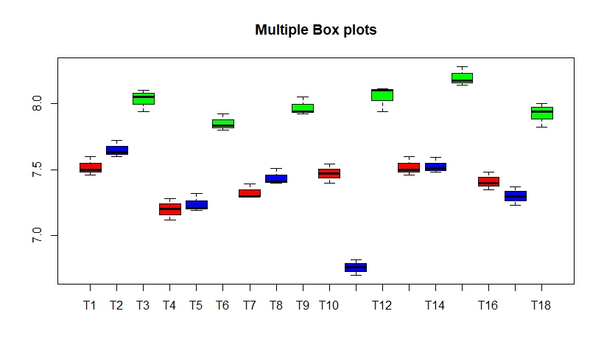
a)
pH
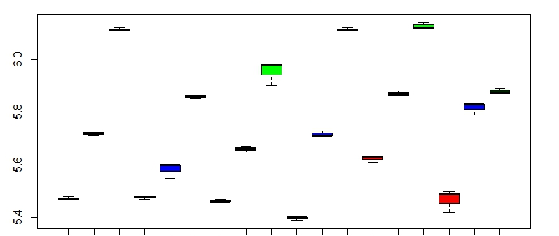
b)
OC (g kg⁻¹)
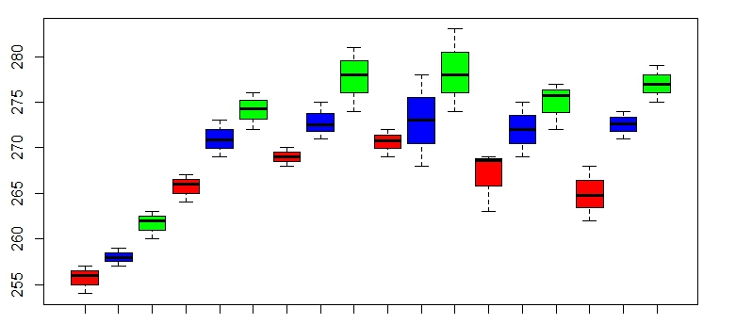
c)
Nitrogen (kg ha⁻¹) (kg ha⁻¹)
d)
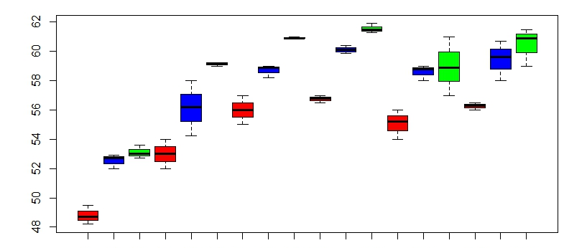
P₂O₅ (kg ha⁻¹)
O₅
(kg ha⁻¹) (kg ha⁻¹)
e)
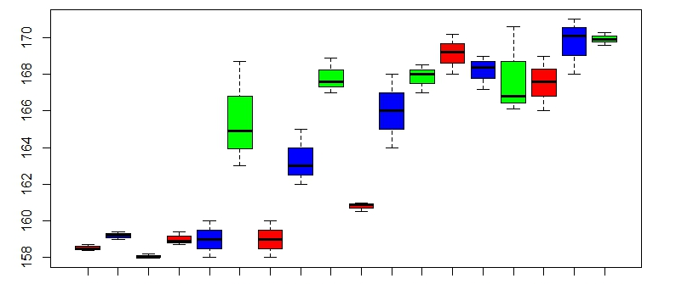
f)
K₂O (kg ha⁻¹)

Fig 4:Boxplot showing the effect of biochar along with different organic amendments on a)soil pH b)Organic Carbon ((g kg⁻¹) c) Nitrogen (kg ha⁻¹)d) P₂O₅ (kg ha⁻¹) e) K₂O (kg ha⁻¹) f) Ca (c mol (p+) kg⁻¹) g) Mg (c mol (p+) kg⁻¹) h) S (mg kg⁻¹)
a)  Fig 5.Effect of biochar and its combination with other organic amendments on a)Bulk density (Mg m⁻³), LSD; 0.016582: CV ;0.7384979: SeM 0.006b)Maximum water holding capacity (%) , LSD; 0.07578479: CV ; 0.1223744: SeM ;0.00208 | b)

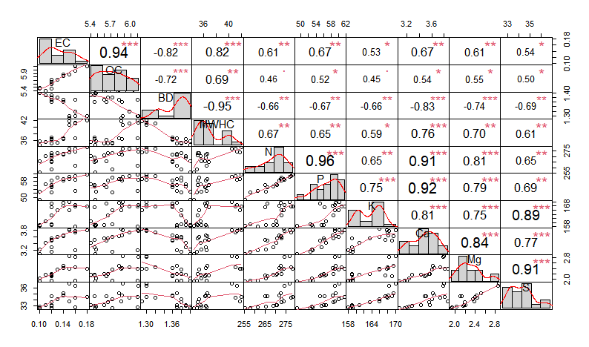
Figure 6: Pearson’s correlation matrix of soil properties. * statistically significant difference at a significance level of 5% ** statistically significant difference at a significance level of 1%, *** statistically significant difference at a significance level of 0.01%

Reference
Agbede TM, Odoja AS, Bayode LN, Omotehinse PO, Adepehin I (2020) Effects of biochar and poultry manure on soil properties, growth, yield and quality of cocoyam (Xanthosoma sagittifolium Schott) grown in sandy soil. Communications in Soil Science and Plant Analysis 51(7), 932-947.
Agegnehu G, Bass AM, Nelson PN, Bird MI (2016) Benefits of biochar, compost and biochar–compost for soil quality, maize yield and greenhouse gas emissions in a tropical agricultural soil. Science of the Total Environment 543, 295-306.
Alburquerque JA, Calero JM, Barrón V, Torrent J, del Campillo MC, Gallardo A, Villar R (2014) Effects of biochars produced from different feedstocks on soil properties and sunflower growth. Journal of Plant Nutrition and Soil Science 177(1),16–25. doi:10.1002/jpln.201200652
Anita EK, Prashant CT, Champa BV, Shivanna M, Nagaraja MS (2018) Secondary and micronutrient status in soils of wine and table type grape orchards of northern Karnataka. International Journal of Chemical Studies 6(3), 2335-2338.
ASTM I (2007) Standard test methods for flexural properties of unreinforced and reinforced plastics and electrical insulating materials. ASTM D790-07.
Blanco-Canqui H (2017) Biochar and soil physical properties. Soil Science Society of America Journal 81, 687–711. doi:10.2136/sssaj2017.01.0017.
Bruun E, Cross A, Hammond J, Nelissen V, Rasse DP, Hauggaard-Nielsen H (2016) Biochar carbon stability and effect on greenhouse gas emissions. In ‘Biochar in European soils and agriculture’ pp. 187-205.( Routledge)
Castro A, da Silva Batista N, Latawiec AE, Rodrigues A, Strassburg B, Silva D, Araujo E, De Moraes LFD, Guerra JG, Galvao G, Alves-Pinto H (2018) The effects of Gliricidia-derived biochar on sequential maize and bean farming. Sustainability 10(3), 578.
Castro A, Da Silva Batista N, Latawiec AE, Rodrigues A, Strassburg B, Silva D, Araujo E, De Moraes LFD, Guerra JG, Galvão G, Alves-Pinto H, (2018) The effects of Gliricidia-derived biochar on sequential maize and bean farming. Sustainability 10(3),.578.
Chaudhari PR, Ahire DV, Ahire VD, Chkravarty M, Maity S (2013) Soil bulk density as related to soil texture, organic matter content and available total nutrients of Coimbatore soil. International Journal of Scientific and Research Publications 3(2), 2250-3153.
Chen Y, Camps-Arbestain M, Shen Q, Singh B, Cayuela ML (2018) The long-term role of organic amendments in building soil nutrient fertility: a meta-analysis and review. Nutr Cycl Agroecosyst 111, 103–125.
De Bang TC, Husted S, Laursen KH, Persson DP, Schjoerring JK (2021) The molecular–physiological functions of mineral macronutrients and their consequences for deficiency symptoms in plants. New Phytologist 229(5), 2446-2469.
de Mendiburu F, de Mendiburu MF (2019). Package ‘agricolae’. R Package, version, 1(3).
Foley JA, DeFries R, Asner GP, Barford C, Bonan G, Carpenter SR, Chapin FS, Coe MT, Daily GC, Gibbs HK, Helkowski JH (2005) Global consequences of land use. Science 309(5734), 570-574.
Gaskin JW, Speir RA, Harris K, Das KC, Lee RD, Morris LA, Fisher DS (2010) Effect of peanut hull and pine chip biochar on soil nutrients, corn nutrient status, and yield. Agron J 102, 623–633
Golzarian MR, Frick RA, Rajendran K, Berger B, Roy S, Tester M, Lun DS (2011) Accurate inference of shoot biomass from high-throughput images of cereal plants. Plant Methods 7,1–11. doi:10.1186/1746-4811-7-2
Guenni O, Romero E, Guédez Y, Bravo de Guenni L, Pittermann J (2018) Influence of low light intensity on growth and biomass allocation, leaf photosynthesis and canopy radiation interception and use in two forage species of Centrosema (DC.) Benth. Grass and Forage Science 73(4), 967-978.
Guo JH, Liu XJ, Zhang Y, Shen JL, Han WX, Zhang WF, Christie P, Goulding K, Vitousek PM, Zhang F (2010) Significant acidification in major Chinese croplands. Science 327:1008–1010. https://doi.org/10.1126/science.1182570
Hagemann N, Joseph S, Schmidt HP, Kammann CI, Harter J, Borch T, Young RB, Varga K, Taherymoosavi, S, Elliott KW and McKenna A (2017) Organic coating on biochar explains its nutrient retention and stimulation of soil fertility. Nature communications 8(1), 1089.
Hammes K, Schmidt MW (2012) Changes of biochar in soil. In ‘Biochar for environmental management’ pp. 201-214. (Routledge)
Haseena K, Balehonnur F, Verma R, Prasanna KT (2022) Impact of Biochar Application on the Chemical Properties of Acidic and Neutral Soil. International Journal of Plant & Soil Science 34(12), 10-18.
Hasler K, Bröring S, Omta SWF, Olfs HW (2015) Life cycle assessment (LCA) of different fertilizer product types. European Journal of Agronomy 69,41-51.
Jackson WA, Flesher D, Hageman RH (1973) Nitrate uptake by dark-grown corn seedlings: some characteristics of apparent induction. Plant Physiology 51(1), 120-127.
Jena RK, Jagadeeswaran R, Sivasamy R (2013) Analogy of soil parameters in particle size analysis through laser diffraction techniques.
Joseph S, Cowie AL, Van Zwieten L, Bolan N, Budai A, Buss W, Cayuela ML, Graber ER, Ippolito JA, Kuzyakov Y, Luo Y (2021) How biochar works, and when it doesn't: A review of mechanisms controlling soil and plant responses to biochar. Gcb Bioenergy 13(11), 1731-1764.
Joseph S, Graber ER, Chia C, Munroe P, Donne S, Thomas T, Nielsen S, Marjo C, Rutlidge H, Pan GX, Li L (2013) Shifting paradigms: development of high-efficiency biochar fertilizers based on nano-structures and soluble components. Carbon Management 4(3),323-343.
Kammann C, Glaser B, Schmidt HP (2016) Combining biochar and organic amendments. In ‘Biochar in European Soils and Agriculture’ pp. 158-186 ( Routledge).
Kammann CI, Schmidt HP, Messerschmidt N, Linsel S, Steffens D, Müller C, Koyro HW, Conte P Joseph S (2015) Plant growth improvement mediated by nitrate capture in co-composted biochar. Scientific reports 5(1), 1-13.
Katkar RN, Lakhe SR, Kharche V K, Magare PN, Laharia GS (2018) Spatial variability of major and micro nutrients in soils of Bhandara District Maharashtra. Agropedology 27(01), 56-62.
Laird DA, Fleming P, Davis DD, Horton R, Wang B, Karlen DL (2010) Impact of biochar amendments on the quality of a typical Midwestern agricultural soil. Geoderma 158, 443–449. doi:10.1016/j.geoderma.2010.05.013
Lehmann J, Joseph S, (2015) Biochar for environmental management: an introduction. In ‘Biochar for environmental management’ pp. 1-13 ( Routledge)
Lehmann JM, Rillig C, Thies J, Masiello CA, Hockaday WC , Crowley D (2011) Biochar effects on soil biota: A review. Soil Biology and Biochemistry 43(9),1812–36. doi:10.1016/j.soilbio.2011.04.022.
Liang B, Lehmann J, Solomon D, Kinyangi J, Grossman J, O'Neill BJOJFJJEG, Skjemstad JO, Thies J, Luizão FJ, Petersen J,Neves EG (2006) Black carbon increases cation exchange capacity in soils. Soil science society of America journal 70(5), 1719-1730.
Lucheta AR, Lambais MR (2012) Sulfur in agriculture. Revista Brasileira de Ciência do Solo 36, 1369-1379.
Major J, Rondon M, Molina D, Riha SJ, Lehmann J (2010) Maize yield and nutrition during 4 years after biochar application to a Colombian savanna oxisol. Plant and soil 333(1),117-128.
Nath TN (2014) Soil bulk density and its impact on soil texture, organic matter content and available macronutrients of tea cultivated soil in Dibrugarh district of Assam, India. International Journal of Development Research 4(2),343-346
Nelissen V, Ruysschaert G, Manka Abusi D, D’ Hose T, De Beuf K, Al-Barri B, Cornelis W, Boeckx P (2015) Impact of a woody biochar on properties of a sandy loam soil and spring barley during a two-year field experiment. European Journal of Agronomy 62, 65-78.
Ngo PT, Rumpel C, Janeau JL, Dang DK, Doan TT, Jouquet P (2016) Mixing of biochar with organic amendments reduces carbon removal after field exposure under tropical conditions. Ecological Engineering 91, 378-380.
Ngo PT, Rumpel C, Ngo QA, Alexis M, Vargas GV, Gil MDLLM, Jouquet P (2013) Biological and chemical reactivity and phosphorus forms of buffalo manure compost, vermicompost and their mixture with biochar. Bioresource Technology 148, 401-407.
Nguyen TTN, Xu CY, Tahmasbian I, Che R, Xu Z, Zhou X, Wallace HM, Bai SH (2017) Effects of biochar on soil available inorganic nitrogen: a review and meta-analysis. Geoderma 288, 79-96.
Oguntunde PG, Abiodun BJ, Ajayi AE,Van De Giesen N (2008) Effects of charcoal production on soil physical properties in Ghana. Journal of Plant Nutrition and Soil Science 171(4), 591-596.
Ohyama T (2010) Nitrogen as a major essential element of plants. Nitrogen assimilation in plants 37(2), 2-17.
Pavinato PS, Rosolem CA (2008) Effects of organic compounds produced by plants on soil nutrient availability. Revista Brasileira de Ciência do Solo 32, 911-920.
Pietikäinen J, Kiikkilä O, Fritze H (2000) Charcoal as a habitat for microbes and its effect on the microbial community of the underlying humus. Oikos 89(2), 231-242Piper CS (1966) Soil and Plant Analysis. Hans Publisher, Bombay
Plaza C, Giannetta B, Fernández JM, López-de-Sá EG, Polo A, Gascó G, Méndez A, Zaccone, C (2016) Response of different soil organic matter pools to biochar and organic fertilizers. Agriculture, Ecosystems & Environment 225, 150-159. https://doi.org/10.1016/j.agee.2016.04.014
Prapagdee S, Tawinteung N (2017) Effects of biochar on enhanced nutrient use efficiency of green bean, Vigna radiata L. Environ Sci Pollut Res 24, 9460–9467 https://doi.org/10.1007/s11356-017-8633-1
Rawat J, Saxena J, Sanwal P (2019) Biochar: a sustainable approach for improving plant growth and soil properties.In ‘ Biochar-an imperative amendment for soil and the environment’.(Eds Abrol V,Sharma P) pp 1-17.
Schulz H, Dunst G, Glaser B (2013) Positive effects of composted biochar on plant growth and soil fertility. Agronomy for sustainable development 33(4), 817-827.
Segura ML, París JIC, Plaza BM, Lao MT (2012) Assessment of the nitrogen and potassium fertilizer in green bean irrigated with disinfected urban wastewater. Commun Soil Sci Plant Anal 43,426–433. doi:10.1080/00103624.2011.638604
Silva IC BD, Basílio JJN, Fernandes LA, Colen F, Sampaio RA, Frazão LA (2017) Biochar from different residues on soil properties and common bean production. Scientia Agricola, 74, 378-382.
Singh PD, Kumar A, Dhyani BP, Kumar S, Shahi UP, Singh A, Singh A (2020). Relationship between compaction levels (bulk density) and chemical properties of different textured soil. IJCS 8(5), 179-183.
Sohi SP, Krull E, Lopez-Capel E, Bol R (2010) A review of biochar and its use and function in soil. Advances in agronomy 105,47-82.
Soto Boni T, Pujol Pereira EI, Avelino Santos A, Rodrigues Cassiolato AM, Maltoni KL (2022) Biomass residues improve soil chemical and biological properties reestablishing native species in an exposed subsoil in Brazilian Cerrado. PloS one, 17(6), e0270215.
Sparks DL, Page AL, Helmke PA, Loeppert RH (2020). Methods of soil analysis, part 3: Chemical methods (Vol. 14). John Wiley & Sons.
Speratti AB, Johnson MS, Sousa HM, Dalmagro HJ, Couto EG (2018) Biochar feedstock and pyrolysis temperature effects on leachate: DOC characteristics and nitrate losses from a Brazilian Cerrado Arenosol mixed with agricultural waste biochars. Journal of environmental management 211, 256-268.
Spokas KA, Cantrell KB, Novak JM, Archer DW, Ippolito JA, Collins HP, Boateng AA, Lima IM, Lamb MC, McAloon AJ, Lentz RD (2012) Biochar: a synthesis of its agronomic impact beyond carbon sequestration. Journal of environmental quality 41(4), 973-989.
Steel RGD, Torrie JH (1980) Principles and procedures of statistics, a biometrical approach (No. Ed. 2). McGraw-Hill Kogakusha, Ltd..
Steiner C, Teixeira WG, Lehmann J, Nehls T, de Macêdo J LV, Blum W E, Zech W (2007) Long term effects of manure, charcoal and mineral fertilization on crop production and fertility on a highly weathered Central Amazonian upland soil. Plant and soil 291, 275-290.
Stitt M (1999) Nitrate regulation of metabolism and growth. Current opinion in plant biology 2(3), 178-186.
Vijay V, Shreedhar S, Adlak K, Payyanad S, Sreedharan V, Gopi G, Sophia van der Voort T, Malarvizhi P, Yi S, Gebert J, Aravind PV, (2021) Review of large-scale biochar field-trials for soil amendment and the observed influences on crop yield variations. Frontiers in Energy Research 9. 710766
Wang Y, Peng S, Hua Q, Qiu C, Wu P, Liu X, Lin X (2021) The long-term effects of using phosphate-solubilizing bacteria and photosynthetic bacteria as biofertilizers on peanut yield and soil bacteria community. Frontiers in Microbiology 12, 693535.
Wang Y, Yin R, Liu R (2014) Characterization of biochar from fast pyrolysis and its effect on chemical properties of the tea garden soil. Journal of Analytical and Applied Pyrolysis 110, 375-381.
Wickham H, Chang W, Wickham M H (2016) Package ‘ggplot2’. Create elegant data visualisations using the grammar of graphics. Version 2(1), 1-189.
Wolf R, Wedig H (2007) Process for manufacturing a soil conditioner. US Patent No WO, 2010055139, p.A1.
Xu G, Sun J, Shao H, Chang SX (2014) Biochar had effects on phosphorus sorption and desorption in three soils with differing acidity. Ecological engineering 62, 54-60.
Yan S, Zhang S, Yan P, Aurangzeib M (2022) Effect of biochar application method and amount on the soil quality and maize yield in Mollisols of Northeast China. Biochar 4(1), 1-15.
Zhang A, Cui L, Pan G, Li L, Hussain Q, Zhang X, Zheng J, Crowley D (2010) Effect of biochar amendment on yield and methane and nitrous oxide emissions from a rice paddy from Tai Lake plain, China. Agriculture, ecosystems & environment 139(4), 469-475.
Zhao X, Wang JW, Xu HJ, Zhou CJ, Wang SQ, Xing GX (2014) Effects of crop‐straw biochar on crop growth and soil fertility over a wheat‐millet rotation in soils of C hina. Soil Use and Management 30(3), 311-319.

