Case Report
Right Facioparesis secondary to Bell's Palsy in a Pregnant Woman with Pre-eclampsia

Abstract
Background: Bell's palsy is becoming more common in women and is frequently associated with pregnancy. Charles Bell was the first to define it in the 19th century as facial muscular paralysis brought on by an unidentified cause which predisposes people to physical, social, and psychological distress, with varying degrees of severity. Effective management, including medical, surgical, and physiotherapy approach, is made possible by early diagnosis and a thorough understanding of the course and risk factors. Aims: to enhance the current understanding of appropriate evidence-based physiotherapy practices for the management of Bell's palsy and to comprehend the role that pregnancy plays as a risk factor for the condition. Case: Right Facioparesis secondary to Bell’s Palsy in a Pregnant woman with Pre-eclampsia. Case Management: Comprehensive assessment was done on the 23/5/2024 and patient was discharged on 12/7/2024. Nine physiotherapy sessions was administered which included Kabat technique and electrical stimulation amongst treatment means. Conclusion: Using the House-Brackmann (HB) grading scale outcome measure to monitor progress of treatment significant recovery was attained from grade iv (moderately severe dysfunction) to grade i (normal facial function).
Keywords: Bell’s Palsy, Pre-eclampsia, Pregnancy, Facioparesis.

INTRODUCTION
The nervous system captivated the Scottish anatomist Sir Charles Bell (1774–1842). his work on characterizing the peripheral nervous system through vivisection, anatomical study, and clinical correlation significantly advanced medical knowledge during his lifetime and marked the beginning of the "post-bell's" era, which saw a sharp rise in the number of publications about acute idiopathic facial palsy, also known as "Bell's palsy" [1].
Bell’s palsy (BP) is a lower motor neuron facial nerve paralysis that causes unilateral facial paralysis that can progress over 48 to 72 hours and result in facial muscle paresis or complete paralysis. it is also known as idiopathic facial paralysis (IFP) or acute facial palsy of unknown cause [2]. In social interactions and expressing of emotions, facial expressions are very vital hence imperative to ascertain the cause and tailor effective management to address facial impairments.
CASE PRESENTATION
A 31 years old woman was referred to department of physiotherapy with chief complaint being pain and inability to move the right side of her face two weeks prior. She was in her usual state of health until 12th of May, 2024 when she wanted to eat and realized that the food was spilling from her mouth. The patient (Gravida 1, Parity 1) who was 33weeks pregnant started antenatal three months before delivery, was on antihypertensives as a result of pre-eclampsia ascertained towards the end of her second trimester, visited a peripheral clinic where she was referred to University of Benin teaching hospital where her vitals was checked with her having a very high blood pressure (212/140mmHg). This informed the medical team to opt for an emergency caesarean section to be carried out. Neonate weighed 1.5kg, cried immediately and was admitted into SCBU. She was administered corticosteroids and remained in the ward for a duration of ten days, after which was discharged and referred to physiotherapy outpatient department for expert management on the 23rd of May, 2024.
Observation And Examination: An unhappy looking young woman who walked into the treatment cubicle unaided. Afebrile to touch, anicteric, acyanosed and in no obvious respiratory distress. Facial deviation to the left side, Patient vitals were stable and was oriented in time, place and person. No slurred speech, pain at right facial region (Numerical pain rating scale: 7/10), nasal fold absent at the right side of face, no forehead sparing, Bells phenomenon present, corneal reflex absent and significant facial symmetry.
Facial asymmetry measurement (reference point: Tragus of the ear to angle of the lip)
At rest Smiling
Right 11.1cm 11.1cm
Left 10.5cm 9.5cm
Cranial nerve (CN) assessment: CNV - Intact, CNVII - Impaired, Radiological investigation (21/05/24) showed normal brain MRI, Outcome measure: House-Brackmann Scale Grade iv (moderately severe dysfunction). Signs include the following: an obvious weakness and/or disfiguring asymmetry is noted, symmetry and tone are normal at rest, no forehead motion is observed, eye closure is incomplete and an asymmetrical mouth is noted with maximal effort.
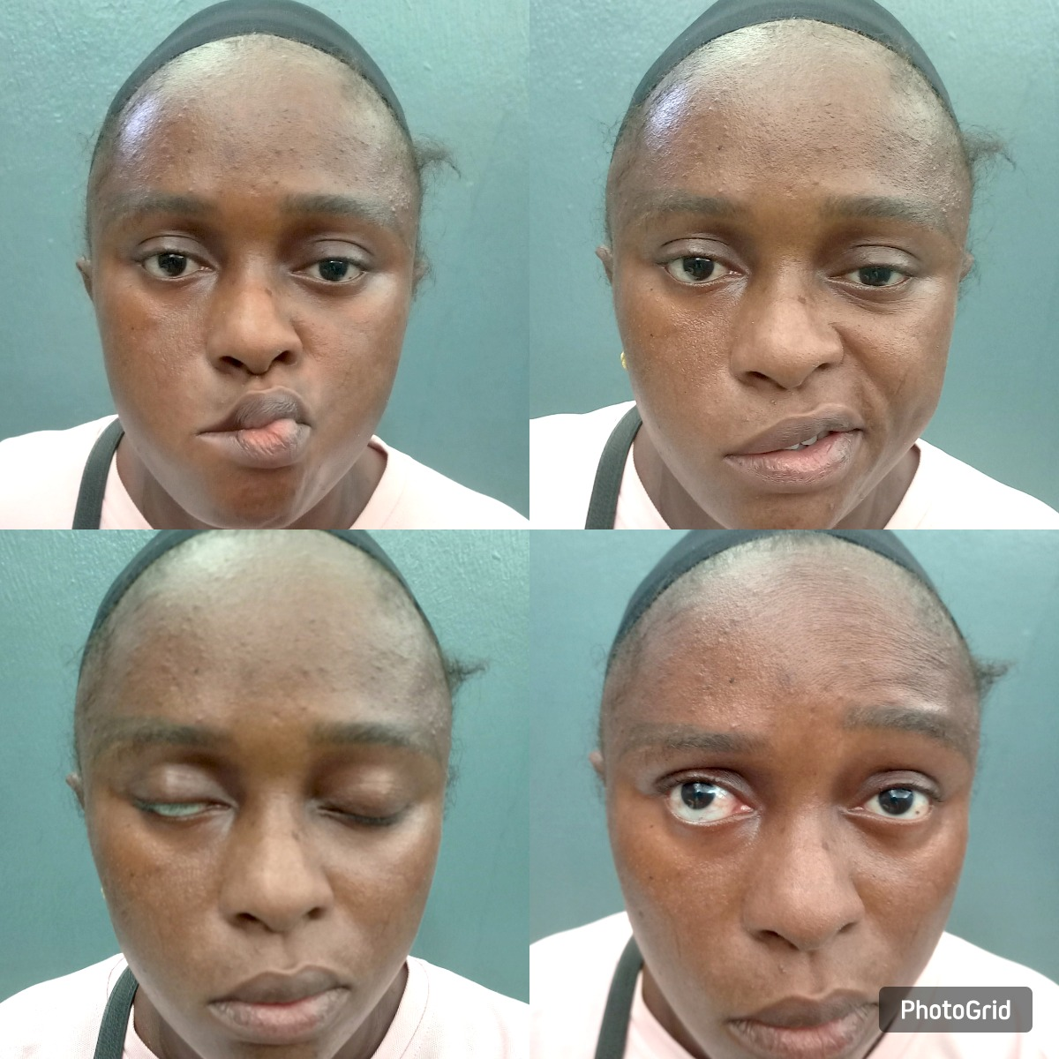
Figure 1: Patient on her first physiotherapy appointment
DISCUSSION
In Federal Teaching Hospital, Ido Ekiti, and Ekiti State University Teaching Hospital, Ado Ekiti, the most frequent cause of facial nerve paralysis accounts for 42.1% of cases [4]. A meta-analysis [5] found that out of 11,813 Bell's palsy patients, 809 (6.62%) patients were pregnant with majority occurring in the third trimester (68.82%).
Pregnancy: Bell's palsy is 3.3 times more likely to affect pregnant women than nonpregnant women; the third trimester is when BP is most common [6]. Possible explanations for the rise in facial nerve palsy during pregnancy include systemic alterations that take place are; the elevation of clotting factors in the blood, total body water causing compression and swelling of the facial nerve, increased levels of female hormones like oestrogen and progesterone, and the weakening of the immune system in the third trimester of pregnancy, leading to reactivation of many viruses [7]. Nerve compression may occur as a result of perineural oedema due to fluid retention, which is most pronounced during the third trimester, and elevated levels of free circulating cortisol in maternal blood leading to immunosuppression may contribute to the increased prevalence of BP during this time [8]. Additionally, hypercoagulability which is present in the late stages of pregnancy may lead to vasa nervorum thrombosis of facial nerve, resulting in increasing blood pressure which is a risk factor of BP. Pre-eclampsia, also known as pregnancy-induced high blood pressure, primarily from the second or third trimester, has been linked to bell's palsy during pregnancy as an indicator [8]. A thorough physical examination and careful observation during the history-taking process while the patient is speaking may reveal subtle symptoms of weakening and provide additional information. A methodical strategy to evaluating a patient who may have Bell's palsy is suggested and described below [9]:
Does the patient suffer facial palsy in the periphery?
The affected side of the forehead wrinkles asymmetrically or not at all when the eyebrows are raised in those with Bell's palsy. If the lower face is weak and the forehead muscles are unharmed, this indicates a central lesion—like a stroke—rather than a peripheral facial nerve lesion, like Bell's palsy.
Is the patient able to close their eyes securely?
The Bell phenomenon occurs when a patient with Bell’s palsy tries to close their eyelids tightly but the damaged side of the eye may remain partially open causing the eyes to deviate laterally and upward.
Does the smile have symmetry?
Take note of one side's nasolabial fold flattening, a sign of facial weakness. Request that the patient holds their breath in their mouth against their to assess the integrity of the buccinator muscle.
Are the patient's lips able to be pursed?
To check for weakness on the afflicted side, ask the patient to purse their lips. When the patient resists, try to stretch their lips apart to test the orbicularis oris muscle. Is a symmetrical grimace present? This will put the muscles used to depress the mouth and platysma angles to the test.
Do senses of taste, hearing, and touch remain intact?
Facial reflexes
It is possible to evaluate several facial reflexes, such as the corneal, palpebral-oculogyric, and orbicularis oculi reflexes. The trigeminal nerve relays the sensory afferent fibres, while the facial nerve relays the motor efferent fibres.
Our patient's symptoms included facial muscular weakness, poor eyelid closure, aching of the ear, pain at the right side of the face, epiphora, food overflowing from the corner of the mouth, and tingling and numbness in the cheek and mouth. Postauricular discomfort, hyperacusis, and taste loss are other symptoms [10]. Facial nerve palsy has many serious side effects, including exposure keratitis, synkinesis, corneal drying with possible ulceration that causes partial or total blindness, facial asymmetry, hemifacial spasm, speech issues, and permanent damage to the facial nerve [11].
Physical Therapy Management: Facial physical therapy helps treat muscle weakness and synkinesis caused by abnormal regeneration, The ultimate goal of therapy is to achieve facial symmetry [12]. The goal for our patient was to alleviate discomfort, strengthen facial muscles, restore facial symmetry, and prevent complications. This was accomplished through evidence based physical therapy practice, including electrotherapy (electrical muscle stimulation – 10 minutes duration per session), infrared therapy, facial massage (stroking, skin rolling, point hacking, and frictional massage techniques), the Kabat Technique (biofeedback using mirror therapy), kinesiotaping, patient education, and home programs such as ocular surface protection, chewing gum on the affected side, and balloon blowing. The effect of various physiotherapy interventions for the treatment and improvement of Bell's palsy symptoms was examined in the modern literature in a systematic review of evidence-based physical therapy practice on the management of the condition by Maria et al., 2021. The study found that patients who underwent a program using the PNF method or the Kabat technique in conjunction with nerve stimulation had an improvement in facial symmetry. When used in conjunction with other techniques or treatments like kinesiotape, mirror therapy, PNF, thermotherapy, and electrotherapy, facial exercises generally appear to enhance the function of the facial muscles [13].
A review after five treatment sessions, a bright looking woman with facial symmetry at rest and insignificant facial asymmetry on movement was observed with the following results from her examination: No pain at right side of the face, absence of Bell's phenomenon, presence of nasal fold and corneal reflex, Movement at forehead, Insignificant facial asymmetry of 0.6cm. Cranial nerve assessment: CNV - intact, CNVII - impaired. Objectively using the House-Brackmann scale, it showed Grade ii (mild dysfunction). The goal of treatment remained the same, Electrical muscle stimulation and Infrared therapy were discontinued from her treatment.
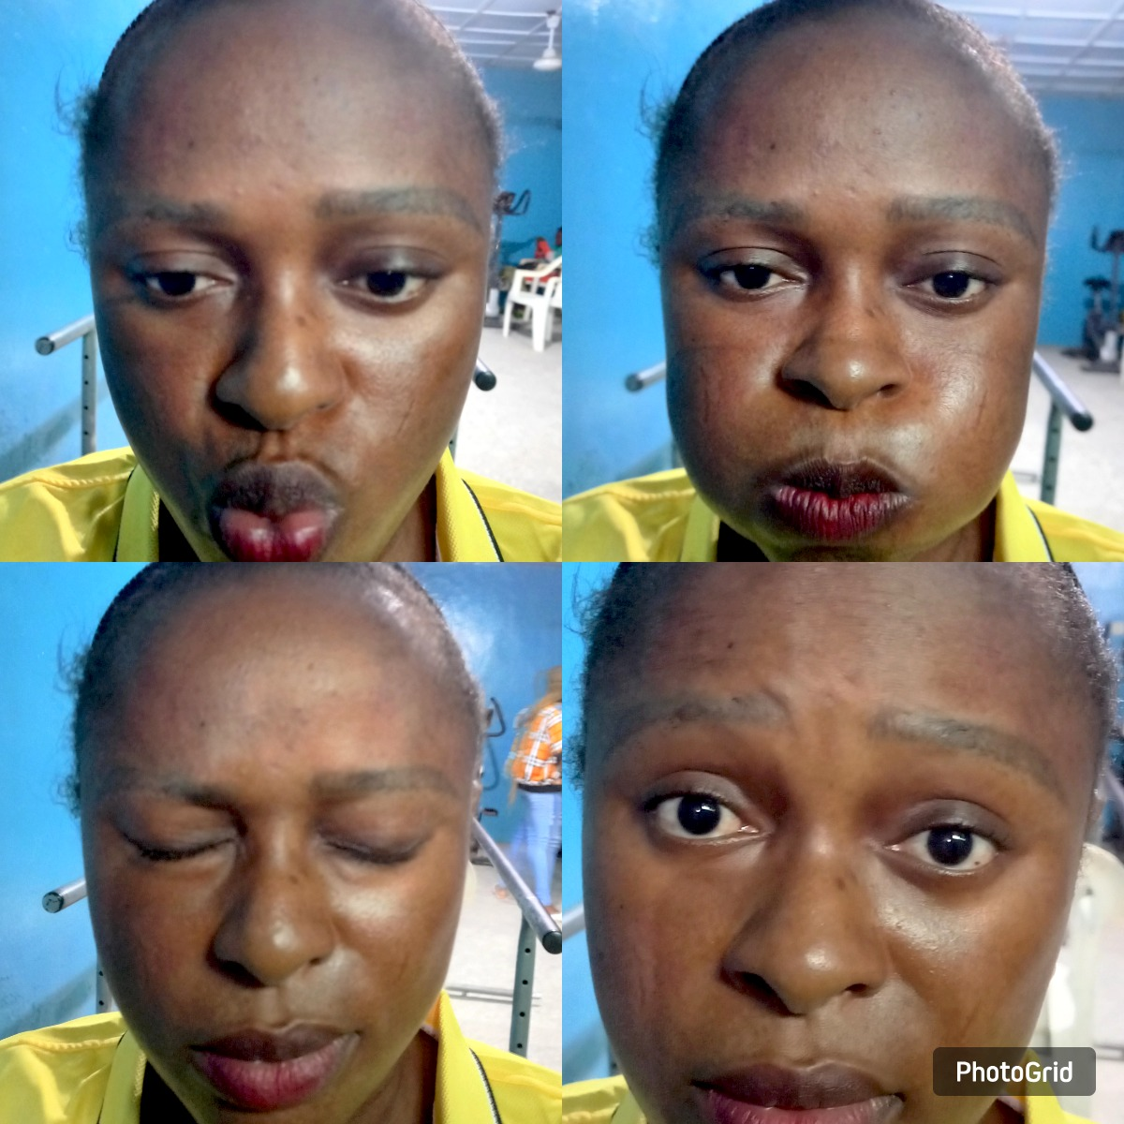Figure 2: Patient on the day of discharge

DISCHARGE SUMMARY
The discharge summary of Miss O.S., who was managed for Right Facioparesis 2⁰ Bell's palsy was assessed on the 23/5/2024 and discharged on 12/7/2024, received a total number of nine physiotherapy sessions:
ON ASSESSMENT | ON REVIEW | ON DISCHARGE
Pain at right side of the face (NPRS:7/10) | Nil pain at right side of the face | Nil pain at right side of the face
Significant facial asymmetry (1.6cm) | Insignificant facial asymmetry (0.6cm) | Nil facial asymmetry
House-Brackmann grading system- Grade IV | House-Brackmann grading system- Grade II | House-Brackmann grading system - Grade 1
Bell's phenomenon present | Bell's phenomenon absent | Bell's phenomenon absent
Corneal reflex present | Corneal reflex absent | Corneal reflex absent
CNV – Intact  CNVII - Impaired | CNV – Intact  CNVII – Impaired | CNV – Intact  CNVII - Intact
No forehead sparing | Movement at the forehead | Movement at the forehead
Table 1: Patients discharge summary
CONCLUSION
We report a case of Right facioparesis due to Bell palsy in a pregnant woman with pre-eclampsia. The clinical presentation included food pouring from the mouth, discomfort, facial muscular weakness, and significant facial asymmetry. Following a comprehensive assessment that included physical examinations and radiological investigations, her treatment consisted of medical and physical therapy approach on outpatient basis. Physical therapy management demonstrated considerable recovery of facial symmetry and muscle strength while preventing complications. It is suggested that a uniform physiotherapy management plan for Bell's palsy be devised to promote evidence-based practice worldwide.
Patient consent for publication: Informed consent was obtained from the patient for publication of this case report and accompanying images. Consent form is available for review by the Editorial Board members of this journal.

COMPETING INTERESTS DISCLAIMER:
Authors have declared that they have no known competing financial interests OR non-financial interests OR personal relationships that could have appeared to influence the work reported in this paper.

REFERENCES
- Eviston, T. J., Croxson, G. R., Kennedy, P. G. E., Hadlock, T., & Krishnan, A. V. (2015). Bell’s palsy: aetiology, clinical features and multidisciplinary care. Journal of Neurology, Neurosurgery & Psychiatry, 86(12), 1356–1361. https://doi.org/10.1136/jnnp-2014-309563
- Singh, A., & Deshmukh, P. (2022). Bell’s Palsy: A Review. Cureus, 14(10). https://doi.org/10.7759/cureus.30186
- Khan, A. J., Szczepura, A., Palmer, S., Bark, C., Neville, C., Thomson, D., et al (2022). Physical therapy for facial nerve paralysis (Bell’s palsy): An updated and extended systematic review of the evidence for facial exercise therapy. Clinical Rehabilitation, 36(11), 1424–1449. https://doi.org/10.1177/02692155221110727
- Olajide, G. T., Adegbiji, W. A., Akinbade, A. O., Olajuyin, A. O., & Olowoyo, P. (2020). Aetiological Profile of Facial Nerve Palsy Seen in Nigerian Tertiary Hospital. International Journal of Innovative Research in Medical Science, 5(06). https://doi.org/10.23958/ijirms/vol05-i06/877
- Neiderman, C., Yael, N., Ungar, O. J., Handzel, O., Razan Masarwy, Rani, A., et al (2023). Bell’s palsy and pregnancy: Incidence, comorbidities and complications. A meta‐analysis and systematic review of the literature. Clinical Otolaryngology, 48(4), 576–586. https://doi.org/10.1111/coa.14042
- Fuzi, J., Spencer, S., Seckold, E., Damiano, S., & Meller, C. (2021). Bell’s palsy during pregnancy and the post-partum period: A contemporary management approach. American Journal of Otolaryngology, 42(3), 102914. https://doi.org/10.1016/j.amjoto.2021.102914
- Bose, S., & Anjankar, A. (2022). Incidence of Facial Nerve Palsy in Pregnancy. Cureus, 14(11). https://doi.org/10.7759/cureus.31426
- Jones, H., Hintze, J., Slattery, F., & Gendre, A. (2023). Bell’s palsy in pregnancy: A scoping review of risk factors, treatment and outcomes. Laryngoscope Investigative Otolaryngology. https://doi.org/10.1002/lio2.1136
- Patel , D. K., & Levin, K. H. (2015). Bell palsy: Clinical examination and management. Cleveland Clinic Journal of Medicine, 82(7), 419–426. https://doi.org/10.3949/ccjm.82a.14101
- Mustafa, A. H. K., & Suleiman, A. M. (2020). Bell’s Palsy: A Prospective Study. International Journal of Dentistry, 2020, 1–5. https://doi.org/10.1155/2020/2160256
- Warner, M., Julia H., & Varacallo, M. (2023). The Facial Nerve. Thieme.
- Walker, N., Mistry, R., & Mazzoni, T. (2023). Facial Nerve Palsy. Treasure Island : Statpearls publishing
- Maria , A., Kottaras, A., Lytras, D., Gatidou, C., Lakovidis, P., & Kottaras, L. (2021). Physiotherapy management of Bell’s palsy - A review of evidenced based physiotherapy practice. International Journal of Advanced Research in Medicine, 3(1), 402–406. https://doi.org/10.22271/27069567.2021.v3.i1g.171

