Case report

Unveiling Metastasis Through Pericardial Effusion: A Clinical Case of Breast Cancer Recurrence

Abstract:
Pericardial effusion, characterized by fluid accumulation in the pericardial cavity, can result from various etiologies, including malignancies. Neoplastic pericardial effusion is particularly concerning, often serving as an early marker of cancer recurrence and complicating clinical management, particularly in oncology patients. This case report discusses a 47-year-old woman with a history of breast cancer who presented with progressive dyspnea and signs of cardiac tamponade. Diagnostic imaging revealed a large circumferential pericardial effusion. Further investigations identified cerebral and hepatic metastases, emphasizing the role of pericardial effusion in detecting metastatic spread. The patient underwent pericardiocentesis, followed by surgical drainage and pleuro-pericardial window then chemotherapy, which led to resolution of symptoms and stabilization. This case highlights the importance of vigilant monitoring for pericardial effusion in breast cancer survivors, particularly those presenting with unexplained respiratory or cardiovascular symptoms, as early detection and prompt intervention are crucial for improving patient outcomes. Comprehensive diagnostic and therapeutic approaches, including echocardiography, fluid analysis, and surgical management, are essential in managing malignant pericardial effusions and preventing recurrence.
Key words: pericardial effusion, breast cancer, chemotherapy, pericardiocentesis.

Introduction:
Pericardial effusion is characterized by the accumulation of fluid within the pericardial cavity, which can arise from a diverse array of etiologies, including infectious processes, autoimmune disorders, trauma, and malignancies (1). Among these, neoplastic pericardial effusion is of particular concern due to its association with advanced cancer and its potential to serve as an early indicator of disease recurrence (2). The presence of pericardial effusion can complicate clinical management and often necessitates prompt intervention, as it may lead to life-threatening complications such as cardiac tamponade. Understanding the underlying mechanisms and risk factors associated with neoplastic effusions is crucial for effective patient monitoring and management.
In this article, we present a clinical case involving a 47-year-old menopausal woman with a history of breast cancer, who was admitted to the emergency department with progressive dyspnea and clinical signs of cardiac tamponade. Diagnostic imaging revealed a significant pericardial effusion, with fluid analysis indicating an exudative profile suggestive of inflammation. Further investigations identified cerebral and hepatic metastases, highlighting the role of pericardial effusion as a potential early marker of cancer recurrence. This case illustrates the importance of vigilant assessment of pericardial effusion in oncological patients, as it may provide critical insights into disease progression and inform timely therapeutic interventions, thereby improving patient outcomes.
Case Presentation:
A 47-year-old menopausal woman presented to the emergency department with dyspnea that had developed over the past 2 weeks, worsening one day prior, and now occurring at rest with orthopnea. Her medical history included a diagnosis of right breast cancer, surgically treated in 2019 via a right Patey procedure, followed by six sessions of chemotherapy, the last of which occurred in June 2021, and fifteen sessions of radiotherapy. Also, chronic headaches have been revealed. She was currently in remission and had no modifiable cardiovascular risk factors. On clinical examination, the patient was found to be tachycardic at a rate of 110 beats per minute, with a blood pressure of 94/55 mmHg, tachypneic at 50 breaths per minute and exhibiting 90% oxygen saturation on ambient air. Cardiac auscultation revealed muffled heart sounds and jugular vein distention, without signs of acute heart failure. Peripheral pulses were palpable, and both pleuropulmonary examination and the remainder of the clinical assessment were unremarkable. An emergency electrocardiogram demonstrated a regular sinus rhythm at 105 beats per minute and diffuse low QRS voltage. A chest radiography indicated cardiomegaly.
In light of these findings, a transthoracic echocardiogram was performed, revealing a large circumferential pericardial effusion (38 mm at the apex, 38 mm at the right ventricle, 28 mm at the right atrium, and 26 mm posteriorly). The left ventricular function was assessed as good. Significant respiratory variation in flow was noted (54% mitral flow, 35% aortic flow, and 60% tricuspid flow), alongside collapse of the right atrium and right ventricle, a "swinging heart" appearance, and inferior vena cava dilation measuring 25 mm. The diagnosis of pericardial tamponade was established, and the patient was urgently transferred to the cardiology intensive care unit, where a subxiphoid pericardiocentesis was performed. This procedure successfully removed 700 cc of sero-sanguinous fluid while maintaining hemodynamic stability through vascular filling.
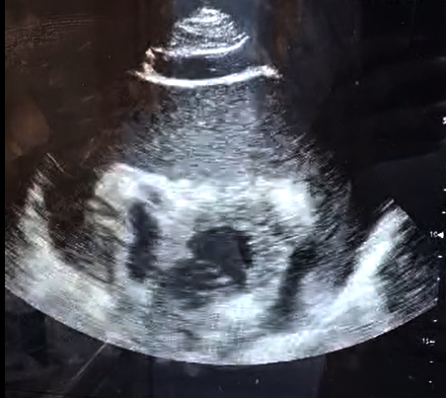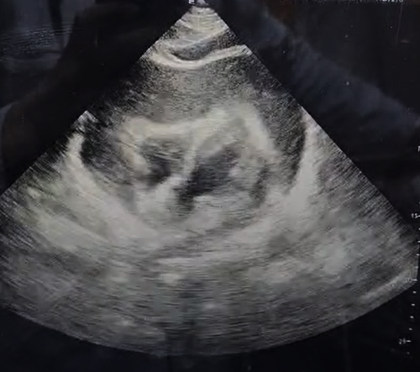
Figure 1: Transthoracic echocardiography showing a large pericardial effusion and a swinging heart. The blue arrow indicates the collapse of the right-sided chambers.
A biological assessment revealed the following:
- Hemoglobin: 12.1 g/dL
- White Blood Cells: 12,250/mm³
- Platelets: 148,000/mm³
- Prothrombin Time: 77%
- Activated Partial Thromboplastin Time (aPTT): 29 seconds
- Sodium: 138 mmol/L
- Potassium: 4 mmol/L
- Urea: 0.39 g/L
- Creatinine: 7.3 mg/L
- Estimated Glomerular Filtration Rate (eGFR): 90.94 mL/min/1.73 m²
- Aspartate Aminotransferase (AST): 36 UI/L
- Alanine Aminotransferase (ALT): 16 UI/L
- C-Reactive Protein (CRP): 11 mg/L
- Erythrocyte Sedimentation Rate (ESR, 1st hour): 34 mm
- Lactate Dehydrogenase (LDH): 375 UI/L
- Thyroid Stimulating Hormone (TSH): 3.98 mUI/L
- Viral serologies : negative
Analysis of the pericardial fluid demonstrated an exudative inflammatory fluid rich in neutrophils. The patient's clinical course was characterized by persistent dyspnea despite the removal of the pericardial fluid. An urgent thoracic CT scan was performed, revealing a pulmonary mass of tissue density in the middle lobe, bilateral pulmonary nodules and micronodules, a pleural effusion, and middle lobe bronchiectasis affecting the ventral segment of the right upper lobe.
After 48 hours, follow-up echocardiography indicated recurrence of the pericardial effusion, which was again circumferential and abundant. Further staging investigations identified the presence of cerebral and hepatic metastases.
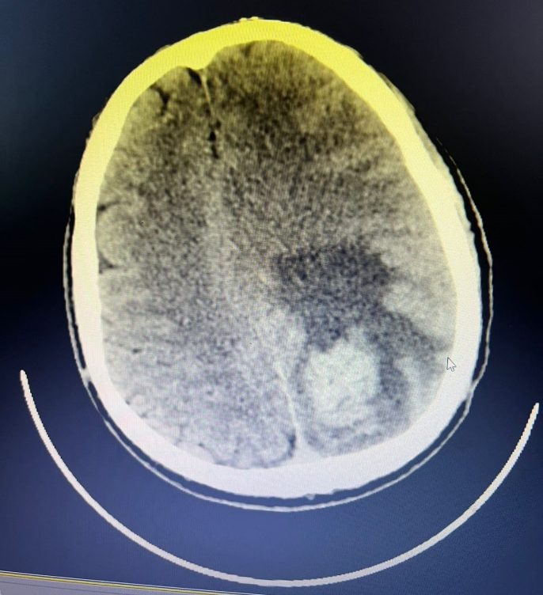
Figure 2 : A cerebral scan revealing a cerebral metastasis.
To prevent recurrence, surgical drainage was performed along with the creation of a pleuropericardial window, placement of a suction drain, and initiation of prophylactic antibiotic therapy. Follow-up echocardiography demonstrated a dramatic regression of the pericardial effusion. The drain was removed 48 hours later after draining 600 cc of pericardial fluid. The postoperative course was uncomplicated, and subsequent echocardiography did not reveal any recurrence. The patient was discharged after 48 hours of monitoring and referred to the oncology unit for the initiation of chemotherapy treatment.
Discussion:
Breast cancer is one of the most prevalent malignancies among women worldwide, with a significant impact on public health due to its high incidence and associated mortality rates, it is considered as the first cause of death from malignant tumors (3). The disease often progresses to advanced stages, leading to metastasis in various organs, including bone, the lungs, liver, and, notably, the pericardium (4). Neoplastic pericardial effusion, characterized by fluid accumulation in the pericardial cavity due to malignant processes, is particularly concerning as it can complicate patient management and serve as an early indicator of cancer recurrence (2). Elucidating the relationship between breast cancer and pericardial effusion is of paramount importance, as the development of pericardial effusion can result in life-threatening complications such as cardiac tamponade. This underscores the necessity for vigilant monitoring and early detection in patients with a history of malignancy.
The risk of breast cancer recurrence remains a significant concern even after initial treatment. A study based on the Danish Breast Cancer Group clinical database suggests that approximately recurrences may occur after 10 years and up to 32 years after primary diagnosis (5). Factors such as tumor grade, hormone receptor status, and initial treatment modalities significantly influence this risk (5) (6). Another study suggest that patients with high-risk tumors face a threefold increase in the likelihood of recurrence or mortality when contrasted with those possessing non-high-risk tumors, a high-risk tumor was defined by the presence of 4 lymph nodes or more, or 1–3 lymph nodes and grade 3, tumor ≥5 cm or Ki-67 ≥20% (7). In patients with a history of breast cancer, the emergence of pericardial effusion may be a critical marker of disease progression, potentially indicating metastatic spread (8). This underscores the importance of continuous monitoring in survivors, especially for those presenting with respiratory or cardiovascular complications, as the early identification of recurrence can enable prompt intervention and enhance patient outcomes.
Accurate diagnosis of pericardial effusion in the context of breast cancer requires a comprehensive assessment involving clinical examination, imaging, and fluid analysis. There are no particular symptoms of cardiac tamponade in patients with breast cancer, and symptoms may be common such as dyspnea, orthopnea, and signs of cardiac tamponade or it can be aggressive such as cardiogenic schock. Chest radiography and electrocardiogram are not specific especially when the pericardial effusion is low or moderate, but they can be useful when there are some abnormalities frequently observed in cardiac tamponade, such as enlarged heart in chest radiography and sinus tachycardia associated to low QRS voltage (amplitude < 0,5 mV in limb leads) (9). Diagnostic imaging, particularly transthoracic echocardiography, plays a pivotal role in confirming the presence and the severity of pericardial effusion; a size exceeding 20 mm indicates a large pericardial effusion (1) (10). Furthermore, transthoracic echocardiography helps in detecting cardiac tamponade by showing enhanced ventricular interdependence, right atrial systolic collapse, right ventricular early diastolic collapse, and plethora of the inferior vena cava (11). In this case, the echocardiographic findings of a large circumferential effusion, along with hemodynamic instability, underscored the urgency of intervention. Fluid analysis is the key point to provide information regarding the etiology, malignant pericardial effusion is frequently hemorrhagic rather than serous or sero-sanguinous with large volume, moreover exudative profiles indicating inflammation or malignancy, guiding subsequent management decisions (12). Lastly, pericardial biopsy and immunohistochemistry may increase the sensitivity and the specifity of the etiological diagnosis.
In cases of significant pericardial effusion, pericardiocentesis is often the first-line treatment to relieve pressure on the heart and stabilize the patient (1). However, this procedure carries risks, including potential perforation of the right ventricular wall, which can lead to serious complications (13) (14). To mitigate recurrence of effusions, particularly in neoplastic cases, more definitive measures such as the creation of a pleuropericardial window may be necessary (15). This surgical approach facilitates drainage and decreases the likelihood of fluid re-accumulation. In addition, initiating chemotherapy is crucial, particularly when metastatic disease is identified, as systemic treatment may help control underlying malignancy and prevent further complications associated with effusion (16). The administration of cytostatic or sclerosing agents via intrapericardial instillation can be contemplated as a therapeutic option in the management of malignant pleural effusions (9).
The presence of pericardial effusion in patients with a history of breast cancer should raise immediate concerns regarding the potential for recurrence and metastasis. Clinicians must maintain a high index of suspicion and ensure thorough investigation when encountering effusion in this context. In certain instances, a malignant pericardial effusion may arise as a complication of recurrent breast cancer; when severe and extensive, it can prove to be fatal (17) (18). As demonstrated in this case, rapid identification and management of effusions can provide critical insights into disease progression and guide therapeutic interventions. By prioritizing the evaluation of recurrence in patients presenting with pericardial effusion, healthcare providers can improve patient outcomes and enhance the overall management of those affected by breast cancer. This approach not only facilitates timely treatment but also fosters a multidisciplinary strategy essential for addressing the complex needs of oncological patients.
Conclusion:
This case study underscores the pivotal role of pericardial effusion as an early indicator of metastatic disease in patients diagnosed with breast cancer, potentially signifying recurrence and the dissemination of malignancy. The rapid progression of cardiac tamponade in this patient underscores the imperative for expeditious identification and intervention in such circumstances, particularly among individuals with a documented history of breast cancer. The utilisation of diagnostic modalities, encompassing transthoracic echocardiography, fluid analysis, and comprehensive imaging, is paramount for confirming the presence of pericardial effusion and informing treatment strategies. The management of pericardiocentesis, surgical drainage, and chemotherapy constitutes a fundamental aspect of the treatment strategy aimed at preventing recurrence and controlling metastatic disease. This case demonstrates the significance of meticulous monitoring in breast cancer survivors, particularly those manifesting unexplained respiratory or cardiovascular symptoms, to enable timely and effective interventions that can considerably enhance outcomes and quality of life. A multidisciplinary approach to care is imperative for optimising management and improving survival rates for patients experiencing neoplastic pericardial effusion.
Ethics approval and consent to participate:
As per international standards or university standards written ethical approval has been collected and preserved by the author(s).
Consent for publication:
As per international standards or university standards, patient written consent has been collected and preserved by the authors.
Availability of data and materials:
Not applicable.
References:
1. Adler Y, Charron P, Imazio M, Badano L, Barón-Esquivias G, Bogaert J, et al. 2015 ESC Guidelines for the diagnosis and management of pericardial diseases. Eur Heart J. 7 nov 2015;36(42):2921‑64.
2. Abdalani B, Moufid O, Amri M, Obeidat S, Assklou A, Benouna MGh, et al. Pericardial Effusion as an Early Indicator of Breast Cancer Recurrence: A Case Report. Int J Med Pharm Case Rep. 21 mai 2024;17(2):74‑80.
3. Smolarz B, Nowak AZ, Romanowicz H. Breast Cancer—Epidemiology, Classification, Pathogenesis and Treatment (Review of Literature). Cancers. 23 mai 2022;14(10):2569.
4. Harbeck N, Penault-Llorca F, Cortes J, Gnant M, Houssami N, Poortmans P, et al. Breast cancer. Nat Rev Dis Primer. 23 sept 2019;5(1):66.
5. Pedersen RN, Esen BÖ, Mellemkjær L, Christiansen P, Ejlertsen B, Lash TL, et al. The Incidence of Breast Cancer Recurrence 10-32 Years After Primary Diagnosis. JNCI J Natl Cancer Inst. 8 mars 2022;114(3):391‑9.
6. Schaffar R, Benhamou S, Chappuis PO, Rapiti E. Risk of first recurrence after treatment in a population-based cohort of young women with breast cancer. Breast Cancer Res Treat. août 2024;206(3):615‑23.
7. Sheffield KM, Peachey JR, Method M, Grimes BR, Brown J, Saverno K, et al. A Real-World US Study of Recurrence Risks using Combined Clinicopathological Features in HR-Positive, HER2-Negative Early Breast Cancer. Future Oncol. juill 2022;18(21):2667‑82.
8. Ilerhunmwuwa N, Sedeta E, Wasifuddin M, Hakobyan N, Aiwuyo HO, Perry JC, et al. Cardiac Tamponade in Patients With Breast Cancer: A Systematic Review. Cureus [Internet]. 30 déc 2022 [cité 25 déc 2024]; Disponible sur: https://www.cureus.com/articles/127794-cardiac-tamponade-in-patients-with-breast-cancer-a-systematic-review
9. Fernandes F, Luzuriaga GDCJ, Dabarian A, Fernandes ID, Celano PM, Valsi IP, et al. Pericardial Disease in Patients with Cancer. ABC Heart Fail Cardiomyopathy. 18 déc 2022;2(4):362‑6.
10. Pérez-Casares A, Cesar S, Brunet-Garcia L, Sanchez-de-Toledo J. Echocardiographic Evaluation of Pericardial Effusion and Cardiac Tamponade. Front Pediatr. 24 avr 2017;5:79.
11. Mori S, Bertamino M, Guerisoli L, Stratoti S, Canale C, Spallarossa P, et al. Pericardial effusion in oncological patients: current knowledge and principles of management. Cardio-Oncol. 16 févr 2024;10(1):8.
12. Shartouni R, Shartouni R, Mahmoodi M, Nikas IP. The Value of Cytology in the Evaluation of Malignant Pericardial Effusions: A Systematic Review. Diagnostics. 1 févr 2022;12(2):367.
13. Moufid O, Abdalani B, Abbassi I, Bouziane M, Bennouna M, Habbal R. Rare Case of Right Ventricular Perforation during Pericardiocentesis: A Case Report. Cardiol Angiol Int J. 23 mai 2024;13(2):130‑3.
14. İLkeli̇ E, Çapci S, Koç A, Eki̇Nözü İ. Right Ventricular Perforation during Pericardiocentesis: A Case Report.
15. Best management of patients with malignant pericardial effusion: a comparative study between imaging-guided pericardiocentesis and surgical pericardial window. J Clin Transl Res [Internet]. 2023 [cité 25 déc 2024]; Disponible sur: https://www.jctres.com/en/09.202303.010/
16. Reynolds PM, Byrne MJ. The Treatment of Malignant Pericardial Effusion in Carcinoma of the Breast. Aust N Z J Med. avr 1977;7(2):169‑71.
17. Woll PJ, Knight RK, Rubens RD. Pericardial Effusion Complicating Breast Cancer. J R Soc Med. août 1987;80(8):490‑1.
18. Ullah F, Naeem A, Shakeel O, Rehman B, Khan S, Riaz S, et al. ISOLATED MASSIVE PERICARDIAL EFFUSION AS A HARBINGER OF BREAST CANCER RECURRENCE. Int J Med Rev Case Rep. 2020;(0):1.

