Case report
A Rare “Big” Problem: A Case Study of Gestational Gigantomastia

.
ABSTRACT

Aim: Gestational gigantomastia is an extremely rare condition, with very few published cases reported worlswide. The aim of this case report is to discuss possible aetiologies of gestational gigantomastia and its treatment options, with the focus to relieve its symptoms, carry the pregnancy to term safely and to prevent recurrence.
Presentation of case: We present a case of a 32-year old female at 37-weeks gestation who presented with rapidly increasing bilateral breasts enlargement and back pain, rendering her mostly bed-bound. Breast ultrasonography showed heterogenous breast parenchyma with a well-defined heterogenous right breast lesion. On examination, bilateral breasts were grossly enlarged, tense, tender, with skin excoriation of inferior mammary folds. There was intrauterine growth retardation, however amniotic fluid index was normal. Initial management was for early elective delivery, however she entered labour spontaneously and successfully delivered a healthy baby boy. Post-delivery, her breasts started to shrink and her pain improved.
Discussion: The aetio-pathologies of gestational gigantomastia is not yet fully understood but may be linked to hormonal imbalance, auto-immune diseases or malignancy. Treatment is focused on relieving symptoms and preventing complications in order to carry the pregnancy to term safely and ultimately, to prevent recurrence.
Conclusion: This rare condition poses minimal risk to the foetus, however may have a significant impact on the mother’s physical and pscyho-social well-being. Early referral to a specialised centre is necessary to manage this condition effectively to full term pregnancy.

Keywords: Gestational gigantomastia, enlarged breast, benign breast, pregnancy

1. INTRODUCTION

Gigantomastia is defined as diffused and excessive breast growth, characterized by 3% of total body weight in excess of breast tissue. Gestational gigantomastia is a subtype of gigantomastia that arises in early pregnancy, typically first or early second trimester. Patients with gestational gigantomastia present with disproportionate growth of one or both breasts accompanied by grossly dilated nipples and areola, and prominent superficial veins. This can disrupt the progression of the developing foetus, and have a negative impact on the mother’s psycho-social well-being. Thus, requiring a multi-disciplinary and holistic approach to manage this condition [3-5]. We present a case of gestational gigantomastia who presented to us at 37-weeks gestation with bilateral breast enlargement in pregnancy. There was no associated breast or axillary lumps. Breast ultrasonography revealed a well-circumscribed heterogenous breast lesion. Case report with literature review is presented.

Provide a factual background, clearly defined problem, proposed solution, a brief literature survey and the scope and justification of the work done.]

2. CASE PRESENTATION

A 32-year old Indonesian female, Gravida 3 Para 2, initially presented to a primary healthcare clinic at 19-weeks gestation with complaint of bilateral breasts enlargement and pain for four months. Her pre-morbid bra size was a cup C, but as the breasts rapidly increased in size, she was unable to wear any supportive undergarments. The increase in weight of the excessive breast tissue had caused further strain to her back and posture, reducing her mobility and restricting her daily activities. She also complained of pain and discomfort from the increase skin friction over her infra-mammary folds and felt uncomfortable to go out in public. She did not have fever or nipple discharge. There was no loss of weight or loss of appetite. She had a previous history of hormonal contraception for four years and practiced turmeric liquid consumption as part of Indonesian traditional medication. Otherwise, there was no family history of malignancy. She achieved menarche at 14 years old and has regular menstrual cycle. This is her first pregnancy of her second union, with no prior history of abnormal breast growth or other complications in her previous two pregnancies. Her last childbirth was more than 8 years ago. She is unemployed, while her husband, who is of Indian nationality, works earning a minimum-wage. Thus, they are subjected to foreigner hospital fees which much more costly. Provisional diagnosis of Phyllodes breast tumour was made. She was referred to the Breast & Endocrine Unit as outpatient, however due to the worsening debilitating effect of the disease, she was unable to attend the appointment as her condition had rendered her close to bed-ridden.
At 37-weeks gestation, she presented again to a tertiary hospital with complaint of rapidly increasing bilateral breasts for more than 8 months. It is associated with bilateral breast pain and worsening back pain, severely limiting her mobility and daily activities. Upon examination, she was alert with good pulse volume and hydration. Vital signs were normotensive, not tachycardic and afebrile. Her bilateral breasts were grossly enlarged extending past the umbilical level, with peau d’orange skin appearance and dilated superficial veins over the anterior chest (Figures 1-3). Bilateral breasts were tense and tender on palpation. There were no breast or axillary lesions palpable. Examination of the inferior aspect of bilateral breast revealed superficial excoriation of the infra-mammary folds, but no skin ulceration or wounds. No other lymph nodes were palpable.
Figures 1-3: Bilateral breast swelling with dilated superficial veins at 37-weeks gestation
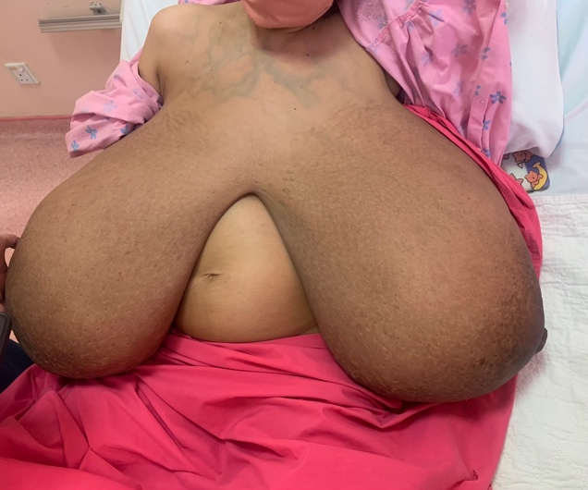 Fig. 1: Bilateral breasts, anterior view
1
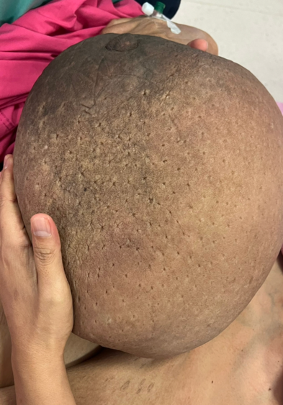 Fig. 2: Right breast, medial view
2

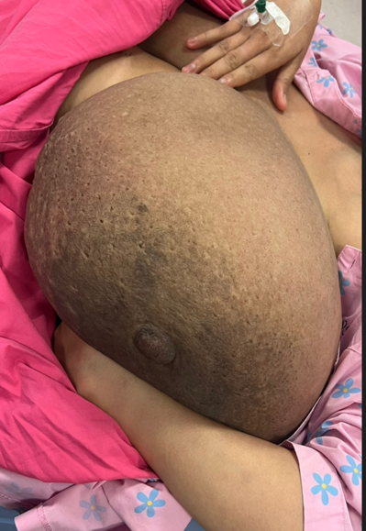 Fig. 3: Left breast, medial view
3
Full blood count, renal profile and electrolytes were all within normal range. She was counselled for further hormonal testing and fine needle aspiration cytology of the axillary lump, however was indecisive due to financial concerns. Breast ultrasonography demonstrated diffused heterogenous hyperechogenicity of bilateral breast parenchyma, with a well-circumscribed hypoechoic lesion with edge shadowing at the upper inner quadrant of right breast, measuring 3.3 x 4.4 x 3.4cm (AP x W x CC). Rest of breasts showed evidence of heterogenous breast parenchyma echotexture bilaterally. There were no enlarged axillary lymph nodes bilaterally. Foetal assessment showed evidence of intrauterine foetal retardation, however amniotic fluid index and abdominal circumference were still within normal range.
She was admitted under obstetrics unit for pain management with the aim for early delivery. However, she entered labour spontaneously at 38 weeks and delivered a healthy baby boy via vaginal delivery, with a birth weight of 2.3kg. At two days post-partum, there was a significant change in the appearance of bilateral breasts (Figures 4-6). Both breasts were less tense with resolving pain. The previously-seen dilated superficial veins over her anterior chest had also resolved. There was marked reduction strain to her back and she was able to ambulate with ease.
Figures 4-6: At post-partum Day 2, bilateral breasts appeared less tense with significant reduction in size and resolved dilated superficial veins over overlying skin.
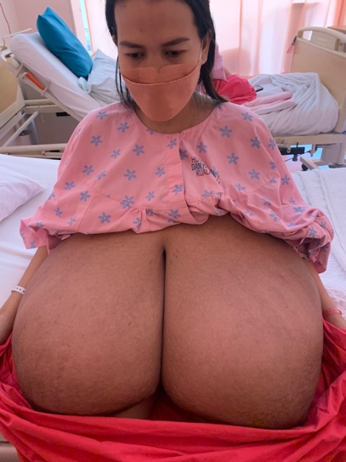 Fig. 4: Bilateral breasts, anterior view
4

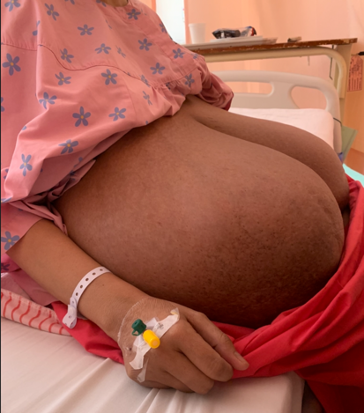 Fig. 5: Right breast, lateral view
5
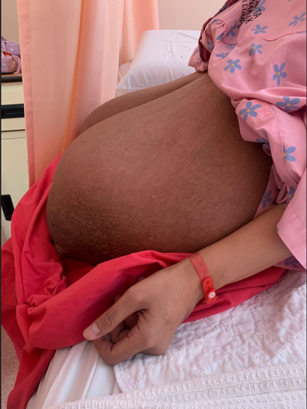 Fig. 6: Left breast, lateral view
6
Medical therapy was not offered as she had presented late in pregnancy. A follow-up review was planned for her in the post-partum period to assess her symptoms and the need for surgery. However, she had defaulted subsequent appointments, most likely due to financial difficulties. She was initially reluctant to even be admitted due to the financial costs, therefore surgical expenses would have been unaffordable for her.

3. discussion

Gigantomastia can be classified into 4 subtypes based on aetiology: juvenile, idiopathic, gestational and drug-induced. It is a rare condition with an incidence rate of 1 in 100,000 globally. It was first reported by Pulmuth in 1684 with only 50 published case reports from 1976-2016. Demographic distribution shows that gestational gigantomastia is more prevalent in North America, followed by South East and Central Asia. Cases have been reported in patients at the ages of 16-35 years, with majority presenting at 26-30 years old, which matches to our patient’s age [6-8].
The aetio-pathology is not yet fully understood but may be associated with systemic diseases such as hormonal imbalance, auto-immune diseases or malignancy [9]. Published case reports have linked gestational gigantomastia to hyperprolactinaemia, hypercalcaemia, deranged liver function, myasthenia gravis, anti-phospholipid syndrome and lymphoma (Hodgkin’s and non-Hodgkin’s lymphoma and T-cell lymphoblastic lymphoma). When unrelated to underlying malignancy, gestational gigantomastia is a benign condition with no known threat to the foetus in-utero. However, it carries a significant social, emotional and physical disability to the expectant mother. The excess weight and size of breast can remarkedly limit their movement, cause significant pain and ulcerations. If poorly treated, infected wounds may lead to sepsis and death [8-10]. Our patient was not known to have autoimmune disease or malignancy, but could possibly be linked to hormonal abnormalities. However, this could not be proven as she could not further laboratory testing. Her foetus was relatively small in size, however was healthy at birth without any significant effect from her condition. However, she had suffered great disability due to the weight of her rapidly-growing breasts that had made her a social recluse and severely limited her daily activities. Fortunately, she did not have any ulcerations or wounds, though there were excoriation of the inferior mammary folds due to friction.
Treatment is initially aimed at symptomatic relief, carrying the pregnancy to term and ultimately to prevent recurrence. First line of care is medical therapy with the use of bromocriptine, which is a D2-agonist that arrests further hyperplasia of breast tissue. It is safe to use in the gestational period and has not been linked to abortion or congenital anomalies. However, there have been isolated cases that report intrauterine gestational growth, therefore foetal growth should be serially monitored on a regular basis. Other options include pain relief with analgesics and the management of any wounds, if present. Elective termination of a viable foetus is not ethical nor indicated as it does not guarantee a cure.
Most cases do not spontaneously resolve after delivery thus, surgical treatment is offered in the post-partum period as definitive therapy. A multi-disciplinary approach is required to postpone surgery as late as possible to avoid complications such as preterm labour. An earlier elective delivery may be planned with the administration of corticosteroid for foetal lung maturity if urgently indicated. Options include mammoplasty and mastectomy with or without breast reconstruction. Mammoplasty gives the patient the choice for breastfeeding in the post-partum, which is essential in developing countries. However, it does not eliminate the risk of recurrence as the remaining breast tissue may undergo hyperplasia in subsequent pregnancies. For patients who have a desire for future pregnancies, bilateral mastectomy and breast reconstruction can be considered.
Fortunately, her symptoms showed spontaneous improvement almost immediately after delivery. She did not require medical therapy and was able to deliver safely a healthy baby without major complications throughout pregnancy. However, the challenge we encountered with our patient is compliancy to seeking medical attention due to her financial difficulties. Her symptoms had appeared at 2-weeks gestation, but she presented at 19-weeks gestation, and then defaulted. If she had presented earlier, medical therapy could have been initiated to help reduce her symptoms. Proper work-up could also have been done to determine the pathological cause and prevent her condition from worsening, or recurring in the future. We are also unable to determine the long-term outcome for her due to lost in follow-up; whether her condition had completely resolve and or if it recurs in future pregnancies.

4. Conclusion

More awareness must be made of this rare condition amongst primary care doctors and obstetricians for early referral to a specialised centre, as it requires a multi-disciplinary management. Further research is needed to better understand and treat this condition to attain optimal foeto-maternal outcome.

Consent (where ever applicable)

All authors declare that informed consent was obtained from the patient for publication of this case report and accompanying images.

Ethical approval (where ever applicable)

All authors hereby declare that all measures taken for the completion of this case report are in accordance to the 1964 Declaration of Helsinki.

References

- Mangla M., Singla D. (2017). Gestational Gigantomastia: A Systematic Review of Case Reports. J Midlife Health, 8(1):40-44

- Fletcher, M. B., Corsini L. M., Meyer M. D., Osswald S. S. (2020). Gestational gigantomastia: A case report and brief review of the literature. JAAD Case Rep, 6(11):1159-1161

- Alhindi, N., Mortada, H., Alzaid, W., Al Qurashi, A. A., & Awan, B. (2023). A systematic literature review of the clinical presentation, management, and outcome of gestational gigantomastia in the 21st century. Aesthetic Plastic Surgery, 47(1), 10-29.

- Qin, F., Si, L., Zhang, H., Zhang, M., Zeng, A., Long, F., ... & Wang, X. (2020). Management of gestational gigantomastia with breast reconstruction after mastectomy: case report and literature review. Journal of International Medical Research, 48(6), 0300060520920463.

- Rakislova, N., Lovane, L., Fernandes, F., Gonçalves, E., Bassat, Q., Mocumbi, S., ... & Carrilho, C. (2020). Gestational gigantomastia with fatal outcome. Autopsy and Case Reports, 10(4), e2020213.

- Dancey, A., Khan, M., Dawson, J., & Peart, F. (2008). Gigantomastia–a classification and review of the literature. Journal of Plastic, Reconstructive & Aesthetic Surgery, 61(5), 493-502.

- Türkan, H., Gökgöz, M. Ş., Taşdelen, İ., & Dündar, H. Z. (2016). Gestational gigantomastia. The journal of breast health, 12(2), 86.

- Okere, U. C., Margenthaler, J. A., Vanko, S., & Kennard, K. (2023). A multi-disciplinary approach to gestational gigantomastia management: a case report. AME Surgical Journal, 3.

- Sanli, A. N. (2024). Unilateral gestational gigantomastia in the third trimester. Journal of Medicine, Surgery, and Public Health, 2, 100083.

- Rezai, S., Nakagawa, J. T., Tedesco, J., Chadee, A., Gottimukkala, S., Mercado, R., & Henderson, C. E. (2015). Gestational gigantomastia complicating pregnancy: a case report and review of the literature. Case reports in obstetrics and gynecology, 2015(1), 892369.

