IDENTIFICATION AND EVALUATION OF NEUROPROTECTIVE EFFECT OF A BUTANOL EXTRACT FROM CENTELLA ASIATICA (L.) URB

Abstract
In recent years, herbal plants have been widely used in the treatment of neurodegenative diseases. Centella asiatica (l.) urb is a significant medicinal plant renowned for its diverse ethnomedicinal applications. The present study evaluated biological activities for neuroprotective effect of C. asiatica. In summary, the plant samples collected from Laocai, Vietnam, were successfully identified using DNA barcoding techniques that focused on the matK and rbcL genes. The sequences obtained were then compared through a similarity search using the NCBI GenBank database. Notably, the extracts of Centella asiatica exhibited high acetylcholinesterase inhibitory activity. Furthermore, the butanol extract of C. asiatica demonstrated the most significant neurotrophic effects in preliminary cell-based screenings, particularly in promoting neurite outgrowth in C6 cells. These findings suggest that C. asiatica, alongside Catharanthus roseus, holds considerable promise as a potential candidate for the development of pharmacological treatments for neurodegenerative diseases.
Keywords
Centella asiatica (l.) urb, neurodegenative diseases, AChE inhibitory, neurite outgrowth
Introduction
Neurdegenative disease are the major cause of physical and cognitive disability worldwide, recently affecting about 15% of the global population [1]. The number of patients has increased significantly in the last 30 years. According to WHO, approximately 55 million individuals globally were diagnosed with dementia in 2019. It is projected that by the year 2050, this number will rise to 139 million [2]. In addition, the burden of chronic neurodegenerative diseases is estimated to double at least in the next two decades [3]. Because of this development, which can be largely attributed to the aging of population, it will be very difficult to maintain access to neurological care for all.
In recent years, medicinal plants have received much attention in the treatment of neurodegenerative diseases due to their natural compounds with low side effects, and complementary to conventional therapies. Many studies demonstrated bioactive compounds from medical plants using for treatment of neurodegenative diseases such as Alzheimer's disease, Parkinson's disease, and Huntington's disease [4-8]. These compounds showed antioxidant, anti-inflammatory, neuroprotective, and neuroregenerative effects [9-14].
Centella asiatica (L.) Urban also known as Gotu kola, Syn. Centella coriacea Nannfd., Pegaga, Madukaparni and belongs to family Apiaceae. It is a tropical medicinal plant, and found many Southeast Asian countries including Vietnam, Malaysiam, Indonesisa, Sri Lanka, China, and India, as well as South Africa and Madagascar [15]. It were commonly used as traditional medicines. Centella asiatica (L.) Urban has been showed many biological activities such as desired for human health such as neuroprotection, antioxidant, anti-inflammatory [16-20], wound healing [21-22], cardioprotective, anticancer, hepatoprotection [19] , and antibacterial [23]. Its biological activities come from its secondary metabolites. Triterpenoids and their glycosides are the main groups of compounds in Centella asiatica (L.) Urban [15, 24-25]. In addition, Centella asiatica (L.) Urban also provide essential oils dominated as sequiterpenes [26]. According to a literature review, Centella asiatica (L.) Urban has been reported to provide comprehensive neuroprotection through multiple mechanisms of action, such as enzyme inhibition, prevention of amyloid plaque formation in Alzheimer's disease, dopamine neurotoxicity in Parkinson's disease, and reduction of oxidative stress [15-27].
The present study focused to identify Centella asiatica (L.) Urban using DNA barcoding. In addition, the acetylcholinesterase inhibitory activity and neurite outgrowth activity of C. asiatica extracts were evaluated. These results have provided insights neuroprotective effect of Centella asiatica (L.) urb. extracts.
Material and methods
1. Collection and identification of Centella asiatica (L.) Urban
C. Asiatica were collected in Sapa, Laocai province in South-west Vietnam in April 2021. The identification of C. asiatica samples was based on morphological characterization. Additionally, DNA barcoding was used, and the nucleotide sequences of the matK and rbcL genes were alimented for identification purposes. The collected plant samples were dried to a constant weight and stored at temperature of -20 °C for the next experiments.
2. DNA extraction, PCR amplification, and sequencing for identification of samples
DNA total was extracted by modified CTAB method [28]. Polymerase chain reaction (PCR) was conducted in 20 µL of the mixture using Phusa Master Mix 2x (Phusa Biochem, Vietnam). The primers used for sample identification were as follows: trnH-psbA (F/R), matK (F/R), rbcL (F/R) (Table 1). PCR products were examined by electrophoresis on a 1% agarose gel and purified with 100% ethanol. The nucleotide sequences of matk and rbcL fragments were determined using the Sanger method and analyzed using BLAST in NCBI .
Table 1. The specific primer for matK and rbcL genes in this study
Gene | Primer | Primer sequences  (5’-3’) | Approximate fragment size (bp)
matK | Forward (F) | ACCGTACTTTTATGTTTACGAGC | 850
matK | Reverse (R) | TCCATCTGGAAATTTCGTTCA | 850
rbcL | Forward (F) | GCAAGTGTTGGATTCAAAGCTGGTG | 550
rbcL | Reverse (R) | TGGTTGTGAGTTCACGTTCT | 550

3. Preparation of Catharanthus roseus extracts
The whole plant (flower, leave, stem, root, seed) of C. asiatica were cut off and then freeze-dried for 48 hours. After drying, the samples were soaked in 90% ethanol. The ethanol extract was carried out through refluxing (55 °C-65 °C) and repeated three times. The ethanol solvent was subsequently removed by employing a rotary evaporator to yield the ethanol extract. The liquid-liquid extraction method was used to extract hexane, ethyl acetate, and butanol fractions from the samples following the modified Asmah et al. protocol [29]. Following that, each extract underwent low-pressure vaporization utilizing a rotary evaporator at 55 ± 2 °C).
4. Thin layer chromatography (TLC)
We conducted thin layer chromatography (TLC) analysis of all extracts of C. asiatica using a normal phase TLC plate, according to Kowalska et al. with minimal modification [30]. We utilized 6 cm x 6 cm normal phase Silica gel 60 F254 HPTLC glass plates (Merck, Darmstadt, Germany) for TLC separations. Chromatographic plates were dried in at 115 °C for 5 min before use. Following, 10 μL of each extract was applied manually as spots to silica gel plates using fine capillary tube. The mobile phase solution for the TLC analysis was optimized by altering its polarity. This was achieved by commencing with the highly non-polar solvent, and subsequently augmenting the polarity. The separated compounds were then visualized under UV light at 254 nm, marked on each TLC plate with a pencil and captured images. Finally, TLC plates were immersed in the Vanillin solution and placed on a hot plate heated to 100 °C until the color visible spots appeared.
5. Acetylcholinesterase (AChE) inhibitory activity
Each C. asiatica extract was evaluated AChE inhibition by the modified Ellman’s method [31]. Briefly, 10 µL of the sample with different concentrations, 15 µL of 0.1 M phosphate buffer (pH 7.7), 125 µL of 3 mM DTNB (17.838 mg of DTNB in 15 mL phosphate buffer, pH 7.7) and 25 µl of 15 mM ACTI (21.675 mg in 5 ml of phosphate buffer, pH 7.7) were mixed. The mixture was placed in an incubator at a temperature of 37 °C for 10 minutes. After the pre-incubation, we added 25 µL of enzyme AChE (0.22 U/mL) to the solution and incubated at 37 °C for 15 min. Enzyme activity was measured in a 96-well plate at 410 nm. The inhibition rate was calculated using the following formula:
$Inhibition rate \left(\%\right)=\frac{A_{S}-A_{B}}{A_{C}-A_{B}}x 100$, (1)
where $A_{S}$, $A_{B}$, $A_{C}$ were the absorbance of the investigated extract sample, blank and control samples, respectively. The inhibitory concentrations (IC₅₀) were estimated based on monitoring the effect of increasing concentrations of these samples in the experiment on the inhibition values. The positive control used in the experiments was berberine chloride. All the assays were repeated three times [31].
6. Maintenance of neuronal cells
The C6 cell line, derived from a rat glial tumor and procured from the American Type Culture Collection (ATCC; MD, USA), was cultured in Dulbecco′s Modified Eagle′s Medium (Sigma-Aldrich). The medium was added 10% FBS (Gibco) and 1% penicillin/streptomycin (100x concentration) under standard conditions of 37 °C and 5% CO₂ in a humidified environment.
7. Neurite outgrowth
Glial C6 cell line was seeded into 24-well plates at 8000 cells in each well, and incubated overnight to get stable cell. Then, cells were treated with various non-toxic concentrations of C. asiatica extracts at final concentrations of 5 µg/ml and 2.5 µg/ml. for 24h. Neurite length was observed and measured under 20x magniﬁcation using a Nikon Eclipse Ti-U microscope from Japan. At least 5 randomly selected areas (100-200 cells/well) were captured in each well under the microscope (Nikon Eclipse Ti-U, Japan). Within these chosen regions, the length of neurite was examined in a total of 100 cells, employing ImageJ software. The experiments were repeated three times.
8. Statistical analysis
The results (mean ± standard deviation (SD) were obtained from three separate measurement. We then used both Student's t-test and one-way analysis of variance (ANOVA) to perform statistical evaluations, followed by GraphPad Prism 10 software. The p-value below 0.05 was considered statistically significant.
Results
1. The identification of C. asiatica using DNA barcoding
To identify collected sample, DNA total was used to amplify target genes with special primer pairs. The results showed that the matKand rbcL genes were successfully ampilfied with the band size of 850, 550 bp, respectively. Comparision of gene sequence by BLAST tool demostrated high similarity to species C. asiatica. As showed in figure 1, sequence of MatK marker has high similarity to Centella asiatica Sequence ID: GQ434230.1 (99.87%), and Centella erecta Sequence ID: ON341148.1 (99.75%). The phylogenetic tree of different Centella species based on matk sequences indicated that our collected sample has a close genetic relationship to Centella asiatica (Fig. 1). Similar results showed with rbcL gene, which share the sequence similarity of 99.27% to Centella asiatica Sequence ID: MK905035.1 (99.82%), and Centella villosa sequence ID: KP110227.1 ( 99.46%). Taken together, morphological features and DNA barcoding results demostrated that the collected sample was Centella asiatic species, belongs to the genus Centella (Fig. 1).
A B
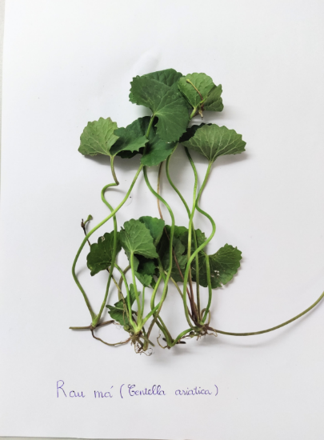
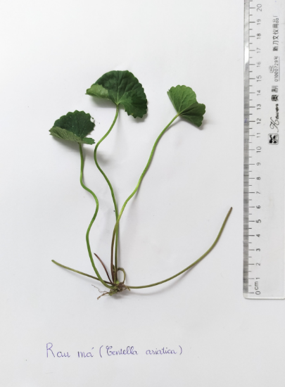
C

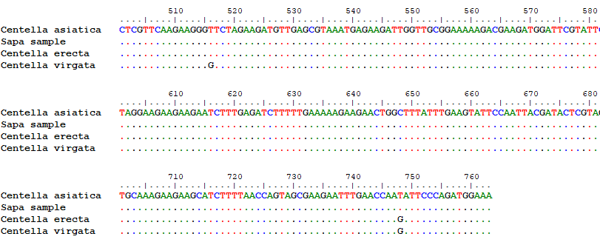
Figure 1. Morphological characterization of Centella asiatic (A), the phylogenetic tree of genus Centella based on matk sequences using MEGA software 11 (B), multiple sequence alignment of four matk sequences from genus Centella (C).
2. C. asiatica extracts Inhibited acetylcholinesterase activity
To evaluate the acetylcholinesterase inhibition of of C. asiatica extracts, in vitro Ellman assay was performed using berberine chloride as a positive control. The results showed that C. asiatica extracts inhibited the activity of acetylcholinesterase in a dose-dependent maner. Butanol extract of C. asiatica showed the most potency in the inhibition effect of acetylcholinesterase with IC50 valua of 270 µg/ml. The weakest inhibition effect of acetylcholinesterase was observed in the hexan extract of C. asiatica with IC50 valua of 420 µg/ml. The difference in the inhibitory Effect of acetylcholinesterase among extracts could be come from the phytochemical component of extracts (Fig 2).
A B
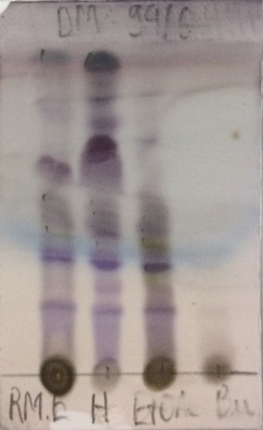
Figure 2. The ACHE inhibition effect of C. asiatica extracts (A), Phytochemistry of C. asiatica extracts by TLC (B).
3. Extracts of C. asiatica induces neurite outgrowth
To measure the effect of inducing neurite outgrowth of C. asiatic extracts, which were added to C6 cell culture medium at two distinct concentrations (5 µg/ml and 10 µg/ml). Neurite outgrowth was observed using a confocal microscope at 20x magnification after 24h incubation. DMSO was used as a negative control. As shown in figure 3, treatment with C. asiatica extracts significantly increased the average neurite length compared to 0.1% DMSO control. Butanol extract of C. asiatica showed the most accelation in neurite outgrowth, and dose-dependent maner. The average neurite length was 1.7 and 2.2 times longer than that of control group, when cells treated with butanol extract of C. asiatica at a concentration of 5.0 and 10.0 µg/ml, respectively. The lowest neurite outgrowth-inducing activities was observed in hexan extract of C. asiatica Fig. 3. Thess results suggested that butanol extract of C. asiatica possesses neurite outgrowth-inducing activity. 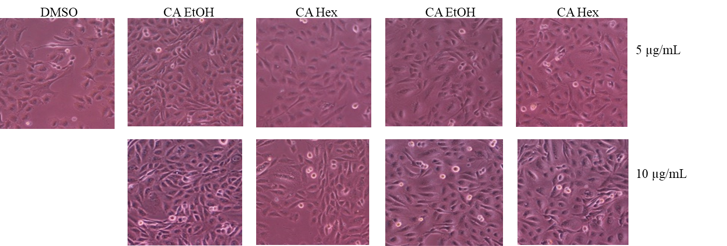

Figure 3. C. asiatica extracts induced neurite outgrowth. C6 cell morphology (A), average neurite length treated with C. asiatica extracts (B)
Discussion
The concept of "DNA barcode" was first introduced by Paul Hebert from the University of Guelph in 2003 [32]. DNA barcodes are standardized sequences of DNA that ideally possess unique characteristics. These sequences typically range in length from 400 to 800 base pairs and serve as a means to identify and classify groups of organisms. This process involves amplifying the DNA, sequencing it, and comparing the results with a reference database that includes relevant sequences from various species. DNA barcoding provides a fast and precise method for identifying various groups. Notably, at the species level, it can be utilized to characterize new or previously unidentified species, as well as cryptic species [33-35]. DNA barcoding has been widely used in the identification of various plant species. The Plant Working Group of the Consortium for the Barcode of Life (CBOL) proposed the chloroplast genes matK and rbcL as promising candidates for plant DNA barcoding [36-37]. In this study, we used genes matK and rbcL to identify our collected sample. Collected samples showed high similarty to Centella asiatic species, belongs to the genus Centella. The matK region is known for its rapid evolution and strong capability for interspecific identification, although the primers used are not universally applicable [38]. On the other hand, rbcL offers high generality, straightforward amplification, and good comparability; however, it lacks efficiency in distinguishing between species. Consequently, other chloroplast regions such as trnH-psbA, trnL, and trnL-F [39-40]. , as well as the nuclear ribosomal Internal Transcribed Spacer (ITS) region, are commonly utilized as supplementary barcodes in conjunction with matK and rbcL [39]. In our study, the chloroplast genes matK and rbcL is useful for identification Centella asiatic species.
Acetylcholine (ACh) plays a crucial role as a neurotransmitter, widely distributed throughout the nervous system. They were hydrolyzed by enzyme acetylcholinesterase, acting in both synapses and neuromuscular junctions. This hydrolysis is essential for terminating nerve impulses, ensuring proper communication within the nervous system. Imbalances in its levels can play a role in the development of neurodegenerative diseases and depressive disorders [41]. Furthermore, AChE inhibitors available on the market not only block the enzyme but also possess several additional properties that may aid in slowing the progression of these diseases [42]. In our study showed that butanol extraction of C. asiatica provided the inhibitory effect of acetylcholinesterase. This biological activity also confirmed by several study. However, the IC50 is still high. In this study, we also revealed the inducing effect of neurite outgrowth of C. asiatic butanol extract. Encouraging and enhancing neurite outgrowth plays a vital role in restoring neuronal function following injury or in the context of neurodegenerative diseases. A promising approach for developing drugs aimed at conditions like Alzheimer's and Parkinson's disease involves fostering the regeneration of neurites. Consequently, emerging therapies are concentrating on identifying molecules that can effectively promote neurite outgrowth [43]. The challenge of utilizing plant extracts in the treatment of these diseases lies in their phytochemical variability. This variability leads to inconsistent results among individual extracts, as they differ in their potency for acetylcholinesterase (AChE) inhibition, as well as their antioxidant and anti-inflammatory properties. Therefore, it is crucial to identify the most promising extracts, isolate their components, and investigate the specific compounds responsible for the observed effects. Once these compounds are identified, they can be modified to optimize their pharmacodynamic and pharmacokinetic properties for better therapeutic outcomes.
Conclusion
In conclusion, the present study has successfully identified C. asiatica using DNA barcoding. Moreover, these results highlight the promising potential of C. asiatica extracts in enhancing neurite outgrowth. They also exhibit notable anti-acetylcholinesterase activity. These indicates that C. asiatica could be potential candidates for the development of pharmacological drugs aimed at facilitating neuronal regeneration. Moving forward, we plan to investigate the expression of genes and proteins associated with their neuroprotective effects of C. asiatica butanol extract for treating neurodegenerative diseases. Moreover, active compound isolation for neuroprotective activities will also be conducted.

References
- The Lancet Neurology. Increasing awareness of the need for brain health. Lancet Neurol. 2024 Apr;23(4):325. doi: 10.1016/S1474-4422(24)00093-0. PMID: 38508822.
- Dorsey E.R., Glidden A.M., Holloway M.R., Birbeck G.L., Schwamm L.H. Teleneurology and mobile technologies: The future of neurological care. Nat. Rev. Neurol. 2018;14:285–297. doi: 10.1038/nrneurol.2018.31.
- Wong W. Economic burden of Alzheimer’s disease and managed care considerations. Am. J. Manag. Care. 2020;26((Suppl. 8)):S177–S183. doi: 10.37765/ajmc.2020.88482.
- Rajaram C, Reddy KR, Sekhar KBC. Neuroprotective activity of Tephrosia purpurea against haloperidol induced Parkinson disease model. Pharmacologia 2015;6(4):125e30.
- Perera J, Tan JH, Jeevathayaparan S, Chakravarthi S, Haleagrahara N. Neuroprotective effects of alpha lipoic acid on haloperidol-induced oxidative stress in the rat brain. Cell Biosci 2011;1:2e6.
- Kabra A, Sharma R, Hano C, Kabra R, Martins N, Baghel US. Phytochemical composition, antioxidant, and antimicrobial attributes of different solvent extracts from Myrica esculenta Buch.-Ham. Ex. D. Don leaves. Biomolecules 2019;9(8):357.
- Bhangale JO, Acharya SR. Anti-Parkinson activity of petroleum ether extract of Ficus religiosa (L.) leaves. Adv in Pharmacolo Sci 2016;2016:1e9.
- Chen P, Lin X, Yang CH, Tang X, Chang YW, Zheng W, et al. Study on chemical profile and neuroprotective activity of Myrica rubra leaf extract. Molecules 2017;22(7):1226.
- Kuo PC, Liao YR, Hung HY, Chuang CW, Hwang TL, Huang SC, et al. Anti-inflammatory and neuroprotective constituents from the peels of Citrus grandis. Molecules 2017;22:967e77.
- Wu L, Du ZR, Xu AL, Yan Z, Xiao HH, Wong MS, et al. Neuroprotective effects of total flavonoid fraction of the Epimedium koreanum Nakai extract on dopaminergic neurons: in vivo and in vitro. Biomed Pharmacother 2017;91: 656e63.
- Hiep NT, Kwon J, Kim DW, Hong S, Guo YQ, Hwang BY, et al. Neuroprotective constituents from the fruits of Maclura tricuspidata. Tetrahedron 2017;73: 2747e59.
- Shagirtha K, Bashir N, MiltonPrabu S. Neuroprotective efficacy of hesperetin against cadmium induced oxidative stress in the brain of rats. Toxicol Ind Health 2017;33:454e68.
- Yang H, Sung SH, Kim J, Kim YC. Neuroprotective diarylheptanoids from the leaves and twigs of Juglans Sinensis against glutamate-induced toxicity in HT22 cells. Planta Med 2011;77:841e5.
- Huang XJ, Tang GY, Liao YM, Zhuang XJ, Dong X, Liu H, et al. 7-(4- Hydroxypheny1)-1-phenyl-4E-hepten-3-one, a diarylheptanoid from Alpinia officinarum, protects neurons against amyloid-beta induced toxicity. Biol Pharm Bull 2016;39:1961e7.
- Gajbhiye N. A., Makasana J., Saha A., Patel I., Jat R. S. (2016). LC-ESI-MS/MS Method for Simultaneous Determination of Triterpenoid Glycosides and Aglycones in Centella asiatica L. Chromatographia 79 (11), 727–739. 10.1007/s10337-016-3089-x
- Singh S., Singh D. R., Banu V. S., N A. (2014). Functional Constituents (Micronutrients and Phytochemicals) and Antioxidant Activity of Centella asiatica (L.) Urban Leaves. Ind. Crops Prod. 61, 115–119. 10.1016/j.indcrop.2014.06.045
- Choi M.-J., Zheng H.-M., Kim J. M., Lee K. W., Park Y. H., Lee D. H. (2016). Protective Effects of Centella asiatica Leaf Extract on Dimethylnitrosamine-Induced Liver Injury in Rats. Mol. Med. Rep. 14 (5), 4521–4528. 10.3892/mmr.2016.5809
- Dewi R. T., Maryani F. (2015). Antioxidant and α-Glucosidase Inhibitory Compounds of Centella Asiatica. Proced. Chem. 17, 147–152. 10.1016/j.proche.2015.12.130
- Intararuchikul T., Teerapattarakan N., Rodsiri R., Tantisira M., Wohlgemuth G., Fiehn O., et al. (2019). Effects of Centella Asiatica extract on Antioxidant Status and Liver Metabolome of Rotenone-Treated Rats Using GC-MS. Biomed. Chromatogr. 33 (2), e4395. 10.1002/bmc.4395
- Ho P. J., Sung J. J., Cheon K. K., Tae H. J. (2018). Anti-inflammatory Effect of Centella asiatica Phytosome in a Mouse Model of Phthalic Anhydride-Induced Atopic Dermatitis. Phytomedicine 43, 110–119. 10.1016/j.phymed.2018.04.013
- Diniz LRL, Calado LL, Duarte ABS, de Sousa DP. Centella asiatica and Its Metabolite Asiatic Acid: Wound Healing Effects and Therapeutic Potential. Metabolites. 2023 Feb 14;13(2):276. doi: 10.3390/metabo13020276. PMID: 36837896; PMCID: PMC9966672.
- Witkowska, K.; Paczkowska-Walendowska, M.; Garbiec, E.; Cielecka-Piontek, J. Topical Application of Centella asiatica in Wound Healing: Recent Insights into Mechanisms and Clinical Efficacy. Pharmaceutics 2024, 16, 1252. https://doi.org/10.3390/pharmaceutics16101252
- Idris F. N., Nadzir M. M. (2017). Antimicrobial Activity of Centella asiatica on Aspergillus niger and Bacillus Subtilis. Chem. Eng. Trans. 56, 1381–1386. 10.3303/CET1756231
- Rafi M., Handayani F., Darusman L. K., Rohaeti E., Wahyu Y., Sulistiyani S., et al. (2018). A Combination of Simultaneous Quantification of Four Triterpenes and Fingerprint Analysis Using HPLC for Rapid Identification of Centella asiatica from its Related Plants and Classification Based on Cultivation Ages. Ind. Crops Prod. 122, 93–97. 10.1016/j.indcrop.2018.05.062
- Torbati F. A., Ramezani M., Dehghan R., Amiri M. S., Moghadam A. T., Shakour N., et al. (2021). Ethnobotany, Phytochemistry and Pharmacological Features of Centella asiatica: A Comprehensive Review. Adv. Exp. Med. Biol. 1308, 451–499. 10.1007/978-3-030-64872-5_25
- Joshi VP, Kumar N, Singh B, Chamoli RP. Chemical Composition of the Essential Oil of Centella asiatica (L.) Urb. from Western Himalaya. Natural Product Communications. 2007;2(5). doi:10.1177/1934578X0700200515
- Chien-Li Chen, Wen-Hao Tsai, Chun-Jen Chen, Tzu-Ming Pan, Centella asiatica extract protects against amyloid β1–40-induced neurotoxicity in neuronal cells by activating the antioxidative defence system, Journal of Traditional and Complementary Medicine, Volume 6, Issue 4, 2016,
- Kiss, T., Karácsony, Z., Gomba-Tóth, A. et al. A modified CTAB method for the extraction of high-quality RNA from mono-and dicotyledonous plants rich in secondary metabolites. Plant Methods 20, 62 (2024). https://doi.org/10.1186/s13007-024-01198-z
- Asmah N, Suniarti DF, Margono A, Mas'ud ZA, Bachtiar EW. Identification of active compounds in ethyl acetate, chloroform, and N-hexane extracts from peels of Citrus aurantifolia from Maribaya, West Java, Indonesia. J Adv Pharm Technol Res. 2020 Jul-Sep;11(3):107-112. doi: 10.4103/japtr.JAPTR_177_19.
- Kowalska T, Sajewicz M. Thin-Layer Chromatography (TLC) in the Screening of Botanicals-Its Versatile Potential and Selected Applications. Molecules. 2022 Oct 5;27(19):6607. doi: 10.3390/molecules27196607. PMID: 36235143; PMCID: PMC9572063.
- Pohanka M, Hrabinova M, Kuca K, Simonato JP. Assessment of acetylcholinesterase activity using indoxylacetate and comparison with the standard Ellman's method. Int J Mol Sci. 2011;12(4):2631-40. doi: 10.3390/ijms12042631.
- Hebert, P.D.; Cywinska, A.; Ball, S.L.; DeWaard, J.R. Biological identifications through DNA barcodes. Proceedings of the Royal Society of London. Ser. B Biol. Sci. 2003, 270, 313–321. [Google Scholar] [CrossRef] [PubMed]
- Jiang, K.W.; Zhang, R.; Zhang, Z.F.; Pan, B.; Tian, B. DNA barcoding and molecular phylogeny of Dumasia (Fabaceae: Phaseoleae) reveals a cryptic lineage. Plant Divers. 2020, 42, 376–385. [Google Scholar] [CrossRef] [PubMed]
- Jourdan, J.; Bundschuh, M.; Copilaș-Ciocianu, D.; Fišer, C.; Grabowski, M.; Hupało, K.; Kokalj, A.J.; Kabus, J.; Römbke, J.; Soose, L.J. Cryptic species in ecotoxicology. Environ. Toxicol. Chem. 2023, 42, 1889–1914. [Google Scholar] [CrossRef]
- Struck, T.H.; Feder, J.L.; Bendiksby, M.; Birkeland, S.; Cerca, J.; Gusarov, V.I.; Kistenich, S.; Larsson, K.-H.; Liow, L.H.; Nowak, M.D.; et al. Finding evolutionary processes hidden in cryptic species. Trends Ecol. Evol. 2018, 33, 153–163. [Google Scholar] [CrossRef]
- Wilson Thau Lym Yong, Anis Adilah Mustafa, Mohammad Rahmat Derise, Kenneth Francis Rodrigues, DNA barcoding using chloroplast matK and rbcL regions for the identification of bamboo species in Sabah, Advances in Bamboo Science, Volume 7, 2024, 100073, doi.org/10.1016/j.bamboo.2024.100073.
- Li, H., Xiao, W., Tong, T. et al. The specific DNA barcodes based on chloroplast genes for species identification of Orchidaceae plants. Sci Rep 11, 1424 (2021). https://doi.org/10.1038/s41598-021-81087-w
- Arca, M., Hinsinger, D. D., Cruaud, C., Tillier, A., Bousquet, J., and Frascaria-Lacoste, N. (2012). Deciduous trees and the application of universal DNA barcodes: A case study on the circumpolar Fraxinus. PLoS One 7:e34089. doi: 10.1371/journal.pone.0034089
- Fazekas, A. J., Burgess, K. S., Kesanakurti, P. R., Graham, S. W., Newmaster, S. G., Husband, B. C., et al. (2008). Multiple multilocus DNA barcodes from the plastid genome discriminate plant species equally well. PLoS One 3:e2802. doi: 10.1371/journal.pone.0002802
- Sass, C., Little, D. P., Stevenson, D. W., and Specht, C. D. (2007). DNA barcoding in the cycadales: Testing the potential of proposed barcoding markers for species identification of cycads. PLoS One 2:e1154. doi: 10.1371/journal.pone.0001154
- Van Enkhuizen J., Janowsky D.S., Olivier B., Minassian A., Perry W., Young J.W., Geyer M.A. The Catecholaminergic-Cholinergic Balance Hypothesis of Bipolar Disorder Revisited. Eur. J. Pharmacol. 2015;753:114–126. doi: 10.1016/j.ejphar.2014.05.063.
- Walczak-Nowicka ŁJ, Herbet M. Acetylcholinesterase Inhibitors in the Treatment of Neurodegenerative Diseases and the Role of Acetylcholinesterase in their Pathogenesis. Int J Mol Sci. 2021 Aug 27;22(17):9290. doi: 10.3390/ijms22179290. PMID: 34502198; PMCID: PMC8430571.
- Jiaxin Yuan, Liyao Xu, Yaobao Han, Zhilin Jiang, Qing Zheng, Yifan Gao, Wei Xing, Zhen Li, Boosting neurite outgrowth and anti-oxidative stress for treatment of Parkinson's disease by biomimetic ultrasmall nanoparticles, Sustainable Materials and Technologies, Volume 39,2024, https://doi.org/10.1016/j.susmat.2023.e00807.

