Review Article
Artificial Intelligence and Machine Learning models in adsorptive removal of toxic heavy metals and textile dyes from wastewater

Abstract
Herein we reviewed It also introduces Artificial intelligence (AI) and Machine learning (ML) models in the optimization and prediction of process parameters during the removal of toxic heavy metals and textile dyes. Adsorption parameters normally optimized include pH, contact time, initial concentration, adsorbent dosage, and temperature. This review focuses on common AI models such as Artificial Neural Networks (ANN), Particle Swarm Optimization, and Genetic Algorithms (GA). Furthermore, the review describes the common prediction statistical indicators such as coefficient of determination (R²), root mean square error (RMSE), mean squared error (MSE), absolute average deviation (AAD), etc. Lastly, this review highlights the significant potential of AI and ML in revolutionizing the field of wastewater treatment and mitigating the environmental impact of industrial pollution.
Keywords: artificial intelligence, wastewater, adsorbents, toxic heavy metals, textile dyes

1. INTRODUCTION
The world's population is increasing rapidly over the last few decades, resulting in natural resource pollution. For the survival of humans, they depend on the available water sources such as the oceans, seas, rivers, lakes, and streams. Due to anthropogenic activities such as agriculture, industrialization, mining, and manufacturing a variety of pollutants have found their way into the ecosystem [1]. These pollutants are mainly due to textile dyes, toxic heavy metals, nanoplastics, fungi, pathogens, personal care products, nitrates, surfactants, insecticides, aromatic compounds, microplastics, and pharmaceuticals [2–7]. Exposure to these pollutants has a variety of side effects such as nausea, vomiting, liver damage, itching, nervous dysfunction, and hormonal imbalance [8, 9].
Several techniques have been applied to remove these pollutants from water such as reverse osmosis [10–14], membrane filtration, advanced oxidation [15–18], photolysis [19], electrochemical processes [20–22], ion exchange, chemical reduction [23, 24], biological treatment (aerobic and anaerobic) [25–27], ozonation [19], and adsorption [28–31]. Most of these have some drawbacks such as high maintenance costs, complexity in operation, and expensive. Adsorption has found wide application due to its simplicity in design, cost-effectiveness, availability, and low maintenance costs [32]. This process occurs when a substance (adsorbate) interacts on the surface of a solid (adsorbent) which occurs through chemisorption or physisorption. The common adsorbents include activated carbon [33], metal-organic frameworks (MOFs) [34, 35], graphene [36–38], carbon nanotubes [39–41], and polymers [42–45].
During analysis finding the accurate operating parameters is always a challenge during real processes particularly in the areas of science and engineering where they are complex reactions [46]. Experimental data while highly important is always energy-intensive and time-consuming making them impractical for comprehensive analysis [47]. Due to these limitations, researchers have applied numerous traditional methods such as isotherms, thermodynamics, and kinetics, though informative have a low scope [42, 48–50]. These models operate under static conditions giving mostly information about the adsorption capacity, mechanisms, entropy changes, and Gibbs energy which all occur at fixed operating conditions [51]. Furthermore, the dependence on batch experiments that vary only one parameter at a time are costly and time-consuming therefore fail to give an insight into the interaction between the different parameters thus affecting the adsorption efficiency [52].
Mathematical modeling and optimization tools have gained large applications in the field of engineering and science. Among all the optimization tools, Response surface methodology (RSM) is the most commonly used statistical tool for process variable optimization [53]. RSM has several shortcomings when optimizing big data sets and more complex reactions thus the need for better and more sophisticated data predictive models [54, 55]. The advancement in computation power in the field of computer science has led to the emergence of Artificial Intelligence (AI) models which offer better accuracy and low run time. AI is characterized by its nonlinearity but also its ability to run complex and intricate data sets. These models are excellent at statistical modeling complex systems thus being able to give accurate insights into the interactions between the various contributing variables and how they influence the adsorption efficiency. AI comprises of a variety models such as gradient boost decision tree (GBDT), linear regression (LG), random forest (RF), support vector regression, and artificial neural networks (ANN) which are used in adsorption studies to remove pollutants. Using various AI models provides invaluable information about the relationship between input and output parameters thus elaborating the dynamics for the reaction dynamics.
This review is aimed at giving information about the importance of artificial intelligence and machine learning models in the optimization and prediction of process parameters in the adsorptive removal of toxic heavy metals and textile dyes. It further highlights how the different AI models are applied in wastewater treatment.
2. AN OVERVIEW OF ARTIFICIAL INTELLIGENCE MODELS

AI is based on computer systems that behave like human intelligence and deal with smart systems as building blocks [56]. The objective of AI systems is to increase on functions of computers that are helpful to human beings such as perception, learning, and problem-solving [57]. The optimization and prediction are based on three main categories which are deep learning, data analytics, and machine learning [56]. The most commonly used AI models for water treatment are shown in Figure 1.
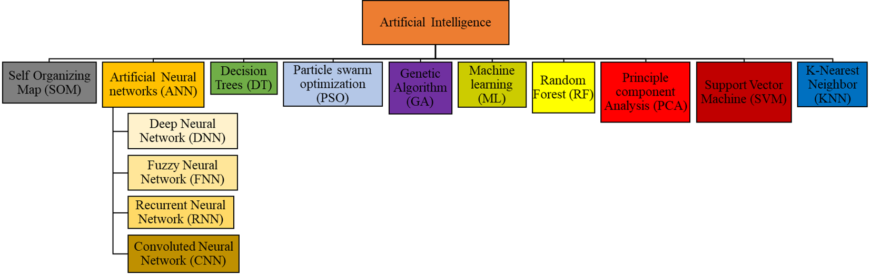
Figure 1. The most common Artificial intelligence models.
2.1 ACTIVATION FUNCTIONS
The activity of the input neurons determines the output through what is known as the activation function. It models the non-linear aspects of the world through its non-linearity. A number of expressions have been used to describe the neuron’s activation function and they include step, sigmoid, tangent sigmoid, or linear function as shown in Table 1.
Table 1. The common activation functions used in artificial intelligence
Activation | Expression | Range | Reference
Sigmoid | $$f\left(x\right)=\frac{1}{1+e^{-x}}$$ | (0,1) | [58]
Tanh | $$f\left(x\right)=\tanh\left(x\right)$$ | (-1,1) | [59]
Linear | $$f\left(x\right)=x$$ | (-∞,+∞) | [60]
ReLU | $$f\left(x\right)=max\left(0,1\right)$$ | (0, +∞) | [61]
ELU | $$f\left(x\right)=\left\{\begin{aligned}a(e^{x}-1), &x<0 \\ x, &x≥0\end{aligned}\right.$$ | (-a, +∞) | [62]
Heaviside | $$f\left(x\right)=\left\{\begin{aligned}0,x<T_{1} \\ 1,x≥T\end{aligned}\right.$$ | (0,1) | [63, 64]
Leaky ReLU | $$f\left(x\right)=max⁡(x,x)$$ | (-∞,+∞) | [65]
Ramp | $$f\left(x\right)=\left\{\begin{aligned}0,x<T_{1} \\ \frac{x-T_{1}}{T_{2}-T_{1}},T_{1}≤x≤T_{2} \\ 1,x≥T_{2}\end{aligned}\right.$$ | (0,1) | [66]

2.2 ARTIFICIAL NEURAL NETWORKS
A mathematical tool developed from the working neural architecture of the human brain is the Artificial neural network (ANN) [67]. This network is made of three layers: the input, hidden and output layers which are all interconnected by many nodes which coordinate to perform particular tasks [68]. Just like real neurons, artificial inputs are taken in and then analyzed through clever non-linear activation functions, then used to predict output according to the experimental data [69]. These neural networks can be used to predict the sorption mechanisms of pollutants in aqueous phase. For the ANN to operate, experimental data must be available to generate training, validation and test sets [70]. The neural network’s effectiveness and functionality are based on the influence of the activation function, data set, input and output normalization and its structure [71]. The working principle of the ANN is based on a number of factors such as the nodes which are normally called neurons that process the information through the use of a unitary computational processor with a transfer function and a summation function [72]. Figure 1 shows the structure of the nodes, weights, and biases which connect the neurons, input and output parameters.
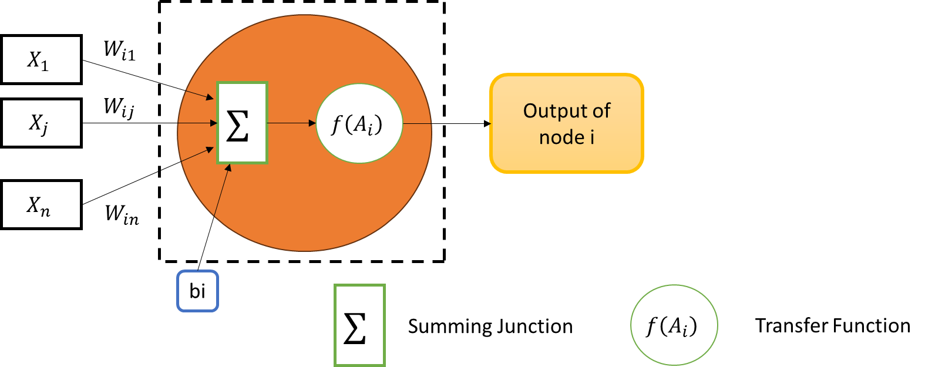Figure 2. The structure of the nodes, weights, and biases
The neural network is described by the activation function, connecting weights, structural properties, and nodes which show the neural network [73]. The input and output layers determine the orientation of the flow of data in the neural network [74]. The three most commonly used transfer functions are the hyperbolic tangent sigmoid transfer function (tansig), linear transfer function (purelin), and the log-sigmoid transfer function (logsig), and [75, 76]. Figure 3 shows the three common transfer functions.
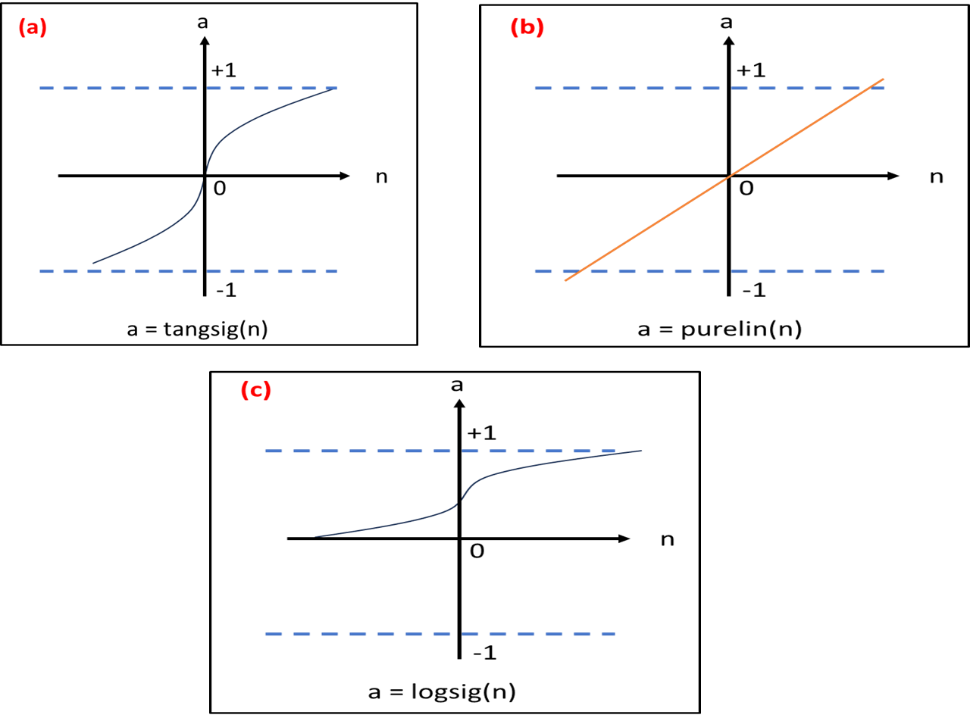
Figure 3. The three most common transfer functions
The classification of the ANN structure is based on two network architectures that is the radial basis function and back propagation network (BPN) [77]. The latter is commonly used since it is based on a reverse error spread but also its multilayer feed-forward mechanism which is known in 80 % of the neural networks [77]. A sigmoid layer, biases, and output layer are used as an approximation to the finite number of discontinuities [78]. Figure 4 shows a diagrammatic representation of a feed-forward BPN.
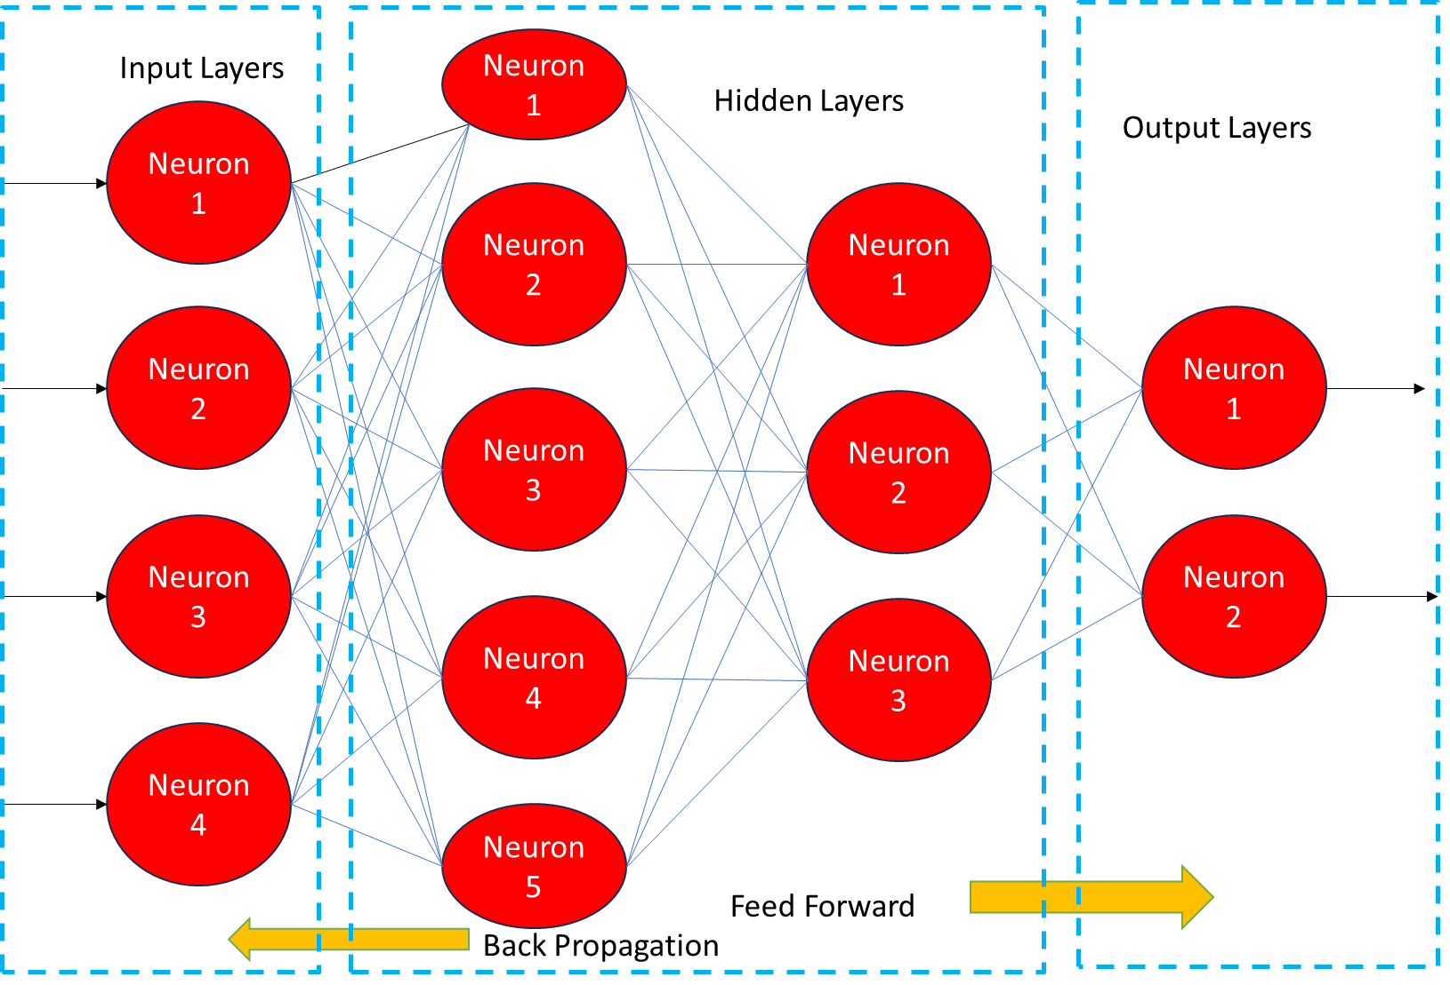
Figure 4. A diagrammatic representation of a feed-forward BPN
ANN models that have found wide application include Recurrent Neural Networks (RNNs), Fuzzy Neural Networks (FNNs), Deep Neural Networks (DNNs) and Convolutional Neural Networks (CNNs) [79–83].
2.2.1 Convolutional Neural Network (CNN)
This network is defined by a deep structure and convolutional computation and is based on a feedforward neural network. It is part of deep learning with the ability to process data in language processing and computer vision. The inputs are processed through the convolutional layers which then move to the pooling that reduces the dimensions and then regression occurs at the connected layers [84]. Figure 5 shows the basic structure of a CNN architecture.
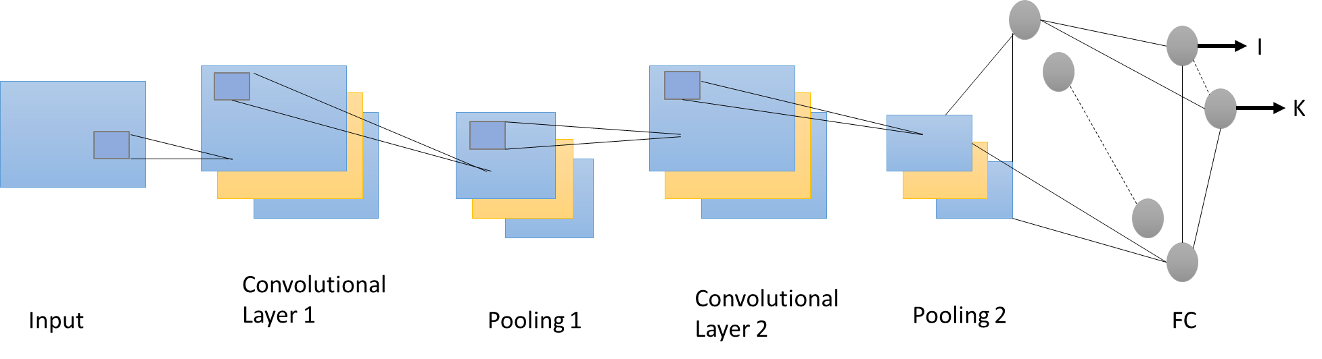
Figure 5. The basic structure of a CNN architecture

2.2.2 Deep Neural Network (DNN)
This is classified with multiple hidden layers but the output and input layers enable it to learn deep and complex data sets where high-level learning occurs through the use of successive low-level layers. It is mainly applied in mapping nonlinear data sets for the input and output layer but also in understanding the complexity of data. Figure 6 shows the basic structure of a DNN.
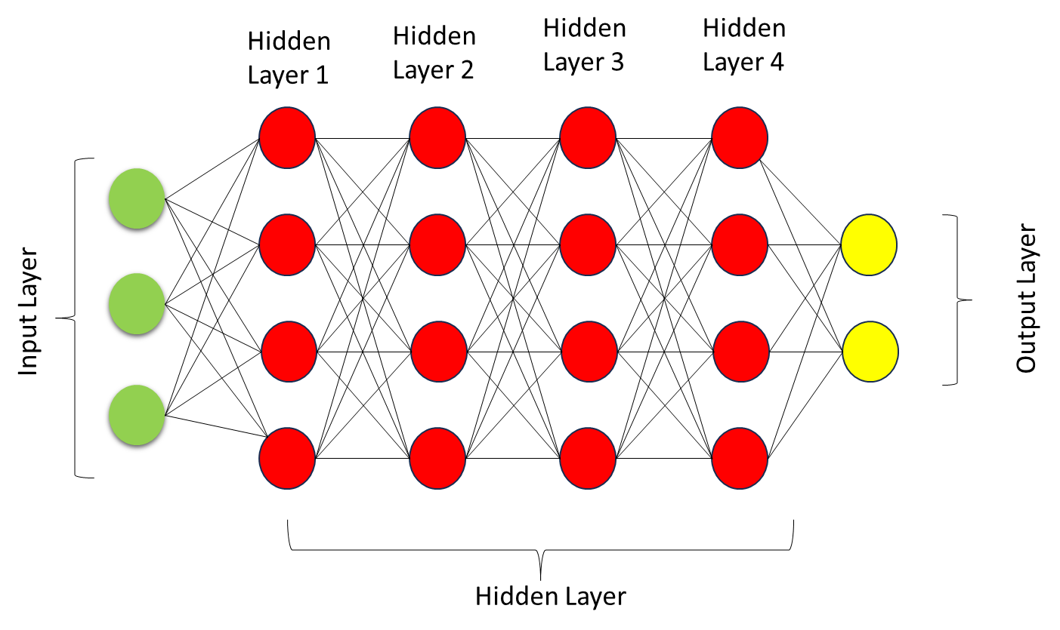
Figure 6. The basic structure of a DNN
2.2.3 Recurrent Neural Network (RNN)
RNN is based on connections of feedback which takes the input data in the form of a sequence and makes recursions to the sequence through the evolution direction. It can determine the nonlinear characteristics of the time series problems through its abilities of parameter sharing, memory, and turing completeness. Long short-term memory (LSTM), is the commonly used RNN through its capacity to have gated units which help to solve the gradient disappearance problem. The basic RNN architecture is shown in Figure 7.
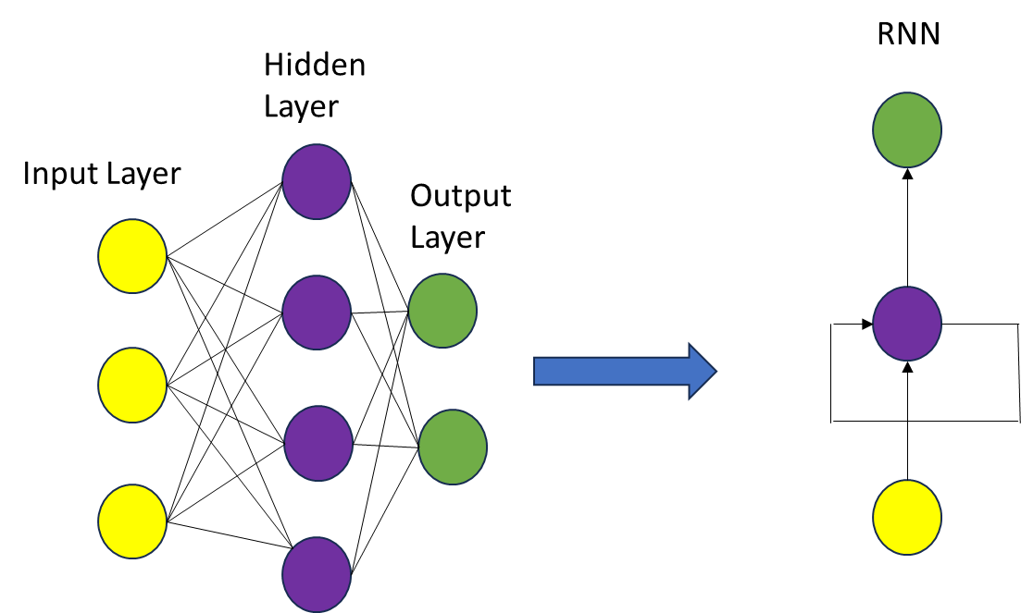
Figure 7. The basic RNN architecture
2.2.4 Fuzzy Neural Network (FNN)
FNN uses both the ANN and fuzzy logic to simulate and predict data sets with uncertainty.
Fuzzy logic is applied in the processing of the input data while ANN trains and outputs the data. It uses the membership function, normalization, and inference to describe the relationship between input and output data while describing the neuron connections by the weights. The basic FNN architecture is shown in Figure 8.
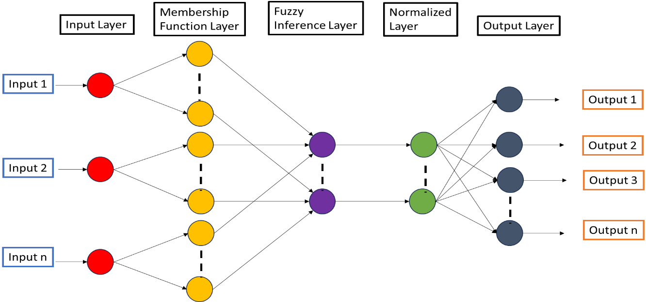
Figure 8. The basic FNN architecture
2.3 MACHINE LEARNING (ML)
This is a sub-category of AI aimed at developing statistical models and algorithms that enable systems to learn from data without having prior knowledge of the data sets [85]. Its objective is to make accurate decisions and predictions based on predictive models and what it has learned from the raw data [86]. Figure 9 shows the common machine learning models.
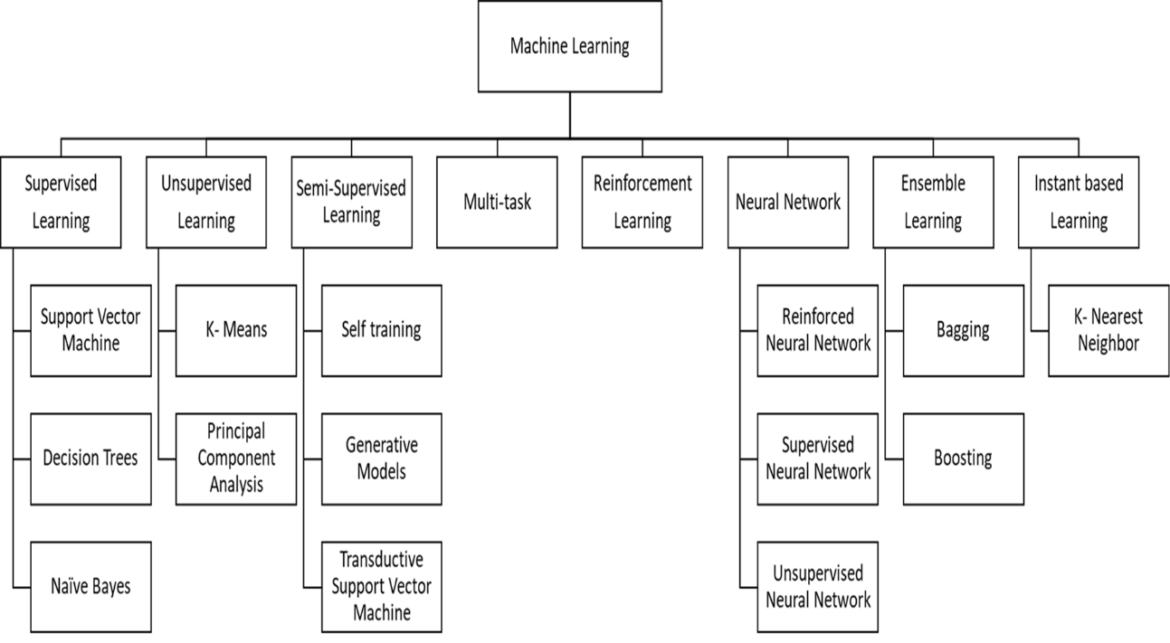
Figure 9. The common machine learning models
2.4 ADAPTIVE-NETWORK-BASED FUZZY INFERENCE SYSTEM (ANFIS)
This is an intelligent model designed using neural networks and fuzzy logic for prediction, regression, and classification. It is modeled using the neural network’s learning capacity plus the fuzzy inference ability of the fuzzy logic to increase the learning of the inference systems [87]. It is used in the modeling of multivariable and nonlinear systems which help in its application in areas such as classification and prediction. Figure 10 shows the basic structure of ANFIS.

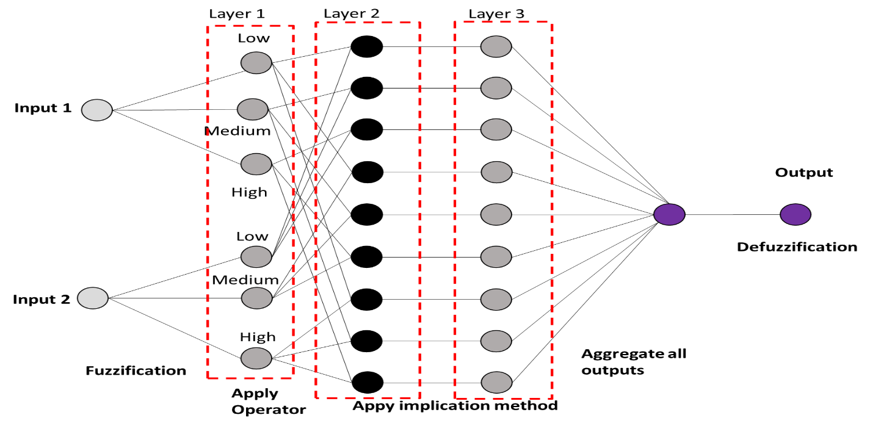
Figure 10. The basic structure of ANFIS
2.5 RANDOM FOREST (RF)
It is normally used to increase the stability and accuracy of the model through the application of multiple decision trees. Through the decision tree training on different random data sets, the accuracy of the model can be improved. Averaging multiple decisions helps in optimization and classification [88]. Figure 11 shows the basic structure of RF.
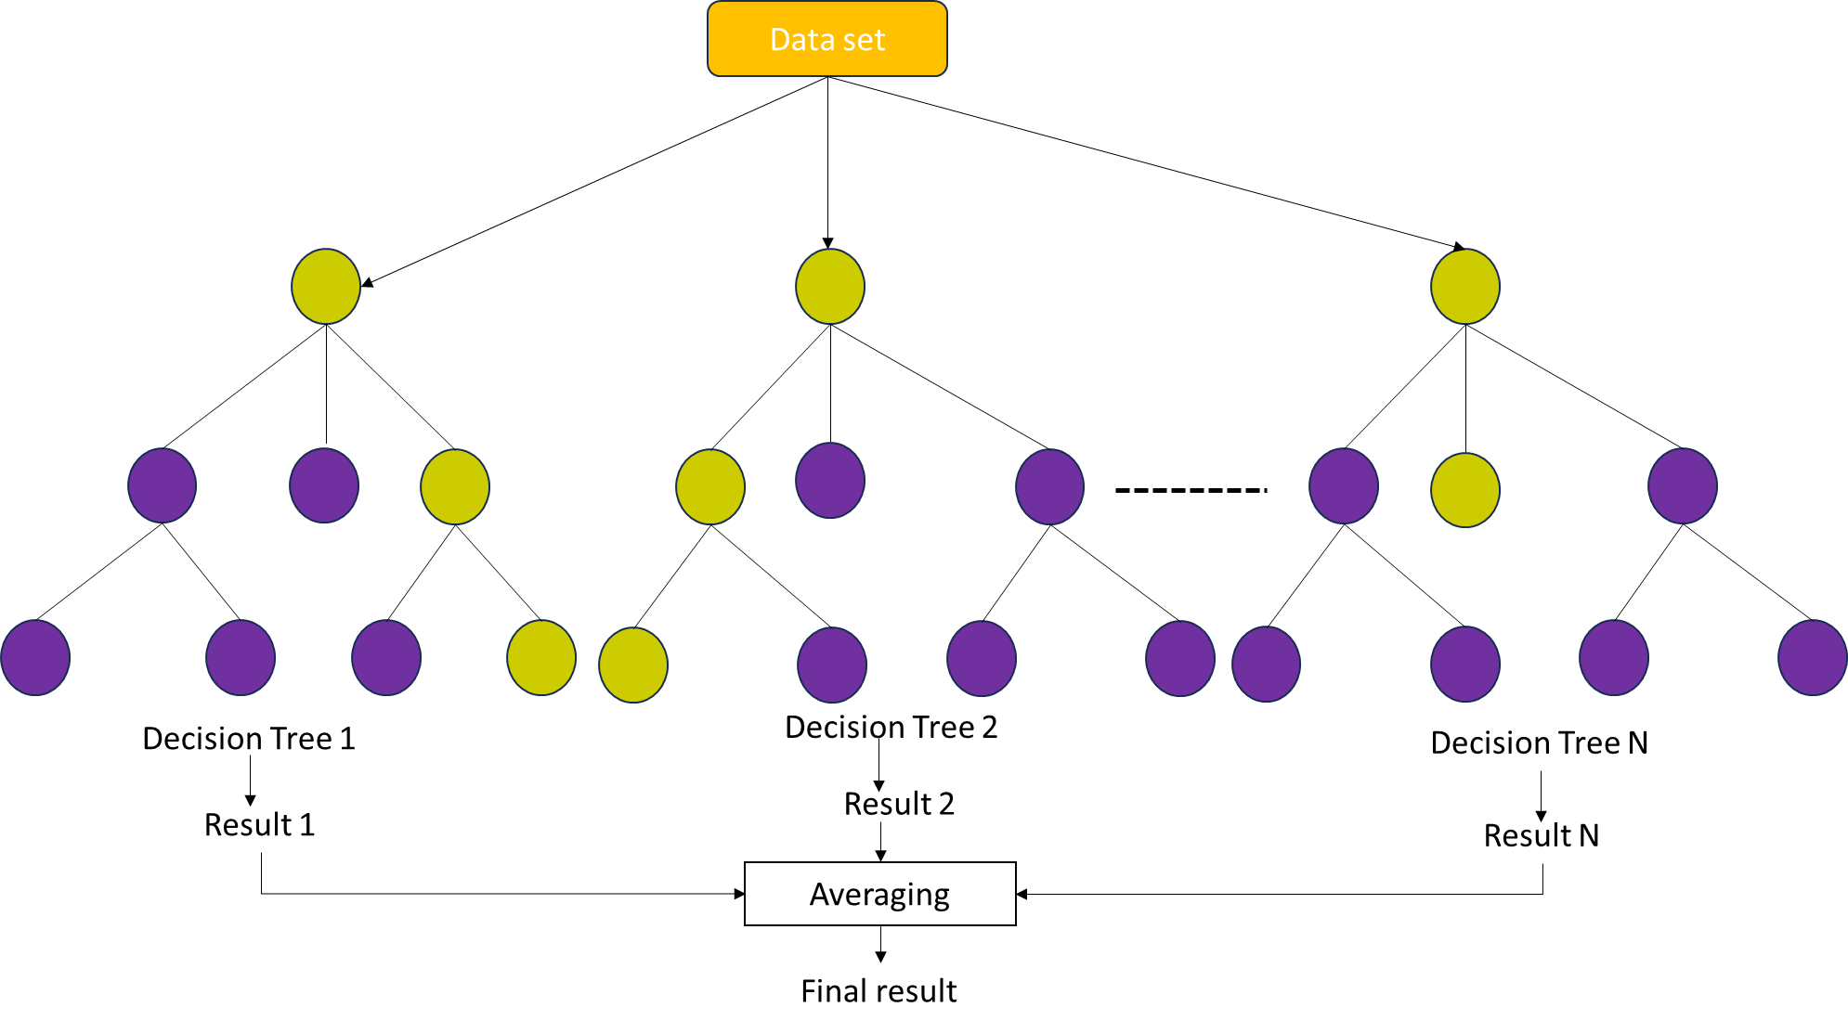
Figure 11. The basic structure of RF
2.6 K-NEAREST NEIGHBORS (k-NN)
This is another algorithm that is simple and commonly used in the regression and classification of data sets. It simulates the category of a new data point based on K neighbors closest to this point through the use of the training sets. Using different data point distance measurements, it can easily modify complex models and deal with nonlinear relationships between the output and input data.
Figure 12 shows a schematic representation of a KNN model.
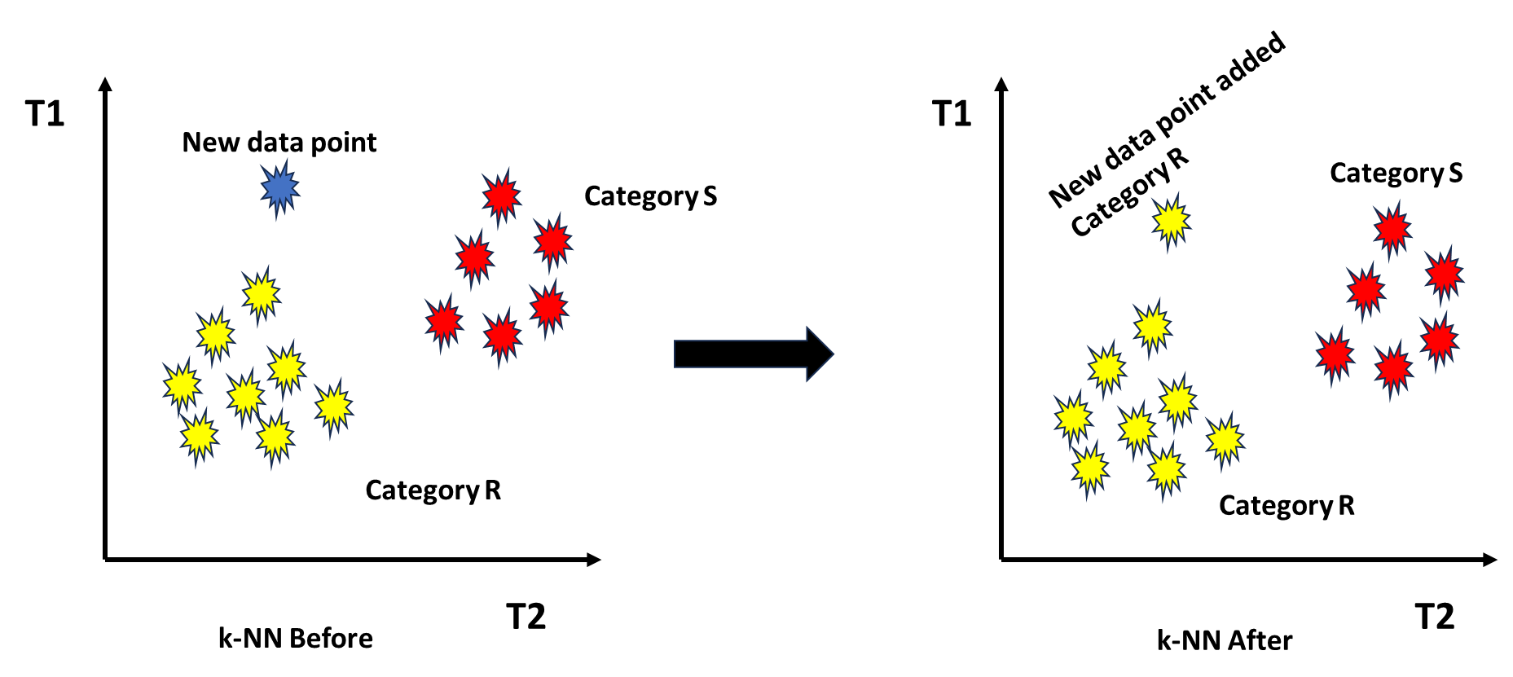
Figure 12. A schematic representation of a KNN model
2.7 DECISION TREE
This model follows a tree where the node shows the input, the edge describes the probable outputs and the leaf node denotes the real output [89]. It uses simple learning decision rules to generate training data that is used for class or data prediction. It is favoured because of its ease of implementation and high accuracy. In this model all problems are looked at starting with the leaves, stem up to the roots which results in many possible solutions. Figure 13 shows the basic structure of a decision tree.
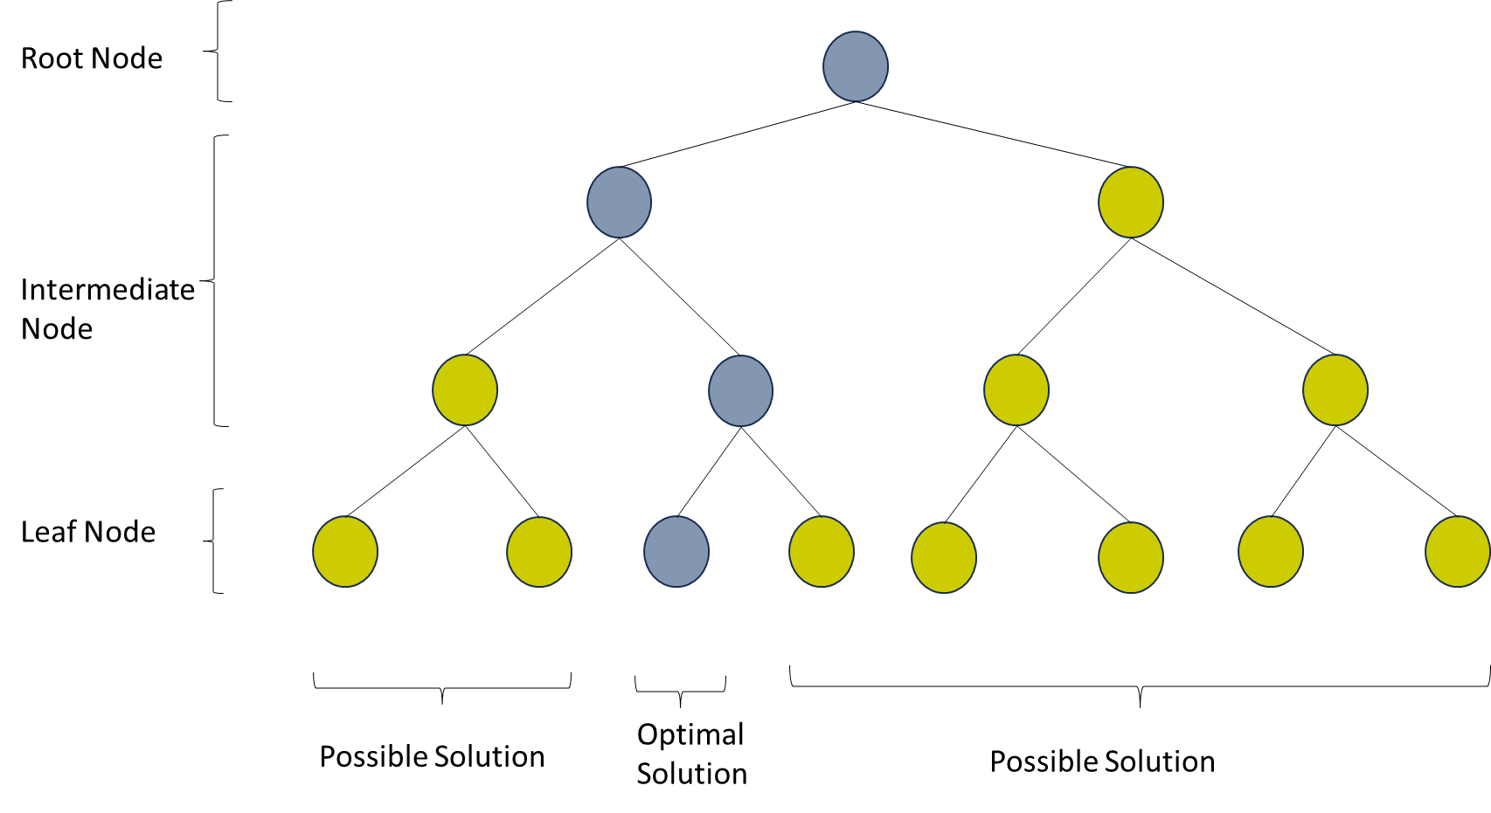
Figure 13. The basic structure of a decision tree.
2.8 PRINCIPAL COMPONENT ANALYSIS (PCA)

It is an algorithm used to train high-dimension data to low-dimension data through a reduction technique and ensure that during the orthogonal transformation, the original data is retained [90]. It is applied in noise filtering, clustering, and language processing. Figure 14 shows a diagrammatic representation of Principle Component Analysis.
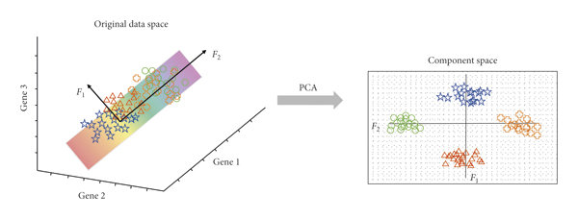
Figure 14. A diagrammatic representation of Principle Component Analysis [91].
2.9 PARTICLE SWARM OPTIMIZATION (PSO)
PSO describes the behavioral patterns of biological systems such as birds, whales, or fish through its ability to optimize the velocity and position to achieve an optimal solution. After each iteration based on the optimal position and the algorithm-defined rule, the individual particles will migrate to the best position through modification of their position and velocity [92]. The position and velocity of the particle is shown by the blue bold lines, P_{best} describes the individual best position, and G_{best} describes the best global position in a given search space. The representation of the Particle Swarm Optimization model is shown in Figure 15.
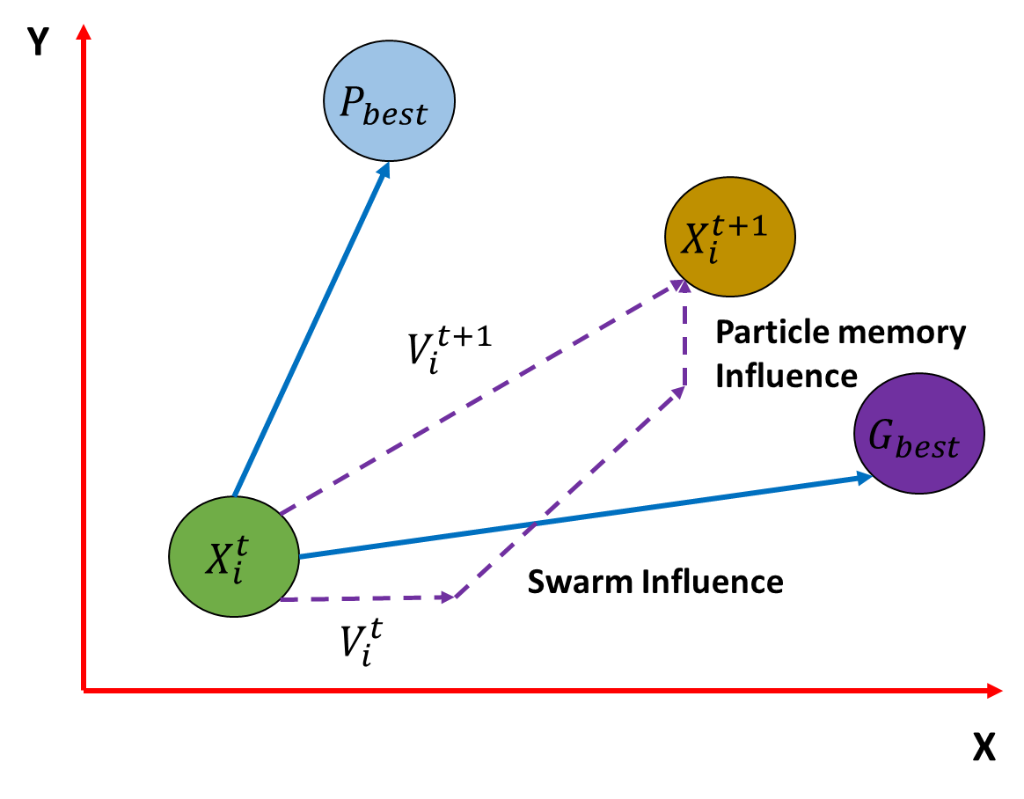
Figure 15. A representation of the Particle Swarm Optimization model
2.10 SUPPORT VECTOR MACHINE (SVM)
SVM deals with training data that is labelled to determine the next step of each category and is based on the mapping of the input vector via a high dimensional space. The basis for the mapping is obtained using a variety of kernel functions such as polynomial and radial basis whereas the datasets determine the function selection [29]. It is mainly used in pattern recognition where a hyperplane is drawn which causes the differentiation between two data sets in the space thus creating a margin for classification. Figure 16 shows a diagrammatic representation of a Support Vector Machine model.
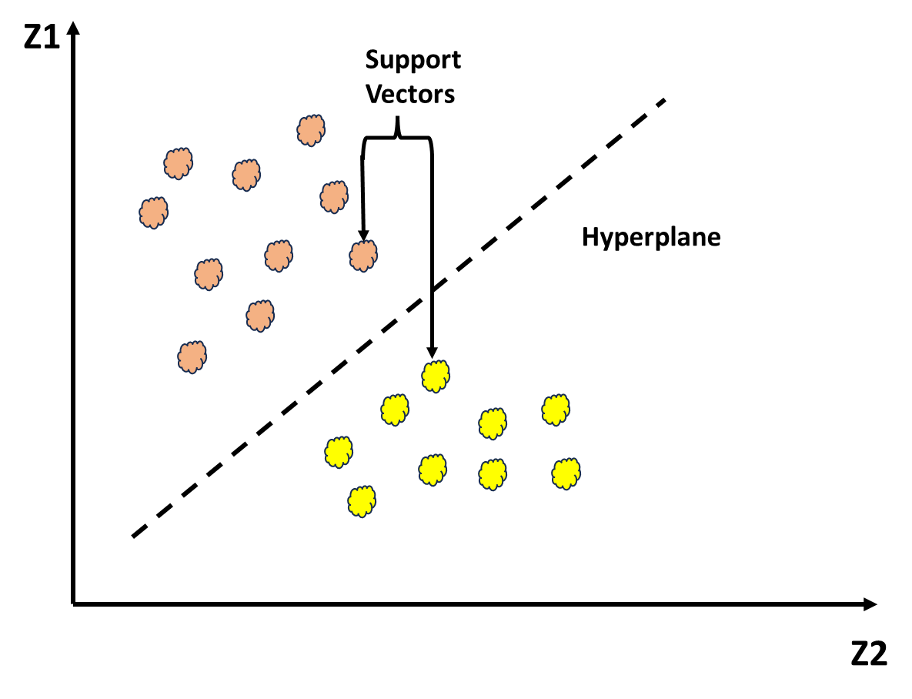
Figure 16. A diagrammatic representation of a Support Vector Machine model
2.11 SELF-ORGANIZING MAP (SOM)
It is based on the input and output layers and is commonly applied in dimensional reduction and clustering. It uses an associated competitive process for input data that projects high dimensional to low dimensional input data without affecting the topology of the data thus making it simple to classify and visualize data points [93]. Figure 17 shows a diagrammatic representation of a Self-Organizing Machine model.
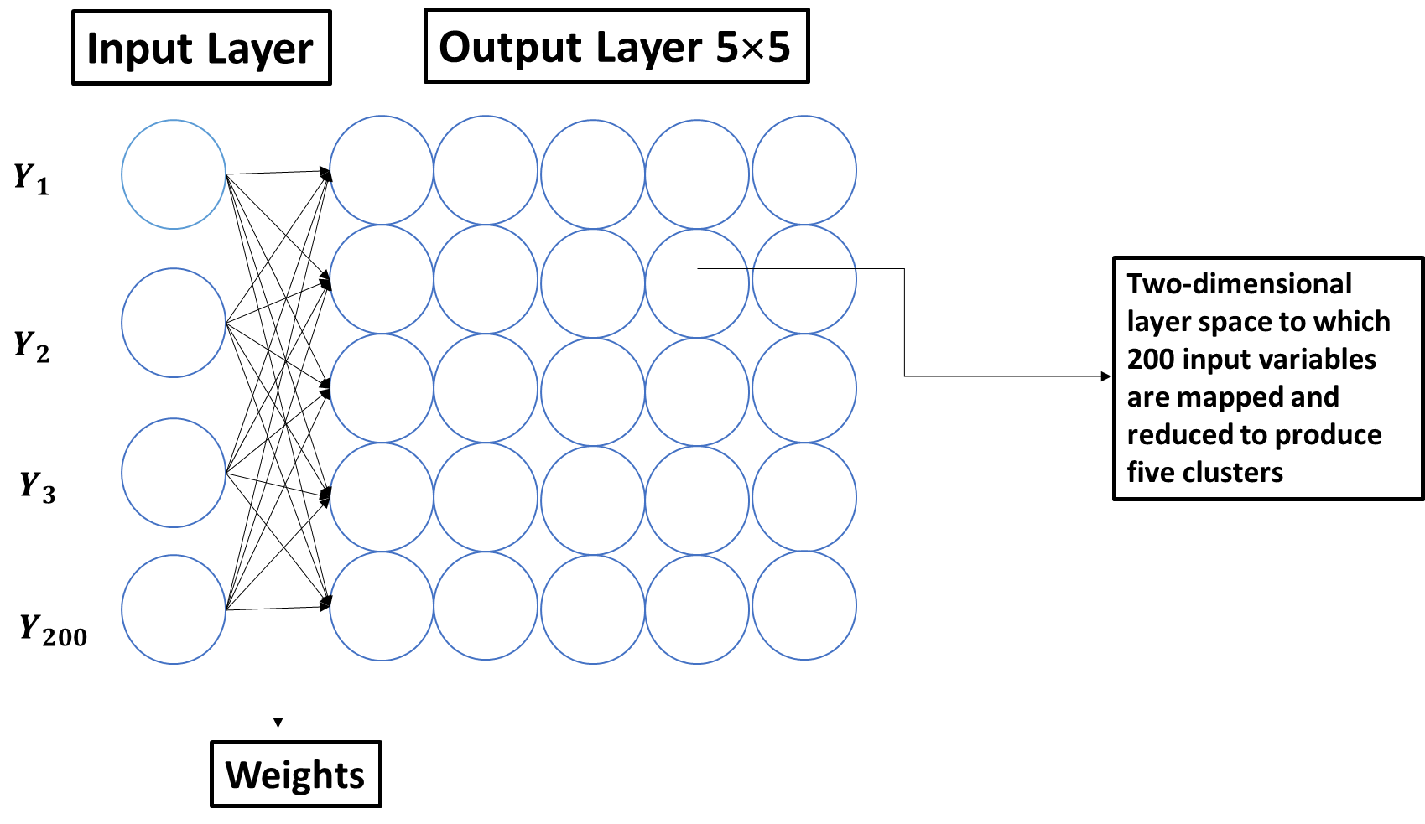
Figure 17. A diagrammatic representation of a Self-Organizing Machine model
2.12 GENETIC ALGORITHM (GA)
It is an optimization and search method based on the evolution of biological systems. Through genetic manipulation, it copies the genetic process of nature leading to offspring that are best adapted to the environment. The local optimal solution does not limit it but rather can be able to search the multidimensional space for the optimal solution through either mutation, crossover, and selection which causes it to deal with complex nonlinear optimization challenges [94].
Figure 18 shows a genetic algorithm with selection, crossover, and mutation processes.
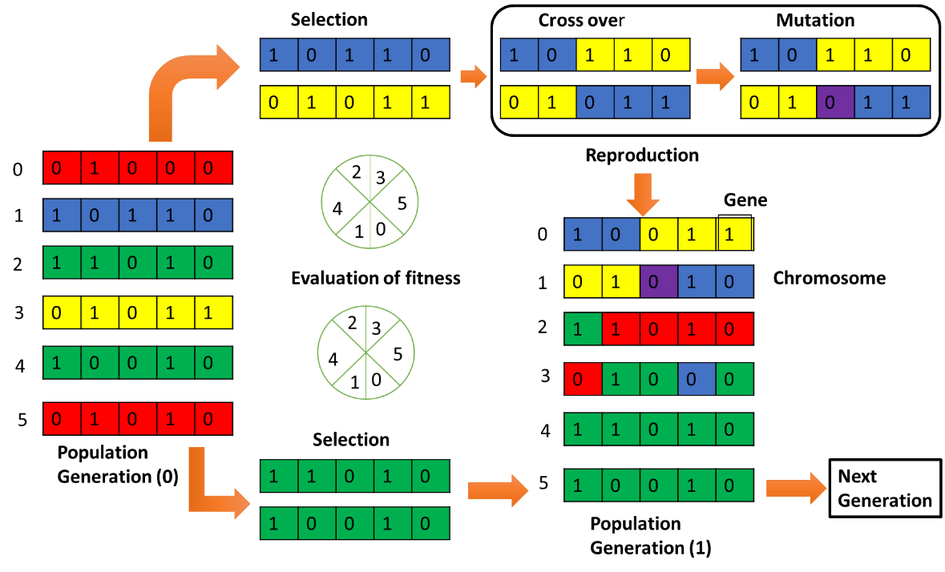
Figure 18. A diagrammatic representation of a genetic algorithm
3.0 PERFORMANCE STATISTICAL INDICATORS
AI model's performance evaluation is based on a number of statistical indicators such as coefficient of determination (R²), root mean squared error (RMSE), mean squared error (MSE), absolute average deviation (AAD), etc. The details of commonly used performance indicators are summarized in Table 2.
Table 2. The commonly used performance parameters
Indicator | Equation | Reference
MSE | $$\frac{\sum{{\left(Z_{i}-Y_{i}\right)}^{2}}}{n}$$ | [95]
Root mean squared error (RMSE) | $$\sqrt{\frac{\sum_{i=1}^{n}{\left(Z_{i}-Y_{i}\right)}}{n}}$$ | [96]
Mean absolute error (MAE) | $$\frac{\sum_{i=1}^{n}{\left(Z_{i}-Y_{i}\right)}}{n}$$ | [97]
Sum of squared error (SSE) | $$\sum_{i=1}^{n}{\left(X_{i}-X_{mean}\right)}$$ | [98]
Absolute average deviation (AAD) | $$\frac{\sum_{i=1}^{n}{\left(X_{i}-X_{mean}\right)}}{N}$$ | [99]
Coefficient of determination (R²) | $$\frac{1-\sum_{i=1}^{n}{\left(Z_{i}-Y_{i}\right)}}{\sum_{i=1}^{n}{\left(Z_{i}-Y_{mean}\right)}}$$ | [100]
Adjusted R² | $$\frac{\left(1-R^{2}\right)X\left(n-1\right)}{\left(n-k-1\right)}$$ | [101]
Normalized RMSE | $$\frac{\sum_{i=1}^{n}{\left(Z_{i}-Y_{i}\right)}}{n}$$ | [102]

4.0 APPLICATION OF ARTIFICIAL INTELLIGENCE IN WASTEWATER TREATMENT
AI models have been extensively applied in wastewater treatment, particularly using the adsorption process. This study will describe two pollutants that is textile dyes and toxic heavy metals will be discussed briefly.
Nwosu-Obieogu et al., [103] used Luffa cylindrica activated carbon (LAC) for the removal of chromium (VI) from wastewater. The variable parameters were contact time, pH, and adsorbent dosage using a batch experiment through ANN and ANFIS. ANN and ANFIS were determined through R² and MSE. The models demonstrated significant predictive behavior with R² (9.9999E−1) and MSE (5.985E−14) for chromium (VI) removal.
Ahmad., [104] investigated the effect of various parameters on the removal of methyl orange dye through the use of PANI/FO nanocomposite. The ANN with a structure of 5-9-1 was used in this study it showed good predictive results. The accuracy was illustrated using R² square value of 0.991, RMSE value of 0.127, AAD value of 0.842 %, and MAE value of 1.418.
In this study Kumari et al., [105] applied four models that are RSM, ANN, k-NN, and ANFIS in removing crystal violet (CV) from wastewater using Sugar cane bagasse (Saccharum officinarum) biochar. The effect of process variables which include adsorbent dosage, pH, temperature, and initial concentration were investigated. The ANN, RSM, k-NN, and ANFIS models obtained R² of 0.9685, 0.9618, 0.9421, and 0.8823, respectively. From the data obtained it was observed that ANN had the best accuracy.
The removal of Pb (II) and Cu (II) using a nanocomposite of rice straw and Fe3O4 was investigated by Khandanlou et al., [106]. Using ANN, the input parameters that is adsorbent dosage, time, and initial concentration with removal efficiency as the output variable were modeled. The model was trained using Batch Backpropagation (BBP), genetic algorithm (GA), quick propagation (QP), Levenberg-Marquardt (LM), and Incremental Back Propagation (IBP) algorithms. RMSE determined that the best training set was due to IBP and topology of 3-9-2 with a superior R².
Esfandyari et al., [107] studied the prediction accuracy of ANN and ANFIS in the removal of Pb (II) and Ni (II) using active sludge. The variables parameters in this study were contact time, pH, temperature, and initial concentration. A Sugeno Fuzzy for ANFIS and a multilayer perceptron for ANN were used in the modeling. The experimental and predicted data were well in agreement with correlation coefficients >98 % although the ANFIS showed higher superiority compared to ANN.
Through the use of chemically modified sugarcane bagasse (SBM) bio-adsorbent Leon et al., [108] removed color from textile real water through the modeling and simulation of the data using ANN. The multilayer feed-forward neural network, with five inputs and one output, was trained with eight neurons in the hidden layer. Using this model a comparison was carried out to understand the fitness of the experimental and predicted data and an (R²) of 0.928 and a mean square error (MSE) of 0.013 were obtained.
Khiam et al., [109] determined the effect of adsorbent dosage, pH, and contact time on the removal of methylene blue using graphene oxide/chitosan composites through the use of ANN-PSO by using experimental data obtained from RSM. ANN-PSO had a good accuracy with R² (=0.998) compared to RSM (R² = 0.981).
Lastly Rafie et al., [110] used hydrothermally synthesized MnFe₂O₄ and CoFe₂O₄ nanoparticles to remove Pb (II) and Cr (VI). The ANN-GA was used to predict the adsorption capacity at both non-equilibrium and equilibrium conditions. Using GA the training (49.5 %), validation (40.5 %), testing (10 %), seven neurons, and input parameters that are contact time, adsorbent dosage, pH, initial concentration, and temperature. The model gave a high predictive accuracy for the modeled data with (R² = 0.998).
5.0 CONCLUSION
Artificial Intelligence (AI) and Machine Learning (ML) models are changing the understanding of the adsorptive removal of toxic heavy metals and textile dyes from wastewater. These models exhibit exceptional predictive capabilities, accurately forecasting adsorption capacities, isotherms, kinetics, and breakthrough curves. This predictive power significantly optimizes treatment processes while minimizing the need for extensive experimental trials. Secondly, these models excel at extracting valuable insights from vast datasets. By analyzing the relationships between adsorbent properties, operating conditions, and pollutant removal efficiency, AI provides a deeper understanding of the underlying adsorption mechanisms. This enhanced understanding facilitates the development of more effective and targeted treatment strategies. Furthermore, AI algorithms play a crucial role in optimizing various process parameters, such as adsorbent dosage, contact time, pH, and temperature. This optimization maximizes pollutant removal while minimizing operational costs and resource consumption. By continuously analyzing data streams, AI-powered systems can dynamically adjust treatment processes in response to changing conditions, ensuring efficient and continuous operation.
Ethics approval and consent to participate
Not applicable.
Consent for publication
Not applicable.
Availability of data and materials
Not applicable.
Competing interests
The authors declare no competing interests.
References
1. Ouyang, B., Xu, W., Zhang, W., Guang, C., Mu, W.: An overview of different strategies involved in an efficient control of emerging contaminants: promising enzymes and the related reaction process. J Environ Chem Eng. 10, 108211 (2022)
2. Heris, S.Z., Etemadi, M., Mousavi, S.B., Mohammadpourfard, M., Ramavandi, B.: Preparation and characterizations of TiO2/ZnO nanohybrid and its application in photocatalytic degradation of tetracycline in wastewater. J Photochem Photobiol A Chem. 443, 114893 (2023)
3. Naghash-Hamed, S., Arsalani, N., Mousavi, S.B.: Facile copper ferrite/carbon quantum dot magnetic nanocomposite as an effective nanocatalyst for reduction of para-nitroaniline and ortho-nitroaniline. Nano Futures. 6, 045003 (2022)
4. Hosseini Nami, S., Mousavi, S.B.: Nitrate removal performance of different granular adsorbents using a novel fe-exchanged nanoporous clinoptilolite. Ind Eng Chem Res. 62, 3659–3671 (2023)
5. Ashrafivala, M., Mousavi, S.B., Heris, S.Z., Heidari, M., Mohammadpourfard, M., Aslani, H.: Investigation of H2O2/UV advanced oxidation process on the removal rate of coliforms from the industrial effluent: A pilot-scale study. Int J Hydrogen Energy. 47, 33530–33540 (2022)
6. Hojjati-Najafabadi, A., Mansoorianfar, M., Liang, T., Shahin, K., Karimi-Maleh, H.: A review on magnetic sensors for monitoring of hazardous pollutants in water resources. Science of The Total Environment. 824, 153844 (2022)
7. Kanan, S., Moyet, M., Obeideen, K., El-Sayed, Y., Mohamed, A.A.: Occurrence, analysis and removal of pesticides, hormones, pharmaceuticals, and other contaminants in soil and water streams for the past two decades: a review. Research on Chemical Intermediates. 48, 3633–3683 (2022)
8. Sangkham, S., Faikhaw, O., Munkong, N., Sakunkoo, P., Arunlertaree, C., Chavali, M., Mousazadeh, M., Tiwari, A.: A review on microplastics and nanoplastics in the environment: Their occurrence, exposure routes, toxic studies, and potential effects on human health. Mar Pollut Bull. 181, 113832 (2022)
9. Mehta, V.N., Ghinaiya, N., Rohit, J. V, Singhal, R.K., Basu, H., Kailasa, S.K.: Ligand chemistry of gold, silver and copper nanoparticles for visual read-out assay of pesticides: A review. TrAC Trends in Analytical Chemistry. 153, 116607 (2022)
10. Yang, L., Xia, C., Jiang, J., Chen, X., Zhou, Y., Yuan, C., Bai, L., Meng, S., Cao, G.: Removal of antibiotics and estrogens by nanofiltration and reverse osmosis membranes. J Hazard Mater. 461, 132628 (2024)
11. Castro, K., Abejón, R.: Removal of Heavy Metals from Wastewaters and Other Aqueous Streams by Pressure-Driven Membrane Technologies: An Outlook on Reverse Osmosis, Nanofiltration, Ultrafiltration and Microfiltration Potential from a Bibliometric Analysis. Membranes (Basel). 14, 180 (2024)
12. Tang, Y., Wu, Y.-H., Tong, X., Bai, Y., Wang, W.-L., Chen, Z., Xu, A., Ikuno, N., Koji, N., Hu, H.-Y.: Fouling characteristics and flux prediction model of reverse osmosis membrane based on hydrophobic fractions in reclaimed water. Sep Purif Technol. 335, 126187 (2024)
13. Wang, X., Li, J., Xu, L., Su, J., Wang, Z., Li, X.: Simultaneous removal of calcium, cadmium and tetracycline from reverse osmosis wastewater by sycamore deciduous biochar, shell powder and polyurethane sponge combined with biofilm reactor. Bioresour Technol. 394, 130215 (2024)
14. Masuodi, P., Bahmanzadegan, F., Hemmati, A., Ghaemi, A.: Evaluating the efficiency of nanofiltration and reverse osmosis membranes for the removal of micro-pollutants using a machine learning approach. Case Studies in Chemical and Environmental Engineering. 9, 100750 (2024)
15. Shahid, M.K., Kashif, A., Fuwad, A., Choi, Y.: Current advances in treatment technologies for removal of emerging contaminants from water–A critical review. Coord Chem Rev. 442, 213993 (2021)
16. Sinha, N., Dahiya, P.: Removal of emerging contaminants from pharmaceutical wastewater through application of bionanotechnology. Development in wastewater treatment research and processes. 247–264 (2022)
17. Morin-Crini, N., Lichtfouse, E., Fourmentin, M., Ribeiro, A.R.L., Noutsopoulos, C., Mapelli, F., Fenyvesi, É., Vieira, M.G.A., Picos-Corrales, L.A., Moreno-Piraján, J.C.: Removal of emerging contaminants from wastewater using advanced treatments. A review. Environ Chem Lett. 20, 1333–1375 (2022)
18. Allabakshi, S.M., Srikar, P., Gangwar, R.K., Maliyekkal, S.M.: Application of plasma-assisted advanced oxidation processes for removal of emerging contaminants in water. New Trends in Emerging Environmental Contaminants. 333–370 (2022)
19. Eniola, J.O., Kumar, R., Barakat, M.A., Rashid, J.: A review on conventional and advanced hybrid technologies for pharmaceutical wastewater treatment. J Clean Prod. 356, 131826 (2022)
20. Gholami, A., Mousavi, S.B., Heris, S.Z., Mohammadpourfard, M.: Highly efficient treatment of petrochemical spent caustic effluent via electro-Fenton process for COD and TOC removal: optimization and experimental. Biomass Convers Biorefin. 14, 17481–17497 (2024)
21. Priyadarshini, M., Ahmad, A., Das, S., Ghangrekar, M.M.: Application of innovative electrochemical and microbial electrochemical technologies for the efficacious removal of emerging contaminants from wastewater: A review. J Environ Chem Eng. 10, 108230 (2022)
22. Pavithra, K.G., Jaikumar, V., Kumar, P.S., Sundarrajan, P.: Removal of emerging pollutants from aquatic system using electrochemical treatment and adsorption: Comparison and analysis. Environ Technol Innov. 23, 101754 (2021)
23. Naghash‐Hamed, S., Arsalani, N., Mousavi, S.B.: The catalytic reduction of nitroanilines using synthesized CuFe2O4 nanoparticles in an aqueous medium. ChemistryOpen. 11, e202200156 (2022)
24. Naghash-Hamed, S., Arsalani, N., Mousavi, S.B.: Facile fabrication of CuFe2O4 coated with carbon quantum dots nanocomposite as an efficient heterogeneous catalyst toward the reduction of nitroaniline compounds for management of aquatic resources. J Photochem Photobiol A Chem. 443, 114822 (2023)
25. Gimeno, O., García-Araya, J.F., Beltrán, F.J., Rivas, F.J., Espejo, A.: Removal of emerging contaminants from a primary effluent of municipal wastewater by means of sequential biological degradation-solar photocatalytic oxidation processes. Chemical Engineering Journal. 290, 12–20 (2016)
26. González-González, R.B., Flores-Contreras, E.A., Parra-Saldívar, R., Iqbal, H.M.N.: Bio-removal of emerging pollutants by advanced bioremediation techniques. Environ Res. 214, 113936 (2022)
27. Morin-Crini, N., Lichtfouse, E., Fourmentin, M., Ribeiro, A.R.L., Noutsopoulos, C., Mapelli, F., Fenyvesi, É., Vieira, M.G.A., Picos-Corrales, L.A., Moreno-Piraján, J.C.: Removal of emerging contaminants from wastewater using advanced treatments. A review. Environ Chem Lett. 20, 1333–1375 (2022)
28. El Messaoudi, N., Ciğeroğlu, Z., Şenol, Z.M., Bouich, A., Kazan-Kaya, E.S., Noureen, L., Américo-Pinheiro, J.H.P.: Green synthesis of nanoparticles for remediation organic pollutants in wastewater by adsorption. In: Advances in chemical pollution, environmental management and protection. pp. 305–345. Elsevier (2024)
29. Cornejo-León, S., Gómez-Navarro, C.S., Contreras-Atrisco, Z.A., Zárate-Guzmán, A.I., Aguilar-Garnica, E., Romero-Cano, L.A.: Development of a sustainability-oriented university laboratory: Insight into adsorption kinetics models for the removal of pollutants from aqueous solution. Environ Res. 258, 119422 (2024)
30. Rostami, M.S., Khodaei, M.M.: Recent advances in chitosan-based nanocomposites for adsorption and removal of heavy metal ions. Int J Biol Macromol. 132386 (2024)
31. Islam, M.A., Nazal, M.K., Angove, M.J., Morton, D.W., Hoque, K.A., Reaz, A.H., Islam, M.T., Karim, S.M.A., Chowdhury, A.-N.: Emerging iron-based mesoporous materials for adsorptive removal of pollutants: Mechanism, optimization, challenges, and future perspective. Chemosphere. 349, 140846 (2024)
32. Kainth, S., Sharma, P., Pandey, O.P.: Green sorbents from agricultural wastes: A review of sustainable adsorption materials. Applied Surface Science Advances. 19, 100562 (2024)
33. Karume, I., Bbumba, S., Kigozi, M., Nabatanzi, A., Mukasa, I. harq Z.T., Yiga, S.: One-pot removal of pharmaceuticals and toxic heavy metals from water using xerogel-immobilized quartz/banana peels-activated carbon. Green Chem Lett Rev. 16, 2238726 (2023)
34. Shahid, M.U., Najam, T., Islam, M., Hassan, A.M., Assiri, M.A., Rauf, A., ur Rehman, A., Shah, S.S.A., Nazir, M.A.: Engineering of metal organic framework (MOF) membrane for waste water treatment: Synthesis, applications and future challenges. Journal of water process engineering. 57, 104676 (2024)
35. Gao, Y., Wang, F., Wang, C.-C., Yi, X.-H.: Microwave-assisted production of metal-organic frameworks for water purification: A mini-review. Surfaces and Interfaces. 44, 103724 (2024)
36. Tabish, T.A., Memon, F.A., Gomez, D.E., Horsell, D.W., Zhang, S.: A facile synthesis of porous graphene for efficient water and wastewater treatment. Sci Rep. 8, 1817 (2018)
37. Saravanan, A., Kumar, P.S., Srinivasan, S., Jeevanantham, S., Vishnu, M., Amith, K.V., Sruthi, R., Saravanan, R., Vo, D.-V.N.: Insights on synthesis and applications of graphene-based materials in wastewater treatment: A review. Chemosphere. 298, 134284 (2022)
38. Rana, K., Kaur, H., Singh, N., Sithole, T., Siwal, S.S.: Graphene-based materials: Unravelling its impact in wastewater treatment for sustainable environments. Next Materials. 3, 100107 (2024)
39. Wang, H., Liu, X., Wang, Y., Tian, Y., Huang, Y., Huang, D., Liu, X.: Carbon nanotubes as a nanocatalyst and nanoreactor for the efficient treatment of pharmaceutical wastewater via CaSO 3 activation. Environ Sci Nano. 11, 1978–1984 (2024)
40. Tijani, J.O., Abdulkareem, A.S., Mustapha, S., Ndamitso, M.M., Bada, S.O., Sagadevan, S.: Polyethyleneglycol-polyhydroxylbutyrate functionalized carbon nanotubes for industrial electroplating wastewater treatment. Sep Purif Technol. 332, 125736 (2024)
41. Won, G., Kim, S., Chang, Y.J., Go, Y., Kim, S.W.: Magnetic carbon nanotube sorbents with macropores formed by salts for oily wastewater treatment. Journal of Industrial and Engineering Chemistry. (2024)
42. Radoor, S., Karayil, J., Jayakumar, A., Kandel, D.R., Kim, J.T., Siengchin, S., Lee, J.: Recent advances in cellulose-and alginate-based hydrogels for water and wastewater treatment: A review. Carbohydr Polym. 323, 121339 (2024)
43. Li, F., Yue, S., Zhao, Z., Liu, K., Wang, P., Zhan, S.: Application of molecularly imprinted polymers in the water environmental field: A review on the detection and efficient removal of emerging contaminants. Materials Today Sustainability. 100904 (2024)
44. Bekchanov, D., Mukhamediev, M., Yarmanov, S., Lieberzeit, P., Mujahid, A.: Functionalizing natural polymers to develop green adsorbents for wastewater treatment applications. Carbohydr Polym. 323, 121397 (2024)
45. Yu, W., Xiong, L., Teng, J., Chen, C., Li, B., Zhao, L., Lin, H., Shen, L.: Advances in synthesis and application of amphoteric polymer-based water treatment agents. Desalination. 117280 (2024)
46. Lowe, M., Qin, R., Mao, X.: A review on machine learning, artificial intelligence, and smart technology in water treatment and monitoring. Water (Basel). 14, 1384 (2022)
47. Shukla, A.K., Alam, J., Mallik, S., Ruokolainen, J., Kesari, K.K., Alhoshan, M.: Optimization and prediction of dye adsorption utilising cross-linked chitosan-activated charcoal: response surface methodology and machine learning. J Mol Liq. 411, 125745 (2024)
48. Hossan, A.: Adsorption of triclosan from aqueous solutions via novel metal–organic framework: Adsorption isotherms, kinetics, and optimization via Box-Behnken design. J Mol Liq. 382, 122065 (2023)
49. Mohrazi, A., Ghasemi-Fasaei, R.: Removal of methylene blue dye from aqueous solution using an efficient chitosan-pectin bio-adsorbent: kinetics and isotherm studies. Environ Monit Assess. 195, 339 (2023)
50. Blachnio, M., Derylo-Marczewska, A., Charmas, B., Zienkiewicz-Strzalka, M., Bogatyrov, V., Galaburda, M.: Activated carbon from agricultural wastes for adsorption of organic pollutants. Molecules. 25, 5105 (2020)
51. Lipnizki, F., Trägårdh, G.: Modelling of pervaporation: Models to analyze and predict the mass transport in pervaporation. Separation and Purification Methods. 30, 49–125 (2001)
52. Safeer, S., Pandey, R.P., Rehman, B., Safdar, T., Ahmad, I., Hasan, S.W., Ullah, A.: A review of artificial intelligence in water purification and wastewater treatment: Recent advancements. Journal of Water Process Engineering. 49, 102974 (2022)
53. Nair, A.T., Makwana, A.R., Ahammed, M.M.: The use of response surface methodology for modelling and analysis of water and wastewater treatment processes: a review. Water science and technology. 69, 464–478 (2014)
54. Li, B., Yue, R., Shen, L., Chen, C., Li, R., Xu, Y., Zhang, M., Hong, H., Lin, H.: A novel method integrating response surface method with artificial neural network to optimize membrane fabrication for wastewater treatment. J Clean Prod. 376, 134236 (2022)
55. Anfar, Z., Ait Ahsaine, H., Zbair, M., Amedlous, A., Ait El Fakir, A., Jada, A., El Alem, N.: Recent trends on numerical investigations of response surface methodology for pollutants adsorption onto activated carbon materials: A review. Crit Rev Environ Sci Technol. 50, 1043–1084 (2020)
56. Alam, G., Ihsanullah, I., Naushad, M., Sillanpää, M.: Applications of artificial intelligence in water treatment for optimization and automation of adsorption processes: Recent advances and prospects. Chemical Engineering Journal. 427, 130011 (2022)
57. Paschen, U., Pitt, C., Kietzmann, J.: Artificial intelligence: Building blocks and an innovation typology. Bus Horiz. 63, 147–155 (2020)
58. Miao, S., Zhou, C., AlQahtani, S.A., Alrashoud, M., Ghoneim, A., Lv, Z.: Applying machine learning in intelligent sewage treatment: A case study of chemical plant in sustainable cities. Sustain Cities Soc. 72, 103009 (2021)
59. Hwangbo, S., Al, R., Chen, X., Sin, G.: Integrated model for understanding N2O emissions from wastewater treatment plants: a deep learning approach. Environ Sci Technol. 55, 2143–2151 (2021)
60. Cangialosi, F., Bruno, E., De Santis, G.: Application of machine learning for fenceline monitoring of odor classes and concentrations at a wastewater treatment plant. Sensors. 21, 4716 (2021)
61. Rodríguez-Rángel, H., Arias, D.M., Morales-Rosales, L.A., Gonzalez-Huitron, V., Valenzuela Partida, M., García, J.: Machine learning methods modeling carbohydrate-enriched cyanobacteria biomass production in wastewater treatment systems. Energies (Basel). 15, 2500 (2022)
62. Ma, J., Ding, Y., Cheng, J.C.P., Jiang, F., Xu, Z.: Soft detection of 5-day BOD with sparse matrix in city harbor water using deep learning techniques. Water Res. 170, 115350 (2020)
63. Li, J., Sharma, K., Li, W., Yuan, Z.: Swift hydraulic models for real-time control applications in sewer networks. Water Res. 213, 118141 (2022)
64. Chatterjee, S., Sarkar, S., Dey, N., Ashour, A.S., Sen, S., Hassanien, A.E.: Application of cuckoo search in water quality prediction using artificial neural network. International Journal of Computational Intelligence Studies. 6, 229–244 (2017)
65. Li, X., Yi, X., Liu, Z., Liu, H., Chen, T., Niu, G., Yan, B., Chen, C., Huang, M., Ying, G.: Application of novel hybrid deep leaning model for cleaner production in a paper industrial wastewater treatment system. J Clean Prod. 294, 126343 (2021)
66. Aka, R.J.N., Wu, S., Mohotti, D., Bashir, M.A., Nasir, A.: Evaluation of a liquid-phase plasma discharge process for ammonia oxidation in wastewater: Process optimization and kinetic modeling. Water Res. 224, 119107 (2022)
67. Jain, A.K., Mao, J., Mohiuddin, K.M.: Artificial neural networks: A tutorial. Computer (Long Beach Calif). 29, 31–44 (1996)
68. Pantic, I., Paunovic, J., Cumic, J., Valjarevic, S., Petroianu, G.A., Corridon, P.R.: Artificial neural networks in contemporary toxicology research. Chem Biol Interact. 369, 110269 (2023)
69. Abdolrasol, M.G.M., Hussain, S.M.S., Ustun, T.S., Sarker, M.R., Hannan, M.A., Mohamed, R., Ali, J.A., Mekhilef, S., Milad, A.: Artificial neural networks based optimization techniques: A review. Electronics (Basel). 10, 2689 (2021)
70. Meng, X., Zhang, Y., Qiao, J.: An adaptive task-oriented RBF network for key water quality parameters prediction in wastewater treatment process. Neural Comput Appl. 33, 11401–11414 (2021)
71. Jawad, J., Hawari, A.H., Zaidi, S.J.: Artificial neural network modeling of wastewater treatment and desalination using membrane processes: A review. Chemical Engineering Journal. 419, 129540 (2021)
72. Basheer, I.A., Hajmeer, M.: Artificial neural networks: fundamentals, computing, design, and application. J Microbiol Methods. 43, 3–31 (2000)
73. Montesinos López, O.A., Montesinos López, A., Crossa, J.: Fundamentals of artificial neural networks and deep learning. In: Multivariate statistical machine learning methods for genomic prediction. pp. 379–425. Springer (2022)
74. Dobay, A., Ford, J., Decker, S., Ampanozi, G., Franckenberg, S., Affolter, R., Sieberth, T., Ebert, L.C.: Potential use of deep learning techniques for postmortem imaging. Forensic Sci Med Pathol. 16, 671–679 (2020)
75. Reynel-Ávila, H.E., Aguayo-Villarreal, I.A., Diaz-Muñoz, L.L., Moreno-Pérez, J., Sánchez-Ruiz, F.J., Rojas-Mayorga, C.K., Mendoza-Castillo, D.I., Bonilla-Petriciolet, A.: A review of the modeling of adsorption of organic and inorganic pollutants from water using artificial neural networks. Adsorption Science & Technology. 2022, 9384871 (2022)
76. Afolabi, I.C., Popoola, S.I., Bello, O.S.: Modeling pseudo-second-order kinetics of orange peel-paracetamol adsorption process using artificial neural network. Chemometrics and Intelligent Laboratory Systems. 203, 104053 (2020)
77. Veit, D.: Neural networks and their application to textile technology. In: Simulation in textile technology. pp. 9–71. Elsevier (2012)
78. Tehlah, N., Kaewpradit, P., Mujtaba, I.M.: Artificial neural network based modeling and optimization of refined palm oil process. Neurocomputing. 216, 489–501 (2016)
79. Zhang, S.-Z., Chen, S., Jiang, H.: A back propagation neural network model for accurately predicting the removal efficiency of ammonia nitrogen in wastewater treatment plants using different biological processes. Water Res. 222, 118908 (2022)
80. Wongburi, P., Park, J.K.: Prediction of sludge volume index in a wastewater treatment plant using recurrent neural network. Sustainability. 14, 6276 (2022)
81. Jawad, J., Hawari, A.H., Zaidi, S.J.: Artificial neural network modeling of wastewater treatment and desalination using membrane processes: A review. Chemical Engineering Journal. 419, 129540 (2021)
82. Hosseinzadeh, A., Zhou, J.L., Altaee, A., Baziar, M., Li, X.: Modeling water flux in osmotic membrane bioreactor by adaptive network-based fuzzy inference system and artificial neural network. Bioresour Technol. 310, 123391 (2020)
83. Bui, H.M., Bui, H.N., Le, T.M., Karri, R.R.: Application of artificial neural networks on water and wastewater prediction: A review. Soft Computing Techniques in Solid Waste and Wastewater Management. 95–109 (2021)
84. Alzubaidi, L., Zhang, J., Humaidi, A.J., Al-Dujaili, A., Duan, Y., Al-Shamma, O., Santamaría, J., Fadhel, M.A., Al-Amidie, M., Farhan, L.: Review of deep learning: concepts, CNN architectures, challenges, applications, future directions. J Big Data. 8, 1–74 (2021)
85. Samuel, A.L.: Some studies in machine learning using the game of checkers. IBM J Res Dev. 3, 210–229 (1959)
86. Dash, S.S., Nayak, S.K., Mishra, D.: A review on machine learning algorithms. Intelligent and Cloud Computing: Proceedings of ICICC 2019, Volume 2. 495–507 (2020)
87. Karaboga, D., Kaya, E.: Adaptive network based fuzzy inference system (ANFIS) training approaches: a comprehensive survey. Artif Intell Rev. 52, 2263–2293 (2019)
88. Genuer, R., Poggi, J.-M., Tuleau-Malot, C.: Variable selection using random forests. Pattern Recognit Lett. 31, 2225–2236 (2010)
89. Han, J., Pei, J., Tong, H.: Data mining: concepts and techniques. Morgan kaufmann (2022)
90. Mamandipoor, B., Majd, M., Sheikhalishahi, S., Modena, C., Osmani, V.: Monitoring and detecting faults in wastewater treatment plants using deep learning. Environ Monit Assess. 192, 148 (2020)
91. Gao, X., Zeng, W., Shen, Y., Guo, Z., Yang, J., Cheng, X., Hua, Q., Yu, K.: Integrated Deep Neural Networks‐Based Complex System for Urban Water Management. Complexity. 2020, 8848324 (2020)
92. Cura, T.: A particle swarm optimization approach to clustering. Expert Syst Appl. 39, 1582–1588 (2012)
93. Qu, X., Yang, L., Guo, K., Ma, L., Sun, M., Ke, M., Li, M.: A survey on the development of self-organizing maps for unsupervised intrusion detection. Mobile networks and applications. 26, 808–829 (2021)
94. Holland, J.H.: Genetic algorithms. Sci Am. 267, 66–73 (1992)
95. Mesellem, Y., Abdallah, A.E.H., Laidi, M., Hanini, S., Hentabli, M.: Artificial neural network modelling of multi-system dynamic adsorption of organic pollutants on activated carbon. Kem. Ind. 70, 39–47 (2021)
96. Gaya, M.S., Abba, S.I., Abdu, A.M., Tukur, A.I., Saleh, M.A., Esmaili, P., Wahab, N.A.: Estimation of water quality index using artificial intelligence approaches and multi-linear regression. Int. J. Artif. Intell. ISSN. 2252, 9 (2020)
97. Al Saleh, H.A.: Wastewater pollutants modeling using artificial neural networks. Journal of Ecological Engineering. 22, 35–45 (2021)
98. Jawad, J., Hawari, A.H., Zaidi, S.J.: Artificial neural network modeling of wastewater treatment and desalination using membrane processes: A review. Chemical Engineering Journal. 419, 129540 (2021)
99. Hosseinzadeh, A., Baziar, M., Alidadi, H., Zhou, J.L., Altaee, A., Najafpoor, A.A., Jafarpour, S.: Application of artificial neural network and multiple linear regression in modeling nutrient recovery in vermicompost under different conditions. Bioresour Technol. 303, 122926 (2020)
100. Nguyen, X.C., Ly, Q.V., Peng, W., Nguyen, V.-H., Nguyen, D.D., Tran, Q.B., Nguyen, T.T.H., Sonne, C., Lam, S.S., Ngo, H.H.: Vertical flow constructed wetlands using expanded clay and biochar for wastewater remediation: a comparative study and prediction of effluents using machine learning. J Hazard Mater. 413, 125426 (2021)
101. Bhagat, S.K., Tung, T.M., Yaseen, Z.M.: Development of artificial intelligence for modeling wastewater heavy metal removal: State of the art, application assessment and possible future research. J Clean Prod. 250, 119473 (2020)
102. Shokri Dariyan, F., Eslami, A., Aghayani, E., Pourakbar, M., Oghazyan, A.: Comparison of artificial neural network and multi-kinetic models to predict optimum retention time for dairy wastewater treatment in the integrated fixed-film activated sludge. Int J Environ Anal Chem. 102, 4594–4608 (2022)
103. Nwosu-Obieogu, K., Dzarma, G.W., Ehimogue, P., Ugwuodo, C.B., Chiemenem, L.I.: Textile wastewater heavy metal removal using Luffa cylindrica activated carbon: an ANN and ANFIS predictive model evaluation. Appl Water Sci. 12, 52 (2022)
104. Ahmad, K.: Remediation of anionic dye from aqueous solution through adsorption on polyaniline/FO nanocomposite-modelling by artificial neural network (ANN). J Mol Liq. 360, 119497 (2022)
105. Kumari, S., Chowdhry, J., Choudhury, A., Agarwal, S., Narad, P., Garg, M.C.: Machine learning approaches for the treatment of textile wastewater using sugarcane bagasse (Saccharum officinarum) biochar. Environmental Science and Pollution Research. 1–19 (2024)
106. Khandanlou, R., Masoumi, H.R.F., Ahmad, M.B., Shameli, K., Basri, M., Kalantari, K.: Enhancement of heavy metals sorption via nanocomposites of rice straw and Fe3O4 nanoparticles using artificial neural network (ANN). Ecol Eng. 91, 249–256 (2016)
107. Esfandyari, M., Khodadadi, M., Ghadirli, R.N., Jafari, D.: Prediction and optimization of heavy metal ions removal efficiency from the active sludge using intelligent systems. Desalination Water Treat. 252, 167–176 (2022)
108. de Leon, V.B., de Negreiros, B.A.F., Brusamarello, C.Z., Petroli, G., Di Domenico, M., de Souza, F.B.: Artificial neural network for prediction of color adsorption from an industrial textile effluent using modified sugarcane bagasse: characterization, kinetics and isotherm studies. Environ Nanotechnol Monit Manag. 14, 100387 (2020)
109. Khiam, G.K., Karri, R.R., Mubarak, N.M., Khalid, M., Walvekar, R., Abdullah, E.C., Rahman, M.E.: Modelling and optimization for methylene blue adsorption using graphene oxide/chitosan composites via artificial neural network-particle swarm optimization. Mater Today Chem. 24, 100946 (2022)
110. Rafie, S.F., Abdollahi, H., Sayahi, H., Ardejani, F.D., Aghapoor, K., Darvanjooghi, M.H.K., Brar, S.K., Magdouli, S.: Genetic algorithm-assisted artificial neural network modelling for remediation and recovery of Pb (II) and Cr (VI) by manganese and cobalt spinel ferrite super nanoadsorbent. Chemosphere. 321, 138162 (2023)

