Opinion Article
Research on the Stability of Steel Pipe Column-Berger Beam Support System

Abstract: The steel pipe column-Berger beam support system is a widely used support structure in bridge construction, featuring simple structure, convenient installation, high bearing capacity and good stability. It is very necessary to conduct stability research on it. In this paper, ANSYS finite element software is used to conduct buckling analysis, node stiffness analysis and initial defect research on the Berger beam support system. The first four buckling modes of buckling analysis, the load-displacement curves corresponding to the node stiffness values of 0-400kN·m/rad of the support system, and the load-displacement curves corresponding to different initial defect ratios are obtained through the research. Through the above research, the design work of the support system can be better promoted.
Keywords: Bailey beam; semi-rigid; Ultimate load-bearing capacity

Introduction
From top to bottom, the combined accessories of the steel pipe column-Bailey beam support system are templates, primary and secondary keels, full hall supports, I-beam distribution beams, Bailey beams, and steel pipe columns. The scope of application of the scaffold system is large terrain height difference and crossing railways, highways, rivers, pipelines, special geology and other conditions. In the development^{[1-8]} process of the bracket system, the material used in the parts has changed from the use of wood to the use of steel, and in the context of the same bridge construction, the steel pipe column Bailey beam bracket system has the advantages of safety and stability, strong bearing capacity, more cost-saving construction cost and more beautiful appearance compared with other support systems. At home and abroad, we have a rigorous attitude towards scaffold research, and continue to move forward to strengthen and consolidate the research on stents. Most of the stent failure forms are instability failure, not strength failure. In order to better make up for the lack of research, the stability of the scaffold system was studied.
1 Establishment of finite elemenxt model
The finite element element model elements are selected as follows, Beam188 beam elements, and the steel pipe columns, distribution beams, bailey beams, and^{[9-12]} vertical crossbars of the full hall support in the finite element model of the steel pipe column-Bailey beam support established in this paper are all simulated by the beam elements. Link180 rod unit, the oblique rod in the full house bracket is simulated by the rod unit. The Combine14 spring element was simulated using a spring element during the semi-rigid study of the bracket joints. A rigid connection is set at the bottom of the model to limit its translational and rotational degrees of freedom; The CP^{[13-17]} command coupling translation and rotational degrees of freedom are used at the connection between the steel pipe column and the channel steel, the connection of the internal components of the Bailey beam, and the connection of the horizontal and vertical inclined rods of the full hall support. In the boundary problem of the distribution beam and the full house bracket and Bailey beam, because the bracket model is a large structure, the elastic effect of the connection has little impact on the overall stability, CERIG ^{[18-22]} is used to establish the rigid area to establish the connection, the establishment process of the model parts is "define the cross-section parameters and material properties of each component→ establish the key points according to the model→ each key point is stretched into lines, give the properties → establish a finite element model", and the mesh size of each component is divided into two parts between the connecting nodes. The research in this paper involves nonlinear analysis, and the element types such as beam elements and rod elements support nonlinear analysis, and the constitutive type adopts the bilinear follow-up strengthening model, and the yield criterion and follow-up strengthening criterion follow the Mises criterion model as shown below.
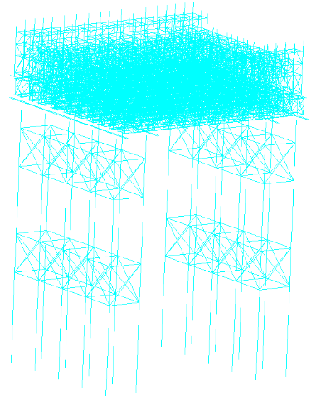
Fig 1. Model diagram
2 Buckling analysis
Buckling analysis is an analytical method used to evaluate the buckling (instability) behavior of a structure or component under force. Buckling is a phenomenon in which a structure loses its balance and suddenly deforms when it is subjected to certain loads, especially compressive loads. The purpose of buckling analysis is to predict the conditions under which a structure may fail due to buckling and to help designers optimize the stability and load-bearing capacity of the structure. The main contents of buckling analysis include: buckling phenomenon, when a structure is subjected to external loads, if the load exceeds a certain critical value, the structure may buckle; After buckling, the structure usually undergoes a large lateral displacement, rather than just a simple deformation. Buckling critical loads, one of the core tasks of buckling analysis is to calculate the buckling critical load of the structure, that is, the maximum load that the structure can withstand before buckling, beyond which the structure will undergo unstable deformation, which may lead to failure. The critical buckling load is closely related to the geometry, material properties, and support conditions of the structure. Buckling modes, which the buckling analysis also solves for buckling modes or buckling modes, which are the shape of the deformation of the structure when buckling occurs. Each buckling mode corresponds to different buckling critical loads and structural deformation characteristics. The following figures show the buckling modes of each part of the analysis.
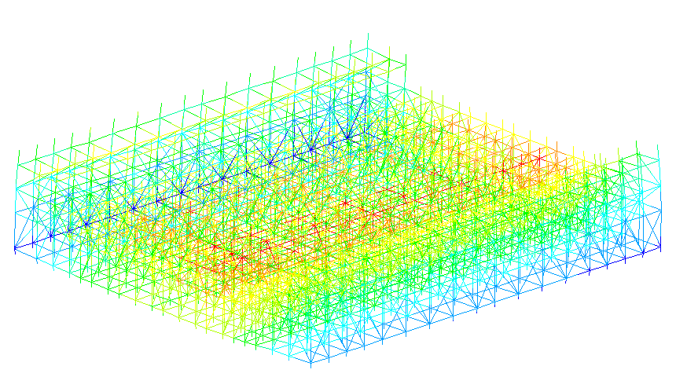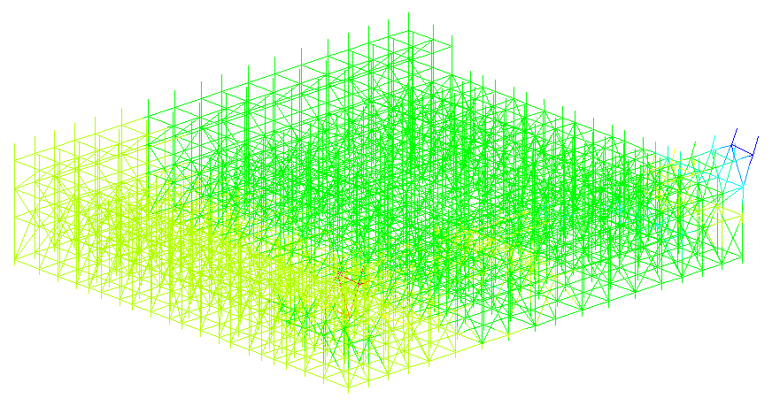
Fig 2.a First-order buckling mode of a full-hall stent Fig 2.b Second-order buckling mode of a full-hall stent
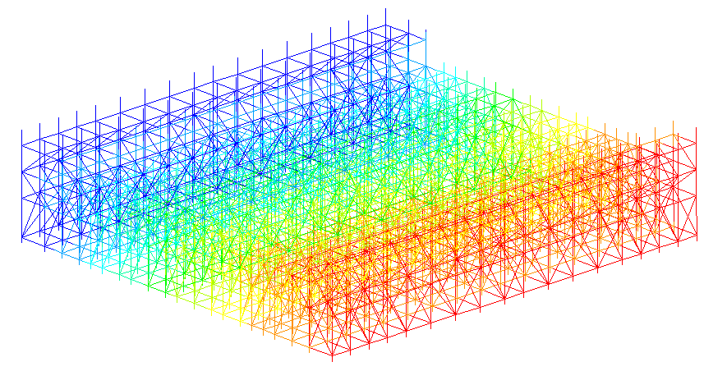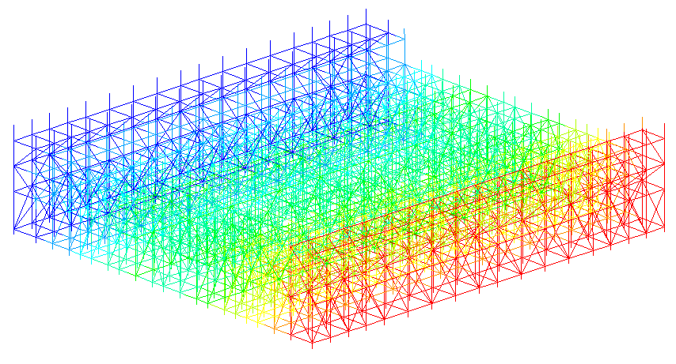
Fig 2.c Third-order buckling mode of full-hall stent Fig 2.d Fourth-order buckling mode of full-hall scaffolding
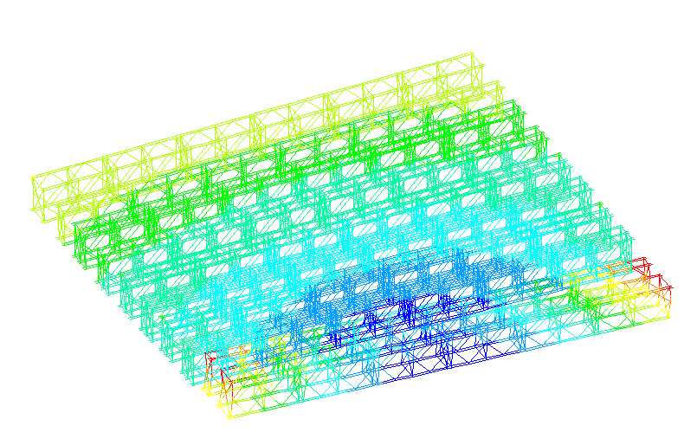 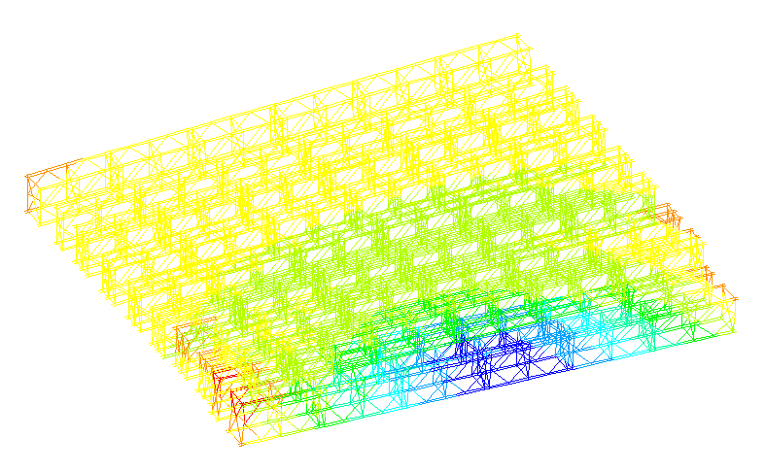Fig 2.e First-order buckling modes of Bailey beams Fig 2f Second-order buckling modes of Bailey beams
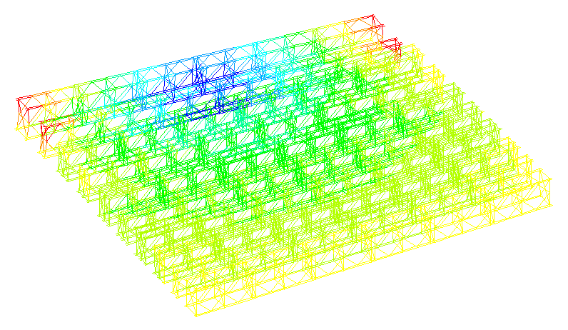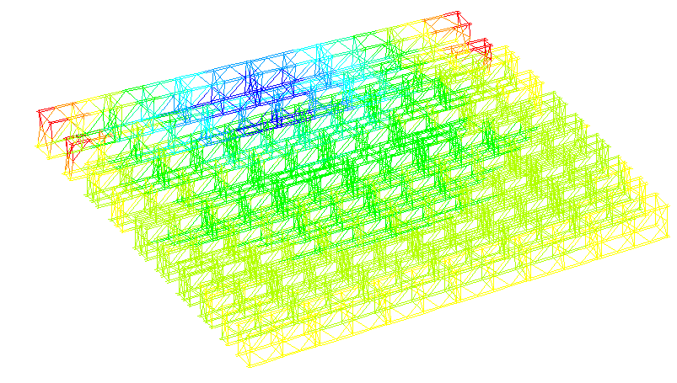
Fig 2.g Bailey beam third-order buckling mode Fig 2.h Fourth-order buckling modes of Bailey beams
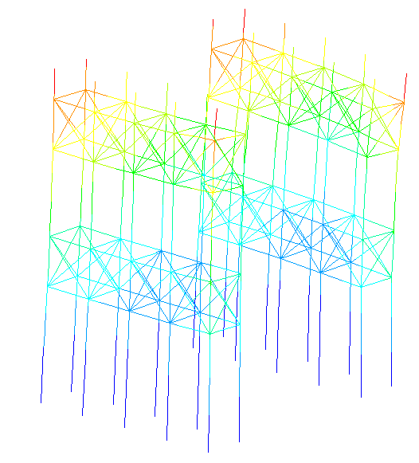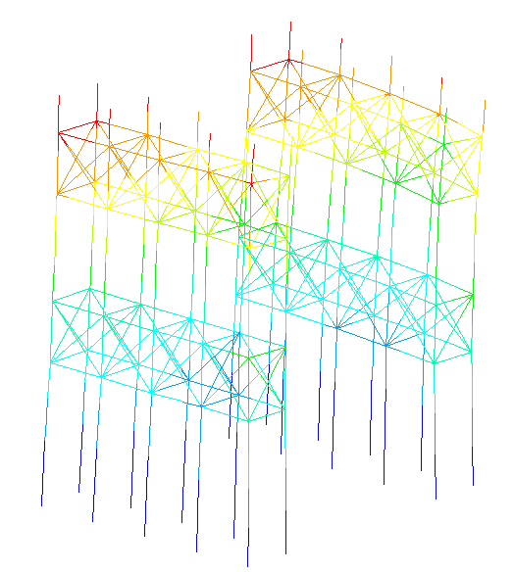
Fig 2.i First buckling mode of a steel pipe column Fig 2.j Second buckling modes of Bailey beams
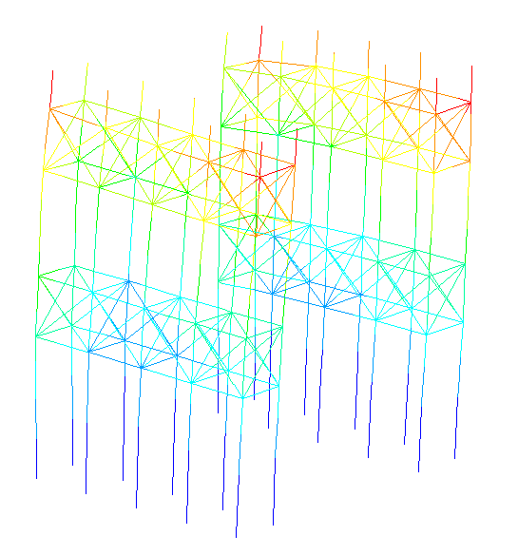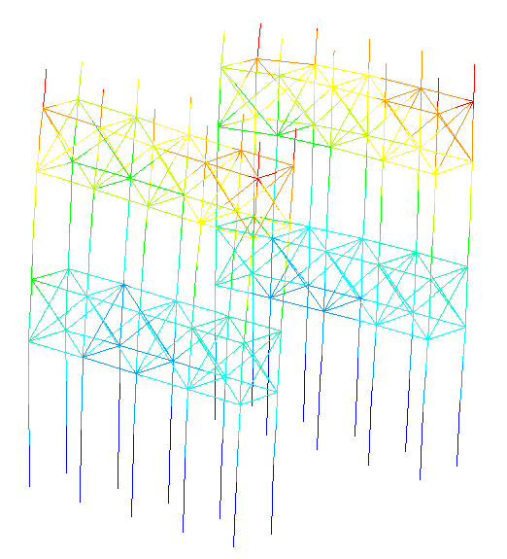
Fig2.k Third buckling mode of a steel pipe column Fig2.l Fourth buckling mode of a steel pipe column

It can be seen from the above diagram that after the buckling analysis, the buckling parts of the full hall bracket are the transverse two sides, the bailey beam is the longitudinal two sides, and the steel pipe column is the connection part with the distribution beam, which should be focused on when carrying out the design work.
3 Semi-rigid connection
A semi-rigid connection is a type of connection between a "rigid connection" and a "flexible connection" in mechanical, structural, or engineering design. Its main feature is that the connecting parts can maintain a certain degree of relative stability between them, but a certain degree of deformation or displacement will occur under the action of external forces. Thus, semi-rigid connections are neither fully rigid nor completely flexible, but have some degree of elasticity or deformability. Unlike rigid connections, semi-rigid connections do not completely suppress the relative displacement between connected parts, and it allows for a certain amount of deformation or rotation. This deformation is controlled and usually occurs due to friction on the contact surfaces between the connected parts, the elasticity of the material, or deformation limitations. In many projects, semi-rigid joints are used as a compromise solution that takes into account the high strength requirements of rigid joints and the deformation adaptability of flexible joints, and is usually used in structures that require a certain deformation capacity. The working principle of semi-rigid connections: the connecting parts are connected by elastic elements, friction, support surfaces or some complex mechanical device. Due to the particularity of these connection methods, under the action of external forces, there will be a certain displacement and deformation of the connecting part, but this deformation is relatively small and can usually be controlled by appropriate design and material selection. Semi-rigid connections do not completely prohibit the relative displacement of components like rigid connections, nor do they have a large deformation capacity like flexible connections. For example, in a steel structure building, if semi-rigidly connected steel beams and steel columns are used, they may have a slight rotation or displacement, but under the load, the relative deformation of the connecting parts will be limited, ensuring the stability and safety of the structure. A semi-rigid connection is a combination of rigid and flexible connection that allows for a certain degree of deformation or displacement while maintaining stability between the connected parts. In many engineering designs, semi-rigid connections are a compromise that offers greater design flexibility and material savings without sacrificing structural safety. However, semi-rigid connection also has its limitations, such as low force transmission efficiency, poor bearing capacity than rigid connection, etc., therefore, it is necessary to select the appropriate connection mode according to the specific engineering requirements, structural characteristics and load requirements in the application, and the following figure is a schematic diagram of semi-rigid connection.
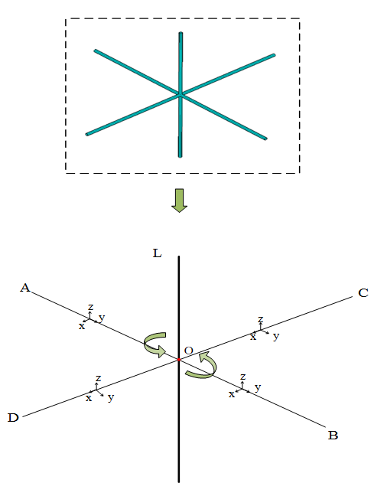

Fig 3a. Schematic diagram of a semi-rigid connection
The principle of semi-rigid connection modeling is to establish a repeating node at the common node, and then add a spring element to define the node stiffness value, so as to achieve a semi-rigid connection. The figure below shows the load-displacement curves for the calculated stiffness of different nodes.
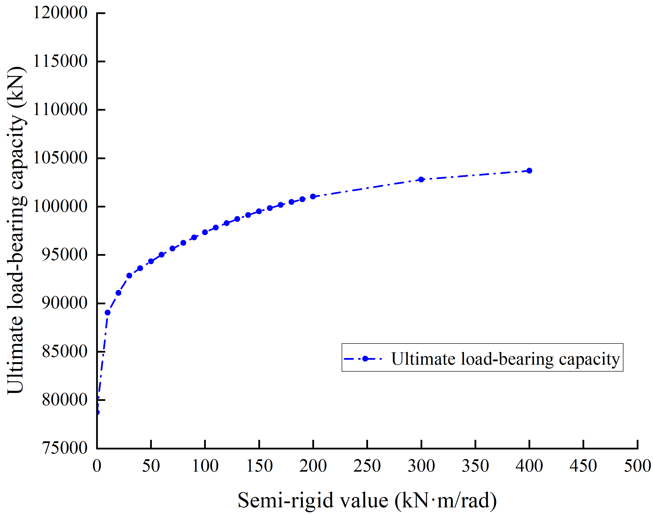
Fig3b. Displacement diagram of the nodal stiffness load

After the semi-rigidity study of the bracket structure, the overall ultimate bearing capacity of the bracket increases greatly when the rotational stiffness of the joint is 20kN·m/rad-200kN·m/rad, and the ultimate bearing capacity of the bracket changes relatively little with the increase of the joint stiffness, because the connection mode of the joint is closer and closer to the rigid connection.
4 Initial defect study
In the steel column-Bailey beam support system, the structural safety depends to a large extent on the stable bearing capacity. In the process of erection preparation and installation, the initial defects such as geometric deviation defects, material defects and connection defects can be said to be almost inevitable, and the existence of initial defects makes the nature and state of the structure at the critical equilibrium point be changed, and at the same time, the nonlinear influence is relatively obvious, and if the measures are not improved, it will have a great impact on the stable bearing capacity of the structure. In order to further study the influence of initial defects on the stability of stents and explore its fundamental connotation, it is necessary to have a deep understanding of initial defects. In the classification of initial defects, they can be roughly divided into geometric defects, material defects, connection defects, environmental defects, and loading defects. Geometric defects refer to defects caused by the shape, size, and position of components that are inconsistent with the design requirements. Errors in the manufacturing process, such as inaccurate molds and improper calibration of processing equipment, can lead to stress concentrations and reduce the load-bearing capacity of the structure. Material defects refer to defects in the material itself, such as cracks, porosity, inclusions, etc. Due to the problems in the process of material production, smelting, casting, heat treatment and other links, the strength and toughness of the material will be reduced, and the risk of the overall structure collapse will be increased. Defect refers to the poor state of the connection part (such as weld, bolt connection, etc.), due to the improper welding process, insufficient processing accuracy of the connector and other factors, it may lead to the failure of the connection part, affecting the stability of the entire structure; Environmental defects refer to the impact on components, such as corrosion, fatigue, etc., because of poor working environment, climate change, chemical media and other factors, may accelerate the aging and failure of materials; Loading defects refer to defects caused by uneven load application or beyond the design scope, which lead to structural deformation and damage due to insufficient consideration of factors such as the use environment and load changes in the design stage, which affects its function and safety. In this paper, the method of simulating the initial defect is the uniform defect mode method, and the following figure shows the analysis diagram of the simulated initial defect.

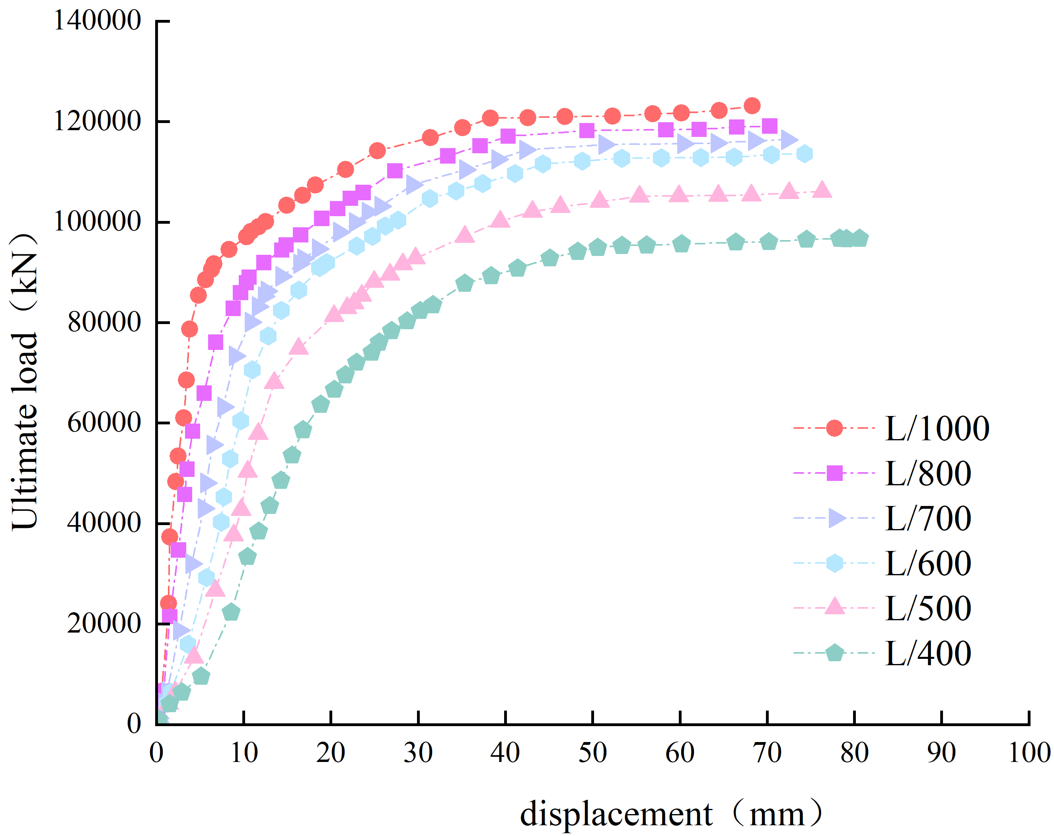
Fig 4 Load-displacement diagrams for various scaling factors
5 Conclusion
In this paper, the buckling analysis, the semi-rigidity of the joint, and the initial defect of the steel pipe column-Bailey beam support system are carried out, and the deformation and force of the structure are studied. At the same time, on the basis of previous research, the influencing factors of the stability of Bailey beam-steel pipe column system were analyzed and studied, and reference suggestions were given. It is conducive to more accurate control of errors in the construction process and improve the safety of the support structure.

References
[1] André J, Beale R, Baptista M A. Risk analysis of bridge falsework cuplok systems[J]. Structure and Infrastructure Engineering, 2017, 13(10): 1327-1349.
[2] Mehri H, Crocetti R. Scaffolding Bracing of Composite Bridges during Construction[J]. Journal of Bridge Engineering,2016, 21(3): 04015060-04015060.
[3] Huang Y L, Chen W F, Chen H J,et al. A monitoring method for scaffold-frame shoring systems for elevated concrete formwork[J]. Computers & Structures, 2000, 78(5):681-690.
[4] Peng J L, Pan A D E, Chen W F. Approximate Analysis Method for ModularTubularFalsework[J]. Journal of Structural Engineering, 2001, 127(3): 256-263.
[5] Peng J, YEN T, KUO C. Analytical and experimental bearing capacities of system scaffolds[J]. Journal of Zhejiang University(Science A:An International Applied Physics & Engineering Journal), 2009, 10(1): 82-92.
[6] Peng J L, Chan S L, Wu C L.Effects of geometrical shape and incremental loads on scaffold systems[J]. Journal of Constructional Steel Research, 2007, 63(4): 448-459.
[7] Peng J L, Yen T, Lin Y, et al. Performance of scaffold frame shoring under pattern loads and load paths[J]. Journal of construction engineering and management, 1997, 123(2): 138-145.
[8] Peng J L, Chen K H, Chan S L, et al. Experimental and analytical studies on steel scaffolds under eccentric loads[J]. Journal of Constructional Steel Research, 2009, 65(2): 422-435.
[9] Peng J L, Pan A D E, Chen W F, et al. Structural modeling and analysis of modular falsework systems[J]. Journal of Structural Engineering, 1997, 123(9): 1245-1251.
[10] Yan Zhu, Guoqing Chen, Xiaolong Li, et al. Comfort assessment for rehabilitation scaffold in road-railway bridge subjected to train-bridge-scaffold coupling vibration[J]. Engineering Structures, 2020, 211: 110426-110426.
[11] Zhao Xiyue. Application of several main scaffolding[J]China Construction Metal Structure,2009,(8):47-50.
[12] Xiong Xianyu, Dai Jun. Structural stability analysis and evaluation of full-hall support for long-span cast-in-situ continuous box girder[J].Journal of Xi'an University of Science and Technology,2020,40(2):268-274.)
[13] Kong Ruifu. Study on ultimate bearing capacity and stability of highway cast-in-situ box girder socket type disc buckle steel pipe formwork support[D].Yunnan University,2022.
[14] Hu Juan. Stability analysis and countermeasures of super-high support for cast-in-situ beam steep slope of north-south expressway in Montenegro[J].Highway,2021, 66(11):174-177.)
[15] Xu Y, Li X, Liu J, et al. Analysis of stable bearing capacity of bowl buckle formwork support under frost heave of foundation[J].Industrial Construction,2022,52(1):108-115.)
[16] Qin Wenxue. Construction technology of continuous beam ultra-high bracket considering the difference of column stiffness[J].Highway,2020,65(1):58-62.)
[17] Liu Yaxiong, Huang Rui, Wang Tianxin, et al. Rigidity and stability of load-bearing members of aluminum alloy attached lifting scaffold[J].Mechanical Design and Research,2023,39(5):207-209.)
[18] Liu Hongbo, Yan Zhicong, Chang Haoteng, et al. Research on bearing performance of double-row scaffolding of super thin-walled steel pipe[J].Journal of Shenyang Jianzhu University(Natural Science Edition),2023,39(5):781-789.)
[19] Wang Daguang, Liu Jialu, Wang Shengchao. Construction technology and benefit analysis of high formwork support of socket wheel buckle scaffolding[J].Construction Economics,2022,43(S1):1036-1039.)
[20] Peng Dongli, Jiang Tianyong. Analysis on deformation law of large-span continuous cast-in-situ box girder support system[J].China and Foreign Highway,2020,40(03):94-99.)
[21] Yu Anwen, Gu Yalu, Yang Li, et al. Research on the selection and mechanical characteristics of curved cast-in-situ box girder bracket in Fuli high-speed soft foundation area[J].Journal of Henan University of Science and Technology(Natural Science Edition),2023,44(5):65-74+8.)
[22] Wu Shuying. Research on safety management of bridge high pier formwork and fastener steel pipe scaffolding under the new situation[J].Engineering Technology Research,2023,8(18):156-158.

