Pesticide contamination of urban lettuce (Lactuca sativa L.) in Yamoussoukro (Côte d'Ivoire).

Abstract

Context: Lettuce is one of the most popular leafy vegetables in Côte d'Ivoire. Often produced in urban agriculture under uncontrolled conditions, lettuce is said to contain pesticide residues that are increasingly used in agriculture. The aim of this study was to assess the pesticide content of urban-grown lettuce consumed by the population of Yamoussoukro the political capital of Côte d'Ivoire.

Methods: A characterization of lettuce production in urban agriculture was carried out through a survey of 117 urban producers. Fifteen (15) lettuces samples were collected from three emblematic sites located in the heart of the city. These samples were analyzed using an HPLC chain (Waters alliance) to identify and measure the pesticide content of lettuce produced and consumed in Yamoussoukro. A chemical risk assessment for pesticides was carried out using the Codex Alimentarius method.

Results: The study revealed that nationals (Ivorians) dominate lettuce production in the city of Yamoussoukro with a rate of 58.97%. This activity is dominated by men with a rate of 55.56%. Various pesticide residues grouped into nine (9) families were detected in lettuces, some at very alarming levels. According to WHO, FAO and European Community standards, 33% of the samples were unacceptable, and therefore unfit for human consumption. The assessment of the health risk linked to consumption due to the presence of Parathion in lettuce would be 28% for chronic intoxication and 2% for acute intoxication. The risk of chronic intoxication by Dimethoate would be 47%, and of acute intoxication 1%. For both Chlorpyriphos and Spirodiclofen, the risks of chronic poisoning of populations are real, but the populations exposed would be low.

Conclusion: Urban-grown lettuce from Yamoussoukro, the political capital of Côte d'Ivoire, often contains pesticide residues in excess of required standards. This lettuce represents a danger and exposes consumer populations to health risks.

Key words: Lactuca sativa, pesticide residues, risk assessment, Yamoussoukro

1. INTRODUCTION

Urban population growth in the major cities of sub-Saharan Africa is increasing the need for food crops, especially market garden produce. In the many shallows and other drainage areas left vacant in cities, varieties of fresh fruit and vegetables are grown and ready for consumption. Yamoussoukro, the political capital of Côte d'Ivoire, is no exception to the rule, as the many lakes surrounding the city make it an ideal location for market gardening. (Tano et al.,
2011; Kpan et al., 2019). Market gardening is therefore an income-generating activity for
urban producers. It is also a source of empowerment and improved living conditions for market gardeners (Kouakou, 2019; AGRA, 2021). Fruits and vegetables from this agriculture are actively involved in the urban human diet due to their accessibility and beneficial health effects (Yao et al., 2016; Dakuyo et al., 2020). These include lettuce, one of the most popular leafy vegetables (Kouassi et al., 2024).
However, urban production of lettuce, like that of other vegetables, faces enormous difficulties. These difficulties are linked to cultivation practices, soil infertility, the use of pesticides and the poor quality of the water used. Indeed, with the implementation of this emergency agriculture often requires heavy use of pesticides to combat pests. Pesticide use is increased particularly in lettuce production, which remains a crop highly susceptible to pests (Tano et al., 2011; Soro et al., 2018). Pesticides are chemical or biological agents capable of destroying pests or controlling their growth and reproduction. They significantly reduce crop losses and increase crop yields (Son, 2018; Orou et al., 2024). Apart from their beneficial effects, pesticides can have harmful for humans and increase environment pollution (Saliou et al., 2013; Ekra et al., 2023). Indeed, poor phytosanitary practices, intensive pesticide use and bioaccumulation phenomena can cause respiratory problems, cancer, headaches, skin and mucous membrane irritation and even death (Kpan et al., 2019; Mambe-Ani et al., 2019). Despite alerts and incidence studies of phytosanitary practices in urban market gardening, the level of pesticide contamination in lettuce produced by urban farmers is less studied. It is in this context that this study was carried out in Yamoussoukro, a city with a high level of urban agricultural production. The aim of the study was therefore to assess the level of pesticide contamination of lettuce produced and consumed in Yamoussoukro. Specifically, the aim was to identify pesticide residues in lettuce, determine levels and assess the health risk associated with consumption of this leafy vegetable.

2. MATERIALS AND METHODS

2.1. Study area
The study area was the city of Yamoussoukro, in central Côte d'Ivoire. The low-lying areas near the Basilica known as Petit Bouaké, behind the Presidency and behind the CIE were chosen as study sites. These sites are located right in the city center.
2.2. Lettuce production data collection

In order to carry out surveys at farmer level, questionnaires were drawn up. These used to gather information on urban lettuce in Yamoussoukro. The lettuce characterization and production survey was divided into two main parts. The first part provided information on the profile of producers (gender, age, nationality, level of education) and the second part concerned the characteristics of urban production (source of irrigation water, type of fertilizer and use of pesticides). In all, one hundred and seventeen (117) lettuce farmers were surveyed. The people surveyed were of both sexes, from all levels of education and all social strata.
2.3. Sampling

Three sites in the center of Yamoussoukro were selected. On each site, three different beds formed a study block. At crop maturity, three lettuce plants (one sample) weighing 500 g were harvested and packed in a stomacher bag. These bags were carefully labelled with an individual identification number. They were then transported in coolers containing cold accumulators to the laboratory for toxicological analysis. A total of 15 lettuce samples (5 per study site) were collected.

2.4. Pesticide analysis techniques

2.4.1. Extraction and separation

To extract pesticide residues from lettuce, 50 g of lettuce shred was taken, then 50 ml of double- distilled water and 100 ml of acetone were added. This mixture was homogenized for 3 minutes using an Ultra Turax blender. The resulting homogenate was filtered through Whatman paper containing glass wool and anhydrous sodium sulfate. To separate the aqueous phase from the organic phase, 20 g NaCl was added to the filtrate, and the mixture shaken vigorously. After shaking, the mixture was left to stand for a few minutes in a separating funnel. The supernatant was collected and its volume reduced to 10 ml using an evaporator (BUCHI). A glass column containing 20 g of activated fluorisil (ACROS) was conditioned with 5 ml acetone. The 10 ml extract was passed through the column, 1 to 2 drops per second. The filtrate was collected in a round-bottomed flask and shaken for about a minute, then left to stand for 10 to 15 minutes. A
5 ml aliquot of the filtrate was evaporated to dryness at 40°C. After evaporation, the round- bottomed flask was left to cool for one minute. Pesticides were recovered with 5 ml hexane and transferred to vials for quantification of active ingredient residues.
2.4.2. Determination of pesticide residues

For Pesticides detection, an HPLC chain (Waters alliance) equipped with a SIL-20A sampler, LC-20AT pump, TRAY tank, DGU-20A5 degasser, CTO-20A oven and SPD-20A UV/VIS detector was used. Data acquisition was performed on a computer running LC solution software. The mobile phase consisted of water (10% - 30%) and Hipersolv grade acetonitrile (70% -
90%). Elution was carried out in isocratic mode. The stationary phase consisted of a Shim pack VPODS reversed-phase column (250 L x 4.6). Wavelengths ranged from 210 nm to 271 nm, while injection volumes were 10 µL and 20 µL. Oven temperature was set at 40°C. For each pesticide, a calibration was performed using the pure standard of the known concentration. From this calibration, the pesticide peak was identified on the sample chromatograms. The areas of the peaks (standards and samples) were used to quantify the various active ingredients present in the lettuce samples. The various pesticide levels were calculated using the following
formula:
$$Cp=\frac{Sc x Ce x V2 x Vf x F}{Se x Me x V1}$$

Cp : active ingredient concentration (mg/kg) ; Sc : sample peak area ; Se : standard peak area ; Ce : standard concentration (mg/L) ; V1: volume to be purified (L) ; V2 : volume after purification (L) ; Vf : final volume (L) ; Me : sample mass (kg) and F : dilution factor.
The quantities of pesticide found in lettuce samples from the city of Yamoussoukro were compared with the Maximum Residue Limits (MRLs) set by the European Union (EU, 2018) and the World Health Organization (WHO, 2019). This was used to determine the acceptability of the lettuce samples. Pesticide levels were also compared with the ADI and ARfD of each chemical compound for the respective chronic and acute risk assessment.

2.4. Data analysis

The various data collected are processed in Excel 2021. For pesticide determination, data were processed using LC solution software. Past 4.17 was used to compare pesticide levels between sites. MATLAB R2016b was used for chemical risk assessment. Treatment results are presented in the form of tables, box plots and curves.

3. RESULTS

3.1. Profile of urban lettuce growers
The profile of urban lettuce growers is summarized in Table I below. Lettuce is produced by both genders in the city of Yamoussoukro. It is dominated by men (55.56%), compared with
44.44% for women. Producers range in age from 30 to 60. Ivorians are more interested in this activity in Yamoussoukro, with a rate of 58.97%. The majority of lettuce growers surveyed in the city are illiterate, with a rate of 82.91%. However, there are also primary school and secondary school growers, with rates of 12. and 4. respectively.
Table I : Profile of urban lettuce farmers

Age

Type

Nationality

Study level
 | Frequency | Percentage (%)
< 30 years | 19 | 16,24
30-60 years | 86 | 73,5
> 60 | 12 | 10,26
Male | 65 | 55,56
Female | 52 | 44,44
Ivorian | 69 | 58,97
Burkinabe | 36 | 30,77
Malian | 12 | 10,26
Illiterate | 97 | 82,91
Primary | 15 | 12,82
Secondary | 5 | 4,27

3.2. Inputs used for lettuce production

The main inputs used in lettuce production in Yamoussoukro are listed in Table II. All farmers surveyed (100%) use water from unprotected wells to water their lettuces. Poultry droppings and chemical fertilizers were used by 62.39% of growers in Yamoussoukro. Other growers (37.61%) use a mixture of poultry dung, cow dung and chemical fertilizer to fertilize their beds. Almost all growers use pesticides to control lettuce pests and diseases.
Table II : Main inputs used in urban lettuce production

Inputs | Frequencies | Percentages (%)
Water from unprotected wells | 117 | 100
Surface water | 0 | 0
Poultry droppings and chemical fertilizers | 73 | 62,39

Poultry droppings, cow dung

and chemical fertilizers
44 37,61

Pesticides 117 100

3.3. Pesticide residues in lettuce

Toxicological analyses of lettuce samples from the town of Yamoussoukro revealed the presence of twelve (12) pesticide residues. Each lettuce sample was contaminated with at least one (1) pesticide residue. These residues belong to the following families (Table III) :
Table III : Concentration (mg/kg or ppm) of pesticides residues extracted from Yamoussoukro
lettuce

 |  | Yamoussoukro
 |  | VMax | CM
Organophosphates | Parathion | 1,31 | 0,19 ± 0,09
Organophosphates | Chlorpyriphos | 1,83 | 0,47 ± 0,15
Organophosphates | Dimethoate | 2,41 | 0,6 ± 0,18
Pyrethroids | Cypermethrin | 2,02 | 0,39 ± 0,15
Pyrethroids | Cyhalothrin | 1,64 | 0,5 ± 0,14
Tetronic Acids | Spirodiclofen | 2,71 | 0,55 ± 0,19
Benzimidazoles / Carbamates | Carbendazim | 1,18 | 0,28 ± 0,1
Organochlorines | Chlorothalonil | 1,29 | 0,31 ± 0,09
Dithiocarbamates | Maneb | 1,33 | 0,12 ± 0,08
Benzamides | Zoxamide | 2,58 | 0,83 ± 0,24
Neonicotinoids | Thiamethoxam | 1,03 | 0,21 ± 0,09
Phenols | Orthophenilphenol | 1,04 | 0,2 ± 0,09
VMax : Maximum Value ; CM : Average Concentration
Statistical analysis showed that there was no significant difference (P > 0.05) between sites in the concentrations of Parathion, Chlorpyriphos, Dimethoate, Cypermethrin, Cyhalothrin, Spirodiclofen, Carbendazim, Chlorothalonil, Maneb, Thiamethoxam and Orthophenilphenol. On the other hand, a significant difference (P < 0.05) was observed between Zoxamide levels from one site to another. The highest values were observed in sites 2 and 3 respectively (0.65 mg/kg and 1.83 mg/kg). The figures below show the concentration variability of the various chemical elements.

3.3.1. Lettuce pesticide compliance with standards

Pesticide levels in lettuce, Maximum Residue Limits (MRLs) and their different classes are summarized in Table IV. For samples with active ingredient levels less than or equal to the MRL, the product is considered acceptable. On the other hand, if the level is strictly higher than the MRL, the product is said to be unacceptable, and therefore unfit for consumption. So
samples contained levels well in excess of the MRLs laid down by the WHO and the European Union. A rate of 33.33 lettuce samples did not comply with the prescribed standards, and were therefore unacceptable and unfit for consumption. The proportion of samples conforming to different standards was 66.67%. Parathion, a product recognized by the WHO as extremely dangerous for consumers, was found in some samples at levels exceeding the MRL. The figures
below show the variability of pesticide levels in lettuce at the various study sites.

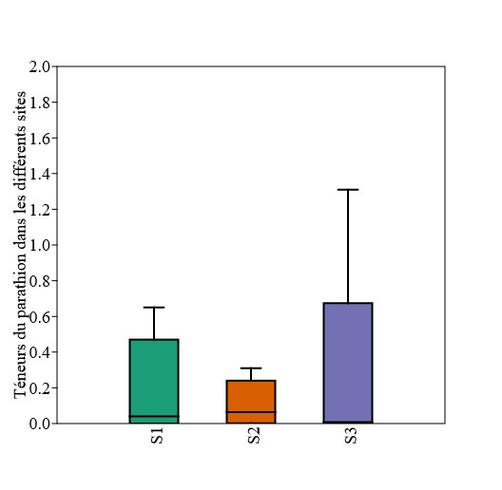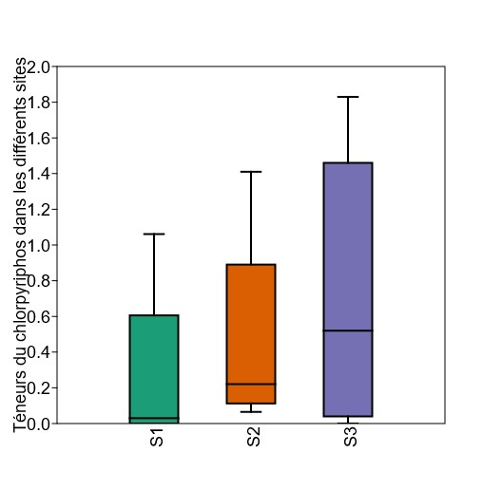P (same) = 0.97 P (same) = 0.27

Chlorpyrifos levels at different sites
Parathion levels at different sites

Figure 1: Content variability
in parathion in sites
Figure 2: Content variability
in chlorpyrifos at the sites

P (same) = 0.76
P (same) = 0.41

Cypermethrin levels at different sites
Dimethoate levels at different sites

Figure 3: Content variability
in dimethoate at the sites
Figure 4: Content variability
in cypermethrin at the sites

P (same) = 0.82
P (same) = 0.28

Cyhalothrin levels at different sites
Spirodiclofen levels at different sites

Figure 5: Content variability
in cyhalothrin in sites
Figure 6: Content variability
in spirodiclofen in sites

P (same) = 0.45
P (same) = 0.11

Carbendazim levels at different sites
Chlorothalonil levels at different sites

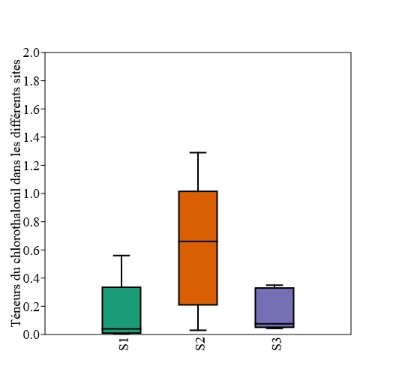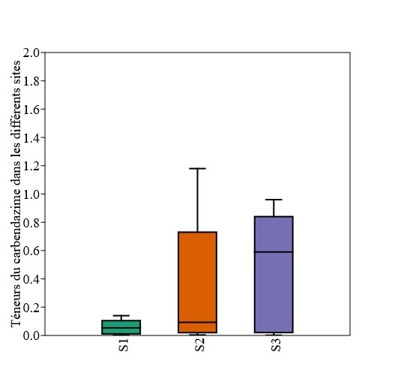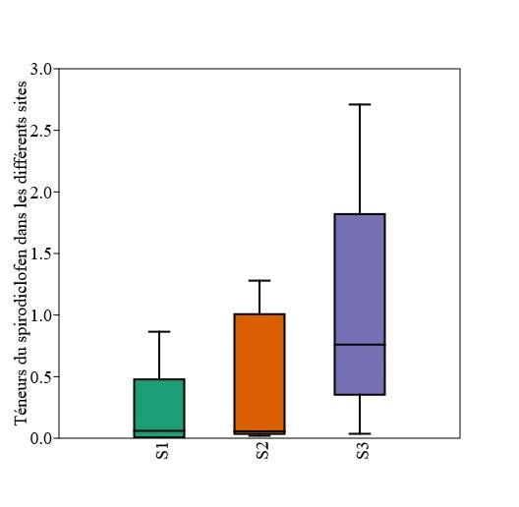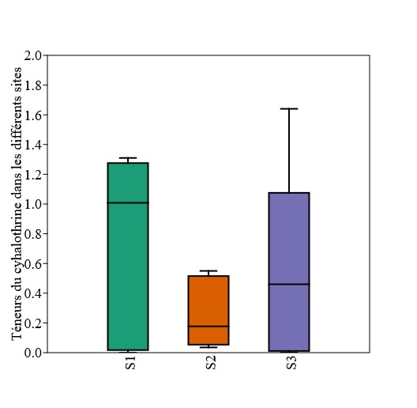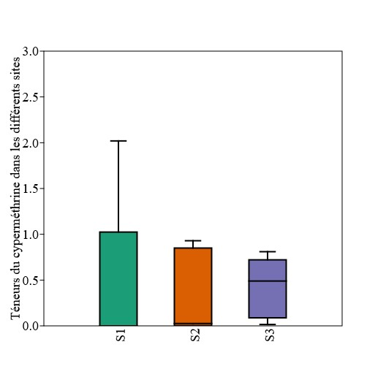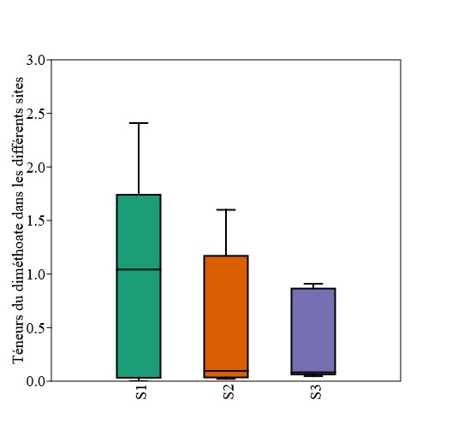Figure 7: Content variability
in carbendazim in sites
Figure 8: Content variability
in chlorothalonil in sites

P (same) = 0.12

P (same) = 0.03

Zoxamide levels at different sites
Maneb levels at different sites

Figure 9: Content variability
in maneb at the sites
Figure 10: Content variability in zoxamide in sites

P (same) = 0.05
P (same) = 0.46
Thiamethoxam levels at different sites
Orthophenilphenol levels at different sites

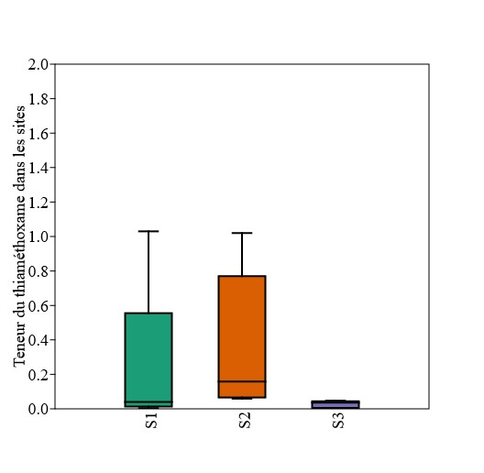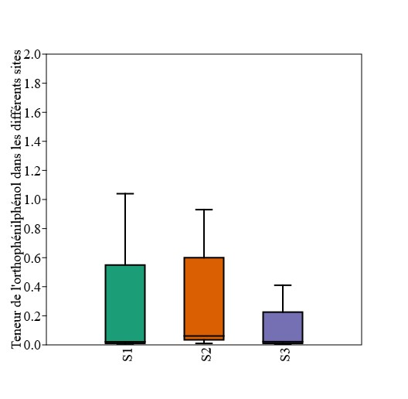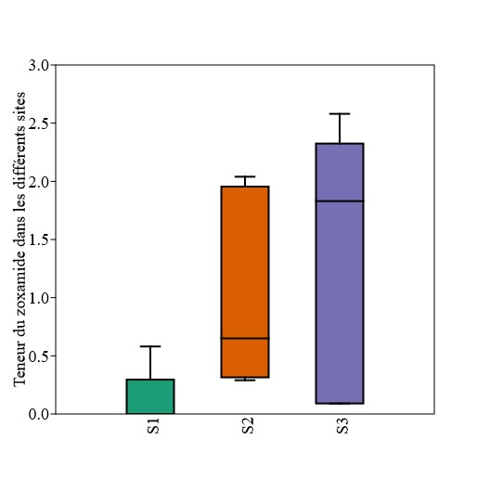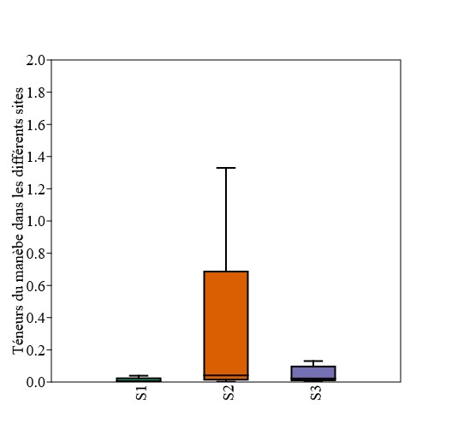Figure 11: Content variability
in thiamethoxam in sites
Figure 12: Content variability
in orthophenilphenol at sites
Table IV : Comparison of active ingredient levels with MRLs

Active ingredients Classes MRL
No. of acceptable
No. of unacceptable
References
(mg/kg) samples (%) samples (%)

Parathion | Ia | 0,05 |  | 9 (60) |  |  | 6 (40)
Chlorpyriphos | II | 0,05 |  | 4 (26,67) |  |  | 11 (73,33)
Dimethoate | II | 0,3 |  | 8 (53,33) |  |  | 7 (46,67)

Cypermethrin II 0,7 11 (73,33) 4 (26,67)
Cyhalothrin II 0,5 9 (60) 6 (40)

(EU, 2018 ; WHO 2019)

MRL : Maximum Residue Limit ; EU : European Union ; WHO : World Health Organization ; Ia : extremely hazardous ; II : moderately hazardous ; III : slightly hazardous ; U : unlikely to present an acute hazard ; NC : Not Classified and % : Percentage.
Spirodiclofen | III | 0,02 | 3 (20) | 12 (80)
Orthophenilphenol | NC | 0,05 | 15 (100) | 0 (0)
Zoxamide | U | 30 | 8 (53,33) | 7 (46,67)
Thiamethoxam | II | 5 | 15 (100) | 0 (0)
Chlorothalonil | U | 0,3 | 15 (100) | 0 (0)
Maneb | U | 5 | 15 (100) | 0 (0) | WHO, 2019
Carbendazim | II | 5 | 8 (53,33) | 7 (46,67)
TOTAL |  |  | 120 (66,67) | 60 (33,33)

4. Chemical risks associated with eating lettuce

Chemical risk assessment for lettuce consumption was carried out according to the method described by the Codex Alimentarius Commission (FAO/WHO, 1999). There are risks of chronic and acute intoxication with Parathion, Dimethoate, Chlorpyriphos and Spirodiclofen. The risk of chronic poisoning with Parathion is 28%. On the other hand, the risk of acute poisoning is 2%. The risk of chronic poisoning with Dimethoate is 47%. While the risk of acute poisoning is 1%. With Chlorpyriphos, the risk of chronic poisoning is 0.3%. The risk of acute poisoning with Chlorpyriphos is non-existent. Spirodiclofen, on the other hand, presents a risk of chronic and acute poisoning. These risks are 0.22%. The figures below show the curves for the chemical compounds at risk.

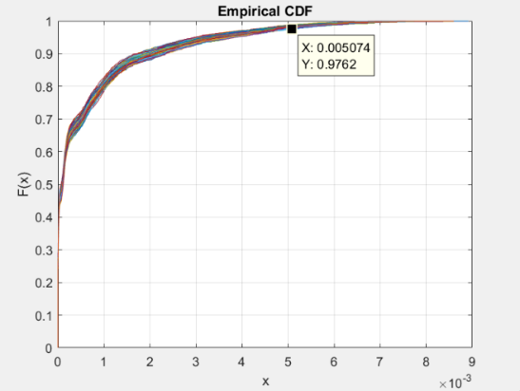
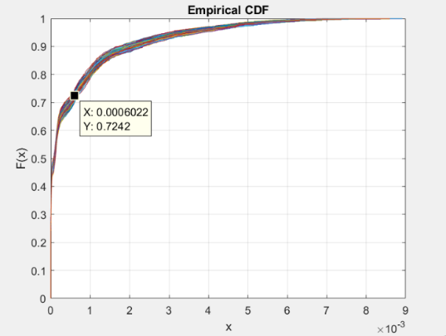

Figure 13: Risk of chronic poisoning with parathion

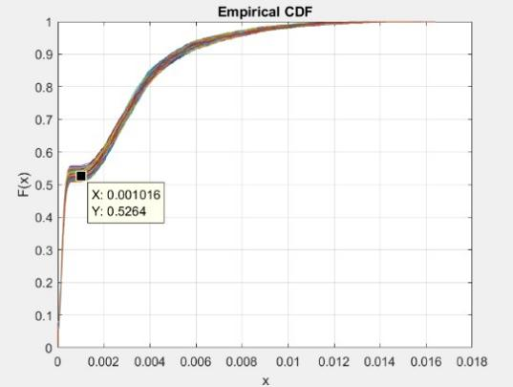
Figure 15: Risk of chronic poisoning with dimethoate

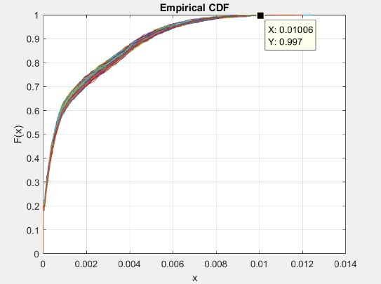

Figure 17: Risk of chronic poisoning with chlorpyrifos
Figure 14: Risk of acute poisoning with parathion

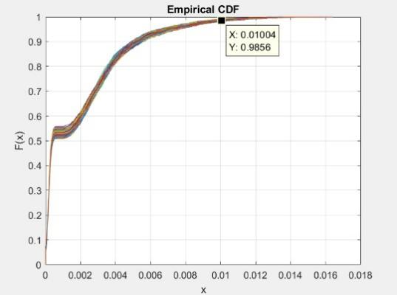
Figure 16: Risk of acute poisoning with dimethoate

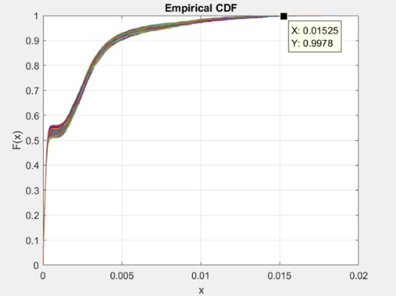

Figure 18: Risk of chronic poisoning
and acute with spirodiclofen
5. DISCUSSION

Urban agriculture, in particular lettuce production, is undergoing significant development in the city of Yamoussoukro. This activity is practiced by both genders. However, it is dominated by men (55.56%) compared to women (44.44%). The strong presence of men in the market gardening activity has been noted in recent similar studies on market gardening (Alio et al., 2017; Bâ et al., 2018; Kouassi et al., 2024). However, these data differ from those reported by Kouassi et al. (2019). Indeed, in a study carried out in Daloa (Côte d'Ivoire), the authors showed that urban lettuce production is dominated by the female gender in 58.1% of cases versus 41.9% for men. The high involvement of men in this activity could be explained by the unavailability of land. The lower-than-average rate for women could be linked to the arduous nature of the work. Added to this is the fact that women are generally specialized in marketing agricultural crops (N'diaye et al., 2021). But also, by the lack of financing for market gardening activities. The omnipresence of senior citizens, or even retirees, seeking additional income and surely the arduous nature of the work (transplanting and irrigation) mean that the age of the producers surveyed is between 30 and 60 (Bâ et al., 2016). This result differs from the studies by N'diaye et al. (2021) and Boukary et al. (2023) on income distribution and economic growth in sub- Saharan Africa and onion bulb farming practices. Market gardening in Yamoussoukro is mainly practiced by Ivorians (58.97%). Contrary to the studies carried out by Ganacadja et al. (2022), the activity is predominantly carried out by non-nationals, with a rate of 87.87%. The high involvement of Ivorians in market gardening in Yamoussoukro is due to the fact that they are increasingly involved in this activity. The percentage of illiterates (82.91%) obtained in this study is higher than the 70% of illiterates reported by Kouassi et al. (2019). This illiteracy rate can be explained by the fact that market gardening does not necessarily require a high level of education. However, the level of education does have an impact on the mastery of Good Agricultural Practices (GAP).
The growers surveyed (100%) use water from unprotected wells to water their lettuces. These risky practices were reported by Kouassi et al. (2024), who showed in a study that urban growers used well water for irrigation. Poultry droppings and chemical fertilizers are used by respondents (62.39%) as fertilizers in the city of Yamoussoukro. This result corroborates those found by De Bon et al. (2019) and Yeo et al. (2022) in their various works on agroecological practices and the challenges of vegetable production in Côte d'Ivoire. A rate of
37.61% of urban lettuce growers use a mixture of poultry droppings, cow dung and chemical fertilizer for bed fertilization. Similar inputs were reported in the work of Boukary et al. (2023), who stated that urban growers use organic manure combined with two types of chemical fertilizer (NPK and urea). The use of these fertilizers proves that cultivable soils are becoming
increasingly nutrient-poor. All growers (100%) use pesticides. In the work of Boukary et al

(2023), 74% of market gardeners were already using pesticides.

The use of pesticides by market gardeners (100%) in the town of Yamoussoukro is an unavoidable practice. This result is contrary to that found by Oula et al. (2021). Indeed, the authors revealed in their work in Côte d'Ivoire that the inappropriate use of registered or unregistered phytopharmaceutical products is widespread, reaching a rate of 97% among the growers surveyed. This high use of pesticides by market gardeners can be explained by repeated plague attacks on lettuce. At least one pesticide residue was found in all lettuce samples from the different study sites. Relatively similar pesticide active ingredients were detected in lettuces from the city investigated. This similarity indicates uniform pesticide use practices across all study sites. We can therefore notice that growers with the same difficulties exchange information on the same production site. A wide variety of active ingredients were detected in lettuces. These active ingredients belong to several families, including Organophosphates, Pyrethroids, Tetronic Acids, Carbamates, Organochlorines, Dithiocarbamates, Benzamide, Neonicotinoids and phenols in high concentrations. Despite the similarities observed, pesticide residue levels differ from site to site. Organophosphates were most abundant in lettuce grown in the study town. Our results are in line with those of Saliou et al (2013). Indeed, in a study conducted on the evolution of pesticide residues in consumer horticultural products in Senegal, the authors reported the presence of pesticide residues belonging to the Organophosphorus, Organochlorine, Carbamate and Pyrethroid families. Similarly, Amadou Diop (2013) reported the presence of these pesticide families in fruit and vegetables. Residue analysis of some pesticide chemical families in fruit and vegetables has also revealed the presence of Organophosphates and Organochlorines (Bounesrag, 2021). Chlorpyrifos and Cypermethrin were also found in fruit and vegetables in a study carried out in Algeria (Samira, 2017; Rahmani, 2019). In contrast with the work of Yao et al. (2016), Lambda cyhalothrin was not detected in lettuces from the study sites. Parathion, an extremely hazardous product (EU, 2018), detected in lettuces from the city of Yamoussoukro was not reported in the work of Kpan et al. (2019). The diversity of active ingredients obtained could be explained by the fact that growers use several types of phytosanitary products to treat lettuce. The different concentrations observed in these pesticide families can be explained by their physicochemical properties. But also by the quantities of active ingredients applied by growers.
Active ingredients declared moderately hazardous (II), slightly hazardous (III) and unlikely to present an acute hazard (U) were reported in our work (EU, 2018; WHO, 2019). These results confirm those reported by Oubellil (2022) in their work on the evaluation and characterization survey of pesticides used in viticulture in Algeria.
The active ingredients detected lettuces from the town of Yamoussoukro sometimes exceed the MRL. The presence of these compounds in lettuces could have negative consequences for human and animal health, as well as for the environment. A rate of 33.33% of samples did not comply with current European Union and WHO standards. In other studies on vegetables, especially lettuce, high rates of non-compliant samples have been reported. This has been noted in studies on lettuce (Narenderan et al., 2019; Pang et al., 2020) and other vegetables (Rahman et al., 2021). These high levels of active ingredients can be explained by overdosing of plant protection products by growers. This could expose consumers to the acute, sub-acute and chronic effects associated with these products. Residue levels below MRLs can be explained on the one hand by the length of the period between application and sampling, and on the other by compliance with the manufacturer's instructions prior to product application (Ahmad et al., 2013; Bakirci et al., 2014). In order to obtain good-quality lettuces, the use of pesticides on lettuce crops could be limited.
Chemical risk assessment has shown that there is a risk of chronic and acute poisoning from parathion, dimethoate, chlorpyrifos and spirodiclofen. In fact, 28% of the population would be exposed to chronic poisoning by parathion and 2% to acute poisoning. On the other hand, 47% of the population would be exposed to chronic intoxication with dimethoate and 1% to acute intoxication. In the case of chlorpyrifos, only 0.3% of the population would be exposed to chronic poisoning. On the other hand, 0.22% of the population would be exposed to chronic and acute intoxication with spirodiclofen. The results obtained from this study corroborate those of Yao et al. (2016). Indeed, the authors showed in their work that lettuce consumers are exposed to the chronic and adverse effects of dimethoate and chlorpyrifos. The adverse effects of these pesticides on human health are manifold. These include digestive, neurological and cardiovascular disorders, peripheral neuropathies and pulmonary complications. But also dermatological, carcinogenic, reproductive and endocrine effects (Thakur et al., 2014).

6. CONCLUSION

The study revealed pesticide contamination of urban-grown lettuce in Yamoussoukro, the political capital of Côte d'Ivoire. It revealed that lettuce is produced by illiterate people at a rate of 82.91%. Pesticide residues were detected in the lettuces. These residues belong to nine (9) pesticide families namely organophosphates, pyrethroids, tetronic acids, carbamates, organochlorines, dithiocarbamates, benzamides, neonicotinoids and phenols. Parathion, an extremely hazardous product, was detected in the lettuces produced. A rate of 33.33% of samples did not comply with current standards. The presence of these compounds in lettuces
could have negative consequences for human health and the environment. The risks of chronic and acute poisoning linked to the consumption of lettuces are real in the city of Yamoussoukro. The relevant authorities need to make growers aware of the harmful effects of pesticides and train them in good farming practices.

REFERENCES

AGRA. (2021). Food Market Demand and Competitiveness. West Africa Region Report.

Ahmad S., Hiroyuki F., Isao W. & Katsuhisa H. (2013). Concentrations of organochlorine pesticides (OCPs) residues in foodstuffs collected from traditional markets in Indonesia. Chémosphère volume 90, 1742 - 1750 p.
Alio S. A., Inoussa M. M., Bakasso Y. & Samna S. O. (2017). Diversity and dynamics of Salmonella isolated from lettuce (Lactuca sativa L.) in vegetable crops in Niger (West Africa). Journal of Applied Biosciences, 119: 11917-11928.
Amadou D. (2013). Diagnosis of pesticide use practices and quantification in the Niayes area of Dakar (Senegal). Doctoral thesis, 241 p.
Ba A. & Cantoreggi N. L. (2018). Urban and peri-urban agriculture (AUP) and the economy of agri-urban households in Dakar (Senegal). Int. J. Environ. Agric. Biotechnol. 3, 195-207.
Ba A., Cantoreggi N., Simos J. & Duchemin E. (2016). Health impacts of urban farmers' practices in Dakar (Senegal). VertigO Rev. Électronique En Sci. L'environnement 16.
Bakirci G. T., Dilek B. Y. A., Fatih B. & Semih O. (2014). Pesticide residues in fruits and vegetables from the Aegean region, Turkey. Food Chemistry volume 160, 379 - 392 p.
Boukary H., Rabe M. M., Bori H., Soumaila Abdoulaye A. & Yahaya B. Z. (2023). Practices
Paysannes de Production de Bulbes d'Oignon (Allium cepa L.) dans une Zone Périurbaine de Niamey : Cas du Site Maraicher de Kollo. ESI Preprints.
Bounesrag A. (2021). Analysis of residues of some chemical families of pesticides in fruits and vegetables. Dissertation, 66 p. Chemical pesticides and human health: the urgent need for a new concept in agriculture. Frontiers in public health, 4, 148.
Dakuyo R., Konate K., Sama H., Sanou A., Kabore K., Diao M., Dibala C. I. & Dicko M. H. (2020). Assessment of onions contamination by pesticides residues and characterization of market gardeners' cultural practices in the region of Boucle du Mouhoun (Burkina Faso). Int. J. Biol. Chem. Sci. 14(9): 3097-3109.
De Bon H., Fondio L. & Dugué P. (2019). Study to identify and analyze constraints to vegetable production according to the major agro-climatic zones of Côte d'Ivoire.
Ekra A. M. E., Kwadjo K. E., Loukou K. K. S., Kra K. D., Guessan B. T. K., Atsain R. E. (2023). Evaluation of health and environmental risks related to phytosanitary practices cucurbit growers in southern and central Côte d'Ivoire. Rev. Ivoir. Sci. Technol. 42 (2023) 19-34.
EU Pesticides Database - European Commission

FAO/WHO. (1999). Principles and guidelines for the conduct of microbiological risk assessment. CAC/GL-30 (1999). Rome, Italy, 6 p.
Ganacadja C., Mavoungou J. F., Mouketou A., Biroungou C. & Nzengue E. (2022). Analyse de Quelques Caractéristiques de la Filière Maraichage dans Trois Provinces du Gabon. ESI Preprints, 55p.
Kouakou P. A. K. (2019). Determinants Economiques et Impact Social du secteur maraîcher dans la Commune de Boundali. Agron Africaine N° Spécial 103-113.
Kouassi A. G., Kouassi K. C., Ouina T. S. T., & Konate I. (2024). Risks of Salmonellosis Linked to the Consumption of Lettuce Grown on the Outskirts and in Unexploited Intra Urban Areas of the City of Bouaké, Central-Côte d'Ivoire. J. Adv. Microbiol, vol. 24, no. 1, pp.
30-38.

Kouassi K. C., Attien Y. P., Coulibaly B., Diomandé S., Benie C. K. D., Konate I. & Koffi N.

R. (2019). Consumption of Traditional Leafy Vegetables (Amaranthus hybridus) and Risk of its Microbial Contamination in Daloa Town (Côte d'Ivoire). Annual Research & Review in Biology, 33(3): 1-14.
Kouassi K. C., Kouassi K. A., Yao K. M., Kouassi A. G. & Koffi N. R. (2019). Assessment of the Risk of Microbial contamination of an Urban Crop in the City of Daloa (Côte d'Ivoire): Case of Lettuce (Lactuca sativa L.). Journal of Food Research, Vol 8, 122-132.
Kpan K. G. K., Yao L. B., Diemeleou C. A., N'guettia R. K., Traore S. K. & Dembele A. (2019).

Phytosanitary practices in peri-urban agriculture and pesticide contamination of foodstuffs:

the case of market gardeners in Port-Bouët (Abidjan). Journal of Animal & Plant Sciences,

41(1): 6847 - 6863.

Mambe-Ani P., Ouattara K. N., Elleingand F. E. & Kadjo V. (2019). Assessment of the impact of pesticide use in urban and periurban agriculture in Abidjan, Côte d'Ivoire. Int. J. Biol. Chem. Sci. 13 (6): 2824-2837.
N'diaye O., Diatta U., Abeudje A., Dramé M., Ndiaye S. & Tidiane Ba C. (2021).

Characterization of market gardening perimeters instituted by women's groups as a resilience strategy in a post-conflict zone (Casamance, Senegal). European Scientific Journal, ESJ, 17(13), 118.
Narenderan S., Meyyanathan S., Karri V. V. S. R., Babu B., & Chintamaneni P. (2019).

Multivariate response surface methodology assisted modified QuEChERS extraction method for the evaluation of organophosphate pesticides in fruits and vegetables cultivated in Nilgiris, south India. Food Chemistry, 300, 125188.
WHO. (2019). Recommended WHO hazard classification of pesticides and guidelines for classification. 104 p.

Orou S. A., Chirawurah D., Houndji A., Achana F., Aputere N. J., Nkansah B. M., & Martin N. A. (2024). Occurrence of pesticide residues and associated ecological risks assessment in water and sediment from selected dams in northern Ghana. PLoS ONE 19(10): e0312273.
Oubellil Z. Y. (2022). Evaluation and characterization survey of pesticides currently used in viticulture in the wilayas of Boumerdès and Tizi-ouzou. Dissertation, 144 p.
Oula P. Q., Martin T., Fondio L., Koné D., Djézou W. B., Parrot L. (2021). Les déterminants de l'usage inadapté des produits phytophamarceutiques en maraichage de contre saison en côte d'ivoire. CIRAD, 15 p.
Pang Y., Zang X., Li H., Liu J., Chang Q., Zhang S. & Wang Z. (2020). Solid phase microextraction of organophosphorous pesticides from food samples with a nitrogen doped porous carbon derived from g-C3N4 templated MOF as the fiber coating. Journal of hazardous materials, 384, 121430.
Rahman M., Hoque M. S., Bhowmik S., Ferdousi S., Kabiraz M. P. & van Brakel M. L. (2021).

Monitoring of pesticide residues from fish feed, fish and vegetables in Bangladesh by GC- MS using the QuEChERS method. Heliyon, 7(3), e06390.
Rahmani K. (2019). Analysis of pesticide residues on some fruits and vegetables by GC / MS.

Thesis, 71 p.

Saliou N., Anastasie M., Moussoukhoye D., Mamadou B. T., Jean R. I. C. & Seydou T. (2013).

Étude de l'évolution des résidus de pesticides dans les produits horticoles de grande consommation au Sénégal. Rev. Ivoir. Sci. Technol. 21 & 22 (2013) 31 - 44.
Samira M., Mohamed L., Sidi M. O., Sihem T., Fahima N. & Ghania O. (2017). Evaluation of pesticide residues in Algerian fruits and vegetables. Foods Additives Contaminants volume
10, 91 - 98 p.
Son D. (2018). Risk analysis of pesticide use and performance measurement of integrated pest management in tomato cultivation in Burkina Faso. PhD thesis, Université de Liège, 212 p.
Soro G., Koffi N. M., Kone B., Kouakou Y. E., M'Bra K. R., Soro P. D. & Soro N. (2018). Use of phytosanitary products in market gardening around the drinking water supply dam in the city of Korhogo (northern Côte d'Ivoire): risks to public health. Environ. Risque Sante, 17 (2): 155 - 163.
Tano B.F., Abo K., Dembélé A. & Fondio L. (2011). Production systems and risky practices in urban agriculture: the case of market gardening in the city of Yamoussoukro, Côte d'Ivoire. International Journal of Biological and Chemical Sciences 5(6): 2317 2329.
Thakur D. S., Khot R., Joshi P. P., Pandharipande M. & Nagpure K. (2014). Glyphosate poisoning with acute pulmonary edema. Toxicology international. 21(3) : 328.

Yao B. L., Kpan K. G. K., Messoum F. G., Dembélé A. & Traoré K. S. (2016). Evaluation of the phytosanitary risk associated with the consumption of lettuce (Lactuca sativa L.) grown in the commune of Port-Bouët (Abidjan). Rev. Mar. Sci. Agron. Vét. 4 (3): 23-30.
Yeo K. T., Fondio L. & Kouakou K. L. (2022). Characterization and diversity of vegetable production systems in central (Bouaké) Côte d'Ivoire with a view to agroecological transition. J Anim Plant Sci 52: 9538-9551.

