Review Article
A mini review about Ficus carica L. its nutrition and health benefits

Abstract
Ficus caric L. also known as common fig is one of the earliest crop that is cultivated in moderate climatic regions of the world. It is among the largest families of angiosperms. Due to its nutritionl value it is consumed in both fresh and dry form Dry fig is a source of carbohydrates, vitamins ,minerals and phenolic components.It has been used traditionally by humans for various purposes such as a source of food and medicine. Not only the fruit but also the bark, leaves and latex of fig plant has essential benefits Fresh fruit,its extract and isolated parts are also important..Fig is also used as anticancer, anti-oxidant,anti -inflammatory and antidiabetic agent. Fruthermore it also provide immunostimulant activity and relieves constipation. This review helps to eloborate the health and various other uses of fig in a possible way because of its emerging benefits in human life.
Key words
Ficus carica ,health and medicine, anticancer, anti-oxidant,anti -inflammatory, antidiabetic
Introduction
Taxonomy of Fig
Kingdom: Plantae
Phylum : Tracheophyta
Class :Rosales
Family: Moraceae
Genus :Ficus
Specie: Ficus carica Linn.
Local name: Anjeer
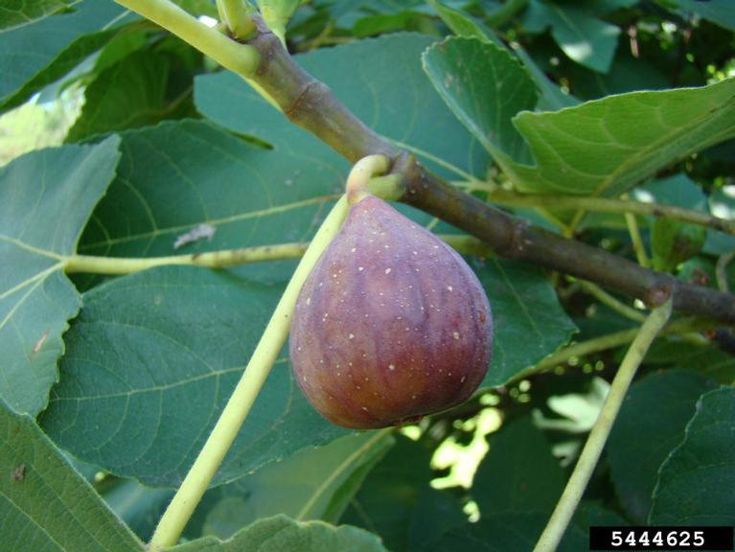

Fig 1: Fruit of Ficus carica L. Source (Rebekah D. Wallace, University of Georgia, Bugwood.org)

Origin
Fucus carica L. also known as fig belongs to Moraceae family.It usually grows in moderate areas such as tropical and subtropical Fig tree are known to be originated from Western Asia and then they moved towards Muddle East and Mediterranean besan.However fossils record indicate that their distribution was in Southern Europe.Afterwards they were brought to America and California (Crisosto et al .,2011 .Nowadays they are cultivated in almost all the moderate climatic areas of the world [16-18].
Habitat and soil conditions
Fig trees are the plants of arid areas and they grow in almost variety of soils. Soil ranges from sandy to loamy ,heavy clay or limestone. They need abundant sunlight and moderate water. Optimum temperature is upto 45 .These plants usually prefer sandy soils because of its dry texture and lime availability. pH of the soil should be 6-6.5 .Their growth is highly effected and deteriorated in acidic soils (Hussain et al .,2021)
Morphology
Fig plant is a deciduous shrub with 10-12m height and a smooth bark.(Al Snafi.,2017) with a profouse root growth extending deep upto 20ft. Leaves are macrophyllous and palmate. Their flowers are of two types . One with edible fruit also called as long styled flowers and other with non edible fruit called as short styled flower (Rahmani and Aldebasi, 2017). Synconium is a specialized fruit of fig plant that is a hollow structure containing many small flowers and seed called pips.Fruit is wrapped in a modified stem tissue( Hussain et al.,2021)

Nutritional Value:
Fig is a great source of vitamins, minerals and organic acids. Figs are rich in carbohydrates containing 92%of it with glucose , fructose and sucrose.They are an important source of nutrition as they are fat and cholesterol free.More than 100 bioactive compounds and enzymes are isolated from it.(Pal ,2020)
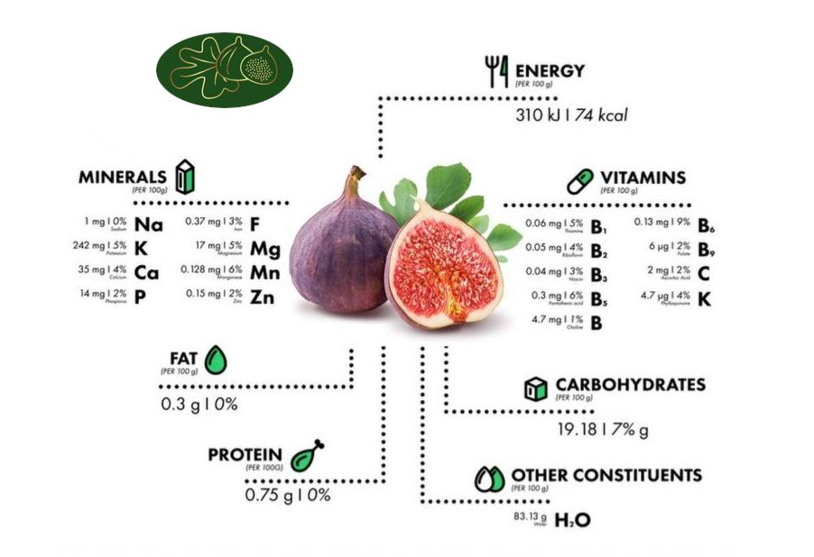
Fig 2: Nutrition information of fig, Source : Google Pinterest
The nutritional composition of Ficus carica for a 50g serving is as follows: It contains 39.6g of water and provides 37 kcal (155 kJ) of energy. The protein content is 0.375g, while the total lipid (fat) is 0.15g, and fiber accounts for 1.45g. The total sugars amount to 8.15g. For vitamins, it contains 1mg of Vitamin C, 0.057mg of Vitamin B-6, 3.5µg of Vitamin A, 0.055mg of Vitamin E, and 2.35µg of Vitamin K. In terms of minerals, it provides 0.1µg of selenium, 0.064mg of manganese, 116mg of potassium, 17.5mg of calcium, 8.5mg of magnesium, and 0.185mg of iron. Additionally, phosphorus content is 7mg, zinc is 0.075mg, and copper is 0.035mg. The sodium content is minimal at 0.5mg. Other nutrients include 0.03mg of thiamin, 0.025mg of riboflavin, 0.2mg of niacin, 3µg of folate, and 2.35mg of choline. It also contains 42.5µg of beta-carotene.
Source: Agriculture Research Service, US Department of Agriculture (USDA), FoodData Central.
Medicinal and Health benefits of Fig
Figs and their leaves are full of nutrients and improve health [19,20]. Not only the fruit but also the leaves, bark and latex are beneficial and were used as traditional medicines. It also provide home remedies and they cure digestion, metabolism , constipation and blood sugar. Due to the phenolic compounds in them ,they cure many ailments. Some of them are discussed below:
Antipyretic
The ethanol extract of fig is effective in reducing normal body temperature (Patil et al.,2010a) It was shown in an experiment during which a dose of ethanol extract of ficus leaves was given to albino rats and it was discovered that it reduce the normal body temperature of rats .
Anti inflammatory
Leaves of fig extracts petroleum ether, chloroform and ethanol which are used as anti inflammatory agent.( Badgujar et al.,2014)
Anti helminthic
Among a few drugs that are used to cure helminthes in humans ,leaf extract of different species of fig are also useful .(Patil et al.,2010a)
Anti constipation
The effect of Ficus carica L. on loperamide induced constipation in rates was studied and fecal pallets were examined and the evidences proved that fig also has soothing effect during constipation.(Kim et al.,2010)
Reducing hypertension
Due to rich in potassium content and having fibers they maintain blood pressure by reducing sodium and increasing potassium in body.
Anti cancer
Fig latex act as a source of anticancer medicine.A mixture of 6-O-acyl, beta – oglucosyl-beta -sitosterols has been extracted which are used as anti cancer agents.Rubnov et al.,2001
Antiviral effect
They hexanic and hexane-ethyl-acetate v/v extract inhibits multiplication of viruses.These 2 extracts are used as antiviral agents.(Aref et al.,2011b).
Anti oxidant properties
Dried figs are consumed and contain more calories than fresh one.Due to its phenolic and fiber composition it provides antioxidant properties.(Vinson et al.,1999).
Immunostimulant Activity
The experiment conducted on mice with hematological and serological tests remarkably indicate that fig act as immunostimulant (Patil et al.,2010c)
Effect on Alzheimer Disease
Long term supplementation of figs activate Neuro inflammation in Transgenic mouse model of Alzheimer’s Disease.(Rahmani and Aldebasi,2017)
Anti diabetic activity
Polyphenolic and flavonoid components of fig were examined to understand its effects on diabetes and obesity. It was observed that ethanol extract of fig was useful as anti diabetic component.(Mopuri & Islam, 2016)
Conclusion
Fig is not only a fruit for taste but it also has so many health benefits .Studied and experiments reveal that fig has the potential to help immune system by fighting against diseases.Thus it paves a path for further pharmacological and medicinal research to serve the humanity.

References

- Agriculture Research Service, US Department of Agriculture. FoodData Central: figs, raw; 2019. Available from: https://fdc.nal.usda.gov/fdc-app.html#/food-details/173021/nutrients. Accessed February 11, 2024.
- Al-Snafi, A. E. (2017). Nutritional and pharmacological importance of Ficus carica-A review. IOSR Journal of Pharmacy, 7(3), 33–48.
- Badgujar, S. B., Patel, V. V., Bandivdekar, A. H., & Mahajan, R. T. (2014). Traditional uses, phytochemistry and pharmacology of Ficus carica: A review. Pharmaceutical Biology, 52(11), 1487–1503. https://doi.org/10.3109/13880209.2014.892515
- Crisosto, H., Ferguson, L., Bremer, V., Stover, E., & Colelli, G. (2011). Fig ( Ficus carica L.). In Elsevier eBooks (pp. 134–160e). https://doi.org/10.1533/9780857092885.134
- Hussain, S.Z., Naseer, B., Qadri, T., Fatima, T., Bhat, T.A. (2021). Fig (Ficus Carica)—Morphology, Taxonomy, Composition and Health Benefits. In: Fruits Grown in Highland Regions of the Himalayas. Springer, Cham. https://doi.org/10.1007/978-3-030-75502-7_6
- Jin Sun Kim, Yeon Ok Kim, Hyun Ju Ryu, Yeon Sig Kwak, Ji Yeon Lee, Hunseung Kang, Isolation of Stress-Related Genes of Rubber Particles and Latex in Fig Tree (Ficus carica) and their Expressions by Abiotic Stress or Plant Hormone Treatments, Plant and Cell Physiology, Volume 44, Issue 4, 15 April 2003, Pages 412–414, https://doi.org/10.1093/pcp/pcg058
- Lazreg Aref, H., Gaaliche, B., Fekih, A., Mars, M., Aouni, M., Pierre Chaumon, J., & Said, K. (2011). In vitro cytotoxic and antiviral activities of Ficus carica latex extracts. Natural Product Research, 25(3), 310–319. https://doi.org/10.1080/14786419.2010.528758
- Mawa, S., Husain, K., & Jantan, I. (2013). Ficus carica L. (Moraceae): Phytochemistry, Traditional Uses and Biological Activities. Evidence-based complementary and alternative medicine : eCAM, 2013, 974256. https://doi.org/10.1155/2013/974256
- Mopuri, R., & Islam, M. S. (2016). Antidiabetic and anti-obesity activity of Ficus carica: In vitro experimental studies. Diabetes & Metabolism, 42(4), 300. https://doi.org/10.1016/j.diabet.2016.07.020

- Pal, Imana. (2020). A COMPREHENSIVE REVIEW ON FICUS CARICA L. – AN UNEXPLORED MEDICINAL PLANT. International Journal of Advanced Research. 8. 876-881. 10.21474/IJAR01/12227.
- Patil, Vikas & Bhangale, S.C. & Patil, V.R.. (2010). Evaluation Of Anti-Pyretic Potential Of Ficus carica Leaves. International Journal of Pharmaceutical Sciences Review and Research. 2. 48-50.
- Rahmani, A. H., & Aldebasi, Y. H. (2017). Ficus carica and its constituents role in management of diseases. The Asian Journal of Pharmaceutical and Clinical Research, 10(6), 49–53.
- Rebekah D. Wallace, University of Georgia, Bugwood.org)
- Rubnov, S., Kashman, Y., Rabinowitz, R., Schlesinger, M., & Mechoulam, R. (2001). Suppressors of cancer cell proliferation from fig (Ficus c arica) resin: Isolation and structure elucidation. Journal of Natural Products, 64(7), 993–996.
- Vinson JA. (1999). The functional food properties of fig. Cereals Foods World 44:82–7
- Desai, Y. M., Patel, J. S., Chaudhary, H. L., & Parmar, A. (2022). Effect of Stem Cutting and Growth Regulators on Rooting and Survival of Fig (Ficus carica L.) Cv. Black Ischia. International Journal of Plant & Soil Science, 34(24), 219–224. https://doi.org/10.9734/ijpss/2022/v34i242633
- Salma, S., Shamsi, Y., Ansari, S., & Nikhat, S. (2020). Ficus Carica L.: a panacea of nutritional and medicinal benefits. Cellmed, 10(1), 1.
- Bouyahya, A., Bensaid, M., Bakri, Y., & Dakka, N. (2016). Phytochemistry and Ethnopharmacology of Ficus carica. International Journal of Biochemistry Research & Review, 14(1), 1–12. https://doi.org/10.9734/IJBCRR/2016/29029
- Yang, Q., Liu, Y., Guo, Y., Jiang, Y., Wen, L., & Yang, B. (2023). New insights of fig (Ficus carica L.) as a potential function food. Trends in Food Science & Technology, 104146.
- Nuri, Z. N., & Uddin, M. S. (2021). A review on nutritional values and pharmacological importance of Ficus carica. Journal of Current Research in Food Science, 2(1), 07-11.

