Original Research Article
Effect of Different Types of Substrate on The Attachment Rate of Brown Mussel Juveniles (Mytilopsis adamsi)

ABSTRACT
Brown mussel (Mytilopsis adamsi) is a potential alternative feed for lobster and crustacean aquaculture in Indonesia, with a balanced nutritional content of 13.29% protein and 80.30% water content, and does not compete with human food needs. This study was conducted because brown mussels are not consumed by humans, so they can be concentrated as lobster feed without competing food sources. By cultivating brown mussels, it is expected to increase lobster productivity in Indonesia and provide consistent fresh feed for cultured lobsters. The development of brown mussels as lobster feed is also encouraged by the Ministry of Marine Affairs and Fisheries (KKP) to overcome the problem of inconsistent feed supply and improve feed quality for lobsters. This study aimed to assess the effect of four types of substrates (80% paranet, PE rope, white net and paris cloth) on the attachment of juvenile brown mussels for 30 days at BPBL West Lombok, using a completely randomized design with 6 replicates. The results showed that PE rope had the highest attachment density in the water column (1.62 fish/cm²) and at the bottom of the container (6.91 fish/cm²). The absolute growth rate was recorded in white netting (860 µm for AP length and 1630.17 µm for DV), while the highest specific growth rate was found in paris cloth for AP (0.154%/day) and PE rope for DV (0.186%/day). It can be concluded that the study showed that PE rope was the best substrate in terms of density. Waring excelled in the absolute growth of brown mussel juveniles. Fabric stood out for AP length-specific growth rate, while rope performed best for DV-specific growth rate. The substrate at the bottom of the container consistently gave better results than that in the water column. Further research is recommended to assess the effect of varying attachment density on other substrate types, as well as longer rearing duration.

Keywords: juvenile/spawn clam, brown mussel, settlement, substrate, absolute growth, specific growth rate.

INTRODUCTION
Brown mussels (Mytilopsis adamsi) are an ideal choice as fresh feed for lobster farming and other crustaceans such as crabs. The brown mussel, a seawater clam originally described from the Gulf of Panama, invaded the indo-pacific oceans in the 19th century. It has been reported from Fiji, India, Malaysia, Singapore, Taiwan, Australia and China but mostly identified as Mytilopsis sallei It contains balanced essential nutrients to support optimal growth and development of lobsters (Wangkulangkul, 2018).
The nutritional content contained in mussels is actually almost the same as other marine life. Brown mussels, which have been tested at BPBL Lombok's integrated research and testing laboratory, show an interesting and useful nutritional profile. Laboratory analysis results showed a moisture content of 80.30%, reflecting the high moisture content of these mussels. In addition, the ash content of 5.12% indicates the amount of minerals contained. Brown mussels also contain a total fat of 1.28% as well as a fairly high protein of 13.29%, making them a good source of protein. The carbohydrate content is relatively low at 1.99%, indicating that these mussels are richer in protein compared to carbohydrates. With this nutritional composition, brown mussels have the potential to be a high-quality feed option for lobster farming.
The protein content in marine animals ranges from 6-24% which is crude protein content and the amount depends on the species, nutritional conditions and muscle type. The habit of bivalves is also thought to be the cause of differences in protein content in bivalves, in addition to the low water binding ability of clam meat affects the low protein content (Bhara et al., 2018).
A suitable substrate allows clams to adhere firmly, prevents drift, and favors successful seed attachment (Hidayat, 2017). Clam larvae have substrate preferences, tending to select clam shells or areas previously inhabited by adult clams (Wagiu et al., 2022). Several studies have been conducted related to the attachment substrate of various types of clams. (Kotta, 2018) found that the density of substrate media affects the attachment of pearl oyster larvae Pinctada maxima. Meanwhile, (Setybudiandi et al., 2017) observed variations in the attachment strength of green mussel Perna viridis byssus on various media. While these studies have provided valuable insights, there are still gaps in knowledge regarding specific substrate preferences for brown mussels.
Therefore, further research should be conducted to identify and characterize substrates that are most suitable for the settlement and growth of brown mussel juveniles. Such research will enrich our understanding of the specific needs of brown mussels, but may also provide valuable insights for the development of more efficient and environmentally friendly aquaculture practices.

METHODOLOGY
This research was conducted for 30 days, starting from September to October 2024 at the West Sekotong Marine Aquaculture Center (BPBL), which is located in Sekotong sub-district, West Lombok Regency, West Nusa Tenggara. This research is an experimental study using a completely randomized design (CRD) consisting of 4 treatments and 6 replicates. Treatment 1 80% paranet (control), treatment 2 PE (polyethylene) rope, treatment 3 white netting, treatment 4 black paris cloth. The construction of the research layout design can be seen in Figure 1 & Figure 2.

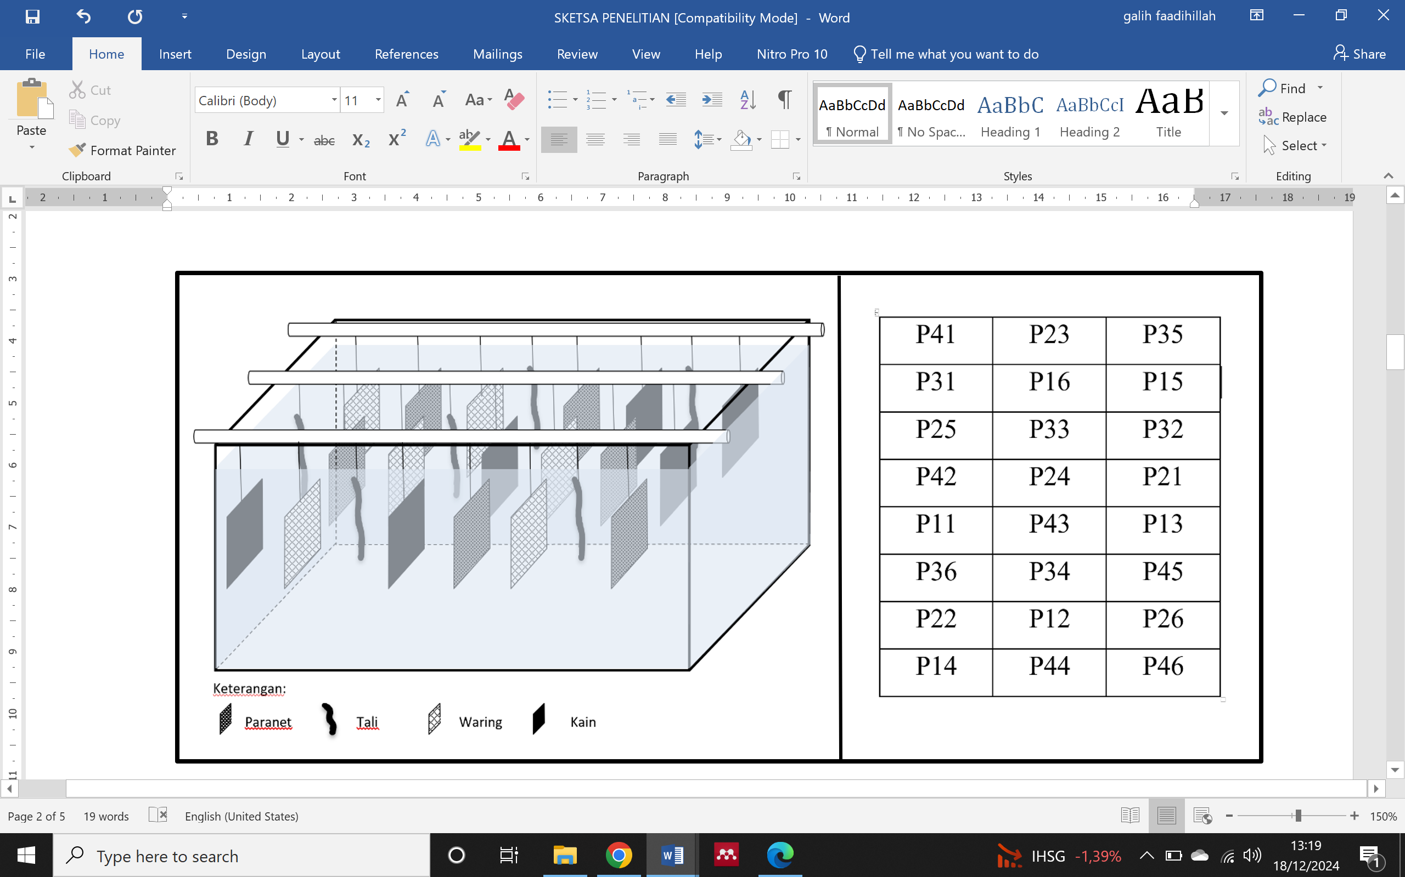
Figure 1. layout of substrates suspended in the water column of each experimental unit.
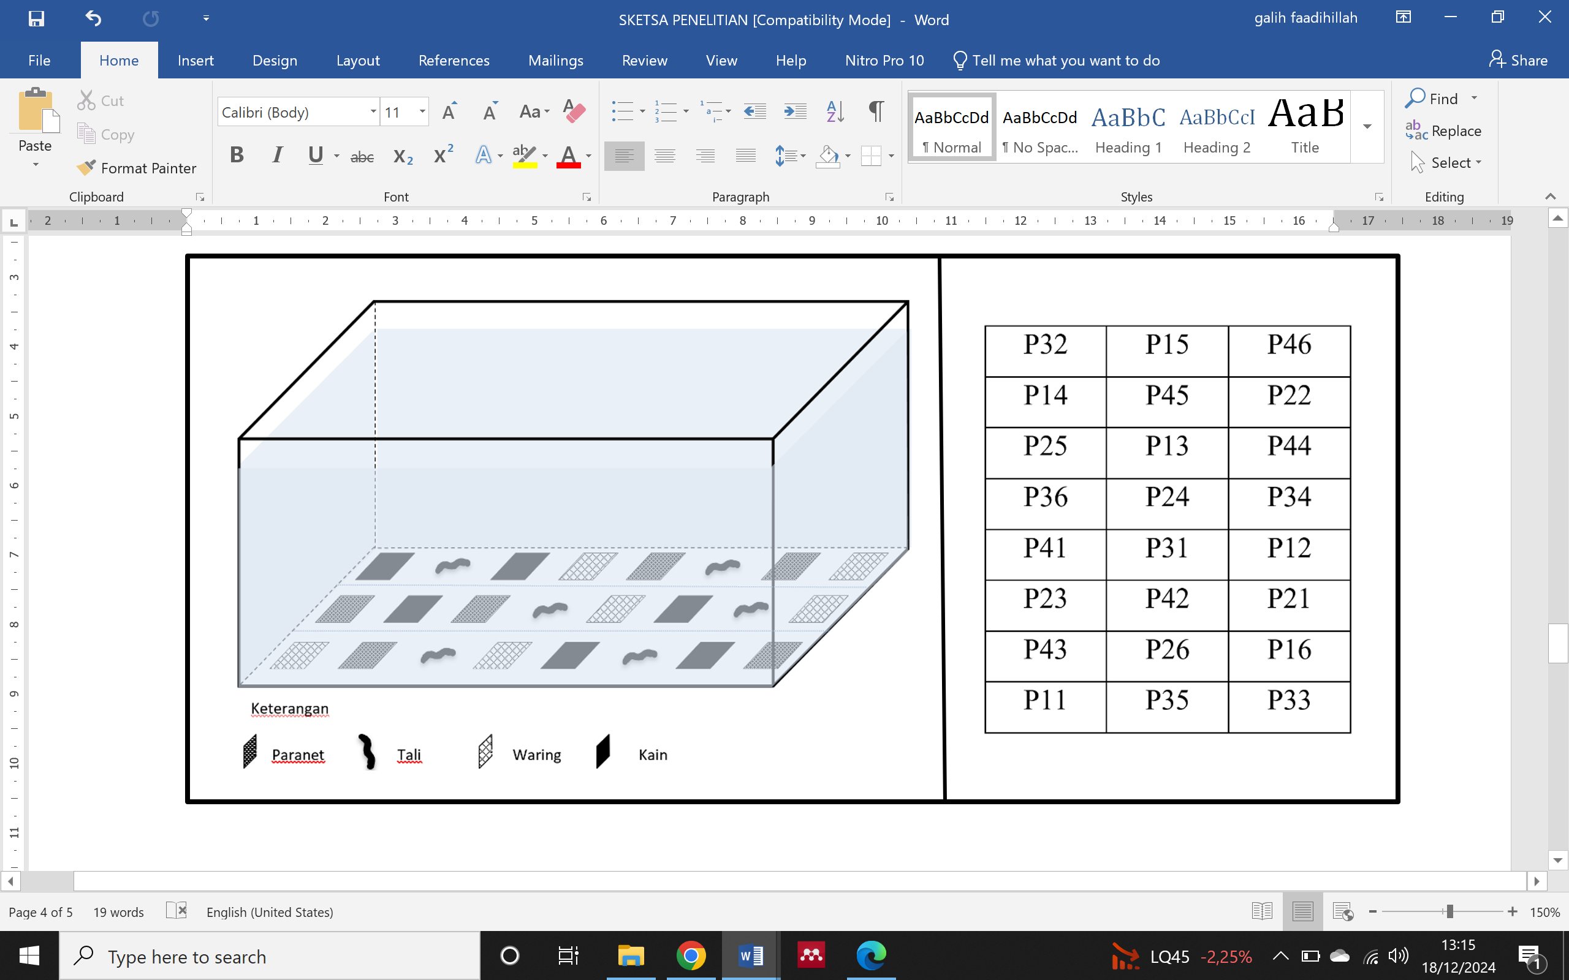

Figure 2. layout of the substrate at the bottom of the container for each experimental unit.
2.1 Research Procedure
The preparatory stage in the cultivation of brown mussels begins with preparing the rearing container, which is a 70 cm x 50 cm x 45 cm container with a volume of 100 liters filled with sea air and equipped with an aeration system to maintain air quality and oxygen. A total of 18,866 14-day-old brown mussel spawn were transferred into the tanks, which were the result of spawning of the parents in the laboratory. For the attachment media, materials such as 0.9 mm diameter PE rope and netting were cut to the required size, then weighted to prevent them from floating in the air.
At the implementation stage, natural food such as Pavlova lutheri, Isochrysis galbana, and Chaetoceros sp. was given once a day at 3:00 pm using a 2 liter plastic container. Air circulation is done daily to remove feed residue and maintain optimal air quality. Larval control is conducted regularly to ensure growth and spat attachment to the substrate, while growth surveys include monitoring environmental factors such as air quality, temperature, salinity, and pH that may affect the survival and growth rate of brown mussel spat.
The position of the Dorsal-Ventral (DV), Anterior Posterior (AP) section of the clam can be seen in Figure 3.
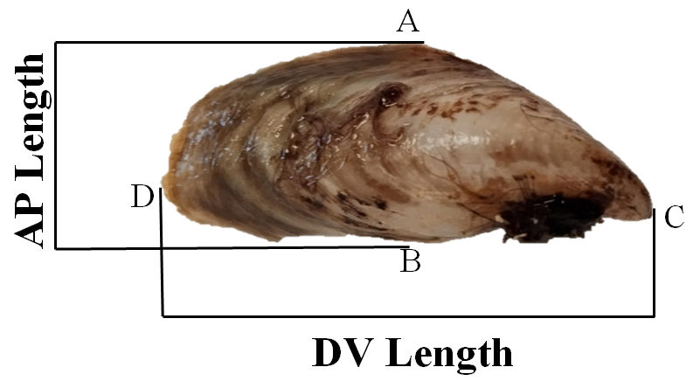

Figure 3. Morphometric measurements of brown mussel juveniles (A: Anterior; B: Posterior; C: Dorsal; D: Ventral)
The morphometric growth of the mussels was measured while attached to the substrate using a microscope with a magnification between 40 and 200. To ensure measurement accuracy, the microscope is equipped with a scale that helps in measuring the exact size of the clam shell.

2.2 Research Parameters
Parameters measured in this study include, Absolute Length Growth, Specific Growth Rate (SGR), density and spat attachment rate of brown mussels, and measuring water quality.
Absolute Length Growth
Calculating the difference between the final length and the initial length of the spat in a certain period (Mukhlis et al., 2021).
$$β = Lt – L0$$
Keterangan :
β = Absolute growth (mm)
L0 = Clam length at the beginning of the experiment (mm)
Lt = Clam length at time (mm)

Specific Growth Rate Expressed in percentage, measured by comparing the weight of mussels at the beginning and end of rearing and the number of individuals in each treatment (Luruk et al., 2023).
$$SGR=\frac{LnWt-LnWo}{t} ×100\%$$
Keterangan :
SGR = Specific growth rate (%/day)
Wt = Average weight at the end of observation (gr)
Wo = Average weight at the beginning of observation (gr)
t = Maintenance time (days)

Attachment rate
attachment rate indicates the success of juvenile colonization, (Sulvina et al., 2015):
$$P=\frac{Po}{Pt}×100\%$$
Keterangan :
P = Shell attachment
Po = Length of Sticking Area
Pt = Total Length of PE Rope

2.3 Data analysis
The study used a completely randomized design (CRD) and the resulting data were analyzed (ANOVA) with the help of the SPSS version 16 application. The purpose of this analysis is to determine the effect of treatment (independent variable), namely the type of substrate on the parameters measured, namely the level of attachment density of brown mussel juveniles, besides that the data analyzed also includes absolute growth and specific growth rate. If the results of the F test showed a significant difference (sig value <0.05) then a further test was carried out using the Duncan test at the 95% confidence level to identify which treatments had significantly different values.

3. RESULTS AND DISCUSSION
3.1 Absolute Length Growth
In order to measure absolute growth, data taken during the study were data on the growth of brown mussel shell length including Anterior-Posterior (AP) and Dorsal-Ventral (DV) lengths both on substrates suspended in the water column and on substrates placed at the bottom of the container.
- Absolute Growth in Water Column
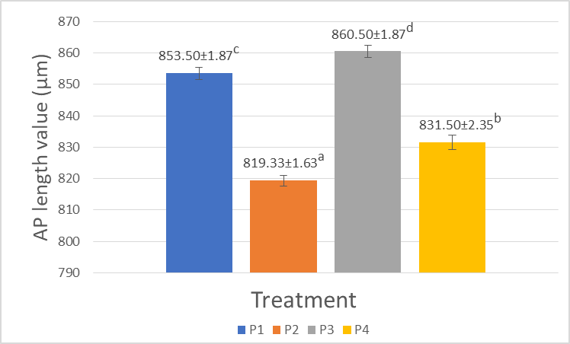
Figure 4. Absolute Growth of Anterior-Posterior (AP) Length in the Water Column
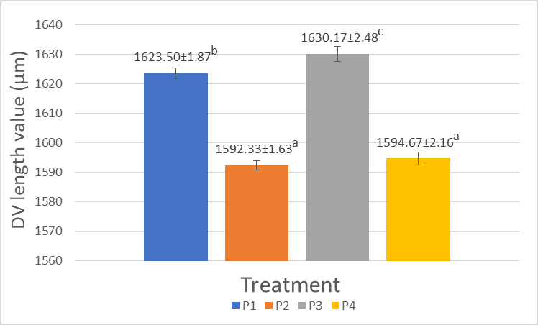
Figure 5. Absolute Growth of Dorsal-Ventral Length (DV) in the Water Column
From the graph above, it can be seen that for Anterior-Posterior (AP) length, all treatments give significantly different results with the average value of Anterior-Posterior (AP) length in a row from the lowest is the treatment P2 (Rope), P4 (Paris cloth), P1 (Paranet 80%), P3 (Waring). As for the Dorsal-Ventral (DV) length, it can be seen that P1 (Paranet 80%) is significantly different from P2 (Tali) P3 (Waring), and P4 (Kain), while P2 (Tali) is significantly different from P3 (Waring) but not significantly different from P4 (Kain).

- Absolute Growth at the Container Bottom
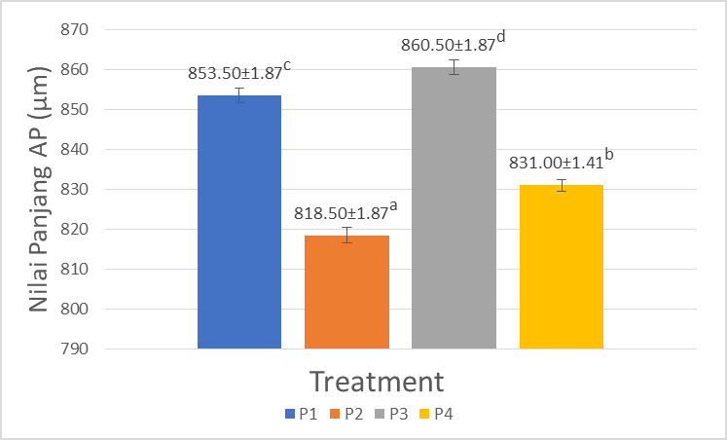
Figure 6. Absolute Anterior-Posterior (AP) Growth at Container Bottom
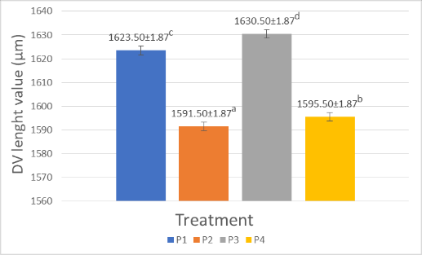
Figure 7. Absolute Dorsal-Ventral (DV) Growth at the Bottom of the Container
From the graph above, it can be seen that for Anterior-Posterior (AP) and Dorsal-Ventral (DV), all treatments give significantly different results with the average value of the length of Anterior-Posterior (AP) and Dorsal-Ventral (DV) respectively from the lowest is the treatment P2 (Rope), P4 (Paris cloth), P1 (80% Paranet), P3 (Waring).
Based on research for 30 days, it shows that the type of substrate has a significant effect on the growth of absolute length of juvenile brown mussels, with a white waring substrate (P3) in the column and bottom waters producing the best growth with an average of 860.50 µm (AP) and 1630.17 µm (DV). Substrate quality is critical to support larval attachment and metamorphosis(Wagiu et al., 2022). The white waring substrate, which has a complex structure and many holes, facilitates the accumulation of microorganisms and nutrients, and allows the movement of mussel larvae. Growth differences between the water column and bottom are influenced by environmental factors. High stocking densities can reduce food availability and inhibit growth due to space constraints, leading to physical contact of individual spat (Rahayu et al., 2024). Spats that are crowded together experience abnormal growth, especially if attached to larger spats. Limiting levels affect the growth rate and growth pattern of individuals (Winanto et al., 2016). Brown mussels prefer to stick to the bottom of the water because of the availability of more abundant food, such as plankton and organic detritus, as well as more stable currents, which make it easier for them to filter food (Langkameng et al., 2021) Space and food availability are major factors in the growth of Pearl mussel spat (Ahmad et al., 2019) Research by (Mazida et al., 2023) also shows that the substrate in the cage system affects the growth of mussels. Factors such as airflow, food availability, and space to move interact with each other in a complex manner.

  - Specific Growth Rate
- Specific Growth in the Water Column
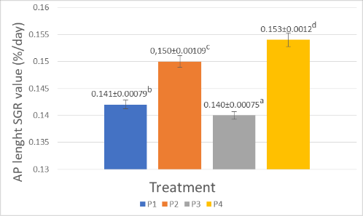
Figure 8. Anterior-Posterior (AP) Specific Growth Rate in the Water Column
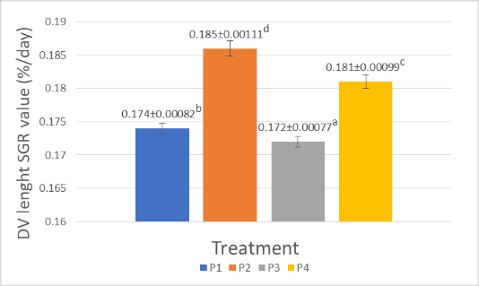
Figure 9. Dorsal-Ventral Specific Growth Rate (DV) in the Water Column
From the graph above, it can be seen that for the length of Anterior-Posterior (AP) and Dorsal-Ventral (DV), all treatments give significantly different results with the average value of Anterior-Posterior (AP) length in a row from the lowest is the treatment of P3 (Waring), P1 (Paranet 80%), P2 (Rope), P4 (Paris cloth), while the average value of Dorsal-Ventral (DV) in a row from the lowest is the treatment of P3 (Waring), P1 (Paranet 80%), P4 (Paris cloth), P2 (Rope).

- Specific Growth on Container Bottom
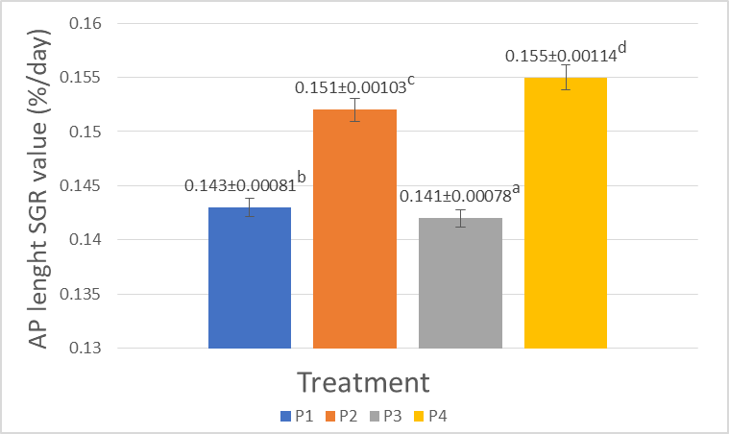
Figure 10. Anterior-Posterior (AP) specific growth rate at the bottom of the container
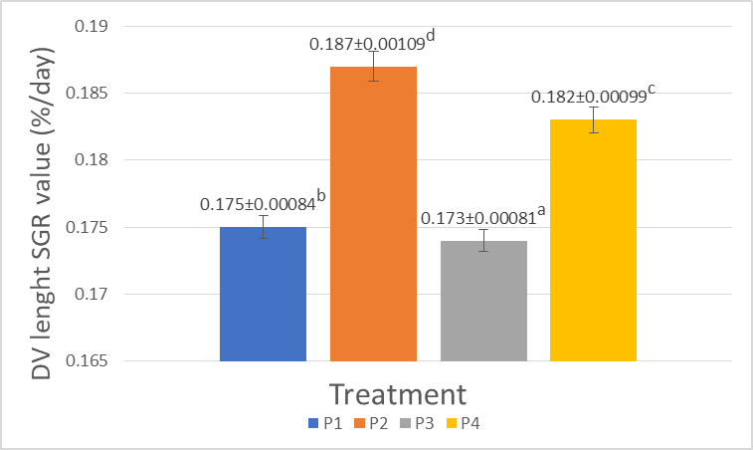
Figure 11. Dorsal-Ventral (DV) specific growth rate at the bottom of the container
From the graph above, it can be seen that for the length of Anterior-Posterior (AP) and Dorsal-Ventral (DV), all treatments give significantly different results with the average value of Anterior-Posterior (AP) length in a row from the lowest is the treatment of P3 (Waring), P1 (Paranet 80%), P2 (Rope), P4 (Paris cloth), while the average value of Dorsal-Ventral (DV) length in a row from the lowest is the treatment of P3 (Waring), P1 (Paranet 80%), P4 (Paris cloth), P2 (Rope).
Based on the available data, the specific Dorsal-Ventral (DV) growth rate of the water column showed different patterns, where substrate P2 (PE rope) recorded the highest value of 0.187 (%/day). Proper substrate selection, taking into account the ability to support nutrient exchange, is key to the success of brown mussel aquaculture. These factors collectively influence the productivity and long-term desirability of brown mussel farming. The paris cloth also shows advantages with its fine texture and small pores that create an optimal microhabitat for nutrient and oxygen exchange. (Rizal & Jailani, 2022) added that mussels obtain their food by filtering the air using their gills to capture small plankton. Although the white waring substrate protects mussels from predators, it is less flexible than PE rope and paris cloth in adjusting the position of air currents.
(Mukhlis et al., 2021) stresses the importance of the quality of the attachment site and the availability of food for the growth of young clams. Research by (Sagita et al., 2017) explains that the number of clams and the type of substrate affect their growth rate due to reduced competition. (Wagiu et al., 2022) explained that clam larvae will grow into young clams, while (Winanto et al., 2016) warned that too many clams in one place can inhibit the growth of their shells. Proper substrate selection is crucial in brown mussel aquaculture, considering the malleability of the material, the ability to support nutrient exchange, and create a good microenvironment for growth. All these factors together determine the long-term success and desirability of brown mussel farming.

  - Water Column Density
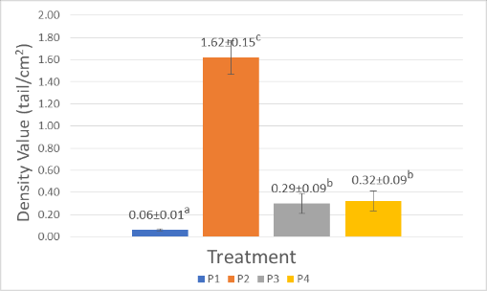
Figure 12: Graph of Density in the Water Column
From the data above, it can be seen that the P2 (Tali) treatment shows higher density results compared to the other treatments. The P2 (Rope) treatment was significantly different from P1 (Paranet 80%), P3 (Waring) and P4 (Paris cloth) (notation). The second density was shown in P4 (Paris cloth) with results that were not significantly different from P3 (Waring) but significantly different from P1 (Paranet 80%). The lowest density was observed in P1 (80% shade cloth).
Mussel density showed significant differences between the column and bottom of the container. In the water column, PE rope achieved the highest density (1.62 individuals/cm²) because its filamentous and rough texture strongly favors larval attachment through the byssus organ. This is reinforced by (Ayu et al., 2024) who explained that rough surfaces are preferred by Pearl clam spat because they provide protection from currents and predators. (Sulvina et al., 2015) found the texture of PE rope to be ideal for P.viridis byssus binding compared to other susbtrates. Paris cloth and white waring were less effective because their surfaces were too smooth, making it difficult for larvae to get a firm grip. (Rosanawita et al., 2017) explained that when spat metamorphose into spat, clams will look for a suitable environment by crawling and attaching to hard objects such as mangroves, wood, or branches. (Kotta, 2018) added that at an optimal density with a suitable substrate, spat can develop well, while a tenuous substrate makes it difficult for the larval attachment process.

3.4 Container Bottom Density
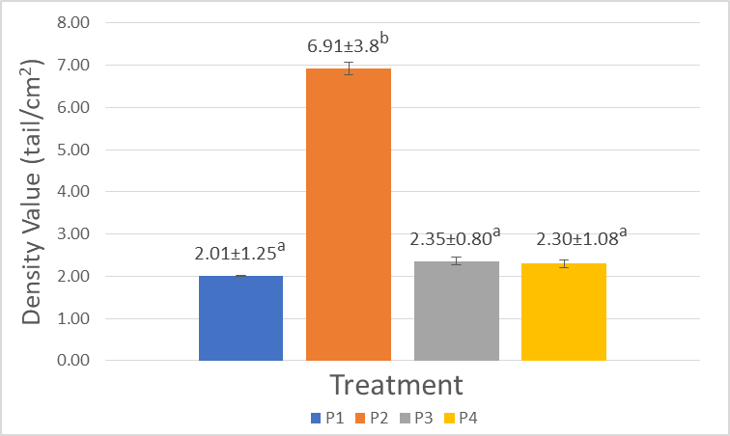
Figure 13: Density at the bottom of the container
From the data above, it can be seen that the P2 treatment (Rope) shows higher density results compared to the other treatments. P2 treatment is significantly different from P1 (80% Paranet), P3 (Waring) and P4 (Paris cloth) (notation). The second density was shown in P3 (Waring) with results that were not significantly different from P4 (Paris cloth) and P1 (Paranet 80%). The lowest density was aimed at P1 (80% paranet).
At the bottom of the container, the density of spat on the pe rope reached a fairly high number of 6.91 individuals/cm², far exceeding the density in the water column. (Inoue et al., 2021) showed that the byssus is very important as a tool for attachment, so that clams can adapt to changes in the aquatic environment, while (Natsir & Allifah AF, 2019) in the Bivalve group that lives attached, there is a significant anatomical modification they developed a special organ called byssus, a complex protein thread structure allows them to adhere strongly to hard surfaces such as rocks or man-made structures. The high density at the bottom is supported by the abundance of organic material and detritus as a nutrient source, coupled with currents that carry more food particles. (Wagiu et al., 2022) revealed that the substrate plays an important role in encouraging larvae to go down to the bottom of the water and attach to preferred substrates. (Toding bua, 2017) added that Bivalves are generally distributed in coastal waters with muddy bottoms mixed with sand, although some species can live on shell substrates such as clay and wood. (Alburhana et al., 2023) highlighted the ability of Bivalves to live for long periods in bottom substrates, making them good bioindicators of water quality. Despite high densities, (Hakim et al., 2024) asserted that as long as nutrient availability is full, this does not inhibit mussel growth. The significant density difference between the water column and bottom reflects the natural preference of mussels for more stable and nutrient-rich conditions at the bottom, where they can grow optimally and form sustainable populations.

  - Water Quality
Research conducted by BPBL Sekotong revealed that water quality parameters greatly influence the environmental conditions in which brown mussels develop.

Table 1. Water quality in rearing containers
Parameters | Value | Optimal range | Source
Temperature (⁰C) | 29.5 | 25-30 | Iyen et al., (2021).
pH | 8.1 | 7.8-8.6 | Junaidi et al., (2019)
DO (ppm) | 6.3 | 4.19-6.24 | (Hidayat, 2017)
Salinity (ppt) | 34 | 0,1 to 34, | Mumladze et al., (2019)

Water quality has a significant impact on brown mussel growth and survival. brown mussels. A temperature of 28.5°C reflects optimal tropical water conditions. At this temperature, enzyme activity in the mussel body functions optimally, supporting efficient digestion and metabolic processes. For brown mussels, the ideal temperature range is between 26-30°C. The optimal temperature range for pearl mussel growth is 25-30°C, provided that temperature changes in the water do not occur rapidly (Iyen et al., 2021).
The pH value of 8.1 indicates a slightly alkaline water condition but is still ideal for clam life. which is still within the limits of quality standards according to Bali Governor Regulation No.8 of 2007 and Decree of the Minister of Environment No. 51 of 2004, where the standard quality of seawater for marine biota is 7-8.5. This is in line with the opinion of (Rosanawita et al., 2017) that the pH of seawater is generally in the range of 6-8. Dissolved oxygen (DO) levels of 6.6 ppm indicate good oxygenation conditions.
Dissolved oxygen is a critical parameter for the life of aquatic organisms, including brown mussels. Brown mussels require dissolved oxygen levels between 4.19-6.24 ppm for optimal conditions. Fluctuations in oxygen levels can affect the growth and reproduction of bivalves, therefore monitoring and managing oxygen levels is an important aspect in mussel aquaculture (Hidayat, 2017).
Salinity of 34 ppt is a typical seawater characteristic that is important for the osmotic regulation of brown mussels, which are osmoconformers. Salinity affects the distribution, growth and reproduction of mussels. Drastic changes can cause stress, such as shell shedding and decreased filtration rates. In addition, increased salinity can decrease oxygen solubility, impacting mussel respiration. Some species, such as Mytilopsis leucophaeata, are tolerant of salinity variations and can survive within 0.1 to 34 ppt. Adaptation to salinity fluctuations involves complex osmoregulatory mechanisms (Mumladze et al., 2019).

4. CONCLUSIONS
In the suspended substrate, the highest density was found in paris rope (1.62 fish/cm²), followed by cloth (0.33 fish/cm²), net (0.30 fish/cm²) and netting (0.06 fish/cm²). the highest growth was achieved in the white net substrate with 1630.17 µm and 860 µm. The highest specific growth rate for AP was paris cloth 0.154 (%/day) and for DV was pe rope 0.186 (%/day). in the substrate at the bottom of the container, the highest density was also in pe rope (6.91 fish/cm²) followed by nets (2.35 fish/cm²) and cloth (2.30 fish/cm²). the highest absolute growth for AP and DV was in the white nets substrate. The highest specific growth rate for ap was paris cloth 0.155 (%/day) and for dv was pe rope 0.187 (%/day). The best substrate based on density was pe rope, while for absolute growth it was waring. The substrate at the bottom of the container showed better results than the one hung on the column.

REFERENCES

Ahmad, Z., Junaidi, M., & Astriana, B. H. (2019). Effect of Pearl Clam (Pinctada maxima) Spat Density with Longline Method on Growth and Survival. Journal of Tropical Biology, 19(2), 221–228. https://doi.org/10.29303/jbt.v19i2.1273
Alburhana, L. S., Setyati, W. A., & Redjeki, S. (2023). Length Weight Relationship of Blood Clams (Anadara granosa) in Berahan Kulon Waters, Demak. Journal of Marine Research, 12(4), 746–753. https://doi.org/10.14710/jmr.v12i4.34119
Ayu, S., Rahman, A., & Abidin, L. O. B. (2024). Use of Collectors from Nets, Wood and Bamboo on the Abundance and Growth of Pearl Clam Spawn Pteria penguin at Palabusa Village Beach. Scientific Journal of the Department of Aquaculture, 9(3), 109–115.
Bhara, A. M., Meye, E. D., & Kamlasi, Y. (2018). Analysis Of Bivalves Content Consumed In The Coastal Coast Of Arubara, Ende. Jurnal Biotropikal Sains, 15(3), 38–48. https://ejurnal.undana.ac.id/index.php/biotropikal/issue/view/no3
Hakim, G., Taufiq-spj, N., & Redjeki, S. (2024). Size Variation of Green Mussels (Perna viridis) in the Coastal Pond of Lorok , Semarang. Journal of Marine Research, 13(4), 617–624.
Hidayat, K. (2017). Growth Performance of Green Mussels (Perna viridis Linn, 1758) and Bawal Bintang Fish (Trachinotus blochii lacepede, 1801) Cultivated in Polyculture and Monoculture on Pasaran Island. Thesis, ST program.
Inoue, K., Onitsuka, Y., & Koito, T. (2021). Mussel biology: from the byssus to ecology and physiology, including microplastic ingestion and deep-sea adaptations. Fisheries Science, 87(6), 761–771. https://doi.org/10.1007/s12562-021-01550-5
Iyen, H., Kasnir, M., & Hamsiah, H. (2021). Analysis of suitability and supportability of mabè mutiara mussel (Pteria penguin) fishing locations in the palabusa flow of bau-bau city. Journal of indonesian tropical fisheries (joint-fish) : Journal of Aquaculture, Capture Fisheries Technology and Management, Marine Science, 4(2), 180–197. https://doi.org/10.33096/joint-fish.v4i2.108
Junaidi, M., Ahmad, Z., & Astriana, B. H. (2019). Effect of Pearl Clam (Pinctada maxima) Spat Density with Longline Method on Growth and Survival. Journal of Tropical Biology, 19(2), 221–228. https://doi.org/10.29303/jbt.v19i2.1273
Kotta, R. (2018). Effects of Different Densities of Substrate Media on the Attachment Process of Pearl Oyster (Pinctada maxima) Larvae. Agrikan: Journal of Fisheries Agribusiness, 11(1), 61. https://doi.org/10.29239/j.agrikan.11.1.61-70
Langkameng, P. A. T., Sunadji, & Tjendanawangi, A. (2021). Effect of different diameters of nylon rope as a collector material on the number of spat attachment, survival and growth of pearl oysters (Pinctada maxima). Jurnal Akuatik, 4(2), 31–37.
Luruk, A., Santoso, P., & Tjendanawangi, A. (2023). Effect of Density on the Growth of Pearl Clams (Pinctada maxima) in the Longline Method. Journal of Vocational Fisheries Sciences (Jvip), 4(1), 147. https://doi.org/10.35726/jvip.v4i1.7086
Mazida, A., Aminin, & Farikhah. (2023). Biometric Analysis and Growth Rate of Green Mussels (Perna viridis) Cultivated in Floating Cages in the Java Sea, Banyuurip Village, Ujungpangkah Subdistrict.. Journal of Marine Research, 12(2), 240–249.
Mukhlis, A., Ilmi, N. K., Rahmatullah, S., Ilyas, A. P., & Dermawan, A. (2021). Acceleration of pearl mussel (Pinctada maxima) seed growth using the immersion method in natural food tanks. Unram Fisheries Journal, 11(1), 1–12. https://doi.org/10.29303/jp.v11i1.224
Mumladze, L., Bikashvili, A., Japoshvili, B., & Anistratenko, V. V. (2019). New Alien Species Mytilopsis leucophaeata and Corbicula Fluminalis (Mollusca, Bivalvia) Recorded in Georgia and Notes on Other Non-Indigenous Molluscs Invaded the South Caucasus. Vestnik Zoologii, 53(3), 187–194. https://doi.org/10.2478/vzoo-2019-0019
Natsir, N. A., & Allifah AF, A. N. (2019). Frequency and Diversity Analysis of Bivalves in the Coastal Waters of Ay Island, Banda District, Central Maluku Regency. Pattimura Proceeding: Conference of Science and Technology, 249–258. https://doi.org/10.30598/pattimurasci.2020.snpk19.249-258
Rahayu, E. P., Hastuti, S., & Widowati, L. L. (2024). Survival and Growth Profile of Green Mussels (Perna viridis) at Different Compound Structure Positions in Timbulsloko, Sayung, Demak. Aquaculture Management and Technology, 13(1), 1–10.
Rizal, S., & Jailani. (2022). Analysis of Plankton Abundance and Growth of Cultured Mud Clam in Mahakam Delta Pond (Solander, 1786). Journal of Tropical Fisheries Science, 1(2), 160–167.
Rosanawita, R., Dewiyanti, I., & Octavina, C. (2017). Effect of Stocking Density on Growth and Survival of Oyster (Crassostrea sp.) Effect. Scientific Journal of Marine and Fisheries Students Unsyiah, 2(1), 213–220.
Sagita, A., Kurnia, R., & Sulistiono, S. (2017). Cultivation of green mussels (Perna viridis l.) with different methods and densities in coastal waters of kuala langsa, aceh. Journal of Aquaculture Research, 12(1), 57. https://doi.org/10.15578/jra.12.1.2017.57-68
Setybudiandi, I., Yonvitner, W. M., & Arief, S. (2017). Attachment Strength of Green Mussel Bysus (Perna viridis) on Attachment Media. Scientific Journal of Biology Education, 2(2), 12–17.
Sulvina, S., Noor, N., Wijayanti, H., & Hudaidah, S. (2015). Effect of different types of rope on the attachment rate of green mussel seeds (Perna viridis). E-Journal of Aquaculture Engineering and Technology, 4(1), 471–478.
Toding bua, A. (2017). Bivalve Community Structure in Juata Laut Beach, Tarakan, North Kalimantan. Biota: Scientific Journal of Life Sciences, 2(1), 29–36. https://doi.org/10.24002/biota.v2i1.1689
Wagiu, F. J. G., Ompi, M., Kaligis, E. Y., Rimper, J. R. T. S. L., Roeroe, K. A., & Manginsela, F. B. (2022). Septifer bilocularis clam attachment to substrate in clam aggregations in tiwoho coastal tidal areas. Journal of Tropical Coastal and Marine, 10(3), 325–331. https://doi.org/10.35800/jplt.10.3.2022.55017
Wangkulangkul, K. (2018). Comments on restricted distribution of Mytilopsis adamsi Morrison, 1946, a non-native false mussel in the Songkhla Lagoon System, southern Thailand. Limnology, 19(1), 151–156. https://doi.org/10.1007/s10201-017-0515-1
Winanto, T., Marasabessy, M. D., & Dody, S. (2016). Optimum Density and Morphology of Pearl Oyster Spawn Pinctada maxima (Jameson) in Maintenance with Different Density Levels. Omni Akuatika, 12(3), 138–143.

