Decoding Investment Intentions: Uncovering How Risk Tolerance, Financial Literacy, and Subjective Norms Drive Students to Begin Stock Investing

ABSTRACT
This study examines the influence of risk tolerance, financial literacy, and subjective norms on the intention to invest in stocks among university students in Bali, Indonesia. The research employs the Structural Equation Modeling - Partial Least Squares (SEM-PLS) method to analyze the relationships between these variables. Risk tolerance reflects the students' willingness to take financial risks, while financial literacy assesses their understanding of financial concepts, and subjective norms measure the perceived social pressure to engage in stock investment. The findings reveal that all three factors financial literacy, risk tolerance, and subjective norms have a positive and significant effect on students' intention to invest in stocks. Higher financial literacy increases confidence in making informed investment decisions, while a greater tolerance for risk enhances their readiness to participate in stock market activities. Additionally, the influence of subjective norms indicates that social and cultural factors play an important role in shaping investment intentions. This study provides a foundation for future research on investment behavior among emerging investors in developing countries.
Keywords: Theory of Planned Behavior. Risk Tolerance, Financial Literacy, Stock Investment Intention.
JEL Classification: G4, G1

1. INTRODUCTION
Investment denotes the allocation of capital for a designated duration with the objective of yielding profit or enhancing the investment's value in the future (Putri & Herlina, 2024). Investment is essential for emerging nations. Investment yields numerous advantages, such as enhanced job prospects, elevated productivity, foreign exchange savings or profits, and more beneficial effects (Ribaj & Mexhuani, 2021). Heightened investment activity will substantially enhance economic development. Investment benefits both the nation and society. The quantity of individuals inclined to engage in Indonesia's capital market is rising (Hati & Harefa, 2019). Investment decision-making is affected by several external and internal elements that significantly influence investors' choices. The Indonesian capital market is predominantly influenced by Generation Z, specifically persons under 30 years of age (Kompas, 2023). Comprehending the investment behaviour of Generation Z is crucial to motivating them to become a catalyst for Indonesia's economy (Mahardika & Zakiyah, 2020).
Behavioural intention is an essential element in the decision-making process (Ainia & Lutfi, 2019). Acquiring a more thorough comprehension of stock investment intentions is crucial, as it enables investors to make informed investment decisions. Traditional finance theory posits that investors are rational and generally make decisions that emphasise risk aversion (Shehata et al., 2021). Risk tolerance denotes the maximum degree of uncertainty an individual may encounter when making personal financial decisions or the inclination to embrace risks linked to prospective chances for profit maximisation (Samsuri et al., 2019). Financial risk tolerance, or aversion, is essential in investment decision-making (Campbell, 2006). Elminejad et al. (2022) demonstrate that stockholders exhibit greater risk tolerance compared to non-shareholders.
Besides risk tolerance, financial literacy significantly impacts the intention to invest in equities. Investors possess a high degree of financial literacy (Herawati & Dewi, 2020). This suggests that the individual has engaged in proficient financial planning capable of forecasting potential future financial instability, or that they have sufficiently prepared to confront impending financial issues. Financial literacy encompasses an individual's comprehension and awareness of fundamental financial principles, including investment, risk management, and financial planning. Herawati & Dewi (2020) assert that individuals possessing a high degree of financial literacy are often more equipped and self-assured in their investment endeavours. Financial literacy enables individuals to comprehend the risks and opportunities linked to stock investment, hence facilitating more effective financial planning and preparation for future economic uncertainties. Moreover, students possessing strong financial literacy are adept at assessing diverse investment alternatives and selecting methods that align with their financial objectives. Consequently, enhancing financial knowledge among students is anticipated to stimulate interest and intent to participate in equities.
A further element is the subjective norm. Subjective norm denotes an individual's impression of the social influence or pressure exerted by their surroundings, including family, friends, and peers, which either endorses or opposes investing decisions (Keni et al., 2024). If a person perceives their social environment as supportive of stock investment, they are likely to have a heightened propensity to invest. The Theory of Planned Behaviour posits that subjective norm significantly influences an individual's behavioural intentions (Rahmayanti et al., 2022). Assistance from their immediate circle might offer moral support and assurance for students to commence stock investment (Elango et al., 2023). Moreover, observing friends or family members who excel in stock investment might enhance an individual's enthusiasm and confidence to pursue analogous endeavours.
The three factors—risk tolerance, financial knowledge, and subjective norms—interact and establish a robust foundation that influences students' intentions to invest in stocks.

2. LITERATURE REVIEW
2.1 Theory of Planned Behavior
Theory of Planned Behaviour (TPB), formulated by Ajzen (1985) from the theory of reasoned action, is utilised to comprehend human behaviour in decision-making processes. Ajzen posits that human intention to engage in a behaviour is shaped by one's attitude towards that behaviour and the prevailing subjective norm. Attitude towards behaviour is a personal element characterised by an individual's assessment of the consequences of that behaviour. If individuals perceive the outcomes of a behaviour as favourable, they are likely to develop a positive attitude towards that behaviour. Subjective norm is a factor that indicates social impact. This encompasses the beliefs or perceptions of others regarding a behaviour. These individuals may not consistently represent the community; they can include relatives, close friends, or even virtual impressions. The Theory of Planned Behaviour posits that actions are not arbitrary or unconsidered; rather, they undergo a planning process that involves the assessment of internal and societal perspectives.
Investment necessitates meticulous planning. Prior to making an investment decision, individuals will meticulously consider the implications, particularly when contemplating entry into stock investment vehicles. The approach involves evaluating their risk tolerance and financial literacy level. Subsequently, an individual will evaluate subjective norms to ascertain societal perceptions of stock investment. Increased awareness of the risks associated with stock investment or potential losses will likely diminish their enthusiasm in investing in stocks.
2.2 Stock Market Investment Intention
Stock investment intention refers to an individual's inclination or incentive to invest in equity instruments (Sobaih & Elshaer, 2023). Comprehending this purpose is crucial for forecasting actual investment behaviour and formulating policies that promote participation in capital markets (Almansour et al., 2023). The choice to commence stock investment may be affected by financial acumen, personal disposition, and psychological elements including attitude, subjective norms, and behavioural control.
2.3 Subjective Norm
A subjective norm is defined as an individual's impression of the significance of others' opinions regarding the performance of a specific action (Ajzen, 1985). East (1993) was the inaugural study to introduce the concept of subjective standards in investment. Subjective norms are societal forces that affect individual behaviour (Yasa et al., 2021; Rahmayanti et al., 2022). Subjective norms are influenced by normative ideas and the inclination to adhere to them (Sundari & Ferdiansyah, 2023; Rahmayanti et al., 2023). Tokuoka (2017) posits that subjective standards can facilitate the dissemination of stock investment among siblings. Moreover, Sobaih & Elshaer (2023) contend that societal pressure may compel individuals to engage in negative behaviours. Individuals may motivate others based on their perceived proficiency and abilities in specific investment categories. Individual investors motivated by subjective norms have more robust investment intentions compared to those who are not (Lai, 2019). Perceived pressure can affect behaviour via intentions. Dewi and Tamara's (2020) research indicates that subjective norms positively and significantly influence investment intentions in bonds. The research of Nugraha and Rahadi (2021) indicates that investment intentions are affected by subjective standards. The proposed hypothesis is:
H1: Subjective norm has a positive and significant influence on the stock market investment intention
2.4 Risk Tolerance
Financial risk tolerance denotes the readiness to embrace ambiguity in financial decision-making. Risk tolerance significantly influences an individual's investment behaviour (Mahardika & Zakiyah, 2021). Investors with a limited risk tolerance may engage in investments without a comprehensive grasp of the associated financial dangers (Sarwar et al., 2020). The degree of risk tolerance influences investors' investment behaviours. Investors possessing a high risk tolerance typically allocate funds to high-value securities. Mahdzan et al. (2020) analysed the investing decisions and behaviours of investors exhibiting high vs low uncertainty avoidance. The study by Mubaraq et al. (2021) revealed that investors exhibiting less uncertainty avoidance demonstrate more adaptability, tolerance with uncertainty, propensity for risk-taking, and acceptance of diverse opinions and activities. Individuals possessing a high risk tolerance intend to invest in more volatile securities (Gerrans et al., 2023). The subsequent hypotheses are proposed for testing based on the preceding discussion:
H2: Risk tolerance has a positive and significant effect on the stock market investment intention
2.5. Financial Literacy
Lusardi (2019) posits that financial literacy encompasses both knowledge and behaviour. Knowledge pertains to comprehensive financial understanding, while application reflects an individual's confidence level. Individuals must leverage their expertise to make informed financial decisions. Tanuwijaya & Setyawan (2021) define financial literacy as the comprehension and implementation of financial concepts by individuals. It empowers individuals to make sound decisions regarding personal finances, including saving, borrowing, investing, and retirement planning (Shaik et al., 2022). Research by Widagdo & Kenny (2022) indicates that financial literacy significantly impacts investment intentions. Furthermore, financial literacy affects decision-making. Insufficient financial literacy results in a preference for traditional, safer financial products over riskier alternatives, leading to diminished profits (Kumari, 2022). The literature reviewed leads to the formulation of the following hypotheses:
H3: Financial literacy has a positive and significant influence on the stock market investment intention
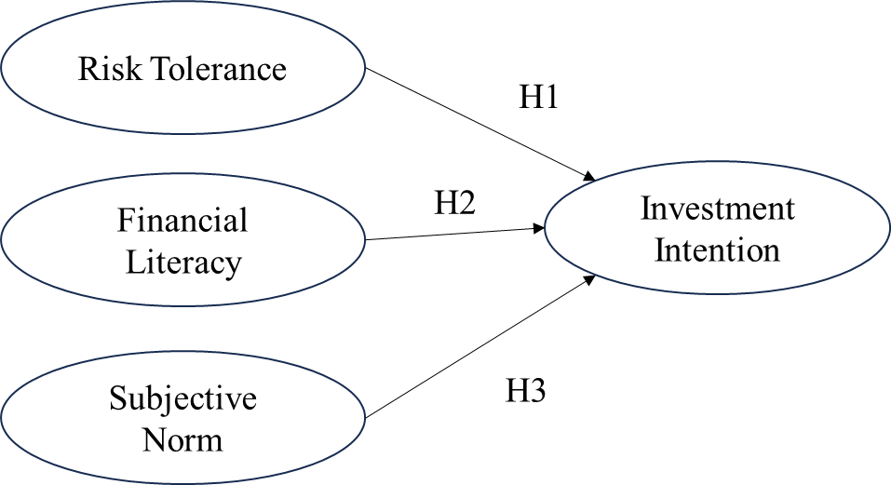
Figure 1. Research Concept Framework

3. RESEARCH METHODS
This research used an associative quantitative methodology to examine the influence of risk tolerance, financial literacy, and subjective norms on the stock investing intentions of students in Bali, utilising the Structural Equation Modelling - Partial Least Squares (SEM-PLS) technique. Data were gathered using a questionnaire on a 5-point Likert scale with statements pertinent to the research variables. The research population comprised students enrolled in Economics and Business degrees at multiple institutions in Bali, with a sample of 150 respondents chosen by purposive selection. The sample criteria encompass active students who have engaged with investing concepts and are residing or studying in Bali. Data analysis methodologies were executed via SmartPLS software. The SEM-PLS approach was selected due to its capability to examine the relationships among latent variables with a very small sample size and its lack of requirement for normal data distribution assumptions. This study aims to elucidate the elements that affect the stock investing intentions of students in Bali.
Table 1. Variable Measurement Indicator
No | Variable | Indicator | Source
1 | Risk Tolerance | I consider myself a high risk taker | Yang et al. (2021)
1 | Risk Tolerance | If I suddenly received a sum of money easily, I would definitely invest some of the money in stocks. | Yang et al. (2021)
1 | Risk Tolerance | I prefer investing in stocks rather than keeping money in a bank account. | Yang et al. (2021)
1 | Risk Tolerance | I consider risk in investing as an opportunity | Yang et al. (2021)
1 | Risk Tolerance | In the investment process, if that happens, I don't mind losing some money. | Yang et al. (2021)
2 | Financial Literacy | I know different types of investments | Sobaih & Elshaer, 2023
2 | Financial Literacy | I know investment has good and bad effects. | Sobaih & Elshaer, 2023
2 | Financial Literacy | I know where to get information  about investment | Sobaih & Elshaer, 2023
3 | Subjective Norm | My coworkers and friends invest in the stock market | Adil et al. (2023)
3 | Subjective Norm | They had a significant influence on me, arguing that I should invest in the stock market. | Adil et al. (2023)
3 | Subjective Norm | People whose opinions I value would prefer me to invest in the stock market | Adil et al. (2023)
4 | Intention to Invest in the Stock Market | I will invest in the stock market frequently | Yang et al. (2021)
4 | Intention to Invest in the Stock Market | I will encourage my friends and family to invest in the stock market | Yang et al. (2021)
4 | Intention to Invest in the Stock Market | I will invest in the stock market in the near future | Yang et al. (2021)
4 | Intention to Invest in the Stock Market | I believe that the stock market is an attractive investment channel. | Yang et al. (2021)

4. RESULTS AND DISCUSSION
This section outlines the results of the analysis of data regarding the influence of risk tolerance, financial literacy, and subjective norms on the stock investing intentions of students in Bali. The Structural Equation Modelling - Partial Least Squares (SEM-PLS) approach was employed to evaluate the relationship between the variables. The findings include the path coefficient value (Original Sample/O), sample mean (Sample Mean/M), standard deviation (Standard Deviation/STDEV), T-Statistics value, and p-value, which serve as the basis for hypothesis testing. Figure 2 illustrates the results of the SEM-PLS study.
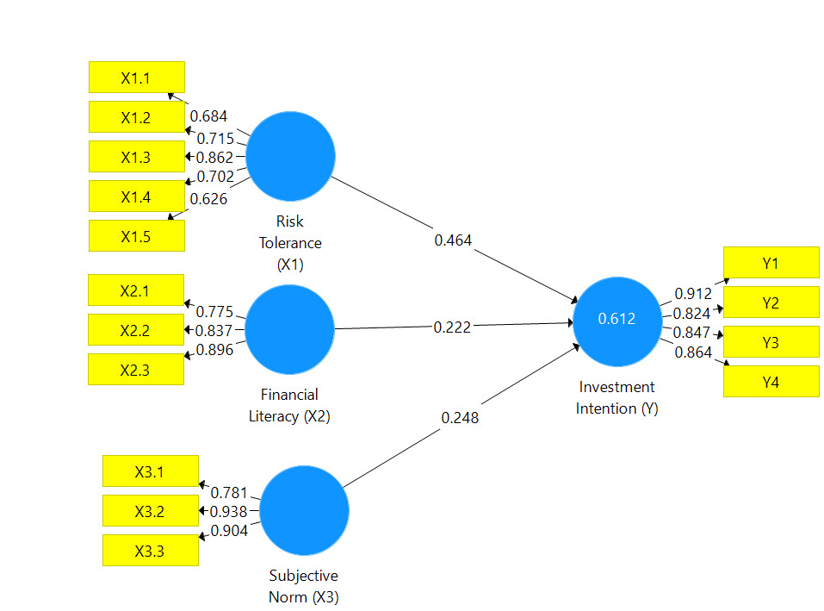
Figure 2 Structural Model

Table 2. Hypothesis Test Results
 | Original Sample (O) | Sample Mean (M) | Standard Deviation (STDEV) | T Statistics (|O/STDEV|) | P Values
Financial Literacy (X2) -> Investment Intention (Y) | 0,222 | 0,219 | 0,066 | 3,391 | 0,001
Risk Tolerance (X1) -> Investment Intention (Y) | 0,464 | 0,468 | 0,065 | 7,174 | 0,000
Subjective Norm (X3) -> Investment Intention (Y) | 0,248 | 0,248 | 0,063 | 3,924 | 0,000

Based on the results of the analysis using the SEM-PLS method, the following results were obtained:
The Influence of Financial Literacy on Stock Investment Intentions
The study results indicate that financial literacy (X2) positively and significantly influences the desire to invest in stocks (Y), evidenced by a path coefficient of 0.222, a T-Statistic of 3.391 (exceeding 1.96), and a p-value of 0.001 (below 0.05). The results demonstrate that financial literacy significantly influences students' inclinations to invest in equities. This conclusion aligns with prior research by Aisa et al. (2021), Malkan et al. (2022), Adil et al. (2023), and Raut and Kumar (2024), which indicated that financial literacy significantly influences investing intentions.
Aisa et al. (2021) demonstrate that students with strong financial literacy are more adept at assessing investment possibilities, comprehending associated risks, and making informed decisions based on available data. The study by Malkan et al. (2022) corroborates this conclusion, indicating that those with elevated financial literacy are more inclined to initiate investment, as they possess a superior comprehension of the long-term advantages of stock investment. Furthermore, Adil et al. (2023) emphasized that financial literacy not only directly affects investment intentions but also mediates additional aspects, including attitudes towards investing and subjective standards. Students who comprehend the notion of investing generally have a more favorable disposition towards equities, perceiving them as a means to attain their financial objectives. The study by Raut and Kumar (2024) revealed that financial literacy enables individuals to navigate market volatility, hence enhancing their confidence to commence stock investments.
This study's conclusions include significant practical relevance. Educational institutions can strategically enhance students' financial literacy through tailored curriculum, seminars, or training programs. Enhancing financial literacy equips students with an understanding of the risks and benefits associated with investing, while also instilling the confidence necessary to initiate stock investments. Consequently, financial literacy can serve as a catalyst for enhancing student engagement in the stock market, so fostering greater financial inclusion. Moreover, financial education initiatives including governmental entities, securities firms, and financial institutions can enhance students' financial literacy. investing simulation programs or user-friendly investing platforms can assist students in applying their financial knowledge realistically, hence enhancing their desire to invest.

The Influence of Risk Tolerance on Stock Investment Intentions
The analysis results indicate that risk tolerance (X1) positively and significantly influences the intention to invest in stocks (Y), evidenced by a path coefficient of 0.464, a T-Statistic of 7.174 (exceeding 1.96), and a p-value of 0.000 (below 0.05). This coefficient is the highest among the other factors, signifying that risk tolerance exerts the most significant influence on investment intentions. Students with a high risk tolerance are more inclined to engage in stock investment, despite the associated risks.
The findings align with earlier research, including studies by Gerrans et al. (2023), Mohta & Shunmugasundaram (2024), and Rizani & Hendrawati (2024), which determined that risk tolerance positively and significantly influences the intention to invest in higher-risk instruments. Stocks, being high-risk investment vehicles, need a greater degree of risk tolerance. Students who can tolerate variations in investment values often perceive stocks as a means to attain higher profits.
Gerrans et al. (2023) discovered that those exhibiting a high degree of risk tolerance are more receptive to the prospective advantages of stock investing, despite the inherent danger of loss. Mohta & Shunmugasundaram (2024) similarly demonstrated that risk tolerance is a principal factor influencing investment decisions in volatile instruments, such as stocks. Rizani & Hendrawati (2024) corroborate this conclusion by highlighting that risk tolerance influences both investing intentions and the choice to diversify portfolios in high-risk assets. These findings affirm that risk tolerance is a crucial determinant of stock investment intentions. Enhancing students' comprehension of risk management will bolster their confidence in participating in the stock market, so fostering the emergence of resilient and informed young investors.
The Influence of Subjective Norm on Stock Investment Intentions
The study results indicate that subjective norm (X3) exerts a positive and substantial influence on the desire to invest in stocks (Y), evidenced by a path coefficient of 0.248, a T-Statistic of 3.924 (exceeding 1.96), and a p-value of 0.000 (below 0.05). This research suggests that subjective norms, encompassing the influence of close individuals such as family, friends, or the social milieu, significantly impact students' inclinations to participate in the stock market. The findings align with other research, including studies by Akhtar & Das (2019), Bhatia & Singh (2023), and Adil et al. (2023), which similarly demonstrated that subjective norms significantly influence stock investing intentions. Assistance from the social environment offers further motivating impetus for individuals to participate in investing activities, particularly for students who are beginning to comprehend the stock market.
In the Theory of Planned Behavior (TPB) framework, subjective norms denote the social pressure or expectations perceived from significant individuals in one's environment. When students perceive support or encouragement from their loved ones to engage in stock investments, this social pressure might enhance their confidence in investing choices, despite the fact that stock investment is frequently seen as a high-risk endeavor.
Research conducted by Akhtar & Das (2019) indicates that subjective norms significantly affect investing decisions, particularly among novices who are more susceptible to the perspectives of others. Bhatia and Singh (2023) discovered that students are more inclined to spend when they perceive support from family or friends regarding their decision. The findings of Adil et al. (2023) substantiate that subjective standards impact intentions and cultivate favorable attitudes towards stock investment. Encouraging robust social support enhances students' confidence in initiating stock investments. An affirmative social milieu can offer moral and emotional reinforcement, assisting individuals in confronting the first obstacles of stock investment. Consequently, subjective norm serves as both an influencing element for intention and a stimulant for cultivating a generation of self-assured and driven young investors.

5. PRACTICAL IMPLICATION
The findings of this study underscore the importance of targeted initiatives to enhance financial literacy, risk tolerance, and the influence of subjective norms on stock investment intentions. Educational institutions can integrate financial literacy programs into their curricula, offering workshops and simulation-based learning to help students grasp investment principles and risk management strategies. These efforts can be complemented by partnerships with financial service providers to create user-friendly investment platforms tailored for beginners, featuring guided tools and risk indicators. Additionally, fostering peer-to-peer learning through investment clubs and student-led initiatives can create a supportive environment for young investors to share insights and experiences.
Collaboration between government entities, universities, and financial institutions can further amplify the impact. Campaigns that involve families and communities in financial education can bridge generational gaps, ensuring consistent support for students exploring investments. Programs such as simulated trading competitions or interactive webinars can provide practical exposure, building confidence among students to participate in stock markets. By addressing these aspects holistically, the findings highlight an opportunity to cultivate a generation of informed and resilient investors who contribute to broader financial inclusion and economic sustainability.

6. CONCLUSION
Based on the analysis, we found that financial literacy, risk tolerance, and subjective norms have a positive and significant influence on stock investment intentions. This study further adds to the understanding of how someone can intend to start investing in stocks. Comprehensive socialization needs to be carried out because in addition to financial literacy, someone tends to be more intent on investing in stocks when those closest to them also invest in stocks. Investment risk management strategies also need to be socialized to further increase a person's financial self-efficacy.
REFERENCES
Adil, M., Singh, Y., Subhan, M., Saleh Al-Faryan, M. A., & Ansari, M. S. (2023). Do trust in financial institution and financial literacy enhances intention to participate in stock market among Indian investors during COVID-19 pandemic?. Cogent Economics & Finance, 11(1), 2169998.
Ainia, Nadya Septi Nur, and Lutfi Lutfi. 2019. The influence of risk perception, risk tolerance, overconfidence, and loss aversion towards investment decision making. Journal of Economics, Business & Accountancy Ventura. 21: 401–13.
Aisa, N. N. (2021). Do financial literacy and technology affect intention to invest in the capital market in the early pandemic period. Journal of Accounting and Investment, 23(1), 49-65.
Ajzen, I. (1985). From intentions to actions: A theory of planned behavior. In Action control: From cognition to behavior (pp. 11-39). Berlin, Heidelberg: Springer Berlin Heidelberg.
Akhtar, F., & Das, N. (2019). Predictors of investment intention in Indian stock markets: Extending the theory of planned behaviour. International journal of bank marketing, 37(1), 97-119.
Almansour, B. Y., Elkrghli, S., & Almansour, A. Y. (2023). Behavioral finance factors and investment decisions: A mediating role of risk perception. Cogent Economics & Finance, 11(2), 2239032.
Bhatia, S., & Singh, N. (2023). Extending theory of planned behaviour for predicting investment intention of millennials by including risk-taking propensity. Afro-Asian Journal of Finance and Accounting, 13(5), 551-573.
Dewi, M. K., & Tamara, D. (2020). The intention to invest in retail bonds in Indonesia. Academic Journal of Interdisciplinary Studies, 9(5), 188.
Elango, D., Ajah, S. N., & Shah, J. (2023). Factors influencing investment intention among gen Z: The antecedent of India. Interdisciplinary Research Review, 18(3).
Elminejad, Ali, Tomas Havranek, and Zuzana Irsova. Relative risk aversion: A meta analysis. EconStor Preprints 260586, ZBW - Leibniz Information Centre for Economic, 2022. Available at https://www.econstor.eu/handle/ 10419/260586
Gerrans, P., Abisekaraj, S. B., & Liu, Z. F. (2023). The fear of missing out on cryptocurrency and stock investments: Direct and indirect effects of financial literacy and risk tolerance. Journal of Financial Literacy and Wellbeing, 1(1), 103-137.
Hati, S. W., and Harefa, W. S. 2019. Analisis Faktor-Faktor Yang Mempengaruhi Minat Berinvestasi Di Pasar Modal Bagi Generasi Milenial (Studi Pada Mahasiswi Jurusan Manajemen Bisnis Politeknik Negeri Batam). Journal of Business Administration, 3(2), 281–295.
Herawati, N. T., & Dewi, N. W. Y. (2020, January). The effect of financial literacy, gender, and students’ income on investment intention: The case of accounting students. In 3rd International Conference on Innovative Research Across Disciplines (ICIRAD 2019) (pp. 133-138). Atlantis Press.
Keni, K., Wilson, N., & Soelaiman, L. (2024, September). Examining the Interplay between Destination Image, Destination Brand Attachment, Subjective Norm and Attitude on Visit Intention. In Twelfth International Conference on Entrepreneurship and Business Management 2023 (ICEBM 2023) (pp. 4-20). Atlantis Press.
Kompas. (2023). Gen Z Dominasi Pasar Modal Indonesia.https://www.kompas.id/baca/ekonomi/2023/10/05/gen-z-masih-dominasi-pasar-modal-indonesia
Kumari, D. A. T. (2020). The Impact of Financial Literacy on Investment Decisions: With Special Reference to Undergraduates in Western Province, Sri Lanka. Asian Journal of Contemporary Education, 4(2), 110-126.
Lai, C. (2019). Personality traits and stock investment of individuals. Sustainability, 11(19), 54- 74. https://doi.org/10.3390/su11195474
Lusardi, A. (2019). Financial literacy and the need for financial education: evidence and implications. Swiss Journal of Economics and Statistics, 155(1), 1–8.
Mahardhika, A. S., & Zakiyah, T. (2020). Millennials’ intention in stock investment: extended theory of planned behavior. Riset Akuntansi dan Keuangan Indonesia, 5(1), 83-91.
Mahdzan, N. S., Zainudin, R., & Yoong, S. C. (2020). Investment literacy, risk tolerance and mutual fund investments: An exploratory study of working adults in Kuala Lumpur. International journal of Business and Society, 21(1), 111-133.
Malkan, M., Malarangan, H., & Nurdin, N. (2022). The Effect of Financial Literacy and Knowledge of Capital Market on Intention to Invest on Islamic Stock Exchange. International Journal of Current Research, 5(2), 363-374.
Mohta, A., & Shunmugasundaram, V. (2024). Moderating role of millennials' financial literacy on the relationship between risk tolerance and risky investment behavior: evidence from India. International Journal of Social Economics, 51(3), 422-440.
Mubaraq, M. R., Anshori, M., & Trihatmoko, H. (2021). The influence of financial knowledge and risk tolerance on investment decision making. Jurnal Ekonomi Bisnis Dan Kewirausahaan, 10(2), 140.
Nugraha, B. A., & Rahadi, R. A. (2021). Analysis of young generations toward stock investment intention: A preliminary study in an emerging market. Journal of Accounting and Investment, 22(1), 80-103.
Putri, E. D., & Herlina, H. (2024). Analisis Kelayakan Investasi Mesin Printing Percetakan Offset untuk Meningkatkan Kapasitas Hasil Output pada PT. XYZ. Jurnal Teknik Industri Terintegrasi (JUTIN), 7(2), 921-932.
Rahmayanti, P., Dharmanegara, I., Yasa, N., Sukaatmadja, I., Pramudana, K., Rahanata, G., ... & Martaleni, M. (2022). What drives millennials and zillennials continuously using instant messaging? Perspective from Indonesia. International Journal of Data and Network Science, 6(1), 17-26.
Rahmayanti, P. L. D., Rahyuda, I. K., Ekawati, N. W., & Setiawan, P. Y. (2023). Intention to Donate on Online Charitable Crowdfunding: Systematic Literature Review and Future Research Agenda. Journal of Economics, Business, and Accountancy Ventura, 26(3), 401-427.
Raut, R. K., & Kumar, S. (2024). An integrated approach of TAM and TPB with financial literacy and perceived risk for influence on online trading intention. Digital Policy, Regulation and Governance, 26(2), 135-152.
Ribaj, A., & Mexhuani, F. (2021). The impact of savings on economic growth in a developing country (the case of Kosovo). Journal of Innovation and Entrepreneurship, 10, 1-13.
Rizani, A. A., & Hendrawaty, E. (2024). Theory of Planned Behavior: The Effect of Financial Literacy and Risk Tolerance on Investment Intention. Journal of Business and Management Review, 5(1).
Samsuri, A., Ismiyanti, F., & Narsa, I. M. (2019). Effects of risk tolerance and financial literacy to investment intentions. International Journal of Innovation, Creativity and Change, 10(9), 40-54.
Sarwar, D., Sarwar, B., Raz, M. A., Khan, H. H., Muhammad, N., Azhar, U., & KASI, M. K. (2020). Relationship of the big five personality traits and risk aversion with investment intention of individual investors. The Journal of Asian Finance, Economics and Business, 7(12), 819-829.
Shaik, M. B., Kethan, M., Jaggaiah, T., & Khizerulla, M. (2022). Financial literacy and investment behaviour of IT professional in India. East Asian Journal of Multidisciplinary Research, 1(5), 777-788.
Shehata, S. M., Abdeljawad, A. M., Mazouz, L. A., Aldossary, L. Y. K., Alsaeed, M. Y., & Noureldin Sayed, M. (2021). The moderating role of perceived risks in the relationship between financial knowledge and the intention to invest in the Saudi Arabian stock market. International Journal of Financial Studies, 9(1), 9.
Sobaih, A. E. E., & Elshaer, I. A. (2023). Risk-taking, financial knowledge, and risky investment intention: expanding theory of planned behavior using a moderating-mediating model. Mathematics, 11(2), 453.
Sundari, S., & Ferdiansah, M. I. (2023, May). Analysis of Z Generations Toward Stock Investment Intention: Testing the Theory of Planned Behavior. In 7th International Conference on Accounting, Management and Economics (ICAME-7 2022) (pp. 564-573). Atlantis Press.
Tanuwijaya, K., & Setyawan, I. (2021). Can financial literacy become an effective mediator for investment intention?. Accounting, 7(7), 1591-1600.
Tokuoka, K. (2017). Is stock investment contagious among siblings? Empirical Economics, 52(4), 1505–1528. doi: 10.1007/s00181-016- 1120-6
Widagdo, B., & Kenny, R. (2022). The role of personality traits, financial literacy and behavior on investment intentions and family support as a moderating variable. Investment Management & Financial Innovations, 19(2), 143.
Yang, M., Mamun, A. A., Mohiuddin, M., Al-Shami, S. S. A., & Zainol, N. R. (2021). Predicting stock market investment intention and behavior among Malaysian working adults using partial least squares structural equation modeling. Mathematics, 9(8), 873.
Yasa, N. N. K., Rahmayanti, P. L. D., Telagawathi, N. L. W. S., Witarsana, I. G. A. G., & Liestiandre, H. K. (2021). COVID-19 perceptions, subjective norms, and perceived benefits to attitude and behavior of continuous using of medical mask. Linguistics and Culture Review, 5(S2), 1259-1280.

