Case report

Molding Facial Growth with Facemask Therapy: A Case Report

Abstract:
Class III malocclusion presents a significant challenge when it comes to treatment during the mixed dentition phase. Its origins are complex, with factors involving both genetics and the environment. The impacts, both on dental and skeletal aspects, of using a facemask therapy in conjunction with maxillary protraction have been extensively studied. While achieving positive results is possible in the late mixed or early permanent dentition stages, outcomes tend to be more favorable when treatment is initiated during the primary or early mixed dentition phase. The case study below illustrates the early intervention in a young patient with maxillary deficiency using a facemask.
WSEDRF

INTRODUCTION

Class III malocclusion and anterior crossbite are commonly encountered clinical issues, particularly in individuals of Asian descent¹. A significant prevalence of Class III malocclusion has been noted in Asian populations such as the Chinese, Japanese, and Koreans.² Treating developing Class III malocclusion remains a complex task for healthcare practitioners, as it involves addressing both skeletal and dental aspects. Patients with Class III malocclusion and anterior crossbites may exhibit various combinations of skeletal and dental issues. Even those with a normally positioned or protruding mandible tend to show a deficiency in the maxilla, with maxillary skeletal retrusion being more prevalent in individuals of Asian descent. Early orthopedic treatment for Class III malocclusions, administered at the end of primary dentition or the beginning of mixed dentition, before the growth spurt, can yield successful outcomes. This treatment aims to achieve facial balance, modify maxillofacial growth and development, and potentially prevent the need for future surgical interventions by enhancing stability.Facemask therapy can result in several beneficial effects, including 1) correcting the discrepancy between the centric relation and centric occlusion, 2) protracting the maxilla by 1 to 2 millimeters, and 3) moving the upper teeth forward and tipping the lower teeth toward the lingual side. These effects are particularly significant in younger patients³. As a result, careful patient selection, an extended treatment duration, and ongoing follow-up are crucial for considering orthopedic growth modification as successful.
Over the past two decades, a standard approach in the early management of cases involving maxillary deficiency has been the combination of rapid maxillary expansion (RME) along with a facemask to protract the maxilla⁴. This case report illustrates the successful use of this procedure in managing Class III malocclusion with maxillary deficiency in a 9-year-old patient.
CASE REPORT
A 9-year-old female patient presented herself at the Department of Orthodontics and Dentofacial Orthopaedics in Regional Dental College and Hospital, Guwahati, Assam. She expressed her primary concern about missing upper front teeth and lower front teeth being positioned too far forward. There were no significant pre- or post-natal history or family medical background. Upon conducting an external examination, it was observed that the patient had a concave facial profile with a lack of projection in the upper jaw (see Figure 1). Her lower lip extended beyond the upper lip, and she displayed an average clinical FMA (Frankfort Mandibular Plane Angle) and an acute nasolabial angle. Her smile was aesthetically pleasing, showing 1 mm of upper incisors and 8 mm of lower incisors, which indicated a vertical deficiency in the upper jaw.
Various records, including study casts, an orthopantomogram (OPG), a cephalogram (as shown in Figure 2), and photographs, were obtained to assess and confirm the diagnosis. During the intraoral examination, it was observed that the gingival tissues appeared normal. The patient exhibited an anterior dental crossbite with a reverse overjet of -4 mm and an overbite of 6 mm, and there was a missing tooth at position 11 (as depicted in Figure 3). Furthermore, the temporomandibular joint function was deemed normal, as there were no indications of pain upon palpation, clicking, popping, or crepitus noises, and the patient displayed a normal range of motion.
Cephalometric analysis revealed a skeletal Class III pattern, primarily attributable to a retruded maxilla and a protruding mandible with a horizontal growth pattern. The assessment of skeletal maturity, as indicated by the Cervical Vertebral Maturation Index (CVMI), showed that the patient was at Stage 3, suggesting a growth potential in the range of 25-65%.

TREATMENT OBJECTIVES
The treatment goals were to address the disparities in the arches both in the front-to-back (sagittal) and side-to-side (transverse) dimensions. This would be achieved by promoting growth in the maxilla while altering the direction of mandibular growth. Additionally, the treatment aimed to correct the anterior crossbite, establish Class I relationships for both molars and canines, ensure proper overbite and overjet, align the midlines, and resolve the impaction of tooth 11.

TREATMENT PLAN
The diagnosed condition was a skeletal Class III malocclusion involving an anterior crossbite and impaction of tooth 11. The selected treatment approach involved utilizing a combination of alternate rapid maxillary expansion and constriction (Alt-RAMEC) along with facemask therapy. This treatment protocol was intended to improve facial aesthetics and dental alignment, ultimately achieving stable occlusion.
TREATMENT PROGRESS
A Hyrax expansion screw, along with an occlusal splint, was inserted. Activation of the expander began 24 hours after its cementation. The activation schedule employed was Alt-RAMEC (as shown in Figure 4). Following four weeks of Alt-RAMEC, a smaller facemask was fitted to commence maxillary protraction, initially with 8 ounces (approximately 200 grams) of bilateral elastic force during the first 14 days (as depicted in Figure 5). Subsequently, the elastic force was increased to 14 ounces (around 500 grams). The patient was instructed to wear the facemask full-time, except during meals, and was strongly encouraged to maintain a high level of oral hygiene. Regular follow-up appointments were scheduled every 6 weeks. At her first follow-up visit while wearing the facemask, a positive overjet was observed. The patient continued wearing the appliance until a 2 mm positive overjet was achieved. Once this 2 mm positive overjet was attained, the appliance usage was reduced to part-time, either during the day or at night (as shown in Figure 6).
TREATMENT RESULT
Following the active treatment, virtually all of the desired skeletal and dental outcomes had been successfully met. The correction of the anterior crossbite had been accomplished, and there was a substantial improvement in the sagittal alignment. The maxilla had been advanced, as evidenced by an increase in the SNA angle from 79 degrees to 81 degrees, a decrease in the SNB angle from 81 degrees to 80degrees, and a change in the ANB angle from -2 to 1, as outlined in Table 1. Once all of the permanent teeth have erupted, the next step will involve commencing treatment with fixed appliances.
DISCUSSION
The effective management of Class III skeletal malocclusion hinges on the early orthopedic treatment approach, aiming to achieve successful outcomes without the need for surgical interventions in adulthood. Early intervention, specifically involving maxillary protraction, has demonstrated its effectiveness, especially in cases characterized by maxillary retrusion, which is a common feature of Class III malocclusion. Additionally, the Alt-RAMEC protocol, when compared to the conventional rapid maxillary expansion (RME), has shown to produce quicker and more genuine skeletal advancement.
One significant reason for addressing the early correction of anterior crossbite is to prevent the potential complications often associated with it. These complications include gingival recession in the labial area of lower incisors^{5,6}, excessive wear of the incisal edges, an increased risk of temporomandibular joint dysfunction⁷, a growth pattern that worsens with age⁸, compromised dental and facial aesthetics, and the related negative psychosocial impacts.
In this particular case, a combination of rapid maxillary expansion and facemask therapy was employed. Various circummaxillary sutures played a vital role in the development of the nasomaxillary complex. The use of an expansion appliance helped "disarticulate" the maxilla, initiating cellular responses in the circummaxillary sutures, thereby allowing for a more favorable response to protraction forces. A bonded Rapid Palatal Expansion (RPE) appliance was utilized, offering several advantages, including a reduced number of appointments, serving as posterior bite blocks to aid in correcting the anterior crossbite, and minimizing buccal crown tipping during expansion due to the appliance's sturdy framework.
Prospective clinical trials have revealed that the maxilla remained stable for up to two years and exhibited long-term success in 67% to 75% of cases.⁹
CONCLUSION
Timely action is crucial when dealing with the development of Class III malocclusion. In the mixed dentition phase, employing facemask therapy proves to be an efficient approach for addressing Class III malocclusion. Utilizing palatal expansion alongside maxillary protraction serves to "unhook" the maxilla and triggers cellular responses in the sutures. This, in turn, leads to a more favorable response to protraction forces, ultimately improving both function and aesthetics.
Statement of Informed Consent Written informed consent was obtained from the subject for the use of photographs for publication. The patient understand that their names and initials will not be published and due efforts will be made to conceal their identity, but anonymity cannot be guaranteed.

FIGURE 1 PRE EXTRORAL PHOTOS
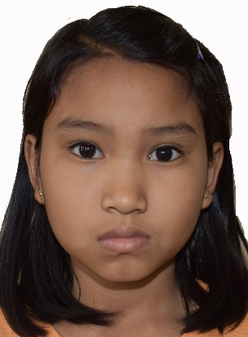
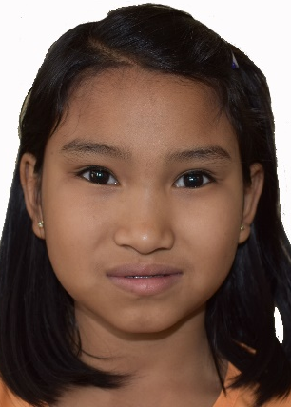
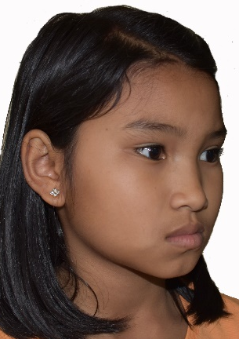

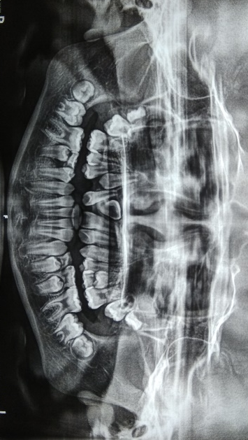
FIGURE 2 PRE LATERAL CEPHALOGRAM AND OPG REORDS
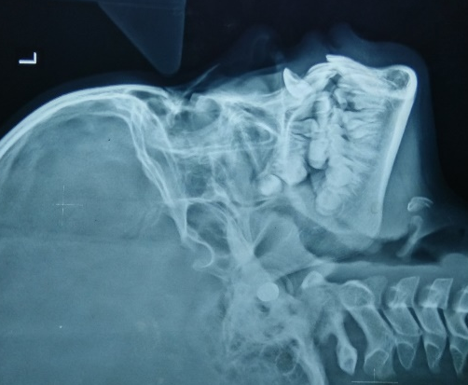

FIGURE 3 PRE INTRAORAL RECORDS
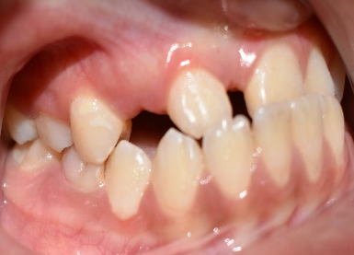
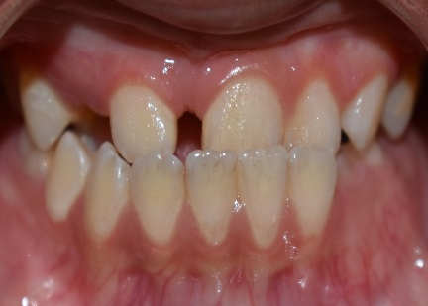
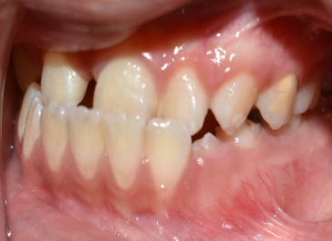

FIGURE 4 BONDED HYRAX FIGURE 5 FACEMASK
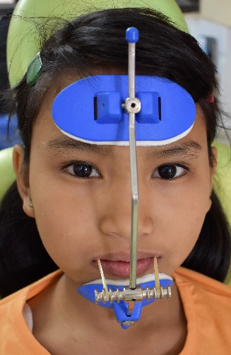
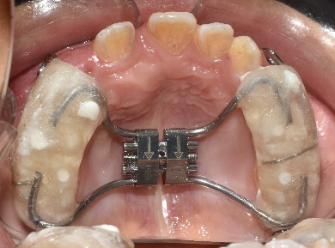

FIGURE 6 POST EXTRORAL RECORDS
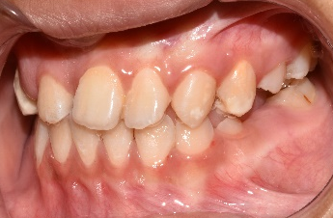
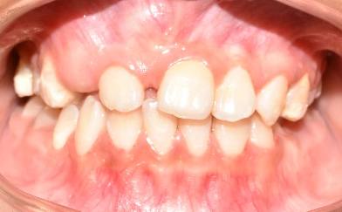
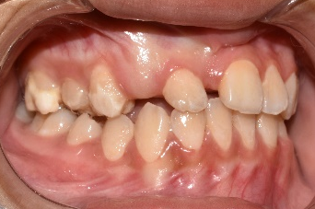


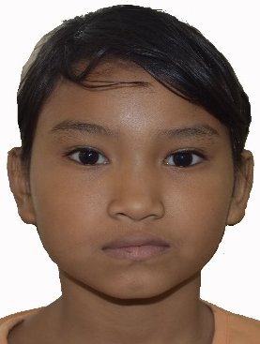
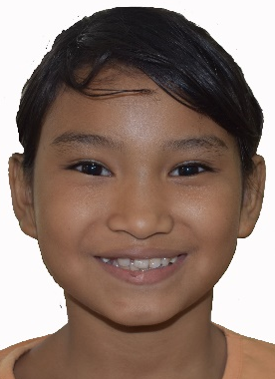

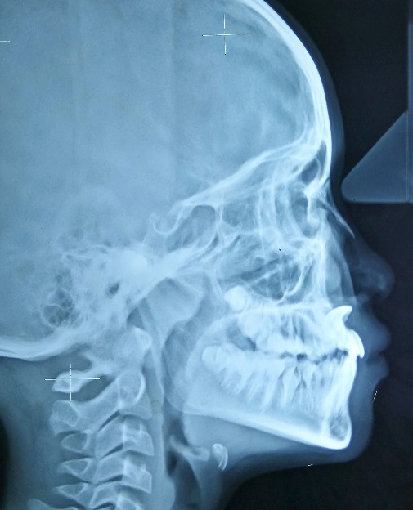

TABLE 1 PRE AND POST TREATMENT CEPHALOMETRIC VALUES
VARIABLES | PRE-TREATMENT | POST -TREATMENT

Sagittal Skeletal
SNA (degree) | 79 | 81
SNB (degree) | 81 | 80
ANB (degree) | -2 | 1
AB plane angle (degree) | 4 | -3
Angle of convexity (degree) | -5 | -1

Vertical Skeletal
SN Mandibular plane (degree) | 27 | 27
Y axis (degree) | 60 | 59
Jaraback ratio (%) | 65 | 65
Sn Occlusal plane (degree) | 16 | 14

Dental Relation
Upper incisor to NA (deg/mm) | 27/5 | 29/5
Lower incisor to NB (deg/mm) | 30/5 | 28/3
IMPA (degree) | 84 | 92
Internincisal angle (degree) | 118 | 119

Soft Tissue
Nasolabial angle | 100 | 101
Lower lip to E line | 4 | 1
Upper lip to E line | 0 | 0

REFERENCE
- Graber TM, Vanarsdall RL, Vig KWL. Orthodontics. Current Principles and Techniques,4rth ed. St Louis: Mosby. 2005;565

- Proffit WR, Fields HW, Jr, Moray LJ. Prevalence of malocclusion and orthodontic treatment need in the United States: Estimates from the NHANES III survey. Int J Adult Orthodon Orthognath Surg. 1998;13:97–106. [PubMed]

- Ishii H, Morita S, Takeuchi Y, Nakamura S. Treatment effect of combined maxillary protraction and chincap appliance in severe skeletal class III cases. Am J Orthod Dentofacial Orthop. 1987;92:304–12.[PubMed]

- Westwood PV, McNamara JA, Jr, Baccetti T, Franchi L, Sarver DM. Long-term effects of class III treatment with rapid maxillary expansion and facemask therapy followed by fixed appliances. Am J Orthod Dentofacial Orthop. 2003;123:

- Harrison RL, Kennedy DB, Leggott JP et al. The association of simple anterior dental crossbite to gingival margin discrepancy. Pediatr Dent 1991; 13: 296-300.

- Harrison RL, Kennedy DH, Leggott JP. Anterior dental crossbite; relationship between incisor crown length and incisor irregularity before and after orthodontic treatment. Pediatr Dent 1993; 15: 394-397.

- Wisth J. Mandibular function and dysfunction in patients with mandibular prognathism. Am J Orthod 1984; 85: 193 – 498

- Miyajima K, McNamara JA Jr, Sana M et al. An estimation of craniofacial growth in untreated Class III female with anterior crossbite. Am J Orthod Dentofacial Orthop 1997; 112: 425-434

- Hagg U, Tse A, Bendeus M. Long term follow up of early treatment with reverse headgear. Eur J Orthod 2003;25:95-102

