Method Article
An overview of seismic isolation technology for super high and rise buildings

ABSTRACT: With the progress of modern building technology and the rapid development of social economy, super high-rise buildings have become an important part of urban landscape, and the number and height of construction in the world are rising. These skyscrapers not only symbolize the prosperity and progress of the city, but also play a vital role in urban planning and construction. Therefore, it is particularly important to ensure the safety of these buildings and their internal facilities, especially the seismic performance in earthquake-prone areas. In this context, seismic isolation technology has been widely used as an effective seismic solution. The traditional seismic design method mainly resists the earthquake by enhancing the strength and stiffness of the structure itself, while the Shock absorption or Shock insulation reduces the impact of the earthquake on the building by introducing energy-consuming components or isolation layers. In addition, the hybrid application method of shock absorption and isolation combines the advantages of both, which not only reduces the transmission of seismic energy, but also improves the overall stability of the structure, and provides a more comprehensive and efficient guarantee for the seismic design of super high-rise buildings.
Keyword：super high-rise building；shock absorption；shock insulation

Introduction
The earthquake is the ground vibration caused by the plate movement on the earth, and it is a natural disaster with great destructive power. Such as landslides, mountain rupture, rock fall and so on. The vibration of the ground will also cause the destruction of buildings, such as house damage or even collapse, bridge fracture, dam cracking, railway track deformation, etc., which poses a great threat to the safety of people 's lives and property. According to statistics, from January 1,2008 to November 25,2019, 567 earthquakes with a magnitude of more than 5 occurred in China. In particular, an 8.0-magnitude earthquake occurred in Wenchuan in 2008, killing and injuring nearly 100,000, which brought great pain to the people of the whole country. Earthquakes pose a great threat to people 's lives and safety, so the seismic design of building structures is particularly important. In recent years, there have been more and more high-rise buildings in China. As of the end of May 2018, 170 super high-rise buildings with a height of more than 250 m have been built in China, and 84 super high-rise buildings with a height of more than 250 m are under construction. The completed super high-rise buildings are mainly distributed in areas with 6 degrees and 7 degrees (0.1g), and the proportion of high-intensity areas with more than 8 degrees is 7 %. The distribution of super high-rise buildings under construction is still dominated by 6 degrees and 7 degrees, but the proportion of high-intensity areas with 8 degrees and above is significantly increased, accounting for 14%. With the gradual increase of super high-rise buildings in high-intensity areas, the seismic design of their structures has become particularly important.
The original design scheme of modern buildings can’t meet the requirements of seismic fortification ^{[1]}. Targeted to strengthen the weak links of building structure ^{[2]}. In the super high-rise building structure, there are many factors affecting the seismic resistance ^{[3]}. The most traditional seismic structural system used in the current construction industry is the ductile structural system ^{[4]}. The idea of structural vibration reduction has become a revolutionary milestone in the design of structural vibration reduction methods ^{[5]}. Different structural systems have different scope of application in the seismic design of structures ^{[6]}. The commonly used methods for structural seismic design include traditional seismic methods, shock absorption or isolation methods, and shock absorption-isolation hybrid application methods ^{[7]}. The corresponding damping device and vibration isolation bearing are set outside the isolation layer to achieve mixed application ^{[8]}. The damping technology is to reduce the influence of seismic waves on the upper part by connecting the changes of the connecting members when the earthquake occurs ^{[9]}. Seismic isolation technology is an important means to effectively resist earthquake disasters and improve urban safety ^{[10]}.

1 The development of engineering earthquake resistance
Earthquakes will cause huge economic losses to human beings and pose a threat to people 's lives. The impact of earthquakes is long-lasting. We usually take various measures to resist the damage caused by earthquakes, including early warning before earthquakes, earthquake prevention and disaster reduction, and engineering earthquake resistance. At present, we still can’t accurately predict the occurrence time of the earthquake, so we can only reduce and prevent the disaster caused by the earthquake through the seismic design of the building structure. The seismic design methods of structures are divided into traditional seismic design methods and structural vibration control methods.

1.1 Traditional seismic methods
The traditional anti-seismic thought can be simply summarized as ' to overcome the rigid '. Traditional earthquake resistance closely connects the foundation with the upper structure, which causes the structure to vibrate and deform. The structure dissipates seismic energy through the bearing capacity and deformation capacity of its own seismic components. Therefore, the seismic energy dissipation components of the structure are particularly important for the safety performance of the structure. Once some factors cause problems in the seismic components of the structure, it will seriously damage the seismic performance of the structure, causing serious damage to the structure during the earthquake, and the main area of the structure will be damaged, and the building will be difficult to repair, causing irreversible damage. The traditional structural seismic design has the following disadvantages:
(1) Security is difficult to guarantee
The traditional structural seismic design method is based on the 'seismic fortification intensity', which will cause many problems. When a super-intensity earthquake occurs, the building structure will be seriously damaged or even collapsed. On the other hand, the earthquake is random. Because of this, the traditional seismic design method is difficult to control the degree of structural damage, and the safety of the structure is difficult to guarantee.
(2) Adaptability is limited
The traditional seismic design method mainly aims at not collapsing under large earthquakes, allowing structural members to be damaged to a certain extent during earthquakes. However, such a simple seismic design of buildings has limitations, because it does not consider the seismic resistance of equipment and instruments in the house, which is not applicable to some special buildings.
(3) Poor economy
The traditional seismic method is that the structure relies on its own seismic resistance to resist earthquakes, and the seismic design of the structure in high-intensity areas will cause more material consumption.

1.2 Structural vibration control method
Due to the limitations of traditional seismic design, many scholars have proposed a new seismic design method-structural vibration control method. Structural vibration control mainly includes base isolation, passive energy dissipation, active and semi-active control, hybrid control, and intelligent control.

2 Structural damping energy dissipation combination system

2.1 Structural energy dissipation
Damping control is mainly divided into the following five categories: (1) Passive control technology. Some energy dissipation devices are set up in the building structure, which can greatly consume the energy transmitted from the earthquake to the interior of the structure when an earthquake occurs. (2) Semi-active control technology. Real-time control of parameters such as stiffness or damping ratio of the structure to reduce the response of the structure, although only less energy is required for control, the control process is more dependent on structural response and external excitation information. (3) Active control technology. It refers to monitoring the dynamic response and external excitation of the structure, and using the calculation system to feedback the solution results of the structural response to the servo system, so that the dynamic response of the structure can be controlled to a certain extent, and finally the active vibration control is completed. However, the realization of the control system not only relies heavily on the structural dynamic response and is susceptible to external information interference, but also requires the input of external energy. (4) Intelligent control technology. The actuators and dampers in the system are made of intelligent materials, which are simple in structure and easy to drive and adjust. (5) Hybrid control technology. Combine the advantages of both and make up for the shortcomings of both.
The displacement-dependent energy dissipator effectively increases the structural damping ratio and shortens the period of the structure. The effect of the displacement-dependent damper on reducing the total base shearing force of the structure is sometimes not significant, and the effect on controlling the displacement of the structure is significant. By increasing the damping of the structure, the velocity-dependent energy dissipator can dissipate the energy and shock of the structure without changing the stiffness and period of the structure, and can achieve the effect of reducing the base shear force and interlayer displacement.

2.2 Structural isolation
The seismic isolation design of the structure refers to the arrangement of the isolation device on a certain layer of the building structure, which separates the upper structure of the building from the lower foundation, reduces or even avoids the transmission of seismic energy from the bottom to the upper structure, so as to effectively protect the upper structure and internal personnel, important equipment and so on. Compared with the traditional structure, the isolation design helps the structure to resist earthquake by ' softness and rigidity ', which effectively prolongs the natural vibration period of the building structure, increases the structural damping, and reduces the dynamic effect of the earthquake on the superstructure. At present, structural isolation is divided into two categories : base isolation and inter-story isolation.
(1) Base-isolated structure
Base isolation design has been widely used in multi-storey and low-rise buildings, especially for some buildings with special requirements, such as buildings with important equipment, key information command center buildings, buildings with explosives, high-risk laboratories, etc., base isolation design can be given priority. In high-intensity areas, the use of base isolation technology to design the structure can appropriately increase the building height limit specified in the specification and solve many problems in practical engineering design. Compared with the traditional seismic design method, the base isolation design technology has the following advantages:
①The isolation layer is used to consume seismic energy, increase the natural vibration period of the structure, and reduce the inter-story shear force and inter-story displacement of the superstructure.
②The design of the building structure is optimized. According to the standard design, some complex components may need special treatment. When the base isolation design is adopted, only the design of the isolation layer needs to be considered, which greatly reduces the workload of the structural design.
③Select the appropriate isolation device and layout position to increase the economic benefits of the entire structural design and reduce the overall cost of the building structure.
(2) Inter-story isolated structure
In practical engineering, there may be some limitations in the design of base isolation. Layer isolation design is a new isolation method developed on this basis. The interlayer seismic isolation technology is still under exploration. The interlayer seismic isolation technology is suitable for the following construction projects:
①Inshore buildings. In offshore areas, the rising tide of sea water may erode the base isolation bearing and accelerate the aging of the bearing. Generally, the isolation layer is set on one or higher floors.
②Storey of old buildings. For the old building storey-adding design, due to the increase of building height and weight, the seismic resistance of the original structure can no longer meet the seismic demand of the structure. Setting the isolation layer on the original structure will reduce the dynamic response of the structure and improve the seismic resistance of the original structure to a certain extent.
③Seismic reinforcement of old buildings. For some buildings with cultural heritage value that need to improve the seismic performance, it can be considered to set the isolation layer under the building roof, which can not only improve the seismic resistance of the structure, but also maintain the original appearance of the building to a certain extent.
④Building reinforcement of important departments. For some buildings that can’t interrupt the operation of the machine, such as post and telecommunications room, information command center and so on, it is very difficult to use the traditional reinforcement method. The interlayer seismic isolation technology can better solve the problem.

2.3 Structural seismic isolation hybrid system
With the wide application of energy dissipation structures and isolation structures in practical engineering, some scholars and designers have found that the combined application of shock absorption and isolation devices can effectively improve the seismic resistance of structures compared with the application of single shock absorption and isolation devices. The combined application of shock absorption and isolation is to add energy dissipation damper on the isolation structure, which can not only make up for the poor seismic effect of single energy dissipation design, but also make up for the problem that the displacement of isolation layer of isolation structure is too large.
The arrangement of viscous dampers in the isolation layer can effectively reduce the displacement of the isolation layer under large earthquakes. The damping effect of the structure using the damping-isolation hybrid application technology is better than that of the structure using the damping or isolation technology alone.

3 Damping and isolation device
The isolation device is generally composed of an isolator and a damper, which has sufficient vertical stiffness and large damping to ensure that the system has good restoring force. Its horizontal lateral stiffness can’t be too small to prevent the risk of overturning of the structure.
The energy dissipation system is generally equipped with energy dissipation components on the structure. The energy dissipation component is in the elastic stage when the structure is subjected to small earthquakes, and resists the earthquake action together with the whole structure. When the structure is subjected to fortification earthquakes and large earthquakes, it first enters the elastic-plastic stage to provide greater damping to the structure, so as ensure that the main structure is not destroyed and achieve the effect of shock absorption.

3.1 Isolation device
The isolation device system is generally divided into two categories according to its functional characteristics:
(1) Separation type: It is composed of independent isolators, dampers, etc., so that they can exert their respective isolation energy dissipation and reset capabilities. The common types of isolation bearings are shown in Fig.1, and the common types of dampers are shown in Fig.2.
(2) Compound type: The isolation system not only has the stiffness of the upper structure of the vertical support, but also has a large horizontal viscous damping. In the analysis of the system, not only consider whether the vertical bearing capacity is satisfied, but also consider the characteristics of its restoring force. HDR-S (high damping rubber bearing) and LRB (lead rubber bearing) are all functional composite isolation device systems.
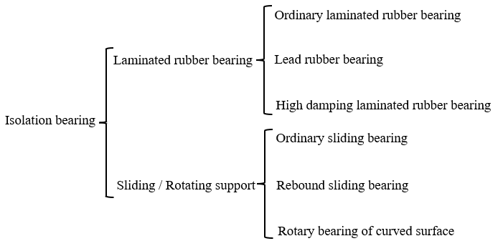
Fig.1 Type of isolation bearing
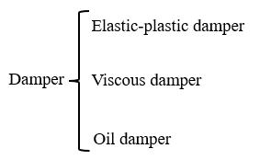
Fig.2 Type of damper
At present, the most widely used in practical engineering is laminated rubber bearing. According to the different materials, laminated rubber bearings can be roughly divided into the following two categories, each with its advantages and disadvantages:
Natural rubber production (LNR) combines thin steel plates and rubber plates together, so its vertical stiffness is large, elastic properties are good, almost no damping performance, and its isolation energy consumption under earthquake action is poor. Generally, it needs to be used with other bearings or dampers with good damping performance.
The lead rubber bearing (LRB) is based on the ordinary laminated rubber bearing. Thick connecting steel plates are arranged in the upper and lower parts, and the lead core is inserted in the center of the bearing. The steel plate and rubber plate are used to bear the vertical load of the superstructure and constrain the horizontal movement of the lead core. On the one hand, the lead core in the center of the bearing improves the energy dissipation capacity of the isolation bearing, and on the other hand, it can provide certain damping. The most widely used.

3.2 Energy absorber
Energy dissipation damper, as an innovative damping technology, plays a vital role in building and bridge engineering. It dissipates the energy generated by earthquakes or other vibrations through mechanisms such as friction, elastic-plastic deformation or viscoelastic deformation, significantly reduces the dynamic response of the structure, and improves the seismic performance and safety of the structure. The application of this technology not only improves the stability and integrity of buildings in earthquakes, reduces the risk of secondary disasters caused by structural damage, but also brings economic benefits, such as reducing the amount of materials used in the seismic design of new or existing structures. In addition, the wide applicability of energy dissipation dampers makes it an effective means to improve the comfort and functionality of sensitive facilities, thus playing an indispensable role in ensuring the safety of people 's lives and property and improving the comprehensive performance of buildings and infrastructure. Passive dampers are widely used in building structures, and the classification of energy dissipation dampers is shown in Fig.3.
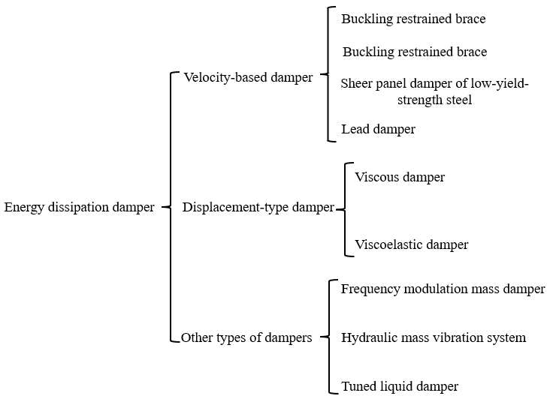
Fig.3 Classification of energy dissipation shock absorbers

4 Application of seismic isolation device
Seismic isolation technology plays a vital role in the field of disaster resistance and mitigation of building structures. It effectively isolates and dissipates seismic energy by installing isolation layers and energy dissipation dampers in key parts of the structure, and significantly reduces the dynamic response of the structure. The technology has a wide range of applications. It not only covers modern engineering projects such as super high-rise buildings, bridges, and important infrastructure, but also plays an important role in the protection and restoration of historical buildings, reflecting its comprehensive benefits in improving structural safety and functionality.
Internationally, some typical structures adopt advanced seismic isolation technology, such as San Francisco International Airport International Terminal in the United States, Wellington Parliament Building in New Zealand and Tokyo Sky Tree in Japan. These cases show the remarkable effect of seismic isolation technology in resisting earthquake disasters and ensuring building safety. Although the seismic isolation technology faces the challenges of design complexity, high initial investment cost and gradual improvement of market acceptance, its innovation and development are still important directions for the progress of building science and technology.
The popularization and application of seismic isolation technology not only improves the seismic capacity of building structures, but also promotes the development of related disciplines, such as structural dynamics, material science and seismic engineering. In addition, with the advancement of computational simulation technology and the development of new materials, the efficiency and effectiveness of seismic isolation technology have been continuously improved, providing strong technical support for the construction industry to move towards safer and more efficient goals.
5 Conclusion
(1) The application of seismic isolation technology makes the rapid development of high-rise buildings, greatly improving the seismic performance of the contact. Compared with the traditional seismic system, the base isolation system and the lower damping-layer isolation hybrid system can effectively extend the natural vibration period of the structure and reduce the impact of the earthquake on the structure.
(2) The seismic isolation combination can effectively reduce the anti-vibration effect of the superstructure, so that the seismic performance of the structure can be effectively improved. For this kind of seismic isolation composite structure, the superposition analysis method can be applied to the design part of the seismic isolation composite structure. For the design, it is necessary to check the damping efficiency according to its overall analysis. In this process, the function of seismic isolation combination is increased by means of superposition analysis.

Reference
- Wei Wei, Zhang Junfu, Wang Hui. New Construction Technology of Seismic Isolation and Energy Dissipation for Class A Buildings [J]. Construction, 2022,44 (11): 2682-2684.
- Tang Jianyu, Pan Wen, Dong Weiqing, et al. A case study on seismic reduction of a super high-rise frame-reinforced concrete core tube structure [J]. Industrial safety and environmental protection, 2021, 47 (07): 55-59.
- Zhu Peng. Research on common problems and solutions in seismic design of super high-rise building structures [J]. Housings, 2019 (06): 17.
- Wu Kunyu. Analysis of the application status and development prospects of seismic isolation technology for building structures [J]. Fujian Building Materials, 2018 (05): 49-50+53.
- Wang Ying. Research on problems and countermeasures of super high-rise building structure design [J]. Technology and innovation, 2022 (12): 4-6+14.
- Li Ye. Discussion on some problems in seismic design of super high-rise structures [J]. Construction Technology, 2022 (13): 109-111.
- Yu Meng.Seismic analysis of super high-rise buildings using seismic isolation hybrid technology [D]. Dalian University of Technology, 2021.
- Li Taoyang, Li Wei. Research on the application of seismic isolation technology in high intensity seismic fortification area [J]. Innovation and application of science and technology, 2022,12 (06): 185-187.
- Cui Jin, Zhu Yiyuan. Discussion on the principle, advantages and disadvantages of seismic isolation technology [J]. Development orientation of building materials, 2021, 19 (20): 96-98.
- Wang Cuikun, Chen Caihua, Cui Mingzhe. Development and Prospect of Building Structure in China [J]. Building Science, 2022,38 (07): 1-8.

