YIELD STABILITY AND GEI BY AMMI MODEL IN NIGER (Guizotia abyssinica L.)

Abstract
The present investigation was carried out with forty Niger genotypes at multi-environments for assessment of genotype x environment interaction and identification of high yielding and stable genotypes of Niger crop. Forty Niger genotypes were tested across five multi-environments in a randomized block design with replication thrice during Kharif, 2018 and Kharif, 2019. Combined analysis of variance and AMMI analysis of pooled data showed that genotype, environment and GEI effect were highly significant (p < 0.01) for seed yield. As per AMMI GGE biplots, two different mega-environments (METs) were identified, the first MET consists E1, E3 and E4 which are potential and excellent sites for discrimination of superior genotypes and second MET includes E2 and E5 were stable places. The genotypes, G28, G33, G8, G17, and G3 (seed yield plant⁻¹), and G6, G33, G8, G17 and G3 (seed yield plot⁻¹) were suitable for favorable environments while G4 and G7 (seed yield plant⁻¹), and G27, G20, G1, G37 and G25 (seed yield plot⁻¹) were suitable for unfavorable environments. Considering all the stability parameters and AMMI GGE biplots, genotypes, G36, G32, G24 and G10 had high mean seed yield and stable across the environments. These superior genotypes about grain yield and GEI impact, and can be recommended for future investigations.
Keywords: Niger, Genotype x Environment Interaction, stability, yield, GGE biplot
Introduction
The concept of genotype x environment interaction might be mimicked when plants adapting to the new or fluctuating of environment. The other idea of genotype by environment interaction (GEI) could be considered as the pleiotropic effect of particular variants across environments (18 & 16). The term genotype refers to the genetic makeup of an organism while environment refers to biophysical factors that have an effect on the growth and development of crop genotype. Genotype x environment interaction refers to two or more genotype performs differently in different environments (17).
Niger crop growers require varieties that are reliable and stable across environments as well as have high yield potential under favorable conditions. However, the response of different genotypes under different environments can be varied. This might be due to the fluctuation of rainfall pattern during cropping season, emerging and remerging disease as well as insects and abiotic factors like different soil status, drought and others stresses (11). Consequently, a variety which performs well in one environment during one season may not perform in different testing sites. This showed that GEI impede on superior genotypes across environment (14). In such situation, it is difficult for breeder to select high yielding stable genotype across tested environments. Thus, plant breeders are stimulated to test multi-environment trials (METs) and select superior as well as stable genotypes that show high grain yield performance across environments.
Statistical analysis of genotype by environment interaction is important to analysis multi- environment trials, METs. Several biometrical methods reported to analysis a pattern of genotype by environmental interaction (GEI), stability and adaptability. Among these biometrical techniques, Additive Main Effects and Multiplicative Interaction (AMMI) and Genotype and Genotype by Environment Interaction (GGE) Biplot are the most common statistical tools used to analysis of MET data to reveal pattern of GEI (13; 28). To compute METs, AMMI model analysis the variance (ANOVA) for genotype, environment and their interaction as well as decompose GEI into principal components. It also used to determine stability of genotype across locations using principal component axis. AMMI also an effective tool to detect the GEI patterns graphically. However, interpretation of output from principal components (PCA) is likely difficult for genotype targeting environment. Thus, GGE biplot is suggested and superior to the AMMI to visualize GEI graphically at mega-environments (26). Furthermore, GGE biplot analysis is efficient to identify: the best performing genotype in the given tested environment, the discriminating power of environment and it rank the cultivars based on mean yield and stability of cultivars (27). Moreover, it helps to assess the relationship between environments and re-planning the targeted environments to test cultivars in plant breeding program (10 & 9). Therefore, the objective of this study was to evaluate different Niger genotypes at multi-environments, to identify high yielding as well as stable niger genotypes and discriminating environments using GGE-biplot analysis.
Materials and Methods
The experiments were conducted at five environments which represent a mid-altitude sub-humid agro-ecology of India and their details were given in Table 1. The testing locations were namely; ARS, Phondaghat (E1), ARS, Shirgaon (E2), Dept. of Agril. Botany, Dapoli (E3), RARS, Karjat (E4) and ARS, Plaghar (E5) during Kharif, 2018 and Kharif, 2019.
Table 1: Details of the experimental testing environments.
Name of Site | Longitude (East) | Latitude (North) | Rainfall (mm) | Mean sea level | Soil type
ARS, Phondaghat (E1) | 73-47˚18” | 16-22˚35” | 3500 | 145.10 | Lateritic
ARS, Shirgaon (E2) | 73.62˚ | 17.45˚ | 3000 | 75 | Lateritic
Dept. of Agril. Botany, Dapoli (E3) | 73˚11’8” | 17˚45’32” | 4000 | 243.84 | Lateritic
RARS, Karjat (E4) | 73˚33” | 18˚91” | 3500 | 200 | Medium black
ARS, Plaghar (E5) | 72.76˚ | 16.69˚ | 2500 | 7 | Medium black
The experiments laid down in randomized block design with three replications having forty niger genotypes (Table 2). Each genotype was planted with spacing of 30 cm and 10 cm between rows and plant, respectively. All recommended agronomic package practices were applied for healthy crop growth.
Table No. 2: List of genotypes/varieties and their sources
Sr. No. | Genotype code | Name of Genotypes | Sourse | Sr. No. | Genotype code | Name of Genotypes | Sourse
1. | G1 | GP-54 | ZARS, Igatpuri | 21. | G21 | NMLT-12 | ZARS, Igatpuri
2. | G2 | GP-57 | ZARS, Igatpuri | 22. | G22 | NMLT-13 | ZARS, Igatpuri
3. | G3 | IGPN 14-2 | ZARS, Igatpuri | 23. | G23 | NMLT-14 | ZARS, Igatpuri
4. | G4 | IGPN 14-6 | ZARS, Igatpuri | 24. | G24 | NMLT-15 | ZARS, Igatpuri
5. | G5 | IGPN 14-9 | ZARS, Igatpuri | 25. | G25 | NGR -1 | ARS, Shirgaon
6. | G6 | IGPN 15-1 | ZARS, Igatpuri | 26. | G26 | NGR -3 | ARS, Shirgaon
7. | G7 | IGPN 15-3 | ZARS, Igatpuri | 27. | G27 | NGR -4 | ARS, Shirgaon
8. | G8 | IGPN 15-4 | ZARS, Igatpuri | 28. | G28 | NGR -5 | ARS, Shirgaon
9. | G9 | IGPN 15-5 | ZARS, Igatpuri | 29. | G29 | NGR -6 | ARS, Shirgaon
10. | G10 | NMLT-1 | ZARS, Igatpuri | 30. | G30 | NGR -18 | ARS, Shirgaon
11. | G11 | NMLT-2 | ZARS, Igatpuri | 31. | G31 | NGR -22 | ARS, Shirgaon
12. | G12 | NMLT-3 | ZARS, Igatpuri | 32. | G32 | NGR -24 | ARS, Shirgaon
13. | G13 | NMLT-4 | ZARS, Igatpuri | 33. | G33 | Devadi Local 2 | Devadi, Solapur
14. | G14 | NMLT-5 | ZARS, Igatpuri | 34. | G34 | Devadi Local 3 | Devadi, Solapur
15. | G15 | NMLT-6 | ZARS, Igatpuri | 35. | G35 | Devadi Local 4 | Devadi, Solapur
16. | G16 | NMLT-7 | ZARS, Igatpuri | 36. | G36 | Devadi Local 5 | Devadi, Solapur
17. | G17 | NMLT-8 | ZARS, Igatpuri | 37. | G37 | Modnimb Local 2 | Modnimb, Solapur
18. | G18 | NMLT-9 | ZARS, Igatpuri | 38. | G38 | Sahyadri | ZARS, Igatpuri
19. | G19 | NMLT-10 | ZARS, Igatpuri | 39. | G39 | Phule Karala | ZARS, Igatpuri
20. | G20 | NMLT-11 | ZARS, Igatpuri | 40. | G40 | Phule Vaitrna | ZARS, Igatpuri
The combined analysis of variance was proceeded to look at G × E and stability of the genotypes across all environments. The AMMI model, which combines standard analysis of variance with IPC analysis (29), was used to investigate of G × E interaction. In AMMI model the contribution of each genotype and each environment to the G x E interaction is assessed by use of the biplot graph display in which yield means are plotted against the scores of the IPCA 1 (29).
The AMMI stability value (ASV) estimated as per formula given by (23) and GSI calculated by the formula suggested by (11).
In this study, GGE biplot method was used to investigate Genotype and Genotype x Environment interaction analysis was conducted using GGE biplot software to evaluate grain yield stability, identify superior genotypes and to visualize pattern of environments graphically. Thus, GGE biplot analyzed according to (28).
Results and discussion
Combined analysis of variance and AMMI analysis showed that genotype, environment and GEI effect were highly significant (p < 0.01) for seed yield. The per cent sum of squares explained for genotype (40.04% & 24.31%), environment (10.52% & 3.35%) and GEI (49.01% & 71.57%) for seed yield plant⁻¹ and seed yield plot⁻¹, respectively of the total experimental variations, indicating the importance of genotypic potential and environment for variations in seed yield (Table 3 & 4). This showed that environments were diverse and affects the seed yield potential of the genotypes. This might be due to fluctuation of rainfall during cropping season, different soil statues and other biotic stress (11). This finding also agreed with (10), (21), (7), (8), (15), (5), (25), (6) and (2). The present study showed that the magnitude of GEI sum of square was triple than genotype mean for seed yield plot⁻¹, indicating the difference responses of genotype across environments.
Stability by AMMI model
As per AMMI model, AMMI stability value (ASV) and Genotype Selection Index (GSI) aids selection of relatively stable high yielding genotypes. Genotypes would have high mean seed yield, IPCA1 score close to zero (positive/negative), small value of ASV and GSI is relatively stable (11). Accordingly, Genotype, G36 (M=3.5g, IPCA1=-0.129, ASV=0.16 and GSI=8) had higher mean yield over than average performance (grand mean) as well as relatively small ASV value and GSI index, respectively, and showed the best stable genotype. Also, G32 (M=3.2g, IPCA1=-0.296, ASV=0.38 and GSI=23), G24 (M=3.3, IPCA1=-0.075, ASV=0.26 and GSI=17) and G10 (M=2.9g, IPCA1=0.015, ASV=0.157 and GSI=11) would have greater mean and small ASV and GSI, and showed relatively stable for seed yield plant⁻¹ (Table 5). Also, Genotype, G36 (M=265g, IPCA1=-0.82, ASV=1.58 and GSI=15) had higher mean yield over than average performance (grand mean) as well as relatively small ASV value and GSI index, respectively, and showed the best stable genotype. Also, G32 (M=257g, IPCA1=-0.10, ASV=0.19 and GSI=6), G24 (M=260g, IPCA1=0.40, ASV=0.77 and GSI=9) and G10 (M=257, IPCA1=-0.61, ASV=1.18 and GSI=13) would have greater mean and small ASV and GSI, and showed relatively stable for seed yield plot⁻¹ (Table 6). The similar results were in conformity with findings of (19), (24), (4), (8), (15), (5), (25), (6) and (2).
Considering both models, G36, G32, G24 and G10 had IPCA1 score close to zero, smaller ASV value, less GSI index with high mean seed yield. This suggesting that these genotypes were most stable over the environments (Table 4 and 5). The similar results were in conformity with findings of (1), (20), (19), (24), (4), (7), (8), (15), (5), (25), (6) and (2).
AMMI GGE Biplots
AMMI biplot is to visualize the stability and adaptability of genotypes across tested environments (13; 12). Moreover, the model also useful on grouping similar performance genotypes and / or environments and also provide some information about GEI in order to identify the genotypes adapted to specific environment. Accordingly, genotypes, G36, G24, G32, G40 (Fig. 1a) were exhibited high yield and stable with high additive main effect for seed yield plant⁻¹ while genotypes, G28, G37, G18, G22, G4, G8, G11 and G17 had IPCA1 score (positive or negative) which were indicating the maximum interaction between genotype and environment. Genotypes, G28, G37, G18, G22 and G11 were suited for favorable whereas G4 and G8 were suited for unfavorable environments. Similarly, environments E1, E2 and E4 showed little interaction and environments E3 and E5 were exert maximum interaction.
Similarly, genotypes, G36, G24, G10, G4, G32 and G2 (Fig. 2a) were exhibited high seed yield and stable with high additive main effect for seed yield plot⁻¹ while genotypes, G6, G33, G8, G17, G3, G27, G20, G37, G1 and G25 had IPCA1 score (positive or negative) which were indicating the maximum interaction between genotype and environment. Genotypes, G6, G33, G8, G3 and G17 were suited for favorable and genotypes, G27, G20, G37, G1 and G25 were suited for unfavorable environments. Similarly, environments E1, E2 and E4 showed little interaction and environments E3 and E5 were exert maximum interaction. The similar results were in harmony with findings of (3), (22), (1), (20), (19), (24), (4), (7), (8), (15), (5), (25), (6) and (2).
The GGE biplot graphically shows GEI of METs and visual genotype to which environment and mega-environments identification (28). From the polygon view of the GGE biplot, the vertex genotype showed the one that give the highest seed yield for each environment in which genotypes lie. Accordingly (Fig. 1b), G38 was the classiest at E1 and E2, G28 and G18 were excellent at E5, G5 and G8 were the best at E4 and G32 was the winning genotype in E3 for seed yield plant⁻¹ suggesting that these genotype won to which environment lie. No any environment felt in genotypes G25, G11 and G18 located on the vertices of the polygon performed either the best or the poorest in one or more environments. Discriminating environments were ranked from top to bottom as E4>E1>E3>E2>E5. Environments, E1, E4 and E3 were found as ideal environments for discrimination of superior genotypes.
For seed yield plot⁻¹ (Fig. 2b), G14 was the winning genotype at E5, G8 was classiest at E2, G17 and G23 were the pre-eminent in E4, G25 and G1 were the excellent at E1 and G6 was best in E3. No any environment felt in genotypes G20, G27 and G8 located on the vertices of the polygon performed either the best or the poorest in one or more environments. Discriminating environments were ranked from top to bottom as E4>E3>E1>E2>E5. Environments, E4, E3 and E1 were observed to be as ideal environments for discrimination of superior genotypes. The similar results were also reported by (22), (1), (20), (19), (24), (4), (7), (8), (15), (5), (25), (6) and (2).
Discriminating ability of tested environments
GGE biplot also view the discriminating and representativeness ability of environments to identify an environment that efficiently discernment the superior genotype in the tested environments. A long/away environmental vector/spoke from origin showed a high capacity to discriminate genotype (27). The discrimination ability of the environments can be obtained by the location of environmental spokes away from origin of GGE biplot. Among tested environments, E1, E3 and E4 were the most discriminating environments that provided adequate information on the performance of the genotypes. Further explanation, these environments were powerful for genotype evaluation and interesting sites to identify superior genotypes. On other hand, E2 and E5 environments falls close to the bi-plot origin and the least discriminating environment (Fig. 1b and Fig. 2b) and it provided little information about the performance difference of genotypes. However, these environments were best for deciding the most stable genotypes under study. The similar results were also reported by (22), (1), (20), (19), (24), (4), (7), (8), (15), (5), (25), (6) and (2).
Therefore, evaluation of multi-environment experiments for distinguishing the effects of the genotype and the environment, and then assess the G x E interaction in a reduced dimensional space with minimum error AMMI stability model is the best and more efficient.
Conclusion
It is concluded that the genotypes, G28, G33, G8, G17, and G3 (seed yield plant⁻¹), and G6, G33, G8, G17 and G3 (seed yield plot⁻¹) were suitable for favorable environments while G4 and G7 (seed yield plant⁻¹), and G27, G20, G1, G37 and G25 (seed yield plot⁻¹) were suitable for unfavorable environments. Considering all the stability parameters and AMMI GGE biplots, genotypes, G36, G32, G24 and G10 had high mean seed yield and stable across the environments. As per AMMI GGE biplots, two different mega-environments (METs) were identified, the first MET consists E1, E3 and E4 which are potential and excellent sites for discrimination of superior genotypes and second MET includes E2 and E5 were stable places.
References
- Abate Mohammed, Firew Mekbib, Amsalu Ayana and Mandefro Nigussie 2015. Genotype x Environment and Stability Analysis of Oil Content in Sesame (Sesamum indicum L.) Evaluated Across Diverse Agro-ecologies of the Awash Valleys in Ethiopia, American Journal of Experimental Agriculture, 9 (2) pp: 1-12.
- Abdelsatar, M.A., Hassan, T.H.A. and Attia, M.A.B. 2020. Stability some sunflower genotypes across divergent environments., Helia, 43(72), pp: 33-49.
- Abeya Temesgen, Kassa Mammo and Dagnachew Lule 2014. Genotype by Environment Interaction and Grain yield stability analysis of Ethiopian linseed and Niger seed varieties, J. Appl. Biosci., 80, pp: 7093-7101.
- Ali, K. and Mohammadi A. 2017. Stability Study of Yield in Sunflower (Helianthus annuus L.) Cultivars using AMMI Method. Journal of Crop Breeding; 9(23) pp:117-124
- Baraki, F., and Gebremariam, G. 2018. Genotype X environment Interaction and Stability of Oil Content of Sesame (Sesamum indicum L.) Genotypes in Northern Ethiopia. Journal of Plant Breeding and Genetics, 6(2), pp:57-65.
- Baraki, F., Tsehaye, Y. and Abay, F. (2019). Grain Yield Performance and Stability Analysis of Sesame (Sesamum indicum L.) Genotypes in Western Tigray, Ethiopia. Journal of Experimental Agriculture International, 29(6), pp: 1-9.
- Bhavsar, V.V. 2017. Phenotypic stability analysis in niger (Guizotia abyssinica L.), Int. J. Res. in Agric. Sci., 4(4), pp: 169-170.
- Boureima Seyni, Yaou Abdoua and Lawali Sitou 2017. Seed yield stability and analysis of genotype x environment interaction of sesame genotypes in central south of Niger, Journal of Animal & Plant Sciences, 34 (3), pp: 5535-5547.
- Dehghani H, Sabaghnia N, Magadha M (2009). Interpretation of genotype by environment interaction for late maize hybrids grain yield using a biplot method. Turkish Journal of Agriculture and Forestry 33: 1-10.
- Fan XM, Kang MS, Chen H, Zhang Y, Tan J, XU C 2007. Yield stability of maize hybrids evaluated in multi-environment trials in Yunnan, China. Agronomy Journal 99: 220-228.
- Farshadfar ER, Mohammadi M, Aghaee, Vaisi Z 2012. GGE biplot analysis of genotype x environment interaction in wheat barley disomic addition lines. Aust. J. Crop Sci. 6: 1074-1079.
- Gauch HG 2006. Statistical analysis of yield trials by AMMI and GGE. Crop Sci. 46: 1488-1500.
- Gauch HG and Zobel RW 1997. Identifying mega-environment and targeting genotypes. Crop Sci. 37:311-326.
- Higginson AD.and Reader T 2009. Environmental heterogeneity, genotype-by-environment interactions and the reliability of sexual traits as indicators of mate quality. Proc. R. Soc. B Biol. Sci. 276, 1153–1159
- Jay Laxami 2017. Stability analysis of Basmati rice genotypes using AMMI model., M.Sc. (Agri.) Thesis submitted to Sher-e-Kasmir University of Agricultural Sciences and Technology of Jammu, Main Campus, Chatha, Jammu, India.
- Juenger TE (2013). Natural variation and genetic constraints on drought tolerance. Curr. Opin. Plant Biol. 16: 274–281.
- Kim J, Taeheon L, Hyun-Jeong L, Heebal K 2014. Genotype-environment interactions for quantitative traits in Korea Associated Resource (KARE) cohorts. Genetics 15: 18.
- Malosetti M, Ribaul JM, van Eeuwijk FA 2013. The statistical analysis of multi-environment data: modeling genotype-by-environment interaction and its genetic basis. Frontiers in Physiology, 4: 44.
- Marisol Garcia-Pena, Sergio Arciniegas-Alarcon, Kaye Basford, Carlos Tadeu dos Santos Dias 2016. Analysis of sunflower data from a multi-attribute genotype x environment trial in Brazil, Communications in Biometry and Crop Science, 11 (2), pp: 127–139.
- Mekonnen Misganaw, Firew Mekbib and Adugna Wakjira (2015). Genotype x environment interaction on sesame (Sesamum indicum L.) seed yield. African Journal of Agricultural Research 10 (21), pp: 2226-2239.
- Mitrović B, Dušan S, Sanja T, Milisav S, Mile I, Goran B, Miloš R 2012. Evaluation of experimental maize hybrids tested in multi-location trials using AMMI and GGE biplot analyses. Turkish Journal of Field Crops 17: 35-40.
- Patil H. E., Ali R. I. and Mali R. S. 2014. Stability analysis in niger (Guizotia abyssinica Cass). Green Farming, 5 (5) pp: 908-910.
- Purchase JL, Hatting H, Van Deventer CS 2000. Genotype x environment interaction of winter wheat (T. aestivum) in South Africa: Stability analysis of yield performance. S Afr J Plant Soil 17: 101-107.
- Seyed Mohammad Nasir Mousavi, Pasha Hejazi, Sanaz kanani Zadeh Khalkhali (2016). Study on stability of grain yield Sunflower Cultivars by AMMI and GGE bi Plot in Iran, Molecular Plant Breeding, 7 (02) pp: 1-6 (doi: 10.5376/mpb.2016.07.0002).
- Tadele Tadesse, Gashaw Sefera, Belay Asmare, Amanuel Teklaign. (2018) Application of AMMI for Grain Yield Stability Analysis in Large Speckled Bean Genotypes Grown in Midlands of Bale Zone. Chemical and Biomolecular Engineering., 3 (3), pp: 17-21.
- Yan W, Kang MS, Woods MB 2007. GGE biplot vs. AMMI analysis of genotype-by-environment data. Crop Sci. 47: 643-653.
- Yan W, Tinker NA (2006). Biplot analysis of multi-environment trial data: Principles and participatory plant breeding: an example of demand applications. Canadian Journal of Plant Science 86: 623-645.
- Yan WL, Hunt WA, Sheng Q, Szlavnics Z 2000. Cultivar evaluation and mega-environment investigation based on the GGE biplot. Crop Sci. 40: 597-605.
- Zobel, R. W., Wright, M. J. and Gauch, H.G. 1988. Statistical Analysis of a Yield Trial. Agron.J, 80 pp: 388- 393.

Table 3: Combined ANOVA for seed yield plant⁻¹ and seed yield plot⁻¹ of 40 niger genotypes tested at five environments.
Characters | Seed yield plant⁻¹ (g) |  |  |  |  | Seed yield plot⁻¹ (g)
Source | DF | SS | MS | F | SS% Explained | DF | SS | MS | F | SS% Explained
Genotype (G) | 39 | 7.46 | 0.19* | 3.26 | 40.04 | 39 | 22224.69 | 569.86** | 1.35 | 24.31
Replication (R) | 2 | 0.08 | 0.04 | 1.91 |  | 2 | 710.06 | 355.03 | 1.79
Environment (E) | 4 | 1.96 | 0.49** | 8.38 | 10.52 | 4 | 3063.10 | 765.77** | 1.82 | 3.35
G x E | 156 | 9.13 | 0.05 | 0.25 | 49.01 | 156 | 65441.41 | 419.49** | 0.80 | 71.57
Residual | 36 | 0.17 | 0.004 | 0.43 |  | 36 | 250.88 | 6.96 | 0.08
Pooled Error | 390 | 90.92 | 0.23 |  |  | 390 | 203262.91 | 521.18
Table 4: ANOVA for AMMI model of pooled data for seed yield plant⁻¹ and seed yield plot⁻¹ of 40 niger genotypes tested at five environments.
Characters | Seed yield plant⁻¹ (g) |  |  |  |  | Seed yield plot⁻¹ (g)
Source | DF | SS | MS | F | SS% Explained | DF | SS | MS | F | SS% Explained
Genotype (G) | 39 | 9.86 | 0.252** | 12.70 | 24.71 | 39 | 55760.13 | 1429.74** | 16.60 | 53.91
Environment (E) | 4 | 26.95 | 0.737** | 338.52 | 67.53 | 4 | 34234.06 | 8558.51** | 99.37 | 33.10
Genotype x Environment | 156 | 3.10 | 0.019* | - | 7.77 | 156 | 13435.23 | 86.12** | - | 12.99
IPCA1 | 42 | 1.25 | 0.029** | 2.61 | 3.13 | 42 | 8400.21 | 200.00** | 2.32 | 8.12
IPCA2 | 40 | 1.01 | 0.025** | 2.22 | 2.53 | 40 | 4353.53 | 108.83** | 1.26 | 4.21
IPCA3 | 38 | 0.66 | 0.017* | 1.53 | 1.65 | 38 | 430.60 | 11.33** | 0.13 | 0.42
Residual | 36 | 0.17 | 0.004 | 0.43 |  | 36 | 250.88 | 6.96 | 0.08
Pooled Residual | 74 | 0.84 | 0.011 | - |  | 156 | 13435.23 | 86.12 | -
Total | 199 | 39.91 | 0.200 | 10.07 |  | 199 | 103429.42 | 519.34 | 6.03
*Significant at 5% level of significance **Significant at 1% level of significance
Table 5: stability parameters of 40 niger genotypes for seed yield plant⁻¹ (g)
Sr. No. | Genotype code | Seed yield plant⁻¹ (g)
Sr. No. | Genotype code | Mean | RYi | IPCA1 | IPCA2 | ASV | RASVi | GSI
1. | G 1 | 2.8 | 5 | 0.004 | 0.095 | 0.10 | 4 | 9
2. | G 2 | 2.9 | 4 | -0.870 | -0.084 | 1.08 | 24 | 28
3. | G 3 | 2.7 | 6 | -0.180 | 0.024 | 0.22 | 12 | 18
4. | G 4 | 2.9 | 4 | -0.297 | 0.077 | 0.37 | 19 | 23
5. | G 5 | 2.7 | 6 | -0.151 | 0.370 | 0.41 | 22 | 28
6. | G 6 | 2.8 | 5 | 0.113 | -0.161 | 0.21 | 11 | 16
7. | G 7 | 2.5 | 8 | -0.101 | 0.122 | 0.17 | 8 | 16
8. | G 8 | 2.7 | 6 | -0.212 | 0.232 | 0.35 | 18 | 24
9. | G 9 | 2.6 | 7 | -0.076 | 0.227 | 0.25 | 14 | 21
10. | G 10 | 2.9 | 4 | 0.015 | 0.157 | 0.16 | 7 | 11
11. | G 11 | 2.8 | 5 | 0.201 | -0.164 | 0.30 | 16 | 21
12. | G 12 | 2.6 | 7 | -0.057 | -0.123 | 0.14 | 5 | 12
13. | G 13 | 2.7 | 6 | 0.122 | -0.037 | 0.16 | 7 | 13
14. | G 14 | 2.7 | 6 | 0.060 | 0.066 | 0.10 | 4 | 10
15. | G 15 | 2.7 | 6 | -0.015 | -0.025 | 0.03 | 1 | 7
16. | G 16 | 2.7 | 6 | -0.140 | -0.080 | 0.19 | 10 | 16
17. | G 17 | 2.7 | 6 | 0.179 | -0.137 | 0.26 | 15 | 21
18. | G 18 | 2.7 | 6 | 0.320 | -0.083 | 0.40 | 21 | 27
19. | G 19 | 2.6 | 7 | -0.164 | 0.068 | 0.21 | 11 | 18
20. | G 20 | 2.5 | 8 | -0.081 | 0.216 | 0.17 | 8 | 16
21. | G 21 | 2.8 | 5 | -0.052 | -0.132 | 0.08 | 3 | 8
22. | G 22 | 2.7 | 6 | 0.287 | 0.049 | 0.41 | 22 | 28
23. | G 23 | 2.8 | 5 | -0.007 | -0.216 | 0.10 | 4 | 9
24. | G 24 | 3.3 | 2 | -0.075 | -0.101 | 0.26 | 15 | 17
25. | G 25 | 2.7 | 6 | 0.102 | -0.242 | 0.23 | 13 | 19
26. | G 26 | 2.9 | 4 | -0.008 | -0.188 | 0.05 | 2 | 6
27. | G 27 | 2.7 | 6 | 0.047 | 0.054 | 0.30 | 16 | 22
28. | G 28 | 2.5 | 8 | 0.433 | 0.296 | 0.55 | 23 | 31
29. | G 29 | 2.7 | 6 | 0.155 | -0.147 | 0.23 | 13 | 19
30. | G 30 | 2.7 | 6 | 0.136 | 0.130 | 0.26 | 15 | 21
31. | G 31 | 2.7 | 6 | -0.103 | 0.195 | 0.19 | 10 | 16
32. | G 32 | 3.2 | 3 | -0.296 | -0.140 | 0.38 | 20 | 23
33. | G 33 | 2.8 | 5 | -0.021 | -0.114 | 0.18 | 9 | 14
34. | G 34 | 2.7 | 6 | 0.182 | 0.175 | 0.25 | 14 | 20
35. | G 35 | 2.9 | 4 | -0.143 | 0.115 | 0.32 | 17 | 21
36. | G 36 | 3.5 | 1 | -0.129 | -0.272 | 0.16 | 7 | 8
37. | G 37 | 2.7 | 6 | 0.311 | 0.033 | 0.41 | 22 | 28
38. | G 38 | 3.3 | 2 | -0.171 | -0.144 | 0.22 | 12 | 14
39. | G 39 | 2.9 | 4 | 0.017 | 0.062 | 0.18 | 9 | 13
40. | G 40 | 3.3 | 2 | -0.122 | -0.175 | 0.15 | 6 | 8
*Significant at 5% level of significance **Significant at 1% level of significance
RYi: Rank of Yield, IPCA: Interaction Principal Component Analyses, ASV: AMMI Stability Value, RASVi: Rank of AMMI Stability Analyses, GSI: Genotypic Selection Index

Fig. 1a. AMMI1 biplot showing mean performance and adaptability of 40 niger genotypes for seed yield plant⁻¹ (g) across five tested environments.
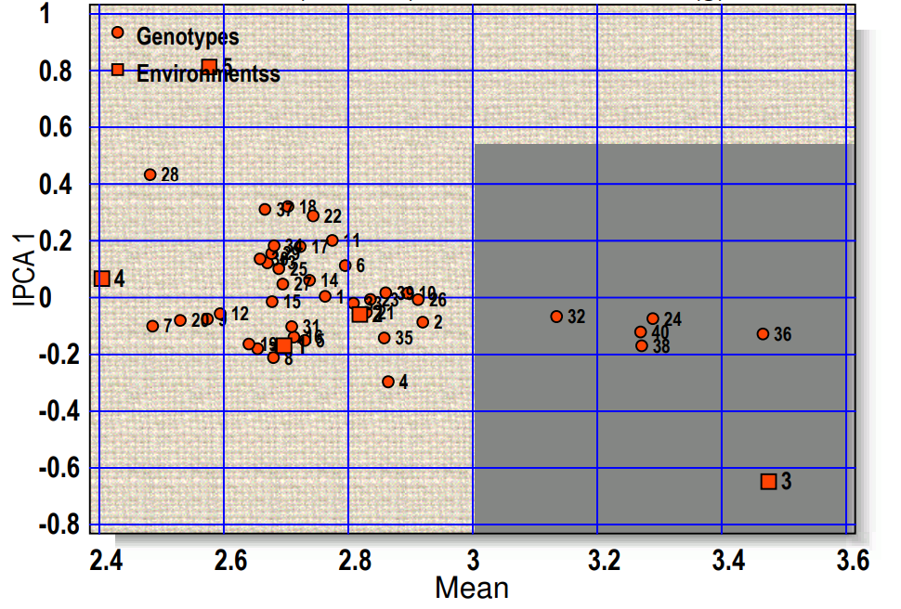
Fig. 1b. Polygon view of the GGE biplot (AMMI2) based on genotype x environment interaction of 40 niger genotypes in five environments.
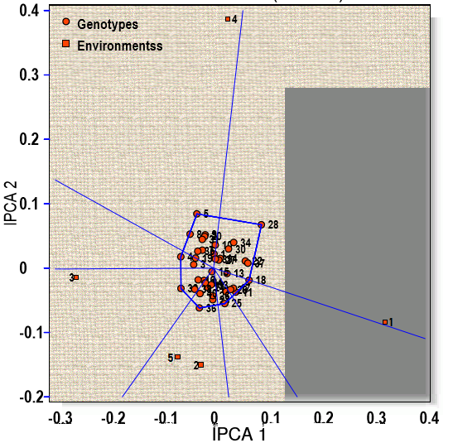

Table 6: Estimation of stability parameters of 40 niger genotypes for seed yield plot⁻¹ (g)
208
Sr. No. | Genotype code | Seed yield plot⁻¹ (g)
Sr. No. | Genotype code | Mean | RYi | IPCA1 | IPCA2 | ASV | RASVi | GSI
1. | G 1 | 229 | 7 | -2.20 | -0.008 | 4.24 | 27 | 34
2. | G 2 | 246 | 5 | -0.70 | 0.005 | 1.35 | 11 | 16
3. | G 3 | 214 | 15 | 2.20 | -0.003 | 4.24 | 27 | 42
4. | G 4 | 253 | 4 | -0.20 | -0.004 | 0.39 | 4 | 8
5. | G 5 | 209 | 19 | 0.20 | 0.005 | 0.39 | 4 | 23
6. | G 6 | 203 | 23 | 3.90 | 0.009 | 7.52 | 31 | 54
7. | G 7 | 222 | 9 | 1.50 | -0.014 | 2.89 | 23 | 32
8. | G 8 | 214 | 14 | 2.60 | -0.017 | 5.02 | 29 | 43
9. | G 9 | 221 | 10 | -0.41 | 0.012 | 0.79 | 8 | 18
10. | G 10 | 257 | 3 | -0.61 | -0.011 | 1.18 | 10 | 13
11. | G 11 | 216 | 13 | 0.81 | 0.008 | 1.56 | 13 | 26
12. | G 12 | 222 | 9 | 1.11 | -0.002 | 2.14 | 18 | 27
13. | G 13 | 217 | 12 | 1.92 | -0.004 | 3.70 | 25 | 37
14. | G 14 | 221 | 10 | -0.81 | -0.015 | 1.56 | 13 | 23
15. | G 15 | 221 | 10 | -0.22 | -0.003 | 0.42 | 6 | 16
16. | G 16 | 206 | 21 | -1.00 | 0.018 | 1.93 | 17 | 38
17. | G 17 | 201 | 24 | 2.20 | 0.025 | 4.24 | 27 | 51
18. | G 18 | 207 | 20 | 0.01 | 0.007 | 0.02 | 1 | 21
19. | G 19 | 210 | 18 | -0.71 | -0.002 | 1.37 | 12 | 30
20. | G 20 | 208 | 20 | -2.45 | 0.013 | 4.73 | 28 | 48
21. | G 21 | 210 | 19 | -1.40 | 0.001 | 2.70 | 20 | 39
22. | G 22 | 211 | 18 | -0.61 | 0.008 | 1.18 | 10 | 28
23. | G 23 | 200 | 25 | -0.81 | 0.023 | 1.56 | 13 | 38
24. | G 24 | 260 | 2 | 0.40 | -0.010 | 0.77 | 7 | 9
25. | G 25 | 232 | 6 | -2.10 | -0.009 | 4.05 | 26 | 32
26. | G 26 | 221 | 10 | -1.42 | 0.018 | 2.74 | 22 | 32
27. | G 27 | 214 | 14 | -2.61 | -0.006 | 5.03 | 30 | 44
28. | G 28 | 205 | 22 | 0.43 | 0.014 | 0.83 | 9 | 31
29. | G 29 | 218 | 11 | -1.20 | 0.006 | 2.31 | 19 | 30
30. | G 30 | 212 | 17 | 1.70 | 0.002 | 3.28 | 24 | 41
31. | G 31 | 209 | 19 | -0.21 | 0.004 | 0.41 | 5 | 24
32. | G 32 | 257 | 3 | -0.10 | -0.013 | 0.19 | 3 | 6
33. | G 33 | 207 | 20 | 2.60 | 0.004 | 5.02 | 29 | 49
34. | G 34 | 213 | 16 | 0.90 | -0.008 | 1.74 | 15 | 31
35. | G 35 | 221 | 10 | 1.41 | 0.006 | 2.72 | 21 | 31
36. | G 36 | 265 | 1 | -0.82 | -0.009 | 1.58 | 14 | 15
37. | G 37 | 217 | 12 | -2.20 | -0.005 | 4.24 | 27 | 39
38. | G 38 | 222 | 9 | -0.05 | -0.140 | 0.17 | 2 | 11
39. | G 39 | 218 | 12 | -0.91 | -0.004 | 1.76 | 16 | 28
40. | G 40 | 224 | 8 | -0.41 | -0.019 | 0.79 | 8 | 16
*Significant at 5% level of significance **Significant at 1% level of significance
RYi: Rank of Yield, IPCA: Interaction Principal Component Analyses, ASV: AMMI Stability Value, RASVi: Rank of AMMI Stability Analyses, GSI: Genotypic Selection Index

Fig. 2a. AMMI1 biplot showing mean performance and adaptability of 40 niger genotypes for seed yield plot⁻¹ (g) across five tested environments.
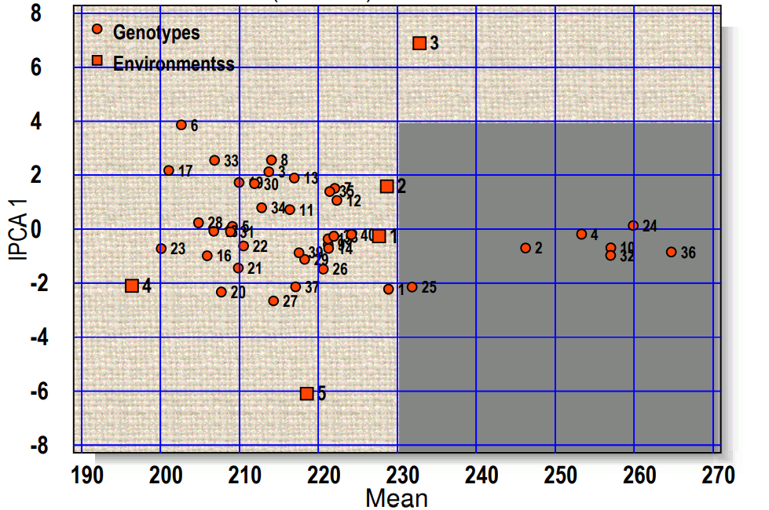
Fig. 2b. Polygon view of the GGE biplot (AMMI2) based on genotype x environment interaction of 40 niger genotypes in five environments.
