MITIGATE THE IMPACT OF VARIOUS ABIOTIC STRESS BY USING GRAFTING IN TOMATO (SOLANUM LYCOPERSICUM L.) AND OTHER VEGETABLES: A COMPREHENSIVE REVIEW

ABSTRACT
Grafting technology has developed as a promising alternative to slow traditional breeding methods for boosting abiotic stressor resistance, soil pathogen tolerance, and fruit vegetable output and quality. Tomato, cucumbers, watermelons, eggplants, muskmelon and sweet papers have been grafted commercially to increase plant tolerance to factors such as salt, drought, waterlogging, the heavy metal toxicity, extreme temperatures, and variations in vegetable crop yield and quality. The goal of this study was to evaluate the research on the effect of grafting in reducing abiotic stressors and increasing vegetable crop production and quality. At different phases of culture, abiotic and biotic stressors harm tomato (Solanum lycopersicum L.), a significant vegetable crop globally. Drought, salt, floods, severe temperatures, and heavy metals may alter plant morphology, physiology, and biochemistry, affecting crop development, production, and quality. Grafting technology is an excellent alternative to delayed breeding operations to reduce biotic and abiotic stressors. Grafted tomatoes have higher osmolytes, antioxidant enzymes, photosynthesis, which improves plant growth and fruit harvests and makes them more tolerant to abiotic challenges. Additionally, tomato grafting on proper rootstocks enhances fruit nutritional value, including lycopene, β-carotene, ascorbic acid, and proteins. This information may help researchers and producers improve vegetable quality, especially under abiotic stress.
Keywords: abiotic stressor resistance, Grafting technology, crop yield, plant morphology,

- INTRODUCTION
Through the process of grafting, plant parts are joined together to establish vascular continuity, enabling the resultant genetically composite organism to carry out the same functions as a single plant. Nevertheless, there have been documented instances of spontaneous grafts occurring across distinct families (Warschefsky et al., 2016). The use of resistant rootstock via vegetable grafting emerged as a strategy to address soil transmitted illnesses, commencing in the 1920s. Grafted vegetables were first cultivated on a large area in Japan and Korea.
Vegetables provide a substantial component of a nutritious dietary regimen, serving as a valuable reservoir of dietary fiber, antioxidants, protein, carbohydrates, vitamins and minerals. The agricultural development worldwide is often hindered by several abiotic variables, such as drought, floods, soil salinity, hot or cold temperatures, oxidative stress, and heavy metal toxicity (Fu et al., 2022). Depletion of water supplies, forest clearing, and unintentional climate change increase the potential for plants to face various abiotic stressors. The worldwide output of vegetables is significantly limited by increasing temperatures, decreasing supply of irrigation water, floods, and salt (Coskun, 2023). The reduction in agricultural output by 50% can be attributed to various abiotic stresses, including water-related factors such as drought, flooding, and hypoxia, temperature variations such as heat, cold, chilling, and freezing, chemical exposures such as mineral deficiency or excess, heavy metal pollutants, pesticides, and gaseous toxins, radiation exposure such as UV and ionizing radiation, as well as mechanical factors like wind, soil erosion, and submergence. The majority of watermelon seedlings in countries such as Korea, Greece, Japan, Spain, Turkey and Italy are grafted. The use of grafted plants is seeing a growing trend in many vegetable cultivations worldwide, including tomato, eggplant, sweet pepper, cucumber, and muskmelons. According to Fu et al. (2022), the process of grafting in vegetables has been seen to improve several aspects of plant vigor, harvesting time, yield, and fruit quality (Tsaballa et al., 2013). Today, we use the practice of grafting to reduce soil-borne pathogen infections and increase resistance to abiotic stresses. (see Figure 1).

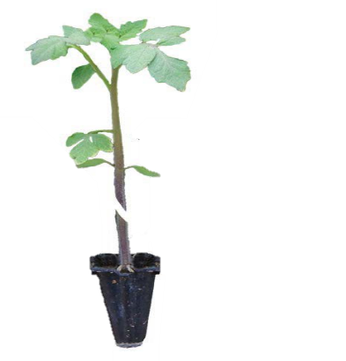
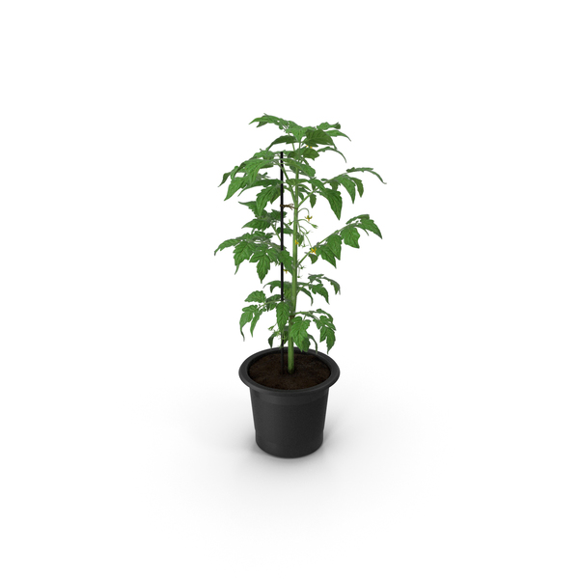

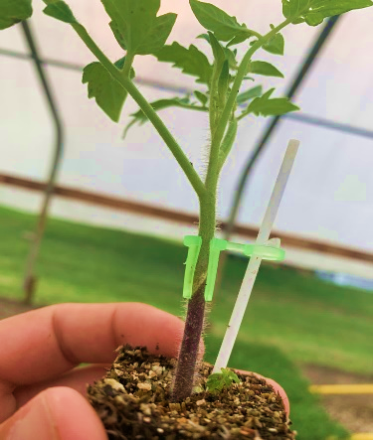
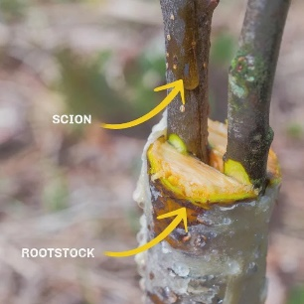
Cut for grafting
Tomato plant
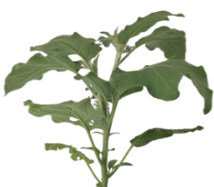
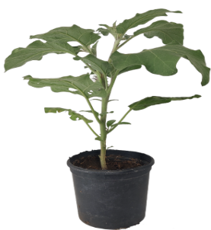

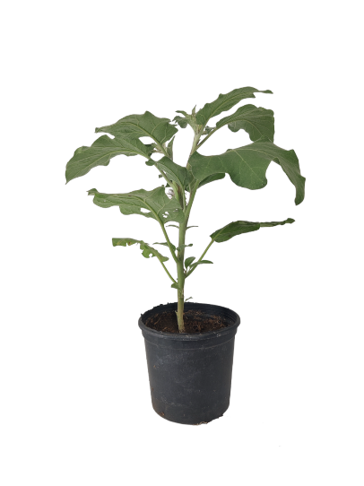
Grafting
Grafted plant
Cut for grafting
Brinjal plant
Figure 1. Grafting of tomato on brinjal plant.

According to FAOSTAT (2019), tomato (Solanum lycopersicum L.) is a significant fruit or vegetable crop, ranking second only to potato. According to FAOSTAT (2019), tomato consumption is mostly connected with India, China, North Africa, the Middle East, and Brazil. The per capita tomato consumption in these regions ranges from 61.9 to 198.9 kg. The tomato fruit is belonging Solanaceae family, which encompasses other commercially significant crops like the potato, pepper, and eggplant.
Tomatoes provide several bioactive components that contribute to overall health and may be readily included into a well-rounded dietary regimen (Martú et al., 2016). While there is a wide range of functional meals available to meet these needs, it is worth mentioning that consuming fruits and vegetables is more efficient for achieving this goal (Viuda-Martos et al., 2014). Tomatoes possess a range of health-promoting components, such as vitamins, carotenoids, and phenolic compounds, which contribute significantly to their nutritional significance (Liu et al., 2016). According to Raiola et al. (2014), the spectrum of physiological activities shown by these bioactive chemicals include antiallergenic, antibacterial, antiinflammatory, vasodilatory, antithrombotic, cardio-protective, and antioxidant actions.
ABIOTIC STRESS IN TOMATO
Vegetable crops exhibit sensitivity to a range of abiotic stressors, such as drought, flood, salt, and extreme temperatures. These stresses have a profound impact on the physiology and development of plants, ultimately resulting in a decrease in output see figure 2.
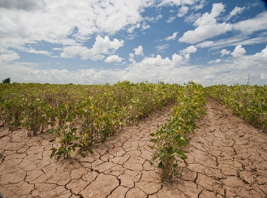
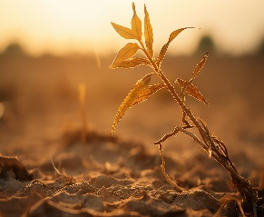
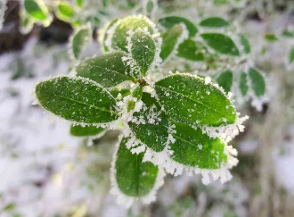
Na⁺, Cl⁻, SO₄⁻
Pb, Hg, Zn, Fe As, Cd

Salinity
Drought
Heavy metals
Cold
Heat

ROS

Oxidative Damage

Alter enzyme and protein
Reduce osmolyte level
Electrolyte leakage
Water Deficiency
Nutrient Deficiency
Nucleic acid Damage

Cell Death

Poor plant growth
Stunted root growth

Reduce Yield and Quality of Plant

Figure 2. Different abiotic stresses affect plant growth, physiology, and production.
Temperature stress:
Temperature is one of the most important environmental factors that significantly affects tomato production. Tomato plants are able to flourish in a broad range of temperatures, fruit set and production are severely restricted when the maximum temperatures (during the day) are higher than 32 degrees Celsius and the lowest temperatures (during the night) are lower than 21 degrees Celsius. According to Jones (2007), the optimal range of temperatures for plant development, fruit set, and yield in tomatoes is between 21 and 29.5 degrees Celsius during the day and between 18.5 and 21 degrees Celsius during the night of the plant.

COLD STRESS:
Low temperature is a prevalent abiotic stressor that diminishes agricultural yield (Duan et al., 2012), impacting around 25% of the global land area (Peel et al., 2007). According to Ronga et al. (2018), tomatoes are classified as cold-sensitive vegetables, since their growth and development are significantly impacted when exposed to temperatures below 12°C. According to Cao et al. (2015), tomato fruit may experience chilling harm when subjected to temperatures above 10°C for a duration of 14 days or temperatures below 5°C for about one week. The development rate and photosynthesis are reduced, and the emergence of truss and fruit growth are delayed when exposed to low-temperature or sub-optimal temperatures above the chilling temperature. Plants may experience cold stress damage during a timeframe of 48 - 72 hours after exposure to stress (Atayee and Noori, 2020).
WATERLOGGING STRESS:
Flooding or waterlogging, which results from the slow movement of gaseous substances in water and the consumption of oxygen by microbes and plant roots, causes oxygen deprivation in plants. Grafting onto resistant rootstocks, namely brinjal, has been suggested as a potential solution to the issue of flooding in tomatoes. Bahadur et al. (2016) and Bhatt et al. (2015) proved that waterlogging tolerance in tomatoes for durations of 4 and 6 days, respectively, by using distinct brinjal rootstocks. According to Mauro et al. (2020), it was observed that the grafting of tomato (cv. 'Dreamer') onto interspecific rootstock 'Maxifort' and 'Beaufort' (S. lycopersicum x S. habrochaites) resulted in improved photosynthesis, root biomass, and growth performance. This improvement was attributed to the buffering effect of root hypoxia under low root zone oxygen conditions (2–3 mg L⁻¹ for 30 days). Figure 3 demonstrates a favorable transformation in vegetable crops as a result of grafting.

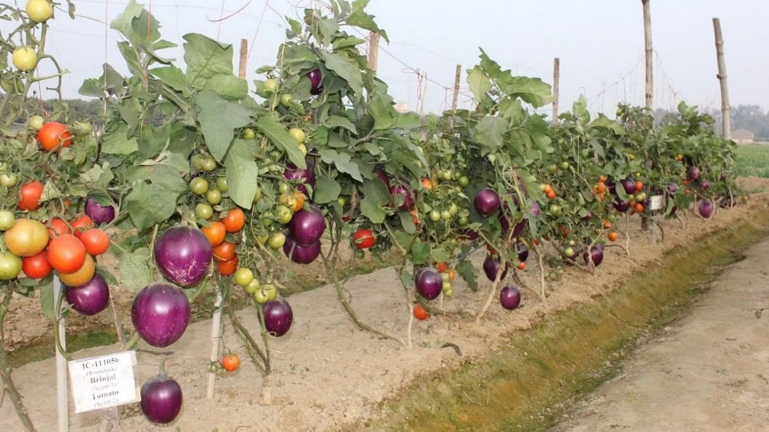
Better stomatal conductance, chlorophyll fluorescence and photosynthesis
Early fruiting, long harvesting period with improved growth, yield and nutritional profile
Improved root architecture for increased water and minerals uptake
Reduction in oxidative stress through osmoprotectants and enzymes
Modification in signal transduction, stress responsive, gene expression, protein
Rootstock mediated tolerance to soil borne pathogens

Figure 3. Beneficial impact of grafting in vegetables
According to Bahadur et al. (2015) grafted watermelon and tomato plants have been shown to have increased adventitious roots and parenchyma production, which is linked to their ability to tolerate waterlogging (Bahadur et al., 2016). The use of promising rootstocks for grafting is widely recognized as a viable strategy for minimizing the adverse impacts of floods in various vegetable crops. For example, Bhatt et al. (2015) shown that tomato plants can tolerate waterlogging or flooding for a duration of 4-6 days by using eggplant as a rootstock (Kato et al., 2001). According to Haghighi and Khosravi (2022), the grafting of cucumber into 'Ferro' and 'Cobalt' resulted in a notable enhancement of flooding stress in cucumber. Grafting has the potential to enhance the tolerance of bitter melon to waterlogging stress (Peng et al., 2020). This improvement is achieved through the upregulation of anaerobic respiration enzymes, namely pyruvate dehydrogenase in both adventitious and taproots. Additionally, grafting also leads to the expansion of the aerenchyma in the adventitious roots of bitter melon. In contrast, the non-grafted plants experienced a reduction in Fv/Fm ranging from 39.6% to 41% and a reduction in CCI ranging from 41% to 100% at 96 hours after exposure to waterlogging stress. In addition, Bahadur et al. (2016) have reported that the physiological, biochemical, and yield parameters, exhibited minimal impact on tomato plants subjected to waterlogging conditions for a duration of up to 96 hours when grafted onto eggplant rootstocks. Grafting research conducted at the World Vegetable Centre in Taiwan found that wild varieties of chili can withstand floods in sweet pepper plants in hot-humid conditions, resulting in enhanced production (Palada & Wu, 2008).
SALINITY STRESS:
The presence of salinity is a significant abiotic stressor that poses a substantial risk to agricultural output. Salinity stress is seen in around one-third of irrigated land worldwide, and projections indicate that by the year 2050, over 50% of the world's cultivated area would experience the adverse effects of soil salinity (Roșca et al., 2023). Salinity arises as a consequence of an inordinate buildup of salts (namely Na⁺, Cl⁻, and SO₄⁻) within the soil or irrigation water. In addition, an excessive number of salts may lead to ion toxicity and an imbalance in nutrients, including potassium (K⁺), calcium (Ca²⁺), and magnesium (Mg²⁺), by disrupting their absorption and/or transportation to the shoots (Sholi, 2012).
HEAVY METAL STRESS:
Agricultural soil contaminated with heavy metals poses risks to human health, the environment, and plant development. Many different sources, including industrial runoff, reclaimed wastewater, and soil amendments, have introduced heavy metals including cadmium, arsenic, lead, mercury, and nickel into agricultural environments. It is possible that soil levels of NO₃, SO₄, H₂PO₄⁻, K⁺, Ca²⁺, Mg²⁺, and metallic micronutrients (such as Cu) may become abnormally high due to these sources. Limited copper transmission to tomato leaves and roots was noted by Savvas et al. (2009) when the tomato variety 'Belladona' was grafted onto the He-Man rootstock (Solanum lycopersicum × S. habrochaites).
DROUGHT STRESS:
With less water available and more people demanding it, drought stress is becoming worse. Seventy percent of the world's fresh water consumption is attributable to agriculture, and that number is projected to climb sharply in the years ahead (Boretti and Rosa, 2015). Drought stress levels determine the extent to which drought reduces crop yields. As shown for barley under field circumstances, crop loss due to severe drought might be entire in the absence of irrigation (Samarah et al., 2009). Results from field experiments were included in a meta-study that found that when water was decreased by around 40%, yields dropped by about 21% in wheat and 39% in maize (Daryanto et al., 2016). Drought in Europe is expected to reduce wheat and maize yields by 10% (Webber et al., 2018).
When comparing species based on their drought resistance, it is important to keep in mind that, similar to other abiotic stressors, drought-induced yield loss differs between cultivars (Mickky et al., 2020). In addition, water scarcity reduces crop quality; for instance, rapeseed seeds have been shown to have less oil when grown in drought (Hussain et al., 2018). The stage of development at which a plant is when drought strikes is an important consideration in determining yield loss. According to Dufková et al. (2022), plants are more susceptible to drought while they are in the reproductive stage. Consequently, according to Wiegmann et al. (2019), improving the timing of plant growth might lead to improved yields. According to Farooq et al. (2016), traits including grain filling, flower output, seed composition, and lifespan are all negatively impacted by prolonged exposure to drought stress during the reproductive period.
Reduced fruit set in tomatoes and chillis, tomato and cabbage splitting, root crop nitrate toxicity, watermelon bitterness, and cucumbers with crooked fruits are some notable impacts of drought stress. According to Padilla et al. (2023), one way to decrease output losses and boost water use efficiency (WUE) during drought is to graft high-yielding vegetable cultivars onto rootstocks that may mitigate the effects of water stress on the shoot. The effects of water stress on the development and output of many vegetable crops have been extensively studied (Djidonou et al., 2013). During drought stress circumstances, interspecific grafting of cucumber plants led to higher plant height and also a notable decrease in leaf lipid peroxidation content (Coskun, 2023). In order to alleviate drought stress in plants, rootstock mediated phytohormone synthesis is also crucial (see table 1).

Table 1. The aims of using grafting in vegetables by using different rootstock.
Plant | Rootstock | Aims | References
Tomato | Solanum lycopersicum x S. habrochaites interspecific hybrid | Able to withstand bacterial, Fusarium, root knot, verticillium, corky root, floods, drought, salt, temperature, longer fruiting, greater yield, and fruit quality. | (Awu et al., 2023)
Eggplant | Solanum torvum and S. integrifolium | This includes plant vigor, yields, nutritional composition, and resistance to bacterial, verticillium, and Fusarium wilts. | (Consentino et al., 2022)
Watermelon | Cucurbita maxima x Cucurbita moschata | Strong roots, Fusarium wilt tolerance, physiological abnormalities, low and high temperature, B. hispida for many diseases tolerance | (Pal et al., 2020)
Cucumber | Cucurbita ficifolia (fig-leaf gourd) | Robust root system, resistance to water stress, phytophthora, low and high temperatures, and nematodes | Zhen et al., 2023
Muskmelon | Cucumis melo, Cucumis metuliferus | Fruit quality, Phytophthora infections, a robust root system, and high soil moisture | (Chawda, 2021)

- QUALITY AND YIELD PARAMETER:
The freshness, texture, flavor and health-related compounds of a vegetable fruit are some of the criteria for determining its quality. Heavy metals, pesticides, and nitrates are some of the undesirable compounds that should be minimized. It is well-known that grafting may alter the nutritional value, taste, and physical characteristics of vegetables, particularly the amounts of minerals, vitamin C, and carotenoids (Rouphael et al., 2010). Because research on the impact of grafting on quality characteristics is mixed, selecting the right rootstock/scion combination is essential for optimal fruit quality. It has been noted that watermelon grafting results in subpar fruit quality, such as lower levels of soluble solids, more yellowish bands in the flesh, bland flavor, uneven texture (due to the presence of more fibers), and less firmness (Lee & Oda, 2003). Grafting is a powerful method for improving the nutritional value and bio-fortification of vegetables
- CONCLUSION:
Significant physiological and biochemical processes such as reduced photosynthetic activity, altered metabolism and enzymatic activity, thermal injury to the tissues, reduced pollination and fruit set, etc. are significantly impacted by abiotic stresses such as low and high temperatures, drought, salinity flooding, heavy metals, and so on, which in turn significantly reduce tomato yield and quality. When compared to the time-consuming process of breeding tomatoes to be more resistant to environmental stress, grafting is a clear winner. Soil and weather circumstances that aren't ideal are common for many vegetable crops that are in the Cucurbitaceous and Solanaceous families. Grafting is a potential method for improving plant production in Cucurbitaceous and Solanaceous vegetables when contact with different types of abiotic stress, including drought, salt, waterlogging, sub- or supra-optimal temperature, heavy metals, and soil-borne pathogens. This can lead to higher yields and improved quality traits. This method might become a game-changer in the future for increasing vegetable yields, especially in the face of abiotic stressors, because to its many advantages. To boost tomato crop growth, production, and quality while conferring resistance to abiotic stressors, suitable tolerant rootstocks should be used. Future research should concentrate on graft compatibility as it is an important component of successful grafting.

REFERENCES:
Atayee, A. R., & Noori, M. S. (2020). Alleviation of cold stress in vegetable crops. J Sci Agric, 4, 38-44.
Awu, J. E., Nyaku, S. T., Amissah, J. N., Okorley, B. A., Agyapong, P. J., Doku, F. E., & Nkansah, G. O. (2023). Grafting for sustainable management of Fusarium wilt disease in tomato production in Ghana. Journal of Agriculture and Food Research, 14, 100710. https://doi. org/10.1016/j.jafr.2023.100710
Bahadur, A., Jangid, K. K., Singh, A. K., Singh, U., Rai, K. K., Singh, M. K., Rai, N., Singh, P. M., Rai, A. B., & Singh, B. (2016). Tomato genotypes grafted on eggplant: Physiological and biochemical tolerance under waterlogged condition. Vegetable Science, 43(2), 208–215.
Boretti, A.; Rosa, L. Reassessing the Projections of the World Water Development Report. NPJ Clean. Water 2019, 2, 15.
Cao, X., Jiang, F., Wang, X., Zang, Y., & Wu, Z. (2015). Comprehensive evaluation and screening for chilling-tolerance in tomato lines at the seedling stage. Euphytica, 205, 569-584.
Chawda, V. (2021). Development of suitable rootstock and standardization of appropriate grafting technology for dry and humid areas of India. Acta horticulture, (1302), 45–48. https://doi.org/10.17660/ActaHortic.2021. 1302.6
Consentino, B. B., Sabatino, L., Vultaggio, L., Rotino, G. L., La Placa, G. G., D’Anna, F., Leto, C., Iacuzzi, N., & De, P. C. (2022). Grafting eggplant onto underutilized Solanum species and bio-stimulatory action of Azospirillum brasilense modulate growth, yield and nutritional functional traits. Horticulturae, 8(8), 722. https:// doi.org/10.3390/horticulturae8080722
Coskun, O. F. (2023). The effect of grafting on morphological, physiological and molecular changes induced by drought stress in cucumber. Sustainability, 15(1), 875. https://doi.org/10.3390/su15010875
Daryanto, S., Wang, L., & Jacinthe, P. A. (2016). Global synthesis of drought effects on maize and wheat production. PloS one, 11(5), e0156362.
Djidonou, D., Zhao, X., Simonne, E. H., Koch, K. E., & Erickson, J. E. (2013). Yield, water-, and nitrogen-use efficiency in field-grown, grafted tomatoes. Hort Science, 48(4), 485-492. https://doi.org/10.21273/ HORTSCI.48.4.485
Duan, M., Feng, H. L., Wang, L. Y., Li, D., & Meng, Q. W. (2012). Overexpression of thylakoidal ascorbate peroxidase shows enhanced resistance to chilling stress in tomato. Journal of Plant Physiology, 169(9), 867-877.
Dufková, H., Berka, M., Psota, V., Brzobohatý, B., & Černý, M. (2023). Environmental impacts on barley grain composition and longevity. Journal of Experimental Botany, 74(5), 1609-1628.
FAOSTAT (2019). Available at: http://www.fao.org/faostat/en/#home [Accessed April 15, 2019]
Farooq, M., Gogoi, N., Barthakur, S., Baroowa, B., Bharadwaj, N., Alghamdi, S. S., & Siddique, K. H. (2017). Drought stress in grain legumes during reproduction and grain filling. Journal of Agronomy and Crop Science, 203(2), 81-102.
Fu, S., Chen, J., Wu, X., Gao, H., & Lü, G. (2022). Comprehensive evaluation of low temperature and salt tolerance in grafted and rootstock seedlings combined with yield and quality of grafted tomato. Horticulturae, 8(7), 595. https://doi.org/10.3390/horticulturae8070595
Haghighi, M., & Khosravi, S. (2022). Effects of grafting on cucumber growth under flooding stress during 15 days in vegetative stage. Journal of Agricultural Science and Technology, 24(4), 873–883. https://jast.modares.ac.ir/arti cle-23-42206-en.html
Hussain, M., Farooq, S., Hasan, W., Ul-Allah, S., Tanveer, M., Farooq, M., & Nawaz, A. (2018). Drought stress in sunflower: Physiological effects and its management through breeding and agronomic alternatives. Agricultural water management, 201, 152-166.
Jones Jr, J. B. (2007). Tomato plant culture: in the field, greenhouse, and home garden. Book CRC press, Pp. 420. ISBN 9780849373954.
Kato, C., Ohshima, N., Kamada, H., & Satoh, S. (2001). Enhancement of the inhibitory activity for greening in xylem sap of squash root with waterlogging. Plant Physiology and Biochemistry, 39(6), 513–519. https://doi. org/10.1016/S0981-9428(01)01262-1
Lee, J. M., & Oda, M. (2003). Grafting of herbaceous vegetable and ornamental crops. Horticultural Reviews, 28, 61–124. https://doi.org/10.1002/9780470650851.ch2
Martí, R., Roselló, S., & Cebolla-Cornejo, J. (2016). Tomato as a source of carotenoids and polyphenols targeted to cancer prevention. Cancers, 8(6), 58. doi: 10.3390/cancers8060058
Mauro, R. P., Agnello, M., Distefano, M., Sabatino, L., San Bautista Primo, A., Leonardi, C., & Giuffrida, F. (2020). Chlorophyll fluorescence, photosynthesis and growth of tomato plants as affected by long-term oxygen root zone deprivation and grafting. Agronomy, 10(1), 137.
Mickky, B., Aldesuquy, H., & Elnajar, M. (2020). Effect of drought on yield of ten wheat cultivars linked with their flag leaf water status, fatty acid profile and shoot vigor at heading. Physiology and molecular biology of plants, 26, 1111-1117.
Pal, S., Rao, E. S., Hebbar, S. S., Sriram, S., Pitchaimuthu, M., & Rao, V. K. (2020). Assessment of Fusarium wilt resistant Citrullus sp. rootstocks for yield and quality traits of grafted watermelon. Scientia Horticulturae, 272, 109497. https://doi.org/10.1016/j.scienta.2020.109497
Palada, M. C., & Wu, D. L. (2008). Evaluation of chili rootstocks for grafted sweet pepper production during the hot-wet and hot-dry seasons in Taiwan. Acta Horticulture, 767(767), 151–158. https://doi.org/10. 17660/ActaHortic.2008.767.14
Peel, M. C., Finlayson, B. L., & McMahon, T. A. (2007). Updated world map of the Köppen-Geiger climate classification. Hydrology and earth system sciences, 11(5), 1633-1644.
Pem, D. E. M., & Jeewon, R. (2015). Fruit and vegetable intake: Benefits and progress of nutrition education interventions-narrative review article. Iranian journal of public health, 44(10), 1309.
Peng, Y. Q., Zhu, J., Li, W. J., Gao, W., Shen, R. Y., & Meng, L. J. (2020). Effects of grafting on root growth, anaerobic respiration enzyme activity and aerenchyma of bitter melon under waterlogging stress. Scientia Horticulturae, 261, 108977. https://doi.org/10.1016/j. scienta.2019.108977
Raiola, A., Rigano, M. M., Calafiore, R., Frusciante, L., & Barone, A. (2014). Enhancing the health-promoting effects of tomato fruit for biofortified food. Mediators of inflammation, 2014. doi: 10.1155/2014/139873
Ronga, D., Rizza, F., Badeck, F. W., Milc, J., Laviano, L., Montevecchi, G., ... & Francia, E. (2018). Physiological responses to chilling in cultivars of processing tomato released and cultivated over the past decades in Southern Europe. Scientia horticulturae, 231, 118-125.
Roșca, M., Mihalache, G., & Stoleru, V. (2023). Tomato responses to salinity stress: From morphological traits to genetic changes. Frontiers in Plant Science, 14, 1118383.
Rouphael, Y., Schwarz, D., Krumbein, A., & Colla, G. (2010). Impact of grafting on product quality of fruit vegetables. Scientia Horticulturae, 127(2), 172–179. https://doi.org/10.1016/j.scienta.2010.09.001
Samarah, N. H., Alqudah, A. M., Amayreh, J. A., & McAndrews, G. M. (2009). The effect of late‐terminal drought stress on yield components of four barley cultivars. Journal of Agronomy and Crop Science, 195(6), 427-441.
Savvas, D., Papastavrou, D., Ntatsi, G., Ropokis, A., Olympios, C., Hartmann, H., & Schwarz, D. (2009). Interactive effects of grafting and manganese supply on growth, yield, and nutrient uptake by tomato. Hort Science, 44(7), 1978-1982.
Sholi, N. J. (2012). Effect of salt stress on seed germination, plant growth, photosynthesis and ion accumulation of four tomato cultivars. American Journal of Plant Physiology, 7(6), 269-275.
Tsaballa, A., Athanasiadis, C., Pasentsis, K., Ganopoulos, I., Nianiou-Obeidat, I., & Tsaftaris, A. (2013). Molecular studies of inheritable grafting induced changes in pepper (capsicum annuum) fruit shape. Scientia Horticulturae, 149, 2–8. https://doi.org/10.1016/j.scienta.2012.06.018
Warschefsky, E. J., Klein, L. L., Frank, M. H., Chitwood, D. H., Londo, J. P., von Wettberg, E. J., & Miller, A. J. (2016). Rootstocks: diversity, domestication, and impacts on shoot phenotypes. Trends in plant science, 21(5), 418-437. https://doi.org/10.1016/j.tplants. 2015.11.008
Webber, H., Ewert, F., Olesen, J. E., Müller, C., Fronzek, S., Ruane, A. C., ... & Wallach, D. (2018). Diverging importance of drought stress for maize and winter wheat in Europe. Nature communications, 9(1), 4249.
Wiegmann, M., Maurer, A., Pham, A., March, T. J., Al-Abdallat, A., Thomas, W. T., ... & Pillen, K. (2019). Barley yield formation under abiotic stress depends on the interplay between flowering time genes and environmental cues. Scientific Reports, 9(1), 6397.
Zhen, X., Sun, Y., Yuan, X., Ma, Z. Y., Hong, Y., & Xia, S. (2023). Impact of Cucurbita moschata resistant rootstocks on Cucumis sativus fruit and Meloidogyne incognita development. Plant Disease, 4. https://doi.org/10. 1094/PDIS-02-22-0319-RE

