Assessment of the impact of Monocrotophos on the Freshwater fish Labeo rohita through Haematological and Histological parameters

ABSTRACT

This study investigated the acute sublethal toxicity of Monocrotophos on the behavioural, haematological, and histological characters of the freshwater fish Labeo rohita. Fish exposed to Monocrotophos (10 ppm and 100 ppm) exhibited notable behavioural alterations, including loss of equilibrium, frequent surfacing, heightened mucus secretion, irregular locomotion, and erratic swimming behaviours. The 96-hour LC₅₀ value for L. rohita was determined to be 48.50 ppm. Sub-lethal concentrations (10, 20, 40, and 60 ppm) were employed to assess the effects of acute exposure over a period of 30 days. The increase in Monocrotophos concentrations led to a consistent decrease in total RBC count and haemoglobin levels, although the total WBC count showed a proportional rise with both concentration and length of exposure. Histopathological analysis revealed significant structural damage to the gill and liver tissues in the treated fish relative to the controls. The findings highlight the substantial behavioural and physiological alterations caused by Monocrotophos exposure in L. rohita. In order to reduce the adverse impact of this chemical on aquatic ecosystems, stringent regulation and attentive application are essential.

Keywords: Acute toxicity; Hematology; Histopathology; Monocrotophos; Labeo rohita

- INTRODUCTION

Pesticides, insecticides, herbicides, and fungicides are synthetic chemicals widely used in agriculture. Organophosphate pesticides frequently used in agriculture and aquaculture include monocrotophos, methyl parathion, diazinon, dichlorvos, chlorpyrifos, glyphosate, trichlorfon, and malathion (Rajan et al., 2024; Li et al., 2023). These chemicals frequently find their way into aquatic ecosystems via agricultural runoff, spray drift, domestic waste discharge, industrial effluents, or direct application. This contamination results in harmful effects on non-target organisms, especially fish.

Fish are particularly vulnerable to waterborne stressors, such as organophosphate toxicity, making them an excellent bio-indicator for assessing water quality (Guo et al., 2021). Labeo rohita is a prominent species of Indian major carp, extensively farmed across Asia, including countries such as Vietnam, Bangladesh, and Nepal. Furthermore, L. rohita can acclimatise under controlled laboratory conditions (FAO, 2000; Nataraj et al., 2023). As noted by Dar et al. (2020) and FAO (2018), this species constitutes 3% of global fish production, 15% of freshwater aquaculture in Asian countries, and 60% of India's overall carp production. L. rohita is widely recognised, enjoys significant consumer demand, and is readily accessible. This species plays a crucial role in ensuring food security across Asian nations.

Monocrotophos is a compound classified as an organophosphate pesticide. These pesticides inhibit acetylcholinesterase (AChE). It induces acute cholinergic effects at elevated concentration levels (Krause et al., 2013). A recent study indicated that pesticides induced neurotoxicity, endocrine modulation, immunotoxicity, and teratogenicity in humans and aquatic species (Dar et al., 2023). Pesticides can infiltrate the aquatic ecosystem via surface runoff, resulting in harmful consequences for the environment and aquatic animals (Davoodi and Gholamreza, 2012). These pesticides may bioaccumulate in aquatic organisms consisting of fish through polluted water or the food chain, potentially impacting the behavioural and physiological processes of these animals (Das et al., 2024).

Multiple studies have indicated that aquatic animals have been impacted by monocrotophos (Velmurugan et al., 2007). It also impacts the internal organs and modifies the histoarchitecture of tissues, as well as metabolic activities, which ultimately influence human beings through the food chain and bioaccumulation process. Previous reports have indicated the toxicity of this compound on certain freshwater fish species (Tamizhazhagan and Pugazhendy, 2016). Consequently, the present study was designed to thoroughly assess the toxicity of Monocrotophos by determining the lethal concentration (LC₅₀) and sub-lethal concentrations on the haematological and histopathological parameters of L. rohita. This is essential for the urgent consideration and management of the hazardous implications associated with this pesticide.

- MATERIALS AND METHODS

  - Collection and acclimatization of experimental animal

The fish used for our study were 100 healthy fingerlings of L. rohita (Rohu). The fish in the length range of (6.3 ± 2.5 cm) were collected from Department of Fisheries, Malampuzha, Palakkad, Kerala, India with no risk of prior pesticide contamination. All the test animals were given bath treatment with 5 ppm KMnO₄ solution for 5 min to minimize the risk of infection and then kept in a plastic tub of 6 L capacity having dechlorinated water (kept nearly constant) and acclimatized in laboratory conditions for a period of 15 days, prior to the experiment. During this period, the fingerlings were fed ad- libitum with fish food obtained from the fisheries department.

  - Test chemical

Monocrotophos is an alkenyl phosphate, specifically the dimethyl (E)-1-methyl-2-(methylcarbomoyl) vinyl phosphate. Monocrotophos is classified as an extremely hazardous pesticide in India (ITRC, 1989). Monocrotophos (Monokem, 36% SL) was sourced from Sree Ramcides Chemicals Ltd., located in Pudukkotai, TN, India. Accurate measurements were taken to prepare the required concentration of Monocrotophos for the current experiment.

  - Experimental Design

    - Range Finding test

The range-finding bioassay was conducted with fish exposed to various amounts of sequential concentrations (1, 10, 100, and 1000 ppm) of Monocrotophos. Six fish were placed in glass troughs filled with 6 L of water, each containing varying concentrations of Monocrotophos. Mortalities were documented at 24, 48, 72, and 96 hours, and dead fish were promptly removed.

  - Determination of LC₅₀ for 96 h

For the determination of Monocrotophos toxicity study, various glass troughs with a capacity of 6 L were utilised, each filled with 4.5 L of dechlorinated tap water. Subsequently, varying concentrations of Monocrotophos at 10, 20, 40, 60, 80, 100, and 120 ppm were introduced into all glass troughs and thoroughly mixed. Six healthy fish were placed into each glass trough from the stock. The parallel control of 6 fish in separate glass troughs was also upheld under comparable conditions. The survival and mortality of fish in the experimental tubs were documented after a period of 96 hours. The concentration at which 50% of the fish were killed after a 96-hour treatment was defined as the median lethal concentration (LC₅₀) for that duration. Five preliminary toxicity tests were carried out to determine the median lethal concentration. The LC₅₀ for 96 hours was determined using the probity analysis method as outlined by Finney in 1978.

2.5 Sublethal toxicity study for 30 days

The sublethal toxicity experiment was conducted concurrently with acute studies. For the study, five thoroughly cleaned glass troughs with a capacity of 10 L were prepared. Each trough was filled with 8 L of water, and 8 randomly selected fish from the stock were transferred into the troughs. Different concentrations of Monocrotophos (10, 20, 40, and 60 ppm) were taken and added to each glass trough (Sprague et al., 1971). The control fish groups utilized in the acute toxicity studies were also preserved for this study. The water was replaced each day to prevent any accumulation of waste and was refreshed with the toxicant. The research was carried out over a period of 30 days. Eight fish were randomly selected from both control and Monocrotophos treated glass troughs and were sacrificed without anaesthesia for further analysis after the completion of the designated exposure period of 30 days.

2.6 Analysis of haematological parameters

The haemoglobin content, total erythrocyte count, and leukocyte count of the blood were estimated. The blood samples were collected and promptly analysed for haematological purposes. The RBC and WBC were diluted with appropriate diluting fluids, and the total content was calculated using an improved Neubauer haemocytometer (Blaxhall, 1972). The Sahli haemoglobinometer was utilised to estimate the haemoglobin (HB) content in both the Monocrotophos - treated fish and the control group.

2.7 Morphological assessment of blood cells

A thin blood film was made by spreading a blood drop evenly on clean grease free slide using smooth edged spreader. Leishman’s stains was employed for the staining of blood films. It provides excellent stain quality and is generally used to differentiate and identify leucocytes. Cytoplasmic details and granules are better stained by Leishman's stain. Blood smears were stained with Leishmans stain for 2 minutes (undiluted stain) and 5-15 minutes (diluted stain) as the former acts faster than the latter. Using the10X, 20X, 40 X objective high-power lenses, the blood smear was observed. The morphologic characteristics of cells were recorded (the shape, the pathologic changes in nuclei, the protoplasm and membranes) and they were registered. Images were captured by digital camera. Also, photographs were taken under compound microscope Leica with the help of a digital camera.

2.8 Comet assay

The collected blood samples were processed for the assay by following Singh et al. (1991). After electrophoretic analysis, the slides were gently neutralized in 0.4 M Tris buffer (pH = 7.5) and were stained using Acridine Orange stain (300- 400 μL of 20μg/ml of distilled water) and analyzed using epifluorescent microscopy (400X, Nikon AFX-1 Optiphot). The captured digital images were analyzed. Cells having no DNA damage had intact nuclei without tails while cells having DNA damage had a comet like appearance in shape. DNA migration length in comets’ tail was projected as DNA damage (Grover et al., 2003). Cells without heads or dispersed heads were not included for analysis and were considered as apoptotic cells.

2.9 Histopathology

For histopathological changes, the gill and liver were promptly excised from the fish, rinsed in an isotonic saline solution, and fixed in a 10% neutral buffered formaldehyde solution (pH 7.2). Following fixation, tissues underwent dehydration through a series of increasingly concentrated alcoholic solutions before being embedded in paraffin wax. Transverse and longitudinal sections, measuring 3-5µm in thickness, were prepared with a rotary microtome (Leica, Germany) and subsequently dried on a slide warmer set at 37°C. The tissues underwent deparaffinization in xylene and were subsequently dehydrated through an ascending series of alcohol. Sections were stained using the standard haematoxylin and eosin (H&E) method. The sections were ultimately cleared in xylene and subsequently mounted in DPX mountant medium. Various sections of each test specimen were examined using a light microscope (Leica, Germany).

2.10 Statistical Analysis

Lethal concentration (LC₅₀) was calculated on the basis of plotting a graph between percentage mortality data and varying concentrations of Monocrotophos. The descriptive data was given as a mean ± standard deviation (SD). The `t` test was applied to determine the level of significance (Fischer, 1950).

- RESULTS AND DISCUSSION

  - Range finding test and Behavioral toxicity of Monocrotophos on L. rohita

A range-finding test was performed to assess the effects of different concentrations of Monocrotophos (1–1000 ppm) on L. rohita over a duration of 96 hours. The findings showed no mortality at concentrations between 1 and 100 ppm after exposure for up to 56 hours. At the highest tested concentration of 1000 ppm, 100% mortality was observed within the first hour of exposure (Table 1). According to these findings, the no observed effect level (NOEL) concerning mortality was determined to be less than 1000 ppm. Based on this data, it can be concluded that the lethal concentration for 50% of the population (LC₅₀) falls within the range of 1–100 ppm. This conclusion highlights the considerable toxicity of Monocrotophos to L. rohita at higher concentrations, stressing the necessity for additional research to accurately ascertain the LC₅₀ value within the specified range.

Table 1. Table showing the results of Range toxicity studies

Groups | Conc. of Monocrotophos  (ppm) | Remarks
Control | --------- | No death
Experimental | 1 | NOEL of Monocrotophos; reported death only after 56 hrs.  (NOEL-No observed effect level)
Experimental | 10
Experimental | 100
Experimental | 1000 | 100% of the fishes subjected to acute poisoning died at the end of 1hr after exposure

In our current toxicity study, fish exposed to Monocrotophos exhibited varying degrees of clinical signs of toxicity. Visual observation indicated that fish exposed to 10 and 100 ppm concentrations of Monocrotophos exhibited several behavioural changes, including rapid opercular movement, loss of equilibrium, frequent surfacing, increased mucus secretion, irregular movement, and erratic swimming, among others (Fig. 1a). The behavioural abnormalities observed in L. rohita exposed to Monocrotophos became more pronounced with increasing concentrations, especially at the highest tested dose of 1000 ppm. At this concentration, the fish showed a loss of body equilibrium and visible haemorrhaging, marked by a red discolouration. The symptoms of acute toxicity escalated swiftly, resulting in complete mortality within only one hour of exposure (Fig. 1b). The quickly lethality highlights the significant toxic effects of Monocrotophos at high doses and indicates a crucial limit beyond which survival is no longer appropriate.

Aquatic organisms that were exposed to varying concentrations of monocrotophos exhibited significant alterations in survival, growth, morphology, and behaviour (Rajan et al., 2024). Furthermore, rats subjected to monocrotophos exhibited modifications in reproductive parameters, including sexual maturity, fertility, prolonged egg development, and an extended duration for the discharge of the initial brood (Singh et al., 2021). The results indicate a significant concentration of monocrotophos in aquatic systems, potentially resulting in detrimental impacts on marine fauna. Exposure to monocrotophos induces numerous metabolic alterations in animals. Water pollution significantly alters the physiological and metabolic processes of fish (Abdel-Tawwab et al., 2019). Pattnaik et al. (2022) recently observed that fishes treated with monocrotophos had irregular, erratic, and darting swimming behaviours due to loss of balance and excessive mucus production.

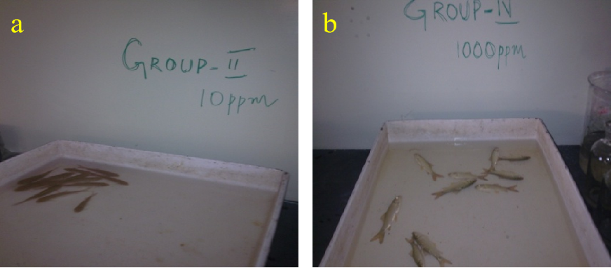

Fig. 1. Behavioural changes in L. rohita exposed to concentration of Monocrotophos for a)10, 100 ppm, the fishes showing a grooming behavior, b)1000 ppm, the fishes dead

Acute toxicity of Monocrotophos

To find the LC₅₀ value of Monocrotophos, the experimental fish (L. rohita) was exposed to various dosage levels ranging from 1 to 120 ppm of Monocrotophos. Following the treatment period of 96 hours, the mortality rates in each group were thoroughly observed and documented. The Monocrotophos exhibited a dose-dependent effect, with mortality rates increasing alongside higher concentrations of Monocrotophos. The exposure of fish for 96 hours at a concentration of 10 ppm of monocrotophos resulted in 16.6% mortality, whereas at a concentration of 60 ppm, approximately 64% mortality was observed. The graphical analysis of percent mortality in relation to different concentrations of Monocrotophos indicates that the lethal concentration (LC₅₀) for achieving 50% mortality of the fishes at 96 hours was 48.5 ppm for L. rohita (Fig. 2).

Binukumari et al. (2016) determined the fatal concentration (LC₅₀) of monocrotophos for the fish L. rohita over a 96-hour period to be 45.1 ppm. Fish were subjected to a sublethal concentration (1/10th of the 96-hour LC₅₀ value, 4.51 ppm) for durations of 24, 48, 72, and 96 hours, as well as for 10, 20, and 30 days. Pattnaik et al. (2022) stated that the 96-hour LC₅₀ value of monocrotophos for Heteropneustes fossilis was found to be 24 ppm (mg L⁻¹). The lethal concentration (LC50) of pesticide for the freshwater bivalve L. rohita is 195 mg/L, 180 mg/L, and 160 mg/L after 48, 72, and 96 hours of exposure, respectively (Maurya et al., 2024). The detrimental effects of pesticides on fish and other aquatic organisms are influenced by various factors, including concentration, exposure duration, bioaccumulation factor, species, age, size, sex of the organism, water quality parameters, pesticide formulation type, and its absorption, accumulation, metabolism, excretion, and degradation (Kumar et al., 2022).

Fig. 2. LC₅₀ concentration of Monocrotophos for L. rohita

3.3 Hematological changes during sublethal exposure periods

The alterations in haematological parameters after the exposure of L. rohita to sublethal doses (10, 20, 40, 60 ppm) for a duration of 30 days were documented. The findings after the exposure of L. rohita to sublethal amounts of Monocrotophos are summarised as follows. The alterations in haematological parameters of the fish L. rohita subjected to a sublethal dosage of 60 ppm of Monocrotophos are shown in Figs. 3 to 5. During sublethal concentration of 60ppm treatment red blood corpuscle (RBC) and hemoglobin levels decreased whereas White blood corpuscle (WBC) increased in the Monocrotophos - treated fishes. The graphical depictions of the alterations in the sublethal study are shown in Figs. 3-5.

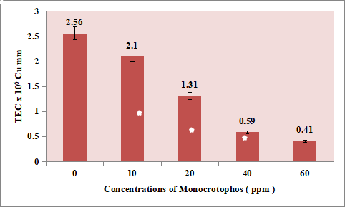

Fig. 3. Graph showing changes in the total erythrocyte count (RBC)
(x10⁶ cu mm) of L. rohita exposed to sublethal concentrations of Monocrotophos. (Data Mean ± SD) * P<0.05

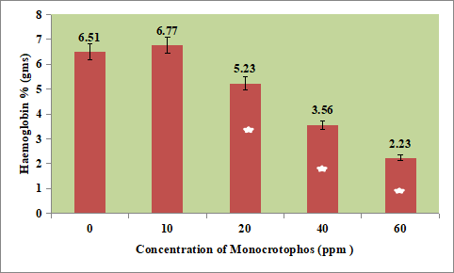

Fig. 4. Graph showing changes in the Haemoglobin content (gm %) of L. rohita exposed to sublethal concentrations of Monocrotophos. (Data Mean ± SD) * P<0.05
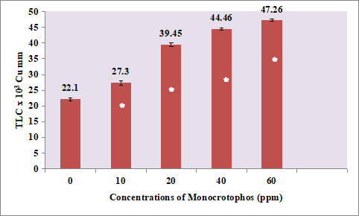

Fig. 5. Graph showing changes in the total leucocyte count
( x10³ cu mm) of L. rohita exposed to sublethal concentrations of Monocrotophos (Data Mean ± SD) * P<0.05

Haematological parameters act as valuable tools for diagnosing the health and physiological condition of fish, and are therefore effective bioindicators for monitoring stress in fish due to xenobiotic exposure (Oluah et al., 2020; Kumar et al., 2022a; Das et al., 2024). From the haematological perspective, there were notable changes in the haematological parameters when compared to control fish, suggesting a variation that depends on concentration and exposure duration. The observed haematological changes occurred due to monocrotophos, which impacted the structural and functional components, physiology, and metabolism of fish blood, as blood plays a crucial role in various physiological processes. The reduction in erythrocyte and haemoglobin counts indicated that the fish's physiological condition had changed due to pesticide exposure (Joseph et al., 2024).

The current research observed a reduction in erythrocyte and haemoglobin counts corresponding to higher concentrations and longer exposure durations. The decrease in erythrocyte counts may result from heightened erythrocyte lysing and hemoglobinization, shrinkage of erythrocytes, destruction of red cells, and inhibition of erythropoiesis (Farag et al., 2021) caused by pesticides.In line with our findings, a reduction in erythrocyte and Hb counts was noted in C. gariepinus subjected to diuron (Joseph et al., 2023); in C. carpio exposed to glyphosate (Gholami-Seyedkolaei et al., 2013); in C. batrachus exposed to monocrotophos (Narra, 2016); and in L. rohita exposed to butachlor (Kumar et al., 2022b), emamectin benzoate (Kumar et al., 2022a), and cypermethrin (Das and Mukherjee, 2003).

This study found that leucocyte count increased alongside higher concentrations and longer durations of monocrotophos exposure. An elevated leucocyte count may indicate that fish can establish a defensive mechanism to manage the toxic stress associated with monocrotophos intoxication. The increases in leucocyte counts observed in this study aligns with the findings regarding sub-lethal concentrations of sumithion on B. gonionotus (Kole et al., 2022); profennofos on O. niloticus (Al-Emran et al., 2022); and ronstar® on C. gairepinus (Oluah et al., 2020).

3.4 Morphological assessment of blood cells

Erythrocytes serve as a crucial diagnostic tool for assessing the functional and structural condition of fish subjected to various toxicants. Erythrocytes can respond to environmental stresses, and changes in erythrocyte characteristics are the most common indicators of toxicants found in aquatic environments (Islam et al., 2020). The blood smear of the control group showed normal erythrocytes and leukocytes, with erythrocytes present in greater numbers than leukocytes (Fig. 6A). Nevertheless, notable changes were noted in the groups treated with Monocrotophos. In fish exposed to 10 ppm Monocrotophos, there was a significant rise in leukocyte counts (Fig. 6B). The erythrocytes in this group exhibited swelling and disrupted membranes, suggesting cellular damage (Fig. 6C). At a concentration of 40 ppm, exposure to Monocrotophos led to the fusion of erythrocyte membranes, which resulted in the creation of syncytia (Fig. 6D). This condition indicates significant membrane damage and impairment of cellular function. Furthermore, necrotic blebs and pyknotic nuclei were noted in erythrocytes, indicating necrotic cell death in the treated groups (Figs. 6E and F). The effects intensified at elevated sub-lethal concentrations of Monocrotophos, resulting in a significant reduction in total erythrocyte counts (Fig. 6G). The results demonstrate significant haematological toxicity caused by Monocrotophos in L. rohita.

The most probable reasons for the decrease in RBC are the destruction of red blood cells and the inhibition of erythropoiesis. Research has demonstrated that disruptions in the haemopoietic process can hasten the breakdown and shrinkage of red blood cells, as well as erythrocyte lysis, which may subsequently result in decreased levels of RBC, HGB, and HCT (Gholami-Seyedkolaei et al. 2013). The frequencies of observed erythrocytic nuclear abnormalities, including degeneration, bi-nucleus, micronucleus, notch nucleus, and nuclear bridge, as well as erythrocytic cellular abnormalities like echinocytes, fusion, elongation, and tear drop morphology, showed a significant increase in a concentration-dependent manner (Ritu et al., 2022). The failure of tubulin polymerisation can lead to various nuclear abnormalities in erythrocytes, including binucleated cells, nuclear buds, nuclear bridges, karyopyknosis, and notched nuclei, which may arise under stress induced by toxicants (Ghaffar et al., 2015; Vardavas et al., 2016). Moreover, the development of binucleated cells and notched nuclei can occur due to mitotic fusions resulting from the aneugenic effects of toxicants (Ventura et al., 2008). Additionally, it can be inferred that these kinds of abnormalities in erythrocytes may lead to morphological alterations in the plasma membrane, which impacts surface deformation and increases the susceptibility of erythrocytes to rupture while traversing small capillaries (Islam et al., 2020).

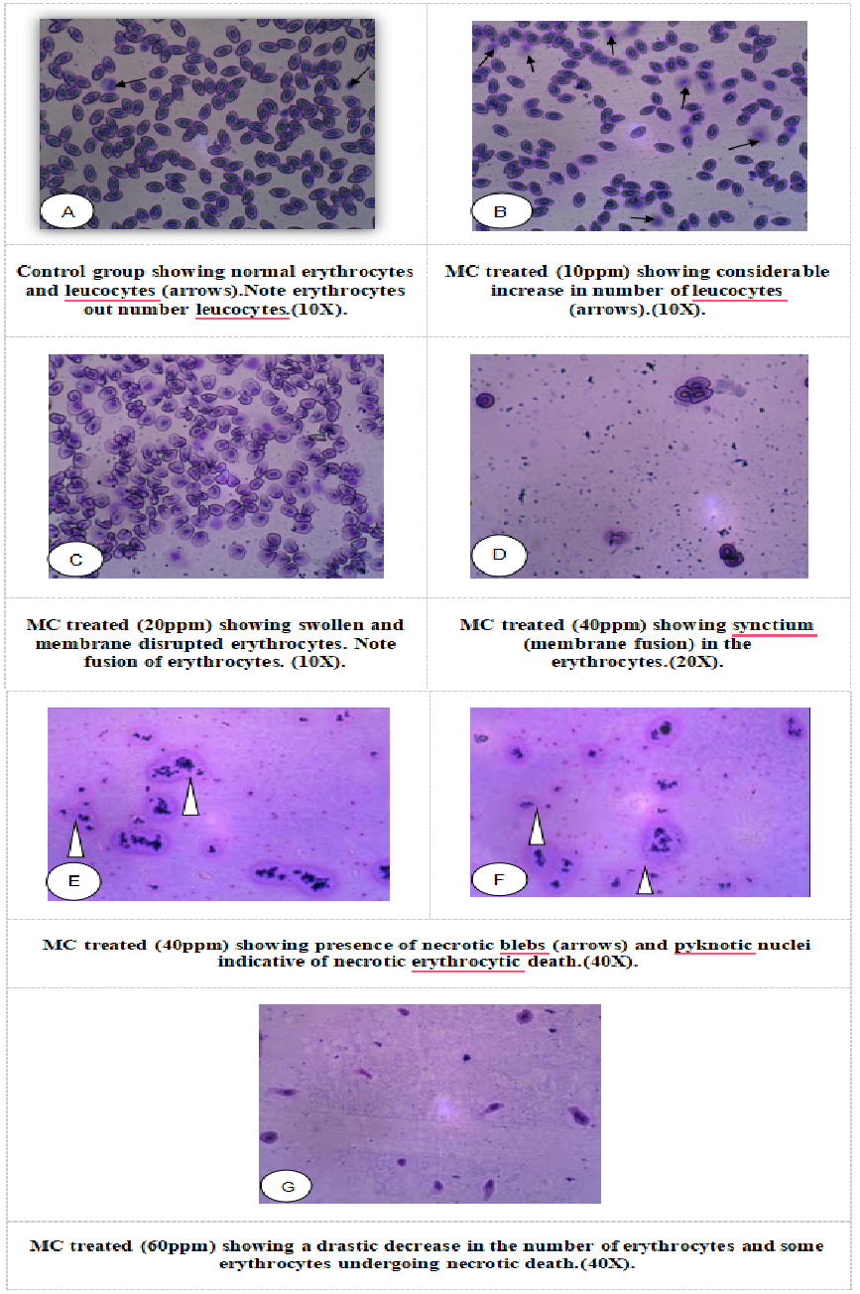

Fig. 6. Morphological Alterations in the blood cells of L. rohita exposed to sublethal concentrations of Monocrotophos

3.5 Comet Assay

Exposure lower concentrations of Monocrotophos resulted in significant changes in erythrocyte shape, indicating that even at sub-lethal levels, the pesticide promotes cellular stress and structural modifications. At a dosage of 40 ppm, exposure to Monocrotophos resulted in substantial DNA damage in the blood erythrocytes of L. rohita (Fig. 7B). This damage triggered a series of biological processes leading to apoptosis, a regulated type of cell death, in contrast to the normal morphology and preserved DNA seen in the control group (Fig. 7A). The observed results underscore the concentration-dependent character of the damage, with higher Monocrotophos concentrations exacerbating the severity of the toxic effects on erythrocyte DNA. At 40 ppm, the level of DNA damage surpassed the repair threshold, initiating cell death processes such apoptosis. Monocrotophos has been shown to induce genotoxicity via DNA damage (Blasiak et al., 2000; Matsumoto et al., 2003) and to modify the nuclear architecture of blood cells (Lim et al., 2003; Sharaf et al., 2010).Toxicities from this possible genotoxicant may cause DNA damage by modifying DNA bases and disrupting DNA strands (Borah, R.N. Yadav, 1995), perhaps resulting in aneuploidy. Evidence is evident in the instance of Channa punctata subjected to atrazine-based herbicides (Nwani et al., 2018).

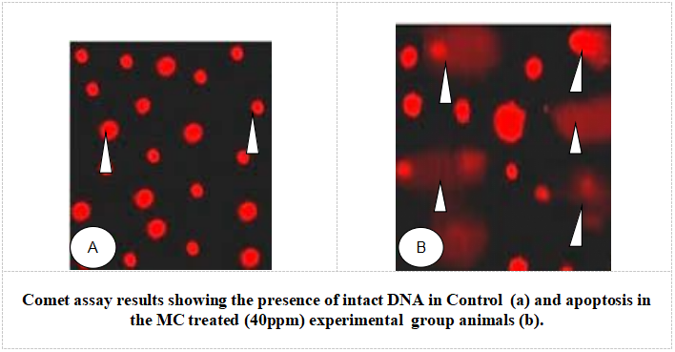

Fig. 7. Apoptotic Cell death as evidenced by Comet Assay in the erythrocytes of L. rohita exposed to sublethal concentrations of Monocrotophos

3.5 Histological alterations

3.5.1 Effect on gill tissue

Histopathological alterations have been observed in the gills of L. rohita subjected to a sublethal dosage of Monocrotophos (60 ppm) over a duration of 30 days (Figs. 8a-f). No alterations were seen in the gill of the control fish (Figure. 8a). Fish gills exposed to Monocrotophos exhibited swelling and erosion, along with curling and clubbing of the gill epithelium in the Secondary Gill Lamellae, and dilation of blood vessels (Figs. 8 b and c). Significant swelling at the ends of secondary gill lamellae owing to lamellar oedema was the prominent histological alteration seen (Figs. 8 d and e). A notable characteristic was the aggregation of lamellae in the secondary gill lamellae. The photomicrograph clearly indicates that lamellar fusion has occurred as a result of extended exposure to Monocrotophos (Fig. 8f).

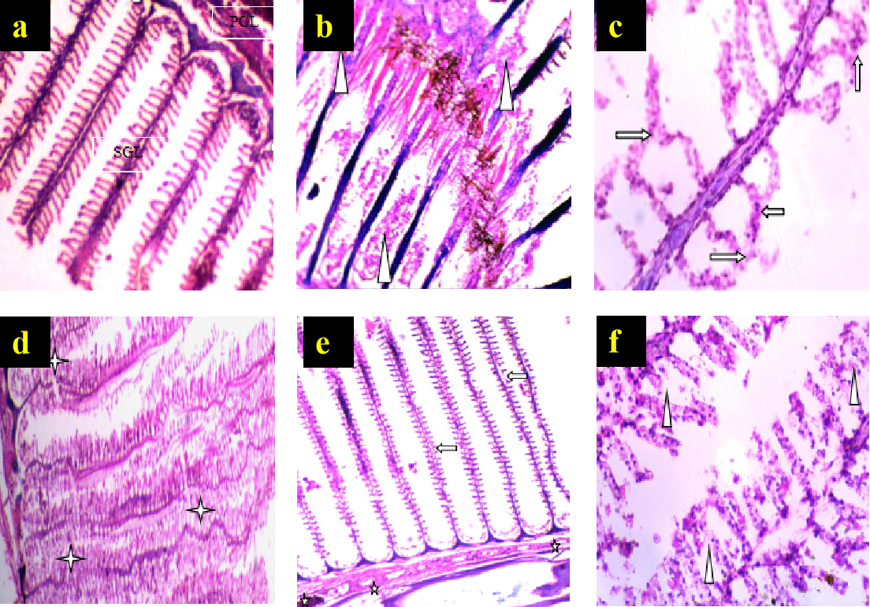

Fig. 8. Histological alterations in Gill of L. rohita exposed to the sublethal
(60 ppm) concentration of Monocrotophos for 30 days.
- Control gill. PGL-Primary Gill Lamellae; SGL-Secondary Gill Lamellae, b- Monocrotophos exposed swelling and erosion of the gill epithelium (arrows), c- curling and clubbing, d- interlamellar bridge formation or fusion. e - epithelial cell degeneration, f- epithelial cell erosion (arrows). Hematoxylin and Eosin stain, magnification: 100 and 400X.

3.5.2 Effect on liver tissue

Medium to extreme histo-pathological anomalies in the liver like congestion, ceroid production, hemorrhage, nuclear pyknosis, karyorrhexis, karyolysis, binucleated hepatocytes, nuclear hypertrophy, eccentric nuclei and vacuolar disintegration were observed at days-30 of the experiment. Numerous histo-pathological defects in the fish liver exposed to high concentrations (60ppm) of Monocrotophos showed vacuolar disintegration, karyorrhexis, karyolysis on days-30 of the experiment (Fig. 9). In liver histology of control group, the hepatocytes were normally arranged in cords of cells (Fig. 9a) In the present study, the liver of L. rohita, treated with sub lethal concentrations of Monocrotophos showed congestion of blood vessels (Fig. 9b), nuclear vacuolization (Fig. 9c) and the pyknotic nuclei released were seen pushed to the sinusoids (Fig. 9d). Karyopyknosis which is marked by irreversible condensation of chromatin, which was followed by karyorrhexis marked by fragmentation of the nucleus in necrotic cells was also observed (Fig. 9e). The displacing and compressing the nucleus karyorrhexis was also observed ,whereby its chromatin is distributed irregularly throughout the cytoplasm, karyopyknosis, nuclear and cytoplasmic vacuolization, cytoplasmic degeneration or collapse leading to increase in size i.e. ballooning degeneration, and the pyknotic nuclei released were seen pushed to the sinusoids, in the most worse condition worn out hepatocytes along with pyknotic nucleus were seen in the sinusoids signifying complete degeneration of hepatic tissue (Fig. 9f).

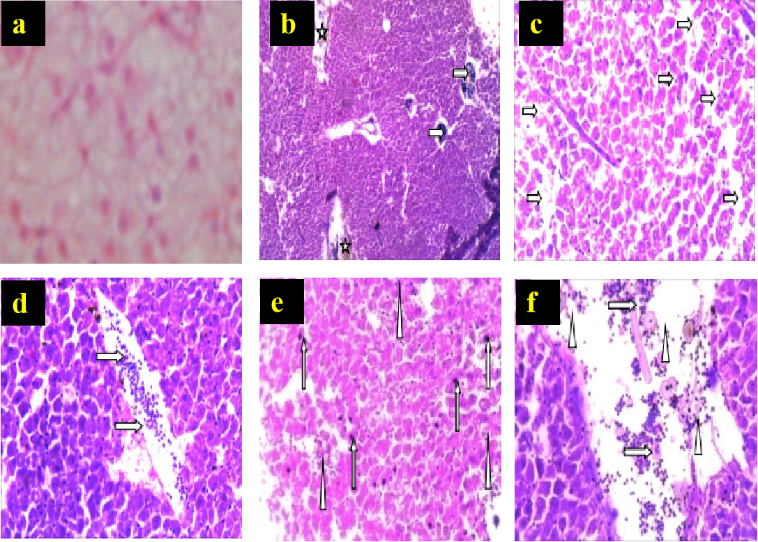

Fig. 9. The affected liver exposed to 60ppm Monocrotophos at days-30
a- control, b- and (b) congestion of blood vessels, c- nuclear vacuolization, d- nuclear pyknosis, e- karyorrhexis, karyolysis, binucleated hepatocytes, nuclear hypertrophy, eccentric nuclei and inflammatory exudate and f- pyknotic nuclei (arrows) and disintegrated hepatocytes from liver tissue . Hematoxylin and Eosin stain, magnification: 100 and 400X.

Our findings are consistent with previous histopathological studies on various fish species, including Heteropneustes fossilis (Pattnaik et al., 2022), Rutilus rutilus (Katuli et al., 2014), Scophthalmus maximus (Rosety-Rodrıguez et al., 2002), Catla catla (Maharajan and Parurukmani, 2012), and Scatophagus argus (Ghasemzadeh et al., 2015). These studies reported that pesticide exposure led to epithelial lifting, necrotic lamellae in gill tissues, oedema, lamellar fusion, and abnormalities in secondary gill lamellae. Similarly, histological alterations in gills following chlorpyrifos exposure have been documented in Oreochromis niloticus (Zahran et al., 2018) and Channa punctatus (Devi and Mishra, 2013). Our current investigation supports these findings, as we observed mucus accumulation within the secondary lamellae and a reduction in inter-lamellar cell mass. Similar observations were reported by Karmakar et al. (2016) in L. rohita exposed to toxicants. Moreover, recent studies have employed histological examinations to characterise the toxic effects of monocrotophos on multiple organs, including the gills, heart, kidney, and liver (Sivakumar et al., 2022).

- CONCLUSION

This research examines the harmful effects of Monocrotophos at sub-lethal doses on various haematological and histopathological parameters of L. rohita gills and liver tissues. Our results revealed that monocrotophos has severe toxic effects on freshwater fish, severely affecting blood biochemistry and tissue integrity in an approach that is dependent on both concentration and exposure duration. These parameters serve to be accurate markers of the fish physiological health and may be used to determine the negative impacts of monocrotophos in aquatic environments. As a result, it is essential to control the broad use of pesticides and take preventative measures to reduce water pollution from this harmful chemical.

COMPETING INTERESTS DISCLAIMER:
Authors have declared that they have no known competing financial interests OR non-financial interests OR personal relationships that could have appeared to influence the work reported in this paper.

REFERENCES
Abdel-Tawwab, M., Monier, M. N., Hoseinifar, S. H., & Faggio, C. (2019). Fish response to hypoxia stress: Growth, physiological, and immunological biomarkers. Fish Physiology and Biochemistry, 45(4), 997–1013.
Al-Emran, M., Hasan, N. A., Khan, M. P., Islam, S. M., Bashar, A., Zulfahmi, I., & Sumon, K. A. (2022). Alterations in hematological parameters and the structure of peripheral erythrocytes in Nile tilapia (Oreochromis niloticus) exposed to profenofos. Environmental Science and Pollution Research. https://doi.org/10.1007/s11356-022-19612-y
Binukumari, S., Devi, K. A., & Vasanthi, J. (2016). Applications in environmental risk assessment of biochemical analysis on the Indian freshwater fish, Labeo rohita exposed to monocrotophos pesticide. Environmental Toxicology and Pharmacology, 47, 200–205.
Blasiak, J., & Kowalik, J. (2000). A comparison of the in vitro genotoxicity of tri- and hexavalent chromium. Mutat. Res., 469, 135–145.
Blaxhall, P. C. (1972). The haematological assessment of the health of freshwater fish: a review of selected literature. Journal of fish biology, 4(4), 593-604.
Borah, T., & Yadav, R.N. (1995). Static bioassay and toxicity of two pesticides, rogor and endosulfan, to air-breathing fish Heteropneustes fossilis with special reference to behavior. Pollut. Res., 15, 435–438.
Dar, S. A., Chatterjee, A., Rather, M. A., Chetia, D., Srivastava, P. P., & Gupta, S. (2020). Identification, functional characterization, and expression profiling of cytochrome P450 1A (CYP1A) gene in Labeo rohita against emamectin benzoate. International Journal of Biological Macromolecules, 158, 1268–1278.
Dar, M. A., Hamid, B., & Kaushik, G. (2023). Temporal trends in the use and concentration of organophosphorus pesticides in Indian riverine water, toxicity, and their risk assessment. Regional Studies in Marine Science, 59, 102814.
Das, B. K., & Mukherjee, S. C. (2003). Toxicity of cypermethrin in Labeo rohita fingerlings: Biochemical, enzymatic, and hematological consequences. Comparative Biochemistry and Physiology Part C: Toxicology & Pharmacology, 134(1), 109–121.
Das, B. K., Nayak, K. K., & Kumar, V. (2024). Alteration of haematological and biochemical biomarkers after sub-lethal chronic malathion (Elathion®) intoxication in freshwater fish, Labeo rohita (Hamilton, 1822). Comparative Biochemistry and Physiology Part C: Toxicology & Pharmacology, 277, 109844.
Davoodi, R., & Abdi, G. (2012). Comparative study on the acute toxicity of synthetic pesticides, permethrin 25% and monocrotophos 36%, and neem-based pesticide, neem gold EC 0.03%, to juvenile Cyprinus carpio Linn. Journal of Biological and Environmental Sciences, 6(16).
Devi, Y., & Mishra, A. (2013). Histopathological alterations in gill and liver anatomy of freshwater, air-breathing fish Channa punctatus after pesticide Hilban® (chlorpyrifos) treatment. Advances in Bio Research, 4(2), 57–62.
Farag, M. R., Alagawany, M., Taha, H. S., Ismail, T. A., Khalil, S. R., & Abou-Zeid, S. M. (2021). Immune response and susceptibility of Nile tilapia fish to Aeromonas hydrophila infection following exposure to bifenthrin and/or supplementation with Petroselinum crispum essential oil. Ecotoxicology and Environmental Safety, 216, 112205.
Finney, D. J. (1978). Statistical methods in biological assay (3rd ed.). Charles Griffin & Company Press, 508.
Ghaffar, A., Riaz, H., Ahrar, K., & Abbas, R. Z. (2015). Hemato-biochemical and genetic damage caused by triazophos in freshwater fish Labeo rohita. International Journal of Agriculture and Biology, 17(4), 637–642.
Ghasemzadeh, J., Sinaei, M., & Bolouki, M. (2015). Biochemical and histological changes in fish, spotted scat (Scatophagus argus) exposed to diazinon. Bulletin of Environmental Contamination and Toxicology, 94(2), 164–170.
Gholami-Seyedkolaei, S. J., Mirvaghefi, A., Farahmand, H., & Kosari, A. A. (2013). Effect of a glyphosate-based herbicide in Cyprinus carpio: Assessment of acetylcholinesterase activity, hematological responses, and serum biochemical parameters. Ecotoxicology and Environmental Safety, 98, 135–141.
Islam, S. M., Rohani, M. F., Zabed, S. A., Islam, M. T., Jannat, R., Akter, Y., & Shahjahan, M. (2020). Acute effects of chromium on hemato-biochemical parameters and morphology of erythrocytes in striped catfish (Pangasianodon hypophthalmus). Toxicology Reports, 7, 664–670.
Joseph, A., Bassey, A., Ebari, S., & Eni, G. (2024). Hormonal and haematological biomarkers as indicators of stress induced by Diuron herbicide toxicity on Clarias gariepinus (Burchell, 1822) sub-adults. Comparative Biochemistry and Physiology Part C: Toxicology & Pharmacology, 276, 109802.
Karmakar, S., Patra, K., Jana, S., Mandal, D. P., & Bhattacharjee, S. (2016). Exposure to environmentally relevant concentrations of malathion induces significant cellular, biochemical, and histological alterations in Labeo rohita. Pesticide Biochemistry and Physiology, 126, 49–57.
Katuli, K. K., Amiri, B.M., Massarsky, A., & Yelghi, S. (2014). Impact of a short-term diazinon exposure on the osmoregulation potentiality of Caspian roach (Rutilus rutilus) fingerlings. Chemosphere, 108, 396-404.
Krause, K. H., van Thriel, C., De Sousa, P. A., Leist, M., & Hengstler, J. G. (2013). Monocrotophos in Gandaman village: India school lunch deaths and need for improved toxicity testing. Archives of Toxicology, 87, 1877–1881.
Kumar, V., Swain, H. S., Das, B. K., Roy, S., Upadhyay, A., Ramteke, M. H., & Banerjee, H. (2022). Assessment of the effect of sub-lethal acute toxicity of Emamectin benzoate in Labeo rohita using multiple biomarker approach. Toxicology Reports, 9, 102–110.
Lim, S., Ahn, S.Y., Song, I.C., Chung, M.H., & Jang, H.C. (2009). Chronic exposure to the herbicide atrazine causes mitochondrial dysfunction and insulin resistance. PLoS One, 4(9), e5186.
Maharajan, A., & Parurukmani, P. S. (2012). Effect of aluminium chloride toxicity against histopathology of gill and liver tissue of Indian major carp, Catla Catla (Hamilton). International Journal of Pharma and Bio Sciences, 3(3), 523–530.
Matsumoto, S.T., Mantovani, M.S., Mallaguti, M.I., & Marin-Morales, M.A. (2003). Investigation of the genotoxic potential of the waters of a river receiving tannery effluents by means of the in vitro comet assay. Cytologia, 68, 395–401.
Maurya, P. K., Jyoti, S., & Maurya, P. K. (2024). Acute toxicity of dithane M-45 in freshwater fish Labeo rohita: A laboratory study. Environment Conservation Journal, 25(4), 1113–1119.
Narra, M. R. (2016). Single and cartel effect of pesticides on biochemical and hematological status of Clarias batrachus: A long-term monitoring. Chemosphere, 144, 966–974.
Nwani, B.D., Nagpure, N.S., Kumar, R., Kushwaha, B., Kumar, P., & Lakra, W.S. (2011). Mutagenic and genotoxic assessment of atrazine-based herbicide to freshwater fish Channa punctatus (Bloch) using micronucleus test and single cell gel electrophoresis. Environ. Toxicol. Pharmacol., 31, 314–322.
Oluah, N. S., Aguzie, I. O., Ekechukwu, N. E., Madu, J. C., Ngene, C. I., & Oluah, C. (2020). Hematological and immunological responses in the African catfish Clarias gariepinus exposed to sublethal concentrations of herbicide Ronstar®. Ecotoxicology and Environmental Safety, 201, 110824.
Pattnaik, S., Samal, S., Mishra, C. S. K., Ghosh, P., Muduli, N., Biswal, M., & Sundaray, J. K. (2022). Effect of organophosphate, Monocrotophos on behavioural, haematological, histological, and biochemical indices in the subtropical catfish Heteropneustes fossilis (Bloch, 1794). Journal of the Indian Society of Coastal Agricultural Research, 40(1), 25–35.
Rajan, D. K., Mohan, K., Rajarajeswaran, J., Divya, D., Thanigaivel, S., & Zhang, S. (2024). Toxic effects of organophosphate pesticide monocrotophos in aquatic organisms: A review of challenges, regulations, and future perspectives. Environmental Research, 244, 117947.
Ritu, R. F., Islam, S. M., Rashid, H., Haque, S. M., Zulfahmi, I., & Sumon, K. A. (2022). Application of fenitrothion on Heteropneustes fossilis causes alteration in morphology of erythrocytes via modifying hematological parameters. Toxicology Reports, 9, 895–904.
Rosety-Rodríguez, M., Ordoñez, F.J., Rosety, M., Rosety, J.M., Rosety, I., Ribelles, A., & Carrasco, C. (2002). Morpho-histochemical changes in the gills of turbot, Scophthalmus maximus L., induced by sodium dodecyl sulfate. Ecotoxicology and Environmental Safety, 51(3), 223-228.
Sharaf, S., Khan, A., Khan, M.Z., Aslam, F., Saleemi, M.K., Mahmood, F. (2010). Clinicohematological and micronuclear changes induced by cypermethrin in broiler chicks: Their attenuation with vitamin E and selenium. Expt. Toxicol. Pathol., 62, 333–341.
Singh, N. P., Danner, D. B., Tice, R. R., Pearson, J. D., Brant, L. J., Morrell, C. H., & Schneider, E. L. (1991). Basal DNA damage in individual human lymphocytes with age. Mutation Research/DNAging, 256(1), 1-6.
Singh, S., Kumar, V., Kanwar, R., Wani, A. B., Gill, J. P. K., Garg, V. K., & Ramamurthy, P. C. (2021). Toxicity and detoxification of monocrotophos from the ecosystem using different approaches: A review. Chemosphere, 275, 130051.
Sivakumar, J., Bhuvaneswari, S., Venu, S., Pathra, A., Rajkumar, M., & Sankarganesh, C. S. P. (2022). Acute toxicity of monocrotophos on histological alterations in the Hong Kong cat fish, Clarias fuscus (Lacepède, 1803).
Sprague, J. B. (1971). Measurement of pollution toxicity to fish III. Sublethal effects and “safe” concentration. Water Research, 5(6), 245–266.
Tamizhazhagan, V., & Pugazhendy, K. (2016). The toxicity effect of monocrotophos 36% EC on the biochemical changes in Labeo rohita (Hamilton, 1882). International Journal for Scientific Research and Development, 3(11), 802–808.
Vardavas, A. I., Stivaktakis, P. D., Tzatzarakis, M. N., Fragkiadaki, P., Vasilaki, F., Tzardi, M., & Tsatsakis, A. M. (2016). Long-term exposure to cypermethrin and piperonyl butoxide cause liver and kidney inflammation and induce genotoxicity in New Zealand white male rabbits. Food and Chemical Toxicology, 94, 250–259.
Velmurugan, B., Selvanayagam, M., Cengiz, E. I., & Unlu, E. (2007). The effects of monocrotophos to different tissues of freshwater fish Cirrhinus mrigala. Bulletin of Environmental Contamination and Toxicology, 78(6), 450–454.
Ventura, B.C., Angeli, D.F., & Marin-Molares, M.A. (2008). Mutagenic and genotoxic effects of the atrazine herbicide in Oreochromis niloticus (Perciformes, Cichlidae) detected by the micronuclei test and the comet assay. Pest. Biochem. Physiol, 90, 42–51.
Zahran, E., Risha, E., Awadin, W., & Palić, D. (2018). Acute exposure to chlorpyrifos induces reversible changes in health parameters of Nile tilapia (Oreochromis niloticus). Aquatic Toxicology, 197, 47–59.

