ECOFRIENDLY PLANT BASED INSECTICIDES AGAINST MOSQUITOES AND COCKROACHES.

ABSTRACT

Mosquitoes and cockroaches are the most important and abundant pest in urban, suburban and rural environment .In recent years, in all tropical and subtropical countries mosquito borne diseases have become major human health problem. Recently we heard increase in the Dengue fever cases, malaria cases and Typhoid fever in residential educational institutions and in our surrounding areas of our district. The diseases transmitted through mosquitoes and cockroaches include malaria, filariasis, yellow fever, Japanese encephalitis dengue fever and Typhoid fever. Biological, chemical, environmental and individual protection measures are taken as vector control measures to prevent spread of malaria, dengue fever and other mosquito-borne diseases. Such serious diseases controlling are becoming increasingly difficult because of high rate of reproduction and development of resistance to insecticides in mosquitoes and cockroaches.
Insect repellents date back to ancient times, with the use of tars, smokes, plant based oils and other modalities. Advancements of chemical sciences have formulated various synthetic repellents and advocated. However, constant and indiscriminate use of these synthetic repellents causes adverse effects on the users . These synthetic insect repellents have been extensively used for mosquito control by killing and thereby preventing adult mosquito bite human beings or by killing mosquito larvae at the breeding sites of vectors. The deleterious impact of these synthetic formulations on non-target population and the development of resistance have brought about the search of alternative, simple and sustainable methods of Mosquitoes and cockroach control.
The need for development of effective insecticides should be taken in to consideration due to toxicity problems, together with the increased incidence of insect resistance . In the most parts of the world, synthetic chemical insecticides continue to be applied for controlling mosquitoes and cockroaches but many of these chemicals are toxic to humans, animals and environment resistance can be problematic in regulating the control. Therefore, the present study natural substances to be used as insecticides for controlling mosquitoes and cockroaches. These Plant based insecticides are safe, eco friendly, cheap, easy to use and have maximum repellence against mosquitoes and cockroaches. Hence, an effort was made to prepare cow dung based herbal mosquito repellent. Studies have shown that many plants have evolved aromatic and insecticidal properties that repel mosquitoes and other insects.

INTRODUCTION

Popular insects include mosquitoes, flies, bugs, cockroaches, ticks, butterflies, moths, bees, wasps and so on and are notorious for their unpleasant, itchy sting.
The two major insects, mosquitoes and cockroches are primarily interested in vector-borne disease transmission Mosquito-borne diseases such as malaria, chikengunya, yellow fever, Rift Valley fever, dengue fever, and filariasis, Japanese encephalitis in many parts of the world produce significant morbidity and mortality in humans and livestock. Cockroaches are known to transmit Salmonella (sp) bacteria which can cause salmonellosis a disease in humans with symptoms similar to food poisoning. According to World Health Organization (WHO) reports, there were approximately 270 million cases of malaria and approximately one million deaths annually. Lymphatic filariasis is another disease which is spread by insects. It is largely caused by the Culex pipiens common house mosquito, and is estimated to be between 100 and 250 million in a year. Over the past few decades, the number of individuals at risk from this urban disease has increased. The Aedes aegypti is widely spread throughout the globe 's tropical, subtropical, and temperate zones, and is one of the largest domestic mosquito species that are both human pests and vectors of disease agents.

OBJECTIVES

- To reduce the problem by using of chemical insecticides causing irritations .
- To prepare very low cost plant based insecticide and can prepare everyone easily.
- To prepare more insecticidal repellent activity than chemical insecticides.
- To prepare plant based Eco-friendly and having low toxicity insect repellents.
- To grow the mosquito repellent plants in schools and in our surrounding areas.

RELEVANCE TO THE SOCIETY

The present research study would benefit the people of any age. Specifically, the residents of villagers and Farmers will benefit. This study use to lessen the chances of being susceptible to insect bites such as mosquito bites that may lead to mosquito-related disease. This research study will be used by any individual to prepare themselves for the rainy and summer season where dengue outbreak in areas are concerned. Through this research, once it is proven effective, they will no longer buy commercial repellents that is expensive and may cause harm to their health and to environment. This study is most beneficial to Government residential Institutions, the schools located in remote areas, slum areas, people who lives in remote areas etc. Herbal medicines are more effective to cure different types of new and old diseases; it has number of applications in respective fields. Organic constituents are degradable harmless to the environment. Various types of diseases like dengue, malaria, typhoid, yellow fever which is caused by mosquito bite and cockroaches.. Many deaths occur every year in India due to mosquitoes transmitted diseases like malaria, dengue, filarial, encephalitis, chickengunea, infiltration and have been to find their way into residences and also breed nearly or in houses having open water storage tanks etc.

SCIENTIFIC PRINCIPLE

The use of chemical pesticides causes pollution and has harmful target effects and may stimulate resistance in pests. Another problem associated with pesticides use is their short term and long term health effect. However, in many cases people applying the pesticides are unaware of how they work and what precautions should be used in their application.

- Lemon Grass (Cymbopogon citrates): Lemon grass is a widely used herb in tropical countries, especially in Southeast Asia. The essential oil of the plant is used in aromatherapy. The compounds identified in Cymbopogon citratus are mainly terpenes, alcohols, ketones, aldehyde and esters. Studies indicate that Cymbopogon citratus possesses various phytochemicals also act as insect repellent.

- “Lemon basil” (Ocimum basilicum citrodorum). Although, Dutta & Dhiman, 2020 observed attraction of mosquitoes on different colours. In view of this present studies and anti-inflammatory and antimalarial properties. Phytochemicals also act as insect repellent.

- Ajwain(Trachispermum ammi); Essential oil of seeds of Trachyspermum ammi (Linn.) Sprauge and its pure constituent thymol against larvicidal, oviposition-deterrent, vapor toxicity, and repellent activity against malarial vector, Anopheles stephensi. Thymol have broad insecticidal activity against arthropod species of agricultural, medical and veterinary importance including Anopheles, Aedes and Culex mosquito and cockroaches.

- Chrysanthemum (Chrysanthemum) – Flowers that Deter Cockroaches
For a flowering plant with vibrant blooms that is also a roach repellent plant, chrysanthemums are an excellent choice. They produce Pyrethrin that kills and deters harmful insects while attracting the butterfly, a beneficial insect.

- Peppermint(Mentha piperita): The peppermint and its essential oil include menthone and pulegone. As a pesticide, the primary active ingredient, menthol, has biocidal properties and is effective at controlling mites, mosquito larvae, and various other pests.

- Campher (cinnamomum camphora): Camphor formula, also known as 2-Camphanone formula or Kampfer . It is a bicyclic monoterpene ketone which is found plants like Cinnamomum Camphora. The molecular or chemical formula of Camphor is C10H16O. Kampfer is colourless to white waxy crystalline powder. It is flammable and has a strong aroma or mothball-like smell. Camphor Oil is extracted from the wood of camphor laurel. It has properties such as anti-inflammatory, analgesic, an insect repellent.

- Thangedu(Senna auriculata):Senna auriculata flowers which has mosquito repellency
which helps in protecting man from mosquitoes and cockroaches too.

- Osage Orange Tree (Maclura pomifera): The osage orange, or hedge apple, is an odd-looking shrub, producing a rotten smell that lures roaches. The green and bumpy, inedible fruit contains natural pesticide juices. Once the insects bite into the fruit’s flesh, it emits a citrus scent that drives them away.
Lavender (Lavandula) – Aromatic Herb that Repels Cockroaches: This flowering herb is famous
for its long stems of purple flowers and delicate, calming fragrance. However, it has other uses, and
that’s keeping the roach, tomato hornworm, asparagus beetle, and other pests at bay with its
essential oil. The lavender serve as a natural insect repellent.

- Citronella (Pelargonium graveolens Citrosa)
Citronella is one of the more popular plants for repelling roaches and other insects. The
plant releases a citrus scent the many bugs hate. Plant it in an outdoor setting, crush the
foliage to emit the smell.

.

- Osage Orange Tree (Maclura pomifera): The osage orange, or hedge apple, is an odd-looking shrub, producing a rotten smell that lures roaches. The green and bumpy, inedible fruit contains natural pesticide juices. Once the insects bite into the fruit’s flesh, it emits a citrus scent that drives them away.

Lavender (Lavandula) – Aromatic Herb that Repels Cockroaches: This flowering herb is famous for its long stems of purple flowers and delicate, calming fragrance. However, it has other uses, and that’s keeping the roach, tomato hornworm, asparagus beetle, and other pests at bay with its essential oil. The lavender serve as a natural insect repellent.
- Citronella (Pelargonium graveolens Citrosa)
Citronella is one of the more popular plants for repelling roaches and other insects. The
plant releases a citrus scent the many bugs hate. Plant it in an outdoor setting, crush the
foliage to emit the smell.

Research method Materials;

Collection of Plants:
Raw material will have been selected based on experience, traditional knowledge and practice by ancestors. Cow dung contains plenty of Menthol, Ammonia, Phenol, Indol, Formalin and specially its bacteriophage eradicate the pathogens and are a recognized disinfectant .Sometimes cow dung only is used for fumigation after drying under sunlight and sometimes cow dung is used as mosquito repellant in combination with other herbal products. Plant products are emerging as a potential source of mosquito control and among them essential oils have special interest due to their insecticidal properties. Here, we are reporting some of the herbal ingredients that available villages .
- LemonGrass (Cymbopogon lexuosus), Lemon basil (Ocimum basilicum citrodorum), Chrysanthemum (Chrysanthemum) , Peppermint(Mentha piperita) Camphor(Cinnamomum camphora) , Lavender (Lavandula) . Ajwain(Trachispermum ammi) , Osage Orange Tree (Maclura pomifera): Citronella (Pelargonium graveolens Citrosa) and Thangedu(Senna auriculata).

Preparation of insecnsestick

By using mortar and pestle, the plant products were crushed using distilled water and were mixed with fresh cow dung; that the cow dung and plant paste were mixed in 1:10 ratio.

Formulation

Agarbatti (Incense sticks), Coils, Cards, Candles, sprays etc. were prepared using the mixture. In case of Cards, the mixture was smeared on Whatmann No. 1 Filter paper. In all types of preparation, either they were dried in the oven at 70c for 6 hr and further kept in the for drying. we will keep under sunlight.

Table1: The constituents in the mosquito and roaches repellent

Sno | Common name | Weight in gms
1 | Lemongrass | 10gms
2 | Lemon basil | 5gms
3 | Chrysanthemum | 5gms
4 | Citronella | 10gms
5 | Osage Orange Tree | 10gms
6 | Peppermint | 10gms
7 | Camphor | 5gms
8 | Ajwain | 5gms
9 | Thangedu | 20gms
10 | Cowdung | 10gms
11 | Acasiagum | 5gms
12 | Lavender (Lavandula) | 5gms

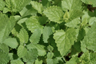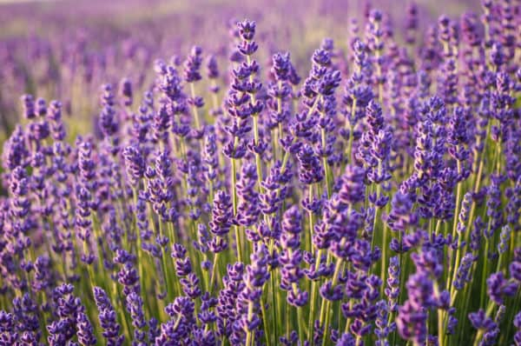

Fig 1 : Peppermint fig 2 : Lavender

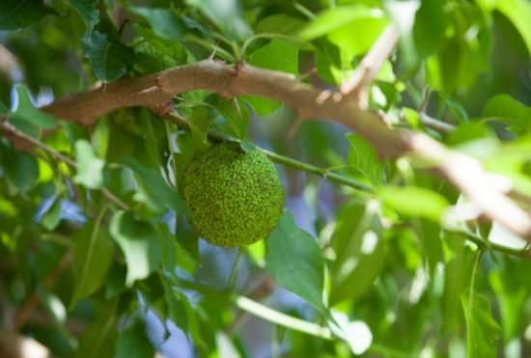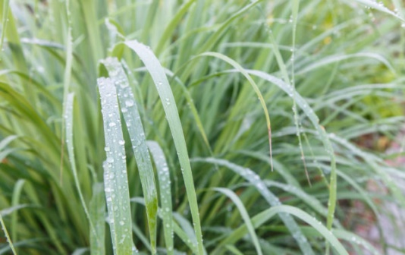
Fig 3 : Osage Orange Tree
Fig 4 : Lemongrass
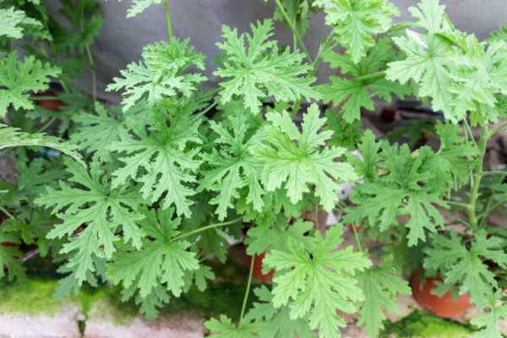
Fig 5 : Citronella fig 6 : Chrysanthemum

  - Laboratory method(Glass chamber or Arm- in –cage) Bio insecticide stick preparation:
Bio insecticidal stick will prepare by using of cow dung and plant extracts two sources will use as stick material. These combinations will be prepared as semi solid paste. Bio insecticide will make manually by a device and coils will be kept in a dry place for drying. The experimental set up will place in glass chambers measuring 140 × 120 × 60 cm for experimentation. A window measuring 60 × 30 cm will situate at the mid bottom of one side of the chamber. Four day old and 100 starved adult females will released into the chamber and provide with 10% sucrose solutions. Repellent activity test and Smoke toxicity will test herbal mosquito repellent from 20 min to 1 hr Intervals respectively . Evaluation will be done against the 3rd and 4th instar nymphs using three bioassay methods; continuous contact toxicity, fumigant toxicity and repellent activity. In the same way collection of cockroaches with insect trap and placed them in above mentioned glass chamber and fed them after few days observe the repellent activity and mortality rate.

Public survey- Community volunteer survey carries to test the health and effectiveness of Bio-insecticide stick and Plant based insectisdal spryas at 10 houses and 10 school in select in our locality. The recipe was circulate to all participants and collects the feedbacks. The analysis will take 1 month to finish. The results will be systematically analysis.

Method 2 (cold extract in ethanol): For spray preparation: LemonGrass (Cymbopogon lexuosus), Lemon basil (Ocimum basilicum citrodorum), Chrysanthemum (Chrysanthemum) , Peppermint(Mentha piperita) Camphor , Lavender (Lavandula) (Cinnamomum camphora). Ajwain(Trachispermum ammi) , Osage Orange Tree (Maclura pomifera): Citronella (Pelargonium graveolens Citrosa) and Thangedu(Senna auriculata).powders will be taken as mentioned above. They will soak in ethanol for 48 hours in a flask and shaken every 30 minutes . After 48 hours, the mixture will be filtered and filled into vaporizers. 2-3 drops of scented oil will add to the vaporizer to provide a pleasant smell. The vaporizer will be connected to an electrical source, and the duration of repellent activity of the solution will check using human volunteer.

RESULTS AND DISCUSSIONS:
LemonGrass (Cymbopogon lexuosus), Lemon basil (Ocimum basillicum citrodorum), Neem (Azadirachta indica), marigold(Tagitus erecta) ,Eucalyptus (Eucalyptus globules), Peppermint(Mentha piperita) Camphor , (Cinnamomum camphora). Ajwain(Trachispermum ammi). The studies shows these plants have insecticide repellent properties. Thangedu(Senna auriculata)which has Flowers repellency which helps in protecting man from mosquitoes and cockroaches too.

The mentioned plants can grow everywhere and we can collect the plant products easily and prepared the powders and oil extracts easily. So every one can prepare easily. There is no adverse effects of the plant based insecticide.
Natural plants namely as: have high degree of repelleny against mosquitoes are recommended as :
LemonGrass (Cymbopogon lexuosus), Lemon basil (Ocimum basilicum citrodorum), Chrysanthemum(Chrysanthemum),Peppermint(Mentha piperita) Camphor(Cinnamomum camphora),Lavender(Lavandula). Ajwain(Trachispermum ammi) , Osage Orange Tree (Maclura pomifera): Citronella (Pelargonium graveolens Citrosa) and Thangedu(Senna auriculata)new active ingredients for inclusion in mosquito coil formulation(Trivedi et al., 2018). These plants contain bioactive compounds which act as repellents aralkaloid, trepenoids,phenolic, proteinase inhibitors and growth regulators which are functioning as a defence against phytophagous insects (Patil et al., 2012). Thangedu(Senna auriculata) flowers which has mosquito repellency which helps in protecting man from mosquitoes and cockroaches too.
Table 2: Sample and ingredients of herbal anti-mosquito stick (Dhoopwati).

 | Sample No | Ingredients
1 | 1.D-1 Dhoop | D-1 Dhoop Lemon basil+ Camphor + lavender
2 | 2. D-2 Dhoop | 2. D-2 Dhoop Thangedu +Lemongrass + lavender
3 | 3. D-3 Dhoop | 3. D-3 Dhoop Osage Orange + campher + Citronella
4 | 4. D-4 Dhoop | 4. D-4 Ajwain + lemongrass + Peppermint+ campher
5 | 5. D-5 Dhoop | 5. D-5 Dhoop Lemon basil + lemongrass+ Chysanthimum + Peppermint +Thangedu+Lavender+ Campher+ Osage Orange+Citronella

Fig 7 : Mosquito repellence Activity

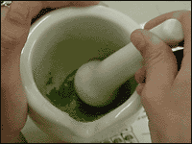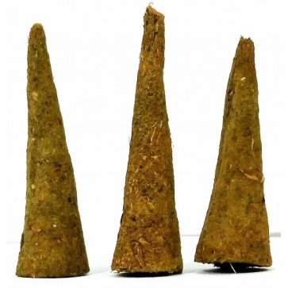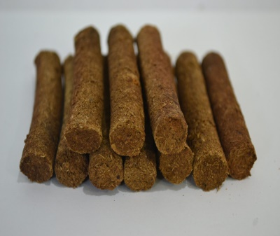

Plate 1 : Preparation of Eco-friendly low toxicity insect repellents

- Conclusion: They are miniscule in size, but mosquitoes are one of the deadliest insects as their bite can cause infections and lead to many health problems. Now, with the onset of monsoons there is an increase in the number of mosquitoes and hence an outbreak of mosquito-borne diseases like malaria, zika, chikungunya and dengue. Growing plants like neem , lemon basil, peppermint, lemongrass, marigold and Eucalyptus are helpful as they act as natural and effective insect repellents. Mint leaves are also an effective mosquito repellent and hence it is advisable to plant trees in the surroundings. Cow dung with neem leaves is very effective in getting rid of mosquitoes. Thangedu(Senna auriculata) flowers which has mosquito repellency which helps in protecting man from mosquitoes and cockroaches too.Adding to marigold, peppermint lemon basil, Eucalyptus and camphur sticks keeps mosquitoes away when out doors. Using camphor, lemongrass oil, Basil oil an aroma sprays are useful. In order to minimise the impact of mosquito bites and get relief from swelling, redness, itching and skin inflammation, any one of the following can be applied on the affected area. The above plant based insecticides have insecticidal properties against cockroaches. The insecticidal plants have aromatic so they against mosquitoes and cockroaches and get rid of so many diseases. These herbal insecticides are eco-friendly and every one can prepare easily because of these plants can grow abundant in every where.

References

1. Achio, S., Ameko, E., Kutsanedzie, F., and Alhassan, S.: Insecticidal effects of various neem preparations against some insects of agricultural and public health concern. International Journal of Research In Biosciences, 1( 2): 11-19 (2012)

2. Dahaliwal, G.,S., and Batwinder, Singh.: Pesticides And Environment, 280-324 (1991)

3. Faujan, B., H., Ahmad, Muhammad, M., Mackeen,, Abdu,l M., Ali, Siti R., Mashirun Mariani and M. Yaacob. Repellency Of Essential Oils Against The Domiciliary Cockroach Periplaneta americana, 16: 391 - 393 (1995)

4. Feng, Chen; Patricia, A, Zungoli and Eric, Benson. Screening of natural insecticides from tropical plants against fire ants, termites, and cockroaches. 39: 313–316 (2009)

5. Gobette, A. Toxicity of Chlorinated Hydrocarbons, Pestic. Biochem. Physiol. 14: 139-143 (1980) 6. Koehler, P.,G., Strong, C.,A., and Patterson, R.,S.:.Differential Susceptibility Of German Cockroach (Dictyoptera: Blattellidae) Sexes And Nymphal Age Classes To Insecticides. J Econ Entomol.; 86: 785–92 (1993).

7. Ling. A., Sulaiman,S. and Othman, H. Evaluation of piper aduncum linn. essential oil (fam: piperaceae) against periplaneta americana (l.), Iran J Arthropod Borne Diseases. 3(2): 1–6 (2009)

8. Ogunleye, R., F. Toxicity bioassays of four different botanicals against the house hold pest: Periplaneta americana (Linnaeus), Journal of Science and Technology. 30(2): 29-32 (2010)

9. Pugazhvendan, S., R., P. Ronald Ross; and K. Elumalai. Insecticidal and repellant activities of four indigenous medicinal plants against stored grain pest, tribolium castaneum (herbst) (coleoptera:tenebrionidae), Asian Pacific Journal of Tropical Disease.16-20 (2012)

10. Randhawa, N., S., and Parmar, B., S.:Neem Research And Development. Pp10-12. (1993)

11. Ratcliffe, D., A Residual Effect of DDT In The Biosphere, Nature,215: 208-210 (1967)

12. Sakuma, M ., and Funkami, H. The linear track olfactometer: an assay device for taxes of the german cockroach, blattella germanica (linn.) toward their aggregation pheromone. Applied Entomology And Zoology.74(6):523-525. (1985)

13. Shay, P., Ngoh; Lione,l E., W., Choo, Fung Y., Pang; Yan, Huang; Manjunatha, R. Kini. and Shuit, H. HO. Insecticidal and repellent properties of nine volatile constituents of essential oils against the american cockroach,54(3): 261-268 (1998)

14. Swan, T. Secondary Compounds As Protective Agents, A Review Of Plant Physiology, 28: 497-501 (1977).

15. Thavara, U., Tawatsin, A., Bhakdeenuan, P., Wongsinkongman, P., Boonruad, T., Bansiddhi, J., Chavalittumrong, P., Komalamisra, N., Siriyasatien, P. and Mulla, M.,S. Repellent activity of essential oils against cockroaches (dictyoptera: blattidae, blattellidae, and blaberidae) in Thailand, Southeast Asian J Trop Med Public Health. 38(4): 663-73 (2007).
16. Mercy Njuguna, Joseph Gichuki, Fredrick Otieno. Efficacy of Plant-based Repellents Against
Anopheles Mosquitoes: A Systematic Review. Biomedical Sciences. Vol. 6, No. 3, 2020, pp. 44-5.

Laura Nyawira Wangai, Kenny Kimani Kamau, Godwil Munyekenye, David Nderu, Eva Maina, William Gitau, Mary Murigi, Susan Kamau,
Mercy Njuguna, Joseph Gichuki, Fredrick Otieno. Efficacy of Plant-based Repellents Against Anopheles Mosquitoes: A Systematic Review.
Biomedical Sciences. Vol. 6, No. 3, 2020, pp. 44-5

