THE ROLE OF TRAINING AND DEVELOPMENT IN WOMEN ENTREPRENEUR EMPOWERMENT IN SMEs, RIVERS STATE

Abstract
The study ascertains the relationship between training and development in women entrepreneur empowerment in SMEs, Rivers State. Five hypotheses were formulated and tested for the purpose of this study. The population for this study comprises of one hundred and forty (140) women company owners and managers. The convenient sampling technique was used in selecting the sample for the study while the Taro Yamane's formula was used to determine the sample size for the study which was one hundred and three (103). Data for the study was collected through the distribution of a well-structured questionnaire. A total of one hundred and three (103) questionnaires were distributed to respondent but only ninety-seven (97) of those questionnaires were retrieved and used for the study. Pearson Moment Correlation Coefficient was used to scrutinize the null hypotheses, via the aid of SPSS 21.0. Finding from the study showed that there is a positive and significant relationship between mentoring and role play, and economic and cultural empowerment in SMEs, Rivers State. the study therefore concludes that there is a significant and positive relationship between training and development in women entrepreneur empowerment in SMEs, Rivers State.
Keywords: Training and Development, Women Entrepreneur Empowerment, Mentoring, Role Play, Economic Empowerment, Cultural Empowerment.

Introduction
Every country looks to its small and medium-sized businesses (SMEs) to drive its economic growth and prosperity. The industry benefits greatly from its low cost of production. Enterprises of a smaller or medium size are more likely to create new jobs than huge organizations. According to John-Akamelu and Muogbo (2018), SMEs play a crucial role in economy expansion, job creation, poverty alleviation, wealth generation, and fair income distribution. Increasing specialization is another consequence of SME growth (Sharafat et al., 2014). More important is the development of marketplaces where there are actual issues with the distribution of jobs and money. It's useful for increasing productivity, delegating tasks, and setting up the foundation for future large-scale endeavours. A large corporation is one category, while manufacturing on a smaller scale is another. The expansion of small and medium-sized businesses is a major unknown driving the rise of the GDP (Awan et al., 2015).
Women's economic empowerment, however, has far-reaching consequences for economies, communities, and individual households (GSMA, 2023) as well. Many studies in poor and middle-income nations have found that women business owners invest a larger portion of their earnings in their families' health, nutrition, and education than do their male counterparts. Additionally, women business owners are more likely to hire other women and partner with women suppliers, so empowering not only their immediate communities but also the entire supply chain (Roest & Bin-Humam, 2021).
Training and development, on the other hand, play a crucial role in improving knowledge, skills, and attitudes, which in turn improves organizational outcomes (Shafiq, 2015), so businesses should offer such opportunities to women business owners (Karim, Choudhury, & Latif, 2019). As Mozael (2015) points out, training and development has become an integral part of most businesses because it increases employee productivity and retention rates, which in turn contributes to the company's overall success. Motivated by theoretical contributions (e.g., Nesa, 2015; Roest & Bin-Humam, 2021; Grace, Divya & Rajarajeswary, 2023), this literature seeks to identify the part that training and development play in empowering women entrepreneurs in SMEs.
There is a dearth of research into the impact of training and development on women business owners in SMEs in Rivers State, which is a significant gap in the existing body of literature on the topic of employee performance. To address this gap, we aimed to investigate how training and development affects women business owners in Rivers State's SMEs.
Problem Statement
Incorporating and empowering women economically requires a concerted effort to foster the growth of women entrepreneurs. Women's economic empowerment can be boosted, as Nesa (2015) explains, because entrepreneurship in the form of SMEs gives women a chance to start and run their own businesses. It's sometimes called the "engine of growth" in developing nations (MIDAS, 2009).
In addition, due to the patriarchal nature of the country's social structure, female small company owners face additional challenges. When compared to men, women business owners face more obstacles when trying to gain access to resources like viable credit from old-style monetary service providers, profitable markets outside of their home town, machinery and facts to launch and develop their business, domestic spurs in trifling initiative growth via training and education for new business owners, budgetary policies that do not discriminate on the basis of gender, and so on.
Training is a structured programme designed to improve an employee's knowledge, abilities, and competence to do their work effectively. As a whole, training affects a company's profitability, productivity, and ability to compete (Grace et al., 2015). In times of economic slowdown or diminishing earnings, however, many organizations may slash training expenses despite the fact that they fail to recognize the importance of training in enhancing productivity. High personnel turnover and the associated expenditures can have a significant impact on an organization's bottom line. The purpose of this research is to establish the significance of training and development in the advancement of female business owners in SMEs in the state of Rivers.
Conceptual Framework
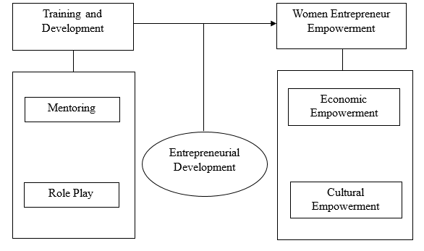Figure 1: Conceptual framework of Training and Development and Women Entrepreneur Empowerment with Entrepreneurial Development as the moderating variable
Source: The dimensions and measures of the independent and dependent variables were adopted from Nassazi (2013) and Maguirre, Camacho, and Gracia-de-la-torre (2016).

The study's overarching goal is to learn how training and development affect the chances of female entrepreneurs succeeding. The specific goals of the research are to;
- Determine whether and how mentoring might help SMEs in Rivers State achieve economic empowerment.
- Explore how mentoring may help SMEs in Rivers State become more culturally empowered.
- Analyze how SME economic empowerment in Rivers State relates to role play.
- Examining the cultural empowerment of SMEs in Rivers State via the lens of role play.
- Determine if the association between training and development and women's empowerment as SME entrepreneurs in Rivers State is moderated by entrepreneurial development.
Research Hypotheses.
The following hypotheses were formulated to answer the questions above tentatively.
HO₁: There is no significant relationship between mentoring and economic empowerment of SME’s in Rivers State.
HO₂: There is no significant relationship between mentoring and cultural empowerment of SME’s in Rivers State.
HO₃: There is no significant relationship between role play and economic empowerment of SME’s in Rivers State.
HO₄: There is no significant relationship between role play and cultural empowerment of SME’s in Rivers State.
HO₅: Entrepreneurial development does not moderate the affiliation linking training and development and women entrepreneur empowerment of SME’s in Rivers State.

Theoretical Framework
Human Capital Theory
Human capital theory, which is grounded on labour markets, education, and economic growth, considers investing in the growth of female business owners to be a worthwhile endeavour. The study presupposes that workers are valuable assets and investigates whether highly-skilled workers produce more than their less-trained counterparts (Osiobe, 2019). In addition, this theory is concerned with the ROI of training, and research has shown that higher levels of training lead to improved productivity in the workplace (Chen, 2020).
Empowerment as Theory
The purpose of the empowerment theory is to determine what kinds of advancements can be made through participation in activities, endeavours, or gatherings, and what kinds of outcomes can be expected as a result. Only if the process encourages the individual to develop their own capabilities, such as the ability to think critically and make sound decisions, will it be truly empowering. Empowerment, on the other hand, only applies to outcomes if the operationalization of empowerment results in magnitudes that increase social control.
Conceptual Review
Training and Development
Kraeger (2017) defines training as "a sequence of activities planned on behalf of an organisation to increase job knowledge and skills or modify attitudes and social behaviour of organisational members to align with organisational goals and job requirements." Development in the workplace refers to the process of learning new skills and honing old ones. Most businesses invest in training and development for their employees so that they may remain competitive and productive in their fields. Because there are so many resources available, those who actively pursue chances tend to thrive in their chosen industries. Training and development that emphasizes professional growth also increases the efficiency of its participants at the personal, team, and organizational levels (Meyer, 2021).
Development, as defined by Kadiresan et al. (2015), involves preparing workers to fill upcoming positions and deal with unforeseen problems.” More so, while discussing the skills gap with their staff, businesses decide who will be trained, which areas need improvement, and when the training will take place (Kum et al., 2014). Training, then, is a collaborative effort between a knowledgeable guide and trainee that results in a successful transfer of information, understanding, competence, and attitude, empowering the trainee to perform well on the job. Recent work is used as a measuring stick in both training and assessment (Lerner, 2018). As a result, employees will be delighted, comforted, and devoted to further developing organisations in accomplishing organisational goals and objectives, because of the effect training and development courses have had on their belief in the management's interest in their growth. They will be able to adapt to new situations, technologies, and intense competition with ease (Khan et al., 2016).
Mentoring
Many people are already aware with the ideas behind mentoring programmes thanks to their exposure to them in apprenticeship and school settings (Ojokuku & Sajuyigbe, 2015). Mentoring is not a recent phenomena; in fact, it has its roots in Greek mythology (Rodd, 2012). Homer addressed mentorship in The Iliad, which was written over two thousand years ago. Odysseus entrusted his home's security to Mentor before setting out for the siege of Troy. After ten years, Mentor became Telemachus' (Odysseus' son) trusted counsellor, friend, teacher, and surrogate father. This story is one of the earliest attempts to open a dialogue on mentoring. People can still remember the teachers, mentors, and educators who made a lasting impression on their lives. Teachers, managers, coworkers, and friends are all examples of influential people in one's life (Rodd, 2012).
According to Adeyemi (2013), mentoring is utilised to build up a company's resources and brainpower, expand its understanding of the industry, and keep it ahead of the competition, making it one of the few tools utilized/needed for preparing tomorrow's talented people. In the field of research training, the term "mentoring" has been used to denote a wide variety of interactions. Examples include advising on academic matters, assessing students' progress, providing informal assistance, and coaching on professional development (Jacobi, 1991). According to both Ayşe et al. (2013) and Akpan et al. (2017), mentoring is defined as "intentional relationships between more experienced and less experienced colleagues that are designed to facilitate knowledge transfer" in the workplace. Mentoring encompasses the management-designed and -encouraged actions taken to train and inspire employees so that the company can keep its competitive edge (Okurame, 2013).
Role Play
In role play, one or more participants assume the identities of fictional characters. As a result, they need to adopt the behaviour they think that person would. By stepping into one other's shoes, both the actors and the viewers develop a deeper understanding of the topic at hand (Furness, 1976, as cited in Vannak, 2013). Since several academics define the term via various theoretical lenses, there is no generally accepted definition of role plays. Anyway, she defined role-play as a type of simulation that emphasises interpersonal interactions from a pedagogical standpoint.
There is a wide range of role-playing activities, from highly scripted guided talks on one end to free-form drama games on the other; from reciting lines from a script to acting out intricate simulated scenarios. says Porter-Ladousse (1987). A variety of role-playing exercises are highlighted throughout these pages. When the speaking duty is limited and supplemented by prepared cues like dialogues, students may feel more at ease improvising than relying on the practised dialogue (Huang, 2008). Some performances may be brief and straightforward, while others may feature elaborate structural elements, as noted by Porter-Ladousse (1987). Since participants' linguistic abilities vary, the task's complexity must also vary.
Women Entrepreneur Empowerment
When discussing women's empowerment, there are four phrases that are universally agreed upon: "option, choice, control, and power" (Jitu, n.d.). In a broad sense, this describes the degree to which a woman is able to direct her own and her family's member, including her ability to make decisions for herself and her loved ones and her degree of resilience and independence in these areas. The term can also refer to a woman's sense of entitlement and confidence in her own ability to make decisions based on her own preferences and best interests. Malhotra et al. (2002) found.
According to Dumbu (2018), many nations are interested in fostering female entrepreneurs since doing so is seen as essential to developing nations' long-term economic success. According to studies conducted by Kaviarasu et al. (2022), female entrepreneurs are vital to the social and economic progress of any given nation. Dewi et al. (2022) found similar results, demonstrating the positive and large impact that women company owners have on societal and economic well-being.
Sajjad et al. (2020) drew similar conclusions from their study, demonstrating that women's entrepreneurship not only benefits the women entrepreneurs' families, but also significantly affects the economy and the social well-being of society as a whole. Women business owners enhance economic growth by making new goods and services available to consumers, and by providing more jobs (Aguiar, 2021). Women business owners are more likely to recruit other women, therefore supporting their ventures helps reduce the gender wage gap (Quak et al., 2022). Women business owners, according to Aguiar (2021), are more likely to reinvest their profits, which benefits the local economy.
Economic Empowerment
The term "economic empowerment of women" refers to women being able to play a significant role in household and professional policymaking as a result of their financial stability. In the context of economic growth, this word refers to women's ability to "participate, contribute, and benefit from growth processes" (OECD, 2012). To be economically empowered, a woman must have both the resources and agency to build her financial future (ICRW, 2011). This gives them the confidence to bargain for a more equitable share of the benefits of economic growth because their efforts have been valued and respected (OECD, 2012). Employment, banking and other financial services, ownership of productive assets, training and access to information about economic prospects all improve as a result of economic empowerment for women (OECD, 2012).
After the year 2000, researchers delved significantly further into the many facets of women's economic empowerment (Priya et al., 2021). However, equality in economic rights between men and women is a key component of women's empowerment (Abigail & Moizza, 2017). Unfortunately, women are not afforded the same opportunities as males in the workplace or in society's economic arena (Hassan & Cooray, 2015; Oztunc et al., 2015).
Cultural Empowerment
According to the research of Rabbani, Zeeshan, and Saleem (2015), culture is "that intricate whole in which are embedded the abilities and habits of a socially integrated human being," including "knowledge, beliefs, arts, morals, law, customs, and other behavioural patterns." The social environment influences how people interpret cultural artefacts and events. Our perspectives can be influenced by our culture. Cultural factors likely have a role in the unique worldviews of people from various backgrounds (Rabbani, Zeeshan, & Saleem, 2015).
Social norms and ideas shape the way people of different cultures conceptualize women's empowerment. Women are treated quite cruelly in many societies around the world. They have no control over any aspect of their lives and are completely dependent on the men. This perspective belittles the importance of empowering women. Since gender issues are societal in nature, there is no silver bullet that can solve all of the myriad complexities associated with them (Jabeen & Iqbal, 2010), indigenous search recognizes to comprehend the phenomenon in each country's own unique context.
Entrepreneurial Development Moderating Training and Development and Women Entrepreneur Empowerment
The term "entrepreneurial development" refers to the process of fostering business acumen through organised learning opportunities (Rao, n.d.). It is concerned with company dynamics, growth, and the study of entrepreneurial activity. Programmes designed to foster entrepreneurship aim to educate and train those already engaged in business and inspire others to join their ranks. More and more students are interested in learning about the ins and outs of entrepreneurship, therefore it has risen in prominence as an area of study in the modern world. The field of entrepreneurship development focuses on helping aspiring business owners hone their abilities so they can run their enterprises more effectively (Baridam, 2014).
Urieto (2015) defines entrepreneurship development as "the process of strengthening and increasing the number of entrepreneurs" through the provision of a variety of classroom coaching and programmes and training. Entrepreneurship development, as defined by Baridam, (2014), is the process of increasing an entrepreneur's competence in conceiving, planning, and executing a business venture, with an eye towards mitigating the related dangers. The training programmes and workshops used for this purpose emphasise the importance of having an entrepreneurial mindset. Pursuing a job in this area means devoting your time to helping aspiring business owners hone their skills and overcome the challenges they face when they establish their ventures.
Adegbite et al. (2007) list ten tasks and abilities that women business owners should cultivate. The ability to turn a vision into a tangible reality, innovativeness, creativity, courage and self-confidence, the willingness to take reasonable risks, mercurial integrity, patience and ingenuity, trust, good judgement, prudence, and hard work all fall under this category. These listed features are what make them functional.
List 1 : Empirical Review
S/N | Author/s | Country | Year of Study | Aim of Study | Methodology | Findings | Gap In Empirical Literature
1 | Mcilongo and Strydom | South Africa | 2021 | The value of mentorship in helping women develop in public service careers | Both descriptive and inferential statistics were employed in the study of the data. | Women in the public sector agree that having a mentor is helpful, and they also agree that the mentor's gender doesn't make a big difference in their careers. Since there are currently no formal procedures in place to facilitate mentoring in the public sector, it falls on managers to ensure that mentorship plans are actually put into practise. | Several facets of mentorship were identified in the study, including female mentors, career help, mentoring policy, and leadership development, all of which contribute to mentees' eventual professional success.
2 | Roseline, Ibrahim, and Opeyemi | Nigeria | 2020 | Effect of entrepreneurship development on women graduates of the National Centre for Women Development (NCWD), Abuja. | Descriptive Statistical Analyses | The results showed that the women were given the opportunity to learn new skills, that they felt more confident in their capacity to manage their firms, and that their enterprises were more likely to last. | The purpose of the study is to fill a knowledge gap by examining how the National Centre for Women Development's (NCWD) 2018 graduating class's enterprises in Abuja have contributed to the creation of jobs for women in Nigeria.
3 | Kumar, Alwi, and Shafiq-ur-Rehman | Pakistan | 2023 | An empirical relationship between entrepreneurial training and economic growth of Pakistan | Non-probabilistic sampling.  Pearson, Spearman and Regression analysis. | It was asserted that entrepreneurial training had a moderate but significant impact on national economic growth | The skilled labour market and the impact that entrepreneurship education can have on Pakistan's economy are the foci of the research.
4 | Urhibo and Orhero | Nigeria | 2023 | Rural women's empowerment in the south-south geopolitical zone of Nigeria, and its effect on rural development. | Non-probability sampling. Pearson Product Moment Correlation, and Linear Regression Analysis | Empowering rural women was found to have a positive and statistically significant impact on rural development by researchers in Nigeria's south-south geopolitical zone. | In Nigeria, there is a lack of data on the effects of women's empowerment on rural development.
5 | Yahya, Bala, and Girei | Nigeria | 2022 | In order to effectively and sustainably build the Nigerian economy, entrepreneurship education and training are necessary. | Theoretical Review | This article therefore argues that empowering students and young adults across all levels of education and training with the tools they need to become self-employed and independent in order to achieve sustainable growth through entrepreneurship education and training will have a significant impact. | In other words, the goal of the article is to investigate entrepreneurship education and training as an absolute necessity for the effective and sustainable growth of the Nigerian economy.
6 | Shetty, Baliga, Gil, Dias, and Shenoy | India | 2021 | Impact of entrepreneurship development programmes on economic aspects of trainees: Evidence from training centres in India | Yamane criteria (1967), multi stage sampling and proportionate sampling method was employed. Kruskal Wallis test | Training interventions on  economic aspects with moderate and low impact in order to make entrepreneurship development programmes more  effective. | Following this, we'll analyse the relevant literature to discuss our key results and pinpoint where more investigation is needed into the assessment and impact of EDPs on organisational effectiveness.
7 | Jaysawal and Saha | India | 2023 | Role of education in women empowerment | Descriptive research design | The education of women is a very strong tool for their empowerment. | The paper seeks to highlight various dimensions of empowerment of women through education

Methodology
Given the variety of study environments, a quasi-experimental approach was taken in the form of a cross-sectional study. All of the small and medium-sized businesses listed in the Rivers State Yellow Pages were considered for this study. Due to the scarcity of data on female business owners, we chose our sample with great care. Therefore, one hundred twenty-four (124) enterprises owned and operated by women constitute the sample population for this analysis. Businesses in the Obio/Akpor Local Government Area include restaurants and hair salons. In total, 140 women company owners and managers were interviewed for this study. This included 68 firm owners and 72 supervisors. The researchers used a convenience sampling strategy to pick their study's participants. The formula developed by Taro Yamane is provided below and was used to determine the appropriate size of the sample to collect data from.
Where,
n = sample size (?)
N = accessible population ()
e = level of significance (0.05)
The sample size (n) = 140
1 + 140 (0.05) ²
= 140
1.35 = 103

In this study, however, qualitative data was gathered via questionnaires. Nassazi (2013) provided the basis for the eight statement items used in the training and development scale (mentoring and role lay), whereas Maguirre et al. (2016) provided the basis for the eight statement items used in the Women Entrepreneur Empowerment scale (economic and cultural empowerment). One hundred and three (103) questionnaires were sent out. One hundred and three (103) surveys were sent out, and 4 were never returned, with 2 having incorrect answers. This implies that the actual sample size was comprised of the remaining ninety-seven (97) surveys. As an indicator of reliability, Cronbach's alpha can be used to showed that the statement items were reliable at above the benchmark. The data set was analyzed using the Pearson Moment Correlation Coefficient.
List 2
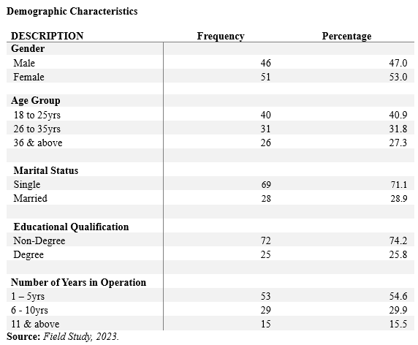
Some of the identified demographic factors discussed were respondent gender, respondent age, respondent marital status, respondent education level, and respondent years in business. According to the data presented above, out of a total of 97 respondents, 46 were males (47%), while 51 were females (53%). Of the 97 people who filled out the survey, 40 (or 40.9%) were between the ages of 18 and 25, 31 (or 31.8%) were between the ages of 26 and 35, and 26 (or 27.3%) were aged 36 and up. According to the data, 69 (or 71.1% of all respondents) do not have a spouse, while 28 (or 28.9% of all respondents) do. Seventy-four (or 74.2%) of the 97 respondents had advanced degrees, while twenty-five (or 25.8%) did not. The researchers also provided evidence of the companies' long histories. The data showed that 53 (54.6%) of respondents said they had worked for their company for 1-5 years, followed by 29 (22.9%) who said they had worked for 6-10 years, and finally 15 (15.5%) who had worked for their company for 11 years or more.
Test of Hypotheses
Table 1: Relationship between mentoring and economic empowerment
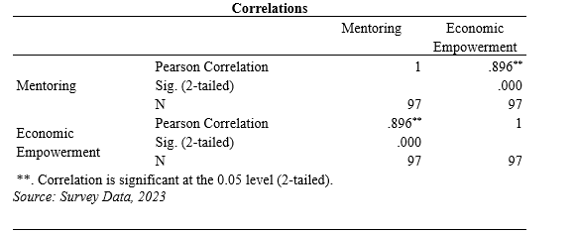
At the p < 0.05 (0.000 < 0.05) level of significance, the data analysis shows a significant result. A high positive correlation (r = 0.896) exists between the two factors. There appears to be a connection between the variables, as evidenced by the findings. This leads us to believe that the alternative is correct and reject the null.

Table 2: Relationship between mentoring and cultural empowerment

The study produced a significant result at the p < 0.05 (0.000 < 0.05) level of significance. As r = 0.537 shows, there is a positive correlation between the two factors. There is a substantial link between the variables, as shown by the findings. This suggests that the alternative can be accepted and the null hypothesis can be abandoned.

Table 3: Relationship between role play and economic empowerment
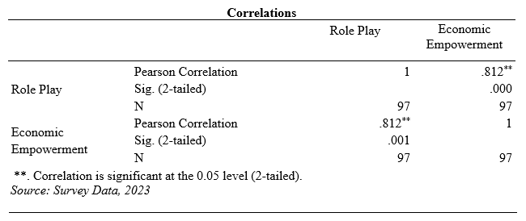
At the threshold of p < 0.05 (0.000< 0.05), the data analysis shows statistical significance. The coefficient of determination (r) for this pair of variables is 0.812, indicating a positive association. There appears to be a connection between the variables, as evidenced by the findings. The null hypothesis is thus rejected and the alternative hypothesis accepted.
Table 4: Relationship between role play and cultural empowerment
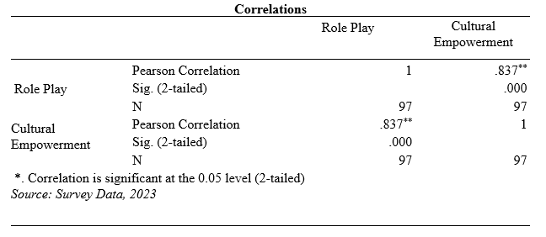
At the 5% significance level (p < 0.05), the statistical analysis showed a significant finding. As r = 0.837 shows, there is a positive correlation between the two factors. Findings point to a statistically significant relationship between the variables. As a result, we choose to believe the alternative hypothesis and reject the null.

Table 5: Entrepreneurial development and the relationship between training and development and women entrepreneur empowerment
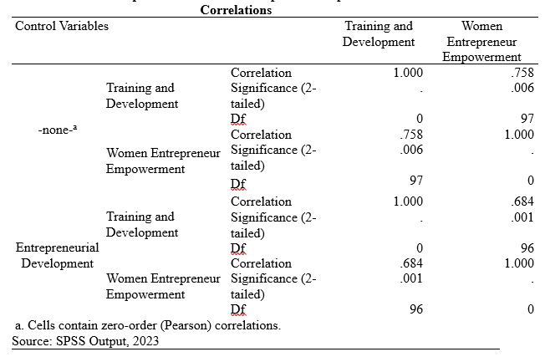

Developing an entrepreneurial mindset appears to attenuate the relationship between training and women's business ownership (rho =.684, p 0.001), as seen in Table 6. Therefore, we conclude that the rise of entrepreneurship development is beneficial for training and development and for the empowerment of women through business. By applying the decision rule, we conclude that the relationship between the predictor and criterion variables is moderated by entrepreneurial development, and we restate the hypothesis that training and development are positively related to women's entrepreneur empowerment.

Discussion of Findings
The first hypothesis (H_{O1}) demonstrated the link between mentoring and financial independence for mentees. The study's findings indicate that mentorship helps small and medium-sized enterprises (SMEs) in Rivers State become more economically independent. A positive link was discovered between the two data sets which is in line with researchers such as GSMA (2023), Akram et al. (2011), and Dutta (2014).
The second set of hypotheses (H_{O2}) discussed how mentoring may help women become culturally empowered. The findings support the hypothesis that mentoring has a positive and statistically significant relationship with cultural empowerment in SMEs in Rivers State. The results of this study are consistent with previous empirical research by Nesa (2015), the GSMA (2023), and Dutta (2014).
The third hypothesis (H_{O3}) stated that there is no correlation between role-playing and economic empowerment. The investigation revealed a positive and statistically significant link between role play and economic empowerment in SMEs in the state of Rivers. All of the claims made by Nesa (2015), GSMA (2023), Dutta (2014), Vannak (2013), and Grace et al. (2023) are supported by the data presented here.
The fourth hypothesis (H_{O4}) asserted that among SMEs, Rivers State, there is no correlation between role play and cultural empowerment. Overall, the results of this hypothesis show that there is a strong connection between role play and cultural empowerment. The results of this study are in line with those of previous empirical studies, including those by Osiobe (2019), Karim et al. (2019), Akpan et al. (2017), and Rabbani et al. (2015).
Fifth hypothesis (H_{O5}): Entrepreneurial development and the relationship between training and development and women entrepreneur empowerment. Results from this study corroborated the significance of training and development for women entrepreneurs and the positive association between these parameters. The results of this study are in line with those of Rao's (n.d.) empirical investigation.
Conclusion and Recommendations
Based on the data provided, we conclude that promoting the economic and cultural empowerment of women business owners is essential to the growth of SMEs in Rivers State, and we highlight the significance of training and development (mentoring and role play) for this industry. Thus, we suggest the following:
- Mentoring women business owners in SMEs is important because it can help them become more productive, strengthen their organizations, acquire new skills, stay ahead of the competition, and achieve economic and social empowerment.
- In order to fully empower women economically, we must ensure that women entrepreneurs are well-informed about what SMEs are and that they receive training through role playing which helps in their development practically in their businesses.
- The proper application of role play training can be highly motivational and engaging on the path to economic and cultural empowerment for women business owners, as it helps them develop and encourage critical thinking about complex and controversial issues surrounding their businesses.
Restrictions in the Research
Inadequate funding severely hampered the study's researcher. Not a lot of resources were available for the targeted study. The reason for this is that there have been few previous works in this field. It was also not possible to survey every woman business owner in a state's micro, small, and medium-sized enterprises (SMEs), leaving space for sample error. The research also had certain gaps, such how it solely focused on SMEs and ignored the rest of the state's economy. Despite the challenges, the research was completed.
Contribution to Knowledge
This research lends empirical evidence for the hypothesis that training and development in women entrepreneur empowerment in SMEs, Rivers State. The conceptual model developed for this research gives novel insight through amassing empirical facts that may be used to inform the development of new theories and the conduct of other investigations in this field.
Areas for Further Studies
The framework of this study should be replicated in other contexts, such as the public sector, the hospitality industry, etc., and future studies should think about including other predictors of women entrepreneur empowerment in addition to training and development.

References
Adegbite, S. A., Ilori, M. O., Irefin, I. A., Abereijo, I. O., & Aderemi, H. O. S. (2007). Evaluation of the impact of entrepreneurial characteristics on the performance of small-scale manufacturing industries in Nigeria. Journal of Asia Entrepreneurship and Sustainability, 3(1), 1.
Adeyemi, J. (2013). Ethics institutionalization, quality of work life, and employee job-related outcomes: A survey of human resource managers in Thailand. Journal of Business Research, 63(1), 20—26.
Aguiar, J. (2021). The importance of women entrepreneurs. https://www.linkedin.com/pulse/importance-women-entrepreneurs-jeffery-aguiar-mba
Akpan, J. W., Owhor, A. G. & Nsikan, E. J. (2017). Workplace mentoring strategies and sustainable commitment of University Teaching Hospital Staff in South-South Region of Nigeria. Global Journal of Medical Research, K Interdisciplinary, 17(1), 27-34.
Awan, A. G., Sharif, I., Nadeem, N., & Iqbal, A. (2015). Impact of small & medium enterprises on poverty: A case study of Khanewal District Pakistan. Journal of Economics and Sustainable Development, 6.
Ayşe, T. C., Cevdet, K. & Halil, I. Z. (2013). Impact of mentoring on organizational commitment and job satisfaction of accounting-finance academicians employed in Turkey. Emerging Markets Journal, 3(2), 1-26.
Chen, X. (2020). Influence of parents' education level on household human capital investment. In 2020 International Conference on E-Commerce and Internet Technology (ECIT) (pp. 97-104). IEEE.
Dewi, R., Eliyana, A., & Anwar, A. (2022). The role of women entrepreneurship antecedents in supporting social and economic well-being. Problems and Perspectives in Management, 20(2). https://doi.org/10.21511
Dutta, P. (2014). Study of women’s empowerment in the district of Bankura (Doctoral dissertation, Ph. D. thesis, University of Burdwan, West Bengal).
Grace, E., Divya, R. P., & Rajarajeswary (2023). The impact of training and development on employee performance in Malaysia’s tertiary education sector. Eur. Chem. Bull., 12(Special Issue 1), 1899-1912.
GSMA (2023). Empowering-women-micro-entrepreneurs-through-mobile.pdf (gsma.com)
Huang (2008). Role play for ESL/EFL Children in the English Classroom. The Internet TESL Journal. http://iteslj.org/Techniques/Huang-RolePlay.html
ICRW (2011). Understanding and measuring women’s economic empowerment: Definition, framework and indicators. http://www.icrw.org/files/publications/Understanding-measuring-womens-economic-empowerment.pdf
Jabeen, N., & Iqbal, M. Z. (2010). Gender and local governance in Pakistan: Promoting participation through capacity building. A Research Journal of South Asian Studies, 25(2), 255-281.
Jacobi, M. (1991). Mentoring and undergraduate academic success: A literature review. Review of Educational Research, 61(1), 505–532.
Jaysawal, N., & Saha, S. (2023). Role of education in women empowerment. International Journal of Applied Research, 9(4), 08-13.
John-Akamelu, C., & Muogbo, U. (2018). Role of small & medium enterprises in poverty eradication in Nigeria. European Journal of Research and Reflection in Management Sciences, 6, 33-48.
Kadiresan, V., Selamat, M. H., Selladurai, S., Ramendran SPR, C., & Mohamed, R. K. M. H. (2015). Performance appraisal and training and development of human resource management practices (HRM) on organizational commitment and turnover intention. Asian Social Science, 11(24).
Karim, M., Choudhury, M. M., & Latif, W. B. (2019). The impact of training and development on employees' performance: An analysis of quantitative data. Noble International Journal of Business and Management Research, 03(02), 25-33.
Kaviarasu, S. J., Ramasamy, P., & M. P., R. (2022). Socio-economic difficulties faced by women entrepreneurs from Chennai city’s slums. Social Science, 1(1).
Khan, A. A., Abbasi, S. O. B. H., Waseem, R. M., Ayaz, M., & Ijaz, M. (2016). Impact of training and development of employees on employee performance through job satisfaction: A study of telecom sector of Pakistan. Business Management and Strategy, 7(1), 29.
Kraiger, K. (2017). Training from an organizational psychology perspective. Oxford Research Encyclopedia of Psychology. https://doi.org/10.1093/acrefore/9780190236557.013.33
Kum, F. D., Cowden, R., & Karodia, A. M. (2014). The impact of training and development on employee performance: A case study of Escon Consulting. Singaporean Journal of Business, Economics and Management Studies, 3(3), 72–105.
Kumar, M., Alwi, S. K., & Shafiq-ur-Rehman (2023). An empirical relationship between entrepreneurial training and economic growth of Pakistan. Journal of Entrepreneurship and Business Venturing, 3(1), 01-15.
Lerner, R. M. (2018). Concepts and theories of human development. Routledge.
Mcilongo, M., & Strydom, K. (2021). The significance of mentorship in supporting the career advancement of women in the public sector, HELIYON, 7(2), e07321.
Meyer, T. K. (2021). How to encourage employees to pursue professional development. Business News Daily. https://www.businessnewsdaily.com/10092-encourage-professional-development.html
MIDAS (2009). Women entrepreneurs in SMEs: Bangladesh perspectives, https://www.google.be/?gfe_rd=cr&ei=8NVgU4SjLYqe8APBxoC4CQ#q=women+entrepreneurs+in+SMEs%2C+bangladesh+perspectives
Mozael, B. M. (2015). Impact of training and development programs on employee performance. International Journal of Scientific and Research Publications, 5(11), 38-42.
Nesa, M. (2015). Economic empowerment of women through entrepreneurship: A study on women SME entrepreneurs in Bangladesh. Dictus Publishing.
Nichter, S., & Goldmark, L. (2009). Small firm growth in developing countries. World Development, Elsevier, 37(9), 1453–1464.
OECD (2012). Women’s economic empowerment. http://www.oecd.org/dac/povertyreduction/50157530.pdf
Ojokuku, R. M., & Sajuyigbe, A. S. (2015). Impact of mentoring on career development of academics in Nigerian Universities.
Okurame, M. (2013). Role of mentoring programs on the employee performance in organizations: A survey of Public Universities in Nyeri County, Kenya. International Journal of Academic Research in Business and Social Sciences, 3(1), 8.
Osiobe, E. U. (2019). A literature review of human capital and economic growth. Business and Economic Research, 9(4), 179-196.
Porter-Ladousse (1987). Role play. Oxford University Press.
Priya, P., Venkatesh, A., & Shukla, A. (2021). Two decades of theorising and measuring women's empowerment: Literature review and future research agenda. In Women's Studies International Forum (Vol. 87, p. 102495). Pergamon.
Quak, E., Barenboim, I., & Guimaraes, L. (2022). Female entrepreneurship and the creation of more and better jobs in sub-Saharan African countries. Institute of Development Studies Research Repository, 2. https://doi.org/10.19088/MUVA.2022.002
Rabbani, S., Zeeshan, M., & Saleem, H. (2015). Cultural perception of women empowerment in Chakwal City. Sci. Int. (Lahore), 27(1), 773-775.
Rao, T. S. (n.d). Entrepreneurial development. Institute Of Aeronautical Engineering.
Rodd, J. (2012). Leadership in early childhood. McGraw-Hill Education.
Roest, J., & Bin-Humam, Y. (2021). Business her own way: Creating livelihoods through informal online commerce (cgap.org)
Roseline, Y. A., Ibrahim, R. R., & Opeyemi, O. A. (2020). Effect of entrepreneurship development on women graduates of the national centre for women development, Abuja. International Journal Of Multidisciplinary Research And Technology, 1(3), 1-15.
Sajjad, M., Kaleem, N., Chani, M. I., & Ahmed, M. (2020). Worldwide role of women entrepreneurs in economic development. Asia Pacific Journal of Innovation and Entrepreneurship, 14(2), 151–160.
Shafik, T. (2015). Efficacy of Training and development programs on employee’s productivity at Bharat Heavy Electricals Limited. International Journal of Allied Practice, Research and Review, II(II), 16-24.
Sharafat, A., Rashid, H., & Khan, M. A. (2014). The role of small and medium enterprises and poverty in Pakistan: An empirical analysis. Theoretical and Applied Economics, 18, 593.
Shetty, G. S., Baliga, V., Gil, M. T., Dias, R. T., & Shenoy, S. S. (2022). Impact of entrepreneurship development programmes on economic aspects of trainees: Evidence from training centres in India. African Journal of Science Technology Innovation and Development, 14(9), 1-17.
Urhibo, B. O., & Orhero, A. E. (2023). Rural women empowerment and development in Nigeria. Journal of Public Administration, Finance and Law, (27), 499-513.
Vannak, H. (2013). Role-play training programme in improving learners’ speaking fluency in the English language. (Masters Thesis, Asia E University, Malaysia).
Yahya, A., Bala, Y., & Girei, M. A. (2022). Entrepreneurship education and training: An imperative towards effective sustainable development in Nigeria economy. International Journal of Management Studies and Social Science Research, 4(5), 31-39.

