BANKING BUSINESS MODELS AND DEPOSIT FUNDING REQUIREMENTS: A STUDY OF SELECTED NIGERIAN DEPOSIT MONEY BANKS

Abstract
The objective of this paper was to examine the empirical evidence of the different business models that Nigerian deposit money banks operate and their deposit funding requirements using the top five Nigerian deposit money banks by asset base. Data were collected from various annual reports of Access Bank, Zenith Bank, FBN Holdings, UBA, and GT Bank from 2005 to 2020. We reviewed the bank’s primary deposit characteristics to establish the prevailing deposit mix, with an inquiry into why banks switch models. We used the cluster analysis technique to analyse the selected banks statements of financial position ratios and identify the different business models the banks had adopted in the period under study. The studied banks, Access, Zenith, FBN Holdings, UBA, and GT Bank, were classified according to the respective business models they adopted using the data characteristics. The identified models are retail-funded, wholesale-funded, and market-oriented. Zenith, UBA, and FBN Holdings adopted wholesale, retail, and market-oriented models, respectively. Access and GT Banks switched models at various times. Across the models, the activities of the banks on the asset side of the balance sheet were mainly funded by customer deposit liabilities. The banks’ deposit structures also indicate that the mixes were skewed in favour of current accounts and savings bank accounts, which are known, in banking parlance, as demand deposits. We conclude that demand deposits are critical and the most vital components of banking institutions deposit structures, irrespective of the business model adopted. Its implications for the profitability, efficiency, and effectiveness of the bank's overall objectives cannot be overemphasized. We also conclude that the reason for switching models in Nigerian deposit money banks flows more from the strategic decisions of the management than regulatory or environmental factors.
Key words: banking business models, Cluster analysis, deposit mix, statement of financial position ratios, asset base
1 INTRODUCTION
A business model is organization’s strategic plan to identify appropriate products and services to deliver, target market to cover and associated expenses with a view to making reasonable profit and operating profitability. It is a distinct business tool that separates one organization/ bank from the others by providing a unique market share according to the business product or services involved. In our context, banking business activities with its associated products and services are our focus.
Ayadi, Arbak, and de Groen (2011), distinguished between the key banking activities and the funding strategies. They used six instruments to define the activity and funding features of a business model in banks from an asset and liability standpoint. They are; customer deposits (as % of assets), trading assets (as % of assets); loans to banks (as % of assets), tangible common equity (as % of assets), domestic activity (as % of assets), and derivative exposures (as % of assets).
The three basic categories of business models in the contemporary banking sector can be defined as retail-funded commercial banks, wholesale-funded commercial banks, and capital markets-oriented banks (Roengpitya, Tarashev, and Tsatsaronis, 2014). The first two categories of bank business models differ primarily in terms of the funding mix (whether we are dealing with retail or wholesale funding), while the third business model indicates that the bank is primarily engaged in the field of trading activities. Banks that are diversified on the asset side with a high reliance on retail deposits are classified as retail. Wholesale banks are predominately wholesale on the asset and liability sides, while market-oriented banks are predominately investment-oriented on the asset side and display diversified funding.
A major feature of the traditional banking model is the use of deposits to fund the bank’s activities and asset portfolio. Deposits constitute the main source of funds for any banking institution. Apart from deposits, other sources of funds include capital and borrowing. Surplus economic units keep their surplus funds with a bank as deposits, primarily for three motives: safety motive, liquidity motive, and earning/speculative motive. Depending on the purpose, a deposit account may be termed a Savings Bank (SB) deposit account, a current deposit (CD) account, a fixed deposit (FD) account, or a recurring deposit (RD) account. It may be either in the form of a demand deposit (DD) or a term deposit (TD). Demand Deposit includes Savings Bank accounts and Current Deposit accounts, popularly known in banking parlance as CASA, while Term Deposit includes Recurring Deposit (RD) and Fixed Deposit (FD) of various flavours.
Deposit mix refers to the combination of various types of deposits (as above) and their share in total deposits. The interest payment obligation for the current deposit account is nil, and for savings bank deposit accounts, it is very low, hence the source of low-cost funds. This underscores the importance of CASA in the deposit mix. It is a major determinant of the size of the bank's net interest margin (NIM) or net revenue from funds (NRFF). It is also an index for efficiency as it impacts the cost-to-income ratio, which is a major profitability index.

It is traditionally held that current account deposits are the most volatile among other account types, while savings and term deposit accounts are the least volatile, leading to a concentration of savings/term deposit mobilisation (interest-bearing) against current account deposits (non-interest bearing). The argument is that savings and term deposits give stability to the bank’s balance sheet and therefore should be a dominant source of deposit liabilities. This traditionally known view may have, as shown in this study, been diluted by the dynamics of business models adopted by deposit money banks.
Amel and Rhoades (1988) and Mehra (1996) adopted more systematic quantitative approaches to identifying and analysing bank business models. Some approaches include linking banks revenue mix with their profitability (Stiroh and Rumble, 2006; Kohler, 2015). Others sustain that the composition of statements of financial position gives a direct link to banks strategic choices than an income statement and composition (Roengpitya, Tarashev, & Tsatsaronis, 2017). The idea behind this is that bank management has control over the exposures they would want to get into, while the income statement can change over time even with an existing strategy in place.
The objective of this study is to examine the empirical evidence of different business models that Nigerian deposit money banks operate using the five top Nigerian banks by asset base from 2005 to 2020 with a view to establishing the dominant funding requirements of the business models for each of the banks studied and bringing to bear the unsustainability of the traditional preference for time deposit accounts in the deposit structure of deposit money banks. A further review of the banks’ primary deposit characteristics is also carried out to reveal the deposit type combinations or deposit mix that make up the deposit funding requirements. It helped validate the traditional view or otherwise. We also inquire about bank switch models and what informs the switch.
The rest of the paper is presented in four sections. Section two reviewed the conceptual and empirical literature. The empirical strategy is discussed in the third section. We presented the analysis and discussion of the findings in Section four. The summary and conclusion were carried out in Section five.
2.0 LITERATURE REVIEW
2.1 Conceptual Framework
2.1.1 Deposit Mix and Cost of Funds
The Central Bank of Nigeria (2012) outlined the framework for determining a bank's cost of funds applicable to different types of deposit liabilities. These include the cost of interbank borrowings, deposit insurance premium payments, and the cost of sterilising funds at the central bank due to reserve requirements. The cost is usually calculated as the total interest exposure annualised, divided by average interest bearing deposits and other interest bearing borrowings, plus average non-interest bearing current account deposits. It is one of the most important input costs for financial institutions. When funds or deposits are cost-effective, they generate better returns if they are lent out as short- and long term loans (Drury, 2000; Mouck, 1997). The difference between the cost of funds and the interest charged to borrowers is known as the spread. And this is the main source of profit for financial institutions.
2.1.2 Banking Business Models
Ayadi et al. (2011) distinguished between the key banking activities (retail versus market or mixed) and the funding strategies in Europe. He used six instruments to define the activity and funding features of a business model in banks from an asset and liability standpoint. They are;
- Customer deposits (as % of assets). The indicator identifies the share of deposits from non-bank and private customers, e.g., households or enterprises, in the total balance sheet, indicating reliance on more traditional funding sources.
- Trading assets (as % of assets). Defined as non-cash assets other than loans, a greater value would indicate the prevalence of investment activities that are prone to market and liquidity risks.
- Loans to banks (as % of assets). The indicator measures the scale of wholesale and interbank activities, which proxy for exposures to risks arising from interconnectedness in the banking sector.
- Total derivative exposures (as % of assets). This measure aggregates all the positive and negative derivative exposures of a bank, which are often identified as one of the key (and most risky) financial exposures of banks with heavy investment and trading activities.
- Tangible common equity (as % of assets). The indicator focuses on the most loss-absorbing parts of a bank’s capital structure, providing an insight into the bank’s risk attitudes and its leverage.
- Domestic activity (as % of assets). While banks that are more domestically-oriented are likely to face fewer cross-border risks, they may also face more concentration risks.
The three basic categories of business models in the contemporary banking sector can be defined as retail-funded commercial banks; wholesale-funded commercial banks, and capital markets-oriented banks (Roengpitya, Tarashev, and Tsatsaronis, 2014). Banks that are diversified on the asset side with a high reliance on retail deposits are classified as retail. Wholesale banks are predominately wholesale on the asset and liability sides, while market-oriented banks are predominately investment-oriented on the asset side and display diversified funding.
2.2 Empirical Review
2.2.1 Deposit Mix and Profitability
Bodla & Verma (2006) examined the impact of a few banking variables on profitability in public sector banks in India. They deployed a step-wise multivariate regression model on temporal data from 1991–1992 to 2003–04. The study found that the explanatory power of some variables, like spread, net interest margin, provision and contingencies, and operating expenses, is significantly high, while others, like business per employee, credit deposit ratio, and non-performing assets as a percentage of net advances, have low explanatory power. The study concludes that variables such as provision and contingencies, net interest margin, spread, and operating expenses have a significant relationship with net profit and therefore are major areas of concern in public sector banks in India.
Shollapur & Bangati (2010) examined the profitability of fund management at the selected Indian banks with the help of cost-benefit analysis and observed that efficient fund management involves raising the proper mix of funds and their applications to generate maximum spread. The study revealed that the overall cost of funds, comprised of the cost of deposits and the cost of borrowings, has maintained a decreasing trend, which reflects smart handling of the source of funds. However, return on application of funds also exhibited declining trends, resulting in a declining spread.
Venkatesan (2012) tried to evaluate empirically the trend and growth in deposit mobilisation by banks in Tamil Nadu from 2000 to 2009. For the purpose of the study, deposits have been classified as current account deposits, savings bank accounts, and term deposits. Time series data collected from the Reserve Bank of India Bulletin was analysed with the help of descriptive statistics and simple regression analysis. The compound growth rate and linear growth rate were also used to arrive at the definite conclusion that there was a significant growth in the mobilisation of all types of deposits.
Baltes and Cozma (2017) estimated the impact of credit, liquidity, and solvency risk on the efficiency of the operational activity of commercial banks listed on the Bucharest Stock Exchange, Romania. The findings from the results obtained by applying multiple linear regressions showed that the level of the “cost to income” indicator during 2010–2015 was significantly influenced by the capitalization level, the lending rate, and the saving rate
Hryckiewicz and Kozłowski (2017) analysed the heterogeneity between various business models among systemically important banks in 65 countries over the period of 2000–2012. For the first time, they identified true banking strategies consisting of different combinations of bank assets and funding sources and assessed their impact on the mortgage crisis. They estimated how distinct strategies had affected bank profitability and risk before the crisis and what impact they had had on the mortgage crisis. Results prove that the asset structure of banks was responsible for the systemic risk before the mortgage crisis, whereas the liability structure was responsible for the crisis itself. Finally, they showed that countries with banks that rely on investment activities experienced a greater but more short-lived drop in GDP compared to countries that have a predominantly traditional banking sector
2.2.2 Identification of Banking Business Models
The first notion of a business model was first used in the field of management studies (Zott and Amitt, 2011). The early work in this area was done by Amel and Rhoades (1988) and Mehra (1996). Prior to this time, a business model was understood as a strategy that translates into similar income statement ratios. However, in recent times, researchers have adopted more systematic quantitative approaches to identifying and analysing bank business models. Some approaches include linking banks revenue mix with their profitability (Stiroh and Rumble, 2006; Kohler, 2015).
Roengpitya, Tarashev, & Tsatsaronis (2017) argued that the composition of statements of financial position gives a direct link to banks” strategic choices than an income statement and composition The idea behind this is that bank management has control over the exposures they would want to get into, while the income statement can change over time even with an existing strategy in place. Agreeably, and most of the time, revenue and profit outcomes are consistent with the statement of financial position over time, but year-to-year variability will reflect factors beyond management control.
Ayadi and de Groen (2014) focused on 173 European banks from 2006 to 2013, and Farnè and Vouldis (2017) focused on 365 euro area banks at the end of 2014. Both studies converge on four banking models. They used a dataset with a small geographical coverage and a shorter time span. They also found that business models with a stronger commercial-banking focus are more robustly identified than models with more extensive capital markets activities.

Mergaerts and Vennet (2016) presented evidence that, for a period of time, variability is higher for income ratios than that of financial position ratios. Therefore, linking business models on the basis of statements of financial position ratios looks more confident and reliable because the model has a direct relationship to whatever choice the bank has made. This will remain stable over time and explains why the transition from one model to another can be attributed to managerial choice instead of other factors that are not endogenous to the system (Ayadi et al., 2011; Ayadi & de Groen, 2014; and Farnè and Vouldis, 2017).
Roengpitya et al. (2017), using a panel of 178 banks for the period 2005–15, experimented with various combinations of statements of financial positions as inputs in cluster analysis to allocate distinct business models to banks. They identified a retail-funded and a wholesale-funded commercial banking model that is robust to the choice of inputs. In comparison, a model emphasising trading activities and a universal banking model were less robustly identified. Both commercial banking models exhibit lower cost-to-income ratios and a more stable return on equity than the trading model. Over the entire sample period, banks that switched into the retail-funded model saw their return on equity improve by 2.5 percentage points on average relative to non-switchers. By contrast, the relative performance of banks switching to the wholesale-funded model deteriorated by 5 percentage points on average

3.0 METHODOLOGY

3.1 Data Collection.

Data from the top five Nigerian deposit money banks by asset base was collected from their respective annual accounts. The banks are Access Bank, Zenith Bank, United Bank for Africa, First Bank Holdings, and GT Bank. The balance sheet sizes of these chosen banks represent 50% of the entire balance sheets of deposit money banks in Nigeria as of 2020. The data collection is from 2005 to 2020. The year 2005 is chosen as it coincides with the year of bank consolidation by the Central Bank of Nigeria. Input variables for cluster analysis from the respective statements of financial positions are customer deposit/asset ratio (CDAR), trading asset ratio (TRAR), bank loan asset ratio (BLAR), tangible common equity/asset ratio (TCER), and domestic activity/asset ratio (DACTR). These are presented in Tables 7 to 11.
3.2 Measurement of Variables
Customer Deposits to Assets Ratio (CDAR): These indicate the share of deposits from non-bank and private customers, e.g., households or enterprises, in the total balance sheet. This shows reliance on more traditional funding.
Trading Assets (as a percentage of Assets) Ratio (TRAR): This is non-cash assets other than loans; a greater value would indicate the prevalence of investment activities that are prone to market and liquidity risks.
Loans to banks (as a percentage of assets) BLAR: This measures the scale of wholesale and interbank activities, which is a proxy for exposure to risks arising from interconnectedness in the banking sector.
Tangible Common Equity (as a percentage of Assets) TCER: This focuses on the most loss-absorbing parts of a bank’s capital structure, providing an insight into the bank’s risk attitude and its leverage.
Domestic Activity (as a percentage of Assets) DACTR: This indicates concentration risk.
3.3 Operational Definitions
Trading assets are defined as total assets minus liquid assets (cash and deposits at the Central Bank of Nigeria) minus total loans minus intangible assets.
Tangible common equity is defined as the common equity minus intangible assets (goodwill and others) minus treasury shares.
Common equity is equal to common stocks, paid up capital, and retained earnings.
3.4 Techniques for Analysis

We used cluster analysis to identify various business models. Cluster analysis is a statistical technique for assigning a set of observations (i.e., a particular bank in a particular year) into distinct clusters (i.e., business models). By definition, observations that are assigned to the same cluster share a certain degree of similarity, as measured by a set of instruments that are considered relevant. The formation of clusters ensures that they are sufficiently dissimilar among themselves, identifying different distinguishing characteristics of the observations they represent. To create the clusters, the initial step is to determine a set of instruments to identify any similarities or distinctions. The second step, more technical in nature, is to determine the methods for measuring similarities, for partitioning the clusters, and for determining the appropriate number of clusters (i.e., the ‘stopping rule’). One of the key problems often encountered in clustering is the presence of missing values. When a particular observation has one or more missing instrument values, it has to be dropped from the cluster analysis since the similarity measures cannot be computed (Wilkinson et al., 2007; Everitt et al., 2011; Calinski &. Harabasz, 1974 ).

4.0 DATA ANALYSIS AND RESULTS

4.1 Descriptive Statistics

Table 1 shows some basic statistics that describe the distributional characteristics of the pooled data. Some of these statistics are also plotted in Figures 1 and 2.

Table 1: Descriptive Statistics
Variable | N
CDAR | 80 | 68.21 | 8.33 | 12.21 | -0.76 | 2.02
TRAR | 80 | 42.56 | 12.47 | 29.29 | 0.30 | 1.23
BLAR | 77 | 10.93 | 11.77 | 107.66 | 1.21 | 0.92
TCER | 80 | 14.75 | 10.48 | 71.09 | 6.97 | 56.71
DACTR | 75 | 18.13 | 12.81 | 70.66 | 2.79 | 14.84

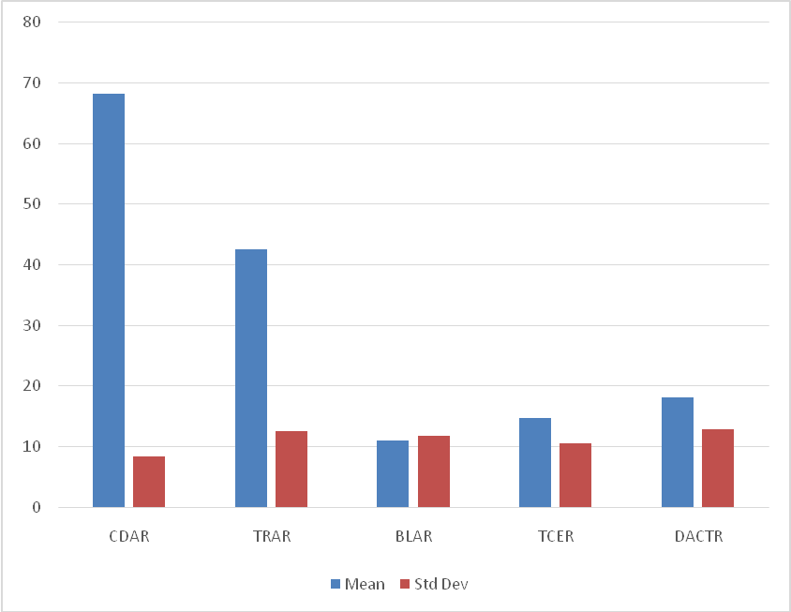
Figure 1: Mean and Standard Deviation Plot

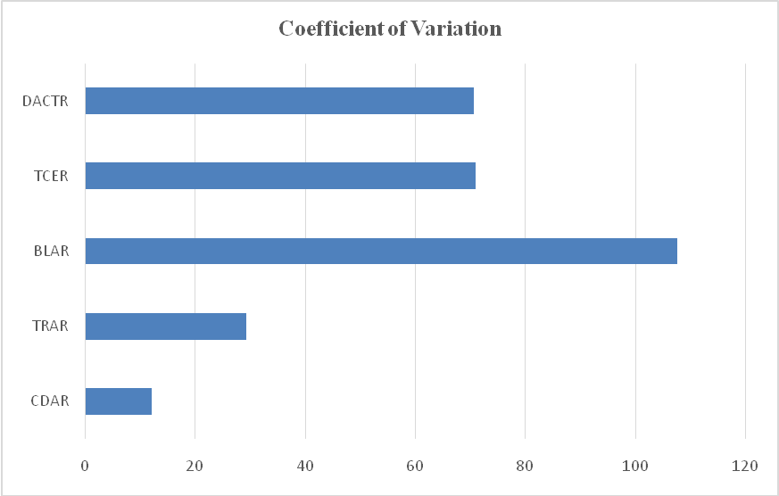
Figure 2: Coefficient of Variation Plot
From Table 1 (see also Figures 1 and 2), we can see that customer deposit to asset ratio (CDAR) has the highest mean value, while domestic activity ratio (DACTR) has the highest standard deviation. However, as indicated by the coefficient of variation (CV), the interbank lending to assets ratio (BLAR) has the highest variability, followed by the tangible common equity ratio (TCER) and the domestic activity ratio, while the deposit to asset ratio has the lowest variability. The skewness coefficient shows that most of the variables have a positively skewed distribution, except CDAR, whose distribution is skewed to the left. On the other hand, the kurtosis coefficient indicates that TCER and DACTR both have a distribution that is characterised by excess kurtosis (KURT > 3), while CDAR, TRAR, and BLAR have a platykurtic distribution (KURT < 3).
4.2 Cluster Analysis
First, we perform the hierarchical cluster analysis to identify the number of clusters that can be extracted from the data. Figure 3 shows the Dendrogram which represents the hierarchical relationships in our data. Secondly, we perform the two-step cluster analysis to classify banks according to their business models. Figure 4 shows the cluster model summary and cluster quality, while Figure 5 shows the cluster size. Tables 2–4 show the cluster profile, cluster labelling, and classification of banks (Wilkinson et al., 2007; Everitt et al., 2011; Calinski, & J. Harabasz, 1974).

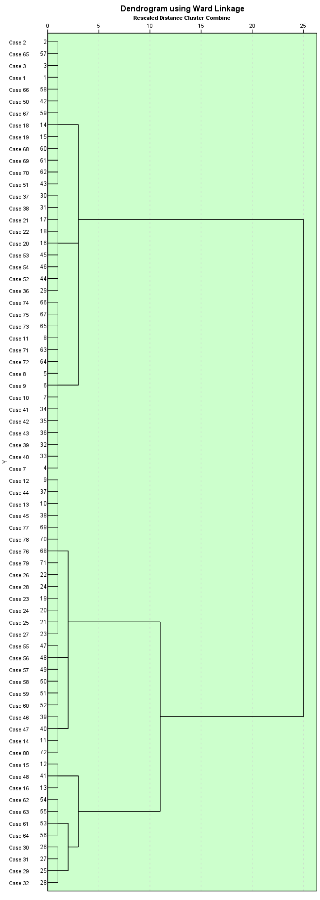
Figure 3: Dendrogram for cluster identification

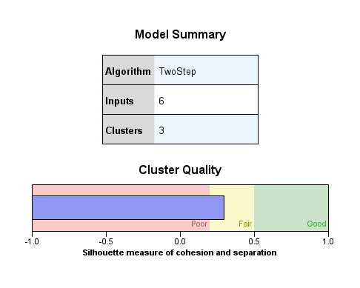
Figure 4: Model Summary and Cluster Quality

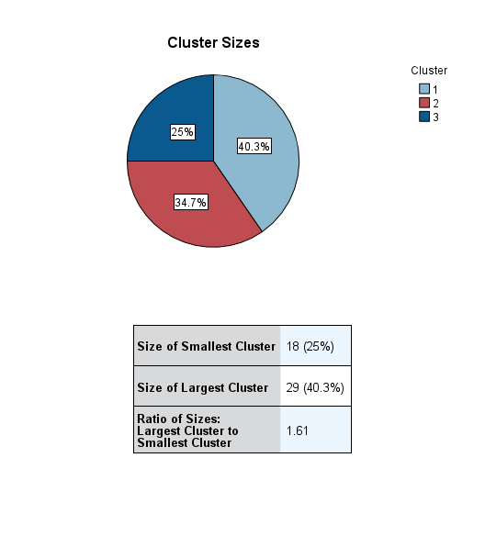
Figure 5: Cluster size
Table 2: Cluster Profiles (Centroids)
Variables | 1 | 2 | 3
Variables | Wholesale | Retail | Market-Oriented
CDAR | 65.38 | 72.95 | 64.83
TAAR | 39.60 | 40.80 | 51.25
BLAR | 8.92 | 5.04 | 18.19
TCER | 16.22 | 10.93 | 12.89
DACTR | 12.26 | 19.15 | 23.66

Table 3: Classification of Banks
Bank | 1 | 2 | 3
Bank | Wholesale | Retail | Market-Oriented
ACCESS | 0% | 92.3% | 7.7%
ZENITH | 100% | 0% | 0%
UBA | 0% | 100% | 0%
FBN | 0% | 0% | 100%
GTB | 87.5% | 0% | 12.5%

Table 4: Switching of Banking Model
 | 1 | 2 | 3
Bank | Wholesale | Retail | Market-Oriented
ACCESS | – | 2006 – 2020 | 2005
ZENITH | 2005 – 2020 | – | –
UBA | – | 2005 – 2020 | –
FBN | – | – | 2005 – 2020
GTB | 2005, 2008 – 2020 |  | 2006 – 2007

As Figure 3 shows, three main clusters can be identified in the data, although, there are also smaller heterogeneous groups within each cluster. From Figure 4, the two-way cluster analysis also identifies three clusters based on six input variables: bank, CDAR, TRAR, BLAR, TCER, and DACTR. The quality of the analysis is fair. From Figure 5, we can see that the largest cluster contains 40.3% of the data, while the smallest cluster contains about 25% of the data; hence, the ratio of the largest cluster to the smallest cluster is 1.61.
From the cluster profiles (centroids) in Table 2, we label the clusters as follows:
Cluster 1 records the lowest trading assets, the highest tangible equity, relatively high customer deposit and interbank lending, and the lowest direct activity. We tag this cluster as a wholesale banking model.
Cluster 2 contains banks with the highest customer deposits, relatively low trading assets, and direct activity, as well as the lowest interbank lending and tangible equity. We name this cluster retail banking model as it comprises banks that rely heavily on stable funding through customer deposits and are rarely involved in interbank lending.
Cluster 3 contains banks with the highest direct activity, the highest interbank liability, the highest trading assets, and the lowest customer deposit ratio. We classify banks in this cluster as having a market-oriented model, as banks that adopt this strategy are deeply involved in trading and market making activities.
Table 3, which classifies banks according to their business models, shows those three banks, namely, ZENITH, UBA, and FBN, maintain one banking model over the period under study, whereas two banks, namely, Access and GTB, switch models. For non-switchers, ZENITH maintained wholesale banking, while UBA and FBN pursued retail banking and market-oriented banking, respectively. However, as Table 4 indicates, ACCESS only adopted the market-oriented model in 2005, while it has been implementing the retail banking model since then. On the other hand, GTB started with the wholesale model in 2005 but implemented the market-oriented model between 2006 and 2007. However, the bank also switched back to the wholesale model in 2008.
4.3 DISCUSSION OF FINDINGS
4.3.1 Business Models and Funding Requirements
The studied banks have adopted retail-funded, wholesale-funded, and market-oriented business models in the period under study. Six critical variables were used in analysing and determining the different models. These are statements of financial position ratios. See Ayadi et al. (2011), Roengpitya, Tarashev, and Tsatsaronis (2017), and Mergaerts and Vander Vennet (2016). It shows the funding requirements and the various activities the banks and various models engage in. Banks with a wholesale strategy had the lowest trading assets, low interbank lending, and low domestic activities. However, it has the highest equity absorbing capacity. Retail-funding banks have moderately low trading assets, domestic activities, loss absorbing capacity, and the lowest interbank lending. The market-oriented are more diversified in assets.
Zenith Bank maintained a wholesale-funded model all through the study period. GT Bank adopted both wholesale and market-oriented models. UBA employed only a retail-funded model, with Access Bank adopting both retail-funded and market-oriented models. FBN Holdings pursues a market-oriented banking model.
The central characteristic across the three models is that the respective activities engaged by the banks were mainly funded by customers’ deposits. The wholesale funded business model has 65.38% of its assets funded by customer deposits. Retail-funded and market-oriented had 72.95% and 64.83% of assets funded by customers’ deposits, respectively. (See Table: 2).
4.3.2 Deposit Characteristics and Mix
Table 5 contains the deposit mix of the five banks studied. Access Bank has an average deposit mix of 53:47; Zenith Bank, 82:18; UBA, 74:26; FBN Holdings, 74:26; and GT Bank, 70:30. All these are skewed towards the current account and savings bank account. It means that out of the total deposit liabilities at Access Bank, 53% are demand deposits, while 47% are term deposits. The same explanations go for Zenith, UBA, FBN Holdings, and GT Bank. This indicates that for the studied bank deposit structure, current deposit accounts and savings bank account balances, otherwise known as demand deposits, play dominant roles. It underscores the importance and role of a deposit plan for any business model to achieve its desired objectives of profitability, efficiency, and effectiveness. This is in line with earlier studies by Shrivaslava (1980), Bodla and Vrma (2006), and Shollapur and Bangati (2010).
Table 5: |  | BANKS BY DEPOSIT MIX in N Billion
 | Access |  | Zenith |  | UBA |  |  | FBN HOLDINGS |  |  |  | GT Bank CASA/ Deposit
Year | Total Deposit | CASA/ dep. ratio | Total Deposit | CASA/ dep. ratio | Total Deposit |  | CASA/ dep. ratio | Total Deposit |  |  | CASA/ dep. ratio | Total Deposit ratio |  | CASA/ dep. ratio
2005 | 34 | 0.56 | 233 | 0.78 | 205 |  | 0.63 | 332 |  |  | 0.67 | 97 0.59 |  | 0.59
2006 | 117 | 0.56 | 393 | 0.76 | 776 |  | 0.72 | 448 |  |  | 0.73 | 215 0.49 |  | 0.49
2007 | 211 | 0.52 | 634 | 0.8 | 905 |  | 0.66 | 599 |  |  | 0.75 | 294 0.59 |  | 0.59
2008 | 430 | 0.45 | 1,188 | 0.88 | 1333 |  | 0.73 | 700 |  |  | 0.79 | 470 0.67 |  | 0.67
2009 | 438 | 0.15 | 1,173 | 0.88 | 1245 |  | 0.73 | 1,339 |  |  | 0.69 | 683 0.51 |  | 0.51
2010 | 486 | 0.5 | 1,318 | 0.82 | 1267 |  | 0.77 | 1,450 |  |  | 0.81 | 761 0.67 |  | 0.67
2011 | 1,236 | 0.61 | 1,655 | 0.83 | 1,445 |  | 0.78 | 1,951 |  |  | 0.85 | 1,026 0.74 |  | 0.74
2012 | 1,298 | 0.62 | 1,929 | 0.8 | 1,720 |  | 0.8 | 2,395 |  |  | 0.79 | 1,148 0.68 |  | 0.68
2013 | 1,403 | 0.62 | 2,276 | 0.78 | 2,161 |  | 0.78 | 2,929 |  |  | 0.76 | 1,427 0.75 |  | 0.75
2014 | 1,573 | 0.57 | 2,537 | 0.82 | 2,169 |  | 0.74 | 3,050 |  |  | 0.66 | 1,618 0.73 |  | 0.73
2015 | 1,756 | 0.58 | 2,557 | 0.78 | 2,081 |  | 0.74 | 2,970 |  |  | 0.67 | 1,610 0.72 |  | 0.72
2016 | 2256 | 0.56 | 2,983 | 0.81 | 2485 |  | 0.79 | 3,104 |  |  | 0.73 | 1,986 0.79 |  | 0.79
2017 | 2695 | 0.47 | 3,457 | 0.83 | 2733 |  | 0.75 | 3,143 |  |  | 0.72 | 2,062 0.82 |  | 0.82
2018 | 3559 | 0.49 | 3,690 | 0.87 | 3349 |  | 0.77 | 3,486 |  |  | 0.77 | 2,273 0.84 |  | 0.84
2019 | 5442 | 0.58 | 4,262 | 0.88 | 3832 |  | 0.73 | 4,019 |  |  | 0.78 | 2,532 0.85 |  | 0.85
2020 | 6545 | 0.65 | 5,339 | 0.94 | 5676 |  | 0.82 | 4,894 |  |  | 0.81 | 3,509 0.89 |  | 0.89
Average | 1842.4375 | 0.530625 | 2226.5 | 0.82875 | 2086.375 |  | 0.74625 | 2300.5625 |  |  | 0.74875 | 1356.9375 0.70815 |  | 0.708125
 |  | Ratio of current and savings account to total deposit
Note: CASA is current deposit and savings bank account balances
Source: Various Annual Accounts of Banks

4.3.3 Model Switching
Zenith Bank, UBA, and FBN Holdings maintained one banking model over the period under study. Access and GT Bank switched models. Access adopted a market-oriented model only in 2005, and since then it has been a retail banking model. GT Bank started with a wholesale model in 2005 and adopted a market-oriented model in 2006 and 2007. However, it switched back to a wholesale model in 2008. The question is: why did Access Bank change from a market-oriented model to a retail-funded in 2006? Why did GT Bank change from a wholesale model to a market-oriented in 2006 and 2007? Why did it go back to wholesale again in 2008? We offer some explanations below:
ACCESS BANK
Access Bank was a small commercial bank founded in 1989 that ranked 65th in size out of 89 banks in the country when Herbert Wigwe and his business partner, Aigboje Aig-Imoukhuede, acquired it in 2002. It was scaled up through a series of strategic mergers and acquisitions over the years, and in 2020, it will be not only Nigeria’s biggest bank but also rapidly becoming one of the top financial institutions in Africa.
In the 2005 annual report of the bank, the Group Managing Director, Aigboje Aig-Imoukhuede, said that “the bank recorded setbacks in 2004 largely attributable to uncertainties, turbulence, and administrative delays that followed the wake of new regulations introduced to govern the recapitalization efforts of the Nigerian banking industry. We therefore will take the necessary steps to ensure that we restore our profit to a level commensurate with our industry position." This sounds like the bank had an intention to evolve a new strategic model that would confront the outcomes of the regulatory and environmental challenges facing the bank. This led to their acquisition of Capital Bank International (formerly Commercial Bank Credit Lyonnaise Ltd.) and Marina International Bank. This strategic move gave them a quantum leap in their asset base. It moved from N66 billion to N174 billion, which translates to 163% growth. Customers’ deposits also moved from N34 billion in 2005 to N117 billion in 2006, an increase of 244%

GT BANK
Guaranty Trust Bank plc was incorporated as a limited liability company licensed to provide commercial and other banking services to the Nigerian public in 1990. The bank commenced operations in February 1991 and has since grown to become one of the most respected and service-focused banks in Nigeria. In September 1996, Guaranty Trust Bank plc became a publicly quoted company and won the Nigerian Stock Exchange President's Merit Award that same year and subsequently in the years 2000, 2003, 2005, 2006, 2007, 2008, and 2009. In February 2002, the Bank was granted a universal banking license and later appointed a settlement bank by the Central Bank of Nigeria (CBN) in 2003.
The Managing Director was quoted in his statement in the 2005 annual report as saying that “the result of GT Bank performance clearly shows the growing strength of the Guaranty Trust Brand and points to the fact that, with your continued support, we will continue to innovate, lead, and help to transform the financial service industry in the foreseeable future." This affirmative statement suggests a bank on its growth trajectory, which would have switched models intuitively. This is corroborated by the fact that the model lasted for only two years and reverted to the earlier wholesale funded model
5.0 SUMMARY AND CONCLUSION
5.1 Summary
The objective of this paper was to examine the empirical evidence of the different business models that Nigerian deposit money banks operate using the five top Nigerian banks by asset base from 2005 to 2020. This was with a view to establishing the deposit funding requirements of the business models for each of the banks studied. Further review of the bank’s primary deposit characteristics was carried out to establish the prevailing deposit mix. This was to interrogate the traditional view that time deposit accounts provide stability to the bank’s balance sheet and are most preferred in the deposit structure of deposit money banks. Again, an inquiry into why banks switch models.
In doing so, selected balance sheet ratios were used as input variables to analyse the funding requirements and activities of the studied banks using cluster analysis. They are customer deposit asset ratio, trading asset ratio, bank lending asset ratio, tangible equity asset ratio, and domestic activity asset ratio. Cluster analysis was used to identify various business models.
The studied banks—Access, Zenith, FBN Holdings, UBA, and GT Bank—were classified according to the respective business models they adopted using the data characteristics. The models were retail-funded, wholesale-funded, and market-oriented. Zenith, UBA, and FBN Holdings adopted wholesale, retail, and market-oriented models, respectively. Access and GT Bank switched models at various times.
The central feature that runs across the three models is that the respective activities engaged by the banks were funded mainly by customers’ deposits. And the bank deposit mixes were all positively skewed towards demand deposits.
5.2 Conclusion
We conclude that demand deposits are critical and the most vital and dominant components of banking institutions deposit structures. This provides an alternative argument to the traditional view that time deposits bring stability to the bank's balance sheet and therefore should be accorded priority in mobilisation. Further research will be needed to investigate how the studied models impact the various banks’ profitability.
Access Bank seems to have reacted to regulatory and environmental factors and their desire to rise and sustain their projected industry position. GT Bank’s switch was a flow. Zenith, FBN Holdings, and UBA never switched. They are all affected by regulatory, legal, and environmental factors. We can therefore conclude that the reason for model switching in Nigeria flows more from the strategic decisions of the management of the banks than environmental and legal factors. This is in line with Ayadi et al. (2011), Ayadi and de Green (2014), and Farne and Vouldis (2017).
References
Access Bank Various Annual Reports from 2005 to 2020
Amel, D F, S A Rhoades (1988) Strategic Groups in Banking. Review of Economics and Statistics, 70 (4), 685–689.
Aneta Hryckiewicz & Łukasz Kozłowski (2017). Banking business models and the nature of financial crisis, Journal of international Money and Finance , 71, 1-24
Ayadi, R, E Arbak and W P de Groen (2011): Business Models in European Banking: A pre- and post-crisis screening, Centre for European Policy Studies (CEPS), Brussels.
Ayadi, R and W de Groen (2014): Banking business models monitor 2014 – Europe, Centre for European Policy Studies and International Observatory on Financial Services Cooperatives.
Bodla, B.S. & Verma, R. (2006). Determinants of Profitability of Banks in India: A Multivariate Analysis. Journal of Services Research, 6(2), 75-89.
Calinski, R.B. and J. Harabasz (1974). A dendrite method for cluster analysis, Communications in Statistics, 3(1), 1-27.
Central Bank of Nigeria (2012). Monetary , credit , foreign trade and exchange policy guidelines

Drury, Colin (2000).Management and Cost Accounting; Van Nostrand Reinhard (UK).

Everitt, B S, S Landau, M Leese and D. Stahl (2011): Cluster analysis, fifth edition, John Wiley.
Farnè, M and A Vouldis (2017): Business models of the banks in the euro area, ECB Working Paper No 2070.
First Bank of Nigeria Holdings Plc various annual reports from 2005 to 2020
GT Bank various annual reports from 2005 to 2020
Köhler, M (2015) Which banks are more risky? The impact of business models on bank stability, Journal of Financial Stability 16, 195–212.
Mehra, A (1996) Resource and Market Based Determinants of Performance in the U.S. Banking Industry, Strategic Management Journal, 17 (4), 307-322.
Mergaerts, F and R Vander Vennet (2016): Business models and bank performance: A long- term perspective, Journal of Financial Stability 22, 57–75.
Mouck, Tom (1997).Panglosian Capital Budgeting Theory in a Complex Adaptive World, The University of New Mexico, USA., Working Paper

Nicolae Baltes and Maria-Daciana Rodean Cozma (2017). Efficiency of operational Activity of Commercial banks in Romania, Expert Journal of Finance, (5), 86-93

Roengpitya, R. Tarashev, N. Tsatsaronis, K.(2014). Bank Business Models, BIS Quarterly Review (2014), 55

Roengpitya, Rungporn, Nikola Tarashev, Kostas Tsatsaronis and Alan Villegas (2017). Bank business models: popularity and performance. Bank of International Settlement Working Papers No: 682.
Shollapur M.R & Baligatti Y.G (2010). Funds Management in Banks: A Cost-Benefit Perspective. International Business & Economics Research Journal, 9(11), 21-3
Stiroh, K J, A Rumble (2006) The dark side of diversification: the case of US financial holding companies, Journal of Banking and Finance 30 (8), 2131–2161.
United bank for Africa various annual reports from 2005 to 2020
Venkatesan S. (2012). An Empirical Approach to Deposit Mobilization of Commercial Banks in Tamilnadu. IOSR Journal of Business and Management, 4(2), 41-45.
Wilkinson, L, L Engelman, J Corter and M Coward (2007).Cluster Analysis in SYSTAT 12 Statistics I, I- 66–122.
Zenith Bank Nigeria Plc various annual reports from 2005 to 2020
Zott, C and R Amit (2011). The business model: Recent developments, and future research, Journal of Management, 37(4), 1019-1042.

