Identification of potentials, constraints and possible intervention areas to improve agricultural and natural resources productivity at Illala sub-watershed, Tigray, Ethiopia

Abstract
Poor intensity and erratic distribution of rainfall in Tigray Region is one of the factors that cause reduction in agricultural and natural resources production. Subsequent water scarcity and inefficient utilization are among the major problems of production in the region. As a solution, introducing improved agricultural and natural resource technologies as well as providing expert support and other help by different actors is critical in alleviating these problems by raising agricultural production and natural resources productivity in attaining food security.
This study is focusing at assessing and evaluating the potentials, problems and forwarding possible solutions. The team has conducted survey using questionnaire, interview of key informants and focus groups discussion, physical observation and by consulting secondary information.
The main objective of the study was to assess the potentials and constraints as well as to recommend possible intervention areas for Illala sub-watershed. The potentials and constraints of production have been identified. Possible interventions have been recommended for agricultural, and natural resources production for the irrigated and non-irrigated areas in the sub-watershed.
Based on the study, the main agricultural and natural resources potentials are suitable agro-ecology, water resource, suitable land and access to market. The main constraints include lack of concreate canals and dams, feed shortage, high prevalence of disease and pests, and lack of improved agricultural and natural resource technologies.
Key words: Constraints, Illala river, Possible interventions, Potentials, Sub-watershed

- Introduction
Land and water resources are the most crucial and limited natural resources found in the earth surface(Pareta & Pareta, 2012; Seifu et al., 2023). Because of its sensitive nature, water and soil resources need to be manage in a sustainable & effective manner for sustainable utilization (Suthar, 2022). The watershed is an ideal unit for management and utilization of natural resources such as, water, soil, land and for mitigation of the impact of natural disasters for achieving sustainable development.
A watershed is defined as natural Hydrologic unit that covers a precise area of land surface from which rainfall in the form of runoff flows to a definite drainage, stream or river at any point, They are hydrologic units considered to be efficient and suitable for the assessment of accessible resources within an area thus influencing subsequent planning and implementation of different development programs within that area (Eshetu et al., 2017; Patode et al., 2017) and it is an ideal unit and accepted approach for planning, development and management of land and water resources (Srinivas et al., 2007). Currently, the concern for the environment protection is increasing day to day due to physical, chemical and biological degradation of the natural resources that have led to the economic, social, and ecological imbalances. The over-exploitation and mismanagement of natural resources have resulted in the degradation of land, soil erosion and shortage of water as a major environmental issue in the contemporary times (Pareta & Pareta, 2012; Patil et al., 2010; Venkataratnam & Sankar, 2018).
The way the relationship taking place between humans and the environment has caused a succession and variety of environmental problems. These are, causing rapid degradation, soil and water contamination, air pollution, loss of crop productivity, erosion, which, in turn, causes overflowing, landslides, siltation of rivers, floods, and desertification, are among many others causes of mismanagement of watersheds. Hence, to solve such problems, the necessary first step in the organization and planning process for the area is diagnosis and evaluation for implementing integrated watershed management approach to improve the sustainable utilization and to sustain the watershed existence (Africa, 2003; Reis et al., 2015).
In solving such problems, the recent technologies of Geographical Information System (GIS) and Remote Sensing (RS) plays a great role in mapping natural resources characterizations in a watershed for further planning and sustainable utilization(Gebre et al., 2015; SAREN et al., 2023; Venkataratnam & Sankar, 2018). Illala sub-watershed is found five-kilometer north eastern direction of Mekelle city covering mainly Felgdaero, Adiwelel, and Lachy areas. It was source of irrigation for production of horticultural and other crops and source of drinking water for animals, small holder farmers and investors of semen administration of Mekelle City throughout the year. The farmers in the area supply fresh vegetables, especially, lettuce, carrot, Swiss charge and so on to Mekelle market and is one of the watersheds that serves to improve the livelihood of the community through different agriculture (Crop, livestock and Natural resources management) related activities for a long period.
Currently, the sub-watershed faces problems of soil erosion, land degradation, shortage of water flow, and water pollution caused by human activities and other natural phenomena. To solve these and other environment related problems with in the watershed, implementing integrated watershed management approach helps the watershed to sustain its flow length, minimize soil erosion, land degradation, improving agricultural production and productivity through introducing improved agricultural technologies, as job creation option for youth’s and to recommend conservation practices. Therefore, this study was aimed to assess the opportunities and constraints in the watershed and to recommend possible interventions for sustainable utilization of the watershed resources effectively.

Problem Statement
The communities living in Ilala watershed have a long-time experience on producing and selling vegetables and other agricultural products in Mekelle City. However, currently the communities are facing to problems of low agricultural productivity due to shortage of irrigation water in the watershed, low provision of improved agricultural inputs (Technologies), soil erosion, and water pollution. Limited activities have been tried to help the communities by Tigray Agricultural Research Institute. However, the research activities so far carried out were scattered and not done in holistic approach considering the watershed approach. Studying on existing land resources and their use, future land use plan, assessing agricultural and natural resources potentials, constraints and possible solutions, water quality and suggesting possible intervention measures that contribute in the development of the watershed will be beneficial to the community. Therefore, this study aims to assess the opportunities, constraints and possible intervention areas in the Illala sub-watershed to implement Integrated Watershed Management Approach (IWMA).

Objectives

1.2.1. General Objective
The general objective of the study was to identify measures/interventions to be taken to improve sustainable utilization of natural and agricultural resources in the sub-watershed and to help the communities by providing improved technologies that increase agricultural and natural resource production and productivities.

1.2.2. Specific Objective
- To delineate watershed hydrological and biophysical characteristics
- To assess the agricultural and natural resource potentials and constraints in the watershed

- Research Methodology

Area description of the study
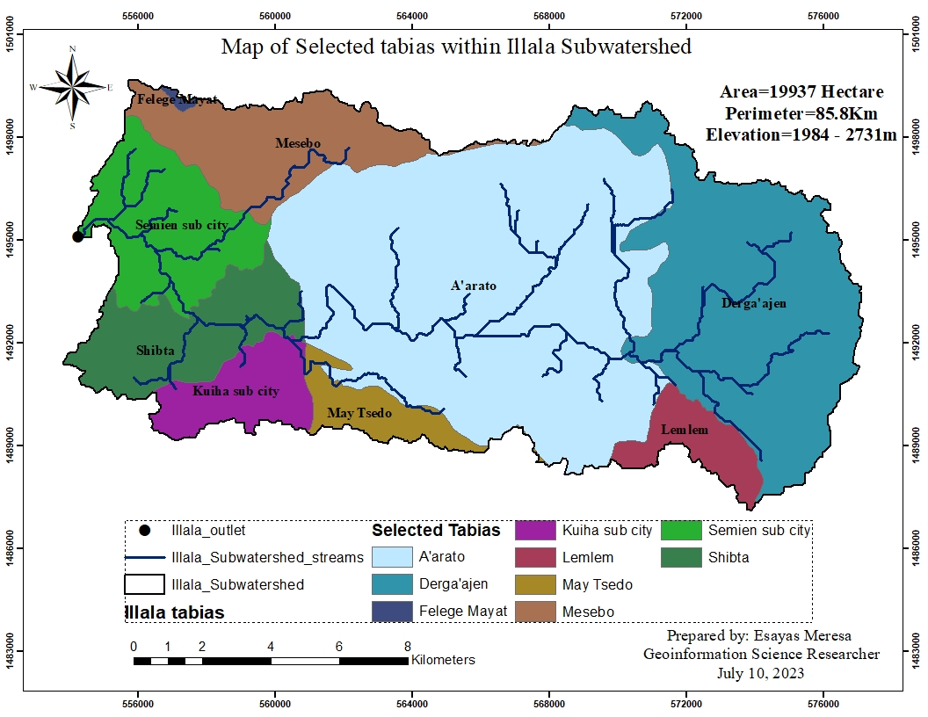
Illala sub-watershed is found five-kilometer north direction from center of Mekelle city, capital of the Tigray Region. It starts draining from the derga’ajen escarpments and flows following steep slopes to join the Geba river. It touches peasant associations (tabias) of Derga’ajen, Lemlem, Arato, May-Tsedo, Kuiha subcity, Shibta, Mesebo Semien subcity and Felege mayat with an area coverage of 19,937 hectare and perimeter of 85.8 kilometer. Geographically it is found from 13.45⁰ to 13.56⁰ N latitude and 39. 49⁰ to 39.71⁰ E longitudes with elevation ranges of 1984 m to 2731m a.m.s.l. and the outlet is found at 13.524⁰N and 39.501⁰E. It receives annual rainfall that ranges from 631mm to 667mm with mean rainfall of 644.9mm and annual average temperature ranges from 15.9⁰c to 19.9⁰c with mean temperature of 17.5⁰c. Agroecologically the sub-watershed is classified into two classes, which are weyna-dega (27.68%) and dega (72.32%) and four soil textural classifications of loam (94.5%), sandy loam (0.02), loamy sand (3.27) and sand (2.23%). (Source: Processed from global data sets).
Figure 1. Geographical location of Illala sub-watershed and its streams

- Results

Hydrological and biophysical characteristics of the Illala Sub-watershed

Stream network and stream order of the sub-watershed
Based on the DEM hydro-processing methodology stream network and stream order of the watershed were developed. The streams flow from upper derga’ajen escarpments into the outlet following the smoothly low elevation of the downstream part of the watershed. Large numbers of streams with short length are generated at the steep slope, and a smaller number of long streams are delineated in the gentle part of the watershed. A total of 63 stream networks(A) and three stream orders(B) were delineated with flow accumulation ratio of greater than 5000 values (Figure:2). The longest and shortest stream distances are 7.07 kilometer and 0.07 kilometer, respectively with mean stream distance of 1.72 kilometer. Stream numbers in each stream order were also calculated and stream order 1 has 32 streams, order 2 has 13 streams and order 3 has 18 streams. Stream order 1 has the longest distance and lowest distance was observed in order 2.
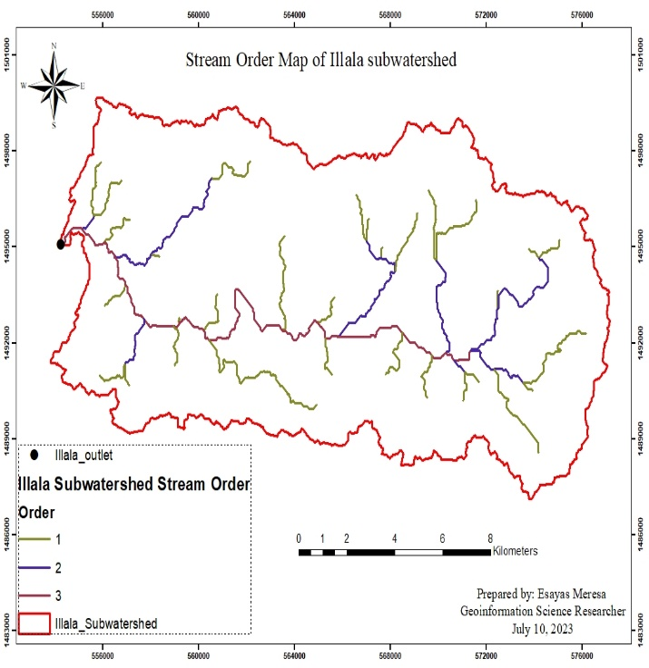
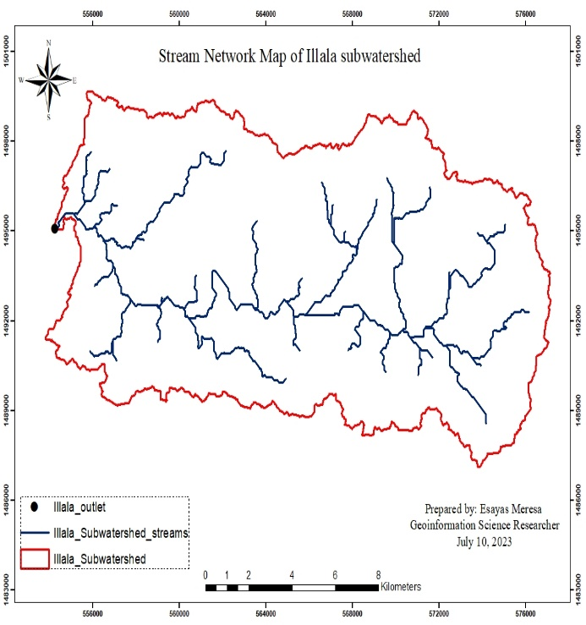
B
A

Figure 2. Stream network(A) and Stream order(B) of the Illala sub-watershed

Slope classification of the sub-watershed
The sub-watershed has a slope range from 0 – 64 degrees with mean slope of 11.5 and standard deviation of 7.7. It was classified into six classes according to FAO slope classification method; classes 0-3% (flat), 3-8% (gentle), 8- 15% (moderate), 15-30% (steep), 30-50% (very steep), and >50% (Extremely steep). Based on the classification, the sub-watershed classified as moderate slope covers 35.8% followed by gentle slope with 31.02% coverage and the least slope class was extremely steep with 0.08% coverage followed by very steep slope 3.04%. Based on the slope classification, some soil and water conservation practices are required in the steep and hilly parts for improving infiltration rate, reducing soil erosion and runoff in the watershed to conserve natural and agricultural resources for wise utilization and future planning.
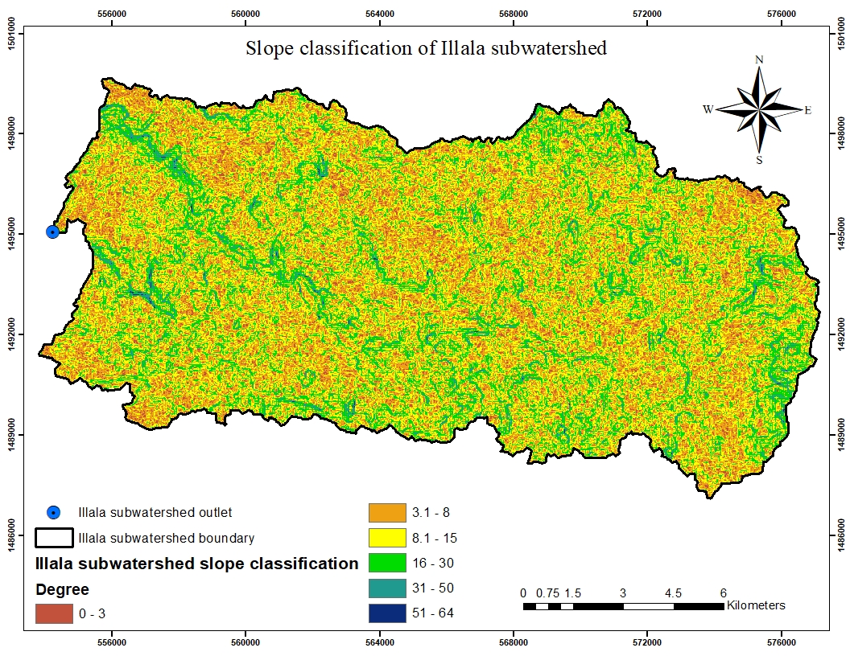
Figure 3. FAO based slope classification of Illala sub-watershed
Table 1. Slope classification and its areal coverage of the sub-watershed
Value | Slope Class | Slope Type | Area (Ha) | Percent
1 | 0-3% | Flat slope | 1412.76 | 7.14%
2 | 3-8% | Gentle slope | 6134.44 | 31.02%
3 | 8-15% | Moderate slope | 7085.24 | 35.8%
4 | 15-30% | Steep slope | 4519.52 | 22.8
5 | 30-50% | very steep | 601.76 | 3.04%.
6 | >50% | Extremely Steep | 16.88 | 0.08%

Annual long-term mean rainfall and temperature distribution of the sub-watershed

According to the long-term mean annual rainfall data processed from www.worldclim.org website, the sub-watershed receives annual mean rainfall that ranges from 631mm to 667 mm with mean rainfall of 644.9 mm per year. The highest rainfall distribution was observed on the mountainous areas and lowest distribution was observed on the flat and steep slopes of the sub-watershed (Figure-4A). In addition, the long-term average temperature of the watershed ranges from 15.9⁰c to 19.9⁰c with mean temperature of 17.5⁰c as mentioned in Figure 4B.
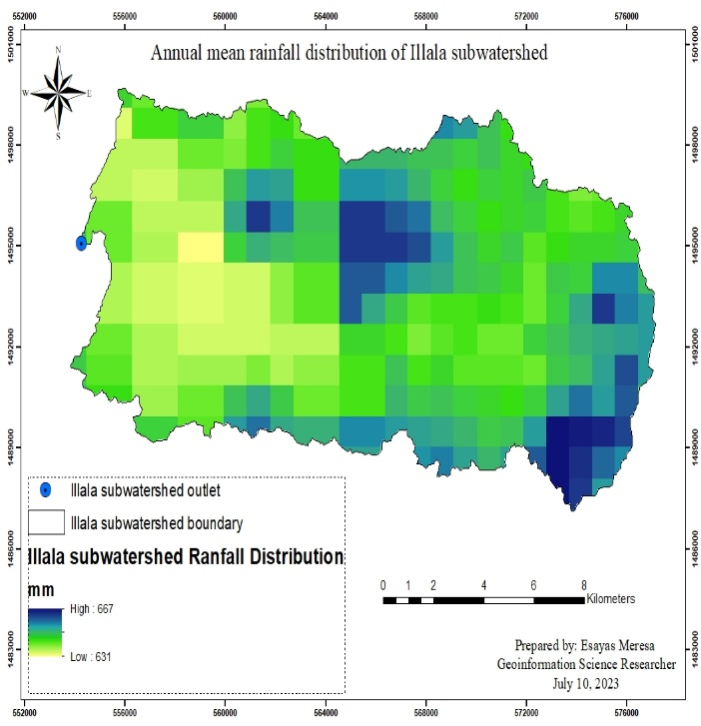
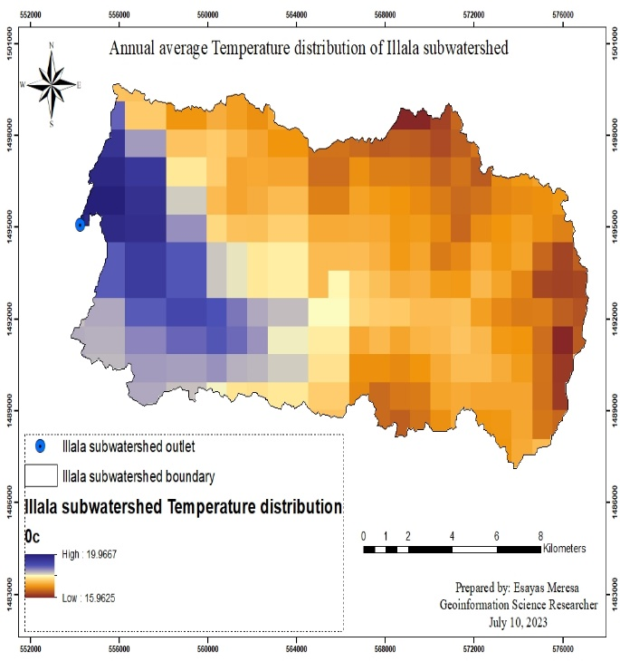
A
B

Figure 4. Annual mean rainfall(A) and annual temperature(B) spatial distribution of the sub-watershed

Agroecological and soil texture classification of the sub-watershed
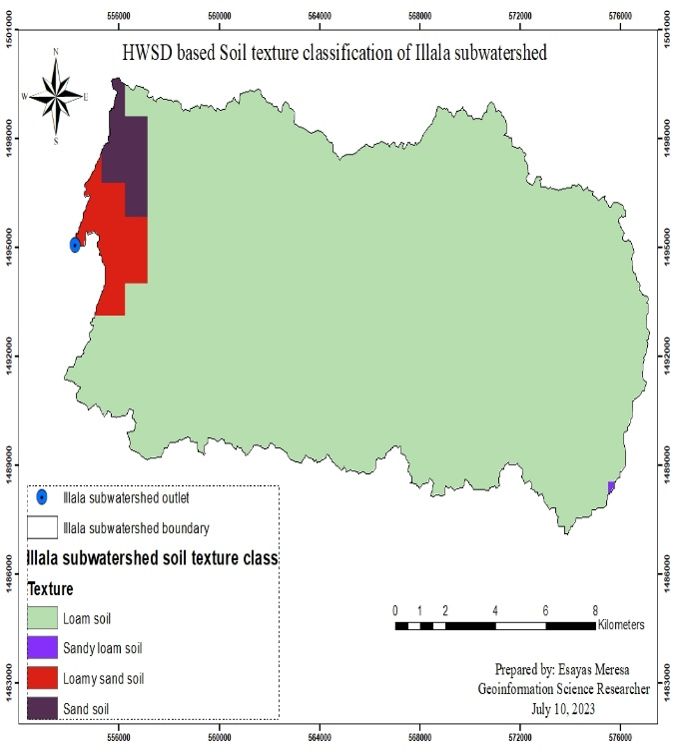
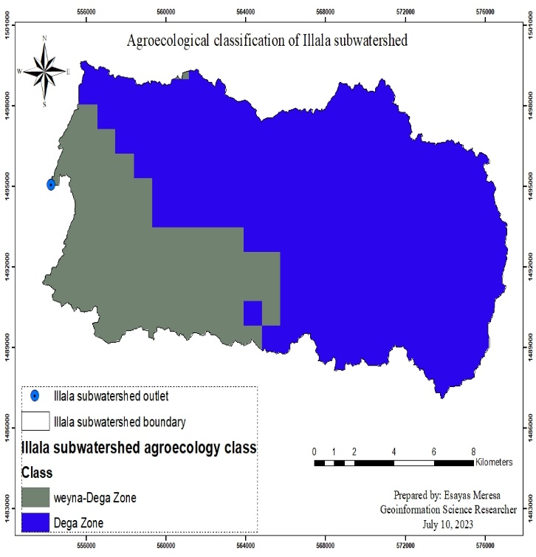
According to the elevation based agroecological classification method, the sub-watershed was classified into two classes, which are weyna-dega (27.68%) and dega (72.32%) as indicated in Figure 5A and based on the Global Harmonized World Soil Database (HWSD) the sub-watershed has four soil textural classes, which are loam (94.5%), sandy loam (0.02), loamy sand (3.27) and sand (2.23%) as mentioned in Figure 5B. (Source: Processed from global data sets).
B
A

Figure 5. Agroecological (A) and soil textural (B) classification of Illala sub-watershed

ESRI-2020 based Land use land cover map of the sub-watershed

The company of Environmental Systems Research Institute (ESRI) produces and provides time series Annual Land Use Land Cover maps of 2017- 2022 for different applications. The maps are derived from European Space Agency (ESA) Sentinel-2 imagery at 10m resolution. Each map is a composite of LULC predictions for 9 classes throughout the year in order to generate a representative snapshot of each year. This dataset was generated by Impact Observatory, used billions of human-labeled pixels (curated by the National Geographic Society) to train a deep learning model for land classification. Each of the maps has an assessed average accuracy of over 75% (Karra, Kontgis, et al. 2021).
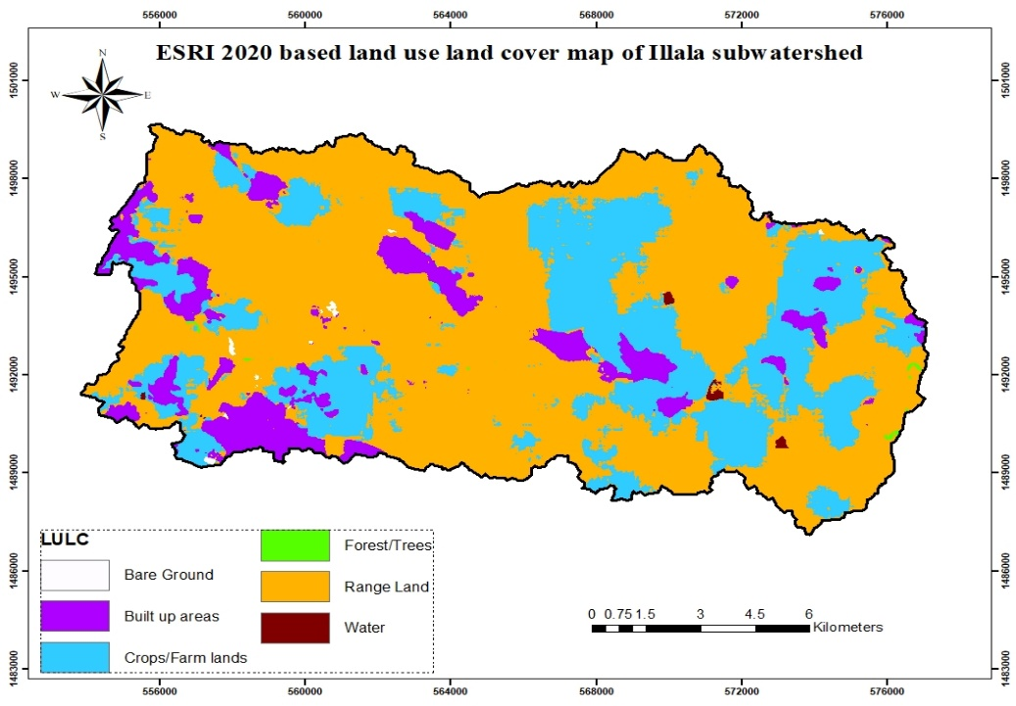
Based on this global land use land cover, the sub-watershed has six major land use land cover class, which are Water, Trees, Crops, Built up areas, Bare ground and Range land classes (Figure 6). The sub-watershed was covered dominantly by range land with 63.4% and followed by crop land with 26.6%. The least land use land cover class was forest/trees with 0.10% and followed by bare ground with coverage of 0.14% (Table 2).
Figure 6. ESRI 2020 based land use land cover map of the Illala sub-watershed

Table 2. Land use land cover class and their area coverage with in the sub-watershed
ID | Code | LULC | AREA_HA | PERCENT
1 | 1 | Water | 38.81 | 0.19
2 | 2 | Forest/Trees | 19.77 | 0.10
3 | 5 | Crops/Farm lands | 5300.54 | 26.59
4 | 7 | Built up areas | 1906.91 | 9.56
5 | 8 | Bare Ground | 28.70 | 0.14
6 | 11 | Range Land | 12643.10 | 63.41
Table 3. ESRI based land use land cover Class definitions
ID | Code | LULC class | Class definitions
1 | 1 | Water | Areas where water was predominantly present throughout the year; may not cover areas with sporadic or ephemeral water; such as rivers, ponds, lakes, oceans.
2 | 2 | Trees | Any significant clustering of tall (~15 feet or higher) dense vegetation, typically with a closed or dense canopy; examples: wooded vegetation, clusters of dense tall vegetation within savannas, plantations, swamp or mangroves
3 | 5 | Crops | Human planted/plotted cereals, grasses, and crops not at tree height; examples: corn, wheat, soy, fallow plots of structured land.
4 | 7 | Built up area | Human made structures; major road and rail networks; large homogeneous  impervious surfaces including parking structures, office buildings and residential housing; examples: houses, dense villages / towns / cities, paved roads, asphalt
5 | 8 | Bare ground | Areas of rock or soil with very sparse to no vegetation for the entire year; large areas of sand and deserts with no to lie vegetation; examples: exposed rock or soil, desert and sand dunes, dry salt ats/pans, dried lake beds, mines.
6 | 11 | Range land | Mix of small clusters of plants or single plants dispersed on a landscape that shows exposed soil or rock; scrub-filled clearings within dense forests that are clearly not taller than trees; examples: moderate to sparse cover of bushes, shrubs and tufts of grass, savannas with very sparse grasses, trees or other plants.
Source: ESRI 10m Annual Land Use Land Cover (2017-2022) - awesome-gee-community-cataloge

Irrigation scheme in the sub-watershed

Irrigation scheme characteristics in the sub-watershed
The whole catchment area of the Illala sub-watershed was estimated to be 19,937 hectares out of which only 481.35ha (2.4%) was used for irrigation which is very low as compared to the average regional irrigation coverage (4%). Consequently, almost all the households found in the Ilala sub-watershed are dependent on subsistence agriculture where the average productivity has been substantially decreased due to the major constraints particularly moisture stress and lack of improved agronomic packages. Currently, the irrigable land in Illala sub-watershed is about 481.35ha that is 338.55ha in Tabia Arato, 138ha in Tabia Derg Ajen and 4.8 ha in Tabia mesebo. Accordingly, the irrigation beneficiaries in these Tabias are 992,293 and 22 in Tabias Arato, Dergajen and Mesebo respectively. However, the number of irrigation beneficiaries is very low as compared to the total number of populations in these Tabias as indicated in Table 4. The irrigation schemes have poor water harvesting systems and poor water management practices. As a result of this, the potential of the irrigable lands and the existing water resources can’t be efficiently used unless development strategies are planned and implemented. Hence, the existing problems will be solved through constructing proper micro dam structure, constructing proper irrigation structures, and proper water management strategies.
Table 4. Population size in some Tabias found in the sub-watershed
Tabia Arato |  |  |  | Tabia Derg Ajen |  |  | Tabia Mesebo
 | Male | Female | Total | Male | Female | Total | Male | Female | Total
Total population | 6846 | 6579 | 13425 | 5116 | 4821 | 9937 | 1161 | 1193 | 2354
Irrigation users | 827 | 165 | 992 | 250 | 43 | 293 | 0 | 0 | 0
Percentage | 12% | 2.5% | 7.4% | 4.9% | 0.9% | 3.0% | 0 | 0 | 0

Potentials and Constraints of irrigation in the sub-watershed
Table 5. Irrigation scheme potentials and constraints
Feleg Daero Irrigation Scheme
Potentials | Rank | Constraints | Rank | Possible Interventions
Sufficient water source | 1 | Shortage of water | 8
Good quality water | 5 | Poor water quality | 6
Suitable land | 2 | Absence of bylaws | 7
Suitable agro ecology | 4 | Soil erosion | 4 | - Biological SWC  - Using gabions  - using cement
Access to market | 8 | Poor maintenance of canals | 2 | - Using lined canals  - Regular maintenance
Good water management skills | 6 | Traditional/Poor water management | 5 | - Irrigation experts  - Training on IWM
Availability of facilities for water pumping | 7 | Absence of energy/ facility for pumping | 9
Water utilization bylaws | 3 | Bore hole utilization | 3 | - Reopen the closed boreholes
 |  | Absence of reservoir/dam | 1 | - Construction of Dams/ check dams
Arato Irrigation Scheme
Potentials | Rank | Constraints | Rank | Remark
Sufficient water source | 3 | Shortage of water | 2
Good quality water | 1 | Poor water quality | 8
Suitable land | 2 | Absence of bylaws | 7
Suitable agro ecology | 4 | Inputs/ fertilizer | 1 | - Enough supply  - Acceptable price  - Utilization
Access to market | 8 | Poor maintenance of canals | 3 | - Expansion of lined canals  - Regular maintenance
Good water management skills | 6 | Traditional/Poor water management | 4 | - Training and manuals on IWM
Availability of facilities for water pumping | 7 | Absence of energy/ facility for pumping | 6
Water utilization bylaws | 5 | Bore hole utilization | 2 | - Reopen some of the boreholes

Crop production

Major crops grown in the sub-watershed
Based on the farmers group discussion and development agents, field crops (Cereals and pulses) and Horticultural crops like vegetables fruits, and species are grown in the sub-watershed both under rain-fed and/or irrigation condition. Swiss charge, cabbage, lettuce, carrot and onion are the major economically important horticultural crops grown in the sub-watershed under irrigation condition while wheat, barley, teff, lentil and linseed are the major field crops grown in the area under rainfed condition (Table 6). Despite this the area has potential to produce potato, apple, avocado and other horticultural crops. In the area crop production plays an important role in improving household income and nutrition and thereby contributes to food security. In addition, according the group discussion with farmers, the current productivity of wheat, barley and teff are 12-20, 8-12 and 12-qt ha⁻¹ respectively while the productivity of lentil and line seed is 4 and 2 qt ha⁻¹ respectively. Furthermore, according to the Wereda office of agriculture the current productivity of wheat, barley, teff, lentil and linseed are 23, 26, 16, 11 and 12 qt ha⁻¹ respectively. The current productivity of Swiss charge, cabbage and carrot are 375, 408, and 141.5 qt ha⁻¹ respectively under irrigation, which are also grown under rainfed condition. Furthermore, lettuce, onion, tomato and potato are grown in the area as major horticultural crops. Despite of this, the current productivity of the crop is below the potential, the area has suitable agro-ecology as a potential to produce horticultural crops. The low productivity in the water shed in general and among farmers in particular is due to the low level of use of improved crop technology package. Variation in districts, access to irrigation, farm size, and annual income of the households have affected the adoption of crop technology package.

Table 6. Major crops type produced and estimated yield (qt/ha) in the sub-watershed
District -Tabia |  | Field crops |  |  |  |  | Horticultural crops
District -Tabia |  | Wheat | Barley | Teff | Lentil | linseed | Swiss charge | Cabbage | Carrot
Semien-Melees | -Area (ha) | 148 | 75 | 404 | 3.5 | 2.75 | 20 | 59 | 8
Semien-Melees | -Productivity (qt/ha | 23 | 26 | 16 | 11 | 12 | 263 | 259.3 | 141.5
Enderta-Arato | Area (ha)
Enderta-Arato | Productivity (qt/ha | 24 | 15 | 13.5 | 5.5 | 6.5 | 250 | 340 | 240
Mean of Sub-water shed | Area (ha)
Mean of Sub-water shed | Productivity (qt/ha | 23.5 | 20.5 | 14.8 | 8.3 | 20.5 | 256.5 | 299.7 | 190.8
Grass pea and potato was also produced as major crop at Arato with productivity of 12 and 160 qt/ha respectively

3.3.2. Potentials and constraints of crop production in the watershed

3.3.2.1 Potentials of crop production
The result of the group discussion indicates that good soil type, Suitable Agro ecology, water source and access to market are the crop production potential in the sub-watershed despite of their rank. According to the interview of the office of agriculture district expert and development agents, the most commonly crop potentials in the area are related to the suitable agro-ecology, good soil type, access to irrigation water and labor, regardless of their rank. Besides, regardless of the demand or access to market, transport is also an opportunity associated with the crop production. In general, suitable agro-ecology, good soil type and access to irrigation water are the three major crop production potentials. Therefore, these potentials have a great role in developing and promoting crop production and productivity especially cereals, leafy vegetables, potato, apple, avocado and peach through introducing improved varieties with their improved management practices.

3.3.2.2 Crop production constraints
According to the farmer group discussion disease and pest, lack of improved seed, low soil fertility, shortage of production inputs, shortage of water, market place or demand and lack of extension service were identified as a major constraint in crop production despite of their rank difference under rainfed and irrigation condition.
Based on the interviewed development agents and agricultural expertise and farmers group discussion diseases and pest, improved variety, low soil fertility, shortage of inputs and market were the most important constraints related with crop production in the study areas under both conditions. Furthermore, low soil fertility, improved agricultural inputs (Variety, fertilizer and agronomic packages), and disease and pest were the three major constraints under irrigation and rainfed condition in semen district, Mekelle Zone where as Disease and pest, extension service /knowledge, improved variety and shortage of irrigation water were the major constraints at Arato tabia, Enderta district that are challenging crop production (Table 7). Farmers faced shortage of water during dry seasons in order to grow potato under irrigation due to reduction of water bodies (rivers/stream, dams) resulting from insufficient rain fall during rainy season. This causes loss of production and productivity of crops especially vegetables. Hence, it needs to strengthen research-extension linkage to develop improved varieties adapted to diverse biotic and a biotic stresses and improved management practices to solve the major constraints of crop production. In addition, construction of dams, cannels and soil water conservation structures also are important to solve water loss. Farmers make compost to solve the low fertility of soil and lack of inorganic fertilizer.

Livestock Production

Types of livestock in the sub-watershed
The major livestock types produced in the watershed included cattle (local), goats, sheep, chicken, equine and honeybees (reared under traditional and modern beehive). According to the key informants, cattle followed by goats and chicken were the most abundant livestock types in the sub-watershed. Despite different types of livestock were produced in the sub-watershed, substandard focus was given to livestock production by the local community. All livestock types in the sub-watershed were produced under conventional production system. In addition, except chicken that included both local and improved breeds, the other livestock types in the sub-watershed were primarily local breeds.

Potentials and constraints of livestock production in the sub-watershed
According to the expert’s observation, the sub-watershed is endowed with huge potential for livestock production. If proper emphasis could be given to livestock production, especially business-oriented livestock production, it would be a potential alternative in improving the livelihood of the community. Because: the sub-watershed is close to the capital of the region that inhabited by several inhabitants with better purchasing power, there is a better access to market, animal clinic, drinking water, and industrial by-product used for livestock feed. In addition, the watershed has good potential for feed production. As indicated in the land use land cover change section above, the largest part of the sub-watershed is covered by rangeland which can serve as a potential for the production of green feed and hay. In addition, the rangeland in the sub-watershed contains suitable sites for honeybee production. Moreover, the sub-watershed is suitable for the cultivation of various improved forages particularly elephant grass along the gullies of Illala river and alfalfa and/or pigeon pea along the boundaries of the irrigation canals and/or plots. There is also a considerable potential for fishery as pond-based fish production can easily be carried out along the irrigation sites of the sub-watershed.

In addition to the expert’s observation, the potentials of the sub-watershed were assessed using focus group discussion and development agents’ DAs (Table 8). According to the information obtained from the focus groups, access to clean and adequate drinking water, access to market and access to animal clinic were the leading potentials for livestock production in the sampled sites (Feleg daero and Arato) of the sub-watershed. On the other hand, based on the information obtained from the DAs, access to market, industrial by-products, water and animal clinic were the leading livestock production potentials in Feleg daero (Semen district). In Arato (Enderta district), according to the DAs, the primary potentials of livestock production include access to animal clinic, access to water and suitable area for feed production (Table 8).

Constraints for livestock production in the sub-watershed
Despite there appear to be huge potential for livestock production in the sub-watershed, concomitantly, there are also potential constrains for livestock production. According to the expert’s observation, the existing livestock production system (conventional production), feed shortage, poor access to improved livestock breeds, disease and substandard focus to livestock production both by the local community and administrators are the major livestock production constraints in the sub-watershed. Due to the close location of the sub-watershed to the capital city, particularly Feleg daero tabia, potential part of the sub-watershed, conventional livestock production is less advisable, particularly due to unavailability of adequate land for conventional type of livestock production. On the other hand, on areas close to big towns/cities, there is good market for livestock products. Thus, under such areas, business-oriented livestock production is more advisable. In addition to the expert’s observation, the constraints of livestock production in the sub-watershed were assessed using focus group discussion and DAs Table 8. According to the information obtained from the focus groups, feed shortage, and unavailability of adequate grazing land were the key constraints in Semen district (Feleg Daero) In Enderta district (Aato) the focus group indicated that substandard administration, feed shortage and poor access to improved livestock breeds were the major constraint for livestock production (Table 9).

Main natural resources available in the sub-watershed
The major natural resource types in the sub-watershed included water, forest, bush, soil and suitable climate. The water available in the sub-watershed is Illala River that is for irrigation as well as for human and animal drinking. The names of tree and bushy plants available in the area are Eucalyptus, “Kinchib”,”Tebeb” , “Serdi”,” girbia”, “siwakerni” and “kuliaw”. Medicinal plants in the watershed also include “Atish”, “chena barya”, “tsa’da bahrzaf”, “Sim’za”, “hohot”, “demekasie”.

Potentials and constraints in production of natural resources
The natural resource potentials available in the area include availability of water, suitable climate and land. The constrains observed are shallow soil depth and poor soil fertility due to soil erosion, steep slope, loss of natural biodiversity due to deforestation, un implementation of existing laws to protect deforestation, lack of improve varieties, have low awareness on how to utilize and manage natural resources for sustainability of the sub-watershed, lack of natural resources management and protection, environmental pollution from factories and stone crashers.

3.5.3. Natural resource possible intervention areas of the sub-watershed

3.5.3.1. Short-term interventions
- Practical training on Farmer Managed Natural Resources (FMNR)
- Provision of intensive technical training on how to utilize, manage and conserve natural resources for improving production and productivity
- Creating Farmers Research Group to introduce improved technologies (Inputs, practices and information) in the sub-watershed
- Introducing economical and multi-purpose tree species
- Planting multipurpose trees in the gully sides to conserve soil and water
- Providing suitable conditions for apiculture in the mountainous and hilly areas in the sub-watershed

3.5.3.2. Medium-term interventions
- Introducing grass stripes for soil and water conservation purposes and as source of feed
- Introducing improved varieties of bamboo species as means of SWC
- Implementing rule and laws for stopping deforestation and environmental pollution
- Constructing soil and water conservation structures, like bench-traces
- Physical soil conservation measures in the mountains and hills
- Introducing biological and physical soil and water conservation technologies for saving soil from erosion and improving ground water infiltration rate by reducing runoff
- Preventing salinity problems that affect water and soil quality

3.5.3.3. Long-term interventions
- Introducing recommended olea tree grafting technique and introducing improved olea species that have higher oil content/production
- Introducing water harvesting techniques (roof and catchment water harvesting)
- Introducing and maintenance of rain fall water harvesting mechanisms (construction small dams, water roof harvesting technologies
- Introducing mountainous for development approach the whole sub-watershed
- Construction of diversions, dams to provide irrigation water for the whole sub-watershed
- Construction of concreate irrigation canals and planning maintenance time
- Introduction of new trees and shrubs to cover the mountains and hills
- Formulating policy that encourage afforestation and wild life preservation
- Issuing proclamations that protect biodiversity
- Solving land tenure administration issues and provision of inputs on time
- Suitability site selection for building water reservoir structures/ earthen or concrete dam
- Introduction and planting of cactus, olive and apple to the unutilized lands

Conclusion and Recommendation

Conclusion
According to the physical observations made, responses to the interviews and secondary information obtained from some research and development works so far, only some support has been provided by research and other governmental and non-governmental organizations to the community in the sub watershed.
The farming community is tired of frequent visits by many different professionals for study but without sufficient solution on the existing problems. Potentials, constraints and possible interventions have been identified generally. Much is left to help the agricultural community in the watershed both under-rainfall and irrigation conditions by different responsible bodies.
Different discipline wise detail studies have to be conducted to understand the existing problems in the area fully.
Professional consultancy is immediately needed by crop, livestock, soil fertility, forestry, irrigation and other experts. Introduction of Improved disease resistant horticultural, cereal, forage and other costly crops as well as bamboos to protect further erosion of the gullies are needed in short term.
Then, the medium-term interventions have to be followed by long-term research and development activities such as construction of main irrigation canals at some points and construction of dams. More land in addition to the currently irrigated could be developed by construction of main canals and dams at the upper parts of the irrigated area.

Recommendation
- Range land covers 63.4% of the catchment, so this should be changed into crop lands, livestock forage production and apicultural activities.
- Integrating physical and biological soil and water conservation structures recommended for conserving natural resources and to sustain the water flow.
- The community in the sub-watershed needs attention by the government in providing agricultural inputs (fertilizer and improved varieties) intime, assigning of skilled and professional developmental experts in the irrigation scheme and in solving administrative issues raised by them.
- Implementing rule and law guidelines for protecting deforestation, biodiversity conservation and environmental pollution should be needed.
- Reopening of boreholes, construction of concreate canals and Dams are crucial components of the sub-watershed to be implemented by stakeholders.
- Detail research and development activity were needed in the sub-watershed for improving agricultural and natural resources production and productivity through introduced improved technologies.
- This study uses as base line information for further detail investigation by agricultural experts, researchers, governmental Organizations, and NGOs, and respected organization.

- References
Africa, S. (2003). Mapping and Analysis of Surface Structures of Watersheds Employing Remote-Sensing Data and Gis. Applied Sciences, August, 10–16.
Eshetu, M., Sebboka, S., & Gezachew, F. (2017). Assessment , Resources Characterization and Mapping of Ilasa Watershed in the Case of Goba Distinct in Highland of Bale Zone , Southeastern Ethiopia. 17(6), 499–513. https://doi.org/10.5829/idosi.aejaes.2017.499.513
ESRI 10m Annual Land Use Land Cover (2017-2022) - awesome-gee-community-catalog https://gee-community-catalog.org/projects/S2TSLULC/
Gebre, T., Kibru, T., Tesfaye, S., & Taye, G. (2015). Analysis of Watershed Attributes for Water Resources Management Using GIS: The Case of Chelekot Micro-Watershed, Tigray, Ethiopia. Journal of Geographic Information System, 07(02), 177–190. https://doi.org/10.4236/jgis.2015.72015
Karra, Kontgis, et al. “Global land use/land cover with Sentinel-2 and deep learning. ”
IGARSS 2021-2021 IEEE International Geoscience and Remote Sensing Symposium. IEEE, 2021.
Pareta, K., & Pareta, U. (2012). Kuldeep Pareta et al. Integrated watershed modeling and characterization using GIS and remote sensing techniques. Indian Journal of Engineering, 1(1), 81–91. www.discovery.org.inhttp://www.discovery.org.in/ije.htm
Patil, S. S., Nagaraju, M. S. S., & Srivastava, R. (2010). Characterization and evaluation of land resources of basaltic terrain for watershed management using remote sensing and GIS. 38(1), 16–23.
Patode, R. S., Pande, C. B., Nagdeve, M. B., Moharir, K. N., & Wankhade, R. M. (2017). Planning of Conservation Measures for Watershed Management and Development by using Geospatial Technology – A Case study of Patur Watershed in Akola District of Maharashtra. Current World Environment, 12(3), 706–714. https://doi.org/10.12944/cwe.12.3.22
Reis, D. R., Plangg, R., Tundisi, J. G., & Quevedo, D. M. (2015). Physical characterization of a watershed through GIS: a study in the Schmidt stream, Brazil. Brazilian Journal of Biology, 75(4 suppl 2), 16–29. https://doi.org/10.1590/1519-6984.01313suppl
SAREN, S., DAS, P., & PANDA, S. (2023). GIS-remote sensing-based village-level hydrological balance approach for agricultural water planning. Nova Geodesia, 3(2), 123. https://doi.org/10.55779/ng32123
Seifu, W., Elias, E., Gebresamuel, G., Feyisa, G. L., & Tefera, W. (2023). Characterization and Mapping of Soil-Landscape for Site-Specific Soil Management in Ayiba Watershed, Northern Highlands of Ethiopia. Applied and Environmental Soil Science, 2023(i). https://doi.org/10.1155/2023/8899956
Srinivas, P., Sarala, C., & Chowdary, P. P. (2007). Integrated watershed Management using Remote Sensing And GIS Techniques. Nature Environment and Pollution Technology, 6(3), 463–470.
Suthar, M. V. P. (2022). Watershed Management of Purandar Taluka by Remote Sensing and GIS: A Review. International Journal for Research in Applied Science and Engineering Technology, 10(1), 835–838. https://doi.org/10.22214/ijraset.2022.39906
Venkataratnam, L., & Sankar, T. R. (2018). Remote Sensing and GIS for Assessment , of Degraded Monitoring and Management Lands.

www.worldclim.org

