Contextual intelligence and organizational resilience of hotels in Rivers state

Abstract

This study aimed to explore the relationship between contextual intelligence and organizational resilience in hotels located in Rivers State. The research design employed was cross-sectional, and data was collected from 200 hotel employees in Rivers State through a self-structured questionnaire survey. Respondents were selected using a simple random sampling technique. The analysis of the data was conducted using PLS-SEM software (SmartPLS-SEM 3.2.6) to assess both the direct and indirect relationships among the constructs. The findings revealed a positive and significant association between contextual intelligence and organizational resilience. Additionally, the study found that organizational culture acts as a mediator in the relationship between contextual intelligence and organizational resilience. Based on these results, it is recommended that hotel managers develop the ability to accurately interpret and respond to environmental shifts or changes.

Keywords: Contextual, intelligence, organization, resilience

Introduction
Resilience is a recognized concept across various academic disciplines, encompassing the capacity and proficiency to effectively rebound from disruptions and restore regular operations (Stoverink et al., 2020). The concept of "organizational resilience" refers to a company's ability to effectively manage and recover from a wide range of disruptions, whether they arise internally or externally. This objective is accomplished by incorporating strategic awareness and operational management techniques (Linnenluecke, 2017). The concept of "organizational resilience" pertains to an entity's ability to successfully rebound from adversity, exhibiting enhanced resilience in comparison to its prior condition following a distressing incident (Linnenluecke, 2017). Consequently, possessing this specific characteristic has the potential to improve the overall capacity of the group and its individual members to successfully overcome and conquer diverse challenges (Beuren & Santos, 2019).
The concept of organizational resilience is associated with the ability to adapt effectively to changes in the environment, develop a diverse set of organizational capabilities (Lengnick-Hall et al., 2011), and enable organizations to effectively navigate disruptive challenges and prosper throughout times of crisis. Based on the findings of Kniffin, et al., (2021), it is widely acknowledged among scholars that companies demonstrating resilience tend to outperform those that do not possess this attribute. The application of contextual intelligence is a fundamental strategy for successfully adapting to a dynamic environment.

Sternberg (2015) defines contextual intelligence as the ability to adapt, exert influence, and make decisions proficiently within a specific context. . Kutz (2018) defines contextual intelligence as the ability to adapt to changing environmental conditions in order to maximize one's control or influence within the specific setting. The utilization of contextual intelligence enables organizations to effectively recognize and execute practical resolutions for a wide range of challenges. The occurrence of tangible issues can be ascribed to the fluidity inherent in evolving environments. The concept of contextual intelligence is essential for effectively navigating dynamic environments. Adaptation is the process by which individuals adjust their behavior to conform to the requirements and circumstances of a specific environment. The concept of shaping refers to the act of altering one's environment in order to conform to individual preferences and needs.

Literature review
Contextual intelligence
Plato's statement highlights the importance of a leader's comprehensive understanding of various factors, including the passage of time, seasonal changes, celestial bodies, atmospheric conditions, and other relevant elements. This awareness is crucial for a leader to excel in effectively commanding a vessel. To effectively assume leadership in the complex global landscape that heavily relies on interconnected systems, it is crucial to take into account the contextual factors (Khanna, 2014; Masciulli, 2011). The existence of an encompassing ecosystem is imperative for the cultivation of global leadership. The concept of contextual intelligence is of paramount importance in fostering comprehension of the bidirectional impact between a leader and their surroundings, thereby equipping the leader with the ability to adeptly maneuver within the ever-changing nature of their environment (Osborn et al., 2002). According to Kutz and Bamford-Wade (2013), the concept of "context" is a complex and multifaceted aspect that is encompassed by contextual intelligence (p. 67). Moreover, according to Masciulli (2011), contextual intelligence encompasses a variety of cognitive abilities, including consciousness, inquiry, calculation, reflection, and problem-solving. Moreover, it is crucial to establish a strong interconnection between practical intelligence and other traits associated with effective leadership to guarantee the highest level of performance (p. 74). Leaders who possess the capacity to comprehend and analyze different contexts are equipped to evaluate and distinguish between a wide range of worldviews and cultures, thereby enhancing their effectiveness. Consequently, this process enables individuals to make well-informed decisions within the ever-changing and fast-paced global landscape.

Organizational Resilience
The term "resilience" is etymologically derived from the Latin word "salire," which connotes the action of springing up (Resnick et al., 2011). The term "resilience" is additionally linked to the Latin word "resilire," which signifies the concept of rebounding or bouncing back (Rochas et al., 2014). Furthermore, the term "resilio" is associated with the notion of resilience or the capacity to recover or bounce back (Rochas et al., 2014). The seminal research findings pertaining to resilience were first disseminated by Garmezy in the year 1973. Sternberg & Detterman (2010) is widely acknowledged as the seminal figure in the field of ecological research, specifically for his contributions to the development of ecological resilience theory. Holling utilized the concept of "resilience" to describe systems, including ecosystems, communities, and organizations, that demonstrate the ability to sustain stability despite encountering severe circumstances. Furthermore, the author employed the notion of resilience to clarify the response of dynamic systems when confronted with stressors that disturb their state of equilibrium. Dane & Pratt, (2007). (2007) also utilized the term resilience within the organizational context. Nevertheless, following the terrorist attack on September 11, 2001, there is a growing inquiry into the ability of Sandler O'Neill and Partners to withstand significant financial losses. The aforementioned term is commonly encountered within the realm of organizational contexts. Some critics argue that the introduction of this concept adds an unnecessary and excessive level of complexity, thereby further extending an already overloaded vocabulary of management terminology. Nevertheless, the implementation of this concept is already evident in diverse sectors, encompassing private enterprises, public institutions, non-profit organizations, and non-governmental entities. Moreover, there is a growing consensus regarding its efficacy. The US standard regarding the specifications of organizational resilience has been translated into various languages and has recently gained acceptance from the national standards bodies of the United States, Denmark, and the Netherlands (McAslan, 2010).

As posited by Wildavsky (1988), resilience is a fundamental capacity that empowers individuals to proficiently navigate unanticipated hazards after they have manifested. Resilience can be characterized as a multifaceted and flexible phenomenon that demonstrates variability in its response to the constantly evolving circumstances encountered by individuals throughout their lives. The non-linear and non-permanent nature of resilience is a defining characteristic, as evidenced by prior studies conducted by Lester et al. (2006) and Werner and Smith (1982). Resilience is recognized as a crucial protective mechanism that individuals possess to mitigate the negative impacts of stress. Resilience can be conceptualized as an innate capacity to successfully navigate and rebound from adverse situations, leading to individual development and an expanded array of adaptive mechanisms. This is the rationale for its prominent role within the framework of positive organizing (Sutcliffe & Vogus, 2003). The concept of organizational resilience is widely acknowledged as a critical determinant that enables an organization to efficiently harness its resources and capabilities, not only to tackle prevailing challenges but also to leverage potential opportunities and cultivate sustained prosperity (Lengnick-Hall et al., 2011).
The literature review has uncovered that the term "resilience" has been utilized in various disciplinary domains. Within the realm of neuroscience, researchers such as Siegel (1999) and La Cerra and Bingham (2002) have undertaken investigations pertaining to the phenomenon of resilience. Resilience has been a subject of investigation among psychologists, as evidenced by the works of Masten et al. (1990), Luthar et al. (1997), and Luthar (2003). Furthermore, the comprehension of resilience has been enhanced by the contributions of social science scholars, including Fraser et al. (1999) and Saleebey (2001). Similarly., within the realm of education, resilience has been acknowledged by researchers such as Brown et al. (2001), have not only identified its presence at the individual level but also within families, communities, and wider social contexts (Truebridge, 2010). The investigation and practical application of organizational resilience have been explored in diverse contexts, including healthcare institutions (Mallak, 1998), firefighting teams (Weick, 1993), corporate sectors (Hamel and Valikangas, 2003), and incidents related to terrorism (Beunza and Stark, 2004; Kendra and Wachtendorf, 2001).

Theoretical Background
Resilience Theory
The notion of resilience is utilized in diverse disciplines including psychology (Mitroff, 2005), ecology, and engineering. Following this, it has attracted heightened examination in the field of business and management research, specifically in the context of crisis management or scenarios marked by swift and unforeseeable changes (Freeman et al., 2004). Organizational resilience plays a crucial role in enabling successful adaptation in times of crisis, enabling the organization to not only survive and recover, but also to grow and achieve a competitive edge. Duchek (2017) argues that the cultivation of resilience within organizations is crucial for effectively navigating unpredictable circumstances. This can be achieved through the implementation of strategies such as anticipation, coping, and adaptation.
The extant literature on resilience and its constituent elements (Coutu, 2002) indicates that there remain certain constraints and deficiencies that impede a thorough comprehension of its conceptualization. To provide an example, the study conducted by Freeman et al. (2016) investigates the concept of resilience, which refers to the ability to recover from an adverse situation and return to one's original state. Weick et al. (2014) posit that resilience involves the dynamic process of integrating change, preserving functionality, and leveraging the acquired change.

Saleebey (2001) states that Lengnick-Hall et al. (2012) offer a comprehensive definition of resilience that goes beyond mere recovery. This definition includes the capacity to convert challenges into opportunities, leading to improved performance compared to previous levels. Huang (2016) posits that the attainment of organizational resilience is influenced by multiple factors, such as market orientation, supply chain optimization, strategic corporate reorganization, innovation, and business model transformation. The current investigation employs resilience theory as a conceptual framework to understand the effects of a pandemic on an organization. Mithani (2013) argues that recent studies have exhibited limitations in their understanding of organizational adaptation, primarily stemming from their restricted examination of economic and technological challenges (Brown et al., 2001).

Research methodology
The researcher utilized a descriptive research design in order to examine the relationship. A survey was administered in various hotels located in Rivers State.

The target population of the study consisted of hotel employees, including hotel managers, located within Rivers State. The present study comprised a sample of 200 hotel staff members, who were chosen utilizing the methodology suggested by Krejcie and Morgan (1970). In order to achieve a reliable response rate, a sample size of 300 survey questionnaires was distributed. Out of the total, a successful return of 200 survey items was recorded, indicating a response rate of 66.67%. The research utilized the simple random sampling methodology. The selection of this specific sampling technique was driven by factors such as time efficiency, affordability, ease of execution, and, notably, the objective of attaining generalizability in the study's results. The data was subjected to further analysis utilizing the Partial Least Square Structural Equation Modelling (PLS-SEM 3.2.6) software.
The present study utilized standardized questionnaires as a means of gathering data. The survey questionnaire primarily encompassed three variables, namely contextual intelligence, organizational resilience, and organizational culture. The survey instrument consisted of a total of 20 items, with each item being evaluated using a four-point Likert scale that ranged from 1 (strongly disagree) to 4 (strongly agree). The assessment of internal consistency for the instrument was conducted by calculating Cronbach's alpha coefficient, resulting in a value of 0.814.
Results The data was subjected to rigorous analysis utilizing the statistical software SPSS-23 and the advanced technique of partial least squares, specifically employing the SmartPLS 3.2.6 software. The application of structural equation modeling was utilized to assess the underlying structure of the model. Structural Equation Modeling (SEM) is a research methodology that affords researchers the opportunity to empirically scrutinize the intricate interconnections between various constructs through the utilization of a comprehensive multivariate analysis approach. Moreover, this particular instrument enables the exploration of the degree to which organizational culture functions as an intermediary in the association between contextual intelligence and organizational resilience. In the context of Partial Least Squares Structural Equation Modeling (PLS-SEM), it is possible to evaluate the measurement model to ascertain the dependability and precision of constructs, while also scrutinizing the structural model to facilitate hypothesis testing. The primary objective of employing Partial Least Squares Structural Equation Modeling (PLS-SEM) was to construct a model that possesses a solid theoretical foundation and encompasses both theoretical and practical ramifications (Haenlein & Kaplan, 2004).
- Measurement model
The outer model, commonly known as the measurement model, is frequently mentioned in academic literature when discussing Partial Least Squares Structural Equation Modeling (PLS-SEM). This particular model facilitates the examination of the correlation between the fundamental construct and the individual components. The assessment of a measurement model is conducted to scrutinize both reflective and formative measured variables (Hair, Ringle, & Sarstedt, 2013). In order to evaluate the reflective model, it is crucial to thoroughly examine its reliability and validity (Henseler, Ringle, & Sinkovics, 2009). Moreover, the notion of reliability pertains to the degree to which the research demonstrates coherence and steadfastness. The assessment of the reliability of the items in the study conducted by Picón, Castro, and Roldán (2014) was carried out utilizing the Cronbach's alpha method. The variables being examined in this study have once again reached a satisfactory level of 0.70. The CR limit of 0.70, as suggested by Chaimongkonrojna and Steane (2015), is widely regarded as suitable for conducting research within the realm of social sciences. The construct validity of the variable has been ascertained by assessing both convergent and discriminant validity. The evaluation of convergent validity involves the examination of factor loadings, average variance extracted, and composite reliability (CR). The recommended threshold for the factor loading of each indicator is 0.6. Awang (2015) and Henseler, Ringle, and Sarstedt (2015) have reported that the suggested thresholds for average variance extracted (AVE) and composite reliability (CR) are 0.5 and 0.7, correspondingly. In the present study, it was noted that all of the items demonstrated factor loading values exceeding 0.6. Additionally, it is important to highlight that each construct has satisfactorily achieved the threshold values of 0.5 for average variance extracted (AVE) and 0.7 for composite reliability (CR).

The evaluation of discriminant validity entails assessing the degree of correlation between items that represent separate constructs. The validity of PLS-SEM is assessed through the examination of cross loadings, the application of the Fornell-Larcker criteria, and the evaluation of the Heterotrait-Monotrait ratio (HTMT) (Henseler et al., 2015). The initial criterion proposed by Fornell and Larcker (1981) can be supported by assessing the square root of the diagonal values of the average variance extracted (AVE). The values under consideration should exceed the corresponding squared inter-constructs correlation (SIC) values found off the main diagonal when compared to other variables. In this particular instance, it is observed that the diagonal elements, which represent the square root of the Average Variance Extracted (AVE) values, surpass the values of the off-diagonal elements, which are linked to the Squared Inter-Construct Correlations (SIC). The findings of this study suggest that the measurement model employed exhibits satisfactory discriminant validity. The pertinent data can be found in Table 2. It is recommended to restrict the HTMT ratio to a maximum value of 0.90. The HTMT values observed in the current study are below the recommended threshold of 0.90, as indicated by the data presented in Table 3. The current study meets the requirements specified by Fornell and Larcker, as well as the HTMT ratio, in assessing the discriminant validity of the measurement model. The measurement model of the study is depicted in Table 1, encompassing a comprehensive array of items and variables. The presented table provides information on the factor loadings, Cronbach's alpha, average variance extracted (AVE), and composite reliability values for each item and variable. The measurement model, illustrated in Figure 1, displays the factor loadings and path coefficient values pertaining to job satisfaction, organizational commitment, and organizational performance.

Figure 2: Measurement model
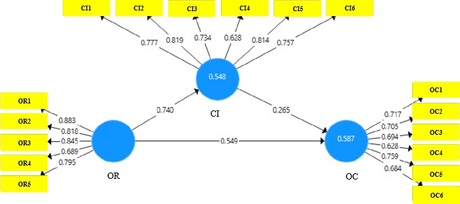

Table 1: Measurement model reliability and validity values
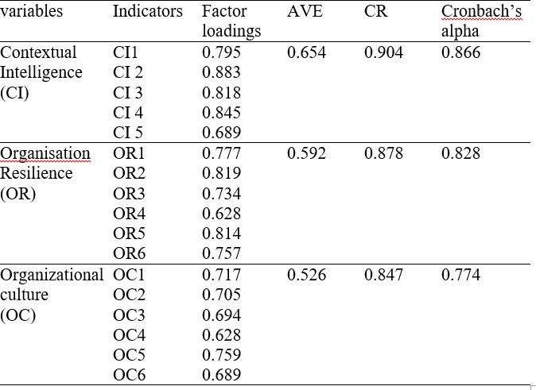
Table 2: Fornell-Larcker criterion
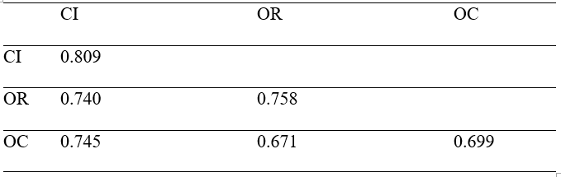
Table 3: Heterotrait-Monotrait ratio (HTMT)
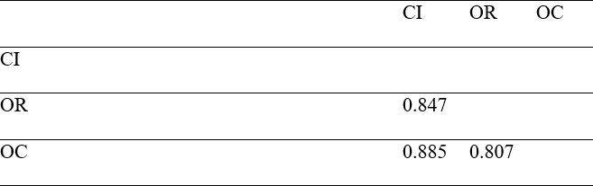
- Structural model
The following stage assesses the results obtained from the structural model in variance-based structural equation modeling (SEM). The current model provides a clear explanation of the regression component and demonstrates the existence of associations within the underlying construct. This study aims to examine the intricate dynamics between the constructs, taking into account both the direct and indirect relationships (Akdol & Arikboga, 2015). The primary metrics of a structural model encompass the assessment of the statistical significance of path coefficients, the determination of the coefficient of determination (R2), the quantification of the effect size (f2), and the evaluation of the predictive relevance (Q2).
Figure 3: Structural model
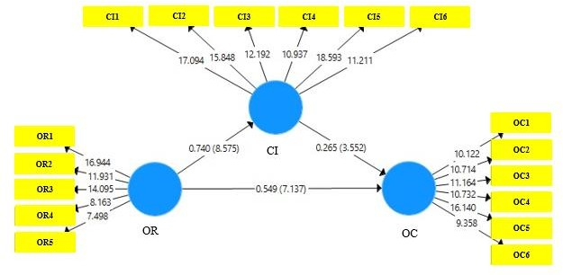

Table 4: R² values of dependent variables
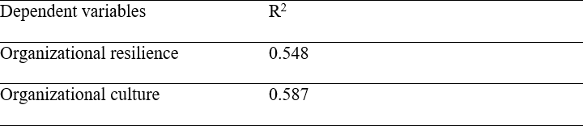
- Hypothesis testing
The current investigation employed PLS-SEM (SmartPLS-SEM 3.2.6) to analyze the suggested hypotheses that delineate the direct impact of an exogenous construct on an endogenous construct. Hypotheses were developed to explore the potential correlation between these variables. The aforementioned relationships were analyzed utilizing a structural path model. Please consult Table 6 for the results of the hypothesis testing that was conducted to investigate the direct influence of contextual intelligence (CI) on organizational resilience (OP) and organizational culture (OC). Table 7 presents the results of hypothesis testing regarding the indirect effect, specifically examining the mediating role of organizational culture in the relationship between CI and OR.

H1: There is a positive and significant relationship between contextual intelligence and organizational resilience.
The present study aimed to examine the correlation between contextual intelligence and organizational resilience among a group of hotel employees, as hypothesized in hypothesis HI. The path coefficient between the variables under consideration has been calculated to be 0.549, and its significance has been established based on a t-value of 7.137 (refer to Figure 3 for further details). The aforementioned discovery indicates a direct correlation between contextual intelligence and organizational resilience, as evidenced by a coefficient of 0.549. Therefore, it is evident that a strong and significant correlation exists between contextual intelligence and organizational resilience.

H2: Organizational culture mediates the relationship between contextual intelligence and organizational resilience
This study aimed to investigate the potential mediating effect of organizational culture on the relationship between contextual intelligence and organizational resilience in the workforce of the hotel industry. The evaluation of mediation is performed through a technique referred to as the total effect, which encompasses both the direct and indirect impacts. Based on the observations depicted in Figure 3, it can be deduced that a direct correlation exists among the three variables. The statistical analysis reveals a significant relationship between contextual intelligence and organizational resilience, as indicated by a path coefficient of 0.549 and a t-value of 7.137. The path coefficient for the association between contextual intelligence and organizational resilience was determined to be 0.740. This coefficient was found to be statistically significant, as evidenced by a t-value of 8.575. Furthermore, it is worth noting that the path coefficient representing the association between contextual intelligence and organizational resilience is 0.265. This coefficient is deemed statistically significant, as evidenced by a t-value of 3.552. Please consult Figure 3 and Table 8 for a comprehensive description of the model. The findings of the study indicate a statistically significant and positive correlation between contextual intelligence and organizational resilience. This is supported by a path coefficient of 0.206, which has a t-value of 3.639. According to the data presented in Table 7, it can be observed that both the upper confidence interval and lower confidence interval (LCI) values exhibit positive values. This suggests that the impact of contextual intelligence on the organizational resilience of hotels in Rivers State is contingent upon the presence of organizational culture.
Table 5: Specific direct effect of CI on OR and OC
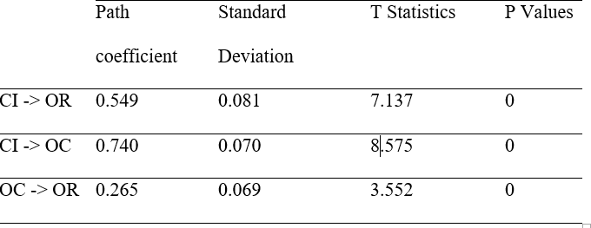

Table 6: Specific indirect effect of JS on OC and OP
Path Standard P LCI UCI coefficient Deviation T Statistics Values 2.50% 97.50% CI -> OC-> OR 0.206 0.057 3.639 0 0.096 0.313

Discussions on Findings
The study's results indicated a statistically significant and positive association between contextual intelligence and organizational resilience. The results of this research investigation align with the conclusions drawn by earlier scholars ((Akdol & Arikboga, 2015). The primary objective of the second hypothesis in this study was to investigate the existence of a positive relationship between contextual intelligence and organizational resilience. Additionally, the study aimed to explore the potential mediating role of organizational culture in this relationship. The present research study further confirmed the significance of organizational culture as a mediating factor in the association between contextual intelligence and organizational resilience, consistent with prior investigations conducted by Ali et al. (2010). The results of the study also indicate that there is a possibility for hotel management to improve risk management practices within the organization by adopting adaptive strategies. These strategies may involve analyzing the responses of competitors in the presence of risks and adjusting their own actions accordingly.

Conclusion and Recommendations
The present study revealed that there exists a positive and statistically significant relationship between the two variables, with the additional finding that organizational culture acts as a mediator in this relationship. Furthermore, this study contributes to the ongoing scholarly endeavors aimed at understanding the relationships that exist between contextual intelligence and organizational resilience in hotels located in Rivers State.
Recommendation;
Based on the findings of the study, the study recommends that;
- Hotel managers should develop forward-looking mentality and sense of direction for where the organistion will be in future.
- Hotel managers should be open to new ideals in order to thrive amidst challenging environment.
- Hotel managers should learn how to appropriately interpret and react to shift or changes in there environments.
References
Akdol, B., & Arikboga, F. S. (2015). The effects of leader behavior on organizational resilience: A research on technology fast50 turkey companies. Procedia-Social and Behavioral Sciences, 195, 278-282.
Ali, I., Rehman, K. U., Ali, S. I., Yousaf, J., & Zia, M. (2010). Corporate social responsibility influences, employee commitment and organizational resilience. African journal of Business management, 4(13), 2796-2801.
Angle, H. L., & Perry, J. L. (1981). An empirical assessment of organizational commitment and organizational effectiveness. Administrative science quarterly, 1-14.
Barkhuizen, N., Rothmann, S., & Van De Vijver, F. J. (2014). Burnout and work engagement of academics in higher education institutions: Effects of dispositional optimism. Stress and Health, 30(4), 322-332.
Batool, M., & Ullah, R. (2013). Impact of Job Satisfaction on Organizational Commitment in Hotels: Study of Commercial Banks in District Peshawar. International Review of Basic and Applied Sciences, 1(2), 12-24.
Birtch, T. A., Chiang, F. F., & Van Esch, E. (2016). A social exchange theory framework for understanding the job characteristics–job outcomes relationship: the mediating role of psychological contract fulfillment. The International Journal of Human Resource Management, 27(11), 1217-1236.
Dane, E. & Pratt, M. (2007). Exploring intuition and its role in managerial decision making. Academy of Management Review, 32(1), 33-54.
Isaack, T. (1978, October). Intuition: An ignored dimension of management. Academy of Management Review, 917-922.
Kniffin, K. M., Narayanan, J., Anseel, F., Antonakis, J., Ashford, S. P., Bakker, A. B., Bamberger, P., Bapuji, H., Bhave, D. P., Choi, V. K., Creary, S. J., Demerouti, E., Flynn, F. J., Gelfand, M. J., Greer, L. L., Johns, G., Kesebir, S., Klein, P. G., Lee, S. Y., Ozcelik, H., Petriglieri, J. L., Roth- bard, N. P., Rudolph, C. W., Shaw, J. D., Sirola, N., Wanberg, C. R., Whillans, A., Wilmot, M. P., & Vugt, M. V. (2021). COVID-19 and the workplace: Implications, issues, and insights for future research and action. American Psy- chologist, 76(1), 63–77
Linnenluecke, M. K. (2017). Resilience in busi- ness and management research: A review of influential publications and a research agenda. International Journal of Management Reviews, 19(1), 4–30
Schäffer, U. (2020). Levers of organizational resilience. Controlling Management Review, 64(6–7), 8–19.
Stoverink, A. C., Kirkman, B. L., Mistry, S., & Rosen, B. (2020). Bouncing back together: Toward a theoretical model of work team resilience. Academy of Management Review, 45(2), 395–422
Su, S., Baird, K. and Munir, R. (2023), "Organisational resilience: the role of organisational culture from an organisational life cycle perspective", International Journal of Manpower, Vol. 44 No. 3, pp. 403-421. https://doi.org/10.1108/IJM-11-2021-0631

