IMPACT OF AN EVAPOPRATIVE COOLING SYSTEM ON THE PHYSOLOGICAL AND CHEMICAL PROPERTIES OF STORED FRUIT

Abstract
This study investigates the impact of evaporative cooling system on the preservation of bush pear (dacryodes edulis), focusing on physiological and chemical properties. By storing fruit under controlled evaporative cooling conditions, we evaluated changes in freshness, nutrient content and weight loss over a specified period. An evaporative cooling structure without any pad and a refrigerator were used as control. Moreover, the result of the rate of weight loss of fruit throughout the storage period was recorded as 1.99 ± 0.14 %/day, 3.78 ± 0.63 %/day, 3.57 ± 0.15 %/day, and 3.9 ± 1.69 %/day for the refrigeration system, evaporative cooling system cooled with coconut husk, modified kenaf blast fibre and control system respectively. Our findings indicate that evaporative cooling effectively maintains fruit quality by reducing spoilage. The result underscore the potential of evaporative cooling systems as a sustainable and efficient method for extending the shelf life of perishable produce.
Keywords: evaluation, weight loss, bush pear, relative humidity

- INTRODUCTION
The art of keeping the quality of agricultural materials and preventing them from deterioration and spoilage over a specific period of time and beyond their normal shelf life is called storage. Crop storage is a very important aspect of postharvest technology. The primary aim of storing agricultural produce is to provide food between the harvest seasons and off-season and also to provide seed for subsequent planting season (Adiaha, 2017). The post-harvest quality of fruits is a critical aspect of the agricultural supply chain, directly impacting both market value and consumer satisfaction. Among the various techniques employed to preserve fruit quality, evaporative cooling systems have gained prominence due to their energy efficiency and ability to maintain optimal storage conditions (Liberty et al., 2013).
Storage structures refers to the facilities that house stored materials for the purpose of preserving their qualities. The selection of storage structures depends on the production level, cultural practices, and the climatic conditions. Evaporative cooling is a form of storage method which has been in use for many centuries in countries for cooling water and for providing thermal comfort in residential structures. This system is based on the principle that when moist but unsaturated air comes in contact with a moist surface whose temperature is higher than the dew point temperature of air, some water from the wetted surface evaporates into air (Kael, 2018).
This study investigates the impact of an evaporative cooling system on the physiological and chemical properties of bush pear (Dacryodes edulis), a fruit of significant economic and nutritional importance in eastern part of Nigeria. Bush pear is renowned for its unique flavor, high oil content, and nutritional benefits, which include essential fatty acids, vitamins, and minerals (Onuegbu et al., 2011). However, like many fruits, bush pear is prone to rapid deterioration post-harvest, resulting in substantial weight loss and degradation of its chemical properties. This necessitates effective storage solutions to prolong shelf life and maintain quality (Karthikeyen et al., 2019).
The aim of this research is to evaluate the efficacy of an evaporative cooling system in preserving the physiological and chemical properties of bush pear during storage. Specifically, the study focuses on quantifying the rate of weight loss and assessing key chemical properties, such as moisture content, oil content, and nutrient composition, under different storage conditions.
By providing a comprehensive analysis of the effects of evaporative cooling on bush pear, this research seeks to contribute valuable insights into post-harvest fruit preservation techniques, with potential implications for enhancing the storage and marketability of bush pear and similar fruits. The findings are expected to offer practical applications for farmers, distributors, and retailers in optimizing storage practices and reducing post-harvest losses.
- METHODOLOGY
- Fruit
Bush pear (dacryodes edulis) was used for the evaluation of this research work. It was purchased freshly from the main market in Akure, Ondo State southern part of Nigeria. Using physical inspection, damaged and unripe fruits were separated from ripe unbruised Bush pear.
The selected fruits were taken to the experimental site for the research activities. The picture of the Bush pear fruit used in the research is as shown in Plate 1
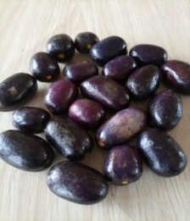

Plate 1: Picture of African pear/Bush pear (dacryodes edulis)
- Equipment
The under-listed equipment and instruments were used in the process of the research work.
- digital weighing balance
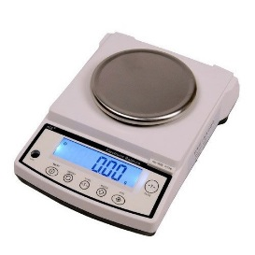
The digital weighing scale (Golden Mettler) with model number 20002 and maximum weight capacity of 2000 grams was used for the measurement of physiological weight loss of the sample of the stored fruits on daily basis (Plate 2). The digital weighing scale was used to measure the weight of the samples during the course of the experiment and it has a precision of ± 0.01 g.

Plate 2: Picture of Golden Mettler digital weighing balance
- Weather station instrument
Weather station instrument coupled with data logger (Plate 3) designed in the department of meteorology the Federal University of Technology, Akure (FUTA) was used in obtaining the relative humidity and temperature of the project site.
- Refrigerator
A 175 litres of double door silver refrigerator (Plate 4) in the post-harvest Laboratory was used as control for the evaporative cooling structures.
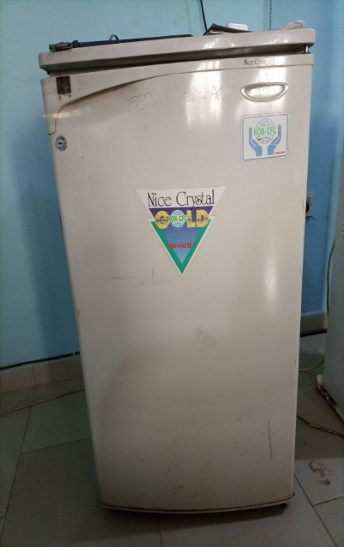
Plate 3: Picture of a refrigerator (Control).
- Developed evaporative cooling system
The evaporative cooling system has a capacity of 0.06m³. It is made of hard wood and it is hexagonal in shape with six sides and edges. The shape was chosen so as to get maximum surface area which will allow air to flow in from every sides. The shape consists of two triangles and one square. The shape is in congruent with the shape of the earth. The sphericity of the earth, allows air to flow from every direction following the principle of turbulent flow which aid cooling in the cooling chamber of the evaporative cooling structure. The structure has three compartments of storage (cooling chamber) demarcated by two trays made of galvanized iron. Furthermore, it has two (2) major walls separated from each other with a space filled with the cooling pads (Coconut husk and modified kenaf blast fibre) and the control (without cooling pad). On the cooling structures, there is a reservoir or tank with 16 liters water capacity with a PVC pipe of 25mm diameter for conveying water from the reservoir to the top edges of the cooling structure through the pipe perforations (2 mm). The flow of water from the overhead reservoir to the pad material uses gravity and was regulated using a tap. As the water drips through the pads, naturally air blows through the wetted pads into the chamber and this led to continuous cooling. Figure 4 shows the developed evaporative cooler with its components.

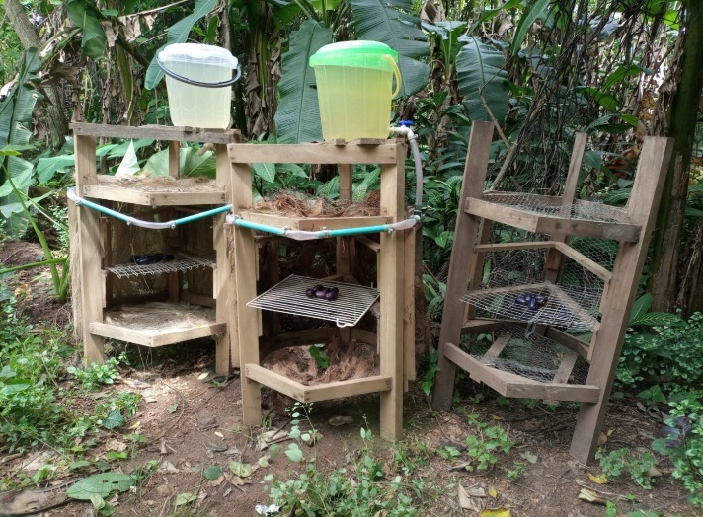
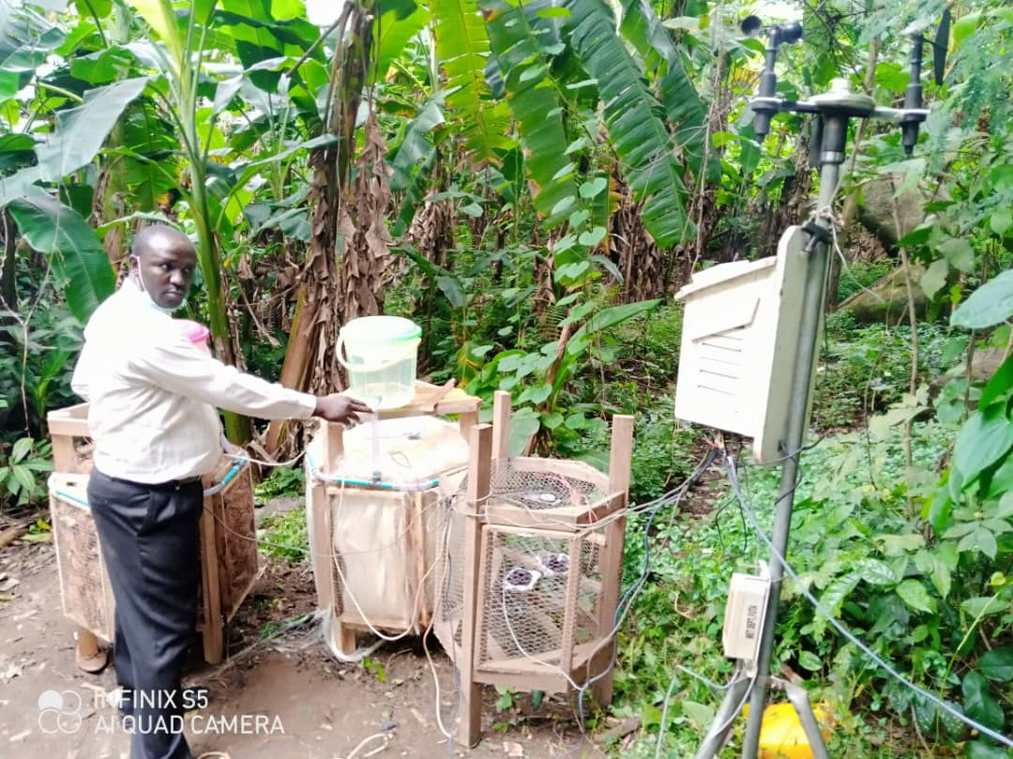

Plate 4: evaporative cooling structures on site connected to the automatic weather station

Experimental procedure for evaluating the developed evaporative cooling structure
The performance test on the developed evaporative cooling structure was carried out at the Meteorological Station of the Federal University of Technology, Akure.

Experimental site
The research work was carried within the premises of the institution at the Meteorological station of The Federal University of Technology, Akure. The Federal University of Technology, Akure is located on latitudes 7⁰14 N and 7⁰ 17 N and within longitude 5⁰ 08 E and 5⁰ 13E. Calibrated data loggers were put in the air space of the structures to take the weather parameters (temperature and relative humidity) of the structures. The weather parameter (ambient temperature, air velocity and relative humidity) of the site were taken using already installed weather station in the site in other to get and accurate readings.

Experimental procedure for evaluating the developed evaporative cooling structure
The load test of the evaporative cooler with stored fruit which involved the comparison of the storage conditions of the interior part of the chamber and the immediate atmospheric condition of the study was done.

Effect of Evaporative Cooling Structures on the stored fruit
The effect of the evaporative cooling structure on the fruits were evaluated based on their physiological and chemical properties.

Physiological property
Physiological property taken into consideration during the experiment is the weight loss of the Bush pear (dacryodes edulis).
- Weight Loss
The differences in weight of the fruit stored in both the control and in the evaporative cooling structure were taken on daily basis. The percentage weight loss was estimated using the equation as given by equation 1 (Fabiyi, 2010).
(1)
Where W₀ is the weight on the first day of storage and W₁ is the weight in the tested day

Chemical properties
Proximate analysis is the determination of the different macronutrients. The proximate parameters analysed were; moisture content, ash, crude fibre, crude protein, crude fat, and carbohydrate of the fresh fruit.

Statistical Analysis
The result of the experiment was presented graphically using excel. Statistical tools such as mean, median and mode were used in the presentation of the result as estimated by excel application. Also, correlation coefficient, standard deviation was used to ascertain the validity of the result generated.
- RESULT AND DISCUSSION

Chemical Properties of the Stored Fresh Bush Pear (dacryodes edulis) Fruits
The result of the proximate analysis of the fresh Bush pear (dacryodes edulis) fruit is graphically illustrated using pie chart in Figure 1. The moisture content has the highest value of (37%) followed by the fat content (28%) compared to other constituents which are of low values (crude fibre content 16%, carbohydrate 13%, and protein content 4%). Ash content has the least value at 2%.

Figure 1: Proximate composition of fresh Bush pear (dacryodes edulis) fruit

Evaluation of the Bush pear in the Cooling Structure
The Physiological property used in evaluating the cooling structures is the weight loss of the African plum/Bush pear (dacryodes edulis) fruit.
    - Weight loss of fruit during storage
The percentage weight loss of Bush pear (dacryodes edulis) in Evaporative cooling structures (ECS) in the morning, afternoon and evening respectively are presented in figure 2. The result shows that maximum weight loss in the morning were recorded as 17.81%, 18.46%, 29.33% and 12.28% for coconut husk, Modified kenaf blast fibre, control and refrigerator respectively.
Generaly, the average weight loss of the fruit for coconut husk, Modified kenaf blast fibre, control and refrigerator in the first 3 days were 8.88%, 10.49%, 6.80% and 5.47% respectively. The mean value increases continuously as the days progresses. However, after the 7days storage, the result shows that the Bush pear (dacryodes edulis) fruit in the control storage structure has the maximum weight loss (29.33%) followed by the coconut husk (23.68%), modified kenaf blast fibre (19.61%) and the least was recorded in the refrigerator (13.34%). This shows that the physical property (size) of the produce was reducing.

Figure 2: The percentage of weight loss of African pear fruit in Evaporative cooling structure (ECS).

Comparative analysis of Fruit weight loss in the cooling structure
The fruit weight loss per day for the Bush pear (dacryodes edulis) fruit in different storage conditions of an evaporative cooling structure in comparison with the refrigeration system is presented in Figure 3. The rate of weight loss of Bush pear (dacryodes edulis) fruit throughout the storage period was recorded as 1.99 ± 0.14 %/day, 3.78 ± 0.63 %/day, 3.57 ± 0.15 %/day, and 3.9 ± 1.69 %/day for the refrigeration system, evaporative cooling system cooled with coconut husk, modified kenaf blast fibre and control system respectively. Bush pear (dacryodes edulis) fruit weight loss per day during storage was statistically the same in coconut hust, modified kenaf blast fibre, and control system and the post hoc result of ANOVA shows that difference in the weight loss of the respective storage conditions were not significantly different at 5% probability level. Meanwhile, the rate of weight loss of the fruit stored in the refrigeration is significantly lower (P < 0.05) compared to those in the evaporative cooling structures and not significantly significantly different from the control storage structure
The weight loss result depicts that the variation in the magnitude of weight loss of the stored fruit was due to the variation condition of the storage structure associated with the environmental conditions and this information agrees with the reported of Mpelasoka et al., (2010) and Zegbe and Mena (2019) for cactus pear fruit stored under atmospheric condition, The remarkable performance of the modified kenaf blast fibre based evaporative cooling structure indicates its feasible way to increase post-harvest life of fruits that are destined for transport to distant markets, storage, and retail handling.
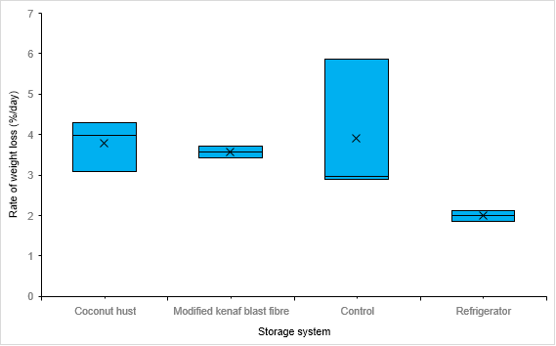
Figure 3: The rate of weight loss of Bush pear fruit in Evaporative cooling system (ECS)
CONCLUSION
The effect of a developed evaporative cooling system on the chemical and physiological properties of Bush pear (dacryodes edulis) was evaluated. It was observed that the rate of weight loss of Bush pear (dacryodes edulis) throughout the storage period was recorded as 3.78 ± 0.63 %/day and 3.57 ± 0.15 %/day for the evaporative cooling systems cooled with coconut husk and Modified kenaf blast fibre respectively. The mean value however increases continuously as the days progresses. However, after the 7days storage, the result shows that the Bush pear (dacryodes edulis) fruit in the control storage structure has the maximum weight loss (29.33%) followed by the coconut husk (23.68%), modified kenaf blast fibre (19.61%) and the least was recorded in the refrigerator (13.34%). This shows that the physical property (size) of the produce was reducing.That of the Modified kenaf blast fibre is lower.
References
- Adiaha, M. S., (2017). Complete guide to agricultural product processing and storage. World Scientific News/International Scientific Journal, 81(1), 1-52. http://www.worldscientificnews.com/
- Kael, E., (2018). Design and Testing of an Evaporative Cooling System Using An Ultrasonic Humidifier. Department of Bioresource Engineering Room MS1-027, Macdonald-Stewart Building, 21111 Lakeshore Road Ste. Anne de Bellevue, Quebec H9X 3V9.
- Liberty, J. T., Okonkwo, W. I and Echiegu, E. A., (2013). Evaporative Cooling: A postharvest technology for fruits and vegetables preservation. International Journal of Scientific & Engineering Research, 4(8), 2257-2266.
- Mpelasoka, B. S., Behboudian, M. H., Dixon, J., Neal, S. M. and Caspari. H. W., (2010). Improvement of fruit quality and storage potential of ‘Braeburn’ apple through deficit irrigation. Journal of Horticultural Science and Biotechnology, 75(5), 615-621.
- Onuegbu, N., Nwosuagwu, U., Kabuo, N., Nwosu, J., and Ihediohanma, N., (2011). The physical properties of Ube (Dacryodes edulis) at different stages of fruit development. Nature and Science, 9(9), 71-75.
- Zegbe, J. A. and Mena J., (2019). Flower bud thinning in ‘Rojo Liso’ cactus pear. Journal of Horticultural Science and Biotechnology, 84(6), 595-598.

