Reflections on Regional Integration and Food Security in Developing Sub-Saharan African Countries

Abstract
Regional integration holds significant potential for Africa, a vast continent with over 1.2 billion people. By fostering strong and equitable economic growth through expanded markets, reducing violence, and enhancing trade liberalization, regional integration can address challenges faced by the continent's numerous small national markets and landlocked countries. It plays a crucial role across various sectors, prompting African governments to sign numerous agreements for regional integration, many of which have overlapping memberships. Key agreements include the Economic Commission for Africa, which supports initiatives such as the Economic Community of West African States (ECOWAS), the Common Market for Eastern and Southern Africa (COMESA), the Economic Community of Central African States (ECCAS), the Southern African Development Community (SADC), and the Arab Maghreb Union (AMU). These initiatives aim to enhance economic growth by improving competitiveness, increasing industrialization, and creating better employment opportunities to reduce poverty in the region.The rationale behind regional integration is to impact economic growth positively by making economies more competitive, fostering industrialization, and offering better employment possibilities that reduce poverty. For regional integration to be successful among African countries, it is essential to overcome divisions that restrict the movement of people, investments, goods, services, and ideas. These divisions have historically hampered economic progress, particularly in developing nations. In summary, regional integration in Africa promises to drive economic growth, reduce poverty, and enhance overall development. However, overcoming existing divisions and fostering cooperation across the continent are crucial steps toward realizing these benefits.
Keywords: Agreements, Community, Division, Economics, Poverty, Reduction, Security

- Introduction
According to research conducted by the United Nations Food and Agriculture Organization (FAO), extreme food and nutritional insecurity affected approximately 153 million people across sub-Saharan Africa in 2014-2015. This figure represents about 26% of the population aged 15 and older. This means that nearly one in four individuals over the age of 15 in sub-Saharan Africa were undernourished (Secretariat, 2019), often unable to eat for an entire day due to a lack of funds or other resources necessary to obtain food. The situation is particularly dire in rural areas, where the lack of funds to purchase food or agricultural inputs is most common (Oloruntoba, 2020). In many African countries, rural areas comprise 60% to 70% of farming households, which are typically smallholder farmers.
Andrew and Alexander (n.d.) highlighted that these smallholder farming households play a critical role in agricultural production, encompassing both crop cultivation and animal husbandry. Despite being responsible for producing the majority of the country's food supply, these farmers are the most at risk of experiencing hunger and poverty (Ngwawi, 2018). Therefore, smallholder farmers are essential starting points for agriculturally oriented interventions aimed at enhancing food and nutrition security (Kayizzi‐Mugerwa et al., 2014). Over the past three years, numerous observational studies have evaluated the connections between agriculture and nutrition. The findings indicate that nutritional and food security depend heavily on the types of crops that can be grown in different regions. The amount of food harvested is influenced by the inputs available to farmers and the amount of rainfall, which directly impacts the year-round availability of food (Islam & Kieu, 2020). Additionally, the incidence of livestock systems is shaped by agroecological conditions, with agro-pastoral systems prevalent in dry regions and mixed crop-livestock systems more common in areas with higher rainfall.
The challenges in linking farm and nutrition data often stem from the temporal scales being consistently out of sync. Typically, assessments of food and nutrition security are conducted over very short time frames (Moyo, 2021). However, the factors influencing these outcomes operate on much longer timescales. Environmental and economic factors, such as climate shocks, conflicts, unemployment, low wages, and food price inflation, as well as a lack of access to and adoption of better technologies, and a lack of institutions, structures, and markets for farmers and consumers, have all had a significant impact on the state of food security and nutrition in developing countries(Davies, 2019).
The current food systems in most African nations have deteriorated. Conflict, climate change, and the COVID-19 pandemic have all been associated with declines. As a result, cases of micronutrient deficiencies may decrease due to improved availability of sufficient food(Mkandawire & Nyantakyi-frimpong, 2014). Hunger has decreased in recent years, with a decline in iodine and vitamin A deficiency in pregnant women, as well as a reduction in malnutrition in children under five. Obesity and underweight in adults have also become less common (Barnekow & Kulkarni, 2017). This suggests that people are becoming less hungry and experiencing improved conditions as wealth increases. Most communities are making efforts to ensure their citizens have access to adequate food, thereby contributing to the achievement of Sustainable Development Goals 1 and 2, which focus on "zero hunger" and "no poverty."
The state of cross-border trade in sub-Saharan Africa is crucial for the economic and social recovery of fragile and conflict-affected states (FCS) (Moyo, 2021). Informal cross-border trade, involving small, unlicensed, and vulnerable traders between neighboring nations, is a significant component of African trade (Ullah et al., 2021). This proximity trade, where produce is typically moved between marketplaces close to the border, has been a longstanding practice, with economies in the region being interconnected for centuries. Cross-border trade through regional integration is seen as a solution to improving food security, nutrition security, and access to adequate food.

Definitions
Regional Integration
Regional integration is the process by which two or more nation-states decide to cooperate and work closely together to create peace, stability, and wealth. Typically, it is a political economy initiative focusing on commercial interests to achieve broader socio-political and security objectives (Barasa, 2018). The goals of regional integration can range from economic to political to environmental, as defined by national governments. It can be organized through intergovernmental decision-making, supranational institutional structures, or a combination of both(Leshoele, 2019).
Food Security
Food security is achieved when all people, at all times, have physical, social, and economic access to sufficient, safe, and nutritious food that meets their dietary needs and food preferences for an active and healthy life(Barasa, 2018). This means that everyone has reliable access to enough food to maintain a healthy and active lifestyle.
Nutritional Security
Nutritional security exists when all individuals, at all times, have access to sufficient, safe, and nutritious food that meets their dietary needs and food preferences for an active and healthy life ( et al., 2014). Beyond food security, nutritional security considers the systemic factors affecting a person's nutritional health, focusing on access to essential nutrients, not just calories. Malnutrition and overnutrition are significant issues in many developing countries, and promoting nutritional security can foster economic and pro-poor development.
Adequate Food
Adequate food refers to the availability of food in sufficient quantity and quality to meet people's nutritional needs while being free of harmful ingredients (Islam & Kieu, 2021). Adequate food must meet the necessary nutritional requirements and be of a respectable quality, although not necessarily exceeding the minimum acceptable standards(De Melo & Tsikata, 2014).

Scope of Regional Integration
Regional Integration: A Path to Economic Growth and Food Security
Regional integration involves an agreement among multiple countries to pursue common objectives, such as trade and monetary policies (Olayode, 2020). In its simplest form, regional integration unites separate states within a region into a larger entity. The degree of integration depends on the willingness and commitment of independent sovereign states to share their sovereignty. Fleischer, Debroy, and Chakraboty highlight various challenges to deep integration, particularly in controlling the broader business environment. For developing countries, regional integration can boost incomes by facilitating cross-border trade and improving food security (Islam & Kieu, 2021). It supports economic growth by striving to meet trade market objectives and goals. Member countries expect that they will: (a) adhere to and implement agreed-upon policies, and (b) achieve rapid economic growth and improved welfare, including food security. Previous regional integration efforts have focused on reducing trade barriers, enhancing cross-border movement of people, capital, goods, and labor, lowering the risk of armed conflict through Confidence and Security-Building Measures, and adopting unified regional stances on issues such as the environment, climate change, and migration.
In the current global economic system, regional integration agreements are recognized as crucial for future international development. These agreements have gained new perspectives and significance, driven by the need for nation-states to integrate their economies to promote rapid economic growth, reduce conflict, and foster mutual trust(Enaifoghe, 2019). African countries often see closer economic integration with neighbors as a first step toward opening larger regional markets for trade and investment. This promotes efficiency, productivity growth, and competitiveness by reducing trade and investment costs and risks, alongside border barriers(Mlambo, 2019). Bilateral and sub-regional trade agreements are promoted as tools for economic growth, encouraging economic deregulation, securing existing reforms, and promoting further structural adjustments to reduce the likelihood of a return to protectionism. Consequently, Regional Integration Agreements (RIAs) have become highly significant. Many developing countries are parties to at least one, and often several, such agreements, as are most industrialized countries(Qobo, 2009). Over 35% of global trade occurs under these agreements. While their primary goal is to reduce economic barriers between member countries, their structures can vary. In many cases, lifting trade restrictions or liberalizing economies has increased Gross Domestic Product (GDP), but it has also led to greater global inequality, wealth concentration, and more frequent and severe economic crises(Hart & Padayachee, 2010).
Studies by De Melo and Tsikata (2014), and others suggest that developing countries benefit from regional integration through policies like the removal of unnecessary tariffs and uniform customs regulations. This is particularly advantageous for countries that struggle to reach international markets, such as Chad, Lesotho, Namibia, Malawi, and Niger. Dependence on one-on-one trade negotiations with more powerful states often limits the impact on poverty reduction in developing countries. In summary, regional integration can enhance food and nutritional security in developing countries by reducing export tariffs and quotas among member states. These agreements encourage agricultural trade and create favorable markets for agricultural products and other natural resources(Kayizzi-Mugerwa et al., 2014). For instance, in the event of a crop or animal disease outbreak, member states can collaborate to address the issue using improved technology and agricultural systems. Many African countries produce agricultural products in excess, which can lead to poor pricing within those countries (e.g., maize in Zambia, bananas in Uganda, beef in Botswana). However, excess agricultural produce can achieve better prices in neighboring countries, provided cross-border trade is facilitated.
Africa is home to several key regional economic communities, each playing a vital role in the continent's development and integration. These communities include the Economic Community of West African States (ECOWAS), the Southern African Development Community (SADC), the Common Market for Eastern and Southern Africa (COMESA), and the East African Community (EAC). Each of these organizations contributes significantly to promoting economic cooperation, political stability, and social progress across their respective regions.
ECOWAS, for example, focuses on enhancing economic integration and political stability in West Africa, working towards a single market and the free movement of goods, services, and people. SADC aims to promote sustainable economic growth and development in Southern Africa, with a strong emphasis on infrastructure development, industrialization, and trade facilitation (Koboyatau, 2023). COMESA seeks to improve economic integration among its member states in Eastern and Southern Africa, fostering a competitive and diversified regional economy. Meanwhile, the EAC works towards deeper economic and political union among its East African member states (Andrew & Alexander, n.d.), with goals such as establishing a common market, a monetary union, and eventually a political federation.
Together, these regional economic communities are instrumental in driving Africa's overall development, fostering regional cooperation, and positioning the continent as a formidable player on the global stage (refer to figures below).

The Economic Community of West African States (ECOWAS) is a regional organization that brings together 15 diverse nations in West Africa (Nwangwu et al., 2019). Founded in 1975, ECOWAS aims to promote economic integration and political cooperation among its member states. These countries represent a rich tapestry of cultures, languages, and economies that collectively shape the West African landscape. The 15 ECOWAS members are Benin, Burkina Faso, Cabo Verde, Cote d'Ivoire, The Gambia, Ghana, Guinea, Guinea-Bissau, Liberia, Mali, Niger, Nigeria, Senegal, Sierra Leone, and Togo (Figure 1). Each of these nations contributes its unique history and resources to the organization. For instance, Nigeria stands as the most populous country in Africa and the continent's largest economy, while Cabo Verde is an archipelago of volcanic islands off the West African coast (Makinde, 2022). Cote d'Ivoire is renowned for its cocoa and coffee production, while Ghana is known for its gold reserves and historical significance as the first sub-Saharan African country to gain independence. Despite their differences, these countries work together through ECOWAS to address common challenges, foster regional stability, and pursue shared goals of development and prosperity for the people of West Africa.

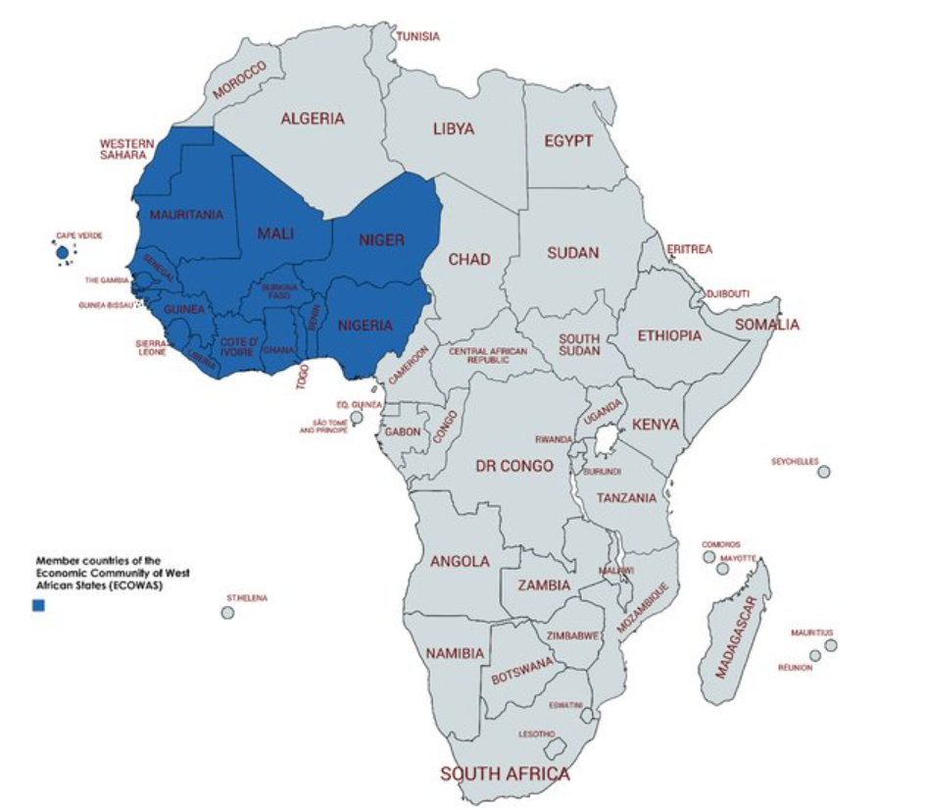
Figure 1: Map of Africa indicating the 16 member countries of Economic Community of West African States (ECOWAS)

The Common Market for Eastern and Southern Africa (COMESA) is a regional organization comprising several member states committed to economic integration and cooperation. The member states of COMESA are diverse and include: Burundi, Comoros, the Democratic Republic of Congo, Djibouti, Egypt, Eritrea, Eswatini, Ethiopia, Kenya, Libya(Adika, 2022), Madagascar, Malawi, Mauritius, Rwanda, Seychelles, Somalia, Sudan, Tunisia, Uganda, Zambia, and Zimbabwe (Figure 2). Each of these countries brings unique cultural, economic, and geographical characteristics to the organization, fostering a rich environment for collaboration and mutual development (Anber, 2018). By working together within COMESA, these nations aim to improve trade, enhance investment opportunities, and strengthen political and economic stability across the region. The shared goals of sustainable development and poverty reduction are central to COMESA's mission, making it a pivotal institution in the advancement of the member states' collective interests on the global stage.
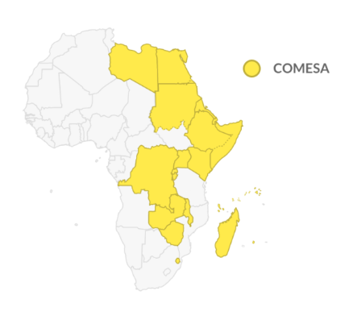
Figure 2: COMESA countries
The East African Community (EAC) is a dynamic regional economic community that brings together six partner states: the Republics of Burundi, Kenya, Rwanda, South Sudan, the United Republic of Tanzania, and the Republic of Uganda (Figure 3). With its headquarters located in Arusha, Tanzania, the EAC plays a crucial role in fostering economic integration, political cooperation, and social development among its member states (Ahmadalipour et al., 2019). The community serves a population of approximately 150 million citizens, working towards collective goals such as the establishment of a common market, a monetary union, and, ultimately, a political federation(Signé & Johnson, 2018). By promoting trade, investment, and infrastructure development, the EAC aims to enhance the economic prosperity and quality of life for its citizens. The organization also focuses on harmonizing policies across various sectors, including agriculture, healthcare, education, and environmental conservation, ensuring sustainable growth and development in the region. The EAC's efforts contribute significantly to regional stability and integration, making it a vital entity in the advancement of East Africa's socio-economic landscape(Jetschke & Murray, 2020).
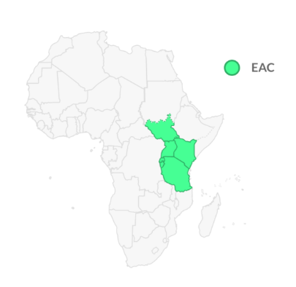
Figure 3: East African Community countries
The Southern African Development Community (SADC) is a prominent Regional Economic Community dedicated to fostering economic integration and sustainable development across Southern Africa. Comprising 16 member states—Angola, Botswana, Comoros, the Democratic Republic of Congo, Eswatini, Lesotho, Madagascar, Malawi, Mauritius, Mozambique, Namibia, Seychelles, South Africa, the United Republic of Tanzania, Zambia, and Zimbabwe (Figure 4)—SADC aims to promote regional cooperation and socio-economic growth(Kayizzi-Mugerwa et al., 2014). These diverse member states collaborate to enhance trade, investment, and infrastructural development within the region (Coleman & Rosberg, 2023). SADC's objectives include the reduction of poverty, improvement of living standards, and achievement of peace and security. By harmonizing policies and regulatory frameworks, SADC facilitates the free movement of goods, services, and people, thus boosting regional economic integration. The community also focuses on various sectors such as agriculture, energy, transport, and human development, ensuring a comprehensive approach to regional development (Aeby, 2019). SADC's efforts are crucial in addressing common challenges such as climate change, food security, and health issues, thereby ensuring a sustainable and prosperous future for all member countries.
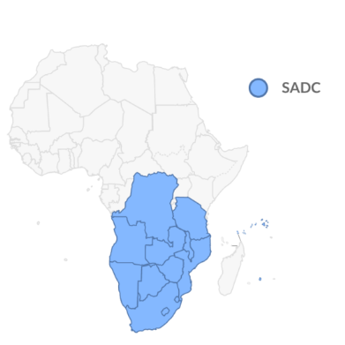
Figure 4: SADC countries

Benefits of Regional Integration
Regional integration helps nations overcome barriers that restrict the movement of people, capital, goods, services, and ideas (Hartzenburg, 2011). These barriers, particularly in developing nations, hinder economic progress due to geographic divisions, inadequate infrastructure, and ineffective policies. By linking markets for goods, services, and factors of production, regional integration allows nations to bypass these costly barriers, facilitating the movement of people, ideas, capital, energy, and goods (Nhamo et al., 2018). It addresses geographic divisions, infrastructure deficiencies, and trade and investment regulations, as well as financial and macroeconomic policies and the provision of shared public goods like natural resources, security, and education. For Africa to thrive, it must prioritize meaningful regional integration more than it has in the past, focusing on economic development over political cohesion. Countries like Botswana and Rwanda have made such decisions, but efforts to advance governance, sound economic policies, and the rule of law often lag.
According to the Coleman and Rosberg (2023), regional integration supports agricultural and industrial production across national borders, enabling economies of scale for investors and creating larger markets and new business opportunities for both small and large companies. It also helps dismantle monopolies and improves cross-border spillovers between landlocked and coastal countries. Additionally, integration can boost regional security, as increased international trade often results in less conflict(Nhamo et al., 2018). For Africa's small and fragmented economies, deeper market integration for goods, infrastructure services, and key production components (people and capital) is crucial both economically and strategically. The African Continental Free Trade Area gained new momentum in 2018 after being ratified by African leaders. With the right mix of ambition and practicality, regional integration has the potential to significantly benefit both Africa and the rest of the world.
In conflict-affected regions like the Central African Republic, Ethiopia, Sudan, Mali, and the Democratic Republic of Congo, heads of state have made efforts to negotiate ceasefires and engage in dialogue with rebels(Ngwawi, 2018). While some attempts have been successful, others have not. For example, in the Democratic Republic of Congo, national troops have sought aid from the Ugandan government to combat rebels and restore peace in certain areas of the country.

Non-Benefits of Regional Integration
Security and Regional Integration
As countries join Regional Trade Agreements (RTAs), they often experience increased intra-regional commerce and investment, fostering beneficial connections and interdependence. This can enhance trust, make war a less attractive option, and reduce the likelihood of international conflicts(Shava et al., 2021). However, RTAs might also lead to industrial concentration in one or a few countries, potentially causing tensions if divergence outpaces convergence. On the positive side, Regional Integration Agreements (RIAs) can enhance intra-regional security by promoting collaboration and establishing systems to address shared concerns. This cooperation can extend to "shared defense" or reciprocal military aid, thereby bolstering international security.
Domestic Reforms and RTAs
Without RTAs, a government might pursue time-inconsistent welfare-improving policies, such as adjusting tariffs during trade shocks or seizing foreign investments. For RTAs to serve as effective commitment mechanisms, two conditions must be met: the benefits of staying must outweigh those of leaving (Aeby, 2019), and the threat of punishment must be credible. High-quality regional integration agreements commit countries to trade policies and can lock them into micro and macroeconomic reforms or democratization if the underlying incentives align with the RTA's implementation. However, the low cost of exit and enforcement challenges can limit RIAs' effectiveness as tools for shared reform commitments.
Signaling Intentions
Although entering RTAs requires significant political capital and incurs transaction costs, countries may do so to signal their policy direction or economic stability to attract investment (Akinyi, 2020). This is particularly important for nations struggling with policy consistency and legitimacy.
Insurance Against Risks
RTAs can also act as insurance against risks like macroeconomic instability, trade shocks, trade wars, or a resurgence of protectionism (Signé & Johnson, 2018). While this insurance argument may not be crucial for agreements among developing countries, it becomes significant in asymmetric terms-of-trade shocks, such as fluctuations in oil prices.
Coordination and Negotiating Strength
RTAs can facilitate policy coordination and enhance negotiating strength by fostering a give-and-take strategy during negotiations. This can lead to more unified stances and increased visibility and credibility in multilateral negotiations, such as those with the World Trade Organization (WTO). Collective bargaining power is particularly relevant for underdeveloped and fragmented countries (Jetschke & Murray, 2020), enabling them to negotiate as a bloc rather than on a country-by-country basis, potentially improving negotiation outcomes.
Conflict Resolution
Illegbe's study details how heads of state have taken steps to halt hostilities and engage in dialogue with rebels in conflict-ridden countries like the Central African Republic, Ethiopia, Sudan, Mali, and the Democratic Republic of the Congo (DRC) (Aeby, 2019). While some efforts have been unsuccessful, progress has been made. For example, the DRC has sought assistance from Uganda to combat rebels and restore peace in certain areas.

Case Studies; Regional Integration in Africa
The study “Regional Integration in Africa: Challenges and Prospects" by De Melo and Tsikata (2014) provides an insightful analysis of the multifaceted nature of regional integration in Africa. It underscores the historical and political complexities arising from the colonial legacy, which resulted in geographically artificial states with arbitrary borders and significant ethnolinguistic diversity. These factors have contributed to Africa's high conflict rates and substantial trade and communication costs. The study highlights that the Regional Economic Communities (RECs) in Africa, such as ECOWAS, COMESA, and ECCAS, were initially envisioned as building blocks for African unity post-independence, as seen in the Lagos Plan of Action adopted in 1980. These RECs aimed to foster pan-African unity and continental industrialization through free trade among member states and high tariff barriers for non-members. However, the authors point out several challenges that have impeded the success of these integration efforts. A significant barrier has been the reluctance of African leaders to cede national sovereignty to a supranational authority, which is necessary for coordinated economic and political integration. This reluctance, coupled with the continent's vast diversity in terms of resources, geography, and languages, has weakened commitment to pan-Africanism and led to a multitude of vague objectives. Moreover, the linear model of integration adopted by many African RECs has largely ignored behind-the-border measures that could reduce trade costs. The failure to implement such measures has limited the potential economic benefits of regional integration, as evidenced by the minimal impact on trade costs despite the formation of these economic blocs.
Hartzenburg (2011) examined regional integration in Africa. Despite numerous regional integration arrangements (RIAs), implementation has been poor and intra-African trade remains low at 10-12% of total trade. Hartzenberg identified key challenges including small, fragmented economies, focus on tariff reduction over non-tariff barriers, weak legal foundations, lack of rules-based implementation, limited private sector involvement, and overlapping RIA memberships. The study argued that the linear market integration model may be inappropriate for Africa, suggesting instead a deeper integration agenda addressing behind-the-border issues like services, investment, and competition policy. Hartzenberg highlighted the new Tripartite Free Trade Area between COMESA, EAC, and SADC as an attempt to address past shortcomings through market integration, infrastructure development, and industrialization. However, the study emphasized that success ultimately depends on member states' genuine commitment to rules-based integration. The study underscores the complexity of regional integration in Africa and the need for a more nuanced, comprehensive approach.
In the study "Regional Integration and Food Security in Developing Sub-Saharan African Countries" by Kayizzi-Mugerwa, Anyanwu, and Conceição (2014), several key findings are highlighted. The authors emphasize that regional integration is crucial for enhancing productivity and improving living standards in Africa. By giving producers access to regional markets and linking them into sophisticated regional value chains, competitiveness can be significantly raised. The study also notes that regional integration can help overcome constraints such as small national economies and high transportation costs. Moreover, integration fosters competition, price convergence, and technological innovation, enabling African countries to better compete globally. Additionally, the presence of many landlocked countries and high transportation costs underscore the urgency for regional integration in Africa. Despite numerous efforts, including the establishment of regional trade blocs and political commitments, progress has been hindered by infrastructure constraints, non-tariff barriers, and slow implementation of agreements.
Qobo (2009) paper examines the challenges of regional integration in Africa and prospects for establishing a "United States of Africa". Qobo argues that past integration efforts have largely failed due to misplaced priorities and leaders' unwillingness to cede sovereignty. He contends that successful integration requires bold domestic economic reforms and political liberalization as prerequisites. Rather than pursuing grand visions, Africa needs to focus on pragmatic, gradual steps towards integration. Qobo emphasizes that integration should be outward-oriented toward global engagement, not inward-looking. He highlights the importance of normative convergence on democracy and human rights among member states. The paper suggests prioritizing developmental coordination and infrastructure over rapid trade integration. Qobo proposes that external "agents of restraint" like aid providers can help ensure reform implementation. He sees potential in rationalizing overlapping regional economic communities to accelerate integration. The author advocates for a "developmental regionalism" focused on collective betterment beyond just trade expansion. Finally, Qobo suggests that project-based cooperation on regional public goods may be more effective than sweeping region-wide schemes. Overall, the paper argues that Africa must overcome domestic governance and economic challenges to achieve meaningful regional integration.
Tanyanyiwa et al., 2014 explored the challenges and opportunities for regional integration in Africa, focusing on the Southern African Development Community (SADC). They highlighted the persistent efforts by African countries to achieve regional integration as a strategy for economic development, poverty alleviation, and improved standards of living. Despite the formation of various Regional Economic Communities (RECs) and the aspiration to create a Continental Free Trade Area (CFTA) by 2017, the authors found that these initiatives have not fully realized their intended objectives. Key impediments include inadequate infrastructure, political instability, and the lack of effective policy implementation. The study emphasized the potential benefits of regional integration, such as increased trade, investment, and economic cooperation, which are critical for addressing the challenges of small markets and landlocked geographies in Africa.
Geda and Seid (2015) study, "The potential for internal trade and regional integration in Africa," published in the Journal of African Trade, examines the significant potential for intra-Africa trade. Utilizing various empirical models, the study identifies the main challenges impeding this potential, such as weak infrastructure, low productivity, and inadequate trade facilitation, which collectively result in acute export supply constraints. Despite these barriers, the study highlights the critical role of innovative policies that extend beyond mere trade liberalization. These policies should focus on enhancing regional and domestic infrastructures, harmonizing macroeconomic policies, and improving trade-enabling institutions. Furthermore, the study emphasizes the need for a regionally focused diversification plan, leveraging existing regional economic communities (RECs) as vehicles for promoting intra-Africa trade and advancing regional integration. The authors argue that addressing these constraints is essential for realizing the potential for trade and fostering economic development across Africa.
Conclusion
This study has explored the intricate relationship between regional integration and food security in developing Sub-Saharan African countries. Regional integration has been identified as a critical strategy for overcoming the numerous economic and social challenges faced by these countries. By reducing barriers to trade, investment, and the movement of people and goods, regional integration fosters economic growth, enhances market efficiency, and promotes social stability. Furthermore, the establishment of Regional Trade Agreements (RTAs) and Regional Integration Agreements (RIAs) has been shown to improve agricultural productivity, ensure food security, and enhance nutritional security across the region. The benefits of regional integration extend beyond economic growth. By fostering cooperation and mutual dependence among member states, regional integration reduces the likelihood of conflicts and enhances regional security. Moreover, it promotes the adoption of better governance practices and sound economic policies, which are essential for sustainable development. However, the success of regional integration in achieving these goals depends heavily on the commitment of member states to adhere to agreed policies and the effective implementation of these agreements.
Based on the findings of this study, several recommendations can be made to enhance the effectiveness of regional integration in promoting food security in Sub-Saharan Africa. Firstly, member states should demonstrate a strong commitment to regional integration by adhering to agreed policies and ensuring their effective implementation. Strengthening governance structures and enhancing the rule of law are critical to achieving these objectives. Secondly, investment in infrastructure, particularly in transportation, energy, and information and communication technology (ICT), is essential to facilitate the movement of goods, services, and people. Improved infrastructure will enhance market access and reduce transaction costs, thereby promoting economic growth and food security. Thirdly, member states should prioritize the development of the agricultural sector by adopting modern farming techniques, improving access to agricultural inputs, and investing in research and development. This will enhance agricultural productivity and ensure food security. Fourthly, reducing trade barriers and facilitating cross-border trade are essential for economic growth. Member states should work towards harmonizing trade policies and regulations to promote intra-regional trade and attract foreign investment. Fifthly, regional integration should aim to promote inclusive growth by ensuring that the benefits of economic development are equitably distributed. Policies should be designed to address the needs of vulnerable populations, including smallholder farmers and rural communities. Sixthly, enhancing regional security through cooperation and mutual defense agreements can reduce the risk of conflicts and promote stability. Member states should work together to address security challenges and promote peace and stability in the region.
Seventhly, embracing technological advancements and innovation can significantly enhance agricultural productivity and food security. Member states should invest in technology and innovation to drive economic growth and development. Lastly, regional integration requires collaboration and partnerships among member states, development partners, and the private sector. Strengthening these partnerships will enhance the effectiveness of regional integration initiatives and promote sustainable development. In conclusion, regional integration presents a significant opportunity for Sub-Saharan African countries to achieve food security and sustainable economic growth. By addressing the challenges and implementing the recommendations outlined in this study, member states can harness the full potential of regional integration to promote development and improve the well-being of their populations.

References
Adika, G. (2022). Sustaining economic growth in COMESA: challenges and prospects. International Journal of Finance & Economics, 27(1), 301–311.
Aeby, M. (2019). SADC–the southern arrested development community?: Enduring challenges to peace and security in Southern Africa. Nordiska Afrikainstitutet.
Ahmadalipour, A., Moradkhani, H., Castelletti, A., & Magliocca, N. (2019). Future drought risk in Africa: Integrating vulnerability, climate change, and population growth. Science of the Total Environment, 662, 672–686.
Akinyi, C. R. (2020). Challenges and Prospects of African Integration; a Comparative Analysis of the Eac and Comesa (2000-2020). University of Nairobi.
Anber, M. (2018). COMESA-EAC-SADC trepertite free trade area: challenges and prospects.
Andrew, O. I., & Alexander, S. D. (n.d.). ECOWAS and Regional Peacekeeping Integration: A Review of Challenges.
Barasa, B. (2018). Local and regional variations in conditions for agriculture and food security in Uganda.
Barnekow, S. E., & Kulkarni, K. G. (2017). Why regionalism? A look at the costs and benefits of regional trade agreements in Africa. Global Business Review, 18(1), 99–117.
Coleman, J. S., & Rosberg, C. G. (2023). Political parties and national integration in tropical Africa. Univ of California Press.
Davies, R. (2019). Promoting regional integration in Southern Africa: an analysis of prospects and problems from a South African perspective. Routledge.
De Melo, J., & Tsikata, Y. (2014). Regional integration in Africa: Challenges and prospects. World Institute for Development Economics Research, 1–22. http://www.ferdi.fr/sites/www.ferdi.fr/files/publication/fichiers/wp93_de_melo_web.pdf%0Ahttp://www.oxfordhandbooks.com/view/10.1093/oxfordhb/9780199687107.001.0001/oxfordhb-9780199687107-e-014
Enaifoghe, A. O. (2019). South Africa’s politics of regional integration in SADC and its socio-economic implications. Journal of African Foreign Affairs, 6(1), 85–106.
Geda, A., & Seid, E. H. (2015). The potential for internal trade and regional integration in Africa. Journal of African Trade, 2(1–2), 19. https://doi.org/10.1016/j.joat.2015.04.001
Hart, K., & Padayachee, V. (2010). South Africa in Africa: from national capitalism to regional integration. In The Political Economy of Africa (pp. 428–446). Routledge.
Hartzenburg, T. (2011). Regional integration in Africa Economic Research and Statistics Division Regional Integration in Africa.
Islam, M. S., & Kieu, E. (2020). Tackling regional climate change impacts and food security issues: A critical analysis across ASEAN, PIF, and SAARC. Sustainability, 12(3), 883.
Islam, M. S., & Kieu, E. (2021). Climate change and food security in PIF. International Political Economy Series, 99–126. https://doi.org/10.1007/978-3-030-70753-8_5
Jetschke, A., & Murray, P. (2020). Diffusing regional integration: the EU and Southeast Asia. In From Europeanisation to Diffusion (pp. 174–191). Routledge.
Kayizzi-Mugerwa, S., Anyanwu, J. C., & Conceição, P. (2014). Regional Integration in Africa: An Introduction. African Development Review, 26(S1), 1–6. https://doi.org/10.1111/1467-8268.12102
Kayizzi‐Mugerwa, S., Anyanwu, J. C., & Conceição, P. (2014). Regional integration in Africa: an introduction. African Development Review, 26(S1), 1–6.
Koboyatau, K. T. (2023). The Southern African Development Community (SADC). National University of Lesotho.
Leshoele, M. (2019). Regional integration prospects, challenges and opportunities in Africa: A case of the tripartite free trade area. Innovation, Regional Integration, and Development in Africa, 107–120.
Makinde, O. (2022). A Critical Appraisal of the Economic of West African States (ECOWAS). Available at SSRN 4039248.
Mkandawire, P., & Nyantakyi-frimpong, H. (2014). Regionalism, food security and economic development (Issue 23). https://www.africaportal.org/publications/regionalism-food-security-and-economic-development/
Mlambo, D. N. (2019). Unearthing the challenges and prospects of regional integration in Southern Africa. Journal of Public Affairs, 19(1), e1882.
Moyo, I. (2021). Migration and regional integration in Africa: Some critical disjunctures. In Regionalism, Security and Development in Africa (pp. 60–73). Routledge.
Ngwawi, J. (2018). Realigning infrastructure with industrialisation SADC assesses progress. EnERgy, 7, 10.
Nhamo, L., Ndlela, B., Nhemachena, C., Mabhaudhi, T., Mpandeli, S., & Matchaya, G. (2018). The water-energy-food nexus: Climate risks and opportunities in southern Africa. Water, 10(5), 567.
Nwangwu, C., Enyiazu, C., Nwagwu, E. J., & Ezeibe, C. C. (2019). Interrogating the Relevance of the ECOWAS in Global Political Economy. Central European Journal of International & Security Studies, 13(2).
Olayode, K. O. (2020). ECOWAS and triangular cooperation for peacebuilding in West Africa: Challenges and prospects from the Liberian and Sierra Leonean experiences. Regional Economic Communities and Peacebuilding in Africa, 96–108.
Oloruntoba, S. O. (2020). Pan-Africanism, regional integration and development in Africa. In Pan Africanism, Regional Integration and Development in Africa (pp. 1–14). Springer.
Qobo, M. (2009). Regional integration, trade and conflict in Southern Africa. Regional Trade Integration and Conflict Resolution, 45.
Secretariat, S. (2019). Status of Integration in the Southern African Development Community. Gabarone, Botswana: SADC.
Shava, G. N., Nkengebeza, D., Phuthi, N., Mpuang, K. D., & Alava, J. (2021). Achieving Sustainable Development Goal (SDG) 4 on Quality in Education Challenges and Opportunities, Experiences from Southern African (SADC) Universities. International Journal of Research and Innovation in Social Science, 5(07), 559–573.
Signé, L., & Johnson, C. (2018). The potential of manufacturing and industrialization in Africa. Africa Growth Initiative.
Ullah, A., Pinglu, C., Hashmi, S. H., & Ullah, S. (2021). Nexus of regional integration, socioeconomic determinants and sustainable development in belt and road initiative countries. PLoS ONE, 16(7 July), 1–29. https://doi.org/10.1371/journal.pone.0254298
Vincent Itai, T., & Constance, H. (2014). Challenges and Opportunities for Regional Integration in Africa: The Case of Sadc. IOSR Journal of Humanities and Social Science, 19(12), 103–115. https://doi.org/10.9790/0837-19124103115

