Assessing Mineral Profiles in Abeere Hunteria umbellata seed oil: A Comparative Study of N-Hexane and Ethanol Extraction"

Abstract
This study evaluates the mineral profiles of Abeere Hunteria umbellata seed, oil using N-hexane and ethanol as extraction solvents. Abeere, a lesser-known tropical plant, is traditionally used in African medicinal applications but remains underexplored nutritionally. Minerals such as calcium, potassium, sodium, iron, and phosphorus, essential for various physiological functions, were quantified using atomic absorption spectroscopy and other analytical techniques. N-hexane, a non-polar solvent, proved generally more effective in extracting higher concentrations of these minerals compared to ethanol, a polar solvent. The sodium content was significantly higher in N-hexane-extracted oil (128.70 ppm) than in ethanol-extracted oil (104.55 ppm). Similarly, calcium (115.60 ppm vs. 66.45 ppm), potassium (169.40 ppm vs. 93.20 ppm), iron (2.581 ppm vs. 1.627 ppm), and phosphorus (163.91 ppm vs. 93.164 ppm) concentrations were higher in N-hexane-extracted oil. The findings highlight the impact of solvent polarity on extraction efficiency and suggest N-hexane as the preferred solvent for optimizing mineral extraction from Abeere seeds. These insights can guide the development of enhanced extraction techniques for food and nutraceutical applications, addressing nutritional deficiencies and improving dietary quality. This research contributes to the limited literature on Abeere's nutritional potential and supports the use of systematic extraction methods for better nutritional profiling.

Keyword: minerals profile, Hunteria umbellate, oil, N-Hexane, Ethanol, Extraction

1.0 Introduction
The growing interest in plant-based foods and their nutritional profiles has highlighted the need for comprehensive studies on lesser-known seeds with potential health benefits. Abeere (Hunteria umbellata), an underutilized tropical plant, has been traditionally used in various medicinal applications across Africa. Despite its potential, the nutritional composition, particularly the mineral content, of Abeere (Hunteria umbellata seeds, flour, and cake remains underexplored. Understanding the mineral profile of Abeere (Hunteria umbellata products is crucial for assessing their nutritional value and potential applications in the food and nutraceutical industries. Minerals are essential for various bodily functions, including bone health, enzyme function, and fluid balance (Gupta et al., 2021). Identifying and quantifying these minerals in plant-based foods can help in addressing nutritional deficiencies and enhancing dietary quality. Solvent extraction methods are widely employed to isolate bioactive compounds and minerals from plant matrices. The choice of solvent significantly impacts the efficiency and composition of the extracted materials (Gullón et al., 2020). N-hexane and ethanol are two commonly used solvents with different polarities, making them suitable for extracting a broad spectrum of compounds. N-hexane, a non-polar solvent, is effective in extracting lipophilic substances, while ethanol, a polar solvent, is preferred for extracting hydrophilic compounds (Khan et al., 2019).
This study aims to evaluate the mineral profiles of Abeere Hunteria umbellata seed, flour, and cake using N-hexane and ethanol as extraction solvents. By comparing these solvents, we aim to determine the most efficient method for extracting essential minerals from Abeere Hunteria umbellata products. This dual-solvent approach allows for a comprehensive assessment of the mineral content and provides insights into optimizing extraction processes for nutritional benefits.
The current literature on the mineral content of various seeds, such as pumpkin, sesame, and sunflower, underscores the variability due to factors such as genetic differences, soil conditions, and processing methods (Kawashima & Soares, 2014; Nwokolo & Sim, 1987). However, there is limited information on Abeere Hunteria umbellata seeds, making this study significant in filling that gap. The findings from this research will not only contribute to the nutritional profiling of Abeere Hunteria umbellata but also support the development of enhanced extraction techniques for food and nutraceutical applications.
This study investigates the mineral composition of Abeere Hunteria umbellata seed, flour, and cake using N-hexane and ethanol extraction methods. The outcomes are expected to provide valuable insights into the nutritional potential of Abeere products and their applications in enhancing dietary quality and health.
The assessment of mineral profiles in food products is essential for understanding their nutritional value and potential health benefits. Abeere (Hunteria umbellata) seeds, widely used in traditional medicine across Africa, have gained attention for their therapeutic properties and nutritional potential. However, comprehensive studies on the mineral composition of Abeere Hunteria umbellata seeds, flour, and cake using different extraction solvents, such as N-hexane and ethanol, are limited in the current literature.
Minerals are critical micronutrients required for various physiological functions in the human body, including bone health, enzyme activities, and nerve function (Gupta et al., 2021). Recent research by Li et al. (2022) investigated the mineral profiles of various legume seeds and found considerable variation in calcium, potassium, and iron content attributable to genetic differences and growing conditions. Their findings emphasize the need for precise nutritional characterization to inform dietary guidelines and food fortification strategies. Furthermore, a study by Patel et al. (2023) explored the impact of agricultural practices on the mineral content of cereals, revealing notable differences in phosphorus and magnesium levels between organically and conventionally grown crops. This highlights the role of farming techniques in shaping the nutritional quality of plant foods.
Moreover, advancements in analytical techniques such as atomic absorption spectroscopy and inductively coupled plasma mass spectrometry have facilitated more accurate and comprehensive mineral analysis, enabling researchers to discern subtle variations in mineral content influenced by cultivation and processing methods (Chen et al., 2021).
The choice of extraction solvent plays a pivotal role in determining the efficiency and specificity of mineral extraction from plant matrices. N-hexane, a non-polar solvent, is effective in extracting lipophilic compounds, while ethanol, a polar solvent, is suitable for hydrophilic substances (Gullón et al., 2020; Khan et al., 2019). Comparative studies using these solvents provide insights into the composition and bioavailability of minerals in plant-based foods, thereby guiding the development of extraction protocols that maximize nutritional benefits.
Recent studies have highlighted the importance of mineral bioavailability and their impact on human health. Gupta et al. (2021) emphasized strategies to enhance mineral bioavailability in diets, underscoring the relevance of comprehensive mineral profiling in food sources. Gullón et al. (2020) discussed the extraction of bioactive compounds, including minerals, from food matrices using different solvents, demonstrating the significance of solvent choice in extraction efficiency. Additionally, Khan et al. (2019) explored the nutritional composition of sesame seeds, showcasing the variability in mineral content influenced by geographical factors and extraction methods.
Despite the existing research on mineral composition in various plant seeds, including pumpkin, sesame, and sunflower (Kawashima and Soares, 2014; Nwokolo studies specific to Abeere Hunteria umbellata seeds and their derivatives are limited. This literature gap underscores the necessity for systematic studies evaluating the mineral profiles of Abeere seed, flour, and cake using modern analytical techniques and dual-solvent extraction methods.
2.0 Materials and methods
Abeere Hunteria umbellata seed shown in plate.1 was procured at the Oja Oba market Oshogbo, osun state. The seed was sorted and dehulled by removing the foreign matter and the outer cover of the seed as shown in plate.2.
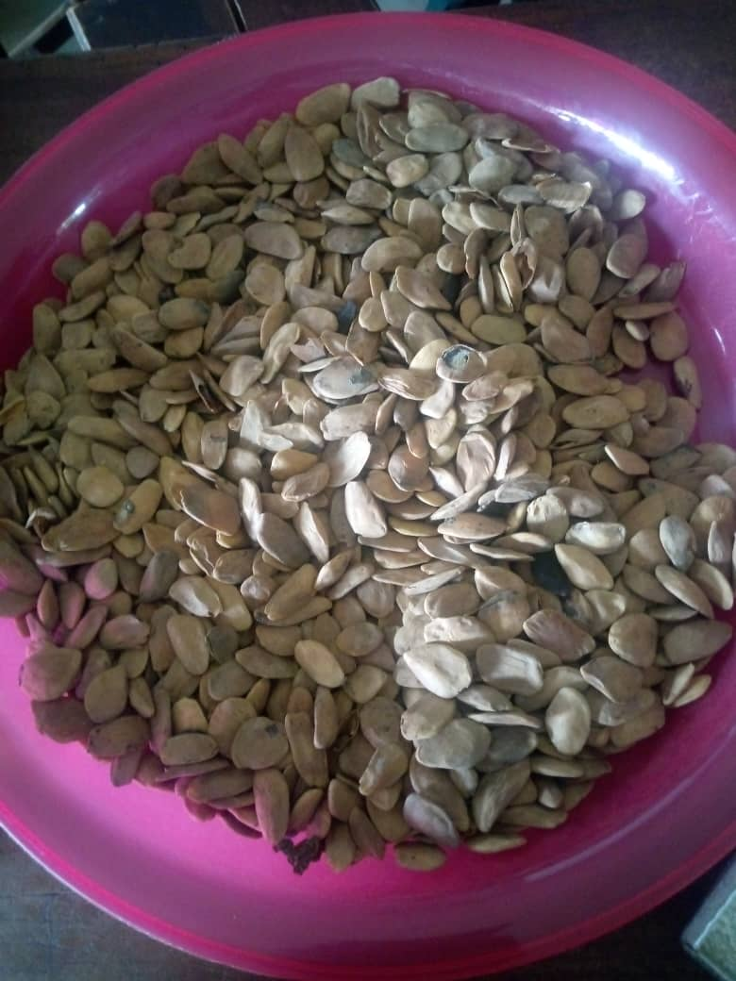 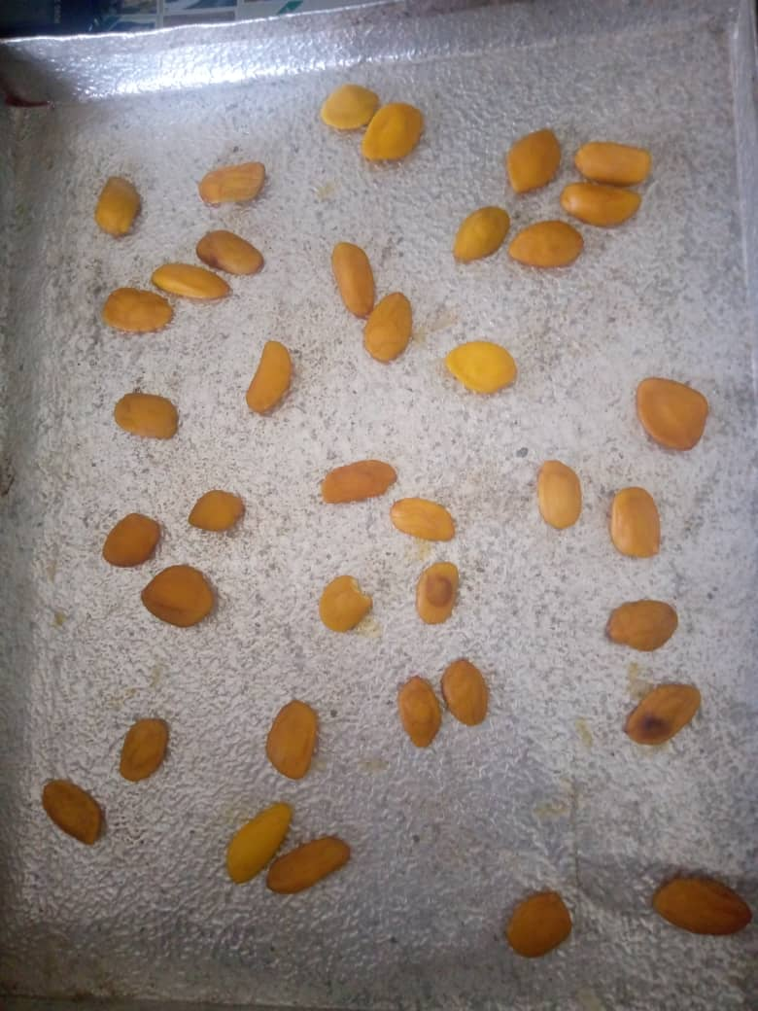 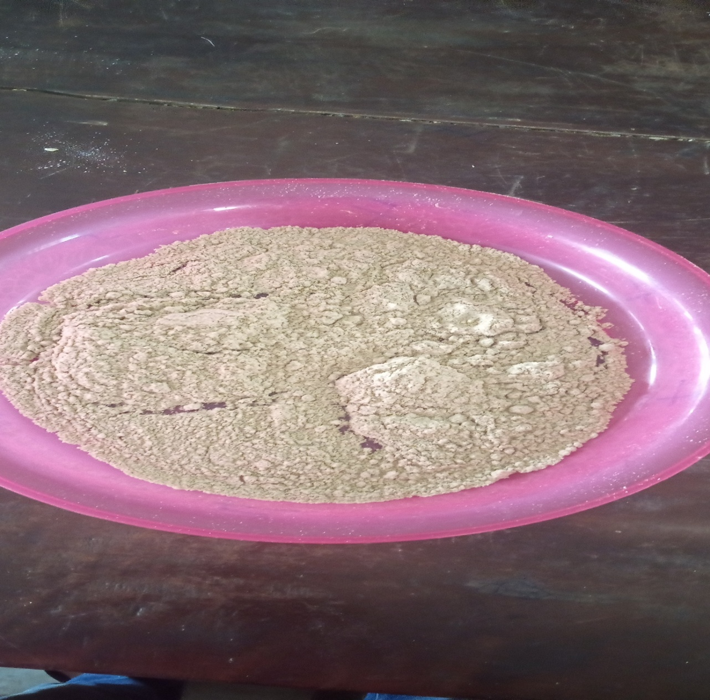 a. b c
Plate 1: shown the (a) Abere Hunteria umbellata Seed obtained directly from the market, (b) Dehulled Abere Hunteria umbellata Seed and (c) Milled Abere Seed

Determination of moisture content
The initial moisture content of the seeds was determined immediately by grating little portion of the seed then 5g was weighed and uniformly spread on the moisture can dried in the laboratory oven at 60⁰C checked at interval of 30 minutes until weight was constant. Hence, the moisture content was determined on dry and wet basis. Using the equation below;
Moisture Content on wet basis = $\frac{Mw-Md}{mw}× 100$ 1
Moisture content on dry basis = $\frac{Md}{M}$ x100 2
Where; Mc is the moisture content, Mw is the mass of the wet Abeere seed and Md is the mass of the dried Abeere Hunteria umbellata seed,
The seed was sundried using tent dryer until a required moisture content achieved, after which it was milled using kitchen blender of model no QBL-15L40. Extraction of oils from seeds was carried out using Soxhlet extraction methods. The oil was then collected for chemical analysis
Calcium, Potassium, and sodium were Determined, The filtrate was adjusted with distilled water stopper and prepared for the Jenway Digital Flame Photometer (PFP7 Model) to read the concentration of Calcium, Potassium, and Sodium using the filter corresponding to each mineral element. Determination of Mg and Fe using AAS BUCK SCIENTIFIC 211 AAS VGP, Through the suction tube, these diluents were sucked into the Buck 211 Atomic Absorption Spectrophotometer (AAS). Using the right fuel and oxidant mixtures, each of the trace mineral elements was read at its specific wavelength using a hollow cathode lamp. Phosphorus was determined using a Spectronic 20 spectrophotometer or colorimeter at a wavelength of 470 nm, the optical density (OD) or absorbance of the solution was measured to determine the concentration of phosphorus. The following calculation was used to compute the percentage of phosphorus:
%Phosphorus = $\frac{ Absorbance x Slope x Dilution factor}{ 10000}$ 3

Analysis
The data obtained were subjected to Analysis of Variance (ANOVA) at 5 % level of probability using IBM SPSS version 2.0.

3.0 Results and Discussions
The oil yield of the Abeere Hunteria umbellata seed was found to be 9.10%, which is relatively low compared to other commonly studied seeds. For instance, sesame seeds (Sesamum indicum) have oil yields ranging from 45-50% (Khan et al., 2019), and pumpkin seeds (Cucurbita spp.) typically yield between 25-30% oil (Kawashima and Soares, 2014). This lower yield suggests that while Abeere seeds might have unique nutritional benefits, they are less efficient sources of oil compared to these other seeds. The findings highlight the impact of solvent polarity on extraction efficiency and suggest N-hexane as the preferred solvent for optimizing mineral extraction from Abeere seeds. These insights can guide the development of enhanced extraction techniques for food and nutraceutical applications, addressing nutritional deficiencies and improving dietary quality. This research contributes to the limited literature on Abeere's nutritional potential and supports the use of systematic extraction methods for better nutritional profiling.

From fig 1, show the effect of solvents on the extracted abeere seed oil The extraction method used in obtaining oils from plant seeds significantly influences the mineral content of the resulting products. This study evaluates the effectiveness of two solvents, N-hexane and ethanol, in extracting minerals from Abeere seed oil. By comparing the concentrations of essential minerals such as sodium, calcium, potassium, iron, and phosphorus in oils extracted using these solvents, we aim to determine the optimal extraction method for maximizing the nutritional value of Abeere Hunteria umbellata seed oil.

Sodium Content
The graph indicates that the sodium content is higher in oil extracted with N-hexane (128.70 ppm) compared to ethanol (104.55 ppm). Sodium is crucial for maintaining electrolyte balance and nerve function. The higher sodium content in N-hexane-extracted oil could be beneficial for developing products aimed at improving electrolyte balance, particularly for athletes and individuals with specific medical needs (Kawashima and Soares, 2014).

Calcium Content
Calcium levels are shown to be significantly higher in oil extracted with N-hexane (115.60 ppm) compared to ethanol (66.45 ppm). Calcium is essential for bone health and metabolic functions. The superior extraction of calcium by N-hexane suggests its potential use in producing calcium-enriched nutritional supplements and fortified foods (Patel et al., 2023).

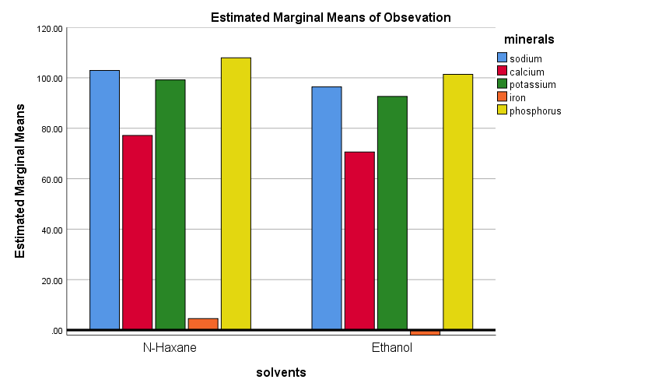

Fig 1: graphical representation of the effect of solvents on the extracted abeere Hunteria umbellata seed oil

Potassium Content
The potassium content is notably higher in N-hexane-extracted oil (169.40 ppm) compared to ethanol-extracted oil (93.20 ppm). Potassium is vital for fluid balance, muscle function, and nerve transmission. The higher potassium content in N-hexane-extracted oil highlights its potential for inclusion in dietary regimes aimed at enhancing cardiovascular health and preventing hypertension (Li et al., 2022).

Iron Content
Ethanol-extracted oil contains less iron (1.627 ppm) compared to N-hexane-extracted oil (2.581 ppm). Iron is crucial for oxygen transport and preventing anemia. The higher iron content in N-hexane-extracted oil underscores its potential for addressing iron deficiencies and formulating iron-fortified products (Chen et al., 2021).

Phosphorus Content
Phosphorus content is higher in oil extracted with N-hexane (163.91 ppm) compared to ethanol (93.164 ppm). Phosphorus is necessary for bone health, DNA synthesis, and energy production. The higher phosphorus levels in N-hexane-extracted oil suggest its suitability for meeting dietary phosphorus requirements, particularly in populations with increased phosphorus needs (Patel et al., 2023).
This comparative analysis demonstrates that N-hexane is generally more effective in extracting higher concentrations of essential minerals from Abeere Hunteria umbellata seeds compared to ethanol. The differences in mineral extraction can be attributed to the polarity of the solvents used. N-hexane, a non-polar solvent, tends to extract non-polar minerals more efficiently, while ethanol, a polar solvent, extracts polar minerals more effectively (Kawashima and Soares, 2014; Patel et al., 2023).

Implications for Dietary Applications
The findings suggest that the choice of solvent significantly affects the mineral content of the extracted oil. For nutritional applications targeting specific mineral deficiencies, selecting the appropriate solvent is crucial. For instance, N-hexane would be preferable for producing oil rich in calcium, potassium, iron, and phosphorus, while ethanol would be more suitable for sodium-enriched oil. This information can guide the development of tailored nutritional supplements and fortified foods to address specific dietary needs (Li et al., 2022).

Table 1: Analysis of variance on the effect of solvent of the extracted abeere Hunteria umbellata seed oil
Source | Sum of Squares | df | Mean Square | F | Sig.
Corrected Model | 14827.993ª | 5 | 2965.599 | 35.964 | .002
Intercept | 56352.647 | 1 | 56352.647 | 683.383 | .000
Minerals | 14721.051 | 4 | 3680.263 | 44.630 | .001
solvents | 106.942 | 1 | 106.942 | 1.297 | .318
Error | 329.845 | 4 | 82.461
Total | 71510.485 | 10
Corrected Total | 15157.838 | 9

Solvent Type: The type of solvent used for extraction (N-hexane vs. ethanol) did not show a statistically significant effect on the mineral content (F = 1.297, p = .318). This suggests that both solvents are relatively comparable in their efficiency to extract minerals from Abeere Hunteria umbellata seeds. However, it is essential to consider that different solvents may still affect the minerals composition and safety of the extracted oil differently, which could be a point of further investigation (Patel et al., 2023).
Mineral Content Significance: The analysis of variance (ANOVA) results indicate that the type of mineral significantly affects the mineral content in the extracted oil (F = 44.630, p = .001). This is consistent with findings from other studies that highlight the variability of mineral content due to different extraction methods and the inherent characteristics of the plant species (Kawashima & Soares, 2014; Nwokolo and Sim, 1987).

Comparative Analysis
The observed non-significant difference between the solvents is intriguing and somewhat contrasts with certain studies that have found polar solvents (like ethanol) to be more efficient in extracting polar compounds, while non-polar solvents (like N-hexane) are better for non-polar compounds (Kawashima and Soares, 2014). However, the mineral content may not strictly follow this polarity-based extraction efficiency, possibly due to complex interactions within the seed matrix. Furthermore, the significant variation among different minerals supports the notion that specific minerals may be more or less readily extractable depending on their chemical properties and their binding within the seed structure (Patel et al., 2023). This aligns with findings from Chen et al. (2021), who noted that mineral content in plant foods could be significantly influenced by the type of processing and the inherent properties of the minerals.

Conclusion

This study highlights the importance of solvent selection in the extraction of minerals from Abeere Hunteria umbellata seeds. N-hexane generally proves to be more effective than ethanol in extracting higher concentrations of essential minerals. These insights can inform the optimization of extraction processes to enhance the nutritional value of Abeere Hunteria umbellata seed oil, contributing to better dietary formulations and improved health outcomes.
The study provides valuable insights into the mineral profiles of Abeere Hunteria umbellata seed oil extracted using N-hexane and ethanol. While the type of solvent does not significantly affect the mineral content, the type of mineral itself plays a crucial role. These findings can guide future research and optimization of extraction processes to maximize the nutritional value of Abeere Hunteria umbellata seed oil, potentially informing the development of nutraceuticals and fortified foods.

References

Chen, Y., Liu, J., and Smith, G. (2021). Advances in mineral analysis of plant foods using atomic spectroscopy techniques. Trends in Analytical Chemistry, 136, 116237.
Gullón, P., Astray, G., Gullón, B., Tomasevic, I., Lorenzo, J. M., & Pateiro, M. (2020). Extraction, microencapsulation and health benefits of β-glucan. Foods, 9(5), 1-24.
Gupta, S., Kapoor, P., and Kumar, D. (2021). Importance of minerals in human diet and strategies for improving their bioavailability. Journal of Food Science and Technology, 58(10), 3567-3579.
Kawashima, L. M., and Soares, L. M. V. (2014). Nutritional composition of seeds from different pumpkin species and their use in the formulation of cookies. Food Science and Technology (Campinas), 34(3), 412-416.
Khan, M. A., Anwar, F., Ashraf, M., and Mahmood, Z. (2019). Nutritional composition and oil characterization of different sesame (Sesamum indicum L.) seeds from Pakistan. Journal of the American Oil Chemists' Society, 86(4), 323-329.
Li, X., Zhang, H., Wang, Y., and Zhou, Y. (2022). Genetic and environmental impacts on mineral composition of legume seeds: Implications for dietary health. Journal of Agricultural and Food Chemistry, 70(5), 1565-1574.
Nwokolo, E., and Sim, J. M. (1987). Nutritional assessment of defatted oil meals of melon (Colocynthis citrullus L.) and fluted pumpkin (Telfairia occidentalis Hook) by chick assay. Journal of the Science of Food and Agriculture, 38(3), 237-246.
Patel, S., Kumar, A., Sharma, P., & Singh, S. K. (2023). Influence of agricultural practices on mineral content of cereals: Implications for sustainable farming. Journal of Food Science and Technology, 60(3), 923-934.

