Malaria vaccines targeting Pfs25 antigen in parasite mosquito stages to block transmission

Abstract.
Transmission of malaria involves Anopheles mosquitoes as the vectors of Plasmodium parasite. Malaria eradication program includes the distribution of insecticide-treated bednets. However, the Anopheles mosquitoes have developed insecticide resistance hence it is necessary to find other modalities to eradicate the disease. Because the parasites undergo several stages in the mosquito midgut before developing into infective stages that migrate to the salivary gland, it is of interest to target the mosquito stages in a vaccination to block the transmission. Human vaccination with the antigen of the mosquito stages may induce production of specific antibodies against the stages that might be transferred into mosquito during blood meal, binding with the antigen of the mosquito stages in the midgut and subsequently disrupt the development of the parasite. Such vaccine is called transmission blocking vaccine (TBV). An effective TBV should induce high titer of antibody for a long time. One of the leading antigens is Pfs25. Here we review the update of TBV development targeting Pfs25, advances in the transmission blocking assay, and challenges in the development of TBVs.
Keywords: TBV, Pfs25, malaria, Plasmodium, mosquito stages, TBA
- Introduction
Malaria eradication has been a long-term goal with many challenges to face. Several strategies have been employed such as deployment of artemisinin-based therapy, distribution of insecticide-treated bednets, and vector control measures but there is no significant change in the number of cases and deaths in the last few years. Based on the latest WHO malaria report 2019, the number of cases worldwide is still around 230 million with estimated deaths of 400000 per year [1].
Therefore, a novel modality for transmission blocking such as vaccination should be developed. Since malaria parasite life cycle involves two hosts, the human and mosquitoes, vaccination may target the parasite stages either in human or in the mosquitoes. Targeting the mosquito stages may inhibit the growth of the parasite in the mosquitoes which eventually block the transmission into human. Such vaccines are called transmission blocking vaccine (TBV) [2].
In this review we will discuss about the update of the development of the TBVs, advances in the transmission blocking assay, and challenges in the development of the TBVs.
- Transmission Blocking Vaccine (TBV) Targets Mosquito Stages
The life cycle of Plasmodium spp in the mosquitoes starts when a female Anopheles mosquito feeds from an infected human. During the blood meal, Plasmodium gametocytes are taken up by the mosquito. In the mosquito midgut, the macrogametocytes and microgametocytes mature into gametes which will fuse to form the ookinete. The ookinete migrates to the external surface of the stomach and matures into an oocyst that contains up to 10,000 sporozoites in a few days (Fig 1). The sporozoites are then released to the circulation when an oocyst ruptures, reaching the salivary gland where they are ready to be injected into the human when the mosquito takes the next blood meal [3,4].
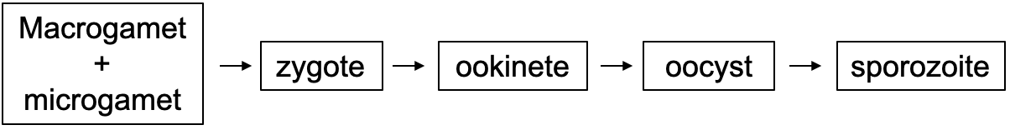

Fig 1. The development of malaria parasite in the mosquitoes. The gametocytes are taken up from an infected human during blood meal which develop into gametes in mosquito midgut. Final stages are sporozoites that are injected into human skin during another blood meal.

The surface proteins of the mosquito stages have been targeted for development of TBVs, such as Pfs25, Pfs28, Pfs48/45 and Pfs230 [2]. When these antigens are injected into human body, they induce antibodies in the blood that will be ingested into mosquito during a blood meal and subsequently disrupt the development of the parasite. Inducing antibodies against the stages in the mosquitoes would be more advantageous than antibodies against the erythrocytic stages because the number of parasites in the midgut is far lower than the number of parasites in human circulation. Thus, the higher the titer of the induced antibody, the more efficacious the TBV is to inhibit the formation of the mosquito stages [5].
Among all vaccine targets, Pfs25 has been the leading candidate showing promising results from several animal studies in different laboratories and has entered clinical trials [6,7]. Pfs25 is a cysteine-rich 217-amino acid composed of four tandem epidermal growth factor (EGF)-like domains and encoded by a 0.65-kb gene. Pfs25 is predicted to be a 25-kDa glycosylphosphatidylinositol (GPI)-anchored protein belonging to a 13-member P25 family of proteins [8,9]. The protein is involved in ookinete formation, survival in the mosquito midgut, and a possible role in parasite traversal of the mid-gut epithelium [10,11]. Based on structural analyses of the P. vivax ortholog Pvs25, the Pfs25 molecule is thought to be triangular and flat, and extensively expressed on the ookinete surface, forming a protective interlocking sheet [9,12,13]. Below we discuss about several Pfs25-targeting vaccine candidates reported recently.
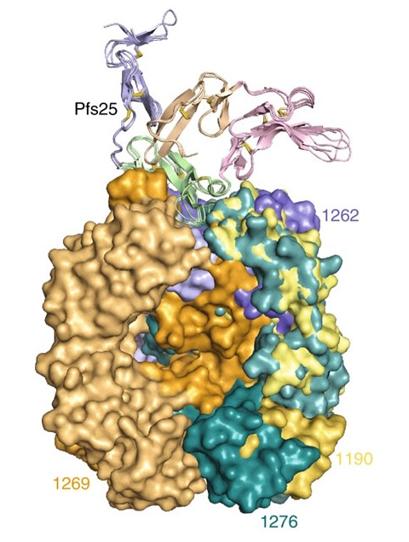
Fig 2. Superposition of site 1a antibody–Pfs25 co-complex crystal structures. Pfs25 is shown as cartoon and colored according to EGF-like domain [9].

Pfs25-EPA
This vaccine consists of Pfs25H, a recombinant Pichia pastoris expressed Pfs25 protein with a 6-histidine fusion tag adjuvanted on Alhydrogel (Table 1) [14]. The antigen was conjugated to EPA, a recombinant, detoxified ExoProtein A from Pseudomonas aeruginosa to enhance the vaccine immunogenicity. The Pfs25-EPA has entered a phase 1 clinical trial but despite the ability to induce antibody titer against Pfs25 with minimal adverse events, the antibody titer reduced to near baseline after one year [15]. A study by Sara A. Healy in 2021 compare the effectivity of pfs25-EPA and Pfs230D1-EPA in mice and human[16]. The result identified that Pfs25-EPA and Pfs230D1-EPA induced similar serum functional activity in mice, but Pfs230D1-EPA induced significantly greater activity in rhesus monkeys. In US adults, 2 vaccine doses induced complement-dependent activity in 4 of 5 Pfs230D1-EPA recipients but no significant activity in 5 Pfs25-EPA recipients, and combination with Pfs25-EPA did not increase activity more than Pfs230D1-EPA alone (Table 1).

Table 1. Phase 1 clinical trials of Pfs25-based vaccines

Author (year) | Vaccine | Number of subjects | Results
Talaat KR, et al. (2016) [15]. | Pfs25-EPA / Alhydrogel | 30 | - The vaccine was well tolerated  - 9/11 subjects develop TRA 50%
Sara A. Healy et al (2020) [16]. | Pfs25-EPA/Alhydrogel | 5 | - The vaccine was well tolerated 0 of 5 individuals had TRA greater than 50%
J.A. Chichester et al.(2018) [17]. | Pfs25 VLP-FhCMB /Alhydrogel | 44 | - Acceptable safety and tolerability profile  - TRA was significant after the 3rd dose in 2/8 subjects (80% and 77%)
de Graaf et al. (2021) [19]. | ChAd63-Pfs25-IMX313/ MVA-Pfs25-IMX313 prime-boost | 26 | - Both vaccines were well tolerated and demonstrated a favorable safety profile  - Median Transmission Reduction Activity (TRA) was 25.3%

Pfs25 VLP-FhCMB
Pfs25 VLP-FhCMB is a chimeric non-enveloped virus-like particle (VLP) comprising Pfs25 which is fused to the Alfalfa mosaic virus coat protein and manufactured in Nicotiana benthamiana plants. It has also entered a clinical trial, but the result was unsatisfactory due to the poor efficacy despite the ability to induce antibody titer against Pfs25. It was reported that the transmission reducing activity (TRA) was less than 80% in majority of study subjects (Table 1) [17].

ChAd63-Pfs25-IMX313/MVA-Pfs25-IMX313
This vaccine is a fusion of Pfs25 to IMX313, an oligomerization technology to produce a homogenous, self-assembling oligomers of Pfs25 resembling a nanoparticle. The particles are then expressed in the viral vectors, chimpanzee adenovirus serotype 63 (ChAd63) and MVA [18]. A first phase clinical trial using this vaccine has already done by Hans de Graaf et al [19] between 2019 until 2021. The result shows that the vaccines were immunogenic and induced both antibody and T-cell responses against Pfs25. However, significant TRA was not observed in most volunteers by standard membrane feeding assay, suggesting the need for an alternative vaccine formulation (Table 1) [19]. Another study by Marija Zaric [20] reveals the reason behind this result. They found that the key determinant for the poor anti-Pfs25 antibody formation in humans was the lack of CD4+ T cell recognition of Pfs25-IMX313 derived peptide epitopes. This is supported by correlations established between the ratio of proliferated antigen-specificCD4+/Tfh-like T cells, CXCL13 sera levels, and the corresponding numbers of circulating Pfs25-specific memory B cells, that consequently reflected on antigen-specific IgG sera levels [20].

Ad5-Pfs25
The Ad5-Pfs25 is a Pfs25 encoding gene delivered by adenovirus type 5 vector. In an animal study, this vaccine was used as a prime injection of a boost of Ad5 viral particles displaying only the Pfs25 epitope targeted by the specific antibodies against Pfs25 4B7 and 1D2 (Pfs25 aa 122–134) [21]. Another animal study used the Ad5-Pfs25 in a heterologous prime-boost with a Modified vaccinia Ankara (MVA)-vectored Pfs25, resulted in a 96% reduction in the oocyst intensity [22]. However, no report yet about whether this vaccine has entered a cinical trial.

- Advances in transmission blocking assay
Efficacy of a TBV are evaluated using a method known as transmission blocking assay (TBA). To date, there are two kinds of TBA; standard membrane feeding assay (SMFA) and direct feeding assay (DFA). The oocyst numbers and prevalence are counted and compared between the immunized and control groups for the inhibition calculation. The efficacy could be presented in two outreads; transmission-blocking activity (TBA) and transmission-reducing activity (TRA) [6].

3.1 SMFA and DFA
In an SMFA, after immunization, sera are collected and then mixed with the mosquito blood meal in a membrane feeder containing P falciparum strain NF54 that has been induced for gametocytogenesis. After taking blood, mosquitoes are maintained for around 10 days and then their midgut are dissected for oocyst examination for their intensity and prevalence (Fig 3). This method is used more commonly in transmission blocking assay, including in human trials.

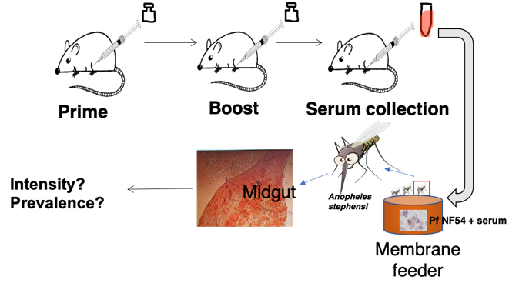
Fig 3. Standard Membrane Feeding Assay. After immunization (prime and boost), sera are collected and mixed with the P falciparum culture for membrane feeding of the mosquitoes. The development of oocyst in the mosquito midgut are evaluated after 10-12 days

In a DFA, sera from immunized mice are not collected, but the mice are infected with the transgenic parasite P berghei containing the Pfs25 gene (PbPfs25DR3) (Fig 4) [22]. It has been suggested that this assay is twice as effective as SMFA[23].

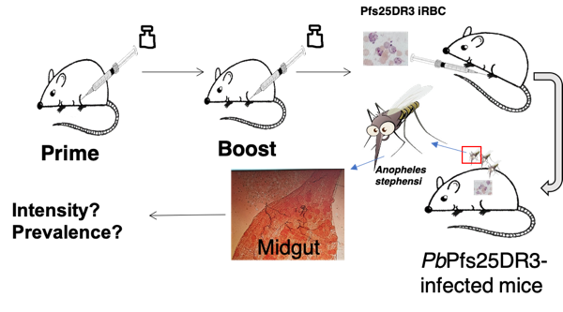
Fig 4. Direct Feeding Assay. After immunization (prime and boost), mice are infected with the PbPfs25DR3. Mosquitoes are allowed to take blood directly from the mice and the development of oocyst in the midgut are evaluated after 10-12 days

TBA and TRA
The Transmission-reducing activity (TRA) indicates the percent inhibition of mean oocyst intensity which is calculated using the formula: 100 x [1 – (mean number of oocysts in the test group/mean number of oocysts in the control groups)]. Whereas transmission-blocking activity (TBA) indicates the % inhibition of oocyst prevalence which is evaluated as: 100 x [1 – (proportion of mosquitoes with any oocysts in the test group/proportion of mosquitoes with any oocysts in the control groups)] [24]. It was reported that the variability of inter-laboratory result might be reduced by reporting the TBV efficacy in TRA [25].
- Challenges in the development of TBV
Since the Pfs25 are expressed in the mosquito stages, natural infection cannot boost the immune response against this antigen. Thus, the antibody titer may wane over time. To overcome this problem, an effective TBV should be able to induce a long-lasting immune response, particularly antibody induction. An induction of long-term antibody response has been reported previously in a study using Ad5-Pfs25 prime followed by an adeno-associated virus serotype 1 (AAV1)-vectored Pfs25 boost [26].
Another point at issue is vaccination should give protection to the people who get vaccinated with the TBV, in addition to inhibit the transmission. This was addressed by the study on potential mixing of Pfs25-IMX313 with RTS,S/AS01 in one formulation [7]. It was reported that the mixture was able to induce immune responses against the pre-erythrocytic stage and the mosquito stage hence it may be effective for both protection and transmission blocking. Another approach was to produce a multi-stage vaccine, combining the sequence of antigen of both stages in one construct. In an animal study using DFA, a heterologous prime-boost using Ad5-AAV1 delivering the multistage PfCSP-Pfs25 antigen induced long-term antibody titer against both antigens. In addition, the vaccine achieved high efficacy of 99% TRA even after almost 1 year[27]. If such efficacy can be reached in human, we may achieve the goal to eradicate malaria.
- Conclusion
An effective vaccine targeting the antigen of the mosquito stages of malaria parasite might be a powerful alternative modality for malaria control. More intensive studies are needed to explore the potency of Pfs25 as the leading candidate to be an effective TBV.
References

- WHO. (2019, 4 December 2019). "The "World malaria report 2019" at a glance." Retrieved 20 September 2020, from https://www.who.int/news-room/feature-stories/detail/world-malaria-report-2019.
- Duffy, P. E. and D. C. Kaslow. A novel malaria protein, Pfs28, and Pfs25 are genetically linked and synergistic as falciparum malaria transmission-blocking vaccines. Infect Imm. 1997;65(3): 1109.
- Institute of Medicine (US) Committee for the Study on Malaria Prevention and Control. 1991. 6, Parasite Biology. Malaria: Obstacles and Opportunities. M. V. Oaks SC Jr, Pearson GW, et al. Washington DC, National Academies Press
- Aly, A. S. I., A. M. Vaughan and S. H. I. Kappe. Malaria parasite development in the mosquito and infection of the mammalian host. Ann rev microbiol. 2009;63: 195-221.
- Miura, K., D. B. Keister, O. V. Muratova, J. Sattabongkot, C. A. Long and A. Saul. Transmission-blocking activity induced by malaria vaccine candidates Pfs25/Pvs25 is a direct and predictable function of antibody titer. Malar J. 2007;6(1): 107.
- Miura, K., E. Takashima, B. Deng, G. Tullo, A. Diouf, S. E. Moretz, D. Nikolaeva, M. Diakite, R. M. Fairhurst, M. P. Fay, C. A. Long and T. Tsuboi. Functional comparison of Plasmodium falciparum transmission-blocking vaccine candidates by the standard membrane-feeding assay. Infect Imm. 2013;81(12): 4377.
- Brod, F., K. Miura, I. Taylor, Y. Li, A. Marini, A. M. Salman, A. J. Spencer, C. A. Long and S. Biswas. Combination of rts,s and pfs25-imx313 induces a functional antibody response against malaria infection and transmission in mice. Front Imm. 2013;9: 2780.
- Kaslow DC, Quakyi IA, Syin C, Raum MG, Keister DB, Coligan JE, et al. A vaccine candidate from the sexual stage of human malaria that contains EGF-like domains. Nature. 1988;333:74–6.
- Scally, S.W., McLeod, B., Bosch, A. et al. Molecular definition of multiple sites of antibody inhibition of malaria transmission-blocking vaccine antigen Pfs25. Nat Commun. 2017;8: 1568. https://doi.org/10.1038/s41467-017-01924-3.
- Sauerwein, R. W. and T. Bousema. Transmission blocking malaria vaccines: Assays and candidates in clinical development. Vaccine. 2015;33(52): 7476-7482.
- Baton LA, Ranford-Cartwright LC. Do malaria ookinete surface proteins P25 and P28 mediate parasite entry into mosquito midgut epithelial cells? Malar J. 2005;4:15.
- Saxena AK, Singh K, Su HP, Klein MM, Stowers AW, Saul AJ, et al. The essential mosquito-stage P25 and P28 proteins from Plasmodium form tile-like triangular prisms. Nat Struct Mol Biol. 2006;13:90–1.
- Stowers AW, Keister DB, Muratova O, Kaslow DC. A region of Plasmodium falciparum antigen Pfs25 that is the target of highly potent transmission-blocking antibodies. Infect Immun. 2000;68:5530–8.
- Zhu, D., Y. Wu, H. McClellan, W. Dai, K. Rausch, D. Jones, J. Aebig, E. Barnafo, B. Butler, L. Lambert, D. L. Narum and P. E. Duffy. Accelerated and long term stability study of Pfs25-EPA conjugates adjuvanted with Alhydrogel®. Vaccine. 2017;35(24): 3232-3238.
- Talaat, K. R., R. D. Ellis, J. Hurd, A. Hentrich, E. Gabriel, N. A. Hynes, K. M. Rausch, D. Zhu, O. Muratova, R. Herrera, C. Anderson, D. Jones, J. Aebig, S. Brockley, N. J. MacDonald, X. Wang, M. P. Fay, S. A. Healy, A. P. Durbin, D. L. Narum, Y. Wu and P. E. Duffy. Safety and immunogenicity of pfs25-epa/alhydrogel®, a transmission blocking vaccine against Plasmodium falciparum: an open label study in malaria naïve adults. PLoS One. 2016;11(10): e0163144.
- Healy, S.A. et al. ‘Pfs230 yields higher malaria transmission-blocking vaccine activity than Pfs25 in humans but not mice’, Journal of Clinical Investigation. 2021;131(7), pp. 1–10. Available at: https://doi.org/10.1172/JCI146221.
- Chichester JA, Green BJ, Jones RM, Shoji Y, Miura K, Long CA, Lee CK, Ockenhouse CF, Morin MJ, Streatfield SJ, Yusibov V. Safety and immunogenicity of a plant-produced Pfs25 virus-like particle as a transmission blocking vaccine against malaria: A Phase 1 dose-escalation study in healthy adults. Vaccine. 2018;36(39):5865-5871.
- Li, Y., D. B. Leneghan, K. Miura, D. Nikolaeva, I. J. Brian, M. D. J. Dicks, A. J. Fyfe, S. E. Zakutansky, S. de Cassan, C. A. Long, S. J. Draper, A. V. S. Hill, F. Hill and S. Biswas. Enhancing immunogenicity and transmission-blocking activity of malaria vaccines by fusing Pfs25 to IMX313 multimerization technology. Sci rep. 2016;6: 18848-18848.
- de Graaf, H. et al. ‘Safety and Immunogenicity of ChAd63/MVA Pfs25-IMX313 in a Phase I First-in-Human Trial’. Frontiers in Immunology. 2021;12;1–13.
- Zaric, M. et al. Poor CD4+ T Cell Immunogenicity Limits Humoral Immunity to P. falciparum Transmission-Blocking Candidate Pfs25 in Humans. Frontiers in Immunology. 2021;12:1–15.
- McGuire, K. A., K. Miura, C. M. Wiethoff and K. C. Williamson. New adenovirus-based vaccine vectors targeting Pfs25 elicit antibodies that inhibit Plasmodium falciparum transmission. Malar J. 2017;16(1): 254.
- Goodman, A. L., A. M. Blagborough, S. Biswas, Y. Wu, A. V. Hill, R. E. Sinden and S. J. Draper. A viral vectored prime-boost immunization regime targeting the malaria pfs25 antigen induces transmission-blocking activity. PLoS One. 2011; 6(12): e29428.
- Diallo, M., A. M. Touré, S. F. Traoré, O. Niaré, L. Kassambara, A. Konaré, M. Coulibaly, M. Bagayogo, J. C. Beier, R. K. Sakai, Y. T. Touré and O. K. Doumbo. Evaluation and optimization of membrane feeding compared to direct feeding as an assay for infectivity. Malar J. 2008; 7(1): 248.
- Miura, K., B. J. Swihart, B. Deng, L. Zhou, T. P. Pham, A. Diouf, T. Burton, M. P. Fay and C. A. Long. Transmission-blocking activity is determined by transmission-reducing activity and number of control oocysts in Plasmodium falciparum standard membrane-feeding assay. Vaccine. 2016;34(35): 4145-4151.
- Miura, K., B. J. Swihart, M. P. Fay, C. Kumpitak, K. Kiattibutr, J. Sattabongkot and C. A. Long. Evaluation and modeling of direct membrane-feeding assay with Plasmodium vivax to support development of transmission blocking vaccines. Sci Rep. 2020;10(1): 12569.
- Yusuf, Y., T. Yoshii, M. Iyori, H. Mizukami, S. Fukumoto, D. S. Yamamoto, T. B. Emran, F. Amelia, A. Islam, I. Syafira and S. Yoshida. A viral-vectored multi-stage malaria vaccine regimen with protective and transmission-blocking efficacies. Front Imm. 2019;10: 2412-2412.
- Yusuf, Y., T. Yoshii, M. Iyori, K. Yoshida, H. Mizukami, S. Fukumoto, D. S. Yamamoto, A. Alam, T. B. Emran, F. Amelia, A. Islam, H. Otsuka, E. Takashima, T. Tsuboi and S. Yoshida. Adeno-associated virus as an effective malaria booster vaccine following adenovirus priming. Front Imm. 2019;10: 730.

