Chicken Rearing Practices in Tigray, northern Ethiopia

Abstract
The study was conducted to characterize chicken production practices in the eastern and southeastern zones of Tigray region. It was conducted in Hawzien, Degua-tembien and Hintalo-Wejirat Districts. Two peasant associations were selected from each district and 178 households were interviewed. The average age of the respondents was 38 years who were illiterate (71.3%) and primary school completed (15.2%). In the districts, the major crops grown were wheat, barley, and teff. However, maize and pea were also grown commonly. The households had an average flock size of 6 chicks, 3 pullets, 3 cockerels, 4 hens, and 2 cocks, and 98.9% and 99.4% of the farmers provided supplementary feeds and water to their chickens, respectively, in addition to scavenging. About 79% of farmers kept their chickens in private houses, while 16.5% slept in perches. Eggs used for hatching were stored in plastic containers (56.5%), in local containers mixed with dung (27.1%), and mixed straw (6.8%). Incubation was also mainly done from October to February, using locally available materials like metallic, plastic, grass, and pits. This process should be aligned with the availability of feed resources and suitable environmental conditions. Therefore, this indigenous knowledge is important to document, use, and improve farmers' experience for further research, modification and developmental interventions in the region.
Keywords: Flock size, Hatching, House, Incubation, and Supplementary feed.
- Introduction
Poultry, particularly chickens, is the world’s most extensively kept and abundant type of livestock species globally [1]. According to [2] report, village poultry accounts for more than 70% of poultry products and 20% of animal protein consumption in Africa. Similarly, [3] also reported that poultry production has significant economic, social, nutritional, and cultural benefits, particularly in low-income countries. They provide high animal protein in the form of eggs and meat [4, 5].
In Ethiopia, chicken production plays a key role in human nutrition and food security, poverty reduction, sources of income and employment opportunities [6, 7, and 8]. Currently, in the country, there are approximately 57 million chickens, of which 78.86% are local, 12.02% are hybrids and 9.12% are exotic breeds [9]. The diverse AEs prevailing in Ethiopia, together with the large number of chickens, could be a promising attribute for improving the sector and increasing its contribution to the gross domestic product (GDP) [8]. For a long time, eggs from poultry have been known to play an important nutritional role in humans and are also a nutritional reservoir for developing embryos [10, 11]. Similarly, [12] indicated that eggs are readily digested and can provide a significant portion of the nutrients required daily for growth and maintenance of body tissues. Additionally, chicken and chicken products are relatively affordable [8].
In Ethiopia, the rearing of chicken is primarily limited to backyard operation with a few low-productivity birds that mostly scavenge for feed. Eggs and meat produced in this way are insufficient to supply the increased demand for eggs and poultry meat in metropolitan areas. The price of eggs and meat has been steadily rising, indicating rising local demand [13]. Similarly, according to in Ethiopia, poultry serves multiple purposes such as providing eggs for hatching, sale, and home consumption, as well as production of birds for sale, processing, replacement, and home consumption. Chicken has a short generation interval and higher feed conversion efficiency, thus providing a cheap source of animal protein. Additionally, chicken meat is the most palatable and easily digestible animal meat and contains essential amino acids required for human beings, and eggs are richly endowed with nutrients [14]. Chickens also have a socio-cultural and religious role mainly in the rural communities throughout Ethiopia [15]. Therefore, the objectives of this study were to document, use, and improve farmers' experience for further research, modification and developmental interventions in the poultry sector in the region.
- Materials and Methods
  - Study area: the three study districts were located in two zones (eastern and southeastern) of the Tigray regional state, northern Ethiopia. A total of six villages (two villages from each district) were selected. Hawzen district (Hayelom and Debrehiwot Peasant Associations (PAs)) is located at 14⁰00’0.00’’N and 39⁰19’60.00’’E and both villages representing midland agro ecology. Similarly Degua-tembien and Hintalo-wajerat districts are found at a latitude and longitude of (13⁰29’59.99’’ N and 39⁰14’60.00’’E and 13⁰09’60.00’’N and 39⁰39’59.99 E, respectively (Figure 1). Seret and Melfa PAs from Degua-tembien and Senale from Hintalo-wajerat were representing the highland agro-ecology whereas Mesanu PAs from Hintalo-wajerat was representing the midland agro-ecology.
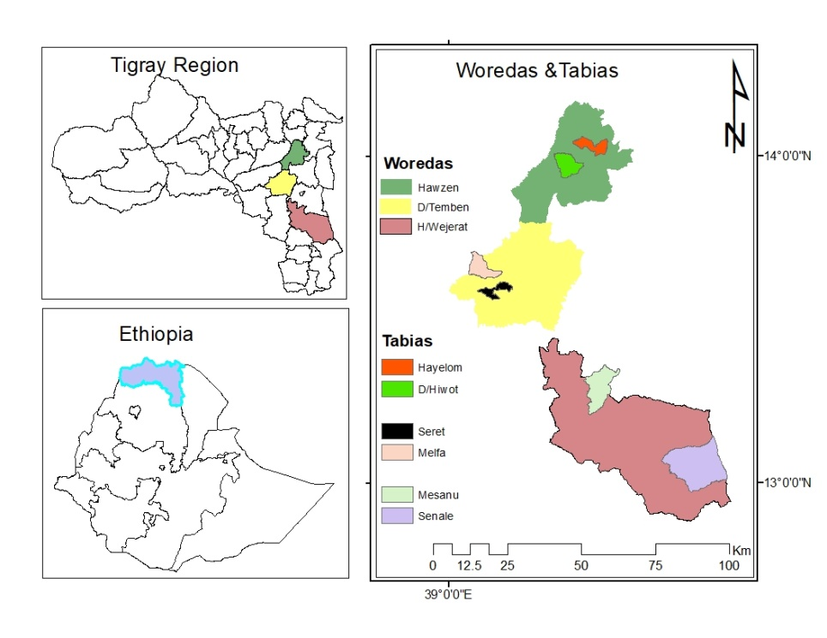
Figure 1. Map of the study area
  - Sample determination and selection of participants
Multi-stage sampling technique was employed to select the peasant association (PA) which is the smallest administration unit and respondents. Six sample PAs were purposively selected to represent midland and highland (three PAs from midland and three PAs from highland agro ecology) based on chicken population number and access to roads. A stratified sampling technique was employed to stratify the PA of the midland (1500-2500 meters above sea level) and highland (>2500 masl) [16] agro-ecology. A total of 178 chicken owners (approximately sixty farmers from each study districts) who had three or more chickens were interviewed. A rapid field survey was conducted before the main survey to validate the geographical distribution of the chicken, concentration, and population number of the indigenous chicken ecotypes and to obtain a representative sample from the district; sampling framework was developed and used for the process.
  - Methods of data collection
The household survey was used to gather data on the socio-economic characteristics, farming system, flock size, feeding and watering of chickens, feed resources and feeding practices, hatching and brooding practices.
  - Ranking Methods
Ranking was used to determine the major cereal grains grown and method of eliminating unwanted broodiness in laying hens. Participants were asked to rank their first to sixth in each of the above listed parameters, and the most important reasons listed from the first to third were considered.
Index=Sum (n × number of HHs ranked first) + (n-1) × number of HHs ranked second + (n-2) × number of HHs ranked third +… + 1xnumber of HHs ranked last) for one factor divided by the sum of (n × number of HHs ranked first+ (n-1) × number of HHs ranked second+…. +1 × number of HHs ranked last) for all factors and n=number of factors under consideration. The variable with the highest index value is the most economically important [17].
Cocks to Hen ratio: Cocks to hens ratio was calculated as the ratio of the total number of breeding cocks to the total number of laying hens.
  - Data analysis
The collected data were analyzed using the Statistical Package for Social Sciences (SPSS) software version 20 [18], and descriptive statistics were used to compare percentages and one-way ANOVA for the flock composition and livestock holding with Tukey’s test to compare means.
The following model was used:
Yi= μ + Ai + ei
Where Yi= response of variables
μ: overall population mean for the corresponding chicken age groups across districts
Ai: effect of i^{th} districts (1, 2, 3)
ei: residual error
- Results and discussions
  - Socio-economic characteristics of respondents
The average age, educational status, family size, land size and farming activity of respondents are presented in Table 1. These parameters play significant roles in the chicken production system. The average ages of the respondents were 44.38, 34.43 and 35.04 years in Hawzen, Degua-temben and Hintalo-wajerat districts respectively. The overall mean ages of the respondents were 37.98 years. This value indicated that medium aged people are participating in chicken production in the region which was lower than reported by [19] and [20].
The educational status of the farmers rearing chickens was majorly illiterate with an average family size of 5.79 per household which is lower than the report of 6.9 [21] in southern Ethiopia but it was higher than the 5.2 national average [22] and the average landholding size of 1.27ha/household. Generally, the major farming activities of the respondents were crop-livestock mixed agriculture.
Table 1: Socio-economic characteristic of respondents
Parameters | Districts |  |  | Overall mean
Parameters | Hawzen | D’temben | H/wajirat | Overall mean
N | 60 | 60 | 58 | 178
Age of respondents (years) | 44.38 | 34.43 | 35.04 | 37.98
Educational status (%)
Illiterate | 80 | 63.30 | 70.70 | 71.30
Religious |  |  | 3.40 | 1.10
Writing and reading | 3.30 |  | 5.20 | 2.80
Primary | 13.30 | 20 | 12.10 | 15.20
Junior and high school | 3.30 | 16.70 | 8.60 | 9.60
Family size (mean ± SD)
Number of adult male | 1.88 ± 1.12 | 1.10 ±1.20 | 1.91± 1.52 | 1.63 ± 1.31
Number of adult female | 1.97±1.00 | 1.45±0.75 | 2.16 ±1.25 | 1.85±1.06
Number of girls under 15 | 1.13± 0.83 | 1.20±1.05 | 1.29±1.06 | 1.21±0.98
Number of boys under 15 | 1.03±1.10 | 1.07±1.16 | 1.21± 0.81 | 1.10± 1.04
Total family size | 6.01±4.05 | 4.82±4.16 | 6.57±4.64 | 5.79±4.39
Land size (Mean ± SD) (ha) | 0.98±0.79 | 1.52± 1.85 | 1.31±2.31 | 1.27±1.74
Farming activity
Livestock production | 3.30 | 6.70 | 12.10 | 7.30
Crop production | 31.70 | 25 | 15.50 | 24.20
Mixed | 65 | 65 | 69 | 66.30
Trade |  | 3.30 | 1.70 | 1.70
Employed |  |  | 1.70 | 0.60
D’temben= Degua-temben, H/wajirat= Hintalo-wajirat
  - Major cereal grain production system
The major cereal grains grown in the study area is presented in Table 2. Wheat, Taff, finger millet, and sorghum were the major crops grown in Hawzen, whereas barely, wheat, Taff and sorghum were the major crops grown in Degua-temben and Hintalo-wajerat districts. Therefore, the major crops grown in the study districts were wheat, barely, sorghum and Taff. However, hanfets (a mixture of wheat and barley), maize, and pea were also grown. Hence, farmers use mainly wheat and barley for poultry feed supplementation and rarely do they use hanfets, sorghum, finger millet and maize in addition to scavenging.
Table 2: Major cereal grains grown in the study areas
Cereal grains | Study districts |  |  |  |  |  | Overall
Cereal grains | Hawzen |  | D/temben |  | H/wajerat
Cereal grains | Index | Rank | Index | Rank | Index | Rank | Index | Rank
Wheat | 0.34 | 1 | 0.38 | 1 | 0.25 | 2 | 0.34 | 1
Taff | 0.13 | 2 | 0.15 | 3 | 0.17 | 4 | 0.14 | 3
Finger millet | 0.12 | 3 | 0.09 | 5 | 0.02 | 6 | 0.06 | 5
Sorghum | 0.11 | 4 | 0.07 | 6 | 0.2 | 3 | 0.12 | 4
Barely | 0.1 | 5 | 0.17 | 2 | 0.3 | 1 | 0.20 | 2
Hanfets | 0.09 | 6 | 0.02 | 7 | 0 | 8 | 0.04 | 6
Maize | 0.06 | 7 | 0.02 | 7 | 0.06 | 5 | 0.03 | 7
Pea | 0.01 | 8 | 0.11 | 4 | 0.01 | 7 | 0.06 | 5
  - Livestock holding
The average livestock flock/herd sizes per household are presented in Table 3. The overall average livestock holdings were 5.46 goats, 1.45 donkeys, 2.54 local cattle, 3.33 crossbred cattle, 5.27 sheep, 5.46 exotic chickens, 8.60 local chickens, 5.38 crossbred chickens, 7.67 camel, and 1.71 modern and 0.27 traditional beehives respectively. Chickens were the most dominantly produced animals in the study districts and farmers managed diversified livestock species. This diversified farming practice can provide several benefits such as ensuring food security, conserving biodiversity, improving dietary preferences, increasing household income, reducing vulnerability to shocks, and creating job opportunities. Farm diversification can be also considered as a means to minimize risks and provide insurance against crop failures. This value was higher in all flocks except cattle and chicken than reported by [23] in eastern Ethiopia.
  - Flock size of indigenous chicken based on sex and age
The mean values of indigenous chicken flock size per household are presented in Table 4. The overall average flock size per household was 6.22 chicks, 3.37 pullets, 2.58 cockerels, 3.88 hens and 1.61 cocks. The mean flock size per household was 18.24 in Hawzen, 16.19 in D’temben and 18.17 in H/wajerat districts and the overall flock size of the study area was 17.66 chicken/household. However, there was no difference (p>0.05) of flock ownership among the study districts. The present findings were lower than 24.31 reported by [24] in southern Tigray but higher than 11.15 reported by [25] in western Ethiopia. The variation in flock size might be due to farm land size, production system and agro-ecology. However, [9] reported that laying hens were the predominant flock followed by chicks in Ethiopia. Similarly, laying hens were the dominant flock in southern Ethiopia as reported by [26]. The average cocks to hens ratio across the study districts was 1:2 implying better breeding males as compared to the recommended ratio of 1:10.

Table 3: Herd/flock size, livestock composition of respondents
Parameters | Woreda of respondents |  |  |  |  |  | Overall mean
Parameters | Hawzen |  | D’temben |  | H/wajerat |  | Overall mean
Parameters | Range | Mean ± SD | Range | Mean ± SD | Range | Mean ± SD | Overall mean
Goats | 1-6 | 2.5 ± 2.3 | 1-10 | 5.25 ± 2.74 | 1-15 | 7.25± 5.06 | 5.46 ± 3.94
Donkey | 1-2 | 1.3 ± 0.47 | 1-5 | 1.78 ± 1.11 | 1-3 | 1.41 ± 0.75 | 1.45 ± 0.77
Local cattle | 1-7 | 2.76 ± 1.4 | 0-5 | 2.3 ± 1.30 | 0-5 | 2.53 ± 1.35 | 2.54 ± 1.36
Cross cattle | 1-7 | 4.0 ± 2.94 | 0-2 | 2.0 ± 0.00 | 0 | 0 | 3.33 ± 2.50
Sheep | 1-14 | 5.38 ± 3.08 | 3-8 | 5.0 ± 1.73 | 1-20 | 5.17 ± 3.91 | 5.27 ± 3.26
Exotic chicken | 1-22 | 5.88 ± 4.92 | 2-28 | 5.61 ± 5.22 | 1-16 | 4.83 ± 3.85 | 5.46 ± 4.70
Local chicken | 0-22 | 7.67 ± 5.22 | 1-23 | 7.11 ± 4.64 | 1-44 | 10.83 ± 6.5 | 8.60 ± 5.88
Cross chicken | 1-12 | 4.77 ± 2.80 | 2-13 | 5.83 ± 4.10 | 1-15 | 5.79 ± 3.65 | 5.38 ± 3.34
Camel |  | 0 | 0-11 | 11.0 ± 0.00 | 2-10 | 6.0 ± 5.66 | 7.67 ± 4.93
Modern bee hives | 1-3 | 1.67 ± 1.16 | 1 | 1.0 ± 0.00 | 1-3 | 2.0 ± 1.00 | 1.71 ± 0.95
Traditional bee hives | 1-2 | 1.5 ± 0.71 | 0-1 | 0.11 ± 0.32 | 0-2 | 0.75 ± 0.96 | 0.27 ± 0.57
Where, SD= standard deviation
Table 4: Indigenous chicken flock size according to age and sex of the respondents
Parameters | Districts |  |  |  |  |  | Overall mean
Parameters | Hawzen |  | D’temben |  | H/wajerat |  | Overall mean
Parameters | Range | Mean ± SD | Range | Mean ± SD | Range | Mean ± SD | Overall mean | p<0.05
Chicks | 2-9 | 5.67 ± 2.50 | 1-20 | 5.82 ± 4.17 | 1-25 | 6.77 ± 4.56 | 6.22 ± 4.04 | 0.59
Pullets | 2-8 | 3.67 ± 1.53 | 0-10 | 3.32 ± 2.06 | 0-7 | 3.25 ± 1.70 | 3.37 ± 1.78 | 0.72
Cockerel | 1-5 | 2.64 ± 1.57 | 1-4 | 2.14 ± 1.03 | 1-7 | 2.82± 1.79 | 2.58 ± 1.54 | 0.45
Hens | 0-52 | 4.60 ± 7.23 | 0-43 | 3.39 ± 5.59 | 1-15 | 3.69 ± 2.63 | 3.88 ± 5.52 | 0.50
Cocks | 1-6 | 1.66 ± 1.32 | 1-4 | 1.52 ± 0.83 | 1-5 | 1.64 ± 1.13 | 1.61 ± 1.10 | 0.87
Total |  | 18.24±14.15 |  | 16.19±13.68 |  | 18.17±11.81 | 17.66±13.98
Cock: hen ratio |  | 1:2.8 |  | 1:2.2 |  | 1:2.3 | 1:2.4

  - Chicken husbandry practice
    - Housing
Night time resting of chickens, type of house and frequency of cleaning chickens house are presented in Table 5. In the study areas, chickens sleep in the night in a separate shelter which was stone made wall with grass/soil roof. The chicken houses or separate shelters were majorly cleaned daily. This result indicated that farmers in this area showed development or improvement to protect their health and their chicken’s safety which was acquired from different training, experience sharing and field days given by different organizations. However, the house made for chickens were below the standard. Unlike this study, [27] and [28] reported that 56.86% and 76.9% of the respondents share same room with chicken respectively which disagrees with present finding..
Table 5: Type of housing and cleaning frequency of chicken house
Parameters (%) | Woreda of respondents |  |  | Overall mean
Parameters (%) | Hawzen | D’temben | H/wajirat | Overall mean
N | 60 | 60 | 58
Chicken sleep at night
Separate shelter | 86.7 | 60 | 87.9 | 79
Perch in the house | 8.3 | 33.3 | 6.9 | 16.5
Perch in the kitchen | 1.7 | 1.7 | 1.7 | 1.7
Perch on the veranda | 3.3 | 3.3 |  | 2.3
Perch on trees |  | 1.7 |  | 0.6
Type of poultry house
Stone wall + grass roof/soil | 94.3 | 86.1 | 52.8 | 76.8
Stone made with corrugated iron | 1.9 | 11.1 | 15.1 | 9.2
Wooden made with grass roof | 3.8 |  | 3.8 | 2.8
Wooden made with corrugated iron |  |  | 7.5 | 2.8
Gabion with gabion |  | 2.8 | 20.8 | 8.5
Frequency of cleaning the house
Daily | 93.2 | 83.3 | 78.9 | 85.2
Every other day | 3.4 | 6.7 | 7 | 5.7
Every three day | 3.4 | 10 | 14 | 9.1

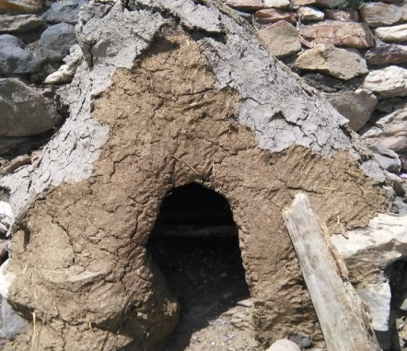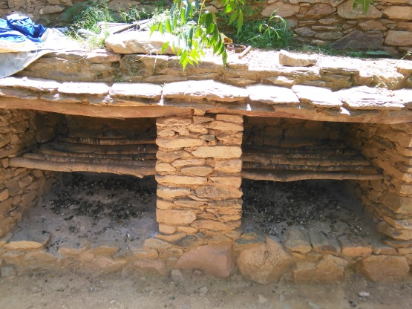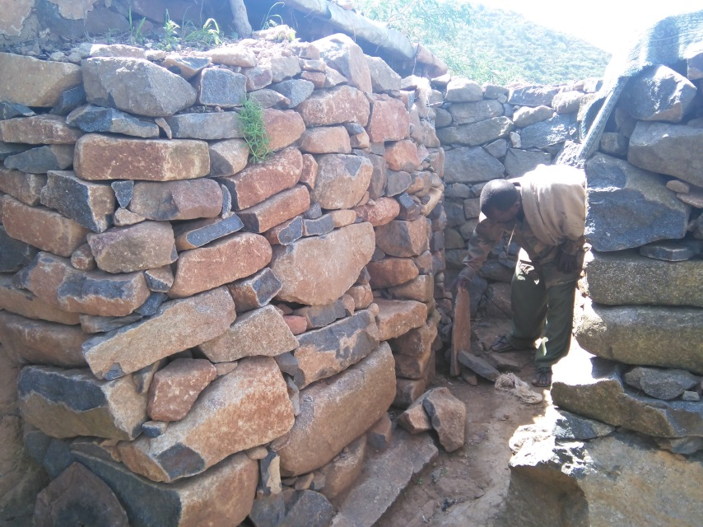
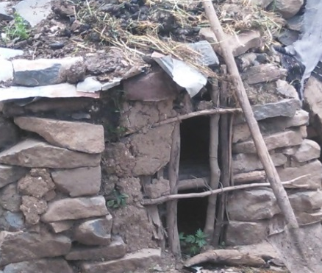
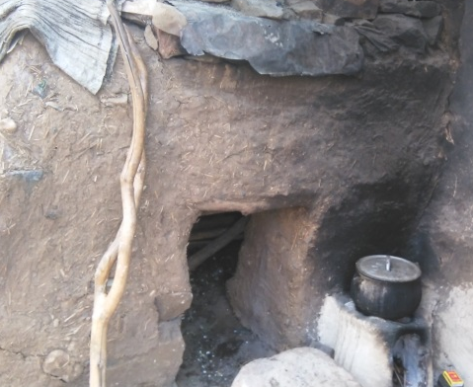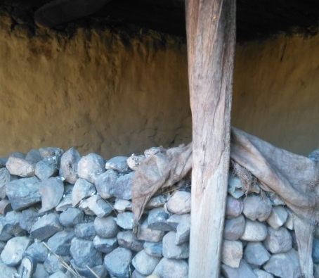
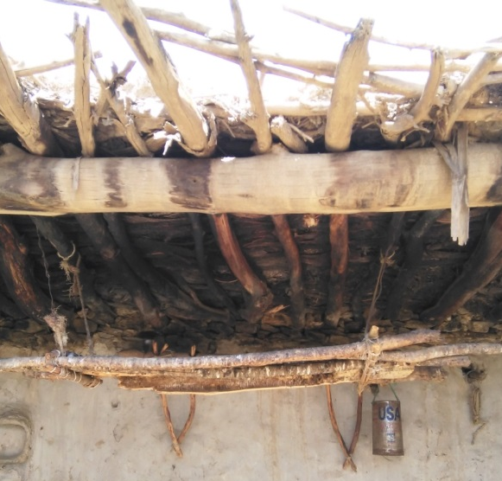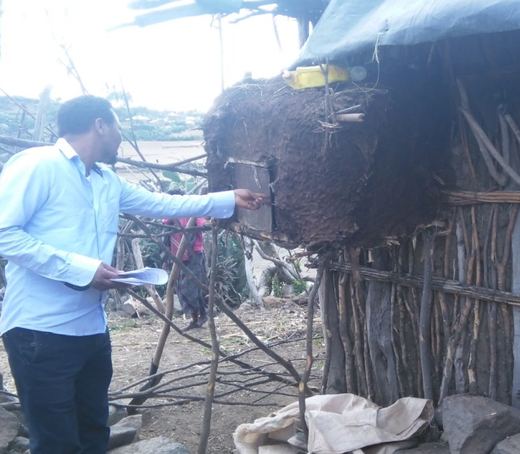
Picture 1: Different types of chicken housing in the study districts
    - Chicken Feed resources and feeding practice
The type of supplementary feed, supplementation frequency and feeding materials are presented in Table 6. About 98.9% of the respondents provide supplementary feed to their chicken regardless of their age difference with cereal grains (91.5%), cereal grain and household left over (3.4%), cereal by products (2.8%) and fruits and vegetables (2.3%) whereas, 1.1% of them did not provide feed to their chicken at all. The respondents provide supplementary feed to their chicken every day (93.7%), every three days (4.0%) and every other day (2.3%) by spreading on the floor (68.6%), by feeder (22.7%) and by both feeder and spreading on the floor (8.7%). The types of chicken feeders utilized across the districts were made of plastic (76.3%), earthen pot (16.9%), stone made (1.7%) and wooden trough (5.1%).
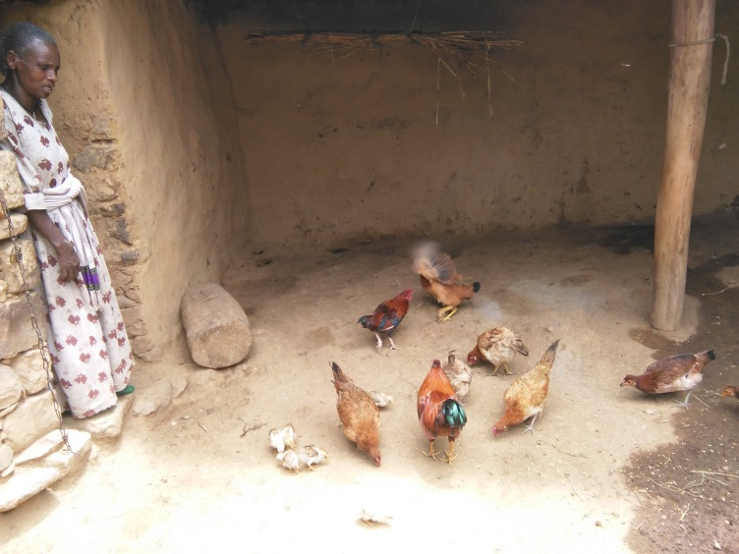
Picture 2: Spreading supplementary feed on the ground
Table 6: Feed resources and feeding practice
Parameters (%) | Districts |  |  | Overall mean
Parameters (%) | Hawzen | D’temben | H/wajirat | Overall mean
N | 60 | 60 | 58 | 178
Providing supplementary feed
Yes | 100 | 98.3 | 98.3 | 98.9
No |  | 1.7 | 1.7 | 1.1
Type of supplementary feed
Cereal grains | 83.3 | 98.3 | 93 | 91.5
Cereal by product |  | 1.7 | 7 | 2.8
Fruits and vegetables left over | 6.7 |  |  | 2.3
Cereal grain and household left over | 10 |  |  | 3.4
Frequency of supplementation
Every day | 98.3 | 95 | 87.5 | 93.7
Every other day | 1.7 |  | 5.4 | 2.3
Every 3 days |  | 5 | 7.1 | 4
Feed provision
By feeder | 23.3 | 28.8 | 15.1 | 22.7
Spreading on the floor | 68.3 | 67.8 | 69.8 | 68.6
Both | 8.3 | 3.4 | 15.1 | 8.7
Type of feeder
Made of plastic | 93.5 | 50 | 61.1 | 76.3
Earthen pot | 3.2 | 40 | 27.8 | 16.9
Stone made | 3.2 | 10 | 5.6 | 1.7
Wooden trough |  |  | 5.6 | 5.1

    - Seasons of feed scarcity and availability
The main seasons with scarce of feed for chickens were May, June, July and September, seasons of crop production in the region. Whereas, the seasons with enough available feed resources were October to April, seasons of crop harvest in the study districts (figure 2).

Figure 2: Seasons of feed shortage for chicken
    - Chicken Watering and sources of water
Water provision, frequency of watering, and type of drinkers are presented in Table 7. Therefore, the result showed that about 99.4% of the respondents provide water to their chicken with ad-libitum (90.7%), once a day (8.7%) and twice a day (0.6%). The respondents’ utilized different local materials for drinking their chicken that is locally available like plastic made (77.4%), stone made (10.2%), earthen pot (5.6%), metallic made (4.0%) and wooden made (2.8%) across the study districts. However, it higher than the report of [29] in which 27% of the respondents use plastic whereas most of them (42%) use clay for drinking their chickens.
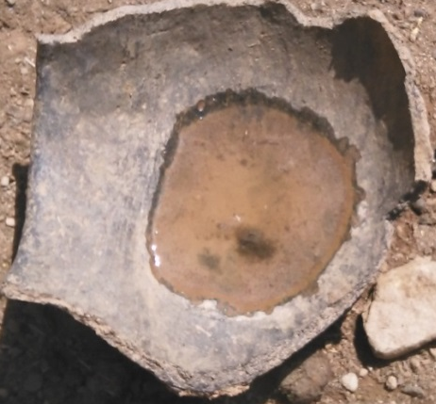
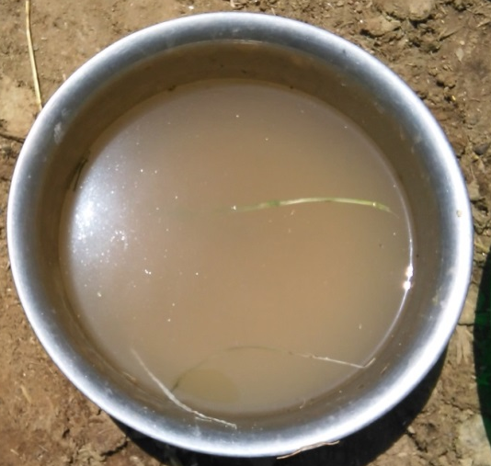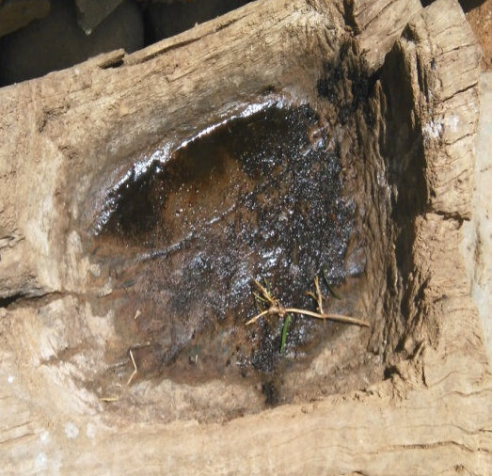
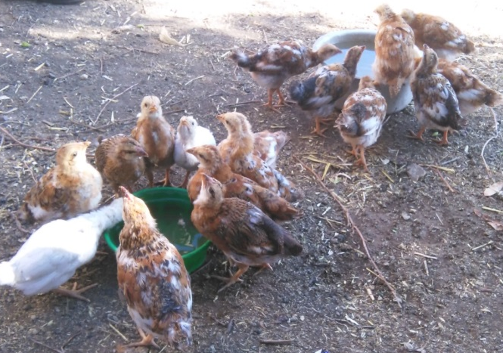
Picture 3: Drinkers of chicken in the study districts
The main sources of water for chicken during dry season were hand pump in all districts but water well is also used as sources of water in both D/temben and H/wajerat, whereas, river water is used in H/wajerat districts. However, river, dam/pond and spring were also used as sources of water in the study districts (figure 3). The main sources of water for chicken during wet season were hand pump and rain water in all study districts whereas; water well is sources of water in both D/temben and H/wajerat districts but river in H/wajerat districts. However, dam/pond and spring water were also used as sources of water in all districts (figure 3).
Table 7: Provision of water, watering frequency and type of drinkers of chicken
Parameters (%) | Districts |  |  | Overall mean
Parameters (%) | Hawzen | D’temben | H/wajirat | Overall mean
N | 60 | 60 | 58 | 178
Provide water
Yes | 100 | 98.3 | 100 | 99.4
No |  | 1.7 |  | 0.6
Frequency of watering
Once a day | 23.7 |  | 1.8 | 8.7
Twice a day |  | 1.7 |  | 0.6
Ad- libitum | 76.3 | 98.3 | 98.2 | 90.7
Do you have drinkers
Yes | 98.3 | 100 | 100 | 99.4
No | 1.7 |  |  | 0.6
Type of drinkers
Plastic | 85 | 81.7 | 64.9 | 77.4
Earthen pot | 5 | 6.7 | 5.3 | 5.6
Wooden trough | 5 | 1.7 | 1.8 | 2.8
Stone made | 3.3 | 5 | 22.8 | 10.2
Metal made | 1.7 | 5 | 5.3 | 4.0

Figure 3: Sources of water for chicken during wet and dry season
  - Hatching and brooding practices
Eggs stored for incubation/hatching, for consumption in dry and rainy season and egg collection frequency are presented in Table 8. In the districts, eggs for incubation/hatching were stored in plastic container (56.5%), mixed with dung (27.1%), put in container with straw (6.8%), mixed with flour (5.6%) and mixed with grain (4.0%). Similarly, eggs for consumption were stored in plastic container (63.2%), in any container (22.4%), mixed with grain (7.5%), put in straw (4.6%) and mixed with flour (2.8%).
Incubation is practiced in different seasons and eggs were stored for two weeks (56.4%), until incubation (21.8%), three weeks (12.7%) and one week (9.1%) in the dry season. Similarly, in the rainy season eggs were stored for two weeks (51.4%), three weeks (22.0%), until incubation (17.4%), and one week (9.2%). Most respondents collect eggs, every day (91.2%), every two days (4.1%), every three days (3.5%) and weekly (0.6%) across the study districts.

Table 8: Hatching, brooding, collecting and egg storage practices
Parameters (%) | Districts |  |  | Overall mean
Parameters (%) | Hawzen | D’temben | H/wajirat | Overall mean
N | 60 | 60 | 58 | 178
Store eggs for incubation and hatching
Mixed with grain | 5 | 1.7 | 5.3 | 4
Mixed with flour | 1.7 | 3.3 | 12.3 | 5.6
Put in straw | 1.7 | 5 | 14 | 6.8
In plastic container | 71.7 | 60 | 36.8 | 56.5
Mix with dung | 20 | 30 | 31.6 | 27.1
Store eggs for home consumption
Mixed with grain | 8.5 | 3.4 | 10.5 | 7.5
Mixed with flour |  | 5.2 | 1.8 | 2.3
Put in straw | 3.4 | 1.7 | 8.8 | 4.6
In plastic container | 71.2 | 63.8 | 54.4 | 63.2
In any container | 16.9 | 25.9 | 24.6 | 22.4
Store eggs before incubation in dry season
One week | 10.2 | 9.6 | 7.4 | 9.1
Two week | 74.6 | 48.1 | 44.4 | 56.4
Three week | 11.9 | 1.9 | 24.1 | 12.7
Until incubation | 3.4 | 40.4 | 24.1 | 21.8
Store eggs before incubation in wet season
One week | 16.1 | 7.1 | 5.6 | 9.2
Two week | 58.1 | 64.3 | 30.6 | 51.4
Three week | 16.1 | 21.4 | 27.8 | 22
Until incubation | 9.7 | 7.1 | 36.1 | 17.4
Egg collection frequency
Every day | 93 | 93.3 | 87 | 91.2
Every 2 days | 1.8 | 1.7 | 9.3 | 4.1
Every 3 days | 3.5 | 3.3 | 3.7 | 3.5
Weekly | 1.8 | 1.7 |  | 0.6

    - Seasons of setting eggs
The main seasons suitable for setting eggs for hatching were October to May (D/temben), October to March (Hawzen) and H/wajerat districts. This is mainly related with the availability of feed and suitable temperature to chicks (figure 4).

Figure 4: Suitable seasons of setting eggs for hatching

  - Incubation materials
The major materials used for incubation of local chickens were mud and wooden made in all districts, clay in D/temben and H/wajerat districts and cartoon in D/temben. However, metallic made, plastic made, grass made and circular pit were the materials used for incubation across the study districts (figure 4). Similarly, straw, ash, soil and sand were used for bedding during incubation in all districts but sheep dung was mainly used for bedding material in D/temben and H/wajerat districts (figure 4).

Figure 5: Materials used for incubation and their bedding of indigenous chickens
    - Methods of eliminating unwanted broodiness
The rank index of unwanted broodiness elimination methods are presented in Table 9. Unwanted broodiness is a common behavior of indigenous chicken in the study districts and farmers practice different methods to eliminate such behaviors traditionally since it affects the production and productivity of the chicken. Therefore, the main elimination methods of unwanted broodiness were hanging upside down, disturbing the hen, taking hens to another place, inserting feather to nostrils and tying hens at the back. However, some farmers also practice taking away hen nest and immersing hens in cold water.
Table 9: Elimination methods of unwanted broodiness behavior of local chickens
Methods | Study districts |  |  |  |  |  | Overall
Methods | Hawzen |  | D/temben |  | H/wajerat
Methods | Index | Rank | Index | Rank | Index | Rank | Index | Rank
Hanging upside down | 0.28 | 1 | 0.29 | 1 | 0.2 | 3 | 0.26 | 1
Disturbing | 0.27 | 2 | 0.21 | 3 | 0.22 | 2 | 0.23 | 2
Inserting feather to nostril | 0.14 | 4 | 0.01 | 6 | 0.03 | 6 | 0.08 | 4
Taking to another place | 0.17 | 3 | 0.28 | 2 | 0.34 | 1 | 0.26 | 1
Taking away nest | 0.01 | 6 | 0.04 | 5 | 0.08 | 5 | 0.04 | 5
Tying back side | 0.13 | 5 | 0.16 | 4 | 0.11 | 4 | 0.13 | 3
Immersing in cold water |  |  |  |  | 0.02 | 7 | 0.01 | 6

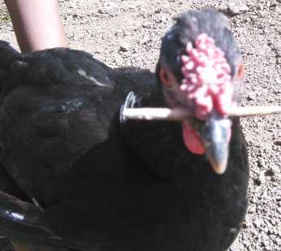
Picture 4: One example of eliminating unwanted broodiness behavior in chickens
  - Conclusions and recommendations
The study revealed that the chicken production system was integrated with crop-livestock production agriculture which contributes supplementary protein sources to the family, income generation through sale of chickens and eggs, replacement stock/hatching and socio-cultural activities. It was an extensive or scavenging production system, on which chicken depends on free grazing with limited supplementation of locally available feed resources like cereal grains, and household left over, cereal by products, fruits and this was supplemented to chickens daily majorly spreading on the floor and to some extent by feeders made of locally available materials. and chicken housing is improving in which chickens slept at night in separate shelter which was made with grass or soil roof and the shelter was cleaned daily. Similarly, chicken feed scarcity was observed during May to November a season of crop production whereas, December to April was months of enough feed availability, a season of crop harvest in the region.
Hand pump was the main sources of water to chickens during wet and dry seasons and water was given to chicken freely in plastic containers, stone, earthen pot, metallic and wooden materials based on the availability. Farmers use eggs for hatching, consumption and income generation and mainly stored in plastic materials for two weeks. In addition, farmers have their own local knowledge in eliminating broody behavior of local chickens. The most common methods used were hanging hens upside down, taking hens to another place, disturbing the hen and tying at the back. Therefore, documentation of farmer’s knowledge and experience on chicken husbandry will be important for further improvement of the poultry sector research and development.

References:
- Moreki JC, Dikeme R, Poroga B. The role of village poultry in food security and HIV/AIDS mitigation in Chobe District of Botswana. Livestock Research for Rural Development. 2010; available at http://www.lrrd.org/lrrd22/3/more22055.htm.
- Kitalyi AJ. Village chicken production systems in rural Africa: Household food security and gender issues (No. 142). 1998; Food and Agriculture Org.
- Tadesse D, Singh H, Esatu W, Dessie T. Study on productive performances and egg quality traits of exotic chickens under the village production system in East Shewa, Ethiopia. African Journal of Agricultural Research. 2013; 8(13), 1123-1128.
- Ahmad F, Ahsan-ul-haq AM, Hussain J, Siddiqui MZ. Production performance of White Leghorn hens under different lighting regimes. Pak. Vet. J. 2010; 30, 21-24.
- Moula N, Diaw MT, Salhi A, Farnir F, Antoine-Moussiaux N, Leroy P. Egg production performance of local Kabyle hen and its crossbreds with ISABrown strain in semi-intensive conditions. International Journal of Poultry Science. 2013; 12(3), 148-152.
- Kejela, Y. Production performance of chicken under farmers’ management and their roles at urban household economy in southern Ethiopia. Agricultural Sciences. 2020; (11) 178-190.
- Tolasa, B. Current status of indigenous and highly productive chicken breeds in Ethiopia. Advances in Agriculture. 2021; 8848388.
- Ayalew H, Yinnesu A, Misganaw G, Molla M, Birhan M, Chanie D, Kindie T, Amsalu D. Performance evaluation and sustainability challenges of tropically adopted exotic chicken breeds in northwest Ethiopia. Cogent Food and Agriculture. 2023; 9(1), 2202221
- Central Statistical Agency (CSA). Agricultural Sample Survey 2020/21: Report on livestock and livestock characteristics. Statistical Bulletin. 2021; No. 589, Vol. II, Addis Ababa.
- Sun C, Liu J, Yang N, Xu G. Egg quality and egg albumen property of domestic chicken, duck, goose, turkey, quail, and pigeon. Journal of Poultry Science. 2019; 98(10), 4516-4521.
- Liswaniso S, Qin N, Shan X, Chimbaka I, Sun X, Xu R. Quality characteristics, phenotypic correlations and principal component analysis of indigenous free range chicken eggs in Lusaka, Zambia. International Journal of Environmental and Agriculture Research. 2020; 6(1), 29-35.
- Ibrahim A, Abare Y, Salisu B, Abdulkarim A. Effects of strain and storage period on some quality characteristics of chicken eggs. Nigerian Journal of Animal Science and Technology. 2020; 3(2), 52-65.
- Kumsa T, Yigezu Z, Ayana I, Tafesse M. Livestock resource potentials constraints and opportunities for intervention by the private sector. 2008.
- Lahkotia RL. Poultry Eggs. Agro bios (India). 2002; Jodhpur. 342p
- ESAP (Ethiopian Society of Animal Production). Commercialization of Livestock Agriculture in Ethiopia. Proc. 16th Annual Conference of the Ethiopian Society of Animal Production held in Addis Ababa, Ethiopia. 2009; Part I, ESAP. Plenary Session. 195p.
- Ethiopian Agricultural Research Organization (EARO). Summary of Livestock Research 441 strategies. Animal Science Directorate, EARO. Addis Ababa. 2000; Ethiopia.73p.
- Kosgey IS. Breeding objectives and breeding strategies for small ruminants in the tropics. PhD Thesis. 2004; Wageningen University. The Netherlands
- Statistical Package for Social Sciences (SPSS). SPSS 20.0 for Windows User’s Guide Release. 2011; Chicago, SPSS Inc.
- Zewdu S, Kassa B, Agza B, Alemu F. Village chicken production systems in Metekel zone, Northwest Ethiopia. Wudpecker Journal of Agricultural Research. 2013; Vol. 2(9), pp. 256 – 262.
- Shishay M, Berhanu B, Tadelle D. Village Chicken Production Constraints and Opportunities in Western Zone of Tigray, Northern Ethiopia. Journal of Biology, Agriculture and Healthcare. 2014; Vol.4, No.27.
- Mekonnen GM. Characterization of smallholder poultry production and marketing system of Dale, Wonsho and Loka Abaya weredas of Southern Ethiopia. A Thesis submitted to the department of animal and range sciences, Awassa College of agriculture. School of graduate studies Hawassa University Awassa. 2007; Ethiopia.
- Moreda E, Hareppal S, Johansson A, Sisaye T, Sahile Z. Characteristics of Indigenous Chicken Production System in South West and South Part of Ethiopia. British Journal of Poultry Sciences. 2013; 2 (3): 25-32.
- Abera B, Geta T. Study on Challenges and Opportunities of Village
Chicken Production in Haramaya District, Eastern
Ethiopia. International Journal of Scientific and Research Publications, 2014; Volume 4, Issue 12.
- Gebremariam B, Mazengia H, Gebremariam T. Indigenous chicken production system and breeding practice in southern Tigray, north Ethiopia. Journal of Poultry, Fish and Wildlife Science. 2017; 5(1), 1-8.
- Demissu H. Evaluation of productive and reproductive performances of different strains of chickens under varied management systems in Western Ethiopia. PhD dissertation, Addis Ababa University, Bishoftu. 2020; Ethiopia.
- Yadessa E, Tulu D, Bogale A, Mengistu G, Aleme M, Shiferawu S, Esatu W, Amare A. Characterization of smallholder poultry production systems in Mezhenger, Sheka and Benchi-Maji zones of south western Ethiopia. Academic Research Journal of Agricultural Science and Research. 2017; 5(1), 10-19.
- Hailu A, Mazengia H, Wuletaw Z. Indigenous chicken production system and breeding practice in North Wollo, Amhara region, Ethiopia. Scholarly Journal of Agricultural Science. 2013; Vol. 3(10), pp. 433-444.
- Letebrhan G, Aberra M, Sandip B, Gebremedhn B. Characterization of village chicken production system under traditional management in Gantaafeshum district of Eastern Tigray, Ethiopia. Livestock Research for Rural Development. 2015; 27 (9).

