DEGRADATIVE CAPABILITY OF MICROBIAL CULTURE, CARROT PEEL WASTE AND CARBON DOT IN REMEDIATION OF PETROLEUM HYDROCARBON IN SOIL

Abstract
Aim:To determine the degradative capability of microbial culture, carrot peel waste and carbon dot in remediation of petroleum hydrocarbon in soil.
Study Design: Microbial culture (MC), organic (Carbon dot and Carrot peel) amendments were used in stimulating and remediating the impacted soil.
Place and Duration of Studies:Environmental Management and Toxicology, Federal University of Petroleum Resource, Effurun. Nigeria. One Month
Methodology: Physicochemical parameters were done on the entire samples. Total cultural heterotrophic bacteria (TCHB) and hydrocarbon utilizing bacteria (HUB).Isolates were identified using their macroscopic, microscopic and biochemical characteristics. A total of ten bacteria species where identified, three were used as consortium which include, Arthrobacter specie, Pseudomonas species and, Bacillus species. Characterization of the Coconut husk, revealed its authenticity, elemental composition and the peak, it exhibited photoluminescence under the ultra violet fluorescent light. Microbial culture (MC), organic (Carbon dot and Carrot peel) amendments were used in stimulating the impacted soil.
Results: The total petroleum hydrocarbon for the polluted and control samples was 2018mg/kg and 0.003mg/kg respectively. The concentration in polluted sample are 11.62, and 8.50 (mg/kg) while for control sample are <0.001, and <0.001 (mg/kg) .. It was observed that within the first and the last week of exposure the values of TPH reduced drastically when used singly and in combination, with microbial culture, Carrot peel and Carbon dot having the insignificant values of (0.028±0.002), CMC (0.044±0.003) and Carrot peel 0.007±0.002).for the combined amendment, TPH was so drastic that it was almost within detectable limit with concentration C (0.005±0.002),B (0.017±0.002) and A (0.055±0.002) Statistical analysis revealed there was significant difference (at P =05) in organic carbon values with respect to the different amendments.
Conclusion: Studies have showed that using biostimulation and bioaugumentation is a good practice for cleaning up soiled environment, this practice is safe, eco-friendly and cost effective,.

Key words: Carbon dot, Carrot peel waste, Microbial Culture, Bioremediation

1. INTRODUCTION
Soil is certainly the source of most of our food; it does much more for human kind. However its quality/health affects three important facets of sustainable land management: Productivity of crops and livestock, Environmental quality of natural resources, health of plants, animals, and humans.. However, petroleum use results in environmental deterioration [38,14,37]
During petroleum production, storage and transportation, refining and processing, as well as spills and discharges of petroleum hydrocarbons often occur as a result of blowout accidents during oilfield development, leakage from oil pipelines and storage tanks, oil tanker and tanker leakage accidents, oil well waxing, and during overhauls of refineries and petrochemical production equipment [10,11,37]
.
Petroleum spill is one of the most common cause of soil pollution in the environment, the release of hydrocarbons into the environment whether accidentally or due to human activities is the main cause of water and soil pollution irrespective of the fact that it is the major source of energy globally, [33]
.
Crude oil is extracted from offshore oil rigs in seawater and transported to the shore. Crude oil recovered from the sub surface is of no use directly, for this reason it must undergo refining for a variety of applications. The oil refinery methods and processes refine products like petrol, gasoline, diesel, jet fuel, asphalt, wax, lubricating oil, tar, kerosene, and liquefied petroleum gas (LPG), etc. The petroleum industry supplies a substantial quantity of world’s energy demands in addition to popular petro-chemical intermediates required for production of extensive range of goods viz. solvents, dye stuffs, pharmaceuticals, polymers, and new chemicals etc. All these goods generate environmental pollution when discharged in the environment. [21,34].

2. MATERIAL AND METHODS
2.1. The study area
The contaminated soil samples were sourced from an Auto Mechanic workshop located at Ugbomro junction. Soil samples from the surface horizons (0-15m) were collected into sterile labelled polyethylene plastic bag. The coordinate of the locations are Latitude5°56’37.16’’N Longitude 5°81’80.85’’E and the non impacted (control) sample was taken from the College of science premises in Federal University of Petroleum Resources, Warri, Delta State its coordinates are Latitude 5.5703345’N Latitude 5.840970’E respectively.

2.2. Carrot peel waste, ( Daucus carota), were purchased from a neighbouring vegetable market. The peels were varied and macerated at a ratio of 1 kg in 2.0 Litre of distilled water, it was soaked in water and then kept in room temperature of 25 ⁰C for 24hours with continuous rousing. The medium was filtered, decanted and autoclaved at 121⁰C for 15 minutes, it was preserved at a temperature of 4⁰C for subsequent use. Modified method of [3].The coordinates of the locations are Latitude 5°560’501’N, Longitude 5’793’150’E
2.3. Coconut shaft was sourced locally in Obogu village. The shaft was trimmed in bit and homogenized thereafter 50g of the biomass powder (coconut shaft) was weighed into 1000ml of distilled water. The mixture was boiled on the heating element for 2hours at 100/⁰C thereafter it was exposed to ultra violet lamp (after filteration) and it fluorescence with green colouration. The resulting blend was clean, and the filtrate was transferred into a conical flask and properly sealed with foil paper to make air-tight. The remains was poured into petri dishes and dried in the oven at temperature of 105⁰C. After drying, the carbon dots were deposited at the surface of the Petri dishes which was scrapped and stored in sample bottle for further use and analysis. The coordinates of the locations are Latitude 5.456756.5 N Longitude 5.634906E.Modified methods of [32,37,7,36].
2.4. Physicochemical analysis of the amendments
2.4.1. Physicochemical parameter and heavy metal analysis of the impacted and pristine soils The above were determined using methods from APHA (2008).
2.4.2. Characterization of Carrot Peel Waste
Total soluble solids (TSS) were determined by dehydration in the oven at 105 ^{O}C until a constant weight was achieved, while the pH was determined using pH meter (Hi77700P instrument, and pocket sized pH meter). Calcium, magnesium, phosphorus, nitrate and nitrite were determined by digital titrator, .the mean of the measurement was taken
2.4.3. Gas Chromatographic (GC-FID) Analysis

Total Petroleum Hydrocarbon (TPH)
Ten grams (10g) of soil samples (polluted sample and control sample) was transferred into an extraction bottle, spiked with known amount of the internal standard (0.1ml of squalene) and dried with anhydrous sodium sulphate. The dried sample was then extracted with a known volume of a mixture of n-hexane and dichloromethane in the ratio of 3:1 by shaking with a sonicator. The extract was cleaned in a silica gel column and the final volume of extract is taken, 1.0µl of the final volume of the extract was injected into an already calibrated Gas Chromatograph equipped with capillary column and identification with data processing software (DATA APEX CLARITY).
2.5 Characterization of Coconut shaft (Carbon dot)
2.5.1 Synthesis of the Biomass
The method of synthesis described here is the hydrothermal method. About 50g of the biomass powder (coconut shaft) was weighed into 1000ml of distilled water. The mixture was boiled on the heating element for 2hours at 100/⁰C thereafter it was exposed to ultra violet lamp (after filteration) and it fluorescence with green colouration.Modified method of [7,36].
2.5.1 UV-Spectroscopy
UV-Vis can be used for kinetics experiments by examining the change in absorbance over time. For a kinetics experiment, take an initial reading of the sample. Quickly add the reagent to start the chemical reaction. Stir it well to mix with the sample. If a small amount is added, this could be done in a cuvette. Alternatively, mix the reagent with sample and quickly pour some in a cuvette for a measurement. Measure the absorbance at the λ_{max} for the analyte of interest over time. If using up the reagent being measuring (i.e. absorbance is going up because there is less reagent to absorb), then the decay will indicate the order of the reaction.Using a calibration curve, make a plot of analyte concentration vs time, converting the absorbance value into concentration. From there, this graph can be fit with appropriate equations to determine the reaction rate constants.
2.5.2 ENERGY DISPERSIVE X-RAY (EDX)
I. Energy dispersive X-ray analysis (EDX) The analytical process is done by bombarding the specimen with a beam of high energy electrons. The bombardment of electrons results in ejection of X-rays from the atoms on the specimen surface.
II.Preparation of the samples for analysis by Energy-dispersive X-ray spectroscopy (EDX) and Backscattered Electron Imaging (BEI) are usually coated with carbon. This is because carbon has a low atomic number and the peak of the X-ray graph of carbon doesn't interfere with other peaks of other elements.
2.6. Microbiological Analysis
2.6.1. Isolation, Screening and Identification of Hydrocarbon Utilizing Bacteria and Total Heterotrophic Bacteria
All media were prepared according to manufacturer’s specifications and autoclaved at 121⁰C for 15 minutes at 15 psi (pounds per square inch).
The method of [12] was adopted in the isolation and identification of total culturable heterotrophic bacteria and for the HUB The vapour phase method of [23] was adopted, Culture depended method was applied to calculate approximately the total population count of the microorganisms present via viable cell count. One (1) gram each of the soil was suspended in 9ml of sterile distilled/water which was aseptically carried out under laminar flow; aliquots (0.3ml) of the dilutions were plated out using appropriate media for the enumeration of the micro*organisms. Plate count agar(PCA) was used for the enumeration of heterotrophic bacteria (THBC) [12] while mineral salt agar(MSA) was used in the enumeration of hydrocarbon utilizing bacteria(HUB) however individual colonies were recorded as colony forming units (cfu/g)
2.7. Experimental Design
Soil was air-dried, homogenized and filtered with a 2.36mm sieve to remove the debris and lumps according to the modified methods of [16,17].The set up was conceded in a glass container left in room temperature (25-28⁰C) it was done in triplicate using various concentrations as the case may be, moisture content was adjusted by adding between 10ml and 5ml of sterile distilled water, turned with spatula for homogeneity every day for proper aeration as this was done weekly throughout the period of the study. Samples were collected at four weeks interval (0-28-56-84) for metabolic and microbial analyses [16].
    - Natural attenuation
Two hundred (200) grams of impacted soil (Field) sample (10:190; 1:199.9) were weighed into each labeled glass containers in triplicate [17],two concentrations10,000mg/kg and 1000mg/kg (1% and 0.1%) respectively, the impacted soil was left uninterrupted for a period of one week before amendment and for acclimatization to take place [24].
    - Biostimulation
The impacted soil were amended with these nutrients: Carbon dot, Carrot peel and Composite microbial Culture (12:8:180;1.2:0.8:198;0.12:0.08:199.8) all in100,000mg/kg,10,000mg/kg and 1000mg/kg(200g),according to the combined and modified method of [17,6,28].
    - Biostimulation and Bioaugumentation
Consortium of microorganism coupled with the other amendments (CMC, Carrot peel waste, and Carbon dot) were used here alongside the impacted soil (field sample) in three concentration of 100,000mg/kg10,000mg/kg and 1000mg/kg respectively in 10%, 1% and 0.1% all in 200grams. [17,6,28].The experiment was set up in a completely randomized block design with four experimental parallels.
2.8. Statistical Analysis
Data were statistically analyzed by Data Analysis Tool pack of Microsoft Office Excel 2007 (Microsoft, New York, NY, USA). TPH, residual moisture, and microbiological analysis of crude oil polluted soil amended with carrot peel waste, and the control soil during 28 days of treatments, p=05 was used to judge the statistical significance.

3.0. RESULTS AND DISCUSSION
3.1. Properties of the impacted soil and the control
Table 1 Soil (control sample and polluted sample) physicochemical parameters are shown in Table 1. and 3. .The pH value of crude oil polluted soil is lower as compared to that of the control sample. The highest pH value (7.80) was recorded for the control soil sample which is neutral/slightly alkaline while the lowest soil pH (6.50) was recorded for the polluted soil sample. The decrease in pH value may be due to increase in degradation of crude oil by microorganisms in the soil resulting in accumulation of acidic metabolites [15]. As shown in Table 1, the electrical conductivity (EC) of the control sample was 67µs/cm and the polluted sample was 61µs/cm i.e the electrical conductivity of control sample is higher. EC is a function of level of contamination at the polluted site, the higher the level of spill the lower the EC [26].
The total organic carbon (TOC) of control sample is 1.7596% and for the polluted soil sample was 0.335% and the reason is that the soil polluted with crude oil which contain hydrocarbon has more carbon content compared to that of the control soil sample that is not polluted [30]. However, the moisture content of crude oil polluted soil was lower than that of control soil sample. The highest soil moisture (11.25%) was recorded for the control sample while the lowest soil moisture (10.17%) was recorded as the polluted sample and this may be due to the fact that crude oil can coat the soil and consequently prevent the penetration of water or it can be caused by microorganism which utilize water for their activities [29].
The amount of nitrate in the control soil sample was 19.45mg/kg and that of polluted soil sample was2.68mg/kg which means that there is no presence of nitrate in the polluted soil sample. The reduction of nitrate in the polluted soil is an indication that the limiting nutrients were released to the microorganism involved [20]. Also, crude oil pollution leads to the deterioration of soil mineral nutrients. For phosphate, the control soil sample was 9.30mg/kg while the polluted soil sample was 10.05mg/kg. For Magnesium, the control soil sample was 48.80mg/kg while for the polluted soil sample was 68.90mg/kg. The result indicated that the phosphate and Magnesium levels of the polluted sample are higher than that of the control sample because of the pollution exerts adverse effects on soil conditions, microorganisms and plants [34].
Control soil sample for calcium reads 4120mg/kg and for the polluted soil sample it was 4250mg/kg and that of potassium for the control soil sample was 55.01mg/kg while that of the polluted soil sample was 76.30mg/kg. The control soil sample for sodium was 1840mg/kg and the polluted soil sample was 2116mg/kg while that of magnesium, the polluted soil sample was 68.90mg/kg and control soil sample was 48.80mg/kg this due to the deterioration of soil structure [29].
The cation exchange capacity (CEC) which is the calculation from the absorbance obtained from the various cations and the activities of the individual ions. For the control soil sample it was 4.20meq/100g while the polluted soil sample was 7.30meq/100g. It was observed that the lower concentrations of calcium, potassium, sodium and CEC were found in the control soil sample and higher for the polluted samples except for magnesium and the increase depends on the concentration of the contamination.
The concentration of lead in the polluted soil sample was higher than the concentration in the control sample. Lead (Pb) concentration in polluted soil was 11.62mg/kg and the control soil 8.50mg/kg.
The increase in the concentration of heavy metals in the polluted soil may be due to the hydrocarbon pollution which altered the physico-chemical parameters of the soil as well as increasing the concentration of heavy metals. [14]
The total petroleum hydrocarbon (TPH) concentration for the control sample was 0.003mg/kg and polluted sample was 2018mg/kg, the polluted sample is extremely higher than that of control sample because it was contaminated with hydrocarbon found in crude oil and this petroleum hydrocarbon released to the environment (soil) leads to its increase in toxicity [9].

Table 1.: Physicochemical parameters of the polluted soil sample and control soil sample
PARAMETERS  P^{H} | UNIT | SAMPLE A(CS)  6.50 | SAMPLE B(C)  7.80
HEAVY METALS
Lead (Pb) | Mg/kg | 11.62 | 8.50
Arsenic (As) | Mg/kg | <0.001 | <0.001
LIGHTER METALS
Sodium (Na) | Mg/kg | 2116 | 1840
Potassium (K) | Mg/kg | 76.30 | 55.01
Calcium (Ca) | Mg/kg | 4250 | 4120
Magnesium (Mg) | Mg/kg | 68.90 | 48.80
Moisture Content | % | 10.17 | 11.25
Electrical Conductivity (EC) | µs/cm | 61 | 67
CationExchangeCapacity(CEC)  ORGANICS  Total Petroleum Hydrocarbon | Mg/kg  Mg/kg | 7.30  2018 | 4.20  0.003
Total Organic Carbon (TOC) | % | 0.335 | 1.7596
Nitrate (NO₃) | Mg/kg | 2.68 | 19.45
Phosphate (PO₄) | Mg/kg | 10.05 | 9.30

Table 2.: Physicochemical parameter of TPH, _{p}H, moisture content and TOC
SOIL | Total Petroleum Hydrocarbon (Mg/kg) | PH | Moisture Content (%) | Total Organic Carbon (%)
Contaminated soil | 2018 | 6.50 | 10.17 | 0.335
Uncontaminated soil | 0.003 | 7.50 | 11.25 | 1.7596

3.2 Physicochemical content of the carrot peel waste
As shown in Table 3 Where Calcium 29.04 ± 2.01, Magnesium 6.28 ± 0.20, Phosphorus, 23.09 ± 1.20, Nitrate 2.01 ± 0.20, Nitrite 0.4 ± 0.02, Total solid extract (%)17.21 ± 2.04, Moisture (%)80.76 ± 4.30, pH 5.41 ± 0.95.
Table 3.: Physicochemical content of carrot peel waste
____________________________________
Elements (mg/L) Carrot Peel Waste
__________________________________________
Calcium 29.04 ± 2.01
Magnesium 6.28 ± 0.20
Phosphorus 23.09 ± 1.20
Nitrate 2.01 ± 0.20
Nitrite 0.4 ± 0.02
_________________________________________
Parameters
_________________________________________
Total solid extract (%) 17.21 ± 2.04
Moisture (%) 80.76 ± 4.30
pH 5.41 ± 0.95
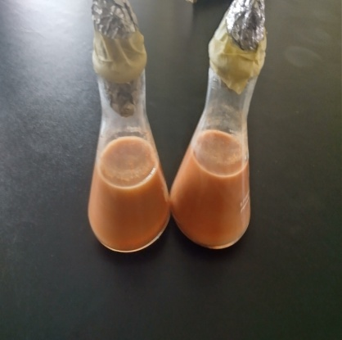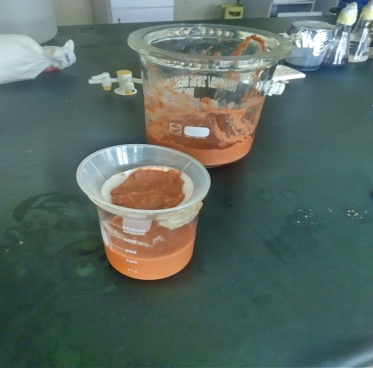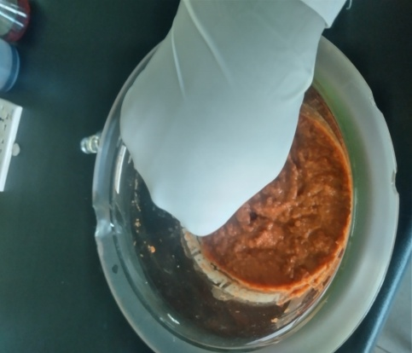
Plate: 1.Processing and extraction of carrot peel waste
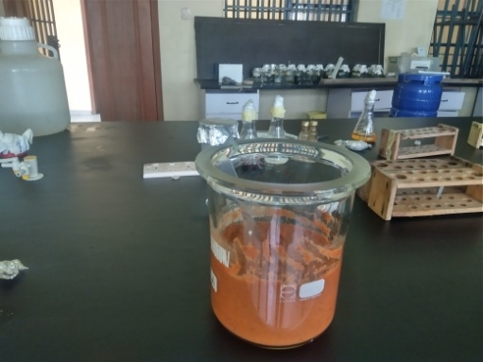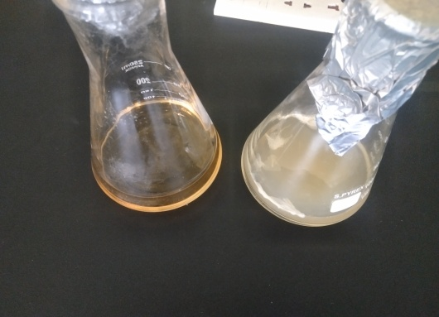
Carrot extract and Bacteria Cconconsortia
Plate 2: Carrot peel extract and Consortium of Hydrocarbon utilizing Bacteria

3.3.. Synthesis and characterization of Carbon dot
Biosynthesis of Carbon dot materials using plant materials is also known as phyto nanotechnology is greatly encouraged to reduce the use of toxic chemicals during synthesis and to produce eco-friendly, simple, cost-effective nano materials that are scalable, bio-compatible, and easily synthesized with the use of universal solvent (water). These nanomaterials are better, uniform, and have fine particle sizes with longer half-life [21].
It improves soil physiology and increases productivity, and it also assists with crop residue management.Many studies report that the soil acidity was reduced considerably, and essential mineral uptake increased with residual effects for the following season [25] In carbondot significant quantities of K and small amounts of Mg, Ca, Cu, Zn and Fe are present, which have potential as fertilizer.Hydrothermal method was adopted for the synthesis of the biomass(Coconut shaft), with some modification. [28, 31].

Plate 3: Synthesis of Carbon dots (C-dots) from Coconut shaft using Hydrothermal Method

3.3.1 Characterization of Carbon dot
The EDX results (Figure 1.0) revealed 69.10% C, 7.20%, O 2.22% Na,3.20%Fe,0.23% Ca and 0.33% Si. The occurrence of the carbon may possibly be credited to the biomolecules of the plant extract, and soil carbon as well provides nutrient through mineralization and helps to aggregate soil particles (structure) and provide resilience to physical degradation, it increases microbial activity, water storage and availability to plants and protects the soil from erosion, This simply showed that the plant extract barely serve as bioreductant and also stabilized and capped the nano particles.

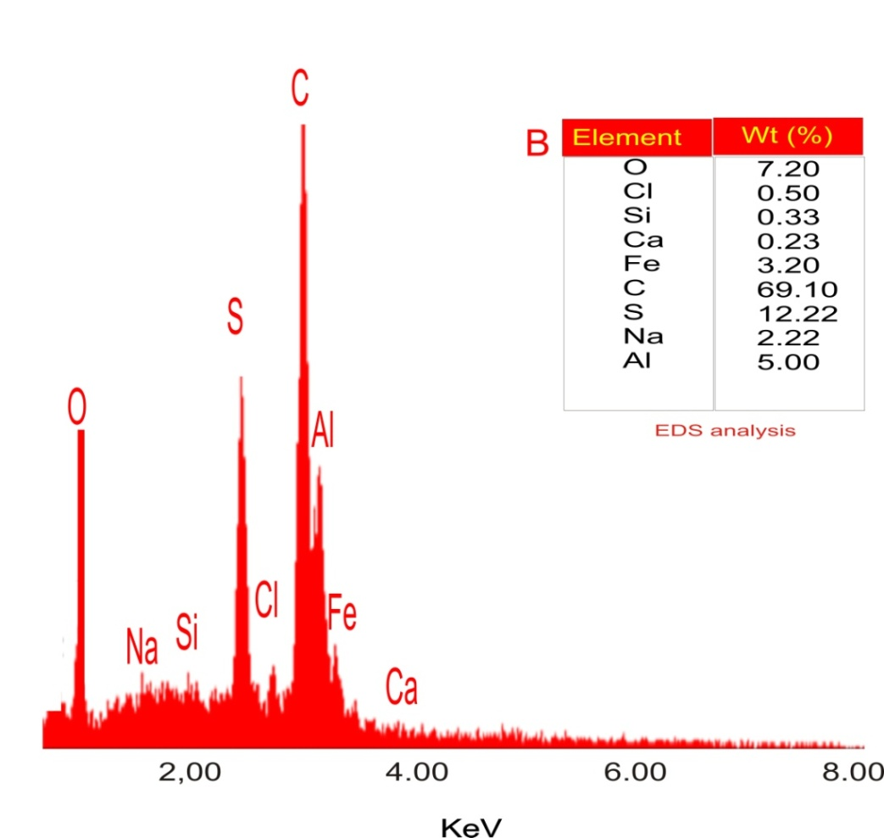
Figure 1.0: EDX micrograph of carbon dot from coconut shaft

UV–visible spectroscopy showed the bare eyes picturing of the biomass synthesis displaying its colour change from brown-coloured clarification to a greenish colouration. The formation of the nanoparticles was verified by UV–visible spectroscopy showing absorption peak at 342 nm as shown in Figure 2.0. The absorbance value recorded is an indication of elevated absorption of the ammendment and the wavelength of absorption is in tandem with other reports [2]. In the report of [18,19].

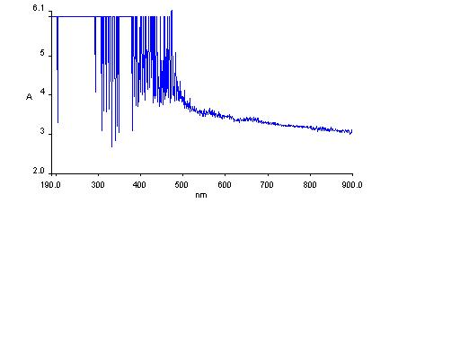
Figure 2.0: UV–visible spectroscopy of the Biomass

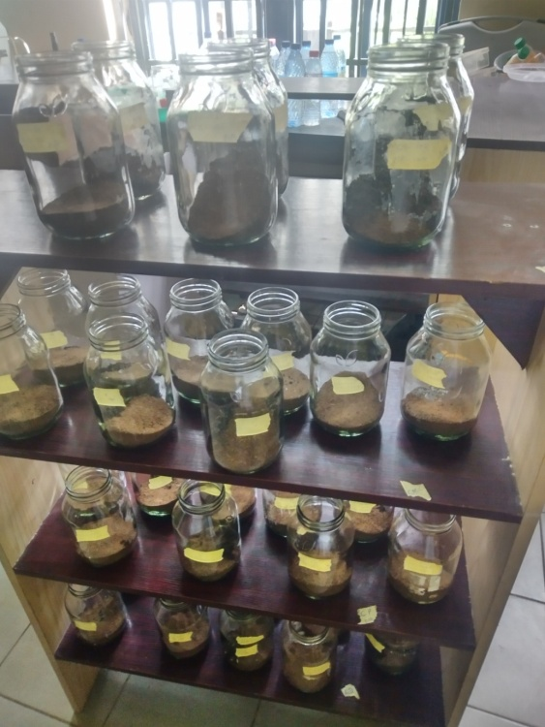
Plate 4: Laboratory Set up

3.4 Isolation and Identification of Bacteria Isolates
Soil was air-dried, homogenized and filtered with a 2.36mm sieve to remove debris and lumps according to the modified methods of [16,17].The set up was conceded in a glass container left in room temperature (25-28⁰C) it was done in triplicate using various concentrations as the case may be, moisture content was adjusted by adding between 10ml and 5ml of sterile distilled water, turned with spatula for homogeneity every day for proper aeration as this was done weekly throughout the period of the study. Samples were collected at four weeks interval (0-28) for metabolic and microbial analyses [16].
The genetic distribution of total culturable heterotrophic bacteria isolates are described in Table 4. which. Shows the hydrocarbon utilizing bacteria present in the polluted soil. A total of ten (10) Bacteria isolates from the polluted soil sample was identified as: Bacillus specie, Proteus specie Bacillus specie Pseudomonas species, Bacillus specie, Micrococcus specie, Bacillus specie, Arthrobacter Specie, Staphylococcus species, and Proteus Specie using the mineral salt media composed by [8]. However three of the microbial culture was used in consortia (Arthrobacter Specie, Pseudomonas specie and Bacillus specie) for the set up respectively.
Table 4.: Cultural and morphological characteristics of the total culturable heterotrophic bacteria isolates
SN | IG | Gram Reaction | Morphologialcharacteristis | Cat alase | Oxidase | Indole | Citrate | Mothionine | Methl Red | VP | H2S | Gas prod. | Sla | Bu | Glucose | Lactose | Maltose | Sucrose | Tent. Org.
1. | 1A | + | Rod | + | - | - | + | + | - | + | - | - | B | A | A | A | A | - | Bacillus specie
2. | 1B | - | Rod | + | - | + | - | + | + | - | + | + | A | A | A/G | A/G | A/G | A/G | Proteus specie
3. | 2A | - | Rod | + | + | - | + | + | - | + | - | - | B | A | A | A | A | A | Pseudomonas specie
4. | 2B | + | Rod | - | - | - | + | + | + | + | - | - | B | A | A | A | A | A | Bacillus specie
5. | 3A | - | Rod | + | + | - | + | + | - | + | - | - | B | A | A | A | A | A | Pseudomonas specie
6. | 3B | + | Rod | + | - | - | + | + | - | + | - | - | B | A | A | A | A | A | Bacillus specie
7. | 4A | + | Cocci | + | - | -` | + | - | + | - | - | - | B | A | A | A | A | A | Micrococcus Specie
8. | 5A | + | Rod | + | - | - | + | + | - | + | - | - | A | A | A | A | A | A | Arthrobacter Specie
9. | 7A | + | Cocci | + | - | - | + | - | - | + | - | - | A | A | A | A | A | A | Staphylococcus Specie
10. | 8B | - | Rod | + | - | - | - | + | + | - | + | + | A | A | A | A | A | A | Proteus Specie
IC; Isolate code, GR; Gram reaction, CM; Cell morphology, Cat; Catalase, Ox; Oxidase, Ind; Indole, Cit; Citrate, Mot; Motility, MR; Methyl red, VP; Voges Proskauer, H2S; Hydrogen sulphide, Sla; Slant, Bu; Butt, Glu; Glucose, Lac; Lactose, Mal; Maltose, Suc; Sucrose, Org; Organism, A/G; Acid and gas.
Figure .3 shows the percentage occurrence of isolates Bacillus specie occurred three times, Proteus species twice and Pseudomonas twice others occur in single.

Figure .3: The percentage occurrence of Isolates
The isolation of hydrocarbon utilizing microorganisms from petroleum-polluted environment is taken as evidence that those organisms are the active hydrocarbon degraders in that environment. The microbial group capable of survival in such environment are those that have developed enzymatic and physiological responses that enable them to use the hydrocarbon present as substrates [12].
When these organisms use the hydrocarbon as substrate for growth, they release extra cellular enzymes and acids which are capable of breaking down the hydrocarbon molecule, by reducing the long chains of hydrogen and carbon, hence converting the hydrocarbon into simpler forms or products that can be absorbed by the organisms for nutrition and growth. These organisms that are capable of growth on this substrate use the energy produced to synthesize cellular components, releasing carbon (iv) oxide, water and energy used for the production of biomass.
3.5 Biodegradation Studies.
For the biodegradation studies, displayed in Table 5 to Table 6.The set up was designed in triplicate; it was monitored in the laboratory in a room temperature (25-27⁰C) for a period of 0-28days. during the period of exposure, and results were all represented in mean standard deviation, and their Colony Forming Unit (cfu/g) was achieved, however the following was achieved within the first and last week of the experimental design for the total heterotrophic bacterial count (THBC), for the natural attenuation (Control) (0-28days) ranged between 30.00±0.00 and 44.00±1.00 and for the biostimulation set up concentration A in carbon dot at the initial stage shows 37.50±1.50 and 139.00±1.00,concentration B showed 34.50±0.50 and 80.50±1.50 while concentration C recorded 35.00±1.00 and 77.00±1.00, for Carrot Peel Concentration A gives38.00±1.00 and 141.00±36.00, B 34.00±1.00 and 105.00±2.00, C 30.50±0.50 and 91.00±2.00 for the CMC, A showed 31.50±1.50 and 129.50±4.50 and for B 32.50±2.50 and 118.00±44.00, for C 31.00±1.00 and 63.00±2.00. It is known that cfu/g counts are higher in polluted soil than unpolluted soil, and microbial counting of a contaminated site is the simplest method to monitoring microbial activities that can be used for bioremediation, The mean values of microbial counts obtained from polluted soil, In polluted sample the THB had a mean value of a similar observation was reported by [12]. Petroleum hydrocarbon degrading bacteria are ubiquitous in nature and can utilize these compounds as sources of carbon and energy. Bacteria displaying such capabilities (Pseudomonas species, Bacillus species etc) are often exploited for the bioremediation of petroleum oil contaminated environment, recent studies have identified bacteria from more than 79 genera that are capable of degrading petroleum hydrocarbon [33].For the Hydrocarbon utilizing bacteria (HUB), the log cfu/g of control in two concentrations as well for 1% we have 35.00±2.00 and 92.00±6.00 for 0.1% we have 38.50±4.50 and 61.50±6.50 for the biostimulation the concentration of carbon dot A revealed 38.00±1.00 and 74.50±2.50 for B we have 36.00±1.00 and 83.00±10.00 for the C we have 35.00±1.00 and 88.50±2.50. for the CMC we have A 34.50±2.50 and 53.50±3.50 in that concentration, for B we have 31.00±1.00 and 52.00±2.00, for C we have 32.50±0.50 and 60.00±2.00, for Carrot peel A is 32.50±0.50 and 57.00±2.00, for B we have 36.00±1.00 and 49.00±1.00 for C we have 30.00±0.00 and 47.00±1.00, all recorded within the initial and the final duration of the experimental set up. The difference between THB and HUB counts was observed to be minimally insignificant which suggest that most of the microorganisms present in the various polluted sample sites are hydrocarbon degraders that can withstand the concentrations of hydrocarbons and also use them as source of carbon. [22,12]. By the end of the study, population of indigenous oil degrading microbiota increased rapidly, which corresponds to high availability of hydrocarbons during these periods [4].Crude oil polluted soil amended with organic matter may stimulate growth of the indigenous oil degrading micro biota in it [1]. Similar observations have been reported using organic amendment [22]. The mean difference is significant at the P =.05 level between THBC and % abundance of HUB in the samples.
During this period some parameters were analysed and result obtained from the spectrophotometer showed that the control (Natural attenuation) were within the range of 0.84±0.03and 0.71±0.04, for the A (12%) whereas the B (1.2%) 0.06±0.00 and 0.05±0.00 and C (0.12) recorded 0.54±0.00 and0.38±0.00 within the period of exposure (0-28 days), drastic reduction of TPH was observed within the initial and the final stage of the laboratory experiment. For the biostimulation set up, Carbon dot (CD) with three concentrations, A was within the range of 0.089±0.003and 0.067±0.002, while B was within 0.052±0.002 and 0.052±0.002, C was within 0.057±0.002 and 0.028±0.002,for the Biaaugumentatio and Biostimulation, drastic reduction were recorded for the 28 day of exposure of the three concentrations the reduction of the TPH was so drastic that it was almost within detectable limit especially with concentration C (0.005±0.002),B (0.017±0.002) and A (0.055±0.002) respectively, as this is a true fact that microbes has catalytic effect on hydrocarbons. For Carrot peel, concentration A were within 0.143±0.005 and 0.065±0.002, while for the B they are 0.082±0.004 and 0.067±0.002, for C 0.008±0.002 and 0.007±0.002.

Figure 4. Total Heterotrophic Bacteria Count (THB) 10³ cfu/g In NATURAL ATTENUATION (Natural and contaminated soil)

Figure 5. Total Heterotrophic Bacteria Count (THB) 10³ cfu/g In Biostimultion (Carbon dot)

Figure 6. Total Heterotrophic Bacteria Count (THB) 10³ cfu/g In Biostimultion (Carrot peel)

Figure 7. Total Heterotrophic Bacteria Count (THB) 10³ cfu/g In Biostimultion (Composite Microbial Culture)

HYDROCARBON UTILIZING BACTERIA

Figure 8. Hydrocarbon Utilizing Bacteria (HUB) 10³ cfu/g In Natural attenuation (Natural and cocntaminated soil )

Figure 9. Hydrocarbon Utilizing Bacteria (HUB) 10³ cfu/g Biostimulation (Carbon dot )

Figure 10. Hydrocarbon Utilizing Bacteria (HUB) 10³ cfu/g Biostimulation (Carrot peel)

Figure 11. Hydrocarbon Utilizing Bacteria (HUB) 10³ cfu/g Biostimulation (Composite Microbial Culture)

Spectrophotometer Count (THB)

Figure 12. Total Spectrophotometer Count 10³ cfu/g Natural attenuation (Contaminated and Natural soil)

Figure 13. Total Spectrophotometer Count 10³ cfu/g Biostimulation (Carbon dot)

Figure 14. Total Spectrophotometer Count 10³ cfu/g Biostimulation (Carrot peel)

Figure 15. Total Spectrophotometer Count 10³ cfu/g Biostimulation (Composite Microbial Culture)

Figure 16. Total Spectrophotometer Count 10³ cfu/g Biostimulation and Bioaugumentation

4.0. CONCLUSION
This study established that biodegradation of hydrocarbon polluted soil microbiota with carbon dot, carrot peel waste and microbial culture enhanced the degradation of the polluted soil under laboratory conditions. The Total Petroleum Hydrocarbon degradation in the contaminated soil was enhanced by bio-stimulation with nutrients present in the amendments in comparison to the pristine soil (control) Degradation of TPH increased after 28 days of incubation during bioremediation. The biodegradation of the Hydrocarbon polluted soil microbiota was positively related to TPH degradation efficiency during bio-remediation. Carrot peel waste, containing high amounts of phosphorus, enhanced bioremediation of crude oil polluted soil by increasing microbial activities of biodegrading bacteria, The result from the EDX showed Carbon as the highest elemental composition which is an indication that the Biomass (Carbon dot) is highly rich in Carbon, and as an amendment could possibly contribute to the soil carbon which provides nutrient through mineralization and helps to aggregate soil particles (structure) and provide resilience to physical degradation,

REFERENCE
1. Abioye, PO.; Aziz, AA. Agamuthu, P.. Enhanced biodegradation of used engine oil in soil amended withorganic wastes. Water Air Soil Pollut., 2010,(209), 173–179.
2. Adeyemi JO, Elias E Elemike E.., Onwudiwe DC. ZnO nanoparticles mediated by aqueous extracts of Dovyalis caffra fruits and the photocatalytic evaluations.Mater. Res. Express 2019.6: 125091.
3. Acourene, S.; Tama, M. Utilisation des Dattes de Faible Valeur Marchande (Rebuts de Deglet-Nour, Tinissineet Tantboucht) Comme Substrat pour la Fabrication de la Levure Boulangère. Rev. Energ. Ren. 2018
4 Al-Kindi, S., Abed, RM. Comparing oil degradation efficiency and bacterial communities in contaminated.soils subjected to biostimulation using different organic wastes. Water Air Soil Pollut. 2018 (227), 36.
5. APHA. Standard Methods for the Examination of Water and Waste Water. 22nd Edition, American Public Health Association, American Water Works Association, Water Environment Federation.2012
6. .Azubuike, CC., Chikere, CB. and Okpokwasili, GC. Bioremediation techniques_classification based on site of application: principles, advantages, limitations and prospects. World J. Microbiol. Biotechnol.2016 ;32 (11);180.
7. Boadu KO1, Asiamah I., Anang AM, John KB., Wanjala P. Muyoma.. Characterization of Chemically Activated Carbons Produced from Coconut and Palm Kernel Shells Using SEM and FTIR Analyses. American Journal of Applied Chemistry2021; 9(3); 90-96
8.. .Bushnell ID., Haas, HF.The utilization of certain hydrocarbons by microorganisms Journal of Bacteriology, 194;141,653.http;//www.scirp.org
9. Cermak, JH., Stephenson, GL., Birkholz, D., Wang, Z. and Dixon, DG.. Toxicity of petroleum hydrocarbon distillates to soil organism. Environmental Toxicology Chemistry.2010; (7) 29: 2685-2694.
10. Chaerun S.K., Tazaki K., Asada R., Kogure K.. Bioremediation of coastal areas 5 years after the Nakhodka oil spill in the Sea of Japan: isolation and characterization of hydrocarbon-degrading bacteria. Environ. Int. 2004;30; 911–922. 10.1016/j.envint.2004.02.007
11. Chen, W., Li, J., Sun, X., Min, J., Hu, X.. High efficiency degradation of alkanes and crude oil by a salt-tolerant bacterium Dietzia species CN-3. Int. Biodeterior. Biodegrad. 2017; (1)29;110–118.
12. Chikere, CB., Ekwuabu, CB.. “Culture – dependent characterization of hydrocarbon utilizing bacteria in selected crude oil – impacted sites in Bodo, Ogoniland, Nigeria”. African Journal of Environmental Science and Technology 2015,;8(6): 61-76.
13. De la Huz, R., Lastra, M., López, J. Other Environmental Health Issues: Oil Spill. In Encyclopedia of Environmental Health;Nriagu, J.O., Ed.; Elsevier: Burlington, NJ, USA, 2018.;251–255.DOI:10.5772/Intechopen.76082.
14. Dora N. The Role of Soil pH in Plant Nutrition and Soil Remediation. Applied and Environmental Soil Science 2019; 9 pages https:// doi.org/10.1155/2019/5794869
15. Ejileugha C, Okerentugba PO, Okonkwo IO . Interaction of cyanobacteria and aerobic heterotrophic bacteria in crude oil biodegradation in the Niger Delta region of Nigeria. Researcher. 2015;7(12): 32-38.
16. Emami, S., Pourbabaei, AA., Alikhani, HA. Interactive effect of nitrogen fertilizer and hydrocarbon pollution on soil biological indicators. Springer Environmental Earth Science, 2014;72(9); 3513-3519.
17. Ezekoye, CC, Amakoromo ER Abiye Anthony Ibiene.. Laboratory
Based Bioremediation of Hydrocarbon Polluted Mangrove Swamp
Soil in the Niger Delta Using Poultry Wastes. Microbiol Res J Int. 2017;19(2):1–14.
18. Ghamsari, M. S., Alamdari, S., Han, W.,and Hyung-Ho P. Impart of Nanostructure thin ZnO film in Ultraviolet Protection. International Journal of Nanomedicine 2016,;(12):207-216. https://dx.doi.org/10.2147/IJN.5118637.
19. Gupta, M., Tomar, RS., Kaushik, S., Mishra, R.., Sharma, D., Effective antimicrobial activity of green ZnO nano particles of Catharanthus roseus. FrontierMicrobiology.2018;9:1–13. https://doi.org/10.3389/fmicb.2018.02030.
20. Ibiene AA, Orji FA, Orji-Nwosu EC . Microbial population dynamics i n crude oil- polluted soils in the Niger Delta. NJFE. 2011; 7(3): 8-13.
21. Ijaz, I., Gilani, E.,Nazir, A., Bukhari, A. Detail Review on Chemical, Physical and Green Synthesis, Classification, Characterizations and Applications of Nanoparticles. Green Chemistry Letters and Reviews, 2020;13(3) :59-81, https://doi.org/10.1080/17518253.2020.1802517
22. Jones A.M James II, Akpan, PS, Eka II ,Oruk, AE Ibuot,, AA .Characterization of Hydrocarbon Utilizing Bacteria in waste engine oil impacted sites.doi: https://doi.org/10/1101/2020.03.21.998872, doi 10.36462/h biosci.2021B
23. Okerentugba, P. O., Ataikiru, T. L. Ichor T. Isolation and characterisation of hydrocarbon utilizing yeast (HUY) isolates from palm wine. American Journal of Molecular Biology. 201;,6: 63-70.
24. Orji, FA., Abiye, AI., Dike, EN. Laboratory scale bioremediation of petroleum hydrocarbon - polluted mangrove swamps in the Niger Delta using cow dung. Malaysian Journal of Mi crobiology, 2012; 8(4); 219-228
25. Panwar, NL., Kothari, R., Tyagi, VV. Thermochemical conversion of biomass—eco friendly energy routes. Renew Sustain Energy Rev.2012; 16(4):1801–1816
26 Pathak H, Bhatnagar K, Jaroli DP . Physico-chemical properties of petroleum polluted soil collected from transport Nagar (Jaipur). Ind. J. Fund. Appl. Life Sci. 2011; 1(3): 84-89.
27. Rahman, KSM Rahman, T.J. Kourkoutas, I. Petsas, R. Marchant, IM. Banat.Enhanced bioremediationof n-alkane in petroleum sludge using bacterial consortiumamended with rhamnolipid and micronutrients,” BioresourceTechnology, . 2003 ; 90, (2); 159–168,
28. Saeed M , Kamel, H. Bioremediation potential of Biochar foRemediating crude oil, 2021; .28. (5); 2667-2677 http;//doi.org/10.106/J.SJBS.2021.03.044
29. Snehal VK. Bioremediation of petroleum hydrocarbon polluted sites for the conservation of soil microbial diversity. A PhD thesis. University of Punes, India 2014,;143pp
30. Sulaiman, AA., Dominic, BS. Graeme, IP. Effects of hydrocarbon contamination on soil microbial community and enzyme activity. Journal of King Saud University-Science. 2015; 27(1):31-41.
31. Tan, K. L. Hameed, BH. Insight into the adsorption kinetics models for the removal of contaminants from aqueous solutions, Journal of the Taiwan Institute of Chemical Engineers,2017,;01-24,
32. Tang, L., Ji, R., Cao, X., Lin, J., Jiang, H., Li, X., Teng, C. M., Luk, S., Zeng, J., Hao, L., & Lau, S. P. ACS Nano, 2012;6, 5102–5110.
33. Tremblay J., Yergeau E., Fortin N., Cobanli S., Elias M., King T. L., . Chemical dispersants enhance the activity of oil-and gas condensatedegrading marine bacteria. ISME J. 2017,;11 2793–2808. 10.1038/ismej.2017.129
34. Uche, OM., Owhondah, WM. and Augustine, UA. The Omoku old pipeline oil spill: total hydrocarbon content of affected soils and the impact on the nutritive value of food crops. Archive Applied Science Research. 2011;,3: 514-521.
. 35. Varjani, SJ. Upasani, VN.A new look on factors affecting microbial degradation of petroleum hydrocarbon pollutants. Int.Biodeterior. Biodegrad. 2017;120, 71–83.
36. Wang, H., Gao, Y., Wang, Q., Li, X., & Li, Y. Biodegradation of crude oil by an indigenous bacterial consortium from Penglai 19-3 oil spill in Bohai Sea, China. Marine Pollution Bulletin,2018 ;136, 58-65.
37 .Xu E. Microganism degrading organic pollutant and their potential for the bioremediation of contaminated environment. 2018;2) 8 85 https//doi.org//0.3389.fmicb.2018.02885
38 Xue J., Yu Y., Bai Y., Wang L., Wu Y. Marine oil-degrading microorganisms and biodegradation process of petroleum hydrocarbon in marine environments: a review. Curr. Microbiol. 2015;71; 220–228.

